U.S. Drought Monitor Report: An assessment of screening snow, clouds, and other poor quality pixels out of eMODIS NDVI prior to calculation of phenology metrics, with a focus on start of season time (SOST)

Danny Howard, Mike Steuck, and Jess Brown

Objectives:
The overall objective of this effort was to provide data and information to support an investigation of the influence that snow, clouds, and other poor quality pixels have on eMODIS smoothing and ultimately the phenological metrics. Specific objectives include:
  - Quality data associated with a 3 year historical weekly eMODIS data should be stacked and processed
  - Create a newly smoothed historical NDVI time series for Continental United States (CONUS) where the annual winter NDVI baseline is an improved estimate of snow-free conditions
  - Calculate phenology metrics with snow-free smoothed data
  - Compare existing smoothed NDVI and metrics with newly constructed historical NDVI and metrics
  - Provide recommendations about snow data influence on the metrics (e.g. start of season)
  - Complete report including sections on processing details, snow data characteristics, comparison between current start of season and post-snow start of season data
  - Deliver data and a report NLT 1 July 2016
Activities Overview:
- Investigated NOAA annual snow cover averages to determine the consecutive three year period for the temporal focus on this activity. Determined 2011 – 2013 to be appropriate.
- Downloaded, processed, smoothed, and stacked 2010 – 2014 eMODIS NDVI using a new masking procedure, which masks snow, clouds, and other poor quality pixels prior to NDVI smoothing
- Calculated all V2 phenology metrics for 2011 – 2013 (AMP, DUR, EOSN, EOST, MAXN, MAXT, SOSN, SOST, TIN)
- Studied the impacts that removing snow, clouds, and other poor quality pixels had on the V2 smoothed NDVI data and V2 phenology metrics
  - Performed visual inspections/comparisons and extracted weekly time series pixel values of V1/V2 smoothed NDVI for 2010 and 2012 at selected flux tower locations and aspen sites
  - Performed visual inspections/comparisons, calculated difference images, and compared extracted pixel values of V1/V2 phenology metrics for 2011 - 2013 at selected flux tower locations and aspen sites
- Developed a set of V2 phenology metrics maps for 2011 – 2013 and an accompanying set of V1-V2 difference image maps
- Provided a results-based recommendation on the NDVI processing procedure
- Documented activities and findings in report format – including the following attachments (data, graphics, and tables – See attachments section in Appendix 1):
  - eMODIS Phenology Metrics SOP
  - Phenology Metrics & NDVI Pixel Extractions Table
  - SOST Difference Image Data Tables and Histograms
  - V2 2011 – 2013 Phenology Metrics Data (BSQ/HDR)
  - V2 2011 – 2013 Phenology Metrics Graphics (PNG)
  - 2011 – 2013 V1 – V2 Phenology Metrics Difference Image Data (BSQ/HDR)
  - 2011 – 2013 V1 – V2 Phenology Metrics Difference Image Graphics (PNG)
  - Flux Towers and Aspen Sites Points Shapefile
  - 2012 NDVI Data (Unsmoothed, Smoothed_V1, Smoothed_V2)
  - Comparison Graphics and Difference Image Graphics Organized into a word document (AMP, DUR, EOSN, EOST, MAXN, MAXT, SOSN, TIN)
Methodology Details:
- V2 NDVI Processing
  - Downloaded and unzipped 2010 - 2014 eMODIS NDVI and Quality Band (Collection 5)
    - Source: https://dds.cr.usgs.gov/emodis/CONUS/historical/TERRA/
  - Developed a python script to systematically apply an ESRI Raster Calculator function that set all non-best quality pixels (value 0 in the eMODIS Quality Band) to ‘-1999,’ to be ignored by the smoothing application
    - Effectively masking snow, clouds, and other poor quality pixels
  - Utilized ENVI software to create 62 band stacks for 2010—2014
    - 52 bands plus 5 bands of padding on the front and back ends
  - Utilized ENVI software to apply data scaling for the 2010—2014 stacks
    - Byte((b1/100) + 100)
  - Executed the Smooth.v6.16.exe application to temporally smooth the 2010—2014 NDVI stacks
  - Removed the padding from the final 52 band smoothed NDVI stacks 2010—2014 to create the final V2 smoothed NDVI products
  - Note: This process, without step b, was also performed on 2010 and 2012 NDVI (V1 smoothed NDVI) to be used for the NDVI comparison of unsmoothed, V1 smoothed, and V2 smoothed NDVI products
- Phenology Metrics Processing
  - Created three 3-year image stacks (156 bands) for input into the IDL metrics processing code
    - (2010, 2011, 2012); (2011, 2012, 2013); (2012, 2013, 2014)
  - Subset each 3-year image stack into 16 subsets to fall under the 2GB processing limit of the IDL metrics processing code
  - Executed the IDL metrics processing code on all subsets to create AMP, DUR, EOSN, EOST, MAXN, MAXT, SOSN, and TIN phenology metrics
  - Extracted annual metrics from all IDL metrics processing output and merged the 16 subsets back into seamless mosaics for post processing
  - Applied the following ENVI Band Math equations to reclassify out of range pixels:
    - [(b1 le 0) * 0 + (b1 gt 0 and b1 le 1000) * b1 + (b1 gt 1000) * 0], Where b1 = AMP
    - [(b1 lt 1) * (-1000) + (b1 ge 1 and b1 le 365) * b1 + (b1 gt 365) * (-1000) ], Where b1 = DUR
    - [(b1 le 0) * 0 + (b1 gt 0 and b1 le 1000) * b1 + (b1 gt 1000) * 0], Where b1 = EOSN
    - [(b1 lt 1) * (-1000) + (b1 ge 1 and b1 le 450) * b1 + (b1 gt 450) * (-1000) ], Where b1 = EOST
    - [(b1 le 0) * 0 + (b1 gt 0 and b1 le 1000) * b1 + (b1 gt 1000) * 0], Where b1 = MAXN
    - [(b1 le 0) * (-1000) + (b1 gt 0 and b1 le 365) * b1 + (b1 gt 365) * (-1000) ], Where b1 = MAXT
    - [(b1 le 0) * 0 + (b1 gt 0 and b1 le 1000) * b1 + (b1 gt 1000) * 0], Where b1 = SOSN
    - [(b1 lt -150) * (-1000) + (b1 ge -150 and b1 le 365) * b1 + (b1 gt 365) * (-1000) ], Where b1 = SOST
    - [(b1 le 0) * 0 + (b1 gt 0 and b1 le 20000) * b1 + (b1 gt 20000) * 0], Where b1 = TIN
  - Applied the following ENVI Band Math equations to apply a byte data scaling:
    - [byte (b1/10)], Where b1 = AMP
    - [byte ((b1/10) + 100)], Where b1 = EOSN
    - [byte ((b1 / 10) + 100)], Where b1 = MAXN
    - [byte ((b1 / 10) + 100)], Where b1 = SOSN
    - [byte (b1/100)], Where b1 = TIN
  - Applied the following ENVI Band Math equations to set water pixels accordingly:
    - [byte((b1 eq 0) * 255 + (b1 ne 0) * b2)], Where b1 = Water and b2 = AMP
    - [(b1 eq 0) * 1000 + (b1 ne 0) * b2], Where b1 = Water and b2 = DUR
    - [((b1 eq 0) * 255 + (b1 ne 0) * b2)], Where b1 = Water and b2 = EOSN
    - [(b1 eq 0) * 1000 + (b1 ne 0) * b2], Where b1 = Water and b2 = EOST
    - [((b1 eq 0) * 255 + (b1 ne 0) * b2) ], Where b1 = Water and b2 = MAXN
    - [(b1 eq 0) * 1000 + (b1 ne 0) * b2], Where b1 = Water and b2 = MAXT
    - [byte((b1 eq 0) * 255 + (b1 ne 0) * b2) ], Where b1 = Water and b2 = SOSN
    - [(b1 eq 0) * 1000 + (b1 ne 0) * b2], Where b1 = Water and b2 = SOST
    - [byte((b1 eq 0) * 255 + (b1 ne 0) * b2) ], Where b1 = Water and b2 = TIN
  - Imported all V2 phenology metrics data into the standardized mapping templates to develop East and West phenology metrics maps for 2011 - 2013)
- Difference image Processing
  - Calculated V1 minus V2 difference images for DUR, EOST, MAXT, and SOST using the following ENVI Band Math equation:
    - (b1 eq (1000) or b2 eq (1000)) * (1000) + (b1 eq (-1000) or b2 eq (-1000)) * (-1000) + (b1 ne (-1000) and b1 ne (1000) and b2 ne (1000) and b2 ne (-1000)) * fix(fix(b1) - fix(b2))
      - (Where b1 = V1 and b2 = V2)
      - This equation was designed to ignore out of range (-1000) and water pixels (1000) in the difference calculation
  - Calculated V1 minus V2 difference images for AMP and TIN using the following ENVI Band Math equation:
    - (b1 eq (0) or b2 eq (0)) * (0) + (b1 eq (255) or b2 eq (255)) * (255) + (b1 ne (0) and b1 ne (255) and b2 ne (0) and b2 ne (255)) * fix(fix(b1) - fix(b2))
      - (Where b1 = V1 and b2 = V2)
      - This equation was designed to ignore out of range (0) and water pixels (255) in the difference calculation
  - Calculated V1 minus V2 difference images for EOSN, MAXN, and SOSN using the following ENVI Band Math equation:
    - (b1 eq (100) or b2 eq (100)) * (100) + (b1 eq (255) or b2 eq (255)) * (255) + (b1 ne (100) and b1 ne (255) and b2 ne (100) and b2 ne (255)) * fix(fix(b1) - fix(b2))
      - (Where b1 = V1 and b2 = V2)
      - This equation was designed to ignore out of range (100) and water pixels (255) in the difference calculation
  - Created difference maps for all phenology metrics for 2011 - 201)
  - Applicable attachments (See attachments section in Appendix 1)
    - eMODIS Phenology Metrics SOP
Results and Comparison:
- SOST Evaluation
  - While all phenology metrics were generated and evaluated to some degree in this effort, the focus of this report was on the SOST metric (time/day of the start of the growing season). Here the impacts that the new NDVI smoothing method had on the resulting SOST (V2 SOST) phenology metric were assessed. This was done by performing visual and statistical difference imaging between V1 SOST (current SOST product, calculated with the regular smoothed NDVI) and V2 SOST.
    - Visual Comparison – The 2011 – 2013 V2 SOST data were imported into the standardized phenology metrics mapping templates and a set of East and West maps were produced. These maps were produced to the exact specifications as the V1 SOST maps to ensure a meaningful comparison. A visual comparison of the V1 and V2 maps revealed similar patterns of SOST throughout the country with some clear reduction in image line artifacts (noted in: PA in 2011, IA in 2012, IL in 2013). Another improvement noted in the visual comparison was a general reduction of image noise in the V2 data, a potential result of masking out sporadic poor quality pixels.
    - Difference Imaging – It is important to understand that the SOST values of the standardized maps are classified into monthly color ranges, limiting the level of detectable difference. To bolster the visual comparison, difference images were calculated and mapped. In the calculation (ENVI band math equation provided in [3.a] of Methodology section), water pixels (1000) and no season pixels (-1000) were specially handled to avoid adding confusion to the difference images. Essentially, only pixels that were in-season and non-water in both V1 and V2 SOST were included in the difference. A histogram for each difference image was also provided to show the distribution of the difference. These elements added another level of difference detail to the comparison.
  - Applicable attachments (See attachments section in Appendix 1)
    - SOST Difference Image Data Tables and Histograms
    - V2 2011 – 2013 Phenology Metrics Data (BSQ/HDR)
    - V2 2011 – 2013 Phenology Metrics Graphics (PNG)
    - 2011 – 2013 V1 – V2 Phenology Metrics Difference Image Data (BSQ/HDR)
    - 2011 – 2013 V1 – V2 Phenology Metrics Difference Image Graphics (PNG)
    - Comparison Graphics and Difference Image Graphics Organized into a word document (AMP, DUR, EOSN, EOST, MAXN, MAXT, SOSN, TIN)
  - Below (Figures 1 – 15), for each year, the V1 and V2 SOST maps (Eastern and Western US) are situated in a side-by-side fashion followed by the difference image/accompanying histograms.
2011 Start of Season Time (East)
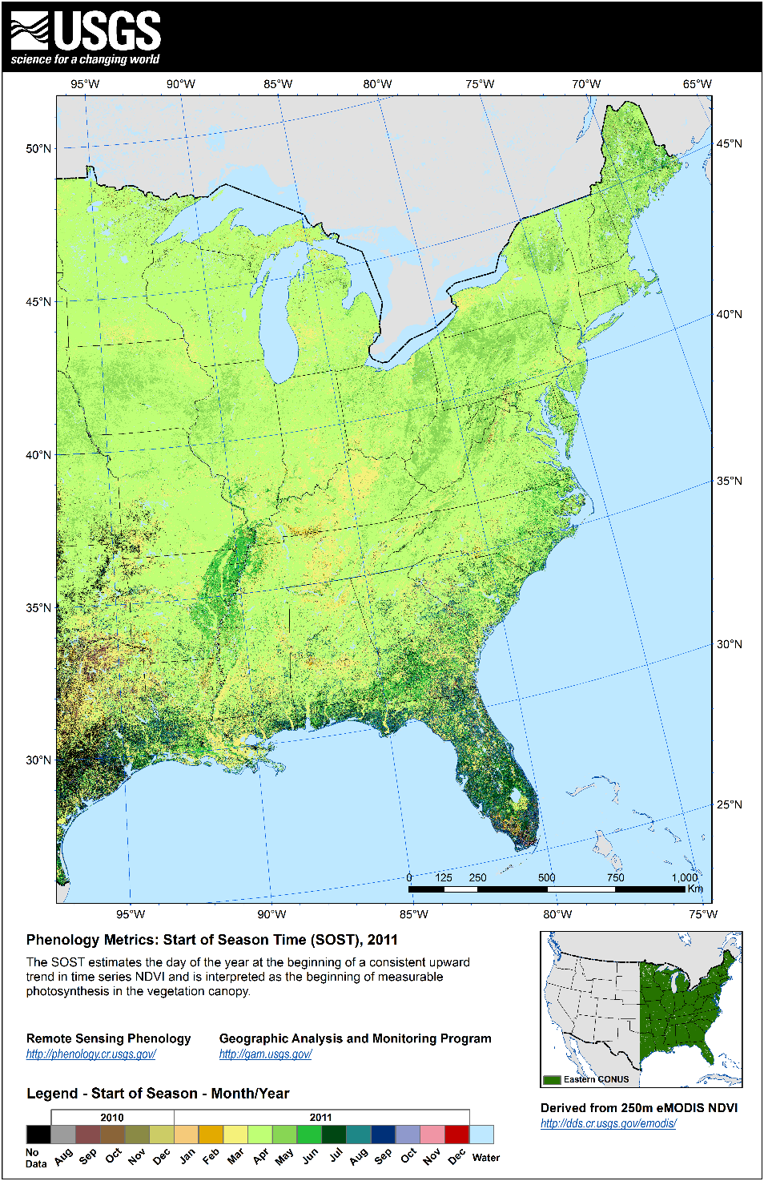 | 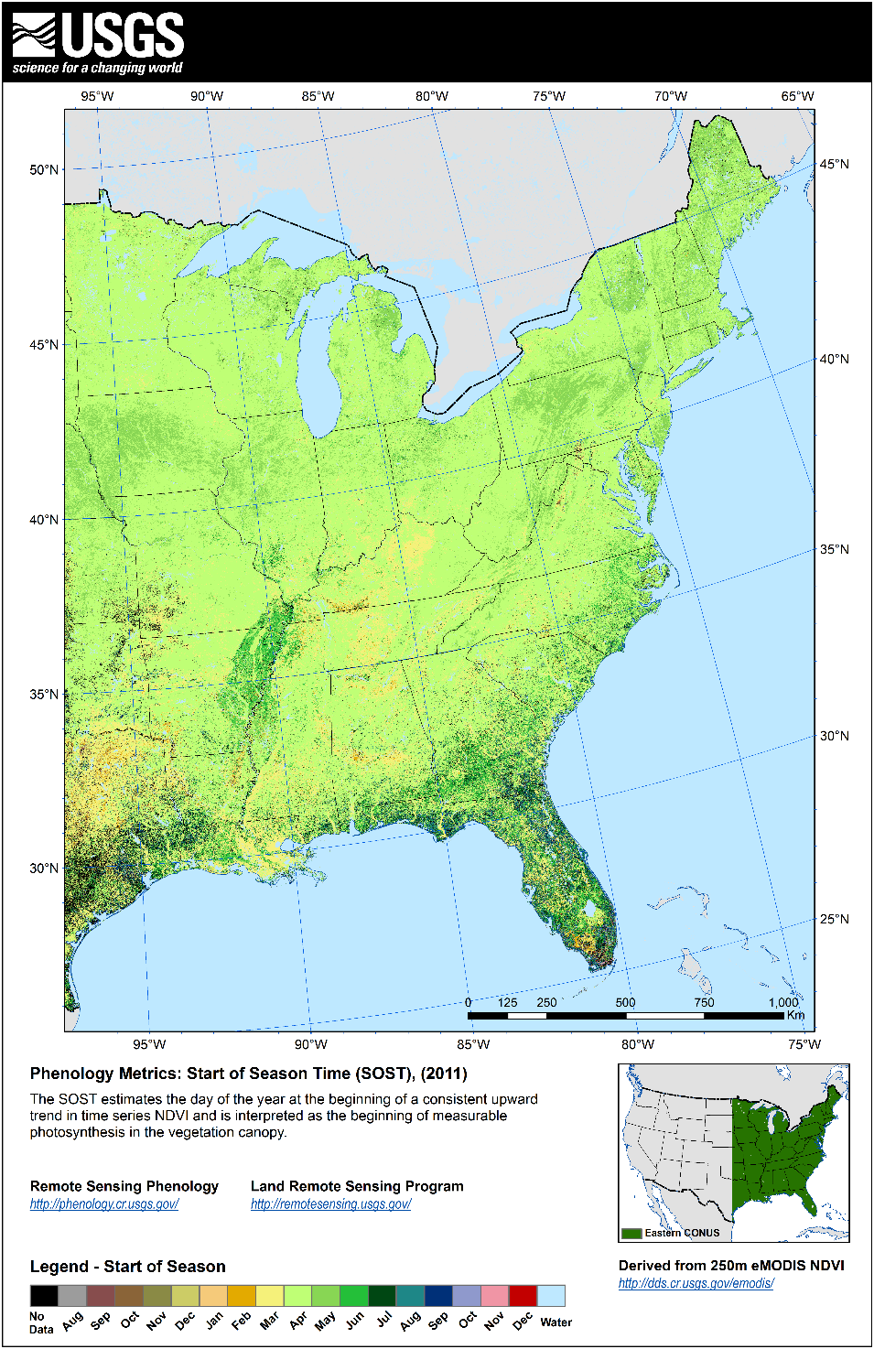
Figure 1. 2011 V1 SOST | Figure 2. 2011 V2 SOST
2011 Start of Season Time (West)
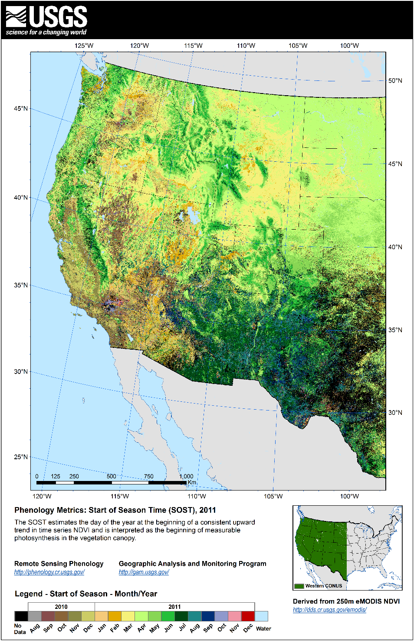 | 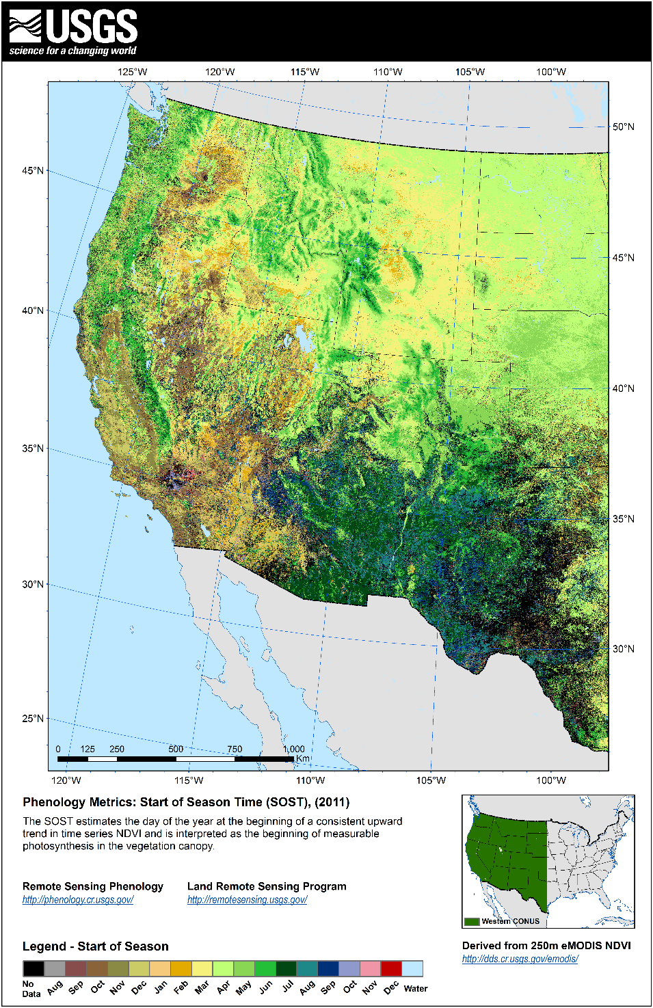
Figure 3. 2011 V1 SOST | Figure 4. 2011 V2 SOST

2011 Start of Season Time Difference Image (V1 – V2)
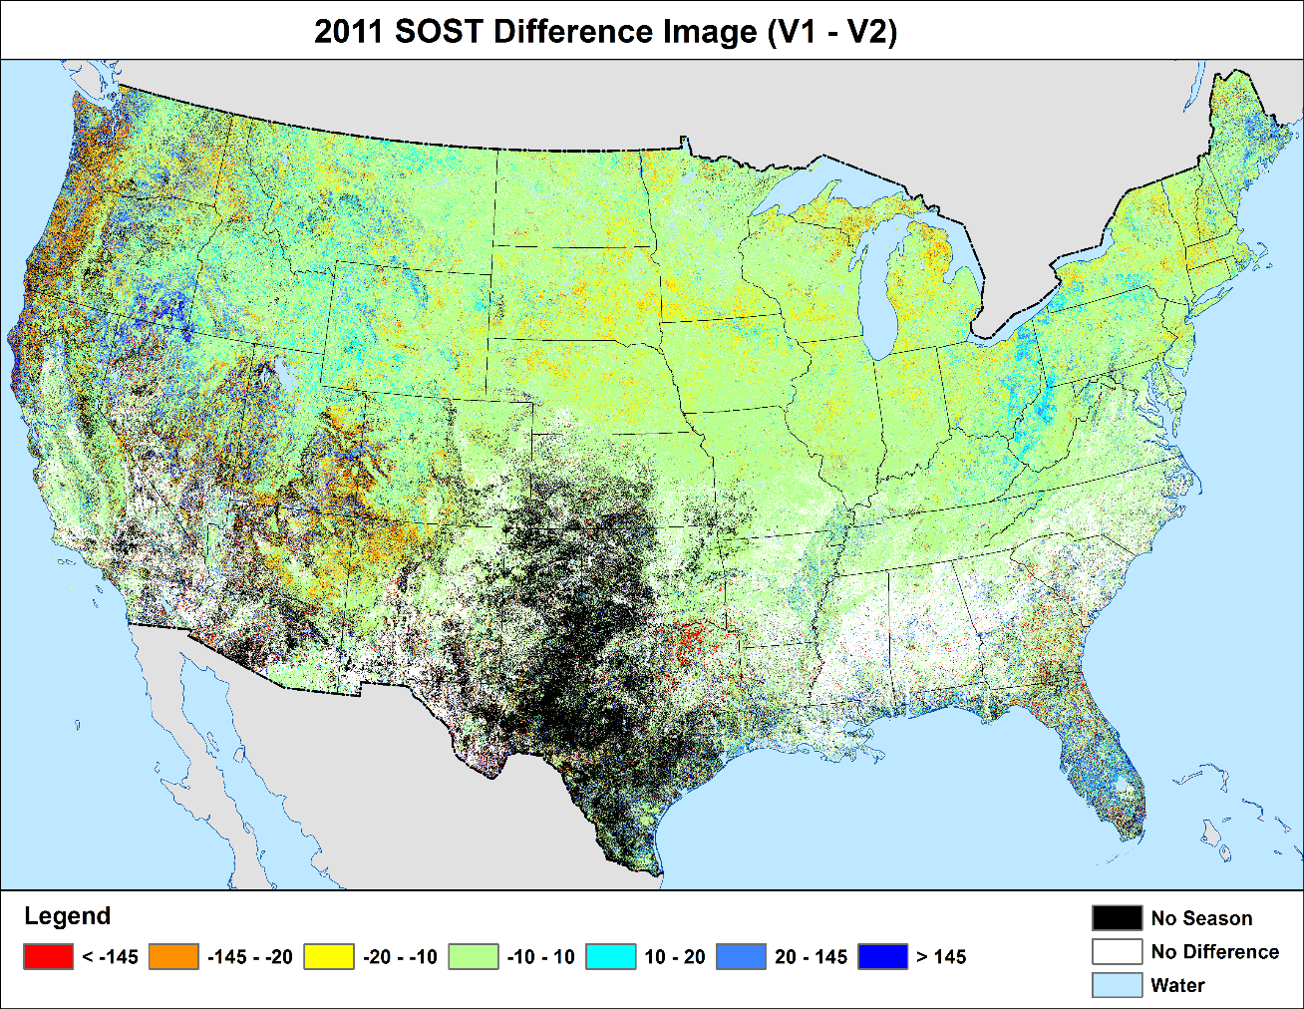
Figure 5. 2011 SOST difference image and histogram

2012 Start of Season Time (East)
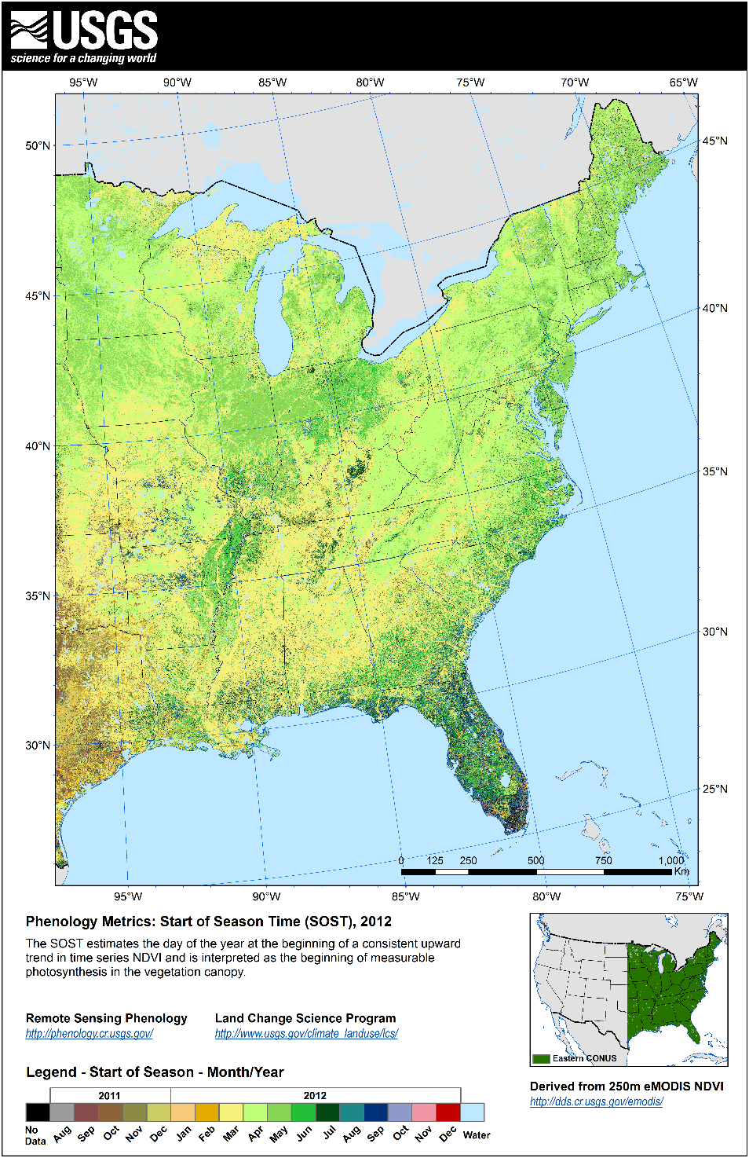 | 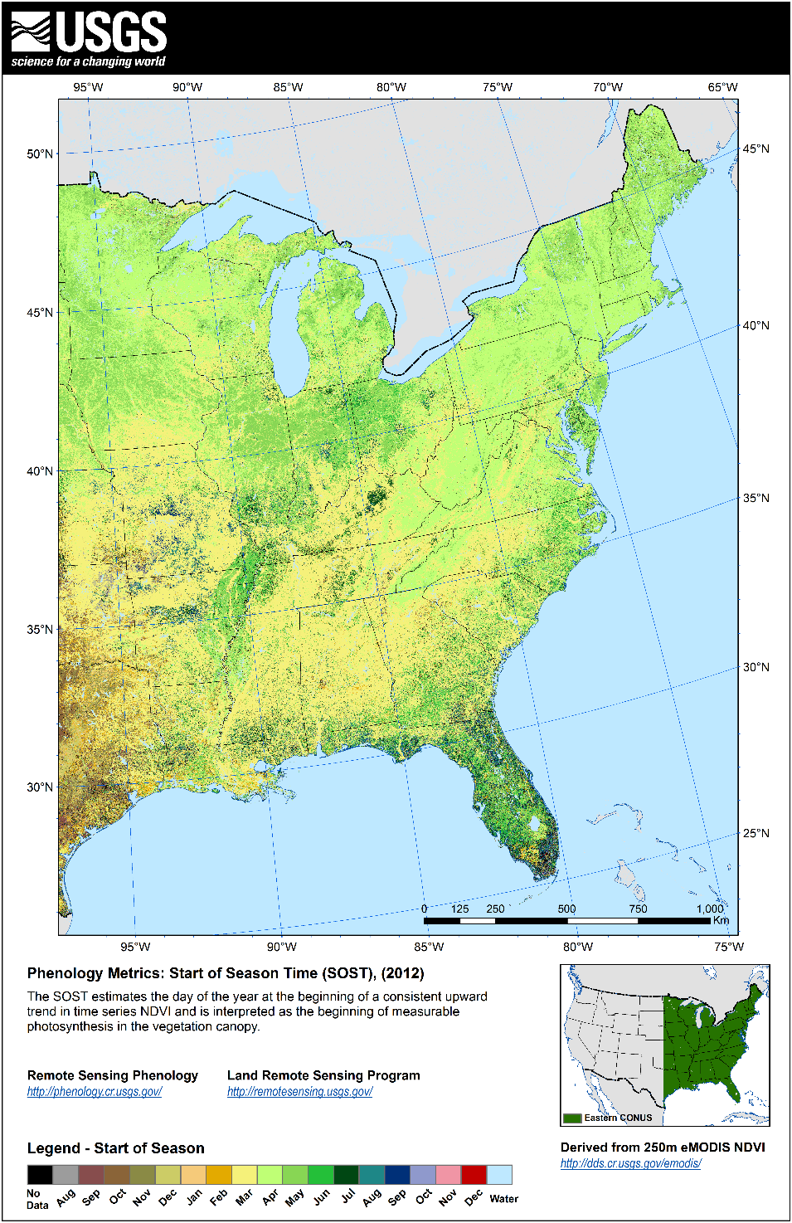
Figure 6. 2012 V1 SOST | Figure 7. 2012 V2 SOST
2012 Start of Season Time (West)
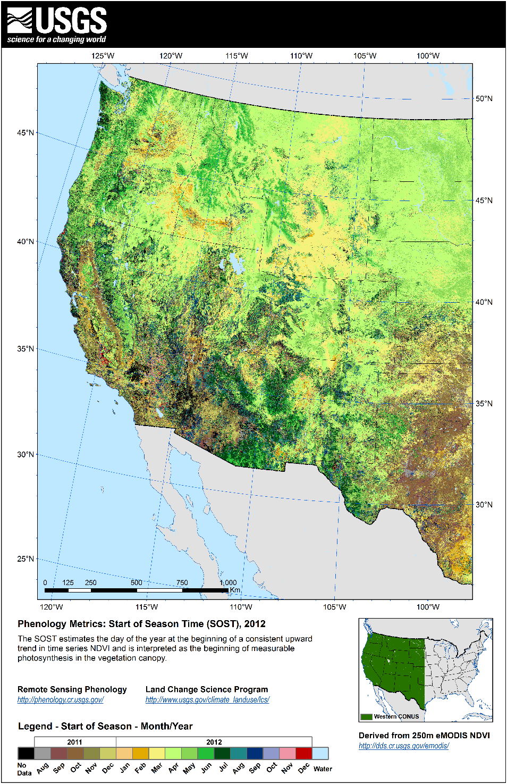 | 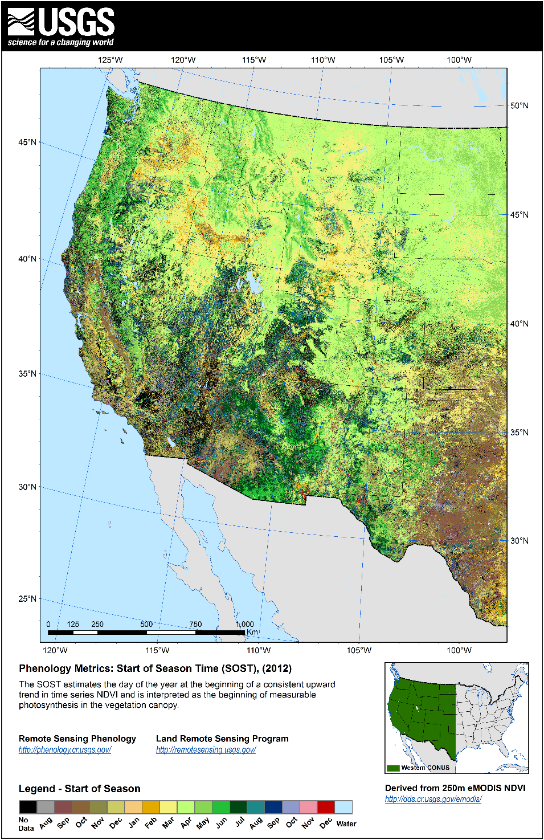
Figure 8. 2012 V1 SOST | Figure 9. 2012 V2 SOST

2012 Start of Season Time Difference Image (V1 – V2)
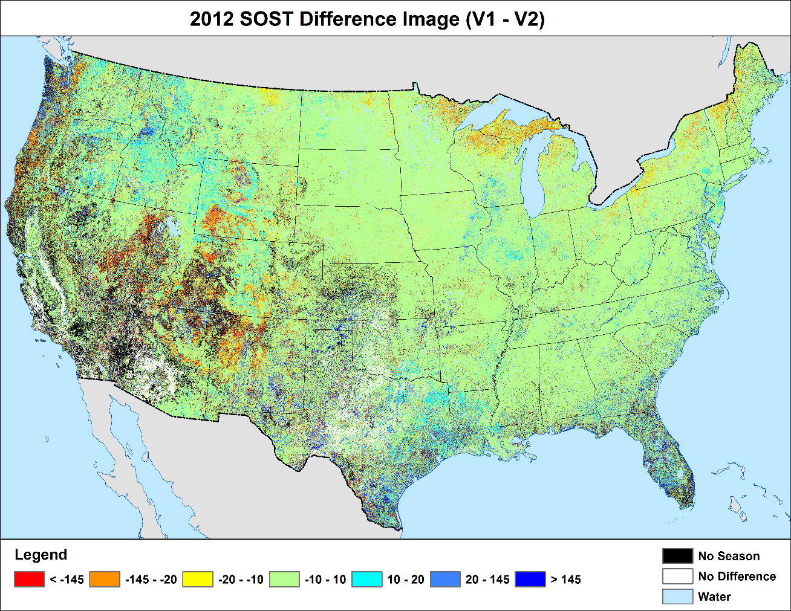
Figure 10. 2012 SOST difference image and histogram

2013 Start of Season Time (East)
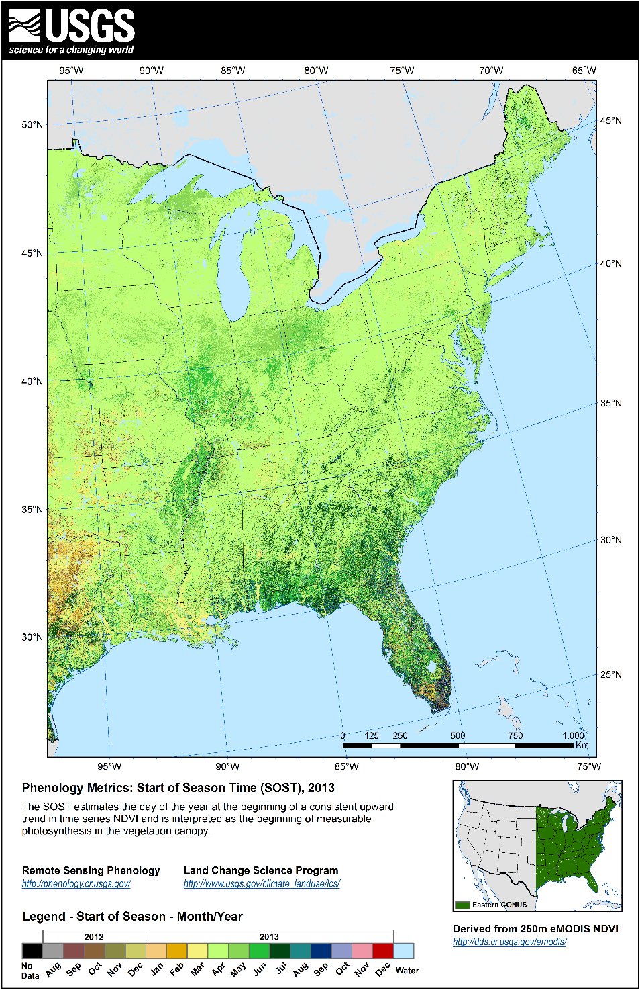 | 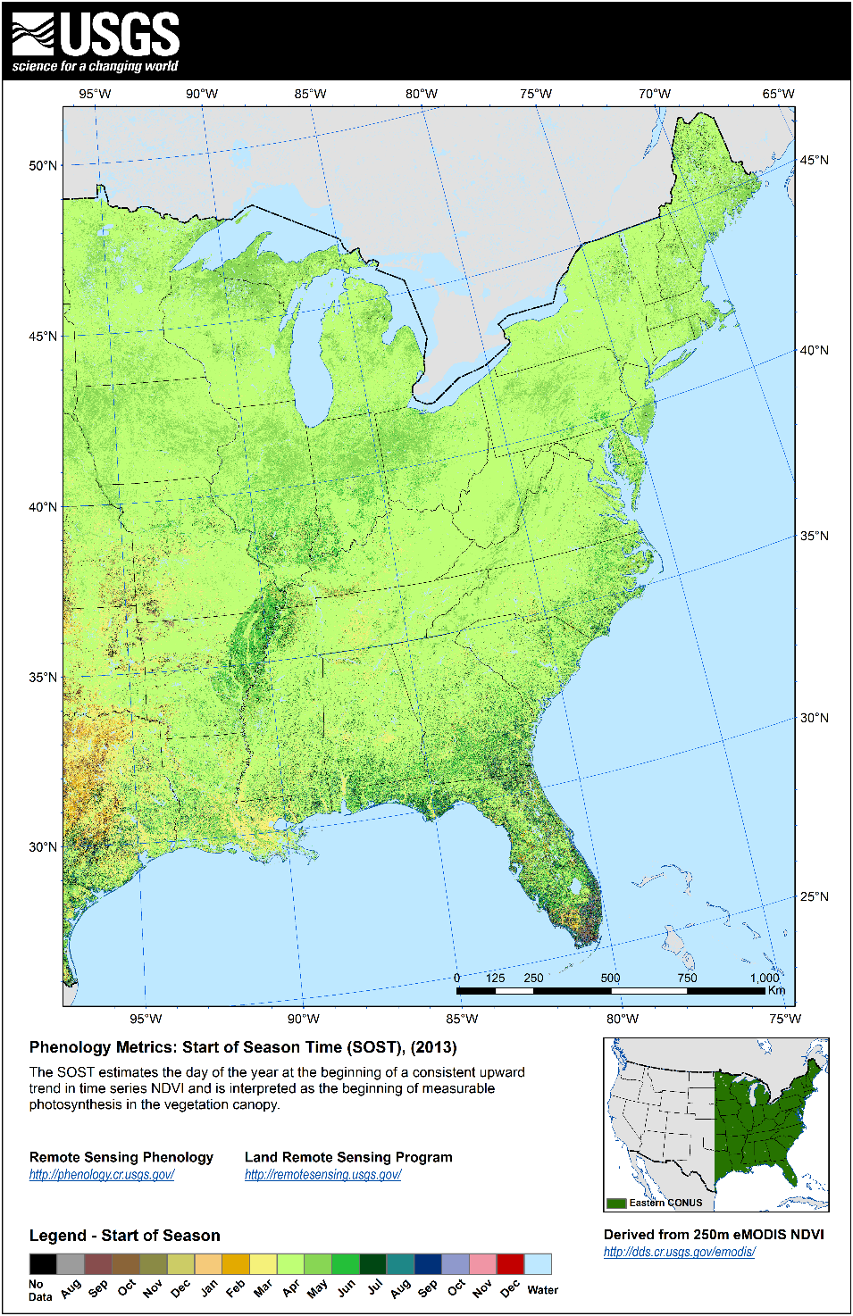
Figure 11 2013 V1 SOST | Figure 12. 2013 V2 SOST
2013 Start of Season Time (West)
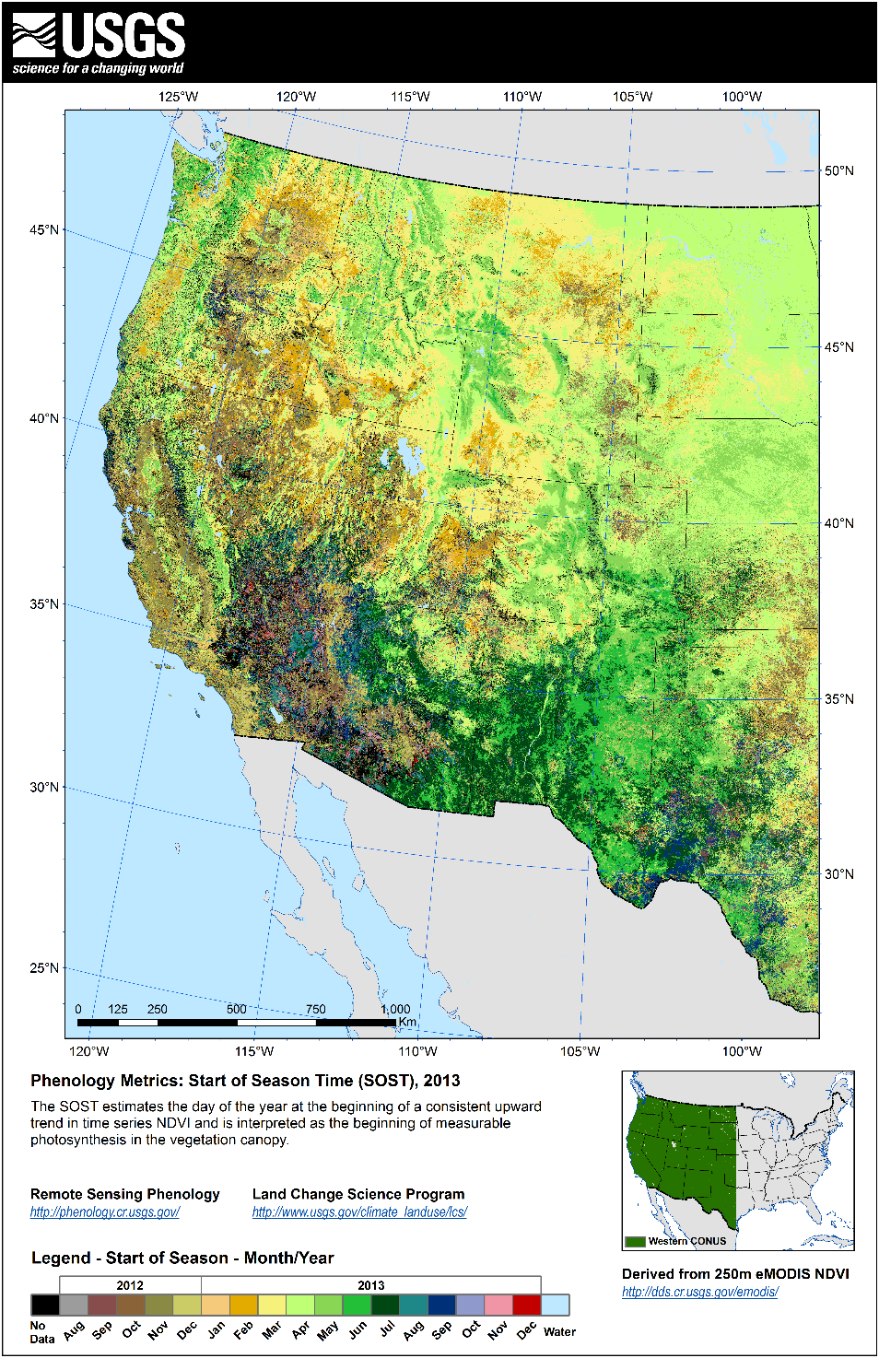 | 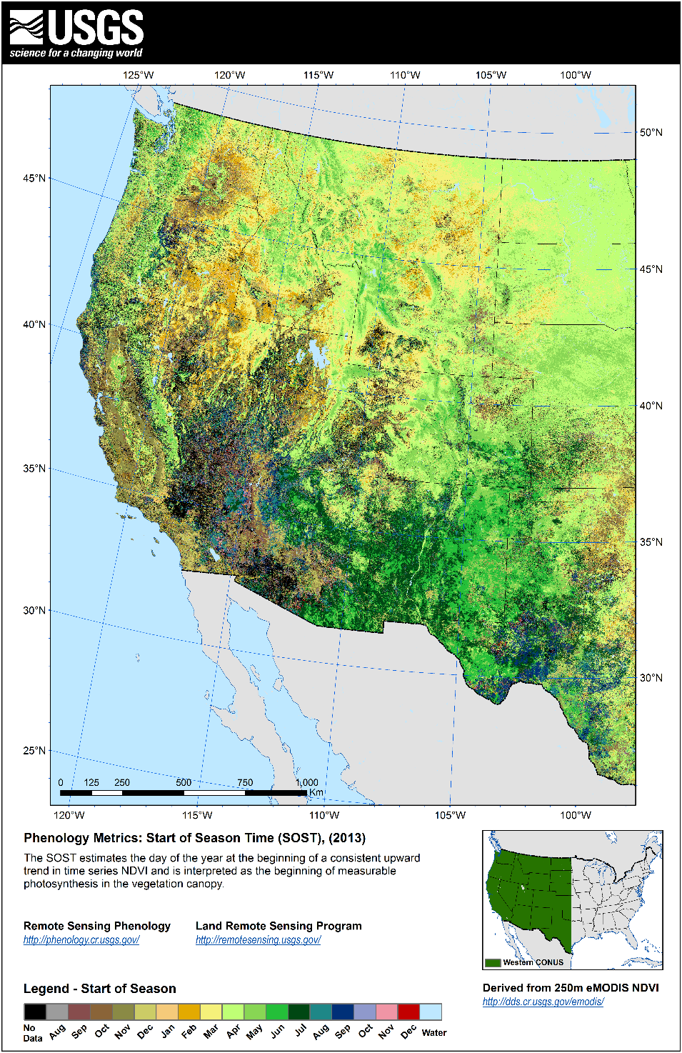
Figure 13. 2013 V1 SOST | Figure 14. 2013 V2 SOST

2013 Start of Season Time Difference Image (V1 – V2)
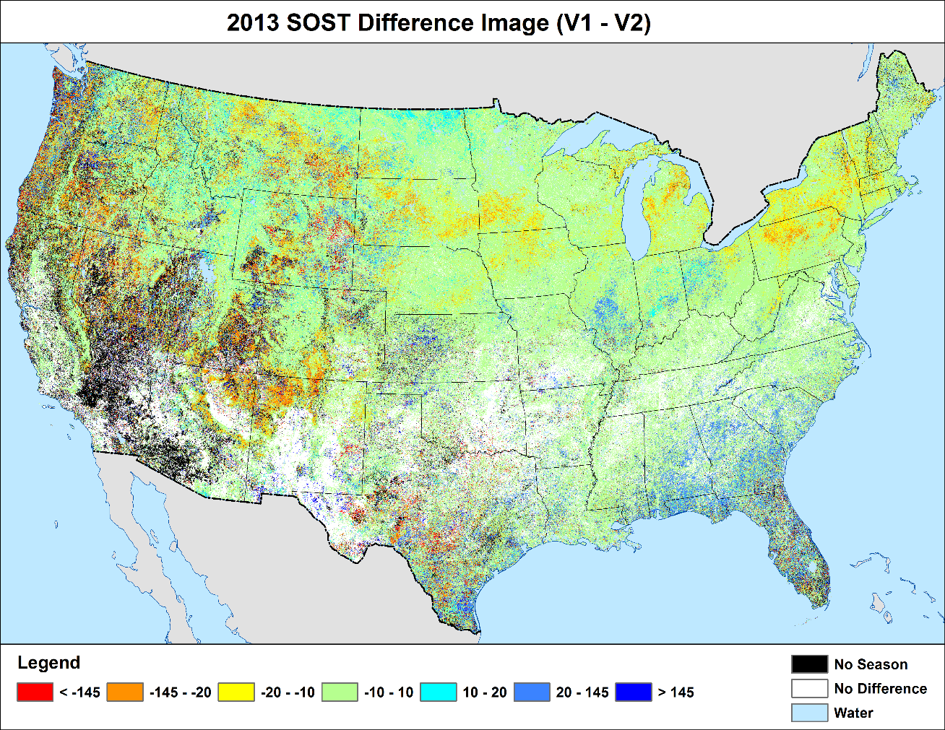
Figure 15. 2013 SOST difference image and histogram

- Smoothed NDVI Evaluation
  - The new NDVI smoothing procedure was applied on weekly eMODIS NDVI data for years 2010 – 2014 to supply sufficient data for calculating the 2011 – 2013 phenology metrics. For the content of this report, the year 2012 was chosen for an in-depth comparison between the V1 and V2 smoothed time series NDVI data, with the unsmoothed NDVI data serving as a point of reference. The comparison presented in this section is the result of a visual assessment.
    - Visual Comparison – Using ENVI software, the three NDVI products for 2012 (unsmoothed, V1 smoothed, and V2 smoothed) were loaded into adjacent display windows for a visual evaluation. Numerous composites were reviewed in this manner and two winter composites were chosen for highlighting in this report, composite 66 – 72 and composite 297 – 303. Browsing through the imagery, the advantages of the smoother become clearly evident (in both V1 and V2). Large patches of clouds and other poor quality artifacts are removed and the overall image quality is greatly improved. Moreover, in many cases, the V2 smoothed NDVI further enhances these noted improvements over the V1 smoothed NDVI and was also found to remove hard line artifacts in the data. These enhancements were most prevalent in the late fall to early spring composites – a time when the composites are most inundated with poor quality pixels (ie., snow, clouds, and other poor quality). Results of the V1 and V2 smoothed NDVI were much more similar in the growing season.
  - Applicable attachments (See attachments section in Appendix 1)
    - 2012 NDVI Data (Unsmoothed, Smoothed_V1, Smoothed_V2)
  - Below (Figures 16 – 21), for each composite the unsmoothed, V1 smoothed, and V2 smoothed NDVI displays are situated in a side-by-side-by-side fashion showing the described improvements from one product to the next. These snapshots were taken at various locations in the US; the smaller image in the lower left corner of each tile gives location detail.
Raw Unsmoothed NDVI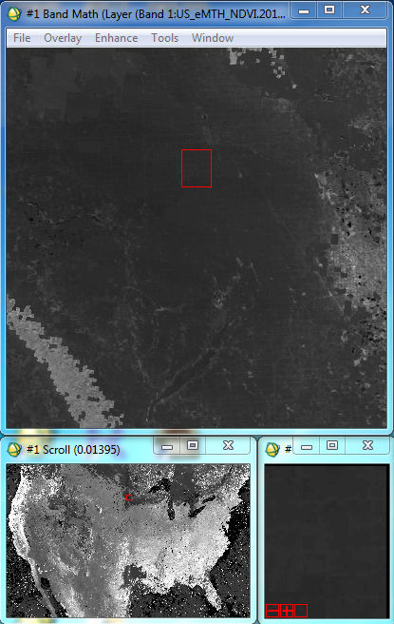 | Smoothed NDVI V1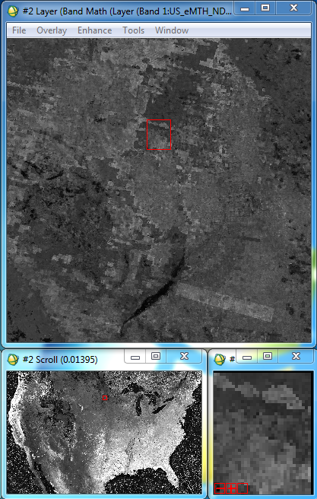 | Smoothed NDVI V2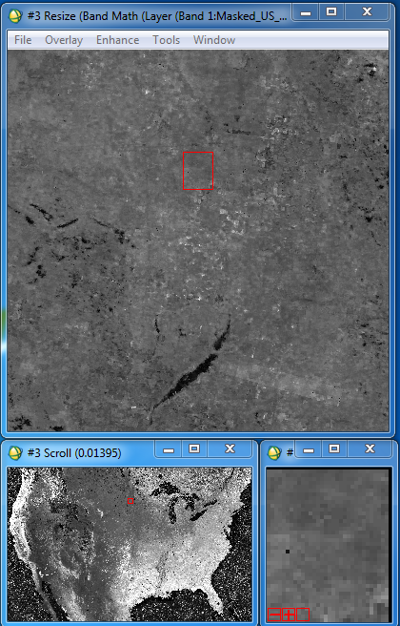
Figure 16. 2012 - Composite 66 – 72: Upper Midwest
Raw Unsmoothed NDVI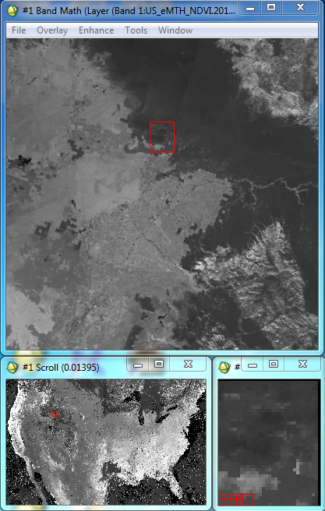 | Smoothed NDVI V1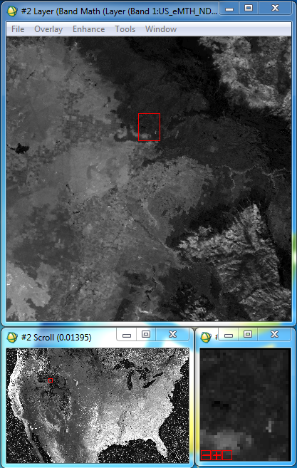 | Smoothed NDVI V2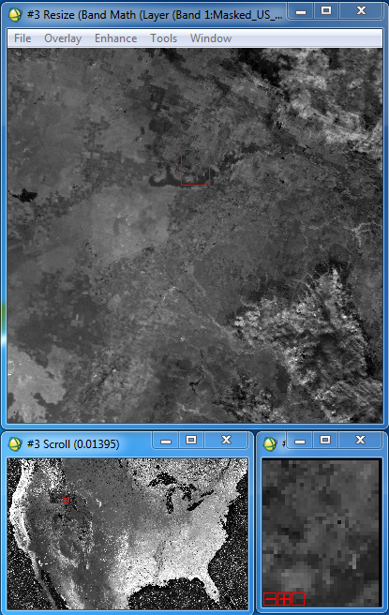
Figure 17. 2012 - Composite 66 – 72: Rocky Mountains
Raw Unsmoothed NDVI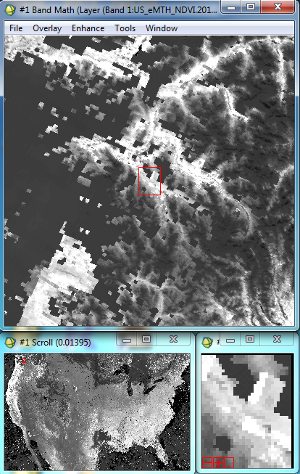 | Smoothed NDVI V1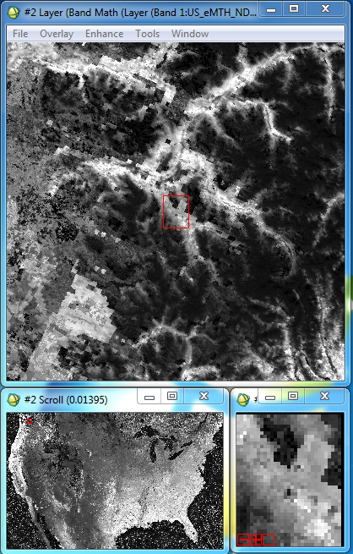 | Smoothed NDVI V2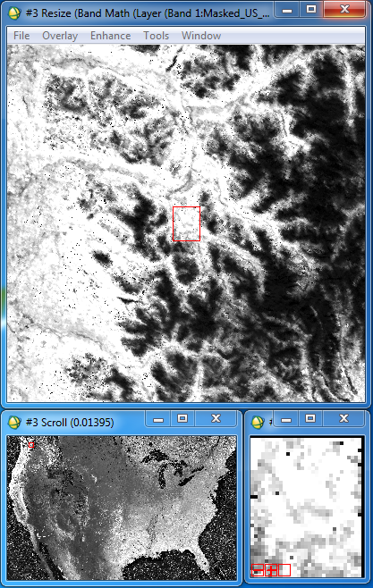
Figure 18. 2012 - Composite 66 – 72: Extreme Northwestern US
Raw Unsmoothed NDVI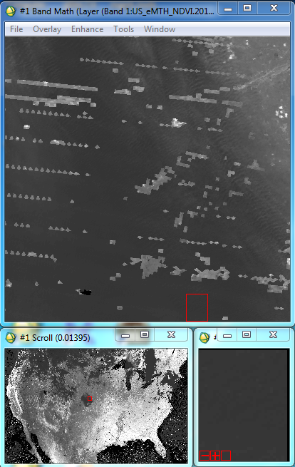 | Smoothed NDVI V1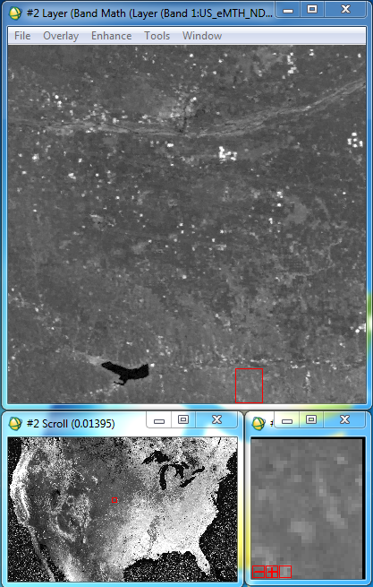 | Smoothed NDVI V2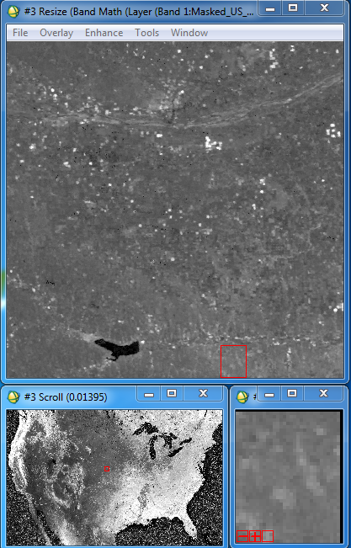
Figure 19. 2012 - Composite 297 – 303: Central Midwest
Raw Unsmoothed NDVI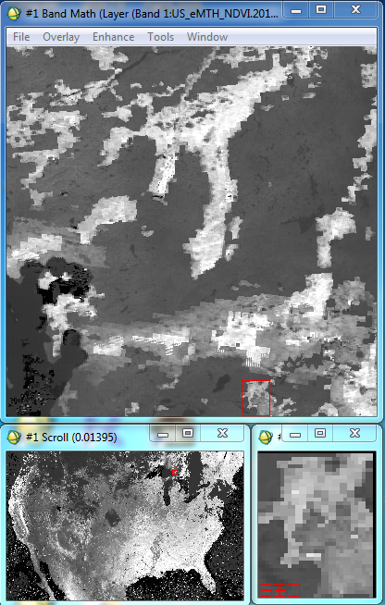 | Smoothed NDVI V1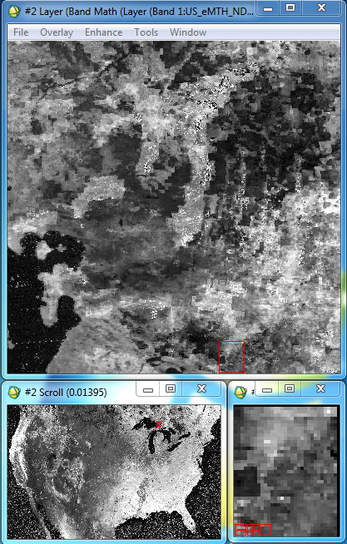 | Smoothed NDVI V2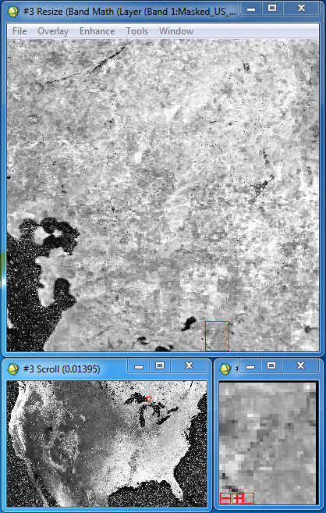
Figure 20. 2012 - Composite 297 – 303: Great Lakes
Raw Unsmoothed NDVI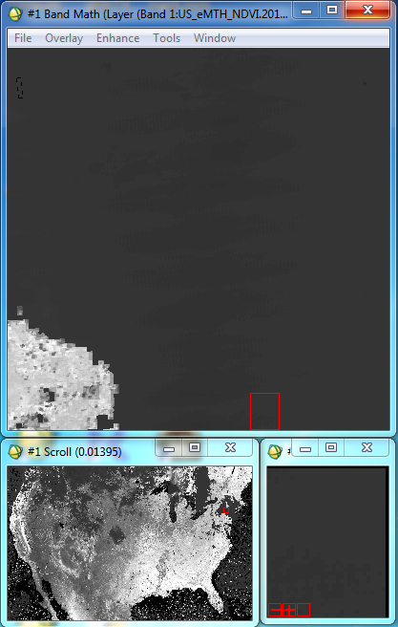 | Smoothed NDVI V1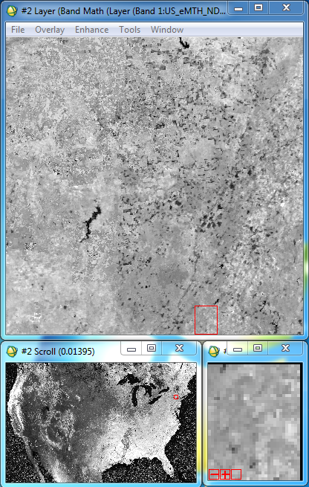 | Smoothed NDVI V2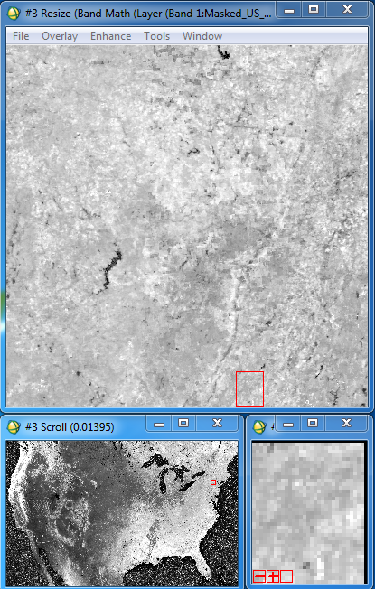
Figure 21. 2012 - Composite 297 – 303: Northeastern US

- Connecting smoothed NDVI Time Series Information with the Phenology Metrics
  - To gain a more comprehensive understanding of the full time series fluctuation between the unsmoothed, V1 smoothed, and V2 smoothed NDVI, the difference between V1 and V2 phenology metrics, and how the data are interconnected, a point-based time series extraction tool was created for evaluating the 2012 data. For this application, 146 points were derived from flux towers and aspen site XY locations (Figure 22). For each point, the full 2012 time series (52 weeks) of unsmoothed NDVI, V1 smoothed NDVI, V2 smoothed NDVI, all V1 2012 phenology metrics (AMP, DUR, EOSN, EOST, MAXN, MAXT, SOSN, SOST, TIN), and all V2 phenology metrics values were extracted, imported into an excel table, and finally setup in a dynamically linked table and chart for viewing all the extracted information at each of the 146 point (See attachments section in Appendix 1: [1.b]). This tool simplified the evaluation between the three NDVI products and the two phenology metrics versions and can be used to reveal differences and study connections between the data.
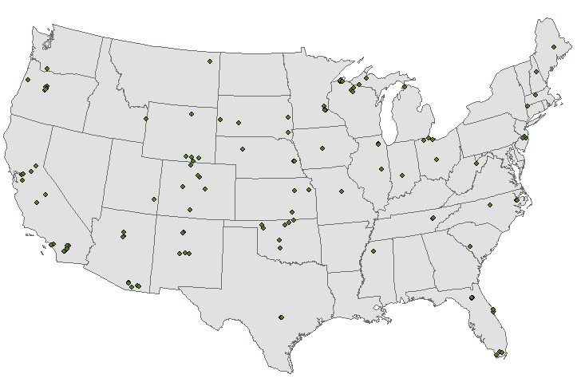
Figure 22. Flux towers and aspen site locations

- Applicable attachments (See attachments section in Appendix )
  - Phenology Metrics & NDVI Pixel Extractions Table
  - Flux Towers and Aspen Sites Points Shapefile
- Below (Figures 23 – 26), four point locations were selected for highlighting the capability of the point-based time series extraction tool. The table at the top of each tile shows V1 and V2 phenology metrics values, with a calculated difference, and the chart shows the three NDVI time series curves.
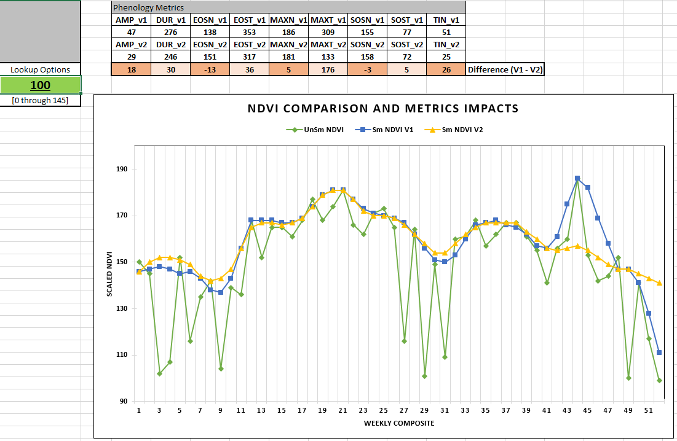
Figure 23. 2012 weekly NDVI values (unsmoothed, smoothed v1, and smoothed v2) and annual phenology values (v1 and v2) at Aspen locations and flux towers. Point ID: 100.
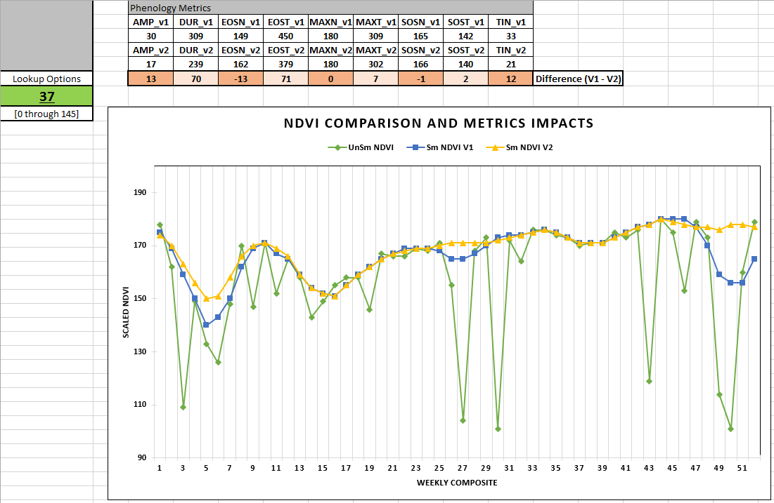
Figure 24. 2012 weekly NDVI values (unsmoothed, smoothed v1, and smoothed v2) and annual phenology values (v1 and v2) at Aspen locations and flux towers. Point ID: 37.
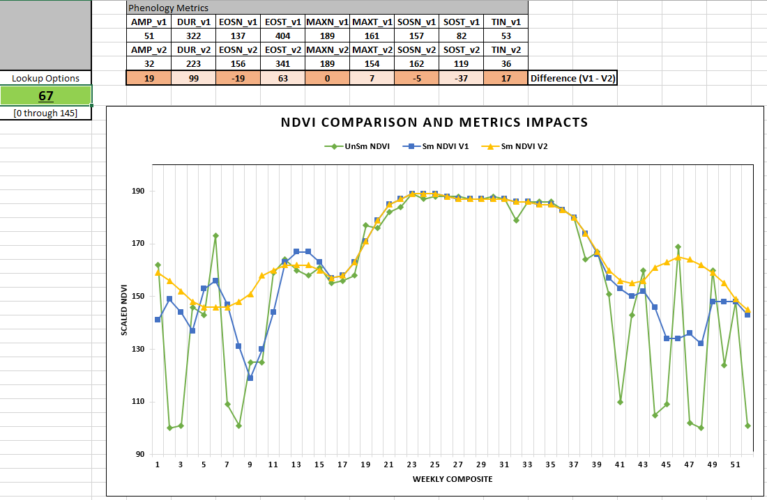
Figure 25. 2012 weekly NDVI values (unsmoothed, smoothed v1, and smoothed v2) and annual phenology values (v1 and v2) at Aspen locations and flux towers. Point ID 67.
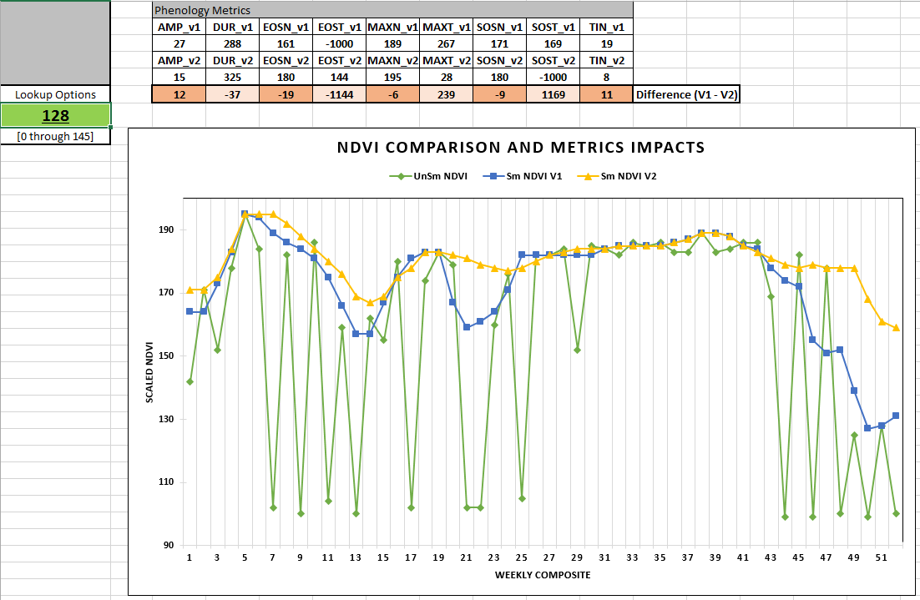
Figure 26. 2012 weekly NDVI values (unsmoothed, smoothed v1, and smoothed v2) and annual phenology values (v1 and v2) at Aspen locations and flux towers. Point ID 128.
Report Recommendation:
- Based on the results of this activity, it is recommended to utilize the new masking procedure to produce smoothed eMODIS NDVI. In the review of the 2010 and 2012 original smoothing method versus the new smoothing method, which masked out poor quality pixels (snow, cloud, and other poor quality types), the new method was shown to consistently remove areas of artifacts in the data that were likely introduced from snow, cloud, and other poor quality pixels (illustrated in the NDVI side by side graphics in part 2 of the Results and Comparison section). These improvements carried through to the V2 phenology metrics results by reducing some hard line artifacts and image noise (illustrated in the SOST side by side graphics in part 1 of the Results and Comparison section and also in the phenology metrics side by side graphics in attachment [1.j] of Appendix 1). Time series smoothed NDVI data are used as an input source in numerous environmental modeling applications, like the development of phenology metrics, highlighting the importance of data quality. Through the implementation of this new masking procedure, the quality improvements observed in this report could likely be captured in other applications.
Appendix:
- Attachments (About 50 GB - loaded onto a Vegetation Dynamics project external hard drive and onto \90daytemp\dhoward\Staged\USDM_NDVI_Quality_Phenology_Metrics_Report):
- eMODIS Phenology Metrics SOP – \\Attachments\eMODIS_Phenology_Metrics_SOP_6_24_2016.docx
- Phenology Metrics & NDVI Pixel Extractions Table – \\Attachments\Point_Extraction_2012_ALL_Dynamic_Chart.xlsx
- SOST Difference Image Data Tables and Histograms – \\Attachments\SOST_V1-V2_Difference_Histograms.xlsx
- V2 2011 – 2013 Phenology Metrics Data (BSQ/HDR) – \\Attachments\PhenologyMetrics_V2_BSQ\
- V2 2011 – 2013 Phenology Metrics Graphics (PNG) – \\Attachments\PhenologyMetrics_V2_PNG
- 2011 – 2013 V1 – V2 Phenology Metrics Difference Image Data (BSQ/HDR) – \\Attachments\DifferenceImages_BSQ\
- 2011 – 2013 V1 – V2 Phenology Metrics Difference Image Graphics (PNG) – \\Attachments\DifferenceImages_PNG
- Flux Towers and Aspen Sites Points Shapefile - \\Attachments\ExtractionPoints_Flux_Aspen\
- 2012 NDVI Data (Unsmoothed, Smoothed_V1, Smoothed_V2) - \Attachments\2012_NDVI_Data\
- Comparison Graphics and Difference Image Graphics Organized into a word document (AMP, DUR, EOSN, EOST, MAXN, MAXT, SOSN, TIN) - \Attachments\Metrics_Comparisons.docx

