Python Training at EROS Norman Bliss and Josh Picotte June 10-24, 2013

June 10: 10:30 - 12:30 Training Rooms A & B Session 1 N. Bliss
June 11: 10:30 - 12:30 Training Rooms A & B Session 2 N. Bliss
June 17: 2:00 - 4:00 Front half Session 3 N. Bliss
June 21: 12:30 - 2:30 Front half Session 4 N. Bliss
June 24: 2:00 - 4:00 Front half Session 5 J. Picotte

Abstract
Python is a powerful programming and scripting language. It is useful for data analysis in geographic information systems (GIS) because it is the scripting language for ESRI products such as ArcGIS. It is also useful for many other purposes, such as file handling (copy, rename, delete), and programming small tasks (e.g., tools to return coordinate locations given a raster location, and vice versa) as well as large or complex tasks (e.g., quickly characterizing the neighborhood of every pixel in an image). If EROS users have ArcGIS on their systems, they already have access to Python. The course will deal with Python 2.6 (or 2.5) but not Python 3.0 or higher.
Most of the training will be an introduction to the capabilities of the language, and some of the features that make writing scripts easy and powerful. There are many supporting packages, but only a few of these will be covered in the class if time is available, such as the Numeric Python (NumPy) array processor and an interface to image data with GDAL (the Geospatial Data Abstraction Language).
The course will be organized as 5 sessions of 2 hours each. The first four will cover the basics of the language, and will be taught by Norman Bliss. The fifth will be taught by Josh Picotte. It will cover writing scripts that can be executed as batch jobs that enable efficient processing of large amounts of data, and an introduction to working with geospatial programs in Python (i.e. GDAL, ArcGIS, ERDAS, and R).
Participants will be expected to bring a laptop with Python already installed (Sessions 3 to 5). Python should be already installed on your laptop if ArcGIS is currently installed. Otherwise, you will need to install Python (http://www.python.org/download/releases/). These course notes serve as a workbook for the exercises.
Outline
Session #1: Introductions, “problems you want to solve”, overview of the course, the integrated development environment (IDLE), basic Python objects: comments, variables, integers, floats, strings, arithmetic and logical (Boolean) operators, print statements, methods on strings (slicing, finding substrings, string formatting for printing).
Session #2: Python objects for dealing with collections of data: lists, tuples, sets, dictionaries, and methods on these objects.
Session #3: Built-in operators (for example, len, range, min, max, dir, raw_input), help, basics of writing scripts in Python, indentation, iteration (for loops, while loops), “if” statements.
Session #4: Using modules, using files, writing functions, preview of advanced topics (array processing, GDAL, ArcGIS SearchCursor).
Session #5: Introduction to several methods for batch processing in Python and geoprocessing in ArcGIS, GDAL, ERDAS, and R. If time permits, there will a be a brief introduction on how to connect to databases (e.g. MySQL and Postgresql).

Basics
Introduction: What is Python? Why Python? finding Help, books,
caveat about the trainer (a user, not a professional programmer)
Quick Tour (see some examples without understanding the details)
Mutable versus immutable
Basic commands: comments, print, import, traceback, interpreting error messages, try: ... except: ..., raise Exception
Basic syntax: indentation, semicolon, line continuation
Assignment, expressions, dynamic typing, shared references
Variable types: strings, string escape sequences, integers, float, boolean,
long integers (L), None
Name rules and conventions, reserved words
Arithmetic operations (e.g., integer division), modulo
Methods on objects (e.g., string methods), string formatting
Collections: tuples, lists, dictionaries, sets. Operators on or to create these.
Built-in operators: len( ), del( ), range( ), dir( ), max( ), min( ), raw_input( )
Slicing (strings, tuples, lists)
Writing scripts in Python, indentation for blocks
Conditionality (if... elif... else...), logical operators, True, False, pass, break, continue, in (e.g., k in D)
None for null values (test: x is None)
Looping (for, while)
Using modules
math, time, glob, zipfile, etc.
Files (open, close, read, write)
Writing functions (def), passing arguments, return
Arrays (NumPy), slicing arrays
ArcGIS scripting (arcgisscripting, arcpy)

Intermediate
map( ) (I use to make interpreted maps from a query result and a mapunit key raster)
list comprehensions
dynamic print formatting
reading and writing .csv files (make spreadsheets from your data)
scopes for variables (within functions or modules), global
“Garbage collection”, Memory Error

More individualized
Methods of geoprocessing
Raster to NumPy array
ArcGIS 9.3 with GDAL
ArcGIS 10 Raster_To_NumPy_Array command
Processing arrays
map( ) with dictionaries
map algebra in NumPy
spatial fuctions (e.g., write your own spatial analysis functions) (Optional)
Database manipulation
Reading and writing a .dbf file directly in Python
Using SQL with Python

More advanced
reading and writing binary files (struct), fileunit.seek( ), fileunit.tell( )
unicode strings (basics)
Arrays revisited (e.g., indexing arrays with arrays)
exec( ) (dynamic code)
directory tree objects

Not covered
Downloading or installing Python and related software
Documentation using Python conventions
Bitwise operations, octal, hexidecimal, complex numbers
Lambda functions
Classes (object oriented programming)
Creating modules
Graphical User Interfaces
Debugging tools
Commercial programming interfaces (the training uses IDLE)
Persistant storage (e.g., pickle, shelve)
Regular expressions (the re module, pattern matching for strings)
Structured text: XML

Training Issues
1. What experience with programming and with Python do you have?
2. What are your goals and expectations for the training?
3. Any interest in writing your own spatial analysis functions?
4. Any interest in using SQL with Python? Other topics on the “not covered” list?
5. How do you learn new software? E.g., would it work to introduce 4 or 5 ideas, and then have an exercise or two covering all of them, or do you want an exercise on each new idea?
- Introduction Session 1

  - What is Python?

  - Why Python?

  - Finding Help

  - Books

  - Caveat about the trainer (Norman Bliss)
I am a user of Python.
I am not a professional programmer.
I had one two-day training course with ESRI materials in 2007.
I am self taught after that.
I want to learn from you and help you solve practical problems.
I think Python is fun to use.
- Quick tour
Show some examples of applications, but let understanding the details come later.
  - Print a list of files
Print names of all Python files in a directory.
>>> import glob
>>> import os
>>> pathname = r'D:\12ProjectPlan\PythonTraining\Examples'
>>> filename_py_list = glob.glob( os.path.join( pathname, '*py' ) )
>>> filename_py_list
['D:\\12ProjectPlan\\PythonTraining\\Examples\\zzz.nbb.20110621.findcode.01.py', 'D:\\12ProjectPlan\\PythonTraining\\Examples\\zzz.nbb.20110621.findstring.in.one.file.01.py', 'D:\\12ProjectPlan\\PythonTraining\\Examples\\zzz.nbb.query.listing.count_tiles.02.py', 'D:\\12ProjectPlan\\PythonTraining\\Examples\\zzz.nbb.query.tile.print.30m150km.01.py', 'D:\\12ProjectPlan\\PythonTraining\\Examples\\zzz.SSURGO.04.load.any.dictionary.01.py']

>>> for filename_py in filename_py_list:
basename_py = os.path.basename( filename_py )
print basename_py

zzz.nbb.20110621.findcode.01.py
zzz.nbb.20110621.findstring.in.one.file.01.py
zzz.nbb.query.listing.count_tiles.02.py
zzz.nbb.query.tile.print.30m150km.01.py
zzz.SSURGO.04.load.any.dictionary.01.py

This shows:
- importing modules
- assigning a raw string to a name (pathname)
- using a module’s function to return a list of filenames
- embedding another function in the call to the first function
- the os.path.join function provides platform independent method for joining filenames (it figures out what pathname separator is needed)
- glob.glob handles wildcards (the asterisk * ) and returns a list
- the list is ugly to read
- a simple for loop is used to strip off the pathnames and return a listing that is easier to read
- typing is dynamic, you don’t need to specify what kind of variable is being used (here, strings)
  - Define an array, test if array elements are equal
Arrays are very useful if the data are regular and have two or more dimensions. Array functions are very fast, and work on whole arrays or sub-arrays with a single code statement.
>>> import numpy as np # NumPy is the Numeric Python array processor
>>> seq_ar = np.arange( 20 )
>>> seq_ar
array([ 0, 1, 2, 3, 4, 5, 6, 7, 8, 9, 10, 11, 12, 13, 14, 15, 16, 17, 18, 19])
>>> seq_ar.reshape(4,5) # (rows, columns)
array([[ 0, 1, 2, 3, 4],
[ 5, 6, 7, 8, 9],
[10, 11, 12, 13, 14],
[15, 16, 17, 18, 19]])
>>> seq_ar.reshape(2,10)
array([[ 0, 1, 2, 3, 4, 5, 6, 7, 8, 9],
[10, 11, 12, 13, 14, 15, 16, 17, 18, 19]])
>>> seq_ar
array([ 0, 1, 2, 3, 4, 5, 6, 7, 8, 9, 10, 11, 12, 13, 14, 15, 16, 17, 18, 19])
>>> a_ar = b_ar = seq_ar.reshape(4,5) # multiple equal signs
>>> a_ar
array([[ 0, 1, 2, 3, 4],
[ 5, 6, 7, 8, 9],
[10, 11, 12, 13, 14],
[15, 16, 17, 18, 19]])
>>> b_ar
array([[ 0, 1, 2, 3, 4],
[ 5, 6, 7, 8, 9],
[10, 11, 12, 13, 14],
[15, 16, 17, 18, 19]])
>>> a_ar == b_ar
array([[ True, True, True, True, True],
[ True, True, True, True, True],
[ True, True, True, True, True],
[ True, True, True, True, True]], dtype=bool)
>>> a_ar[0,0] = 99 # change a “pixel” in one of the arrays
>>> a_ar
array([[99, 1, 2, 3, 4],
[ 5, 6, 7, 8, 9],
[10, 11, 12, 13, 14],
[15, 16, 17, 18, 19]])
>>> b_ar # notice it changed in the other array: they share memory
array([[99, 1, 2, 3, 4],
[ 5, 6, 7, 8, 9],
[10, 11, 12, 13, 14],
[15, 16, 17, 18, 19]])
>>> seq_ar # this array too: they share memory
array([99, 1, 2, 3, 4, 5, 6, 7, 8, 9, 10, 11, 12, 13, 14, 15, 16,
17, 18, 19])
>>> b_ar = b_ar.reshape(5, 4) # now 5 rows, 4 columns
>>> b_ar
array([[99, 1, 2, 3],
[ 4, 5, 6, 7],
[ 8, 9, 10, 11],
[12, 13, 14, 15],
[16, 17, 18, 19]])
>>> a_ar == b_ar # the arrays are now different shapes, and can't be compared cell by cell
False

>>> c_ar = a_ar.copy() # make a new copy of the array (not pointer)
>>> c_ar
array([[99, 1, 2, 3, 4],
[ 5, 6, 7, 8, 9],
[10, 11, 12, 13, 14],
[15, 16, 17, 18, 19]])
>>> c_ar[0,0] = c_ar[0,0] + 1
>>> c_ar
array([[100, 1, 2, 3, 4],
[ 5, 6, 7, 8, 9],
[ 10, 11, 12, 13, 14],
[ 15, 16, 17, 18, 19]])
>>> a_ar == c_ar # because it is a copy, it does not share memory
array([[False, True, True, True, True],
[ True, True, True, True, True],
[ True, True, True, True, True],
[ True, True, True, True, True]], dtype=bool)

>>> d_ar = c_ar / 10 # note: integer division truncates
>>> d_ar
array([[10, 0, 0, 0, 0],
[ 0, 0, 0, 0, 0],
[ 1, 1, 1, 1, 1],
[ 1, 1, 1, 1, 1]])
This shows:
- Numeric Python (NumPy) is a module, use import.
- The module was given a new name when imported (np).
- The numpy module contains a function to create an array with a sequence of numbers (arange).
- Calling the function uses a dot (.) syntax (object oriented programming).
- The array object also has functions ( .reshape( ) ).
- If you don’t save the result to a name (variable), it is printed to the screen.
- Reshaping without saving didn’t change the orignial object.
- You can save two references to the object in one statement ( a_ar = b_ar = ).
- a_ar and b_ar are the same, and can be compared cell by cell.
- In Python, counting positions in a sequence starts with zero.
- a_ar, b_ar, and seq_ar are all names that address the same place in memory.
- Changing a value in one of these changes it in all of them.
- This can be a “gottcha” until you understand it; it can be useful when you do understand.
- a_ar and b_ar retained the shapes that they were assigned.
- Operaters, such as the equality operator == may have different meanings depending on their context (i.e., depending on the objects being compared).
- # can be used to start a comment.
- You can manipulate individual values of arrays, portions of arrays, or whole arrays.
- Array slicing will be covered later (to address portions of arrays).
- Immutable versus mutable
- Immutable means “not changable”.
- Mutable means “changable”.
- numbers, strings, and tuples are immutable..
  - you can assign the same name to a new object, but don’t think in terms of changing the original object.
- lists, dictionaries, and sets are mutable
  - you can add or delete objects
  - you can replace objects in lists or dictionaries
  - you can change the order of lists (sort)
- Getting started
Put the “PythonTraining” folder on the desktop and open it. Open the “PythonScripts” folder under that. Right click on the icon for “TrainingCode.01.py” and select “Edit with IDLE”. It opens the file for editing with IDLE (Python’s Integrated Development Environment) and it also opens a Python Shell. When you run the script, any results (e.g., from print statements) will display in the PythonShell window. Also, you can use the PythonShell to execute Python statements interactively.

To run the “TrainingCode.01.py” script, make the window active (left click anywhere in the window) and hit the F5 key (alternatively, select Run >> Run Module). The output of the print statements will appear in the PythonShell.

We will use the PythonShell interactively to test example code from these notes. We will return to writing and editing scripts later in the course.

To gain experience, try typing examples starting with the next section (1 + 2 + 3).
- Basic commands
  - Just type...
The interactive prompt is shown as >>> .
You can use the Python Shell like a calculator.
>>> 1 + 2 + 3
6
You can type the name of a variable and it will return the value.
>>> a = 3
>>> a
3

If you type a variable name that has not been defined, an error message is returned.
>>> undefined

Traceback (most recent call last):
File "<pyshell#420>", line 1, in <module>
undefined
NameError: name 'undefined' is not defined
  - Comment
A pound sign (#) makes the rest of the line become a comment
>>> a = 3 # a comment appears in red in IDLE
>>> # A comment can be the only thing on a line.

Use Alt-3 to comment blocks of code. Highlight the lines to be commented and hit Alt-3. Notice that the 3 key also has the #. Comments appear in red in IDLE.
Before Alt-3
print 'Current timestamp is %s' % timestamp

print
print 'DEMO: work of the program goes here...'
print
After Alt-3
print 'Current timestamp is %s' % timestamp

## print
## print 'DEMO: work of the program goes here...'
## print
Use Alt-4 to uncomment blocks of commented code. Notice that the text colors in IDLE change back to the usual pattern.
print 'Current timestamp is %s' % timestamp

print
print 'DEMO: work of the program goes here...'
print

Triple-quoted strings can also appear in the code as a comment. This allows for newlines (typed with the “Enter” key) to be part of a string and is useful for program documentation (i.e., history of the code). See the comment at the beginning of the script that is open.
"""
Training module #1: basic structure.

TrainingCode.01.py 11/22/2011 N. Bliss

"""
  - print
>>> a_string = 'Hello world!'
>>> a_string
'Hello world!'
>>> print a_string
Hello world!

>>> a = 10
>>> a
10
>>> print a
10

>>> b = 3 / 10.
>>> b
0.29999999999999999
>>> print b
0.3

>>> print '%10.5f' % b
0.30000

>>> print '%20s %20s' % ( a_string, a_string )
Hello world! Hello world!
>>> print '%20s %-20s' % ( a_string, a_string )
Hello world! Hello world!

Print formatting functionality may be different in Python 3.0 and above. More on string formatting later.
  - Import
The import statement makes modules available to your program.
>>> import time
>>> time.localtime()
(2011, 11, 7, 19, 7, 7, 0, 311, 0)

You can get some documentation on the module (two underscores before and two underscores after the “doc”):
>>> print time.__doc__
This module provides various functions to manipulate time values.

There are two standard representations of time. One is the number
of seconds since the Epoch, in UTC (a.k.a. GMT). It may be an integer
or a floating point number (to represent fractions of seconds).
The Epoch is system-defined; on Unix, it is generally January 1st, 1970.
The actual value can be retrieved by calling gmtime(0).

The other representation is a tuple of 9 integers giving local time.
The tuple items are:
year (four digits, e.g. 1998)
month (1-12)
day (1-31)
hours (0-23)
minutes (0-59)
seconds (0-59)
weekday (0-6, Monday is 0)
Julian day (day in the year, 1-366)
DST (Daylight Savings Time) flag (-1, 0 or 1)
If the DST flag is 0, the time is given in the regular time zone;
if it is 1, the time is given in the DST time zone;
if it is -1, mktime() should guess based on the date and time.

Variables:

timezone -- difference in seconds between UTC and local standard time
altzone -- difference in seconds between UTC and local DST time
daylight -- whether local time should reflect DST
tzname -- tuple of (standard time zone name, DST time zone name)

Functions:

time() -- return current time in seconds since the Epoch as a float
clock() -- return CPU time since process start as a float
sleep() -- delay for a number of seconds given as a float
gmtime() -- convert seconds since Epoch to UTC tuple
localtime() -- convert seconds since Epoch to local time tuple
asctime() -- convert time tuple to string
ctime() -- convert time in seconds to string
mktime() -- convert local time tuple to seconds since Epoch
strftime() -- convert time tuple to string according to format specification
strptime() -- parse string to time tuple according to format specification
tzset() -- change the local timezone

You can get this information and more with:
>>> help( 'time' )
Try a few of the functions to see what they do. Use the syntax and substitute a function name from the above list for the position in italics.
>>> time.function()
  - traceback
>>> import traceback
>>> traceback.__doc__
'Extract, format and print information about Python stack traces.'

>>> 1 / 0
Traceback (most recent call last):
File "<pyshell#68>", line 1, in <module>
1 / 0
ZeroDivisionError: integer division or modulo by zero
  - interpreting error messages
Messages are generally quite clear about what caused the error and where it was located. Here, there was only one line at the >>> prompt, so it identified line 1. It repeats the offending line ( 1 / 0 ). The “ZeroDivisionError” clearly identified what went wrong. If you get error messages you don’t understand, please ask the instructors for help.
  - try: ... except: ...
If the an error occurs in a try: block, control goes to the except: block rather than having the program fail and stop.
>>> try:
1 / 0
except:
print 'You may have a divide-by-zero situation...'

You may have a divide-by-zero situation...

The try: and except: pair allows errors to be captured and appropriate action to be taken. Error handling can be more sophisticated. In this case, allowing the default (traceback) message might have been better because the traceback message is more likely to be accurate. It is possible to test for the various types of errors (e.g., “ZeroDivisionError”) and execute code appropriate to the error.
I use an outer try: and except: pair to wrap all the code in my programs to help give a traceback of any nested modules that are involved.
  - raise Exception
>>> for i in range(10):
print i
if i == 5:
raise Exception

0
1
2
3
4
5
Traceback (most recent call last):
File "<pyshell#83>", line 4, in <module>
raise Exception
Exception

I use this as a brute-force way of stopping my program if I am debugging and want to stop at a particular place or with a particular condition (here, after i equals 5).
- Basic syntax
Information that you will need to get started:
  - Indentation
Blocks of code are defined by indentation only.
>>> for i in range(3):
for j in range(2):
print i, j, i + j

0 0 0
0 1 1
1 0 1
1 1 2
2 0 2
2 1 3
  - Exercise: interactive editing
Enter the following to practice with nested blocks of indented code.
>>> for i in range(3):
for j in range(2):
print i, j, i + j

You will need to hit the <Enter> key an extra time to execute the code in the Python Shell. After it has run, place your cursor in the code which you just typed and hit the <Enter> key. It will copy the whole block of code to your current prompt. Edit the code to put a print statement with a text string of dashes ('------------') above the for j statement. Move your cursor to the bottom of the block (e.g., down arrow) and hit <Enter>. The code will now execute again with your edits.

Repeat the block of code and comment out the for j line (place cursor anywhere in the line and hit Alt-3 (think # sign). Place the cursor anywhere in the print statement and hit Ctrl-[ (left square bracket). What happens? Use the down arrow until it stops moving the cursor and then hit <Enter>. Where did the program get the value j?

Note: Alt-4 has the opposite effect of Alt-3.
Ctrl-] has the opposite effect of Ctrl-[.

Practice a bit with these, but do not necessarily run the code (or see what type of error message you might get).

Result: part of what you have done may look like this:
>>> for i in range(3):
print '------------'
for j in range(2):
print i, j, i + j

------------
0 0 0
0 1 1
------------
1 0 1
1 1 2
------------
2 0 2
2 1 3
White space (blanks) after the beginning of the line does not matter.
>>> for i in range( 3 ):
print '------------'
for j in range( 2 ):
print i, j, i + j

------------
0 0 0
0 1 1
------------
1 0 1
1 1 2
------------
2 0 2
2 1 3
>>>
An exception to the indentation rule may occur if there is only a single statement in the block. Here, the print statement is placed on the same line as the if statement.
>>> PRINT_SWITCH = True
>>> if PRINT_SWITCH: print 'PRINT_SWITCH is True'

PRINT_SWITCH is True
  - Semicolon ( ; ) for multiple statements on a line
Multiple statements can occur on a line if separated by a semicolon. This is usually avoided in a program because it can make the program hard to read.
>>> a = 32; b = 10.; c = 5; (a / b) * c
16.0
  - Line continuation
Use line continuation to spread one statement over multiple lines.
A backslash (\) can be used as a line continuation character (think of “escaping” the “Enter” keystroke). It is also possible to have line continuation in structures that are opened with (, [, or { without using the backslash. I prefer this method to the backslash. Comments are possible within such structures.
>>> abcde = \
'abcde'
>>> abcde
'abcde'

>>> a_tuple = (
1, # first element of the tuple
2, # second element of the tuple
) # finally close the tuple
>>> a_tuple
(1, 2)
- Assignment, expressions, dynamic typing, references
  - Assignment
Setting the value of a variable with an equal sign.
>>> a = 10
>>> b = a
>>> c = a + b
To view the value of an object, just type its identifier. Be careful, you don’t want to do this with a dictionary with 1,000,000 entries.
>>> c
20

>>> s = 'A string is an immutable object. This one is assigned to a variable named "s".'
>>> s
'A string is an immutable object. This one is assigned to a variable named "s".'
>>> print s
A string is an immutable object. This one is assigned to a variable named "s".

Variable names start with an alphabetic character, can use alphabetic, numeric, and underscore characters. Names are case sensitive, so “a” is not the same as “A”.
  - Expressions
Not all expressions are assignments. For example, boolean expressions can be evaluated directly. For example, the double equal sign ( == ) is the operator to test for equality.
>>> 5 == 5
True
>>> a = 5
>>> b = a # an assignment
>>> a == b # evaluating a boolean expression
True
  - Dynamic typing
Unlike the C programming language, the type of a variable is not defined in advance, and a variable name can be reassigned to an object of a different type.
>>> a = 5
>>> a
5
>>> a = ("A", 'tuple', 'containing', 'strings')
>>> a
('A', 'tuple', 'containing', 'strings')
>>> a = 5
>>> a
5
  - Shared references
Objects with the same value may be given the same place in memory. Usually this is not a concern, but there may be some issues in more advanced cases (e.g., store tuples not lists as values in a dictionary).
>>> a = 5
>>> b = a # an assignment
>>> a == b # evaluating a boolean expression
True
>>> a is b # not just equal, but same location in memory
True

>>> a = 5 # integer
>>> b = 5. # floating point
>>> a == b # both equal five
True
>>> a is b # one is integer, the other float, not the same memory
False
- Reserved words
  - Keywords
Reserved words are the building blocks of Python code. Do not use these on the left side of an equal sign (assignment statement) or you may overwrite the functionality of the word, and Python will (likely) fail.

>>> help( 'keywords' )

Here is a list of the Python keywords. Enter any keyword to get more help.

and elif if print
as else import raise
assert except in return
break exec is try
class finally lambda while
continue for not with
def from or yield
del global pass
  - Other words to avoid
Although these are not official keywords, they are very important for built in functionality, and should not be used as variable names. Any word that changes color when you type it in IDLE should be avoided in this way.
bool int max str
dir len None string float min range

Also avoid using names that are used in the import statements, except in the role approprate to that use. Some that I use include:
arcgisscripting gdal os struct time arcpy numpy osgeo sys
- Variable types
  - Strings
Strings are immutable. You can assign a new string to a given variable name but the name then points to a different location in memory.
Strings can be quoted with a single quote, a double quote, or a triple quote (3 single quotes). The triple quote method allows strings to contain a variety of single or double quotes, or white space (newlines, tabs, etc.).
>>> s_single = 'Single quoted string contains double quoted "a"'
>>> s_single
'Single quoted string contains double quoted "a".'
>>> print s_single
Single quoted string contains double quoted "a".

>>> s_double = "Double quoted string contains single quoted 'b'."
>>> s_double
"Double quoted string contains single quoted 'b'."
>>> print s_double
Double quoted string contains single quoted 'b'.

>>> s_triple = '''A triple quoted string isn't hard to use to describe "c".
It even allows newlines (the Enter key) or Tabs Tabs Tabs.'''
>>> s_triple
'A triple quoted string isn\'t hard to use to describe "c".\nIt even allows newlines (the Enter key) or Tabs \tTabs \tTabs.'
>>> print s_triple
A triple quoted string isn't hard to use to describe "c".
It even allows newlines (the Enter key) or Tabs Tabs Tabs.
    - String escape sequences (backslash)
The backslash (\) is the escape character in Python. It tells the interpreter that the following character has special treatment (depending on the context).
In the previous section, we saw that backslashes were introduced into the strings to represent tabs, newlines, and quote marks.
The following table gives the string escape sequences (highlight in yellow indicates relevant for this training; Lutz, p. 126):

Escape Meaning

\newline Ignored (continuation)
\\ Backslash (keeps a \) (e.g., used in pathnames)
\’ Single quote (keeps ‘)
\” Double quote (keeps “)
\a Bell
\b Backspace
\f Formfeed
\n Newline (linefeed)
\r Carriage return
\t Horizontal tab
\v Vertical tab
\N{id} Unicode database ID
\uhhhh Unicode 16-bit hex
\Uhhhhhhhh Unicode 32-bit hex
\xhh Hex digits value
\ooo Octal digits value
\0 Null (doesn’t end string)
\other Not an escape (kept)
In Python, the zero (null) byte does not terminate a string as in the C programming language. It is possible to embed binary zeros into a string:
>>> s_b0 = 'a\0b\0c'
>>> s_b0
'a\x00b\x00c'
>>> len( s_b0 )
5
  - Raw strings
A raw string has the character “r” before the initial quote mark to define a string. It becomes part of the string specification, and indicates that backslashes are to be used without escaping. I always use this form for filenames that contain backslashes.
>>> filename = r'D:\12ProjectPlan\PythonTraining'
>>> filename
'D:\\12ProjectPlan\\PythonTraining'

import os # os for “operating system” functions and constants
>>> os.path.exists( filename )
True

Bad results when the r is not used:
>>> filename_bad = 'D:\12ProjectPlan\PythonTraining'
>>> filename_bad
'D:\nProjectPlan\\PythonTraining'
>>> print filename_bad
D:
ProjectPlan\PythonTraining
>>> os.path.exists( filename_bad )
False

Without the raw string format, the interpreter imbedded a newline in the filename and Python could not find the file.
Later, a system-independent way of specifying the separator between elements will be discussed. Here’s a preview (on Windows):
>>> os.sep
'\\'
  - Operations on strings
Here are some basic operations on strings. String functions and selecting portions of strings (slicing) will be covered later.
    - Length of a string
Use the len( ) function to find the number of characters (including special characters) in a string.
>>> a_string = 'ABC'
>>> len( a_string )
3
>>> b_string = 'abc123'
>>> len( b_string )
6
>>> len( '\n' )
1
>>> c_string = '''A
B
C'''
>>> c_string
'A\nB\nC'
>>> print c_string
A
B
C
>>> len( c_string )
5

>>> filename
'D:\\12ProjectPlan\\PythonTraining'
>>> len( filename )
31
The newline or double backslashes in the screen view represent a single character internally.
>>> len( '\\' )
1
    - Concatenating strings
Two or more strings can be joined with the “+” operator.
>>> a_string = 'abc'
>>> b_string = '123'
>>> c_string = a_string + b_string
>>> c_string
'abc123'
    - Repeating strings
The “*” operator will repeat a string an integer number of times.
>>> d_string = a_string * 5
>>> d_string
'abcabcabcabcabc'
>>> len( d_string )
15
    - Inclusion in a string
Use the “in” operator to test for inclusion in a string.
>>> 'a' in d_string
True
>>> a_string in d_string
True
>>> 'k' in d_string
False
    - Iterating on a string
If you use a for loop on a string, it will return one character at a time:
>>> a_string = 'abc'
>>> for a_character in a_string:
print a_character

a
b
c
    - Exercise: Think about strings
What does it mean to say that strings are immutable?
What are four ways of defining strings?
How does Python handle it when you use a triple quoted string, and include both single and double quotes within it? (Hint: type the name of the string without using the print statement).
    - Exercise: String escape sequences (backslash)
Recall that the backslash (\) is the escape character in Python.
Try embedding a \t for “Tab” and \n for “newline” in a string. What do you need to do to make a backslash appear in the output of a print statement?
  - Numbers
Examples of numbers (not all covered in this training; Lutz, p. 94).
Literal Interpretation

1234, -24, 0 Normal integers (C longs)
999999999999999999L Long integers (unlimited size)
1.23, 3.14e-10, 4E210, 4.0e+210 Floating point numbers (C doubles)
0177, 0x9ff, 0XFF Octal and hex literals for integers
3+4j, 3.0+4.0j, 3J Complex number literals
  - Integers
Normal arithmetic operators are as expected.
>>> -12 # negative number
-12
>>> -12 + -15 # addition
-27
>>> -12 - -15 # subtraction
3
>>> 3 * 9 # multiplication
27
>>> 27 / 9 # integer division includes truncation
3
>>> 28 / 9 # integer division includes truncation
3
>>> 28 // 9 # force integer division to use truncation (Python 3.0)
3
>>> 2**8 # exponentiation
256
>>> 2**8 - 1 # largest value in unsigned 1 byte ( 8 bit) integer
255
>>> 2**16 - 1 # largest value in unsigned 2 byte (16 bit) integer
65535
>>> 2**32 - 1 # largest value in unsigned 4 byte (32 bit) integer
4294967295L
Knowing these largest values will be useful in dealing with NumPy arrays and SSURGO rasters.
  - Floating point numbers
If one term in an expression is a floating point number, the result will be floating point.
>>> 1.0 + 2
3.0
Don’t be bothered by extra digits if you list a floating point number. The print statement will clean this up.
>>> 11 / 10.
1.1000000000000001
>>> print 11 / 10.
1.1
The rules of precedence are familiar (exponentiation before multiplication before addition). Please ask if you don’t know about precedence rules.
>>> 2 ** 3 * 4 + 5 # 8 times 4 is 32 plus 5
37
>>> 5 + 4 * 2 ** 3 # precedence rules apply
37
>>> 2 ** (3 * 4) # use parentheses to change order of computation: 2 to the 12th power
4096
>>> 2 ** (3 * 4) + 5 # then add 5
4101
  - Converting integer to float, or float to integer
Use the int( ) and float( ) functions. These can also be used with strings (if the type is correct).
>>> int( 1.23 ) # truncation occurs
1
>>> int( '123' ) # convert string to integer
123

But:
>>> int( '1.23' )

Traceback (most recent call last):
File "<pyshell#317>", line 1, in <module>
int( '1.23' )
ValueError: invalid literal for int() with base 10: '1.23'

>>> float( 100 ) # integer to float
100.0
>>> float( '100' ) # character string representing a number to float
100.0
>>> float( '100.12345' )
100.12345000000001

Functions can be nested.
>>> float( int( 100.12345 )) # float to integer (truncates) to float
100.0
  - Integer division
In Python 2.x, a single slash represents division, but if all arguments are integers, then integer division (with truncation) is performed. A double slash forces integer division. This will change in Python 3.x, where a single slash will return floating point if necessary, even if all arguments are integers, and the double slash will be needed to force integer division with truncation.

>> 15 / 4
3
>>> 15 / 4.
3.75
>>> 15 // 4 # force integer division with truncation (even Python 3.0)
3
>>> 15 // 4. # truncation occurs, float returned
3.0

Having a decimal point on one argument will make the result floating point, but be careful because order of execution may matter. This is less apparent when you are using variable names.
>>> 32 / 10
3
>>> 32 / 10.
3.2000000000000002
>>> (32 / 10) * 5. # truncation occurs inside the parentheses
15.0
>>> (32 / 10.) * 5 # floating point division is inside the parentheses
16.0

Same example using variable names.
>>> a = 32
>>> b = 10
>>> c = 5.
>>> (a / b) * c # truncation is not as obvious when variables are used
15.0

You can force one of the variables to be of type “float”.
>>> (float(a) / b) * c # forcing a float inside the parentheses
16.0
  - Modulo
Modulo returns the remainder from integer division. The operator is the percent sign. (The percent sign also has other meanings in Python, depending on the context.)
>>> 10 % 5
0
>>> 11 % 5
1
>>> 12 % 5
2
The divmod( ) function returns both the result of integer division and the remainder as a tuple.
>>> divmod( 11, 5 )
(2, 1)
>>> for i in range(10,16):
print i, divmod( i, 5)

10 (2, 0)
11 (2, 1)
12 (2, 2)
13 (2, 3)
14 (2, 4)
15 (3, 0)
  - Boolean (True, False)
The True and False built-in boolean values can be assigned to variables. The bool( ) function will return a True or False value, but often this function is implicit (e.g., in the conditional part of an if statement, just type the expression without typing “bool( )” ).
>>> true_boolean = True
>>> false_boolean = False
>>> true_boolean
True
>>> false_boolean
False

Numbers that are zero are False, all other numbers are True. As always, be careful and do not assume that floating point representations are exact.
>>> bool( 1 )
True
>>> bool( 0 )
False
>>> bool( 0.0 )
False
>>> bool (0.0000000000000001 ) # close to zero but not zero
True
>>> if 1:
print '1 evaluates to True in a boolean expression'
else:
print 'Seems false to me...'

1 evaluates to True in a boolean expression

An empty string will evaluate to False, a string with any characters in it will evaluate to True.
>>> bool( '' )
False
>>> if '':
print 'True string'
else:
print 'False string'

False string

>>> # the character string representing a binary zero is not an empty string
>>> if '\x00':
print 'True string'
else:
print 'False string'

True string
  - Exercise: Boolean
Try typing some expressions that will return True or False. Try using the bool( ) function with some Python objects and see what they return.

What do you expect?
>>> 4 == 7
>>> 7 == 7
>>> 5 > 3; 5 < 3
>>> (5 > 3, 5 < 3)
>>> bool( "Hi there!" )
>>> bool( 7 )
>>> bool( None )
>>> bool( [] ) # [] represents an empty list
  - Long integers (L)
An integer ending with the letter “L” is a long integer and can have an unlimited number of digits (up to the capacity of computer memory). There is a computational overhead to using long integers.
>>> an_integer = 5
>>> an_integer + 1000000000000000
1000000000000005L

I needed to initialize a long integer when counting pixels for the conterminous United States and storing the results in a dictionary.
>>> count_pixels = 0L

Later, do the accumulation of counts inside a for loop with something like
count_pixels = count_pixels + 1
and store the count in a dictionary, and the numbers will remain long integers.
  - None (None)
The None is a special object representing a null value. It can be in lists or other collections, but it will have special behavior.
>>> a_None = None # None can be assigned to a variable name
>>> a_None # nothing is listed
>>> print a_None
None
>>> 6 + None

Traceback (most recent call last):
File "<pyshell#375>", line 1, in <module>
6 + None
TypeError: unsupported operand type(s) for +: 'int' and 'NoneType'

>>> print min( None, 2, 3 )
None
>>> print max( None, 2, 3 ) # check out behavior, don’t assume
3
  - Augmented assignments
When working with indexes, such as in for loops, it may be useful to increment the indexes, as with:
index = index + 1
The augmented assignment is a shortcut that accomplishes the same thing.
index += 1
For example:
>>> index = 0
>>> for i in range( 4 ):
print i, index
index += 1

0 0
1 1
2 2
3 3

The augmented assignments can also be used with subtraction (-=), multiplication (*=), division (/=), etc.
>>> num_add = 100.
>>> num_sub = 100.
>>> num_mult = 100.
>>> num_div = 100.
>>> for i in range(1,6): # start with 1 to avoid divide by zero
num_add += i
num_sub -= i
num_mult *= i
num_div /= i
print '%10d %10.4f %10.4f %10.4f %10.4f' % ( i, num_add, num_sub, num_mult, num_div )

1 101.0000 99.0000 100.0000 100.0000
2 103.0000 97.0000 200.0000 50.0000
3 106.0000 94.0000 600.0000 16.6667
4 110.0000 90.0000 2400.0000 4.1667
5 115.0000 85.0000 12000.0000 0.8333
- Name rules and conventions
Variable names may contain letters, digits, and underscores. They must start with a letter or an underscore. Usually, variable names that start with underscores are used for special purposes by advanced programmers, so it is best to avoid them in normal use.
>>> a = 6
>>> a123 = 6
>>> a_123 = 6
>>> 123_a = 6
SyntaxError: invalid syntax

I (Norman) have my own conventions for naming things. Basically, the first part of the name is what the value represents, and the last part of the name (except for simple strings and numbers) is what type of object it is. More on this later.
- Methods on objects
Python is very “object oriented”. I will introduce how methods are applied to objects using strings as examples. Later we will see how this works for other types of objects such as tuples, lists, dictionaries, etc.
  - Methods on strings
A string or the name of a string can be followed by a dot (.), and a function name, and that function will be performed on the string. Function names are always followed by parentheses, and arguments (if any) are contained within the parentheses. If there are no arguments, the open and close parentheses are still needed. The functions will generally return a result, which can be assigned to a new name.

To see listing of all of the functions available for strings, use the dir( ) function on an instance of a string. I have highlighted in yellow those that I use most frequently.
>>> a_string = 'ABC' # create an instance of a string
>>> dir( a_string )
['__add__', '__class__', '__contains__', '__delattr__', '__doc__', '__eq__', '__ge__', '__getattribute__', '__getitem__', '__getnewargs__', '__getslice__', '__gt__', '__hash__', '__init__', '__le__', '__len__', '__lt__', '__mod__', '__mul__', '__ne__', '__new__', '__reduce__', '__reduce_ex__', '__repr__', '__rmod__', '__rmul__', '__setattr__', '__str__', 'capitalize', 'center', 'count', 'decode', 'encode', 'endswith', 'expandtabs', 'find', 'index', 'isalnum', 'isalpha', 'isdigit', 'islower', 'isspace', 'istitle', 'isupper', 'join', 'ljust', 'lower', 'lstrip', 'partition', 'replace', 'rfind', 'rindex', 'rjust', 'rpartition', 'rsplit', 'rstrip', 'split', 'splitlines', 'startswith', 'strip', 'swapcase', 'title', 'translate', 'upper', 'zfill']

You can use the .__doc__ method on the function name to get some documentation on the function. You will likely not directly use the other methods with underscores, but the names give clues about Python capabilities. For example, '__lt__' is a clue that strings can be compared and one string can be “less than” another string, but you would not likely call this function explicitly. Rather, such a comparison would happen in the background when you sort a list of strings.
>>> print a_string.split.__doc__
S.split([sep [,maxsplit]]) -> list of strings

Return a list of the words in the string S, using sep as the
delimiter string. If maxsplit is given, at most maxsplit
splits are done. If sep is not specified or is None, any
whitespace string is a separator.

>>> print a_string.join.__doc__
S.join(sequence) -> string

Return a string which is the concatenation of the strings in the
sequence. The separator between elements is S.

The split method will split a string and make a list of the parts using a sub-string as the separator character(s).

>>> a_string = 'Return a list of the words in the string S, using sep as the delimiter string.'

>>> # Example 1. Use the default (white space) as the separator.
>>> a_string.split() # no argument inside the parentheses.
['Return', 'a', 'list', 'of', 'the', 'words', 'in', 'the', 'string', 'S,', 'using', 'sep', 'as', 'the', 'delimiter', 'string.']

>>> # Example 2. Use the word “of” as the separator.
>>> a_string_split_list = a_string.split('of') # split on "of", notice that "of" is not in the result.
>>> a_string_split_list
['Return a list ', ' the words in the string S, using sep as the delimiter string.']

>>> # Example 3. Join a list, with the hyphen as the joining element.
>>> a_string = 'Return a string which is the concatenation of the strings in the sequence. The separator between elements is S.'
>>> a_string_split_list = a_string.split()
>>> a_string_split_list
['Return', 'a', 'string', 'which', 'is', 'the', 'concatenation', 'of', 'the', 'strings', 'in', 'the', 'sequence.', 'The', 'separator', 'between', 'elements', 'is', 'S.']
>>> a_string_hyphen = '-'.join( a_string_split_list )
>>> a_string_hyphen
'Return-a-string-which-is-the-concatenation-of-the-strings-in-the-sequence.-The-separator-between-elements-is-S.'
>>> len( a_string )
112
>>> len( a_string_hyphen )
111
Notice that the double blank in the original string is now only a single character. Here, the string to be joined upon is given explicitly ( '-' ). A variable name representing a string could also be used:
>>> a_string_list = ['A', 'big number', '7']
>>> blank = ' '
>>> new_string = blank.join( a_string_list )
>>> new_string
'A big number 7'
  - String formatting
When printing strings, you can give a simple list of variables, but then Python determines the format.
>>> a = 2; b = 3; c = 4
>>> print a
2
>>> print a,b,c
2 3 4

To control printing, you can use a print format, followed by a percent sign, followed by the variable (a second meaning of the percent sign, besides modulo). The percent sign within the format string (a third meaning of the percent sign) is used to introduce the format for a single variable. Additional rules are given below.
>>> print '%s' % a
2
>>> print '%5s' % a # right justified within 5 characters
2

When there is more than one variable in a print format string, a tuple (bounded by parenthesis) is given to specify the variables.
>>> print '%5s %10s %15s' % ( a, b, c )
2 3 4

In the %s format, a negative number will left-justify the characters.
>>> print '%5s %-10s %15s' % ( a * 1000, b * 100, c * 10 )
2000 300 40

The %s format is intended for strings, but Python will force other objects into strings if possible, as was done above. The %d format is intended for integers.
>>> print '%5d %-10d %15d' % ( a * 1000, b * 100, c * 10 )
2000 300 40
An error will result if you try to pass something other than an integer to a %d format.
>>> print '%5d %-10d %15d' % ( a * 1000, b * 100, 'BAD' )

Traceback (most recent call last):
File "<pyshell#430>", line 1, in <module>
print '%5d %-10d %15d' % ( a * 1000, b * 100, 'BAD' )
TypeError: int argument required

You will also get an error if the number of formats and the number of values do not match.
>>> print '%5d %-10d %15d' % ( a * 1000, b * 100, )

Traceback (most recent call last):
File "<pyshell#431>", line 1, in <module>
print '%5d %-10d %15d' % ( a * 1000, b * 100, )
TypeError: not enough arguments for format string

>>> print '%5d %-10d' % ( a * 1000, b * 100, 'BAD' )

Traceback (most recent call last):
File "<pyshell#432>", line 1, in <module>
print '%5d %-10d' % ( a * 1000, b * 100, 'BAD' )
TypeError: not all arguments converted during string formatting

The following formats are the ones I commonly use (see Lutz, pp. 141-142):

Code Meaning

%s String (or any object)
%d Decimal (integer)
%f Floating point decimal
%% Literal % sign

The general structure of the format string looks like this:

%[(name)][flags][width][.precision]code

I do not use name. The square brackets here indicate optional fields. The flags can be for things like left justification (-), numeric sign (+), and zero fills (0). The width is the total field width. The .precision (note the dot . ) is for the number of digits following the decimal point. The decimal point itself must be accounted for in the width.

>>> n = 1234.5678
>>> print '%f %5f %5.f %.2f %10.2f' % ( n, n, n, n, n )
1234.567800 1234.567800 1235 1234.57 1234.57

1) The %f lets Python choose the width and precision.
2) The %5f is too small, and Python overrides it with its usual width and precision.
3) The %5.f allows 5 positions before the decimal point (and does not print a decimal point). Only 4 characters are needed, so there is an extra space. Rounding occurs.
4) The %.2f specifies 2 places after the decimal point, and only what is needed before.
5) The %10.2f is a full definition of width and precision.

>>> print '%4.2f' % ( 1234.5678, )
1234.57
Python will still override the width if there are too many digits before the decimal point. Formatting does not override accuracy for representing significant digits. The columns on your listings may not line up as you expect, but all the data will be there.

If you need a percent sign in the output (a literal % sign), then use an extra % as the escape character.
>>> print '%5.2f%%' % 6.789
6.79%
- Collections (overview) Session 2
Four types of objects are very useful for collecting data.
- [ ] Lists (denoted with square brackets [ ] ) are mutable. You can add to, delete from, and sort lists. The order of objects within a list is maintained (or manipulated).
- ( ) Tuples (denoted with parentheses ( ) ) are immutable. You cannot change a tuple (although you can assign something else to the same name). The order of objects within a tuple is maintained.
- { } Dictionaries (denoted with curly braces { } ) are mutable. You can add to and delete from dictionaries. There is no order inherent in a dictionary (i.e., Python controls the internal sequence, not the user). Thus, sorting does not apply. If you want a look-up table, think “dictionary”.
- set( ) Sets (denoted with the word “set” and parentheses) are mutable. You can add to and delete from sets. There is no order inherent in a set. Functions for set operations (union, intersection, difference, etc.) are provided.
Some of the slicing approaches that apply to lists and tuples also apply to strings.
A table of these properties is as follows:
Object | Slicing? | Mutable? | Sortable? | Example role
String | Yes | No | No | text, filenames
List | Yes | Yes | Yes | data
Tuple | Yes | No | No | data
Dictionary | No | Yes | No | data, look up table
Set | No | Yes | No | set operations (union, intersection)

- Lists
Define an empty list with square brackets and no object between them.
>>> empty_list = []
>>> empty_list = [ ] # extra spaces can be anywhere (almost)
>>> empty_list
[]

Almost any type of object can be in a list. For example:
Import the math and numpy modules:
>>> import math
>>> import numpy as np
Define a function:
>>> def a_function( dummy ):
return dummy # a function that returns its argument
Define a fileunit:
>>> a_fileunit = open( r'D:\12ProjectPlan\PythonTraining\DummyText.txt', 'r')

Define an array:

>>> an_array = np.zeros( (2,3),dtype=np.uint8)
>>> an_array
array([[0, 0, 0],
[0, 0, 0]], dtype=uint8)

Example: make a list with many types of objects: string, integer, floating point number, built-in constant, the None object, a dictionary, set, function, fileunit, and array. (Note: this is an artificial example for training. Normally, I would not make such a collection).
>>> mixed_list = [ 'A string', 1, 234.5678, math.pi, None, {'one':1}, set( ['a', 'b'] ), a_function, a_fileunit, an_array ]
>>> mixed_list
['A string', 1, 234.56780000000001, 3.1415926535897931, None, {'one': 1}, set(['a', 'b']), <function a_function at 0x01615270>, <open file 'D:\12ProjectPlan\PythonTraining\DummyText.txt', mode 'r' at 0x01B884A0>, array([[0, 0, 0],[0, 0, 0]], dtype=uint8)]

The elements in the list can be easily addressed in a for loop.
>>> for element in mixed_list:
print element

A string
1
234.5678
3.14159265359
None
{'one': 1}
set(['a', 'b'])
<function a_function at 0x01615270>
<open file 'D:\12ProjectPlan\PythonTraining\DummyText.txt', mode 'r' at 0x01B884A0>
[[0 0 0]
[0 0 0]]

More commonly, I make lists with the same type of objects, but can index them or sort them.
>>> integers_list = [3, 1, 4, 1, 5, 9]
>>> for integer in integers_list:
print integer, # comma omits the newline after each element

3 1 4 1 5 9

>>> for integer in integers_list:
print '%2d %3d' % ( integer, integer * 2 )

3 6
1 2
4 8
1 2
5 10
9 18

>>> integers_list.sort() # a list is sorted “in place” (do not assign)
>>> integers_list
[1, 1, 3, 4, 5, 9]

Note: if you try to assign the output of the sort operation, you will get confused (you won’t find the result), but the list will have been sorted.
>>> integers_list = [3, 1, 4, 1, 5, 9]
>>> integers_list
[3, 1, 4, 1, 5, 9]
>>> result = integers_list.sort() # BAD STYLE: don’t do this
>>> result
>>> result is None
True
>>> integers_list
[1, 1, 3, 4, 5, 9]

You can count the number of instances of a value in the list:
>>> integers_list.count(1)
2

You can locate the first instance of a value in the list (Python counts from zero):
>>> integers_list.index(9)
5

To see all the operations that you can do on a list, use the dir( ) function on an instance of a list. Do not use the ones with underscores (unless you are an advanced user and can anticipate the result). Go ahead and try the ones that do not have underscores on a test list and see what they do.
>>> dir( mixed_list )
['__add__', '__class__', '__contains__', '__delattr__', '__delitem__', '__delslice__', '__doc__', '__eq__', '__ge__', '__getattribute__', '__getitem__', '__getslice__', '__gt__', '__hash__', '__iadd__', '__imul__', '__init__', '__iter__', '__le__', '__len__', '__lt__', '__mul__', '__ne__', '__new__', '__reduce__', '__reduce_ex__', '__repr__', '__reversed__', '__rmul__', '__setattr__', '__setitem__', '__setslice__', '__str__', 'append', 'count', 'extend', 'index', 'insert', 'pop', 'remove', 'reverse', 'sort']

To get help on what these do:
>>> help( list )
Help on class list in module __builtin__:

class list(object)
| list() -> new list
| list(sequence) -> new list initialized from sequence's items
|
| Methods defined here:
|
| __add__(...)
| x.__add__(y) <==> x+y

lines deleted

|
| reverse(...)
| L.reverse() -- reverse *IN PLACE*
|
| sort(...)
| L.sort(cmp=None, key=None, reverse=False) -- stable sort *IN PLACE*;
| cmp(x, y) -> -1, 0, 1
|
| ----------------------------------------------------------------------
| Data and other attributes defined here:
|
| __new__ = <built-in method __new__ of type object at 0x1E1D7AB8>
| T.__new__(S, ...) -> a new object with type S, a subtype of T

Appending to a list is often useful. Here, define an empty list and fill it with the square of the elements in the integers_list. The new list retains the order in which the elements were added.
>>> integers_list
[1, 1, 3, 4, 5, 9]
>>> integers_squared_list = [] # define an empty list
>>> integers_squared_list
[]
>>> for integer in integers_list:
integer_squared = integer * integer
integers_squared_list.append( integer_squared ) # no = sign

>>> integers_squared_list
[1, 1, 9, 16, 25, 81]
  - Exercise: about lists
Are lists mutable or immutable?
Do lists maintain their order?
Define an empty list.
Make a list by typing in the elements.
Print the list (in these exercises, print always means print to the screen).
Find the first index of one of the elements. Did it return the number for the position in the list that you expected?

If I define:
>>> a_list = ['a', 'b', 'c', 'A', 'B', 'C']
What do you expect?
>>> print a_list.reverse()
Explain what happened and show the current state of the list. What if you do it again?

How would you add an element to the end of the list? (Hint: append).
How would you join two lists together? (Hint: + ).
- Tuples
Tuples are immutable, so they are useful when you want to be sure that your data will not be inadvertantly changed by the program. Sometimes I use tuples of integers or strings as keys or values in a dictionary.

Tuples are defined by parentheses, but if there is only a single element, follow it with a comma.
>>> a_tuple = (1,)
>>> a_tuple
(1,)

If there is more than one element, a final comma is optional.
>>> two_tuple = (1,2)
>>> two_tuple
(1, 2)
>>> three_tuple = (1, 2, 3, )
>>> three_tuple
(1, 2, 3)

As with lists, tuples can hold many types of objects. Here, put the same elements as the mixed_list above into a tuple:
>>> mixed_tuple = ('A string', 1, 234.5678, math.pi, None, {'one':1}, set( ['a', 'b'] ), a_function, a_fileunit, an_array )
>>> mixed_tuple
('A string', 1, 234.56780000000001, 3.1415926535897931, None, {'one': 1}, set(['a', 'b']), <function a_function at 0x01615270>, <open file 'D:\12ProjectPlan\PythonTraining\DummyText.txt', mode 'r' at 0x01B884A0>, array([[0, 0, 0],
[0, 0, 0]], dtype=uint8))

It is also possible to do this by using the tuple( ) operator on the mixed_list.
>>> mixed_2_tuple = tuple( mixed_list )

You can use a for loop to iterate over the elements of the tuple:
>>> for element_2 in mixed_2_tuple:
print element_2

A string
1
234.5678
3.14159265359
None
{'one': 1}
set(['a', 'b'])
<function a_function at 0x01615270>
<open file 'D:\12ProjectPlan\PythonTraining\DummyText.txt', mode 'r' at 0x01B884A0>
[[0 0 0]
[0 0 0]]

Notice that if you use the built-in help, that all of the methods have underscores. Because tuples are immutable, there are no user-functions for changing them.
>>> help( tuple )
Help on class tuple in module __builtin__:

class tuple(object)
| tuple() -> an empty tuple
| tuple(sequence) -> tuple initialized from sequence's items
|
| If the argument is a tuple, the return value is the same object.
|
| Methods defined here:
|
| __add__(...)
| x.__add__(y) <==> x+y

lines deleted

The built-in methods may give you a clue about things you can do. For example, there is an x.__add__(y) method which is equivalent to an x+y method. Thus, you may experiment with things like:
>>> a1_tuple = (1, 2, 3)
>>> a2_tuple = (4, 5, 6)
>>> a1_tuple + a2_tuple # here, the + operator does concatenation
(1, 2, 3, 4, 5, 6)
>>> a1_tuple + 3
Traceback (most recent call last):
File "<pyshell#238>", line 1, in <module>
a1_tuple + 3
TypeError: can only concatenate tuple (not "int") to tuple

How would you use a1_tuple and a2_tuple to make a new tuple a4_tuple with the value
(1, 2, 3, 4, 5, 6, 3) ?

  - Exercise: about tuples
Are tuples mutable or immutable?
Do tuples maintain their order?
Define an empty tuple.
Make a tuple by typing in the elements.
Make a tuple of a single element. Print it. How do you know if it is a tuple? If it isn’t, what do you need to do to make the desired tuple?

In what situations might you want to use a tuple rather than a list? When might you want a list rather than a tuple?
- Dictionaries
Dictionaries are useful whenever you have need for a “look-up table”. Entries in a dictionary are made up of pairs of data: a key and a value. The key is used to access the dictionary, which will then return the value. A dictionary is mutable, so that entries can be added or deleted. Python determines the sequence for objects in the dictionary, not the user. Dictionaries use curly braces “{” and “}”. A colon “:” separates the key from the value. Keys must be immutable. Values can be almost any type of Python object. I use tuples in preference to lists when a collection is needed for the value in a dictionary.

Define an empty dictionary:
>>> empty_dictionary = {}
>>> empty_dictionary
{}

>>> a1_dictionary = {'one':1} # string key, integer value
>>> a1_dictionary
{'one': 1}

You can add to a dictionary by specifying the key in square brackets, and assign the value.
>>> a1_dictionary['two'] = 2
>>> a1_dictionary
{'two': 2, 'one': 1}

To return the value, specify the dictionary with the key in square brackets.
>>> a1_dictionary['one']
1
>>> a1_dictionary['two']
2

If you try to access a key that is not there, a “KeyError” will be returned.
>>> a1_dictionary['three']
Traceback (most recent call last):
File "<pyshell#276>", line 1, in <module>
a1_dictionary['three']
KeyError: 'three'

You can test if a key is in a list with a simple in test (returns a boolean):
>>> 'one' in a1_dictionary
True
>>> 'three' in a1_dictionary
False

You can make lists of the keys and values, or both together as “items”.
>>> # .keys() is a built-in method for dictionary objects
>>> a1_key_list = a1_dictionary.keys()
>>> a1_key_list
['two', 'one']

>>> # .values() is a built-in method for dictionary objects
>>> a1_value_list = a1_dictionary.values()
>>> a1_value_list
[2, 1]

>>> # .items() is a built-in method for dictionary objects
>>> a1_item_list = a1_dictionary.items()
>>> a1_item_list # returns a list with tuples of (key, value)
[('two', 2), ('one', 1)]

You can loop through the dictionary using for with in:
>>> for a1_key in a1_dictionary:
a1_value = a1_dictionary[a1_key]
print '%s %10d' % (a1_key, a1_value)

two 2
one 1

The syntax above is the preferred syntax, better than explicitly making the list of keys:
>>> # this works, but is not the preferred syntax
>>> for a1_key in a1_dictionary.keys():
a1_value = a1_dictionary[a1_key]
print '%s %10d' % (a1_key, a1_value)

two 2
one 1

If you need to sort based on keys, then make the list explicitly, sort it, and loop on the list.
>>> a1_dictionary['three'] = 3 # add two more items to the dictionary
>>> a1_dictionary['four'] = 4
>>> a1_dictionary
{'four': 4, 'three': 3, 'two': 2, 'one': 1}

>>> a1_key_list = a1_dictionary.keys()
>>> a1_key_list
['four', 'three', 'two', 'one']

>>> a1_key_list.sort() # remember, a sort is IN PLACE
>>> a1_key_list
['four', 'one', 'three', 'two']

>>> for a1_key in a1_key_list: # loop on the sorted keys
# do the look-up in the print statement
print '%-6s %5d' % ( a1_key, a1_dictionary[a1_key] )

four 4
one 1
three 3
two 2

This example was contrived: normally we would not sort the alphabetical names of numbers. Later, we will discuss how to produce sorted listings from information in the value part of the dictionary (e.g., SSURGO mapunits sorted by the legend key (lkey) ).

To see what methods are available, you can use:
>>> help( dict )
Help on class dict in module __builtin__:

class dict(object)
| dict() -> new empty dictionary.
| dict(mapping) -> new dictionary initialized from a mapping object's
| (key, value) pairs.
| dict(seq) -> new dictionary initialized as if via:
| d = {}
| for k, v in seq:
| d[k] = v
| dict(**kwargs) -> new dictionary initialized with the name=value pairs
| in the keyword argument list. For example: dict(one=1, two=2)
|
| Methods defined here:
|
| __cmp__(...)
| x.__cmp__(y) <==> cmp(x,y)
|

lines deleted
or
>>> dir(a1_dictionary) # on an instance of a dictionary, or dir( dict )
['__class__', '__cmp__', '__contains__', '__delattr__', '__delitem__', '__doc__', '__eq__', '__ge__', '__getattribute__', '__getitem__', '__gt__', '__hash__', '__init__', '__iter__', '__le__', '__len__', '__lt__', '__ne__', '__new__', '__reduce__', '__reduce_ex__', '__repr__', '__setattr__', '__setitem__', '__str__', 'clear', 'copy', 'fromkeys', 'get', 'has_key', 'items', 'iteritems', 'iterkeys', 'itervalues', 'keys', 'pop', 'popitem', 'setdefault', 'update', 'values']
  - Exercise: about dictionaries
Dictionaries are useful whenever you have need for a _________?.
Are dictionaries mutable or immutable?
Do dictionaries maintain their order?
Define an empty dictionary.
Make a dictionary by typing in the elements.
Make a dictionary by typing, but use <Enter> after the opening curly brace, and after every dictionary entry, and then follow with the closing curly brace. Try adding comments on the lines along with the entries. What happens to the comments when you print the dictionary?

Make a list of the keys in the dictionary. (Hint: there is a built-in function for this).
Make a list of the values in the dictionary.
Make a list of tuples of the key-value pairs in the dictionary. (Hint: items).

How can you know if a particluar key is already in the dictionary?
- Sets
Sets are valuable if you want to do set operations. Every entry in a set is unique (there are no duplicates). Sets are mutable, so you can add and remove elements. Python controls the order in a set, not the user.
Some possible applications:
- If you have a long list (e.g., all the soil map unit keys (mukey) in CONUS) and want to know if the entries are unique, make the list into a set and compare the length of the set to the length of the list. If the lengths are different, then there are duplicates in the original list. (Note: the mukey are unique).
- If you have two lists and want to know which elements are in both lists, make sets of each and do the “intersection”.
- If you have two lists, and want to know which elements in one are not in the other, make sets of each and do a “difference” of the sets.

Define an empty set:
>>> empty_set = set()
>>> empty_set
set([])

Notice the keyword “set”, the parentheses, and the empty list inside the parentheses.
A set takes one and only one argument (e.g., a list or other sequence).
>>> a1_set = set( [ 1, 2, 3 ] ) # interactively type the list
>>> a1_set
set([1, 2, 3])

>>> a2_list = [4, 5, 6]
>>> a2_set = set( a2_list ) # define set from named list
>>> a2_set
set([4, 5, 6])

>>> a2_tuple = (4, 5, 6)
>>> a2_set = set( a2_tuple ) # define set from named tuple
>>> a2_set
set([4, 5, 6])

>>> bad_set = set( 1 ) # OOPS: didn’t use a list or tuple, etc.
Traceback (most recent call last):
File "<pyshell#350>", line 1, in <module>
bad_set = set( 1 )
TypeError: 'int' object is not iterable

Find unique values in a list:
>>> pi_digits_list = [3, 1, 4, 1, 5, 9]
>>> pi_digits_list
[3, 1, 4, 1, 5, 9]
>>> len( pi_digits_list )
6
>>> pi_digits_set = set( pi_digits_list )
>>> pi_digits_set
set([1, 3, 4, 5, 9])
>>> len( pi_digits_set )
5
The set has less elements than the list, so we know that the elements in the list are not unique.

Union of two sets (order doesn’t matter)
>>> a1_set
set([1, 2, 3])
>>> pi_digits_set
set([1, 3, 4, 5, 9])
>>> a3_set = a1_set.union( pi_digits_set )
>>> a3_set
set([1, 2, 3, 4, 5, 9])
>>> a4_set = pi_digits_set.union( a1_set )
>>> a4_set
set([1, 2, 3, 4, 5, 9])
>>> a3_set == a4_set # test if the sets are the same
True

Intersection of two sets (order does not matter):
>>> a1_set
set([1, 2, 3])
>>> a4_set
set([1, 2, 3, 4, 5, 9])
>>> a1_set.intersection( a4_set )
set([1, 2, 3])
>>> a4_set.intersection( a1_set )
set([1, 2, 3])

Difference of two sets (the order does matter):
>>> a4_set.difference( a1_set ) # in a4_set but not in a1_set
set([9, 4, 5])

>>> # there are no elements in the a1_set are not in the a4_set
>>> a1_set.difference( a4_set )
set([])
Thus, it returns the empty set.
  - Exercise: about sets
Are sets mutable or immutable?
Do sets maintain their order?
Define an empty set.
Make a set by typing in the elements.
What are some possible applications of sets (in your work)?:

Make two sets of integers, having some elements that are the same and some elements that are different in the two sets.
Test the functions for union and intersection. Are the results as you expected?
Test the function for difference in two ways:
Elements in the first set that are not in the second set.
Elements in the second set that are not in the first set.
Label these cases with comments in your Python Shell.
- Converting from one type of collection to another
Lists to sets, sets to lists, dictionaries to lists, etc.
Some of these operations have already been illustrated, such as making a list from a tuple and vice versa. Making lists of the keys or values of a dictionary has also been illustrated.

Making a set from a dictionary acts only on the keys. (Note, keys in a dictionary are already unique).
>>> a1_dictionary
{'four': 4, 'three': 3, 'two': 2, 'one': 1}
>>> a5_set = set( a1_dictionary )
>>> a5_set
set(['four', 'one', 'three', 'two'])

If you need to convert lists into a dictionary, you can use the zip( ) built-in function.
>>> a1_key_list
['four', 'three', 'two', 'one']
>>> a1_value_list
[4, 3, 2, 1]
>>> a1_zip_list = zip( a1_key_list, a1_value_list )
>>> a1_zip_list # a list of tuples
[('four', 4), ('three', 3), ('two', 2), ('one', 1)]
>>> a2_dictionary = dict( a1_zip_list )
>>> a2_dictionary
{'four': 4, 'one': 1, 'three': 3, 'two': 2}
- Indexing and slicing: strings, tuples, lists
Slicing is a way to return a portion of Python objects that retain an order. Specifically, strings, lists, and tuples are all collections that retain the order of their elements.

The Python conventions for indexing and slicing take a bit of work to get used to, but they are very convenient and useful once you have mastered them. There are two features that are not intuitive: counting starts from zero, and the end of a range is beyond the index of last element that you want to return. I will introduce the concepts with examples of a string, and then show how similar rules also apply to lists and tuples. Use square brackets for indexing or slicing. A colon (:) is used to define a range within the slicing brackets. Indexing returns a single element. Slicing returns zero or more elements.
  - Indexing and slicing principles
An example of indexing in a string of digits:
>>> digits_string = '012345'
>>> digits_string
'012345'
>>> len( digits_string ) # this string has six elements (characters)
6
>>> digits_string[0] # return the first element (index zero)
'0'
>>> digits_string[5] # return the sixth element (index 5)
'5'

If you try to give an index beyond the end of the string, an error will be returned. Because counting starts with zero, the index 6 would reference the 7th element, but there are only 6 elements in the digits_string:
>>> digits_string[6]
Traceback (most recent call last):
File "<pyshell#419>", line 1, in <module>
digits_string[6]
IndexError: string index out of range

Some pictures may help:
When indexing elements, think of the index numbers being within boxes, starting with zero.

0 | 1 | 2 | 3 | 4 | 5

Thus, the first element is indexed with ‘0’ and the last with ‘5’ of this string with six characters. There is a single integer within the square brackets (no colon).
>>> digits_string[2] # return the third element
'2'

When doing slicing, think of the range (numbers on each side of the colon) being defined by the edges of the boxes, with the first being to the left of the first box, and the last being to the right of the last box. Again, start counting with zero.

0 1 2 3 4 5 6
0 | 1 | 2 | 3 | 4 | 5

A slice to return the first element has zero (the left edge), followed by a colon, followed by “1” (the right edge):
>>> digits_string[0] # returns the first element with indexing
'0'
>>> digits_string[0:1] # returns the first element with slicing
'0'
>>> digits_string[0:2] # returns the first two elements with slicing
'01'
>>> digits_string[0:6] # returns the whole string with slicing
'012345'
>>> digits_string[5:6] # returns the last element with slicing
'5'

You can leave off the first or last numbers in the slice, and it goes to the end of the object.
>>> digits_string[1:] # all elements after the first (2nd and beyond)
'12345'
>>> digits_string[:5] # all elements before the last (fifth and before)
'01234'

If you leave off both the first and last numbers in the slice, it returns the whole sequence.
>>> digits_string[:] # returns all elements
'012345'

You can use negative numbers in slicing to address cell edges reading from right to left.

0 1 2 3 4 5 6
0 | 1 | 2 | 3 | 4 | 5
-6 -5 -4 -3 -2 -1

>>> digits_string[-1:] # returns the last element
'5'
>>> digits_string[-2:] # returns the last two elements
'45'
>>> digits_string[2:-2] # skips the first two and last two elements
'23'
>>> digits_string[3:3] # first index equals last: returns empty string
''
>>> digits_string[4:3] # first index after last: returns empty string
''
>>> digits_string[4:-6] # first index after last: returns empty string
''
  - Slicing tuples
Slicing tuples is like slicing strings, but the elements of the tuple are returned as a new tuple (rather than substrings of characters).
>>> digits_tuple = ( 0, 1, 2, 3, 4, 5, )
>>> digits_tuple
(0, 1, 2, 3, 4, 5)

>>> digits_tuple[2:4] # slicing a tuple returns a tuple
(2, 3)
>>> digits_tuple[:-2] # all except the last two elements
(0, 1, 2, 3)
>>> digits_tuple[4:3] # first index after last: returns empty tuple
()
  - Slicing lists
Slicing lists is like slicing strings, but the elements of the list are returned as a new list (rather than substrings of characters).
>>> digits_list = [ 0, 1, 2, 3, 4, 5, ]
>>> digits_list
[0, 1, 2, 3, 4, 5]
>>> len( digits_list )
6

>>> digits_list[2:4] # slicing a list returns a list
[2, 3]
>>> digits_list[:-2] # all except the last two elements
[0, 1, 2, 3]
  - Copying lists [:]
Slicing a list with only a colon between the brackets has the effect of making a new copy of the list. This can be important if you really want a new copy, so that changes to the first or new list do not affect the other reference.
>>> digits_2_list = digits_list # new reference, same spot in memory
>>> digits_2_list
[0, 1, 2, 3, 4, 5]

>>> digits_2_list == digits_list
True
>>> digits_2_list is digits_list # True: uses same spot in memory
True

# slicing syntax creates a new spot in memory
digits_3_list = digits_list[:]

>>> digits_3_list == digits_list # True: the lists are equal
True
>>> digits_3_list is digits_list # False: not the same spot in memory
False

This is important because if you change a list, then every reference to the list at that spot in memory returns the changed values. This was illustrated with arrays in the first lesson.
>>> digits_list[3] = 300 # assign a new value to one element
>>> digits_list
[0, 1, 2, 300, 4, 5]
>>> digits_2_list # references the same spot in memory
[0, 1, 2, 300, 4, 5]
>>> digits_3_list # not the same spot in memory (copied with [:] )
[0, 1, 2, 3, 4, 5]

Optional exercise:
>>> # Explicitly check the memory addresses of these objects.
>>> # The first two are the same. The third is different.
>>> id( digits_list ), id( digits_2_list ), id( digits_3_list )
(29870960, 29870960, 29870920)
Note: The numbers you get will be different because they are unique to each computer and Python session.
- Built-in operators Session 3
These are always avaliable (they are built-in to the core of Python).
To see a full list, type:
>>> help( '__builtin__' )
Help on built-in module __builtin__:

NAME
__builtin__ - Built-in functions, exceptions, and other objects.
omit full listing
abs(...)
abs(number) -> number

Return the absolute value of the argument.

all(...)
all(iterable) -> bool

Return True if bool(x) is True for all values x in the iterable.

any(...)
any(iterable) -> bool

Return True if bool(x) is True for any x in the iterable.
omit full listing
  - Length len( )
Returns the length of the object. If the object is a dictionary, it is the number of keys (or items). If objects are nested, it is the length of the outer grouping. For example, here is a tuple of tuples:
>>> a_tt = ( # parenthesis opens the outer tuple
(1, 'one'), # tuples inside the outer tuple
(2, 'two'),
(3, 'three'),
) # parenthesis closes the outer tuple
>>> a_tt
((1, 'one'), (2, 'two'), (3, 'three'))
>>> len( a_tt )
3
>>> len( a_tt[0] ) # length of the tuple (1, 'one')
2
  - Delete del( )
Deletes a reference (pointer) to an object. When all references to the object have been deleted, Python should free up the memory used by the object (usually, but not guaranteed).
>>> a = 2**31
>>> a
2147483648L
>>> del( a )
>>> a
Traceback (most recent call last):
File "<pyshell#438>", line 1, in <module>
a
NameError: name 'a' is not defined
  - Range range( )
Returns a list of integers. The syntax is

range( [start,] stop [,step] )

If only one argument is given, it is interpreted as range(stop). If two arguments, it is interpreted as range( start, stop ). If three arguments, it is interpreted as range( start, stop, step ). If you need step, you must specify start. If start is omitted, it is set to zero. If step is omitted, it is set to 1. The stop parameter for the range( ) function is like the upper limit of a slicing specification: it is like the right edge of the box in the illustrations above (or the next index if the sequence were to be continued).
>>> range(10) # 10 is interpreted as "stop"
[0, 1, 2, 3, 4, 5, 6, 7, 8, 9]
>>> range(0, 10) # 0 is "start", 10 is "stop"
[0, 1, 2, 3, 4, 5, 6, 7, 8, 9]
>>> range(0, 10, 1) # 0 is "start", 10 is "stop", 1 is "step"
[0, 1, 2, 3, 4, 5, 6, 7, 8, 9]

>>> range( 2, 10, 2 ) # starts with "2", ends before "10"
[2, 4, 6, 8]
>>> range( 3, 10, 2 ) # starts with "3", ends before "10"
[3, 5, 7, 9]

>>> range( -100, -400, -50 ) # negative step, numbers decreasing
[-100, -150, -200, -250, -300, -350]
>>> range( -400, -100, 50 ) # positive step, numbers increasing
[-400, -350, -300, -250, -200, -150]

The range( ) function is very useful as a way of defining indexes used in for loops. I often use range( len( collection) ) together to make an index for looping through all objects in a collection (e.g., a list or tuple).
  - dir( )
This returns properties of an object (including a class or a module, etc.). The behavior may depend on the type of object. It is useful for a quick look at what methods are available for an object (users typically access the ones without underscores).
>>> dir( digits_list )
['__add__', '__class__', '__contains__', '__delattr__', '__delitem__', '__delslice__', '__doc__', '__eq__', '__ge__', '__getattribute__', '__getitem__', '__getslice__', '__gt__', '__hash__', '__iadd__', '__imul__', '__init__', '__iter__', '__le__', '__len__', '__lt__', '__mul__', '__ne__', '__new__', '__reduce__', '__reduce_ex__', '__repr__', '__reversed__', '__rmul__', '__setattr__', '__setitem__', '__setslice__', '__str__', 'append', 'count', 'extend', 'index', 'insert', 'pop', 'remove', 'reverse', 'sort']
  - min( ), max( )
These are useful functions to find extremes in lists or tuples or sets. They work on string objects as well as numbers.
>>> n_list = [ 0, 1, 2, 3 ]
>>> min( n_list )
0
>>> max( n_list )
3

>>> a_list = ['a', 'b', 'c', 'A']
>>> min( a_list ) # Capital letters come before lowercase in sort order
'A'
>>> max( a_list )
'c'

To check on the sort order of strings:
>>> ord( 'A' ) # return the numeric code of an ASCII character
65
>>> ord( 'a' )
97
>>> ord( 'c' )
99

>>> n_set = set( range(15) ) # demo min and max of a set
>>> n_set
set([0, 1, 2, 3, 4, 5, 6, 7, 8, 9, 10, 11, 12, 13, 14])
>>> min( n_set )
0
>>> max( n_set )
14
  - raw_input( )
This lets a script obtain input from the user. It returns a string. If you are wanting a number, use int( ) or float( ) to convert it.
>>> raw_input( 'A prompt: ' ) # colon space, makes prompt more readable
A prompt: My input is here.
'My input is here.'
Colors of “input” and “is” are by IDLE, but these are just parts of a string, not keywords.

>>> a_float = float( raw_input( 'Enter your height (cm): ' ) )
Enter your height (cm): 193
>>> a_float
193.0
  - Exercise: more practice with built in functions
The built-in functions and operators are always avaliable (they are built-in to the core of Python).
    - Exercise: Length len( )
What do you expect when you use the len( ) function on the name of a dictionary? What if you have elements of a list or tuple which are also lists or tuples; how does len( ) behave?
    - Exercise: Delete del( )
Practice creating and deleting objects of various types.
What do you expect from this? Try it to see what happens.
>>> del( 'abc' )
    - Exercise: Range range( )
Try the range( ) function with various combinations of start, stop, and step:
range( [start,] stop [,step] )
Be sure to try a negative step.

Think of a list of integers that you would like to produce, and use the range( ) function to produce it. (E.g., all even integers between 20 and 50 inclusive).

Why do you think that I often use range( len( collection) )?
    - Exercise: dir( )
The dir( ) function is useful for a quick look at ________?
    - Exercise: min( ), max( )
These are useful functions to find extremes in lists or tuples or sets. Try this on some objects you have already created. What happens if the None object is an element of a collection?
    - Exercise: raw_input( )
This lets a script obtain input from the user. It returns a string. Although it is really applicable to a script, you can try it in the Python Shell.
Code the example and try it:
>>> result = raw_input( 'A prompt: ' )
What might you want to do with a number returned by this function (assuming you are prompting for a number)? Try coding the conversion as part of the same statement.
- Writing scripts in Python
Until now, the examples have been coded interactively at the >>> prompt in a Python Shell. As we get into loops (for loops and while loops) and more complicated code, it will be easier to write scripts (Python programs). My examples will have some characteristics of modules, and can be used as modules (but I am not an expert on using modules in the most efficient way).

A Python script is basically a text file, and it is named with the extension “.py”.

When coded in IDLE or another Python Editor, the editor performs syntax checking as you type, and may give color coding of the variables to aid in correct typing. IDLE has additional features that help with indentation.
  - Indentation
In Python, indentation is used to define blocks of code. Indentation is required (not optional) and must be consistent within a block. This is different than the C programming language which uses curly braces to define blocks { }, or equivalent structures in other languages (e.g., BEGIN, END). Having clean indentation and omitting extra characters makes a program easy to read. Use the Tab key to add indentation. IDLE does not embed tabs into the text, but converts them to spaces. You can also use Ctrl-] to move a highlighted block of code to the right, and Ctrl-[ to move a highlighted block of code to the left. This is very helpful when editing (e.g., wrap a block of code in a for loop).
  - __main__
When writing modules, if you want to have some code that will execute when the module is run as a stand-alone program but not when the functions or constants in it are called from another program (with an import statement), then imbed the portion to be run in a stand-alone environment in a special block:
if __name__ == '__main__':

This will evaluate to True if the program is running stand-alone, and to False if it is being imported by another program.
Here is a listing of a demonstration program. It shows an overall structure, including indentation.

For this program, the whole script fits in one screen capture
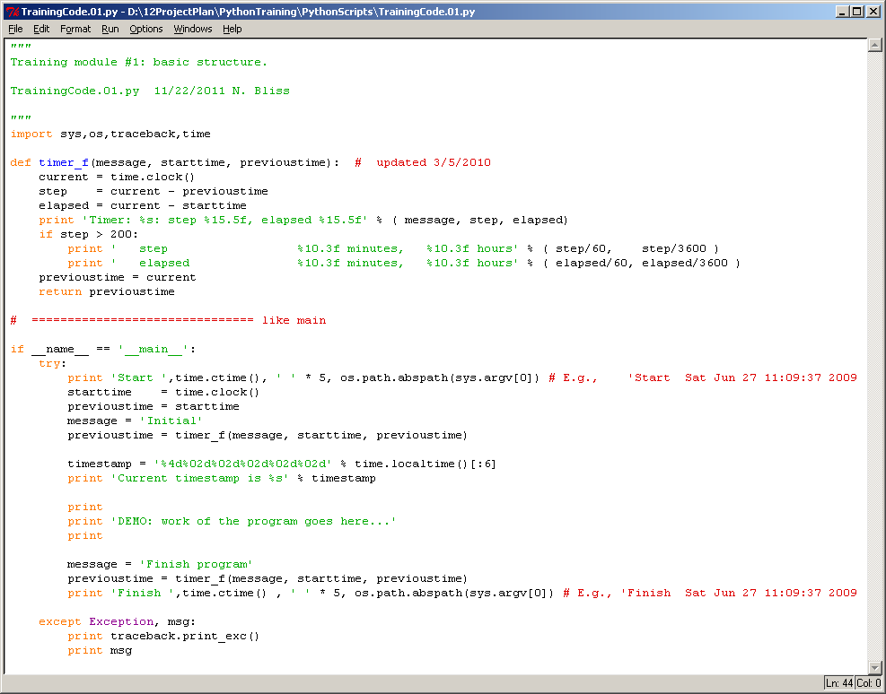
It imports from some standard python modules, defines a function, starts the “main” program that will execute if run by itself, uses try: and except: blocks, and all the lines in a block are vertically aligned (good indentation).

After saving the file (Ctrl-s), hit the keyboard “F5” key when the Python script window is active, it will bring the Python Shell window foward and produce output (here only to this screen).
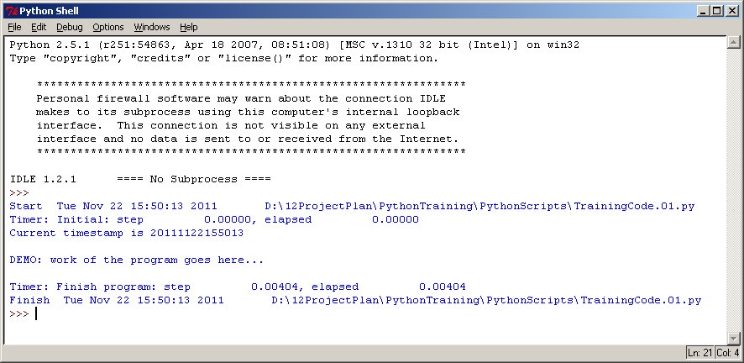
This executed in 4 milliseconds. It uses the time module to give the current date and time, and it uses the os and sys modules to help print the name of the program that is being run. Functions from the traceback module would be used if there were an error in execution.

You can also run the script by going to Run on the task bar, and selecting Run module F5. Occasionally the F5 doesn’t work but this will work.

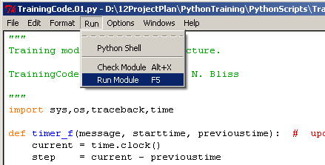

For this class, we will use the above code as a starting point, and insert new things in place of the line:
print 'DEMO: work of the program goes here...'

We will start with a “SaveAs” in the File menu to make a new file, edit the first line with the purpose of the program, document the new name and date and your name in the code, make the code changes, and then “Save” and “Run”.
  - Exercise: A new Python script
A Python script is basically a text file, and it is named with the extension “.py”.

From your Python Shell:
Click on File >> New Window

In the new window, click on File >> SaveAs, and if necessary create a folder for PythonTraining, and within that a folder for PythonScripts, and save the file with a name like “TrainingCode.02.py”.

Type a triple quote ('''), <Enter>, a short sentence such as “First practice script.”, <Enter> and the name of the script, the date, your name, <Enter> and a triple quote to end the string (which is a comment).

Type the code in the example below. The IDLE editor will automatically indent after your try: line. After typing the first print line and <Enter> to finish the line, hit <Backspace> to move the indentation to the left margin before typing except:.
When done, use Ctrl-s (or the File menu) to Save.
Notice that before saving, there is an asterisk (*) before and after the file name in the title bar of the window, and when you have saved the file, that goes away.
Before saving:
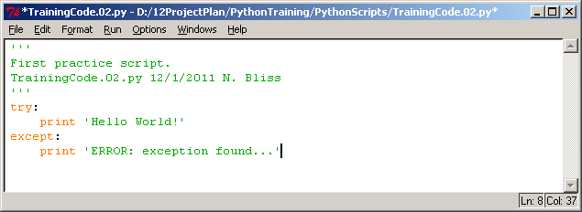
After saving:
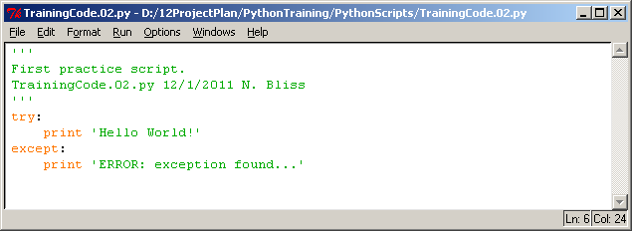
Hit F5 while your script window is the active window (e.g., click on the title bar if needed) to run the program. The output of the program should show in your Python Shell which is automatically brought forward.

Edit your script to put a divide by zero (1/0) on the line above “print 'Hello World!'”. Save and run again.
- Conditionality (if ... elif ... else)
Much of the power of programs comes from taking different actions depending on some condition in one or more of the variables.
  - Syntax for if: elif: else:
The general form of a if statement is:
if test1:
statements1
elif test2: # optional
statements2
else: # optional
statements3
Only one of the blocks of statements will be executed. There can be any number of elif statements (think: “else if”). A colon is at the end of the line for all three forms. In IDLE, the indentation of the next block is automatic. To end the block, you can use the “Backspace” key to “reverse-Tab” and come out one level of indentation (align to the indentation one level towards the left). The test is a boolean expression that will evaluate to True or False. Recall that empty strings or lists or the number zero will evaluate to False.
  - True, False
Here are four examples with all combinations of True and False in the two tests, to make the behavior explicit.
>>> if True:
print 'Case 1'
elif True: # did not reach this test
print 'Case 2'
else:
print 'Case 3'

Case 1
>>> if True:
print 'Case 1'
elif False: # did not reach this test
print 'Case 2'
else:
print 'Case 3'

Case 1
>>> if False:
print 'Case 1'
elif True:
print 'Case 2'
else:
print 'Case 3'

Case 2
>>> if False:
print 'Case 1'
elif False:
print 'Case 2'
else:
print 'Case 3'

Case 3
    - Exercise: practice with “if” statements
In Python, indentation is used to define blocks of code. You have already seen indentation with the the try: and except: statements. Here is an example that adds a few if statements to show indentation.
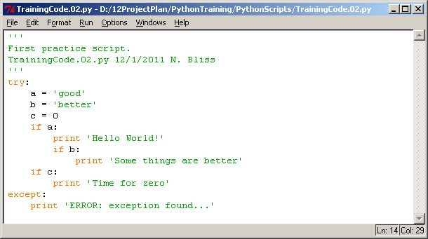
Can you predict the behavior before running it? What happens if you make variable a a null string and run the program? After doing that, hit Ctrl-z and Ctrl-s with your program window active and run it again. What happened?
Test your own ideas. This was a trivial example, but you may want to do something different.
  - Logical operators and comparison operators
There are three logical operators: not, and, or
not x Switch False to True or switch True to False
x and y True if both x and y are True
x or y True if one or both of x and y are True

The not has precedence over and, and and has precedence over or. Operations with higher precedence are executed first. Use parentheses to change the order of evaluation (inside first, then outward).

The comparison operators are:
x < y less than
x <= y less than or equal to
x > y greater than
x >= y greater than or equal to
x == y equal to
x != y not equal to
x <> y not equal to (discontinued in Python 3.0, do not use)
x is y is the same as (i.e., shares the same spot in memory)(test None)
x is not y is not the same as
x in y x is an element in y (collection or string)
x not in y x is not an element in y (collection or string)

Illustrate the precedence: and is evaluated before or:
>>> for i in [True, False]:
for j in [True, False]:
for k in [True, False]:
print '%-5s or %-5s and %-5s evaluates to %-5s' % ( i, j, k, i or j and k )

True or True and True evaluates to True
True or True and False evaluates to True
True or False and True evaluates to True
True or False and False evaluates to True
False or True and True evaluates to True
False or True and False evaluates to False
False or False and True evaluates to False
False or False and False evaluates to False

Use parentheses to obtain a different result:
>>> for i in [True, False]:
for j in [True, False]:
for k in [True, False]:
print '( %-5s or %-5s ) and %-5s evaluates to %-5s' % ( i, j, k, ( i or j ) and k )

( True or True ) and True evaluates to True
( True or True ) and False evaluates to False
( True or False ) and True evaluates to True
( True or False ) and False evaluates to False
( False or True ) and True evaluates to True
( False or True ) and False evaluates to False
( False or False ) and True evaluates to False
( False or False ) and False evaluates to False
  - in (e.g., k in D)
To test if an element is in a collection, or a substring is in a string, use the in operator.
>>> 'abc' in 'abcde'
True
>>> 'abc' in 'edcba'
False

>>> a_list
['a', 'b', 'c', 'A']
>>> 'A' in a_list
True
>>> 'Q' in a_list
False

I often test if a key is in a dictionary, and if not then add it.
I use the not in test here so the program is more readable. (Ask why if you want to.)
>>> pi_digits_list
[3, 1, 4, 1, 5, 9]

>>> # it is my convention to use _d_ in name to identify a dictionary.
>>> count_d_pi_digit = {} # create an empty dictionary
>>> for pi_digit in pi_digits_list:
if pi_digit not in count_d_pi_digit:
# key is not in the dictionary, add it
count_d_pi_digit[pi_digit] = 1
else:
# key is already in the dictionary, accumulate the count
count_d_pi_digit[pi_digit] = count_d_pi_digit[pi_digit] + 1

>>> pi_digit_key_list = count_d_pi_digit.keys()
>>> pi_digit_key_list.sort()
>>> for pi_digit in pi_digit_key_list:
print '%d %3d' % ( pi_digit, count_d_pi_digit[pi_digit])

1 2
3 1
4 1
5 1
9 1
For SSURGO, I might use this approach to count the number of components in each mapunit, etc.
  - is (e.g., x is None)
In most cases, we don’t care if one object shares the same space in memory as another (but I recommend against storing lists in dictionaries because of referencing issues). But to find out if an object is None, it may be best to use the is test. We saw this earlier:
>>> result = integers_list.sort() # don’t do this
>>> result
>>> result is None
True
- Looping
Along with if statements, the looping statements (for, while) give computer programs great power.
  - for
Use for rather than while if you know in advance how many times you want the loop to execute. Small examples of for loops have been introduced above. The simple syntax, which I normally use, is:
for target in object:
statements
Notice that the for line always ends with a colon (:). IDLE will automatically indent the next line. When done typing statements at that level of indentation, you can use the <Backspace> key to return to the level of indentation of the for keyword. The target can be a simple variable, or a tuple or other type of object, depending on what is in the object collection. Generally, the statements will make use of the target object(s) in calculations or if statements, etc.

I often use the range built-in function to define indexes for looping over a list.
First, use range by itself:
>>> range(5)
[0, 1, 2, 3, 4]
>>> for i in range(5):
print i

0
1
2
3
4
Now, use range( ) and len( ) together to loop over a list, the length of which could have changed dynamically earlier in the program.
>>> a_list
['a', 'b', 'c', 'A']
>>> len( a_list )
4
>>> for index_a in range( len( a_list ) ): # executes as range( 4 )
a = a_list[index_a]
print index_a, a

0 a
1 b
2 c
3 A
Now, change the list, but loop with exactly the same code:
>>> a_list.append( 'B' ) # one way to change the list
>>> a_list = a_list + [ 'C' ] # another way to change the list
>>> a_list
['a', 'b', 'c', 'A', 'B', 'C']
>>> len( a_list )
6
>>> # Use the same for loop
>>> for index_a in range( len( a_list ) ): # loop will execute 6 times
a = a_list[index_a]
print index_a, a

0 a
1 b
2 c
3 A
4 B
5 C

Let’s make a list that has tuples for values, and the loop the tuples.
>>> i_a_list = []
>>> for index_a in range( len( a_list ) ):
a = a_list[index_a]
i_a_list.append( (index_a, a) ) # appending a tuple to the list

>>> i_a_list
[(0, 'a'), (1, 'b'), (2, 'c'), (3, 'A'), (4, 'B'), (5, 'C')]

Now use a for loop, extracting the values of the tuples as we go.
>>> for (index_a, a) in i_a_list:
print index_a, a

0 a
1 b
2 c
3 A
4 B
5 C
  - Exercise: more practice with “for” loops
As a starting point, use the sample program introduced earlier in the class notes.

From the Python Shell, click on File >> Open..., and select TrainingCode.01.py, and click Open. This should be under the PythonTraining\PythonScripts directory.

Run the program with F5 while the script window is active.

Do a SaveAs in the TrainingCode.01.py window, and save with the name ‘TrainingCode.03.py”.

Edit the “Purpose” line (first line of the comment) and add something about this program, for example:
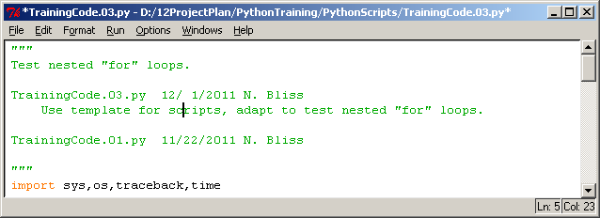

Place the cursor anywhere on the line
print 'Current timestamp is %s' % timestamp
and hit Alt-3 to comment out the line. It should now look like:
## print 'Current timestamp is %s' % timestamp

Use the cursor to highlight the line:
print 'DEMO: work of the program goes here...'
and start typing to replace it with new code. When done, it should look like this:
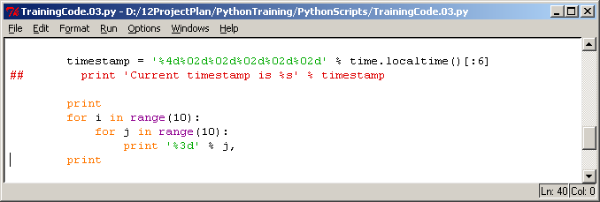
Then “Save” and “Run”.
Well, it did what I asked, but what I want is a nice block of numbers from 0 to 99 in 10 rows. What do I need to do to fix this? (Hint: the comma on the print statement supresses newlines. A print statement by itself (with nothing else) introduces a newline.)

Edit the program so that it produces output with the following form:
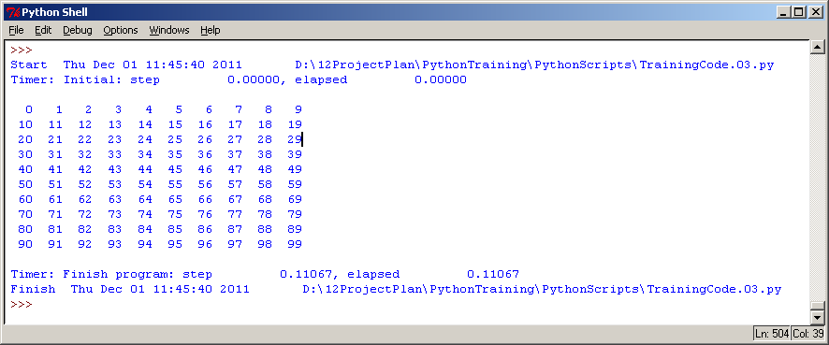
  - while
A while loop is useful when you don’t know in advance how many times the loop should be executed, but control will depend on something in the data. Here, stop listing the pi_digits if a digit equal to 5 is found or if the end of the list is reached.
>>> pi_digits_list = [3, 1, 4, 1, 5, 9]
>>> index_pi_digit = 0
>>> pi_digits_test = True
>>> while pi_digits_test:
pi_digit = pi_digits_list[index_pi_digit]
if pi_digit == 5:
pi_digits_test = False
else:
print pi_digit
index_pi_digit += 1
if index_pi_digit == len( pi_digits_list ):
pi_digits_test = False

3
1
4
1

Be careful that you also account for the case where the condition is not met in the data (avoid an infinite loop). Here, the test is for a digit equal to 7, so the loop is stopped by the second if test. If the second if test were not present, then an error message would be returned in this program, but that would not always be the case.
>>> index_pi_digit = 0
>>> pi_digits_test = True
>>> while pi_digits_test:
pi_digit = pi_digits_list[index_pi_digit]
if pi_digit == 7:
pi_digits_test = False
else:
print pi_digit
index_pi_digit += 1
if index_pi_digit == len( pi_digits_list ):
pi_digits_test = False

3
1
4
1
5
9
If an infinite loop is running, try to stop it with Ctrl-c in your Python Shell window. This may only work if it is printing something to the screen. If all else fails, use the Windows Task Manager to end your Python session.
  - pass, break, continue
Additional control in for and while loops is available with the pass, break, and continue keywords.
The pass keyword is used in an if statement if there is no other executable statement in a block. It does nothing, but is useful as a placeholder (perhaps you want to code something later).
>>> for pi_digit in pi_digits_list:
if pi_digit == 1:
pass
else:
print pi_digit

3
4
5
9

Note that a comment is not enough to define a block of statements in an if structure. Without using the pass statement, the Python interpreter won’t find anything between the if and the else:
>>> for pi_digit in pi_digits_list:
if pi_digit == 1:
# NOTE: plan to code an action for digit 1
else:
print pi_digit

File "<pyshell#685>", line 4
else:
^
IndentationError: expected an indented block

The pass statement applies only inside the if block, but if you want to skip all the rest of the for loop for a given iteration of the loop, then use the continue statement.
First, illustrate the previous example with pass and another print statement after the if ... else... block.
>>> for pi_digit in pi_digits_list:
if pi_digit == 1:
pass
else:
print pi_digit
print 'Second time printing of pi_digit', pi_digit

3
Second time printing of pi_digit 3
Second time printing of pi_digit 1
4
Second time printing of pi_digit 4
Second time printing of pi_digit 1
5
Second time printing of pi_digit 5
9
Second time printing of pi_digit 9
Notice that the rest of the for loop statements were executed, even when pi_digit == 1 was True. If we change the pass to continue, then the remainder of the block will not execute, and control returns to the for statement for the next iteration.
>>> for pi_digit in pi_digits_list:
if pi_digit == 1:
continue
else:
print pi_digit
print 'Second time printing of pi_digit', pi_digit

3
Second time printing of pi_digit 3
4
Second time printing of pi_digit 4
5
Second time printing of pi_digit 5
9
Second time printing of pi_digit 9

If we want to stop the for loop altogether, then use the break statement. Then the rest of the block will not be executed, and the for loop will not be executed again.
>>> for pi_digit in pi_digits_list:
if pi_digit == 1:
break
else:
print pi_digit
print 'Second time printing of pi_digit', pi_digit

3
Second time printing of pi_digit 3
  - for or while with an else clause
The for and while statements can also have an else statement, which is executed when the loop is done if a break was not executed. (See Lutz, pp. 248-257).
The general syntax for the for loop:
for target in object: # assign object items to target
statements1
if test1: break # exit loop now, skip else
if test2: continue # go to top of loop now
else:
statements2 # if we didn’t hit a ‘break’

The general syntax for the while loop:
while test1:
statements1
if test2: break # exit loop now, skip else
if test3: continue # go to top of loop now
else:
statements2 # if we didn’t hit a ‘break’

For an example of the while loop with else, I will code the while statement into a function to more easily demonstrate the test (Lutz, p.253):
>>> def is_prime( y ):
# given a positive integer greater than 1,
# return a factor or indicate prime
x = y / 2
while x > 1:
if y % x == 0: # remainder
print y, 'has factor', x
break
x = x - 1
else:
print y, 'is prime'

>>> for y in range(2,24):
is_prime(y)

2 is prime
3 is prime
4 has factor 2
5 is prime
6 has factor 3
7 is prime
8 has factor 4
9 has factor 3
10 has factor 5
11 is prime
12 has factor 6
13 is prime
14 has factor 7
15 has factor 5
16 has factor 8
17 is prime
18 has factor 9
19 is prime
20 has factor 10
21 has factor 7
22 has factor 11
23 is prime

- Using modules
Some of the built-in modules are very useful, even if you are new to Python. Many other modules are available (see www.python.org) and are beyond the scope of this course.
  - math
The math module provides mathematical functions and constants.
>>> import math
>>> dir( math )
['__doc__', '__name__', 'acos', 'asin', 'atan', 'atan2', 'ceil', 'cos', 'cosh', 'degrees', 'e', 'exp', 'fabs', 'floor', 'fmod', 'frexp', 'hypot', 'ldexp', 'log', 'log10', 'modf', 'pi', 'pow', 'radians', 'sin', 'sinh', 'sqrt', 'tan', 'tanh']
>>> help( math )
Help on built-in module math:

NAME
math

FILE
(built-in)

DESCRIPTION
This module is always available. It provides access to the
mathematical functions defined by the C standard.

FUNCTIONS
acos(...)
acos(x)

Return the arc cosine (measured in radians) of x.

asin(...)
asin(x)

Return the arc sine (measured in radians) of x.
omit full listing
For example, the floor( ) function:
floor(...)
floor(x)

Return the floor of x as a float.
This is the largest integral value <= x.
>>> float( int( -0.1 ))
0.0
>>> math.floor( -0.1 )
-1.0
Experiment a bit. Here are more suggestions.
>>> math.pi # constant for trigonometry
3.1415926535897931
>>> math.e # constant for logarithms
2.7182818284590451
>>> math.log10( 100 )
2.0
>>> 10 ** 2.0
100.0

>>> math.log( 100 )
4.6051701859880918
>>> math.e ** 4.6051701859880918
100.00000000000001
>>> math.exp( 4.6051701859880918 )
100.00000000000004
  - time
I use the time module to document my work. I also keep track of execution times, so that I can see how efficiently the program is working.
>>> import time
>>> time.ctime()
'Mon Nov 28 12:24:09 2011'
>>> time.localtime() # this is the result from Python 2.5
(2011, 11, 28, 12, 24, 23, 0, 332, 0)
A listing of the options for the time module is given in the introduction of these notes (section 5.4, import).
  - glob
The glob module is useful for making a list of filenames using a wildcard.
This was illustrated in section 2.1, “Print a list of files”.
>>> help( 'glob' )
Help on module glob:

NAME
glob - Filename globbing utility.
omit full listing
  - zipfile
This a useful module for zipping or unzipping files (e.g., .zip).
>>> help( 'zipfile' )
Help on module zipfile:

NAME
zipfile - Read and write ZIP files.
omit full listing
  - sys and os
The sys (system) and os (operating system) modules are very helpful for handling filenames. The os module has a sub-module called os.path which also has many useful functions.

In a script, you can use
os.path.abspath(sys.argv[0])
to return a string with the name of the script. I always include this in a print statement at the beginning and end of my scripts, so that I can copy and paste from my Python Shell into my daily notes, and have a record of what script was run at what time.

The filename separator is available as
>>> os.sep
'\\'
and by coding os.sep rather than the actual separator, you can help make your code more system independent (able to run on Windows, Unix, Mac, etc.).

To find if a file exists (try a pathname that really exists on your computer):
>>> filename = r'D:\12ProjectPlan\PythonTraining\Examples\text_ascii_01.txt'
>>> os.path.exists( filename )
True

Also check out (output not listed here):
>>> help( os.getcwd )
>>> help( os.mkdir )
>>> help( os.makedirs )

There are many other useful features for filenames.
- Files
Reading and writing files is very useful for processing large amounts of data. In this section, files that do not have proprietary formats will be discussed. These include text files (ASCII), such as the “Comma Separated Values” file (.csv) which can be opened as a spreadsheet in Excel. Binary files are more efficient for representing numbers because a binary representation of the number is used, rather than using 1 byte for representing each character of the number.
  - ASCII versus binary
ASCII files (character text) are readable by all computers (although there are different conventions on return and newline). Binary files are more efficient for numbers, but have additional issues (byte-order is specified as “little endian” or “big endian”), and will generally need additional documentation (metadata) for the user to understand what is in the file. Reading and writing ASCII files will be covered here, and the binary files will be considered briefly in a more advanced section.
  - Open
Use the built-in open( ) function to open a file. The function has two parameters, a filename and a string that indicates whether it is to be opened for reading or writing, and whether it is a binary file. The output of the open( ) function is assigned to a name that I will call a “file unit”.
>>> # 'w' for writing
>>> fo1ascii = open( r'D:\12ProjectPlan\PythonTraining\Examples\text_ascii_01.txt', 'w' )
>>> fo1ascii
<open file 'D:\12ProjectPlan\PythonTraining\Examples\text_ascii_01.txt', mode 'w' at 0x01E09608>

The file unit that is created has some methods available:
>>> dir( fo1ascii )
['__class__', '__delattr__', '__doc__', '__enter__', '__exit__', '__getattribute__', '__hash__', '__init__', '__iter__', '__new__', '__reduce__', '__reduce_ex__', '__repr__', '__setattr__', '__str__', 'close', 'closed', 'encoding', 'fileno', 'flush', 'isatty', 'mode', 'name', 'newlines', 'next', 'read', 'readinto', 'readline', 'readlines', 'seek', 'softspace', 'tell', 'truncate', 'write', 'writelines', 'xreadlines']
  - Writing
We can write to the file with the .write( ) function applied to the file unit object.
First, without newlines, then with newlines:
>>> a_list
['a', 'b', 'c', 'A', 'B', 'C']
>>> for index_a in range( len( a_list ) ):
a = a_list[index_a]
fo1ascii.write( a )
>>> # do again with newlines
>>> for index_a in range( len( a_list ) ):
a = a_list[index_a]
write_string = a # here just a single character (more later)
fo1ascii.write( write_string + '\n' ) # add a newline
  - Close
To close a file, specify the file unit with the .close( ) function. The .close( ) function does not require any parameters.
>>> fo1ascii
<open file 'D:\12ProjectPlan\PythonTraining\Examples\text_ascii_01.txt', mode 'w' at 0x01E09608>
>>> fo1ascii.close()
>>> fo1ascii
<closed file 'D:\12ProjectPlan\PythonTraining\Examples\text_ascii_01.txt', mode 'w' at 0x01E09608>
View the file in NotePad. Note that the first newline was encountered only after the first item was already written in the second loop.
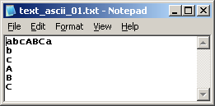
  - Reading
We can use read from this file using similar methods:
>>> filename = r'D:\12ProjectPlan\PythonTraining\Examples\text_ascii_01.txt'
>>> # 'r' for reading
>>> fi1ascii = open( filename, 'r' )
>>> b_list = [] # create an empty list
>>> for index in range(6):
b = fi1ascii.read( 1 ) # read one byte at a time (no newlines)
b_list.append( b )

>>> b_list
['a', 'b', 'c', 'A', 'B', 'C']
>>> # read by lines
>>> c_list = []
>>> for index in range(6):
c_line = fi1ascii.readline()
c = c_line.rstrip()
c_list.append( c )

>>> c_list
['a', 'b', 'c', 'A', 'B', 'C']

Now, we have read back all of the data that we wrote. What happens if I try to read past the end of the file?
>>> d = fi1ascii.read( 1 ) # read one byte at a time
>>> d
''
It does not give an error message, it just returns an empty string.
Close the file.
>>> fi1ascii.close()
Now trying to read will give an error.
>>> d = fi1ascii.read( 1 ) # read one byte at a time
Traceback (most recent call last):
File "<pyshell#779>", line 1, in <module>
d = fi1ascii.read( 1 ) # read one byte at a time
ValueError: I/O operation on closed file

Open the ASCII file again, and read all lines into a list with a single statement. Print the list.
>>> fi1ascii = open( filename, 'r' )
>>> text_ascii_01_line_list = fi1ascii.readlines()
>>> for text_ascii_01_line in text_ascii_01_line_list:
# rstrip removes the newline before printing
print text_ascii_01_line.rstrip()

abcABCa
b
c
A
B
C
>>> fi1ascii.close()
Note that the newline character ('\n') is part of each line in the list. If we didn’t strip them first, then that newline would be printed as well as the one generated by the print statement, and the output would be double-spaced. You can see the newlines by observing the list in raw form. The string method “rstrip” (right-strip) removes any white space (blanks, tabs, newlines, etc.) from the right edge of the string.
>>> text_ascii_01_line_list
['abcABCa\n', 'b\n', 'c\n', 'A\n', 'B\n', 'C\n']
- Writing functions
Functions are initiated with a def( ) statement (think: “define”). They may contain a return statement to return a value or other Python object from the function.
  - Advantages of functions
Functions increase the efficiency of coding. If there is something to be done two or more times in a program, coding it into a function reduces the amount of code, and isolates the functionality so that it can be more easily fixed if changes are needed. It is possible to over-do making functions and lose the readibility of the code. The variable names in a function are generally isolated from the outside program.
  - def
A function has the following general syntax:
def function_name( argument_1, argument_2, ...):
statements
return return_value
The def keyword is followed by the function name, open parenthesis, zero or more arguments, close parenthesis, and a colon. The parentheses are required, even if there are no arguments.

Here is a simple function with no arguments and no return value.
>>> def print_dashes_f():
print '---------------------------------------'
To call the function, just specify its name, followed by parentheses.
>>> print_dashes_f()
---------------------------------------

We can use this in a for loop:
>>> for i in range(5):
print i
print_dashes_f()

0
---------------------------------------
1
---------------------------------------
2
---------------------------------------
3
---------------------------------------
4
---------------------------------------
  - arguments
The arguments to a function can be most any type of Python object. They are included between the parentheses in the function definition and function call. Because the names inside and outside may be different, the position matters. Here there is just one argument, a list. (Keywords may also be defined and used, defaults values are also possible).
>>> city_list = ['Lincoln', 'Sioux Falls', 'Morgantown', 'Ft. Worth']
>>> def print_from_list_f( name_list ):
for name in name_list:
print '..................', name

>>> print_from_list_f( city_list )
.................. Lincoln
.................. Sioux Falls
.................. Morgantown
.................. Ft. Worth

Note that while names in functions are protected, if you change some of the arguments (e.g., sorting a list) the changed object will be evident outside the function. (This could be a “gottcha”.) Here, define a function to sort a list, and the list is sorted even though I did not specify a return statement.
I have two lists available in the program or Python Shell:
>>> a_list
['a', 'b', 'c', 'A', 'B', 'C']
>>> a1_key_list
['four', 'three', 'two', 'one']
I define a function. I use the name “a_list” in the function.
>>> def sort_list_f( a_list ):
# sort a list
a_list.sort()

Send the a1_key_list to the function:
>>> sort_list_f( a1_key_list )
>>> a1_key_list
['four', 'one', 'three', 'two']
>>> a_list # the original a_list was not changed
['a', 'b', 'c', 'A', 'B', 'C']
>>> sort_list_f( a_list ) # now send a_list to the function
>>> a_list # now a_list has been changed
['A', 'B', 'C', 'a', 'b', 'c']
Recap: The variable names in the function are isolated from the variable names in the calling program, but it is possible to change mutuable objects inside the function.
  - return
The return statement is optional, but can be used to return values back to the calling program. The function call is placed on the right side of the assignment statement.
>>> def my_square_root_f( a_number ):
import math
a_square_root_result = math.sqrt( a_number )
return a_square_root_result

>>> input_value = 24
>>> output_value = my_square_root_f( input_value )
>>> output_value
4.8989794855663558
- Arrays
The array processing module is called NumPy, but is not a built-in part of Python. It must be installed separately. When I tried installing Python and NumPy together on my home computer, I had problems until I downloaded a free package from Enthought at http://enthought.com/products/epd.php that had them packaged together. They also offer more advanced versions and support for a fee (e.g., 64-bit NumPy). There is a link to the Enthought website from the main Python website (www.python.org). I believe Enthought products are available to USGS users, but I have not tried to make use of this source.
  - NumPy (Numeric Python)
NumPy is fun, just like Python is fun.

Programs are easy to code (once you figure out the syntax) because operations on entire arrays are controlled by a single statement. It is not necessary (although it is possible) to loop through each pixel in an image. The underlying executable code is generally coded in C or Fortran, so execution is fast (whereas Python is an interpreted language so execution is slower if you are looping pixels).
Once NumPy is installed on your system, you can import it as with any other module. To keep names short in the program, I follow a recommended convention, and change the name from “numpy” to “np” for use in my programs.
>>> import numpy as np

Numpy is a complicated package, but there are some built-in tools to help find what you need.
>>> print np.__doc__
NumPy
==========

You can support the development of NumPy and SciPy by purchasing
the book "Guide to NumPy" at

http://www.trelgol.com

It is being distributed for a fee for only a few years to
cover some of the costs of development. After the restriction period
it will also be freely available.

Additional documentation is available in the docstrings and at

http://www.scipy.org.

Available subpackages
---------------------
core --- Defines a multi-dimensional array and useful procedures
for Numerical computation.
lib --- Basic functions used by several sub-packages and useful
to have in the main name-space.
random --- Core Random Tools
linalg --- Core Linear Algebra Tools
fft --- Core FFT routines
testing --- Numpy testing tools

These packages require explicit import
f2py --- Fortran to Python Interface Generator.
distutils --- Enhancements to distutils with support for
Fortran compilers support and more.

Global symbols from subpackages
-------------------------------
core --> *
lib --> *
testing --> NumpyTest

Utility tools
-------------

test --- Run numpy unittests
pkgload --- Load numpy packages
show_config --- Show numpy build configuration
dual --- Overwrite certain functions with high-performance Scipy tools
matlib --- Make everything matrices.
__version__ --- Numpy version string

You can get a clue as to the possible operations or data types for use with arrays:
>>> dir( np )
['ALLOW_THREADS', 'BUFSIZE', 'CLIP', 'ERR_CALL', 'ERR_DEFAULT', 'ERR_DEFAULT2', 'ERR_IGNORE', 'ERR_LOG', 'ERR_PRINT', 'ERR_RAISE', 'ERR_WARN', 'FLOATING_POINT_SUPPORT', 'FPE_DIVIDEBYZERO', 'FPE_INVALID', 'FPE_OVERFLOW', 'FPE_UNDERFLOW', 'False_', 'Inf', 'Infinity', 'MAXDIMS', 'MachAr', 'NAN', 'NINF', 'NZERO', 'NaN', 'NumpyTest', 'PINF', 'PZERO', 'PackageLoader', 'RAISE', 'RankWarning', 'SHIFT_DIVIDEBYZERO', 'SHIFT_INVALID', 'SHIFT_OVERFLOW', 'SHIFT_UNDERFLOW', 'ScalarType', 'ScipyTest', 'True_', 'UFUNC_BUFSIZE_DEFAULT', 'UFUNC_PYVALS_NAME', 'WRAP', '__all__', '__builtins__', '__config__', '__doc__', '__file__', '__name__', '__path__', '__version__', '_import_tools', 'abs', 'absolute', 'add', 'add_docstring', 'add_newdoc', 'add_newdocs', 'alen', 'all', 'allclose', 'alltrue', 'alterdot', 'amax', 'amin', 'angle', 'any', 'append', 'apply_along_axis', 'apply_over_axes', 'arange', 'arccos', 'arccosh', 'arcsin', 'arcsinh', 'arctan', 'arctan2', 'arctanh', 'argmax', 'argmin', 'argsort', 'argwhere', 'around', 'array', 'array2string', 'array_equal', 'array_equiv', 'array_repr', 'array_split', 'array_str', 'asanyarray', 'asarray', 'asarray_chkfinite', 'ascontiguousarray', 'asfarray', 'asfortranarray', 'asmatrix', 'asscalar', 'atleast_1d', 'atleast_2d', 'atleast_3d', 'average', 'bartlett', 'base_repr', 'binary_repr', 'bincount', 'bitwise_and', 'bitwise_not', 'bitwise_or', 'bitwise_xor', 'blackman', 'bmat', 'bool', 'bool8', 'bool_', 'broadcast', 'byte', 'byte_bounds', 'c_', 'can_cast', 'cast', 'cdouble', 'ceil', 'cfloat', 'char', 'character', 'chararray', 'choose', 'clip', 'clongdouble', 'clongfloat', 'column_stack', 'common_type', 'compare_chararrays', 'complex', 'complex128', 'complex192', 'complex64', 'complex_', 'complexfloating', 'compress', 'concatenate', 'conj', 'conjugate', 'convolve', 'copy', 'core', 'corrcoef', 'correlate', 'cos', 'cosh', 'cov', 'cross', 'csingle', 'ctypeslib', 'cumprod', 'cumproduct', 'cumsum', 'delete', 'deprecate', 'diag', 'diagflat', 'diagonal', 'diff', 'digitize', 'disp', 'distutils', 'divide', 'dot', 'double', 'dsplit', 'dstack', 'dtype', 'e', 'ediff1d', 'emath', 'empty', 'empty_like', 'equal', 'errstate', 'exp', 'expand_dims', 'expm1', 'extract', 'eye', 'f2py', 'fabs', 'fastCopyAndTranspose', 'fft', 'finfo', 'fix', 'flatiter', 'flatnonzero', 'flexible', 'fliplr', 'flipud', 'float', 'float32', 'float64', 'float96', 'float_', 'floating', 'floor', 'floor_divide', 'fmod', 'format_parser', 'frexp', 'frombuffer', 'fromfile', 'fromfunction', 'fromiter', 'frompyfunc', 'fromstring', 'generic', 'get_array_wrap', 'get_include', 'get_numarray_include', 'get_numpy_include', 'get_printoptions', 'getbuffer', 'getbufsize', 'geterr', 'geterrcall', 'geterrobj', 'gradient', 'greater', 'greater_equal', 'hamming', 'hanning', 'histogram', 'histogram2d', 'histogramdd', 'hsplit', 'hstack', 'hypot', 'i0', 'identity', 'iinfo', 'imag', 'index_exp', 'indices', 'inexact', 'inf', 'info', 'infty', 'inner', 'insert', 'int', 'int0', 'int16', 'int32', 'int64', 'int8', 'int_', 'int_asbuffer', 'intc', 'integer', 'interp', 'intersect1d', 'intersect1d_nu', 'intp', 'invert', 'iscomplex', 'iscomplexobj', 'isfinite', 'isfortran', 'isinf', 'isnan', 'isneginf', 'isposinf', 'isreal', 'isrealobj', 'isscalar', 'issctype', 'issubclass_', 'issubdtype', 'issubsctype', 'iterable', 'ix_', 'kaiser', 'kron', 'ldexp', 'left_shift', 'less', 'less_equal', 'lexsort', 'lib', 'linalg', 'linspace', 'little_endian', 'load', 'loads', 'loadtxt', 'log', 'log10', 'log1p', 'log2', 'logical_and', 'logical_not', 'logical_or', 'logical_xor', 'logspace', 'long', 'longdouble', 'longfloat', 'longlong', 'ma', 'mat', 'math', 'matrix', 'max', 'maximum', 'maximum_sctype', 'may_share_memory', 'mean', 'median', 'memmap', 'meshgrid', 'mgrid', 'min', 'minimum', 'mintypecode', 'mod', 'modf', 'msort', 'multiply', 'nan', 'nan_to_num', 'nanargmax', 'nanargmin', 'nanmax', 'nanmin', 'nansum', 'nbytes', 'ndarray', 'ndenumerate', 'ndim', 'ndindex', 'negative', 'newaxis', 'newbuffer', 'nonzero', 'not_equal', 'numarray', 'number', 'obj2sctype', 'object', 'object0', 'object_', 'ogrid', 'oldnumeric', 'ones', 'ones_like', 'outer', 'pi', 'piecewise', 'pkgload', 'place', 'poly', 'poly1d', 'polyadd', 'polyder', 'polydiv', 'polyfit', 'polyint', 'polymul', 'polysub', 'polyval', 'power', 'prod', 'product', 'ptp', 'put', 'putmask', 'r_', 'random', 'rank', 'ravel', 'real', 'real_if_close', 'rec', 'recarray', 'reciprocal', 'record', 'remainder', 'repeat', 'require', 'reshape', 'resize', 'restoredot', 'right_shift', 'rint', 'roll', 'rollaxis', 'roots', 'rot90', 'round', 'round_', 'row_stack', 's_', 'savetxt', 'sctype2char', 'sctypeDict', 'sctypeNA', 'sctypes', 'searchsorted', 'select', 'set_numeric_ops', 'set_printoptions', 'set_string_function', 'setbufsize', 'setdiff1d', 'seterr', 'seterrcall', 'seterrobj', 'setmember1d', 'setxor1d', 'shape', 'short', 'show_config', 'sign', 'signbit', 'signedinteger', 'sin', 'sinc', 'single', 'sinh', 'size', 'sometrue', 'sort', 'sort_complex', 'source', 'split', 'sqrt', 'square', 'squeeze', 'std', 'str', 'str_', 'string0', 'string_', 'subtract', 'sum', 'swapaxes', 'take', 'tan', 'tanh', 'tensordot', 'test', 'testing', 'tile', 'trace', 'transpose', 'trapz', 'tri', 'tril', 'trim_zeros', 'triu', 'true_divide', 'typeDict', 'typeNA', 'typecodes', 'typename', 'ubyte', 'ufunc', 'uint', 'uint0', 'uint16', 'uint32', 'uint64', 'uint8', 'uintc', 'uintp', 'ulonglong', 'unicode', 'unicode0', 'unicode_', 'union1d', 'unique', 'unique1d', 'unravel_index', 'unsignedinteger', 'unwrap', 'ushort', 'vander', 'var', 'vdot', 'vectorize', 'version', 'void', 'void0', 'vsplit', 'vstack', 'where', 'who', 'zeros', 'zeros_like']

You can also try
>>> help( np )
Help on package numpy:

NAME
numpy

FILE
c:\arcgis\python25\lib\site-packages\numpy\__init__.py
omit full listing

but the listing has 30,789 lines of output, so it is not printed here. From the listing you can find the syntax for particular commands. Or try help on the single command. For example, the where command handles conditionality, like an if statement (or the CON statement in ArcGIS):
>>> help( np.where )
Help on built-in function where in module numpy.core.multiarray:

where(...)
where(condition, | x, y)

The result is shaped like condition and has elements of x and y where
condition is respectively true or false. If x or y are not given,
then it is equivalent to condition.nonzero().

To group the indices by element, rather than dimension, use

transpose(where(condition, | x, y))

instead. This always results in a 2d array, with a row of indices for
each element that satisfies the condition.
  - Creating arrays
Once numpy has been imported, several useful functions are available for creating arrays.
In analogy to the range( ) function in Python, the arange function makes an array with a sequence of integers.
>>> a1_ar = np.arange(20)
>>> a1_ar
array([ 0, 1, 2, 3, 4, 5, 6, 7, 8, 9, 10, 11, 12, 13, 14, 15, 16, 17, 18, 19])
Some familiar operations can be applied to the array (but more on this later):
>>> len( a1_ar )
20
>>> dir( a1_ar )
['T', '__abs__', '__add__', '__and__', '__array__', '__array_finalize__', '__array_interface__', '__array_priority__', '__array_struct__', '__array_wrap__', '__class__', '__contains__', '__copy__', '__deepcopy__', '__delattr__', '__delitem__', '__delslice__', '__div__', '__divmod__', '__doc__', '__eq__', '__float__', '__floordiv__', '__ge__', '__getattribute__', '__getitem__', '__getslice__', '__gt__', '__hash__', '__hex__', '__iadd__', '__iand__', '__idiv__', '__ifloordiv__', '__ilshift__', '__imod__', '__imul__', '__index__', '__init__', '__int__', '__invert__', '__ior__', '__ipow__', '__irshift__', '__isub__', '__iter__', '__itruediv__', '__ixor__', '__le__', '__len__', '__long__', '__lshift__', '__lt__', '__mod__', '__mul__', '__ne__', '__neg__', '__new__', '__nonzero__', '__oct__', '__or__', '__pos__', '__pow__', '__radd__', '__rand__', '__rdiv__', '__rdivmod__', '__reduce__', '__reduce_ex__', '__repr__', '__rfloordiv__', '__rlshift__', '__rmod__', '__rmul__', '__ror__', '__rpow__', '__rrshift__', '__rshift__', '__rsub__', '__rtruediv__', '__rxor__', '__setattr__', '__setitem__', '__setslice__', '__setstate__', '__str__', '__sub__', '__truediv__', '__xor__', 'all', 'any', 'argmax', 'argmin', 'argsort', 'astype', 'base', 'byteswap', 'choose', 'clip', 'compress', 'conj', 'conjugate', 'copy', 'ctypes', 'cumprod', 'cumsum', 'data', 'diagonal', 'dtype', 'dump', 'dumps', 'fill', 'flags', 'flat', 'flatten', 'getfield', 'imag', 'item', 'itemset', 'itemsize', 'max', 'mean', 'min', 'nbytes', 'ndim', 'newbyteorder', 'nonzero', 'prod', 'ptp', 'put', 'ravel', 'real', 'repeat', 'reshape', 'resize', 'round', 'searchsorted', 'setfield', 'setflags', 'shape', 'size', 'sort', 'squeeze', 'std', 'strides', 'sum', 'swapaxes', 'take', 'tofile', 'tolist', 'tostring', 'trace', 'transpose', 'var', 'view']

As before, you are likely to only want the ones without the underscores.
>>> a1_ar.size
20
>>> a1_ar.dtype # we created an array of 32 bit signed integers
dtype('int32')
>>> a1_ar.nbytes # at 4 bytes and 20 elements, uses 80 bytes in memory
80

Another function to create arrays is np.zeros( ).
With this function, specify the number of elements in each dimension as a tuple. The default indexing of the dimensions has the rightmost dimension changing fastest, and the leftmost dimension changing most slowly. In this example, I think of it as creating two sub_arrays that have 3 rows and 4 columns each.
>>> a2_ar = np.zeros( (2, 3, 4), dtype=np.uint8)
>>> a2_ar
array([[[0, 0, 0, 0],
[0, 0, 0, 0],
[0, 0, 0, 0]],

[[0, 0, 0, 0],
[0, 0, 0, 0],
[0, 0, 0, 0]]], dtype=uint8)
The command above made use of a built-in NumPy data type for unsigned 8-bit integers:
>>> np.uint8
<type 'numpy.uint8'>

If you want a whole array initialized to a particular value, you can add that value to the zero array.
>>> a_255_ar = np.zeros( (2, 3, 4), dtype=np.uint8) + 255
>>> a_255_ar
array([[[255, 255, 255, 255],
[255, 255, 255, 255],
[255, 255, 255, 255]],

[[255, 255, 255, 255],
[255, 255, 255, 255],
[255, 255, 255, 255]]], dtype=uint8)

The np.array function will convert another type of object into an array (if possible).
>>> pi_digits_list
[3, 1, 4, 1, 5, 9]
>>> pi_digits_ar = np.array( pi_digits_list ) # don’t forget the np.
>>> pi_digits_ar
array([3, 1, 4, 1, 5, 9])
Say you want to find out the data type of this object. The first example is generic, and the second is more specific.
>>> type( pi_digits_ar )
<type 'numpy.ndarray'>
>>> pi_digits_ar.dtype
dtype('int32')
  - Reshaping arrays
The reshape function will change the shape of an array. Here, save three new arrays, and show that the original is unchanged.
>>> a1_ar
array([ 0, 1, 2, 3, 4, 5, 6, 7, 8, 9, 10, 11, 12, 13, 14, 15, 16, 17, 18, 19])

>>> a1_2d_ar = a1_ar.reshape( 4, 5 )
>>> a1_2d_ar
array([[ 0, 1, 2, 3, 4],
[ 5, 6, 7, 8, 9],
[10, 11, 12, 13, 14],
[15, 16, 17, 18, 19]])

>>> a1_2d_2_ar = a1_ar.reshape( 2, 10 )
>>> a1_2d_2_ar
array([[ 0, 1, 2, 3, 4, 5, 6, 7, 8, 9],
[10, 11, 12, 13, 14, 15, 16, 17, 18, 19]])

>>> a1_3d_ar = a1_ar.reshape( 2, 2, 5 )
>>> a1_3d_ar
array([[[ 0, 1, 2, 3, 4],
[ 5, 6, 7, 8, 9]],

[[10, 11, 12, 13, 14],
[15, 16, 17, 18, 19]]])
>>> a1_ar
array([ 0, 1, 2, 3, 4, 5, 6, 7, 8, 9, 10, 11, 12, 13, 14, 15, 16, 17, 18, 19])
Return a tuple with the shape of the array:
>>> a1_3d_ar.shape
(2, 2, 5)
  - printing arrays
If you try to print a large array on the screen of your Python Shell, it returns just the corners (thankfully). Here, the array has 25 million entries.
>>> a4_ar = np.arange( 25000000, dtype=np.uint32).reshape(5000, 5000)
>>> a4_ar
array([[ 0, 1, 2, ..., 4997, 4998, 4999],
[ 5000, 5001, 5002, ..., 9997, 9998, 9999],
[ 10000, 10001, 10002, ..., 14997, 14998, 14999],
...,
[24985000, 24985001, 24985002, ..., 24989997, 24989998, 24989999],
[24990000, 24990001, 24990002, ..., 24994997, 24994998, 24994999],
[24995000, 24995001, 24995002, ..., 24999997, 24999998, 24999999]], dtype=uint32)
  - Flattened arrays, the Python map() function
You can take a multi-dimensional array and make a one-dimensional array with the flatten function. This function makes a copy of the array. Here, we can see it is the same as the original one-dimensional array from which it was derived (before we reshaped it). In general image processing, we would receive a two-dimensional image, so the flattening step would be necessary.
>>> a1_2d_ar
array([[ 0, 1, 2, 3, 4],
[ 5, 6, 7, 8, 9],
[10, 11, 12, 13, 14],
[15, 16, 17, 18, 19]])

>>> a1_flatten_ar = a1_2d_ar.flatten()
>>> a1_flatten_ar
array([ 0, 1, 2, 3, 4, 5, 6, 7, 8, 9, 10, 11, 12, 13, 14, 15, 16, 17, 18, 19])
We can use a flattened array with the Python map() function, which takes a function and an iterable (I will make a list) and applies the function to every element of the iterable and returns a list. I use this for my home-made map algebra calculations with arrays of 25,000,000 pixels, including assigning attributes to mukeyint (the integer version of mukey) and it runs in seconds.
>>> help( map )
Help on built-in function map in module __builtin__:

map(...)
map(function, sequence[, sequence, ...]) -> list

Return a list of the results of applying the function to the items of
the argument sequence(s). If more than one sequence is given, the
function is called with an argument list consisting of the corresponding
item of each sequence, substituting None for missing values when not all
sequences have the same length. If the function is None, return a list of
the items of the sequence (or a list of tuples if more than one sequence).
    - Exercise: using the map() function and a dictionary for image reclassification
We will use the flattened array and assume it represents some image data (an integer code) before the reclassification. From my soil work, this might be the map unit key (mukeyint).

Make a dictionary (ficticious in this example) to associate a value with each mukeyint.
>>> # make a dictionary to return a value for each mukeyint
>>> value_d_mukeyint = {}
>>> for mukeyint in range(24): # ficticious process for making a mock attribute table
value = mukeyint * 1.234
if mukeyint not in value_d_mukeyint:
# key does not exist, add it
value_d_mukeyint[mukeyint] = value
else:
# key already exists
print 'ERROR: duplicate mukeyint detected'

>>> value_d_mukeyint
{0: 0.0, 1: 1.234, 2: 2.468, 3: 3.702, 4: 4.9359999999999999, 5: 6.1699999999999999, 6: 7.4039999999999999, 7: 8.6379999999999999, 8: 9.8719999999999999, 9: 11.106, 10: 12.34, 11: 13.574, 12: 14.808, 13: 16.042000000000002, 14: 17.276, 15: 18.509999999999998, 16: 19.744, 17: 20.978000000000002, 18: 22.212, 19: 23.445999999999998, 20: 24.68, 21: 25.914000000000001, 22: 27.148, 23: 28.381999999999998}

Make a function to be used by the map() process.
>>> def value_f_mukeyint( mukeyint ):
return value_d_mukeyint[mukeyint] # dictionary must have all cases

Make a list from the flattened array. The list retains its order. This is the “spatial data”, so duplicates are possible (expected, necessary, etc. except in this example).
>>> mukeyint_list = list( a1_flatten_ar.flatten() )
>>> mukeyint_list
[0, 1, 2, 3, 4, 5, 6, 7, 8, 9, 10, 11, 12, 13, 14, 15, 16, 17, 18, 19]

Apply the map function (a Python function, not a NumPy function).
>>> value_list = map( value_f_mukeyint, mukeyint_list )
>>> value_list
[0.0, 1.234, 2.468, 3.702, 4.9359999999999999, 6.1699999999999999, 7.4039999999999999, 8.6379999999999999, 9.8719999999999999, 11.106, 12.34, 13.574, 14.808, 16.042000000000002, 17.276, 18.509999999999998, 19.744, 20.978000000000002, 22.212, 23.445999999999998]

Get the dimensions of the original array.
>>> shape_a1_2d_ar_tuple = a1_2d_ar.shape
>>> shape_a1_2d_ar_tuple
(4, 5)

Make the list back into an array, and re-shape it properly.
>>> value_ar = np.array( value_list, dtype=np.float32).reshape( shape_a1_2d_ar_tuple )
>>> value_ar
array([[ 0. , 1.23399997, 2.46799994, 3.7019999 , 4.93599987],
[ 6.17000008, 7.40399981, 8.63799953, 9.87199974, 11.10599995],
[ 12.34000015, 13.57400036, 14.80799961, 16.04199982, 17.27599907],
[ 18.51000023, 19.74399948, 20.97800064, 22.21199989, 23.44599915]], dtype=float32)
[I reduced the font size so the 4 x 5 dimensionality is more evident.]

All of this happens fast even with 25,000,000 pixels, because it does not require looping pixel by pixel, but works on arrays or uses the map( ) function that works on single objects (like the list).

Optional: capture this sequence in a Python script. Do SaveAs on your current (saved) python script, naming it “TrainingCode.09.map_mukeyint_to_value.py”.

In an operational setting, this result would be written out to a GIS file (e.g., .img or .tif).
  - Slicing arrays
Slicing arrays is similar to slicing strings, lists, and tuples, in that counting starts with zero, and the ending index is past (at the ‘right’ edge of) the objects to be selected. Here, however, there are more dimensions, and the dimensions are separated with commas.
Given a 2-d array, a single index will return a “row” of the array as a 1-d array.
>>> a1_2d_ar
array([[ 0, 1, 2, 3, 4],
[ 5, 6, 7, 8, 9],
[10, 11, 12, 13, 14],
[15, 16, 17, 18, 19]])
>>> a1_2d_ar[0]
array([0, 1, 2, 3, 4])

You can address a single element of the array with an index for each dimension. This returns a single value, rather than an array:
>>> a1_2d_ar[3,4]
19

If you want the same element, but need it to be an array, then use slicing but still only return the one element:
>>> a1_2d_ar[3:4, 4:5]
array([[19]])

If you want a column of the array, you need to use a colon and a comma to indicate that all rows are to be considered.
>>> a1_2d_ar[:, 0]
array([ 0, 5, 10, 15])

For this example, omit the first and last rows and columns:
>>> a1_2d_ar[1:3, 1:4]
array([[ 6, 7, 8],
[11, 12, 13]])

You could obtain the same result with negative indices for the upper limits of the range (count backwards from the end of each dimension).
>>> a1_2d_ar[1:-1, 1:-1]
array([[ 6, 7, 8],
[11, 12, 13]])

Or, this example could be coded with variables for the slicing indices, based on the array’s characteristics:
>>> (rows, cols) = a1_2d_ar.shape # returns a tuple
>>> rows
4
>>> cols
5
>>> a1_2d_ar[1:rows - 1,1:cols - 1] # subtraction before slicing
array([[ 6, 7, 8],
[11, 12, 13]])
  - Array algebra
With array algebra, entire arrays can be processed with a single command. NumPy will do what is called “broadcasting” which is to re-use elements of a smaller array if needed to match the size of a larger array. This only works if multiples of the smaller array fit exactly into the larger array. This also works with scalar constants. Thus, we can multiply an array by a number and the result will be an array.

Add two arrays:
First make an array that is the complement of a1_2d_ar (see previous section):
>>> a5_ar = np.arange( 19, -1, -1).reshape(4,5)
>>> a5_ar
array([[19, 18, 17, 16, 15],
[14, 13, 12, 11, 10],
[ 9, 8, 7, 6, 5],
[ 4, 3, 2, 1, 0]])
Then add the two arrays:
>>> a6_ar = a1_2d_ar + a5_ar
>>> a6_ar
array([[19, 19, 19, 19, 19],
[19, 19, 19, 19, 19],
[19, 19, 19, 19, 19],
[19, 19, 19, 19, 19]])

Multiply this by a constant:
>>> a6_ar * 20
array([[380, 380, 380, 380, 380],
[380, 380, 380, 380, 380],
[380, 380, 380, 380, 380],
[380, 380, 380, 380, 380]])

Divide the integer array by an integer; note that truncation occurs.
>>> a6_ar.dtype
dtype('int32')
>>> a6_ar / 5
array([[3, 3, 3, 3, 3],
[3, 3, 3, 3, 3],
[3, 3, 3, 3, 3],
[3, 3, 3, 3, 3]])

Divide the integer array by a floating point number, the type of the array is changed:
>>> a7_ar = a6_ar / 5.
>>> a7_ar
array([[ 3.8, 3.8, 3.8, 3.8, 3.8],
[ 3.8, 3.8, 3.8, 3.8, 3.8],
[ 3.8, 3.8, 3.8, 3.8, 3.8],
[ 3.8, 3.8, 3.8, 3.8, 3.8]])
>>> a7_ar.dtype
dtype('float64')

Make a new array that only retains values greater than 11, and sets other values to zero.
>>> a1_2d_ar
array([[ 0, 1, 2, 3, 4],
[ 5, 6, 7, 8, 9],
[10, 11, 12, 13, 14],
[15, 16, 17, 18, 19]])
>>> # Syntax: np.where( condition, if_True, if_False )
>>> a8_ar = np.where( a1_2d_ar > 11, a1_2d_ar, 0 )
>>> a8_ar
array([[ 0, 0, 0, 0, 0],
[ 0, 0, 0, 0, 0],
[ 0, 0, 12, 13, 14],
[15, 16, 17, 18, 19]])
  - Built in functionality for arrays
There are functions for sums, minimum, maximum, etc. Be careful with these because they may apply only to one dimension at a time.

First, you may not get what you expect if you use ordinary Python functions:
>>> max( a1_2d_ar )
Traceback (most recent call last):
File "<pyshell#956>", line 1, in <module>
max( a1_2d_ar )
ValueError: The truth value of an array with more than one element is ambiguous. Use a.any() or a.all()

Instead, use the NumPy functions with the dot syntax:
>>> a1_2d_ar.max()
19
>>> a1_2d_ar.max(0) # max of the first dimension returns row as array
array([15, 16, 17, 18, 19])
>>> a1_2d_ar.max(1) # max of the 2nd dimension returns column as array
array([ 4, 9, 14, 19])
>>> a4_ar.max() # 25 million pixels in a sequence
24999999
>>> a4_ar.min() # 25 million pixels in a sequence
0
>>> a4_ar.sum() # 25 million pixels in a sequence
2462010336

Sum of the last dimension of a four dimensional array, and return a three dimensional array:
>>> a9_ar = np.arange( 81 ).reshape( 3, 3, 3, 3 )
>>> a9_ar
array([[[[ 0, 1, 2],
[ 3, 4, 5],
[ 6, 7, 8]],

[[ 9, 10, 11],
[12, 13, 14],
[15, 16, 17]],

[[18, 19, 20],
[21, 22, 23],
[24, 25, 26]]],

[[[27, 28, 29],
[30, 31, 32],
[33, 34, 35]],

[[36, 37, 38],
[39, 40, 41],
[42, 43, 44]],

[[45, 46, 47],
[48, 49, 50],
[51, 52, 53]]],

[[[54, 55, 56],
[57, 58, 59],
[60, 61, 62]],

[[63, 64, 65],
[66, 67, 68],
[69, 70, 71]],

[[72, 73, 74],
[75, 76, 77],
[78, 79, 80]]]])
>>> a9_ar.sum() # grand total
3240
>>> a9_ar.sum(3) # the 4th dimension (like columns of the sub-arrays)
array([[[ 3, 12, 21],
[ 30, 39, 48],
[ 57, 66, 75]],

[[ 84, 93, 102],
[111, 120, 129],
[138, 147, 156]],

[[165, 174, 183],
[192, 201, 210],
[219, 228, 237]]])
>>> a9_ar.sum(3).sum(2).sum(1).sum(0) # executes sum(3) first
3240

Transpose switches dimensions. In a 2-d case, this switches rows and columns.
>>> a1_2d_ar
array([[ 0, 1, 2, 3, 4],
[ 5, 6, 7, 8, 9],
[10, 11, 12, 13, 14],
[15, 16, 17, 18, 19]])

>>> a10_ar = a1_2d_ar.transpose()
>>> a10_ar
array([[ 0, 5, 10, 15],
[ 1, 6, 11, 16],
[ 2, 7, 12, 17],
[ 3, 8, 13, 18],
[ 4, 9, 14, 19]])

>>> a1_2d_ar.shape # before
(4, 5)
>>> a10_ar.shape # after transpose
(5, 4)
  - Indexing arrays (with index arrays)
If you need detailed control over indexing, the indicies of rows and columns can be provided by arrays. This is a simple example, and the same results could be achieved more easily with slicing.
Extract a subset of an array using indexing arrays:
Code an index of rows as a nested list of lists, and make it into an array:
>>> a11_row_index_list = [[ 1, 1, 1],
[2, 2, 2],
[3, 3, 3]]
>>> a11_row_index_ar = np.array( a11_row_index_list )
>>> a11_row_index_ar
array([[1, 1, 1],
[2, 2, 2],
[3, 3, 3]])
Create an index of columns by transposing the rows (again, a trivial example).
>>> a11_col_index_ar = a11_row_index_ar.transpose()
>>> a11_col_index_ar
array([[1, 2, 3],
[1, 2, 3],
[1, 2, 3]])
Extract an array the same shape as the index arrays from the original array:
>>> a1_2d_ar # original array
array([[ 0, 1, 2, 3, 4],
[ 5, 6, 7, 8, 9],
[10, 11, 12, 13, 14],
[15, 16, 17, 18, 19]])
>>> a11_ar = a1_2d_ar[ a11_row_index_ar, a11_col_index_ar ]
>>> a11_ar
array([[ 6, 7, 8],
[11, 12, 13],
[16, 17, 18]])
Reversing the index arrays is like transposing the output array:
>>> a12_ar = a1_2d_ar[ a11_col_index_ar, a11_row_index_ar ]
>>> a12_ar
array([[ 6, 11, 16],
[ 7, 12, 17],
[ 8, 13, 18]])

There is a built in function for doing histograms on arrays. See:
>>> print np.histogram.__doc__
Compute the histogram from a set of data.
omit full listing
It returns a tuple of two arrays: the values (counts) of the histogram, and the lower edges of the bins. The default number of bins is 10, but I will specify 4 here:
>>> np.histogram( a1_2d_ar, bins=4 )
(array([5, 5, 5, 5]), array([ 0. , 4.75, 9.5 , 14.25]))
>>> np.histogram( a12_ar, bins=4, range=(0, 19) ) # previous example
(array([0, 3, 3, 3]), array([ 0. , 4.75, 9.5 , 14.25]))
  - Sampling from an array using slicing
As in slicing of strings, lists, or tuples, three slicing elements can be provided to represent the start, stop, and increment. For arrays, these can be provided for each dimension. There are also rules for omitting dimensions (beyond the scope of these notes).
Given a 2-d array, sample every third pixel in each of the row and column dimensions (take the center pixel of each 3x3 pixel window).
>>> a13_2d_ar = np.arange( 10000, dtype = np.uint16).reshape(100,100)
>>> a13_2d_ar
array([[ 0, 1, 2, ..., 97, 98, 99],
[ 100, 101, 102, ..., 197, 198, 199],
[ 200, 201, 202, ..., 297, 298, 299],
...,
[9700, 9701, 9702, ..., 9797, 9798, 9799],
[9800, 9801, 9802, ..., 9897, 9898, 9899],
[9900, 9901, 9902, ..., 9997, 9998, 9999]], dtype=uint16)
>>> a13_2d_ar.shape
(100, 100)
>>> a14_2d_ar = a13_2d_ar[1:100:3, 1:100:3]
array([[ 101, 104, 107, ..., 191, 194, 197],
[ 401, 404, 407, ..., 491, 494, 497],
[ 701, 704, 707, ..., 791, 794, 797],
...,
[9101, 9104, 9107, ..., 9191, 9194, 9197],
[9401, 9404, 9407, ..., 9491, 9494, 9497],
[9701, 9704, 9707, ..., 9791, 9794, 9797]], dtype=uint16)
>>> a14_2d_ar.shape
(33, 33)
  - Views into an array: neighbor pixels (moving window)
For efficient “moving window” applications, it is possible to define multiple views into a single array (in memory) and extract information for analysis without re-reading the data. Because array processing methods are used, it is not necessary to have for loops to loop the rows and columns of the image (which is slow in Python because it is an interpreted language). The array processing functions are fast (because they are programmed in C) and work on the whole images with a single line of code.
Given the 2-dimensional array (100 x 100) above:
>>> a13_2d_ar
array([[ 0, 1, 2, ..., 97, 98, 99],
[ 100, 101, 102, ..., 197, 198, 199],
[ 200, 201, 202, ..., 297, 298, 299],
...,
[9700, 9701, 9702, ..., 9797, 9798, 9799],
[9800, 9801, 9802, ..., 9897, 9898, 9899],
[9900, 9901, 9902, ..., 9997, 9998, 9999]], dtype=uint16) Define a view into the center pixels of the array (omit one row and column on each edge). This corresponds to the area shaded yellow just above:
>>> a13_2d_CC_ar = a13_2d_ar[1:99, 1:99]
array([[ 101, 102, 103, ..., 196, 197, 198],
[ 201, 202, 203, ..., 296, 297, 298],
[ 301, 302, 303, ..., 396, 397, 398],
...,
[9601, 9602, 9603, ..., 9696, 9697, 9698],
[9701, 9702, 9703, ..., 9796, 9797, 9798],
[9801, 9802, 9803, ..., 9896, 9897, 9898]], dtype=uint16)
>>> a13_2d_CC_ar.shape
(98, 98)
Define another view into the same original array that represents the pixels to the North of the array just defined ( a13_2d_CC_ar ). All the arrays in this series will have dimensions (98 x 98).
>>> a13_2d_NN_ar = a13_2d_ar[0:98, 1:99]
>>> a13_2d_NN_ar
array([[ 1, 2, 3, ..., 96, 97, 98],
[ 101, 102, 103, ..., 196, 197, 198],
[ 201, 202, 203, ..., 296, 297, 298],
...,
[9501, 9502, 9503, ..., 9596, 9597, 9598],
[9601, 9602, 9603, ..., 9696, 9697, 9698],
[9701, 9702, 9703, ..., 9796, 9797, 9798]], dtype=uint16)
>>> a13_2d_NN_ar.shape
(98, 98)
Define another view into the same original array that represents the pixels to the NorthEast of the array for the center pixels ( a13_2d_CC_ar ).
>>> a13_2d_NE_ar = a13_2d_ar[0:98, 2:100]
>>> a13_2d_NE_ar
array([[ 2, 3, 4, ..., 97, 98, 99],
[ 102, 103, 104, ..., 197, 198, 199],
[ 202, 203, 204, ..., 297, 298, 299],
...,
[9502, 9503, 9504, ..., 9597, 9598, 9599],
[9602, 9603, 9604, ..., 9697, 9698, 9699],
[9702, 9703, 9704, ..., 9797, 9798, 9799]], dtype=uint16)
>>> a13_2d_NE_ar.shape
(98, 98)

Once this has been done for all the 8-way connectivity directions around the center cells ( a13_2d_CC_ar ) a variety of spatial analyses could be done. For this illustration, only the sum of the three views will be computed as a contrived example. A single pixel is highlighted in yellow to illustrate these calculations (407 = 202 + 102 + 103 ).
>>> a13_2d_sum_CC_NN_NE_ar = a13_2d_CC_ar + a13_2d_NN_ar + a13_2d_NE_ar
>>> a13_2d_sum_CC_NN_NE_ar
array([[ 104, 107, 110, ..., 389, 392, 395],
[ 404, 407, 410, ..., 689, 692, 695],
[ 704, 707, 710, ..., 989, 992, 995],
...,
[28604, 28607, 28610, ..., 28889, 28892, 28895],
[28904, 28907, 28910, ..., 29189, 29192, 29195],
[29204, 29207, 29210, ..., 29489, 29492, 29495]], dtype=uint16)
>>> a13_2d_sum_CC_NN_NE_ar.shape
(98, 98)
>>> a13_2d_sum_CC_NN_NE_ar[1, 1]
407
>>> a13_2d_CC_ar[1, 1]
202
>>> a13_2d_NN_ar[1, 1]
102
>>> a13_2d_NE_ar[1, 1]
103

- ArcGIS scripting (arcgisscripting, arcpy)
ESRI (the maker of ArcGIS) has selected Python as the scripting language for its products. A user imports and instantiates the geoprocessor (see the next section), and then can run most commands and set most control variables using Python code. This allows moving from an interactive processing environment (clicking through menus and pop-ups) to a programming environment, where there is program control based on conditions (does the input file exist?) and a capability to process large amounts of data efficiently (e.g., loop through multiple datasets and/or apply a series of processing steps).

ESRI has changed the name of the geoprocessor in moving from ArcGIS 9.3 (arcgisscripting) to ArcGIS 10.0 (arcpy). There are some differences in how the commands behave for the same functionality. Both arcgisscripting and arcpy need to be imported with the import statement, but only the arcgisscripting needs to be instantiated by an assignment statement gp = arcgisscripting.create(9.3). The arcpy module functionality is available without this extra statement. The arcgisscripting geoprocessor is available from ArcGIS 10.0 which allows some backward compatibility.
  - Finding Python for use with ArcGIS
You can open a Python window from the ArcMap toolbar. For example, start the 9.3 geoprocessor and execute a geoprocessor function:
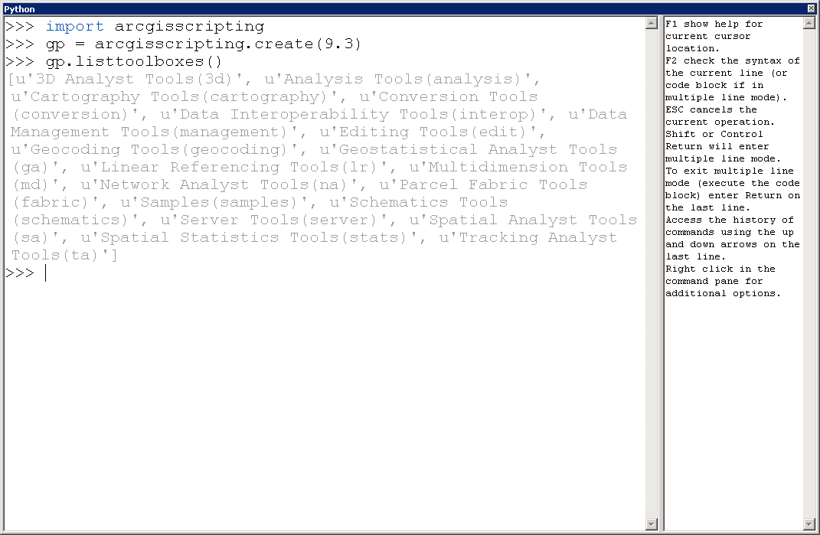

I prefer to write scripts as .py files, and open them with IDLE, where I can edit them (if needed) and run them (e.g., F5). When opening a file with IDLE, it opens a Python Shell.
  - Instantiation of the geoprocessor, help
To start the geoprocessor, import the module and instantiate the geoprocessor (create an instance). This requires that the ArcGIS software is installed and a license is available.
>>> import arcgisscripting
>>> gp = arcgisscripting.create(9.3)

As with other objects, some help is available to find out what methods are available.
>>> dir( arcgisscripting )
['ExecuteAbort', 'ExecuteError', 'ExecuteWarning', '__doc__', '__file__', '__name__', 'create']

>>> dir( gp )
['adderror', 'addfielddelimiters', 'addidmessage', 'addmessage', 'addreturnmessage', 'addtoolbox', 'addwarning', 'checkextension', 'checkinextension', 'checkoutextension', 'checkproduct', 'clearenvironment', 'command', 'copyparameter', 'createobject', 'createrandomvaluegenerator', 'createscratchname', 'createuniquename', 'describe', 'exists', 'getinstallinfo', 'getmessage', 'getmessages', 'getparameter', 'getparameterastext', 'getparametercount', 'getparameterinfo', 'getparametervalue', 'getreturncode', 'getseverity', 'getsystemenvironment', 'insertcursor', 'issynchronous', 'listdatasets', 'listenvironments', 'listfeatureclasses', 'listfields', 'listindexes', 'listinstallations', 'listrasters', 'listtables', 'listtoolboxes', 'listtools', 'listworkspaces', 'loadsettings', 'parsefieldname', 'parsetablename', 'productinfo', 'qualifyfieldname', 'qualifytablename', 'refreshcatalog', 'removetoolbox', 'resetenvironments', 'resetprogressor', 'savesettings', 'searchcursor', 'setparameter', 'setparameterastext', 'setproduct', 'setprogressor', 'setprogressorlabel', 'setprogressorposition', 'testschemalock', 'updatecursor', 'usage', 'validatefieldname', 'validatetablename']

For help on the geoprocessor commands (as run on a system with ArcGIS 10):
>>> help( arcgisscripting )
Help on module arcgisscripting:

NAME
arcgisscripting

FILE
d:\arcgis\desktop10.0\bin\arcgisscripting.pyd

CLASSES
exceptions.RuntimeError(exceptions.StandardError)
ExecuteAbort
ExecuteError
ExecuteWarning
omit full listing
| message

FUNCTIONS
NumPyArrayToRaster(...)
NumPyArrayToRaster(in_array, {lower_left_corner}, {x_cell_size}, {y_cell_size}, {value_to_nodata})

Converts a NumPy array to a raster.

Arguments:
in_array -- The NumPy array to convert to a raster.
lower_left_corner -- The lower left corner of the output raster to position the NumPy array.The X and Y values are in map units.
x_cell_size -- The cell size in the x direction specified in map units. The input can be a specified cell size (type: double) or an input raster.
y_cell_size -- The cell size in y direction specified in map units. The input can be a specified cell size (type: double) or an input raster.
value_to_nodata -- The value in the NumPy array to assign to NoData in the output raster.

Results:
The output raster.

RasterToNumPyArray(...)
RasterToNumPyArray(in_raster, {lower_left_corner}, {ncols}, {nrows}, {nodata_to_value})

Converts a raster to a NumPy array.

Arguments:
in_raster -- The input raster to convert to a NumPy array.
lower_left_corner -- The lower left corner within the in_raster from which to extract the processing block to convert to an array. The x- and y-values are in map units.
ncols -- The number of columns from the lower_left_corner in the in_raster to convert to the NumPy array.
nrows -- The number of rows from the lower_left_corner in the in_raster to convert to the NumPy array.
nodata_to_value -- The value to assign the in_raster NoData values in the resulting NumPy array. The data type depends on the type of the in_raster.

Results:
The output NumPy array.

create(...)
create({version}) -> object
Create the Geoprocessor object.

getmytoolboxespath(...)
getmytoolboxespath()
Get the path to my toolboxes

getsystemtoolboxespath(...)
getsystemtoolboxespath()
Get the path to system toolboxes

More complete help is available from ArcGIS itself (e.g., start ArcMap and press F1 or click on Help). See exercise for listing tools within toolboxes.
  - Differences: ArcGIS 9.3 and ArcGIS 10.0
Start the Help in ArcGIS, and search on “what’s new in ArcGIS 10” and select “A quick tour of what’s new in ArcGIS 10”.
    - Commands that are available
When run on a system with ArcGIS 9.3 (not ArcGIS 10), the RasterToNumPyArray function (and reverse) were not present:

>>> help( arcgisscripting )
Help on module arcgisscripting:

NAME
arcgisscripting

FILE
c:\arcgis\bin\arcgisscripting.pyd
omit full listing
| message
| exception message

FUNCTIONS
create(...)
create({version}) -> object
Create the Geoprocessor object.
    - Some commands have different syntax
The changes may be small, such as in the capitalization of a command name, but it is enough to make it so some scripts developed under ArcGIS 9.3 won’t work under ArcGIS 10.0 or vice versa.
In earlier verisons of ArcGIS, the syntax for the next row of a cursor was:
row = cursor.Next( ) # Next is capitalized

The arcgisscripting under both ArcGIS 9.3 and ArcGIS 10.0 allow both Next and next, but arcpy requires that the function name be lowercase next, although the next() command is not needed as much (see the following section).
>>> rows_MetadataTable = arcpy.SearchCursor( dataset_MetadataTable )
>>> row = rows_MetadataTable.Next()
Traceback (most recent call last):
File "<pyshell#45>", line 1, in <module>
row = rows_MetadataTable.Next()
AttributeError: 'Cursor' object has no attribute 'Next'
    - Some commands give different output
In ArcGIS 9.3, the command to open a search cursor to loop through the records of a table in a file geodatabase produces an object that is not iterable (cannot be used in a for loop), whereas in ArcGIS 10.0 the object is iterable and works in a for loop.
Here is an arcgisscripting session started under ArcGIS 10.0.
Python 2.6.5 (r265:79096, Mar 19 2010, 21:48:26) [MSC v.1500 32 bit (Intel)] on win32

>>> import arcgisscripting
>>> gp = arcgisscripting.create(9.3)
>>> dataset_MetadataTable = r'Y:\elev\users\bliss\2011_june_21\sdm-20110628.gdb\sdm_dbo_MetadataTable'
>>> rows_MetadataTable = gp.SearchCursor( dataset_MetadataTable )
>>> rows_MetadataTable
<geoprocessing cursor object object at 0x02FEB300>

>>> for row in rows_MetadataTable:
TablePhysicalName = row.getValue( 'TablePhysicalName' )
if TablePhysicalName == 'mapunit':
TableId = row.getValue( 'TableId' )
print 'TablePhysicalName %s, TableID %s' % ( TablePhysicalName, TableId )

TablePhysicalName mapunit, TableID 259
>>> del( rows_MetadataTable ) # remove the cursor object
Here is an arcgisscripting scripting session started under ArcGIS 9.3:
The same commands are used, with different result:
Python 2.5.1 (r251:54863, Apr 18 2007, 08:51:08) [MSC v.1310 32 bit (Intel)] on win32

>>> import arcgisscripting
>>> gp = arcgisscripting.create(9.3)
>>> dataset_MetadataTable = r'Y:\elev\users\bliss\2011_june_21\sdm-20110628.gdb\sdm_dbo_MetadataTable'
>>> rows_MetadataTable = gp.SearchCursor( dataset_MetadataTable )
>>> rows_MetadataTable
<geoprocessing cursor object object at 0x01603620>
>>> for row in rows_MetadataTable:
TablePhysicalName = row.getValue( 'TablePhysicalName' )
if TablePhysicalName == 'mapunit':
TableId = row.getValue( 'TableId' )
print 'TablePhysicalName %s, TableID %s' % ( TablePhysicalName, TableId )

Traceback (most recent call last):
File "<pyshell#15>", line 1, in <module>
for row in rows_MetadataTable:
TypeError: 'geoprocessing cursor object' object is not iterable

Let’s do the reverse. Here is a method that works with arcgisscripting started under ArcGIS 9.3 (picking up after the search cursor object is defined):
>>> row = rows_MetadataTable.next()
>>> row
<geoprocessing row object object at 0x016031B8>
>>> while row:
TablePhysicalName = row.getValue( 'TablePhysicalName' )
if TablePhysicalName == 'mapunit':
TableId = row.getValue( 'TableId' )
print 'TablePhysicalName %s, TableID %s' % ( TablePhysicalName, TableId )
row = rows_MetadataTable.next()

TablePhysicalName mapunit, TableID 259
>>> del( row, rows_MetadataTable )

Now, try this set of statements on the arcgisscripting started under ArcGIS 10.0:
>>> row = rows_MetadataTable.next()
>>> row
<geoprocessing row object object at 0x01F46458>
>>> while row:
TablePhysicalName = row.getValue( 'TablePhysicalName' )
if TablePhysicalName == 'mapunit':
TableId = row.getValue( 'TableId' )
print 'TablePhysicalName %s, TableID %s' % ( TablePhysicalName, TableId )
row = rows_MetadataTable.next()

TablePhysicalName mapunit, TableID 259
>>> del( row, rows_MetadataTable )
In this case, the method that worked under ArcGIS 9.3 also worked under ArcGIS 10.0.
Both these approaches worked under the arcpy geoprocessor (as long as next was lowercase).
- Planning for Python 3.0 and above
The transition to Python 3.0 does not guarantee backward compatability, so both Python 2.7.2 and Python 3.2.2 are supported as the latest production versions at the present time.
  - Integer division
Integer division will return a floating point number unless truncation is forced with two slashes: //
  - Formatting for print statements
The print statement is changed, and has an entirely new way of providing formatting. It is powerful, but different, and will require recoding programs.
- Python modules, other help
Print a listing of available modules. Those in italics (maybe more) are my own (not standard in Python).
>>> help( 'modules' )

Please wait a moment while I gather a list of all available modules...

AutoComplete _strptime imaplib quopri
AutoCompleteWindow _struct imghdr random
AutoExpand _subprocess imp re
BaseHTTPServer _symtable imputil readline
Bastion _testcapi inspect repr
Bindings _threading_local ipipe rexec
CGIHTTPServer _tkinter ipy_app_completers rfc822
CallTipWindow _types ipy_autoreload rgbimg
CallTips _weakref ipy_bzr rlcompleter
Canvas _winreg ipy_completers robotparser
ClassBrowser aboutDialog ipy_constants rpc
CodeContext aifc ipy_defaults run
ColorDelegator anydbm ipy_editors runpy
ConfigParser arcgisscripting ipy_exportdb sched
Cookie array ipy_extutil scitedirector
Debugger astyle ipy_fsops select
Delegator asynchat ipy_gnuglobal sets
Dialog asyncore ipy_greedycompleter setuptools
DocXMLRPCServer atexit ipy_jot sgmllib
EditorWindow audiodev ipy_kitcfg sha
FileDialog audioop ipy_legacy shelve
FileList base64 ipy_leo shlex
FixTk bdb ipy_lookfor shutil
FormatParagraph bin_string_124_03 ipy_p4 signal
GrepDialog binascii ipy_profile_doctest site
HTMLParser binhex ipy_profile_none smtpd
HyperParser bisect ipy_profile_numpy smtplib
IOBinding bsddb ipy_profile_scipy sndhdr
IPython bz2 ipy_profile_sh socket
IdleHistory cPickle ipy_profile_zope sqlite3
InterpreterExec cProfile ipy_pydb sre
InterpreterPasteInput cStringIO ipy_rehashdir sre_compile
LutzLearning522Employee calendar ipy_render sre_constants
MimeWriter cgi ipy_server sre_parse
MultiCall cgitb ipy_signals ssurgo01
MultiStatusBar chunk ipy_stock_completers ssurgo_m001_string_124byte_binary_01
ObjectBrowser clearcmd ipy_synchronize_with ssurgo_m001_string_124byte_binary_02
OutputWindow cmath ipy_system_conf ssurgo_m002_timer
ParenMatch cmd ipy_traits_completer ssurgo_m003_sdm_dbo_binary
PathBrowser code ipy_vimserver ssurgo_m004_sdm_dbo_binary
Percolator codecs ipy_which ssurgo_m005_sdm_dbo_binary
PhysicalQInput codeop ipy_winpdb ssurgo_m006_sdm_dbo_binary
PhysicalQInteractive collections ipy_workdir stat
PyParse colorsys itertools statvfs
PyShell commands jobctrl string
Queue compileall keybindingDialog stringold
RemoteDebugger compiler keyword stringprep
RemoteObjectBrowser configDialog ledit strop
ReplaceDialog configHandler linecache struct
ScriptBinding configHelpSourceEdit locale subprocess
ScrolledList configSectionNameDialog logging sunau
ScrolledText contextlib macosxSupport sunaudio
SearchDialog cookielib macpath symbol
SearchDialogBase copy macurl2path symtable
SearchEngine copy_reg mailbox sys
SimpleDialog csv mailcap tabnanny
SimpleHTTPServer ctypes markupbase tabpage
SimpleXMLRPCServer curses marshal tarfile
SocketServer datetime math telnetlib
StackViewer dbhash md5 tempfile
StringIO decimal mhlib test
Tix difflib mimetools testcode
Tkconstants dircache mimetypes textView
Tkdnd dis mimify textwrap
Tkinter distutils mmap this
ToolTip doctest modulefinder thread
TreeWidget dumbdbm msilib threading
UndoDelegator dummy_thread msvcrt time
UserDict dummy_threading multifile timeit
UserList dynOptionMenuWidget mutex tkColorChooser
UserString easy_install netrc tkCommonDialog
WidgetRedirector email new tkFileDialog
WindowList encodings nntplib tkFont
ZoomHeight envpersist nt tkMessageBox
_LWPCookieJar errno ntpath tkSimpleDialog
_MozillaCookieJar exceptions nturl2path toaiff
__builtin__ ext_rescapture numeric_formats token
__future__ filecmp numpy tokenize
_ast fileinput ogr trace
_bisect fnmatch opcode traceback
_bsddb formatter operator tty
_codecs fpformat optparse turtle
_codecs_cn ftplib os types
_codecs_hk functools os2emxpath unicodedata
_codecs_iso2022 gapy osgeo unittest
_codecs_jp gc osr urllib
_codecs_kr gdal parser urllib2
_codecs_tw gdalconst pdb urlparse
_csv gdalnumeric pickle user
_ctypes getopt pickleshare uu
_ctypes_test getpass pickletools uuid
_elementtree gettext pipes warnings
_functools glob pkg_resources wave
_hashlib gopherlib pkgutil weakref
_heapq gzip platform webbrowser
_hotshot hashlib popen2 whichdb
_locale heapq poplib win32clip
_lsprof hmac posixfile winsound
_md5 hotshot posixpath writing_bin_string_124_03
_msi htmlentitydefs pprint wsgiref
_multibytecodec htmllib profile xdrlib
_random httplib pspersistence xml
_sha ibrowse pstats xmllib
_sha256 idle pty xmlrpclib
_sha512 idlelib py_compile xxsubtype
_socket idlever pyclbr yftile02poly
_sqlite3 igrid pydoc zipfile
_sre ihooks pyexpat zipimport
_ssl imageop pyreadline zlib

Enter any module name to get more help. Or, type "modules spam" to search
for modules whose descriptions contain the word "spam".

>>> help( 'modules time' )

Here is a list of matching modules. Enter any module name to get more help.

datetime - Fast implementation of the datetime type.
time - This module provides various functions to manipulate time values.
ssurgo_m002_timer - Timer function for ssurgo applications.
_strptime - Strptime-related classes and functions.
test.test_datetime - Test date/time type.
test.test_strftime
test.test_strptime - PyUnit testing against strptime
test.test_time
test.test_timeout - Unit tests for socket timeout feature.
test.time_hashlib
timeit - Tool for measuring execution time of small code snippets.
IPython.GnuplotRuntime - Basic Gnuplot functionality for inclusion in other code.

It gives the location of the module on my system:
>>> help( 'gdal' )
Help on module gdal:

NAME
gdal - # import osgeo.gdal as a convenience

FILE
c:\arcgis\python25\lib\site-packages\gdal-1.6.0-py2.5-win32.egg\gdal.py

FUNCTIONS
AllRegister(...)
omit full listing

>>> help( 'math' )
Help on built-in module math:

NAME
math

FILE
(built-in)

DESCRIPTION
This module is always available. It provides access to the
mathematical functions defined by the C standard.

FUNCTIONS
acos(...)
acos(x)

Return the arc cosine (measured in radians) of x.

asin(...)
asin(x)

Return the arc sine (measured in radians) of x.

atan(...)
atan(x)

Return the arc tangent (measured in radians) of x.

atan2(...)
atan2(y, x)

Return the arc tangent (measured in radians) of y/x.
Unlike atan(y/x), the signs of both x and y are considered.

ceil(...)
ceil(x)

Return the ceiling of x as a float.
This is the smallest integral value >= x.

cos(...)
cos(x)

Return the cosine of x (measured in radians).

cosh(...)
cosh(x)

Return the hyperbolic cosine of x.

degrees(...)
degrees(x) -> converts angle x from radians to degrees

exp(...)
exp(x)

Return e raised to the power of x.

fabs(...)
fabs(x)

Return the absolute value of the float x.

floor(...)
floor(x)

Return the floor of x as a float.
This is the largest integral value <= x.

fmod(...)
fmod(x,y)

Return fmod(x, y), according to platform C. x % y may differ.

frexp(...)
frexp(x)

Return the mantissa and exponent of x, as pair (m, e).
m is a float and e is an int, such that x = m * 2.**e.
If x is 0, m and e are both 0. Else 0.5 <= abs(m) < 1.0.

hypot(...)
hypot(x,y)

Return the Euclidean distance, sqrt(x*x + y*y).

ldexp(...)
ldexp(x, i) -> x * (2**i)

log(...)
log(x[, base]) -> the logarithm of x to the given base.
If the base not specified, returns the natural logarithm (base e) of x.

log10(...)
log10(x) -> the base 10 logarithm of x.

modf(...)
modf(x)

Return the fractional and integer parts of x. Both results carry the sign
of x. The integer part is returned as a real.

pow(...)
pow(x,y)

Return x**y (x to the power of y).

radians(...)
radians(x) -> converts angle x from degrees to radians

sin(...)
sin(x)

Return the sine of x (measured in radians).

sinh(...)
sinh(x)

Return the hyperbolic sine of x.

sqrt(...)
sqrt(x)

Return the square root of x.

tan(...)
tan(x)

Return the tangent of x (measured in radians).

tanh(...)
tanh(x)

Return the hyperbolic tangent of x.

DATA
e = 2.7182818284590451
pi = 3.1415926535897931

IDLE 1.2.1 ==== No Subprocess ==== In a new session
>>> math.pi
Traceback (most recent call last):
File "<pyshell#0>", line 1, in <module>
math.pi
NameError: name 'math' is not defined

>>> import math # math is always available, but you must do the import
>>> math.pi
3.1415926535897931
>>> math.e
2.7182818284590451

>>> r = 3 # radius of a circle
>>> area = math.pi * r**2 # use built-in constant in expressions
>>> area
28.274333882308138
- Bonus exercises
  - Bonus exercise: the time() function
Look at the description of the time function in the Import section above
>>> import time
>>> print time.__doc__
... listing omitted here ...
>>> time.localtime()
(2011, 11, 7, 19, 7, 7, 0, 311, 0)
>>> 24 * 60 * 60 # hours * minutes * seconds in a day
86400
- Find the number of seconds since the beginning of the Epoch at this instant.
- Find the beginning of the Epoch described there.
Hint: The local time at time zero.
- List the leap years since the beginning of the Epoch.
Hint: Years in which the day of year exceeds 365.
Hint: there are 24 * 60 * 60 = 86,400 seconds in a day
  - Bonus exercise solution: the time() function
- Find the number of seconds since the beginning of the Epoch at this instant.
>>> time.time() # your answer will be different
1320769472.698
- Find the beginning of the Epoch described there.
Hint: The local time at time zero.
>>> time.localtime( 0 )
(1969, 12, 31, 18, 0, 0, 2, 365, 0)
The Epoch began at 6 p.m. on December 31, 1969 (my local time)
This was midnight January 1, 1970 at GMT (happy new year)
>>> time.gmtime( 0 )
(1970, 1, 1, 0, 0, 0, 3, 1, 0)

- List the leap years since the beginning of the Epoch.
Hint: Years in which the day of year exceeds 365.
Hint: there are 24 * 60 * 60 = 86,400 seconds in a day
>>> count_days = 0 # optional
>>> for seconds in range(0, 1320769472, 86400):
count_days += 1 # optional
if time.localtime( seconds )[7] > 365:
# finds Dec. 31 of leap years, the 366th day
print time.localtime( seconds )[0] # element zero: the year

1972
1976
1980
1984
1988
1992
1996
2000 ask about the exception to the exception
2004
2008
>>> count_days # your answer will be different # optional
15287
  - Bonus exercise: Slicing arrays
Remember that in Python, counting starts with zero.

Exercise: Take the 25,000,000 pixel array a4_ar and find the minimum, maximum, and mean of every 500x500 sub-array within it (there will be 100 of these). Store the results in a three dimensionial array with shape (3, 10, 10) where the indexes for the first dimension (dimension 0) are 0 is for the minimums, 1 is for the maximums, and 2 is for the means.

Do SaveAs on your current (saved) python script, naming it “TrainingCode.10.slicing_for_subarray_statistics.py”.
Exercise for computing sub-array statistics, illustrate array slicing.

TrainingCode.10.slicing_for_subarray_statistics.py 12/2/2011 N. Bliss
Exercise for computing sub-array statistics, illustrate array slicing.

Comment out unneeded import statements.
Delete unneeded functions and other code.

Steps:
- import numpy as np
- Define some basic constants for the number of rows and columns in the array (5000, 5000) and the size of the sub-array blocks (e.g., rows_block = 500).
- Check that the sub-array blocks divide evenly into the rows and columns of the original array. Print an error message and stop if they do not.
- Make a sequential array of 25,000,000 pixels.
- Make an array of zeros to hold the output data (shape will be (3, 10, 10)).
- Loop indexes of the summary blocks (Hint: two for loops of 10 iterations each).
- Inside the for loops, prepare indices for slicing the main array.
- Extract the sub-array on which statistics will be calculated.
- Store the statistics in the result array.
- Outside the two for loops, print the results array.
- Optional: try formatted printing of the results array.
  - Bonus exercise solution: Slicing arrays
Screen shot of setup:
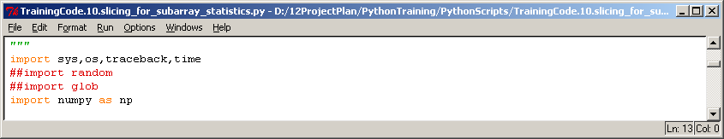
Screen shot of code to process arrays:
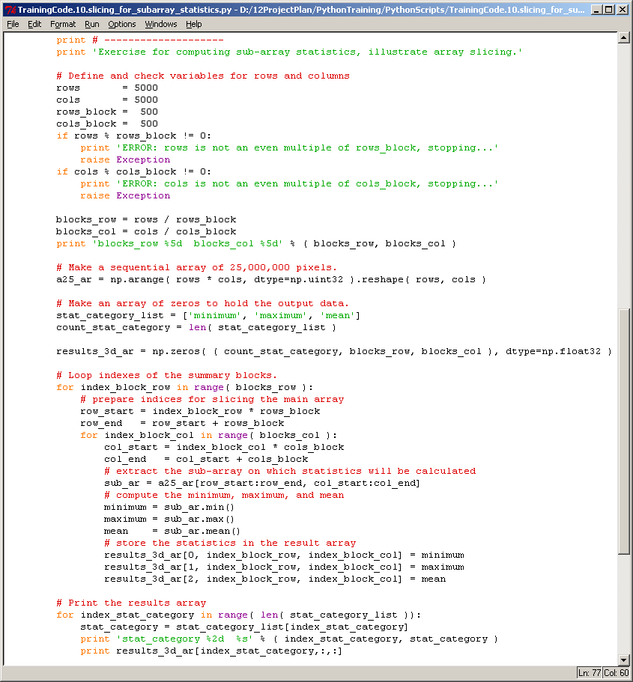
Bonus: code for formatted printing:
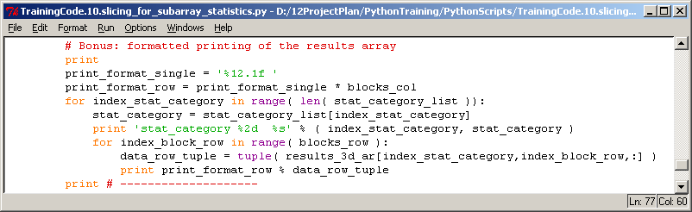
Screen shot of start:
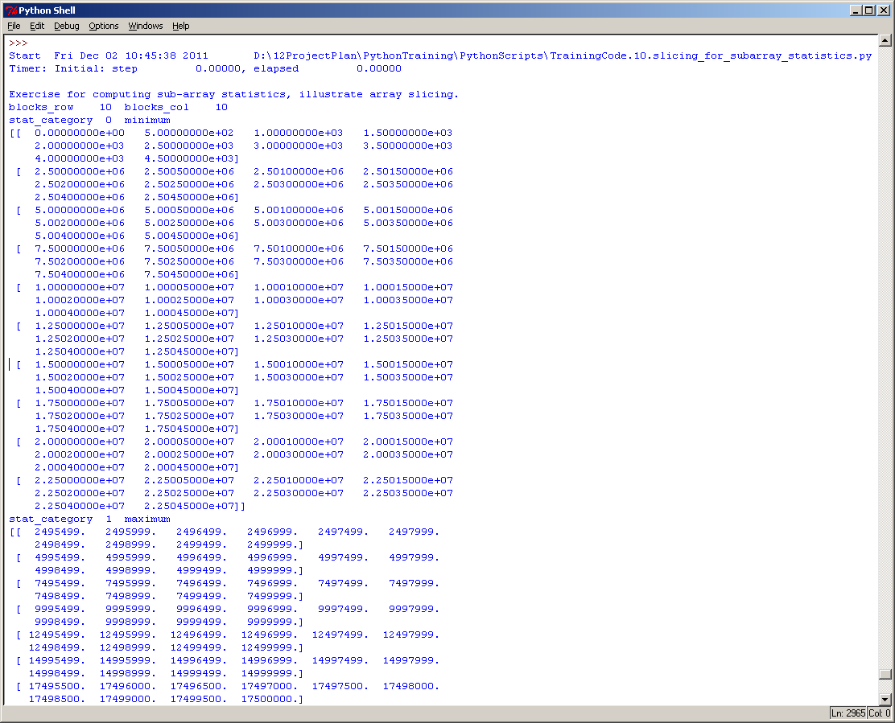
Screen shot of end (with formatted printing):
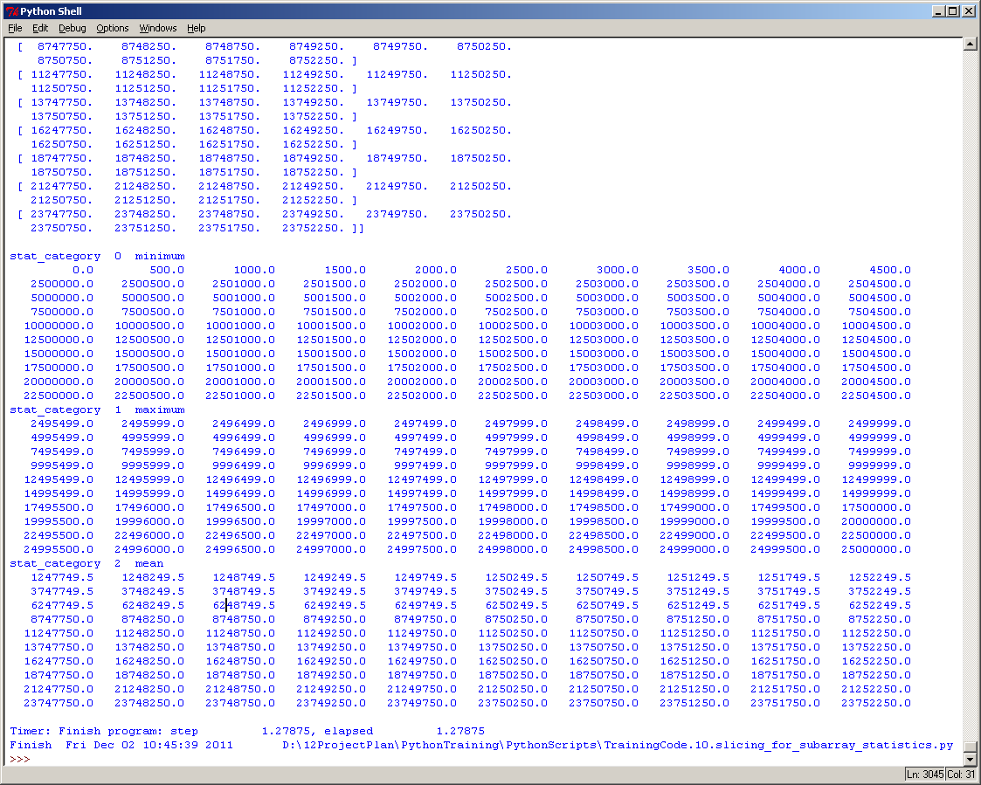

Slicing take-home message:
By counting from zero, the slicing formulas were very simple. Try to get the same results in a programming language that starts counting with one (“1”) and you will see the difference.
# Loop indexes of the summary blocks.
for index_block_row in range( blocks_row ):
# prepare indices for slicing the main array
row_start = index_block_row * rows_block
row_end = row_start + rows_block
for index_block_col in range( blocks_col ):
col_start = index_block_col * cols_block
col_end = col_start + cols_block
# extract the sub-array on which statistics will be calculated
sub_ar = a25_ar[row_start:row_end, col_start:col_end]

If this is not clear, add a print statement to display these start and end indices into the big array.

.

