210714.Notes.docx AK SOC Mapping
OneDrive DOI>>Notes

The normal function for running the python with gdal (from IDLE) failed: incompatible NumPy

Checked notes from 210125.Notes.docx SOC Mapping
found workaround:
Open from the Start menu: Anaconda Prompt (gdalenv)
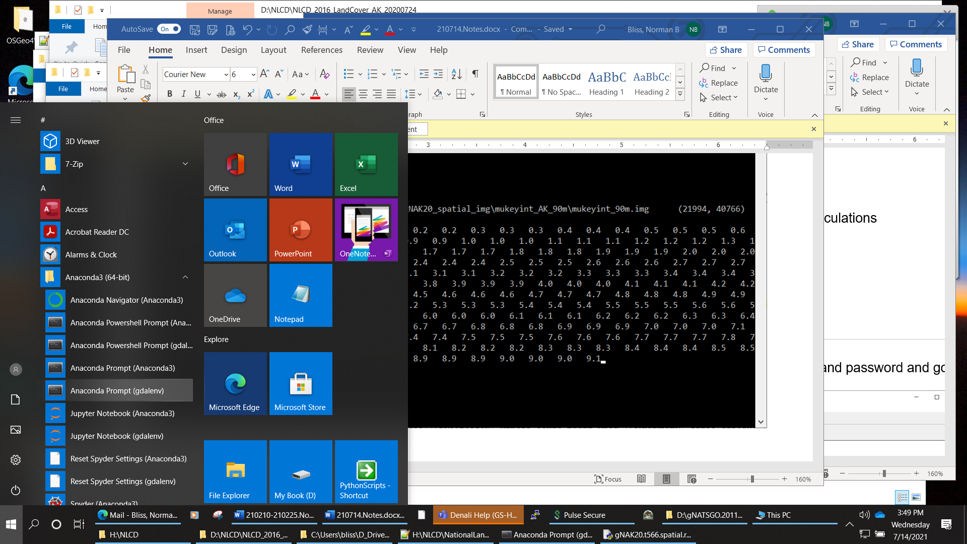
type "python " and the .py filename
Be sure there are no blanks in the pathnames (e.g., "D_drive", not "D drive")

(gdalenv) C:\>python C:\Users\bliss\D_Drive\PythonScripts\gNAK20.t566.spatial.resample.10m_to_90m.Basic.01.py
Start Wed Jul 14 15:27:40 2021 C:\Users\bliss\D_Drive\PythonScripts\gNAK20.t566.spatial.resample.10m_to_90m.Basic.01.py
Timer: Initial: step 0.00000, elapsed 0.00000
numbers of columns and rows per internal virtual tile:
num_pixels_per_tile_col 4995
num_pixels_per_tile_row 4995
filename_spatial_input D:\gNATSGO.201120\gNATSGO_AK\gNAK20_spatial_img\mukeyint_AK_10m\mukeyint.img

Input image parameters:
in_projection
PROJCS["WGS_1984_Albers",GEOGCS["GCS_WGS_1984",DATUM["WGS_1984",SPHEROID["WGS_84",6378137.0,298.257223563]],PRIMEM["Greenwich",0.0],UNIT["Degree",0.0174532925199433]],PROJECTION["Albers_Conic_Equal_Area"],PARAMETER["false_easting",0.0],PARAMETER["false_northing",0.0],PARAMETER["longitude_of_center",-154.0],PARAMETER["standard_parallel_1",55.0],PARAMETER["standard_parallel_2",65.0],PARAMETER["latitude_of_center",50.0],UNIT["Meter",1.0]]
in_geotransform (-2175765.0, 10.0, 0.0, 2383965.0, 0.0, -10.0)
in_nodatavalue 2147483647.0
in_data_type 4

num_pixels_row_input 197946
num_pixels_col_input 366894
num_tiles_row 40
num_tiles_col 74

delta_xmin_soil_NLCD 56565.0
delta_ymax_soil_NLCD 3855.0

Input image parameters:
in_NLCD_projection
PROJCS["WGS_1984_Albers",GEOGCS["WGS 84",DATUM["WGS_1984",SPHEROID["WGS 84",6378137,298.257223563,AUTHORITY["EPSG","7030"]],TOWGS84[0,0,0,-0,-0,-0,0],AUTHORITY["EPSG","6326"]],PRIMEM["Greenwich",0,AUTHORITY["EPSG","8901"]],UNIT["degree",0.0174532925199433,AUTHORITY["EPSG","9122"]],AUTHORITY["EPSG","4326"]],PROJECTION["Albers_Conic_Equal_Area"],PARAMETER["standard_parallel_1",55],PARAMETER["standard_parallel_2",65],PARAMETER["latitude_of_center",50],PARAMETER["longitude_of_center",-154],PARAMETER["false_easting",0],PARAMETER["false_northing",0],UNIT["meters",1]]
in_NLCD_geotransform (-2232345.0, 30.0, 0.0, 2380125.0, 0.0, -30.0)
WARNING: The in_NLCD_nodatavalue is not defined in the input data.
in_NLCD_data_type 1

num_pixels_row_in_NLCD 67844
num_pixels_col_in_NLCD 124236
num_tiles_row_in_NLCD 14
num_tiles_col_in_NLCD 25

xmin_in_NLCD -2232345
ymax_in_NLCD 2380125
delta_xmin_soil_in_NLCD 56580.0
delta_ymax_soil_in_NLCD 3840.0
delta_xmin_soil_in_NLCD / 30. 1886.0
delta_ymax_soil_in_NLCD / 30. 128.0
filename_spatial_output D:\gNATSGO.201120\gNATSGO_AK\gNAK20_spatial_img\mukeyint_AK_90m\mukeyint_90m.img (21994, 40766)
data_code_out uint32
percent complete: 0.0 0.0 0.1 0.1 0.1 0.2 0.2 0.2 0.3 0.3 0.3 0.4 0.4 0.4 0.5 0.5 0.5 0.6 0.6 0.6 0.7
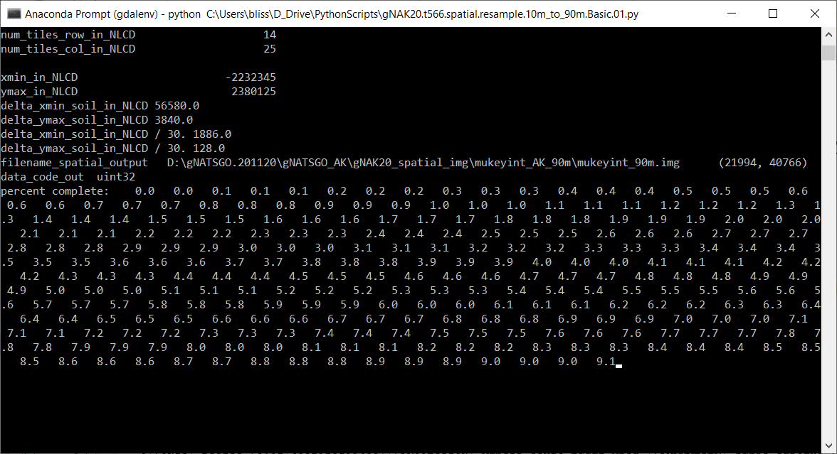
Courier 6
The resampling program goes much faster once the zip program finished. Maybe 1-2 hours rather than overnight.
=-=-=
(gdalenv) C:\>python C:\Users\bliss\D_Drive\PythonScripts\gNAK20.t566.spatial.resample.10m_to_90m.Basic.01.py
Start Wed Jul 14 15:27:40 2021 C:\Users\bliss\D_Drive\PythonScripts\gNAK20.t566.spatial.resample.10m_to_90m.Basic.01.py
Timer: Initial: step 0.00000, elapsed 0.00000
numbers of columns and rows per internal virtual tile:
num_pixels_per_tile_col 4995
num_pixels_per_tile_row 4995
filename_spatial_input D:\gNATSGO.201120\gNATSGO_AK\gNAK20_spatial_img\mukeyint_AK_10m\mukeyint.img

Input image parameters:
in_projection
PROJCS["WGS_1984_Albers",GEOGCS["GCS_WGS_1984",DATUM["WGS_1984",SPHEROID["WGS_84",6378137.0,298.257223563]],PRIMEM["Greenwich",0.0],UNIT["Degree",0.0174532925199433]],PROJECTION["Albers_Conic_Equal_Area"],PARAMETER["false_easting",0.0],PARAMETER["false_northing",0.0],PARAMETER["longitude_of_center",-154.0],PARAMETER["standard_parallel_1",55.0],PARAMETER["standard_parallel_2",65.0],PARAMETER["latitude_of_center",50.0],UNIT["Meter",1.0]]
in_geotransform (-2175765.0, 10.0, 0.0, 2383965.0, 0.0, -10.0)
in_nodatavalue 2147483647.0
in_data_type 4

num_pixels_row_input 197946
num_pixels_col_input 366894
num_tiles_row 40
num_tiles_col 74

delta_xmin_soil_NLCD 56565.0
delta_ymax_soil_NLCD 3855.0

Input image parameters:
in_NLCD_projection
PROJCS["WGS_1984_Albers",GEOGCS["WGS 84",DATUM["WGS_1984",SPHEROID["WGS 84",6378137,298.257223563,AUTHORITY["EPSG","7030"]],TOWGS84[0,0,0,-0,-0,-0,0],AUTHORITY["EPSG","6326"]],PRIMEM["Greenwich",0,AUTHORITY["EPSG","8901"]],UNIT["degree",0.0174532925199433,AUTHORITY["EPSG","9122"]],AUTHORITY["EPSG","4326"]],PROJECTION["Albers_Conic_Equal_Area"],PARAMETER["standard_parallel_1",55],PARAMETER["standard_parallel_2",65],PARAMETER["latitude_of_center",50],PARAMETER["longitude_of_center",-154],PARAMETER["false_easting",0],PARAMETER["false_northing",0],UNIT["meters",1]]
in_NLCD_geotransform (-2232345.0, 30.0, 0.0, 2380125.0, 0.0, -30.0)
WARNING: The in_NLCD_nodatavalue is not defined in the input data.
in_NLCD_data_type 1

num_pixels_row_in_NLCD 67844
num_pixels_col_in_NLCD 124236
num_tiles_row_in_NLCD 14
num_tiles_col_in_NLCD 25

xmin_in_NLCD -2232345
ymax_in_NLCD 2380125
delta_xmin_soil_in_NLCD 56580.0
delta_ymax_soil_in_NLCD 3840.0
delta_xmin_soil_in_NLCD / 30. 1886.0
delta_ymax_soil_in_NLCD / 30. 128.0
filename_spatial_output D:\gNATSGO.201120\gNATSGO_AK\gNAK20_spatial_img\mukeyint_AK_90m\mukeyint_90m.img (21994, 40766)
data_code_out uint32
percent complete: 0.0 0.0 0.1 0.1 0.1 0.2 0.2 0.2 0.3 0.3 0.3 0.4 0.4 0.4 0.5 0.5 0.5 0.6 0.6 0.6 0.7 0.7 0.7 0.8 0.8 0.8 0.9 0.9 0.9 1.0 1.0 1.0 1.1 1.1 1.1 1.2 1.2 1.2 1.3 1.3 1.4 1.4 1.4 1.5 1.5 1.5 1.6 1.6 1.6 1.7 1.7 1.7 1.8 1.8 1.8 1.9 1.9 1.9 2.0 2.0 2.0 2.1 2.1 2.1 2.2 2.2 2.2 2.3 2.3 2.3 2.4 2.4 2.4 2.5 2.5 2.5 2.6 2.6 2.6 2.7 2.7 2.7 2.8 2.8 2.8 2.9 2.9 2.9 3.0 3.0 3.0 3.1 3.1 3.1 3.2 3.2 3.2 3.3 3.3 3.3 3.4 3.4 3.4 3.5 3.5 3.5 3.6 3.6 3.6 3.7 3.7 3.8 3.8 3.8 3.9 3.9 3.9 4.0 4.0 4.0 4.1 4.1 4.1 4.2 4.2 4.2 4.3 4.3 4.3 4.4 4.4 4.4 4.5 4.5 4.5 4.6 4.6 4.6 4.7 4.7 4.7 4.8 4.8 4.8 4.9 4.9 4.9 5.0 5.0 5.0 5.1 5.1 5.1 5.2 5.2 5.2 5.3 5.3 5.3 5.4 5.4 5.4 5.5 5.5 5.5 5.6 5.6 5.6 5.7 5.7 5.7 5.8 5.8 5.8 5.9 5.9 5.9 6.0 6.0 6.0 6.1 6.1 6.1 6.2 6.2 6.2 6.3 6.3 6.4 6.4 6.4 6.5 6.5 6.5 6.6 6.6 6.6 6.7 6.7 6.7 6.8 6.8 6.8 6.9 6.9 6.9 7.0 7.0 7.0 7.1 7.1 7.1 7.2 7.2 7.2 7.3 7.3 7.3 7.4 7.4 7.4 7.5 7.5 7.5 7.6 7.6 7.6 7.7 7.7 7.7 7.8 7.8 7.8 7.9 7.9 7.9 8.0 8.0 8.0 8.1 8.1 8.1 8.2 8.2 8.2 8.3 8.3 8.3 8.4 8.4 8.4 8.5 8.5 8.5 8.6 8.6 8.6 8.7 8.7 8.8 8.8 8.8 8.9 8.9 8.9 9.0 9.0 9.0 9.1 9.1 9.1 9.2 9.2 9.2 9.3 9.3 9.3 9.4 9.4 9.4 9.5 9.5 9.5 9.6 9.6 9.6 9.7 9.7 9.7 9.8 9.8 9.8 9.9 9.9 9.9 10.0 10.0 10.0 10.1 10.1 10.1 10.2 10.2 10.2 10.3 10.3 10.3 10.4 10.4 10.4 10.5 10.5 10.5 10.6 10.6 10.6 10.7 10.7 10.7 10.8 10.8 10.8 10.9 10.9 10.9 11.0 11.0 11.0 11.1 11.1 11.1 11.2 11.2 11.2 11.3 11.3 11.4 11.4 11.4 11.5 11.5 11.5 11.6 11.6 11.6 11.7 11.7 11.7 11.8 11.8 11.8 11.9 11.9 11.9 12.0 12.0 12.0 12.1 12.1 12.1 12.2 12.2 12.2 12.3 12.3 12.3 12.4 12.4 12.4 12.5 12.5 12.5 12.6 12.6 12.6 12.7 12.7 12.7 12.8 12.8 12.8 12.9 12.9 12.9 13.0 13.0 13.0 13.1 13.1 13.1 13.2 13.2 13.2 13.3 13.3 13.3 13.4 13.4 13.4 13.5 13.5 13.5 13.6 13.6 13.6 13.7 13.7 13.8 13.8 13.8 13.9 13.9 13.9 14.0 14.0 14.0 14.1 14.1 14.1 14.2 14.2 14.2 14.3 14.3 14.3 14.4 14.4 14.4 14.5 14.5 14.5 14.6 14.6 14.6 14.7 14.7 14.7 14.8 14.8 14.8 14.9 14.9 14.9 15.0 15.0 15.0 15.1 15.1 15.1 15.2 15.2 15.2 15.3 15.3 15.3 15.4 15.4 15.4 15.5 15.5 15.5 15.6 15.6 15.6 15.7 15.7 15.7 15.8 15.8 15.8 15.9 15.9 15.9 16.0 16.0 16.0 16.1 16.1 16.1 16.2 16.2 16.2 16.3 16.3 16.4 16.4 16.4 16.5 16.5 16.5 16.6 16.6 16.6 16.7 16.7 16.7 16.8 16.8 16.8 16.9 16.9 16.9 17.0 17.0 17.0 17.1 17.1 17.1 17.2 17.2 17.2 17.3 17.3 17.3 17.4 17.4 17.4 17.5 17.5 17.5 17.6 17.6 17.6 17.7 17.7 17.7 17.8 17.8 17.8 17.9 17.9 17.9 18.0 18.0 18.0 18.1 18.1 18.1 18.2 18.2 18.2 18.3 18.3 18.3 18.4 18.4 18.4 18.5 18.5 18.5 18.6 18.6 18.6 18.7 18.7 18.8 18.8 18.8 18.9 18.9 18.9 19.0 19.0 19.0 19.1 19.1 19.1 19.2 19.2 19.2 19.3 19.3 19.3 19.4 19.4 19.4 19.5 19.5 19.5 19.6 19.6 19.6 19.7 19.7 19.7 19.8 19.8 19.8 19.9 19.9 19.9 20.0 20.0 20.0 20.1 20.1 20.1 20.2 20.2 20.2 20.3 20.3 20.3 20.4 20.4 20.4 20.5 20.5 20.5 20.6 20.6 20.6 20.7 20.7 20.7 20.8 20.8 20.8 20.9 20.9 20.9 21.0 21.0 21.0 21.1 21.1 21.1 21.2 21.2 21.2 21.3 21.3 21.4 21.4 21.4 21.5 21.5 21.5 21.6 21.6 21.6 21.7 21.7 21.7 21.8 21.8 21.8 21.9 21.9 21.9 22.0 22.0 22.0 22.1 22.1 22.1 22.2 22.2 22.2 22.3 22.3 22.3 22.4 22.4 22.4 22.5 22.5 22.5 22.6 22.6 22.6 22.7 22.7 22.7 22.8 22.8 22.8 22.9 22.9 22.9 23.0 23.0 23.0 23.1 23.1 23.1 23.2 23.2 23.2 23.3 23.3 23.3 23.4 23.4 23.4 23.5 23.5 23.5 23.6 23.6 23.6 23.7 23.7 23.8 23.8 23.8 23.9 23.9 23.9 24.0 24.0 24.0 24.1 24.1 24.1 24.2 24.2 24.2 24.3 24.3 24.3 24.4 24.4 24.4 24.5 24.5 24.5 24.6 24.6 24.6 24.7 24.7 24.7 24.8 24.8 24.8 24.9 24.9 24.9 25.0 25.0 25.0 25.1 25.1 25.1 25.2 25.2 25.2 25.3 25.3 25.3 25.4 25.4 25.4 25.5 25.5 25.5 25.6 25.6 25.6 25.7 25.7 25.7 25.8 25.8 25.8 25.9 25.9 25.9 26.0 26.0 26.0 26.1 26.1 26.1 26.2 26.2 26.2 26.3 26.3 26.4 26.4 26.4 26.5 26.5 26.5 26.6 26.6 26.6 26.7 26.7 26.7 26.8 26.8 26.8 26.9 26.9 26.9 27.0 27.0 27.0 27.1 27.1 27.1 27.2 27.2 27.2 27.3 27.3 27.3 27.4 27.4 27.4 27.5 27.5 27.5 27.6 27.6 27.6 27.7 27.7 27.7 27.8 27.8 27.8 27.9 27.9 27.9 28.0 28.0 28.0 28.1 28.1 28.1 28.2 28.2 28.2 28.3 28.3 28.3 28.4 28.4 28.4 28.5 28.5 28.5 28.6 28.6 28.6 28.7 28.7 28.8 28.8 28.8 28.9 28.9 28.9 29.0 29.0 29.0 29.1 29.1 29.1 29.2 29.2 29.2 29.3 29.3 29.3 29.4 29.4 29.4 29.5 29.5 29.5 29.6 29.6 29.6 29.7 29.7 29.7 29.8 29.8 29.8 29.9 29.9 29.9 30.0 30.0 30.0 30.1 30.1 30.1 30.2 30.2 30.2 30.3 30.3 30.3 30.4 30.4 30.4 30.5 30.5 30.5 30.6 30.6 30.6 30.7 30.7 30.7 30.8 30.8 30.8 30.9 30.9 30.9 31.0 31.0 31.0 31.1 31.1 31.1 31.2 31.2 31.2 31.3 31.3 31.4 31.4 31.4 31.5 31.5 31.5 31.6 31.6 31.6 31.7 31.7 31.7 31.8 31.8 31.8 31.9 31.9 31.9 32.0 32.0 32.0 32.1 32.1 32.1 32.2 32.2 32.2 32.3 32.3 32.3 32.4 32.4 32.4 32.5 32.5 32.5 32.6 32.6 32.6 32.7 32.7 32.7 32.8 32.8 32.8 32.9 32.9 32.9 33.0 33.0 33.0 33.1 33.1 33.1 33.2 33.2 33.2 33.3 33.3 33.3 33.4 33.4 33.4 33.5 33.5 33.5 33.6 33.6 33.6 33.7 33.7 33.8 33.8 33.8 33.9 33.9 33.9 34.0 34.0 34.0 34.1 34.1 34.1 34.2 34.2 34.2 34.3 34.3 34.3 34.4 34.4 34.4 34.5 34.5 34.5 34.6 34.6 34.6 34.7 34.7 34.7 34.8 34.8 34.8 34.9 34.9 34.9 35.0 35.0 35.0 35.1 35.1 35.1 35.2 35.2 35.2 35.3 35.3 35.3 35.4 35.4 35.4 35.5 35.5 35.5 35.6 35.6 35.6 35.7 35.7 35.7 35.8 35.8 35.8 35.9 35.9 35.9 36.0 36.0 36.0 36.1 36.1 36.1 36.2 36.2 36.2 36.3 36.3 36.4 36.4 36.4 36.5 36.5 36.5 36.6 36.6 36.6 36.7 36.7 36.7 36.8 36.8 36.8 36.9 36.9 36.9 37.0 37.0 37.0 37.1 37.1 37.1 37.2 37.2 37.2 37.3 37.3 37.3 37.4 37.4 37.4 37.5 37.5 37.5 37.6 37.6 37.6 37.7 37.7 37.7 37.8 37.8 37.8 37.9 37.9 37.9 38.0 38.0 38.0 38.1 38.1 38.1 38.2 38.2 38.2 38.3 38.3 38.3 38.4 38.4 38.4 38.5 38.5 38.5 38.6 38.6 38.6 38.7 38.7 38.8 38.8 38.8 38.9 38.9 38.9 39.0 39.0 39.0 39.1 39.1 39.1 39.2 39.2 39.2 39.3 39.3 39.3 39.4 39.4 39.4 39.5 39.5 39.5 39.6 39.6 39.6 39.7 39.7 39.7 39.8 39.8 39.8 39.9 39.9 39.9 40.0 40.0 40.0 40.1 40.1 40.1 40.2 40.2 40.2 40.3 40.3 40.3 40.4 40.4 40.4 40.5 40.5 40.5 40.6 40.6 40.6 40.7 40.7 40.7 40.8 40.8 40.8 40.9 40.9 40.9 41.0 41.0 41.0 41.1 41.1 41.1 41.2 41.2 41.2 41.3 41.3 41.4 41.4 41.4 41.5 41.5 41.5 41.6 41.6 41.6 41.7 41.7 41.7 41.8 41.8 41.8 41.9 41.9 41.9 42.0 42.0 42.0 42.1 42.1 42.1 42.2 42.2 42.2 42.3 42.3 42.3 42.4 42.4 42.4 42.5 42.5 42.5 42.6 42.6 42.6 42.7 42.7 42.7 42.8 42.8 42.8 42.9 42.9 42.9 43.0 43.0 43.0 43.1 43.1 43.1 43.2 43.2 43.2 43.3 43.3 43.3 43.4 43.4 43.4 43.5 43.5 43.5 43.6 43.6 43.6 43.7 43.7 43.8 43.8 43.8 43.9 43.9 43.9 44.0 44.0 44.0 44.1 44.1 44.1 44.2 44.2 44.2 44.3 44.3 44.3 44.4 44.4 44.4 44.5 44.5 44.5 44.6 44.6 44.6 44.7 44.7 44.7 44.8 44.8 44.8 44.9 44.9 44.9 45.0 45.0 45.0 45.1 45.1 45.1 45.2 45.2 45.2 45.3 45.3 45.3 45.4 45.4 45.4 45.5 45.5 45.5 45.6 45.6 45.6 45.7 45.7 45.7 45.8 45.8 45.8 45.9 45.9 45.9 46.0 46.0 46.0 46.1 46.1 46.1 46.2 46.2 46.2 46.3 46.3 46.4 46.4 46.4 46.5 46.5 46.5 46.6 46.6 46.6 46.7 46.7 46.7 46.8 46.8 46.8 46.9 46.9 46.9 47.0 47.0 47.0 47.1 47.1 47.1 47.2 47.2 47.2 47.3 47.3 47.3 47.4 47.4 47.4 47.5 47.5 47.5 47.6 47.6 47.6 47.7 47.7 47.7 47.8 47.8 47.8 47.9 47.9 47.9 48.0 48.0 48.0 48.1 48.1 48.1 48.2 48.2 48.2 48.3 48.3 48.3 48.4 48.4 48.4 48.5 48.5 48.5 48.6 48.6 48.6 48.7 48.7 48.8 48.8 48.8 48.9 48.9 48.9 49.0 49.0 49.0 49.1 49.1 49.1 49.2 49.2 49.2 49.3 49.3 49.3 49.4 49.4 49.4 49.5 49.5 49.5 49.6 49.6 49.6 49.7 49.7 49.7 49.8 49.8 49.8 49.9 49.9 49.9 50.0 50.0 50.0 50.1 50.1 50.1 50.2 50.2 50.2 50.3 50.3 50.3 50.4 50.4 50.4 50.5 50.5 50.5 50.6 50.6 50.6 50.7 50.7 50.7 50.8 50.8 50.8 50.9 50.9 50.9 51.0 51.0 51.0 51.1 51.1 51.1 51.2 51.2 51.2 51.3 51.3 51.4 51.4 51.4 51.5 51.5 51.5 51.6 51.6 51.6 51.7 51.7 51.7 51.8 51.8 51.8 51.9 51.9 51.9 52.0 52.0 52.0 52.1 52.1 52.1 52.2 52.2 52.2 52.3 52.3 52.3 52.4 52.4 52.4 52.5 52.5 52.5 52.6 52.6 52.6 52.7 52.7 52.7 52.8 52.8 52.8 52.9 52.9 52.9 53.0 53.0 53.0 53.1 53.1 53.1 53.2 53.2 53.2 53.3 53.3 53.3 53.4 53.4 53.4 53.5 53.5 53.5 53.6 53.6 53.6 53.7 53.7 53.8 53.8 53.8 53.9 53.9 53.9 54.0 54.0 54.0 54.1 54.1 54.1 54.2 54.2 54.2 54.3 54.3 54.3 54.4 54.4 54.4 54.5 54.5 54.5 54.6 54.6 54.6 54.7 54.7 54.7 54.8 54.8 54.8 54.9 54.9 54.9 55.0 55.0 55.0 55.1 55.1 55.1 55.2 55.2 55.2 55.3 55.3 55.3 55.4 55.4 55.4 55.5 55.5 55.5 55.6 55.6 55.6 55.7 55.7 55.7 55.8 55.8 55.8 55.9 55.9 55.9 56.0 56.0 56.0 56.1 56.1 56.1 56.2 56.2 56.2 56.3 56.3 56.4 56.4 56.4 56.5 56.5 56.5 56.6 56.6 56.6 56.7 56.7 56.7 56.8 56.8 56.8 56.9 56.9 56.9 57.0 57.0 57.0 57.1 57.1 57.1 57.2 57.2 57.2 57.3 57.3 57.3 57.4 57.4 57.4 57.5 57.5 57.5 57.6 57.6 57.6 57.7 57.7 57.7 57.8 57.8 57.8 57.9 57.9 57.9 58.0 58.0 58.0 58.1 58.1 58.1 58.2 58.2 58.2 58.3 58.3 58.3 58.4 58.4 58.4 58.5 58.5 58.5 58.6 58.6 58.6 58.7 58.7 58.8 58.8 58.8 58.9 58.9 58.9 59.0 59.0 59.0 59.1 59.1 59.1 59.2 59.2 59.2 59.3 59.3 59.3 59.4 59.4 59.4 59.5 59.5 59.5 59.6 59.6 59.6 59.7 59.7 59.7 59.8 59.8 59.8 59.9 59.9 59.9 60.0 60.0 60.0 60.1 60.1 60.1 60.2 60.2 60.2 60.3 60.3 60.3 60.4 60.4 60.4 60.5 60.5 60.5 60.6 60.6 60.6 60.7 60.7 60.7 60.8 60.8 60.8 60.9 60.9 60.9 61.0 61.0 61.0 61.1 61.1 61.1 61.2 61.2 61.2 61.3 61.3 61.4 61.4 61.4 61.5 61.5 61.5 61.6 61.6 61.6 61.7 61.7 61.7 61.8 61.8 61.8 61.9 61.9 61.9 62.0 62.0 62.0 62.1 62.1 62.1 62.2 62.2 62.2 62.3 62.3 62.3 62.4 62.4 62.4 62.5 62.5 62.5 62.6 62.6 62.6 62.7 62.7 62.7 62.8 62.8 62.8 62.9 62.9 62.9 63.0 63.0 63.0 63.1 63.1 63.1 63.2 63.2 63.2 63.3 63.3 63.3 63.4 63.4 63.4 63.5 63.5 63.5 63.6 63.6 63.6 63.7 63.7 63.8 63.8 63.8 63.9 63.9 63.9 64.0 64.0 64.0 64.1 64.1 64.1 64.2 64.2 64.2 64.3 64.3 64.3 64.4 64.4 64.4 64.5 64.5 64.5 64.6 64.6 64.6 64.7 64.7 64.7 64.8 64.8 64.8 64.9 64.9 64.9 65.0 65.0 65.0 65.1 65.1 65.1 65.2 65.2 65.2 65.3 65.3 65.3 65.4 65.4 65.4 65.5 65.5 65.5 65.6 65.6 65.6 65.7 65.7 65.7 65.8 65.8 65.8 65.9 65.9 65.9 66.0 66.0 66.0 66.1 66.1 66.1 66.2 66.2 66.2 66.3 66.3 66.4 66.4 66.4 66.5 66.5 66.5 66.6 66.6 66.6 66.7 66.7 66.7 66.8 66.8 66.8 66.9 66.9 66.9 67.0 67.0 67.0 67.1 67.1 67.1 67.2 67.2 67.2 67.3 67.3 67.3 67.4 67.4 67.4 67.5 67.5 67.5 67.6 67.6 67.6 67.7 67.7 67.7 67.8 67.8 67.8 67.9 67.9 67.9 68.0 68.0 68.0 68.1 68.1 68.1 68.2 68.2 68.2 68.3 68.3 68.3 68.4 68.4 68.4 68.5 68.5 68.5 68.6 68.6 68.6 68.7 68.7 68.8 68.8 68.8 68.9 68.9 68.9 69.0 69.0 69.0 69.1 69.1 69.1 69.2 69.2 69.2 69.3 69.3 69.3 69.4 69.4 69.4 69.5 69.5 69.5 69.6 69.6 69.6 69.7 69.7 69.7 69.8 69.8 69.8 69.9 69.9 69.9 70.0 70.0 70.0 70.1 70.1 70.1 70.2 70.2 70.2 70.3 70.3 70.3 70.4 70.4 70.4 70.5 70.5 70.5 70.6 70.6 70.6 70.7 70.7 70.7 70.8 70.8 70.8 70.9 70.9 70.9 71.0 71.0 71.0 71.1 71.1 71.1 71.2 71.2 71.2 71.3 71.3 71.4 71.4 71.4 71.5 71.5 71.5 71.6 71.6 71.6 71.7 71.7 71.7 71.8 71.8 71.8 71.9 71.9 71.9 72.0 72.0 72.0 72.1 72.1 72.1 72.2 72.2 72.2 72.3 72.3 72.3 72.4 72.4 72.4 72.5 72.5 72.5 72.6 72.6 72.6 72.7 72.7 72.7 72.8 72.8 72.8 72.9 72.9 72.9 73.0 73.0 73.0 73.1 73.1 73.1 73.2 73.2 73.2 73.3 73.3 73.3 73.4 73.4 73.4 73.5 73.5 73.5 73.6 73.6 73.6 73.7 73.7 73.8 73.8 73.8 73.9 73.9 73.9 74.0 74.0 74.0 74.1 74.1 74.1 74.2 74.2 74.2 74.3 74.3 74.3 74.4 74.4 74.4 74.5 74.5 74.5 74.6 74.6 74.6 74.7 74.7 74.7 74.8 74.8 74.8 74.9 74.9 74.9 75.0 75.0 75.0 75.1 75.1 75.1 75.2 75.2 75.2 75.3 75.3 75.3 75.4 75.4 75.4 75.5 75.5 75.5 75.6 75.6 75.6 75.7 75.7 75.7 75.8 75.8 75.8 75.9 75.9 75.9 76.0 76.0 76.0 76.1 76.1 76.1 76.2 76.2 76.2 76.3 76.3 76.4 76.4 76.4 76.5 76.5 76.5 76.6 76.6 76.6 76.7 76.7 76.7 76.8 76.8 76.8 76.9 76.9 76.9 77.0 77.0 77.0 77.1 77.1 77.1 77.2 77.2 77.2 77.3 77.3 77.3 77.4 77.4 77.4 77.5 77.5 77.5 77.6 77.6 77.6 77.7 77.7 77.7 77.8 77.8 77.8 77.9 77.9 77.9 78.0 78.0 78.0 78.1 78.1 78.1 78.2 78.2 78.2 78.3 78.3 78.3 78.4 78.4 78.4 78.5 78.5 78.5 78.6 78.6 78.6 78.7 78.7 78.8 78.8 78.8 78.9 78.9 78.9 79.0 79.0 79.0 79.1 79.1 79.1 79.2 79.2 79.2 79.3 79.3 79.3 79.4 79.4 79.4 79.5 79.5 79.5 79.6 79.6 79.6 79.7 79.7 79.7 79.8 79.8 79.8 79.9 79.9 79.9 80.0 80.0 80.0 80.1 80.1 80.1 80.2 80.2 80.2 80.3 80.3 80.3 80.4 80.4 80.4 80.5 80.5 80.5 80.6 80.6 80.6 80.7 80.7 80.7 80.8 80.8 80.8 80.9 80.9 80.9 81.0 81.0 81.0 81.1 81.1 81.1 81.2 81.2 81.2 81.3 81.3 81.4 81.4 81.4 81.5 81.5 81.5 81.6 81.6 81.6 81.7 81.7 81.7 81.8 81.8 81.8 81.9 81.9 81.9 82.0 82.0 82.0 82.1 82.1 82.1 82.2 82.2 82.2 82.3 82.3 82.3 82.4 82.4 82.4 82.5 82.5 82.5 82.6 82.6 82.6 82.7 82.7 82.7 82.8 82.8 82.8 82.9 82.9 82.9 83.0 83.0 83.0 83.1 83.1 83.1 83.2 83.2 83.2 83.3 83.3 83.3 83.4 83.4 83.4 83.5 83.5 83.5 83.6 83.6 83.6 83.7 83.7 83.8 83.8 83.8 83.9 83.9 83.9 84.0 84.0 84.0 84.1 84.1 84.1 84.2 84.2 84.2 84.3 84.3 84.3 84.4 84.4 84.4 84.5 84.5 84.5 84.6 84.6 84.6 84.7 84.7 84.7 84.8 84.8 84.8 84.9 84.9 84.9 85.0 85.0 85.0 85.1 85.1 85.1 85.2 85.2 85.2 85.3 85.3 85.3 85.4 85.4 85.4 85.5 85.5 85.5 85.6 85.6 85.6 85.7 85.7 85.7 85.8 85.8 85.8 85.9 85.9 85.9 86.0 86.0 86.0 86.1 86.1 86.1 86.2 86.2 86.2 86.3 86.3 86.4 86.4 86.4 86.5 86.5 86.5 86.6 86.6 86.6 86.7 86.7 86.7 86.8 86.8 86.8 86.9 86.9 86.9 87.0 87.0 87.0 87.1 87.1 87.1 87.2 87.2 87.2 87.3 87.3 87.3 87.4 87.4 87.4 87.5 87.5 87.5 87.6 87.6 87.6 87.7 87.7 87.7 87.8 87.8 87.8 87.9 87.9 87.9 88.0 88.0 88.0 88.1 88.1 88.1 88.2 88.2 88.2 88.3 88.3 88.3 88.4 88.4 88.4 88.5 88.5 88.5 88.6 88.6 88.6 88.7 88.7 88.8 88.8 88.8 88.9 88.9 88.9 89.0 89.0 89.0 89.1 89.1 89.1 89.2 89.2 89.2 89.3 89.3 89.3 89.4 89.4 89.4 89.5 89.5 89.5 89.6 89.6 89.6 89.7 89.7 89.7 89.8 89.8 89.8 89.9 89.9 89.9 90.0 90.0 90.0 90.1 90.1 90.1 90.2 90.2 90.2 90.3 90.3 90.3 90.4 90.4 90.4 90.5 90.5 90.5 90.6 90.6 90.6 90.7 90.7 90.7 90.8 90.8 90.8 90.9 90.9 90.9 91.0 91.0 91.0 91.1 91.1 91.1 91.2 91.2 91.2 91.3 91.3 91.4 91.4 91.4 91.5 91.5 91.5 91.6 91.6 91.6 91.7 91.7 91.7 91.8 91.8 91.8 91.9 91.9 91.9 92.0 92.0 92.0 92.1 92.1 92.1 92.2 92.2 92.2 92.3 92.3 92.3 92.4 92.4 92.4 92.5 92.5 92.5 92.6 92.6 92.6 92.7 92.7 92.7 92.8 92.8 92.8 92.9 92.9 92.9 93.0 93.0 93.0 93.1 93.1 93.1 93.2 93.2 93.2 93.3 93.3 93.3 93.4 93.4 93.4 93.5 93.5 93.5 93.6 93.6 93.6 93.7 93.7 93.8 93.8 93.8 93.9 93.9 93.9 94.0 94.0 94.0 94.1 94.1 94.1 94.2 94.2 94.2 94.3 94.3 94.3 94.4 94.4 94.4 94.5 94.5 94.5 94.6 94.6 94.6 94.7 94.7 94.7 94.8 94.8 94.8 94.9 94.9 94.9 95.0 95.0 95.0 95.1 95.1 95.1 95.2 95.2 95.2 95.3 95.3 95.3 95.4 95.4 95.4 95.5 95.5 95.5 95.6 95.6 95.6 95.7 95.7 95.7 95.8 95.8 95.8 95.9 95.9 95.9 96.0 96.0 96.0 96.1 96.1 96.1 96.2 96.2 96.2 96.3 96.3 96.4 96.4 96.4 96.5 96.5 96.5 96.6 96.6 96.6 96.7 96.7 96.7 96.8 96.8 96.8 96.9 96.9 96.9 97.0 97.0 97.0 97.1 97.1 97.1 97.2 97.2 97.2 97.3 97.3 97.3 97.4 97.4 97.4 97.5 97.5 97.5 97.6 97.6 97.6 97.7 97.7 97.7 97.8 97.8 97.8 97.9 97.9 97.9 98.0 98.0 98.0 98.1 98.1 98.1 98.2 98.2 98.2 98.3 98.3 98.3 98.4 98.4 98.4 98.5 98.5 98.5 98.6 98.6 98.6 98.7 98.7 98.8 98.8 98.8 98.9 98.9 98.9 99.0 99.0 99.0 99.1 99.1 99.1 99.2 99.2 99.2 99.3 99.3 99.3 99.4 99.4 99.4 99.5 99.5 99.5 99.6 99.6 99.6 99.7 99.7 99.7 99.8 99.8 99.8 99.9 99.9 99.9 100.0
percent complete: 100.0
Traceback (most recent call last):
File "C:\Users\bliss\D_Drive\PythonScripts\gNAK20.t566.spatial.resample.10m_to_90m.Basic.01.py", line 707, in <module>
print 'Created %s' % filename_out
NameError: name 'filename_out' is not defined
None
name 'filename_out' is not defined
Timer: ERROR Finish: elapsed 5897.83052
elapsed 98.297 minutes, 1.638 hours
ERROR Finish Wed Jul 14 17:05:58 2021 C:\Users\bliss\D_Drive\PythonScripts\gNAK20.t566.spatial.resample.10m_to_90m.Basic.01.py

(gdalenv) C:\>
correct the line in error
print 'Created %s' % filename_spatial_output
Save as: gNAK20.t566.spatial.resample.10m_to_90m.Basic.02.FIX_AFTER_RUN.py
Courier 6
View the output dataset:
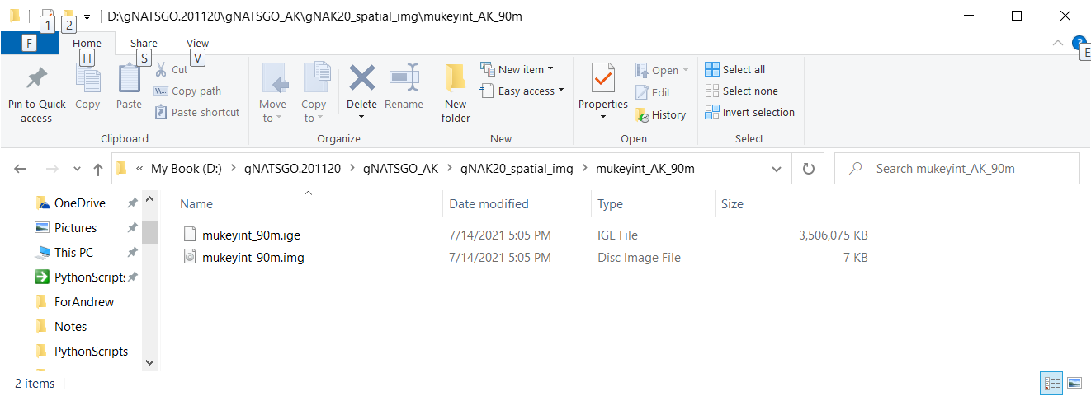
Courier 6
View in ArcGIS
Let ArcMap build the pyramids
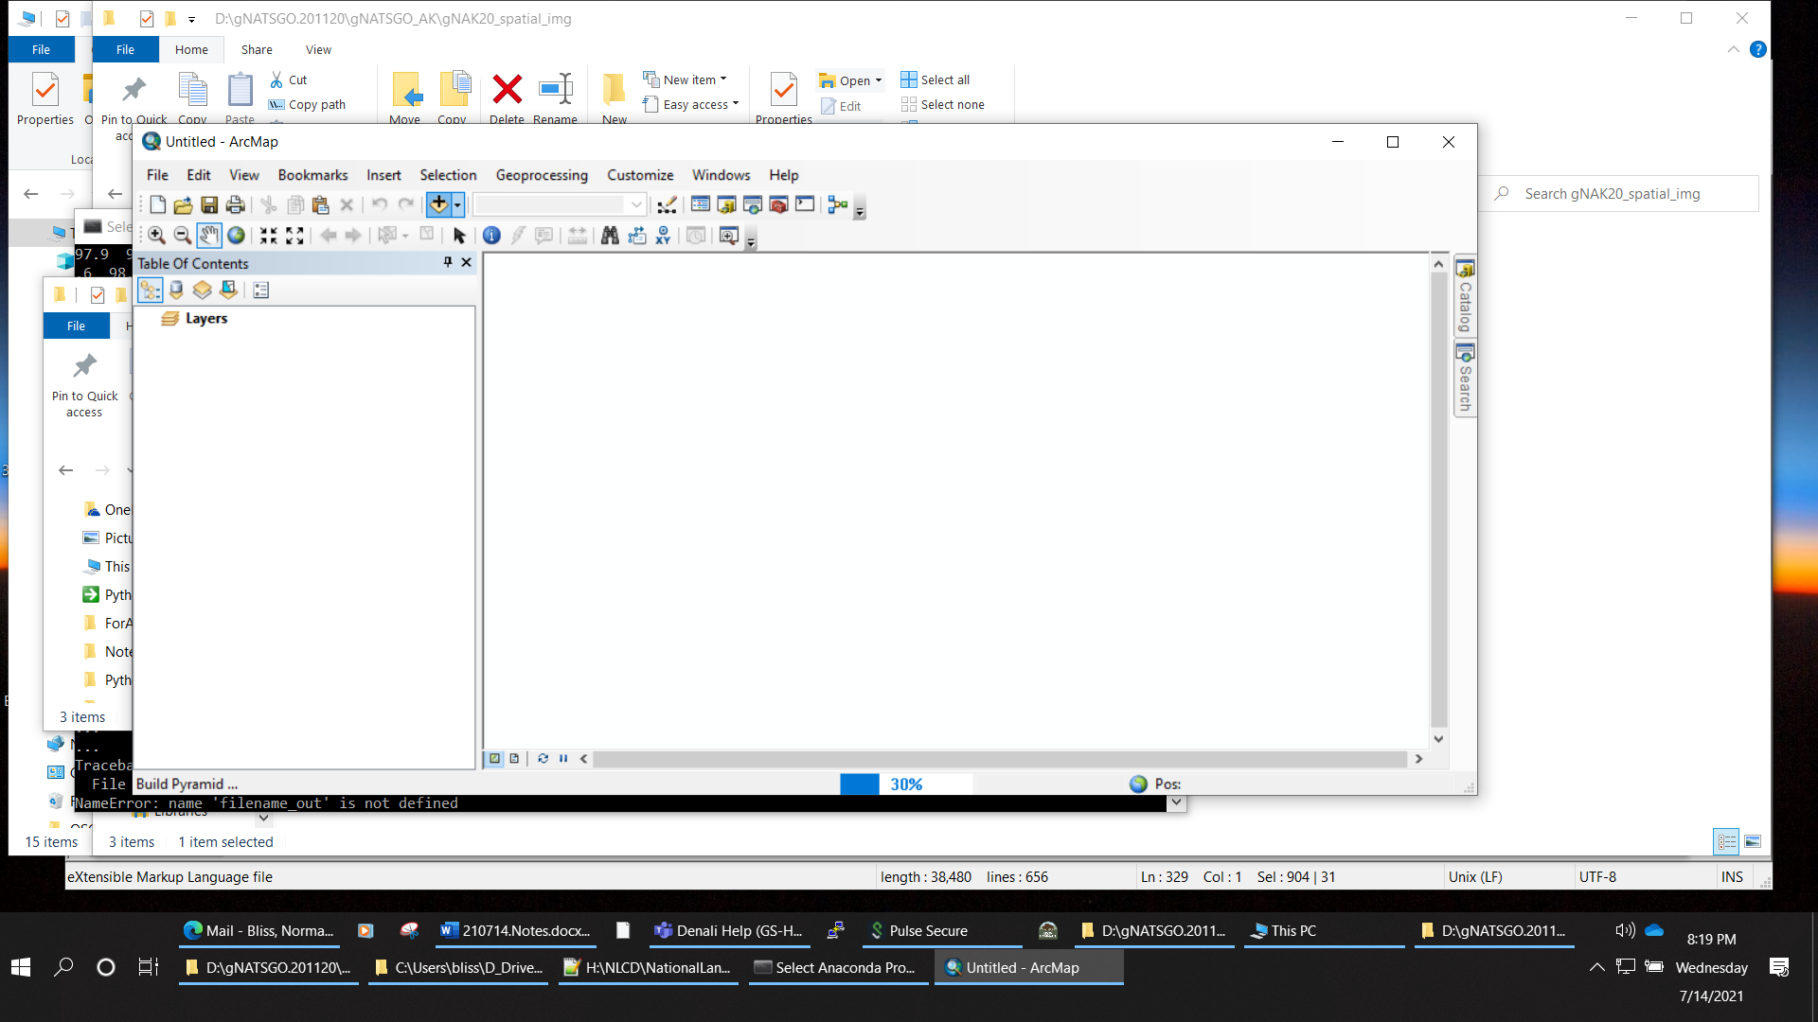
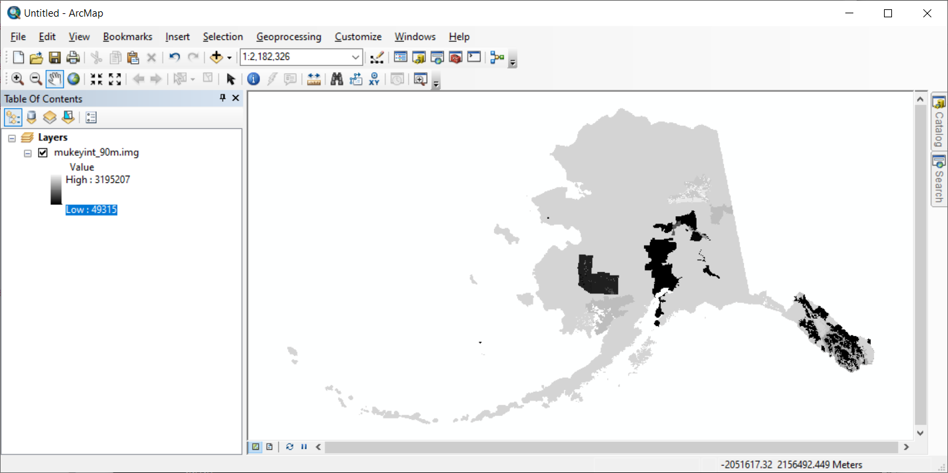
After building pyramids.
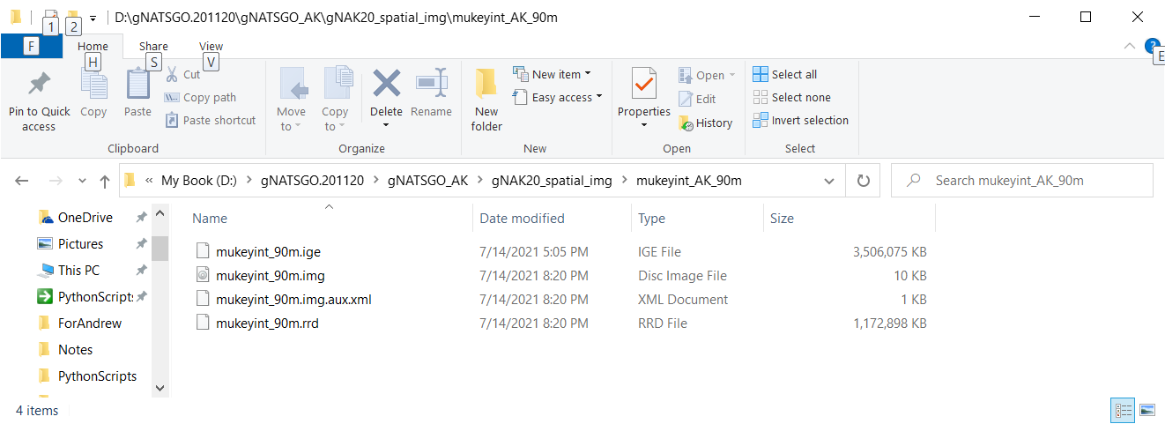
Courier 6
This looks fine. Zip and post for Andrew
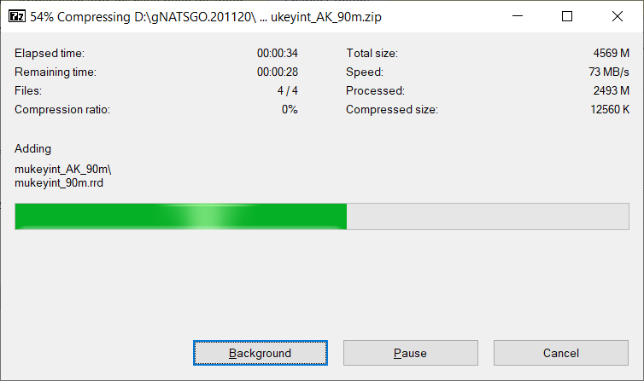
Disconnect D: drive
access Pulse Secure to access edcftp
reconnect D: drive
copy to EDCFTP

Courier 6
Arial 10
Courier 6
Arial 10
Courier 6
Arial 10
Courier 6
Arial 10
Courier 6
Arial 10
Courier 6
Arial 10
Courier 6
Arial 10
Courier 6
Arial 10
Courier 6
Arial 10
Courier 6
Arial 10
Courier 6
Arial 10
Courier 6
Arial 10
Courier 6
Arial 10
Courier 6
Arial 10
Courier 6
Arial 10
Courier 6

