**AppEEARS Point CASE STUDY II– Urban Planning: Combining Local City transportation data with Geospatial Data-derived Environmental Descriptors to examine bus stops that could benefit from heat relief shelters**

Material Written by Danielle Golon1  (dgolon@contractor.usgs.gov)

1 Innovate Inc., contractor to the USGS EROS Center Sioux Falls, South Dakota

**Research Question:**

How can the AppEEARS point sampler be used to generate remote sensing-derived environmental descriptors of bus stops in the Phoenix Metro area to observe which bus stops could benefit from heat relief shelters?

**Goal:**

Access remotely sensed data that can be used to derive environmental descriptors for use in urban planning without downloading the source data for the remote sensing datasets.

**Data Needed:**

|  |  |  |
| --- | --- | --- |
| **Sensor / Mission** | **Product** | **Layer** |
| Daymet | Daily Surface Weather data for North America ([DAYMET.003](https://doi.org/10.3334/ORNLDAAC/1328)) | 1 km daily Prcp (Precipitation) |
| Moderate Resolution Imaging Spectroradiometer (MODIS) | eMODIS Smoothed Normalized Difference Vegetation Index (NDVI)  ([eMODIS_Smoothed_NDVI.001](https://doi.org/10.5066/F7BR8RGQ)) | NDVI |
| Moderate Resolution Imaging Spectroradiometer (MODIS) | Land Surface Temperature ([MOD11A1](https://doi.org/10.5067/MODIS/MOD11A1.006)) | 1 km Daily Daytime LST |
| Moderate Resolution Imaging Spectroradiometer (MODIS) | Land Surface Temperature ([MOD11A1](https://doi.org/10.5067/MODIS/MOD11A1.006)) | 1 km Daily Nighttime LST |

**Software/Tools Needed:**

AppEEARS: <https://lpdaacsvc.cr.usgs.gov/appeears/>

**Estimated Time: 30 minutes**

**Instructions**

**Step 1: Download Data**

Go to <https://edcftp.cr.usgs.gov/?dir=project/lpdaac/AGC%202019> and download the Valley_Metro_Bus_Stops_View_AppEEARS.csv file. The file is a list of 50 sample point locations for bus stops as identified by Valley Metro. A full list of the 7,667 bus stops in the metro can be found below.

**Source Data:** [2019 Valley Metro Bus Stops View](https://geocenter-valleymetro.opendata.arcgis.com/search?groupIds=17de3fc1bc2a43948548613a27eb9c4d)

**Step 2: Extract Point Sample in AppEEARS**

* Go to the AppEEARS homepage <https://lpdaacsvc.cr.usgs.gov/appeears/> and sign-in using your NASA Earthdata Login.
* From the top panel, select “Extract” 🡪 “Point Sample”
* Start a new request
* Provide a name for your sample (AGC 2019 Use Case #2)
* Upload Valley_Metro_Bus_Stops_View_AppEEARS.csv
  + You will now notice the box to your right has been populated with data.
    - The first item is the bus stop number, the second item indicates if there is a currently a shelter at the stop, the last two items are lat/lon locations for the bus stop.
  + Note: When entering information for points in AppEEARS only the latitude and longitude are required. However, if you add in an ID and category, in this case the bus stop number and presence of shelter, you will be able to further explore the data, as we will see later in this activity.
* Set Start Date to 01-01-2016 and End Date to 12-31-2018
* Ensure “Is Date Recurring” is unchecked.
* Under “Select the layers to include in the sample,” choose the following layers from these products (find products by typing in the product name in the search and selecting the appropriate data product. Click on the layer to select.)

|  |  |
| --- | --- |
| **Data Product** | **Layer** |
| Land Surface Temperature ([MOD11A1](https://doi.org/10.5067/MODIS/MOD11A1.006)) | LST_Day_1km |
| Land Surface Temperature ([MOD11A1](https://doi.org/10.5067/MODIS/MOD11A1.006)) | LST_Night_1km |
| Daily Surface Weather data for North America ([DAYMET.003](https://doi.org/10.3334/ORNLDAAC/1328)) | prcp |
| eMODIS Smoothed NDVI  ([eMODIS_Smoothed_NDVI.001](https://doi.org/10.5066/F7BR8RGQ)) | Band_1 |

* Review the data product layers in the “Selected Layers” box that you have chosen and use the “**−**“ symbol to remove any unwanted layers.
* Submit the request. Click on the “Explore” tab to view submission progress.

**Step 3: Reviewing Results in AppEEARS Test Location**

* The length of time for an AppEEARS request to process is dependent upon a number of factors including size of the request and server traffic. In the meantime, you can log-on to an AppEEARS Demo account to view the outputs for the above request:
* Go to <https://urs.earthdata.nasa.gov> and sign out of your personal account. Next, sign in using the username and password provided. From there, return to AppEEARS.
  + **Username: AppEEARSTesting**
  + **Password: NASApixels2017** 
    - Note: AppEEARS may try to automatically log you back in with your personal NASA Earthdata Login account. If this happens please click on sign out while the page is loading. Then navigate back to AppEEARS and sign in with the AppEEARS Testing account.
* Once you are logged in, from the top panel, select “Explore” 🡪 “AGC Use Case #2”

**Step 4: Exploring Results of a Point Sample Request**

Exploring results with a Point sample request is similar to exploring results with an Area sample request but there are some key differences you will see below. Now let’s explore data values for bus stops in the Phoenix Metro area.

**Layer Stats**

* Temporal Comparison Tab
  + This section allows you to compare data over time via a time series or a stacked time series.
* Select “9288, No, 33.45014721, -112.268337” from the Site dropdown, it is towards the bottom of the list.
* Select MOD11A1_006_LST_Day_1km from the Layer dropdown
* Check the Add Line box on the upper right side of the graph

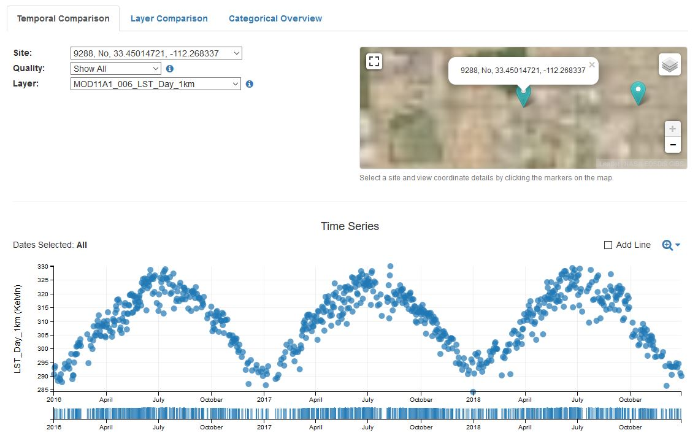

* Figure 1 shows the daily LST data plotted showing seasonality as temperatures are warmer in the summer and cooler in the winter.
  + Note: Just a reminder, these data show the surface temperature of the land, not of the air. See below for a Kelvin to Celsius and Fahrenheit conversion chart.

|  |  |  |
| --- | --- | --- |
| Kelvin | Celsius | Fahrenheit |
| 326 | 52.85 | 127.13 |
| 320 | 46.85 | 116.33 |
| 315 | 41.85 | 107.33 |
| 310 | 36.85 | 98.33 |
| 305 | 31.85 | 89.33 |
| 300 | 26.85 | 80.33 |

* Scroll down further and examine the Stacked Time Series to see how the years compare overlaid on top of each other. For example, the winter of 2017/2018 (Nov – February) seems to be warmer than the previous years.
* Now let’s compare two data products. Compare the Terra MODIS Daytime and Terra MODIS Nighttime LST values, to see if there is any cooling relief during the nighttime at this bus stop.
* Click on the Layer Comparison Tab
* Select 9288, No, 33.45014721, -112.268337 from the Site dropdown
* Check the Add Lines box next to the plot
* Since we are looking at temperatures at the bus stops, let’s update the timeline to look at when temperatures are typically the highest. In this case, let’s look at the summer of 2018.
  + May 30th – Sept 30th, 2018

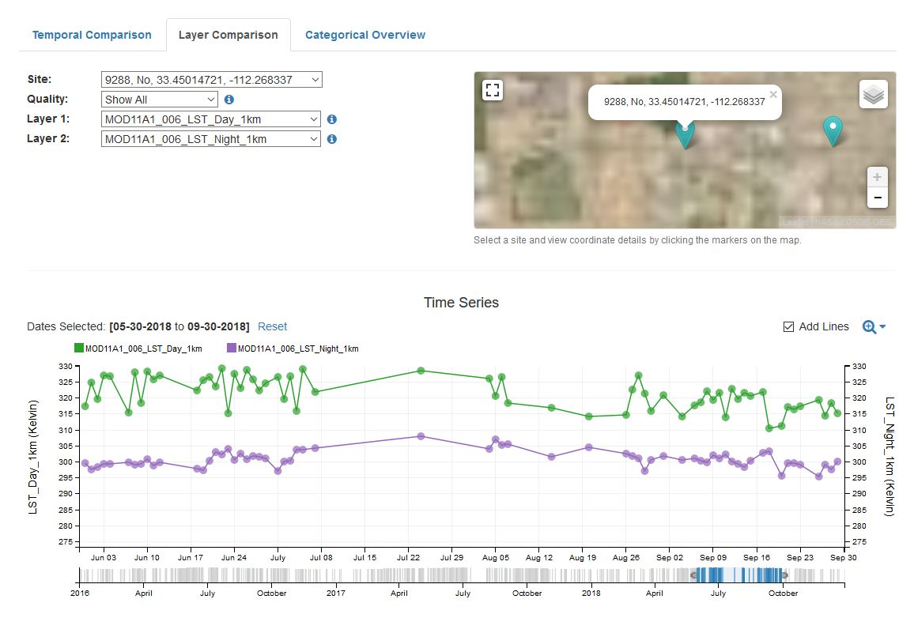

* + Figure 2 shows Daytime LST and Nighttime LST. The temperature of the land does decrease during the night but can still reach up to 308.24 degrees Kelvin (95.162 °F or 35.09 °C), which does not provide the area with much cooling relief at night.
* *(If you have time at the end of the activity, feel free to come back and examine the temperatures of all of the bus stops and compare these temperatures against NDVI and precipitation values, as both of these factors can provide cooling to the area.)*
* Now let’s look at LST values for bus stops without shelters vs bus stops with shelters.
* Click on the Categorical Overview Tab
* Select MOD11A1_006_LST_Day_1km from the Layer dropdown
* Hover over the boxplot for the “No” category to see the average LST values for bus stops with no shelter and then hover over the “Yes” category to compare those temperatures against bus stops with shelter.
* Now click on the “No” boxplot. This will filter the bus stops below to be only bus stops without a shelter.
* Now you can hover over the bus stops to see which bus stops on average reach the highest temperatures and could benefit passengers the most if a heat relief shelter was added.

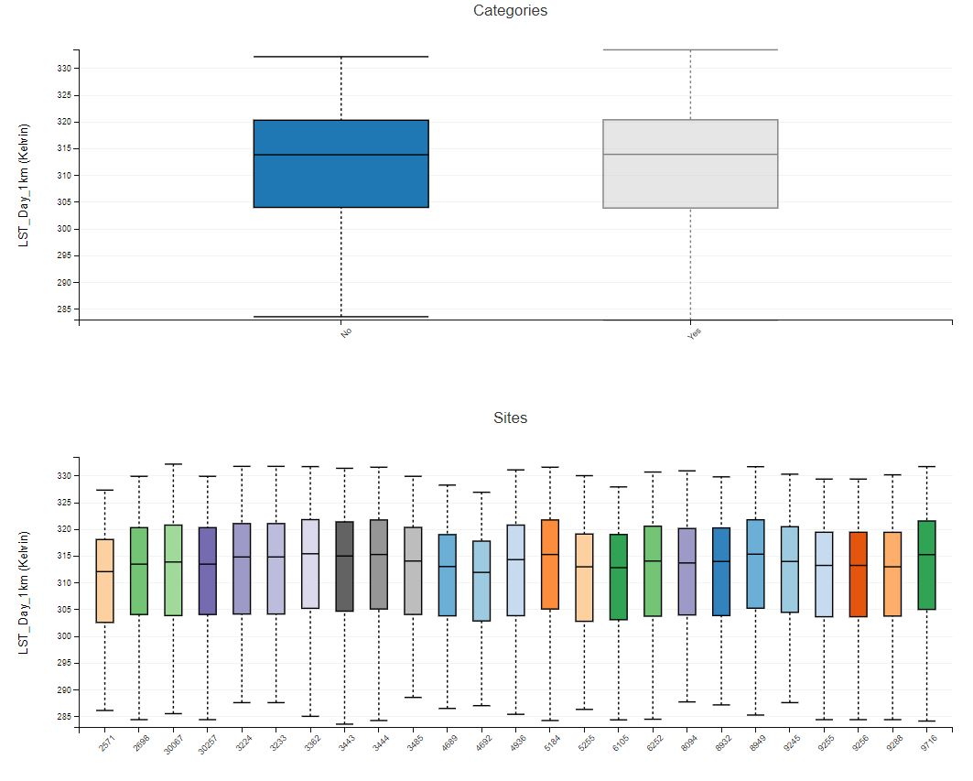

* + Figure 3 shows box and whisker plots of LST values for bus stops identified as not providing shelter for passengers.

**Step 5: Downloading the Contents of an AppEEARS Request**

* If you are satisfied with the initial exploration and would like to further download the data to investigate more, you have two options to download the data. You can either click on the arrow to the right of the request above the map when viewing the Area Sample, see image below, or you can return to the Explore Tab and select “Download the contents of the request”.

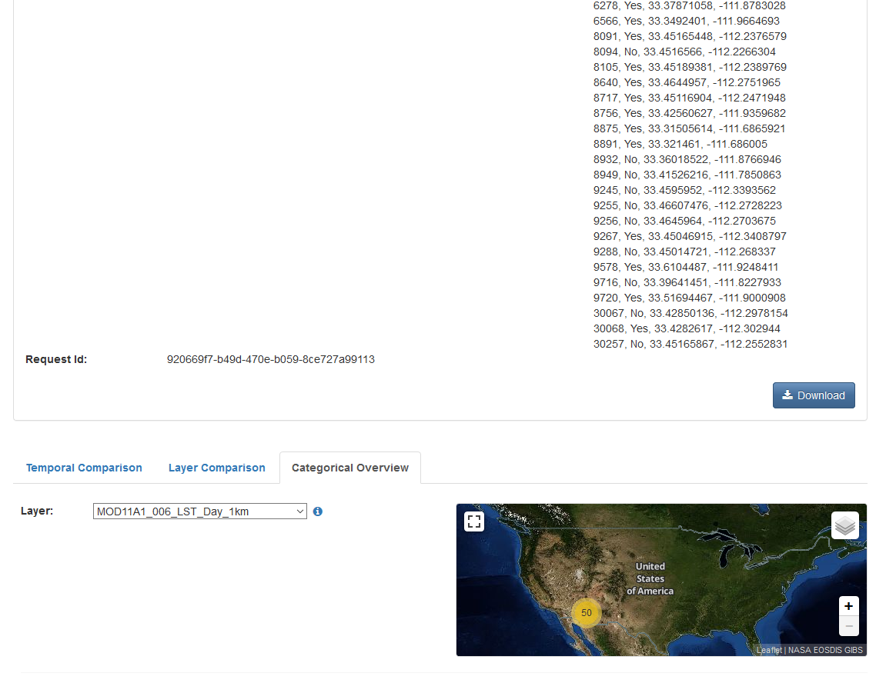

* + Figure 4 shows the location to download data while viewing the sample.

For point requests, you can download a .zip file containing all of the output files, or pick and choose the files you are looking to download. You should see the following files:

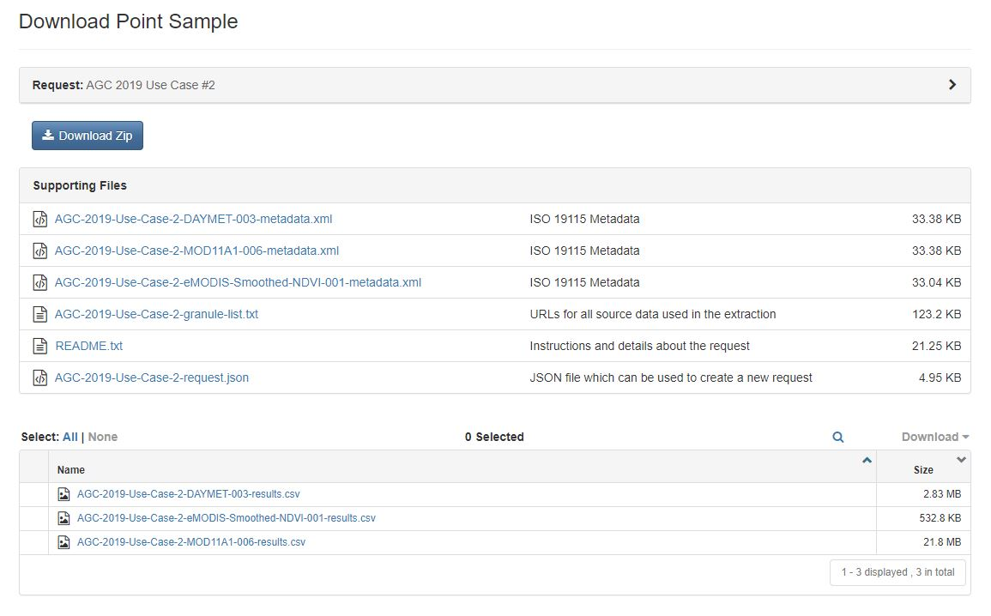

* + Figure 5 shows some of the files you can download from AppEEARS.
* These files include:
  + The metadata
  + URLs for all the source data
  + A README Text file
  + A JSON file which you can share with your colleagues so they can repeat your request.
  + Results by each product in CSV files.
* This concludes Use Case #2. Please feel free to download any of the data to explore the values via your favorite GIS or Spreadsheet program.
  + Note: Once the order has completed on your AppEEARS account the data will be available for 30 days. After 30 days you will need to resubmit your request.

Thank you for attending our session “It *AppEEARS* we have a solution to many of your data issues!”. We will conclude this session with a question and answer period. If you have completed this Use Case early and would like to stick around for the question and answer portion, please feel free to either explore more bus stop values or compare the bus stop LST values against the NDVI or precipitation values. Alternatively, please feel free to explore more involved data tutorials, including tutorials on using R and Python with AppEEARS outputs, from the LP DAAC on the LP DAAC website:<https://lpdaac.usgs.gov/resources/e-learning/>