### OLI Characterize Radiometric Stability (16-day)

#### Background

Radiometric stability of an instrument is fundamental to low uncertainty in the radiometric calibration of data products generated from its data. OLI has requirements on its band average stability over several time intervals, specifically 60 second (about 2 scenes), up to 16-day (one repeat cycle) and 16-days up to 5 years (mission lifetime). This algorithm specifically addresses the 16 day radiometric stability as given as:

OLI-1001 For Bands 1-8, over any time period up to 16 days, after radiometric correction per 5.3.1.2, with one set of gain coefficients that were determined prior to the 16 day period, the scene averaged OLI image data for radiometrically constant targets with radiances greater than or equal to L-typical shall not vary by more than plus or minus 1% (95% or 2 sigma confidence interval) of measured radiance.

OLI-1522 For Band 9, over any time period up to 16 days, after radiometric correction per 5.3.1.2, with one set of gain coefficients that were determined prior to the 16 day period, the scene averaged OLI image data for radiometrically constant targets with radiances greater than or equal to Ltypical shall not vary by more than plus or minus 2% (95% or 2 sigma confidence interval) of measured radiance

After launch the 16-day Radiometric Stability will be used for OLI Key Performance Requirement (KPR) verification.

Radiometric Stability KPR:

The key performance metric is the variation in the band average response of the instrument to a constant radiance (greater than or equal to Ltypical) over any period of time up to 16 days. Of the measurements made over these periods, 95% need to be within 1.2% of the average value for all bands but the cirrus band.

This algorithm characterizes the stability of the OLI bands radiometric response using the on-board calibration devices. In particular, the working Stim lamps will be used every day and the working solar diffuser will be used nominally every 8 days. This algorithm, though not directly related to requirements could also be run on shutter data to characterize dark response stability.

This algorithm will run on bias-corrected and linearized digital numbers from the Lamp Response Characterization and/or Histogram Statistics Characterization database tables; they do not require separate analysis of image data.

#### Dependencies

Histogram Statistics Characterization

Lamp Characterization

Diffuser Characterization

#### Inputs

The inputs to this algorithm come from either the output of other algorithms (DB) or from a set of calibration parameters (CPF). Table 6‑53 lists the inputs of this algorithm.

|  |  |  |  |  |  |
| --- | --- | --- | --- | --- | --- |
| **Descriptions** | **Symbol** | **Units** | **Level** | **Source** | **Type** |
| Lamp Acquisition info: date, time, ID |  |  |  | DB |  |
| Number of samples |  | Counts |  | DB | Int |
| Level-1 Statistics (bias-corrected, linearized) | Qi, i | DN | Nband X NSCA x Ndet | DB (lamp response table) | Float |
|  |  |  |  |  |  |
| Diffuser acquisition info: date, time, ID |  |  |  | DB |  |
| Number of diffuser samples |  | Count |  | DB |  |
| Earth-sun distance | d | [] |  | JPL model | float |
| Level-1 Statistics (bias-corrected, linearized) | Qi, i | DN | Nband X NSCA x Ndet | DB (solar diffuser table) | Float |
| Inoperable detectors, out-of-spec detectors |  |  |  | CPF | integer |
| Relative Gains | rCPF | [] | Nband X NSCA x Ndet | CPF | float |
| Moving window size (multiple window sizes possible, different sizes for lamp and diffuser) | W | Days |  |  | integer |
|  |  |  |  |  |  |

Table 6‑53. Algorithm Inputs

#### Output

|  |  |  |  |  |  |
| --- | --- | --- | --- | --- | --- |
| **Descriptions** | **Symbol** | **Units** | **Level** | **Source** | **Type** |
| Time interval samples (multiple arrays depending on window sizes) |  |  |  |  |  |
| Window size |  | Days |  |  |  |
| Number of samples | Nsamples |  |  |  |  |
| Traveling average means | $\overline{x}$, si | DN | Nband X NSCA x Ndet x Nsamples |  | Float |
| Traveling average uncertainties | CV, uncCV | [] | Nband X NSCA x Ndet x Nsamples |  |  |
| Time periods where the band-average traveling average does not meet spec |  |  |  |  |  |

#### Options

Report data to ASCII report files as well as IDL save file and plots.

**Prototype Code**

**Stability.pro**

**Traveling_average.pro**

**Ploterror.pro, oploterror.pro**

**Fpm_legend.pro, leg.pro**

**Tvread.pro**

#### Procedure

For each appropriate collect, for each band:

1. Extract Lamp Characterization and Diffuser Characterization database table data for each detector; *Qi*, *σi*, *Nvalid*.
   1. For the lamp, only extract the working lamp data, since the other bulb pairs will not be used often enough to provide meaningful trends.
   2. For the panel, use only the working panel data
2. Calculate FPM-average means from per-detector means
3. Calculate band-average means from per-detector means, *QBA*
4. For diffuser data, correct the band-average signal for the Earth-sun distance
$Q=Q_{BA}*d^{2}$

5. For each traveling average window (lamp data, use window sizes of 6, 12 and 16 days; panel, use window size of 16 days) for each per-detector, fpm average and band average:
   1. Calculate traveling average mean and stdev: $\overline{x}$ and *s*.
   2. [Secondary test for KPR] check if two times the CV minus two times the absolute uncertainty in the CV is greater than the specification value. This is a less stringent test than the Chi2 test.
      1. Calculate uncertainty in stdev in each sample in the traveling average: $\frac{{unc}_{s}}{|s|}=\frac{1}{\sqrt{2*\left(n-1\right)}}$ (this is the relative uncertainty in s)
      2. Calculate uncertainty in mean for each sample in the traveling average: ${unc}_{\overline{x}}=\frac{s}{\sqrt{n}}$ (this is the absolute uncertainty in $\overline{x}$)

$\frac{{unc}_{\overline{x}}}{|\overline{x}|}=\frac{s}{\overline{\overline{x}}\sqrt{n}}$ (this is the relative uncertainty in

* + 1. Calculate Coefficient of Variation (CV) and the uncertainty in the CV for each sample in the traveling average

=

* 1. [Primary test for KPR] Calculate Chi2 to test the hypothesis that the variance is less than the specification value.
     1. H0: s2 <= specification, HA: s2 > specification
     2. , ,  = 0.05
     3. = chisqr_cvf( 0.05,  ) [IDL command for Chi2 95% value.]
     4. H0 passes if $χ^{2}<χ_{α,ν}^{2}$ and the band-average is not out-of-spec.

1. For the band-average results, flag bands where the Chi2 H0 is rejected. Mark periods as out-of-specification based on the Chi2 test; decide whether to flag the band as out-of-specification.

#### Maturity

The code is meant for the IAS tool box and thus, is not robust and hands-off as are the usual IAS algorithms. I expect that I will watch the output pop-up as I run this on a monthly basis and will add and subtract functionality as I see fit.

Sample plots:

Lamp collects to be used for analysis

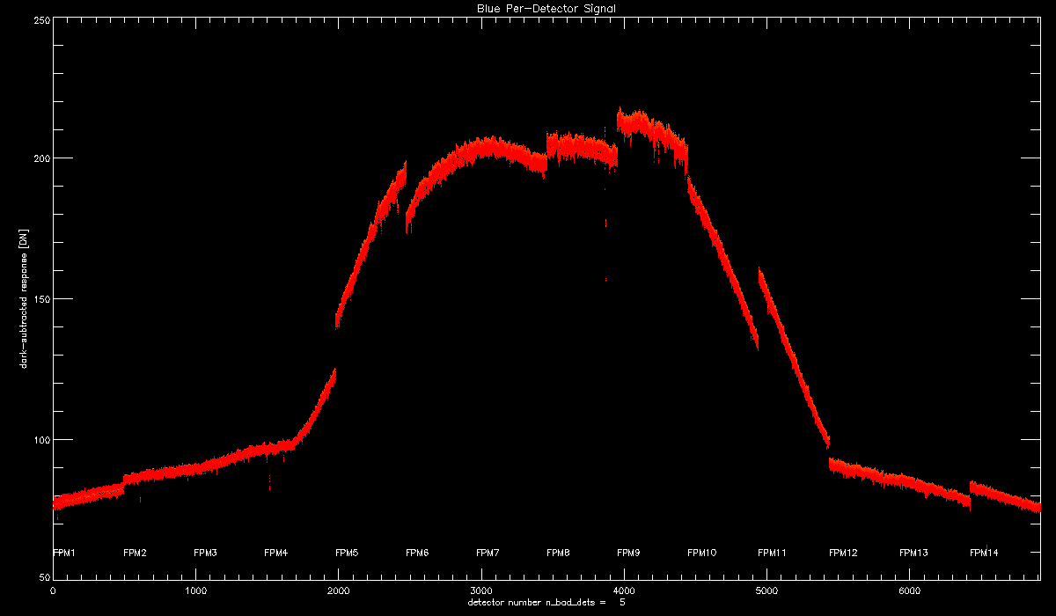

Lamp 16-day traveling average for the band- average signal. There are some 16 day periods where I do not have a valid lamp collect for (due to the way I made up these data).

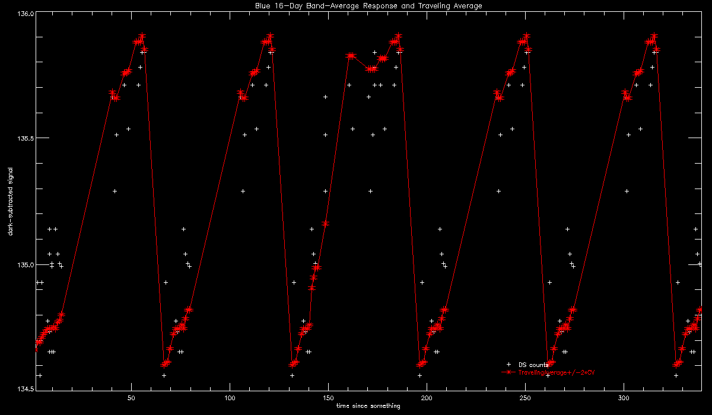

Lamp 4-day traveling average for the band-average signal. There are some 4 day periods where I do not have a valid lamp collect for (due to the way I made up these data).

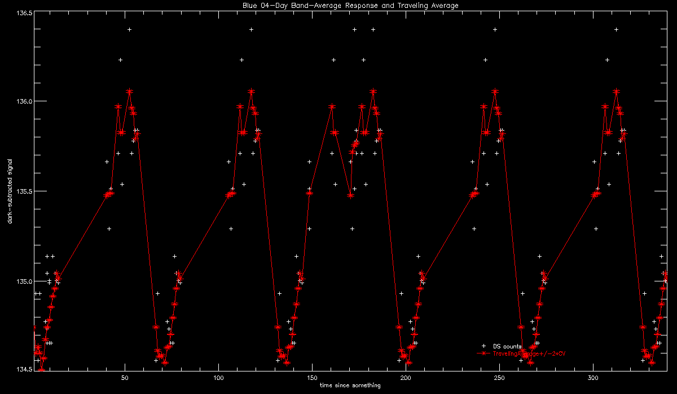

CV of 16-day lamp band-average traveling average, with requirement indicated by dashed line. If CV-2*unc is greater than the specification value, the period would fail the requirement.

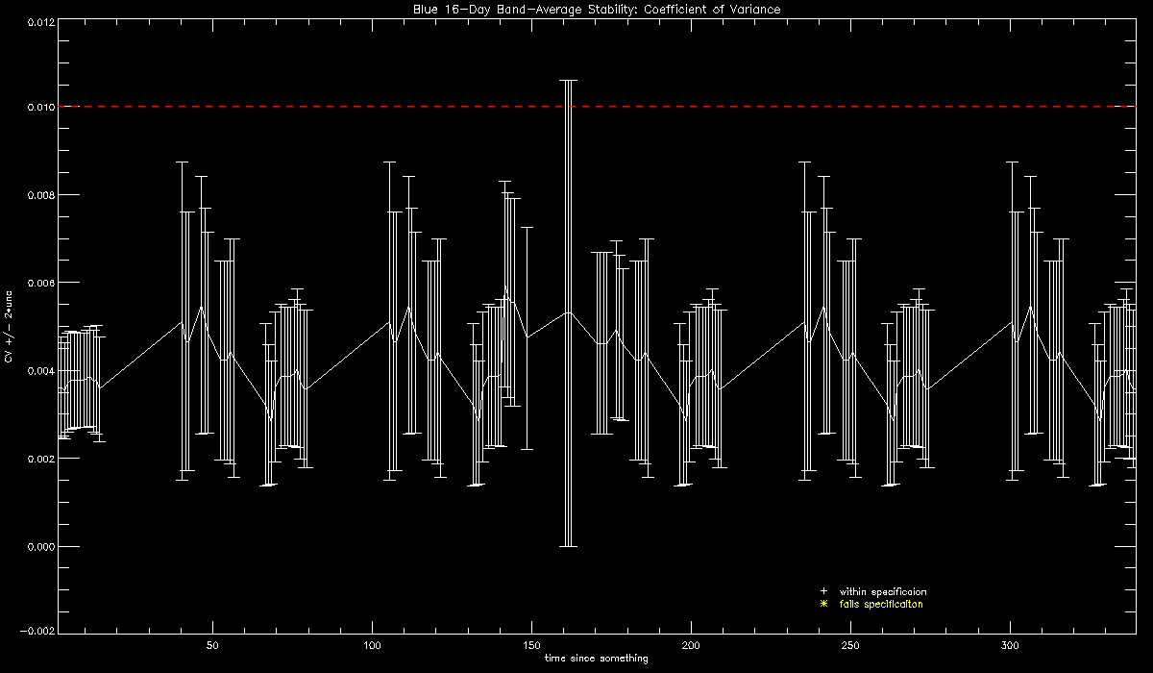

Panel data to be used in analysis (all fabricated)

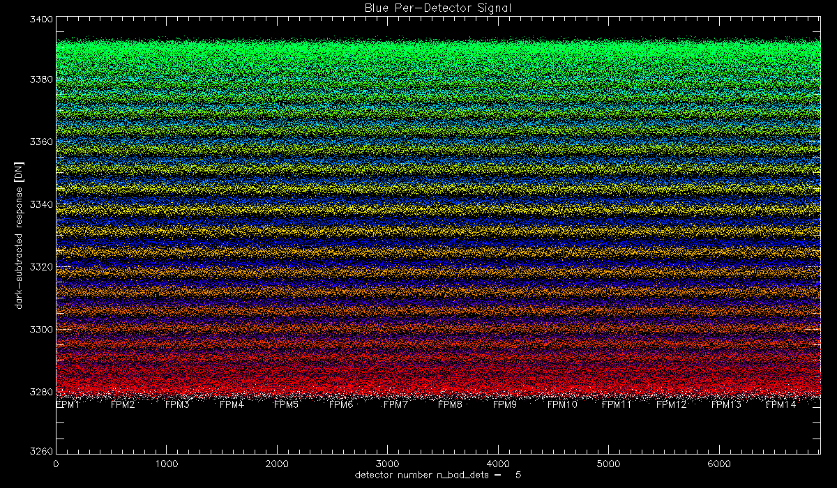

Panel 16-day traveling average. Two FPMs in the collections were outliers.

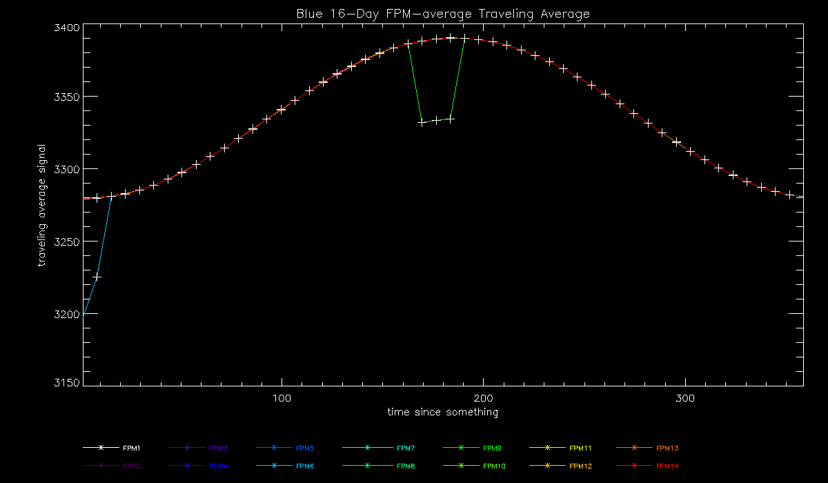

CV of 16-day panel band-average traveling average. If CV-2*unc is greater than the specification value, the period would fail the requirement. Data are well under the 0.01 requirement.

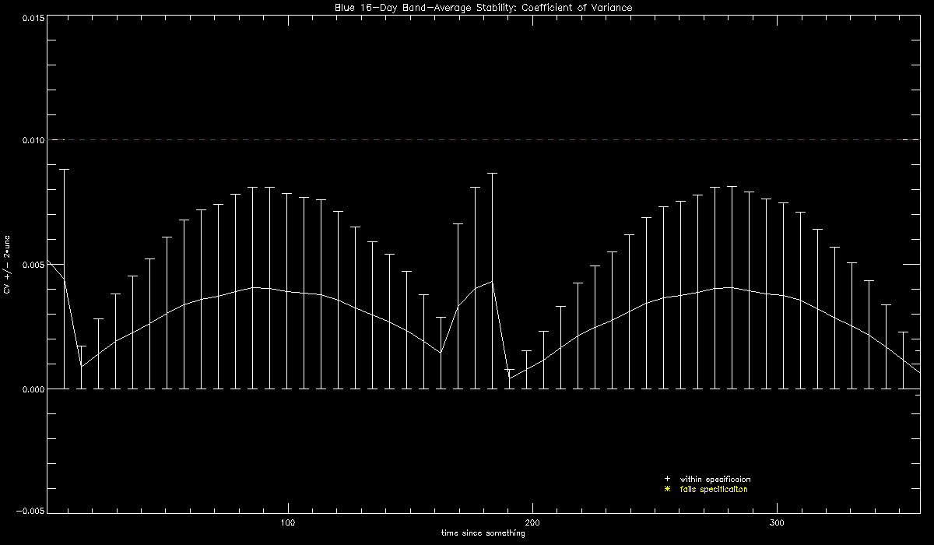

**Earth-Sun Distance Calculation**

The JPL Ephemeris table (DE421) describes the orbits of the sun and planets with very high precision over relatively long time scales[1]. The file is stored as a series of Chebyshev coefficients, which can be interpolated to essentially any desired temporal accuracy. The IDL tool that I use to read from the JPL file requires the date as input and outputs a three element position array. To convert to Earth-sun distance in AU:

;need month, day, year to

ydn2md, year, doy, month, day

pos = run_ephem( month, day, year )

dist = double( sqrt( pos(0)^2 + pos(1)^2 + pos(2)^2. ) )

earth_sun_distance = dist / aukm ;e-s dist correction

1. <http://lheawww.gsfc.nasa.gov/users/craigm/bary/>