### Striping Characterization

#### Background

Evaluation of the effectiveness of relative gain correction to remove striping is typically performed in a qualitative sense, through visual inspection of imagery before and after correction. This method has several limitations, the primary one being that it relies on subjective human interpretation for the evaluation. In addition, inspection of large numbers of corrected images is not realistic. Consequently, a quantitative characterization of striping is needed.

Algorithms have been developed to quantitatively characterize striping through frequency-domain analyses (mostly FFT-based). These can produce an average estimate (across a focal plane module) of the amount of striping at the Nyquist frequency (corresponding to detector-to-detector variation). The disadvantage of this approach is that the results provide no real information about striping at a detector level (i.e., which detectors are more sensitive to striping).

This algorithm determines a quantitative metric for the amount of striping present in an image through calculation of spatial-domain statistics for each detector. These statistics are further processed to obtain a “final” striping metric. In the initial development work it has been found that larger values for this metric tend to positively correlate with more visually apparent striping.

This algorithm will also produce a Striping Correction Matrix that may be used by the Residual Striping Correction algorithm to reduce that amount of striping in the image.

#### Inputs

|  |  |  |  |  |  |
| --- | --- | --- | --- | --- | --- |
| **Description** | **Symbol** | **Units** | **Level** | **Source** | **Type** |
| Scene | *Q* | DN or  W/m2 sr m | Nbands x NSCA x Ndetectors x Nframes |  | Float |
| Saturated pixels |  |  | Nbands x NSCA x Ndetectors x Nframes | LM | Int |
| Impulse noise |  |  | Nbands x NSCA x Ndetectors x Nframes | LM | Int |
| Dropped Frames |  |  | Nbands x NSCA x Ndetectors x Nframes | LM | Int |
| Inoperable detectors |  |  | Nbands x NSCA x Ndetectors | CPF | Int |
| Striping metric cutoffs |  |  | Nband | CPF | Float |

The Striping Metric Cutoffs have a default of 2% of the standard deviation of “all” the images in the archive. This will be fairly constant, so there is not a need to query the database and calculate it every time. A value in the CPF should function adequately. Initialization of this parameter may be done after 100 images are in the archive/database.

#### Outputs

|  |  |  |  |  |  |
| --- | --- | --- | --- | --- | --- |
| **Description** | **Symbol** | **Units** | **Level** | **Destination** | **Type** |
| Overall Striping Metric |  | DN or W/m2 sr µm | Nband | Db | Float |
| Scene Striping Correction Matrix (optional) |  |  | Nband, Nsca, Ndet, Nframe | Residual Striping Correction Algorithm | Float |
| Detector Striping Metric (optional) |  |  | Nband,  NSCA | Report | Float |
| Scene Striping Metric (optional) |  |  | Nband, NSCA | Report | Float |

The Overall Striping Metric is a single number measure of the amount of striping found in the image.

The Scene Striping Correction Matrix is a matrix roughly the same size as the image. It can be subtracted from the image to remove striping.

The Detector Striping Metric is an Ndet-2 array measure of the amount of the striping in each individual detector.

The Scene Striping Metric is an Ndet-2 xNframes-fill-2 measure of the amount of striping at each individual pixel.

#### Options

Write the Overall Striping Metric to database (On by Default)

If the Residual Striping Correction Algorithm is being run the Scene Striping Correction

Matrix needs to be calculated and outputted. If the Residual Striping Correction Algorithm is not being run, the Scene Striping Correction Matrix does not need to be calculated or outputted.

Summary Report (Off by Default)

1. Detector striping metric
2. Scene striping metric
3. Overall striping metric

#### Procedure

1. Read in the processing parameters.
2. Read in an SCA.
3. Find the difference between every pixel in the image and the average of its two neighbors (left and right). When a pixel in the artifact mask or a sample from an inoperable detector is encountered, the Cross-Track Difference (CTDiff should be set to zero. So a pixel in the artifact mask or a sample from an inoperable detector will cause three entries to be zeros in CTDiff (the pixel itself and its two neighbors).



Where *x* denotes a pixel, and *m* and *n* denote row (frame) and column (detector), respectively. This difference is calculated for all pixels in the image except border pixels (one pixel on all sides).

1. Since scene content will cause the largest magnitudes in CTDiff, we will calculate a homogeneity filter.
   1. The first step is to check the Cross-Track Homogeneity (CTHom) by calculating the difference between pixels in the image on either side of the current pixel.



This difference is calculated for all pixels in the image except border pixels (one pixel on all sides). Whenever a pixel in the artifact mask or a sample from an inoperable detector is encountered, CTHom should be zero, so all pixels in the artifact mask and their left and right adjacent pixels will have zero values in CTHom. Thus, inoperable detectors will cause three columns of zeros in CTHom.

* 1. Next we will check the Along-Track Homogeneity (ATHom) by taking the vertical difference between the current pixel and its top and bottom neighbors.



This difference is calculated for all pixels in the image except border pixels (one pixel on all sides). Whenever a pixel in the artifact mask or a sample from an inoperable detector is encountered, ATHom should be zero, so all pixels in the artifact mask and their top and bottom adjacent pixels will have zero values in ATHom. Thus, inoperable detectors will cause one column of zeros in ATHom.

* 1. To help reduce noise, we will average CTHom over five pixels.



ACTHom stands for Average Cross-Track Homogenity. This is done for the entire CTHom image. Pixels in the artifact mask or a sample from an inoperable detector and their left and right adjacent pixels should not be used to calculate this average. Border pixels are averaged with their inside neighbors, this can be seen below for pixels on the left side. Pixels on the right side use similar equations.



* 1. To reduce noise in ATHom, we will average over three pixels.



AATHom stands for Average Aross-Track Homogenity. This is done for the entire ATHom image. Pixels in the artifact mask or a sample from an inoperable detector and their top and bottom adjacent pixels should not be used to calculate this average. Border pixels are averaged with their inside neighbors, this can be seen below for pixels along the top border. Pixels along the bottom border use a similar equation.



* 1. To complete the homogeneity filter, plug ACTHom and AATHom into the equation below.



HomFilt stands for Homogeneity Filter. This will generate a filter mask of roughly 1s and 0s the same size as the original image minus one border pixel from all sides. All pixels in the artifact mask and samples from inoperable detectors and left and right adjacent pixels should be zeroed out. This filter should remove scene content from the calculation of the striping metric.

1. The scene correction matrix is the individual pixel product of the HomFilt and CTDiff. The scene striping metric is essentially the absolute value of the scene correction matrix, but without the divide by two. The scene striping metric shows where, spatially, in the image stripes are located. The higher the value the more striping present.



1. The detector striping metric is the mean of the columns of the scene striping metric. Each of the individual SCA scene striping metric arrays are concatenated to produce a single band array for the detector striping metric. This tells us how stripy a single detector is. The detector striping metric has individual values for each detector except for the first and last detectors.

Figure 6‑84 shows an example detector striping metric.

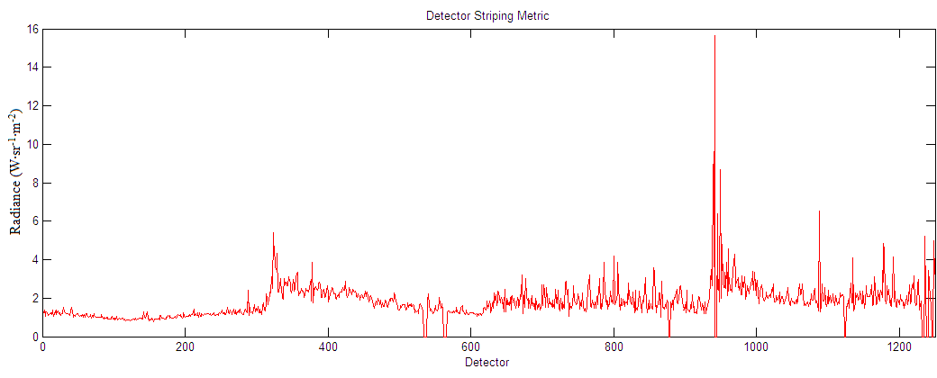

Figure 6‑84. Example Detector Striping Metric

1. The overall striping metric is derived from the detector striping metric.
   1. First the mean of the entire detector striping metric is found.

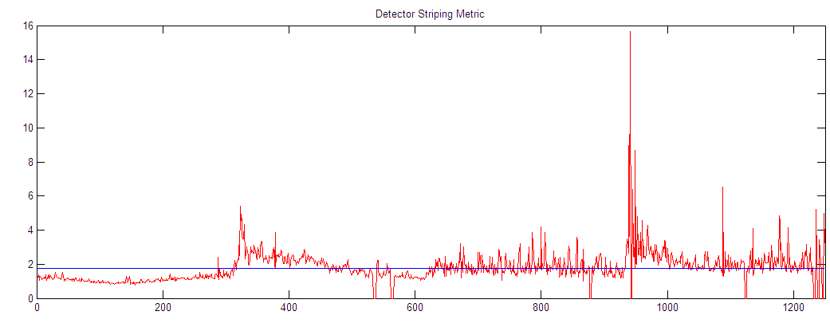

Figure 6‑85. Mean of Detector Striping Metric

* 1. Then a 75 length median filter is applied to the detector metric, and smoothed with a 15 length averaging filter.

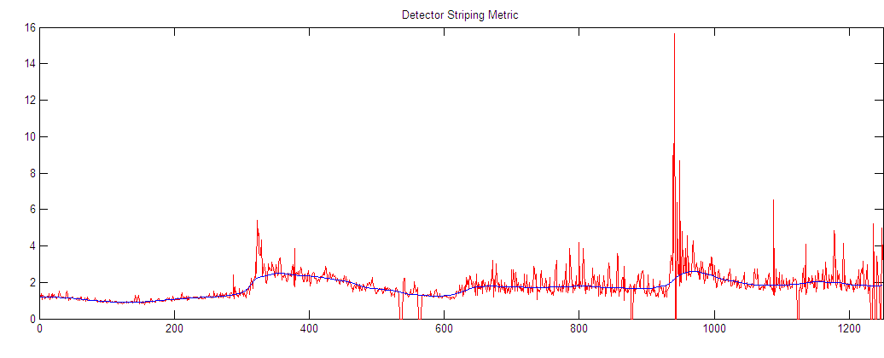

Figure 6‑86. Averaged Median Fit to Detector Striping Metric

For border detectors on the left side, the median filter will find the median of 37 detectors to the right and however many detectors there are to the left. So for the first detector, it will find the median of the first detector and the 37 detectors to the right. For the second detector it will find the median of the first and second detector and the 37 detectors to the right, and so on until the 38 detector when it find the median of the current detector and 37 detectors to the left and right.

Border detectors on the right side are handled the same way except reversed. So for the last detector it will find the median of the last detector and 37 detectors to the left.

The average filter works in a similar way. For the first detector it will take the average of the first detector and 7 detectors to the right.

* 1. This averaged median fit is subtracted out from the detector striping metric.

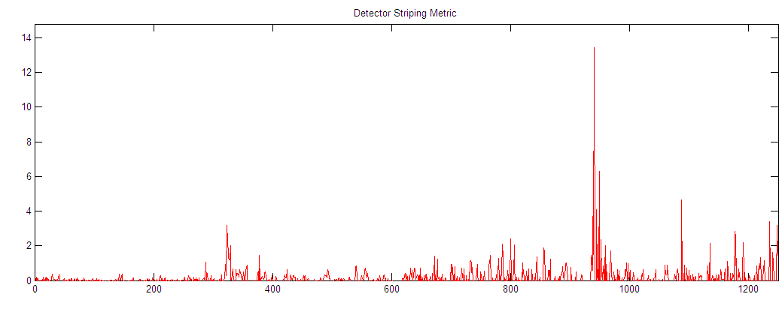

Figure 6‑87. Median Subtracted Detector Striping Metric

* 1. The next factor used for the overall striping metric is the maximum peak from this median filter subtracted detector metric.

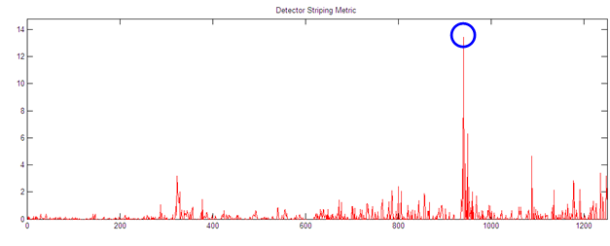

Figure 6‑88. Maximum of the Median Subtracted Detector Striping Metric

* 1. The last factor used is then the mean of the top 15 peaks, including the maximum peak, from the median filter subtracted detector metric. (There are only six peaks circled, but the algorithm should find 15).

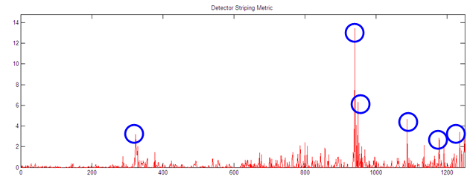

Figure 6‑89. Top Peaks of the Median Subtracted Detector Striping Metric

It is important to find the top 15 individual peaks. Detectors part of a higher spike should not be used. A detector’s two adjacent detectors are considered for determining peaks. If detector *x* has a neighboring detector with a higher value, detector *x* is not a peak. There is no amount a peak must be larger than its neighbors; it must only be larger. One approach to do this is to arrange the detector striping metric numbers in descending order while maintaining the detector to which the metric numbers correspond. Then one can go down the list and if there is neighboring detector above the current detector, the current detector is not an individual peak. Figure 7 shows this more clearly.

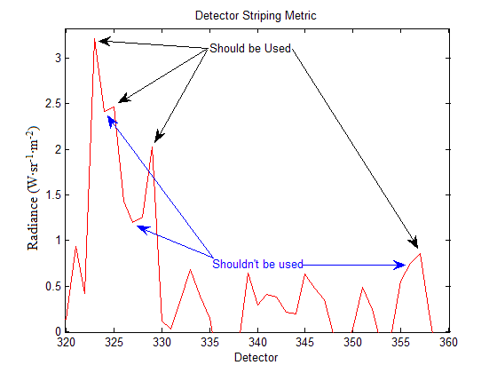

Figure 6‑90. Individual Peak Detectors

* 1. The overall striping metric is the cube root of the product of the mean, maximum peak, and mean of the top 15 peaks. This number will be in radiance units (W·sr-1·m-2·µm). It is also desired to capture this value in DN, so it will have to be backed out of radiance space.



* The mean of the detector striping metric measures the amount of striping present throughout the entire image, odd/even striping being the largest portion.
* The worst single detector stripe is measured by the maximum peak.
* The mean of the top 15 peaks measures the amount of single detector striping throughout the image.

1. If the write striping metric option is on, write the overall striping metric to the database.
2. If the summary report option is on write the overall metric, scene striping metric and detector striping metric to a report.
3. Repeat all steps for all SCAs and Bands.