### Scene Framing Algorithm

#### Background/Introduction

The L8/9 scene framing algorithm uses the spacecraft ancillary data, preprocessed to perform scaling, coordinate conversion, and to repair errors, and the image timing information to determine the locations of scene centers within the interval. It then assigns Worldwide Reference System-2 (WRS-2) path-row coordinates to these scene centers for purposes of subsequent metadata generation.

The Landsat heritage scene framing algorithm will be used to frame nadir-pointing data and to determine the nadir path/row references for off-nadir acquisitions, but the L8/9 capability to point (roll) up to 15 degrees off-nadir will lead to data acquisitions that do not fall on the regular WRS-2 reference grid and will, in some cases, fall entirely outside of the heritage WRS-2 coverage area for acquisitions near the poles. These additional complications require adjustments to the heritage algorithm to address both the scene definition (i.e., where do we declare the scene centers) aspect of scene framing and the WRS-2 grid (path/row) assignment aspect of scene framing. This algorithm addresses those requirements.

The algorithm developed here separates the scene definition and WRS-2 labeling aspects of the scene-framing problem. It also uses different logic for high-latitude (polar region) and low-latitude (non-polar) acquisitions. At high latitudes, off-nadir acquisitions will be poorly aligned with and will sometimes fall outside of the WRS-2 grid, so the heritage (nadir) orbit-based approach to scene center time definition is used in those areas. Using the nadir path/row for scene and interval identification also ensures unique ids as well as consistency with planned acquisitions. Furthermore, to help in identifying coverage of off-nadir acquisitions, especially near the poles, *target* WRS-2 labeling is determined, and any imagery falling outside of the WRS-2 grid uses special target row numbering.

For non-polar regions, the guiding principle is to make even off-nadir scenes as consistent as possible in coverage with the nadir acquisitions of the same region by using a "row-based" approach to scene definition. Defining scene centers at the locations where the OLI[1] boresight crosses the latitudes that correspond to WRS-2 row centers makes the off-nadir scene latitude bounds align with the nadir-viewing scenes from adjacent paths. This should lead to greater consistency in scene coverage and improve the interoperability of nadir and off-nadir data[2]. Therefore, for non-polar regions, scene path/row computation is based on the boresight LOS intersection location. The basic principle in this portion of the algorithm is to treat the boresight location as if it were a sub-satellite point. We can then compute a corresponding orbital central travel angle and apparent descending node based on the nominal Landsat orbital inclination. The actual orbit data are used to determine whether the scene is ascending or descending mode, and the central travel angle and descending node are adjusted accordingly. The central travel angle is used to derive the WRS-2 row and the descending node longitude yields the (fractional) path. Since the scene definition logic is defined by WRS-2 row crossings, for non-polar data, the off-nadir scene paths will typically be fractional and the row will be an integer, whereas in polar areas, the off-nadir scenes target WRS-2 paths and rows will be fractional. These fractional WRS-2 path/rows will have to be rounded to the nearest path/row that represents the data. Target WRS-2 coordinates of nadir-pointing scenes should be integers in both regions. In addition, if the scene center falls too far off the WRS-2 grid, special target row numbers will be assigned (880-88x for the North Pole and 990-99x for the South Pole).

It is important to note that in the metadata, the wrs_path/wrs_row values are always the nadir or orbital path/row of the satellite (and they are used for the scene ids) and the *target* path/row is the LOS path/row. In the non-polar regions, the target row and orbital wrs_row should be equal for nadir viewing imagery. The target path should be between wrs_path-1 and wrs_path+1 at low latitudes, but could vary by more at higher latitudes (approaching the polar regions). In the polar region, off-nadir target path/row will vary quite a bit from the orbital values.

#### Dependencies

The scene-framing algorithm assumes that ancillary data for the full imaging interval, with 8 seconds of extra ancillary data before and after the imagery, is available to provide the required geometric support data; that a CPF containing Earth orientation parameters and OLI & TIRS alignment and offset information is available; and that the image time codes are available.

At a minimum, four seconds of ancillary data are required before and after the imagery to construct consistent attitude and ephemeris time histories for the data set in order to achieve L8/9 geolocation accuracy requirements. An additional four seconds is added as an allowance for late starts/stops, bad/partial frames at the beginning/end, etc. In addition, not all of the instrument telemetry is actually updated in every ancillary data frame, so it takes multiple (up to 4) frames to guarantee a fresh sample.

For calibration collects (lamp, solar, shutter, black body, deep space, etc.), the geolocation framing is not done, and a minimum of two seconds of ancillary are expected before and after the imagery.

A check to ensure the imagery is fully covered by ancillary data should be done at a minimum for all intervals. To avoid potential framing errors, a check for at least 4 seconds of ancillary data before and after the imagery for Earth collects may be prudent. If there is insufficient ancillary data to cover the imagery or processing results in framing errors, the imagery may have to be trimmed to fit within the available ancillary in order to process the data. A tool would have to be written to do this, or Ingest updated to “trim” imagery to fit within the ancillary data.

##### Addendum to Image Trimming

In order to support mission data files from a Live Downlink (as ICs would receive), image “trimming” is being looked at as an Ingest enhancement. The top option being considered is to not actually remove the imagery, but to indicate an interval start/stop frame that fits within the ancillary data, where processing would begin/finish. In that way, no data are thrown away, and there could potentially be updates to “extrapolate” the extent of the ancillary such that sometime in the future this imagery could be processed.

#### Inputs

The scene-framing algorithm and its component sub-algorithms use the inputs listed in the following table. Note that some of these “inputs” are implementation conveniences (e.g., using an ODL parameter file to convey the values of and pointers to the input data).

|  |
| --- |
| **Algorithm Inputs** |
| ODL File (implementation) |
| CPF |
| Spacecraft TAI Epoch Time Reference |
| Earth orientation parameters (UT1UTC, pole wander, leap seconds) |
| OLI/TIRS Focal Plane Parameters |
| OLI/TIRS Parameters |
| Attitude Parameters |
| Orbit Parameters |
| WRS-2 Scene average elevation look-up file |
| Preprocessed Ancillary Data |
| Attitude Data |
| Attitude data UTC epoch: Year, Day of Year, Seconds of Day |
| Time from epoch (one per sample, nominally 50 Hz) in seconds |
| ECI quaternion (vector: q1, q2, q3, scalar: q4) (one per sample) |
| ECEF quaternion (one per sample) |
| Body rate estimate (roll, pitch, yaw rate) (one per sample) in radians/second |
| Roll, pitch, yaw estimate (one per sample) in radians |
| Ephemeris Data |
| Ephemeris data UTC epoch: Year, Day of Year, Seconds of Day |
| Time from epoch (one per sample, nominally 1 Hz) in seconds |
| ECI position estimate (X, Y, Z) (one set per sample) in meters |
| ECI velocity estimate (Vx, Vy, Vz) (one set per sample) in meters/second |
| ECEF position estimate (X, Y, Z) (one set per sample) in meters |
| ECEF velocity estimate (Vx, Vy, Vz) (one set per sample) in meters/second |
| L0R Data Contents |
| OLI Image Time Codes (one per frame) |
| TIRS Image Time Codes (one per frame) |
| Instrument-specific minimum number of frames per full scene (O:7001,T:2801) |
| Instrument-specific minimum number of overlap frames per scene (O:1322 [756 FOV + 566 overlap], T:1080 [800FOV + 168 overlap+ 112 misalignment]) |
| Number of polar region rows for nadir scene center calculations (6) |
| Minimum latitude for special target row numbering (82.61deg) [Highest latitude if the roll shifts the imagery ~50% off the nadir pointing ground coverage.] |

Note: Both ECI and ECEF attitude and ephemeris data are specified as inputs, but the baseline algorithm makes use of only the ECEF versions.

#### Outputs

The following table contains the scene-framing algorithm outputs.

|  |
| --- |
| Scene Framing Data |
| Number of scenes in the interval |
| For each scene in the interval: |
| Scene center time: year, day of year, seconds of day UTC |
| Scene start time: year, day of year, seconds of day UTC |
| Scene stop time: year, day of year, seconds of day UTC |
| Scene corner information. |
| OLI start/center/stop frame numbers |
| TIRS start/center/stop frame numbers |
| Assigned orbital WRS-2 path |
| Assigned orbital WRS-2 row |
| Assigned target WRS-2 path |
| Assigned target WRS-2 row |

##### Approach Overview

Scene Framing consists of the following:

1. Using the ephemeris data, determine the WRS-2 orbital (i.e., nadir) range – this is also called the “heritage method.”
2. Determine scene center times for each row at the focal plane boresight position (OLI: Boresight is located between SCA7 & 8, TIRS: Boresight is located in the middle of SCA A, B, & C). This is performed by three different methods, depending on the row identified:
   1. LOS latitude crossing for non-polar rows,
   2. Nadir position for Polar Region Rows (within +/-6 rows of the poles),
   3. Zero Z-Velocity time for Polar Rows (246 or 122).
3. Determine each instrument’s scene center frame number based on the center time, from which the start and stop frame numbers and times are determined using each instrument’s minimum frame counts (given above).
4. Check and adjust scene start/stop times to ensure adequate overlap. This is mainly needed for off-nadir collects that transition to/from the polar region rows.
5. From each scene’s center coordinates, determine the closest Target Path/Row. This helps determine the closest WRS-2 coverage for off-nadir imaging. In addition, for extremely high latitude, special target row numbers are used (88x and 99x) to help identify imagery viewed “off the WRS-2 grid” around the poles.
6. Scene metadata (corner points, sun azimuth/elevation, etc.) are then completed.

#### Prototype Code

None

Note: The functionality described in this algorithm relies on geometric processing capabilities described in other OLI/TIRS algorithm description documents. These algorithms will be referenced as necessary.

##### Scene Sizes

Full scene declaration is based on a minimum number of frames (OLI: 7001, TIRS:2801); anything less is considered a partial scene. See Appendix A: Scene Sizing Background (6.1.3.9.1) for an overview of the fields-of-view and calculations to define the number of OLI and TIRS frames in a full WRS-2 scene. The L8/9 imaging instruments (OLI and TIRS) are pushbroom instruments with significantly large fields-of-view in the along-track direction. In addition, both instruments have redundant detectors that can be selected for active imaging. Since it is desirable to have a constant minimum frame size for Level-0 scenes to be considered “full,” the minimum scene frame size for each instrument is set large enough to always ensure enough coverage to produce full Level-1 scenes, which are approximately 180km in length. There is also a one-second tolerance on the boresight alignment between the two instruments.

The standard length of a full Level-0 OLI scene is given by the following:

|  |  |  |
| --- | --- | --- |
| OLI Sample Rate | 4.236 | Milliseconds / frame |
| OLI FOV SCA Staggering | 1.7 | Degrees (along-track) The angle required for the leading and trailing imaging bands of the SCAs to cover a point on the ground relative to the center of the focal plane. See Appendix A (6.1.3.9.1). |
| OLI FOV Frames | 756 | Frames (along-track) |
| WRS-2 Scene | 24 | Seconds (center-to-center) |
| 5664 | Frames (center-to-center) |
| WRS-2 Scene Overlap | 566 | Frames (5% top & 5% bottom) |
|  | 6230 | Frames (180km coverage, 5664+566) |
|  | 6986 | Frames (adjusted for FOV, 6230+756) |
| L0 Scene Length | 7001 | 15 frame cushion added (6986 + 15) |
|  | 29.67 | Seconds for 7001 frames |
| Minimum OLI Overlap (Starti-to-Stopi-1) | 1322 | Frames (756 FOV + 566 overlap) |

Similarly, the standard length of a full Level-0 TIRS scene is given by the following:

|  |  |  |
| --- | --- | --- |
| TIRS Sample Rate | 14.286 | Milliseconds / frame |
| TIRS FOV SCA Staggering | 5.0 | Degrees (along-track) The angle required for the leading and trailing imaging bands of the SCAs to cover a point on the ground relative to the center of the focal plane. See Appendix A (6.1.3.9.1). |
| TIRS FOV Frames | 800 | Frames (along-track, includes science rows) |
| WRS-2 Scene | 24 | Seconds (center-to-center) |
| 1680 | Frames (center-to-center) |
| WRS-2 Scene Overlap | 168 | Frames (5% top & 5% bottom) |
|  | 1848 | Frames (180km coverage, 1680+168) |
| L0 Scene Length | 2648 | Frames (adjusted for FOV, 1848+800) |
| 2760 | Frames (adjusted alignment tol, 2648+112) |
| 2801 | 41 frame cushion added (2760 + 41) |
| 40.01 | Seconds for 2621 frames |
| Minimum TIRS Overlap (Starti-to-Stopi-1) | 1080 | Frames (800 FOV + 168 overlap + 112 align) |

Note: If the instrument start and stop times between OLI and TIRS are not properly synchronized, there could be multiple partial scenes at the beginning and/or ending of the interval. Based on the start time values above, TIRS collects should start/end roughly 5 seconds before/after OLI [(40.01 – 29.67)/2 =5.17]

##### Partial Scenes

A Full WRS-2 scene product with approximately ten percent overlap is defined as 180 km in along-track direction. Additionally, the Field-of-View (FOV) offset for each instrument and the boresight misalignment is included in the minimum number of frames to ensure coverage. For OLI, this is 7001 frames, and for TIRS, this is 2801 frames. Partial WRS-2 scenes are defined as anything less than a Full WRS-2 scene. For partial scenes, the scene center is computed from the image frame closest to the nominal WRS-2 scene center. In other words, for partial scenes with more than half of a scene in length, the computed scene center is the “actual” WRS-2 scene center. For partial scenes with less than half of a scene in length, the computed scene center is the point within the imagery that is closest to the WRS-2 scene center. For short partials that are at the start of an interval, this would be at the center point of the first line, and for partials that are at the end of an interval, this would be the center point of the last line.

In addition, L8/9 has two instruments that are commanded on/off separately, so there may be times when one sensor is collecting data over a WRS-2 coverage area, while the other instrument is not. One likely scenario is that the instrument start and stop times between OLI and TIRS are not properly synchronized, e.g., the TIRS start time is more than 5 seconds before/after OLI. This could lead to “incidental” partials. Incidental partials are considered partials because the data from one of the instruments is a partial or does not exist, while data from the other instrument is full or partial over the same WRS-2 path/row. The table below defines when “incidental” partials would occur:

|  |  |  |
| --- | --- | --- |
| **OLI** | **TIRS** | **Scene** |
| Full | Full | Full |
| Full | Partial | Partial (incidental) |
| Full | None | Partial (incidental) |
| Partial | Full | Partial (incidental) |
| Partial | Partial | Partial |
| Partial | None | Partial (incidental) |
| None | Full | Partial (incidental) |
| None | Partial | Partial (incidental) |

Scenes are classified as partials (incidental) even though one of the instruments may have the full WRS-2 coverage, with overlap. Currently, products are not made from incidental partials, as a combined scene collect is considered a partial. In the future, a combined scene collect with a full scene for one instrument and partial for the other may be separated such that a product can be made from the full scene.

Partials from an OLI Only or TIRS Only collect are not considered incidental partials.

##### Minimum Scene Overlap

WRS-2 scenes are defined to be at least 180 km long, which means approximately 10 percent overlap from scene to scene. Due to the pushbroom FOV nature of the L8/9 instruments, the start of a scene in Level-0 format needs to begin much earlier and end much later than past satellites to achieve 10 percent overlap in all bands on all Sensor Chip Assemblies (SCA). As illustrated in the following diagram, the minimum overlap requires 5 percent from each scene and ½ the FOV SCA staggering from each scene (See Figure 6‑15). In other words, the minimum number of frames for overlap is 10 percent of the center-to-center frame requirement + the total FOV SCA staggering requirement. In addition, to assure minimum overlap of scenes from different orbits, the alignment counts are factored into the minimum overlap for TIRS.

For OLI, the center-to-center requirement is 5664 frames, making the 10 percent minimum overlap requirement 566 frames, and the FOV SCA staggering is 756 frames. Therefore, the minimum start-to-stop overlap is 566+756 = 1322 frames.

For TIRS, the center-to-center requirement is 1680 frames, making the 10 percent overlap requirement 168, and the FOV SCA staggering is 800 (including the allowance for science row deselect). In addition, the OLI-to-TIRS alignment adjustment is 112 frames. This makes the minimum start-to-stop overlap 168+800+112 = 1080 frames.



Figure 6‑7. Minimum Overlap

##### Boresight Center

When the scene centers are determined from the LOS model, a boresight center is approximated from LOS projections of nearby detectors.

For OLI, the panchromatic band is the innermost band in the FOV, and SCA 7 & 8 are the closest SCAs to the center. Therefore, the left-most detector on SCA 8 and the rightmost detector on SCA 7 are used to average the latitude and longitude values obtained from the LOS projection. In Figure 6‑8, the red dot marks the estimated boresight center using the projection of the two black detectors.

SCA 7

SCA 8

Pan Band

Pan Band

Figure 6‑8. OLI Boresight Center

For TIRS, since the focal plane is made up of an odd number of SCAs, the boresight is first estimated by averaging two LOS latitude/longitude values from the outside two SCAs, then averaging the result with the center detector from the center SCA. In Figure 6‑9, the blue dot represents the average of the outside two detectors, and the red dot shows the average with the center SCA’s detector, yielding the boresight center estimate.

Note: The boresight estimate will vary with the actual rows selected for each SCA and will vary with latitude. Near-polar collects use an alternate method defined below.

SCA C

SCA B

10.8um Band

10.8um Band

SCA A

10.8um Band

Figure 6‑9. TIRS Boresight Center

#### Procedure

The primary tasks performed by the scene-framing algorithm include the following:

1. Load and preprocess the ancillary ephemeris and attitude data, and determine the image interval time span.
   1. The spacecraft ephemeris and attitude data from the interval ancillary data stream is quality checked and prepared for subsequent use by the ancillary data-preprocessing algorithm. The Ancillary Data Preprocessing Algorithm Description Document (ADD) (6.1.4) describes this algorithm.
   2. Load the interval image time codes for both instruments, if present, and determine the imaging interval start and stop times.
   3. Verify that the preprocessed ancillary data completely covers the imaging interval and there is at least 8 seconds of ancillary data before and after the image data. Note: 8 seconds is expected operationally, but 4 seconds may be sufficient for processing.
2. Compute/Identify Orbital WRS-2 path/row (also known as nadir path/row) coverage within the imaging interval.
   1. Determine the ancillary time closest to the beginning of imaging, but not after. The ancillary time should be the latest of ACS, Ephemeris, and Inertial Measurement Unit (IMU) times, and the imaging time should be the earliest of OLI and TIRS image start times.
   2. Determine the ancillary time closest to the end of imaging, but not before. The ancillary time should be the earliest of ACS, Ephemeris, and IMU times, and the imaging time should be the latest of OLI and TIRS image end times.
   3. Use the heritage nadir scene framing algorithm Determine Nadir WRS-2 Path/Row Sub-Algorithm below and the preprocessed ancillary data to compute the starting and ending fractional WRS-2 scene path/row values. The rounded values define the Orbital WRS-2 path/row span of the interval. These orbital path/rows are used for scene and interval ids even for off-nadir imaging, and for determining how the scene center times are computed.
   4. Loop through the identified rows and use the heritage nadir scene framing algorithm Determine Nadir WRS-2 Path/Row Sub-Algorithm below and the preprocessed ancillary data to find the times where the fractional WRS-2 scene row values are whole numbers, i.e., where frow ≅ int(frow). These times define the initial nadir scene center times for each row.
   5. Note: Because the above calculations are only done based on ancillary and ancillary data are captured before and after the imagery, the first and last scene center times calculated might fall outside of the imagery collected. These center times are adjusted below.
3. Adjust scene center times within the rows found. The initial nadir scene center times are adjusted in the following ways:
   1. For non-polar region rows (Orbital WRS-2 rows from 5 through 115 and from 129 through 239)[3]; the scene center times are adjusted based on the OLI boresight[4] location.
      1. Define the OLI boresight line-of-sight vector as: [ 0 0 1 ]T
      2. Use the preprocessed ancillary data to interpolate the ECEF attitude quaternion at the scene center time, as described below in the Interpolate Attitude Quaternion Sub-Algorithm. Note that the scene center ECEF ephemeris will already have been computed by the nadir scene-framing algorithm.
      3. Project the OLI boresight, to the WGS84 ellipsoid surface (i.e., using height = 0), using the algorithm described in the Forward Model, Get LOS Sub-Algorithm section of the OLI Line-of-Sight Projection/Grid Generation Algorithm Description Document (see 6.2.1).

Note:

* + - * Using the nadir scene center time, found above, allows us to bypass step a).1. Find Time,
* Defining the OLI boresight LOS in step i. above takes the place of a).2. Find LOS,
* The quaternion interpolation of step ii. above replaces a).3. Find Attitude,
* Steps a).4. through a).7. of the Get LOS sub-algorithm can then be used to compute the geodetic latitude and longitude of the boresight intersection point.
  + 1. Compute the (fractional) WRS-2 path/row corresponding to the boresight latitude/longitude using the Convert Geodetic Latitude/Longitude to WRS-2 Path/Row Sub-Algorithm described below.
    2. Round the row to the nearest integer. This is the adjusted row to determine a new scene center time from.
    3. Use the Search for Scene Center Time Sub-Algorithm described below to adjust the scene center time until the boresight intersection point matches the scene center adjusted row.
    4. Declare the scene center time to be the new scene center.
  1. For polar rows (Orbital WRS-2 rows122 and 246); the zero-crossing time of the z-component of the velocity vector from the ECEF ephemeris is the new scene center time. Note that this method will probably be close to, if not the same as, the initial nadir scene center time, but is preferred implementation for accuracy and historical purposes.
  2. For polar region rows (six rows adjacent to either side of the polar rows: Orbital WRS-2 rows 1-4, 116-121, 123-128, 240-245, and 247-248); the initial nadir scene center times will not be adjusted due to the large amount of overlap of path/rows at the pole. The new scene center time will be set to the nadir scene center time found above.[5]

1. Compute the scene extents
   1. Determine the scene center frames for each instrument. If the first scene’s center is before the start of imagery, a negative frame number is estimated. If the last scene’s center is after the end of imagery, a frame number larger than the interval length is used. These are temporary values used in the next step.
   2. Compute scene start and stop frames:
      1. start framei = max( 0, center_framei – (NOMINAL_SIZE/2)).
      2. stop framei =

min(total_frames, center_framei + (NOMINAL_SIZE/2)).

* 1. Adjust the first and last scene center frames to be within the actual imagery, if needed (i.e., if first center < 0, make it 0 and if the last center > interval last frame, make it the last frame).
  2. Check for adequate overlap between scenes, and adjust if needed:

overlap = scene stop framei - scene start framei+1.

if( overlap < minimum overlap )

delta = (minimum overlap – overlap)

start diff = (delta) / 2;

if( start diff >= scene start framei+1 )  
 start diff = scene start framei+1;

scene start framei+1 -= start diff;

stop diff = (delta – start diff);

scene stop framei += stop diff;

if ( scene stop framei > total_frames )  
 scene stop framei = total_frames;

* 1. See if the first and last partials are completely within the overlap regions of adjacent scenes. If so, remove them.
  2. Set the scene start, stop, and center times to the corresponding frame times.
  3. Determine which scenes are partial or full.
     1. length = stop framei – start framei;
     2. if ( length < NOMINAL_SIZE )  
         scene is PARTIAL  
        else  
         scene is FULL
     3. Note that for combined (OLI + TIRS) collects, both lengths must be greater than or equal to the corresponding nominal sizes for the scene to be FULL.

1. Check the complete list of scene center times to ensure that no two adjacent scene centers are more than 48 seconds apart (two times the normal scene center-to-center interval). If any two consecutive scene centers exceed this limit, error out (the polar region will need to be enlarged). **This should never happen.**
2. Compute the corresponding *target* WRS-2 path/row coordinates and lat/long for each adjusted scene center time in the interval (new scene center times from step 3-4 above).
   1. Define the OLI boresight line-of-sight vector as: [ 0 0 1 ]T
   2. Use the preprocessed ancillary data to interpolate the ECEF attitude quaternion at the adjusted scene center time, as described in the Interpolate Attitude Quaternion Sub-Algorithm below.
   3. Project the OLI boresight, to the WGS84 ellipsoid surface (i.e., using height = 0), using the algorithm described in the Forward Model Get LOS Sub-Algorithm section of the OLI Line-of-Sight Projection/Grid Generation Algorithm Description Document (see 6.2.1).

Note:

* + - Using the adjusted scene center time, found above, allows us to bypass step a).1. Find Time,
    - Defining the OLI boresight LOS in step i. above takes the place of a).2. Find LOS,
    - The quaternion interpolation of step ii above replaces a).3. Find Attitude,
    - Steps a).4 through a).7 of the Get LOS sub-algorithm can then be used to compute the geodetic latitude and longitude of the boresight intersection point.
  1. Compute the (fractional) WRS-2 path/row corresponding to the boresight latitude/longitude using the Convert Geodetic Latitude/Longitude to WRS-2 Path/Row Sub-Algorithm described below. Round the values to the nearest integers. This is the target path/row.
  2. Determine if the scene center position is off the WRS-2 grid. For collections near the poles, it is possible to look off-nadir toward the pole, into an area not defined by the WRS-2 grid. If the geodetic latitude just calculated is above 82.61 degrees, this is considered off the WRS-2 grid and a special naming convention is used. To allow unique target row assignments, the North Pole area is assigned a row of 88n, and the South Pole area is assigned a row of 99n, where n is a sequential number. Up to seven scenes can be covered in these areas; therefore, the scenes are assigned target row numbers 880 to 886, or 990 to 996 in the interval.

#### Corner Coordinate Framing

The corner points represent the WRS-2 extent of a scene on the ground in north-up latitude and longitude coordinates. Using the scene’s starting and ending frames, found above, a Line-of-Sight is calculated at the first and last pixel in those frames (use the Forward Model Get LOS Sub-Algorithm section of the OLI Line-of-Sight Projection/Grid Generation Algorithm Description Document (see 6.2.1) and TIRS Line-of-Sight Projection/Grid Generation Algorithm Description Document (see 6.3.1). Due to the layout of the bands and SCAs on the focal plane, there are along-track offsets between bands within each SCA, along-track offsets between even and odd SCAs, and a reversal of the band ordering in adjacent SCAs. To create more uniform image coverage, the leading and trailing imagery associated with these offsets is “trimmed” based on an active area bounds.

To account for band offsets, the frames and pixels from the outermost bands should be used in the corner calculations. For the OLI corner calculations, the Cirrus band is used, and similarly, the 10.8 µm band is used for TIRS. Using the outermost bands ensures that every band is bounded by the corner coordinates. To account for the SCA offsets, a minbox representing a rectangular active image frame is defined that excludes the excess trailing imagery from even SCAs, and the excess leading imagery from odd SCAs.

##### OLI Active Image Area

The active image area (minbox) for OLI is computed by constructing 8 critical SCA corner points from the Cirrus band, labeled C1 through C8 in Figure 6‑10. Points C1 and C2 define the top edge of the active area, C3 and C4 the right edge, C5 and C6 the bottom edge, and C7 and C8 the left edge. Note that points C1 and C8 are the same (the upper-left corner of SCA01), as are points C4 and C5 (the lower-right corner of SCA14). Use the forward model to project these eight line/sample locations to object space, computing the latitude/longitude coordinates for each point. The average elevation over the WRS-2 path/row is used as a rough adjustment from the WGS84 ellipsoid in the elevation parameter of the forward model for the eight line/sample to latitude/longitude calculations. Use the WRS-2 Scene average elevation look-up file to determine the average elevation for the path/row being processed.

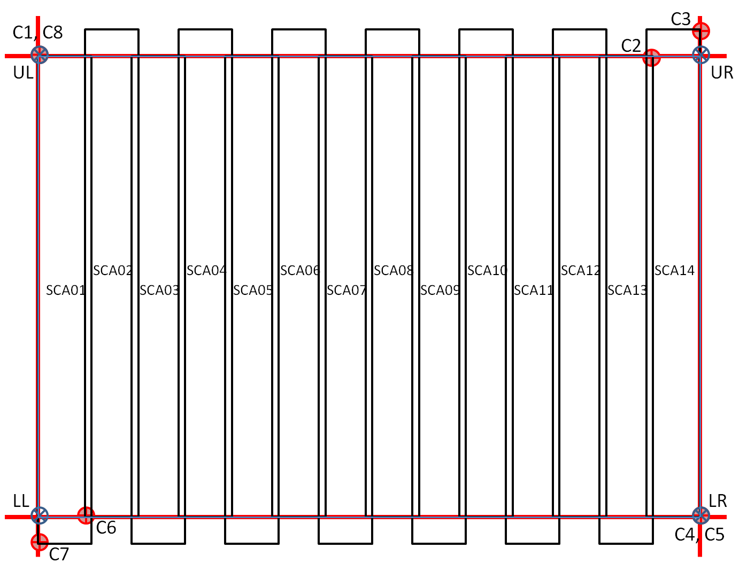

Figure 6‑10. Active OLI Image Area

The remainder of the calculations and determination of the minbox framing of the active OLI image area is described in the Calculating the Active Image Area section of the OLI Line-of-Sight Projection/Grid Generation ADD (see 6.2.1). The results of these calculations should be the latitude and longitude of the four bounding corner points represented by the blue points in Figure 6‑10.

##### TIRS Active Image Area

The active image area (minbox) for TIRS is computed by constructing 8 critical SCA corner points from the 10.8 µm band, labeled C1 through C8 in Figure 6‑11. This figure depicts the current understanding of the TIRS field of view orientation with respect to object space, but the algorithm described here will work as long as the SCAs are numbered sequentially across the field of view, in either direction. Points C1 and C2 define the top edge of the active area, C3 and C4 the right edge, C5 and C6 the bottom edge, and C7 and C8 the left edge. Note that points C4 and C5 are the same (the lower- right corner of SCA01), as are points C6 and C7 (the lower-left corner of SCA03). Use the forward model to project these eight line/sample locations to object space, computing the latitude/longitude coordinates for each point. The average elevation over the WRS-2 path/row is used as a rough adjustment from the WGS84 ellipsoid in the elevation parameter of the forward model for the eight line/sample to latitude/longitude calculations. Use the WRS-2 Scene average elevation look-up file to determine the average elevation for the path/row being processed.

C8

C3

C4, C5

C6, C7

SCA03

SCA02

SCA01

UL

LL

UR

LR

C2

C1

Figure 6‑11. Active TIRS Image Area

The corner point assignments are made by examining the SCA across-track and along-track Legendre coefficients to determine: 1) whether SCA01 is on the left (+Y) or right (-Y) side of the scene; 2) whether even or odd SCAs lead; and 3) whether the sample number increases in the –Y or +Y direction. If the across-track Legendre constant term (coef_y0) for SCA01 is positive, then it is the left-most SCA and SCA03 is the right-most. If the along-track Legendre constant term (coef_x0) for SCA01 is greater than that for SCA02, then the odd SCAs lead. If the across-track Legendre linear term (coef_y1) for SCA01 is negative, then the sample number increases in the –Y direction.

Having determined the orientation of the SCAs, assign the top edge to the left-most leading SCA Upper-Left (UL) corner and the right-most leading SCA Upper-Right (UR) corner, the right edge to the right-most SCA UR and Lower-Right (LR) corners, the bottom edge to the right-most trailing SCA LR corner and left-most trailing SCA lower-left (LL) corner, and the left edge to the left-most SCA LL and UL corners. As shown in the figure, for the TIRS: C1 = SCA02 (left-most leading SCA) UL, C2 = SCA02 (right-most leading SCA) UR, C3 = SCA01 (right-most SCA) UR, C4 = SCA01 (right-most SCA) LR, C5 = SCA01 (right-most trailing SCA) LR, C6 = SCA03 (left-most trailing SCA) LL, C7 = SCA03 (left-most SCA) LL, and C8 = SCA03 (left-most SCA) UL. Note that these assignments are based on the current TIRS SCA ordering of SCA-B = SCA01, SCA-C = SCA02, and SCA-A = SCA03, and could change if the SCA numbering system is revised. If this were to happen, the change would be reflected in the Legendre coefficients, so the logic described here would automatically compensate.

The Calculating the Active Image Area section of the TIRS Line-of-Sight Projection/Grid Generation ADD describes the remainder of the calculations and determination of the minbox framing of the active TIRS Image area. The results of these calculations should be the latitude and longitude of the four bounding corner points represented by the blue points in Figure 6‑11.

As depicted in Figure 6‑12, the lower corner coordinates correspond to the leading edge (last line) of a scene, and upper coordinates correspond to the trailing edge (first line) of a scene from the outermost bands on the SCAs. Leading/Trailing edges are based on which SCA/Band/Detectors are first/last in relation to the direction of flight (ascending or descending) relative to the ground.

Lower

Left

Upper

Left

Lower

Right

Descending

Upper

Right

South

West

North

East

North

West

South

East

Upper

Right

Lower

Right

Upper

Left

Ascending

Lower

Left

South

West

North

East

North

West

South

East

Figure 6‑12. Leading/Trailing Scene Edge

##### Determine Nadir WRS-2 Path/Row Sub-Algorithm

The ephemeris data are used to define the nadir WRS-2 path and row. The following routine is called to determine the nadir-pointing position of the satellite for Landsat Scene IDs and to determine scene center times for polar region rows. This is also known as the “heritage nadir scene framing algorithm.”

Inputs:

* *ecef_pos, ecef_vel* (Ephemeris State Vector in Earth-Centered, Earth-Fixed coordinates).
* CPF WRS-2 Constants:
  + *Long_Path1_Row60* (longitude of Path 1 at Row 60 = -64.6 deg).
  + *WRS_Cycle_Days* (number of days per WRS cycle = 16 days)
  + *WRS_Cycle_Orbits* (number of orbits per WRS cycle = 233 orbits)
  + *Scenes_Per_Orbit* (number of scenes or rows in each orbit = 248 rows)
  + *Descending_Node_Row* (row number of equator when descending = 60)
  + *Omega_E* (WGS-84 Earth's inertial rotation rate, rad/sec)

Outputs:

* Fractional WRS-2 Orbital Path & Row.

Procedure:

1. Convert the CPF path 1 row 60 longitude to radians.



1. Compute the Earth angular rate (solar to account for orbital precession).



1. Compute the spacecraft angular rate.



1. Normalize the incoming position and velocity vectors.



Adjust the velocity vector by Earth’s inertial rotation rate. Note: If the ephemeris data have already been preprocessed, the ADP output ECEF ephemeris can be used, and this velocity adjustment is not needed.



and normalize.



1. Compute the spacecraft angular momentum.



1. Compute the vector to the descending node.



and normalize.



1. Compute the central travel angle from the descending node and the spacecraft position vector.



1. Compute the row number from the central angle.



1. Compute the longitude of the instantaneous descending node.



1. Compute the path number from the longitude of row 60.



Note: The (0.5 – Descending_Node_Row) is the distance in WRS rows from the start of the path (row 0.5) to the descending node (row 60).

1. Make sure the row number is in range.

*while ( frow < 0.5 )*

*fpath = fpath – 16;*

*frow = frow + Scenes_Per_Orbit;*

*while ( frow > Scenes_Per_Orbit + 0.5 )*

*fpath = fpath + 16;*

*frow = frow – Scenes_Per_Orbit;*

1. Make sure the path number is in range.

*while ( fpath < 1 )*

*fpath = fpath + WRS_Cycle_Orbits;*

*while ( fpath > WRS_Cycle_Orbits )*

*fpath = fpath – WRS_Cycle_Orbits;*

*frow = frow – Scenes_Per_Orbit;*

##### Interpolate Attitude Quaternion Sub-Algorithm

Given a sequence of time-stamped quaternions, (**qi**, ti), and a time, t0, at which the interpolated quaternion is desired:

1. Step through the quaternion time stamps to identify the latest quaternion time, ti, which is less than or equal to the interpolation time of interest, t0.
2. Calculate the quaternion **q** that rotates **qi** to **qi+1**:

**q** = **qi+1** **q'i**

where: **q'i** is the conjugate of quaternion **qi**. See the quaternion conjugation and quaternion multiplication sub-algorithms below.

1. If the sign of the fourth element of **q,** q4, is negative, change the sign of the entire quaternion.
2. Decompose the **q** quaternion into its angle () and axis of rotation (**x**) form:

sin(/2) = sqrt( q1*q1 + q2*q2 + q3*q3 )

cos(/2) = q4

❑ = 2 * atan( sin(/2) / cos(/2) )

**x** = [ q1/sin(/2) q2/sin(/2) q3/sin(/2) ]T

noting that if sin(/2) = 0 then **x** = **0**.

1. Linearly interpolate the angle 0 at time t0:

0 =  * (t0 - ti) / (ti+1 - ti)

1. Construct the quaternion corresponding to the new rotation angle 0:

**q0** = [ sin(0/2) **x**T cos(0/2) ]

1. Apply the new delta quaternion to **qi** to compute **q0**, the quaternion at time t0:

**q0** = **q0** **qi**

*Quaternion Conjugation Sub-Algorithm*

The conjugate **q'**, of a quaternion **q**, is computed by inverting the sign on the first three elements of **q**:

q' = [ -q1 -q2 -q3 q4 ]

*Quaternion Multiplication Sub-Algorithm*

The product **c**, of quaternions **a** and **b** is given by:

c1 = a4 b1 + a3 b2 - a2 b3 + a1 b4

c2 = -a3 b1 + a4 b2 + a1 b3 + a2 b4

c3 = a2 b1 - a1 b2 + a4 b3 + a3 b4

c4 = -a1 b1 - a2 b2 - a3 b3 + a4 b4

Note: Quaternion multiplication does not commute. Also, note that other formulations of quaternion multiplication are possible. Any consistent formulation should work in the interpolation equations above.

##### Convert Geodetic Latitude/Longitude to WRS-2 Path/Row Sub-Algorithm

Given a boresight geodetic latitude , and longitude , and the corresponding spacecraft velocity Z component Vz (to determine whether the scene is ascending or descending):

1. Compute the geocentric latitude , from the geodetic latitude , and the WRS84 ellipsoid semi-major (a) and semi-minor (b) axes:

❑ = atan( tan(  ) * b/a * b/a )

1. Use the geocentric latitude and the nominal Landsat orbital inclination (*i* = 98.2 degrees) to compute the longitude offset to the apparent descending node:

off = asin( tan(  ) / tan ( - *i*) )

This calculation should include a test to ensure that the argument of the asin function is in the range -1 to +1, clipping the value to this range if necessary (e.g., for latitudes outside the standard WRS-2 range).

1. Calculate the central travel angles for both the descending and ascending cases:

CTAd = asin( -sin(  ) / sin ( - *i*) )

CTAa =  - CTAd

As above, the range of the asin function argument should be clipped to the range -1 to +1.

1. Compute the allowable range of central travel angles on a given WRS path as:

min CTA = (0.5 - 60.0)/248 * 2

max CTA = (248.5 - 60.0)/248 * 2

1. Add or subtract 2 to the descending and ascending central travel angles to bring them within the allowable range.

If ( CTAd < min CTA ) CTA'd = CTAd + 2

Else if ( CTAd > max CTA ) CTA'd = CTAd - 2

Else CTA'd = CTAd

If ( CTAa < min CTA ) CTA'a = CTAa + 2

Else if ( CTAa > max CTA ) CTA'a = CTAa - 2

Else CTA'a = CTAa

1. Compute the Earth rotation angles from the adjusted central travel angles:

d = CTA'd * Earth rotation rate / Spacecraft angular rate

a = CTA'a * Earth rotation rate / Spacecraft angular rate

1. Calculate the apparent descending node longitudes for the descending and ascending cases:

DNd =  - off + d

DNa =  + off +  + a

1. Select the descending or ascending case:

If ( Vz > 0.0 )

CTA' = CTA'a

DN = DNa

Else

CTA' = CTA'd

DN = DNd

1. Compute the (fractional) WRS-2 row number from the central travel angle:

row = row at equator (60) + CTA' / 2 * number of rows (248)

1. Compute the (fractional) WRS-2 path number:

0 = (longitude of path 1 at equator) - DN + 2

If ( 0 > 2 ) 0 = 0 - 2

path = 0 * number of paths (233) / 2 + 1

##### Search for Scene Center Time Sub-Algorithm

Given a scene center time (t0) and the corresponding WRS-2 row (row0) and a target (integer) row (rowT):

1. Compute the nominal WRS-2 row rate:

row rate = number of rows (248) / orbital period

1. Compute the row error:

row error = row0 - rowT

1. If the absolute value of the row error is less than 0.005, use the current scene center and exit the search.
2. Save the previous scene center time and row:

rowL = row0

tL = t0

1. Adjust the scene center time:

t0 = t0 - (row error) / (row rate)

1. Interpolate the spacecraft ephemeris and attitude at the new scene center time.
2. Project the boresight to the WGS84 ellipsoid at the new scene center time.
3. Compute the WRS-2 path/row at the boresight latitude/longitude as described above. This yields a new value of row0.
4. Compute the WRS-2 row rate:

row rate = (row0 - rowL) / (t0 - tL)

1. Continue the iterations at step 2 above.

Note: This sub-algorithm is only used for non-polar scenes, so the row transition from 248 to 1 is not an issue.

#### Maturity

The Scene Framing Algorithm is an attempt to document how OLI and TIRS scene sizes were derived and how to determine scene centers, orbital WRS-2 path/rows, and target WRS-2 path/rows. In addition, it addresses where to calculate corner point information to form the coordinates of the WRS-2 frame for the metadata. This algorithm relies on invoking all or part of the ancillary data preprocessing (6.1.4) and LOS projection algorithms.

Because this document was written before launch, most of the OLI and TIRS instrument information is known for the supporting calculations. However, there may be changes due to results from various instrument and spacecraft tests. As more data are received and analyzed, appropriate changes will be made as necessary.

#### Notes

Significant algorithm assumptions and notes, including those embedded in the text above, are as follows:

1. Ancillary data for the full imaging interval with 8 seconds of extra before and after the interval are available to provide the required geometric support data. A minimum of 4 seconds of extra ancillary data before and after **may** be sufficient for processing.
2. In the polar transition regions (rows 5, 115, 129, and 239), there may be larger scenes framed in situations where the spacecraft is rolled "away" from the pole (see step 2.d. of the main algorithm procedure above). In this configuration, the distance between scene centers can exceed 5664 OLI multispectral image frames. This occurs because the OLI is looking toward the equator where the rows are growing farther apart in latitude, while the spacecraft is flying at higher latitude where the rows are closer together in latitude. It thus takes more than a nominal row of flight time for the boresight to traverse one row of latitude. Other possible approaches would be to move the transition region toward the equator by five rows for intervals that are rolled toward the equator. The approach adopted here is to allow the off-nadir Level 0 Reformatted Product (L0Rp) scenes to be somewhat longer than nadir scenes.

##### Appendix A – Scene Sizing Background

###### OLI

The bore sight of the OLI telescope is parallel to the spacecraft +Z axis, which means it will be nadir pointing. The 14 OLI SCAs are arranged in two rows of seven, as shown in Figure 6‑13. The Field of View (FOV) of the telescope is 15 degrees in the cross-track direction and 1.7 degrees in the along-track direction.

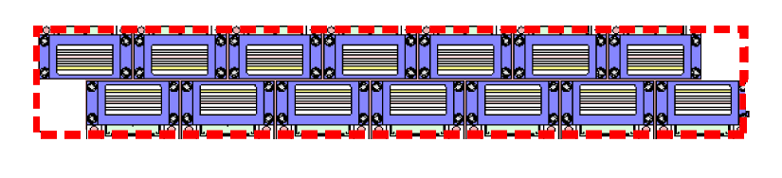

1.7 deg

Figure 6‑13. OLI SCA Layouts and FOV

The telescope bore sight will traverse one scene (i.e., scene center to scene center) in about 24 seconds, given the nominal orbit rate.

*WRS_Cycle_Days = 16 days*

*WRS_Cycle_Orbits = 233*

*Scenes_Per_Orbit = 248*

*Seconds_Day = 86400*

Calculate Spacecraft Angular Rotational rate:

$$ω= \frac{2*π*WRS_Cycle_Orbits}{WRS_Cycle_Days*Seconds_Day}=0.0010591049\frac{radians}{seconds}$$

Calculate time between successive WRS rows:

$$△t=\frac{WRS_Cycle_Days *Second_Day}{WRS_Cycle_Orbits*Scenes_Per_Orbit}=23.923577 seconds$$

The size of an OLI scene, in lines, can be calculated with respect to the bore sight with the following calculations. Rounding the above number to 24 seconds, the number of OLI lines between successive WRS rows is as follows:

*OLI_Frame_Rate = 236 lines / second*

$$OLI Lines=\frac{△t}{OLI_Frame_Rate}=5664 Lines$$

In addition, by definition of Landsat WRS products, WRS scenes are overlapped with the previous row by 5 percent, and the next row by 5 percent. The total number of OLI lines needed for the overlap is then 10 percent.

$$OLI Lines=OLI Lines+0.1*\frac{Δt}{OLI_Frame_Rate}=6230 Lines$$

However, the L8/9 OLI bands within each SCA are staggered with respect to the bore sight.

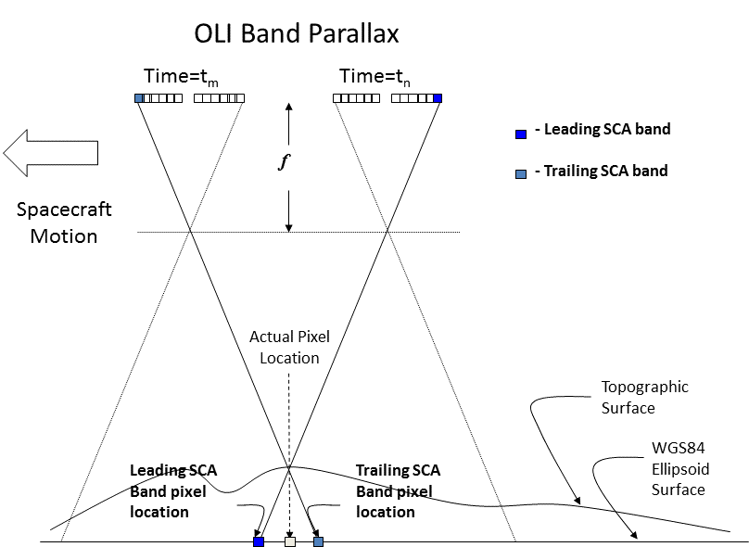

Figure 6‑14. OLI Band/SCA Band Parallax

This staggering represents a time difference between when the leading set of detectors within a SCA, for a given band, image the start and end of the WRS scene, and when the trailing set of detectors within a SCA, for a given band, image the start and end of the WRS scene.

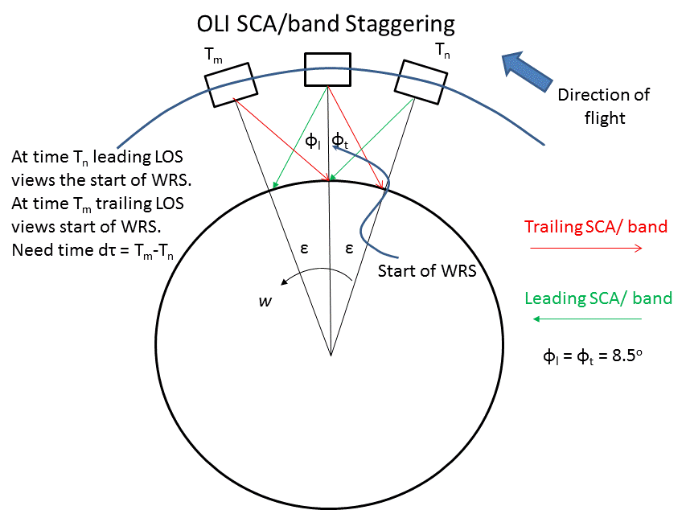

Figure 6‑15. OLI SCA/Band Staggering

The extra time required for the leading and trailing imaging bands of the SCAs to cover a point on the ground relative to the center of the focal plane will vary with position in orbit and scene elevation. Extra lines of imaging will be required at the beginning and end of the interval, or about 1.5 seconds of extra data on each side. This means that imaging must start at least 1.5 seconds prior to the telescope bore sight reaching the leading edge of the first scene in the desired interval and must continue for at least 1.5 seconds after passing over the trailing edge of the last scene of an interval. This will assure that all bands in all SCAs have completely imaged the scene.

Looking at the OLI Legendre LOS polynomials and determining the leading and trailing look vectors, the difference in radians/degrees is as follows:

Leading_LOS = 1.436414e-02 radians = 0.8230046 degrees

Trailing_LOS = -1.444101e-02 radians = -0.8265414 degrees

The difference between these two numbers represents a field of view of 1.65 degrees. Rounding this to 1.7 degrees (0.85 leading and 0.85 trailing), we can determine the amount of time needed to pad either the leading or trailing acquisition of the OLI WRS scene in terms of time. If the maximum satellite altitude is present at the poles and the minimum satellite altitude is present at the equator, the minimum and maximum number of lines needed in the L0Rp can be calculated.

*α = 0.85 degrees*

*Orbital_Radius = 7083445,719 meters*

*Semi_Major_Axis = 6378137.0 meters*

*Semi_Minor_Axis = 6356752.3142 meters*

*Major_Alt = Orbital_Radius – Semi_Major_Axis = 705308.72 meters*

*Minor_Alt = Orbital_Radius – Semi_Major_Axis = 726693.40 meters*

The ground distance covered at these two altitudes represented on the Earth are found as follows:

$$GD_Major=Major_Alt*tan⁡α=10464.234 meters$$

$$GD_Minor=Minor_Alt*tan⁡α=10781.505 meters$$

These ground distances represent an angular orbit change of the following:

$$ε=\operatorname{atan}\left(\frac{GD_Major}{Semi_Major_Axis}\right)=0.00164063 radians$$

$$ε=\operatorname{atan}\left(\frac{GD_Minor}{Semi_Minor_Axis}\right)=0.00169607 radians$$

Using the spacecraft angular rotational rate gives a delta time due to the staggering of the SCAs as the following:

$$dτ=\frac{ε}{ω}=1.5 and 1.6 seconds$$

Using the OLI frame rate, the number of OLI lines needed for this (maximum) delta time is as follows:

$$△Lines SCA Staggering=1.6 seconds*OLI_Frame_Rate=378 Lines$$

The total number of lines needed within an OLI WRS scene is then

Total Lines = (nominal size + 5% overlap + SCA staggering)

$$OLI Lines=OLI Lines+2*△Lines SCA Staggering=6986 Lines$$

For convenience and ease of use, the final number of OLI lines will be rounded to 7001 lines. An odd number is used so that a center line is found and the same number of before and after lines (3500) are used to define the entire L0R scene.

In terms of time, a single scene will take about 29.6 seconds:

1.6 sec (378 lines for leading edge SCA coverage)

+ 1.2 sec (5% overlap on leading edge)

+ 24.0 sec (time for WRS scene)

+ 1.2 sec (5% overlap on trailing edge)

+ 1.6 sec (378 lines for trailing edge SCA coverage)

= 29.6 sec (29.67 for 7001 lines)

###### TIRS

The TIRS SCAs are larger and farther apart than the OLI SCAs, which will require TIRS to begin imaging earlier, and continue for a longer duration than OLI in order to image a scene completely. The along-track of the TIRS instrument is 4.95 degrees (Figure 6‑16), requiring an additional 9.43 seconds (4.714 seconds for the leading and trailing edges) of imaging to assure all bands in all three SCAs have completely imaged the scene. The same logic used for calculating the number of OLI lines can be used for TIRS.

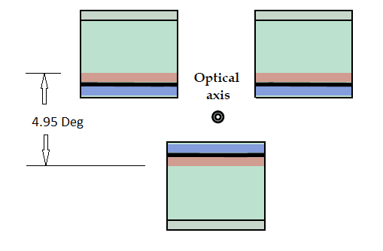

Figure 6‑16. TIRS Layout and FOV

The size of a TIRS scene, in lines, can be calculated with respect to the bore sight with the following calculations. The number of TIRS lines between successive WRS rows:

*TIRS_Frame_Rate = 70 lines / second*

$$TIRS Lines=\frac{△t}{TIRS_Frame_Rate}=1680 Lines$$

In addition, by definition of Landsat WRS products, WRS scenes are overlapped with the previous row by 5 percent and the next row by 5 percent. The total number of TIRS lines needed for the overlap is then 10 percent.

$$TIRS Line=TIRS Line+0.1*\frac{△t}{TIRS_Frame_Rate}=1848 Lines$$

Looking at the TIRS Legendre LOS polynomials and determining the leading and trailing look vectors, the difference in radians/degrees is as follows:

Leading_LOS = 4.623841e-02 radians = 2.65 degrees

Trailing_LOS = -3.989761e-02 radians = -2.29 degrees

The difference between these two numbers represents a field of view of 4.94 degrees. Rounding this to 5 degrees (2.7 leading and 2.3 trailing), we can determine the amount of time needed to pad either the leading or trailing acquisition of the TIRS WRS scene in terms of time. If the maximum satellite altitude is present at the poles and the minimum satellite altitude is present at the equator, the minimum and maximum number of lines needed in the L0Rp can be calculated. Using the spacecraft angular rotational rate gives a delta time due to the staggering of the SCAs as:

*dτ = 4.92 seconds (maximum)*

Using the TIRS frame rate, the number of TIRS lines needed for this (maximum) delta time is as follows:

$$△Lines SCA Staggering=5 seconds*TIRS_Frame_Rate=350 Lines$$

This delta is further extended by 50 lines to include the possible use of the secondary, or *science,* rows. The total number of lines needed within a TIRS WRS scene is then

Total Lines = (nominal size + 5% overlap + SCA staggering + 50 science)

$$TIRS Lines=TIRS Lines+2*(Δ Lines SCA Staggering+50)=2648 Lines$$

In terms of time, a single scene will take about 37.8 seconds:

5.0 sec (350 lines for leading edge SCA coverage)

+ 0.7 sec (50 lines to include science rows)

+ 1.2 sec (5% overlap on leading edge)

+ 24.0 sec (time for WRS scene)

+ 1.2 sec (5% overlap on trailing edge)

+ 0.7 sec (50 lines to include science rows)

+ 5.0 sec (350 lines for trailing edge SCA coverage)

= 37.8 sec

To ensure TIRS fully covers OLI, additional lines should be added to account for any misalignment between the OLI and TIRS bore sights (which has a one-second tolerance) and OLI to ACS alignment, any biases present in the pointing of the SSM, etc. In addition, the above calculations use nominal values, prelaunch information, and rounding liberties that should be taken into consideration.

The TIRS number of lines can also be calculated based on the number of OLI lines to ensure full coverage of the TIRS data with OLI data. The number of TIRS lines can be found by first scaling the OLI number of lines needed to cover the 180km scene (6230 lines) by the ratio of the nominal line sample rates of OLI-to-TIRS:

$$TIRS Lines=6230 OLI Lines*\frac{70 Hz}{236 Hz}=1848 Lines$$

This number then needs to be adjusted for the TIRS leading and trailing SCA/band staggering. From the above TIRS calculations, this value is 700 lines. Another 112 lines are needed for the alignment tolerances and 100 lines to include the science rows. The total number of lines needed within a TIRS WRS scene that will fully cover the OLI data is then:

$$TIRS lines=1848+700+100+112=2760 Lines$$

For convenience and ease of use, the final number of TIRS lines will be rounded to 2801 lines. An odd number is used so that a center frame is found and the same number of before and after frames (1400) is used to define the entire L0R scene.

This is equivalent to 40.01 seconds of TIRS data to cover the 29.67 seconds of OLI data. This means TIRS imaging will need to start/end approximately 5.2 seconds before/after OLI to ensure adequate coverage.

From the calculations listed above, the size of the OLI will be 7001 lines (multispectral) and the size of the TIRS will be 2801 lines (thermal).

##### Appendix B – Comparison of Partial Scene Definitions

LSDS-270 Landsat 7 (L7) Enhanced Thematic Mapper Plus (ETM+) Level 0 Reformatted Archive (L0Ra) Data Format Control Book (DFCB) has the following discussion of partial scenes:

For a partial scene with more than half a scene length data, the computed "actual" scene center is also expected to happen in the proximity of the nominal WRS scene center. The "actual" scene center for a greater than half a scene length partial scene may also be computed from the available actual Payload Correction Data (PCD) and indexed to actual data in the band file. For a partial scene with less than half a scene length data, the scene center may have to be computed from extrapolated* ephemeris (no actual PCD may be available from the subinterval). The computed "imaginary" scene center for such a partial scene (less than half a scene) is still determined in the proximity of the nominal WRS scene center, but there will not be any actual band data in the subinterval band file for which to relate the scene center. The computed "imaginary" scene center for a partial scene with less than half a scene length data is indexed to an "imaginary scan" (non-existent scan 0) in the band file.

* For L8/9, extrapolation of ancillary data beyond the existing ancillary/ephemeris was not provided and/or is not possible. The above method will not work for L8/9, so it was decided that the scene center would actually represent the center of the partial (although the implementation currently takes the first or last line in the scene closest to the WRS-2 center. A future release will address this difference).

The current LSDS-524 Landsat Metadata Definition Document (LMDD) definition for L8/9 partial scenes is as follows:

FULL = Full WRS scene - the standard 180 x 185km WRS size.

PARTIAL = Partial WRS scene - less than full and includes the scene center, or greater than half and includes the scene center.

The definition provided in Configuration Change Request (CCR) #598 reads:

PROPOSED: .”..less than a full scene that is not covered by overlap."

RATIONALE FOR CHANGE

-provide consistency with heritage Landsat

-have all scene metadata available in the Inventory

-enable future ability to handle ad hoc requests for partial scenes in Subsetter

The current LSDS-270 Landsat 7 (L7) Enhanced Thematic Mapper Plus (ETM+) Level 0 Reformatted Archive (L0Ra) Data Format Control Book (DFCB) definition for partial scenes is as follows:

Full – A full WRS scene product with approximately ten percent overlap is defined as 180km. For OLI, this is 7001 frames (~28.86-meter MS lines) and for TIRS, this is 2801 frames (~86.91-meter lines).

Partial – Considered less than a full scene.

Scene Center - The computed "actual" scene centers are from the image frame closet to the nominal WRS scene center

1. For any Thermal Infrared Sensor (TIRS) only Earth acquisitions, the TIRS boresight is used.
2. In contrast, framing all off-nadir data based on the spacecraft position instead of the boresight location was rejected, as it would lead to off-nadir scenes exhibiting an along-track shift relative to the adjacent path nadir data.
3. Note that these rows were selected as the boundary of the polar region because a 15-degree roll at this latitude corresponds to approximately a one row offset from nadir.
4. Use the TIRS boresight if OLI isn’t present.
5. Note that the number of adjacent rows may have to be adjusted if the polar region boundary scene sizes do not frame to the proper sizes.