### Coordinate Systems

#### Coordinate System Definitions

The L8/9 IAS geometric algorithms use ten coordinate systems. These coordinate systems are referred to frequently in the remainder of this document and are briefly defined here to provide context for the subsequent discussion. They are presented in the order in which they would be used to transform a detector and sample time into a ground position.

1. OLI Instrument Line-of-Sight (LOS) Coordinate System

The OLI LOS coordinate system is used to define the band and detector pointing directions relative to the instrument axes. These pointing directions are used to construct LOS vectors for individual detector samples. This coordinate system is defined so that the Z-axis is parallel to the telescope boresight axis and is positive toward the OLI aperture. The origin is where this axis intersects the OLI focal plane. The X-axis is parallel to the along-track direction, with the positive direction toward the leading, odd numbered, SCAs (see Figure 6‑1). The Y-axis is in the across-track direction, with the positive direction toward SCA01. This definition makes the OLI coordinate system nominally parallel to the spacecraft coordinate system, with the difference being due to residual misalignment between the OLI and the spacecraft body.

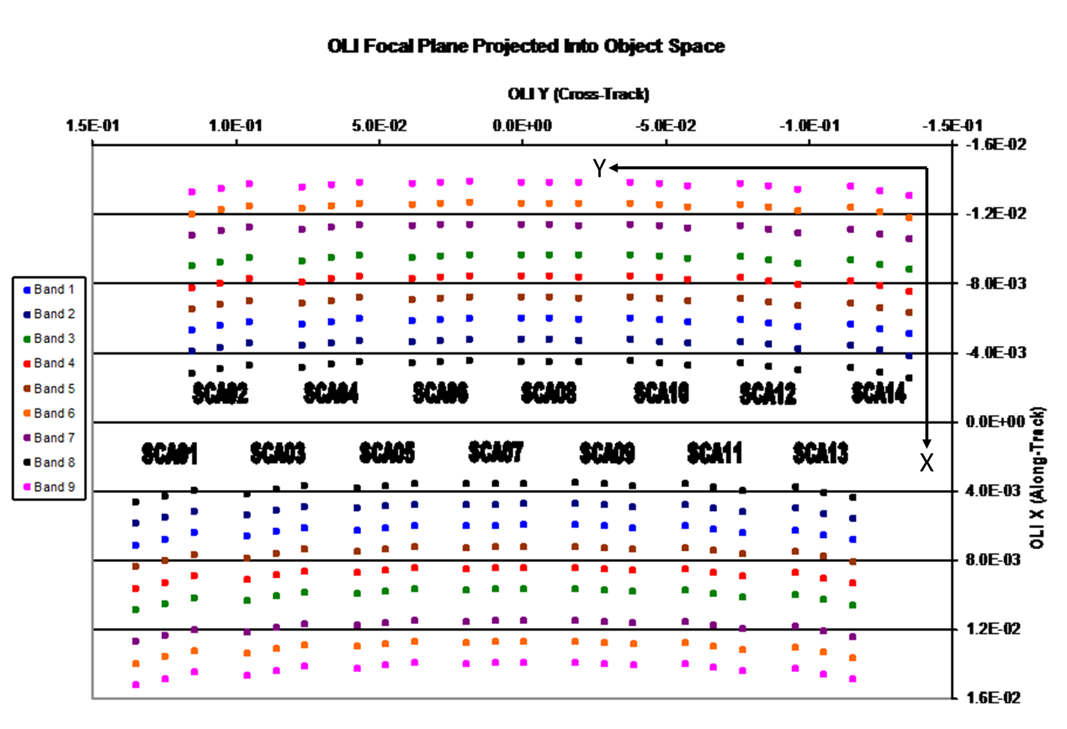

Figure 6‑1. OLI Line-of-Sight Coordinate System

1. TIRS Instrument Coordinate System

The orientations of the TIRS detector LOS directions and of the TIRS Scene Select Mirror (SSM) are both defined within the TIRS instrument coordinate system. TIRS LOS coordinates define the band and detector-pointing directions relative to the instrument axes. These pointing directions are used to construct LOS vectors for individual detector samples. These vectors are reflected off the SSM to direct them out the TIRS aperture for Earth viewing. The TIRS LOS model is formulated so that the effect of a nominally pointed SSM is included in the definition of the detector lines-of-sight, with departures from nominal SSM pointing causing perturbations to these lines-of-sight. This formulation allows TIRS LOS construction to be very similar to OLI, and is described in detail below, in the TIRS Line-of-Sight Model Creation algorithm (see 6.3.1).

The TIRS coordinate system is defined so that the Z-axis is parallel to the TIRS boresight axis and is positive toward the TIRS aperture. The origin is where this axis intersects the TIRS focal plane. The X-axis is parallel to the along-track direction, with the positive direction toward the leading SCA, SCA02 (see Figure 6‑2). The Y-axis is in the across-track direction, with the positive direction toward SCA03. This definition makes the TIRS coordinate system nominally parallel to the spacecraft coordinate system, with the difference being due to residual misalignment between the TIRS and the spacecraft body.

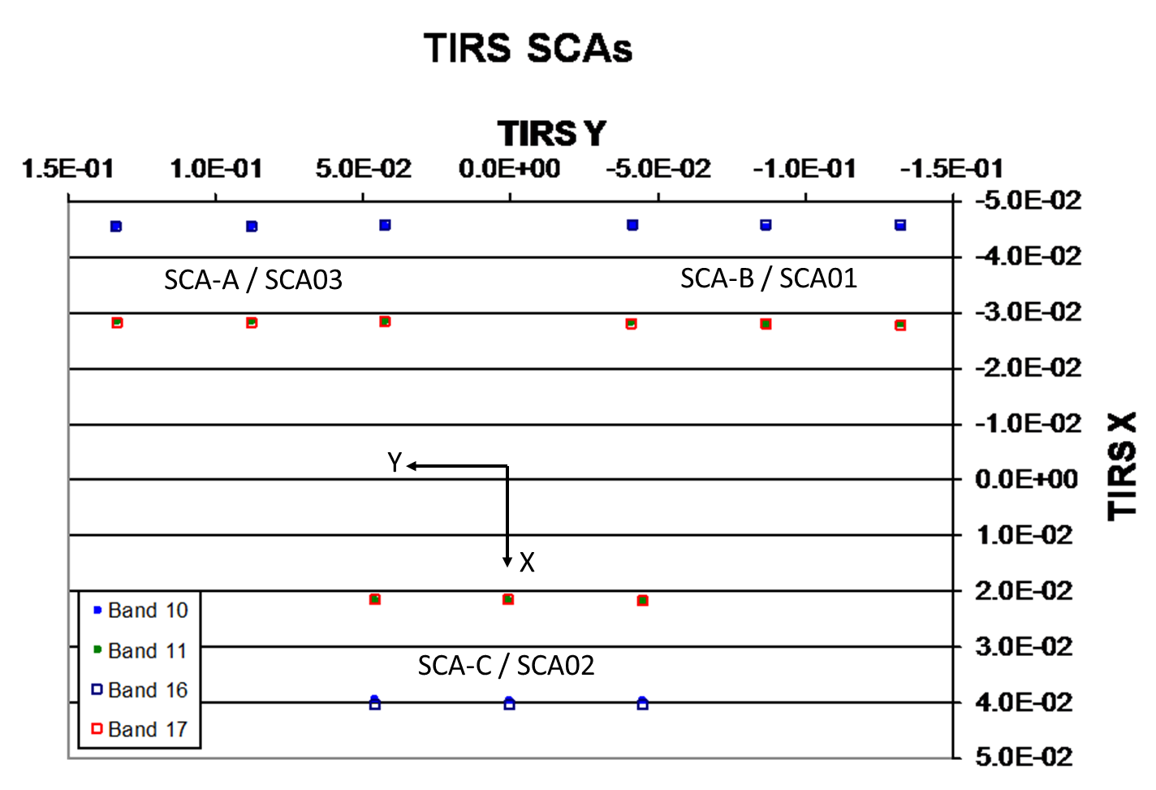

Figure 6‑2. TIRS Line-of-Sight Coordinates

1. Spacecraft Coordinate System

The spacecraft coordinate system is the spacecraft-body-fixed coordinate system used to relate the locations and orientations of the various spacecraft components to one another and to the OLI and TIRS instruments. It is defined with the +Z axis in the Earth-facing direction, the +X axis in the nominal direction of flight, and the +Y axis toward the cold side of the spacecraft (opposite the solar array). This coordinate system is useful during observatory integration and prelaunch test, where it is used to determine the prelaunch positions and alignments of the attitude control sensors (star trackers and Space Inertial Reference Unit (SIRU)) and instrument payloads (OLI and TIRS). The spacecraft coordinate system is nominally the same as the navigation reference system (see below) used for spacecraft attitude determination and control. However, for reasons explained below, these two coordinate systems are treated separately.

1. Navigation Reference Coordinate System

The navigation reference frame (a.k.a., the attitude control system reference) is the spacecraft-body-fixed coordinate system used for spacecraft attitude determination and control. The coordinate axes are defined by the spacecraft Attitude Control System (ACS), which attempts to keep the navigation reference frame aligned with the (yaw-steered) orbital coordinate system (for nominal nadir pointing) so that the OLI and TIRS boresight axes are always pointing toward the center of the Earth. The orientation of this coordinate system relative to the inertial coordinate system is captured in spacecraft attitude data.

Ideally, the navigation reference frame is the same as the spacecraft coordinate system. In practice, the navigation frame is based on the orientation of the absolute attitude sensor (i.e., star tracker) being used for attitude determination. Any errors in the orientation knowledge for this tracker with respect to the spacecraft body frame will lead to differences between the spacecraft and navigation coordinate systems. This becomes important if the absolute attitude sensor changes (for example, by switching from the primary to the redundant star tracker during on-orbit operations). Such an event would effectively redefine the navigation frame to be based on the redundant tracker, with the difference between the spacecraft and navigation frames now resulting from redundant tracker alignment knowledge errors, rather than from primary tracker alignment knowledge errors. This redefinition would require updates to the on-orbit instrument-to-ACS alignment calibrations. Therefore, the spacecraft and navigation reference coordinate systems are different because the spacecraft coordinate system is fixed but the navigation reference can change.

1. SIRU Coordinate System

The spacecraft orientation rate data provided by the spacecraft attitude control system’s inertial measurement unit are referenced to the SIRU coordinate system. The SIRU consists of four rotation-sensitive axes. This configuration provides redundancy to protect against the failure of any one axis. The four SIRU axis directions are determined relative to the SIRU coordinate system, the orientation of which is itself measured relative to the spacecraft coordinate system, both prelaunch and on-orbit, as part of the ACS calibration procedure. The IAS uses this alignment transformation to convert the SIRU data contained in the L8/9 spacecraft ancillary data to the navigation reference coordinate system for blending with the ACS quaternions.

1. Orbital Coordinate System

The orbital coordinate system is centered at the spacecraft, and its orientation is based on the spacecraft position in inertial space (see Figure 6‑3). The origin is the spacecraft’s center of mass, with the Z-axis pointing from the spacecraft’s center of mass to the Earth’s center of mass. The Y-axis is the normalized cross-product of the Z-axis and the instantaneous (inertial) velocity vector, and corresponds to the negative of the instantaneous angular momentum vector direction. The X-axis is the cross-product of the Y and Z-axes. The orbital coordinate system is used to convert spacecraft attitude, expressed as Earth-Centered Inertial (ECI) quaternions, to roll-pitch-yaw Euler angles.



Figure 6‑3. Orbital Coordinate System

1. ECI J2000 Coordinate System

The ECI coordinate system of epoch J2000 is space-fixed with its origin at the Earth's center of mass (see Figure 6‑4). The Z-axis corresponds to the mean north celestial pole of epoch J2000.0. The X-axis is based on the mean vernal equinox of epoch J2000.0. The Y-axis is the cross-product of the Z and X axes. The Explanatory Supplement to the Astronomical Almanac published by the U.S. Naval Observatory describes this coordinate system in detail. Data in the ECI coordinate system are present in the L8/9 spacecraft ancillary data form of attitude quaternions that relate the navigation frame to the ECI J2000 coordinate system.



Figure 6‑4. Earth-Centered Inertial (ECI) Coordinate System

1. ECEF Coordinate System

The Earth-Centered Earth-Fixed (ECEF) coordinate system is Earth-fixed, with its origin at the Earth’s center of mass (see Figure 6‑5). It corresponds to the Conventional Terrestrial System defined by the Bureau International de l’Heure (BIH), which is the same as the U.S. Department of Defense World Geodetic System 1984 (WGS84) geocentric reference system. This coordinate system is described in the Supplement to Department of Defense World Geodetic System 1984 Technical Report, Part 1: Methods, Techniques, and Data Used in WGS84 Development, TR 8350.2-A, published by the National Geospatial-Intelligence Agency (NGA).



Figure 6‑5. Earth-Centered Earth-Fixed (ECEF) Coordinate System

1. Geodetic Coordinate System

The geodetic coordinate system is based on the WGS84 reference frame, with coordinates expressed in latitude, longitude, and height above the reference Earth ellipsoid (see Figure 6‑6). No ellipsoid is required by the definition of the ECEF coordinate system, but the geodetic coordinate system depends on the selection of an Earth ellipsoid. Latitude is the angle between the ellipsoid normal and its projection onto the equator, while longitude is the angle between the local meridian and the Greenwich meridian. The scene center and scene corner coordinates in the Level 0R product metadata are expressed in the geodetic coordinate system.



Figure 6‑6. Geodetic Coordinate System

1. Map Projection Coordinate System

Level 1 products are generated with respect to a map projection coordinate system, such as the Universal Transverse Mercator (UTM), which provides mapping from latitude and longitude to a plane coordinate system that is an approximation of a Cartesian coordinate system for a portion of the Earth’s surface. It is used for convenience as a method of providing digital image data in an Earth-referenced grid that is compatible with other ground-referenced data sets. Although the map projection coordinate system is only an approximation of a true local Cartesian coordinate system at the Earth’s surface, the mathematical relationship between the map projection and geodetic coordinate systems is defined precisely and unambiguously.

#### Coordinate Transformations

Eight key transformations relate the ten coordinate systems used by the IAS geometric algorithms. These transformations are referred to frequently in the remainder of this document and are defined here. They are in the logical order in which a detector and sample number would be transformed into a ground position.

1. OLI-to-Navigation Reference Transformation

The OLI instrument alignment matrix describes the relationship between the OLI instrument and navigation reference coordinate systems. The transformation from sensor coordinates to navigation reference coordinates is a three-dimensional rotation, implemented as a matrix multiplication, and an offset to account for the distance between the ACS reference and the instrument aperture. This spacecraft center of mass-to-sensor offset is measured prelaunch and is not expected to be updated on-orbit. The ACS-to-OLI transformation matrix is initially defined as a static (non-time varying) rotation, with improved estimates provided postlaunch. Subsequent analysis may detect repeatable variations with time, which can be effectively modeled, making this a (slowly) time-varying transformation. The nominal rotation matrix is the identity matrix.

1. TIRS-to-Navigation Reference Transformation

The TIRS instrument alignment matrix describes the relationship between the TIRS instrument and navigation reference coordinate systems. Like the OLI, the transformation from sensor coordinates to navigation reference coordinates is a three-dimensional rotation, implemented as a matrix multiplication, and an offset to account for the distance between the ACS reference and the instrument aperture. This spacecraft center of mass-to-sensor offset is measured prelaunch and is not expected to be updated on-orbit. The ACS-to-TIRS transformation matrix measured directly prelaunch. Postlaunch, improved estimates will be provided by estimating the OLI-to-TIRS alignment and combining that with the ACS-to-OLI alignment previously described. Note that any TIRS pointing offsets that are due to errors in SSM alignment knowledge will be attributed to the overall ACS-to-TIRS alignment by the on-orbit calibration. The nominal ACS-to-TIRS rotation matrix is the identity matrix.

1. SIRU-to-Navigation Reference Transformation

The SIRU coordinate system is related to the navigation reference coordinate system by the SIRU alignment matrix, which captures the orientation of the SIRU axes with respect to the navigation base. This transformation is applied to the SIRU measurements present in the spacecraft ancillary data prior to their integration with the ACS quaternions. The SIRU alignment is measured pre-flight, and is nominally oriented with a 45-degree rotation about the X-axis, relative to the spacecraft/navigation reference coordinate system.

1. Navigation Reference-to-Orbital Transformation

The spacecraft attitude defines the relationship between the navigation reference and orbital coordinate systems. This transformation is a three-dimensional rotation matrix, with the components of the rotation matrix being functions of the spacecraft roll, pitch, and yaw attitude angles. The nature of the functions of roll, pitch, and yaw depends on the exact definition of these angles. The conventions adopted in the L8/9 model are described below in the Ancillary Data Preprocessing algorithm (6.1.4). Since the spacecraft attitude is constantly changing, this transformation is time varying. The nominal rotation matrix consists of a latitude-dependent rotation about the Z-axis (yaw). This “yaw-steering” is designed to compensate for the effects of Earth rotation as spacecraft motion passes the OLI and TIRS detector arrays over the Earth’s surface.

1. Orbital-to-ECI Transformation

The relationship between the orbital and ECI coordinate systems is based on the spacecraft's instantaneous ECI position and velocity vectors. The rotation matrix to convert from orbital to ECI can be constructed by forming the orbital coordinate system axes in ECI coordinates:

P = spacecraft position vector in ECI

V = spacecraft velocity vector in ECI

Teci/orb = rotation matrix from orbital to ECI

b3 = –p / |p| (nadir vector direction)

b2 = (b3 x v) / |b3 x v| (negative of angular momentum vector direction)

b1 = b2 x b3 (circular velocity vector direction)

Teci/orb = [ b1 b2 b3 ]

1. ECI-to-ECEF Transformation

The transformation from ECI-to-ECEF coordinates is a time-varying rotation due primarily to the Earth’s rotation, but it also contains more slowly varying terms for precession, astronomic nutation, and polar wander. The ECI-to-ECEF rotation matrix is expressed as a composite of these transformations:

Tecr/eci = A B C D

A = polar motion

B = sidereal time

C = astronomic nutation

D = precession

Each of these transformation terms is described in more detail below in the Ancillary Data Preprocessing algorithm (6.1.4). Note that L8/9 uses the precession, nutation, and sidereal time definitions from the IAU resolutions of 1997-2000, as described in U.S. Naval Observatory Circular 179. This is a newer formulation than was used in the heritage Landsat 7 system.

1. ECEF-to-Geodetic Transformation

The relationship between ECEF and geodetic coordinates can be expressed simply in its direct form:

*e*2 = 1 – b2 / a2

N = a / (1 – *e*2 sin2(*lat*))1/2

X = (N + *h*) cos(*lat*) cos(*lon*)

Y = (N + *h*) cos(*lat*) sin(*lon*)

Z = (N (1 – *e*2) + *h*) sin(*lat*)

where:

X, Y, Z = ECEF coordinates

*lat*, *lon*, *h* = geodetic coordinates

N = ellipsoid radius of curvature in the prime vertical

*e*2 = ellipsoid eccentricity squared

a, b = ellipsoid semi-major and semi-minor axes

The closed-form solution for the general inverse problem (the problem of interest here) involves the solution of a quadratic equation, and is not typically used in practice. Instead, an iterative solution is used for latitude and height for points that do not lie on the ellipsoid surface.

1. Geodetic-to-Map Projection Transformation

The transformation from geodetic coordinates to the output map projection depends on the type of projection selected. John P. Snyder’s Map Projections – A Working Manual, USGS Professional Paper 1395 gives the mathematics for the forward and inverse transformations for the UTM, Lambert Conformal Conic, Transverse Mercator, Oblique Mercator, Polyconic, Polar Stereo Graphic, and the Space Oblique Mercator (SOM).