* + 1. TIRS Scene Select Mechanism (SSM) Model Fit Algorithm

# Background/Introduction

In December 2014, failures in the Landsat 8 TIRS SSM mirror encoder circuitry made it necessary to operate the instrument with the SSM in an open loop control mode (mode-0) with the SSM position encoder turned off. This anomaly was eventually resolved by switching to the redundant “B-side” TIRS electronics, allowing TIRS SSM operations to continue in the nominal closed loop control mode (mode-4). Subsequent anomalous behavior in the B-side electronics raised the possibility of having to perform sustained TIRS operations in mode-0, leading to a requirement for an operational SSM position estimation, modeling, and prediction capability. This capability would replace the SSM encoder position measurements provided in the downlinked ancillary data; which are unavailable when operating in the open loop mode-0 with the encoder turned off; with SSM position estimates calculated using a time-varying model of SSM position. This algorithm uses estimates of the SSM position, derived from individual calibration scenes, and any available SSM encoder telemetry to construct such a time-varying model of SSM motion/position. This model is then used to predict SSM pointing in support of TIRS Level 1 data processing.

The SSM calibration algorithm uses the trended output of the TIRS SSM calibration algorithm and combines those single-scene estimates of SSM position with available SSM encoder measurements collected during the first few minutes following a mode-4 to mode-0 switch, to construct an integrated measurement data set (see note #1). These measurements are used to adjust the parameter values in a linear with exponential decay model that was empirically determined to track actual SSM motion following a mode-0 switch. The time density and duration of the measurement data set determines which model parameters are candidates for adjustment in any given invocation of the model fit logic. Once a refined set of model parameter values are computed, they are used to generate a table of estimated SSM positions for the time period following the mode switch, suitable for use in the geometric correction of TIRS data acquired during that time period (see note #2).

The algorithm consists of several sub-functions, controlled by a graphical user interface (GUI), that together implement the steps needed to create the SSM position estimate records used in Level 1 data processing. These sub-functions include:

1. Identifying a new mode-4 to mode-0 switch event and creating an initial SSM position model for the time period following the event.
2. Modifying the parameters (i.e., start date/time) of an existing mode-0 switch event. This may be necessary to correct an event that was initially created based upon a planned switch time to the actual event time.
3. Gathering the available measurements of SSM position for the time period following the switch event, including both SSM encoder measurements reported in the TIRS telemetry and scene-based position measurements derived by the SSM calibration algorithm, and using these measurement data to solve for updates to the current SSM position model parameters. This includes using the time distribution of data points to determine the subset of model parameters that can be reliably solved for given the available data coverage.
4. Using the updated model parameter values to generate a table of SSM position estimates covering the time span following the corresponding mode-4 to mode-0 switch event.

Mode-4 to mode-0 switch events and the associated estimated SSM pointing model parameter values are stored in the geometric trending database so that they are available to serve as either the starting point of a new model fit operation using newly acquired data, or to generate an updated SSM position table to support Level 1 processing.

# Dependencies

The TIRS SSM model fit algorithm assumes that either Level 1 processing or TIRS stored state of health (SOH) data ingest processing has extracted, preprocessed, and stored (in the geometric trending data base) the available SSM encoder telemetry for the mode-0 operating period. It also assumes that the TIRS SSM Calibration Algorithm 6.3.8 has analyzed one or more scenes and created estimated SSM positions which have also been stored in the geometric trending data base.

# Inputs

The TIRS SSM calibration algorithm uses the inputs listed in the following table. Note that some of these “inputs” are implementation conveniences (e.g., using an ODL parameter file to convey the values of and pointers to the input data). The second column in the table shows which algorithm operation: 1) mode-switch event identification (Add Event), 2) mode-switch event update (Edit Event), 3) data gathering and model fit (Fit Model), or 4) SSM position table generation (Generate Position); uses each input.

|  |  |
| --- | --- |
| **Algorithm Inputs** | **Operation** |
| ***User Input*** | Control |
| Operation selection: | Control |
| 1. Add new switch event. | Control |
| 2. Edit existing switch event. | Control |
| 3. Fit SSM position model. | Control |
| 4. Generate SSM position table. | Control |
| Event date as year, day of year, second of day  or UTC year, month, day, hour, minute, second. | Add Event  Edit Event |
| Event selection (from displayed list) | Edit Event  Fit Model |
| Fit Solution Acceptance | Fit Model |
| Position Table Start date/time (year, day of year, second of day) | Generate Position |
| Position Table End date/time (year, day of year, second of day) | Generate Position |
| Position Table Acceptance | Generate Position |
| ***CPF Service*** | Add Event  Fit Model |
| Calibration Parameter File (CPF) Path | Add Event  Fit Model |
| ***Calibration Parameter File (see note #3)*** | Fit Model  Generate Position |
| SSM nadir reference angles (side A and side B) | Fit Model |
| Leap second table (for spacecraft clock to/from UTC conversion) | Fit Model |
| Default Fit Quality Threshold (new parameter – 1 value) | Fit Model |
| Telemetry and Image Observation Weights (new parameters – 2 values, one for telemetry observations and one for image observations) | Fit Model |
| Apriori Parameter Weights (new parameters – 8 values, one per model parameter) | Fit Model |
| Model Parameterization Break Points (new parameters – 4 values that define the time break points between the 1, 3, 5, 7, and 8 parameter versions of the model fit) | Fit Model |
| Model Observation Gap Windows (new parameters – 3 pairs of values, each pair defining a time window which, lacking any observations, would cause the introduction of apriori parameter observations) | Fit Model |
| Convergence Threshold Weights (new parameters – 8 values, one per model parameter) | Fit Model |
| Sampling Interval Table (new parameters – variable number, nominally 14, of pairs of values, each pair defining a start time, in seconds, and a time increment, in seconds, to use in constructing the SSM position table entry times). | Generate Position |
| ***SSM Mode Switch Event Table (new table)*** | All |
| Mode switch ID, year, day of year, seconds of day (UTC) (see Table 1) | All |
| ***TIRS_TELEMETRY_COMMAND Table*** | Fit Model |
| L0R_TIME_DAYS_FROM_J2000 | Fit Model |
| L0R_TIME_SEC_OF_DAY | Fit Model |
| MC_ENCODER_FLAGS | Fit Model |
| SSM_MECH_MODE | Fit Model |
| SSM_ENCODER_POSITION_SAMPLE_2 | Fit Model |
| ***TIRS_TELEMETRY_CIRCUIT Table*** | Fit Model |
| L0R_TIME_DAYS_FROM_J2000 | Fit Model |
| L0R_TIME_SEC_OF_DAY | Fit Model |
| ELEC_ENABLED_FLAGS | Fit Model |
| ***TIRS_SSM_ESTIMATION Table (TIRS SSM Calibration Output)*** | Fit Model |
| SSM Angle Estimation Epoch as year, day of year, seconds of day | Fit Model |
| SSM Estimated Position in counts (or radians) | Fit Model |
| ***TIRS_SSM_ESTIMATION_SCA Table (TIRS SSM Calibration Output)*** | Fit Model |
| SCA Number | Fit Model |
| Post-Fit Along-Track RMSE | Fit Model |
| Post-Fit Across-Track RMSE | Fit Model |
| Number of Points | Fit Model |
| ***SSM Mode 0 Model Parameter Table (new table)*** | Add Event  Fit Model  Generate Position |
| Model ID, switch ID, algorithm version, nadir reference, model parameter values, date added, date disabled (see Table 2) | Add Event  Fit Model  Generate Position |

# Outputs

|  |  |
| --- | --- |
| **Algorithm Outputs** | **Operation** |
| ***Output To User*** | All |
| Switch Event (switch ID, year, day of year, seconds of day (UTC) | Edit Event |
| Switch Event List | All |
| Invalid Event Message | Add Event  Edit Event |
| Model Parameters (see Model Parameter Table contents above) | Fit Model |
| Model Fit Statistics (fit RMSE for telemetry observations, image observations, and all observations) | Fit Model |
| Updated Observations with Fit Residuals (observation date/time, seconds from mode switch, days from mode switch, observation type, measured encoder counts, modeled encoder counts, residual in counts) | Fit Model |
| Plot of observed and modeled encoder positions vs. time since switch (optional) | Fit Model |
| SSM Position Estimates (year, day of year, second of day, position in encoder counts) | Generate Position |
| ***CPF Service*** | Add Event  Fit Model |
| CPF Request (based upon date) | Add Event  Fit Model |
| ***SSM Mode Switch Event Table (New) (See Table 1 for details)*** | Add Event  Edit Event |
| Switch event ID, year, day of year, seconds of day | Add Event  Edit Event |
| ***SSM Mode 0 Model Parameter Table (New) (See Table 2 for details)*** | Add Event  Fit Model |
| Model ID, switch ID, algorithm version, nadir reference, model parameter values, date added, date disabled | Add Event  Fit Model |
| ***SSM Mode 0 Position Estimate Table (New) (See Table 3 for details)*** | Generate Position |
| Year, day of year, seconds of day, encoder position, quality flag, associated model ID, date added, date disabled. | Generate Position |
| ***SSM Model Fit Report File (see Table 4 for details)*** | Fit Model |
| Report generation date/time and location | Fit Model |
| Mission (Landsat 8) and sensor (TIRS) | Fit Model |
| Original model parameters | Fit Model |
| Updated model parameters | Fit Model |
| Fit statistics | Fit Model |
| Updated observations with model fit residuals | Fit Model |

# Options

User Operation Selection (Add Event, Edit Event, Fit Model, Generate Positions)

TIRS SSM Model Parameter Trending User Confirmation

TIRS SSM Position Estimate Trending User Confirmation

# Procedure

The TIRS SSM Model Fit Algorithm is used for on-orbit estimation of the TIRS scene select mechanism position time history while operating in open loop (mode-0) control. This algorithm is necessary to provide the SSM position information needed to process TIRS data collected in mode 0 with sufficient accuracy to meet the TIRS-to-OLI band registration, and the TIRS image registration, geodetic accuracy, and geometric accuracy requirements.

*Mathematical Background*

During the TIRS SSM anomaly of December 2014 through March 2015 it was determined experimentally that when released from closed loop control, the SSM reacts to the residual magnetic torque in the motor by moving, rapidly at first, and then at a decaying rate, away from the nominal nadir pointing position. It was found that the magnitude and variability of this post-switch motion can be reduced by applying decreasing-sized motor motions in alternate directions prior to releasing the SSM. This so-called “pendulum” maneuver is the planned operational implementation of mode 4 (closed loop) to mode 0 (open loop) switch operations if and when those become necessary to extend mission life.

An empirical model was fitted to the measured SSM positions following mode 0 switching events to allow predictions of SSM position for future times and to smooth/regularize the image-based measurements used to monitor SSM position in the absence of SSM encoder data. This model includes an initial position offset, a position rate/slope parameter, and three decaying exponential terms with time constants varying from a few minutes to several days. The form of the model is:

$$P\left(t\right)=a_{0}+a_{1}\left(1-e^{-{t_{seconds}}/{τ_{1}}}\right)+a_{2}\left(1-e^{-{t_{days}}/{τ_{2}}}\right)$$

$+a_{3}\left(1-e^{-{t_{days}}/{τ_{3}}}\right)+St_{days}$ (1)

Where:

P(t) = SSM position offset from nominal nadir position (in counts) as a function of time from switch to mode 0 (t). The time is shown in units of both seconds and days to simplify the presentation of the equation by hiding the conversion factors.

a0 = Initial constant offset parameter (in counts).

a1 = Magnitude of the first (short time constant) exponential decay term (in counts).

a2 = Magnitude of the second (medium time constant) exponential decay term (in counts).

a3 = Magnitude of the third (long time constant) exponential decay term (in counts).

1 = Time constant (in seconds) of the first exponential decay term.

2 = Time constant (in days) of the second exponential decay term.

3 = Time constant (in days) of the third exponential decay term.

S = Slope (long term rate) of SSM motion (in counts per day).

The parameters of this non-linear equation are solved for using measurements of SSM position derived from direct encoder telemetry (where available immediately after the switch) and from calibration scenes processed through the TIRS Scene Select Mechanism (SSM) Calibration Algorithm (refer to the algorithm description document of the same name for details) to generate scene-average SSM position estimates. The current best estimates of the parameter values are used as the starting point for a Taylor series expansion linearization of equation (1). This linearization requires the partial derivatives of the P(t) equation with respect to each of the eight model parameters:

$$\hat{P}\left(t,θ_{i}+∆θ\right)≅ \hat{P}\left(t,θ_{i}\right)+\frac{∂P}{∂a_{0}}∆a_{0}+\frac{∂P}{∂a_{1}}∆a_{1}+\frac{∂P}{∂a_{2}}∆a_{2}+\frac{∂P}{∂a_{3}}∆a_{3}$$

$+\frac{∂P}{∂τ_{1}}∆τ_{1}+\frac{∂P}{∂τ_{2}}∆τ_{2}+\frac{∂P}{∂τ_{3}}∆τ_{3}+\frac{∂P}{∂S}∆S$ (2)

Where:

$θ_{i}={\left[\begin{matrix}\begin{matrix}\begin{matrix}a_{0i} & a_{1i}\end{matrix} & \begin{matrix}a_{2i} & a_{3i}\end{matrix}\end{matrix} & \begin{matrix}\begin{matrix}τ_{1i} & τ_{2i}\end{matrix} & \begin{matrix}τ_{3i} & S_{i}\end{matrix}\end{matrix}\end{matrix}\right]}^{T}$ (3)

= The vector of parameter values after the ith iteration.

$∆θ={\left[\begin{matrix}\begin{matrix}\begin{matrix}{∆a}_{0} & {∆a}_{1}\end{matrix} & \begin{matrix}{∆a}_{2} & {∆a}_{3}\end{matrix}\end{matrix} & \begin{matrix}\begin{matrix}{∆τ}_{1} & {∆τ}_{2}\end{matrix} & \begin{matrix}{∆τ}_{3} & ∆S\end{matrix}\end{matrix}\end{matrix}\right]}^{T}$ (4)

= The vector of parameter value corrections for the current iteration.

$\frac{∂P}{∂a_{0}}=1$ (5a)

$\frac{∂P}{∂a_{1}}=\left(1-e^{{-t_{seconds}}/{τ_{1}}}\right)$ (5b)

$\frac{∂P}{∂a_{2}}=\left(1-e^{{-t_{days}}/{τ_{2}}}\right)$ (5c)

$\frac{∂P}{∂a_{3}}=\left(1-e^{{-t_{days}}/{τ_{3}}}\right)$ (5d)

$\frac{∂P}{∂τ_{1}}=\frac{{-a}_{1{ t}_{seconds}}}{τ_{1}^{2}}e^{{-t_{seconds}}/{τ_{1}}}$ (5e)

$\frac{∂P}{∂τ_{2}}=\frac{{-a}_{2}{ t}_{days}}{τ_{2}^{2}}e^{{-t_{days}}/{τ_{2}}}$ (5f)

$\frac{∂P}{∂τ_{3}}=\frac{{-a}_{3}{ t}_{days}}{τ_{3}^{2}}e^{{-t_{days}}/{τ_{3}}}$ (5g)

$\frac{∂P}{∂S}=t_{days}$ (5h)

= The partial derivatives of the model equation with respect to the 8 parameters.

For each observation, the vector of partial derivatives, evaluated at the current parameter values and the time of the observation, provide the linearized observation coefficients:

$A_{j}={\left[\begin{matrix}\begin{matrix}\begin{matrix}\frac{∂P}{∂a_{0}} & \frac{∂P}{∂a_{1}}\end{matrix} & \begin{matrix}\frac{∂P}{∂a_{2}} & \frac{∂P}{∂a_{3}}\end{matrix}\end{matrix} & \begin{matrix}\begin{matrix}\frac{∂P}{∂τ_{1}} & \frac{∂P}{∂τ_{2}}\end{matrix} & \begin{matrix}\frac{∂P}{∂τ_{3}} & \frac{∂P}{∂S}\end{matrix}\end{matrix}\end{matrix}\right]}^{T}$ (6)

= The vector of partial derivatives for observation j.

The linearized measurement, Bj, is the difference between the measured value of SSM position, Pj, and the value predicted by the model using the current model parameter values:

$B_{j}=\left[P_{j}-\hat{P}\left(t_{j},θ_{i}\right)\right]$ (7)

= The difference between the measured position for observation j and the current position model evaluated at the current parameter values and the jth observation time.

Each observation gets a weight based upon its source, encoder telemetry or calibration scene estimate, since the actual encoder observations are more precise than the image-based measurements. In each case the weight is the inverse of the estimated variance of the measurement.

$W_{j}=\left[w_{encoder} or w_{image}\right]$ (8)

The linearized coefficients, measurements, and weights for each observation are used to assemble the normal equations for a weighted least squares solution for the parameter correction vector:

$N=\sum_{j}{A_{j} W_{j} A_{j}^{T}}$ (9a)

$C=\sum_{j}{A_{j} W_{j} B_{j}}$ (9b)

$∆θ=N^{-1} C$ (9c)

$θ_{i+1}=θ_{i}+∆θ$ (9d)

With this formulation, individual parameters can be removed from the solution by manipulating the normal equations directly. Specifically, by zeroing out the column (in N) and row (in N and C) associated with the parameter to be deleted and inserting a value of 1 in the diagonal element of N corresponding to the deleted observation. This forces the correction for that parameter to be zero.

A priori pseudo-observations can also be injected to limit, but not fully constrain, the adjustment allowed for a particular, poorly observed, parameter. This is accomplished by adding a weight term to the diagonal element of N corresponding to the parameter, and adding the difference between the initial value of the parameter and the current estimated value of the parameter, multiplied by the weight term, to the element of C corresponding to the parameter. The weight term should be equal to the inverse of the estimated variance of the initial parameter value (i.e., 1/2). For example, to add an a priori observation to parameter i, set N(i,i) = N(i,i) + 1/2 and C(i) = C(i) + (0(i) – (i))/2 where 0(i) is the initial value of parameter i and (i) is the current (last iteration) value of parameter i.

The iterative solution continues until it converges, i.e., the calculated corrections are acceptably small. The final set of parameter values can then be used to calculate the final observation residuals using equation (7) above.



Figures 3, 4, and 5 show the top level process flows for the overall SSM model fit algorithm, not just the least squares fit to the encoder and measured data, Add Event, Fit Model, and Generate Positions operations are available through a set of IAS utilities that help create the end-to-end steps needed in order to perform the calibration of the SSMs’ behavior. These diagrams are intended to show the high level process flow and should not be construed as comprehensive data flow diagrams.

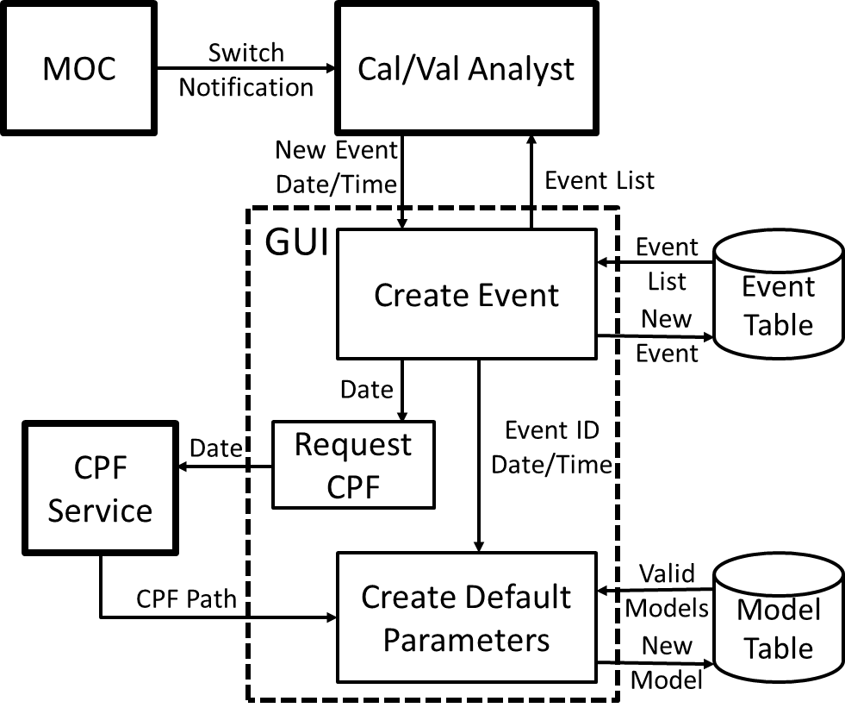

Figure 3: Add SSM Mode Switch Event Process Flow

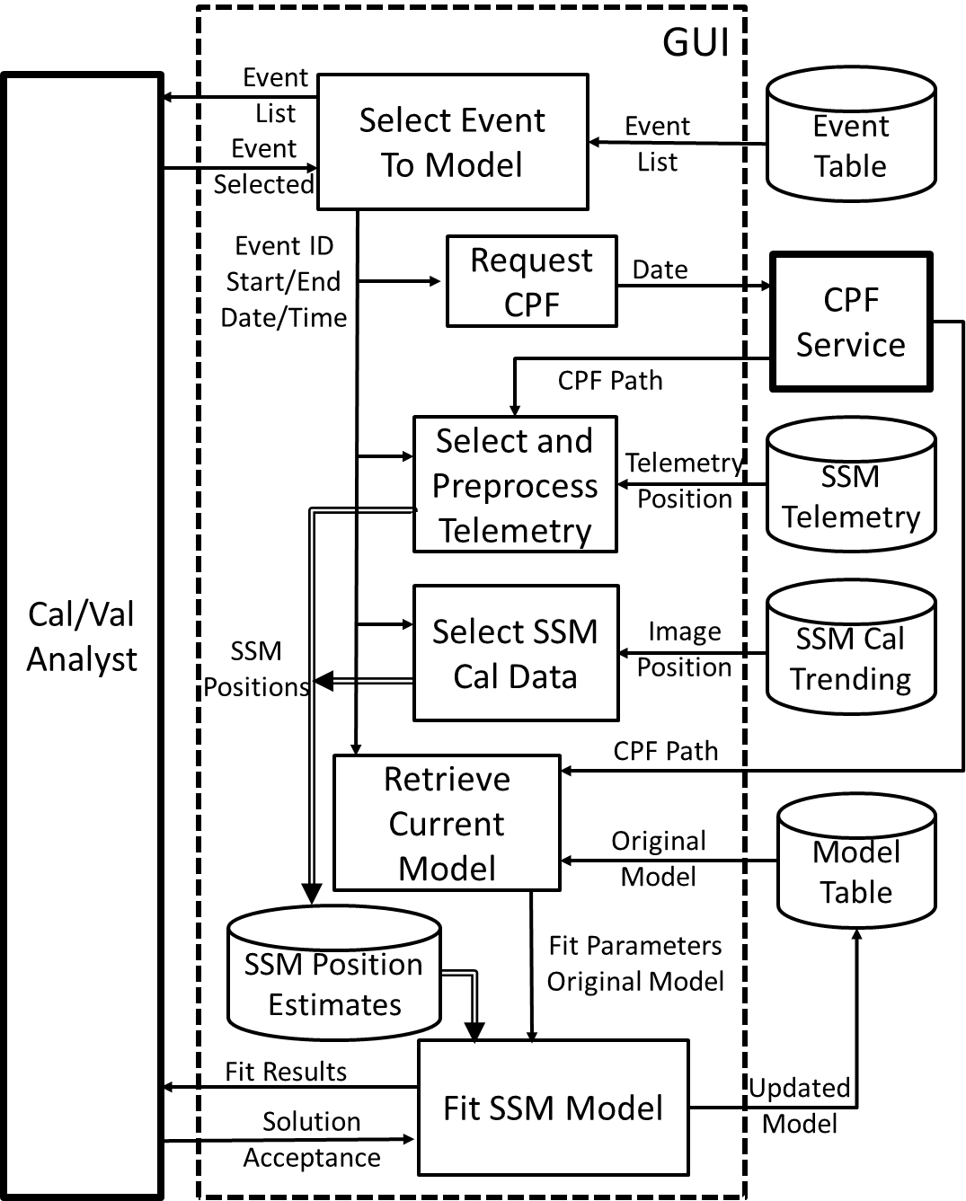

Figure 4: Fit SSM Model Process Flow

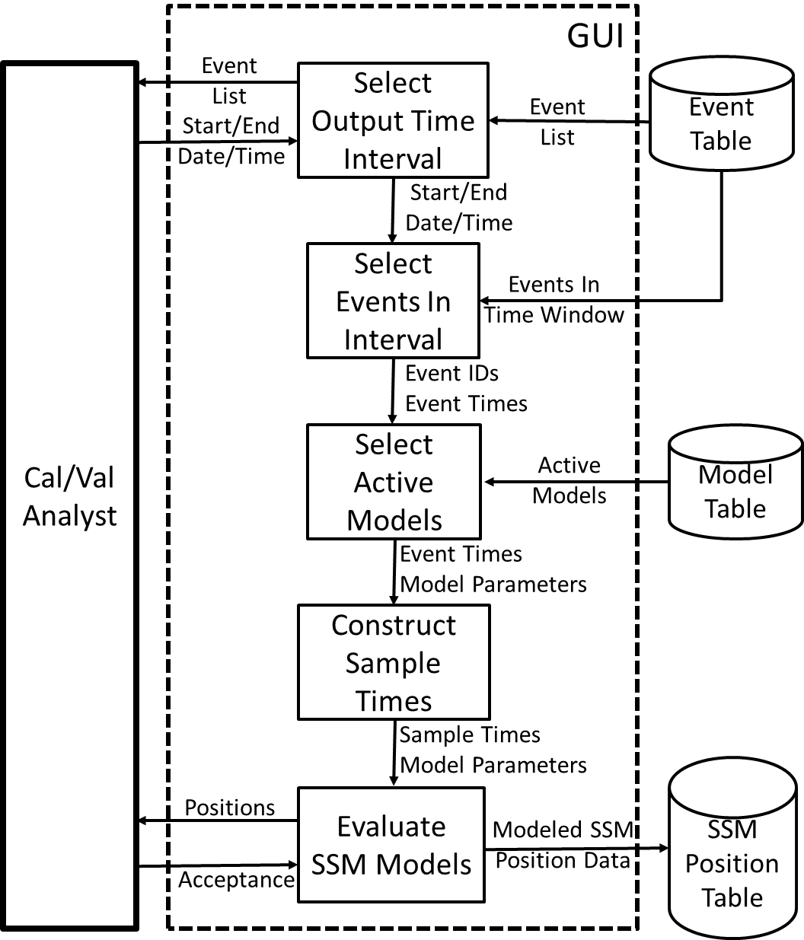

Figure 5: Generate SSM Position Table Process Flow

* + - 1. **Algorithm Output Details**

The TIRS SSM model fit algorithm populates three new database tables: 1) an SSM mode switch event table (defined in Table 1) that uniquely identifies each mode switch event and stores the associated event date and time; 2) an SSM mode 0 model parameter table (defined in Table 2) that stores the model parameter values needed to generate SSM position estimates as a function of time; and 3) an SSM mode 0 position table (defined in Table 3) containing the actual SSM position estimates spanning the period of mode 0 operations, generated using the model parameters.

|  |  |  |
| --- | --- | --- |
| **SSM Mode Switch Event Table** | **Units** | **Field Type** |
| Switch event ID (key) | - | Sequence |
| Event year | Years | Integer |
| Event day of year | Days | Integer |
| Event seconds of day (UTC) | Seconds | Integer |

**Table 1: TIRS SSM Mode Switch Event Table Contents**

The switch event ID field is suggested as an Oracle sequence but any mechanism for yielding uniquely identifiable records that can be easily referenced from other tables is acceptable.

|  |  |  |
| --- | --- | --- |
| **SSM Mode 0 Model Parameters Table** | **Units** | **Field Type** |
| Model ID (key) | - | Sequence |
| Associated mode switch ID (link to SSM Mode Switch Event Table) | - | External Key |
| Algorithm version number | - | Integer |
| Encoder Nadir Position | Counts | Integer |
| Constant Offset from Nadir (a0) | Counts | Double |
| First Exponential Magnitude (a1) | Counts | Double |
| Second Exponential Magnitude (a2) | Counts | Double |
| Third Exponential Magnitude (a3) | Counts | Double |
| First Exponential Time Constant (1) | Seconds | Double |
| Second Exponential Time Constant (2) | Days | Double |
| Third Exponential Time Constant (3) | Days | Double |
| Long Term Slope (S) (in counts per day) | Counts per Day | Double |
| Date Added (date and time to nearest second) | Seconds | Oracle Date |
| Date Disabled (NULL or date and time to nearest second) | Seconds | Oracle Date |

**Table 2: TIRS SSM Mode 0 Model Parameter Table Contents**

|  |  |  |
| --- | --- | --- |
| **SSM Mode 0 Position Estimate Table** | **Units** | **Field Type** |
| Year | Years | Integer |
| Day of year | Days | Integer |
| Seconds of day (UTC) | Seconds | Integer |
| Encoder position | Counts | Integer |
| Quality flag:  0 = predicted (i.e., generated before the event)  1 = updated/preliminary (i.e., generated during the event)  2 = final (i.e., generated after the event) | - | Integer |
| Associated model ID (link to SSM Mode 0 Model Parameters Table) | - | External Key |
| Date Added (date and time to nearest second) | Seconds | Oracle Date |
| Date Disabled (NULL or date and time to nearest second) | Seconds | Oracle Date |

**Table 3: TIRS SSM Mode 0 Position Estimate Table Contents**

The contents of the SSM mode 0 position estimate table can be written to one or more ASCII text file(s) for dissemination to external users (e.g., International Cooperators). Only the first five fields (year, day of year, seconds of day, encoder position, and quality flag) would be included in the file output with regards to the SSM position. The header to this file contains the format version, creation date, start date, end date, and number of records. The contents for this file is shown in figure 4.

|  |  |  |
| --- | --- | --- |
| **SSM Mode 0 Position Estimate Table ASCII Format** | **Units** | **Field Type** |
| Format Version |  | Integer |
| Creation Date | YYYY:DOY:SOD UTC | String |
| Start Date | YYYY:DOY:SOD UTC |  |
| End Date | YYYY:DOY:SOD UTC |  |
| Number Records |  | Integer |
| For each SSM Mirror Record |  | Integer |
| Year | Years | Integer |
| Day of year | Days | Integer |
| Seconds of day (UTC) | Seconds | Integer |
| Encoder position | Counts | Integer |
| Quality flag:  0 = predicted (i.e., generated before the event)  1 = updated/preliminary (i.e., generated during the event)  2 = final (i.e., generated after the event) | - | Integer |

Table 4: **TIRS SSM Mode 0 Position Estimate Table Contents ASCII Version**

The contents of the output TIRS SSM model fit report file are summarized in Table 5. Note that the first four fields listed are part of the standard report header. Most of this information (other than the standard report header) is presented to the user prior to acceptance of the model fit as valid.

|  |  |
| --- | --- |
| **Field** | **Description** |
| Date and time | Date (day of week, month, day of month, year) and time of file creation. |
| Spacecraft and instrument source | L8 and TIRS |
| Processing center | EROS |
| Software version | Software version used to create report |
| Associated mode switch event ID | Mode switch event sequence number |
| Mode switch date and time | Year, day of year, seconds of day (UTC) |
| Original model ID | ID of model used as starting point |
| Algorithm version | Version number of algorithm used to create original model |
| Encoder nadir | Nadir reference value (in counts) |
| Original a0 | Original value of constant offset from nadir (in counts) |
| Original a1 | Original value of first exponential magnitude (in counts) |
| Original a2 | Original value of second exponential magnitude (in counts) |
| Original a3 | Original value of third exponential magnitude (in counts) |
| Original 1 | Original value of first exponential time constant (in seconds) |
| Original 2 | Original value of second exponential time constant (in days) |
| Original 3 | Original value of third exponential time constant (in days) |
| Original slope | Original value of long term slope (in counts per day) |
| Original model date | Date/time original model was created |
| Updated model ID | ID of newly created model |
| Algorithm version | Version number of algorithm used to create updated model |
| Encoder nadir | Nadir reference value (in counts) |
| Updated a0 | Updated value of constant offset from nadir (in counts) |
| Updated a1 | Updated value of first exponential magnitude (in counts) |
| Updated a2 | Updated value of second exponential magnitude (in counts) |
| Updated a3 | Updated value of third exponential magnitude (in counts) |
| Updated 1 | Updated value of first exponential time constant (in seconds) |
| Updated 2 | Updated value of second exponential time constant (in days) |
| Updated 3 | Updated value of third exponential time constant (in days) |
| Updated slope | Updated value of long term slope (in counts per day) |
| Updated model date | Date/time updated model was created |
| Telemetry RMSE | RMS fit residual for telemetry observations |
| Image RMSE | RMS fit residual for image observations |
| Combined RMSE | RMS fit residual for all observations |
| Telemetry count | Number of telemetry observations |
| Image count | Number of image observations |
| Total count | Total number of observations |
| Observation Records: | For each observation used in the fit: |
| Observation date/time | Year, day of year, seconds of day |
| Seconds from mode switch | Observation time offset, in seconds, from mode switch event |
| Days from mode switch | Observation time offset, in days, from mode switch event |
| Observation type | Type of observation: telemetry or image |
| Measured position | Measured position in encoder counts |
| Modeled position | Final modeled position in encoder counts |
| Position residual | Position residual (measured minus modeled) in encoder counts |

**Table 5: TIRS SSM Model Fit Report Details**



# Notes

Some assumptions, limitations, and implementation notes include:

1. The model fitting procedure is designed to work with data created as a result of executing nominal alternate SSM operations concept mode switch procedures. This implies that: 1) the mode switch will follow a “pendulum” maneuver to reduce the magnitude of subsequent SSM motion; 2) a reasonable amount (~2000 seconds, minimum) of encoder data will be captured following the mode switch; 3) the SSM will remain in mode 0 long enough to collect sufficient data to model its trajectory, nominally for 14 days but for at least 7 days; and 4) no extreme off-nadir spacecraft maneuvers (i.e., lunar calibrations) occur during the mode 0 period. Mode switch events that do not conform to these conditions are not expected to achieve acceptable model fits using this algorithm. This excludes most of the mode switch events during the initial SSM anomaly period from December 2014 to March 2015.
2. As a consequence of note #1, above, the SSM position table must be preloaded with externally generated SSM position records for mode 0 time periods that cannot be successfully modeled with the current algorithm. This applies to the original side A SSM anomaly time period.
3. The parameters identified as new CPF parameters could also be stored in an algorithm-specific configuration file, since they have no relevance for external users of Landsat 8 data.

*.*