Open-source burn severity mapping tool
Workshop Exercise

Association for Fire Ecology 11th International Fire Ecology and Management Congress
New Orleans, LA
12/02/2025

Goal: The purpose of the exercise is to introduce participants to open source methodologies to map fire perimeters and burn severity using remotely sensed data. This exercise builds upon documentation materials developed for the open-source Fire Mapping Tool (FMT; https://mtbs.gov/qgis-fire-mapping-tool) QGIS plugin that are distributed with the tool’s download. Please refer to this documentation for additional tool specific information.

For this exercise we have chosen four different wildfires, including the 2021 Greenwood, 2023 Louisiana, 2024 Retreat, and 2024 Waterfall Mountain (Table 1), to allow for examination of fire mapping in different locations. These locations present differences in vegetation, seasonal variation, climate, and weather conditions that impact their mapping of perimeter and burn severity. We recommend that you choose one, or several if time permits, that are of special interest to you.

Table 1: Example wildfires used within this workshop exercise and their related information including state, fire date, Monitoring Trends in Burn Severity (MTBS) ID, latitude, longitude, Landsat worldwide referencing system 2 (WRS) path/row, and Sentinel military grid referencing system (MGRS).
Wildfire Name | State | Fire Date | MTBS ID | Latitude | Longitude | Landsat WRS2 Path/Row | Sentinel MGRS
Greenwood | Minnesota | 8/15/2021 | MN4755309164820210815 | 47.589 | -91.56 | 26/27 | 15TXN
Tiger Island | Louisiana | 8/22/2023 | LA3067309343920230822 | 30.735 | -93.465 | 24/39 | 15RVQ
Retreat | Washington | 7/23/2024 | WA4667112099220240723 | 46.704 | -120.939 | 45/27 | 10TFS
Waterfall Mountain | Virginia | 3/20/2024 | VA3866407859220240320 | 38.675 | -78.575 | 16/33 | 17SQC

Exercise 1 Instructions:
Note: For this exercise we chose to use the Tiger Island Wildfire.

- Enter fire information
Open the FMT (Fig. 1) and click on “File” in the FMT interface (Fig. 1). Select “Add Fire” and an interface (Fig. 2). Edit the fire information as necessary for your chosen fire. Click on “CreateEventId” (Fig. 2) to save this information to the “FireInfo.sqlite” Spatialite database (C:\Users\uesrname\AppData\Roaming\QGIS\QGIS3\profiles\default\python\plugins\FMT3).

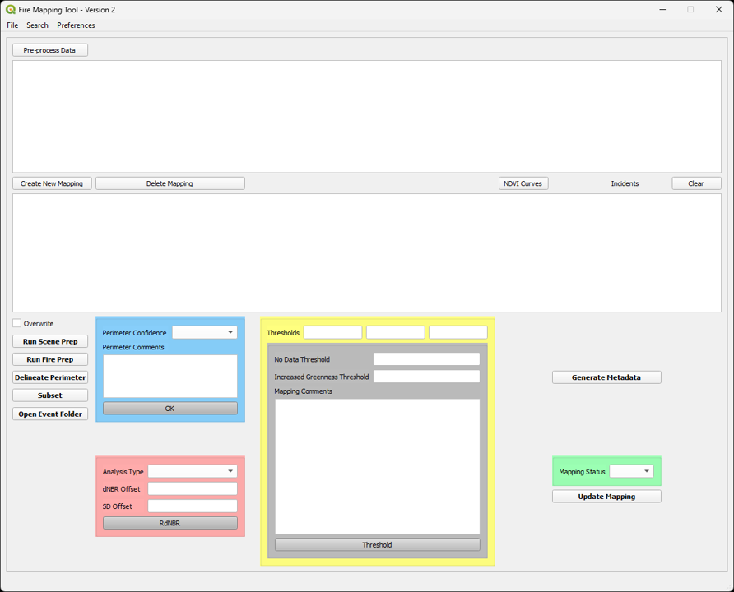
Figure 1: View of the QGIS Fire Mapping Tool (FMT) interface that will be used to enable the mapping of any fire within the U.S. using Landsat or Sentinel2 imagery.

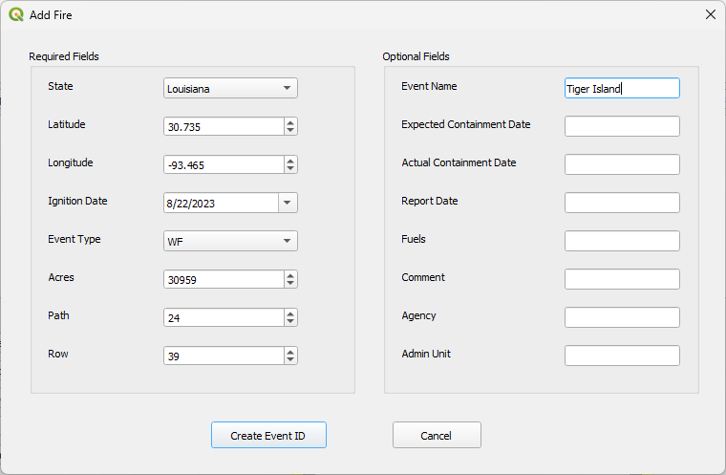
Figure 2: Add fire information to the “Add Fire” box within the fire mapping tool (FMT). Required fields are pre-populated with dummy data. These should be edited as necessary.
Once you have saved your fire information, you will need to search for your fire information. Click on “Search” in the FMT (Fig. 1) and select your “Search By” preference. One of the easiest ways to search is by year (Fig. 3). Select your fires year from the drop down menu and click on search.

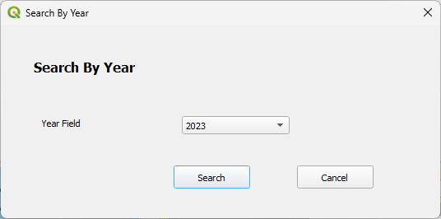
Figure 3: To search for fires by year, select the year for which you have added fire information and click on “search”.

- Image selection
Once you have chosen your fire it is necessary to think about what type of assessment that you want to perform. Does it make sense to perform an initial or extended assessment? Your answer to this question will help guide which imagery you will choose to perform the assessment. For example, the Tiger Island Wildfire occurred in an area where there is rapid post-fire regrowth. Rapid vegetation recovery can therefore obscure burn severity within a short period of time. If a user is interested in understanding post-fire damage it is necessary to assess the fire within one or two months post-fire. However, if a user wanted to understand whether a forest has recovered (at least in terms of vegetation regrowth and spectral “greenness” recovery) then a user might want to perform an extended assessment in which imagery is obtained one year post-fire during the peak of green.

An easy way to examine how the greenness changes throughout the year based on seasonal and weather conditions, you can use the MTBS Normalized Difference Vegetation Index (NDVI) curve tool (Fig. 5, https://mtbs.gov/ndvi-graphs). Click on the “NDVI Curves” button and you will be taken to the site with the NDVI graphs for the Landsat WRS2 Path/Row that was entered (Fig. 2) for your fire. The NDVI tool shows how green that a given date is with NDVI values between 0 (low greenness) and 1 (high greenness). For the Tiger Island Wildfire, the NDVI value is around 0.80 at the date of occurence. The NDVI graph within one month before and after the fire shows consistently high values around this value, suggesting that for an initial assessment that imagery from this time frame should be reasonable to obtain imagery.
If performing an extended assessment, you would want to determine when the highest NDVI values are during the summer months. This timeframe, around August, suggests that you could obtain a good pre-fire image either during the same year as the fire or one year previously during this time frame. The post-fire image would then be obtained one year after the fire during the same time frame.

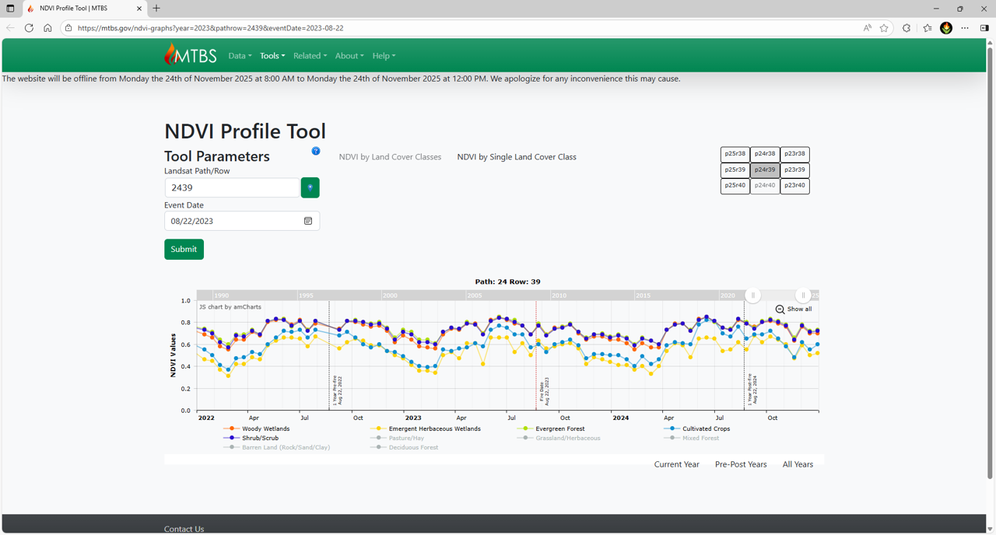
Figure 5: The NDVI profile tool allows you to see the NDVI values for different vegetation for a given LANDSAT worldwide referencing system 2 (WRS2) path (p) and row (r). In this example we can see the NDVI profile for Path/Row 2429, which covers the Tiger Island Wildfire.

Now it’s time to get imagery. If imagery had not been processed for you, then you would examine the Landsat (https://earthexplorer.usgs.gov/) and Copernicus Sentinel 2 archives (https://browser.dataspace.copernicus.eu/) archives. Because of large data volumes and potential network issues, data for all fires (Table 1) have been downloaded for you. Raw data is available in “FiremappingQGIS/raw” “landsat” and “sentinel2” folders.

Landsat data has the following naming schema to identify important information (https://www.usgs.gov/faqs/what-naming-convention-landsat-collections-level-1-scenes):

LXSS_LLLL_PPPRRR_YYYYMMDD_yyyymmdd_CC_TX

Where:

L = Landsat
X = Sensor (“C”=OLI/TIRS combined, “O”=OLI-only, “T”=TIRS-only, “E”=ETM+,
“T”=“TM, “M”=MSS)
SS = Satellite (”07”=Landsat 7, “08”=Landsat 8)
LLL = Processing correction level (L1TP/L1GT/L1GS)
PPP = WRS path
RRR = WRS row
YYYYMMDD = Acquisition year, month, day
yyyymmdd - Processing year, month, day
CC = Collection number (01, 02, …)
TX = Collection category (“RT”=Real-Time, “T1”=Tier 1, “T2”=Tier 2)

So, if we wanted an initial assessment post-fire image for the Tiger Island Wildfire we could use “LC09_L1TP_024039_20230830_20230830_02_T1.tar”. This is a Landsat 9 image from path/row 24/39 for 8/30/2023. If we wanted a pre-fire image we could use “LC09_L1TP_024039_20230814_20230814_02_T1.tar”, which is a Landsat 9 image, from path/row 24/39 for 8/14/2023.

Sentinel 2 imagery has a different naming convention (https://sentiwiki.copernicus.eu/web/s2-products):

MMM_MSIXXX_YYYYMMDDHHMMSS_Nxxyy_ROOO_Txxxxx_<Product Discriminator>.SAFE

The products contain two dates. The first date (YYYYMMDDHHMMSS) is the datatake start sensing time. The second date is the "<Product Discriminator>" field, which is 15 characters in length, and is used to distinguish between different end user products from the same datatake. Depending on the instance, the time in this field can be earlier or slightly later than the datatake sensing time.

The other components of the filename are:

MMM: is the mission ID(S2A/S2B)

MSIXXX: MSIL1C denotes the Level-1C product level/ MSIL2A denotes the Level-2A
product level

YYYYMMDDHHMMSS: the datatake sensing start time

Nxxyy: the Processing Baseline number (e.g. N0204)

ROOO: Relative Orbit number (R001 - R143)

Txxxxx: Tile Number field

SAFE: Product Format (Standard Archive Format for Europe)

A potentially good Sentinel 2 image would be “S2A_MSIL1C_20210923T170031_N0500_R069_T15TXN_20230112T030713.SAFE.zip”, which is a Sentinel 2 C (Corrected; Only use “1C” Sentinel 2 images with the FMT) from military grid referencing system (MGRS) 15TXN for 9/23/2021. A good pre-fire image could be “S2A_MSIL1C_20210814T165901_N0500_R069_T15TXN_20230212T200622.SAFE.zip” Sentinel 2 C from MGRS 15TXN for 8/14/2021.

The FMT will not allow you to mix pre- and post-fire Landsat and Sentinel 2 images. So, make sure that you decide on which sensor you want to use. Copy your data in the correct “landsat” or “sentinel2” FireMappingQGIS/raw folder and then click on “Pre-process data” (Fig. 1), select the “Sensor” you want from the drop down menu, click on the “Files” that you want, identify the correct region (conterminous U.S. (CONUS, Alaska, Hawaii, or Puerto Rico), “Sampling” method (Nearest Neighbor, Bilinear, or Cubic), and click “Process” (Fig. 6).

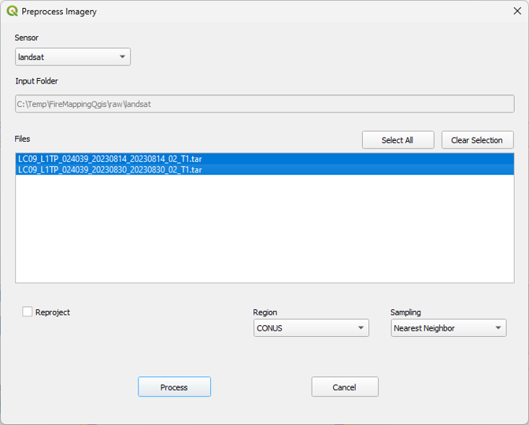
Figure 6: The Preprocess imagery tool bar allows you to select imagery and processing methods for Landsat and Sentinel 2 data.

Processing the Landsat or Sentinel 2 data may take a little time. Once the process is done, then “Processing files completed” message will pop up on your computer screen. The data is saved in the “img_src” landsat or sentinel2 folders. Landsat files will be nested in their respective path/row folder (e.g., 024039) and image name (e.g., 802403920240824_L1; “img_src/landsat/024039/ 802403920240824_L1”), while Sentinel 2 files will be nested in the tile (e.g., 15R;), subtile (e.g., 15RVQ), and image name (e.g., A15RVQ20230831_30m_L1C; “img_src/sentinel/15R/15RVQ/ A15RVQ20230831_30m_L1C” ) folders. Please note that only 30 m Landat products are produced, while 30 m and 20 m Sentinel 2 products are produced. The image products for Landsat and Sentinel 2 include reflectance “_REFL” and Normalized Burn Ratio (NBR) “_NBR”. These images will be used in the perimeter and burn severity portions of the mapping process.

- Running Scene Prep
If you have both pre- and post-fire images available, then you can run scene prep to yield a differenced NBR (dNBR) image. The dNBR image shows the between image change in reflectance resulting from vegetation and soil disturbance. Scaled (by 1000) values of dNBR range between -2000 and 2000, with higher values indicating change. Values of disturbed areas, including fires, are typically above 100. Highlight the mapping that you want to run and click on “Run Scene Prep” to produce a dNBR (“_dnbr.tif”) image (Fig. 1).

- Running Scene Prep
To produce the burn boundary (“_burn_bndy.shp”) and mask (“_mask.shp”) shapefiles and QGIS project files (“.qgs”) highlight the mapping that you want to run and click on “Run Fire Prep” (Fig. 1).

- Delineate Perimeter
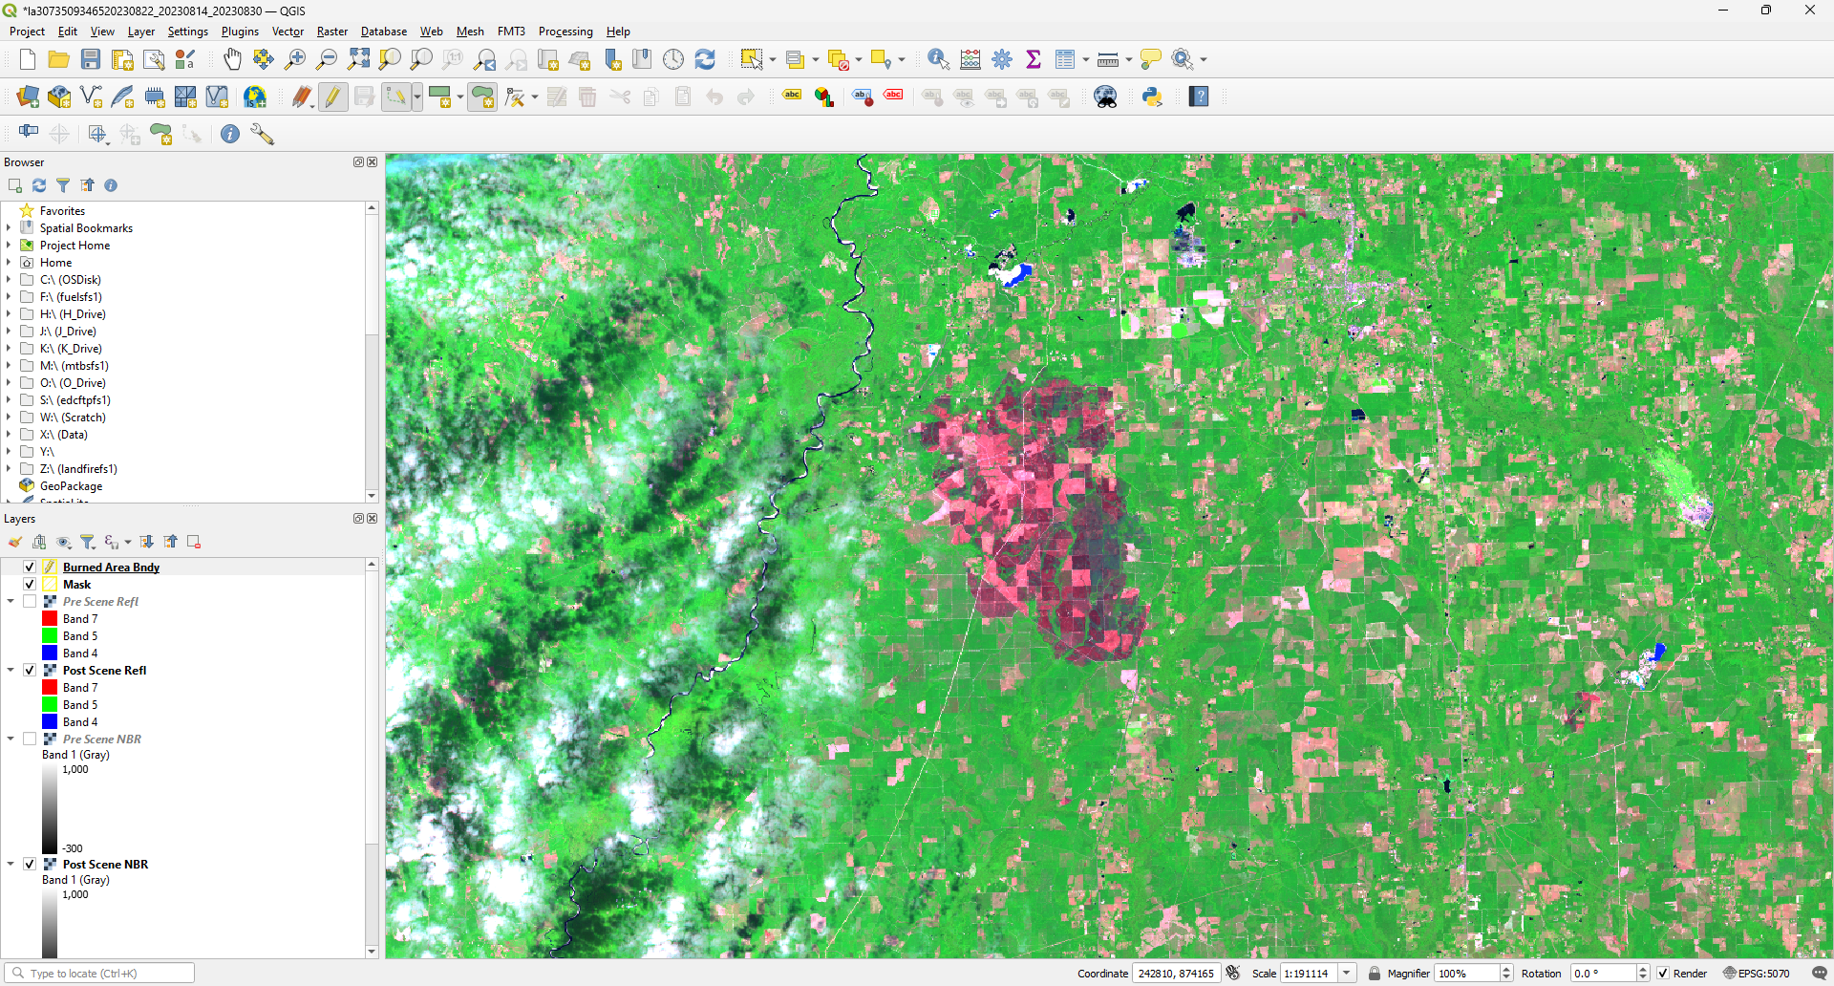
Click on “Delineate Perimeter” to open the “.qgs” project file within QGIS. This project file will load the pre- and post-fire reflectance and NBR images and dNBR image (Fig. 7). Click on the “Burned Area Bndy” shapefile and the (Fig. 7) to begin editing the shapefile. Zoom into the location of the fire that you want to map. Click on the “add polygon symbol” to begin mapping the fire. You can change the digitizing modes by selecting the digitizing options. Commonly used options are “digitize with segment” (click and point) or “stream digitizing” (click once and trace until you right click) are used. Click near the fire perimeter to begin tracing it. Once you are done mapping the fire, “right click” and enter in “1” for the “Id” and click “ok”. If you are good with the mapping then you can select to save and stop editing the shapefile. There are multiple tools to edit the shapefile as needed, although a commonly used one with many options is the “Advanced Digitizing Toolbar”. To use these tools, select “View”, “Toolbars”, and check the “Advanced Digitizing Toolbar”. Make sure that you save any changes to the shapefile. When you are done you should see something like Fig. 8 for the Tiger Island Wildfire.

In this example there are no clouds or water bodies that need to be masked out from this mapping. If there were areas to mask then you would follow the same procedures above to edit the “Mask” file within the QGIS project (Fig. 7).

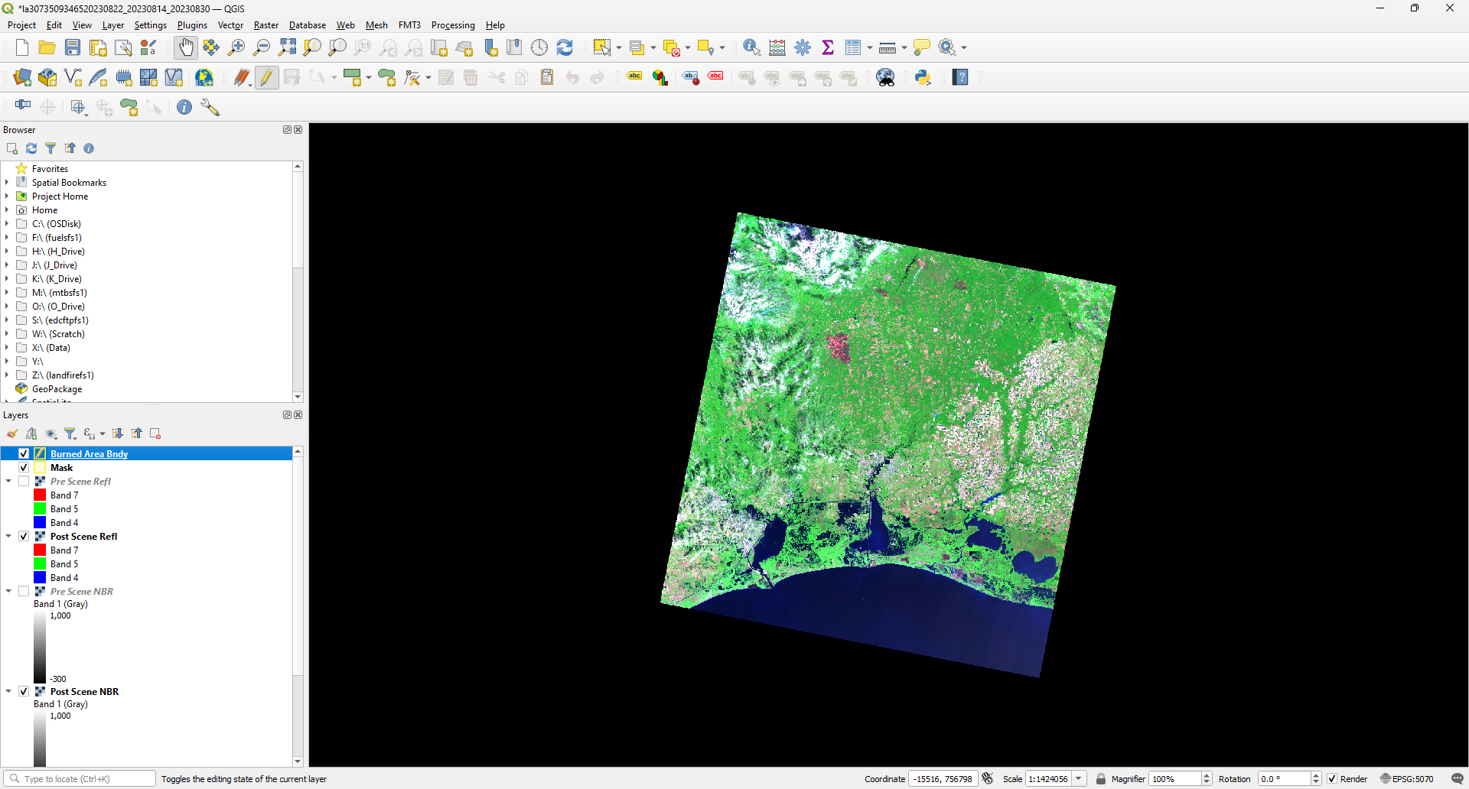
Figure 7: Example of a QGIS project in which the “Burned Area Bndy” is being edited.

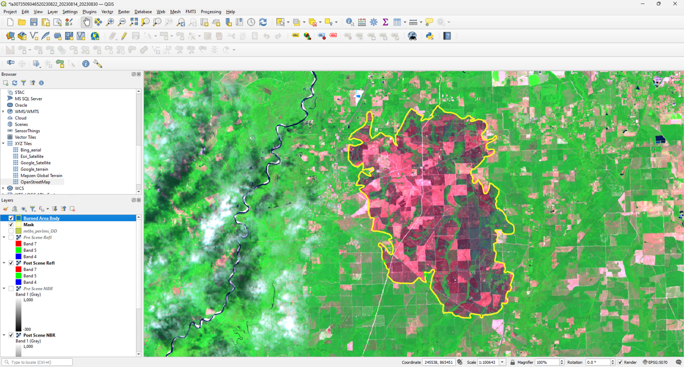
Figure 8: Mapped fire perimeter within QGIS for the Tiger Island Wildfire.

- Subset
Once you have saved the “Burned Area Bndy” and “Mask” (if needed) shapefiles, you can then run Subset (Fig. 1). The subset function will clip the input pre- and post-fire reflectance and NBR images and a dNBR image. Additionally, this step populates the dNBR offset, standard deviation (SD) offset, and threshold values.

- Perimeter Confidence and Comments
The perimeter confidence defaults to “High”, indicating that the user can see the fire scar and does not have concerns with its placement. If the user does have concerns, then they can change the confidence to “Low”. A user can also type in any comments that they may have about the perimeter. Both values will be saved to the shapefile when the user clicks on “Ok”.

- Relativized differenced NBR (RdNBR)
The dNBR and standard deviation (SD) offset values are calculated for the entirety of the image examining all dNBR values between -100 and 100. Limiting the values to this range allows for the calculation of offsets without masking clouds, water, and other areas of disturbance. If you prefer, then you can change the offset values by calculating the offset manually (see FMT3 User Guide, “Determine dNBR offset value”; pg. 19). When you click on the “RdNBR” button (Fig. 1), then these values will be saved to the database and a RdNBR image will be produced.

- Thresholds
Per image NBR or dNBR thresholds are suggested based on the input imagery. These can also be visually estimated and replaced if you think that they are incorrect. The FMT3 User Guide section “7. FMT3 STEP: Threshold” (pg. 20) contains an exhaustive example of how to visually threshold burn severity breakpoints based on changes in vegetation greenness. Once you have determined the burn severity thresholds, then you can click on the “Threshold Button” (Fig. 1) to create the “_nbr6.tif” or “_dnbr6.tif” image. Automated breakpoint estimates for this exercise were 84, 356, and 744 respectively. The MTBS project for this fire estimated low, moderate, and high severity breakpoints to be 65, 345, and 645. Comparatively, the FMT and MTBS low and moderate breakpoints were within the range dNBR standard deviation offset value of 30. The difference between FMT and MTBS high dNBR burn severity breakpoint was 99, suggesting that the FMT tool is underestimating high burn severity threshold for this fire. However, visually MTBS and FMT burn severity class estimates were similar (Fig. 9). Additionally, the difference in acreage between MTBS and FMT estimates were +10% for low, -8% for moderate, and +16% for high burn severity classes.

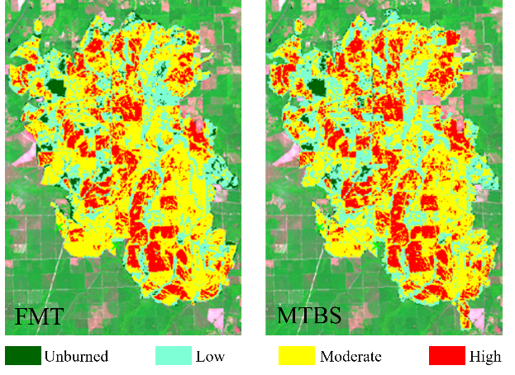
Figure 9: Fire Mapping Tool (FMT) and Monitoring Trends in Burn Severity classifications of unburned, low, moderate, and high burn severity for the 2023 Tiger Island Wildfire.

- Generate Metadata
Once you have completed mapping the perimeter and burn severity of the fire, you can then generate metadata for your mapping by clicking on the “Generate Metadata” button (Fig. 1). The metadata “_metadata.txt” file will then automatically be produced.

- Update Mapping
The last step (optional) the mapping process is to change the “Mapping Status” from “in-progress” to “complete” from the drop down menu. Once you click on “Update Mapping” (Fig. 1), then this input will be saved to the backend Spatialite database.

