**Changing Fire Effects Over Forty Years: Mining critical information about wildfires and their effects from Monitoring Trends in Burn Severity data**

Joshua Picotte, Birgit Peterson, Kurtis Nelson, and Chris Woody

US Geological Survey, Earth Resources Observation and Science Center

*Introduction*

Wildfires are frequently portrayed as damaging with profound effects on society and ecosystems. These effects include harmful changes such as ecosystem type change from forest to shrub or grasslands (Landesmann et al., 2021), largescale erosion (Scott et al., 2009 and Pierson et al., 2011), and reduction in water quality (Smith et al., 2011 and Rust et al., 2018). However, wildfires can also have beneficial effects on the landscape that are often overlooked in light of the substantial negative effects. These positive changes include thinning of overly dense tree stands (Fernandes and Botelho, 2003), creation of fire breaks (Suffling et al., 2008), and improved habitat for threatened and endangered species (Penman et al., 2011). Examining the effect of fuel treatments (including fire) on subsequent burned area and burn severity through time can help inform future land management decisions that result in a more resilient landscape.

Using two publicly available datasets we examined the effects of both previous wildfires and fuel treatments on subsequent wildfire area and burn severity. The fuel treatments considered in our analyses included prescribed fire, logging, mastication, and mechanical thinning. We examined the overall effect of these natural and anthropogenic disturbances to determine whether they increased or reduced subsequent wildfire occurrence and burn severity, and whether there are geospatial differences in effectiveness.

*Methods*

We used Monitoring Tends in Burn Severity (MTBS) fire perimeters and thematic burn severity data and LANDFIRE disturbance data to conduct our analyses and examine trends in burned area and burn severity within the conterminous US (CONUS). The relevant data were extracted and then incorporated into a geospatial database (Figure 1 and Table 1) to make analysis more efficient. Once the geodatabase was compiled, we identified areas that had reburned after an earlier wildfire or prescribed fire (i.e., “reburns”) and areas of anthropogenic disturbance that had subsequently burned (i.e., “treatment burns”). The identified reburns and treatment burns were then used to extract MTBS thematic burn severity (i.e., unburned, low, moderate, and high) class that intersected the fire perimeter. MTBS burn severity was also identified for each fire perimeter that was outside of the reburns or treatment burns. Additionally, the 85 Omernik III Ecoregions (Omernik and Griffin 2014) were used to group fires and examine of the characteristics and effects of reburns and treatment burns into ecologically relevant units. Specifically, we assessed whether prior disturbance caused by either fire or treatment had a significant effect on the extent or severity of a subsequent fire compared to the extent and severity of a fire burning through previously undisturbed areas. We also examined how long any effects of prior fire or treatment have on subsequent wildfire characteristics, and, critically, how effective they may be long-term in reducing burn severity.

*Significant Results*

Overall, we found that:

1. Fires were widely spread across CONUS (Figure 1) with 83 Omernik III Ecoregions having at least one fire. The number of fires per Omernik III Ecoregion ranged from 1 to 4609.
2. Fire number and area in eastern Omernik III Ecoregions was lower than for western Omernik III Ecoregions (Table 2).
3. Reburned fire number was greater and area was less in eastern Omernik III Ecoregions when compared to western Omernik III Ecoregions (Table 2).
4. Both burned (Figure 1) and reburned area (Figure 2) have increased significantly over time.
5. 17,476 fires burned into areas previously burned, with a median value of three previous burns per reburned fire.
6. The number of treatment reburns are increasing significantly through time (Figure 3).
7. Reburned fires were significantly smaller than fires without a previous burn (Table 3).
8. The number of treatment reburns in eastern Omernik III Ecoregions was lower than in western Omernik III Ecoregions.
9. If a previously burned area reburns, then the reburned area is likely exhibit significantly less severe burn severity (i.e., lower percentage of moderate and high severity) than the area that was not reburned (Table 3). This suggests that previous burns have a moderating effect on subsequent fires. However, areas with frequent prescribed burning or that are dominated by grasslands or shrubs, including Southern Florida Coastal Plains, Flint Hills, High Plains, and Atlantic coastal plains, did not always show these trends,.
10. Similar results were observed for treatment reburned area and severity (Table 3). Previously treated fires were significantly smaller in size than untreated. Additionally, all classes of treatments excluding herbicide resulted in a significant reduction in subsequent burn severity.
11. Moderate and high burn severity was significantly less (as a percentage) in reburn areas as compared to previously unburned areas (Table 3).
12. Previous fire reduced burn severity, i.e., a lower total percentage of moderate and high severity area, at the CONUS scale for up to 15 years.
13. Treatment reburns (pooled, excluding fire) reduced burn severity for 5 years at the CONUS scale.
14. When time since reburn and reburned burn severity were grouped by Omernik III Ecoregions, time was not related to reburn burn severity for most areas. However, five forest or shrub dominated Omernik III Ecoregions (e.g., chaparral) showed a positive increase in burn severity with time. Two forested Omernik III Ecoregions showed decreases in severity over time, suggesting that they may become less likely to burn over time.
15. Similarly, when time since treatment and burn severity were subdivided by Omernik III Ecoregions, time since treatment was often not related to burn severity for most Omernik III Ecoregions. However, for mechanical treatments in California chaparral there was an increase in burn severity as time increased. Negative relationships between burn severity and time were evident in harvested Sierra Nevada forests, suggested that burn severity can increase in logged areas because of remaining fuels (e.g., slash).
16. Small sample size was a problem for investigating disturbance over time per disturbance type and Omernik III ecoregion.

Achievements

* The MTBS and LANDFIRE Disturbance Database (Table 1) was developed to allow for all comparisons reported in this report. Updating of the database has been automated (i.e., Python scripting) to allow for future updates.
* All analyses and figure generation have been scripted to allow for reproducibility.
* We contributed “Fire Occurrence and Burn Severity” to the 2024 USGS US Landscapes Report. Our contribution uses work funded by the Moore Foundation to explore differences in fire occurrence and differences between reburned and disturbed areas.

Continued Work

* We are planning on releasing the entirety of the database though a ScienceBase Data Release.
* There is the potential for results to be developed into a peer-reviewed publication.
* We will distribute the database to the LANDFIRE project.

*References*

Landesmann, J.B., Tiribelli, F., Paritsis, J., Veblen, T.T. and Kitzberger, T., 2021. Increased fire severity triggers positive feedbacks of greater vegetation flammability and favors plant community‐type conversions. Journal of Vegetation Science, 32(1), p.e12936.

Omernik, J.M. and Griffith, G.E., 2014. Ecoregions of the conterminous United States: evolution of a hierarchical spatial framework. Environmental Management, 54, pp.1249-1266.

Penman, T.D., Christie, F.J., Andersen, A.N., Bradstock, R.A., Cary, G.J., Henderson, M.K., Price, O., Tran, C., Wardle, G.M., Williams, R.J. and York, A., 2011. Prescribed burning: how can it work to conserve the things we value?. International Journal of Wildland Fire, 20(6), pp.721-733.

Pierson, F.B., Williams, C.J., Hardegree, S.P., Weltz, M.A., Stone, J.J. and Clark, P.E., 2011. Fire, plant invasions, and erosion events on western rangelands. Rangeland Ecology & Management, 64(5), pp.439-449.

Rust, A.J., Hogue, T.S., Saxe, S. and McCray, J., 2018. Post-fire water-quality response in the western United States. International Journal of Wildland Fire, 27(3), pp.203-216.

Scott, D.F., Curran, M.P., Robichaud, P.R. and Wagenbrenner, J.W., 2009. Soil erosion after forest fire. In Fire effects on soils and restoration strategies (pp. 193-212). CRC Press.

Smith, H.G., Sheridan, G.J., Lane, P.N., Nyman, P. and Haydon, S., 2011. Wildfire effects on water quality in forest catchments: A review with implications for water supply. Journal of Hydrology, 396(1-2), pp.170-192.

Suffling, R., Grant, A. and Feick, R., 2008. Modeling prescribed burns to serve as regional firebreaks to allow wildfire activity in protected areas. Forest Ecology and Management, 256(11), pp.1815-1824.

*Tables*

**Table 1:** Description of the MTBS and LANDFIRE Disturbance Database tables, including the table name and per table number of fields (Field N) , presence (Y) or absence (N) of geometry (GEOM), and description.

|  |  |  |  |
| --- | --- | --- | --- |
| **Table** | **Field N** | **Geom** | **Description** |
| akdistint | 8 | Y | Intersection of 1999-2021 LANDFIRE (LF) disturbances with fire perimeters within Alaska (AK) |
| dist_dd | 6 | Y | LF disturbances |
| fireint | 8 | Y | Intersections of MTBS fires |
| hidistint | 8 | Y | Intersection of LF disturbances within Hawaii (HI) and Monitoring Trends in Burn Severity (MTBS) fires |
| mtbs_burn_severity | 8 | N | MTBS1984-2021 per fire number of pixels for each burn severity class |
| mtbs_insidedist_severity_lcmap | 22 | N | Count of each MTBS burn severity pixel class for each Land Change Monitoring Assessment and Projection (LCMAP) classification with each intersecting disturbance and reburned area |
| mtbs_intersect_reburn_sev_lcmap | 22 | N | Count of each MTBS burn severity pixel class for each LCMAP classification for reburned areas |
| mtbs_outsidedist_severity_lcmap | 22 | N | Count of each MTBS burn severity pixel class for each LCMAP classification for areas not within disturbed areas |
| mtbs_perims | 24 | Y | MTBS1984-2021 fire perimeters |
| om3 | 13 | Y | Omernik III (OM3) ecoregions |
| om3_mtbs | 2 | N | Intersection between OM3 and MTBS |
| pad | 34 | Y | Protected Area Database (PAD) |
| stdistint | 8 | Y | Intersection of 1999-2021 LF disturbances with fire perimeters within the conterminous US (CONUS) |
| us_states | 12 | Y | CONUS States |

**Table 2:** Area in hectares (H) and number (N) of fires, reburns, and treatment reburns were examined within the conterminous United States (CONUS), eastern Omernik III Ecoregions, and Western Omernik III Ecoregions. The percentage (%) of N and H for eastern versus western Omernik III Ecoregions are also provided.

|  |  |  |  |  |  |  |
| --- | --- | --- | --- | --- | --- | --- |
| **Category** | **CONUS N** | **CONUS H** | **Eastern N (%)** | **Eastern H (%)** | **Western N (%)** | **Western H (%)** |
| Fires | 31,163 | 90,264,433 | 13,400 (43%) | 11,734,376 (13%) | 17,763 (57%) | 78,530,057 (87%) |
| Reburn | 51,304 | 39,204,337 | 30,782 (60%) | 10,193,128 (26%) | 20,522 (40%) | 29,011,209 (74%) |
| Treatment Reburn | 3,494 | 1,821,290 | 734 (21%) | 163,916 (9%) | 2,760 (79%) | 1,657,374 (91%) |

**Table 3:** Mann Whitney U-tests examined whether first-burn area or percentage of moderate and high areas were greater than the Reburn and Treatment Reburn areas.

Sample size (N) and U-values for each test are provided. P-values were significant (P ≤ 0.001) for all tests.

|  |  |  |  |  |  |
| --- | --- | --- | --- | --- | --- |
| **Type** | **N Area** | **U Area** | **N Moderate and High** | **U Moderate** | **U High** |
| Reburn | 29013 | 107334116 | 29013 | 123682563 | 124378127 |
| Treatment Reburn | 29222 | 88574417 | 4622 | 3073692.5 | 3148285.5 |

*Figures***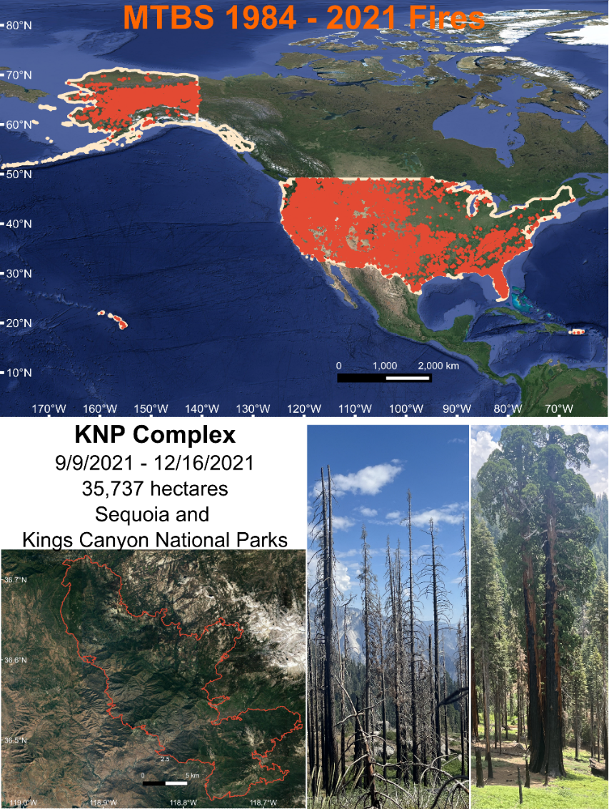**

**Figure 1:** Map of the 1984 -2021 Monitoring Trends in Burn Severity (MTBS) fires mapped within all 50 states and territories. The KNP Complex fire is provided as an example of a zoomed in fire perimeter and associated examples of on the ground burn severity effects to the vegetation.

**Figure 2:** Area trends in large Monitoring Trends in Burn Severity (MTBS) between 1984 and 2021.

**Figure 3:** Trends in reburned area through time as identified in the MTBS dataset between 1984 and 2021.

**Figure 4:** Trends in anthropogenic disturbances through time as identified in the LANDFIRE disturbance dataset between 1999 and 2021.