DOI agency/bureau: USGS
USGS Mission Area: Water Resources
USGS Program: National Streamflow Information Program
Cost Center: Office of the AD Water
Program Name2:
Project title: River Observing System (RiOS): An uncrewed aircraft system payload for measuring river surface velocity
Project description: The U.S. Geological Survey and the National Aeronautics and Space Administration have developed a multi-sensor uncrewed aircraft system (UAS) payload called the River Observing System (RiOS). RiOS includes a thermal infrared camera, visible camera, a laser range finder, an inertial navigation system, embedded computer for storing data, and a wireless link for transmitting data to a ground station. The power supply to RiOS is contained on the payload, and all sensor systems are independent of the UAS platform. The RiOS payload enclosure is a custom fabricated carbon fiber shell that is rigidly mounted to the frame of a DJI Matrice 600 Pro hexacopter using a “toad in the hole” quick-release mechanism. The thermal images collected from RiOS were used as input to a particle image velocimetry algorithm (PIV) to estimate the surface flow velocities of the Sacramento River. A publication describing these results is available here: https://www.mdpi.com/2073-4441/16/13/1870.
Sensor Type: Multispectral (approx. 4-12 bands);Thermal;Camera;
Platform type: UAS;
URL: https://www.mdpi.com/2073-4441/16/13/1870
Graphic or Image Upload: https://doimspp.sharepoint.com/sites/GS-EROSSCIENCESWI/Shared Documents/Communications Outreach/Documentation Science/DOI Remote Sensing Report/DOI RS Activities Report, 2024/Graphic or Image Upload/RiOS_Paul Kinzel.JPG
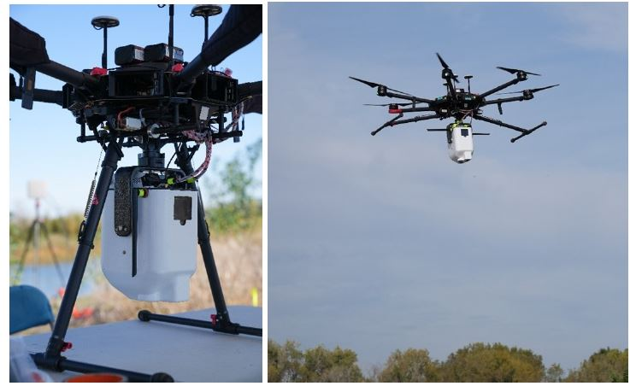
Caption for Graphic or Image: Images of the DJI Matrice 600 Pro hexacopter equipped with the River Observing System (RiOS) payload. Photographs by Massimo Vespignani, NASA, used with permission.
Author name: Paul Kinzel
Author business email: pjkinzel@usgs.gov

DOI agency/bureau: USGS
USGS Mission Area: Ecosystems
USGS Program: Water Availability and Use Science Program
Cost Center: Southwest Biological Science Center
Program Name2:
Project title: Colorado Delta Riparian Plant Health Improvement
Project description: Our research and findings while monitoring riparian plant health along Mexico's arid Colorado River Delta are supporting better ecohydrological decision-making and are helping a binational team working on protecting, restoring, and maintaining native vegetation within the 150-km long riparian corridor. The riparian corridor lacks water due to a reduction in frequent flows and due to increases related to climate change metrics such as heat and drought, human infrastructure, and disturbances. Altered riparian land cover may result from specific land cover disturbance changes, which may include invasive species, or changes to age class, resulting in plant compositional changes. These factors may also lead to declines in riparian plant health resulting from fire, beetles, lower flow volume, and increasing soil and water salinities. In response to the degradation, restoration efforts have positively impacted the riparian habitats and native plant health, although vegetation greenness and corresponding water use continue to decline in unrestored reaches.

Restoration efforts focusing on small plots have successfully revitalized habitat in the riparian corridor. This study is part of the monitoring effort and science associated with Minute 323 of the 1944 U.S. and Mexico Water Treaty. The science from USGS Southwest Biological Science Center provided the riparian restoration monitoring results for greenness, a proxy for plant health, and ETa using weather station potential ET, remote sensing geospatial and Landsat-8 Operational Land Imager (OLI) data (2014-2022). Using the Nagler empirical model for ETa, “ET(EVI2)” is estimated over each 16-day Landsat-8 OLI overpass period, by considering the 8-days before- and after- the overpass date. ET(EVI2) for these uncultivated riparian species is best measured as annual peak growing season (May 1 to October 30).

In the Colorado River Delta, Reach 4 contains restoration sites, but also unrestored riparian areas. Our findings reveal a notable increase in vegetation greenness within the restoration sites over nine years, with an average increase of 41.3%, which may be partially due to targeted water deliveries at the restoration sites. Conversely, greenness in adjacent, unrestored control areas declined by 27.3%. The study showed a 22.1% increase in ETa in restored areas, compared to a 30.8% reduction in unrestored regions. Restored sites in Reach 4 experienced ETa increases up to 12.2%, whereas their unrestored counterparts showed a decline of 21.4%. Valuable estimates are provided of riparian greenness and water use that may assist natural resource managers who are tasked with allocating water and managing habitats within similar riparian corridors.
Sensor Type: Multispectral (approx. 4-12 bands);
Platform type: Satellite;
URL: https://doi.org/10.1111/rec.14226
Graphic or Image Upload: https://doimspp.sharepoint.com/sites/GS-EROSSCIENCESWI/Shared Documents/Communications Outreach/Documentation Science/DOI Remote Sensing Report/DOI RS Activities Report, 2024/Graphic or Image Upload/ETa_EVI2_4Plots_ColoradoDeltaRestoration_Pamela Nagler.jpg
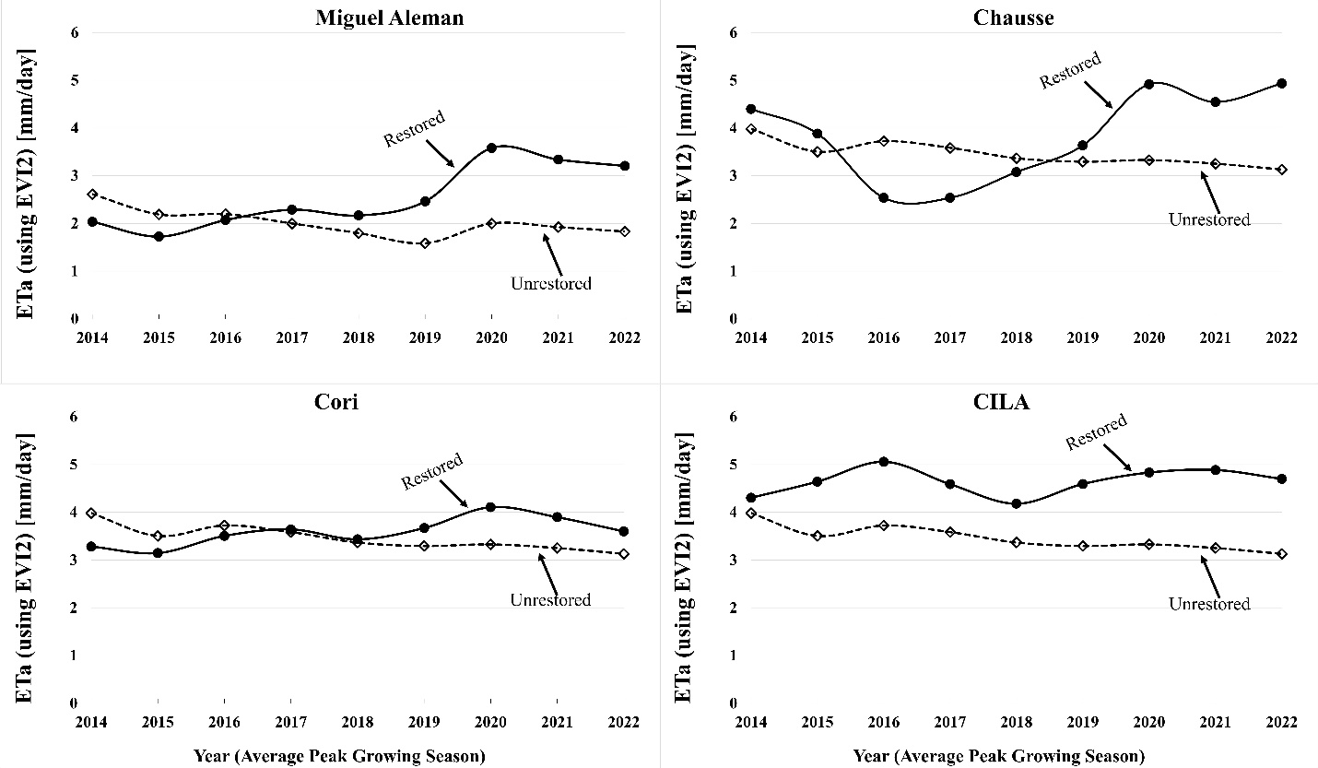
Caption for Graphic or Image: ETa_EVI2_4Plots_ColoradoDeltaRestoration
Author name: Pamela Nagler
Author business email: pnagler@usgs.gov

DOI agency/bureau: USGS
USGS Mission Area: Ecosystems
USGS Program: Land Change Science
Cost Center: Western Geographic Science Center
Program Name2:
Project title: Satellite-derived fire intensity in Alaskan boreal forests
Project description: A central question in wildfire research is how increasingly frequent and severe fires will alter landscapes. Will these changes promote the regrowth of different species, or will burned landscapes eventually recover to their original state? U.S. Geological Survey (USGS) researchers are investigating this question in Alaska’s boreal forests, where vegetation is closely tied to soil characteristics. Deciduous trees such as aspen (Populus tremuloides) and birch (Betula neoalaskana) thrive in thin, mineral soils, while conifers such as black spruce (Picea mariana) do best in thick organic layers. Unusually severe or frequent wildfires that consume organic soil material may disrupt cycles of conifer regeneration, potentially leading to a shift towards deciduous dominance.

To better understand the conditions that influence wildfire intensity in boreal environments, USGS researchers are using data from the National Aeronautics and Space Administration’s Moderate Resolution Imaging Spectrometer (MODIS) satellite. MODIS provides measurements of fire radiative power (FRP), a proxy for fire intensity, which is largely determined by the amount and condition of available fuel. By combining 20 years of MODIS FRP data across Alaska with a long-term record of fire perimeters (1940 - present) and a contemporary map of landcover species, researchers can examine how fire history—that is, the number and timing of previous burns--and vegetation type have influenced fire intensity over the past two decades. This analysis will help provide insights into the potential future appearance of boreal landscapes, both in Alaska and beyond.

Sensor Type: Multispectral (approx. 4-12 bands);
Platform type: Satellite;
URL:
Graphic or Image Upload: https://doimspp.sharepoint.com/sites/GS-EROSSCIENCESWI/Shared Documents/Communications Outreach/Documentation Science/DOI Remote Sensing Report/DOI RS Activities Report, 2024/Graphic or Image Upload/Walker_AK_burn_sm_Jessica Walker.png
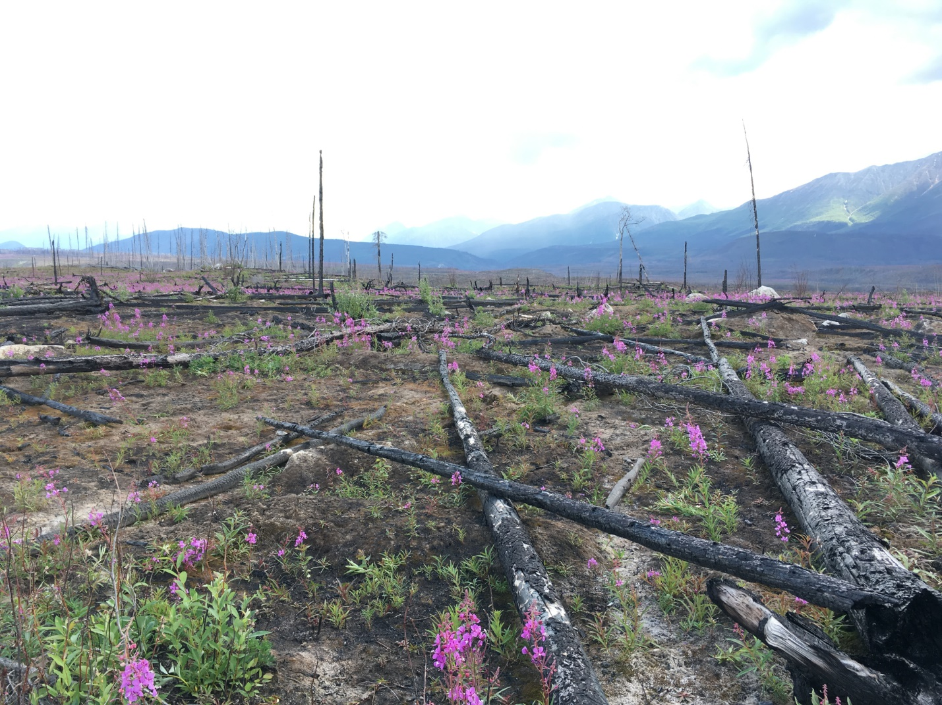
Caption for Graphic or Image: Figure 1. A burned landscape in Wrangell-St. Elis National Park, Alaska. Photo credit: Jessica Walker, U.S. Geological Survey.
Author name: Jessica Walker
Author business email: jjwalker@usgs.gov

DOI agency/bureau: USGS
USGS Mission Area: Ecosystems
USGS Program: Climate Research & Development
Cost Center: Western Geographic Science Center
Program Name2:
Project title: Drowning in Data: How Remote Sensing is Monitoring Wet Ecosystems
Project description: Between 2020 and 2022, members of the Patterns in the Landscape – Analyses of Cause and Effect (PLACE) Project published a series of papers introducing cloud-based approaches to map surface water at monthly scales using Landsat 30-m imagery, and at weekly times scales using MODIS imagery. These published models are scalable, making it possible to create maps regionally or nationally. Published works demonstrate how the models can be applied to analyze long-term surface water dynamics in the conterminous United States and in other countries. The project team is also actively using surface water models to better understand the causes and consequences of inundation, such as how inundation may affect economic activities like agriculture.

As the PLACE project team engages with scientists and potential collaborators, we recognize that dense surface water time series present a great opportunity to investigate other “wet” ecosystems like wetlands and meadows. Wetlands regularly share certain characteristics with open water, like standing water and moist soils. Many common indicators of wetness can be detected using remote sensing. One of the complexities of mapping wetlands is that water is often mixed with vegetation or may only be present intermittently. A recently published paper by the PLACE team incorporates this knowledge and past research into a large-scale wetland mapping effort based in the state of Arizona. But our goal of investigating how well surface water, wetland, and vegetation change products correspond to different driving forces does not stop at water and wetlands. Meadows can be quite similar to wetlands. Over the last year, the PLACE project has forged a partnership with a team of academic and non-profit researchers focused on the health and restoration of mountain meadows scattered throughout the Sierra Nevada Mountain Range of California. One of the challenges in studying mountain meadows using the methods that the PLACE team has already developed is that these meadows are often very small in size, and using moderate-scale data (e.g., Landsat) is often inappropriate.

To resolve this limitation, PLACE is working on developing analyses using finer-scale remote sensing data to help assess meadow health. High-resolution datasets to aid in these assessments are limited, but access and capacity are growing. For example, an ambitious plan by the USGS 3D Elevation Program (3DEP) intends to collect (light detection and ranging (lidar) data for most of the conterminous United States by 2024 through broad Federal coordination. Further, the USDA National Agriculture Imagery Program (NAIP) acquires and distributes high-resolution aerial imagery (<= 2 meters) either annually or biennially for the conterminous United States. Another open access image source are the Sentinel satellites, which are part of the European Space Agency (ESA) and made free and open access by the European Delegated Act. And finally, the USGS is the beneficiary of images made accessible through the Commercial Smallsat Data Acquisition (CSDA) program, which was established by NASA's Earth Science Division (ESD) to identify, evaluate, and acquire commercial small-satellite (smallsat) data that support NASA's Earth science research and application goals. Collectively, access to lidar data and imagery make it possible to map geomorphic characteristics (i.e., channel width and depth) and trends in vegetation greenness within mountain meadows with greater precision. Over the next year, the project will be engaging with our partners to develop meadow health measurements that can be applied consistently across a wider range of meadows, supplementing and/or reducing the need for extensive field work and informing restoration efforts.
Sensor Type: Multispectral (approx. 4-12 bands);Lidar (terrestrial or bathymetric);
Platform type: Airplane;Satellite;
URL: https://www.usgs.gov/centers/western-geographic-science-center/science/patterns-landscape-analyses-cause-and-effect
Graphic or Image Upload: https://doimspp.sharepoint.com/sites/GS-EROSSCIENCESWI/Shared Documents/Communications Outreach/Documentation Science/DOI Remote Sensing Report/DOI RS Activities Report, 2024/Graphic or Image Upload/SanCarlosPeridot-2000_Christopher Soulard 1.jpg
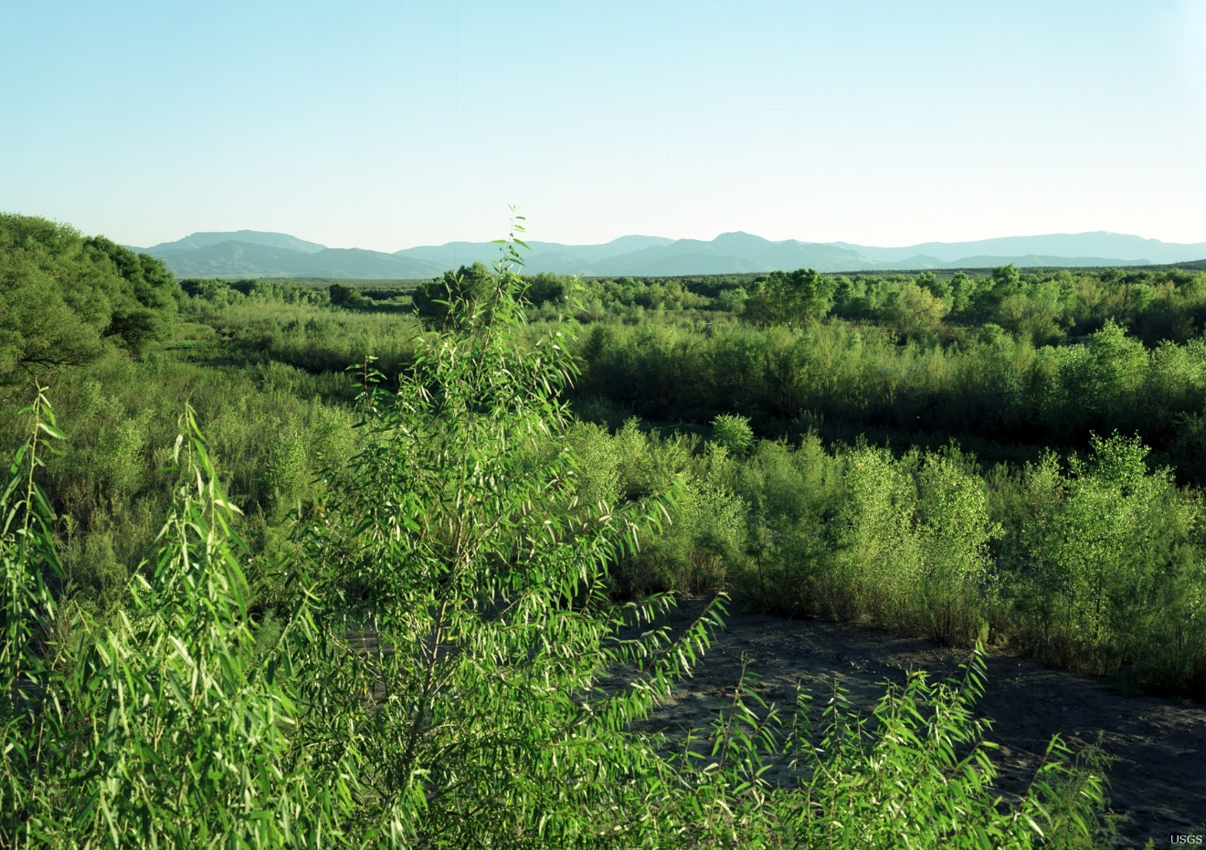
Caption for Graphic or Image: Cottonwoods, black willows, and tamarisk are riparian woodland species found in the wooded wetland class in the Arizona wetland map.
Author name: Christopher Soulard
Author business email: csoulard@usgs.gov

DOI agency/bureau: USGS
USGS Mission Area: Ecosystems
USGS Program: Species Management Research Program
Cost Center: Columbia Environmental Research Center
Program Name2:
Project title: Tracer Studies to Assess Sturgeon Habitat on the Missouri River
Project description: Tracer studies using a visible dye can yield insight on the dispersion processes that redistribute materials within a river, including both pollutants and organisms. Whereas typical approaches involve measuring dye concentration at a few fixed points over time, remote sensing can provide spatial information and geographic context. This type of data is useful for testing numerical flow models and can highlight areas with suitable habitat for key species or identify locations where hazardous substances might accumulate. Researchers from three USGS units --- the Columbia Environmental Research Center, National Uncrewed Systems Office, and Hydrologic Remote Sensing Branch --- are developing a framework for remote sensing of tracer dye concentrations to facilitate dispersion studies in rivers.

These scientists conducted a tracer experiment along the Sheepnose Bend reach of the Missouri River near Lexington, MO. On May 11, 2024, the team introduced a reddish-purple dye into the river from a boat and then characterized its movement using both standard field equipment and various remote sensing systems. Water quality sondes placed within the flow at a series of discrete points recorded the passage of the dye plume over time and were used to calibrate estimates of dye concentration derived from several types of images.

A crewed fixed-wing aircraft flew over the entire ~10 km-long site eight separate times during the experiment, capturing snapshots that show the movement of the dye plume over a two-hour period. Meanwhile, two separate Uncrewed Aircraft Systems (UAS) collected data from a subset of the reach where relatively large numbers of sturgeon larvae are captured annually. To better understand the habitat conditions within this area, one UAS acquired videos with a typical RGB (red, green, blue) camera. The other UAS was equipped with a hyperspectral imaging system that provides detailed information on the reflectance of light in visible and near-infrared wavelengths. The hyperspectral system is also distinct in that rather than capturing a full two-dimensional image, the sensor records a series of individual scan lines. By hovering in place above the river, the UAS repeatedly observed the same cross-section to monitor the passage of the dye.

Ongoing work is focused on relating remotely sensed data to field measurements of dye concentration so that different kinds of images can be used to produce transects and maps that quantify dispersion patterns and habitat conditions within the Missouri River.

Sensor Type: Hyperspectral;Video;Camera;
Platform type: Airplane;UAS;
URL:
Graphic or Image Upload: https://doimspp.sharepoint.com/sites/GS-EROSSCIENCESWI/Shared Documents/Communications Outreach/Documentation Science/DOI Remote Sensing Report/DOI RS Activities Report, 2024/Graphic or Image Upload/StudyArea_Carl Legleiter.jpg
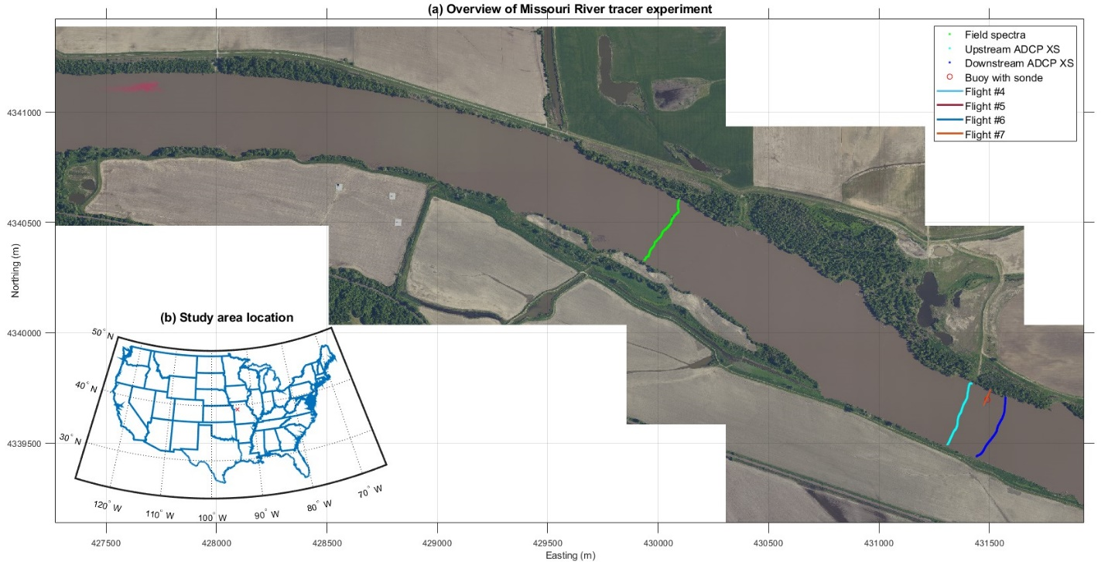
Caption for Graphic or Image: (a) Overview of a tracer experiment conducted along the Missouri River showing a pulse of visible dye pulse shortly after injection into the channel and the locations of field measurements that were used to estimate dye concentrations from remotely sensed data. These data sets include field spectra, velocity measurements made with an acoustic Doppler current profiler (ADCP) at two cross sections (XS), a buoy with a sonde measuring dye concentration, and hyperspectral image transects from four flights by an uncrewed aircraft system (UAS). Because the four transects overlap at this scale, only the line for Flight #7 is visible. (b) Inset map showing the location of the study area within contiguous United States.
Author name: Carl J. Legleiter
Author business email: cjl@usgs.gov

DOI agency/bureau: USGS
USGS Mission Area: Ecosystems
USGS Program: Land Change Science
Cost Center: Southwest Biological Science Center
Program Name2:
Project title: U.S.-Mexico Borderland & Vegetation Community Map
Project description: A high-resolution, binational vegetation community map that spans the entire U.S.-Mexico borderlands has been a long-standing necessity. To address this need, we designed unique data fusion methods, which included the use of Landsat imagery to produce the first prototype landcover map for a portion of the transboundary ‘desert ecoregion’ falling within the Mojave and Sonoran Deserts and overlapping the North American Bird Conservation Initiative’s Bird Conservation Region 33 (BCR33). Our approach using remote sensing from ground, aerial, and satellite sensors homogenized classification systems across both nations to support meaningful habitat distribution for research and resource management. Traditionally, mapping efforts in this region have been impeded by logistics related to the nature of a complex international border, differing national needs and plans, and resources allocations and priorities. To overcome these obstacles, we employed remote sensing imagery, machine learning techniques and field validation in this culturally, ecologically, and topographically complex border region. This map provides scientific support to inform land management decisions and to meet the management needs of stakeholders of the transboundary desert ecoregions. The creation of this map has been a long-standing priority for diverse partners on both sides of the U.S.-Mexico border. The results from this undertaking by scientists from the USGS Southwest Biological Science Center and the Sonoran Joint Venture, part of the U.S. Fish and Wildlife Service (FWS) Migratory Bird Program, were produced in conjunction with data engineers from the Department of Biosystems Engineering at the University of Arizona and validated with field verification through collaborators from Wildlands Network, the Borderlands Program. BCR33 is an area of high biodiversity, providing habitat for bird species of concern. The Phase-I map supports the FWS recovery plan efforts related to conservation planning activities for many species, including Yellow-billed Cuckoo, Cactus Ferruginous Pygmy-Owl, Southwestern Willow Flycatcher, Yuma Ridgway’s Rail, Bendire’s and LeConte’s thrashers, Masked Bobwhite, and non-avian species such as vertebrates including the iconic jaguar, and endangered plants such as Bartram’s stonecrop and the Pima pineapple cactus. In 2024, we completed a Phase-II map for the full BCR33 region (not shown), increasing the understanding of the binational nature of vegetation communities. This work is crucial for the protection, conservation, and restoration of vegetation, habitat, and ecosystems, particularly for threatened and endangered species. Our project deliverables include an end-to-end medium and fine resolution remote sensing-based data fusion method and an online toolset to map the transboundary vegetation communities in our study region.
Sensor Type: Multispectral (approx. 4-12 bands);
Platform type: Satellite;
URL: https://doi.org/10.3390/rs15051266
Graphic or Image Upload: https://doimspp.sharepoint.com/sites/GS-EROSSCIENCESWI/Shared Documents/Communications Outreach/Documentation Science/DOI Remote Sensing Report/DOI RS Activities Report, 2024/Graphic or Image Upload/Melichar-etal_2023_remotesensing-BCR33Map_Pamela Nagler.jpg
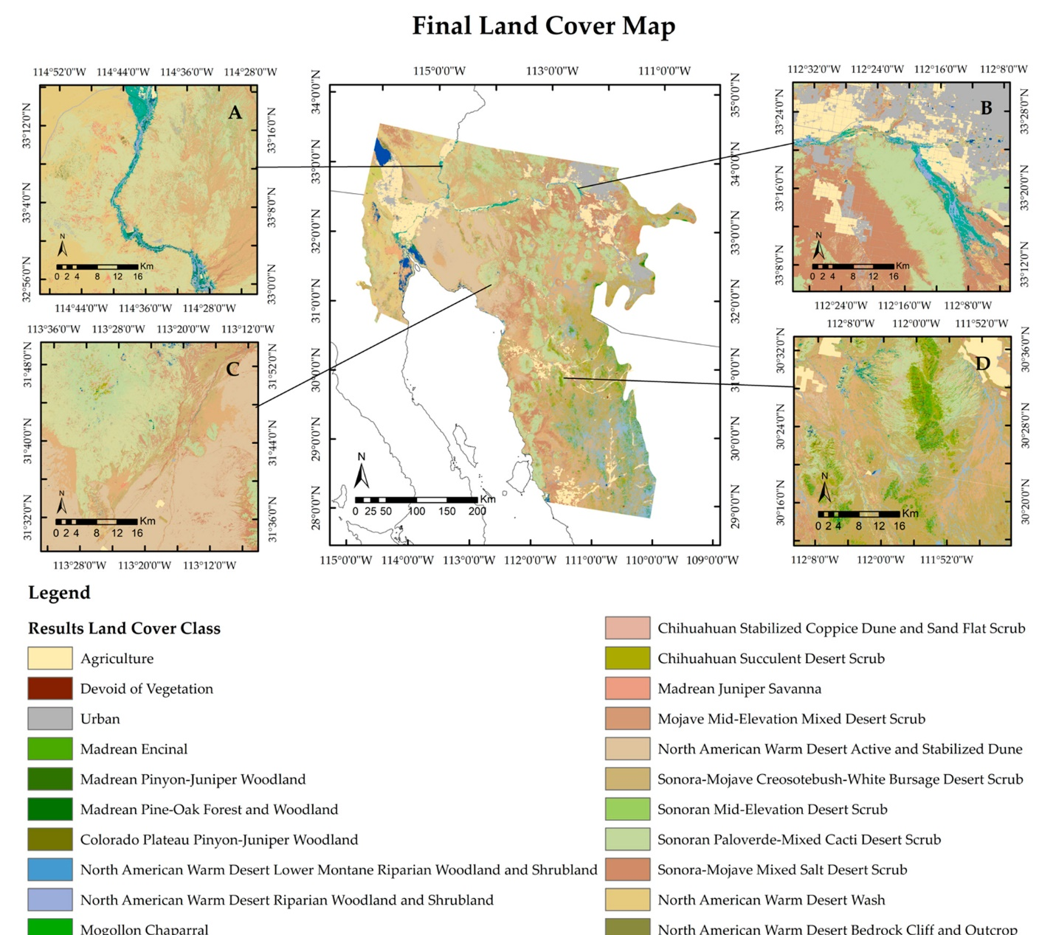
Caption for Graphic or Image: Melichar-etal_2023_remotesensing-BCR33Map.jpg
Author name: Pamela Nagler
Author business email: pnagler@usgs.gov

DOI agency/bureau: USGS
USGS Mission Area: Core Science Systems
USGS Program: **unspecified​**
Cost Center: Earth Resources Observation and Science (EROS) Center (Geography)
Program Name2:
Project title: Rangeland Condition Monitoring Assessment and Projection (RCMAP)
Project description: Rangelands occupy huge swathes of land in the US, typically where climate and/or soils are too harsh for either forest or agriculture. Rangeland ecosystems provide critical wildlife habitat, forage for livestock, carbon sequestration, provision of water resources, and recreational opportunities. At the same time, rangelands are vulnerable to climate change, fire, and anthropogenic disturbances. The arid-semiarid climate in most rangelands fluctuates widely, impacting livestock forage availability, wildlife habitat, and water resources. Many of these changes can be subtle or evolve over long time periods, responding to both climate and anthropogenic driving forces.

Scientists from the U.S. Geological Survey (USGS) Earth Resources Observation and Science (EROS) Center and the Bureau of Land Management developed the Rangeland Condition Monitoring Assessment and Projection (RCMAP) project. This project quantifies the percent cover of rangeland components across the western United States using Landsat imagery from 1985–2023 in the current generation. The RCMAP product suite includes ten fractional components (annual herbaceous, bare ground, herbaceous, litter, non-sagebrush shrub, perennial herbaceous, sagebrush, shrub, tree, and shrub height) and the temporal trends of each.

Data show much of the rangelands of the Western U.S. have experienced change, though most of this change is gradual. Weather variation is the leading driver of change, followed by fire. The time-series can track increased herbaceous cover and decreased bare ground cover in wet years, and the opposite in dry years. Deeper root systems in shrubs and trees insulate these components from interannual weather variation to some extent.

RCMAP is currently evaluating enhanced artificial intelligence methods such as convolutional neural networks that leverage spatial and/or temporal patterns to reduce mapping error. Additionally, hyperspectral imagery such as from Earth Surface Mineral Dust Source Investigation (EMIT) has been tested and found to significantly increase classification accuracy by capturing portions of electromagnetic spectrum where separation among important rangeland targets exists.

RCMAP fractional component time-series data spanning 1985–2023 and trends analysis products are now available for download at https://www.mrlc.gov/ and on the rangelands viewer application. This dataset is designed for out-of-the-box application and provides a foundation for both historical and future monitoring at ecosystem scales. Land managers and scientists can use annual fractional cover maps to monitor changes to vegetation composition, evaluate past management practices, target future improvements, determine locations of critical wildlife habitat, assess effects of climate change and interannual variation, and appraise landscape health and fragmentation.

Sensor Type: Hyperspectral;Multispectral (approx. 4-12 bands);
Platform type: Satellite;
URL: https://www.mrlc.gov/
Graphic or Image Upload:
Caption for Graphic or Image: Rangeland managers need information on the current vegetation condition and how the landscape has changed through time. RCMAP classifies western U.S. rangelands as fractional (0-100%) cover of ten ground cover components for each year in a time-series stretching from 1985 to 2023. This long-term perspective is key to understanding vegetation response to climate change, altered management practices, and to disturbance.

Author name: Matthew Rigge
Author business email: mrigge@usgs.gov

DOI agency/bureau: USGS
USGS Mission Area: Core Science Systems
USGS Program: Land Change Science
Cost Center: Geosciences and Environmental Change Science Center
Program Name2:
Project title: Climate change will impact surface water extents and dynamics across the central United States
Project description: Aquatic features, like rivers, lakes, ponds, and wetlands, respond to episodic, seasonal, and interannual variability in climatic conditions, by expanding and contracting in extent and water level. Therefore, changes in precipitation and evaporative demand, as expected with climate change, will likely impact these surface water dynamics. Previous efforts, however, have not projected changes across the full range of surface water conditions, or considered site-based variability in the amount of water expansion and contraction. We integrated Sentinel-1 and Sentinel-2 based algorithms to track monthly surface water extent (2017-2021) for 32 sites across the central United States. Median surface water extent was highly variable across sites, ranging from 3.9% to 45.1% of a site. To account for landscape-based differences (e.g., water storage capacity, land use) in the response of surface water extents to meteorological conditions, individual statistical models were developed for each site. Future changes to climate were defined as the difference between 2006-2025 and 2061-2080 using MACA-CMIP5 (MACAv2-METDATA) Global Circulation Models. Time series of climate change adjusted surface water extents were projected. Annually, 19 of the 32 sites (59%) under RCP4.5 and 22 of the 32 sites (69%) under RCP8.5 were projected to show an average decline in surface water extent. Projected declines were projected to increase under dry condition, suggesting the impacts of drought will be exacerbated. Projected changes were also often seasonally variable, with the greatest decline in surface water extent expected in summer and fall seasons. In contrast, many of the northern sites showed a projected increase in surface water in most seasons, likely attributable to projected increases in winter and spring precipitation exceeding increases in projected temperature. Our work produces the first suite of climate change projections of surface water extent across the central U.S. that explicitly considers variability in how surface water responds to climate inputs and enables projections across a range of climate and land use conditions. Projected changes in surface water extents can inform future estimates of regional and national surface water storage, which can guide conservation and mitigation efforts as well as help us plan for future flood and drought events.
Publication link: Climate Change Will Impact Surface Water Extents and Dynamics Across the Central United States - Vanderhoof - 2024 - Earth's Future - Wiley Online Library

Sensor Type: Multispectral (approx. 4-12 bands);
Platform type: Satellite;
URL: Climate Change Will Impact Surface Water Extents and Dynamics Across the Central United States - Vanderhoof - 2024 - Earth's Future - Wiley Online Library
Graphic or Image Upload: https://doimspp.sharepoint.com/sites/GS-EROSSCIENCESWI/Shared Documents/Communications Outreach/Documentation Science/DOI Remote Sensing Report/DOI RS Activities Report, 2024/Graphic or Image Upload/Figure6_Melanie Vanderhoof.png
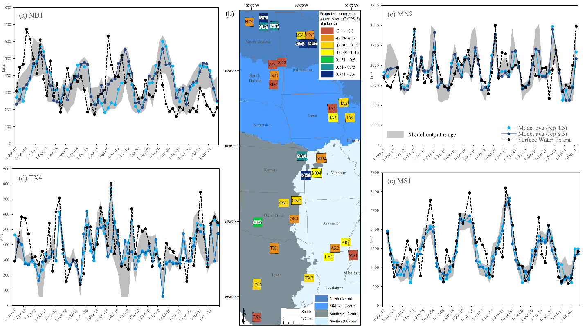
Caption for Graphic or Image: Figure. (a) Observed and projected surface water extent in ND1, (b) projected change to median surface water extent at RCP8.5 using the 20-model average, as well as (c) observed and projected surface water extent in MN2, (d) TX4, and (e) MS1.
Author name: Melanie Vanderhoof
Author business email: mvanderhoof@usgs.gov

DOI agency/bureau: USGS
USGS Mission Area: Core Science Systems
USGS Program: National Land Imaging Program
Cost Center: Geosciences and Environmental Change Science Center
Program Name2:
Project title: UAS 3D Model for Geoheritage Sites of the Nation Project
Project description: Geoheritage refers to geologic features and landforms with scientific, educational, cultural, economic, and aesthetic significance.

The USGS National Cooperative Geologic Mapping Program’s Geoheritage Sites of the Nation Project is developing an initial inventory of geoheritage sites to showcase the geodiversity and natural heritage on Federal public lands across the United States and Territories. To allow the public to remotely explore geologic sites of significance, the project is building an interactive web application, the Geoheritage Sites of the Nation viewer, to provide an educational and outreach tool to 1) raise awareness of significant geologic sites, 2) communicate the role of geology in our natural heritage, and 3) increase accessibility and relevance of geologic mapping and geoscience topics more broadly to the public.

The Marsh-Felch Dinosaur Quarry site at the Bureau of Land Management (BLM) Garden Park Fossil Area north of Cañon City has been selected as the highlight site for Colorado. One of the most complete dinosaur skeletons ever unearthed was found there. The fossil discoveries around present-day Garden Fossil Park Area sparked the “Bone Wars” of the late 1800s, and inspired the selection of the Colorado state fossil, the Stegosaurus.

Geographer Paco Van Sistine of the USGS Geosciences and Environmental Change Science Center is leading the development of the interactive web viewer and aspires to feature eye-catching three-dimensional (3D) models of the geoheritage sites. One way to generate 3D models of natural features is to collect a series of overlapping photographs using uncrewed aircraft systems (UAS), also known as drones, and process them using structure-from-motion (SfM) photogrammetry software.

In July 2024, USGS National Uncrewed Systems Office (NUSO) remote pilots Victoria Scholl and Matthew Burgess conducted flights using a Skydio X10 UAS to safely and efficiently obtain high-resolution imagery of this famous fossil site. Using its 3D Scan capability, the Skydio X10 autonomously determines where to capture photos to achieve coverage across a volume of interest. The aircraft is equipped with multiple collision avoidance cameras and can maneuver through areas with complex terrain to capture imagery. Over the course of three flights, the UAS captured nearly 3,000 photos across the quarry. Using SfM software, these images will be processed to generate a 3D model of this world-renowned fossil site for inclusion in the Geoheritage web application.

This project marks the first time that USGS remote pilots have utilized the Skydio X10’s technologically advanced 3D scan capabilities for a geologic feature.
Sensor Type: Camera;Video;
Platform type: UAS;
URL: https://www.usgs.gov/centers/geology-energy-and-minerals-science-center/science/geoheritage-sites-nation#overview
Graphic or Image Upload: https://doimspp.sharepoint.com/sites/GS-EROSSCIENCESWI/Shared Documents/Communications Outreach/Documentation Science/DOI Remote Sensing Report/DOI RS Activities Report, 2024/Graphic or Image Upload/Low res 3D model Skydio X10 images Metashape_Victoria Scholl.png
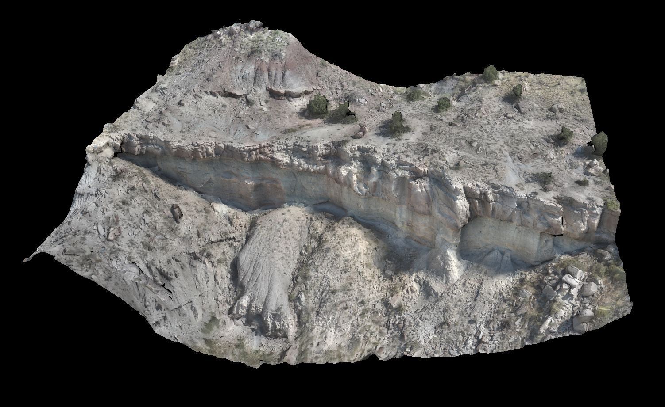
Caption for Graphic or Image: 3D model of the Marsh-Felch Dinosaur Quarry site in Colorado, generated using the UAS-acquired images.
Author name: Victoria Scholl
Author business email: vscholl@usgs.gov

DOI agency/bureau: USGS
USGS Mission Area: **unspecified​**
USGS Program: National Land Imaging Program
Cost Center: **unspecified**
Program Name2:
Project title: Federal Uncrewed Systems (UxS) Workshop hosted by USGS and NASA
Project description: On September 10-12, 2024, the USGS National Innovation Center and NASA will host over 120 federal uncrewed systems (UxS) users, managers, and administrators at the 6th Federal UxS Users Workshop to share their collective knowledge and expertise in ground, water, and airborne UxS operations, applications, and innovations. The workshop is being held at the Southwestern Indian Polytechnic Institute (SIPI) in Albuquerque, New Mexico for the first time and will showcase federal agency updates on UxS, presentations on recent missions, flight demonstrations, and panel discussions, as well as student activities. Attendees will have the opportunity to attend both technical and topical breakout groups sessions over the three-day event. Technical breakout sessions will cover topics ranging from AI/ML applications and sensors and payloads to data management. Topical breakouts will range from geomorphic change, wildland fire, and wildlife tracking to forest and vegetation change detection and marine applications. The goal of the breakouts is to set the stage for the current state of the science, outline a path for the next 5-10 years of needs, and generate policy recommendations for achieving future success. Three panel sessions will cover university programs, collaborative opportunities, and future research directions. Participants at the workshop will include representatives from USACE, NASA, BIA, BIE, BLM, USCG, FBI, DHS, FEMA, NOAA, ORNL, USFS, USGS, FWS, DOI, BOR, EPA, OSMRE, and USDA. We also have 20 people from 7 different universities attending, including many students. There will be student-focused activities as well as tabling for recruitment during the poster session. Hosting at SIPI will help engage the next generation of UxS users, expand our efforts on Tribal lands, and ensure our Federal UxS capacity is world class for decades to come. Our overarching goal is to approach UxS remote sensing applications with a whole-of-Government team, leveraging successes within our Agencies to accelerate our national UxS enterprise, ultimately focusing group expertise and capacity on shared challenges and new opportunities.

Sensor Type: Camera;Gas detector;Hyperspectral;IFSAR / SAR / Radar;Lidar (terrestrial or bathymetric);Multispectral (approx. 4-12 bands);Sound (sonar or acoustic);Thermal;Video;
Platform type: UAS;
URL: https://www.usgs.gov/centers/national-innovation-center/science/6th-federal-uxs-workshop
Graphic or Image Upload: https://doimspp.sharepoint.com/sites/GS-EROSSCIENCESWI/Shared Documents/Communications Outreach/Documentation Science/DOI Remote Sensing Report/DOI RS Activities Report, 2024/Graphic or Image Upload/6th UxS Workshop Logo_cropped_Tamara Wilson.jpg

Caption for Graphic or Image: Logo for the 6th Federal UxS Users Workshop
Author name: Tamara Wilson
Author business email: tswilson@usgs.gov

DOI agency/bureau: USGS
USGS Mission Area: Core Science Systems
USGS Program: National Land Imaging Program
Cost Center: Geosciences and Environmental Change Science Center
Program Name2:
Project title: UAS 3D Scan of the Perry’s Victory and International Peace Memorial
Project description: The U.S. Geological Survey National Uncrewed Systems Office (NUSO) and the National Park Service (NPS) Heritage Document Programs partnered in May 2024 to perform an Uncrewed Aircraft System (UAS)-based 3D scan of Perry’s Victory and International Peace Memorial in Ohio.

Perry’s Victory and International Peace Memorial was established to honor those who fought in the Battle of Lake Erie, during the War of 1812, and to celebrate the long-lasting peace among Great Britian, Canada, and the United States. The memorial rises 352 feet over Lake Erie and is situated 5 miles from the longest undefended border in the world (NPS). The monument was constructed in 1913 and serves as the final resting place for six officers, three American and three British, who died in combat.

During this mission, NUSO utilized two different UAS to provide a full photogrammetric survey of the exterior of the monument. Data collection was first performed with a fully autonomous Skydio X10 UAS using its 3D Scan capabilities to generate a digital twin of the monument, which was also the first time DOI utilized UAS 3D Scan for a historical structure. It took six hours of flight time using the Skydio X10 to capture high-resolution imagery of the monument's exterior. A second UAS carried a Sony A7R4 camera system and was flown manually to capture stereo imagery to supplement the autonomous imagery collection.

NPS architects and engineers conducted terrestrial laser scans (TLS) of the outside base of the monument and the interior of the structure. The NPS will combine the TLS derived point clouds and the UAS-provided point cloud in the analysis and documentation package. The intent of the project is to document Perry’s Victory and International Peace Memorial with a historical report, measured drawings, and archival photographs for inclusion in the collection at the Library of Congress.
Sensor Type: Camera;Video;
Platform type: UAS;
URL: https://www.nps.gov/pevi/index.htm
Graphic or Image Upload: https://doimspp.sharepoint.com/sites/GS-EROSSCIENCESWI/Shared Documents/Communications Outreach/Documentation Science/DOI Remote Sensing Report/DOI RS Activities Report, 2024/Graphic or Image Upload/Perry_Victory_Memorial_UAS_Victoria Scholl.png
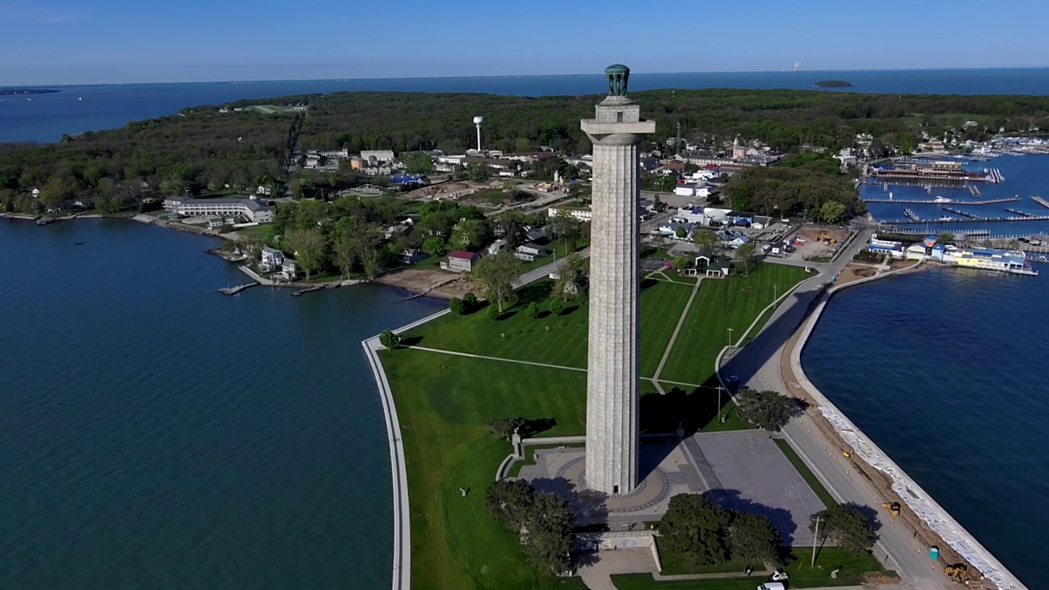
Caption for Graphic or Image: Image of the Perry's Victory and International Peace Memorial taken from a UAS.
Author name: Lance Brady
Author business email: lrbrady@usgs.gov

DOI agency/bureau: USGS
USGS Mission Area: Ecosystems
USGS Program: Climate Research & Development
Cost Center: Western Geographic Science Center
Program Name2:
Project title: Central California crop type mapping of trends and patterns from 2005 to 2020
Project description: California’s croplands are some of the most economically important, productive, and diverse in the United States. This agricultural landscape can be dynamic, as farmers alter crop types and acreage in response to market trends, climate change, and natural hazards such as floods and droughts. To better understand these changes, researchers for the U.S. Geological Survey (USGS) are developing accurate, long-term crop type data to support monitoring trends and patterns in croplands across time. The USGS team used high-resolution aircraft-based aerial imagery from the U.S. Department of Agriculture’s National Agriculture Imagery Program and moderate-resolution satellite imagery from Landsat 5, 7, and 8 to build a machine learning model to identify nine different crop types. This model was applied to remotely sensed images of California croplands beginning in 2005 and ending in 2020. The results showed a statistically significant decline in total area of field crops and pasture crops across the date range. Deciduous fruit and nut crops, citrus and subtropical crops, and fallow/young perennial crop types were all found to have increased in total area during the study date range. In general, these results suggest a shift from crops that are replanted every year (annual) to crops that keep growing or regrow every year (perennial). The results also showed that crop types in the southwestern Central Valley and the Sacramento-San Joaquin River Delta changed frequently between map dates, while the Salinas, Napa, and Santa Maria Valleys had more enduring crop types. The developed crop type maps and dataset can aid managers and decision makers for resource planning. More information can be found online here.
Sensor Type: Multispectral (approx. 4-12 bands);
Platform type: Airplane;Satellite;
URL: https://doi.org/10.1002/agg2.20553
Graphic or Image Upload: https://doimspp.sharepoint.com/sites/GS-EROSSCIENCESWI/Shared Documents/Communications Outreach/Documentation Science/DOI Remote Sensing Report/DOI RS Activities Report, 2024/Graphic or Image Upload/Smith - DOI RS Report graphic_Britt Smith.jpg
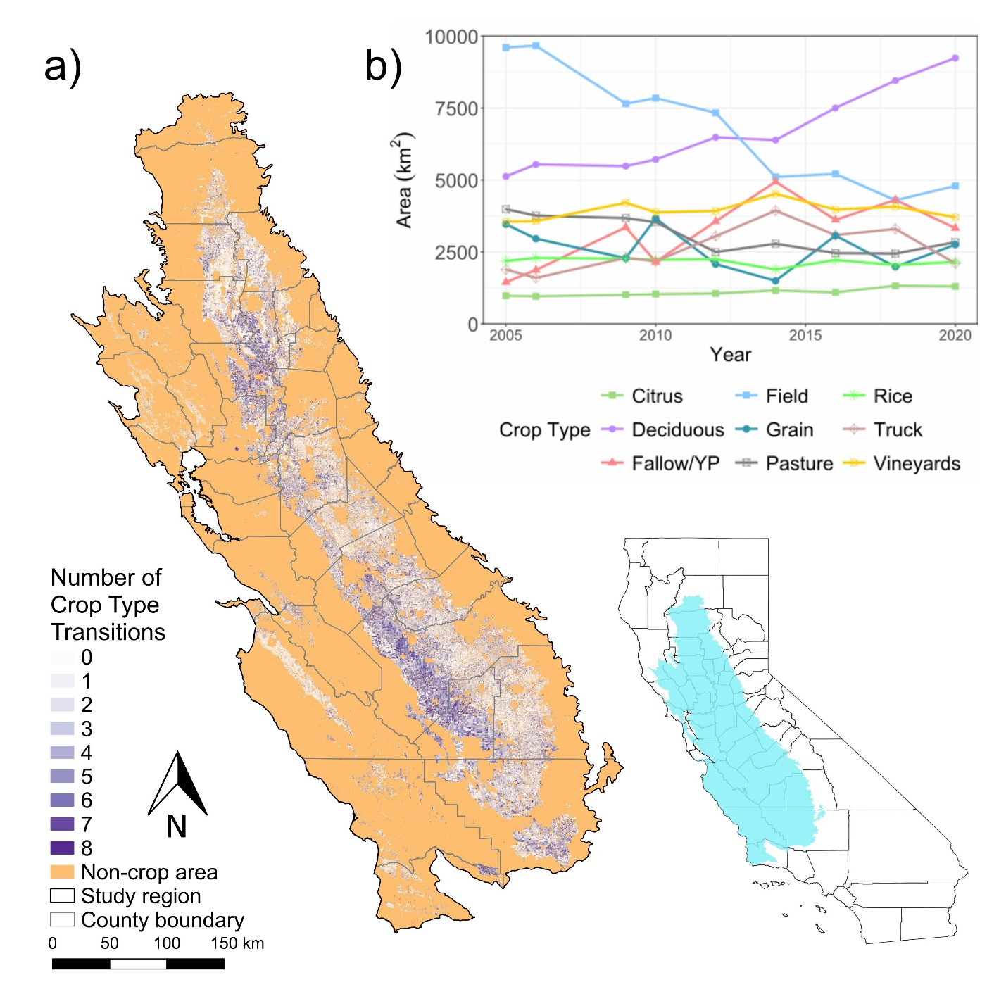
Caption for Graphic or Image: a) The number of crop type transitions for each field across the study time period in central California. Darker shades of purple indicate greater numbers of crop type changes. b) Total area of each crop type for each year examined across the study period in central California. The associated manuscript is available here.
Author name: Britt W. Smith
Author business email: bwsmith@usgs.gov

DOI agency/bureau: USGS
USGS Mission Area: Core Science Systems
USGS Program: National Geospatial Program
Cost Center: NGTOC Denver
Program Name2:
Project title: Using Imagery to Crowdsource The National Map
Project description: The National Map Corps (TNMCorps), a crowdsourced mapping project, relies on volunteers to assist the USGS National Geospatial Program by collecting and editing man-made structures data for The National Map. Through their participation, volunteers make important contributions to the USGS’s ability to provide the Nation with accurate mapping information.

Volunteers collect and update different structure feature types in all 50 states, as well as in Puerto Rico and the U.S. Virgin Islands. The Pacific Territories were added in 2022. The structure feature types include schools, colleges and universities, fire and emergency management stations, law enforcement, prisons and correctional facilities, hospitals, ambulance services, cemeteries, post offices, courthouses, city/town halls, trailheads, visitor centers, and campgrounds. Through a tiered-editing approach, volunteers improve the structures data by adding new features, removing obsolete points, and correcting existing data. The updates are then incorporated into The National Map and ultimately into U.S. Topo maps. As of July 31st 2024, more than 3,900 users have made more than 909,000 edits to over 600,000 unique points.

Getting started is easy. After walking through a simple registration process, volunteers begin editing using an internally developed web-based mapping platform that was released in July 2024. The primary base layer uses The National Map Web services and consists primarily of 1-meter resolution digital orthophoto imagery provided by the U.S. Department of Agriculture National Aerial Imagery Program (NAIP), which is supplemented by 2-foot or better high-resolution orthoimagery over urban areas.

TNMCorps incorporates a variety of strategies to motivate and engage volunteers while simultaneously facilitating focused data collection resulting in high-quality data. These strategies include the tiered-editing process, mapping challenges, virtual recognition badges, social media engagement, bi-monthly newsletters, and news releases. Volunteers are from the general public and include retirees, students, geospatial professionals, and anyone with an interest in contributing to The National Map.
Sensor Type: Camera;
Platform type: Airplane;
URL: https://www.usgs.gov/core-science-systems/ngp/tnm-corps
Graphic or Image Upload: https://doimspp.sharepoint.com/sites/GS-EROSSCIENCESWI/Shared Documents/Communications Outreach/Documentation Science/DOI Remote Sensing Report/DOI RS Activities Report, 2024/Graphic or Image Upload/TNMCorps_Contributions_FY24_Erin Korris.jpg
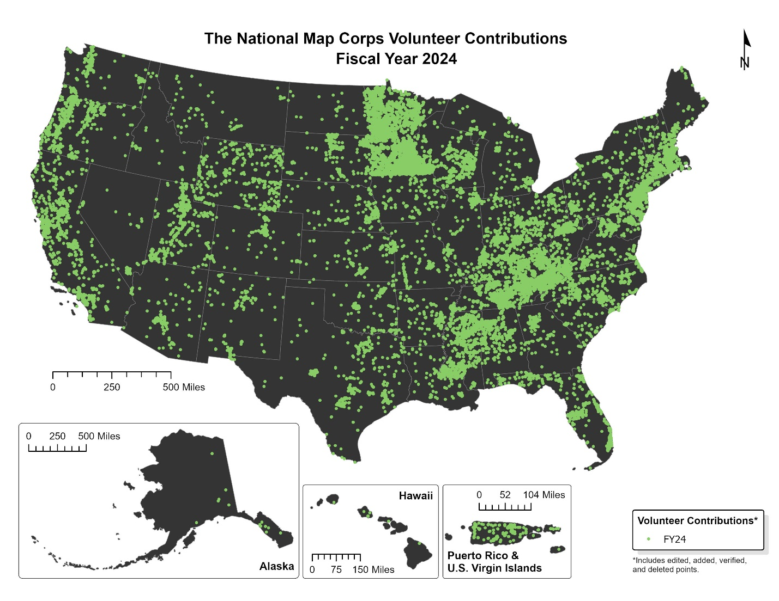
Caption for Graphic or Image: USGS TMNCorps volunteer contributions from October 1, 2023, to July 31, 2024. Each point on the map represents a single volunteer-edited structure feature. These volunteer contributions include edited, added, verified, and deleted points.
Author name: Erin Korris
Author business email: ekorris@usgs.gov

DOI agency/bureau: USGS
USGS Mission Area: Core Science Systems
USGS Program: National Land Imaging Program
Cost Center: Western Geographic Science Center
Program Name2:
Project title: Agricultural cropland studies using new-generation hyperspectral sensors
Project description: Recently launched and upcoming spaceborne hyperspectral sensors from multiple countries provide an opportunity to advance agricultural studies. For example, the near-continuous hyperspectral data can facilitate crop type classification and estimation of crop biophysical and biochemical characteristics, important for addressing issues of global food and water security. However, most classification and regression models rely on large amounts of reference data for training and validation. The U.S. Geological Survey (USGS) Global Hyperspectral Imaging Spectral-library of Agricultural crops (GHISA) project generates and collates spectral signatures of crops from global collaborators into a comprehensive reference spectral library (see Figure 1). It contains spectra from various sensors and platforms, years and times of year, crop types and their growth stages, and agroecological zones. Scientists from the USGS are investigating two new-generation hyperspectral sensors (Germany’s Deutsches Zentrum fur Luft- und Raumfahrt (DLR) Earth Sensing Imaging Spectrometer (DESIS)) onboard the International Space Station (ISS) acquiring data in the 402-1000 nanometer (nm) region in 2.55 nm bands, and Italy’s ASI’s and PRecursore IperSpettrale della Missione Applicativa (PRISMA) acquiring data in the 407-2497 nm region in 10-12 nm bandwidths) and establishing machine learning, deep learning, and artificial intelligence (ML/DL/AI) workflows on the cloud for large-scale crop type classification and mapping.

The overarching goals of these studies are to investigate the performance of sensors for studying agricultural crops. Specific objectives are to 1) study the characteristics of new-generation sensors; 2) develop spectral libraries of agricultural crops; and 3) classify key agricultural crops leveraging ML/DL/AI on the cloud. The USGS team has found that a single hyperspectral image can outperform time-series multispectral imagery for crop classification in certain cases (see https://doi.org/10.1109/JSTARS.2022.3204223). A related study (see https://doi.org/10.14358/PERS.22-00039R2) found that using ML and optimal hyperspectral narrowbands (OHNBs), rather than all bands, can differentiate seven crop types with overall accuracies of 83-90% in California. OHNBs can also be used to build hyperspectral vegetation indices to estimate crop biophysical and biochemical characteristics like biomass/yield. Information about how to maximize crop yield while conserving water helps promote global food and water security (see https://doi.org/10.3390/rs15194894 for more information). To learn more about GHISA and access data, visit the project website at https://usgs.gov/wgsc/ghisa.

Sensor Type: Hyperspectral;Multispectral (approx. 4-12 bands);
Platform type: Satellite;on International Space Station;
URL: https://usgs.gov/wgsc/ghisa
Graphic or Image Upload:
Caption for Graphic or Image: Figure 1: June DESIS and PRISMA spectra. Comparisons between June Deutsches Zentrum fur Luft- und Raumfahrt (DLR) Earth Sensing Imaging Spectrometer (DESIS) and PRecursore IperSpettrale della Missione Applicativa (PRISMA) spectra for: a) almonds, b) corn and cotton, c) rice and tomatoes, and d) grapes and pistachios. The associated paper is available at https://doi.org/10.14358/PERS.22-00039R2.
Author name: Itiya Aneece
Author business email: ianeece@usgs.gov

DOI agency/bureau: USGS
USGS Mission Area: Core Science Systems
USGS Program: National Land Imaging Program
Cost Center: Geosciences and Environmental Change Science Center
Program Name2:
Project title: 2024 Tortoise Habitat Survey, Palo Alto Battlefield National Historic Park
Project description: In March of 2024 the National Uncrewed Systems Office, Western Geographic Science Center and the National Park Service conducted UAS operations over the Palo Alto Battlefield National Historic Park. Uncrewed Aerial Systems (UAS) are becoming important tools for understanding wildlife distributions and improving habitat prioritization and conservation. UAS data can provide spatially extensive and high-resolution maps of vegetation type and cover, topography and other landscape features that support analyses of habitat selection and suitability. For Texas tortoise, habitat features such as particularly dense shrubs, grasses, and cacti, incontiguous patches, and small hills are challenging to map using field surveys and satellite remote sensing, are better suited for UAS data collection. Data collected to generate high resolution UAS data at Palo Alto Battlefield National Historical Park to evaluate habitat use by Texas tortoise. Several models of UAS were used to collect data including Wingtra One Gen II to collect visible, near infrared and a new lidar payload, and the DJI M600 carrying a Yellowscan Mapper + lidar unit.

Sensor Type: Camera;Lidar (terrestrial or bathymetric);Multispectral (approx. 4-12 bands);
Platform type: UAS;
URL:
Graphic or Image Upload: https://doimspp.sharepoint.com/sites/GS-EROSSCIENCESWI/Shared Documents/Communications Outreach/Documentation Science/DOI Remote Sensing Report/DOI RS Activities Report, 2024/Graphic or Image Upload/Picture3_Lance Brady.jpg
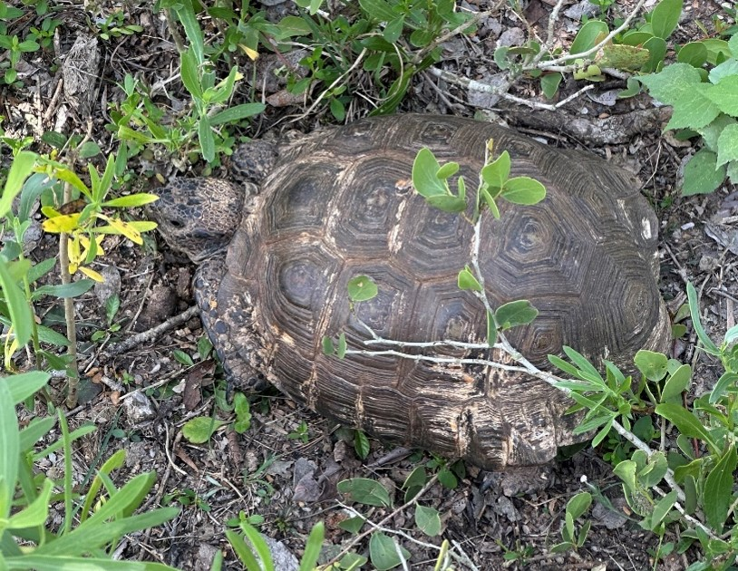
Graphic or Image Upload: https://doimspp.sharepoint.com/sites/GS-EROSSCIENCESWI/Shared Documents/Communications Outreach/Documentation Science/DOI Remote Sensing Report/DOI RS Activities Report, 2024/Graphic or Image Upload/Picture2_Lance Brady.jpg
Graphic or Image Upload: https://doimspp.sharepoint.com/sites/GS-EROSSCIENCESWI/Shared Documents/Communications Outreach/Documentation Science/DOI Remote Sensing Report/DOI RS Activities Report, 2024/Graphic or Image Upload/Picture1_Lance Brady.jpg
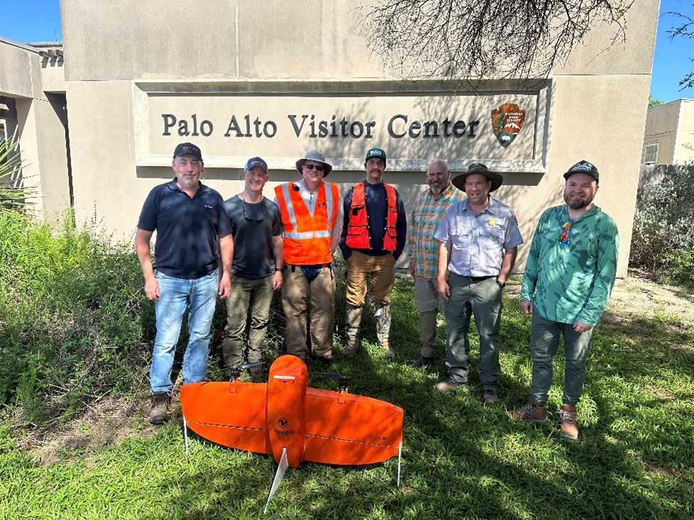
Caption for Graphic or Image: Picture1: Picture of the UAS Project Team at Palo Alto Battlefield National Historic Park NPS Visitors Center located near Brownsville, Tx. From left to right, Scott McTavish (Wingtra), Keith Williams (Wingtra), Matt Burgess (NUSO), Josh Von Nonn (WGSC), Lance R. Brady (NUSO), Lee Bragg (NPS), Samuel Chambers (WGSC)
Picture2: Texas tortoise in the wild located at the Palo Alto Battlefield National Historic Park.
Picture3: Verifying successful lidar data collection while in the field at Palo Alto Battlefield National Historic Park.
Author name: Lance R. Brady
Author business email: lrbrady@usgs.gov

DOI agency/bureau: USGS
USGS Mission Area: Energy and Minerals
USGS Program: Mineral Resources Program
Cost Center: Geology and Geophysics Science Center
Program Name2:
Project title: Airborne Magnetic and Radiometric Surveys Unlocking Earth's Secrets for Science and Resource Exploration
Project description: The U.S. Geological Survey (USGS) is taking to the skies with high-resolution airborne magnetic and radiometric surveys as part of the Earth Mapping Resource Initiative (EMRI, https://www.usgs.gov/special-topics/earth-mri). This ambitious undertaking, covering parts of the conterminous United States including Alaska and Puerto Rico, not only supports critical minerals resource assessments but also fuels a broader range of geophysical, geological, and geochemical research, with additional applications such as earthquake hazards and mine waste characterization. The survey data are publicly accessible, promoting scientific collaboration and discovery. Magnetic surveys measure the subtle variations in the Earth’s magnetic field, revealing differences in the magnetic properties of rocks and minerals beneath the surface. Radiometric surveys detect natural low-level radioactivity emitted by rocks and soils, providing information on the distribution of potassium, uranium, and thorium which indicate specific rock types. Scientists employ specialized software to analyze the magnetic and radiometric signatures from the surveys to make map products that unveil hidden patterns not readily seen with other methods. The EarthMRI map viewer (https://ngmdb.usgs.gov/emri/#3.2/40/-96) offers a user-friendly interface to explore where surveys have been conducted and are planned. This interactive tool also provides direct links to download the magnetic and radiometric survey data, complete with full citations, streamlining access for researchers.
Sensor Type: Magnetometry and radiometric sensing;
Platform type: Helicopter;
URL: https://www.usgs.gov/special-topics/earth-mri
Graphic or Image Upload: https://doimspp.sharepoint.com/sites/GS-EROSSCIENCESWI/Shared Documents/Communications Outreach/Documentation Science/DOI Remote Sensing Report/DOI RS Activities Report, 2024/Graphic or Image Upload/Helipcopter_magrad2_Carrie Middleton.png
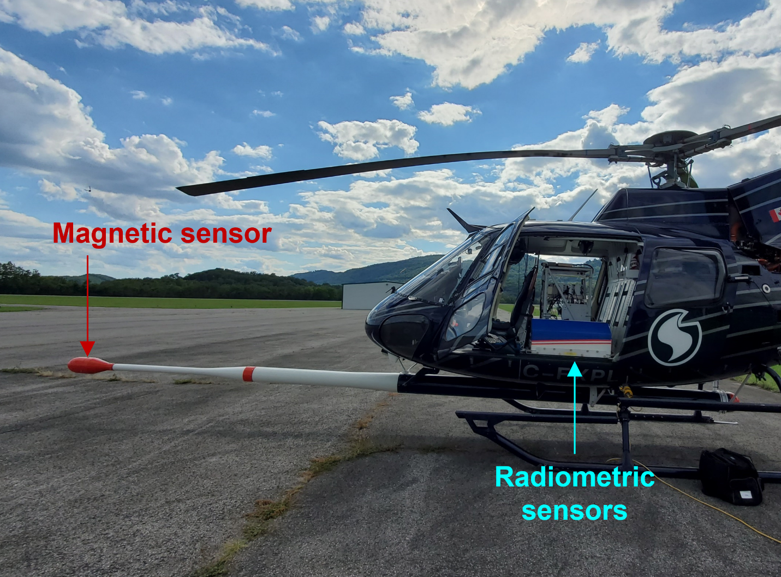
Caption for Graphic or Image: A helicopter configured with magnetic and radiometric sensors for geophysical surveying (USGS)
Author name: Carrie Middleton
Author business email: cmiddleton@usgs.gov

DOI agency/bureau: USGS
USGS Mission Area: Ecosystems
USGS Program: Land Management Research Program
Cost Center: Columbia Environmental Research Center
Program Name2:
Project title: UAS-based imagery collection for baseline data in advance of dam removal and Cuyahoga River stream restoration
Project description: Imagery collected using Uncrewed Aircraft Systems (UAS) are being used to monitor stream restoration along the Cuyahoga River. Scientists from the U.S. Geological Survey (USGS) Columbia Environmental Research Center and Utah Water Science Center are collecting imagery to document baseline conditions prior to the planned removal of the Cuyahoga Gorge Dam in Summit County Ohio. Leaf-off imagery of the dam and reservoir from 2024 will complement leaf-on imagery collected in 2022. Together these data sets are being used to develop digital elevation and vegetation height models for Gorge Metro Park, operated by Summit County, Ohio.

Downstream of the dam, UAS imagery and field observations will provide baseline data to initiate monitoring of changes in steelhead trout habitat following dam removal. USGS researchers will gather imagery of riparian areas within the CUVA; collaborators from Summit Metro Parks and the University of Missouri will collect imagery between the reservoir and CUVA. Together, more than more than 35 river miles will be imaged to support fish habitat and terrestrial vegetation monitoring.

Challenges within the study area include limited sight lines due to steep terrain, a densely populated urban area, limited areas suitable for operational staging, commercial centers, high-traffic roadways, and concerns about public safety in heavily used urban parks. Preliminary scouting in August 2024 identified dozens of potential launch points for data collection within CUVA and around the gorge dam. The restoration itself is being performed by the U.S. Army Corps of Engineers and the U.S. Environmental Protection Agency as part of the Great Lakes Restoration Initiative. Monitoring of removal effects is a collaborative effort between those agencies, USGS, and numerous other State and Federal agencies.

Sensor Type: Camera;Multispectral (approx. 4-12 bands);
Platform type: UAS;
URL: https://www.usgs.gov/centers/columbia-environmental-research-center/science/uas-and-other-remote-sensing-and-imagery
Graphic or Image Upload:
Caption for Graphic or Image: The Ohio-Edison Dam (left) on the Cuyahoga River is being removed to provide habitat connectivity for steelhead trout and to expose steep slopes and cataracts currently submerged under the dam reservoir (similar to those at right). Imagery collected using UAS will document changes in slopes and vegetation as waters recede following dam removal and track the movement of sediment through the river system downstream of the dam, including Cuyahoga Valley National Park.
Author name: Matthew Stuckhoff
Author business email: mstruckhoff@usgs.gov

DOI agency/bureau: USGS
USGS Mission Area: Ecosystems
USGS Program: Land Management Research Program
Cost Center: Columbia Environmental Research Center
Program Name2:
Project title: Habitat restoration monitoring at Swan Lake NWR
Project description: Scientists from the USGS Columbia Environmental Research Center are using satellite images and data from and Uncrewed Aircraft Systems (UAS) to monitor terrestrial vegetation and wetland restoration at Swan Lake National Wildlife Refuge, Missouri, USA. Restoration activities will include modification of spillways for the two main reservoirs within the refuge, removal or setback of multiple levees, and modification of floodplain landforms. Restoration will also include vegetation management to reduce invasive species and promote vegetation that provides food to waterfowl and migratory birds that use the refuge. Modifications will enable greater control of water in reservoirs while creating a more natural hydrologic regime for the floodplains of the Grand River and tributary streams. These changes will provide enhanced moist-soil management capabilities and improve recruitment of hard-mast producing trees and other desirable vegetation.
A map of current vegetation is being generated from freely-available satellite imagery. Imagery collection using UAS are scheduled for fall 2024 to provide leaf-off imagery for development of digital elevation models and documentation of baseline conditions prior to restoration implementation. The same data will be used to refine vegetation community maps and document the occurrence of selected plant species. Vegetation plot data collected by USGS researchers will be used to characterize mapped vegetation communities. Additional UAS-based imagery collected after restoration will be used to monitor vegetation and hydrological changes resulting from restoration activities.
The restoration is a project of by the U.S. Army Corps of Engineers, the U.S. Department of Agriculture Natural Resources Conservation Service, the North Central Missouri Regional Water Commission and All State Consulting. Monitoring is a collaborative effort between the same entities, the USGS, and the University of Missouri.

Sensor Type: Camera;Multispectral (approx. 4-12 bands);
Platform type: UAS;
URL: https://www.usgs.gov/centers/columbia-environmental-research-center/science/uas-and-other-remote-sensing-and-imagery
Graphic or Image Upload: https://doimspp.sharepoint.com/sites/GS-EROSSCIENCESWI/Shared Documents/Communications Outreach/Documentation Science/DOI Remote Sensing Report/DOI RS Activities Report, 2024/Graphic or Image Upload/PrelimMapDOIRSReport2024_Matthew Struckhoff.jpg
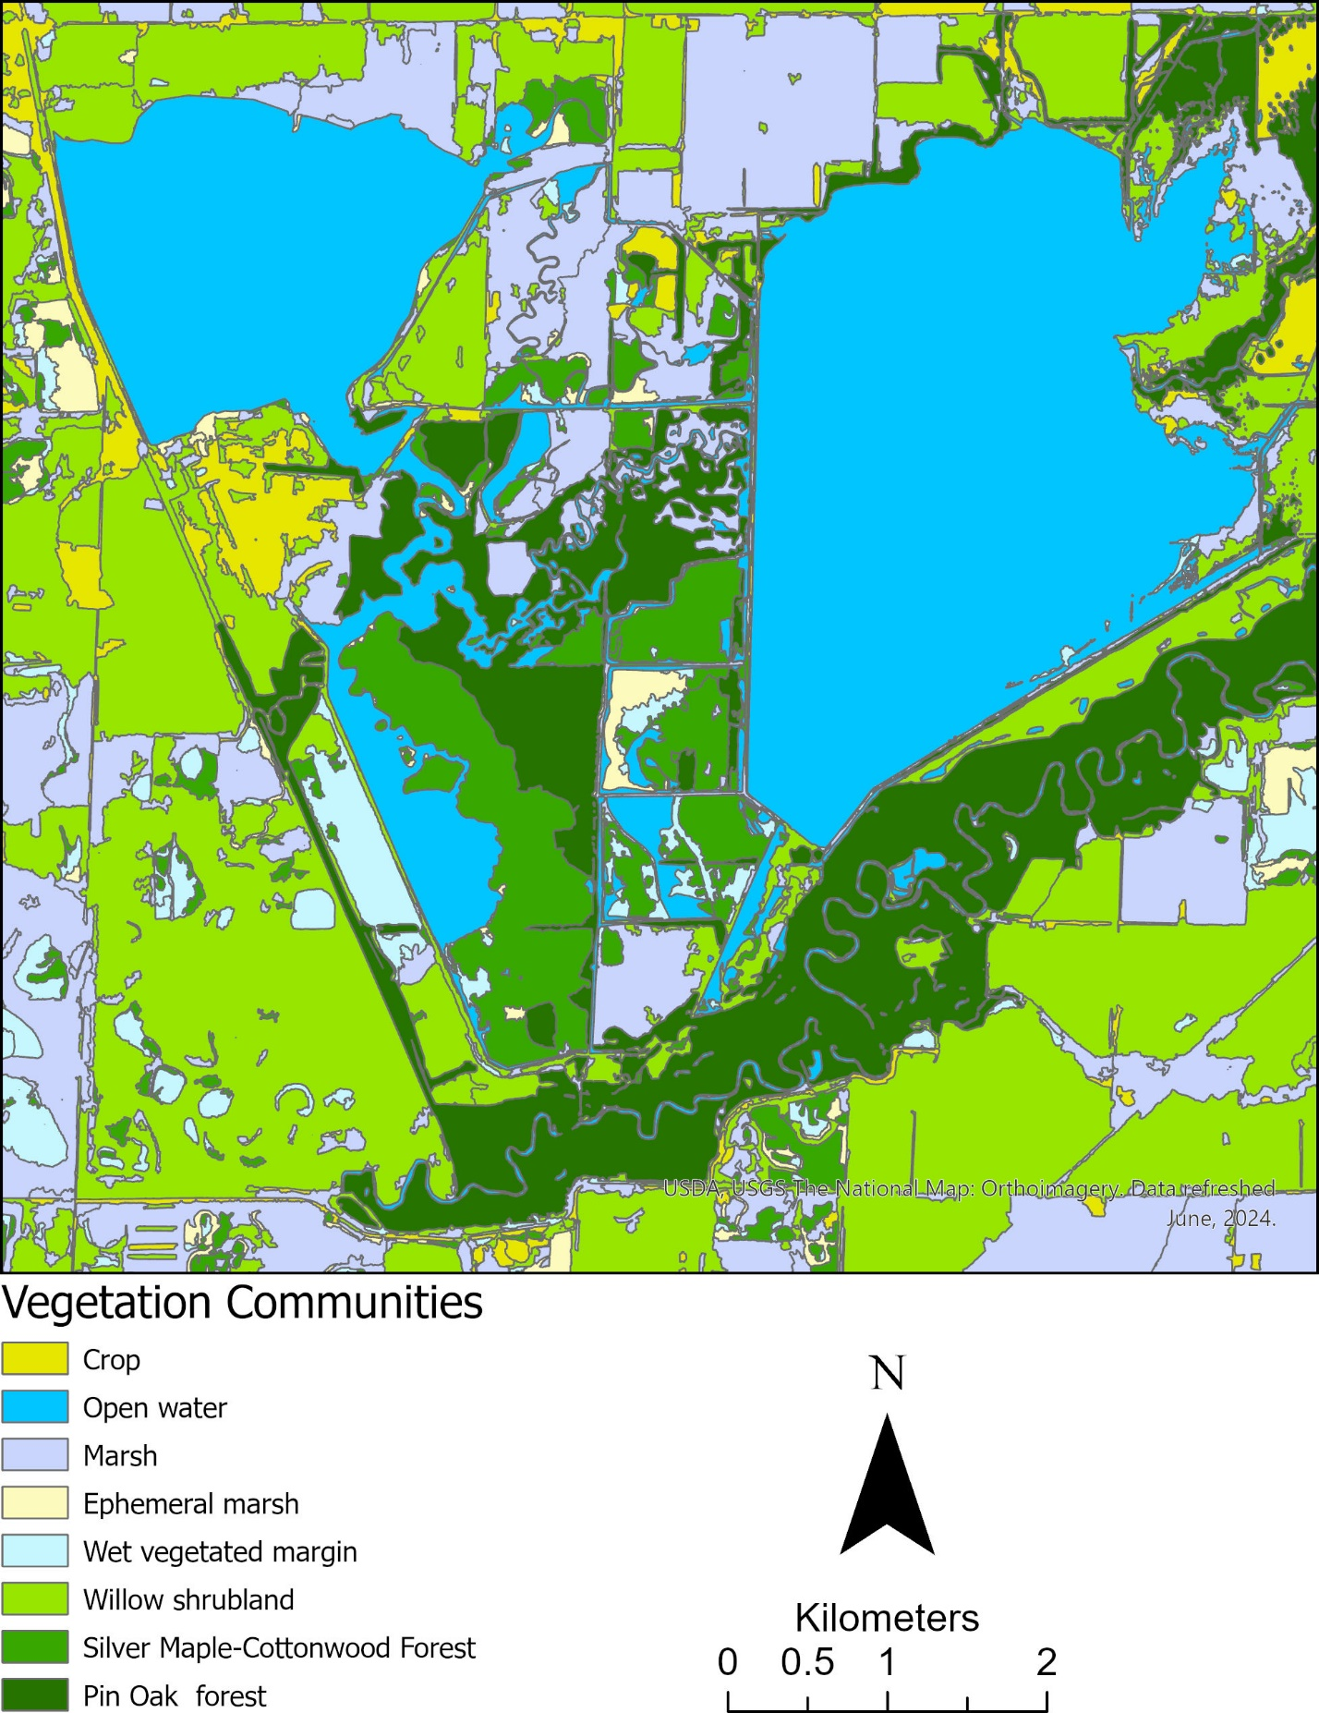
Caption for Graphic or Image: A preliminary map of vegetation communities at Swan Lake National Wildlife Refuge. A refined map based on imagery collected using uncrewed aerial systems will inform restoration implementation and document baseline conditions prior to restoration activities. Those activities include spillway modifications to two reservoirs, levee setbacks, and changes to floodplain shape. Vegetation management will focus on invasive species reduction and promotion of species to attract waterfowl to the refuge.
Author name: Matthew Struckhoff
Author business email: mstruckhoff@usgs.gov

DOI agency/bureau: USGS
USGS Mission Area: Ecosystems
USGS Program: Land Change Science
Cost Center: Western Geographic Science Center
Program Name2:
Project title: Climate, land use, and groundwater recharge projections
Project description: Climate change in California is expected to alter future water availability, impacting water supplies needed to support future housing growth and agriculture demand. In groundwater-dependent regions like California's Central Coast, new land-use related water demand and decreasing recharge is already stressing depleted groundwater basins. We developed a spatially explicit state-and-transition simulation model that integrates climate, land-use change, water demand, and groundwater gain-loss to examine the impact of future climate and land use change on groundwater balance and water demand in five counties along the Central Coast from 2010 to 2060. The model incorporated downscaled groundwater recharge projections based on a Warm/Wet and a Hot/Dry climate future from a spatially explicit hydrological process-based model. Two urbanization projections from a parcel-based, regional urban growth model representing 1) recent historical and 2) state-mandated housing growth projections were used as alternative spatial targets for future urban growth. Agricultural projections were based on recent historical trends from remote sensing data. Annual projected changes in groundwater balance were calculated as the difference between land-use related water demand, based on historical estimates, and climate-driven recharge plus agriculture return flows. Results indicate that future changes in climate-driven groundwater recharge, coupled with cumulative increases in agricultural water demand, result in overall declines in future groundwater balance, with a Hot/Dry future resulting in cumulative groundwater decline in all but Santa Cruz County. Cumulative declines by 2060 are especially prominent in San Luis Obispo (−2.9 to −5.1 Bm3) and Monterey counties (−6.5 to −8.7 Bm3), despite limited changes in agricultural water demand over the model period. These two counties show declining groundwater reserves in a Warm/Wet future as well, while San Benito and Santa Barbara County barely reach equilibrium. These results suggest future groundwater supplies may not be able to keep pace with regional demand and declining climate-driven recharge, resulting in a potential reduction in water security in the region. However, our county-scale projections showed new housing and associated water demand does not conflict with California's groundwater sustainability goals. Rather, future climate coupled with increasing agricultural groundwater demand may reduce water security in some counties, potentially limiting available groundwater supplies for new housing.

Wilson, T.S., Selmants, P.C., Boynton, R.M., Thorne, J.H., Van Schmidt, N., and T. Thomas (2024). Will There Be Water? Climate Change, Housing Needs, and Future Water Demand in California. Journal of Environmental Management, 369, 122256 https://doi.org/10.1016/j.jenvman.2024.122256.

Sensor Type: Multispectral (approx. 4-12 bands);
Platform type: Satellite;
URL: https://www.usgs.gov/publications/will-there-be-water-climate-change-housing-needs-and-future-water-demand-california
Graphic or Image Upload: https://doimspp.sharepoint.com/sites/GS-EROSSCIENCESWI/Shared Documents/Communications Outreach/Documentation Science/DOI Remote Sensing Report/DOI RS Activities Report, 2024/Graphic or Image Upload/Fig 3 Probability of Fallow_Tamara Wilson.ai
Caption for Graphic or Image: Average annual probability (expressed in percent) of cropland fallowing with future housing under a Warm/Wet (A) and Hot/Dry (B) climate future from 2010 to 2060 across 50 Monte Carlo simulations (grey areas represent areas with no change) and (C) the associated time series showing the average fallow area in the Warm/Wet (blue) and Hot/Dry (brown) climate futures.
Author name: Tamara Wilson
Author business email: tswilson@usgs.gov

DOI agency/bureau: USGS
USGS Mission Area: Ecosystems
USGS Program: Land Management Research Program
Cost Center: Upper Midwest Environmental Sciences Center
Program Name2:
Project title: Automating the Detection and Classification of Wildlife in Aerial Imagery
Project description: The US Geological Survey (USGS), Bureau of Ocean Energy Management (BOEM), and US Fish and Wildlife Service (FWS) are partnering on a multi-year effort to develop deep learning algorithms and tools for the detection and classification of seabirds and other marine wildlife in aerial imagery. The tools and workflows developed by this project will be used by BOEM to assess wildlife populations as part of planning and monitoring for offshore energy development.

Specific objectives of this project include: (1) collecting and annotating an archive of aerial imagery to train deep learning algorithms, (2) developing deep learning algorithms for detection and taxonomic classification, and (3) producing counts and locations of detected wildlife in a format that helps BOEM decision makers.

BOEM and FWS have collected millions of images during survey flights over the Atlantic Outer Continental Shelf and the Great Lakes. The USGS Upper Midwest Environmental Sciences Center (UMESC) archives and manages this data to train machine learning models. UMESC hosts a customized annotation tool to serve data out to wildlife experts at New Jersey Audubon to apply labels to objects in the imagery. UMESC also uses USGS high-performance computing resources to run machine learning detection models. Development of several initial candidate models has produced encouraging results on a benchmark training dataset, including a YOLOv8 model capable of detecting eight classes, such as birds, mammals, reptiles, and artificial material. During testing, this model detected over 175K birds in 500K images in approximately 2 days using USGS Tallgrass supercomputer resources (Figure 1).

Future algorithm development will refine the detection model to classify wildlife at more specific taxonomic levels. UMESC is working to train a new model using taxonomic families and is collaborating with the University of Michigan to develop algorithms that can reach species level identification. UMESC researchers are also investigating the influence of environmental background and image characteristics on the performance of wildlife detection models. For more information on this project, visit our USGS project page at https://www.usgs.gov/centers/upper-midwest-environmental-sciences-center/science/deep-learning-automated-detection-and.
Sensor Type: Camera;
Platform type: Airplane;
URL: https://www.usgs.gov/centers/upper-midwest-environmental-sciences-center/science/deep-learning-automated-detection-and
Graphic or Image Upload: https://doimspp.sharepoint.com/sites/GS-EROSSCIENCESWI/Shared Documents/Communications Outreach/Documentation Science/DOI Remote Sensing Report/DOI RS Activities Report, 2024/Graphic or Image Upload/WorkflowPic_Aaron Murphy.jpg
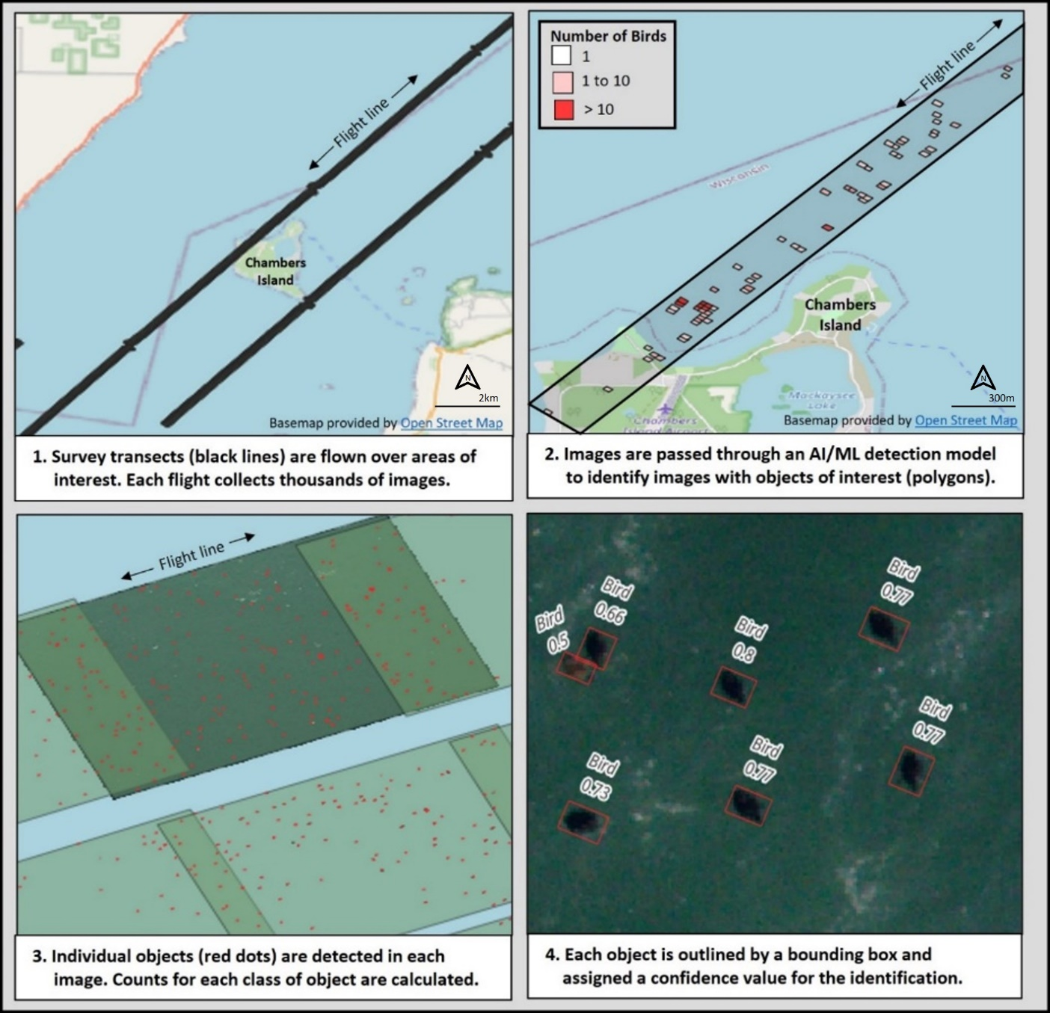
Caption for Graphic or Image: Figure 1. Overview of workflow to detect wildlife objects in aerial imagery. The images are actual output from a trained, 8-class detection model tested on the USGS Tallgrass supercomputer.
Author name: Aaron Murphy
Author business email: amurphy@usgs.gov

DOI agency/bureau: USGS
USGS Mission Area: Core Science Systems
USGS Program: National Land Imaging Program
Cost Center: Earth Resources Observation and Science (EROS) Center (Geography)
Program Name2:
Project title: The First Annual National Land Cover Database: Thirty-nine Years of Land Cover Change
Project description: Improving information on the characteristics of land cover, understanding the basic drivers of change, and identification of potential consequences of change on human and natural systems can empower greater insight into the impacts and feedback of human activity, climate change, and other drivers. To meet its needs, the geospatial community has called for a new generation of monitoring data and information as input for many applications. Land cover and land change products need to span larger geographic extents, over longer time periods, at higher spatial resolutions, and provide more systematic and consistent information on change than ever before. To help meet these growing demands, the United States Geological Survey (USGS) has developed the Annual NLCD Collection 1 Science Products.
The National Land Cover Database (NLCD) and Land Change Monitoring, Assessment, and Projection (LCMAP) merged methodologies to produce Land Cover and Fractional Impervious Surface (along with other derived products) – at annual time steps, called Annual NLCD. The legacy methodologies from these projects were combined with modern innovations in geospatial deep learning and harmonic modeling to create the next generation of land cover and land change information from Landsat Collection 2 satellite observations (U.S. Landsat Analysis Ready Data).
The initial release in 2024 of Annual NLCD Collection 1.0 (https://doi.org/10.5066/P94UXNTS) includes six geospatial raster products for the Conterminous U.S. (CONUS) for 1985 – 2023 listed below. The thematic land cover product depicts land cover using the legacy NLCD classes. The product suite provides powerful time-series information at a 30-m spatial resolution about annual land cover and its change across time. Future annual updates of these products for CONUS are planned.
1) Land Cover
2) Land Cover Change
3) Land Cover Confidence
4) Fractional Impervious Surface
5) Impervious Descriptor
6) Spectral Change Day of Year
Annual land cover and other related products are intended to meet a growing user need for information at higher temporal frequency and over a longer record. There are many types of scientific studies that have applied annual land cover information including estimating biological carbon emissions, projecting future land use, tracking urban development and heat island effects, documenting forest fragmentation or conservation practices, modeling wildfire hazards, tracking water quality and quantity, and understanding change in wildlife habitat and ecosystem disturbance/disease.

Sensor Type: Multispectral (approx. 4-12 bands);
Platform type: Satellite;
URL: https://www.usgs.gov/annualNLCD
Graphic or Image Upload: https://doimspp.sharepoint.com/sites/GS-EROSSCIENCESWI/Shared Documents/Communications Outreach/Documentation Science/DOI Remote Sensing Report/DOI RS Activities Report, 2024/Graphic or Image Upload/Annual NLCD graphic 6 products_Jesslyn Brown.png
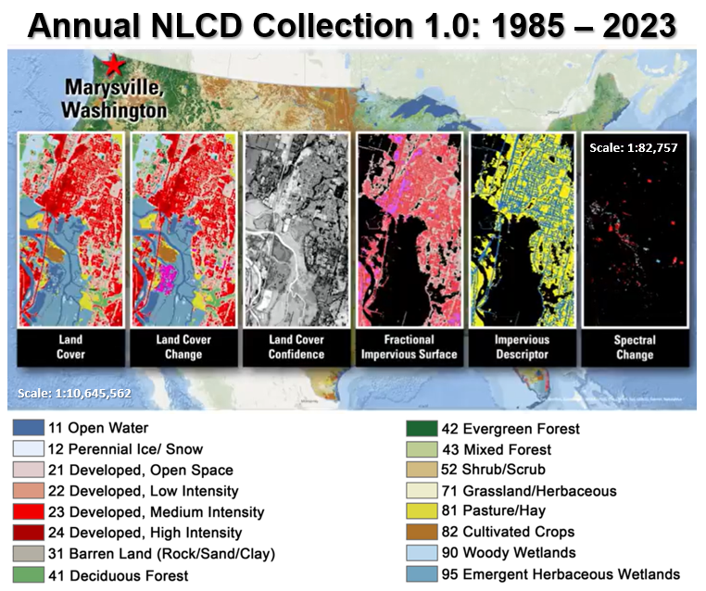
Caption for Graphic or Image: Annual NLCD Collection 1.0 includes six geospatial raster products across the Conterminous U.S. (CONUS) for 1985 – 2023 at 30-m spatial resolution.
Author name: Jesslyn Brown
Author business email: jfbrown@usgs.gov

DOI agency/bureau: USGS
USGS Mission Area: Core Science Systems
USGS Program: Land Change Science
Cost Center: Western Geographic Science Center
Program Name2:
Project title: Mapping Surface Water Mercury in San Francisco Bay using Remote Sensing Imagery
Project description: San Francisco Bay has a long history of mercury (Hg) pollution associated with both legacy contamination from the Gold Rush era and modern inputs. Hg is a potent neurotoxin that poses risk to humans and wildlife. Scientists from the USGS Western Geographic Science Center, California Water Science Center, and Water Mission Area aim to map multiple chemical forms of Hg in the surface water of South San Francisco Bay (SSF Bay) to help inform local restoration activities and monitor water quality, particularly after atmospheric river events. The scientist's goals are to understand how extreme weather events and wetland restoration activities in the area influence Hg distributions in the SSF Bay in terms of runoff pollution and methyl mercury production. Previous studies have mapped Hg by leveraging known biogeochemical relationships between water quality variables visible with remote sensing (i.e. Colored Dissolved Organic Matter, CDOM; total suspended sediments, TSS) and Hg species (particulate and dissolved total and methylmercury). The scientists collected in-situ water quality data to quantify these relationships in SSF Bay. Simultaneously, they gathered surface-level hyperspectral radiometry measurements and 10m Sentinel-2 satellite imagery. Using the surface-level radiometry, we created and tested remote sensing retrieval algorithms for CDOM and TSS, which were applied to Sentinel-2 imagery to generate initial maps of TSS and CDOM at 10m resolution. The scientists used these TSS and CDOM maps to create initial maps of the four Hg species of interest via their statistical relationships. Future work will continue to refine these models and examine the response of mercury in SSF Bay to atmospheric rivers and restoration. Results will provide temporal and spatial water quality information to bay-wide managers and conservation and restoration groups.
Sensor Type: Multispectral (approx. 4-12 bands);
Platform type: Satellite;
URL: https://www.usgs.gov/centers/western-geographic-science-center/science/remote-sensing-mercury-pollution-south-san
Graphic or Image Upload: https://doimspp.sharepoint.com/sites/GS-EROSSCIENCESWI/Shared Documents/Communications Outreach/Documentation Science/DOI Remote Sensing Report/DOI RS Activities Report, 2024/Graphic or Image Upload/DOIRS_figure_v1_2024_Nicole Taylor.png
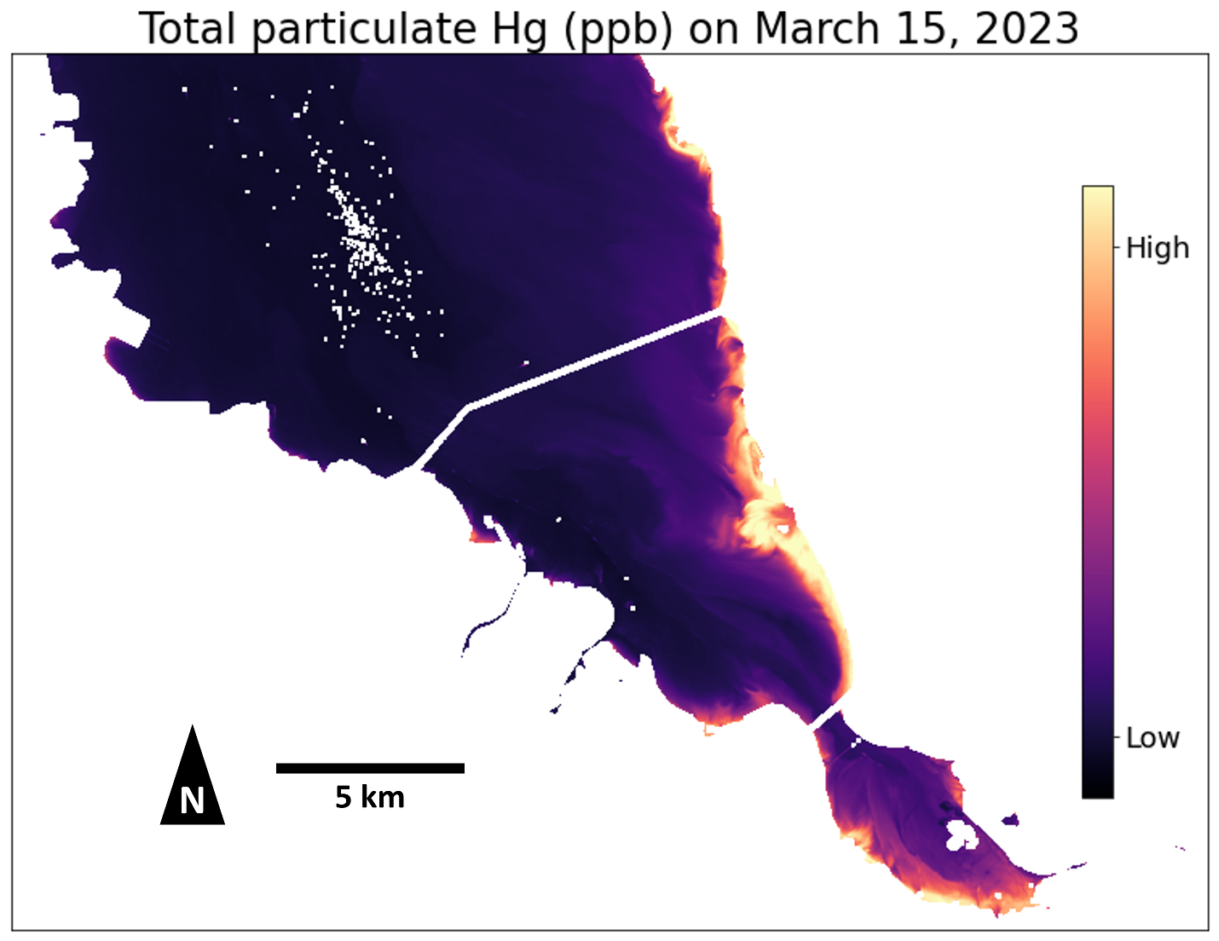
Caption for Graphic or Image: Modeled estimations of Total Particulate Mercury (TpHg) in South San Francisco Bay on March 15, 2023 after a series of atmospheric rivers hit the area. Elevated TpHg along the northeastern shoreline correspond to higher suspended sediment concentrations.
Author name: Niky Taylor
Author business email: ntaylor@usgs.gov

DOI agency/bureau: USGS
USGS Mission Area: Core Science Systems
USGS Program: National Land Imaging Program
Cost Center: Alaska Science Center
Program Name2:
Project title: The Rusting of Arctic Rivers: Freshwater Ecosystems Respond to Rapidly Uptaking Metals
Project description: Across Alaska’s arctic, rivers and creeks that once flowed clear are turning orange and cloudy. These impaired waters exhibit increases in sulfate, iron, and trace metal concentrations and decreases in macroinvertebrate diversity and fish abundance. The appearance of orange waters, commonly associated with acid mine drainage or other environmental contaminants, commands the attention of the general public, land managers, and scientists alike. The stark color change is also an excellent signal for detection by the suite of remote sensing satellites presently in in orbit. Additionally, thanks to an increasingly accessible record of historical satellite observations, namely those acquired by the Landsat satellite campaign, we can objectively detect and temporally constrain the various instances of water impairment across the Brooks Range and the Alaskan Arctic.

Remote sensing resources and expertise and the Alaska Science Center, funded through NLI, have been brought to bear to address key objectives established by a multidisciplinary ground of researchers including the US Geological Survey, National Park Service, University of California-Davis, University of Alaska-Anchorage, and Alaska Pacific University. Specific remote sensing objectives include further mapping the spatial distribution of orange streams, constraining the temporal onset of impairment events across national parks in the Arctic Inventory & Monitoring Network, and developing a predictive model relying on environmental parameters and GIS to determine susceptibility and resilience under future climate scenarios.

References:
Metal mobilization from thawing permafrost to aquatic ecosystems is driving rusting of Arctic streams
https://www.nature.com/articles/s43247-024-01446-z

Chemistry of Orange and Reference Streams in Northwestern Alaska
https://alaska.usgs.gov/products/data.php?dataid=611

Macroinvertebrates from Rivers in Northwest Alaska, 2015-2019
https://www.sciencebase.gov/catalog/item/65d7db7cd34ec3e1801d8188

Estimates of Iron Mineralization in Select Reaches of Three Alaska Arctic Rivers Derived from Historical Landsat Imagery
https://alaska.usgs.gov/products/data.php?dataid=642
Sensor Type: Multispectral (approx. 4-12 bands);
Platform type: Satellite;
URL: https://www.usgs.gov/centers/alaska-science-center/science/rusting-arctic-rivers-freshwater-ecosystems-respond-rapidly
Graphic or Image Upload: https://doimspp.sharepoint.com/sites/GS-EROSSCIENCESWI/Shared Documents/Communications Outreach/Documentation Science/DOI Remote Sensing Report/DOI RS Activities Report, 2024/Graphic or Image Upload/Layout_Carson Baughman.jpg
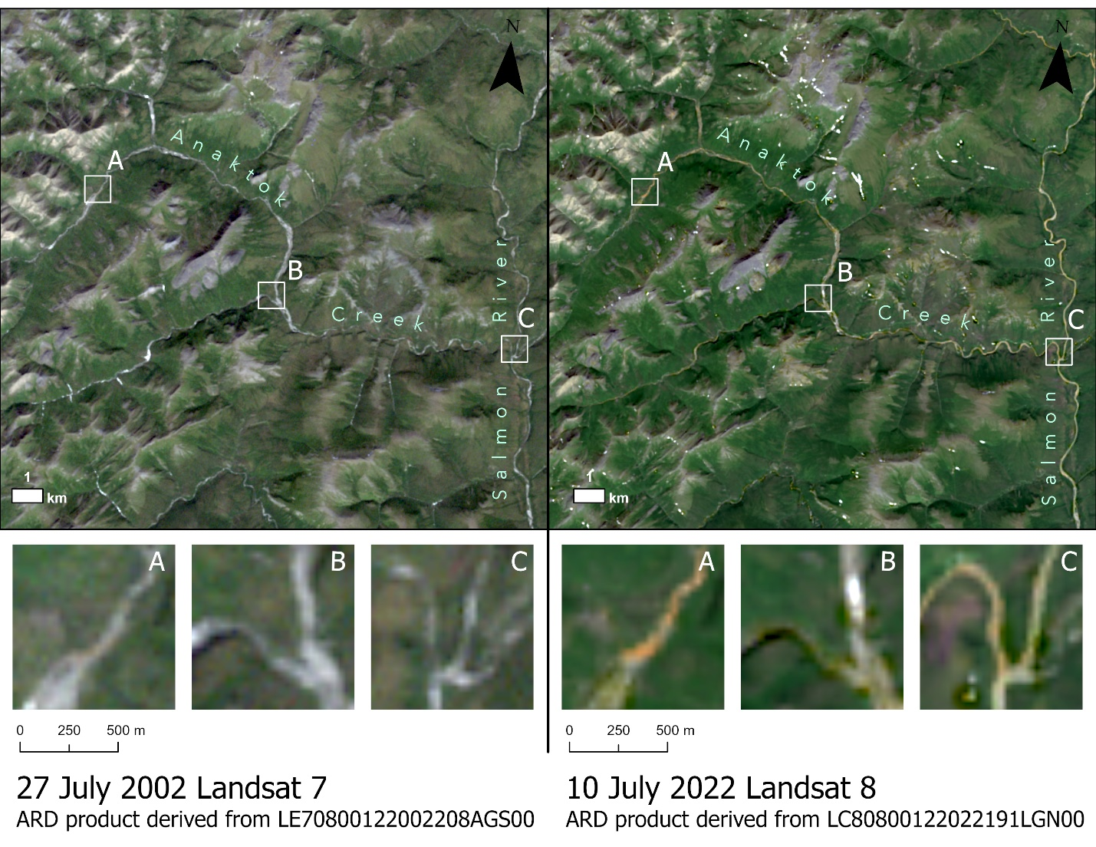
Caption for Graphic or Image: Two views of the Anaktok Creek watershed in northwest Alaska. In 2002, the creek bed appears unimpaired throughout the drainage based on the color (grey) of bed material withing the creek. Only a small portion of the upper headwaters (inset A) suggests slight impairment. In 2022, The vast majority of the drainage basin appears impaired as indicated by the orange staining.
Author name: Carson Baughman
Author business email: cbaughman@usgs.gov

DOI agency/bureau: USGS
USGS Mission Area: Water Resources
USGS Program: National Streamflow Information Program
Cost Center: Office of the AD Water
Program Name2:
Project title: RIPod: A multi-spectral camera pod for imaging rivers
Project description: The USGS Hydrologic Remote Sensing Branch and the Oregon Water Science Center developed a multispectral imaging solution that can be deployed from widely available, Cessna 182 aircraft without any modification to the aircraft. The River Imaging pod or RIPod is a compact system that contains a suite of remote sensing instruments selected to optimize mapping river corridors. Currently, the RIPod includes a 10-band multispectral camera, a 12-megapixel visible camera, a 12-megapixel near-infrared camera, and a thermal infrared camera. All the cameras contained in the pod can be programmed to automatically capture imagery, requiring no intervention on the part of the pilot. The RIPod provides a cost-effective solution for collecting high-resolution imagery over large spatial extents (10s to 100s of miles). In FY24, the RIPod was used to collect remote sensing data along several rivers in the Willamette River basin including: the Clackamas River, Willamette River, McKenzie River, Quartzville Creek, and Middle Santiam River. The imagery is being used to evaluate image velocimetry algorithms and optical depth retrieval techniques with the goal of providing scalable tools for high resolution river corridor mapping. RIPod development and testing is part of the Next Generation Water Observing Systems program in the Willamette Basin.
Sensor Type: Camera;Multispectral (approx. 4-12 bands);Thermal;
Platform type: Airplane;
URL:
Graphic or Image Upload: https://doimspp.sharepoint.com/sites/GS-EROSSCIENCESWI/Shared Documents/Communications Outreach/Documentation Science/DOI Remote Sensing Report/DOI RS Activities Report, 2024/Graphic or Image Upload/USGS_pod_Paul Kinzel.jpg
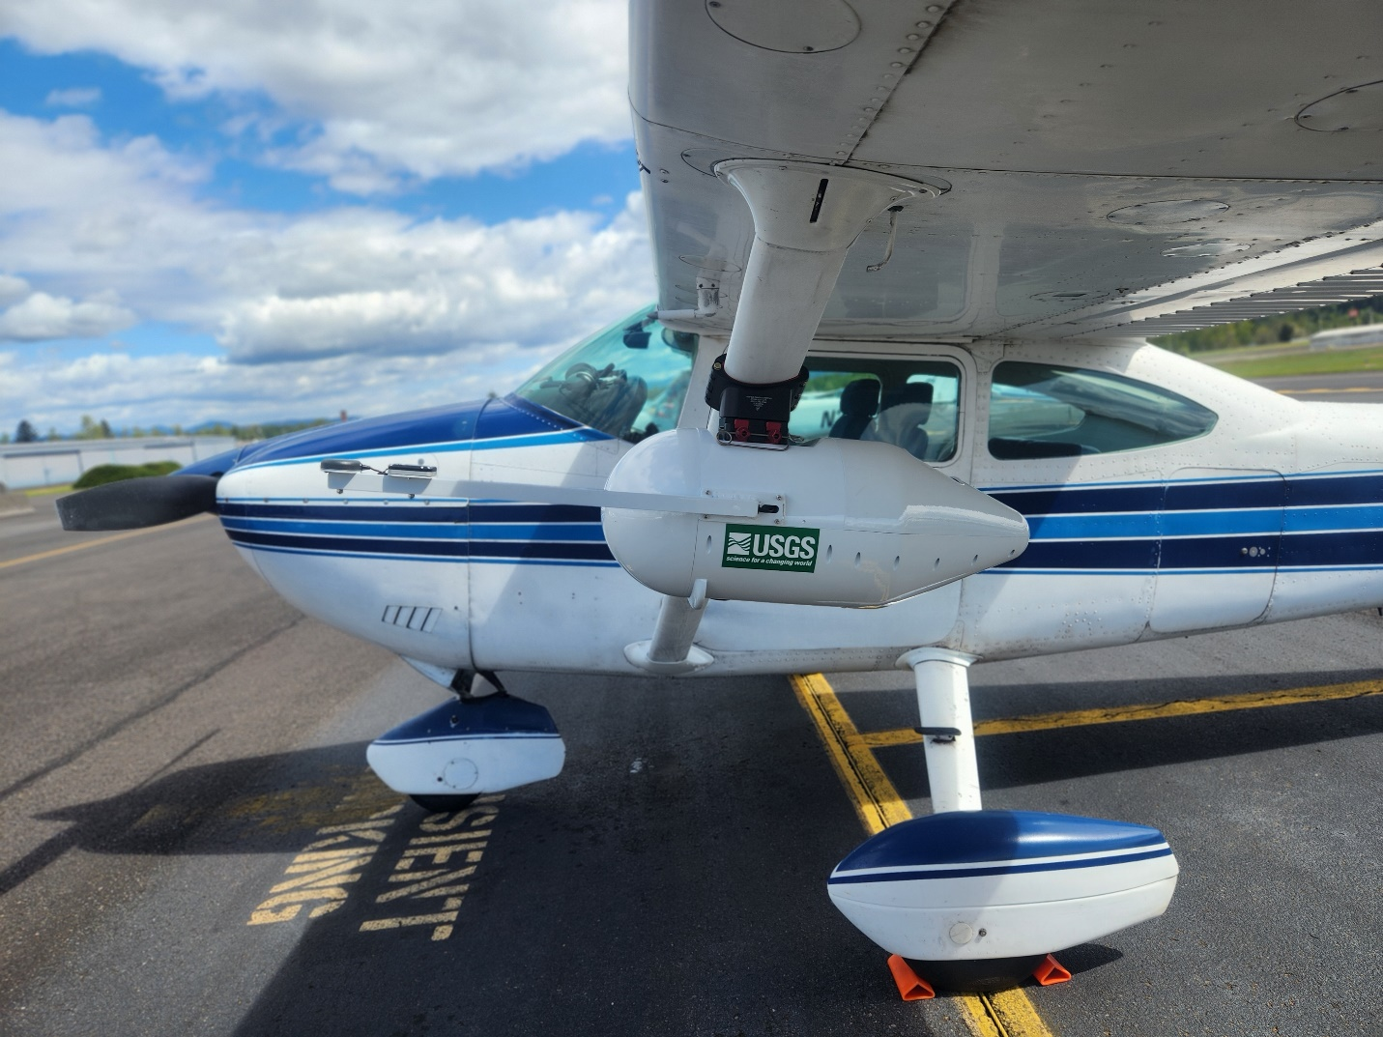
Caption for Graphic or Image: Photograph of RIPod mounted to the strut of a Cessna 182 aircraft. The pod can be mounted on most Cessna 182 aircraft and does not require modification to the aircraft.
Author name: Paul Kinzel
Author business email: pjkinzel@usgs.gov

DOI agency/bureau: USGS
USGS Mission Area: Core Science Systems
USGS Program: National Land Imaging Program
Cost Center: Western Geographic Science Center
Program Name2:
Project title: Landsat-derived Global Rainfed and Irrigated Area Product
Project description: Climate variability and ballooning populations are putting unprecedented pressure on agricultural croplands and their water use, which are vital for ensuring global food and water security in the twenty-first century. In addition, the COVID-19 pandemic, military conflicts, and changing diets have added to looming global food insecurity. Therefore, there is a critical need to produce consistent and accurate global cropland products at fine spatial resolution (e.g., farm-scale, 30m or better), which are generated consistently, accurately, and routinely (e.g., every year). In this regard, earlier we produced the world’s first Landsat-derived global cropland extent product @ 30m (GCEP30) (Thenkabail et al., 2021; download @ LP DAAC) funded by NASA MEaSUREs and USGS. The high impact of our previously-funded NASA GFSAD products such as Landsat-derived global cropland extent product @30m or GCEP30, 1km cropland dominance, and 1km irrigated versus rainfed is demonstrated by the use of these data by 126 countries (Oliphant et al., 2022) during 2018-2021 (97 countries in 2021 alone, 72 countries in 2022 alone), continued average downloads every month by about 20 countries, publication of 12 key peer-reviewed articles which already have about 1500 citations in a short time-period (2017-present), and use for a wide range of applications. Therefore, the overarching goal of this continuity global food security-support analysis data (GFSAD) project is to develop comprehensive data and products in support of global food and water security in the twenty-first Century. This is achieved by developing cropland models, maps, and monitoring tools leading to a wide array of products using machine learning algorithms (MLAs), satellite sensor based big-data analytics, and cloud-computing. We focus on producing three distinct Landsat-derived global cropland products in this new GFSAD project:
1. Landsat-derived Global Rainfed and Irrigated Product @ 30m (LGRIP30; Figure 1).
2. Landsat-derived Global Cropping Intensity Product @ 30m (LGCIP30) &
3. Landsat-derived Global Crop Type Products @ 30m (LGCTY30)
This study presents and discusses Landsat-derived Global Rainfed and Irrigated-area Product @ 30m (LGRIP30; Figure 1; https://www.usgs.gov/apps/croplands/app/map) for the nominal year 2015. The LGRIP30 cropland product was generated using Landsat-8 time-series data, multiple supervised and unsupervised Machine learning algorithms (MLAs) such as random forest, support vector machines, decision trees, ISOCLASS clustering, and spectral matching techniques (e.g., Thenkabail et al., 2021, Oliphant et al., 2019, Teluguntla et al., 2018, 2017, 2015, Xiong et al., 2017a, b, Gumma et al., 2022, 2020, 2018, 2016, Phalke et al., 2020, Massey et al., 2017, Zeng et al., 2025, Thenkabail et al., 2012, 2009, 2007, 2005), utilizing the Google Earth Engine (GEE) (Gorelick at al., 2017) and\or other cloud platforms.

Sensor Type: Multispectral (approx. 4-12 bands);
Platform type: Satellite;
URL: https://www.usgs.gov/centers/western-geographic-science-center/science/global-food-and-water-security-support-analysis
Graphic or Image Upload: https://doimspp.sharepoint.com/sites/GS-EROSSCIENCESWI/Shared Documents/Communications Outreach/Documentation Science/DOI Remote Sensing Report/DOI RS Activities Report, 2024/Graphic or Image Upload/remote-sensing-report-2024-GFSAD-1g1-figure_Pardhasaradhi Telugu.png
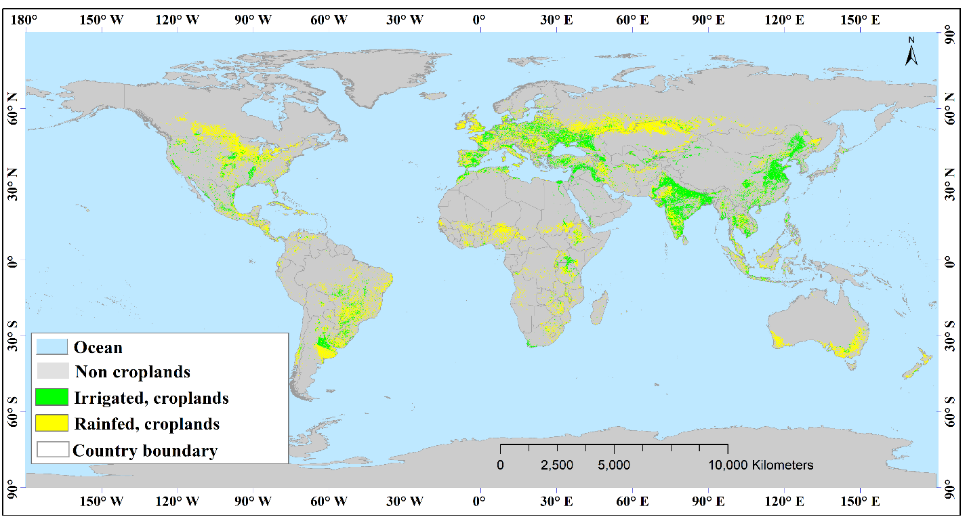
Caption for Graphic or Image: The Landsat-derived global rainfed and irrigated-area product @ 30m (LGRIP30). Browse full resolution of this image at: https://www.usgs.gov/apps/croplands/app/map
Author name: Pardhasaradhi Teluguntla, Prasad Thenkabail
Author business email: pteluguntla@usgs.gov, pthenkabail@usgs.gov

DOI agency/bureau: USGS
USGS Mission Area: Core Science Systems
USGS Program: Land Change Science
Cost Center: Western Geographic Science Center
Program Name2:
Project title: Habitat modeling for Texas tortoise using GPS tracking and Unoccupied Aerial Systems (UAS) mapping
Project description: In the Lower Rio Grande Valley of Texas, Texas tortoises (Gopherus berlandieri) are listed as a threatened species due to habitat loss and fragmentation from urban development, agriculture, and other land uses. In partnership with the National Park Service (NPS), a methodology was developed at Palo Alto Battlefield National Historical Park that combines Uncrewed Aerial Systems (UAS) mapping with GPS tracking to better understand tortoise habitat needs. This approach models and measures the energy tortoises expend navigating fragmented landscapes, offering data for targeted conservation efforts.

In March 2024, researchers from the Western Geographic Science Center, the National Uncrewed Systems Office, and the NPS collected UAS and field data at Palo Alto Battlefield. Multispectral imagery was captured with a MicaSense RedEdge-P sensor, and lidar data was gathered using a Hesai scanner on a WingtraOne Gen II fixed-wing VTOL, as well as a YellowScan Mapper+ on a DJI M600 multi-rotor copter. These datasets produced a 4 cm resolution orthomosaic, as well as digital surface (DSM), terrain (DTM), and canopy height models (CHM). The Mapper+ lidar created the DTM for tortoise energy expenditure modeling, while the Wingtra lidar and orthoimagery mapped vegetation structure and habitat.

Convolutional neural networks (CNNs) are being used to detect and map key plants like prickly pear (Opuntia spp.), essential for tortoises, as well as invasive species, such as Guinea grass (Megathyrsus maximus), which impede tortoise movement. Understanding plant distributions is crucial for effective park management and habitat restoration.

Simultaneously, GPS tracking records for 12 tortoises, and their step lengths and turning angles, informed the classification of tortoise behaviors using a Hidden Markov Model. Using the mapped tracks of traveling tortoises in combination with the DTM, the researchers have developed a mathematical function to estimate the caloric cost of transport (COT) based on speed, slope direction, and tortoise lung capacity. This in-turn was translated to a geospatial cost-distance model which can convert a DTM and habitat model to a map of tortoise energy expenditure across a landscape, i.e., a measure of the accessibility and connectivity of tortoise habitats and populations.
This research will directly inform management at the park by guiding habitat restoration, invasive species control, and infrastructure design to minimize impacts on tortoise pathways. Beyond this park, these methods can be adapted to other species and landscapes, offering a scalable framework for monitoring wildlife movement and managing habitat connectivity across fragmented ecosystems.

Sensor Type: Lidar (terrestrial or bathymetric);Multispectral (approx. 4-12 bands);
Platform type: UAS;
URL: https://www.usgs.gov/centers/western-geographic-science-center/science/impacts-anthropogenic-land-cover-changes-wildlife
Graphic or Image Upload:
Caption for Graphic or Image: Images showing (a) the WingtraOne Gen II fixed wing VTOL, (b) the YellowScan Mapper+ on a DJI M600 multi-rotor copter, (c) a Texas tortoise at the study site, and (d) a sample of tortoise GPS tracks classified by behavior state, shown overlaying the DTM
Author name: Samuel Chambers, Joshua von Nonn, Miguel Villarreal, Lance Brady, Matthew Burgess
Author business email: schambers@usgs.gov

DOI agency/bureau: USGS
USGS Mission Area: Ecosystems
USGS Program: Land Management Research Program
Cost Center: Wetland and Aquatic Research Center
Program Name2:
Project title: Mapping irregularly flooded wetlands, high marsh, and salt pannes/flats
Project description: Irregularly flooded wetlands provide important ecosystem services, such as providing habitat for fish and wildlife, enhancing water quality enhancement, ameliorating flooding impacts, supporting coastal food webs, and protecting coastlines from erosion. Mapping irregularly flooded wetlands is a daunting challenge given their expansive coverage and dynamic nature. Furthermore, coastal wetlands are expected to change drastically over the coming century due to accelerated sea-level rise and changes in the frequency and intensity of extreme storms. Consequently, coastal managers need baseline information on the current spatial distribution of wetlands along with efficient repeatable methods for observing change in these important and dynamic environments.

Researchers from the U.S. Geological Survey Wetland and Aquatic Research Center and Mississippi State University have jointly produced geospatial datasets of irregularly flooded wetland probability and high marsh and salt panne/flat habitats across the northern Gulf of Mexico coast, from Texas to Florida (Figure 1). Additionally, the data release produced through this effort also includes a map from Lake Pontchartrain, Louisiana to the Florida Big Bend delineating the coverage of irregularly flooded wetlands dominated by Juncus roemerianus (Black needlerush), a supplemental map with a second high marsh class in Texas dominated by succulents and Distichlis spicata, a project-specific field reference dataset, and spatial metadata showing the elevation data used to create these products. These products are the first regional map of elevation-based irregularly flooded wetland probability map and high marsh and salt panne/flat map along the northern Gulf of Mexico coast and provide a baseline condition from which future changes can be compared.

This effort is the result of research funded by the National Oceanic and Atmospheric Administration's RESTORE Science Program under award NA19NOS4510195 to Mississippi State University and the U.S. Geological Survey. Many other agencies assisted with the development of these products, including the U.S. Fish and Wildlife Service, Tall Timbers Research Station, Texas Tech University, Louisiana State University, Grand Bay National Estuarine Research Reserve, Weeks Bay National Estuarine Research Reserve, Embry-Riddle Aeronautical University, and the Forbes Biological Station. The maps are publicly available (https://doi.org/10.5066/P9MLO26U) and can be viewed via ArcGIS Online (https://usgs.maps.arcgis.com/home/item.html?id=98d03a92d84940b9ac67e5c339c6eb2b). The elevation-based irregularly flooded wetland probability map produced via this study was published in Remote Sensing of Environment (https://doi.org/10.1016/j.rse.2023.113451) and the high marsh and salt pannes/flats map was published in Geocarto International (https://doi.org/10.1080/10106049.2023.2285354).

Sensor Type: IFSAR / SAR / Radar;Lidar (terrestrial or bathymetric);Multispectral (approx. 4-12 bands);
Platform type: Satellite;
URL: https://doi.org/10.1080/10106049.2023.2285354
Graphic or Image Upload: https://doimspp.sharepoint.com/sites/GS-EROSSCIENCESWI/Shared Documents/Communications Outreach/Documentation Science/DOI Remote Sensing Report/DOI RS Activities Report, 2024/Graphic or Image Upload/Fig4_example_Nicholas Enwright.jpg
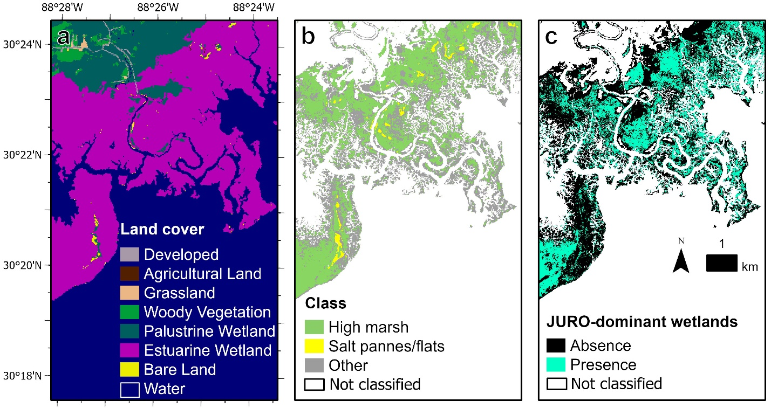
Caption for Graphic or Image: Fig 1. Example of high marsh and salt pannes/flats map products for the Grand Bay estuary, Mississippi, USA. (a) land cover map modified from the National Oceanic and Atmospheric Administration’s Coastal Change Analysis Program 30-m layer. (b) map of high marsh, salt pannes/flats, and other irregularly flooded wetlands. (c) map of irregularly flooded wetlands dominated by Juncus roemerianus. White areas in panes b and c represent areas outside the coastal wetland mask. (Figure is from https://doi.org/10.1080/10106049.2023.2285354).
Author name: Nicholas Enwright
Author business email: enwrightn@usgs.gov

DOI agency/bureau: USGS
USGS Mission Area: Ecosystems
USGS Program: Land Management Research Program
Cost Center: Wetland and Aquatic Research Center
Program Name2:
Project title: Accounting for Uncertainty in Coastal Wetland Migration Potential
Project description: During this century, accelerated sea-level rise (SLR) will impact habitats across the entire coastal zone. Natural resource managers require information on how these important coastal ecosystems may change over time to assist with future-focused land management and stewardship. High-resolution elevation data provide a foundational layer needed to understand regional hydrology and ecology under present and future conditions. However, elevation bias is typically unknown in wetlands, and can be substantial. While DEM products often provide elevation uncertainty information in the product metadata, these estimates typically are not representative of vertical uncertainty in wetlands ((e.g., https://doi.org/10.1080/2150704X.2024.2368924). Understanding elevation uncertainty in lidar data and accounting for the error is an important first step for producing or refining static or hydrodynamic models to estimate contemporary and future water surface levels and predicting future ecologic shifts, such as upslope migration of tidal marsh.

Using Duvall and Nassau counties in northeast Florida as a case study, researchers from the U.S. Geological Survey and NPS identified potential wetland migration areas while integrating uncertainty in ground surface elevation, current water levels, and SLR scenarios. A DEM developed from lidar data collected in 2018 and 2019 was used as the elevation source data for this study. Elevation error in coastal wetlands was reduced using in situ observations and remotely sensed data. The reduced error DEM was then used to identify potential migration of both regularly and irregularly flooded wetlands and identified land cover and land use types vulnerable to future ocean water exposure. The approach used Monte Carlo simulations to incorporate uncertainty in elevation after error reduction, current water levels, and SLR scenarios to assess the probability of an area being within regularly or irregularly flooded zones for the intermediate-low and intermediate-high SLR scenarios for 2050 and 2100 (https://oceanservice.noaa.gov/hazards/sealevelrise/sealevelrise-tech-report.html; Figure 1). This project also included use of Monte Carlo simulations to estimate the probability of inundation under various SLR scenarios and contemporary high tide flooding thresholds for several NPS units in the South Atlantic-Gulf Region, including: 1) Timucuan Ecological and Historic Preserve; 2) De Soto National Memorial; 3) Biscayne National Park; 4) Big Cypress National Preserve; 5) Dry Tortugas National Park; and 6) San Juan National Historic Site. The wetland migration portion of this study was published in Estuaries and Coasts (https://doi.org/10.1007/s12237-024-01363-6). Similar studies are underway in collaboration with NPS for other NPS units in the southeastern U.S. and in collaboration with the U.S. Fish and Wildlife Service in Texas.
Sensor Type: IFSAR / SAR / Radar;Lidar (terrestrial or bathymetric);Multispectral (approx. 4-12 bands);
Platform type: Satellite;Airplane;
URL: https://doi.org/10.1007/s12237-024-01363-6
Graphic or Image Upload:
Caption for Graphic or Image: Fig 1. Opportunities for and barriers to wetland migration of irregularly oceanic-flooded wetlands (IFW) and regularly oceanic-flooded wetlands (RFW) with sea-level rise in Duvall and Nassau Counties, Florida, USA for 2050 (a) and 2100 (b) for the intermediate-high scenario (https://oceanservice.noaa.gov/hazards/sealevelrise/sealevelrise-tech-report.html). While not differentiated in the map, the “Developed barriers” could be either future IFW or RFW. Upland areas and water are from the National Oceanic and Atmospheric Administration’s 2016 30-m and 10-m beta land cover products. Figure is from https://doi.org/10.1007/s12237-024-01363-6).
Author name: Nicholas Enwright
Author business email: enwrightn@usgs.gov

DOI agency/bureau: USGS
USGS Mission Area: Water Resources
USGS Program: **unspecified​**
Cost Center: **unspecified**
Program Name2:
Project title: Groundwater Exploration in Kenya: Athi and Tana River Basins
Project description: The purpose of the Program is to develop a sound understanding of the potential for development of groundwater supplies in selected African countries and to build local capacity to plan and conduct the hydrologic investigations and monitoring necessary to help ensure that groundwater resources are developed and managed efficiently and sustainably.

The US Geological Survey collaborated with Northern Arizona University and New Mexico State University in a project funded by the United States Agency for International Development-Kenya and East Africa Mission to investigate the use of satellite image data, along with hydrological and geological data sets, to research and develop maps of potential of groundwater resources in the Athi and Tana River Basins.

The U.S. Geological Survey is assisting the U.S. Agency for International Development in implementing the Program by working with local professionals to utilize remote sensing data and technology and other hydrologic information to map potential groundwater resources and conduct hydrogeologic assessments in selected areas in Africa.

The Program specifically aims to increase household access and utilization of water resources. Recent results are described in a report for USAID: Groundwater Exploration and Assessment in the Eastern Lowlands and Associated Highlands of the Ogaden Basin Area, Eastern Ethiopia: Phase 1 Final Technical Report (https://water.usgs.gov/international/final_approved_version-090414.pdf).

Sensor Type: Multispectral (approx. 4-12 bands);IFSAR / SAR / Radar;
Platform type: Satellite;
URL: https://www.usgs.gov/centers/new-jersey-water-science-center/science/africa-groundwater-exploration-and-assessment
Graphic or Image Upload: https://doimspp.sharepoint.com/sites/GS-EROSSCIENCESWI/Shared Documents/Communications Outreach/Documentation Science/DOI Remote Sensing Report/DOI RS Activities Report, 2024/Graphic or Image Upload/55d0afb2-4110-4e33-90f4-9ae8ca1186c0_Tyler King.jpg
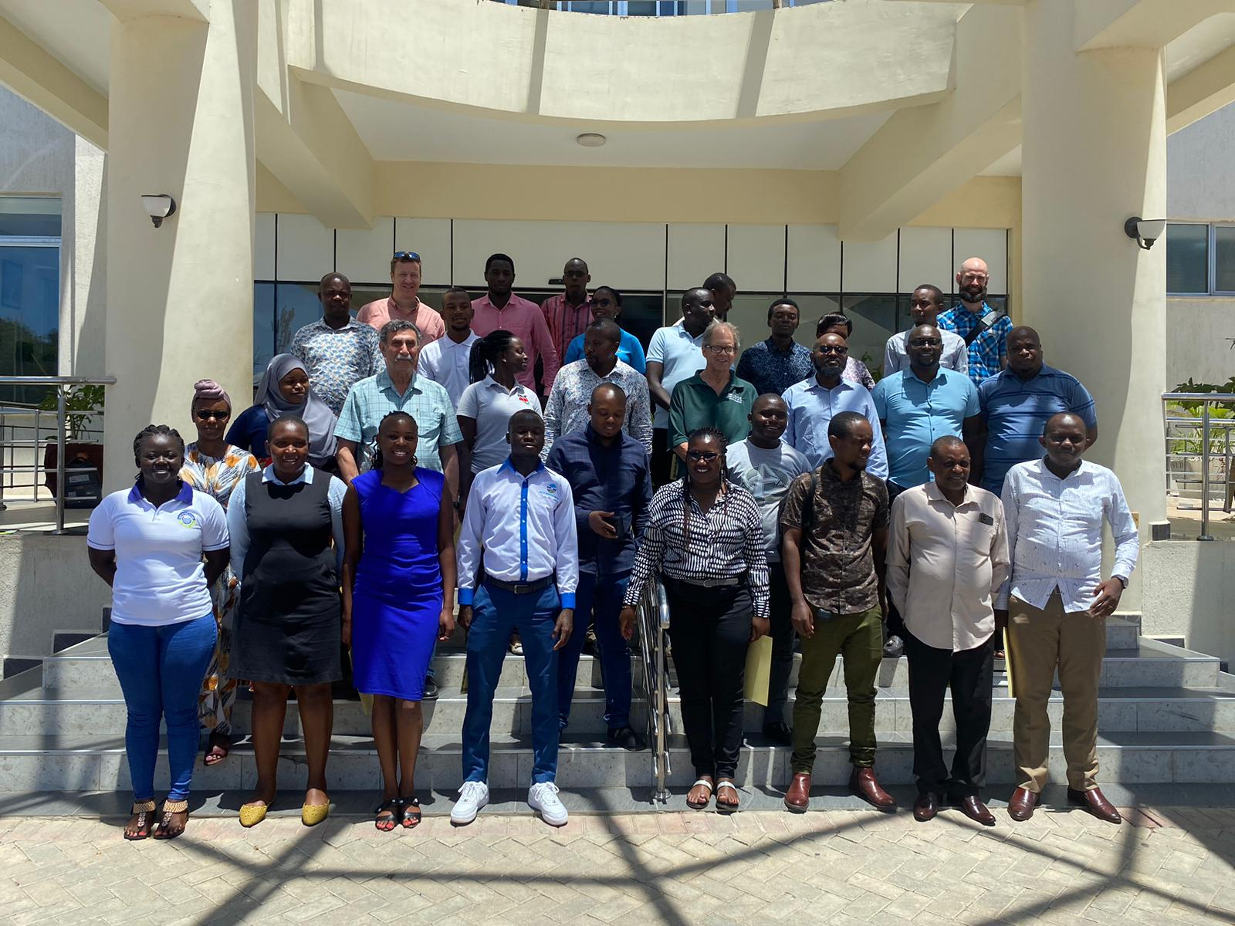
Caption for Graphic or Image: Participants in remote sensing and groundwater modeling classes in Mombasa, Kenya
Author name: Richard Kropp, Saud Amer, Wayne Belcher, Tyler King, Pat Chavez, Amanda Robertson
Author business email: rkropp@usgs.gov, samer@usgs.gov, wbelcher@usgs.gov, tvking@usgs.gov, patchavez@nau.edu, arobertson@usaid.gov

DOI agency/bureau: USGS
USGS Mission Area: Core Science Systems
USGS Program: Land Change Science
Cost Center: Earth Resources Observation and Science (EROS) Center (Geography)
Program Name2:
Project title: Landscape Water Requirement Satisfaction Index for Africa
Project description: With global food insecurity on the rise, efforts to predict crop failure and famine have only increased in importance. The United States Geological Survey (USGS) Famine Early Warning Systems Network (FEWS NET) provides key stakeholders, including the United States Agency for International Development (USAID), national governments, and non-governmental organizations, geospatial dataset products to monitor droughts, floods, and food insecurity (www.usgs.earlywarning.gov).

The Africa-wide Landscape Water Requirement Satisfaction Index (L-WRSI) is the latest data product from the FEWS NET. L-WRSI is a ratio index (in percent) that tracks how well precipitation meets water needs of vegetation across a landscape. A maximum (100) L-WRSI value indicates that the landscape’s water needs are adequately met while index values less than 50 indicate severe damage from poor distribution of precipitation. Creating L-WRSI involves the use of remotely-sensed Normalized Difference Vegetation Index (NDVI) to determine the water-demand phenology of the landscape. Phenology refers to the study of periodic biological events, like the timing of leaf emergence or flowering, which are influenced by seasonal and climate variations. In this context, NDVI phenology is used to represent the optimal plant condition and water demand of the landscape for a given day, capturing the compounded seasonal changes in vegetation growth, health, and climate. The NDVI phenology is then used to parameterize a water balance model (VegET), which integrates data from remotely-sensed precipitation (CHIRPS), soils, and atmospheric demand to simulate daily soil moisture and actual evapotranspiration. This simulation helps decision-makers to understand the contribution or shortage of seasonal precipitation in meeting landscape water requirements for optimal biomass production.

The first historical L-WRSI has been generated for the entire continent of Africa since 1982 as a 3-month rolling index, updated every dekad (~10 days). Timeseries of spatially-averaged L-WRSI by administrative boundaries can be generated using FEWS NET’s online tool-- the Early Warning Explorer (EWX).

Figure shows L-WRSI of Africa for the months of January through March. A timeseries of Precipitation, L-WRSI, and the L-WRSI anomaly are shown for Malawi. Panel E illustrates the 2005 drought with a below normal L-WRSI in much of Malawi that provoked a food crisis (https://www.nytimes.com/2007/12/02/world/africa/02malawi.html).

Sensor Type: Multispectral (approx. 4-12 bands);
Platform type: Satellite;
URL: https://earlywarning.usgs.gov/fews/product/960
Graphic or Image Upload: https://doimspp.sharepoint.com/sites/GS-EROSSCIENCESWI/Shared Documents/Communications Outreach/Documentation Science/DOI Remote Sensing Report/DOI RS Activities Report, 2024/Graphic or Image Upload/Figure Final_Gabriel Senay.jpg
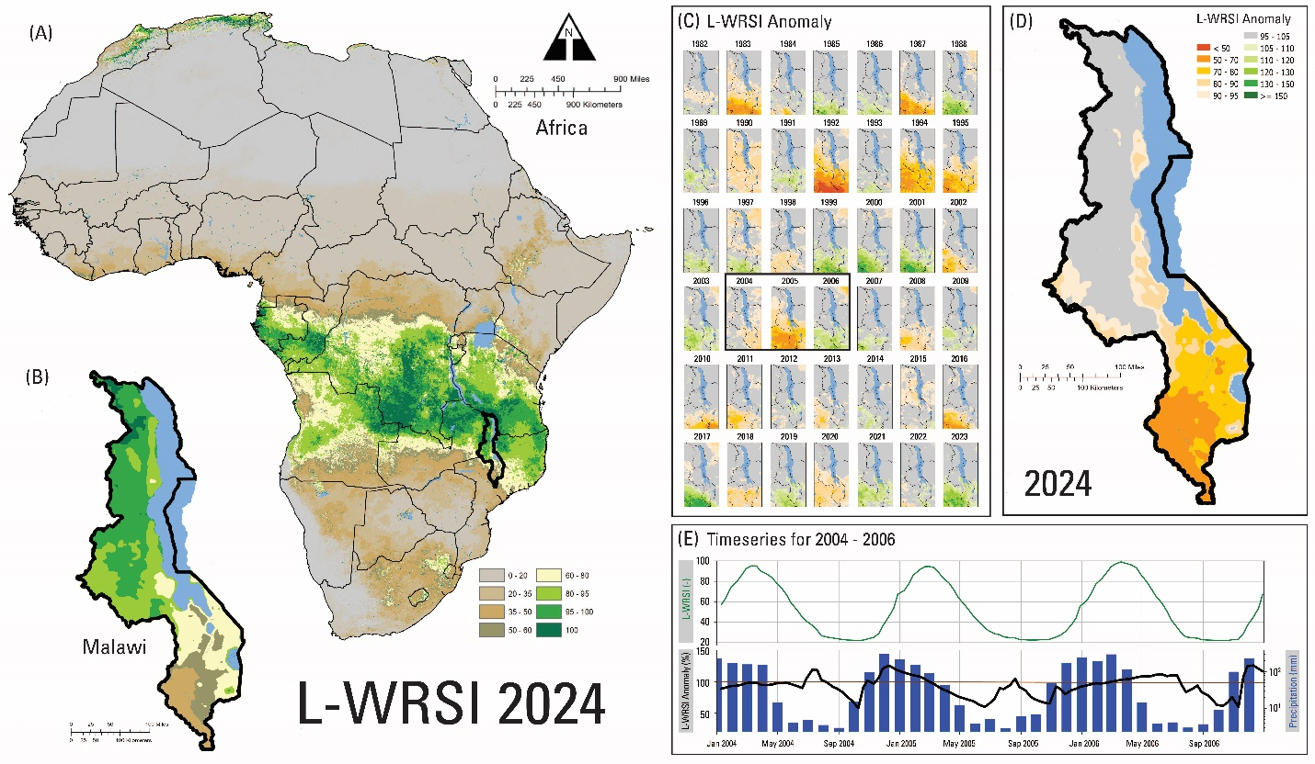
Caption for Graphic or Image: Landscape Water Requirement Satisfaction Index (L-WRSI): (A) Africa-wide L-WRSI for the months of January through March 2024, (B) L-WRSI of Malawi , January-March 2024, (C) L-WRSI Anomaly (January – March) for Malawi (1982-2023), (D) L-WRSI Anomaly (January – March) of Malawi (2024), (E) Country-average timeseries of L-WRSI, L-WRSI Anomaly, and precipitation for Malawi (2004-2006) showing more months with below 100% L-WRSI Anomaly (brown line) in 2005 compared to either 2004 or 2006.
Author name: Gabriel Senay
Author business email: senay@usgs.gov

DOI agency/bureau: USGS
USGS Mission Area: Energy and Minerals
USGS Program: Mineral Resources Program
Cost Center: Geology and Geophysics Science Center
Program Name2:
Project title: Hyperspectral imaging supports natural resource evaluations
Project description: An extensive area of the southwestern United States, 368,000 sq. km, was covered with hyperspectral imagery from April through July 2024 for the USGS Earth Mapping Resources Initiative (Earth MRI; https://www.usgs.gov/special-topics/earth-mri). Hyperspectral imagery collects light reflecting from the Earth using a spectrometer flown on an aircraft or spacecraft. This type of remote sensing allows the comparison of spectral patterns in each pixel of an image to patterns in a spectral library of materials that have been measured in a laboratory. This pattern matching allows a material to be detected and its distribution across a landscape to be mapped. Imaging spectrometers (hyperspectral imagers) have hundreds of narrow spectral channels, making the Earth MRI hyperspectral data like Landsat data, but with 4 times finer spatial resolution and with 40 times more spectral information!

The goals of the Earth MRI program are to advance knowledge of the geologic framework in the US and to identify areas with potential to contain critical mineral resources. Enhancement of our mineral supply will decrease the Nation’s reliance on foreign sources of minerals that are fundamental to our economy and security. Earth MRI will use hyperspectral data to map minerals at the Earth’s surface, including previously mined areas to assess resource recovery from waste. Hyperspectral data acquired this year include more the 1 billion spectral measurements to assist the Earth MRI program. The four-year acquisition program, 2023-2026, aims to acquire more than 1 million sq. km of data for portions of the states of CA, NV, AZ, UT, ID, WY, CO, NM, and TX.

Gathering and analyzing hyperspectral data over such a large area is only possible through partnerships with other federal agencies and state geological surveys. Through an interagency agreement NASA Armstrong Flight Research Center flies a high-altitude aircraft (the ER-2 at 65,000 ft) with a hyperspectral sensor measuring reflected sunlight and a multispectral sensor measuring infrared energy. Pairing the ER-2 with these sensors allows collection over large areas with finely detailed images. NASA has branded the data collection as the Geological Earth Mapping experiment (GEMx). In studies with the California State Geological Survey (CGS), images from the hyperspectral dataset are being analyzed to support mapping of potential lithium resources. USGS and CGS are cooperating to apply the hyperspectral data to aid field sampling and resource evaluations. Beyond minerals, hyperspectral data have many demonstrated uses, for example, mapping native and invasive vegetation species and detecting hydrocarbon contamination from oil spills. Earth MRI regional hyperspectral data are available from https://aviris.jpl.nasa.gov/GEMX/.

Sensor Type: Hyperspectral;Thermal;
Platform type: Airplane;
URL: https://www.usgs.gov/special-topics/earth-mri
Graphic or Image Upload: https://doimspp.sharepoint.com/sites/GS-EROSSCIENCESWI/Shared Documents/Communications Outreach/Documentation Science/DOI Remote Sensing Report/DOI RS Activities Report, 2024/Graphic or Image Upload/DOI_RS_figure_Raymond Kokaly.jpg
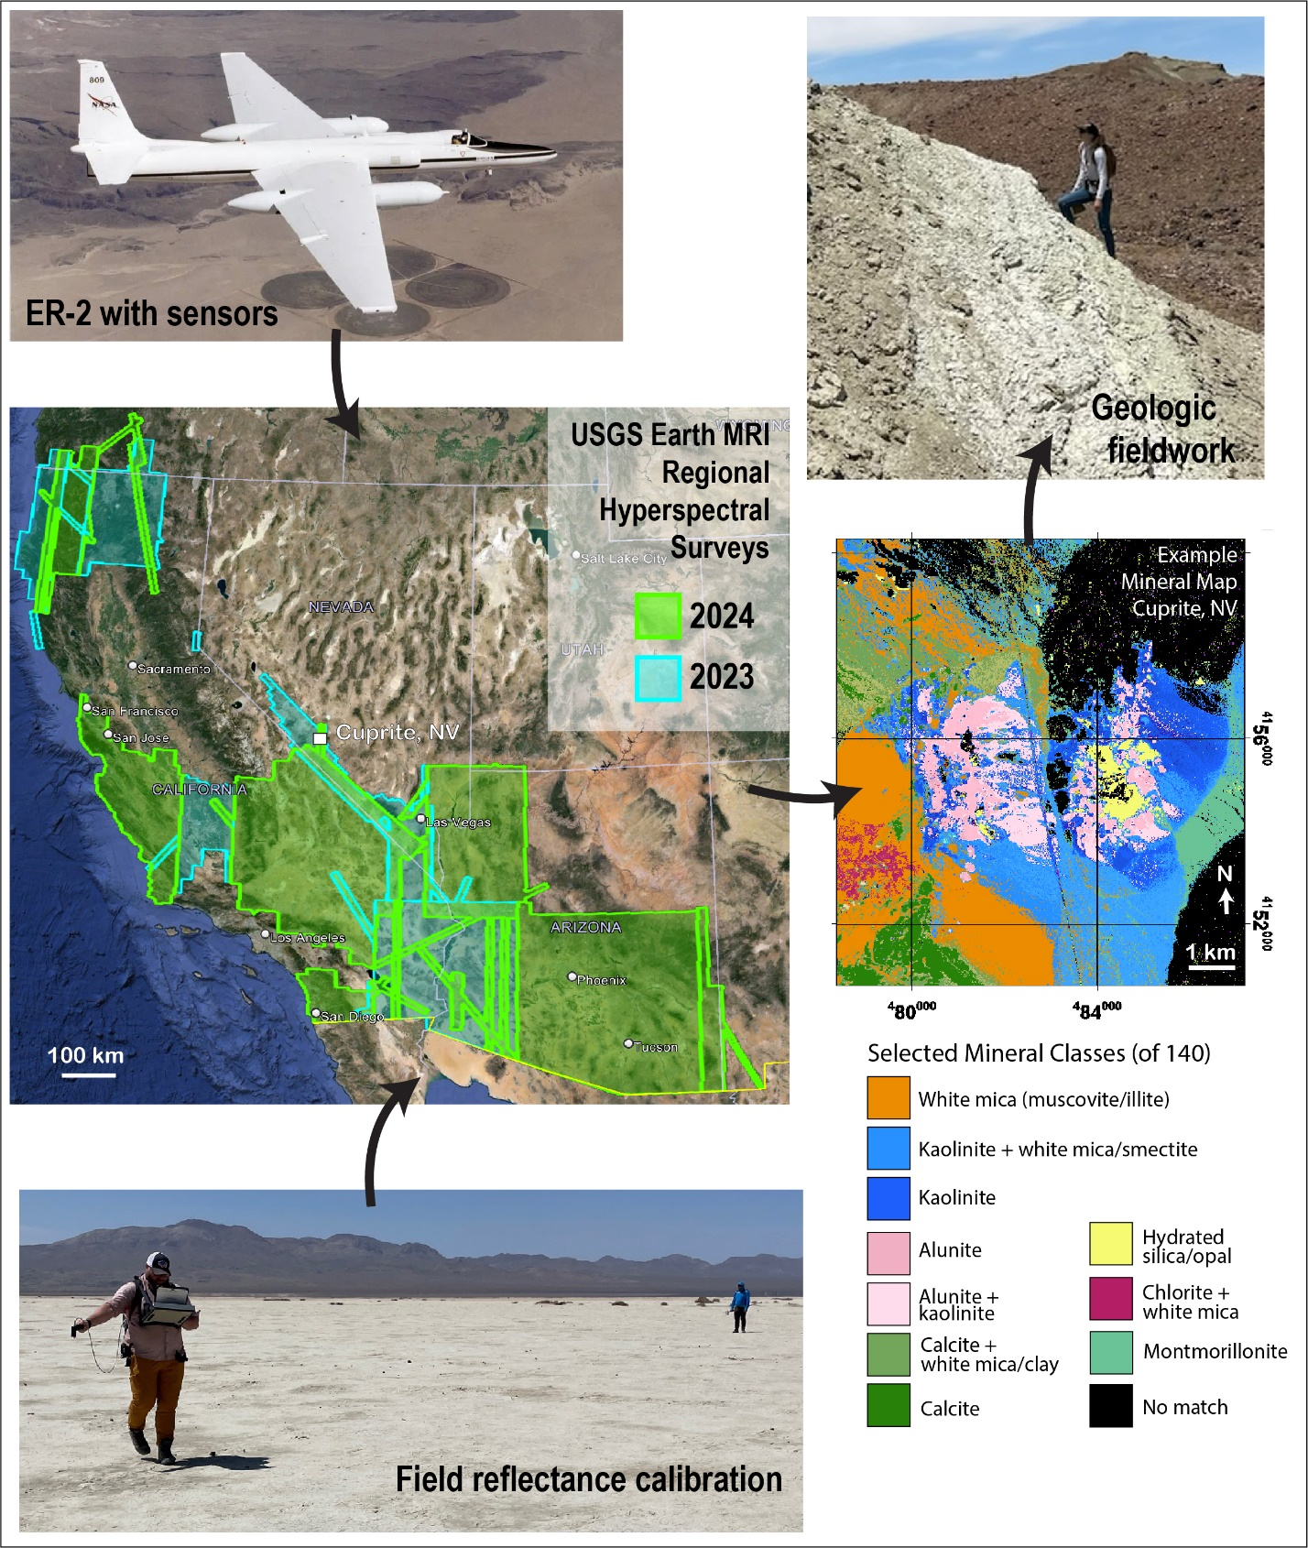
Caption for Graphic or Image: Activities of the Earth MRI hyperspectral acquisitions include high altitude airborne surveys, field calibration measurements, data processing and mineral map generation, and geologic field work.
Author name: Raymond Kokaly
Author business email: raymond@usgs.gov

DOI agency/bureau: USGS
USGS Mission Area: Natural Hazards
USGS Program: Coastal and Marine Geology Program
Cost Center: Woods Hole Coastal and Marine Science Center
Program Name2:
Project title: Aerial Imagery Provides High-Quality Coastal Maps
Project description: Sandy coasts like those on Cape Cod are constantly changing and it is a challenge to keep maps up to date. Researchers in the U.S. Geological Survey Remote Sensing Coastal Change Project, part of the Coastal and Marine Hazards and Resources Program, National Hazards Mission Area, use aerial imagery to study coastal change. The gold standard for mapping is airborne lidar, which provides high accuracy over large survey areas, but lidar surveys are expensive and infrequent – the last regional survey on Cape Cod was in 2018. However, surveys derived from aerial imagery using structure-from-motion photogrammetry can provide comparable accuracy and coverage at a fraction of the cost. The image below was acquired as part of a mapping effort on Cape Cod in November 2023. About 14,420 images were acquired on four overlapping flightlines along 135 km of Cape Cod shoreline during 4 hours of flying. The resulting digital elevation models (accurate to about 0.15 m) and orthomosaics allow us to chart shoreline locations, measure beach slopes (for use in wave-runup forecasts), and determine landcover for coastal habitat assessment. These data will be used to manage natural resources by our National Park Service partners at the Cape Cod National Seashore and as input to the USGS Total Water Level Coastal Change forecasts.
Sensor Type: Camera;
Platform type: Airplane;
URL: https://www.usgs.gov/programs/cmhrp/science/remote-sensing-coastal-change
Graphic or Image Upload: https://doimspp.sharepoint.com/sites/GS-EROSSCIENCESWI/Shared Documents/Communications Outreach/Documentation Science/DOI Remote Sensing Report/DOI RS Activities Report, 2024/Graphic or Image Upload/2023-1104-173858-DSC04463-N7251F_Christopher Sherwood.jpg
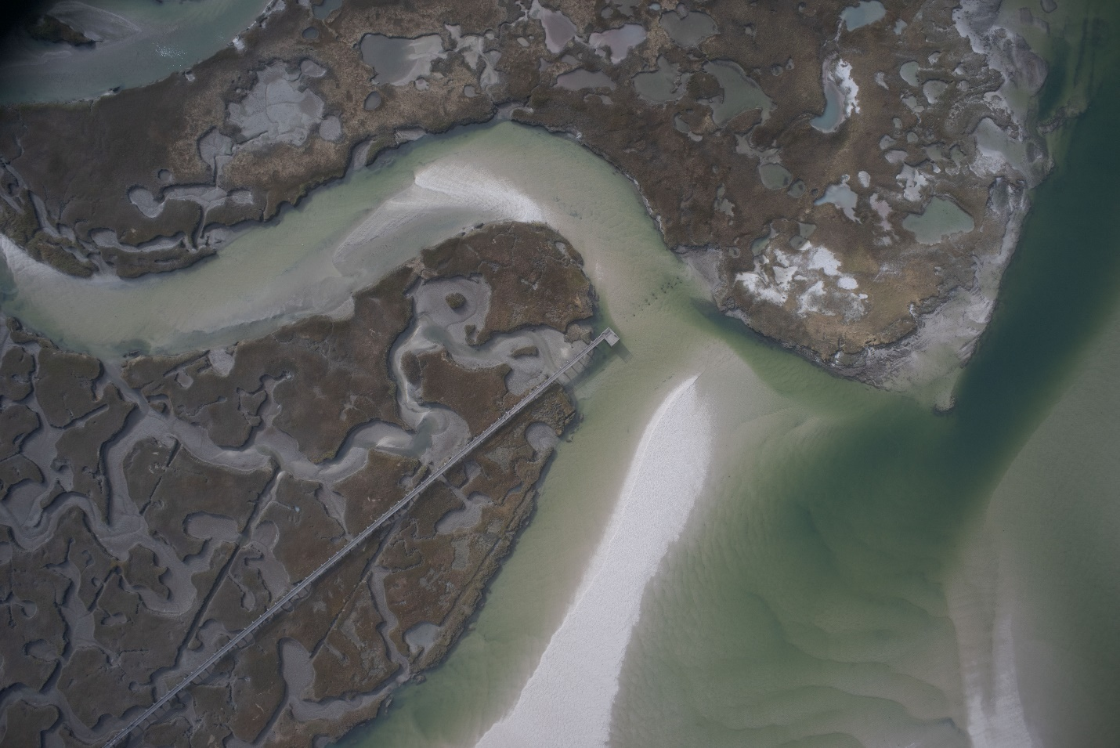
Caption for Graphic or Image: Aerial image of a marsh and small tidal inlet at Grays Beach, Yarmouth, MA on November 4, 2023. One of 10,420 images used to form composite orthomosaics and digital elevation models.
Author name: Chris Sherwood, Jin-Si Over, C. Wayne Wright
Author business email: csherwood@usgs.gov

DOI agency/bureau: USGS
USGS Mission Area: Core Science Systems
USGS Program: Science Support
Cost Center: Office of Land Remote Sensing (Geography)
Program Name2:
Project title: Reporting for the Eruption of Lewotobi Volcano, Indonesia
Project description: Timely delivery of essential volcano data to local observatory scientists is critical to ensure local populations are as prepared as possible for threatening volcanic activity. As part of this information sharing, scientists from the USGS National Civil Applications Center (within the Core Science Systems Mission Area) aided the USGS Volcano Disaster Assistance Program (VDAP). Through this collaboration, critical observations and high spatial resolution commercial satellite information was shared with the local volcano observatory during the Lewotobi Volcano eruption on Flores Island in Indonesia. Satellite imagery is a critical tool used in monitoring changes at active volcanoes as ground observations may be limited due to the dangerous activity, clouds, or even the destruction of monitoring instruments.
NCAC tasks and analyzes commercial high spatial resolution satellite imagery made available through the NextView contract. NextView provides U.S. Government users access to a variety of commercially available satellite imagery sources at no cost, including the WorldView-2 imagery included in this report.
Lewotobi Volcano’s Lakilaki Crater began showing signs of activity in mid-December 2023. The initial eruption began on December 23, 2023, with ash plumes being observed. National Civil Applications Center (NCAC) scientists reviewed satellite imagery that showed that between December 31, 2023, and January 4, 2024, a new vent had opened up on the lower southeast slope (#1 on figure) . No other apparent changes to this vent were observed during the eruption, apart from some minor ash deposition.
Between January 8, 2024, and January 11, 2024, satellite data showed that the Lakilaki Crater filled with lava and started to move down the east-southeast slope (#2 on figure). Within days, the lava flow was advancing steadily toward coastal villages and the main coastal road (#3 on figure) on the island. By the end of January 2024, commercial satellite imagery allowed NCAC scientists to confidently confirm that the lava flow had stopped advancing, coming to within 2 kilometers (1.25 miles) of the coastal villages.
With high resolution commercial satellite imagery and timely observations provided by NCAC scientists, VDAP scientists confidently provided critical and timely information to Indonesian volcano scientists and decision makers. This unique program provides a vital service and is a critical element of global volcano disaster risk reduction. Because volcanoes can erupt with little to no warning, often in remote and hard to access regions, timely collection and analysis of satellite imagery provides unique data and techniques for prompt analysis and time-sensitive reporting, reducing the potential for loss of life and property.
Sensor Type: Multispectral (approx. 4-12 bands);
Platform type: Satellite;
URL:
Graphic or Image Upload: https://doimspp.sharepoint.com/sites/GS-EROSSCIENCESWI/Shared Documents/Communications Outreach/Documentation Science/DOI Remote Sensing Report/DOI RS Activities Report, 2024/Graphic or Image Upload/Lewotolok_Volcano_DOI_RS_new_Steven Smith.jpg
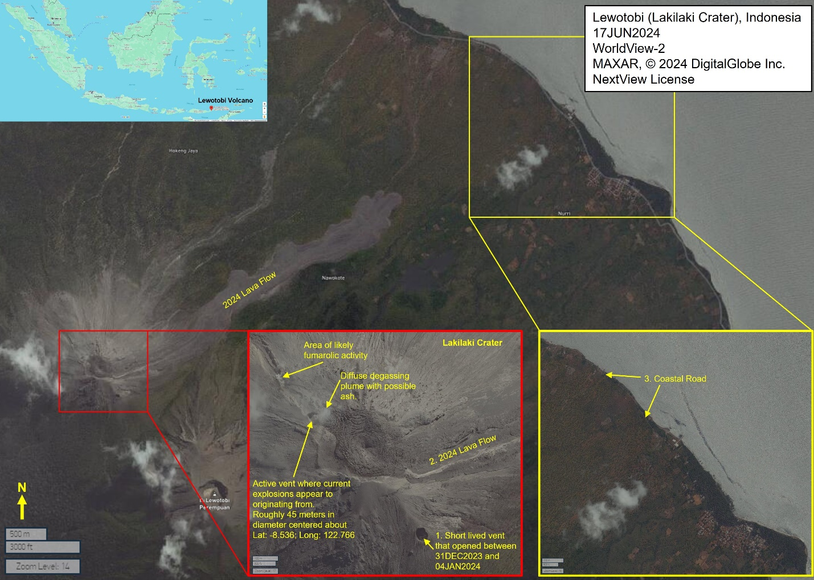
Caption for Graphic or Image: MAXAR WorldView-2 satellite image of Lewotobi Volcano’s Lakilaki Crater showing the lava flow features, vents, and steam (fumarolic) activity in relation to the coastal road and nearby village. © 2024 DigitalGlobe, Inc. NextView License.
Author name: Steven J. Smith, Chelsea L. Carbo, Chelsea J. Cook, Peter G. Rinkleff, and Rick Wessels
Author business email: stevenjsmith@usgs.gov

DOI agency/bureau: USGS
USGS Mission Area: Ecosystems
USGS Program: Land Change Science
Cost Center: Earth Resources Observation and Science (EROS) Center (Geography)
Program Name2:
Project title: The LANDFIRE Program At 20
Project description: The LANDFIRE program is celebrating its 20th anniversary this year. This anniversary reflects years of work dedicated to producing hundreds of wall-to-wall Landsat-based 30m geospatial layers that are integral in capturing vegetation and wildland fuel dynamics for the United States and territories. LANDFIRE stands out as the only national project delivering consistent, nationwide inventory data:
• Mapping 700+ vegetation types, Existing Vegetation Type (EVT) Ecological Systems (ES) within the conterminous US and 90 km into Canada and Mexico (Figure 1) and working to align mapping to National Vegetation Classification Standard (NVCS) set by the Federal Geographic Data Committee (FGDC).
• Mapping wildland fire fuel characteristics that supports prioritizing fuel management projects and identifying at risk communities.
• Producing standardized datasets that support the national management of fire and natural resources to help protect people, natural resources, and property.
• Provides the spatial fuels data needed for fire behavior modeling on large wildfires and for prescribed fire planning.

At the heart of LANDFIRE's products lies its innovative use of remotely sensed data coupled with operational (NFPORS, FACTS, etc.) data sets and data from related programs (NLCD, MTBS, RAVG, etc.). LANDFIRE recently developed innovative compositing processes that leverage Harmonized Landsat Sentinel-2 (HLS) data to make a single set of seasonal disturbance and vegetation products (four per year) at the same time (a significant time savings). In years past, separate compositing campaigns were needed for disturbance and vegetation composites. The HLS-based composited imagery provides much clearer images, therefore eliminating a time-intensive manual cleaning process. All compositing processes are automated and optimized to run on the USGS high performance computing environment (HPC) with current efforts to transition these methods to the cloud for even greater efficiencies.

LANDFIRE actively tests and implements new machine learning (ML) and artificial intelligence (AI) classifiers with methods to tune the models for these products. All ML/AI methodologies have been developed to scale from the desktop computer to the cloud. Ultimately, these new modeling techniques can only overcome some data limitations. The newest ML/AI algorithms often require large amounts of data to model continuous and thematic variables more accurately. To address this challenge LANDFIRE has been actively engaged in obtaining new three-dimensional (3D) remotely sensed data sources, including satellite, airborne, and terrestrial lidar datasets. Additionally, LANDFIRE has tackled challenges caused by data inconsistencies by adjusting the data distribution and removing outliers, ultimately minimizing product errors, and ensuring continued data quality.

In the upcoming years, the LANDFIRE program will continue to innovate and improve products. The LANDFIRE program eagerly anticipates the new LANDSAT and Sentinel satellites, which will allow for continued product development. Research into new 3D fuels models to better predict fire behavior will help continue to drive the future of the LANDFIRE program.

Sensor Type: Lidar (terrestrial or bathymetric);Multispectral (approx. 4-12 bands);
Platform type: Satellite;Ground based / sensor web / web cam;
URL: https://www.landfire.gov/
Graphic or Image Upload: https://doimspp.sharepoint.com/sites/GS-EROSSCIENCESWI/Shared Documents/Communications Outreach/Documentation Science/DOI Remote Sensing Report/DOI RS Activities Report, 2024/Graphic or Image Upload/EVT2022wZoom_Joshua Picotte.png
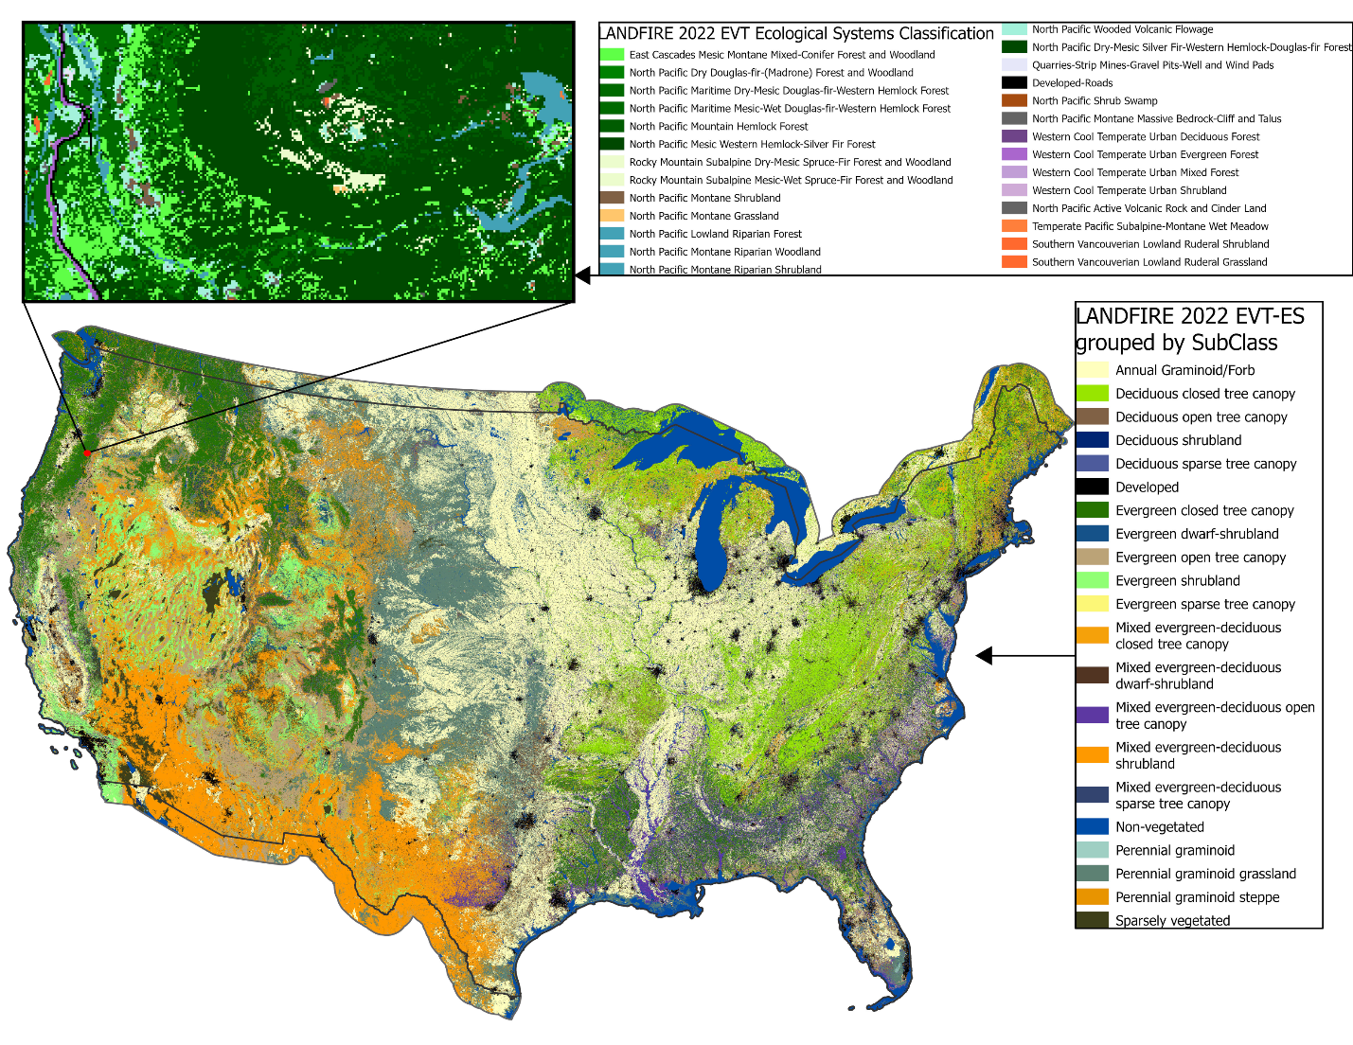
Caption for Graphic or Image: LANDFIRE 2022 Existing Vegetation Type (EVT) Ecological Systems Classifications (ES) were produced for the conterminous US and 90 km into Canada and Mexico. The inset map shows zoomed in EVT-ES map of a forested area within Oregon.
Author name: Joshua Picotte
Author business email: jpicotte@usgs.gov

DOI agency/bureau: USGS
USGS Mission Area: Core Science Systems
USGS Program: National Land Imaging Program
Cost Center: Office of Land Remote Sensing (Geography)
Program Name2:
Project title: Barrier Island Breach Evolution at Fire Island National Seashore
Project description: Barrier islands provide a sanctuary and stable environmental conditions to a large host of biodiverse wildlife communities, including protection from otherwise devastating storms. An upcoming USGS Open File Report is being produced by scientists from the USGS National Civil Applications Center (NCAC), within the Core Science Systems Mission Area, which utilizes satellite imagery to track the evolution of a barrier island breach at Fire Island National Seashore in New York, as part of the Global Fiducials Library (GFL).
The GFL is a database of high resolution, panchromatic U.S. National Imagery Systems data for select global sites that are available to the public at no cost. It is currently maintained by the NCAC and hosted at the EROS Data Center. The GFL sites are collected to provide a time series to monitor change and understand the dynamic and environmentally sensitive areas on Earth.
This report focuses on the barrier island breach created at Fire Island National Seashore, after Hurricane Sandy moved through the region in 2012. The study combines aerial photography, declassified U.S. National Imaging Systems satellite imagery, and commercial satellite imagery to provide a time series of data illustrating the evolution of changes, including the degradation and eventual rebuilding of the barrier island over time. NCAC tasks and analyzes commercial high spatial resolution satellite imagery made available through the NextView contract. NextView provides U.S. Government users access to a variety of commercially available satellite imagery sources at no cost, including the WorldView-2 imagery included in this report.
The breaching of Fire Island allowed for coastal erosional and depositional processes to create a flood shoal delta on the bay side of the island. The mixing of oceanic water with the bay water caused changes in temperature and salinity conditions along with the increase in sediment on the bay side of the island. NCAC scientists are continuing to study this area.
Sensor Type: Multispectral (approx. 4-12 bands);
Platform type: Satellite;
URL: https://www.usgs.gov/global-fiducials-library-data-access-portal
Graphic or Image Upload: https://doimspp.sharepoint.com/sites/GS-EROSSCIENCESWI/Shared Documents/Communications Outreach/Documentation Science/DOI Remote Sensing Report/DOI RS Activities Report, 2024/Graphic or Image Upload/Fire_Island_Images_Steven Smith.jpg
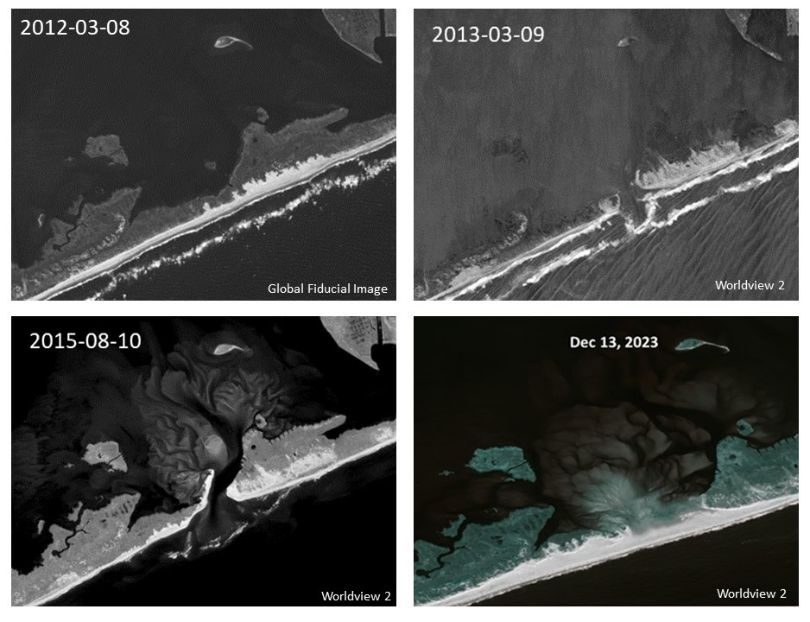
Caption for Graphic or Image: A collection of Global Fiducial Library and MAXAR WorldView-2 satellite images of Fire Island National Seashore in New York. Images are from March 8, 2012 - pre-breach; March 9, 2013 - the initial breach formed after Hurricane Sandy impacted the island; August 10, 2015 - formation of the flood shoal delta created after Hurricane Sandy; and December 13, 2023 - after the breach closed up. © 2023 DigitalGlobe, Inc. NextView License WorldView-2.
Author name: Steven J. Smith, Chelsea L. Carbo, Chelsea J. Cook, and Peter G. Rinkleff
Author business email: stevenjsmith@usgs.gov

DOI agency/bureau: USGS
USGS Mission Area: Energy and Minerals
USGS Program: Mineral Resources Program
Cost Center: Geology and Geophysics Science Center
Program Name2:
Project title: Airborne and drone-based radiometric geophysics for mine waste characterization
Project description: Airborne radiometric methods use naturally emitted gamma rays to remotely measure approximate amounts of radioelements potassium, uranium, and thorium within Earth’s the upper 0-0.5 meters. Recent high-resolution airborne surveys as part of Earth Mapping Resources Initiative (Earth MRI) have shown the unique advantages of radiometrics via the characterization of both geologic variations and mine waste. For mine waste applications, radiometrics complements other remote sensing methods like lidar and satellite imagery because of its ability to see through vegetation and provide information on waste composition. These data can then help with 1) determining potential remediation needs, and 2) examining the potential for critical minerals, which are essential for advanced technologies and clean energy applications.
For instance, airborne radiometric data collected in New York revealed elevated thorium anomalies, which correlate with the presence of rare earth elements (considered critical commodities) associated with mine waste (https://doi.org/10.5382/econgeo.4689). One of the thorium-identified mine waste areas was covered in vegetation, making it difficult to identify using lidar or satellite imagery. Additionally, for two mine waste sites identifiable via satellite imagery and lidar, the radiometric data indicated elevated thorium concentrations in only one of the piles, suggesting a compositional difference between them. This example illustrates how airborne radiometrics can be a valuable tool for both identifying and characterizing mine waste.
The next stage of this effort is to use radiometric methods from drones (Figure 1), which provide much higher resolution than is possible from an airplane or helicopter and can image geochemical variations within individual mine waste or tailing piles. The USGS recently collected drone-based radiometric data over mine waste and tailings piles in New Mexico, and is working towards imaging potential localized zones of potassium, uranium, and thorium within the waste. Understanding this zoning will provide guidance towards collaborative sampling and characterization of these mine waste areas with a goal of evaluating potential for critical mineral resources.

Sensor Type: Radiometric;
Platform type: UAS;
URL:
Graphic or Image Upload: https://doimspp.sharepoint.com/sites/GS-EROSSCIENCESWI/Shared Documents/Communications Outreach/Documentation Science/DOI Remote Sensing Report/DOI RS Activities Report, 2024/Graphic or Image Upload/drone_minewaste_Chloe Gustafson.jpg
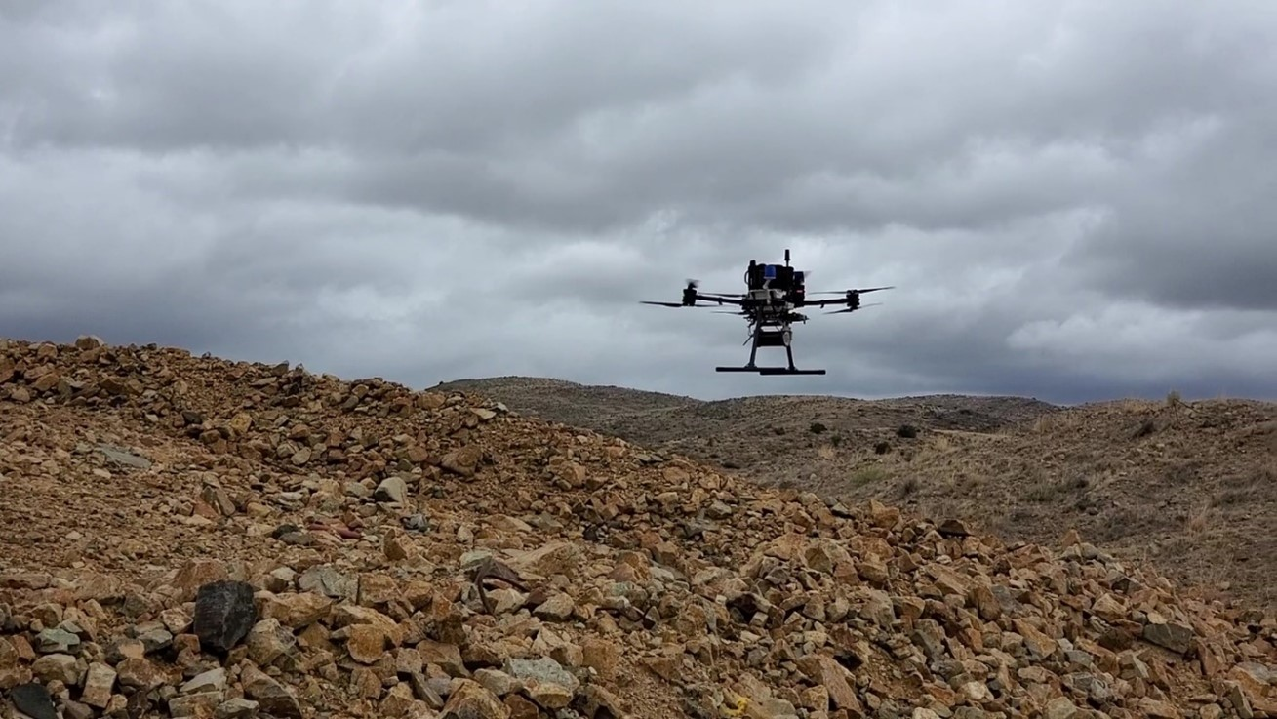
Caption for Graphic or Image: Figure 1. Radiometric sensor attached to the bottom of drone flying over a mine waste pile in New Mexico.
Author name: Chloe Gustafson
Author business email: cgustafson@usgs.gov

DOI agency/bureau: USGS
USGS Mission Area: Core Science Systems
USGS Program: National Land Imaging Program
Cost Center: Western Geographic Science Center
Program Name2:
Project title: Maps of intertidal microbial biofilm taxonomic and trait diversity from multi-scale spectroscopy
Project description: Intertidal microbial biofilms, or microphytobenthos, support estuarine biogeochemical cycling, the physical stability of mudflats, and food webs, particularly those of migratory shorebirds. Photosynthetic biofilms dominated by diatoms, cyanobacteria and chlorophytes represent a significant fraction of biofilm biomass and contain pigments that can be detected with remote sensing. These diverse biofilm taxonomic groups vary in indicator pigments and functional traits related to biogeochemical cycling and nutritional quality. Scientists from the USGS Western Geographic Science Center, USGS Western Ecological Research Center San Francisco Bay Estuary Field Station, and California State University Monterey Bay modeled and mapped the spatial variation in biofilm distribution, quantity, diversity, and functional traits using multi-scale spectroscopic data collected within South San Francisco Bay, California, USA (South Bay). To create maps, the scientists developed single and multiple response partial least squares regression (PLS) models of chlorophyll-a (chl-a; biomass indicator), indicator pigments: fucoxanthin and diadinoxanthin (diatom indicator), zeaxanthin (cyanobacteria indicator), and chl-b (chlorophyte indicator), and functional traits: carbohydrates, lipids and total organic carbon using paired in-situ biofilm data and field spectra from an ASD full spectrum spectrometer. A new biofilm index (B-index) was developed with 5 mm HySpex spectra to detect biofilm presence/absence. The B-index and PLS models were scaled to the South Bay with a 3.7m AVIRIS-NG hyperspectral image collected April 15, 2021. The percent normalized root mean square error (%RMSE) of PLS models based on AVIRIS-NG test samples ranged from 12.7% for chl-a to 49% for chl-b; six of the eight models had a %RMSE of 23% or below. Mapped taxonomic groups differed in their distribution of mapped traits; average lipid concentrations were three times higher in areas indicated as diatoms compared to other groups. These maps represent the first time that the spatial variation of an important shorebird food resource - biofilm quality - has been quantified. This information will support the South Bay Salt Pond Restoration Project, the largest tidal wetland restoration project in the Western U.S., where a key question is whether tidal marsh restoration will lead to mudflat erosion and impacts to biofilm. Results can also be used to inform the contribution of intertidal biofilm to carbon and nutrient cycling.
Sensor Type: Hyperspectral;
Platform type: Ground based / sensor web / web cam;Airplane;
URL: https://www.sciencebase.gov/catalog/item/644950d1d34ee8d4aded8fe6
Graphic or Image Upload: https://doimspp.sharepoint.com/sites/GS-EROSSCIENCESWI/Shared Documents/Communications Outreach/Documentation Science/DOI Remote Sensing Report/DOI RS Activities Report, 2024/Graphic or Image Upload/F8.nutrient maps_Kristin Byrd.jpg
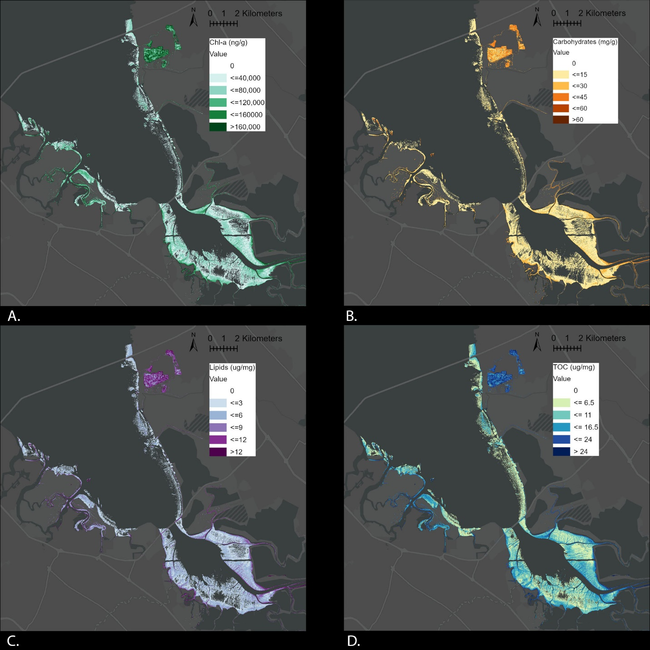
Caption for Graphic or Image: Maps of intertidal biofilm A. chl-a concentration, B. carbohydrates, C. lipids, and D. total organic carbon in South San Francisco Bay, April 15, 2021, based on final partial least squares regression models and AVIRIS-NG 3.7 m hyperspectral airborne imagery
Author name: Kristin Byrd
Author business email: kbyrd@usgs.gov

DOI agency/bureau: USGS
USGS Mission Area: Core Science Systems
USGS Program: National Land Imaging Program
Cost Center: Office of Land Remote Sensing (Geography)
Program Name2:
Project title: Aircraft 3/Firehawk Wildland Fire Mapping
Project description: The USGS National Civil Application Center (NCAC) works in coordination with the National Interagency Fire Center (NIFC) and the National Geospatial-Intelligence Agency (NGA) to provide wildland fire mapping support under the Aircraft 3 (AC3)/Firehawk program. NIFC is an interagency activity hosted by the Bureau of Land Management and is comprised of the U.S. Forest Service, Bureau of Land Management, Bureau of Indian Affairs, National Park Service, National Fish and Wildlife Service, National Weather Service, and Association of State Foresters. National wildfire coordinators work with NCAC and NGA analysts to task and analyze current wildland fires and deliver mapping products showing fire perimeter and intensity used in daily tactical and strategic operations.
AC3 products are derived from classified US. National Imagery data sources. While the source imagery data and the specific capabilities of these data are classified, the derived products are disseminated at the unclassified level so they can be used by incident commanders and other data consumers.
AC3 first activation on the 2024 fire season was on June 3 and as of August AC3 has mapped over 5.5 million acres across 10 states and provided over 200 mapping products. Of note, AC3 supported the Park Fire in California, the 4th largest fire in California history. AC3 was able to fill in while other assets were not available or able to support due to resource limitations.
NCAC and NGA analysts generate time-critical data products and provide them to wildland fire incidents that cannot easily be reached by NIFC aircraft including remote and isolated locations such as Alaska and Hawaii.
Below are two examples of a finished AC3 products provided to NIFC for further distribution. The first map is of the 2024 SQF Lightning fire incident in California. The second incident is the Park fire in California.
Sensor Type: US National Imaging System;
Platform type: Satellite;
URL:
Graphic or Image Upload: https://doimspp.sharepoint.com/sites/GS-EROSSCIENCESWI/Shared Documents/Communications Outreach/Documentation Science/DOI Remote Sensing Report/DOI RS Activities Report, 2024/Graphic or Image Upload/AC3 Lightning fire_Peter Rinkleff.jpg
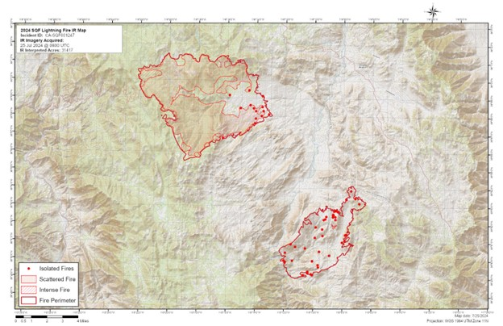
Graphic or Image Upload: https://doimspp.sharepoint.com/sites/GS-EROSSCIENCESWI/Shared Documents/Communications Outreach/Documentation Science/DOI Remote Sensing Report/DOI RS Activities Report, 2024/Graphic or Image Upload/AC3 Park Fire_Peter Rinkleff.jpg
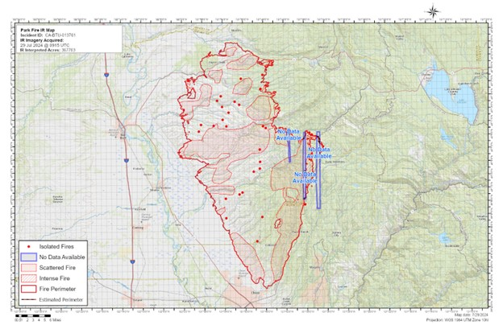
Caption for Graphic or Image: Example Aircraft 3 / Firehawk map products from the Park Fire and SQF Lightning Fire in California.
Author name: Peter G. Rinkleff, Jeffery Ganuza, John (JD) Mejstrik, Steve Mackie, Anthony Feliciano, Jon Griffith
Author business email: prinkleff@usgs.gov

DOI agency/bureau: USGS
USGS Mission Area: Natural Hazards
USGS Program: Coastal/Marine Hazards and Resources Program
Cost Center: St. Petersburg Coastal and Marine Science Center
Program Name2:
Project title: Observing Coastal Recovery After Hurricane Ian with Aerial Imagery
Project description: Hurricanes move quickly through an area and unleash devastating winds and flooding that inflict rapid damage on coastal communities, while the recovery of these areas can take years as natural processes and anthropogenic influences interact to replenish sediment, restore ecosystems, and rebuild infrastructure. The U.S. Geological Survey (USGS) Remote Sensing of Coastal Change (RSCC) project, funded by the Coastal and Marine Hazards and Resources Program within the Natural Hazards Mission Area, captures storm-induced change and recovery of coastal swaths using aerial imagery surveys. These images are processed using structure-from-motion photogrammetry, resulting in high-resolution three-dimensional point clouds, digital surface models (DSMs) and orthomosaic images, which can be used to measure storm impacts such as changes in beach volume, transformations of landcover and habitats, and severity of infrastructure damage. In response to Hurricane Ian’s landfall in late September 2022, RSCC has conducted repeat aerial imagery surveys of the west coast of Florida to observe the immediate storm impacts, including after Hurricane Idalia impacted the area in August 2023, and the subsequent coastal recovery between the events. The sequence of aerial imagery surveys shows the beach response and recovery to extreme storm events, as well as damages and improvements to the infrastructure, in the 2 years after the storm. Understanding the current state of the coastline and how beaches recover is important for determining the vulnerability of coastal communities and habitats to future storms. USGS researchers will continue to analyze these data to better understand how beaches naturally recover from extreme storm events, knowledge that will be used to validate and improve predictive models of coastal change.
Sensor Type: Camera;
Platform type: Airplane;
URL:
Graphic or Image Upload: https://doimspp.sharepoint.com/sites/GS-EROSSCIENCESWI/Shared Documents/Communications Outreach/Documentation Science/DOI Remote Sensing Report/DOI RS Activities Report, 2024/Graphic or Image Upload/IanRecovery_Jennifer (Jenna) Bro.jpg
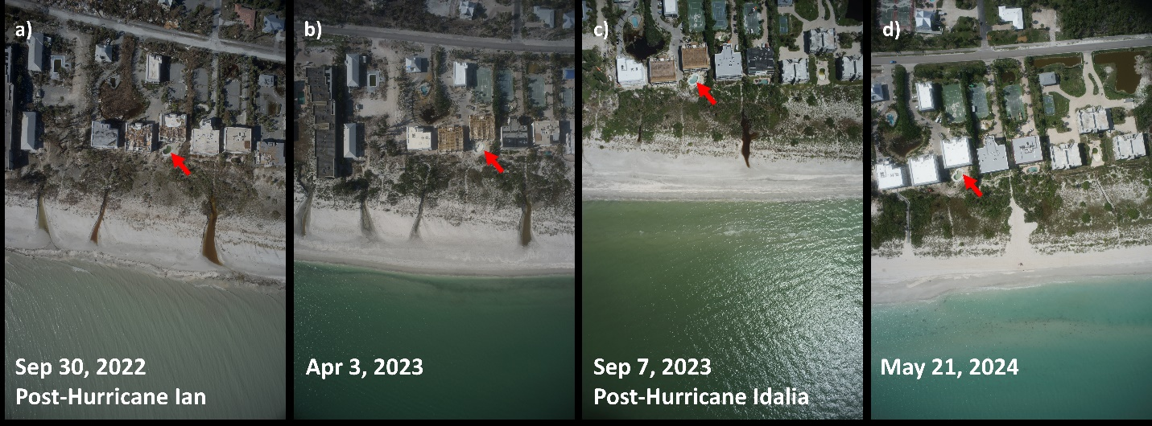
Caption for Graphic or Image: Aerial images showing the change in coastal conditions at Sanibel Island, Florida, including (a) significant erosional cuts in the beach due to Hurricane Ian in September 2022, (b) infilling of these cuts near the shoreline about 6 months after the storm in April 2023, (c) minor erosion of the lower beach due to Hurricane Idalia in September 2023, and (d) the cuts being completed infilled in May 2024. Red arrow shows a common feature in all images for comparison.
Author name: Jenna Brown
Author business email: jennabrown@usgs.gov

DOI agency/bureau: USGS
USGS Mission Area: Core Science Systems
USGS Program: National Land Imaging Program
Cost Center: Western Geographic Science Center
Program Name2:
Project title: An automated cropland fallow algorithm (ACFA) for Great Plains of the United States of America
Project description: Fallow agriculture, the practice of leaving land unplanted during a growing season, plays a critical role in many crop rotations. Accurately assessing the extent of fallow land is essential for two primary reasons: 1) evaluating crop productivity for food security, and 2) assessing water usage for effective management and conservation. This study fills this knowledge-gap by developing methods and models for mapping fallow agricultural lands in the Northern Great Plains of USA. The approach utilizes an easily implementable decision tree algorithm for ease of interpretability. Using the Google Earth Engine (GEE) cloud platform, the robust ACFA model was applied for 7 independent years (2010-2014, 2016, and 2018; the years not used in model development) using MODIS 16-day time-series data to differentiate fallow lands from other land cover types. Accuracy assessments were conducted for the years 2010-2014, 2016, and 2018. For the 7 independent years, overall accuracies were ranging from 96% to 98.8%.
Sensor Type: Multispectral (approx. 4-12 bands);
Platform type: Satellite;
URL: https://doi.org/10.1080/17538947.2024.2337221
Graphic or Image Upload: https://doimspp.sharepoint.com/sites/GS-EROSSCIENCESWI/Shared Documents/Communications Outreach/Documentation Science/DOI Remote Sensing Report/DOI RS Activities Report, 2024/Graphic or Image Upload/2018insert_Adam Oliphant.png
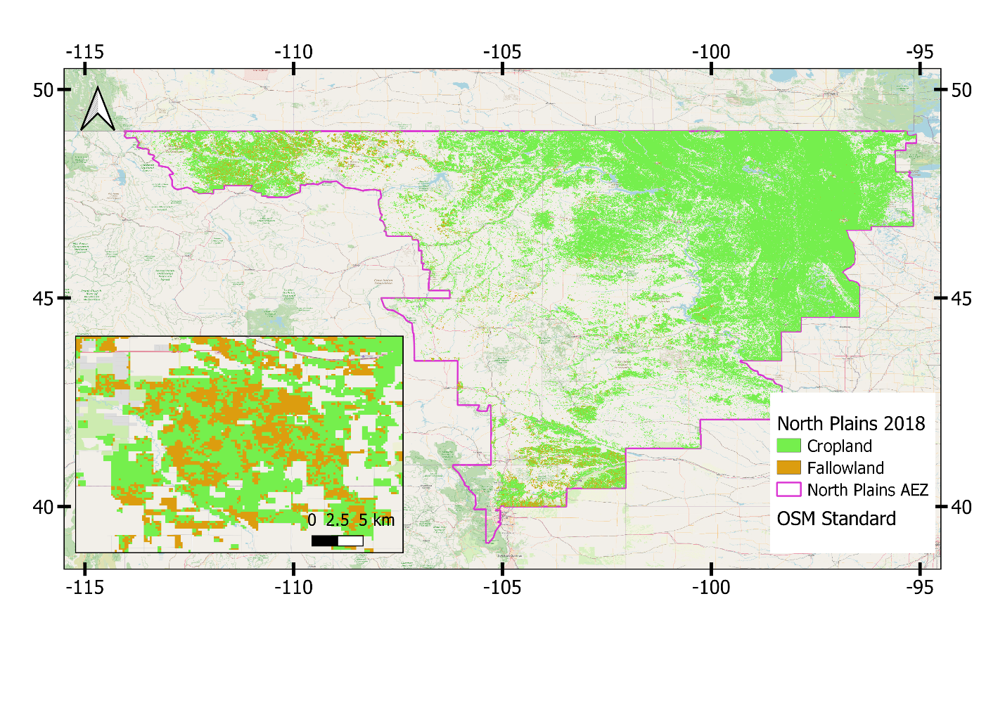
Caption for Graphic or Image: Figure 1: Cropland and cropland fallow map for 2018 produced using MODIS imagery and decision trees. [Source: Oliphant et al. 2024]
Author name: Adam J Oliphant
Author business email: aoliphant@usgs.gov

DOI agency/bureau: USGS
USGS Mission Area: **unspecified​**
USGS Program: **unspecified​**
Cost Center: Geology and Geophysics Science Center
Program Name2:
Project title: Earth MRI magnetic data assist with earthquake hazards in South Carolina
Project description: Airborne magnetic survey data, which measure subtle variations in Earth’s magnetic field, can be used to image geology and faults at Earth’s surface and up to several kilometers below. In South Carolina, a M~7 earthquake in 1886 nearly destroyed the city of Charleston, SC, and the region is considered at risk for future earthquakes. Data collected collaboratively through the Earth Mapping Resources Initiative (Earth MRI) and USGS Earthquake Hazards Program are being used to image faults that have slipped in recent geologic time and may pose risk today. The magnetic methods work by imaging contrasts between rocks that have different amounts of magnetic minerals, such as iron-rich basalts vs. sandstones. Such contrasts could be generated by a fault that juxtaposes different rocks. For example, in December 2021, a swarm of relatively low-magnitude earthquakes (Mw<3.6) started near the town of Elgin, SC, about 30 km from the capital city of Columbia, SC. These earthquakes are well-aligned with a lineament visible in the aeromagnetic data, which is interpreted as the causative fault. These earthquakes continue today. A number of other lineaments are visible near Charleston, SC. Comparisons to other datasets, such as seismic reflection data, show that these faults have been active in the last 2 million years, and may continue to be active in the future. For more information, see Shah, A. K., Pratt, T. L., & Horton, J. W. Jr., 2023, Rift basins and intraplate earthquakes: New high-resolution aeromagnetic data provide insights into buried structures of the Charleston, South Carolina seismic zone. Geochemistry, Geophysics, Geosystems, 24, e2022GC010803. https://doi.org/10.1029/2022GC010803
Sensor Type: Magnetic;
Platform type: Airplane;
URL:
Graphic or Image Upload: https://doimspp.sharepoint.com/sites/GS-EROSSCIENCESWI/Shared Documents/Communications Outreach/Documentation Science/DOI Remote Sensing Report/DOI RS Activities Report, 2024/Graphic or Image Upload/Remote_Sensing_Earthquakes_Anjana Shah.png
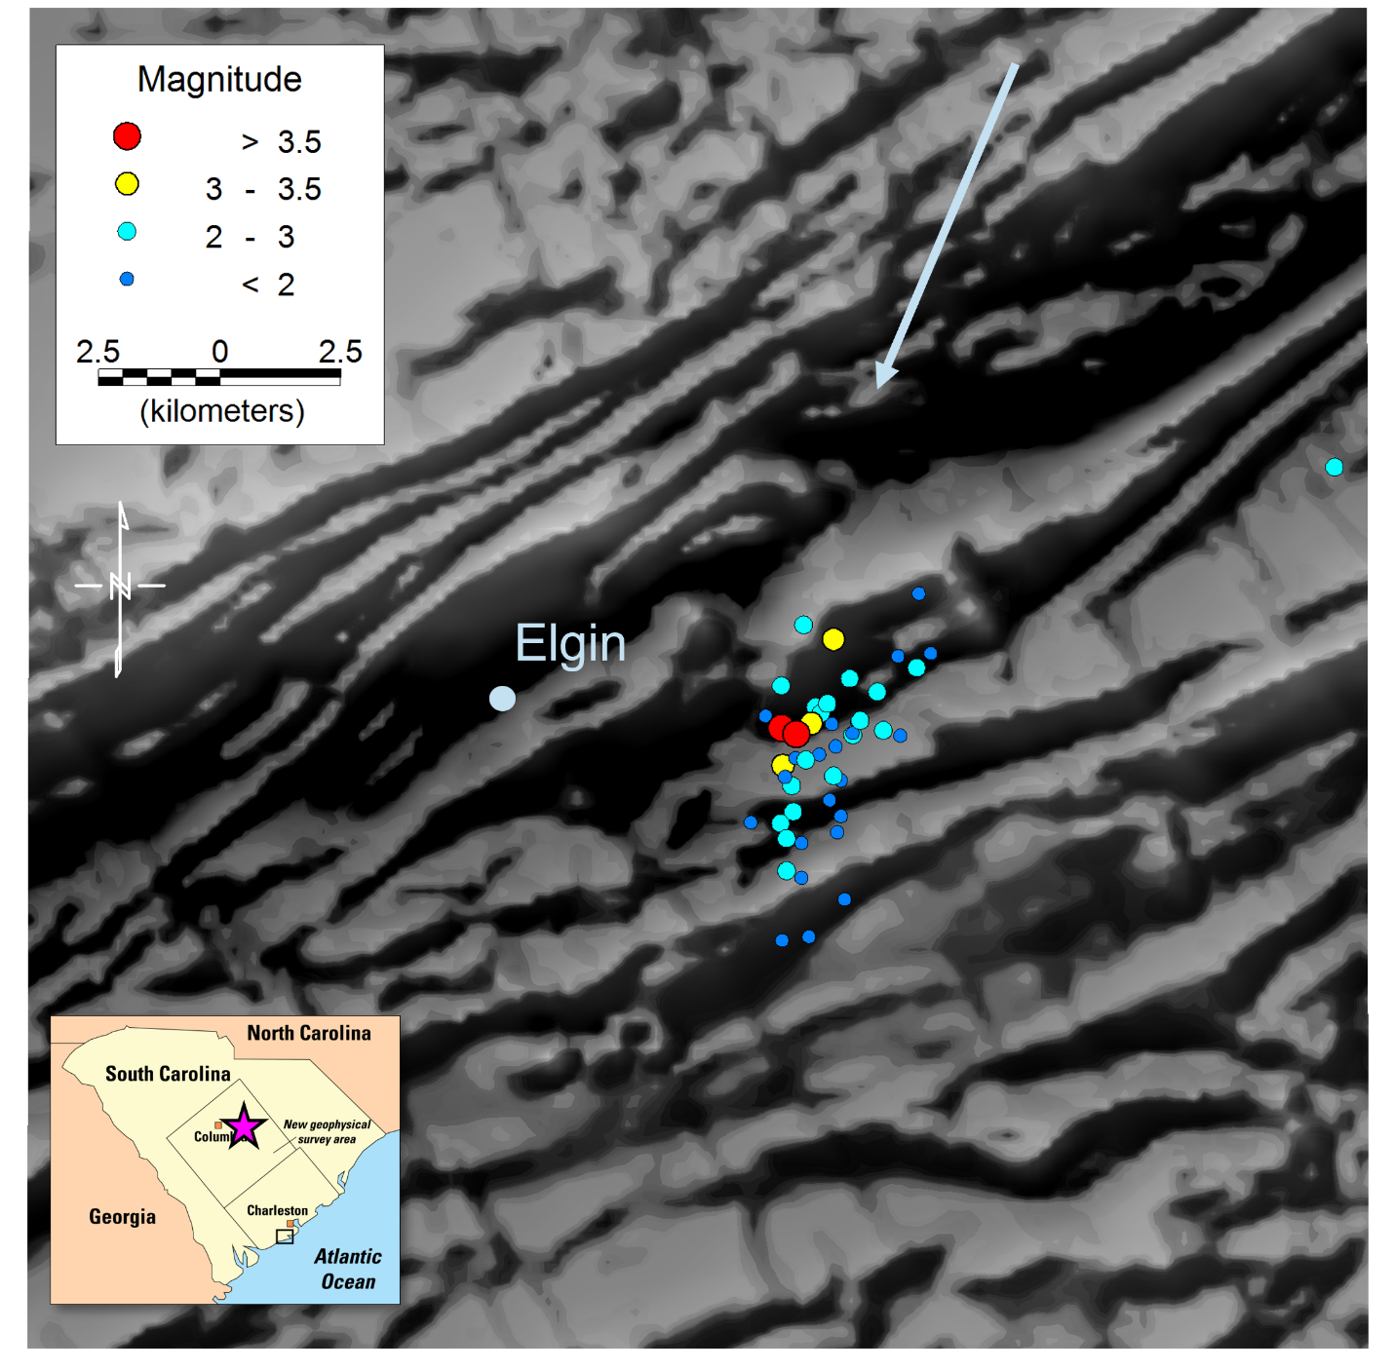
Caption for Graphic or Image: The Elgin earthquake swarm (circles), colored by magnitude, over a grayscale shaded relief image of the magnetic field, reduced to pole, near Elgin, SC. The earthquakes are aligned with a NNE-trending magnetic lineament (see arrow), interpreted as the causative fault. This fault crosses other NE-trending lineaments that represent faults and folds. Other NW-trending lineaments represent dikes that were emplaced at the time of opening of the Atlantic Ocean.
Author name: Anjana K Shah
Author business email: ashah@usgs.gov

DOI agency/bureau: USGS
USGS Mission Area: Energy and Minerals
USGS Program: Mineral Resources Program
Cost Center: Geology and Geophysics Science Center
Program Name2:
Project title: Airborne radiometric data assist geologic mapping and highlight critical mineral resources in the eastern US
Project description: The Earth Mapping Resources Initiative (Earth MRI) is collecting radiometric and magnetic data that can be used to map geology and highlight critical mineral resources. Prior to Earth MRI, high-resolution airborne radiometric data coverage was available over less than 1% of the US, so the Earth MRI data are providing numerous new insights. These methods, which show variations in radioelements potassium, thorium, and uranium within the upper 0-0.5 m of Earth’s surface beneath vegetation and other cover, act as “remote geochemistry” detectors. There are multiple applications including geologic mapping, highlighting certain mineral resources (such as the Earth MRI discovery of rare earth elements in northern Maine), characterizing mine waste, and indicating potential radon risk. An example of using these data for geologic mapping is shown in the attached figure. Here, within the crystalline rock of Virginia and North Carolina, the new data highlight metamorphic rocks high in Th (green), ancient magma bodies rich in K (magenta), sandstones that have neither, and various other rock types. Within adjacent sediments of the Atlantic Coastal Plain, the data highlight K-rich river flood plains, where the contrast with actual rivers reveal a history of river migration and stream piracy. Subtle green areas within the Atlantic Coastal Plain sediments delineate areas with known placer deposits containing titanium, zirconium, and rare earth elements, each which are considered critical commodities. Some of these areas were mined for over a decade. Geologic mapping continues in the region today.
Sensor Type: Radiometric sensor;
Platform type: Airplane;
URL: https://www.usgs.gov/data/airborne-magnetic-and-radiometric-survey-virginia-and-north-carolina-fall-zone-2021
Graphic or Image Upload: https://doimspp.sharepoint.com/sites/GS-EROSSCIENCESWI/Shared Documents/Communications Outreach/Documentation Science/DOI Remote Sensing Report/DOI RS Activities Report, 2024/Graphic or Image Upload/Remote_Sensing_Virginia_NC_Anjana Shah.png
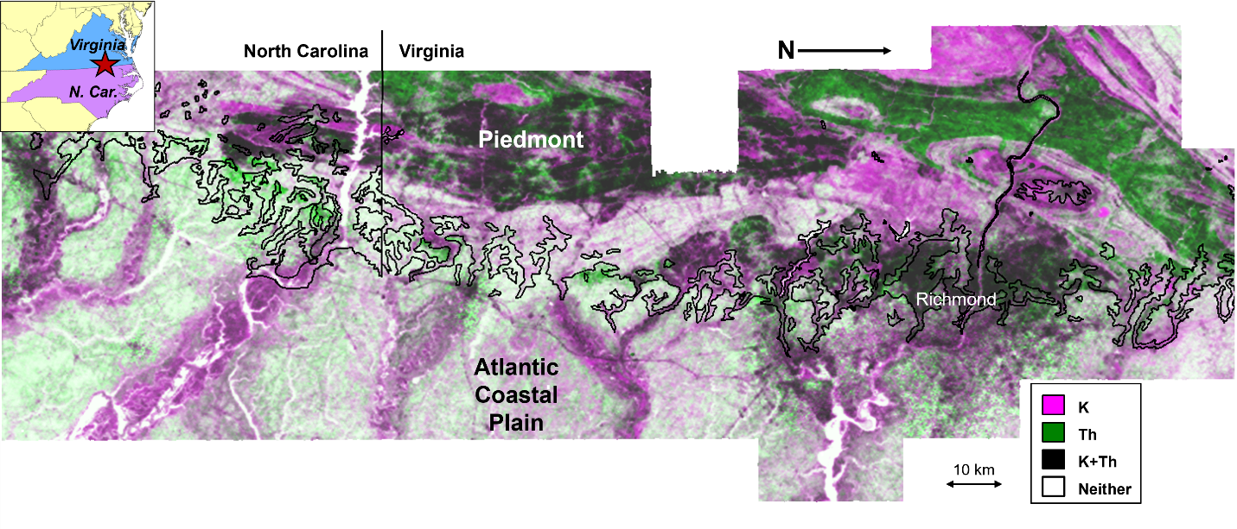
Caption for Graphic or Image: Earth MRI airborne radiometric imagery; magenta = Km (potassium), green = Th (thorium), black = K+Th, white = neither. The survey was conducted in an area where Piedmont crystalline rocks (upper part of map) meet Atlantic Coastal Plain sediments (lower part of map); the black wavy line roughly delineates the boundary tween the two zones. The varying amounts of K and Th represent different lithologies in the Piedmont and variations in sediment composition in the Coastal Plain.
Author name: Anjana K Shah
Author business email: ashah@usgs.gov

DOI agency/bureau: USGS
USGS Mission Area: Core Science Systems
USGS Program: National Geospatial Program
Cost Center: National Geospatial Program
Program Name2:
Project title: The 3D National Topography Model: Integrating High Resolution Elevation and Hydrography Data
Project description: The USGS 3D National Topography Model is a new initiative that updates and integrates USGS elevation and hydrography data to model the Nation in three dimensions (3D). The 3DNTM is comprised of three components: an ongoing effort to complete the national 3D Elevation Program (3DEP) baseline dataset, the development of the next generation hydrography and elevation programs, and a longer-term goal to fully integrate hydrography, elevation, and other data from The National Map in a 3D data model. All three components are in progress. At the end of Fiscal Year 2024, 3DEP data were available or in progress for 94.7 percent of the Nation. Fiscal Year also 2024 marks the first full year of production of the 3D Hydrography Program that is using the 3DEP baseline to derive all new surface water for the Nation. Based on the 3D Nation Study results and input from a broad range of stakeholders, the USGS National Geospatial Program has finalized a new design for the next generation of 3DEP that provides increased lidar quality levels and refresh rates. The program will work to expand the level of interagency coordination for topobathymetric lidar acquisition for inland rivers. The next generation of 3DEP will also build in more flexibility to meet changing user needs and take advantage of improvements in mapping technologies, including development of a 3D Nation Ecosystem to improve access and sharing of 3D elevation information. The concept of a fully integrated 3D model is at the early stages of research and development.
Sensor Type: Lidar (terrestrial or bathymetric);Sound (sonar or acoustic);
Platform type: Airplane;
URL: https://www.usgs.gov/3d-national-topography-model
Graphic or Image Upload: https://doimspp.sharepoint.com/sites/GS-EROSSCIENCESWI/Shared Documents/Communications Outreach/Documentation Science/DOI Remote Sensing Report/DOI RS Activities Report, 2024/Graphic or Image Upload/Chuck Carter 3DNTM graphic_Cindy Thatcher.png
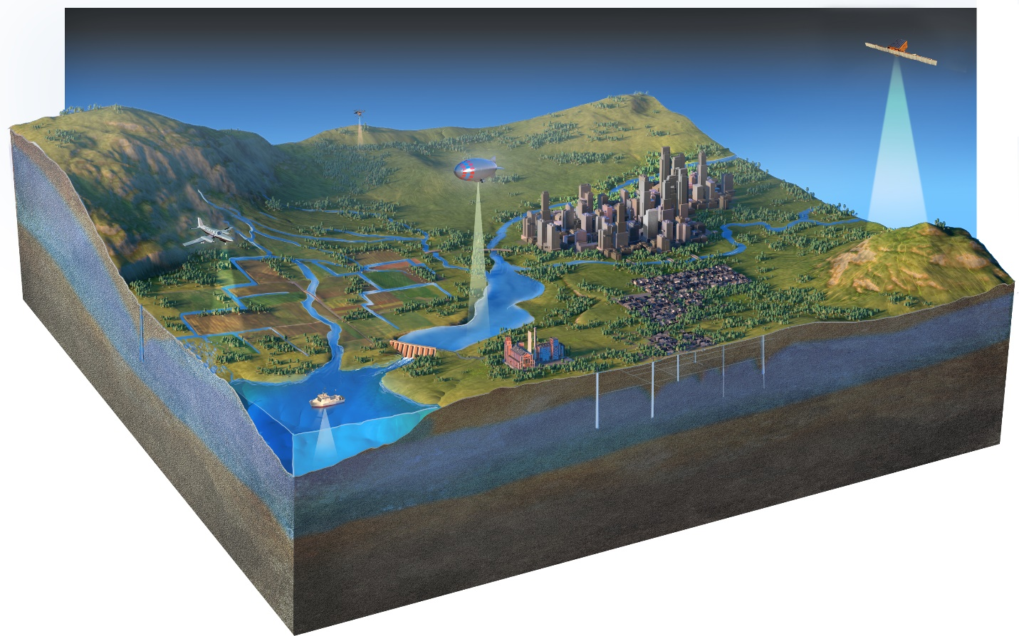
Caption for Graphic or Image: The 3D National Topography Model (3DNTM) delivers the terrestrial component of the 3D Nation vision of a continuous data surface from the depths of the oceans to the peaks of the mountains.
Author name: Vicki Lukas
Author business email: vlukas@usgs.gov

DOI agency/bureau: USGS
USGS Mission Area: Natural Hazards
USGS Program: Volcano Hazards Program
Cost Center: Volcano Science Center
Program Name2:
Project title: Airborne lidar survey of St Vincent, Eastern Caribbean, following the 2020-21 eruption of La Soufrière Volcano
Project description: La Soufrière Volcano is a 1,220 m high stratovolcano that occupies the northern half of the island of St. Vincent, Lesser Antilles, Eastern Caribbean. It has a long history of explosive and sometimes devastating eruptions. Beginning in December 2020 and ending in April 2021, La Soufrière Volcano produced a Volcano Explosivity Index (VEI) 4 eruption that greatly impacted the landscape, communities, and infrastructure on the island of St. Vincent. The eruption produced intense ash plumes, heavy ashfall, and pyroclastic flows down several river valleys. During and following the eruption, destructive lahars (volcanic mudflows) impacted rivers valleys and coastal communities for months. The USGS-USAID Volcano Disaster Assistance Program (VDAP) provided remote assistance to our counterparts at the University of the West Indies Seismic Research Center (UWI-SRC) throughout the eruption, predominantly through satellite remote sensing observations. Following the eruption, VDAP contracted the acquisition of airborne lidar though the U.S. Geological Survey's Geospatial Products and Services Contract of the entire island to support our partners throughout the Eastern Caribbean to study the eruption’s impacts, assist in recovery and planning efforts, model hazards, and conduct various other scientific investigations. This data release contains the results of this survey that include 0.6 m and 1 m resolution bare-earth digital elevation models (DEMs) and associated shaded-relief rasters of the island of St. Vincent. The DEMs cover approximately 400 sq km and were created from high-precision airborne lidar surveys performed between December 4, 2021-February 17, 2022. Some gaps exist in these data due to persistent, dense cloud cover in this tropical region. A shapefile of building footprints throughout the island is also included in this data release.
Sensor Type: Lidar (terrestrial or bathymetric);
Platform type: Airplane;
URL: https://doi.org/10.5066/P13ZHRG3
Graphic or Image Upload: https://doimspp.sharepoint.com/sites/GS-EROSSCIENCESWI/Shared Documents/Communications Outreach/Documentation Science/DOI Remote Sensing Report/DOI RS Activities Report, 2024/Graphic or Image Upload/LaSoufriere_lidar_Angie Diefenbach.jpg
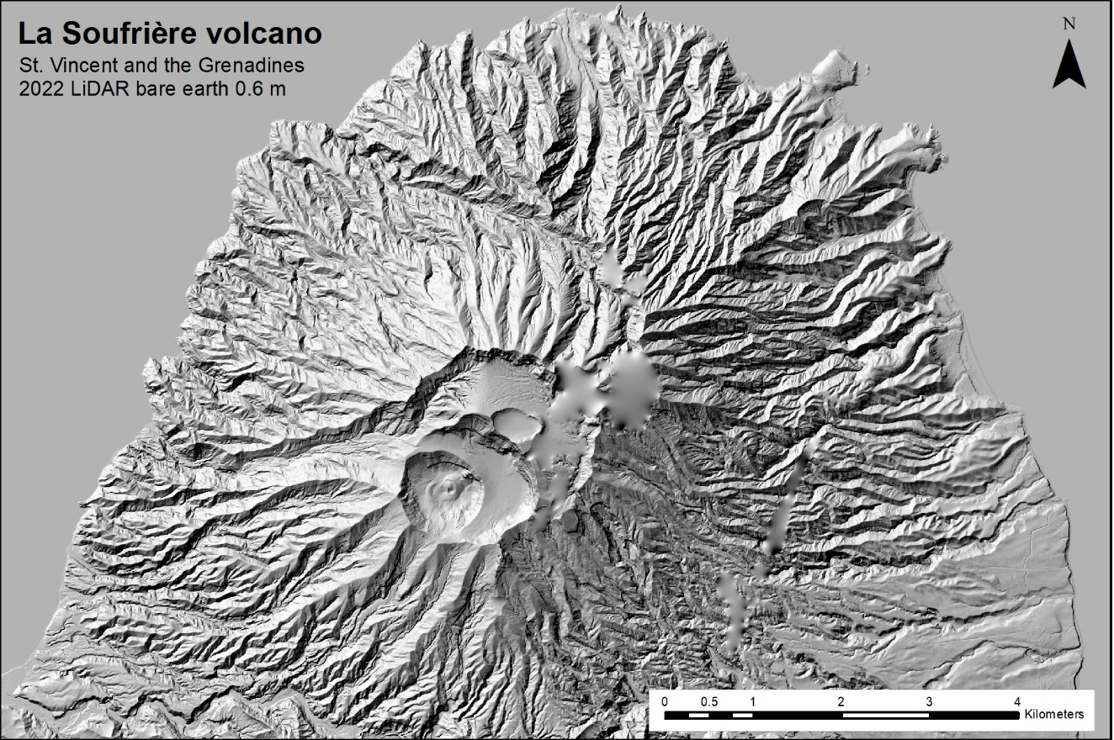
Caption for Graphic or Image: Shaded relief image of La Soufrière Volcano produced from aerial lidar surveys following the 2020-2021 eruption.
Author name: Angie Diefenbach
Author business email: adiefenbach@usgs.gov

DOI agency/bureau: USGS
USGS Mission Area:
USGS Program:
Cost Center: Western Geographic Science Center
Program Name2:
Project title: Crop water productivity ("crop per drop") cloud models to save water in California's Central Valley
Project description: Demand for food and water are increasing while the extent of arable land and accessible fresh water are decreasing. This poses global challenges as economies continue to develop and the population grows. With agriculture as the leading consumer of water at approximately 80% of human water consumption, a better understanding of how water is used to produce food may help support the increase of Crop Water Productivity (CWP; kg/m3), the ratio of crop output per unit of water input (or crop per drop). This is a critical issue in the highly irrigated Central Valley of California, a major agricultural growing region facing ongoing water variability challenges. Efficient use of water is crucial to agricultural sustainability, however, traditionally measuring CWP has been difficult and time-consuming. Therefore, this research aimed to leverage cloud computing by developing an innovative methodology utilizing remote sensing to measure, map, and model CWP across vast areas. To test these methods, nine crops including commonly grown staple crops and high-water consuming cash crops were selected from a study area in the San Juaquin Valley west of Fresno, California. By implementing Google Earth Engine, a cloud-based platform to process Landsat satellite image data in conjunction with ground based meteorological data, crop water use was estimated. Then, this was combined with agricultural reports to estimate crop yield information to calculate CWP in a given growing season as published in Foley et al., 2023. Moreover, this allowed for estimating the potential amount of water that can be saved from increasing CWP as an increase in CWP is widely considered a practical approach for saving maximum quantities of water.
This study demonstrates how remote sensing can provide timely, large-scale assessments of agricultural water use and crop production. This information is valuable for farmers, water managers, and policymakers that can help in making more informed decisions about water allocation and conservation strategies. This research is particularly relevant to remote sensing science as it showcases the power of combining long-term satellite data archives with cloud computing. The methods developed in this study show promising capability to be applicable to other water scarce regions and providing more insight on global agricultural water management. By harnessing the power of satellite remote sensing technology and big data analytics, this work can aid in more sustainable farming practices and improving water resource management, benefiting both agriculture and the greater environment in California and beyond.

Sensor Type:
Platform type:
URL:
Graphic or Image Upload:
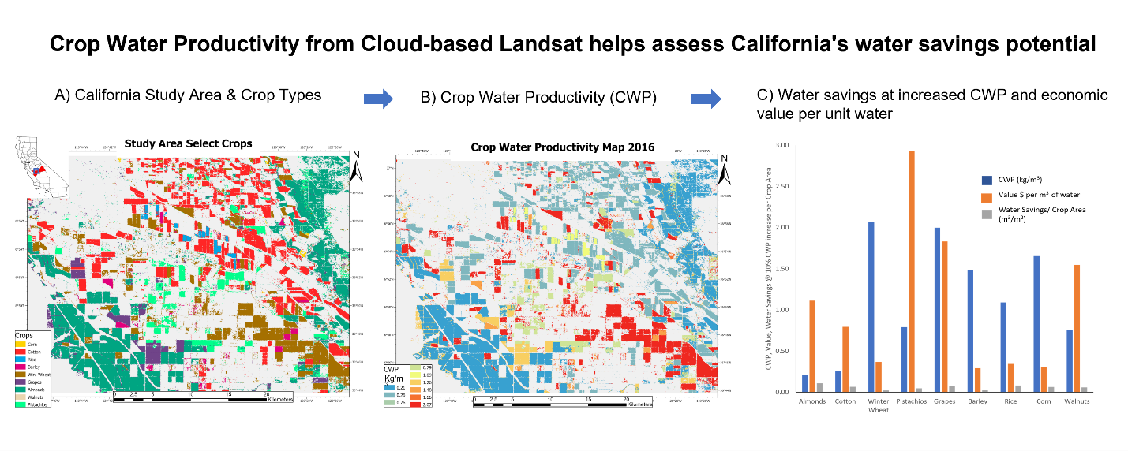
Caption for Graphic or Image: A cloud-based Landsat-derived scalable workflow was developed to estimate Crop Water Productivity (CWP) and Water Savings for nine commonly grown and water intensive crops in the Central Valley of California. A) A crop type map centered in Firebaugh, CA 61 km West of Fresno, CA displaying the crops of interest in order of largest to smallest area covered including almonds, cotton, winter wheat, pistachios, grapes, barley, rice, corn, and walnuts. B) A map displaying CWP (kg/m3) calculated for each individual crop from the 2016 growing season in this study area. C) A chart displaying per crop calculated CWP (kg/m3) per crop along with Water Savings potential per area (m3/m2) with a 10% increase in CWP, and the estimated Economic Crop Water Productivity (ECWP $/m3) as a ratio of the 2016 market value ($) of crop produced per m3 of water used in this study area order of Area The related manuscript can be found here Foley et al., 2023.
Author name: Daniel Foley
Author business email: dfoley@usgs.gov

