**DOI agency/bureau:** OSMRE

**USGS Mission Area:**

**USGS Program:**

**Cost Center:**

**Program Name2:** Technology Management Division, Geospatial Services Branch

**Project title:** Storytelling with Satellite Imagery: Coal Mining and Reclamation in the Southwest

**Project description:** The Geospatial Information Services (GIS) Branch within the Office of Surface Mining Reclamation and Enforcement (OSMRE) uses commercial satellite imagery to tell the story of surface coal mines via Esri’s ArcGIS StoryMap web-based application. Although OSMRE keeps most of its published image services and geospatial content available to internal users only, they have made the StoryMaps available publicly.

The Navajo Mine StoryMap features the Navajo Mine situated in the northwestern corner of New Mexico. The Navajo Mine has been producing coal for over 60 years and provides energy to hundreds of thousands of homes across the American Southwest. The Navajo Mine is owned and operated by the Navajo Transitional Energy Company, LLC whose sole shareholder is the Navajo Nation.

The StoryMap provides an overview of the mine’s origin prior to the Surface Mining Control and Reclamation Act of 1977 through its current status. It uses various geospatial features to illustrate its geographical location and extent, active coal mining operations and reclamation, as well as historical and current visual comparisons.

One of the features is a time-lapse video that uses PlanetScope scenes to show the growth of the Dixon Coal Pit as active mining progresses south and east over the span of 8 years.

The StoryMap has an integrated web scene that allows viewers to explore the mine site in 3 dimensions. The main view features an orthorectified 2024 Maxar image. The image is draped over a digital surface elevation model that was generated from that collect. Users can zoom in/out, rotate, and tilt the view. They can also click on the feature points on the scene to view the corresponding geotagged photos that were taken on-site along with a brief description of the site.

Additional OSMRE mine team leaders have asked the GIS team to create more StoryMaps for their respective mines. Below is the link to the Navajo Mine StoryMap.

**Sensor Type:** Multispectral (approx. 4-12 bands);

**Platform type:** Satellite;

**URL:** https://storymaps.arcgis.com/stories/df0c6b657ae14f67bce6ee0598a3ffe3

**Graphic or Image Upload:** https://doimspp.sharepoint.com/sites/GS-EROSSCIENCESWI/Shared Documents/Communications Outreach/Documentation Science/DOI Remote Sensing Report/DOI RS Activities Report, 2024/Graphic or Image Upload/aplascencia_osmre_2024_R1-F1_Aldo Plascencia.JPG

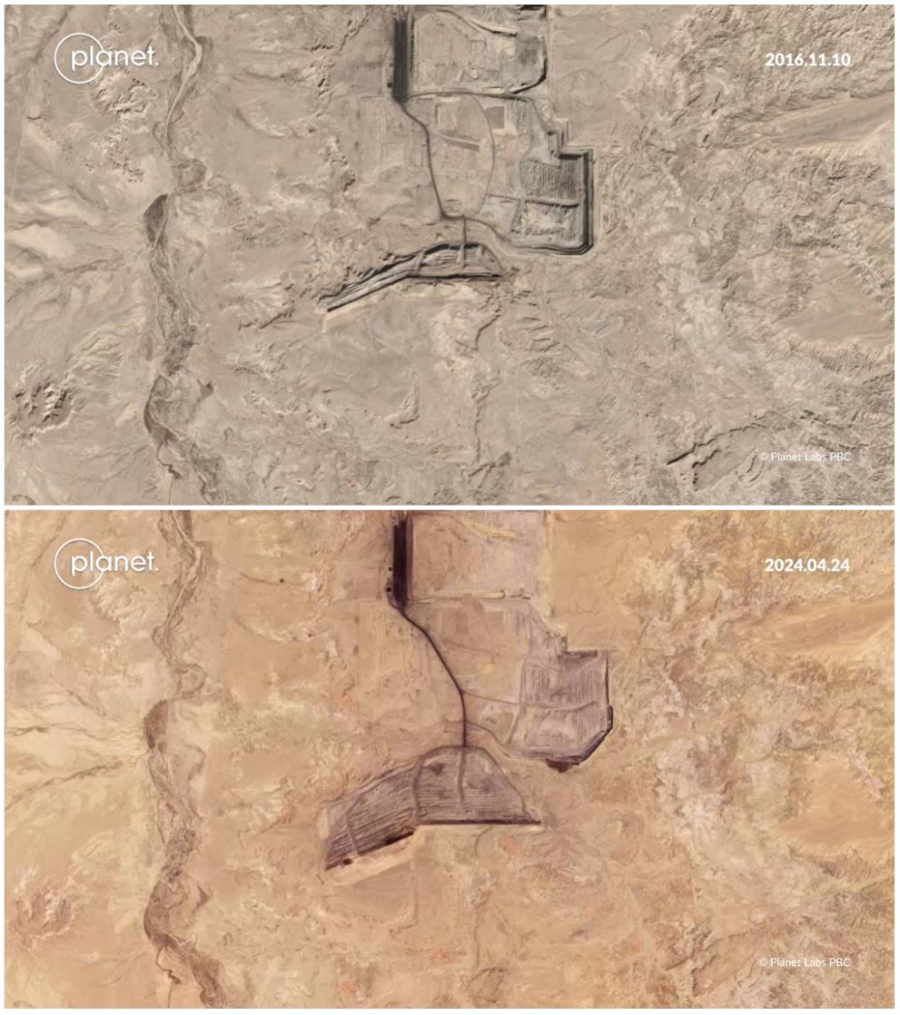

**Graphic or Image Upload:**  https://doimspp.sharepoint.com/sites/GS-EROSSCIENCESWI/Shared Documents/Communications Outreach/Documentation Science/DOI Remote Sensing Report/DOI RS Activities Report, 2024/Graphic or Image Upload/aplascencia_osmre_2024_R1-F2_Aldo Plascencia.JPG

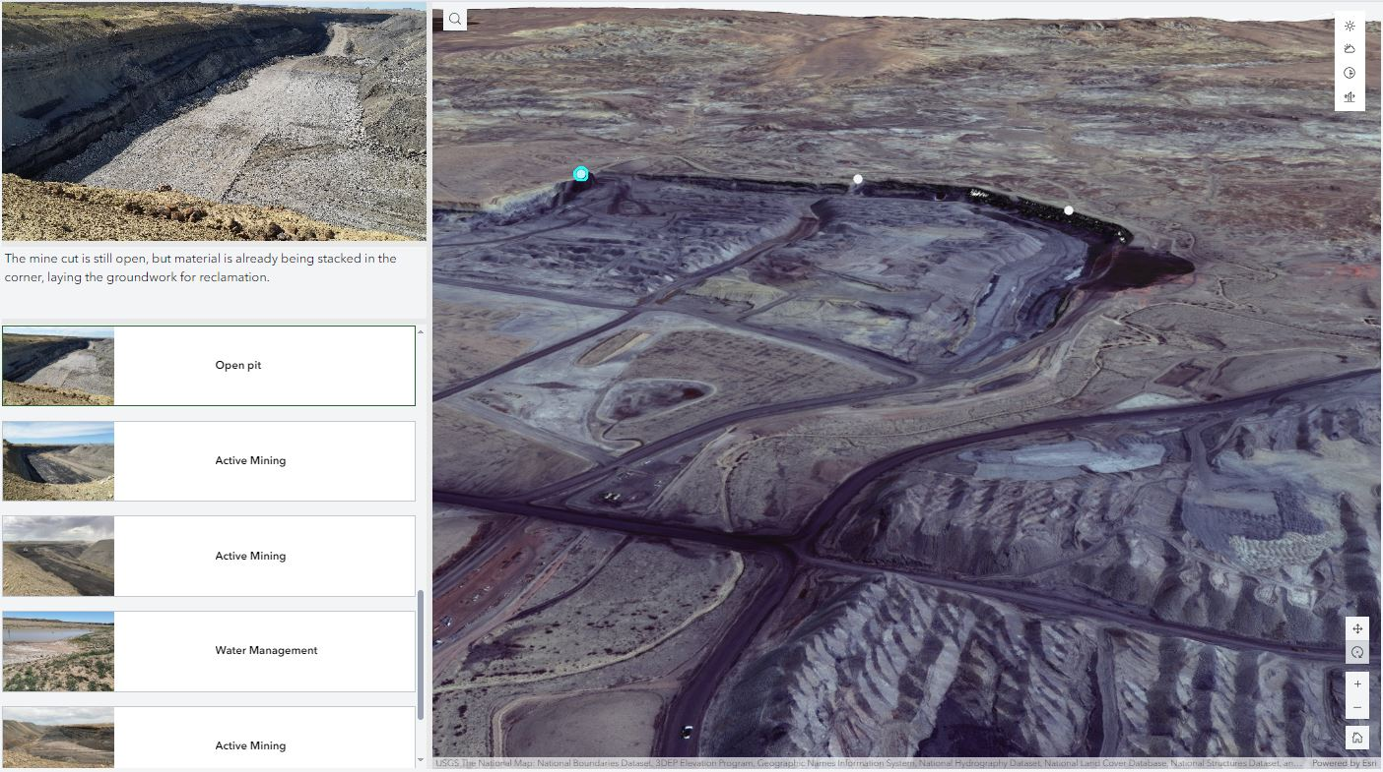

**Caption for Graphic or Image:** PlanetScope images of the Dixon Coal Pit from November 10, 2016 (top) and April 4, 2024 (bottom).

Geotagged photos of the Navajo Mine (left) and an interactive map scene using an April 2, 2024, WorldView-2 image (right).

**Author name:** Aldo Plascencia

**Author business email:** aplascencia@somre.gov

**DOI agency/bureau:** OSMRE

**USGS Mission Area:**

**USGS Program:**

**Cost Center:**

**Program Name2:** Technology Management Division, Geospatial Services Branch

**Project title:** Supporting Field Personnel with Remotely Sensed Data

**Project description:** The Geospatial Information Services (GIS) Branch within the Office of Surface Mining Reclamation and Enforcement (OSMRE) leverages a multitude of resources to support field personnel with remotely sensed data.

OSMRE inspectors conduct 4 complete inspections and 12 partial inspections at every surface coal mine where OSMRE is the regulatory authority. The States and Indian Tribal Lands that have their own coal regulatory program conduct their own inspections, and OSMRE personnel conducts oversight inspections on a percentage of those sites. This in turn leaves the limited number of OSMRE inspectors to travel often and cover sites in several States.

OSMRE field personnel have been leveraging remotely sensed data and geospatial support from the GIS Branch to reduce the number of trips and amount of time spent in the field.

Under the NextView contract, the GIS team requests new monthly collects of commercial high-resolution satellite imagery over several surface coal mines. In addition, the GIS team has access to the imagery archive containing all exiting MAXAR sensor collects. This is a valuable resource as there is no additional cost to the organization. Also, OSMRE has a small contract in place with PlanetLabs, which provides access to medium-resolution daily image collects and the ability to task a limited amount of high-resolution SkySat collects to help fill in the data gaps. The GIS team can also collect data with Unmanned Aircraft Systems over smaller sites that require detailed photogrammetric and mapping support.

The GIS Branch compiles these remotely sensed datasets onto web maps and shares them with OSMRE staff and interested State and Tribal partners. The maps can be used in an office environment to conduct virtual partial inspections, or they can be loaded onto mobile devices to assist with a physical inspection in a remote location lacking cell service.

In addition to reducing the number of physical visits to the sites, inspectors can use these tools to plan their time in the field and allocate more time to features that need more attention.

**Sensor Type:** Multispectral (approx. 4-12 bands);

**Platform type:** UAS;Satellite;

**URL:**

**Graphic or Image Upload:** https://doimspp.sharepoint.com/sites/GS-EROSSCIENCESWI/Shared Documents/Communications Outreach/Documentation Science/DOI Remote Sensing Report/DOI RS Activities Report, 2024/Graphic or Image Upload/aplascencia_osmre_2024_R2_F1_Aldo Plascencia.JPG

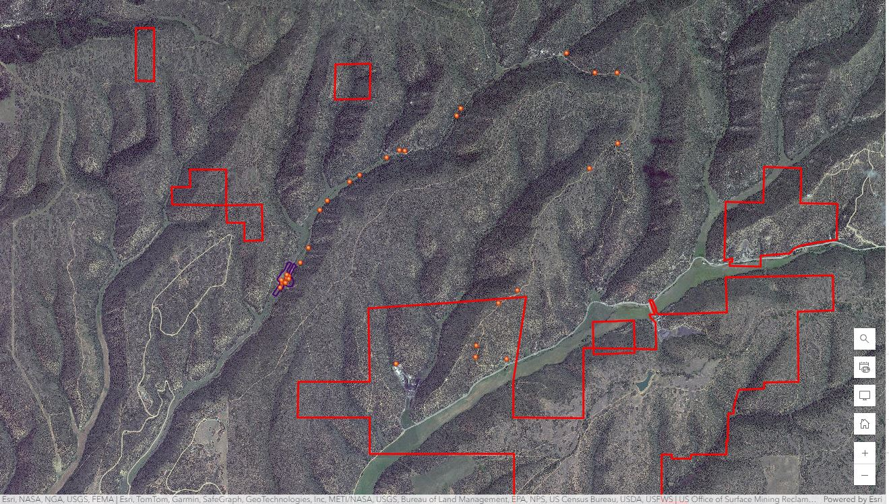

**Caption for Graphic or Image:** Basic web map of the King II Coal Mine in Colorado containing an August 29, 2024, WorldView-2 satellite image, lease permit boundaries, and GPS point features collected by an inspector.

**Author name:** Aldo Plascencia

**Author business email:** aplascencia@osmre.gov