**DOI agency/bureau:** NPS

**USGS Mission Area:**

**USGS Program:**

**Cost Center:**

**Program Name2:** Gates

**Project title:** Collaboration with NASA DEVELOP

**Project description:** NASA DEVELOP (https://appliedsciences.nasa.gov/what-we-do/capacity-building/develop) is a program that cultivates the next generation of remote sensing technology users and leaders. They collaborate with agencies, communities, and organizations to address environmental and policy concerns through the practical application of NASA Earth science information. These projects help both participants and partners learn more about using geospatial information across 9 thematic areas, including Ecological Conservation. NASA DEVELOP worked in collaboration with the Alaska Region of the National Park Service on two 10-week long projects in 2024.

In the first, 4 early career remote sensing scientists teamed up with a NPS biologist to better understand the phenology of rivers freezing up in the fall. Rivers in northern Alaska can remain frozen for 6 months or more. When freeze up occurs can greatly impact access to critical subsistence resources, like caribou. Caribou easily travel across frozen and unfrozen rivers, but there is a period of time between these two stages, when large flows of ice move down the flowing river, when caribou avoid crossing. The scientists used a combination of remote sensing sensors, including synthetic aperture radar (SAR), to detect and quantify when rivers in northwest Alaska were liquid, frozen, and the critical ‘in between’ stage.

In the second project, another 4 early career remote sensing scientists teamed up with a NPS biologist to document the phenology and changes over time in the Normalize Difference Vegetative Index (NDVI) in and around the calving grounds of Western Arctic Herd, which was once the largest caribou herd on the continent. NDVI and ΔNDVI (the rate of change in NDVI over time) are indices of caribou forage quality and quantity. These attributes are thought to lead to the repeated use of caribou calving grounds over time. The team used an array of data based off of different Landsat and MODIS satellites to track these indices on the calving grounds in hopes to better understand caribou ecology in the region as well as improve the management of this herd.

**Sensor Type:** IFSAR / SAR / Radar;Multispectral (approx. 4-12 bands);

**Platform type:** Satellite;

**URL:**

**Graphic or Image Upload:** https://doimspp.sharepoint.com/sites/GS-EROSSCIENCESWI/Shared Documents/Communications Outreach/Documentation Science/DOI Remote Sensing Report/DOI RS Activities Report, 2024/Graphic or Image Upload/24-DOI-river-ice_Kyle Joly.png

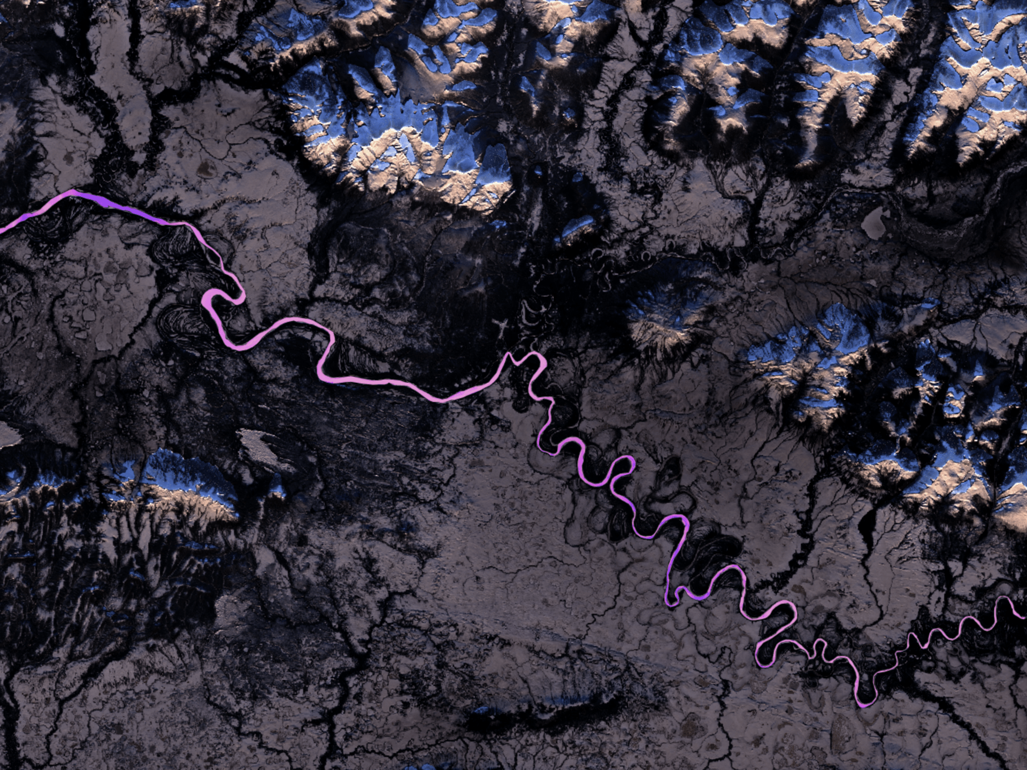

**Caption for Graphic or Image:** Image of identifying river ice (magenta) in Kobuk Valley National Park, northwest Alaska - NASA DEVELOP.

**Author name:** Kyle Joly

**Author business email:** kyle_joly@nps.gov

**DOI agency/bureau:** NPS

**USGS Mission Area:**

**USGS Program:**

**Cost Center:**

**Program Name2:** NPS Alaska Region, NPS Inventory and Monitoring Program, Arctic Inventory and Monitoring Network

**Project title:** Monitoring Permafrost Thaw Slumps in Arctic Alaska

**Project description:**

Retrogressive thaw slumps (RTS) are dramatic features of the Arctic landscape caused by thaw and subsidence of permafrost, followed by downslope flow of liquified sediment and water. The National Park Service, Arctic Inventory and Monitoring Network monitors the growth of selected RTS in northwestern Alaska. We studied the growth in area, the rate of advance of the main thaw escarpment, and the amount of subsidence using three-dimensional models created from small-format (35 mm) aerial photographs in multiple years from 2010 to 2020, supplemented with high-resolution satellite images from 2006 to 2023.

Thirteen of the study slumps were present before 2016. Most of these slumps were initiated in the years 2004-2005. Eight slumps had largely stabilized by our previous sample date (2014 or 2016) and grew little from then to our most recent sample date (2019 or 2020). Four slumps continued growing rather uniformly from 2016 through 2020, with scarp migration rates of 7 to 37 m yr-1 in 2019-2020. Just one of these older slumps showed markedly increased growth in recent years. Sediment transport into nearby water bodies from these slumps was greatly reduced relative to the early years in the slumps’ lives because they were either growing very little, or the growth had progressed hundreds of meters from adjacent water bodies and the sediment mobilized at the advancing scarp was being deposited on the slump floor.

The most striking development was the re-initiation of slump activity in the vicinity of a previously stabilized slump near Douglas Creek in Gates of the Arctic National Park and Preserve. Four new slumps were first visible on 2016 satellite images and grew rapidly through 2023, with scarps advancing at rates of up to 60 m yr-1 and elevation loss at the scarp up to 10 m. Approximately 137,000 m3 of material was lost from the slump footprints of three of the slumps as of 2020.

**Sensor Type:** Camera;Multispectral (approx. 4-12 bands);

**Platform type:** Airplane;Satellite;

**URL:** https://irma.nps.gov/DataStore/Reference/Profile/2302317

**Graphic or Image Upload:**

**Caption for Graphic or Image:** Growth of slumps two slumps in the Noatak National Preserve, Alaska. Slump perimeters outlined on a 2020 orthophoto (upper). Elevation change of the slumps from 2016 to 2020 (lower).

**Author name:** David Swanson

**Author business email:** david_swanson@partner.nps.gov

**DOI agency/bureau:** NPS

**USGS Mission Area:**

**USGS Program:**

**Cost Center:**

**Program Name2:** Scientists in Parks, ESLR

**Project title:** Laser Focus: Using Terrestrial LiDAR Data for Climate Change Adaptation Planning

**Project description:** Talking to satellites and shooting lasers is all part of an average day of terrestrial LiDAR collection at Blackstone River Valley National Historical Park (BLRV). The park utilized a Trimble Total Station with an SX12 scanner to collect critical elevation data and topographical data to be used to inform management decisions for climate change-induced river flooding. Scientists in Parks intern Sarah Heavren and BLRV Management and Program Analyst Kevin Rice spearheaded the data collection. They used the Total Station at Slater Mill (Pawtucket, RI), Roger Williams National Memorial (Providence, RI), the Little Red Shop (Hopedale, MA), and the canal at Blackstone River State Park (Lincoln, RI).

The data were collected by establishing control points using a Trimble R12i GNSS receiver and setting up the scanner to capture high-quality data on points of interest while creating a complete scan of the park site. There were three main goals for scanning: deriving critical elevation data; deriving high-precision topographic data for each location; and creating complete scans of the area to be used for visualizations.

Once the data were collected, the scans were imported into Trimble Business Center, where the points were categorized into regions, such as the ground or vegetation. Elevations of potential flood entryways in buildings, such as doorways, windows, and basement windows, were extracted to be used for river flooding adaptation planning. Elevations of critical waterway infrastructure at Slater Mill were also extracted to further inform flooding management decisions. To derive topographical information, the ground points for each location were exported to ArcGIS Pro and converted into a digital elevation model and a hill shade raster file. The scans at Slater Mill, Roger Williams National Memorial, and Blackstone River State Park will be used by Peter Stempel at Pennsylvania State University to create flooding visualizations.

Collecting elevation and topographical data using terrestrial LiDAR is still a relatively new approach to climate change flooding adaptation planning, especially in the context of river flooding. The data are available for download on the NPS DataStore through the NPS Integrated Resource Management Applications: https://irma.nps.gov/DataStore/Reference/Profile/2305535.

**Sensor Type:** Lidar (terrestrial or bathymetric);

**Platform type:** Ground based / sensor web / web cam;

**URL:**

**Graphic or Image Upload:** https://doimspp.sharepoint.com/sites/GS-EROSSCIENCESWI/Shared Documents/Communications Outreach/Documentation Science/DOI Remote Sensing Report/DOI RS Activities Report, 2024/Graphic or Image Upload/RS_blurb_Sarah Heavren.jpg

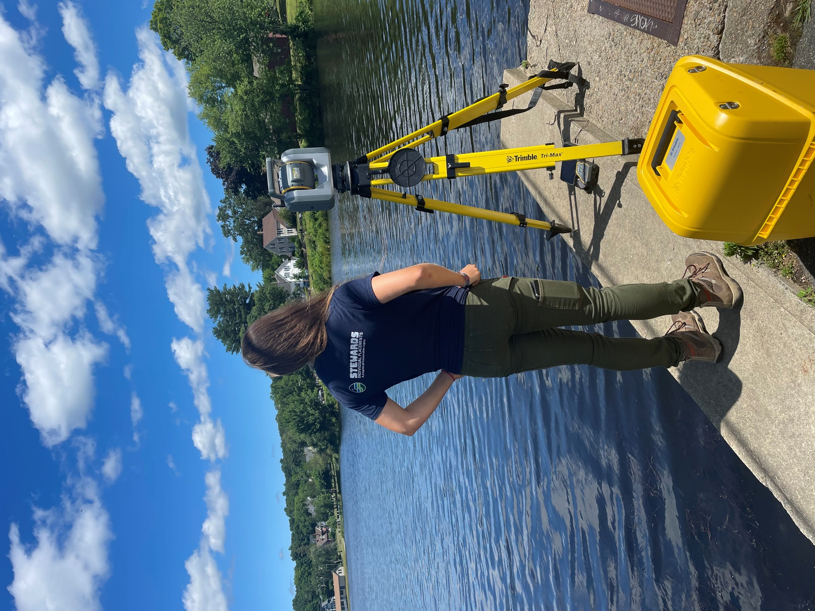

**Caption for Graphic or Image:** Scientists in Parks intern Sarah Heavren with the Trimble SX12 scanner collecting data across the pond at the Little Red Shop in Hopedale, MA.

**Author name:** Sarah Heavren

**Author business email:** sarah_heavren@partner.nps.gov

**DOI agency/bureau:** NPS

**USGS Mission Area:**

**USGS Program:**

**Cost Center:**

**Program Name2:** Northeast Coastal and Barrier Network

**Project title:** Salt Marsh Extent Monitoring at Northeast Coastal & Barrier Network Parks

**Project description:** Over approximately 59,220 hectares, the Northeast Coastal & Barrier Network (NCBN) is comprised of eight coastal parks stretching from Massachusetts to Virginia that are home to some of the most ecologically similar collections of lands within the National Park Service. At the intermediary of land and sea, coastal salt marshes are essential to biological diversity, filtering nutrients from upland sources, and protecting coastal areas from storms by absorbing wave energy. NCBN coastal marshes are changing in the wake of climate change-induced impacts. In the past, NCBN monitored salt marsh vital signs through time-intensive and costly field work. With advanced technology allowing easy access to high resolution imagery for data analysis, the NCBN program aims to use satellite imagery to monitor park coastal marshes to greatly expand the extent of marsh area we monitor.

For this project, DHA Scientists-in-the-Parks (SIP) intern Edward Cascella worked with the Southeast Coast I&M Network and researchers at the USGS Woods Hole Coastal and Marine Science Center to draft multiple Standard Operating Procedures (SOPs) for using satellite imagery to monitor the unvegetated/vegetated areas of our coastal marshes. Based off a previous USGS study of the unvegetated/vegetated ratio (UVVR) at Fire Island National Seashore, Cascella successfully collected Coastal National Elevation Database (CoNED) DEM data and high-resolution NAIP aerial imagery to classify salt marsh imagery into vegetated and unvegetated cover and quantify that area for future change analyses. While the study area was Fire Island National Seashore, the analysis was documented through SOPs to set up the network for a repeatable, succinct step-by-step process of evaluating our coastal marshes quantitatively across multiple network parks. Using remote sensing and these draft SOPs, NCBN will be able to greatly expand the extent of area monitored and better understand where vegetated marsh extent is decreasing to inform management decision-making in the parks. This project will serve as an integral portion of NCBN’s future Salt Marsh monitoring plan.

**Sensor Type:** Lidar (terrestrial or bathymetric);Multispectral (approx. 4-12 bands);Camera;

**Platform type:** Airplane;

**URL:**

**Graphic or Image Upload:** https://doimspp.sharepoint.com/sites/GS-EROSSCIENCESWI/Shared Documents/Communications Outreach/Documentation Science/DOI Remote Sensing Report/DOI RS Activities Report, 2024/Graphic or Image Upload/HosPoint_Edward Cascella.jpg

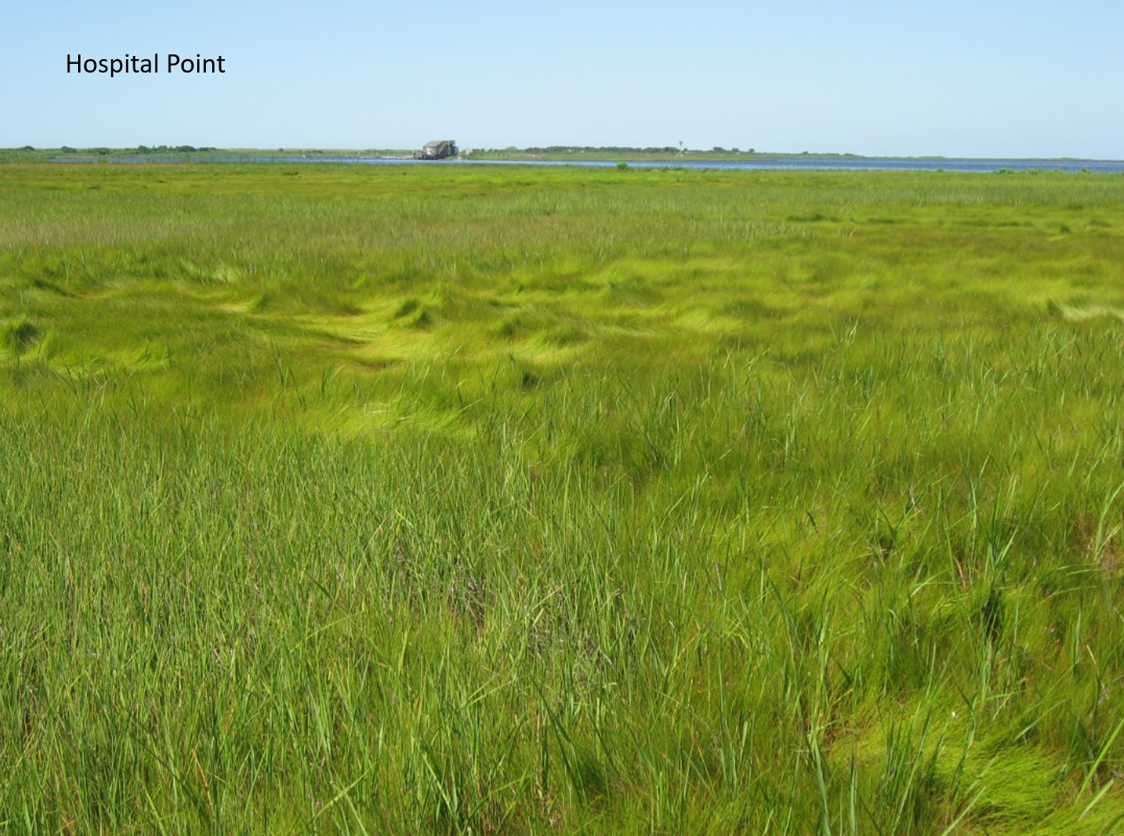

**Caption for Graphic or Image:** Hospital Point marsh at Fire Island National Seashore

**Author name:** Edward Cascella

**Author business email:** edward_cascella@partner.nps.gov , edward_cascella@uri.edu

**DOI agency/bureau:** NPS

**USGS Mission Area:**

**USGS Program:**

**Cost Center:**

**Program Name2:** Northeast Archeological Resources Program

**Project title:** UAS LiDAR for April 19, 1775, American Revolutionary War KOCOA (tactical) landscape analysis, Minute Man National Historical Park, Massachusetts

**Project description:** Established in 1959, Minute Man National Historical Park in Massachusetts preserves cultural resources associated with the first day of the American Revolution April 19, 1775; a running battle of episodic skirmishes between British soldiers and Provincial forces. The sites where these skirmishes occurred beginning at the North Bridge in Concord and moving thorough Miriam’s Corner, Elm Brook Hill, and Parker’s Revenge are interpreted for their connection with events at the dawn of the American Revolution.

One of the bloodiest engagements on that fateful day in 1775 occurred at Elm Brook Hill in the town of Lincoln. While the general area of the battle is known from historical documentation, the exact location of the battle is not known. In preparation for the 250th anniversary of the Revolution, NPS Northeast Archeological Resources Program partnered with Minute Man National Historical Park, Advanced Metal Detecting For Archaeologists, American Veterans Archaeology Recovery Program, Friends of the Minute Man National Historical Park, and NPS Midwest Archeological Center to investigate Elm Brook Hill using an integrated archeological approach to identify the location of the fighting, interpret the tactical engagement between the British and Provincial forces, and to uncover intimate details about the men that fought fiercely on that first day of the Revolution.

The team deployed a suite of scientific archeological methods and tools to map evidence of the battle. Unmanned aerial system (UAS) LiDAR obtained a high-resolution 3D terrain model of the battlefield and surrounding area. Complementary data from systematic metallic survey, soil coring, and ground penetrating radar surveys (GPR), are integrated in Geographic Information System (GIS) software to query data based on KOCOA principles, tactical assessment of the historic terrain using key terrain (K), observation and field of fire (O), cover and concealment (C), obstacles (O), and avenues of approach and egress (A) to interpret and visualize the Elm Brook Hill battle.

The results of the project provide the park with evidence-based information for the park’s restoration of the 1775 Elm Brook battlefield and will enhance interpretation of the battle through newly developed programs and public exhibits. Importantly, the results of this investigation will provide a tangible foundation for effective and sustainable resource protection and management of the Elm Brook Hill Battlefield.

**Sensor Type:** Lidar (terrestrial or bathymetric);metallic surveys, ground penetrating radar;

**Platform type:** UAS;Ground based / sensor web / web cam;

**URL:**

**Graphic or Image Upload:** https://doimspp.sharepoint.com/sites/GS-EROSSCIENCESWI/Shared Documents/Communications Outreach/Documentation Science/DOI Remote Sensing Report/DOI RS Activities Report, 2024/Graphic or Image Upload/CropDeCosta_Hall1775_Margaret (Meg) Wilke.jpg

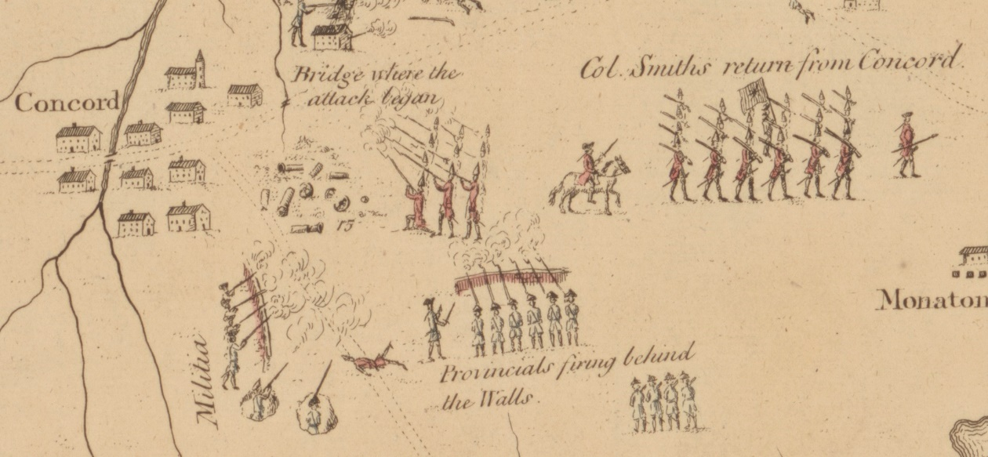

**Caption for Graphic or Image:** British Retreat from Concord 1775. De Costa, J. and Charles Hall (1775). (adapted https://www.loc.gov/item/gm71002447/).

**Author name:** Margaret W. Wilkes, PhD

**Author business email:** meg_wilkes@nps.gov