**DOI agency/bureau:** FWS

**USGS Mission Area:**

**USGS Program:**

**Cost Center:**

**Program Name2:** Biological Sciences

**Project title:** Land surface phenology for assessing habitat differences of an endangered prairie grouse

**Project description:** The Attwater’s greater prairie chicken (Tympanuchus cupido attwateri) was once a common inhabitant of coastal tallgrass prairie from Louisiana southward along the Texas Gulf Coast. Over-hunting and habitat loss from conversion of native prairie to cropland and monocultures for livestock pastures led to widespread population declines by the early to mid-1900s. The species persists in two remnant native prairie grasslands in Texas, one of which is the 43 km2 Attwater Prairie Chicken National Wildlife Refuge (APCNWR) located 100 km west of Houston. To assess habitat conditions, we worked with the Boston University’s Center for Remote Sensing to extend the annual high-resolution (30 m HLS pixels) land surface phenology (LSP) metrics from 2016 to 2022. This was achieved using Harmonized Landsat 8 and Sentinel-2 (HLS) imagery covering APCNWR. The phenology metrics were retrieved using an interpolated daily time series of the HLS 2-band Enhanced Vegetation Index (EVI2), adding three additional years to the MSLSP30NAv011 product. To assess the phenology of prairie chicken habitat, we conducted a preliminary comparison of georeferenced lek locations from year 2016 to 2022 within native prairie (n = 253) against nearby randomly selected exotic prairie (n = 71). The distinction between native versus exotic prairie locations were determined by using 2023 enhanced digital land cover data from Texas Parks and Wildlife Department Landscape Ecology Program’s Ecological Mapping Systems. All lek and random locations were also evaluated using digital biomass data (30 m Landsat pixels) from the USDA-ARS Rangeland Analysis Platform (RAP) to assess annual productivity. We found that greater LSP differences between lek locations in native prairie and pastures dominated by non-native exotic grasses were linked with periods of low productivity (Figure 1A). Additionally, we observed shifts in the growing cycle for the Julian day of 50% greenness increase (x50PCGI), 50% greenness decrease (x50PCGD), onset of greenness increase (OGI), and peak greenness (Peak) that occurred later at lek locations for years 2018 and 2022. Annual productivity, measured as the integrated EVI2 (EVIarea) and maximum EVI2 (EVImax) values from LSP growing cycle metrics, tended to be lower at lek locations for all years, except during extreme drought conditions in 2022, as shown from RAP biomass data (Figure 1B). For 2022, lek OGI and onset of greenness decrease (OGD, not shown) was 70 and 51 days later, on average, than exotic pasture respectively. These annual and inter-annual LSP metrics showed high potential for distinguishing critical habitat differences that could help identify locations capable of supporting population recovery efforts. Future work will seek to pair GPS telemetry data with phenology and other environmental data to understand habitat selection and population parameters such as survival, abundance, and reproductive rates at additional sites.

**Sensor Type:** Multispectral (approx. 4-12 bands);

**Platform type:** Satellite;

**URL:**

**Graphic or Image Upload:** https://doimspp.sharepoint.com/sites/GS-EROSSCIENCESWI/Shared Documents/Communications Outreach/Documentation Science/DOI Remote Sensing Report/DOI RS Activities Report, 2024/Graphic or Image Upload/Sesnie_Figure1_Steven Sesnie.png

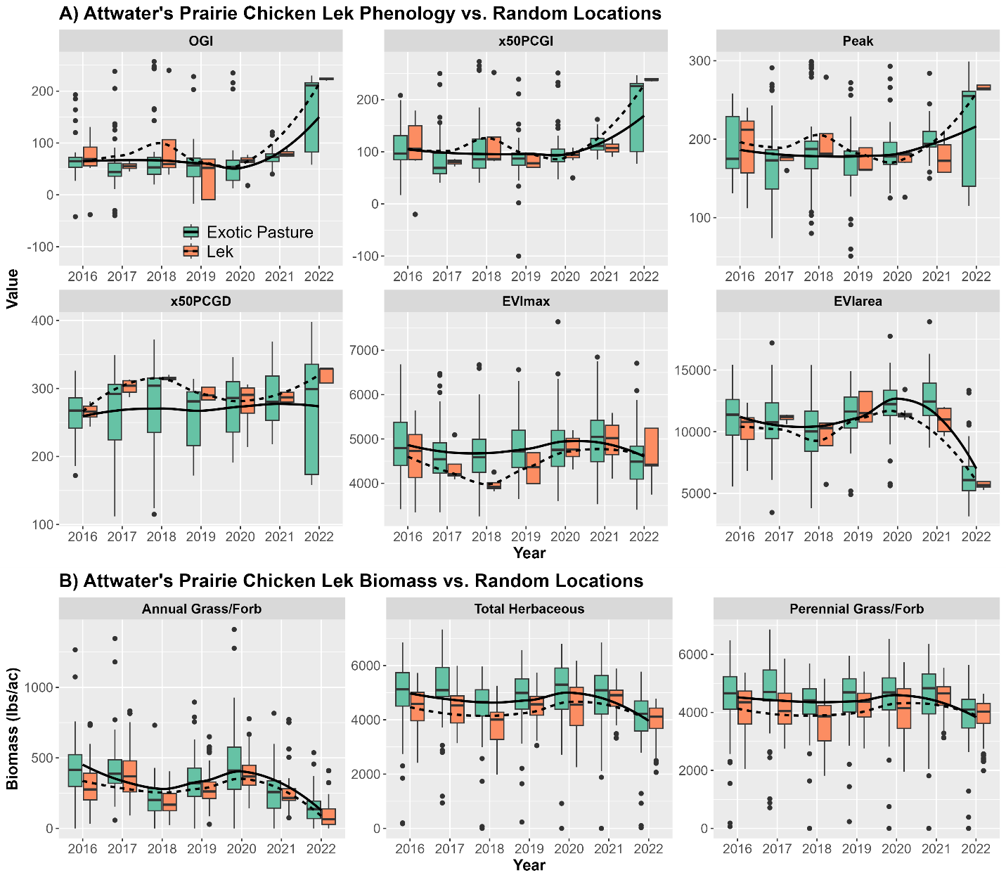

**Caption for Graphic or Image:** Figure 1. Plot of grassland A) 30 m HLS land surface phenology and B) 30 m RAP biomass measures for Attwater’s greater prairie chicken lek locations (n = 253) in native prairie compared with random exotic pasture locations close to leks (n = 71). Trend lines were fit to each data set using a loess fitting function.

**Author name:** Steven Sesnie; Randy Stewart; Jim Mueller

**Author business email:** steven_sesnie@fws.gov; david_stewart@fws.gov; jim_mueller@fws.gov

**DOI agency/bureau:** FWS

**USGS Mission Area:**

**USGS Program:**

**Cost Center:**

**Program Name2:** Division of Migratory Bird Management

**Project title:** Enhancing Migratory Bird Surveys with Thermal Imagery and Deep Learning

**Project description:** The U.S. Fish and Wildlife Service (USFWS) Division of Migratory Bird Management is aiming to improve upon migratory bird surveys by utilizing aerial remote sensing combined with deep learning (a form of artificial intelligence) analyses to automate survey counts. The goal is to provide accurate wildlife counts while simultaneously reducing risk to pilots by allowing aerial surveys to occur at higher altitudes. In partnership with the College of William and Mary, USFWS has previously demonstrated that thermal remote sensing technology, coupled with deep learning, can provide accurate counts of sandhill cranes (Antigone canadensis) at night during their critically important migratory stopover in the Platte River Valley of Nebraska. For our 2023 study, we expanded our collaboration to also include the expertise of the U.S. Geological Survey Northern Prairie Wildlife Research Center, the Crane Trust and the International Crane Foundation. In March of 2023, the project moved from a demonstration to a full, operational survey of areas used by sandhill cranes in the region, including the collection of >75,000 night-time thermal images while the birds were roosting on or near the Platte and North Platte Rivers. In addition, we obtained thermal imagery in places where ducks and geese were congregating to help distinguish these species. A YOLO (You Only Look Once) detection model was developed to predict and count sandhill cranes. The detection model was initially based on the laborious manual labeling of birds in imagery, but a semi-automatic, "human-in-the-loop," approach was then used to rapidly increase these labels and improve the model. The results predicted that 1.088 million (± 6.4%) sandhill cranes were present during this survey. This detection model also resulted in georeferenced locations of sandhill cranes, which has implications for understanding their habitat as well as their response to management. Overall, this study is the first complete survey of roosting sandhill cranes on the Platte River and shows these innovative surveys can be accomplished at a broad spatial scale. Emerging remote sensing and deep learning technologies offer opportunities to improve on traditional surveys used by harvest managers, and the enhanced spatial information provided by these approaches fosters new applications in habitat management and other environmental management arenas.

**Sensor Type:** Thermal;

**Platform type:** Airplane;

**URL:**

**Graphic or Image Upload:** https://doimspp.sharepoint.com/sites/GS-EROSSCIENCESWI/Shared Documents/Communications Outreach/Documentation Science/DOI Remote Sensing Report/DOI RS Activities Report, 2024/Graphic or Image Upload/Figure1 Pickens sandhill cranes_Bradley Pickens.jpg

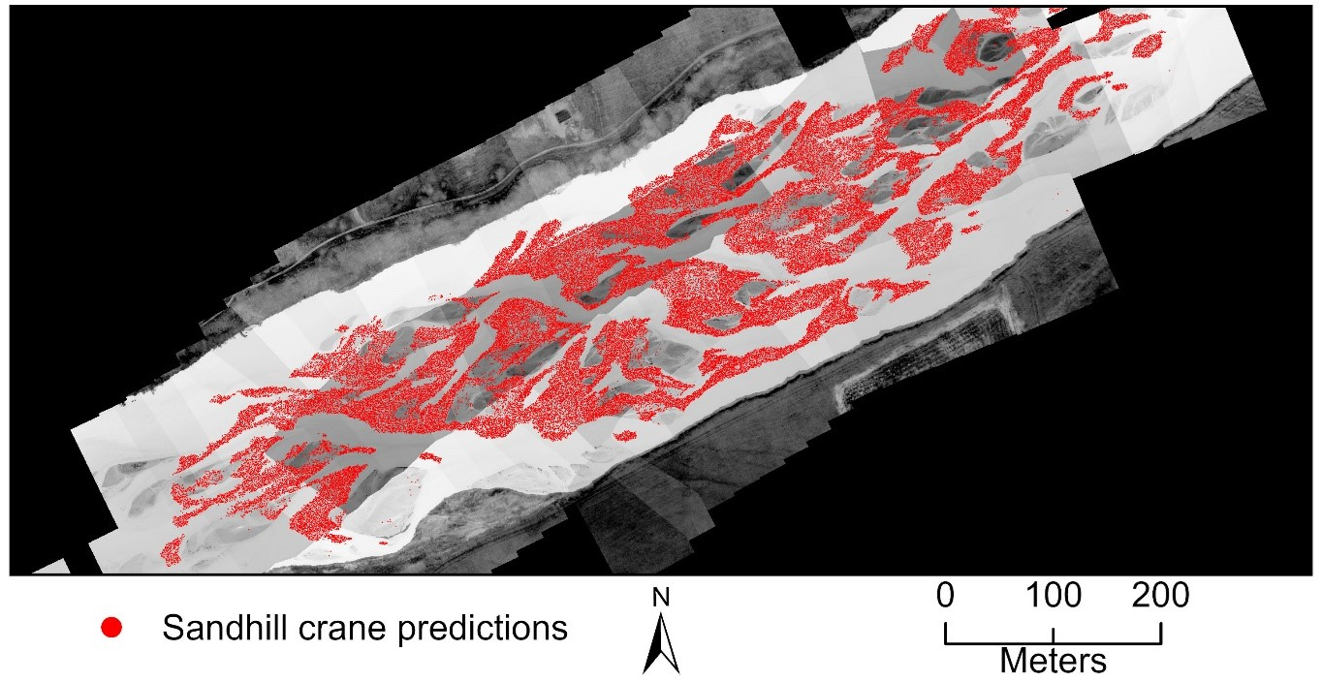

**Caption for Graphic or Image:** Figure 1. An example mosaic of thermal images showing sandhill crane on the Platte River of Nebraska, USA with sandhill crane predictions indicated by red circles.

**Author name:** Bradley Pickens

**Author business email:** bradley_pickens@fws.gov

**DOI agency/bureau:** FWS

**USGS Mission Area:**

**USGS Program:**

**Cost Center:**

**Program Name2:** Division of Migratory Bird Management

**Project title:** Applying Deep Learning to Detect and Classify Ocean Wildlife

**Project description:** The U.S. Fish & Wildlife Service (FWS) is using airborne remote sensing technologies to improve aerial migratory bird surveys with the objectives of: 1) enhancing safety of aircrews by allowing flight at higher altitudes, 2) improving the quality of wildlife population data by minimizing errors and quantifying uncertainty. Deep learning methods are being advanced to automate data processing and improve the cost-efficiency of remote sensing technologies for surveys covering broad geographic areas and generating very large image datasets. The FWS is partnering with the Bureau of Ocean Energy Management (BOEM), U.S. Geological Survey (USGS), academic institutions, and private contractors to accomplish these objectives. Initial focus has been on marine bird and other wildlife surveys given overlapping agency requirements for these data. The project is part of the Atlantic Marine Assessment Program for Protected Species (AMAPPS). Because of the focus on marine wildlife, the project has implications for informing renewable energy development and may increase the efficiency of both public and private environmental monitoring programs. The collaboration has now collected more than 3 million images in the marine environment, spanning from Marine to Florida (example, Figure 1). A workflow is now being established to advance the imagery data from the sensors, to an AI detection model in the aircraft, to a species classification algorithm that is able to distinguish and count each species, and then a georeferenced location is obtained for each bird. More specifically, a cutting-edge artificial intelligence/deep learning algorithm has been developed to automatically detect seabirds in imagery. This detection algorithm has 80 to 90% accuracy across a wide range of seabird species. In FY25, we will continue to iterate on this model using a human-in-the-loop technique to improve model generalization. Avian experts are continuing to label species in imagery to provide training data for species classification models. Preliminary results of deep learning models to classify species have shown promising results and will continue to be developed. Overall, the efficiency gained by these technologies will help inform diverse management decisions, such as the development of renewable energy in Outer Continental Shelf systems, population monitoring for species of concern, and the setting of harvest limits for species that utilize these habitats.

**Sensor Type:** Camera;

**Platform type:** Airplane;

**URL:**

**Graphic or Image Upload:** https://doimspp.sharepoint.com/sites/GS-EROSSCIENCESWI/Shared Documents/Communications Outreach/Documentation Science/DOI Remote Sensing Report/DOI RS Activities Report, 2024/Graphic or Image Upload/Figure1_seabird_Bradley Pickens.png

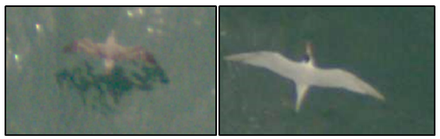

**Caption for Graphic or Image:** Figure 1. Imagery of Cory's shearwater (left) and a royal tern (right) flying over the Atlantic Ocean as captured from aircraft surveys. High resolution imagery is being used by the Fish & Wildlife Service to survey migratory seabirds to improve understanding of their abundance and distribution.

**Author name:** Bradley Pickens

**Author business email:** bradley_pickens@fws.gov

**DOI agency/bureau:** FWS

**USGS Mission Area:**

**USGS Program:**

**Cost Center:**

**Program Name2:** National Wildlife Refuge System

**Project title:** Mapping Phragmites using LiDAR at Fish Springs National Wildlife Refuge

**Project description:** In 2022, the U.S. Fish and Wildlife Service (FWS) partnered with the USGS National Geospatial Technical Operations Center to collect Quality Level 1 Light Detection and Ranging (LiDAR) data to support topo-bathymetric mapping activities at Fish Springs National Wildlife Refuge in western Utah. Data was collected on September 24, 2022, using fixed wing aircraft, and delivered to FWS in spring 2023. In addition to hydrologic applications, FWS staff used the high-quality LiDAR data to map patches of invasive phragmites (Phragmites australis) across the 17,922-acre refuge so effective control strategies could be developed.

Phragmites, a tall robust plant, can form monotypic dense patches which commonly crowds out native wetland vegetation and provides little in terms of wildlife habitat or food resources. FWS staff used the classified LAS point data to construct first return rasters, from which height above ground rasters were created by subtracting the underlying ground surface elevations. To minimize confusion with native marsh plant communities which tend to be shorter stature plants, raster cells were filtered and aggregated (by height) to include only pixels greater than 1.5 meters. Concurrent with lidar collection, high-resolution (10-cm) true color imagery was also collected. This imagery, in conjunction with ongoing ground visits by refuge staff, was used to investigate the promising nature of LiDAR to accurately map phragmites patches.

Preliminary results indicated approximately 2,520 patches (>200 ft2 in size) of phragmites covering 154 acres across the refuge (Figure 1). Refuge staff are currently developing strategies to leverage limited resources to address high priority areas including those scheduled for future marsh enhancement projects slated to begin in 2025. This data will be used to track success (and effectiveness) of treatments through time.

**Sensor Type:** Lidar (terrestrial or bathymetric);Camera;

**Platform type:** Airplane;

**URL:**

**Graphic or Image Upload:** https://doimspp.sharepoint.com/sites/GS-EROSSCIENCESWI/Shared Documents/Communications Outreach/Documentation Science/DOI Remote Sensing Report/DOI RS Activities Report, 2024/Graphic or Image Upload/Figure1_Phragmites_Patches_FHS_Lidar_Hillshad_Mike Artmann.jpg

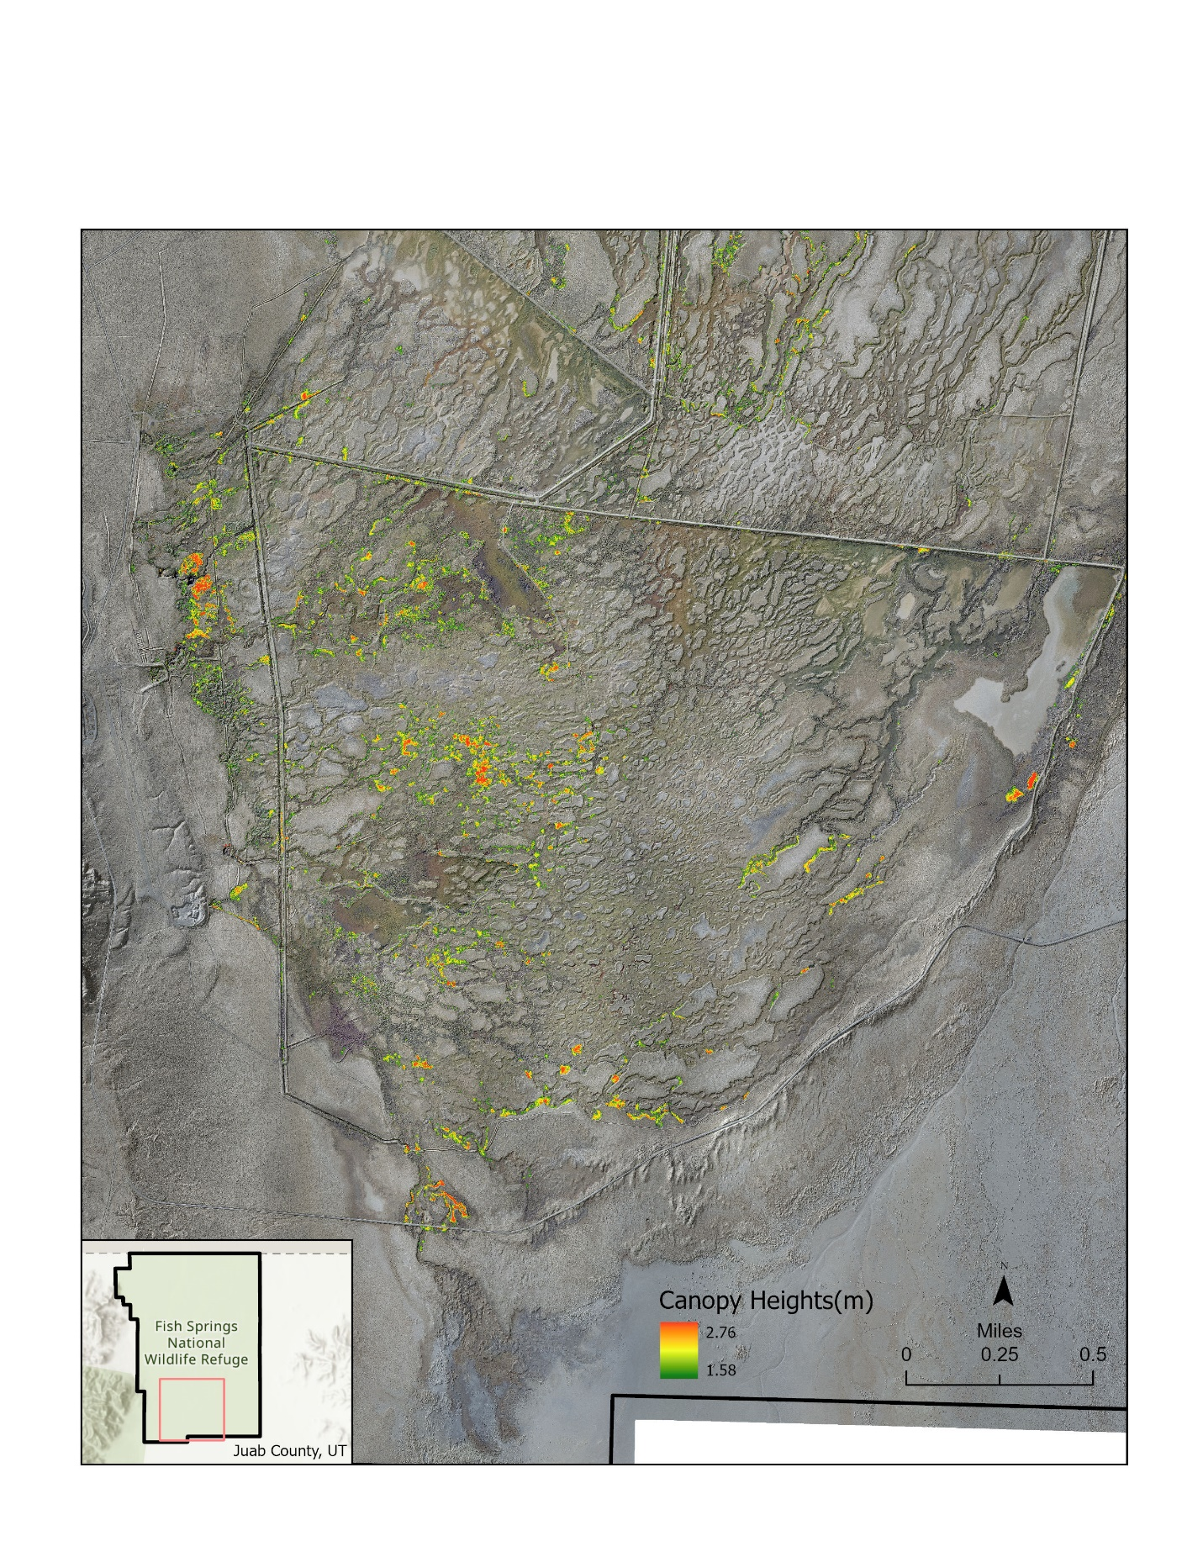

**Caption for Graphic or Image:** Caption – Figure 1. LiDAR data was used to map phragmites patches across Fish Springs National Wildlife Refuge, a spring-fed oasis in western Utah. Located in the southern part of the refuge, the Avocet Unit has numerous phragmites patches throughout.

**Author name:** Mike Artmann

**Author business email:** mike_artmann@fws.gov

**DOI agency/bureau:** FWS

**USGS Mission Area:**

**USGS Program:**

**Cost Center:**

**Program Name2:** Refuges

**Project title:** Precision Monitoring of Colonial Nesting Islands Using UAVs and Machine Learning

**Project description:** Monitoring colonial waterbirds at nesting sites is a common technique for tracking population trends, informing conservation decisions, and understanding ecosystem health. Censusing these nesting sites has considerable effort and risk. Traditional colonial waterbird monitoring includes traversing the colony on foot, surveying via boat, or surveying aerially using small, manned aircraft. Each of these methods has challenges and consequences. Small Unmanned Aerial Vehicles (UAVs) are widely available and have become a useful wildlife management and research tool. Where this technology has been applied in waterbird studies, the use of UAVs was found to result in more precise count estimates than traditional, ground surveys. Manually counting and digitizing the very large sets of photos or videos, however, is a time-consuming task. To reduce the time needed to generate accurate counts from waterbird colony imagery, we developed guidelines for acquiring UAV footage of colonial waterbird nesting islands and a deep-learning tool that can be applied to precisely, accurately, and efficiently count and digitize multi-species waterbird colonies. We developed and trained these machine-learning algorithms to identify 16 classes of waterbirds nesting together on islands along the Texas coast using convolutional neural network-based object detectors. These algorithms can also be trained to detect and identify other species and be applied to monitoring efforts in a variety of habitats. We found the use of UAV-collected aerial imagery and deep learning can significantly improve the accuracy of monitoring events, while reducing staff processing time and colony disturbance. This tool is now being updated for use in other ecosystems and on other species of birds.

**Sensor Type:** Camera;

**Platform type:** UAS;

**URL:**  https://doi.org/10.48550/arXiv.2210.04868

**Graphic or Image Upload:** https://doimspp.sharepoint.com/sites/GS-EROSSCIENCESWI/Shared Documents/Communications Outreach/Documentation Science/DOI Remote Sensing Report/DOI RS Activities Report, 2024/Graphic or Image Upload/AI tool_Anna Vallery.png

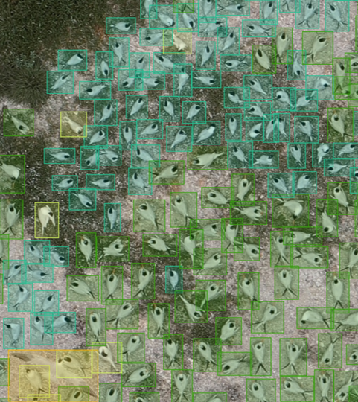

**Caption for Graphic or Image:** Example of UAV imagery from Chester Island, Texas that was annotated to train machine learning algorithms on identification of visually similar tern species (Royal and Sandwich Tern).

**Author name:** Anna Vallery

**Author business email:** anna_vallery@fws.gov