**DOI agency/bureau:** BOR

**USGS Mission Area:**

**USGS Program:**

**Cost Center:**

**Program Name2:** Newlands Project Annual Determination

**Project title:** Use of NDVI to Determine the Irrigation Status of the Newlands Project Lands

**Project description:** The Bureau of Reclamation administers the Operating Criteria and Procedures (OCAP) for the Newlands Project (Project), located near Fallon, Nevada. Annually, OCAP directs Reclamation to determine the allocated irrigation status for approximately 77,000 acres of agricultural fields and wetlands. Remote sensing techniques have been implemented to ensure regular and effective monitoring of the irrigation status of these lands in the Project.

Orthorectified and radiometrically corrected surface reflectance imagery is collected each month during the growing season. This 4-band multispectral imagery product is designed for temporal analysis and monitoring applications. The imagery is downloaded and processed into color infrared and Normalized Difference Vegetation Index (NDVI) products to monitor the irrigation status of the fields in the Project with respect to the water allocation that has been provided to the field. The average NDVI value is derived per field each month and the maximum value is used to establish whether the field was irrigated and estimate Project water demand. A web app is developed in ArcGIS Online and the results are shared with the stakeholders.

This program serves as a remarkable example of leveraging remote sensing-based techniques to meet Reclamation’s water management responsibilities. By adopting new technologies, Reclamation and its partner organizations can follow more streamlined processes that improve data collection accuracy and water usage estimates.

**Sensor Type:** Multispectral (approx. 4-12 bands);

**Platform type:** Satellite;

**URL:** https://www.usbr.gov/mp/lbao/aboutus/criteria.html

**Graphic or Image Upload:** https://doimspp.sharepoint.com/sites/GS-EROSSCIENCESWI/Shared Documents/Communications Outreach/Documentation Science/DOI Remote Sensing Report/DOI RS Activities Report, 2024/Graphic or Image Upload/AD_RemoteSensing_LBAO_Cynthia Valen.jpg

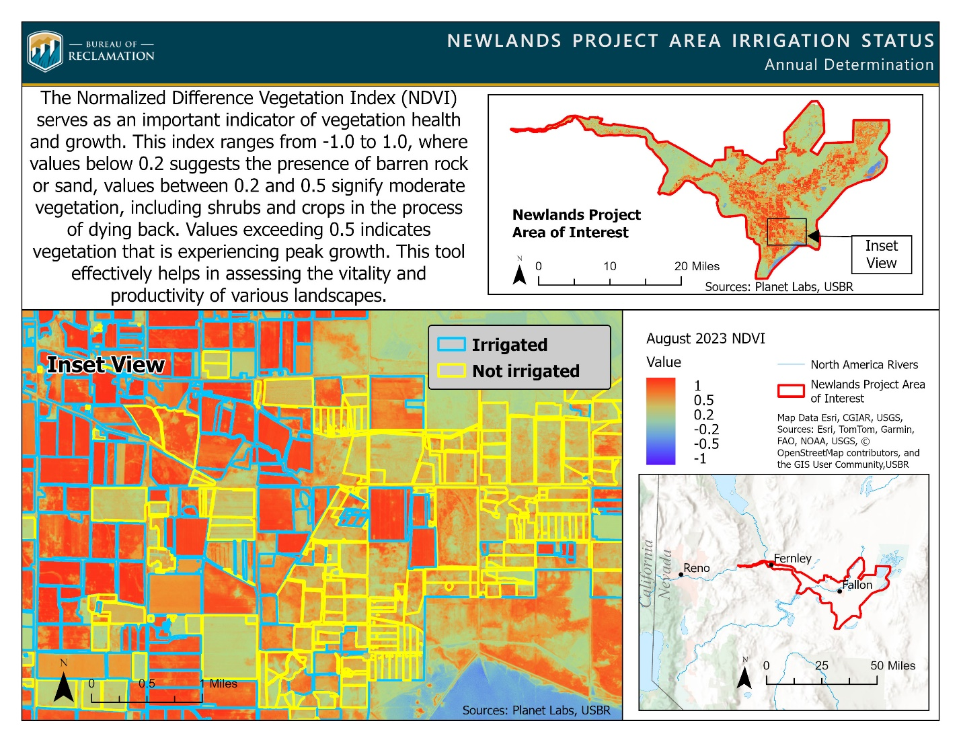

**Caption for Graphic or Image:** NDVI imagery is utilized to assess whether a field is irrigated or not.

**Author name:** Cindy Valen

**Author business email:** cvalen@usbr.gov

**DOI agency/bureau:** BOR

**USGS Mission Area:**

**USGS Program:**

**Cost Center:**

**Program Name2:** Lower Colorado Region Consumptive Uses and Losses

**Project title:** Estimating Consumptive Use of Irrigated Agriculture in the Lower Colorado River System

**Project description:** The Department of the Interior is tasked with reporting the annual consumptive uses and losses of water from the Colorado River System on a 5-year basis. The largest category of consumptive use in the 5-year reports is consistently irrigated agriculture. Because the study area is so vast (around 132,000 square miles) with around 600,000 – 900,000 acres irrigated annually, the Bureau of Reclamation (Reclamation) relies upon remotely sensed data to estimate the consumptive uses and losses of irrigated agriculture.

In the 2012 Colorado River Basin Water Supply and Demand Study (LINK: https://www.usbr.gov/lc/region/programs/crbstudy/finalreport/index.html), Reclamation agreed to recalculate consumptive uses and losses data for the lower Colorado River System from 1971–2005 using updated and consistent methods. To do so, Reclamation contracted with the U.S. Geological Survey (USGS) to produce monthly and annual images of Normalized Difference Vegetation Index (NDVI) and net evaporation raster files based on the Operational Simplified Surface Energy Balance (SSEBop) method (Senay et al., 2013) (LINK: https://onlinelibrary.wiley.com/doi/10.1111/jawr.12057#:~:text=The%20increasing?msockid=183b59e0357463fd334a4a0834a262f9) for the entire lower Colorado River System. The NDVI and SSEBop evapotranspiration data were then used to calculate the consumptive use of irrigated agriculture.

Reclamation developed a logistic regression model based on known non-irrigated fields to predict irrigation status of each field within the lower Colorado River System for each year. The model’s predictions were checked manually using the historical NDVI data and imagery. Only irrigated fields were included in the irrigated agriculture evapotranspiration estimates. For each year, evapotranspiration data from the irrigated fields were summed to the necessary reporting unit to estimate consumptive use by irrigated agriculture across the lower Colorado River System. The estimated consumptive use for irrigated agriculture was between 2.4 million and 3.4 million acre-feet depending on the year. The data are contained in Reclamation’s Lower Colorado River System Consumptive Uses and Losses Report, Recalculated 1971–2005, as well as the associated dataset and data visualization tool, which include consumptive uses and losses data through 2015. The report and associated data can be found on Reclamation’s Lower Colorado Region web page (LINK: https://www.usbr.gov/lc/region/g4000/wtracct.html#CUL).

**Sensor Type:** Multispectral (approx. 4-12 bands);Thermal;

**Platform type:** Satellite;

**URL:** https://www.usbr.gov/lc/region/g4000/wtracct.html#CUL

**Graphic or Image Upload:** https://doimspp.sharepoint.com/sites/GS-EROSSCIENCESWI/Shared Documents/Communications Outreach/Documentation Science/DOI Remote Sensing Report/DOI RS Activities Report, 2024/Graphic or Image Upload/RSA_Report_Graphic_2024_Sean Schrag-Toso.jpg

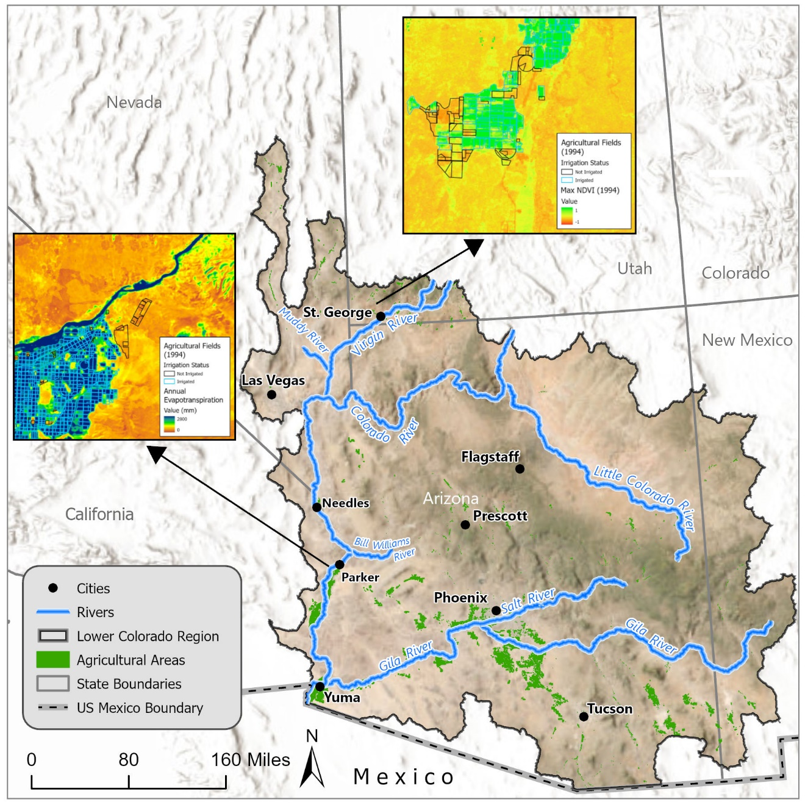

**Caption for Graphic or Image:** Example of 1994 data showing irrigated fields and annual evapotranspiration.

**Author name:** Troy Wirth, Sean Schrag-Toso

**Author business email:** twirth@usbr.gov, sschragtoso@usbr.gov