DOI agency/bureau: BLM
USGS Mission Area:
USGS Program:
Cost Center:
Program Name2: Cadastral Surveying
Project title: Revolutionizing Cadastral Surveying: The Impact of LiDAR Technology
Project description: The Bureau of Land Management (BLM) Cadastral Survey program is changing the way land and resource management is done through the use of Light Detection and Ranging (LiDAR) technology. LiDAR technology allows surveyors to gather detailed information about the land, which helps in various activities, including studying river movements, planning land development, and investigating fires.

Incorporating LiDAR technology allows Cadastral Survey to offer enhanced services to customers, going beyond traditional survey products. By providing professional evaluation and data-driven solutions, Cadastral Surveyors can ensure the safety, sustainability, and success of their projects, ultimately leading to better land and resource management practices.

One application of LiDAR is in studying historic riverbanks. By using this technology, surveyors can accurately map how riverbanks have changed over time. River movement study mapping allows surveyors to analyze and accurately map the natural dynamics of changes in riverbanks, offering precise and detailed verification of historical riverbank locations in the field to apply boundary management solutions.

LiDAR is also valuable in fire investigations and is being used to scan origin areas for fire investigations. When a fire occurs, understanding its origin and how it spread is crucial. LiDAR creates detailed maps of the affected landscape, allowing investigators to pinpoint where the fire started and how it moved. This information is critical for comprehending wildfire behavior and for providing valuable insights to fire investigators.

Another important use of LiDAR is in creating Digital Elevation Models (DEMs). These models provide a 3D representation of the land's surface, showing features like elevation, slope, and topographical features. DEMs are valuable for various engineering projects, such as building roads, planning urban areas, and developing infrastructure. By using LiDAR to generate these models, surveyors support engineering solutions by providing accurate data, leading to better planning and execution of engineering projects.

Overall, LiDAR technology is enhancing cadastral surveying services by providing accurate and detailed data for a range of applications. This improved understanding of the land not only enhances safety and sustainability but also leads to more effective management of boundaries and natural resources.
Sensor Type: Camera;Video;Lidar (terrestrial or bathymetric);
Platform type: UAS;Ground based / sensor web / web cam;Airplane;
URL: Instagram: @blmnmcadastral
Graphic or Image Upload: https://doimspp.sharepoint.com/sites/GS-EROSSCIENCESWI/Shared Documents/Communications Outreach/Documentation Science/DOI Remote Sensing Report/DOI RS Activities Report, 2024/Graphic or Image Upload/River Movement Study #1_Michael Hart.jpg
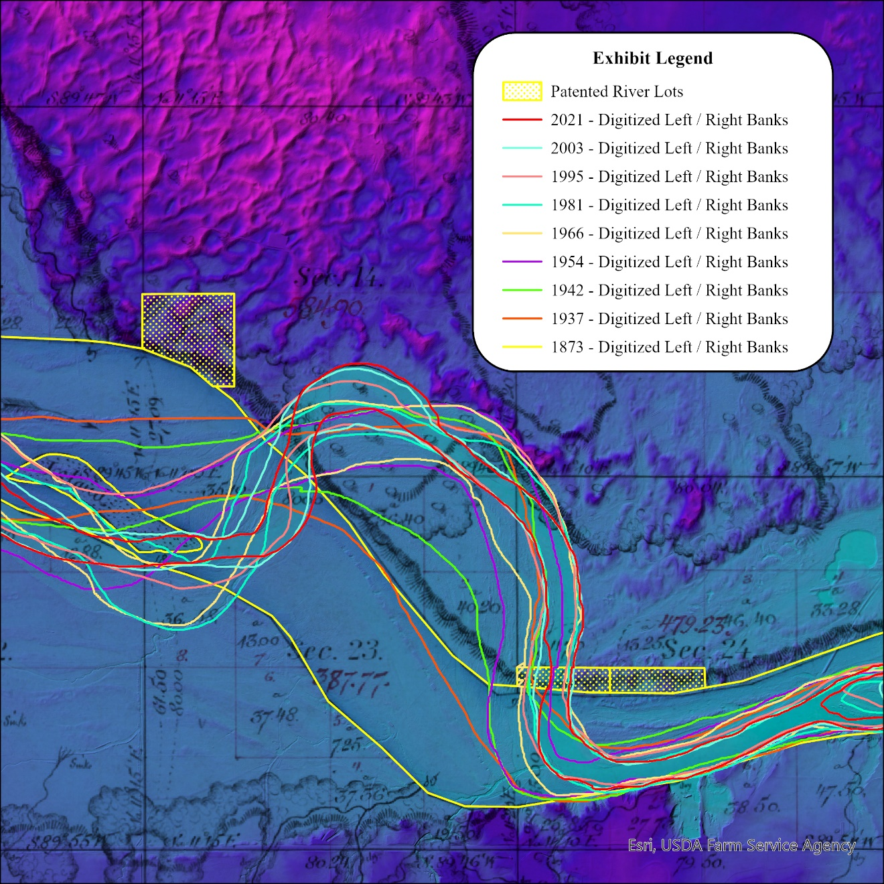
Graphic or Image Upload: https://doimspp.sharepoint.com/sites/GS-EROSSCIENCESWI/Shared Documents/Communications Outreach/Documentation Science/DOI Remote Sensing Report/DOI RS Activities Report, 2024/Graphic or Image Upload/River Movement Study 3D_Michael Hart.jpg
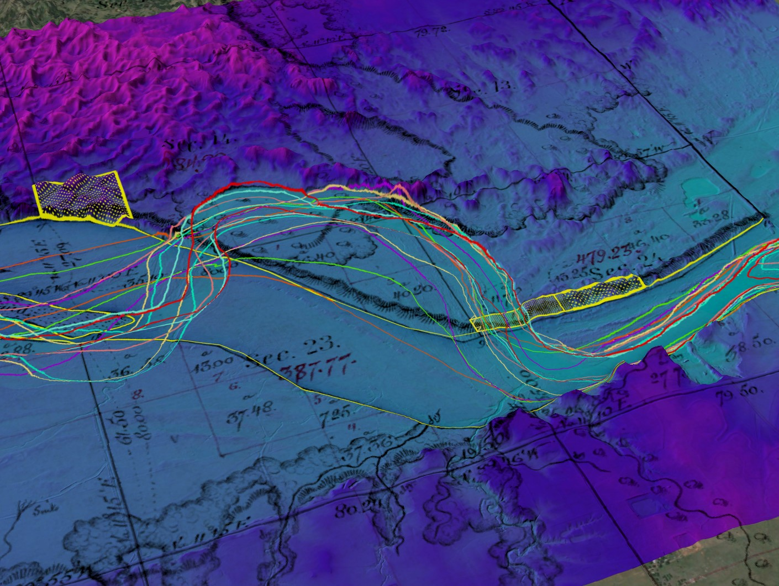
Graphic or Image Upload: https://doimspp.sharepoint.com/sites/GS-EROSSCIENCESWI/Shared Documents/Communications Outreach/Documentation Science/DOI Remote Sensing Report/DOI RS Activities Report, 2024/Graphic or Image Upload/Engineering Topographic Survey_Michael Hart.jpg
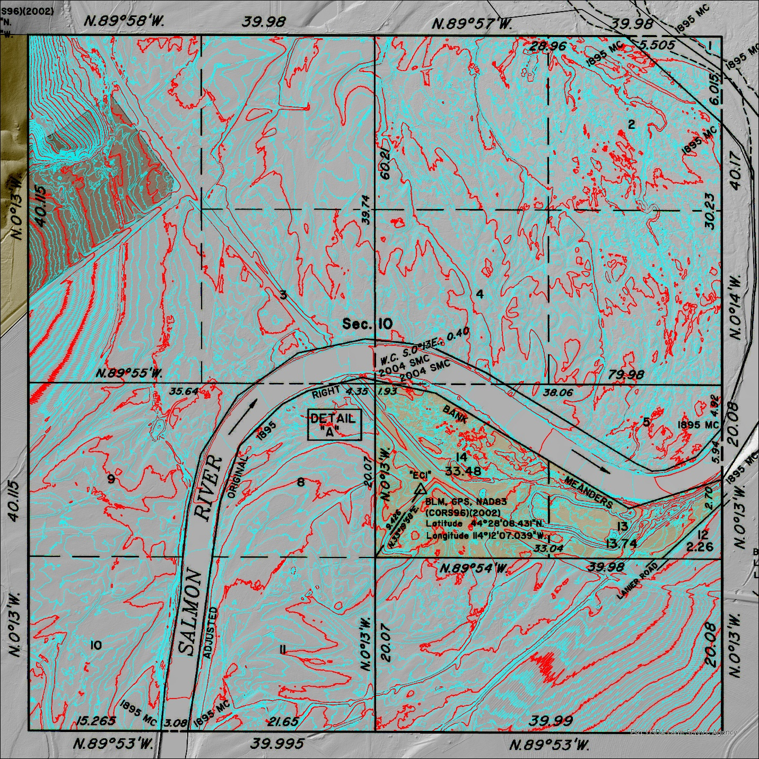
Caption for Graphic or Image: Graphic #1 - River Movement Study (Cimarron River)
Graphic #3 - River Movement Study 3D View (Cimarron River)
Graphic #2 - Topographic Survey (Challis, Idaho)

Author name: Michael Hart
Author business email: mlhart@blm.gov

DOI agency/bureau: BLM
USGS Mission Area:
USGS Program:
Cost Center:
Program Name2: National Operations Center Remote Sensing
Project title: Archaeological Documentation with Photogrammetry and Terrestrial Lidar
Project description: Garnet, Montana, regarded as the state’s best preserved ghost town, is managed by BLM’s Missoula Field Office (MFO). Given that many of the structures are nearly 150 years old, MFO staff are concerned about overall maintenance and the impact of snow loads on building integrity, particularly roofs. Due to these concerns, MFO partnered with BLM’s National Operations Center (NOC) to document the site using uncrewed aerial systems (UAS) and terrestrial laser scanning. Over two days in September 2023, the NOC conducted UAS flights to create 3D models of the site with photogrammetry. Terrestrial mobile laser scanning complemented UAS mapping by capturing data of key building interiors, as well as vertical or overhanging features not visible from an aerial perspective (Fig 1).

The resulting point clouds and 3D mesh represent a baseline dataset for future change-detection mapping missions. In the meantime, the photogrammetry point cloud is being used to quantify roof sag on key buildings by calculating roof point distance to a best-fit plane (Fig 2). There are also plans to use the 3D model (Fig 3) as interpretive resource to share information on the site for visitors that cannot visit in person.

Sensor Type: Camera;Lidar (terrestrial or bathymetric);Video;
Platform type: Ground based / sensor web / web cam;UAS;
URL:
Graphic or Image Upload: https://doimspp.sharepoint.com/sites/GS-EROSSCIENCESWI/Shared Documents/Communications Outreach/Documentation Science/DOI Remote Sensing Report/DOI RS Activities Report, 2024/Graphic or Image Upload/Fig 1 Wells Hotel Floorplan_Jacob (Jake) Slyder.PNG
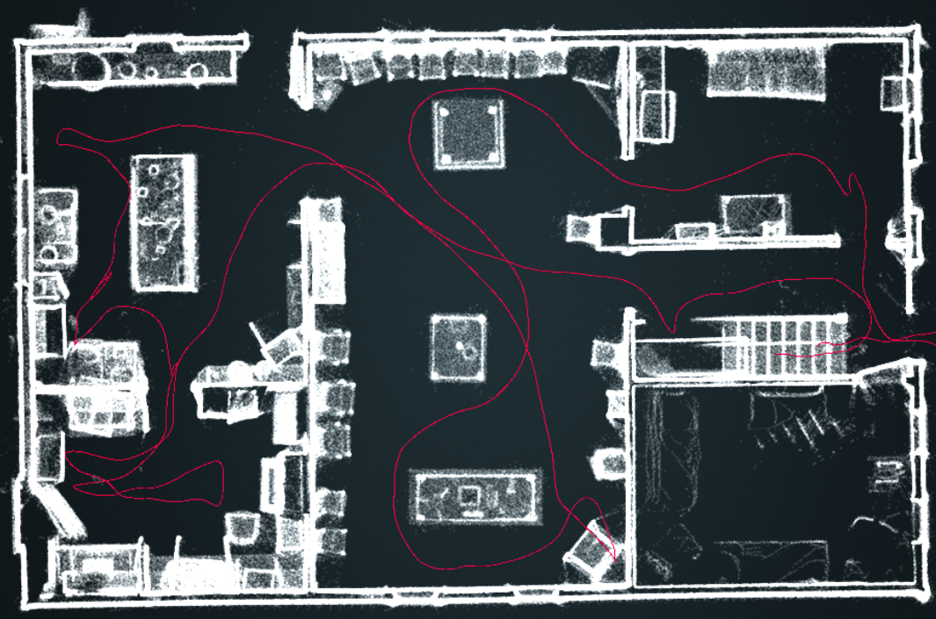
Graphic or Image Upload: https://doimspp.sharepoint.com/sites/GS-EROSSCIENCESWI/Shared Documents/Communications Outreach/Documentation Science/DOI Remote Sensing Report/DOI RS Activities Report, 2024/Graphic or Image Upload/Fig 2 Post Office Roof Sag_Jacob (Jake) Slyder.PNG
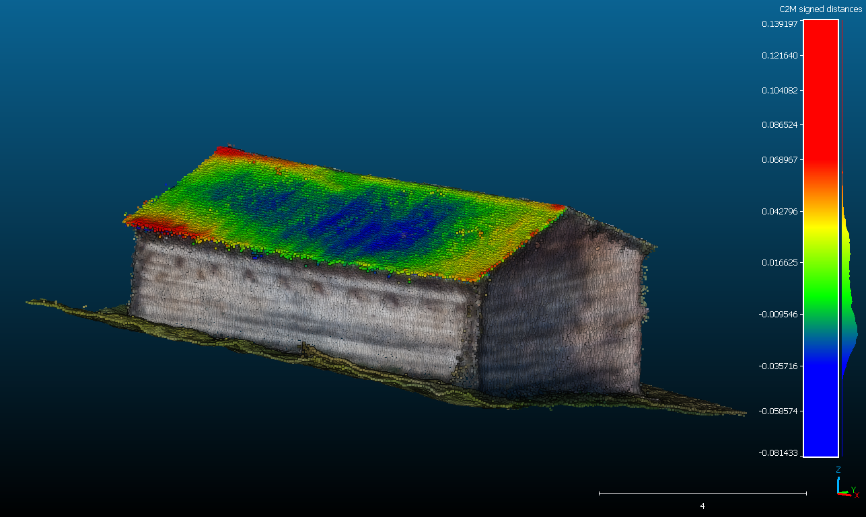
Graphic or Image Upload: https://doimspp.sharepoint.com/sites/GS-EROSSCIENCESWI/Shared Documents/Communications Outreach/Documentation Science/DOI Remote Sensing Report/DOI RS Activities Report, 2024/Graphic or Image Upload/Fig 3 Site Model_Jacob (Jake) Slyder.PNG
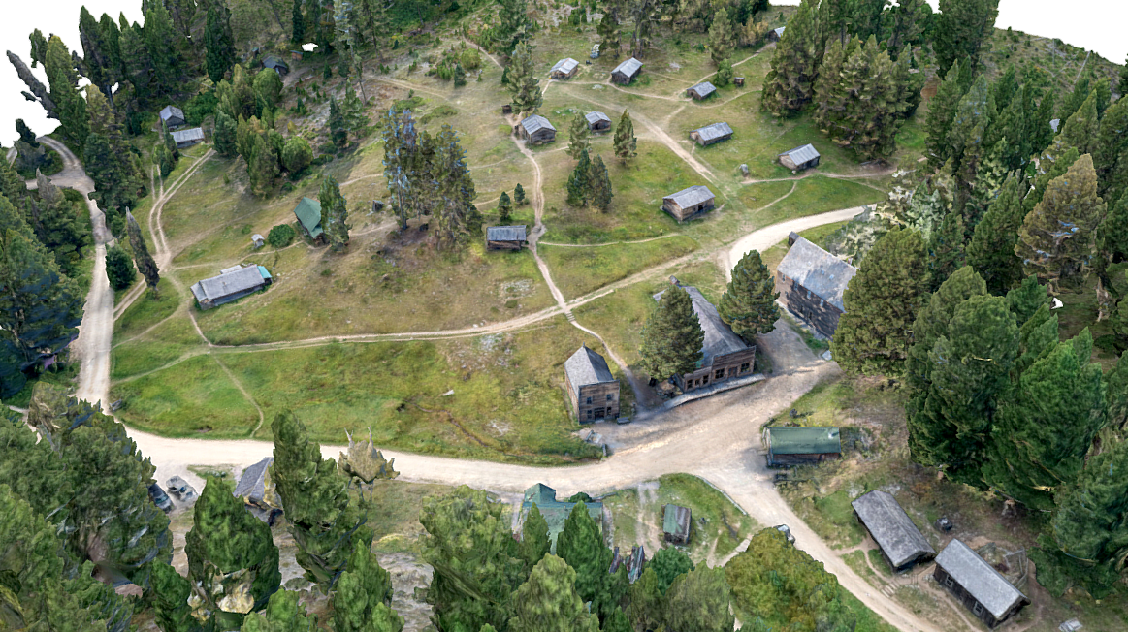
Caption for Graphic or Image: Figure 1: Floorplan of Wells Hotel 1st floor with scanning path depicted in red.

Figure 2: Point cloud model of Garnet post office with roof sag (measured as distance from point cloud to a flat plane) as high as 3-4cm.

Figure 3: 3D mesh and texture of Garnet townsite.
Author name: Jake Slyder, Julian Cross
Author business email: jslyder@blm.gov, jcross@blm.gov

DOI agency/bureau: BLM
USGS Mission Area:
USGS Program:
Cost Center:
Program Name2: National Operations Center Remote Sensing
Project title: Combining Satellite and Terrestrial Lidar to Improve Disturbance and Mining Monitoring
Project description: Over the past few years, southeastern New Mexico has seen unprecedented oil and gas development, creating a need for BLM’s Carlsbad Field Office (CFO) to efficiently monitor surface disturbances related to energy development and associated caliche mining. Of particular importance was finding a methodology to identify illegal mining, where minerals owned by the federal government were being removed without a permit or royalty payments. Historically, these mineral trespasses were only discovered by incidental observations in the field or based on reports from the public.

In collaboration with CFO, the BLM’s National Operation’s Center (NOC) developed the Change and Disturbance Event Detection Tool (CDEDT), a web-based tool for finding satellite imagery over an area of interest and highlighting surface change between two user-specified dates. Currently, CDEDT includes Sentinel-2, Landsat (missions 5-9), Sentinel-1, and NAIP datasets. The tool allows users to identify change by thresholding various remote sensing indices and converting these areas to a GeoJSON for export to their preferred GIS software.

By leveraging CDEDT to analyze Sentinel-2 satellite imagery, CFO geologists have identified and prosecuted numerous trespasses, recovering more than $5.6 million. These recoveries have allowed CFO to procure survey-grade GNSS and terrestrial lidar equipment to further remote sensing to streamline trespass investigations.

After several years of evaluation and integration, CDEDT and lidar scanning workflow are now operational within the group. Staff use CDEDT to identify new disturbances using a brightness index, then compare the resulting polygons to known disturbances and permits using a custom geoprocessing tool. If the presence of a disturbance on BLM lands can’t be explained by a known permit, geologists conduct a field visit. If a mineral trespass is found, this visit will entail walking the perimeter of the pit as well as scanning it using a handheld lidar scanner. Using a variety of data sources, such as 2018 USGS 3DEP lidar, geologists can use a GIS to run a cut fill or similar operation to estimate the volume of material removed.

The CDEDT tool does not require a license and is open to all users at https://blm-gee-cdedt.projects.earthengine.app/view/change-and-disturbance-event-detection-tool-cdedt.

Sensor Type: Lidar (terrestrial or bathymetric);Multispectral (approx. 4-12 bands);
Platform type: Ground based / sensor web / web cam;Satellite;
URL: https://blm-gee-cdedt.projects.earthengine.app/view/change-and-disturbance-event-detection-tool-cdedt
Graphic or Image Upload:
Caption for Graphic or Image: Figure 1: Newly constructed wellpad delineated from a brightness index using CDEDT.

Figure 2: A hillshade of a 5-acre caliche pit scanned with terrestrial lidar, with colors representing the change in surface height from 2018 to 2023.
Author name: Jake Slyder, Chris Cole, Zeke Salaz, Dennis Akins
Author business email: jslyder@blm.gov, cjcole@blm.gov, rsalaz@blm.gov, dakins@blm.gov

DOI agency/bureau: BLM
USGS Mission Area:
USGS Program:
Cost Center:
Program Name2: Geology
Project title: Clarks Fork Pit Reclamation
Project description: The Clarks Fork Pit is comprised of four excavations, each about 100 x 25 feet, located along the Wyoming-Montana border within the viewshed of the Nez Perce Historic Trail and the stunning Clarks Fork Canyon. The mystery: There is no record of when or why these pits were excavated, though they are likely associated with old oil and gas leases in the area. With the use of Bipartisan Infrastructure Law (BIL) funding for revegetation and hazard mitigation on mined lands, the BLM Cody Field Office will reclaim this site in 2024 by restoring the disturbed area to contour, spreading topsoil, and seeding native plant species. This will restore the viewshed of the area to a natural state.
BLM remote pilots acquired aerial images pre-mitigation, with intent to reacquire the area post-mitigation, to quantify and document landscape changes. Natural color aerial images were collected over 20 acres with stereo overlap using a Sony RX1RII digital camera mounted underneath a DJI M600 uncrewed aerial system (UAS). The M600 overflew the site at a height of 200 feet above ground level, and the camera was triggered by an intervelometer every 2 seconds. The stereo overlap of the imagery allowed for the creation of a 3-dimensional model of the site, a digital surface model, and an orthomosaic with spatial resolution of 0.75 cm. Permanent aluminum caps were installed and surveyed by BLM Wyoming Cadastral so that future spatial products of this site can be precisely aligned with the current output. BLM’s in-house UAS program data collection excels at capturing high-resolution imagery and elevation data over small acreages at very low cost with minimal lead time required. Several other BIL-funded mine land reclamation projects were similarly documented within the Cody Field Office in 2024.
Sensor Type: Camera;
Platform type: UAS;
URL:
Graphic or Image Upload: https://doimspp.sharepoint.com/sites/GS-EROSSCIENCESWI/Shared Documents/Communications Outreach/Documentation Science/DOI Remote Sensing Report/DOI RS Activities Report, 2024/Graphic or Image Upload/ClarksFork_Samuel Cox.jpg
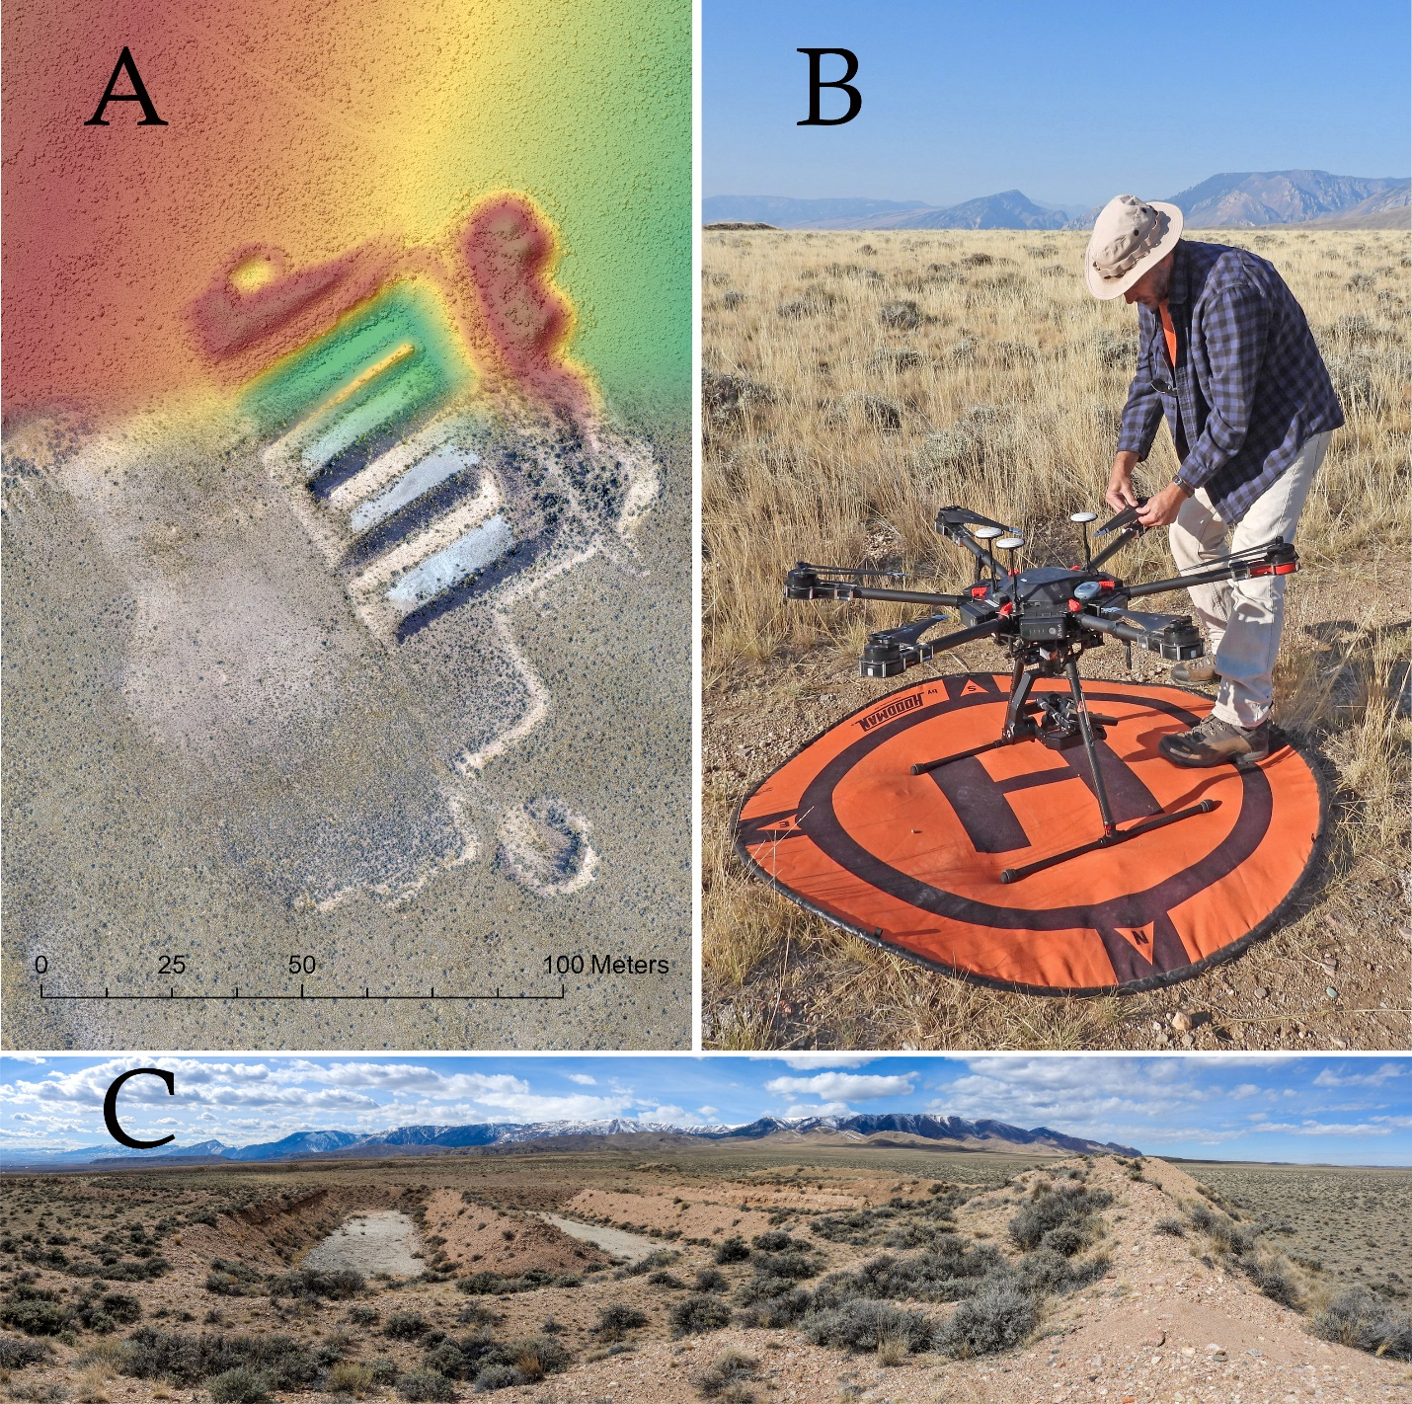
Caption for Graphic or Image: (A) The Clarks Fork Pit 1.5-cm digital surface model (top) fades into the 0.75-cm orthomosaic (bottom), both created from UAS imagery; (B) A BLM remote pilot prepares the M600 UAS for a mapping flight; (C) Excavated pits and tailings pile at the site.
Author name: Sam Cox & Lisa Marks
Author business email: secox@blm.gov, lmarks@blm.gov

DOI agency/bureau: BLM
USGS Mission Area:
USGS Program:
Cost Center:
Program Name2: National Operations Center, Remote Sensing Section
Project title: Mapping Abandoned Mine Lands in Oregon with Uncrewed Aerial Systems
Project description: An estimated 1 million abandoned mine land (AML) features exist on BLM lands, but only a small fraction have been inventoried and characterized in the field. The BLM is working to mitigate both physical hazards, like open adits and shafts, as well as environmental hazards commonly present at AML sites. Addressing these hazards requires extensive testing and characterization by multiple specialists, all relying on the same baseline information. The BLM Oregon and Washington AML Unit and the Prineville District Offices plan to do an extensive characterization of AML features at the Maury and Platner complexes near Prineville, Oregon. Both sites were mercury mines, and due to the hazardous waste products associated with that type of mine, have the potential to escalate to Comprehensive Environmental Response, Compensation, and Liability Act (CERCLA), or Superfund, sites. Remote sensing data, particularly from UAS, is crucial for providing this baseline data quickly, efficiently, and safely, minimizing the need for on-site time and reducing or eliminating contact with contaminated waste and equipment.

In July 2024, BLM National Operations Center (NOC) joined field staff from both offices to collect high-resolution 3D geospatial data at these mine sites using Uncrewed Aerial Systems (UAS). To map approximately 100 acres at Maury and 400 acres at Platner, 948 and 1,510 stereo-images were collected, respectively, using a combination of nadir and oblique flights. The stereo imagery was processed photogrammetrically to produce high-resolution, 3D data using Agisoft Metashape. By surveying precise control points with a global navigation satellite system (GNSS) receiver at each site, these 3D data can serve as a baseline for comparison to any data collected in the future. Detailed orthomosaic imagery, high-resolution elevation surfaces (Figure 1), and estimated material volumes derived from this mapping effort will support the environmental remediation of the site.
Sensor Type: Camera;
Platform type: UAS;
URL: https://www.blm.gov/programs/aml-environmental-cleanup/aml
Graphic or Image Upload: https://doimspp.sharepoint.com/sites/GS-EROSSCIENCESWI/Shared Documents/Communications Outreach/Documentation Science/DOI Remote Sensing Report/DOI RS Activities Report, 2024/Graphic or Image Upload/PrinevilleAML_Map_resize_Julian Cross.jpg
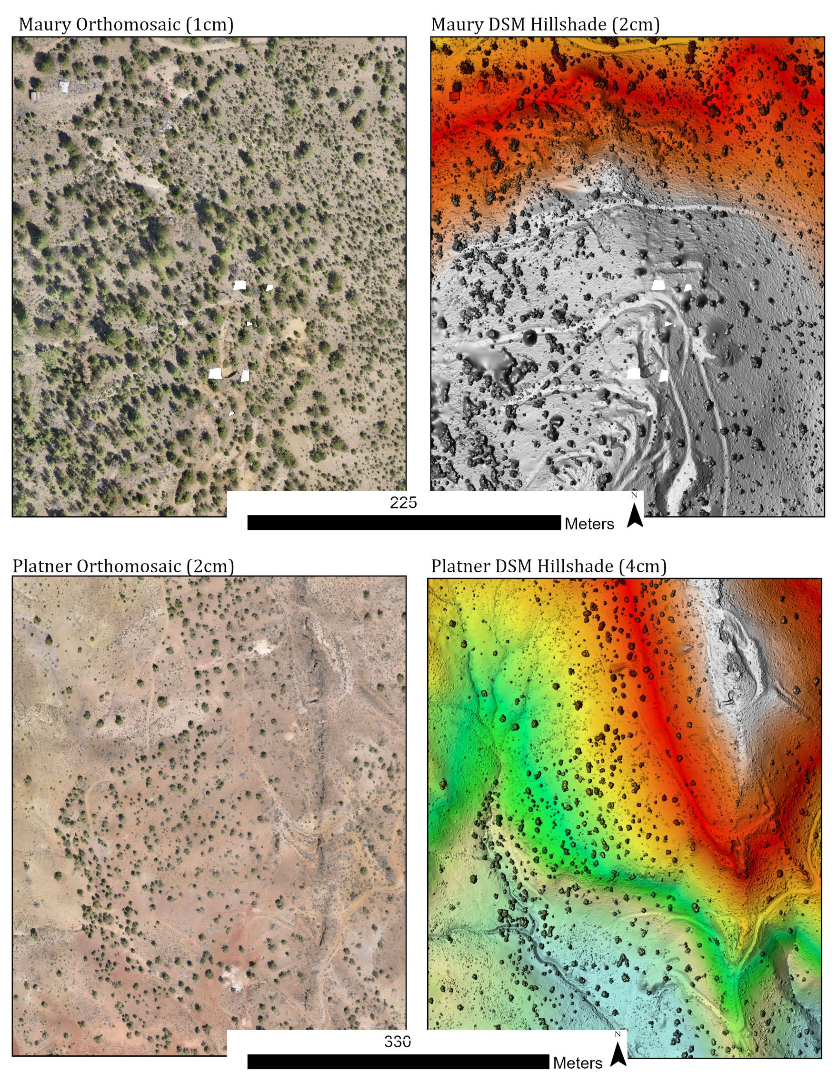
Caption for Graphic or Image: Orthomosaic (left) and digital surface model (DSM) hillshade (right) for the Maury (top) and Platner (bottom) mine complex sites. The orthomosaic offers a high-resolution (1–2-centimeter resolution), true-color representation of surface features. The hillshade (2–4-centimeter resolution) provides a useful visualization of the topography at the site and highlights terrain features that might not be visible in the orthomosaic.
Author name: Julian Cross
Author business email: jcross@blm.gov

DOI agency/bureau: BLM
USGS Mission Area:
USGS Program:
Cost Center:
Program Name2: BLM Assessment, Inventory and Monitoring (AIM) Team
Project title: Streamlining Vegetation Mapping: The Transition to Multidimensional Multivariate Rasters
Project description: We’ve entered a new era in vegetation mapping, marked by the availability of various Fractional Vegetation Cover products. Among these are the Rangeland Analysis Platform (RAP), developed by the USDA, and the Rangeland Condition Monitoring Assessment and Projection (RCMAP), created by the USGS. These products leverage training data from the BLM Assessment, Inventory, and Monitoring (AIM) program, gathered on the ground and integrated with the Landsat satellite archive. The resulting output models effectively describe the annual cover of major plant functional types—such as trees, shrubs, perennial grasses, and sagebrush—across the western United States from the mid-1980s to the present.

These products empower managers to assess the status and trends of land management areas concerning disturbance, treatment, restoration projects, and more. However, a significant challenge remains: presenting these data in a format that is easily digestible for managers and users. Traditionally, utilizing these products has required a separate raster for each year and variable—resulting in 228 rasters for RAP (covering 38 years and 6 variables) and 351 rasters for RCMAP (spanning 39 years and 9 variables). This fragmentation leads to excessive time spent by users gathering the data into a single location. To address this, the BLM adopted modern Multidimensional Multivariate Raster formats, successfully consolidating all 579 files into just 2 rasters. These “all-in-one” rasters can be directly used in various new tools, including time sliders, the Multidimensional toolbar in Esri’s ArcGIS Pro, and the Multidimensional viewer in the Esri Web Map Viewer. Data from all 579 layers can now be integrated into user projects with a single click and users can easily toggle between them.

The most significant advantage of this approach is the ability to swiftly create Temporal Profiles using the ArcGIS Pro Multidimensional toolbar. As illustrated in the images below, users can chart a single variable at multiple locations or multiple variables at a single location across all years, all within a few clicks and with near-instant response times. This efficiency leads to substantial time savings while also reducing network and server loads, analysis times, and training costs. Additionally, these Multidimensional Multivariate Rasters can be seamlessly utilized across a broad range of tools, including time animations, zonal statistics, trend rasters, anomaly detection, change detection, time cubes, Voxel layers, NetCDF viewers, and more—all achievable with just a few clicks by the user.

Sensor Type: Multidimensional Multivariate;
Platform type: Satellite;
URL: https://www.blm.gov/AIM
Graphic or Image Upload: https://doimspp.sharepoint.com/sites/GS-EROSSCIENCESWI/Shared Documents/Communications Outreach/Documentation Science/DOI Remote Sensing Report/DOI RS Activities Report, 2024/Graphic or Image Upload/Multidimensional Multivariate Raster_Douglas Browning.png
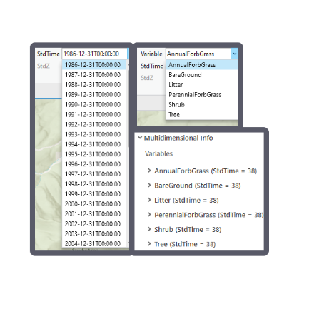
Graphic or Image Upload: https://doimspp.sharepoint.com/sites/GS-EROSSCIENCESWI/Shared Documents/Communications Outreach/Documentation Science/DOI Remote Sensing Report/DOI RS Activities Report, 2024/Graphic or Image Upload/Temporal Profile Multiple Locations_Douglas Browning.gif
Graphic or Image Upload: https://doimspp.sharepoint.com/sites/GS-EROSSCIENCESWI/Shared Documents/Communications Outreach/Documentation Science/DOI Remote Sensing Report/DOI RS Activities Report, 2024/Graphic or Image Upload/Temporal Profile Multiple Variables_Douglas Browning.gif
Caption for Graphic or Image: Multidimensional Multivariate Raster.png Caption: Multidimensional Multivariate Rasters aggregate all time intervals and variables into a single file

Temporal Profile Multiple Locations.gif Caption: Temporal profile of a single variable across multiple locations

Temporal Profile Multiple Variables.gif Caption: Temporal profile of multiple variables at a single location
Author name: Doug Browning, Tim Assal
Author business email: dbrowning@blm.gov, tassal@blm.gov

DOI agency/bureau: BLM
USGS Mission Area:
USGS Program:
Cost Center:
Program Name2: National Operations Center, Remote Sensing Section
Project title: Mapping Abandoned Mine Lands in California with a Hand-held LiDAR Scanner
Project description: An estimated 1 million abandoned mine land (AML) features exist on BLM lands, but only a small fraction have been inventoried and characterized in the field. These sites are often very complex with both physical and environmental hazards, as well as historically significant features present. The BLM Ukiah Field Office is tasked with overseeing the documentation and characterization of AML features at the Helen, Research, and Chicago mercury mines near Middletown, California. Due to the hazardous waste products associated with historical mercury mining, this mine complex has the potential to escalate to a Comprehensive Environmental Response, Compensation, and Liability Act (CERCLA), or Superfund, site. Additionally, some intact historic mining structures here, for example brick retorts and ore furnaces (Figure 1), contribute to the potential historic value of the site under the National Historic Preservation Act (NHPA).
In May 2024, BLM National Operations Center (NOC) staff collected high-resolution 3D data of the mine complex using a hand-held laser scanner. LiDAR scans, 13 in total, were collected at five priority zones identified by the Ukiah Field Office and BLM Oregon and Washington AML Unit staff. Control points were surveyed at each site using a global navigation satellite system (GNSS) receiver so that these 3D data can serve as a baseline for comparison to any data collected in the future. The average georeferencing RMS error across all scans was ±0.21 meters. High-resolution elevation surfaces and detailed 3D models of intact, historically significant mining structures derived from this mapping effort will support the environmental remediation of the site.
Sensor Type: Lidar (terrestrial or bathymetric);
Platform type: Ground based / sensor web / web cam;
URL: https://www.blm.gov/programs/aml-environmental-cleanup/aml
Graphic or Image Upload: https://doimspp.sharepoint.com/sites/GS-EROSSCIENCESWI/Shared Documents/Communications Outreach/Documentation Science/DOI Remote Sensing Report/DOI RS Activities Report, 2024/Graphic or Image Upload/Ukiah_ResearchMine_Furnace_Julian Cross.jpg
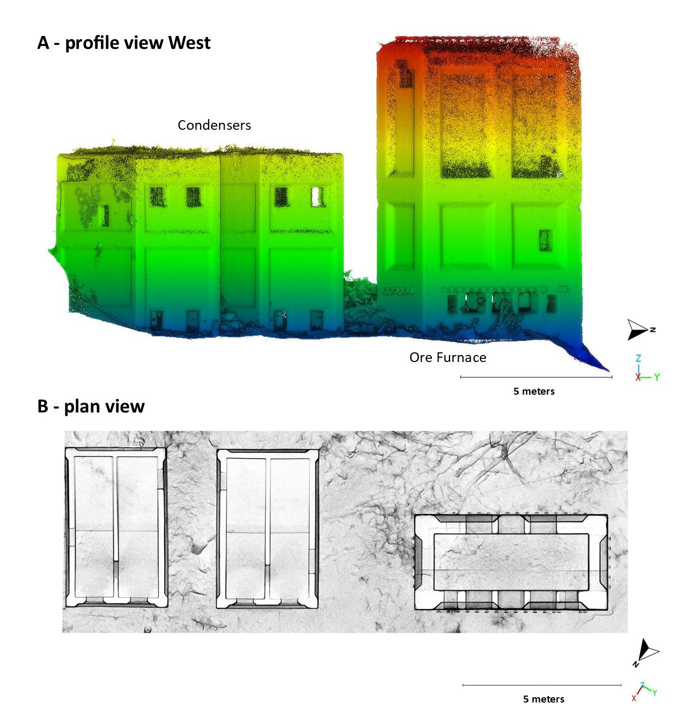
Caption for Graphic or Image: Profile (A) and plan (B) view of 3D scan data of a concrete ore furnace and adjacent condensers found at the Research Mine site. This furnace was an experimental Scott-type fine ore furnace, likely built in 1911, used to fire mercury ore and condense the mercury vapor to liquid. This feature represents the complexity of AML sites well as it has the potential to meet both CERCLA environmental safety and NHPA historic value criteria.
Author name: Julian Cross
Author business email: jcross@blm.gov

DOI agency/bureau: BLM
USGS Mission Area:
USGS Program:
Cost Center:
Program Name2: Geospatial Imaging, National Operations Center
Project title: Mapping Wildfires with Multiscale Satellite Imagery
Project description: Over the past three decades, wildfires have significantly impacted BLM and other public lands. These events have come at a substantial human, environmental and economic cost, and often pose immediate and long-term risks and consequences to our landscape. Remote sensing provides the ability to detect, monitor and map fire events, without risk to human safety.

The National Operations Center (NOC) provides a suite of satellite imagery-derived products supporting the Bureau’s Emergency Stabilization and Rehabilitation (ESR) program. ESR prescribes and implements, where needed, emergency treatments to minimize threats to life or property, or to stabilize and prevent unacceptable degradation to natural and cultural resources resulting from the effects of a fire (https://www.blm.gov/sites/blm.gov/files/uploads/Media_Library_BLM_Policy_Handbook_h1742-1.pdf). NOC remote sensing products allow management officials to accurately identify the spatial extents of fire events, the condition of vegetation and other cover, and the location of fire-retardant applications. These data are primarily developed using Sentinel-2 satellites, but include other moderate resolution platforms such as Sentinel-1 and Landsat as well.

There is also a need to identify heterogeneous fire processes, ecological impacts, and recovery at finer spatial scales than possible with these instruments. In 2024 the NOC evaluated the feasibility of further integrating commercial satellite imagery into ESR support. Systems such as small satellite constellations (SmallSats) can now provide unparalleled spatial resolution and rapid revisit collection frequencies supporting post-fire monitoring and mapping. The BLM successfully acquired post-fire commercial imagery for multiple ESR requests. 50-cm resolution multispectral Planet SkySat imagery were collected over the Cox Pond Fire for the BLM’s Arizona Strip District Office (ASDO) and were used to delineate burned and unburned vegetation cover at a fine spatial scale.

Building on successes achieved this year, the BLM plans to continue commercial imagery collection and exploitation efforts where needed next fire season, and to further standardize acquisition and product development. Finally, the Bureau hopes to reduce latencies impacting the timely access and use of collected imagery for critical post-fire applications.

Sensor Type: Multispectral (approx. 4-12 bands);
Platform type: Satellite;
URL:
Graphic or Image Upload: https://doimspp.sharepoint.com/sites/GS-EROSSCIENCESWI/Shared Documents/Communications Outreach/Documentation Science/DOI Remote Sensing Report/DOI RS Activities Report, 2024/Graphic or Image Upload/2024 DOI RS Report Cole Blackmore Mapping Wil_Christopher Cole.jpg
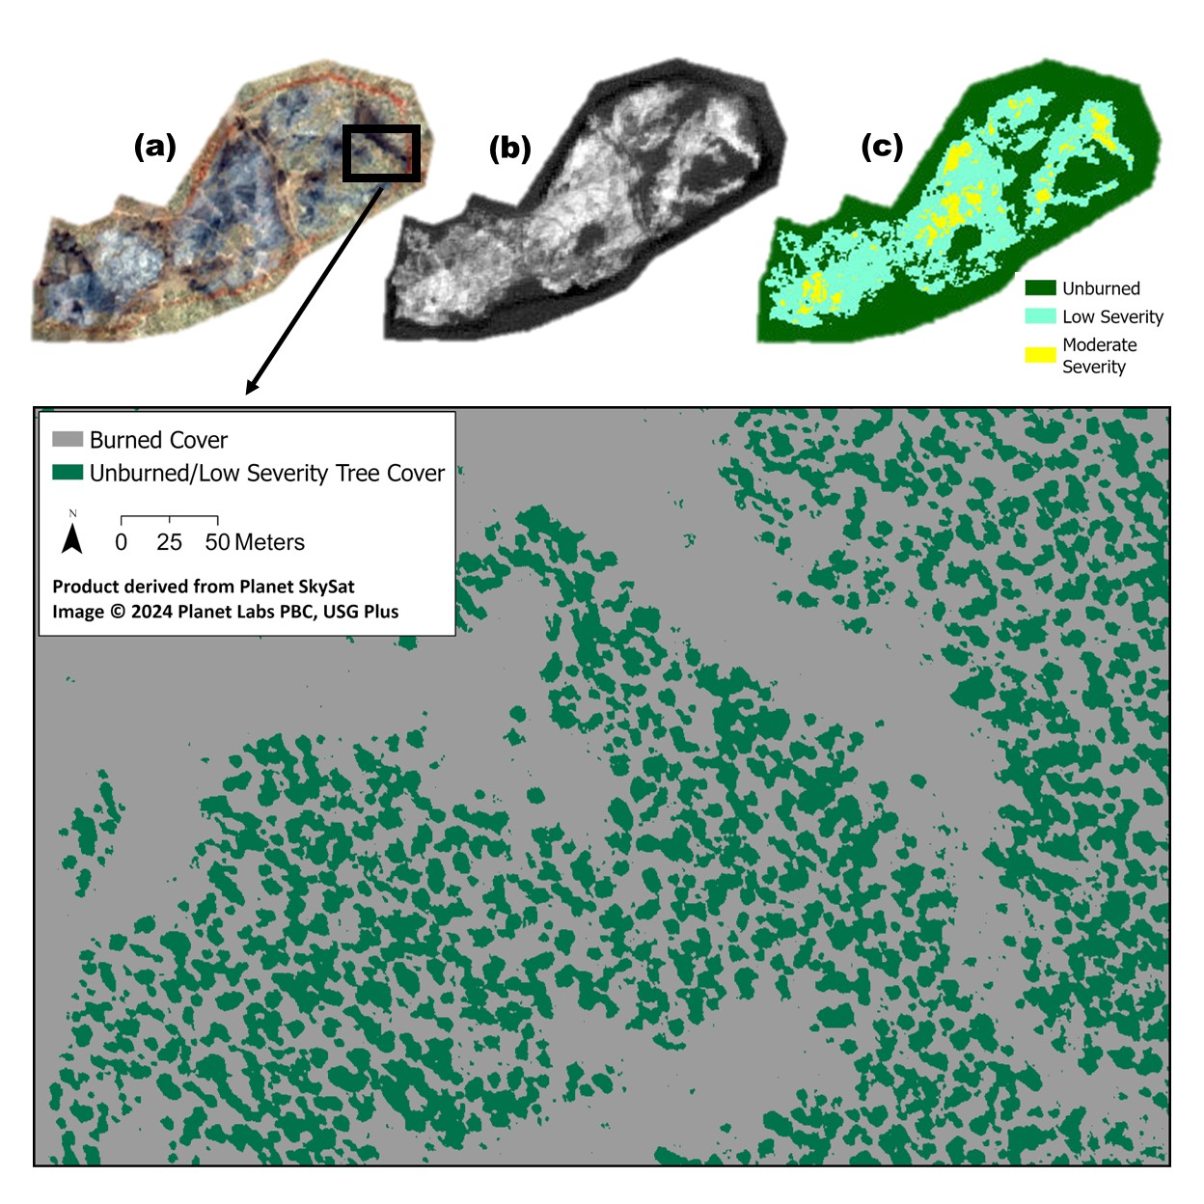
Caption for Graphic or Image: Examples of satellite imagery-derived products supporting BLM Emergency Stabilization and Rehabilitation (ESR). Products were developed for the Cox Pond Fire (2024), located upon lands administered by the Arizona Strip District Office. Figs (a)-(c) show Sentinel-2 10-m resolution post-fire multispectral imagery, and derived products including (b) delta Normalized Burn Ratio (dNBR) from pre- and post-event scenes, and (c) fire severity. Fig (d) illustrates a 50-cm high-resolution product developed from commercial Planet SkySat collected after the fire. Burned cover are shown in grey. Very low severity to unburned tree cover are shown in green.
Author name: Christopher Cole, Pam Blackmore
Author business email: cjcole@blm.gov, pblackmore@blm.gov

DOI agency/bureau: BLM
USGS Mission Area:
USGS Program:
Cost Center:
Program Name2: Geospatial Imaging, National Operations Center
Project title: Fine Scale Vegetation Treatment Planning and Implementation
Project description: Managing landscapes for multiple uses often requires large scale interventions to restore ecosystem function. Vegetation treatments comprise an important component of ecological restoration. The BLM Arizona Strip District Office (ASDO) is implementing a series of vegetation treatments to achieve multiple agency goals, such as to promote and develop healthy, disturbance-resilient landscapes, and to improve wildlife habitat and grazing for livestock. Existing and desired future vegetation cover determine the treatment used for a particular site. For example, ponderosa forests may require prescribed burning of their understory, while shrublands encroached by pinyon and juniper woodlands often require mastication to restore the plant community. Detailed, accurate vegetation cover maps are needed, prior to treatment implementation, to ensure the appropriate method is used in each location. Remote sensing technologies have proven to be a cost-effective way to identify vegetation communities.

The National Operations Center (NOC) and ASDO produced a high-resolution landcover map identifying key vegetation types in the Castle Peak treatment area using the Random Forest (RF) machine learning (ML) algorithm. The RF classifier used WorldView-2 multispectral imagery, vegetation indices, and a lidar-derived canopy height model. The lidar and imagery were collected in 2022 and 2023, respectively. Our classification product included ponderosa pine, pinyon juniper, shrubland, grass and other herbaceous plants. We used a custom RF classifier, implemented in Google Earth Engine, with 200 trees. When compared with training data, our model’s overall accuracy was approximately 0.959 and the kappa coefficient was 0.945. All predictor variables were used in the classification, with the canopy height model having the greatest importance. The classification product has proven invaluable in determining where specific treatments should occur. This is part of a multi-scale strategy using remote sensing to assist with planning, implementing, and monitoring vegetation treatments on ASDO-managed lands.

Sensor Type: Lidar (terrestrial or bathymetric);Multispectral (approx. 4-12 bands);
Platform type: Airplane;Satellite;
URL:
Graphic or Image Upload: https://doimspp.sharepoint.com/sites/GS-EROSSCIENCESWI/Shared Documents/Communications Outreach/Documentation Science/DOI Remote Sensing Report/DOI RS Activities Report, 2024/Graphic or Image Upload/2024 DOI RS Report Cole Blackmore Fine Scale_Christopher Cole.jpg
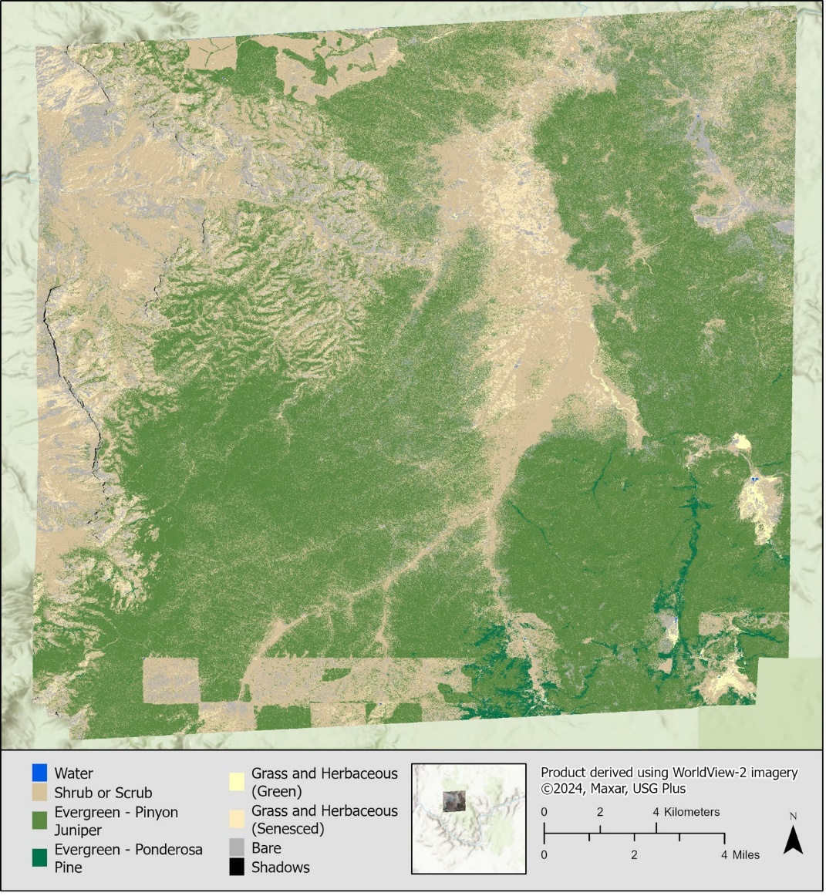
Caption for Graphic or Image: 2.4-meter resolution landcover classification of an area within the Arizona Strip District. Integrated vegetation management teams used this classification to differentiate pinyon juniper from ponderosa pine cover, and other treatment planning objectives.
Author name: Christopher Cole, Pamela Blackmore
Author business email: cjcole@blm.gov, pblackmore@blm.gov

DOI agency/bureau: BLM
USGS Mission Area:
USGS Program:
Cost Center:
Program Name2: Assessment, Inventory and Monitoring (AIM); Aquatics
Project title: Improving accessibility to data to support adaptive management and decision-making
Project description: In recent years, multiple modeled vegetation datasets have emerged and become operational for the western United States, enabling monitoring and analysis of shrubland, grassland, and woodland ecosystems at broad scales. Among these, fractional vegetation cover and herbaceous vegetation production products leverage the Landsat archive and Bureau of Land Management’s (BLM) Assessment, Inventory, and Monitoring (AIM) data to deliver remote sensing-based data tailored to a range of BLM priority decisions. The BLM’s AIM and Aquatics programs have partnered with the Climate Engine team at the Desert Research Institute (DRI) to streamline the availability of remotely sensed data (produced from the USDA and UC Merced) at the scale of BLM land units and alongside core drought and climate indicators.

The BLM Climate and Remote Sensing Data Reports website provides Site Characterization Reports (https://reports.climateengine.org/sitecharacterization) for every BLM state office, district office, field office, and grazing allotment in the conterminous United States for the period from 1986-present. The Site Characterization Reports combine four datasets: 1) Rangeland Analysis Platform (RAP) Vegetation Cover, 2) RAP Production, 3) gridMET, and 4) gridMET Drought. Within the reports, these datasets are summarized and visualized as maps, figures, and tables and collectively provide information on the status and trend of vegetation and climate variables, variability in vegetation communities across land units, and relationships between vegetation and climate. The reports are provided as PNG images and PDF files and the underlying data are provided as CSV files to streamline access to the data and to facilitate use in reporting.

A primary goal for BLM’s partnership with Climate Engine is to provide guidance for BLM staff on assimilating, interpreting, and applying remote sensing and climate data in monitoring and decision support. Through this project, we have developed two tutorial videos and supporting articles for the BLM Climate and Remote Sensing Data Reports. These tutorials are designed for BLM field office staff and provide practical demonstrations and explanations of each of the datasets and figures provided in the reports. The Site Characterization Reports tutorial can be found at https://support.climateengine.org/article/148-using-site-characterization. In addition to the Site Characterization Reports guidance, the reporting website provides near real-time Drought Reports (https://reports.climateengine.org/drought) and accompanying guidance (https://support.climateengine.org/article/128-rangeland-drought-assessment), which were recently included the BLM’s National Drought and Water Availability Instruction Memorandum (IM2024-034).
Sensor Type: Multispectral (approx. 4-12 bands);
Platform type: Satellite;
URL: https://reports.climateengine.org/sitecharacterization
Graphic or Image Upload: https://doimspp.sharepoint.com/sites/GS-EROSSCIENCESWI/Shared Documents/Communications Outreach/Documentation Science/DOI Remote Sensing Report/DOI RS Activities Report, 2024/Graphic or Image Upload/1 - OverviewFigure_Timothy Assal.png
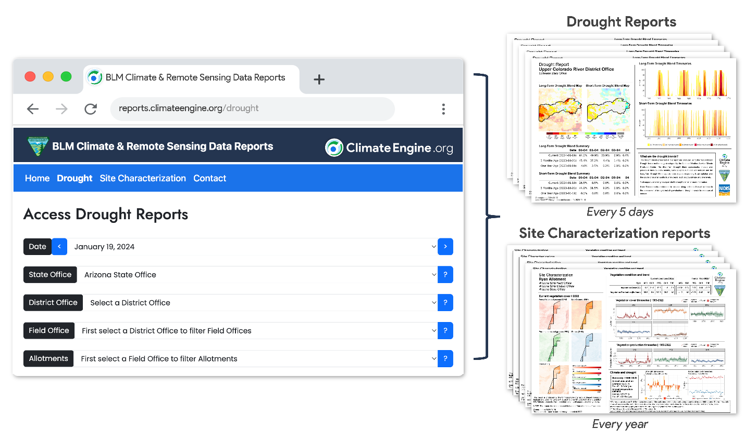
Graphic or Image Upload: https://doimspp.sharepoint.com/sites/GS-EROSSCIENCESWI/Shared Documents/Communications Outreach/Documentation Science/DOI Remote Sensing Report/DOI RS Activities Report, 2024/Graphic or Image Upload/2 - MultiscaleFigure_Timothy Assal.png
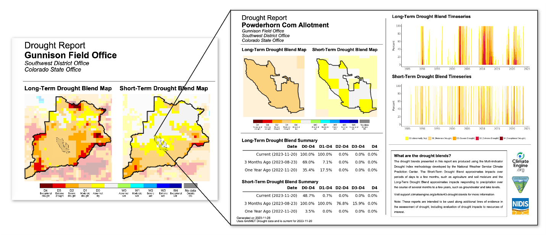
Caption for Graphic or Image: 1 - The new BLM Climate & Remote Sensing Data Reports website provides timely and consistent drought and site characterization reports, increasing accessibility to drought and satellite-based vegetation data for resource managers. (Figure: Eric Jensen, DRI)

2 - The reports are provided consistently for every BLM state office, district office, and field office in the contiguous United States. This consistency provides users with the ability to assess drought and vegetation condition at multiple scales across BLM-managed lands. (Figure: Eric Jensen, DRI)
Author name: Tim Assal
Author business email: tassal@blm.gov

