DOI agency/bureau: USGS
USGS Mission Area: Natural Hazards
USGS Program: Earthquake Hazard Program
Cost Center: **unspecified**
Program Name:
Project title: Satellite imaging of the 475 km (295 mile) long M7.7 Burma earthquake
Project description: Immediately following the devastating magnitude 7.7 earthquake in Burma (Myanmar), USGS scientists of the Earthquake Hazards Program, Geologic Hazards Science Center, and Earthquake Science Center rapidly mapped the 475 km long surface rupture to precisely pinpoint the location and extent of the earthquake. Scientists used pre- and post-earthquake imagery from USGS's Landsat 8 and 9 and the European Space Agency's Sentinel-1 and Sentinel-2 satellites to automatically image the full extent of the earthquake. Given the earthquake was twice as long as expected - due to anomalous "super shear" rupture - the satellite results proved critical in assessing the full extent of the disaster within a few days of its occurrence. The results were directly used in key USGS earthquake information products, like ShakeMap, and made publicly available through an emergency data release. This information provided direct benefit to decision makers and groups responding remotely and in-country to the earthquake disaster.
Desciption Link Overflow: https://earthquake.usgs.gov/earthquakes/eventpage/us7000pn9s/executive
https://experience.arcgis.com/experience/e40a6967c3ea42dd85bf44037e05482b
https://storymaps.arcgis.com/stories/5f3e33e35c5247c9bf5204fa0d6e56e5
Sensor Type: Multispectral (approx. 4-12 bands);IFSAR / SAR / Radar
Platform type: Satellite
URL: https://experience.arcgis.com/experience/e40a6967c3ea42dd85bf44037e05482b
Graphic or Image Upload:
Caption for Graphic or Image: Landsat-8 and 9 maps showing the full extent of the magnitude 7.7 Burma earthquake on March 28, 2025. The dates in the insets indicate the acquisition dates of pre- and post- earthquake images used in the analysis. The white dots show the locations of the mainshock and early afterhshocks reported by the USGS. The long, north south linear feature is the earthquake's surface rupture.
Author name: William Barnhart
Author business email: wbarnhart@usgs.gov

DOI agency/bureau: USGS
USGS Mission Area: Core Science Systems
USGS Program: National Land Imaging Program
Cost Center: Earth Resources Observation and Science (EROS) Center (Geography)
Program Name:
Project title: Rangeland Condition Monitoring Assessment and Projection (RCMAP) Ecological Potential
Project description: Rangelands occupy huge swathes of land in the U.S., typically where climate and soils are too harsh for either forest or agriculture. Rangeland ecosystems provide critical wildlife habitat, forage for livestock, carbon sequestration, provision of water resources, and recreational opportunities. At the same time, rangelands are vulnerable to changes in climate, fire, and anthropogenic disturbances. The arid-semiarid climate in most rangelands fluctuates widely, impacting livestock forage availability, wildlife habitat, and water resources. Many of these changes can be subtle or evolve over long periods, responding to both climate and anthropogenic driving forces.
Scientists from the U.S. Geological Survey (USGS) Earth Resources Observation and Science (EROS) Center and the Bureau of Land Management developed the Rangeland Condition Monitoring Assessment and Projection (RCMAP) project. This project quantifies the percent cover of rangeland components across the western United States using Landsat imagery from 1985–2024 in the current generation. The RCMAP product suite includes 10 fractional components (annual herbaceous, bare ground, herbaceous, litter, non-sagebrush shrub, perennial herbaceous, sagebrush, shrub, tree, and shrub height) and the temporal trends of each. The 2024 RCMAP release expands the study area to include the Great Plains. This dataset is designed for out-of-the-box application and provides a foundation for both historical and future monitoring at ecosystem scales.

To augment the value of RCMAP time-series data, a new generation of Ecological Potential (EP) data has been developed. Understanding of the potential vegetation conditions of a site in an undisturbed state is invaluable for interpreting trends, disturbance impact, and restoration targets. In many cases the number of representative points is limited or lacking altogether. Models used to predict EP cover were trained on ecologically intact sites where annual herbaceous cover is low, no known disturbance or land treatment has occurred over the study period, and bare ground cover is relatively lower than expectations. EP data aid in the interpretation of degradation and trends, and in setting restoration goals. The dynamic spatio-temporal reference for EP modeling results in maps of vegetation cover with limited influence from disturbance, drought, and invasive species. EP data can serve as a baseline for comparison of current rangeland vegetation conditions and trends. Contemporary component cover in 2024 was compared to EP cover to generate departure maps.
RCMAP fractional component time-series data spanning 1985–2024, trends analysis, and EP products are now available for download and on the rangelands viewer application.

Desciption Link Overflow:
Sensor Type: Multispectral (approx. 4-12 bands)
Platform type: Satellite
URL: https://www.mrlc.gov/data/project/rcmap
Graphic or Image Upload: https://doimspp.sharepoint.com/sites/GS-EROSSCIENCESWI/Shared Documents/Communications Outreach/Documentation Science/DOI Remote Sensing Report/DOI RS Activities Report, 2025/Question/bare_ground_departure_Matthew Rigge.jpg
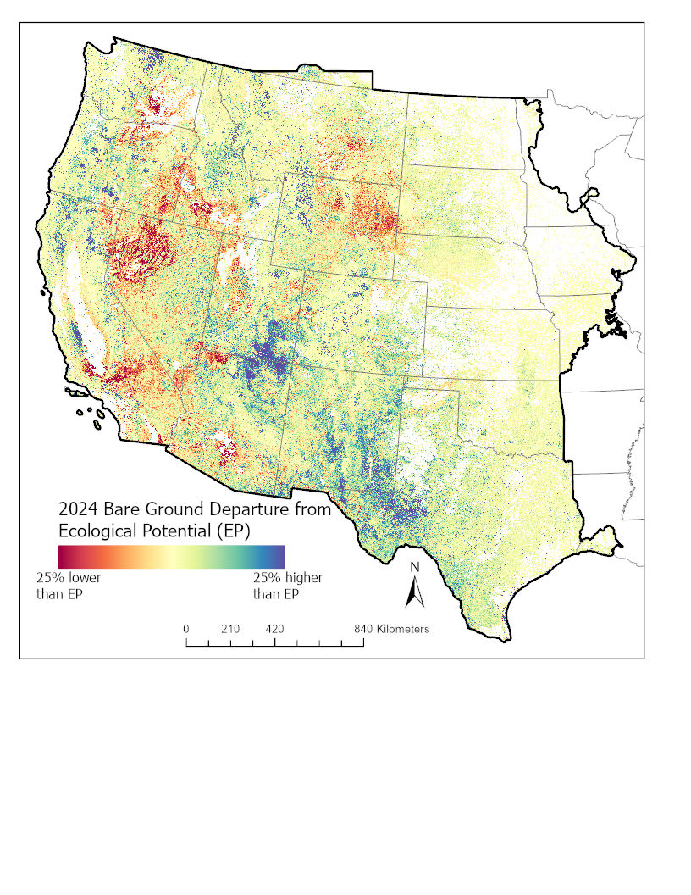
Caption for Graphic or Image: Departure of bare ground in 2024 from Ecological Potential (EP). White shading within the study area (black outline) indicates land cover masking. Many burned areas have higher bare ground than EP, while areas with high annual grass cover tend to have lower bare ground than EP.
Author name: Matthew Rigge
Author business email: mrigge@usgs.gov

DOI agency/bureau: USGS
USGS Mission Area: Core Science Systems
USGS Program: National Land Imaging Program
Cost Center: Earth Resources Observation and Science (EROS) Center (Geography)
Program Name:
Project title: Exotic Annual Grass Mapping: Understanding Fine Fuel Risk
Project description: Exotic annual grass (EAG) cover in rangelands threatens remaining shrubland core areas with shorter fire-return intervals, reduction in grazing forage, and sagebrush obligate species. Scientists from the U.S. Geological Survey (USGS) Earth Resources Observation and Science (EROS) Center and the Bureau of Land Management (BLM) developed fractional cover estimates for exotic annual grass (EAG) species and one native perennial grass species on a weekly basis from mid-April to late June 2025. The data were developed using BLM Assessment, Inventory, and Monitoring (AIM) data plots and weekly composites of Harmonized Landsat and Sentinel-2 (HLS) based Normalized Difference Vegetation Index (NDVI). The cover estimates reflect actual conditions of the previous week and are released in an expedited manner, within 7-13 days of the latest satellite observation used for that weekly prediction. Individual species maps were made for cheatgrass (Bromus tectorum), field brome* (Bromus arvensis), medusahead (Taeniatherum caput-medusae), and for Sandberg blue grass (Poa secunda), a native perennial but with similar phenology to many invasive grasses. These maps provide near-real time information on a critical component of the fine fuel load which can be helpful to understand local-regional fire risks.
The weekly maps of annual EAG cover are complement with annual maps of cover released following the end of the growing season. Expedited and Annual EAG maps are available at ScienceBase and on the MRLC Rangeland Viewer.

Desciption Link Overflow:
Sensor Type: Multispectral (approx. 4-12 bands)
Platform type: Satellite
URL: https://www.mrlc.gov/data/type/exotic-annual-grass
Graphic or Image Upload: https://doimspp.sharepoint.com/sites/GS-EROSSCIENCESWI/Shared Documents/Communications Outreach/Documentation Science/DOI Remote Sensing Report/DOI RS Activities Report, 2025/Question/2024_cheatgrass_cover_Matthew Rigge.jpg
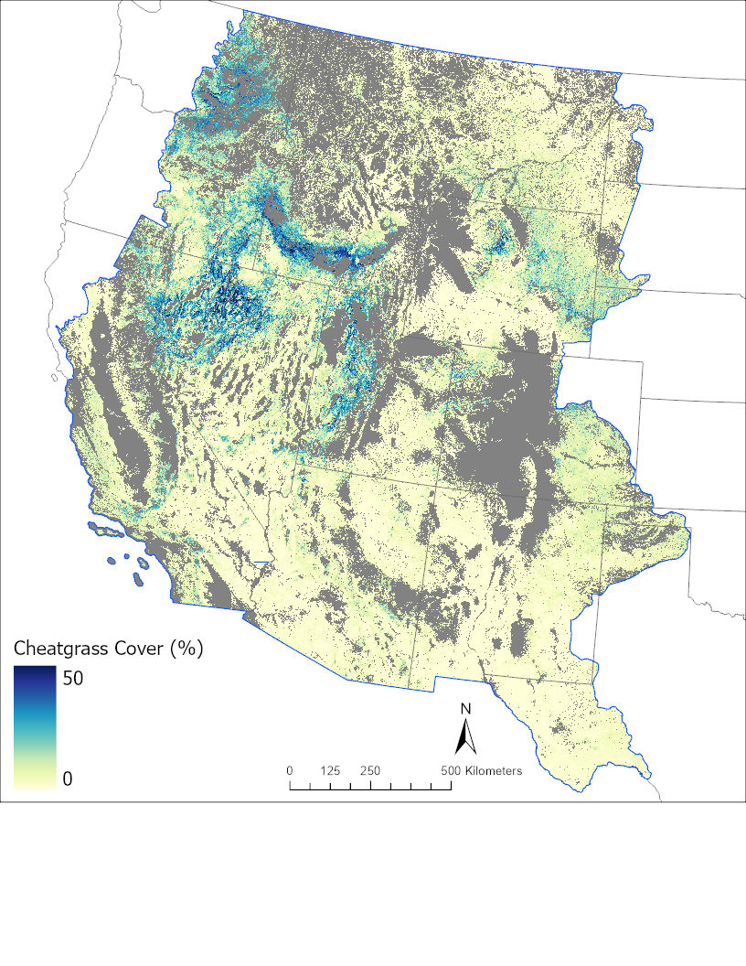
Caption for Graphic or Image: 2024 annual map of cheatgrass across the western U.S. Gray areas are non-rangeland (agriculture, water, urban) or are above 2350 m in elevation where invasive grass cover is scarce.
Author name: Matthew Rigge
Author business email: mrigge@usgs.gov

DOI agency/bureau: USGS
USGS Mission Area: Ecosystems
USGS Program: Land Change Science
Cost Center: Earth Resources Observation and Science (EROS) Center (Geography)
Program Name:
Project title: Increasing Accuracy of Remotely Sensed Evapotranspiration
Project description: Satellite-based estimations of evapotranspiration (ET) reveal how water moves from land to the atmosphere across different landscapes and time periods from individual fields to global scales. Several remotely sensed ET (RSET) products are available with the increasing public satellite missions and advances in ET modeling methods in recent decades. Despite the usefulness of RSET products, the accuracy of these products can vary across different land covers and regions depending on the methods used for ET estimations and inputs from satellite data and global weather datasets.

To improve the accuracy of these RSET products, a new technique called the Water Balance Equivalence (WABE) method was developed (Khand et al., 2025). This method helps correct inaccuracies in RSET products by applying bias corrections using a basin water balance ET (WBET). WABE combines the observed (precipitation minus streamflow) and modeled (for ungagged basins) WBET to generate a near-complete spatially continuous WBET dataset (Figure 1) for the conterminous United States (CONUS).

These modeled or “synthetic” WBET values were computed to fill the spatial gaps of observed WBET, which accounted for nearly half (44%) of the basins in the CONUS. They were simulated with high accuracy – within 2% across the entire CONUS and within 1–12% over 18 regional basins of CONUS. When the WABE-based correction was applied to the Landsat-based ET estimates from the SSEBop model (Senay et al., 2023), the overall bias dropped from 10% to 6% across 37 monitoring sites that use eddy covariance flux towers.

The WABE correction method has the potential to substantially enhance the accuracy of RSET products for numerous applications, including tracking water availability and use in different regions, building basin water budgets for managing water resources effectively and planning for agriculture, public water supply, energy, ecosystem services, and environmental sustainability.

Desciption Link Overflow:
Sensor Type: Thermal
Platform type: Satellite
URL: https://www.sciencedirect.com/science/article/pii/S002216942501162X?via%3Dihub
Graphic or Image Upload: https://doimspp.sharepoint.com/sites/GS-EROSSCIENCESWI/Shared Documents/Communications Outreach/Documentation Science/DOI Remote Sensing Report/DOI RS Activities Report, 2025/Question/HUC8_actual_and_synthetic_WBET_Gabriel Senay.jpg
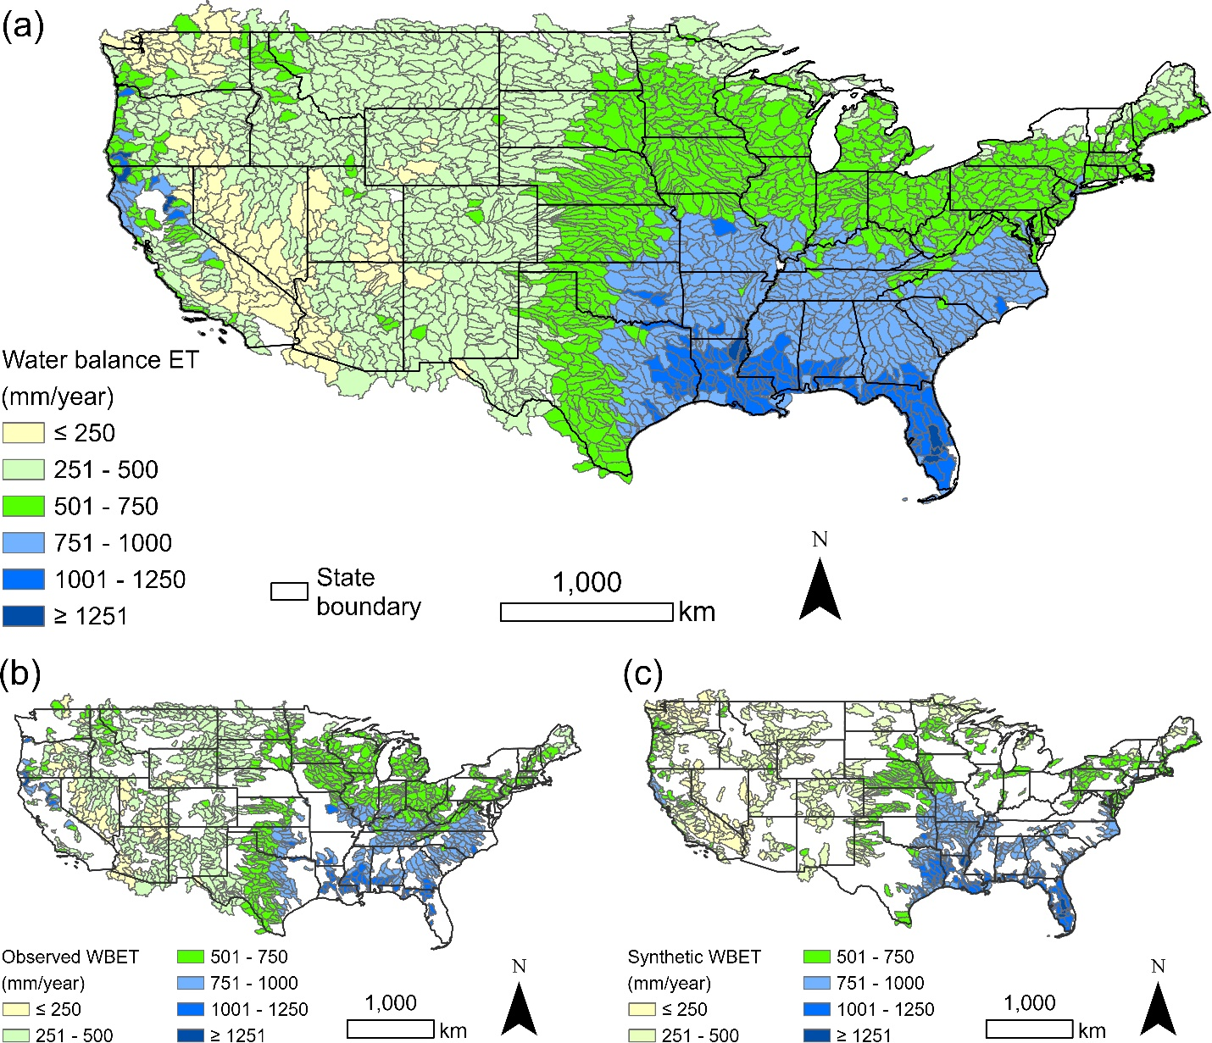
Caption for Graphic or Image: Map of water balance ET (WBET) of HUC8 (eight-digit hydrologic unit code) basins across the conterminous United States (CONUS). The union of observed WBET (b) and synthetic WBET (c) forms the WBET dataset for CONUS (a) which is useful for increasing accuracy of remotely sensed ET products.
Author name: Gabriel Senay
Author business email: senay@usg.gov

DOI agency/bureau: USGS
USGS Mission Area: Ecosystems
USGS Program: Land Management Research Program
Cost Center: Northern Prairie Wildlife Research Center
Program Name:
Project title: Mapping small waterbodies of large conservation concern
Project description: Millions of small waterbodies are dispersed throughout the middle of the North American continent, and billions of dollars have been invested to conserve, restore, and manage these waterbodies in the 20th and 21st centuries. Small waterbody conservation has been supported by different stakeholders aiming at improving water quality, enhancing floodwater storage, and supporting migratory bird breeding habitat. Conservation agencies are using hydrological and biological monitoring, modeling, and mapping to adaptively manage small waterbodies in the face of stressors such as invasive species and climate change. As remote sensing estimates of small waterbody surface water extent have become easier to access, understanding the capabilities and limitations of using remote sensing, especially in areas lacking surface water monitoring, is important for conservation decision making.

Scientists from the USGS Northern Prairie Wildlife Research Center collaborated with scientists with the USFWS Region 3 and Morris Wetland Management District to integrate water level monitoring and process-based hydrological modeling to test remote sensing accuracy, especially related to waterbody size, emergent aquatic vegetation cover, and climatic conditions. We found that the accuracy of satellite surface water estimates diminished for waterbodies < 2 ha. We also found that vegetation reduces accuracy of surface water detection, especially during wet years. Moving forward, we found that well-validated hydrologic models can be used to assess remotely sensed surface water estimates when on the ground monitoring may be limited. These results indicate that sensors commonly used for surface water applications alone may not be able to accurately detect small waterbody surface water, which supports the need for combining monitoring and modeling to understand how small waterbodies may respond to future changes in climate and land use.

These findings help inform management decision making across the USFWS National Wildlife Refuge System – including refuges, wetland management districts, that support a landscape scale network of small waterbodies and grasslands in waterfowl production areas and conservation easements.

Desciption Link Overflow: https://www.sciencedirect.com/science/article/pii/S1470160X25004558#f0005
Sensor Type: Multispectral (approx. 4-12 bands);IFSAR / SAR / Radar;Lidar (terrestrial or bathymetric);Camera
Platform type: Airplane;Satellite;Ground based / sensor web / web cam
URL: https://doi.org/10.1016/j.ecolind.2025.113525
Graphic or Image Upload: https://doimspp.sharepoint.com/sites/GS-EROSSCIENCESWI/Shared Documents/Communications Outreach/Documentation Science/DOI Remote Sensing Report/DOI RS Activities Report, 2025/Question/Fig 2- Side-by-Side_Owen Mckenna.png
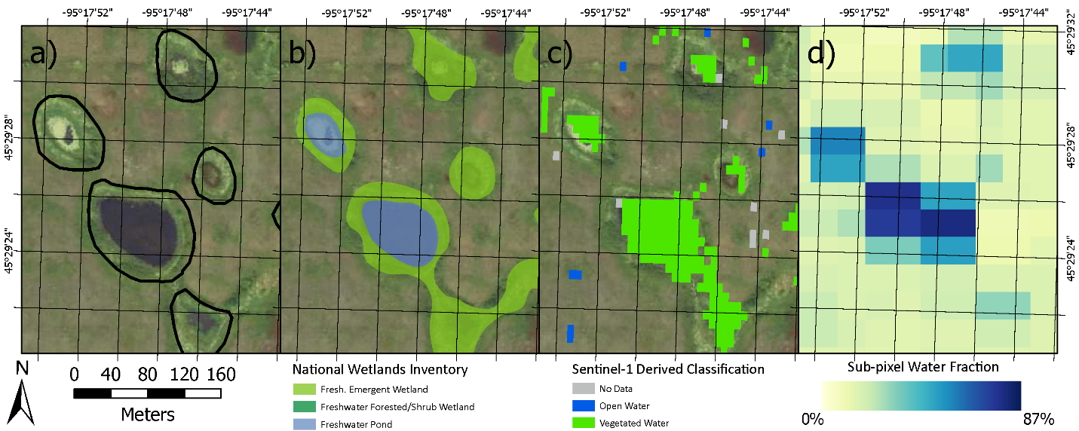
Caption for Graphic or Image: Five waterbodies represented by four different mapping techniques in the Nelson Lake Waterfowl Production Area, Minnesota, USA. (a) 1-meter resolution aerial imagery, with the maximum extent of the basins overlaid. (b) The waterbody complex as delineated and classified by the National Wetlands Inventory. (c) 10-meter satellite imagery (Sentinel-1) classified to Open Water and Vegetated Water extent. (d) 30-meter satellite imagery (Landsat) processed to estimate the fraction of each pixel containing surface water. Aerial imagery for panels A, B, & C from the 2019 US Department of Agriculture National Aerial Imagery Program.
Author name: Owen McKenna
Author business email: omckenna@usgs.gov

DOI agency/bureau: USGS
USGS Mission Area: Natural Hazards
USGS Program: Landslide Hazards Program
Cost Center: Geologic Hazards Science Center
Program Name:
Project title: Interagency landslide mapping response for Hurricane Helene
Project description: Between the 23–27 of September 2024, Hurricane Helene produced one of the most damaging weather events in southern Appalachia history. The resulting regional flooding, landslides, and tree blowdown caused over 100 fatalities, damaged or destroyed critical infrastructure and thousands of structures, and severed connectivity across the region. Together with state, federal, and local partners, the U.S. Geological Survey (USGS) activated their landslide emergency response team (LASER, Landslide Assessments, Situational awareness and Event Response research) to support partner agencies, emergency responders, and search and rescue efforts. LASER coordinated a large interagency effort (https://www.usgs.gov/programs/landslide-hazards/science/2024-hurricane-helene-landslide-hazards), which included rapid remote, aerial, and field mapping of landslides and impacts, hazard modeling and assessments, daily situational reports relaying landslides of concern, and educational and outreach material development.

Over the next several weeks, scientists from 5 USGS science centers (Geologic Hazards Science Center; Geology, Minerals, Energy, and Geophysics Science Center; Florence Bascom Geoscience Center; Earthquake Science Center; Upper Midwest Water Science Center) and 9 partner agencies mapped over 2,000 landslides using data from aerial photos, satellite imagery, derivative products such as satellite Normalized Difference Vegetation Index (NDVI) change maps, and field observations (https://www.sciencebase.gov/catalog/item/66fc243cd34e3d9dd5de00f2). Landslide locations, impacts, and assessments were shared with emergency response personnel (https://www.usgs.gov/publications/preliminary-field-report-landslide-hazards-following-hurricane-helene) and updated in real time via a web-based dashboard (https://www.arcgis.com/apps/dashboards/01b4f51fc0b64002bf7722a9acfc181d). The widespread landslide impacts across remote mountainous areas, lack of field access in the beginning of the response, and necessity to share information across multiple agencies made open access, remotely sensed data critical for this collaborative mapping effort.

Scientists at the USGS Geologic Hazards Science Center continue to investigate this widespread landsliding event to inform landslide loss reduction in the region considering meteorological, geomorphic, and geologic factors. Looking forward, factors such as tree blowdown, undercutting and oversteepening of slopes, and incipient landslide formation may exacerbate landslide hazard in some areas. Future efforts using high resolution remote sensing data such as regional lidar will continue to unravel the nature and extent of landslides and their effects in southern Appalachia and similar environments.

Desciption Link Overflow:
Sensor Type: Multispectral (approx. 4-12 bands);Camera;IFSAR / SAR / Radar
Platform type: Airplane;Helicopter;Satellite
URL: https://www.usgs.gov/programs/landslide-hazards/science/2024-hurricane-helene-landslide-hazards
Graphic or Image Upload: https://doimspp.sharepoint.com/sites/GS-EROSSCIENCESWI/Shared Documents/Communications Outreach/Documentation Science/DOI Remote Sensing Report/DOI RS Activities Report, 2025/Question/HeleneLandslides_Lauren Schaefer.png
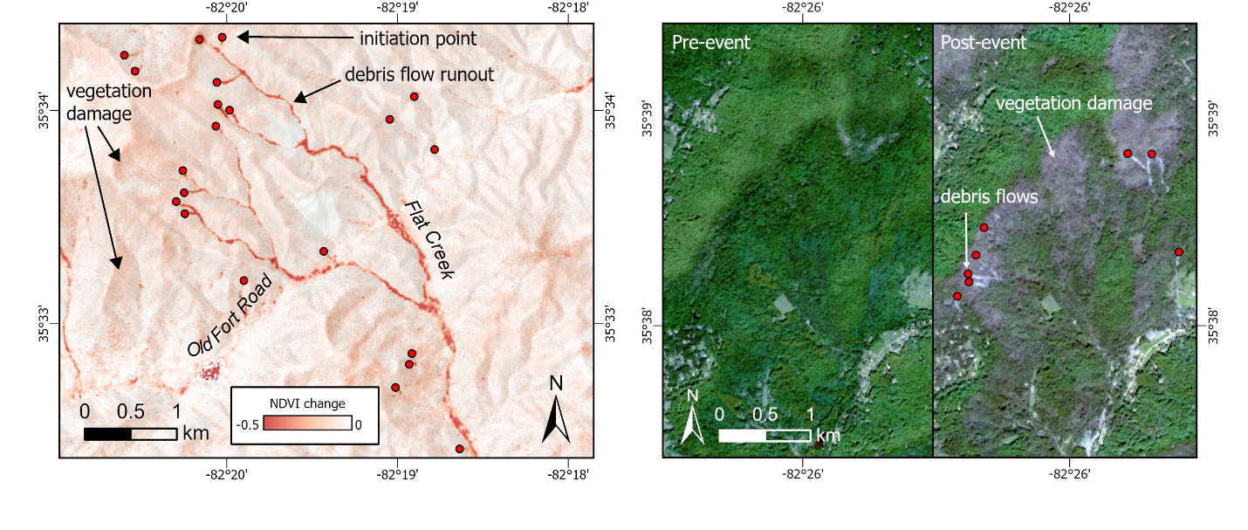
Caption for Graphic or Image: (left) Sentinel-2 Normalized Difference Vegetation Index (NDVI) image highlighting at least 11 source areas that converged into Flat Creek and traveled downstream (south in image), producing a long runout debris flow. Negative values highlight areas where vegetation was present pre-event and has subsequently been removed or damaged post-event. (right) Pre- (22 September 2024) and post-event (12 October 2024) red-green-blue (RGB) Sentinel-2 imagery highlighting debris flows among areas of extensive vegetation damage and tree blowdown.
Author name: Lauren N. Schaefer
Author business email: lschaefer@usgs.gov

DOI agency/bureau: USGS
USGS Mission Area: Core Science Systems
USGS Program: Coastal/Marine Hazards and Resources Program
Cost Center: Earth Resources Observation and Science (EROS) Center (Geography)
Program Name:
Project title: USGS Satellite-derived Bathymetry (SDB) Methods for Integrated Science Applications
Project description: Satellite-Derived Bathymetry (SDB) offers a valuable solution for mapping shallow coastal waters, especially where conventional acoustic methods are limited. Near-shore zones, often called the "white ribbon surf zone", remain difficult to map because vessels collecting acoustic bathymetric soundings cannot safely operate close to shore. These areas also contain spatial gaps in bathymetry and lack sufficient coverage for integrated modeling such as with the USGS Coastal National Elevation Database (CoNED) high-resolution topobathymetric digital elevation models (TBDEMs). Alternatively, optical green topobathy lidar sensors have been highly successful in mapping the littoral zone in 0 to 10 meter water depths. However, lidar and other optical systems are sensitive to environmental conditions, such as bottom type reflectivity, water surface, and most importantly turbidity. Water clarity impacts all optical based systems, but satellites like Landsat or Sentinel offer the repeatability to acquire data on days when waters are clearer or with minimal clouds or haze.

To address these issues, the U.S. Geological Survey (USGS) Earth Resources Observation and Science (EROS) Center and USGS Geology, Minerals, Energy, and Geophysics Science Center through a collaboration between the USGS CoNED Applications Project and USGS EROS Cal/Val Center of Excellence (ECCOE) Project have published two novel SDB methods using stereo photogrammetry based on WorldView imagery and a physics-based approach using ocean optics and optical inversion built on Landsat 8 and 9 imagery. Both approaches can map bathymetry to water depths exceeding 25 meters with vertical accuracy performance better in shallower depths from 0 to 10 meters. One major advantage of both methods is that they do not require external reference data to obtain actual water depths, but results can be improved with an alignment to higher accuracy data such as NASA ICESat-2 ATL24 bathymetry data. ICESat-2 provides an integrated satellite-borne solution to higher accuracy SDB. Under suitable optical conditions, SDB can fill in critical gaps in regional coastal and riverine modeling applications where cross-shore and cross-bank information supply foundational information for hydrologic, hydrodynamic, inundation, and sediment-transport modeling.

SaTSeaD: Satellite Triangulated Sea Depth Open-Source Bathymetry Module at https://www.mdpi.com/2072-4292/15/16/3950

Physics-Based Satellite-Derived Bathymetry (SDB) Algorithm at https://www.mdpi.com/2072-4292/16/5/843
Desciption Link Overflow:
Sensor Type: Multispectral (approx. 4-12 bands);Stereo
Platform type: Satellite
URL:
Graphic or Image Upload: https://doimspp.sharepoint.com/sites/GS-EROSSCIENCESWI/Shared Documents/Communications Outreach/Documentation Science/DOI Remote Sensing Report/DOI RS Activities Report, 2025/Question/FL_2methods_v2a_Jeffrey Danielson.jpg
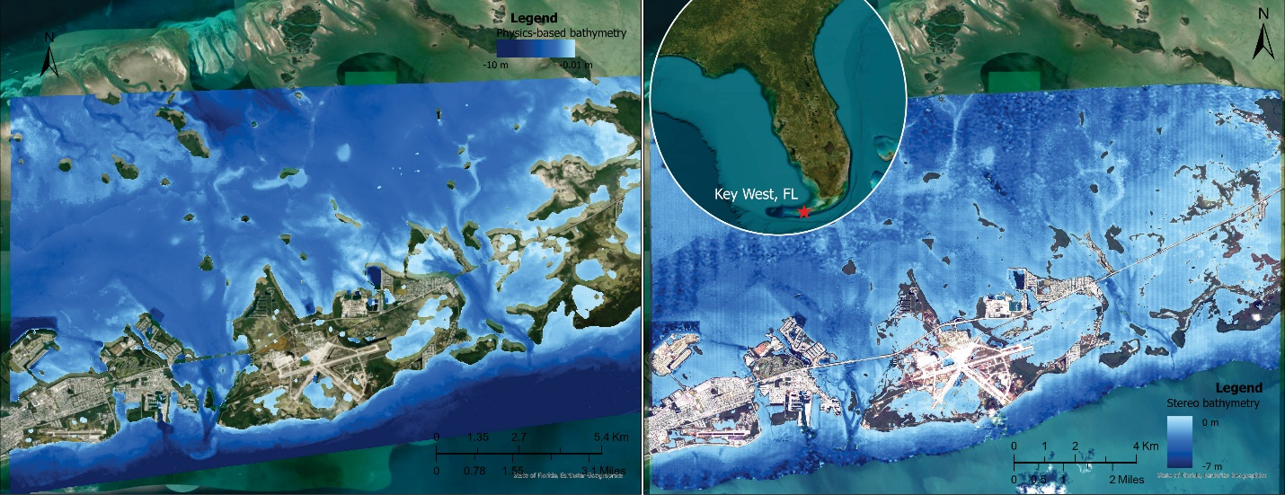
Caption for Graphic or Image: USGS SDB Results at 30 m (Left, Landsat 9, Physics-Based Method) and at 2 m (Right, WorldView-2, Stereo Photogrammetric Method)
Author name: Jeffrey Danielson
Author business email: daniels@usgs.gov

DOI agency/bureau: USGS
USGS Mission Area: Core Science Systems
USGS Program: Astrogeology
Cost Center: Astrogeology Science Center
Program Name:
Project title: Artemis Landing Site Validation and Verification
Project description: The USGS Astrogeology Science Center is reviewing the geospatial data that NASA is using to select landing sites for the return of US astronauts to the surface of the Moon. The center's broad expertise in all aspects of lunar science and cartography provide a unique capability to ensure that the topographic maps and image mosaics of the lunar south pole have the requisite quantity and quality. We are especially focused on quantifying the uncertainties in the datasets so the risks to our astronauts are understood.
Desciption Link Overflow:
Sensor Type: Camera;Lidar (terrestrial or bathymetric);Multispectral (approx. 4-12 bands)
Platform type: Satellite
URL:
Graphic or Image Upload:
Caption for Graphic or Image:
Author name: Laszlo Kestay
Author business email: laz@usgs.gov

DOI agency/bureau: USGS
USGS Mission Area: Ecosystems
USGS Program: Science Support
Cost Center: Western Ecological Research Center
Program Name:
Project title: Aerial imagery and structure-from-motion for islands of the Oregon Coast National Wildlife Refuge, USA
Project description: On 15 August 2024 USGS Western Ecological Research Center scientists teamed up with US Coast Guard Air Station North Bend, OR to fly a remote sensing mission to collect hi-resolution aerial imagery to render orthomosaics and detailed digital topography for 9 islands in the Oregon Coast National Wildlife Refuge Complex. USGS successfully collected and assembled new, high-resolution (~1 cm) digital orthoimagery for the islands and used structure from motion (SfM) to generate hi-resolution (~0.5 m) orthoDEM layers. USGS has developed SfM to become a low-cost technique for coastal change assessments and has developed a robust and tested workflow. The innovative technique uses camera locations and ground control points to produce accurate, high precision digital elevation models (DEMs) and orthorectified color imagery from a set of digital stills. The low-cost imagery-generated data can replace expensive survey techniques including aerial light detection and ranging (LIDAR) and terrestrial laser scanning—and offers the added benefit of including hi-res photographic images. Our new image products inform landscape-level conservation science to evaluate species abundances and habitat change, including the spread of invasive vegetation and ongoing erosion. This information is important for supporting the Refuge’s Comprehensive Conservation Plan that calls on USGS to help establish long-term seabird research to better understand the interrelationship of physical and biological factors that shape refuge lands and resources. Specifically, the Plan calls for assessing the abundance of cryptic burrow- and crevice-nesting seabirds every 10 years. Our new GIS-based imagery forms the foundation to improve, spatially-informed inventory and monitoring for seabirds and plants on the Refuge’s islands. The goal is to deliver a robust baseline that can inform invasive plant management and assess quantitative changes in abundance and habitat for important and unique burrow-nesting seabirds in the future.
Desciption Link Overflow:
Sensor Type: Camera
Platform type: Helicopter
URL:
Graphic or Image Upload: https://doimspp.sharepoint.com/sites/GS-EROSSCIENCESWI/Shared Documents/Communications Outreach/Documentation Science/DOI Remote Sensing Report/DOI RS Activities Report, 2025/Question/unnamed island 106 OCNWRC_Josh Adams.jpg
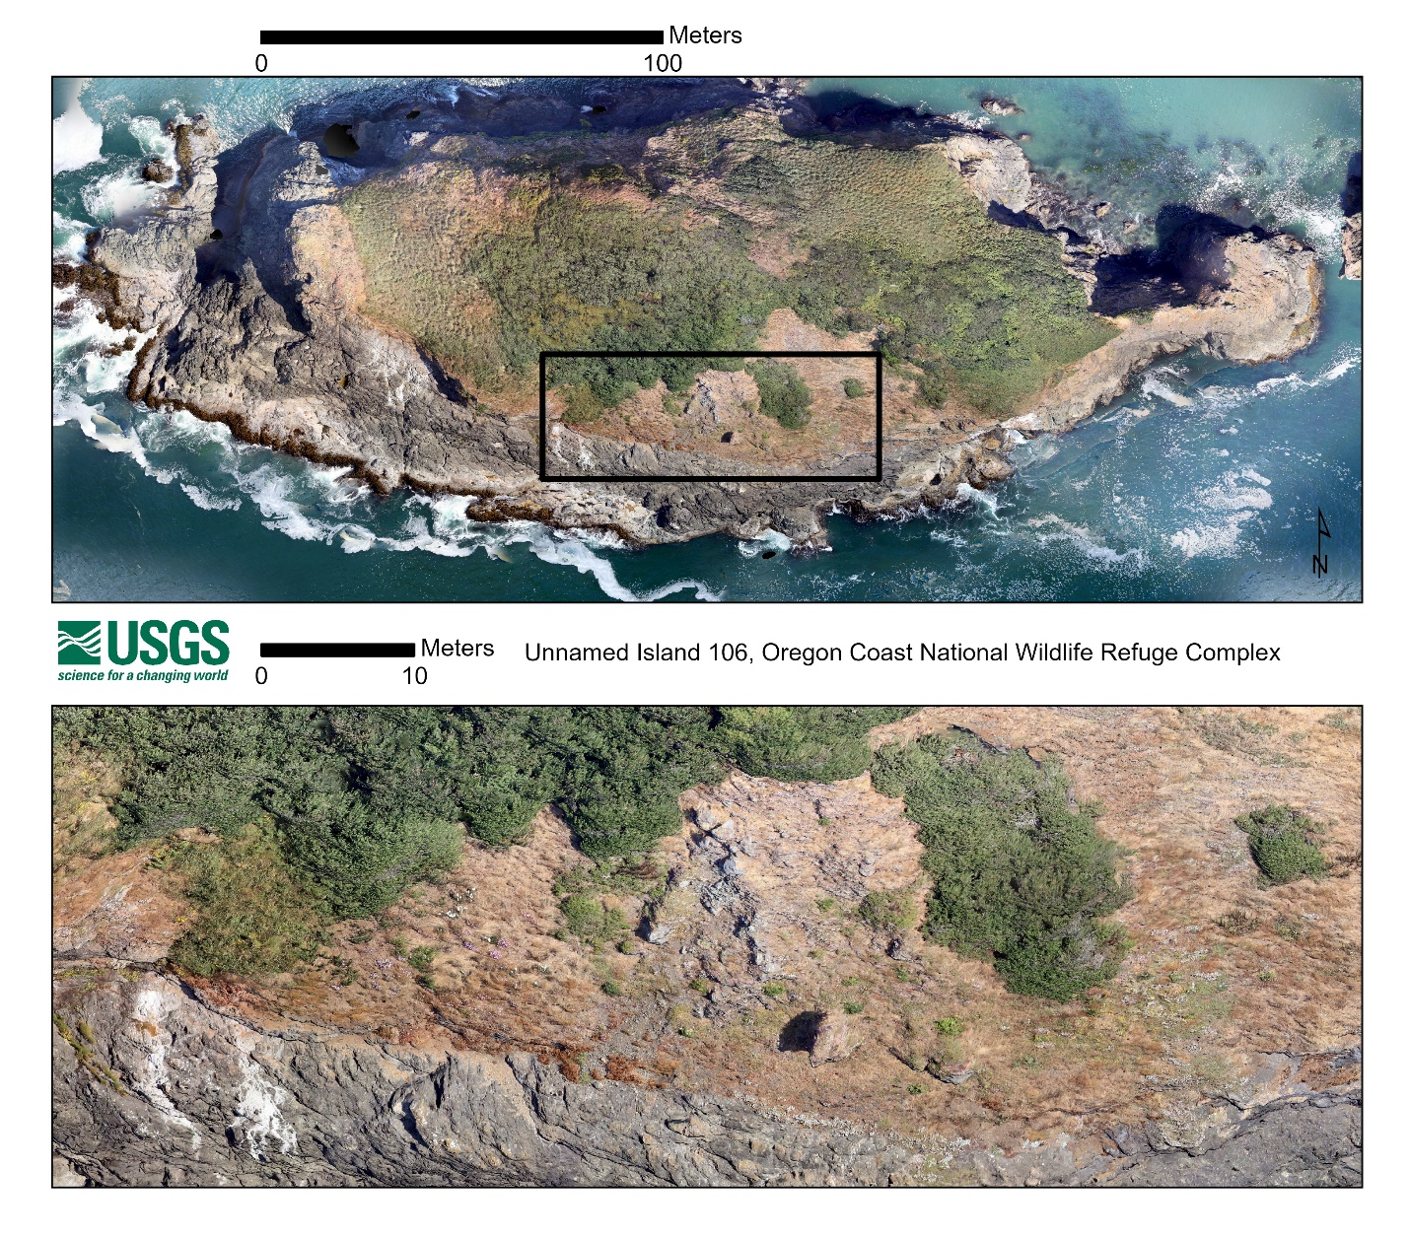
Caption for Graphic or Image: Orthoimage of "Unnamed Island 106", Oregon Coast National Wildlife Refuge (top panel) and zoomed-in section (bottom panel) showing hi-resolution, cm-scale imagery used to resolve substrate type and vegetative cover and composition. (Photos by J. Adams orthomosaic rendered by G. Haight, USGS WERC)
Author name: Josh Adams
Author business email: josh_adams@usgs.gov

DOI agency/bureau: USGS
USGS Mission Area: Core Science Systems
USGS Program: National Land Imaging Program
Cost Center: Western Geographic Science Center
Program Name:
Project title: Global food and water security Support Analysis Data (GFSAD).
Project description: The overarching goal of the global food security-support analysis data (GFSAD) project is to develop comprehensive data and products in support of global food and water security in the twenty-first Century. This is achieved by developing cropland models, maps, and monitoring tools leading to a wide array of products using machine learning algorithms (MLAs), satellite sensor based big-data analytics, and cloud-computing.

This study presents discusses the global food security-support analysis data (GFSAD) Landsat-derived Rainfed and Irrigated-area Product @ 30m for the nominal year 2020 version 2 (GFSADLRIP30 V002; Figure 1) for the CONUS. The LRIP30V002 cropland product was generated using Landsat-8 time-series data, multiple supervised and unsupervised MLAs such as random forest, support vector machines, ISOCLASS clustering algorithm, and spectral matching techniques (e.g., Thenkabail et al., 2021, 2009, 2007; Oliphant et al., 2019; Teluguntla et al., 2018, 2017, 2015; Xiong et al., 2017; Gumma et al., 2022, 2020; Phalke et al., 2020), utilizing the Google Earth Engine (GEE) (Gorelick at al., 2017) and\or other cloud platforms.

The LRIP30 V002 for the CONUS includes five products across three levels:
Level 1 – Generic disaggregated classes of irrigated and rainfed croplands
Level 2 – Aggregated cropping intensity classes of irrigated and rainfed croplands
Level 3 – Final consolidated irrigated and rainfed cropland classes

The five products are:
1. Landsat-Derived Rainfed and Irrigated-Cropland Product L3 2020 30 m V002
2. Landsat-Derived Rainfed-Cropland Product L1 30 m V002
3. Landsat-Derived Irrigated-Cropland Product L1 30 m V002
4. Landsat-Derived Rainfed-Cropland Product L2 30 m V002
5. Landsat-Derived Irrigated-Cropland Product L2 30 m V002

The LRIP30 product for CONUS version 2 (LRIP30 V002) was evaluated for accuracies, errors, precision, and uncertainties. The resulting error matrix showed an overall accuracy of 93.9%. The irrigated class has a producer’s accuracy of 90.2% (errors of omission = 9.8%) and user’s accuracy of 90.8% (errors of commission = 9.2%). This shows that nearly 90% of all irrigated areas are accurately captured and only about 9% non-irrigated areas (User’s accuracy 91%) are mapped as irrigated. The rainfed class has a producer’s accuracy of 95.7% (errors of omission = 4.3%) and user’s accuracy of 95.4% (errors of commission = 4.6%). This shows that nearly 95% of all rainfed areas are accurately captured and about 5% non-rainfed areas are mapped as rainfed. Some mixing cannot be avoided. Overall, these results clearly indicate high accuracies in both irrigated and rainfed cropland mapping. Irrigated and rainfed area statistics for each state of CONUS was computed. The five leading states by net irrigated areas (NIAs) are Nebraska, Texas, Kansas, California, and Arkansas. The five leading states by net rainfed areas (NRAs) are Iowa, North Dakota, Illinois, Minnesota, and South Dakota. Further we estimated irrigated and rainfed areas of all counties of CONUS. The LRIP30 V002 for CONUS 2020 data product was released and accessible through

https://lpdaac.usgs.gov/products/lgrip30_l3v002/
or
LRIP 2020 data download site @ EARTHDATA
https://www.earthdata.nasa.gov/data/catalog/lpcloud-lgrip30-l3-002

1. Conterminous USA (CONUS) Irrigated & Rainfed @30m Level 3 (L3):
https://lpdaac.usgs.gov/products/lgrip30_l3v002/

2. Conterminous USA (CONUS) Irrigated @ 30m Level 2 (L2):
https://lpdaac.usgs.gov/products/lgrip30_l2_irriv002/

3. Conterminous USA (CONUS) Irrigated @ 30m Level 1 (L1):
https://lpdaac.usgs.gov/products/lgrip30_l1_irriv002/

4. Conterminous USA (CONUS) Rainfed @ 30m Level 2 (L2)
https://lpdaac.usgs.gov/products/lgrip30_l2_rainv002/

5. Conterminous USA (CONUS) Rainfed @ 30m Level 1 (L1)
https://lpdaac.usgs.gov/products/lgrip30_l1_rainv002/

The data can be browsed in full resolution at:
https://www.usgs.gov/apps/croplands/app/map
Desciption Link Overflow: https://www.earthdata.nasa.gov/data/alerts-outages/lgrip30-version-2-data-products-released
Sensor Type: Multispectral (approx. 4-12 bands)
Platform type: Satellite
URL: https://www.usgs.gov/centers/western-geographic-science-center/science/global-food-and-water-security-support-analysis
Graphic or Image Upload: https://doimspp.sharepoint.com/sites/GS-EROSSCIENCESWI/Shared Documents/Communications Outreach/Documentation Science/DOI Remote Sensing Report/DOI RS Activities Report, 2025/Question/Figure1_Pardhasaradhi Telugu.png
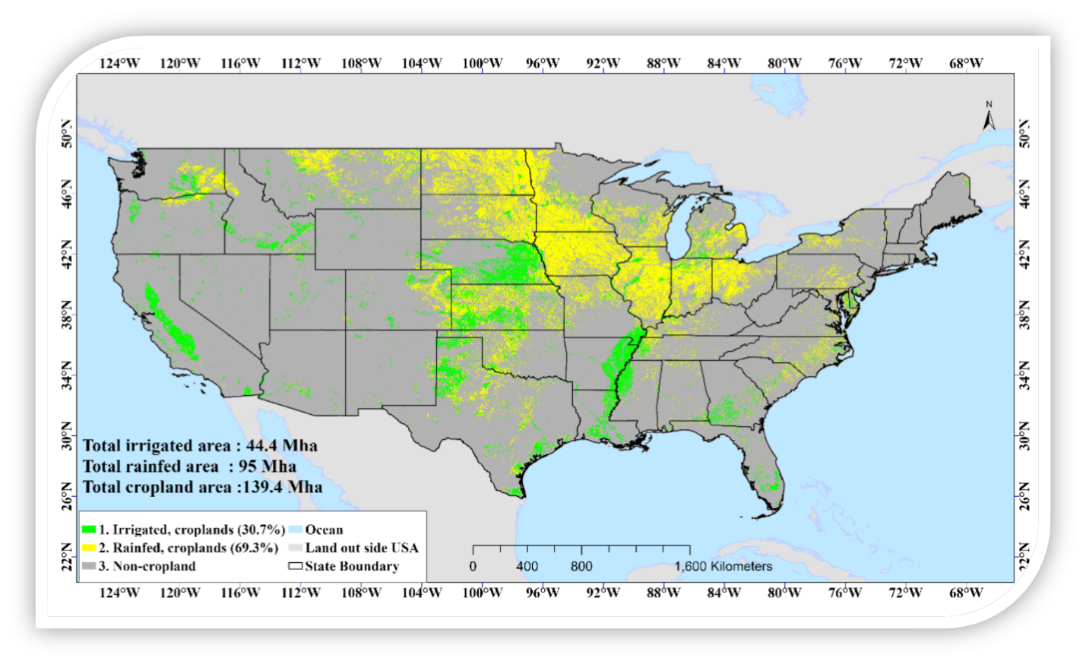
Caption for Graphic or Image: Irrigated and Rainfed cropland map of conterminous United States (CONUS) for the year 2020 based on Landsat 30 m satellite data.
Author name: Pardhasaradhi Teluguntla
Author business email: pteluguntla@usgs.gov

DOI agency/bureau: USGS
USGS Mission Area: Core Science Systems
USGS Program: National Geospatial Program
Cost Center: National Geospatial Program
Program Name:
Project title: High-Resolution Elevation Data Used to Derive Precise Hydrography Features in Eastern Tennessee
Project description: The U.S. Geological Survey acquired high-resolution lidar data in 2016 for 7,769 square miles in eastern Tennessee (TN) as part of an ongoing effort to complete the 3D Elevation Program (3DEP; https://www.usgs.gov/3d-elevation-program) baseline dataset. In 2023, the lidar-derived bare earth elevation data were used for a 3D Hydrography Program (3DHP; https://www.usgs.gov/3d-hydrography-program) project deriving hydrography features, such as lakes, streams, and drainage areas, for a 349 square mile area in eastern TN comprising the Holston River 10-digit hydrologic unit. In July 2025, the elevation-derived hydrography data were published and made publicly available through the 3DHP web feature service. Publication of these 3DHP data online represents a milestone in the development of the next generation hydrography and elevation programs that will directly contribute to the 3D National Topography Model (3DNTM; https://www.usgs.gov/3d-national-topography-model) to better integrate hydrography and elevation data. It is estimated that the fully implemented 3DHP has the potential to provide more than $1 billion in benefits to federal, state, Tribal, territorial, and local governments and others every year, in addition to myriad societal benefits. The 3DHP will directly support better water resources decision-making by providing more accurate, complete, and integrated information than is currently available. The 2016 elevation and 2023 hydrography projects in TN were funded by federal, state, and local partners in order to meet the need for current high-resolution digital elevation and hydrography data, share costs, and eliminate duplication of efforts among the partners.
Desciption Link Overflow:
Sensor Type: Lidar (terrestrial or bathymetric)
Platform type: Airplane
URL: https://www.usgs.gov/3d-hydrography-program/news/usgs-announces-release-updated-3d-hydrography-program-data-service
Graphic or Image Upload: https://doimspp.sharepoint.com/sites/GS-EROSSCIENCESWI/Shared Documents/Communications Outreach/Documentation Science/DOI Remote Sensing Report/DOI RS Activities Report, 2025/Question/Figure_Eliza Gross.jpg
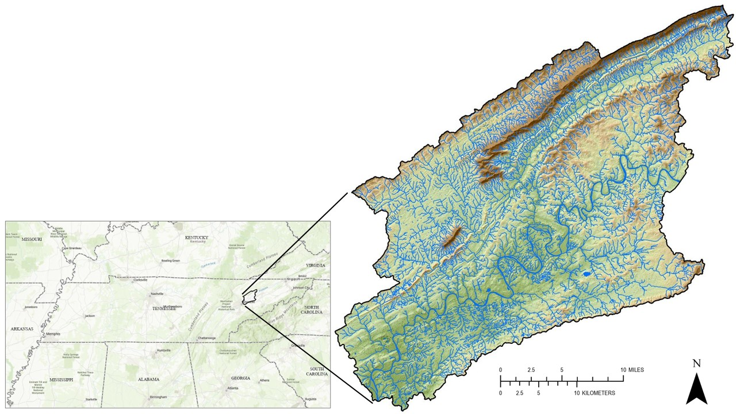
Caption for Graphic or Image: Elevation-derived hydrography data from the 2023 Holston River 10-digit hydrologic unit project overlaid with high-resolution elevation data from the 2016 eastern Tennessee project.
Author name: Eliza Gross
Author business email: egross@usgs.gov

DOI agency/bureau: USGS
USGS Mission Area: Core Science Systems
USGS Program: National Land Imaging Program
Cost Center: Geosciences and Environmental Change Science Center
Program Name:
Project title: From Drones to Space: Mapping Biological Soil Crusts and Mineral Resources
Project description: Airborne and satellite hyperspectral sensors are key to locating and mapping critical mineral resources in arid regions of the Western United States. Two recent missions aimed at mapping mineral and biological resources include the U.S. Geological Survey (USGS) and National Aeronautics and Space Administration (NASA)’s Geological Earth Mapping Experiment (GEMx) equipped with AVIRIS (Airborne Visible/Infrared Imaging Spectrometer) and MASTER (MODIS/ASTER Airborne Simulator) instruments, and NASA’s Earth Surface Mineral Dust Source Investigation (EMIT) imaging spectroscopy instrument on the International Space Station. While lab-based spectroscopy can identify pure spectral signatures of different minerals, field campaigns are needed to quantify the contribution of non-mineral spectra to the signals observed by GEMx and EMIT, helping to calibrate sensor data and improve algorithms to accurately map both biotic and mineral surface properties.

The spatial resolution (area seen on the ground by a pixel) of the GEMx and EMIT imagery is approximately 15 to 60 meters, respectively. Within a single pixel, multiple soils, mineral types, and other materials of interest can be present. Biological soil crusts (biocrusts - communities of cyanobacteria, algae, lichens, mosses, fungi, and other microbes) are ubiquitous across dryland ecosystems, and biocrust community composition and cover are shown to differ across soil mineralogy and texture. Despite the important impact of biocrusts on soil stability, dust emissions, and soil resource availability, determining their spatial distribution, composition, and condition on a broad scale remains a challenge. Incorporating field observations and centimeter-level drone data will help USGS researchers develop data processing techniques to better discern mixed materials present within the coarse pixels of crewed airplane- and satellite-based spectral remote sensing imagery.

In May 2025, Sasha Reed of the Southwest Biological Science Center, Miguel Villarreal of the Western Geographic Science Center (WGSC), and William Kolby Smith of the University of Arizona led a collaborative field campaign near Moab, Utah. USGS remote pilots from the WGSC and National Uncrewed Systems Office (NUSO) collected natural color, multispectral, hyperspectral, and thermal drone imagery over dryland sites with different vegetation and soils. Field-based measurements of vegetation type and location, biocrust cover, composition, surface roughness, and reflectance were collected to relate with the remotely sensed imagery. Spectral measurements were also collected at a nearby airport to support GEMx radiometric calibration.

Combining data across these scales will improve hyperspectral remote sensing mapping capabilities in dryland environments, ultimately leading to more accurate maps of terrestrial natural resources including critical minerals, vegetation, soils, and biocrusts.
Desciption Link Overflow:
Sensor Type: Hyperspectral;Multispectral (approx. 4-12 bands);Thermal
Platform type: Ground based / sensor web / web cam;UAS;Satellite;Airplane
URL: Geological Earth Mapping Experiment (GEMx): https://science.nasa.gov/mission/gemx/ ; Earth Surface Mineral Dust Source Investigation (EMIT): https://earth.jpl.nasa.gov/emit/ ; USGS National Uncrewed Systems Office (NUSO): https://uas.usgs.gov/ ; USGS Biological Soil Crust ("Biocrust") Science: https://www.usgs.gov/centers/southwest-biological-science-center/science/biological-soil-crust-biocrust-science
Graphic or Image Upload: https://doimspp.sharepoint.com/sites/GS-EROSSCIENCESWI/Shared Documents/Communications Outreach/Documentation Science/DOI Remote Sensing Report/DOI RS Activities Report, 2025/Question/2025 USGS UAS GEMx EMIT Remote Sensing Figure_Victoria Scholl.png
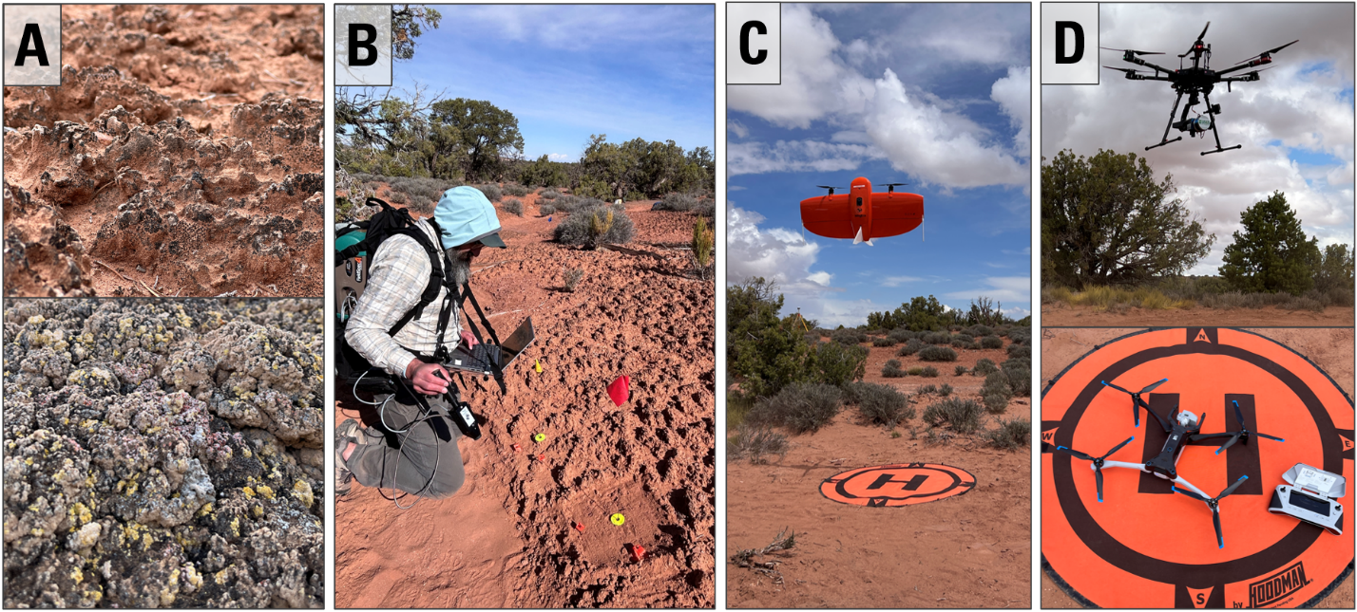
Caption for Graphic or Image: (A) Examples of biocrust at dryland sites with different colors and textures.
(B) Field sampling activities including reflectance measurements of biocrust.
(C) Fixed-wing drone flown to capture natural color and multispectral imagery.
(D) Hexacopter and quadcopter drones flown to collect hyperspectral and thermal data, respectively.
Author name: Miguel Villarreal
Author business email: mvillarreal@usgs.gov

DOI agency/bureau: USGS
USGS Mission Area: Core Science Systems
USGS Program: National Land Imaging Program
Cost Center: Geosciences and Environmental Change Science Center
Program Name:
Project title: Advancing satellite remote sensing radiometric data validation using drones
Project description: From drones to satellites, remote sensing systems can capture beautiful images of our world. Calibration and validation (cal/val) are essential steps to ensure that these images are also reliable for scientific use. Radiometric cal/val involves converting digital imagery data values to meaningful units and assessing their accuracy.

The U.S. Geological Survey (USGS) Earth Resources Observation and Science (EROS) CalVal Center of Excellence (ECCOE) excels in improving the quality of remote sensing data. Their standard radiometric data validation protocol requires a handheld spectrometer operator to walk back and forth across the area while collecting measurements. This procedure yields high-confidence measurements but is time- and labor-intensive.

In collaboration with the USGS National Uncrewed Systems Office (NUSO), ECCOE researchers are exploring uncrewed aircraft system (UAS, also known as drones) remote sensing capabilities and procedures related to the selection of calibration reference materials, quantifying the radiometric accuracy of UAS-based spectral sensors, and potentially utilizing drones to aid in the validation of Earth-observing satellite data.

In June 2025, NUSO collected UAS hyperspectral and multispectral data coordinated with ECCOE field measurements at a large, flat, vegetated field in Golden, CO. This field work was timed to coincide with overpasses by Landsat, Sentinel, and EnMAP satellites, enabling radiometric cal/val comparisons and ultimately advancements in remote sensing data quality research.
Desciption Link Overflow:
Sensor Type: Multispectral (approx. 4-12 bands);Hyperspectral
Platform type: UAS;Satellite
URL: USGS National Uncrewed Systems Office (NUSO): https://uas.usgs.gov/ ; USGS EROS CalVal Center of Excellence (ECCOE): https://www.usgs.gov/calval
Graphic or Image Upload: https://doimspp.sharepoint.com/sites/GS-EROSSCIENCESWI/Shared Documents/Communications Outreach/Documentation Science/DOI Remote Sensing Report/DOI RS Activities Report, 2025/Question/2025 USGS UAS ECCOE_Victoria Scholl.png
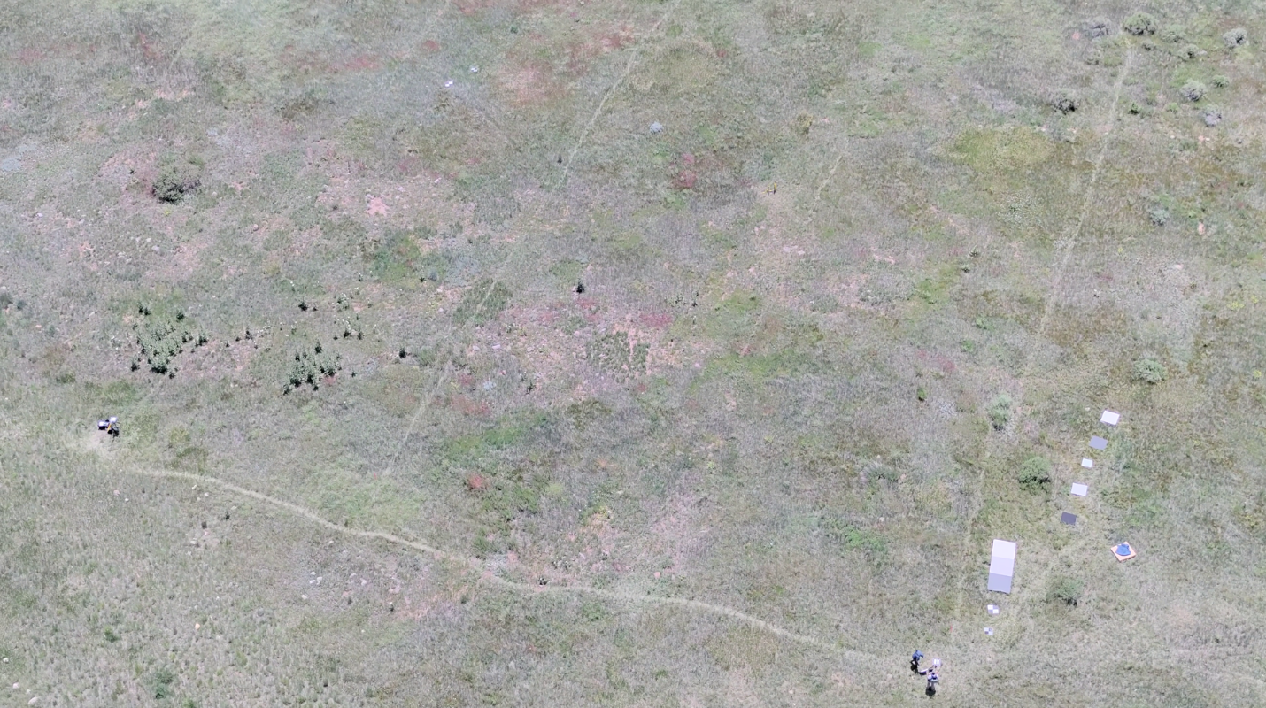
Caption for Graphic or Image: Drone-captured photo of the field mapped during this project. Faint paths formed across the grass from the consistent, repeated pattern walked by the spectrometer operator multiple times per day for multiple days in a row. Reference materials including panels and tarps to be used for cal/val were placed along the edge of the field, seen on the right side of the image.
Author name: Victoria Scholl
Author business email: vscholl@usgs.gov

DOI agency/bureau: USGS
USGS Mission Area: Core Science Systems
USGS Program: National Land Imaging Program
Cost Center: Geosciences and Environmental Change Science Center
Program Name:
Project title: Drones fill in the gaps to map historic ruins at Salinas Pueblo Missions National Monument
Project description: In May 2025, the U.S. Geological Survey (USGS) National Uncrewed Systems Office collected uncrewed aircraft system (UAS, also known as drone) remote sensing data at the Salinas Pueblo Missions National Monument (SAPU) in central New Mexico to use for structural assessments and the development of a historic structure report by the National Park Service (NPS).

The SAPU’s Abó Unit is a unique site with rich history, featuring the weathered remnants of the 17th century Mission of San Gregorio de Abó and surrounding Pueblo mounds. The NPS Southern Arizona Office (SOAR) planned to collect terrestrial laser scans to non-invasively capture a detailed three-dimensional model of the historic church and convento ruins, but this ground-based tool cannot capture the tops of the tall walls.

USGS remote pilots provided technical support to the NPS by safely and efficiently collecting drone-based lidar and imagery, capturing essential data at the top of structure walls to combine with ground-based laser scans. These high-resolution, comprehensive data sets will support development of NPS management strategies and stabilization monitoring protocols to prevent degradation and improve the resiliency of the historic structures. This interagency project also provided an opportunity for USGS to compare cutting-edge UAS lidar and photogrammetry technologies and explore the integration of aerial and terrestrial lidar data for infrastructure mapping applications.
Desciption Link Overflow:
Sensor Type: Camera;Lidar (terrestrial or bathymetric)
Platform type: Ground based / sensor web / web cam;UAS
URL: USGS National Uncrewed Systems Office (NUSO): https://uas.usgs.gov/ ; NPS Salinas Pueblo Missions National Monument: https://www.nps.gov/sapu/
Graphic or Image Upload: https://doimspp.sharepoint.com/sites/GS-EROSSCIENCESWI/Shared Documents/Communications Outreach/Documentation Science/DOI Remote Sensing Report/DOI RS Activities Report, 2025/Question/2025 USGS NPS SAPU UAS Figure_Victoria Scholl.png
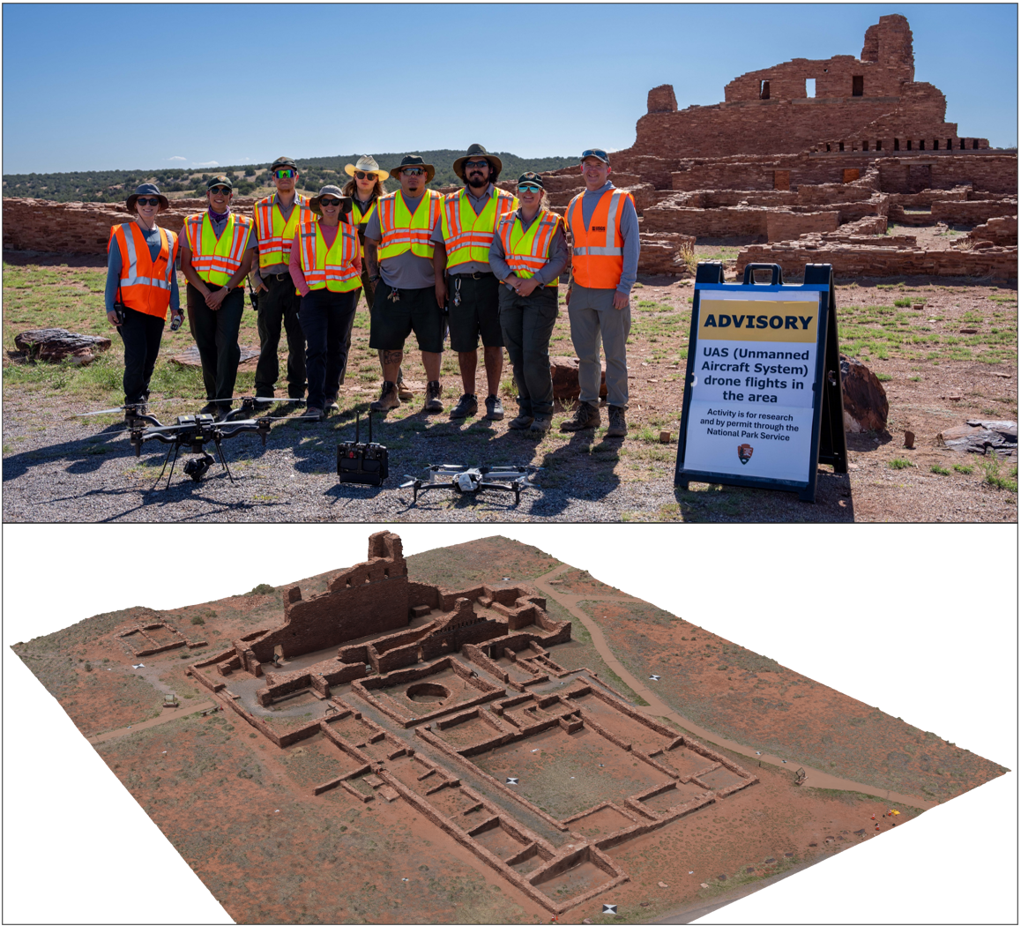
Caption for Graphic or Image: (Top) USGS and NPS personnel stand with drone mapping technologies in front of the Abó Ruins at Salinas Pueblo Missions National Monument in Mountainair, New Mexico.
(Bottom) Preview of the output 3D model of the Abó Spanish Mission Church and Convento generated using drone-captured photos and structure-from-motion photogrammetry processing.
Author name: Victoria Scholl
Author business email: vscholl@usgs.gov

DOI agency/bureau: USGS
USGS Mission Area: Core Science Systems
USGS Program: Astrogeology
Cost Center: Astrogeology Science Center
Program Name:
Project title: Rocks to Rocket Fuel: Mapping critical resources on the Moon
Project description: USGS Astrogeology is paving the way for lunar critical mineral and energy assessments to reach the Gold Standard we’ve been relying on for Earth for decades. Astrogeology characterizes lunar minerals, regolith (the specific type of soil on the Moon), metals, and water ice. These assessments are currently being conducted using a variety of well-developed and/or novel remote sensing techniques over local (<10 km2), regional (~500,000 km2), and global spatial scales. Remote sensing has been the primary technique for the development of many lunar studies as lunar surface data is limited (that is, limited ground validation exists).
Future space exploration activities will require resources, and the work being conducted at Astrogeology can support lunar surface extraction of those critical resources, replacing the excessive launch costs from Earth to cis-lunar space, lunar orbit, and beyond. The lunar surface and subsurface contains metals (e.g., iron, titanium, magnesium), volatiles (e.g., hydrogen, oxygen), and construction material that can be utilized on the Moon or converted into a different form and transported elsewhere for processing or use. The volume, quality, and accessibility of many of these materials is currently unknown and research in this area has historically been underdeveloped. Astrogeology works in many remote sensing fields, through several wavelength ranges, to conduct cutting-edge research in surface studies, deposit model development, and landing site characterization for in situ analyses. The analysis of potential deposits through preliminary prospectivity mapping (e.g., Figure 1 showing two resources) relies heavily on many remote sensing techniques and the development of new techniques. In Figure 1, we show pyroclastic glass mapping, which was developed by USGS co-authors and then refined by USGS authors for a detailed understanding of the distribution and concentration of this potential resource on the lunar surface, a source for volatiles, regolith for construction, and often co-occurs with titanium (Bennett et al., 2016; Pigue, et al., 2023).
Astrogeology released a Circular, “Assessment of Lunar Resources as of 2022” in 2023, describing the state of the field (link provided). Foundational products to this assessment include many remote sensing investigations led by Astrogeology or developed using software, datasets, or frameworks developed by Astrogeology. Additional supports for this work come from legacy development and modeling efforts from USGS work in resource assessments through the decades. This powerful combination of long-standing heritage in critical minerals and energy assessments with cutting-edge remote sensing research will ensure USGS remains a leader in planetary resources.
Desciption Link Overflow: https://pubs.usgs.gov/circ/1507/cir1507.pdf
Sensor Type: Hyperspectral;IFSAR / SAR / Radar;Multispectral (approx. 4-12 bands);Thermal;Large campaign of spacecraft (orbital, landed, roving)
Platform type: Satellite;Landed and roving (off-world)
URL: https://pubs.usgs.gov/circ/1507/cir1507.pdf
Graphic or Image Upload: https://doimspp.sharepoint.com/sites/GS-EROSSCIENCESWI/Shared Documents/Communications Outreach/Documentation Science/DOI Remote Sensing Report/DOI RS Activities Report, 2025/Question/ISRU_figure_Lori Pigue.png
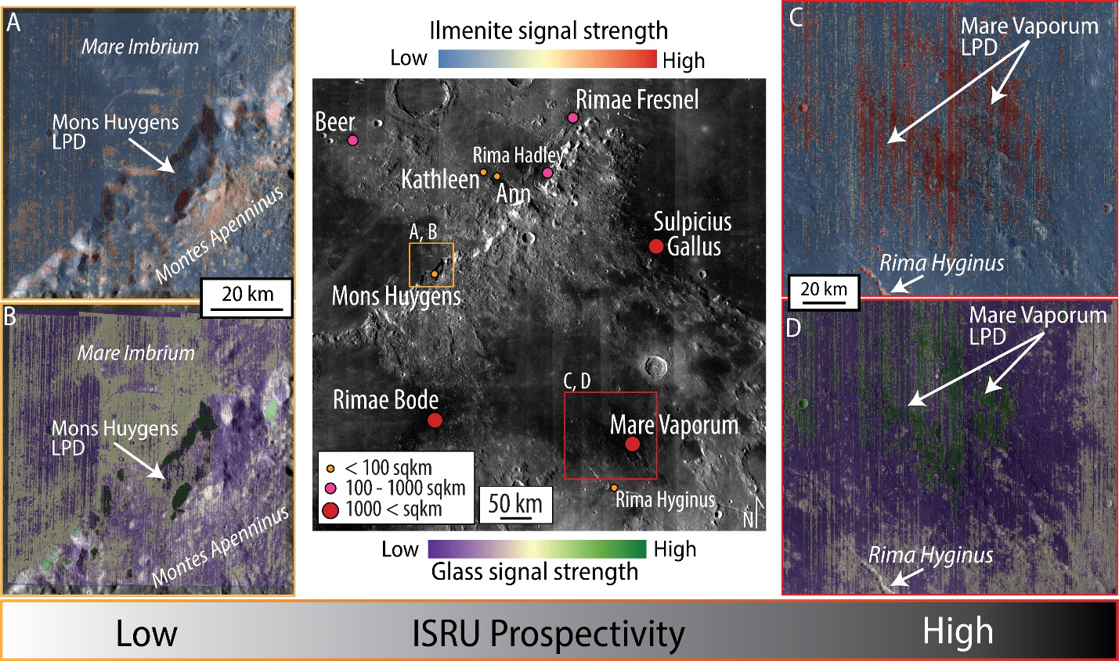
Caption for Graphic or Image: Figure 1: Demonstration of in situ resource utilization prospectivity comparison between two lunar pyroclastic deposits (Mons Huygens LPD, left, and Mare Vaporum LPD, right) within the Montes Apenninus region (center, for reference). Top images show ilmenite signal strength (from Sato et al., 2014), which is a titanium mineral, demonstrating that Mons Huygens is significantly less resource rich in titanium compared to Mare Vaporum. The bottom images show glass signal strength, a proxy for volatiles and easily-processed regolith (indicating use for construction material), also indicating that Mons Huygens has lower resource potential compared to Mare Vaporum. An additional data point is shown in the middle, indicating the areal extent of deposits, with Mons Huygens being relatively small (<100 sqkm) compared to Mare Vaporum (greater than 1000 sqkm).
Author name: Lori Pigue
Author business email: lpigue@usgs.gov

DOI agency/bureau: USGS
USGS Mission Area: Ecosystems
USGS Program: Water Availability and Use Science Program
Cost Center: Southwest Biological Science Center
Program Name:
Project title: Colorado Delta Riparian Growth and Water Use
Project description: The riparian corridor of the Colorado River Delta, which is partitioned between unrestored and restored land cover, has been affected by reduction in river flows since the building of the United States (U.S.) dams and other diversion infrastructure, before reaching the U.S. and Mexico border at Morelos Dam. In addition to the resulting changes in surface flow, there have been changes to the landscape from anthropogenic development, agricultural infrastructure and environmental disturbances. The disturbances stem from increases in pressures, such as heat, increases to the number of days with maximum temperatures, drought and changes to precipitation timing and quantity, increasing soil and water salinities, and fire intensity and frequency, all of which affect available water for the delta riparian ecosystems. In response to the degraded landcover in the Colorado River Delta, restoration efforts have been successful for select riparian designated sites with measurable increases in native plant health for myriad species’ habitat. A key finding is that riparian vegetation condition and actual evapotranspiration (ETa) continue to decline in unrestored reaches. A researcher from USGS Southwest Biological Science Center is using remote sensing tools for monitoring riparian plant health along the Colorado River Delta to improve ecohydrological decision-making. This research is helping a binational team to protect, restore, and maintain native vegetation within select sites of some river reaches of the riparian corridor. Researchers are using Landsat 8 Operational Land Imager (OLI) data spanning 2014–2022 to measure vegetation indices, a proxy for plant greenness or health, and ETa. Using an empirical model for ETa, water use data in the form of ET(EVI2) is estimated over each 16-days considering the 8-days before and after the Landsat overpass date.

In Nagler et al. (2024), the authors focus on describing the response of riparian vegetation greenness and water use to added water to the unrestored riparian corridor of the Colorado River Delta between 2014–2022, under two U.S. Mexico Water Treaty Minutes, 319 and 323. They analyze vegetation responses—measured in terms of EVI2 and ET(EVI2)—to two types of interventions: the 2014 environmental pulse flow delivered from the Reach 1 and the in-channel water deliveries delivered at four sites in Reach 4 during 2021–2022. The response from these events was contrasted with the response from active restoration sites where irrigation systems are used. In summary, the 2021 and 2022 water deliveries increased minimally vegetation greenness in the unrestored riparian corridor when compared with the previous year (2020); in contrast decreases in water use were observed in 2021 and 2022 compared with 2020. During the 2014 pulse flow event similar increases were observed in both plant greenness and water use. The magnitude of increases varied by reach when compared to both events. When comparing greenness and water use between active restoration sites and the unrestored reaches it was observed that both are higher in active restoration sites. These results suggest that while occasional water deliveries can provide some ecological benefits, sustained management interventions—such as irrigation at restoration sites—are more effective at supporting riparian vegetation health and water use in the long term.

The map provides the water delivery points and the data for the associated figure demonstrates the average EVI2 and ETa from 2014 to 2022 for restored sites (diamonds) and unrestored (triangles) reaches (averaged for all seven reaches, Reaches 1–7). Both metrics decrease over time in the unrestored reaches between 2014 and 2022, while the restored sites, averaged together, show increases in both vegetation greenness and ETa, especially from 2018 to 2020. This figure provides a summary of EVI2 and ETa annually and highlights the gap in these metrics between restored and unrestored sites.
Desciption Link Overflow:
Sensor Type: Multispectral (approx. 4-12 bands)
Platform type: Satellite
URL: https://doi.org/10.3390/rs16101801
Graphic or Image Upload: https://doimspp.sharepoint.com/sites/GS-EROSSCIENCESWI/Shared Documents/Communications Outreach/Documentation Science/DOI Remote Sensing Report/DOI RS Activities Report, 2025/Question/Riparian Vegetation EVI2 and ETa in the Color_Pamela Nagler.jpg
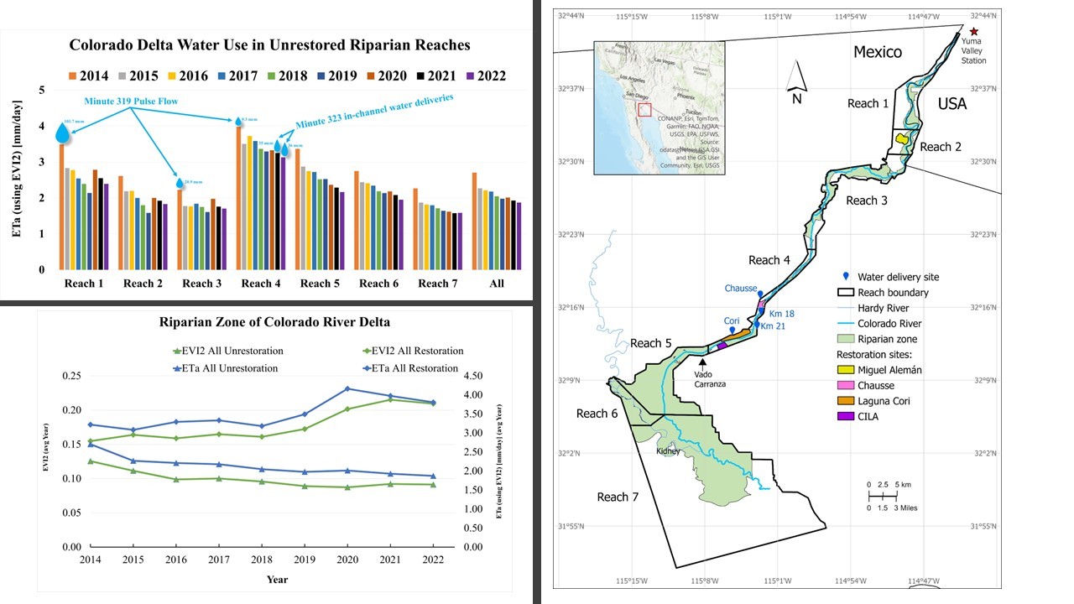
Caption for Graphic or Image: Nine years (2014-2022) of weighted average actual evapotranspiration (ET(EVI2)) as bars for seven reaches of the Colorado River Delta for the unrestored Reaches 1-7 and the average of all reaches for years 2014-2022, with a water droplets symbol showing which year and reach that water was added to the riparian corridor through United States-Mexico Water Treaty Minutes 319 and 323 (upper left); vegetation greenness (EVI2) and ET(EVI2) for eight years 2014-2022 for all unrestored as well as all restored reaches (lower left); map of the Colorado River Delta showing, from north to south, the Yuma Valley Arizona Meteorological Station (AZMET) (red star) located north of the Northerly International Border (NIB) in Yuma, Arizona, United States, and four water delivery sites titled Chausse, Km 18, Km 21, and Cori (right). Figures are from Nagler et al. (2024).
Author name: Pamela Nagler
Author business email: pnagler@usgs.gov

DOI agency/bureau: USGS
USGS Mission Area: Ecosystems
USGS Program: Water Availability and Use Science Program
Cost Center: Southwest Biological Science Center
Program Name:
Project title: Chlorophyll Fluorescence in ET Modelling
Project description: Evapotranspiration (ET)—the transfer of water from soils through evaporation and from plants through transpiration—plays a central role in linking the global water and carbon cycles. Because ET underpins both hydrology and ecosystem functioning, accurate measurement is essential. Remote sensing models can estimate ET across broad landscapes, but their accuracy is limited because they often lack information on how plants regulate water loss through stomata. A promising advancement for improving ET estimation is the use of sun-induced chlorophyll fluorescence (SIF), a satellite-observed signal emitted during photosynthesis. SIF reflects photosynthetic activity related to stomatal conductance and transpiration, making it a valuable proxy for plant water use and a tool for improving ET estimation.

A researcher from the U.S. Geological Survey (USGS) Southwest Biological Science Center, worked with the lead author from the Commonwealth Scientific and Industrial Research Organisation (CSIRO) and other colleagues from Australia, to utilize SIF to improve ET estimation as one technique from a suite of remote sensing tools for monitoring plant function and water use. In Gao et al. (2025) they evaluated whether SIF could enhance ET mapping and monitoring in semi-arid and arid environments, where accurate estimates of tree water use are critical for ecohydrological decision-making. Vegetation types included grassland, cropland, savanna, wooded savanna, evergreen broadleaf forest, floodplains, and plantations. By integrating SIF with other satellite and climate data, the team aimed to generate more reliable ET estimates to support water resource management across diverse ecosystems.

To test this, four potential ET (PET) models were developed using the Penman-Monteith equation: (1) a fixed stomatal conductance model (AETcon), (2) a transpiration-driven canopy conductance (gsc) model (AETT), (3) a gsc model incorporating electron-transfer rate and vapor pressure deficit (AETETR), and (4) a Ball-Berry conductance model (AETGPP). PET was scaled to actual ET (AET) through machine learning that incorporated climate and remote sensing inputs. Model performance was evaluated against in-situ AET observations from 52 Australian sites, including 21 eddy covariance flux towers and 31 sap flow monitoring sites covering multiple plant functional types. Results demonstrated that SIF effectively captured seasonal variation in canopy conductance. AET models using SIF-driven gsc performed better than fixed-conductance models, achieving stronger agreement with observations (R² = 0.64) and reducing prediction error to 0.85 mm per day. In contrast, the fixed conductance model consistently overestimated water use in floodplains and underestimated it in evergreen forests, highlighting its instability across ecosystems. By representing dynamic stomatal behavior, SIF-based models provided more reliable and scalable estimates of ET.

There were four main innovations. First, SIF captures seasonal variation in plant water use, allowing models to better track vegetation responses to changing conditions. Second, SIF-driven models improve accuracy and reduce error compared with fixed assumptions. Third, models relying on constant conductance are less reliable, often misrepresenting water use in different ecosystems. Finally, the broader application of SIF enhances large-scale ET estimation, offering critical hydrological data for regions where field monitoring is sparse. By linking plant photosynthetic signals to water-use estimates, this research demonstrates the value of SIF in advancing ecohydrological modeling. The ability to predict ET more accurately at large scales provides vital insights for hydrology, agriculture, and water management, particularly in water-limited landscapes facing climate-driven declines in rainfall.

Desciption Link Overflow:
Sensor Type: sun-induced chlorophyll fluorescence (SIF);Multispectral (approx. 4-12 bands)
Platform type: Satellite;Ground based / sensor web / web cam
URL: https://doi.org/10.1016/j.jhydrol.2025.133404
Graphic or Image Upload: https://doimspp.sharepoint.com/sites/GS-EROSSCIENCESWI/Shared Documents/Communications Outreach/Documentation Science/DOI Remote Sensing Report/DOI RS Activities Report, 2025/Question/Australia-SIF-ETa_Pamela Nagler.jpg
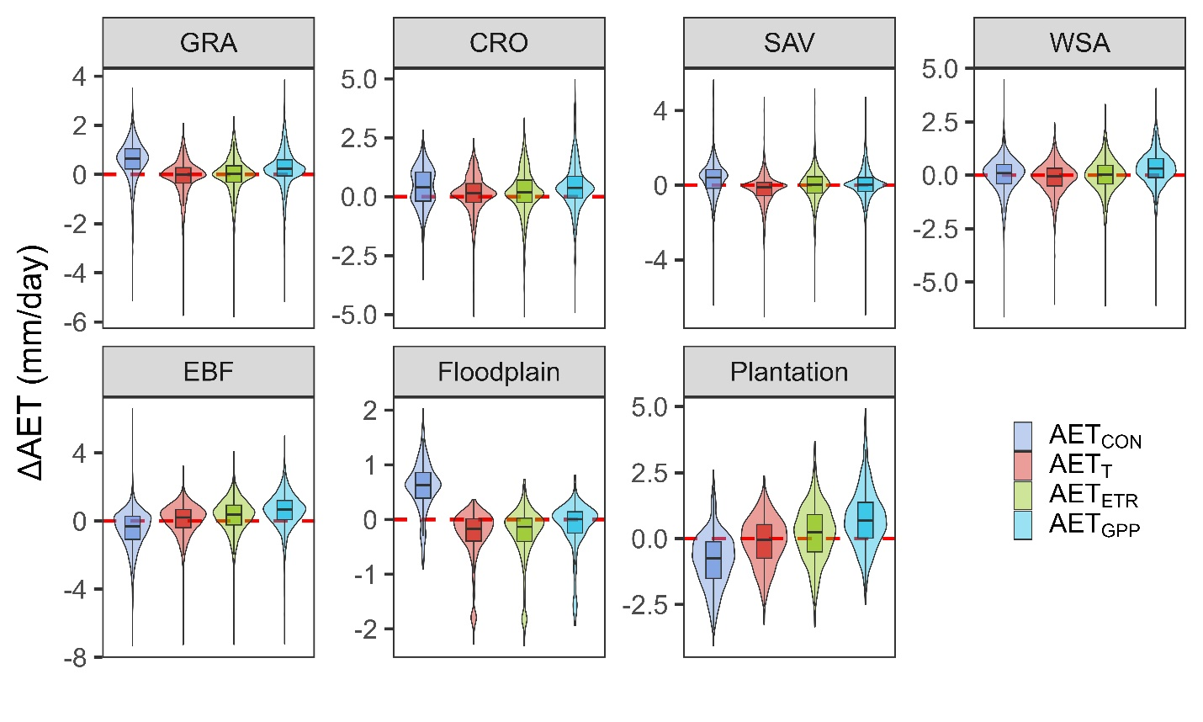
Caption for Graphic or Image: Four actual evapotranspiration (AET) models (CON, T, ETR, GPP; described as 1-4 in text) and the difference between these and the field AETall at seven land cover types: grassland (GRA), cropland (CROP), savanna (SAV), wooden savanna (WSA), evergreen broadleaf forest (EBF), floodplain, and plantation area. Residual AET (∆AET) was residual between modelled ET and field AETall.
Author name: Pamela Nagler
Author business email: pnagler@usgs.gov

DOI agency/bureau: USGS
USGS Mission Area: Energy and Minerals
USGS Program: **unspecified​**
Cost Center: **unspecified**
Program Name:
Project title: 3. Stengel, V. G., Gallegos, T. J., Hubbard, B. E., Cahan, S. M., Wallace, D. S., Identification and characterization of reclaimed and unreclaimed mine features using lidar and temporal remote sensing methods within the coastal plain uranium mining region of Texas. Remote Sensing
Project description: Open-pit uranium mining in the south Texas Gulf Coast region was active during the second half of the 20th century. Although some mines have extensive records documenting the locations and extents with descriptions of reclamation procedures and timelines, abandoned and reclaimed mines with minimal documentation concurrently exist where little is known about locations, reclamation status, and mine waste volumes. The purpose of this study is to demonstrate that advanced mapping of the mining life cycle is helpful for producing basic mine land inventories and assessments of mine waste, including identifying potential undeveloped resources and environmental health issues, as well as in helping to inform proper management, restoration, and reclamation strategies.

We developed a spatiotemporal mapping approach utilizing multiple techniques for distinguishing and mapping known reclaimed mine sites from “unreclaimed” mine sites in a historic uranium mining district along the South Texas Coastal Plains. Lidar laser scanning penetrates the vegetation canopy to expose anthropogenic modifications to the landscape. The Lidar analysis (bare earth elevation surface, slope, topographic contours, topographic textures, and overland-flow hydrography) revealed mine features. Visual interpretation of Landsat imagery and time-series analysis augmented the Lidar analysis revealing the temporal life cycle of mining. The combination of bare earth texture with time-lapse and time-series analyses revealed areas of disturbance for reclaimed mines. The spatiotemporal mapping approach proved to be most useful in identifying and characterizing the known mine pit and pile features, reclamation status, and areas of disturbance due to mining. Two mine waste volume estimation methods resulted in a 21% difference indicating that although the approach helps to map mine features and areas of mining disturbance for the purposes of mine land inventory, additional information is needed to improve the estimation of buried mine waste at reclaimed mine sites.
Desciption Link Overflow: https://doi.org/10.3390/rs16183519
Sensor Type: Lidar (terrestrial or bathymetric);Multispectral (approx. 4-12 bands)
Platform type: Airplane;Satellite
URL:
Graphic or Image Upload:
Caption for Graphic or Image:
Author name: Victoria Stengel
Author business email: vstengel@USGS.gov

DOI agency/bureau: USGS
USGS Mission Area: Water Resources
USGS Program: Groundwater and Streamflow Information Program
Cost Center: Office of the AD Water
Program Name:
Project title: Remote Sensing of Water Quality: Lake Temperature
Project description: Lakes around the world are warming in step with rising air temperatures, a trend that has been accelerating over the past decade. This warming can lead to longer periods of thermal stratification—when warm surface water sits atop cooler, deeper water—disrupting natural mixing processes. These changes can trigger oxygen depletion and increase the risk of harmful algal blooms, threatening aquatic ecosystems and the communities that depend on them.

Despite these risks, most long-term lake temperature studies have focused on large or intensively studied lake ecosystems, leaving a major gap in our understanding of smaller lakes, which are far more numerous. To address this, scientists from the U.S. Geological Survey’s Remote Sensing of Water Quality team developed a new dataset that tracks surface water temperature in lakes as small as 4 hectares across the contiguous United States.

Using satellite data from Landsat 8, the team created a publicly available dataset that includes surface temperature time series for nearly 140,000 lakes from 2013 to the present. The data are available at multiple time scales (individual satellite flyovers, monthly, and annually) and spatial resolutions (lake-wide averages and values at the lake’s center). Each lake is linked to a unique identifier from the National Hydrography Dataset, making it easy to integrate with other environmental data.

This dataset—available here: https://doi.org/10.5066/P13DZ7MP—offers a consistent, scalable, and accessible way to study how lakes are responding to shifting temperature patterns and environmental variability. It enables researchers, resource managers, and policymakers to monitor trends, identify vulnerable ecosystems, and make informed decisions about water quality and ecosystem health. By expanding our ability to study the most common types of lakes, this work helps fill a critical knowledge gap and supports efforts to protect freshwater resources in a rapidly changing world.

Desciption Link Overflow:
Sensor Type: Dynamic Surface Water Extent;Thermal
Platform type: Satellite
URL: https://doi.org/10.5066/P13DZ7MP
Graphic or Image Upload: https://doimspp.sharepoint.com/sites/GS-EROSSCIENCESWI/Shared Documents/Communications Outreach/Documentation Science/DOI Remote Sensing Report/DOI RS Activities Report, 2025/Question/fig01_Timothy Stagnitta.png
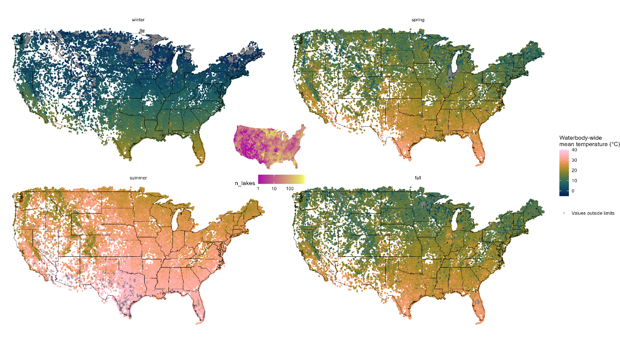
Caption for Graphic or Image: Average seasonal temperature for 139,954 lakes from 2013-2024. The middle hexagon plot displays the total number of lakes within approximately 3,000 hexagons distributed across CONUS, where pink represent a lower density of lakes, and yellow represents a higher density of lakes.
Author name: Tim Stagnitta
Author business email: tstagnitta@usgs.gov

DOI agency/bureau: USGS
USGS Mission Area: Natural Hazards
USGS Program: Volcano Hazards Program
Cost Center: Astrogeology Science Center
Program Name:
Project title: Using Landsat to study thermal areas in Yellowstone
Project description: Yellowstone is a large, dormant, yet restless caldera system that is considered a high-threat volcano, ranked 21 in threat level among 161 active U.S. volcanoes. It contains thousands of thermal features (e.g., hot springs, geysers, mud pots, and fumaroles) that are the surface expression of the deeper magmatic-hydrothermal system. Thermal features tend to cluster into thermal areas – there are about 120 distinct thermal areas in Yellowstone. And it is important to characterize and monitor these thermal areas because changes may be related to geophysical processes indicative of volcanic unrest that often precedes eruptions (e.g., earthquakes or ground deformation), or symptomatic of hazardous conditions (e.g., unstable ground with boiling subsurface temperatures, boiling hot springs, noxious gas emissions, or potential hydrothermal explosions).
Monitoring thermal areas in Yellowstone is important because to recognize and understand changes, we need to know the normal conditions. This is why the USGS Yellowstone Volcano Observatory monitoring plan for Yellowstone calls for regular thermal area monitoring. The goal is to document baseline geothermal activity so that significant changes can be recognized when they occur – changes that may be related to tectonic, magmatic, hydrothermal processes, seasonal groundwater flow cycles, or possibly human activities. This information is relevant to (1) monitoring a long-dormant, yet restless and potentially active volcanic system and (2) supporting decisions regarding infrastructure development, resource protection, and visitor safety.
Thermal area monitoring in Yellowstone is a challenge because there are many thousands of thermal features that are spread out over a large and mostly inaccessible region. We use satellite-based nighttime thermal infrared images (e.g., ASTER, Landsat 8, and Landsat 9) to map, measure, and monitor thermal areas in Yellowstone. Thermal anomaly maps derived from these data are used to assess and update field-based thermal area maps; identify variations in heat output within thermal areas; and differentiate between active and inactive thermal areas. A few years ago, we discovered a previously unknown, newly emerging thermal area in the backcountry. Each year, these data are also used to estimate the geothermal radiant heat output – for individual thermal areas and for the entire park. Data over the last decade indicate that the geothermal radiant heat output from Yellowstone has been relatively stable.

Desciption Link Overflow:
Sensor Type: Thermal;Multispectral (approx. 4-12 bands)
Platform type: Satellite
URL: See: https://www.usgs.gov/observatories/yvo/news/thermal-infrared-remote-sensing-yellowstone-301-thermal-metrics; and linked related articles.
Graphic or Image Upload: https://doimspp.sharepoint.com/sites/GS-EROSSCIENCESWI/Shared Documents/Communications Outreach/Documentation Science/DOI Remote Sensing Report/DOI RS Activities Report, 2025/Question/Figure 1_v1_R Greg Vaughan.png
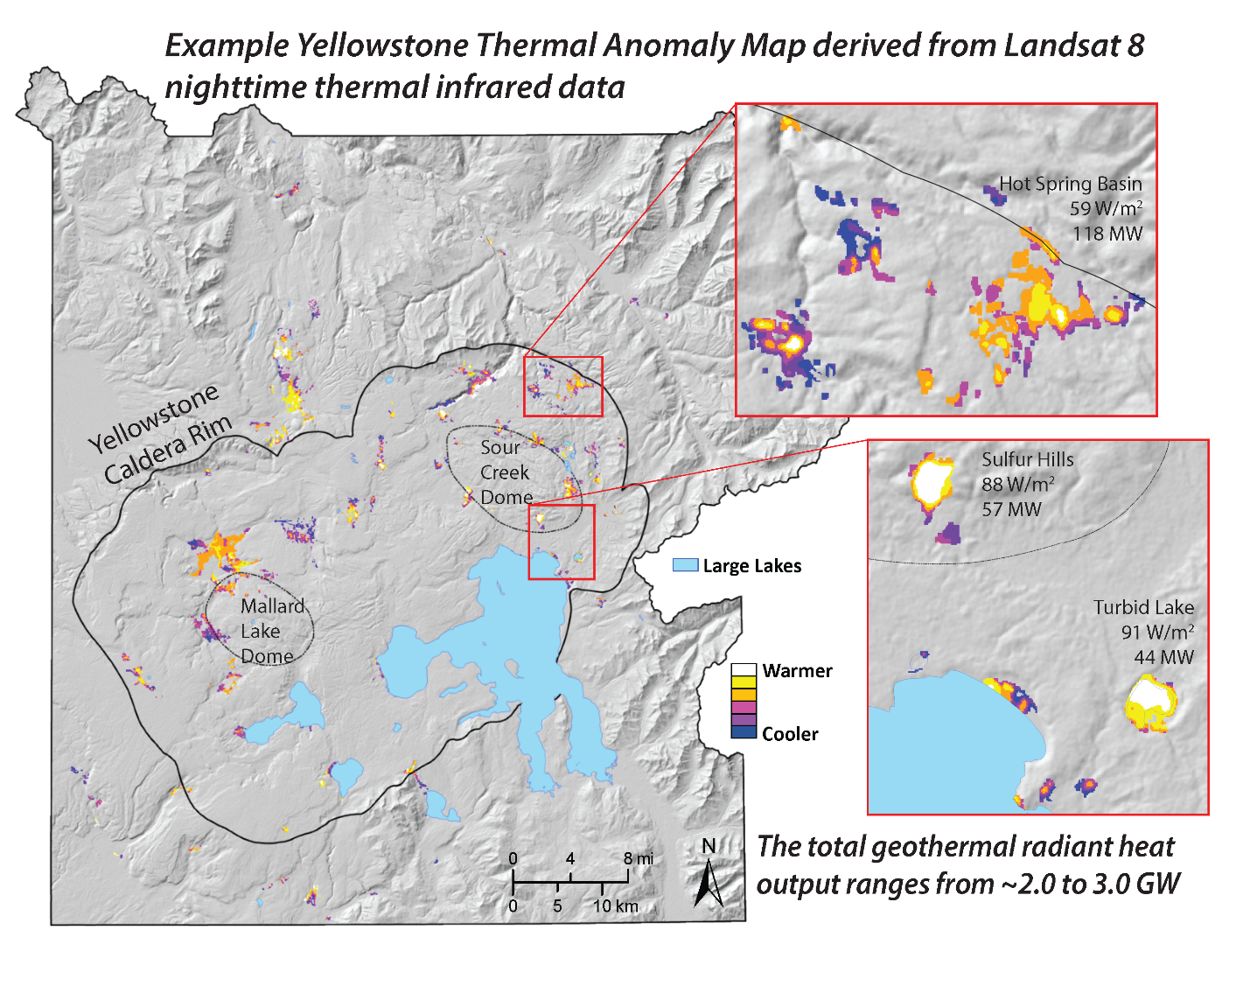
Caption for Graphic or Image: Example thermal anomaly map of Yellowstone National Park based on a Landsat 8 nighttime thermal infrared data. The color ramp indicates the intensity of the above-background thermal anomaly for each thermal area. Lakes are blue. The Yellowstone caldera and resurgent domes are outlined in black. Thermal areas in the inset images are annotated with geothermal radiant emittance values in Watts per square meter (W/m2), and geothermal radiant power output values in megawatts (MW; 1 megawatt is 1 million watts). The total geothermal radiant heat output for Yellowstone ranges from ~2000 to 3000 MW and has been relatively stable over the last decade.
Author name: R. Greg Vaughan
Author business email: gvaughan@usgs.gov

DOI agency/bureau: USGS
USGS Mission Area: Core Science Systems
USGS Program: Volcano Hazards Program
Cost Center: Astrogeology Science Center
Program Name:
Project title: Finding new thermal features in Yellowstone with commercial satellites
Project description: Thermal features in Yellowstone (hot springs, geysers, mud pots, and fumaroles) can change over time. They heat up; they cool down; they migrate as new fluid pathways become available; and sometimes new ones appear – sometimes quietly, and sometimes with a bang. Recently, there have been numerous discoveries of new thermal features. Some have been the result of small hydrothermal explosions, which are like geysers that “go wild” and erupt rocks and mud in addition to hot water and steam. They often leave behind a crater or a new hot spring pool.
Hydrothermal explosions are the most frequent discrete geologic hazard in Yellowstone, yet they are rarely witnessed because they may occur in the backcountry, or at night, or in the off-season. As a result, there is a lot of uncertainty in how frequently they occur. Using data from high-resolution commercial multispectral satellites, combined with field work and measurements of seismic ground shaking and low-frequency sounds, scientists at the USGS Yellowstone Volcano Observatory (YVO) are identifying newly formed thermal features and learning that these events may happen as often as once or twice per year. Information about the frequency, magnitude, and locations of hydrothermal explosions is useful to the National Park Service for infrastructure development, resource protection, and visitor safety.
High-resolution commercial multispectral satellite data are also used for mapping thermal area boundaries and finding / characterizing previously unknown thermal features. For example, high-resolution visible and color infrared images acquired in the winter with snow on the ground are used by YVO scientists to map snow-free zones on land and ice-free zones on frozen lakes, to identify previously unknown thermal features.
Desciption Link Overflow: Also see: https://agupubs.onlinelibrary.wiley.com/doi/10.1029/2025GL115850
Sensor Type: Multispectral (approx. 4-12 bands)
Platform type: Satellite
URL: See: https://www.usgs.gov/observatories/yvo/news/yellowstones-thermal-areas-numbers; and links to related articles.
Graphic or Image Upload: https://doimspp.sharepoint.com/sites/GS-EROSSCIENCESWI/Shared Documents/Communications Outreach/Documentation Science/DOI Remote Sensing Report/DOI RS Activities Report, 2025/Question/Figure 2_v1_R Greg Vaughan.png
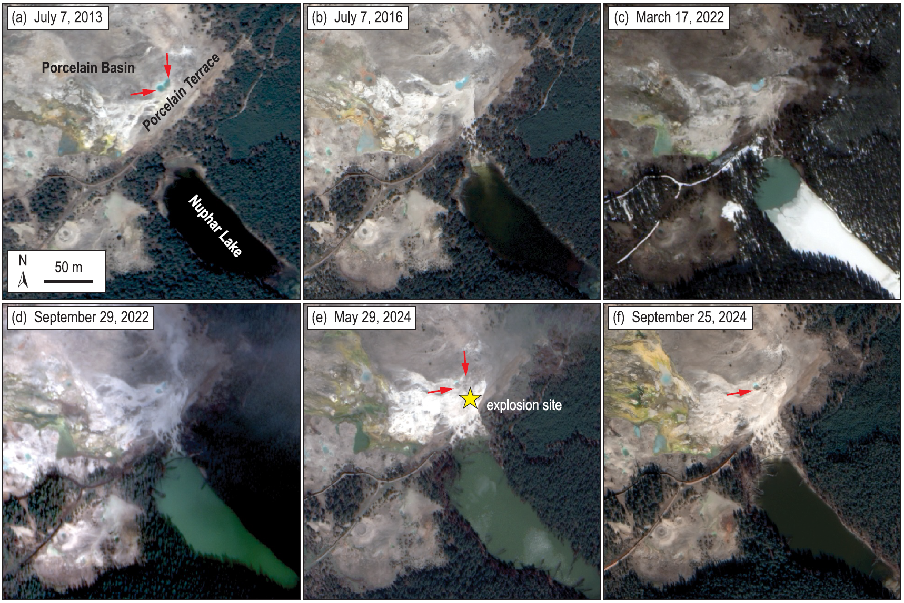
Caption for Graphic or Image: High‐resolution satellite images of the Porcelain Basin and Nuphar Lake area of Norris Geyser Basin. (a) WorldView‐2 from 7 July 2013 showing conditions prior to hydrothermal input from Porcelain Terrace into Nuphar Lake. Note the two distinct blue pools (indicated by red arrows) on Porcelain Terrace (2013, Maxar, USG Plus). (b) WorldView‐3 from 7 July 2016. Hydrothermal input from Porcelain Terrace into Nuphar Lake is evident from a small light colored plume at the northwest end of the lake and from new hydrothermal mineral deposits (white ground) between Porcelain Terrace and the lake (2016, Maxar, USG Plus). (c) WorldView‐2 from 17 March 2022. The northwest end of Nuphar Lake is free of ice due to hydrothermal input from Porcelain Terrace (2022, Maxar, USG Plus). (d) WorldView‐2 from 29 September 2022. High water levels and a change in the color of Nuphar Lake to green/blue indicate accelerated input of hydrothermal fluids from Porcelain Terrace into the lake (2022, Maxar, USG Plus). (e) WorldView‐3 from 29 May 2024. In this post‐explosion view, the blue pools (indicated by red arrows) on Porcelain Terrace immediately northwest of the explosion site (yellow star), which previously were full to overflowing, are mostly empty, and there is no input of hydrothermal fluids into Nuphar Lake, although the lake level remains high. Many of the trees along the margin of the lake are dead due to inundation by silica‐rich water (2024, Maxar, USG Plus). (f) WorldView‐3 from 25 September 2024. One of the pools (indicated by red arrow) on Porcelain Terrace has partially refilled, the level of Nuphar Lake has decreased, and the water has lost the previous blue/green color (2024, Maxar, USG Plus).
Author name: R. Greg Vaughan
Author business email: gvaughan@usgs.gov

DOI agency/bureau: USGS
USGS Mission Area: Core Science Systems
USGS Program: Land Change Science
Cost Center: Earth Resources Observation and Science (EROS) Center (Geography)
Program Name:
Project title: Flood Early Waring in South Sudan
Project description: Devastating flooding is becoming a quasi-annual event in South Sudan—one of the most food insecure countries of the world. The flooding in South Sudan is attributed to the outflows from lakes in the region, such as Lake Victoria, regional precipitation, and slow recession of flood waters during the dry period. The extent of seasonal flooding as well as the areas of permanent wetlands have increased significantly especially since 2019. While floods pose great threats to people’s lives and livelihoods, early warning systems can help communities prepare while activating humanitarian response plans before the worst impacts are realized. Although, skillful flood forecasts are challenging due to the scarcity of in-situ data and the difficulty of simulating complex, near flat, dam-controlled surface water systems such as in South Sudan, satellite datasets such as the National Oceanic and Atmospheric Administration Visible Infrared Imaging Radiometer Suite (VIIRS) Flood Mapping (VFM) product and Landsat based Automated Water Extraction Index provide useful estimates of flooded area in the region.

The USGS Famine Early Warning Systems Network (FEWS NET) project, in collaboration with other FEWS NET science team partners have developed models to forecast monthly VFM area of inundation at seasonal to sub-seasonal timescales. The models incorporate a statistical regression and a geospatial model to predict inundation. The statistical model leverages lag correlation between VFM area and satellite and Earth system model datasets, including: 1) satellite altimetry-based water levels for upstream lakes Victoria, Kyoga, and Albert; 2) Climate Hazards Center Infrared Precipitation with Station (CHIRPS) precipitation data; 3) retrospective runoff and forecasted precipitation, runoff, and streamflow from National Aeronautics and Space Administration’s FEWS NET Land Data Assimilation System (FLDAS)-Forecast model; and 4) past VFM area to forecast inundation. The geospatial model produces the spatially distributed map of the forecasted inundation based on the historical frequency of flooding in South Sudan. The flood forecasts produced by the models were used by the decision support organizations such as FEWS NET for early warning of food insecurity, as well as United Nation Office for the Coordination of Humanitarian Affairs (UN OCHA) and South Sudan government to prepare for and respond in a timely manner to humanitarian assistance for over 1.4 million affected people including 397,000 people displace in South Sudan during 2024 flooding. USGS FEWS NET, together with its science partners, is producing flood forecasts and collaborating with International Flood Technical Working Group to support UN OCHA in preparing timely, life-saving humanitarian assistance in 2025.

Desciption Link Overflow: Not applicable
Sensor Type: Multispectral (approx. 4-12 bands)
Platform type: Satellite
URL: Not applicable
Graphic or Image Upload: https://doimspp.sharepoint.com/sites/GS-EROSSCIENCESWI/Shared Documents/Communications Outreach/Documentation Science/DOI Remote Sensing Report/DOI RS Activities Report, 2025/Question/PredictedFloodMaps_Shahriar Pervez.png
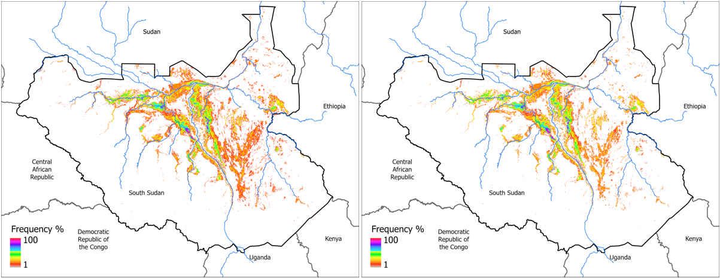
Caption for Graphic or Image: Figure 1. Spatial distribution of predicted flooding with July initial conditions for September (81,100 km2-left panel), and October (68,200 km2-right panel) of 2025 in South Sudan. The predictions were made in August of 2025.
Author name: Md Shahriar Pervez
Author business email: spervez@usgs.gov

DOI agency/bureau: USGS
USGS Mission Area: Core Science Systems
USGS Program: National Land Imaging Program
Cost Center: Earth Resources Observation and Science (EROS) Center (Geography)
Program Name:
Project title: Annual National Land Cover Database (NLCD) Charactering 40 Years Land Cover Land Use Dynamics for the Conterminous U.S.
Project description: Land cover is foundational information for land managers, scientists, policy makers, and the general public. Over the past 30 years, the National Land Cover Database (NLCD) has provided the definitive land cover database for the United States that is consistent and relevant at the national scale, which can make it invaluable for a variety of resource monitoring and management activities, as well as input to numerous modeling applications. The U.S. Geological Survey (USGS) Earth Resources Observation and Science (EROS) Center released Annual NLCD Conterminous U.S. (CU), Collection 1.1. in June 2025. With this release, the USGS builds on the popular Annual NLCD CU Collection 1.0, which debuted in October of 2024 , boasted 6 annual land cover products for 1985 – 2023, and was the initial dataset planned for annual updates. Collection 1.1 fulfills that update goal by adding the year 2024 for a total of 40 years of CU land cover dynamics. The six products are Land Cover, Land Cover Change, Land Cover Confidence, Fractional Impervious Surface, Impervious Descriptor, and Spectral Change Day of Year.
Annual NLCD uses an ensemble of deep learning classification architectures and change algorithms to map, monitor, and synthesize the complexities of land use, cover, and condition change through time. The Annual NLCD annual update strategy was designed to ensure consistency with previous product releases (i.e., 1.0), maintain reliability in time-series analyses, and develop products in a resource-efficient manner. The Annual NLCD has harnessed the full 30-meter Landsat data record to provide timely, long-term, consistent, and detailed land surface change information. NLCD supports thousands of applications in the private, public, and academic sectors. It has been used to assess ecosystem status and health, examine spatial patterns of biodiversity, and develop land management policies. It also serves as a critical data layer in national assessments of surface and ground water quality, wildfire monitoring and modeling, biodiversity conservation efforts and more.
The Annual NLCD products are available for download on EarthExplorer, the MRLC Web Viewer, the MRLC Mosaic Download website, ScienceBase, as Annual NLCD web services, and through USGS Amazon Web Service (AWS) S3 (Oregon us-west-2 region). For quick and easy change analyses, try out the NLCD Enhanced Visualization and Analysis (EVA) tool.

Desciption Link Overflow:
Sensor Type: Multispectral (approx. 4-12 bands)
Platform type: Satellite
URL: https://www.usgs.gov/centers/eros/science/annual-national-land-cover-database
Graphic or Image Upload: https://doimspp.sharepoint.com/sites/GS-EROSSCIENCESWI/Shared Documents/Communications Outreach/Documentation Science/DOI Remote Sensing Report/DOI RS Activities Report, 2025/Question/Annual_NLCD-1.1_Graphic_6panel_Suming Jin.png
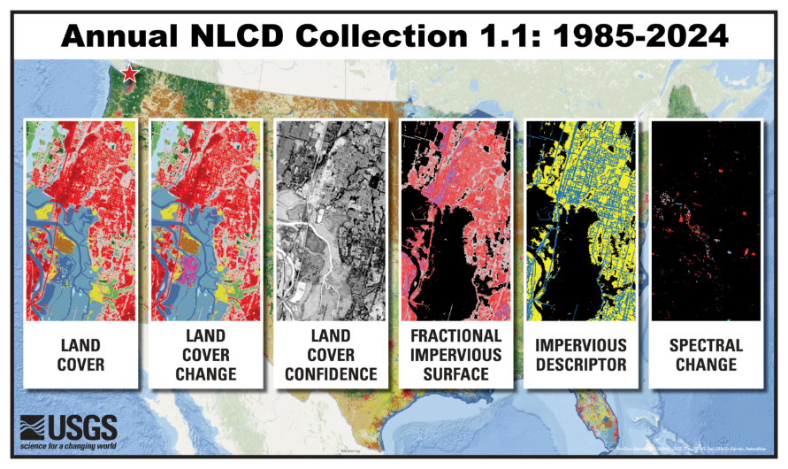
Caption for Graphic or Image: Annual National Land Cover Database (NLCD) product suite
Author name: Suming Jin
Author business email: sjin@usgs.gov

DOI agency/bureau: USGS
USGS Mission Area: Ecosystems
USGS Program: Land Change Science
Cost Center: Southwest Biological Science Center
Program Name:
Project title: Navajo Nation’s Culturally Important Riparian Areas
Project description: Water use estimates are important to the Navajo Nation for resolving water rights and guiding environmental policy, but also for passive and active restoration planning of Culturally Important Riparian Areas (CIRAs). The cultural importance of the areas often has a significance tied to plants, habitat, or other characteristics of a place that were possible under historical site conditions. A researcher from the United States Geological Survey (USGS) Southwest Biological Science Center is using remote sensing for monitoring the health, condition and water use of riparian corridors across the Navajo Nation. In Nagler et al. (2022), efforts to quantify estimates of riparian vegetation greenness through Vegetation Indices (VI) with Landsat-8 OLI (30-m resolution) and plant water use, actual evapotranspiration (ETa), were focused on riparian vegetation, the trees and shrubs that grow along the banks of tributaries, streams, and springs on the Navajo Nation, primarily along the Little Colorado River and its tributary channels. Satellite imagery and weather data were used to estimated how much water was lost in ETa or consumptive use (CU) each year between 2014 and 2020. Nagler et al. (2022) mapped riparian land cover in 2019 using a summer National Agricultural Imagery Program (NAIP) scene (1-m resolution), which provided higher resolution imagery that was useful for distinguishing riparian corridor vegetation cover, including trees and shrub ground cover, from the background drylands. The NAIP data that was used for digitizing riparian vegetation cover provided only the initial estimate of riparian cover, but methods using a novel rasterization process with Landsat allowed for the production of a riparian area that was an inclusive and more accurate area estimate than the digitization process using the one-time NAIP scene and prone to human-error.

These data were then used in combination with VI data from Landsat-8 OLI (30-m) every 16-days from 2014-2020 and Daymet and PRISM climate data, including precipitation and temperature, to calculate potential evapotranspiration using Blaney-Criddle (ETo), to estimate ETa and CU over the entire Navajo Nation. Study objectives included mapping riparian land cover by vegetation type, splitting the Navajo Nation into West and East areas, then quantifying daily and annual water use and calculating riparian CU in acre-feet (AF). This approach provided the first remote sensing–based estimates of riparian water use in this region. Estimates of these hydrologic components (e.g., ET, CU, rainfall) are used to assist decision-making by natural resource managers and water resources planners tasked with managing habitat and water resources.

In a continuation of this study on the Navajo Nation, the focus was only on six selected CIRA sites in Arizona that were considered for active management of channels and springs to benefit multiple system functions. The newer objectives extended the data collected on the six sites through 2024, used three vegetation indices and daily, monthly and peak growing season ET(EVI2) for identifying the pre-restoration water availability and need for only the six CIRA sites before management decisions are made. The data provide natural resource managers and water planners with updated, science-based information to inform the Navajo’s restoration strategies to better manage riparian habitats and water resources in the Little Colorado River system. The data also helps to define restoration objectives that are feasible given the current water availability and modern effects of changing climate or drought. The spatiotemporal VI data at these six sites on the Navajo Nation, will contribute to the understanding of best management practices for restoration sites along the riparian corridors of the Little Colorado River, tributaries and streams.

Desciption Link Overflow:
Sensor Type: Multispectral (approx. 4-12 bands)
Platform type: Satellite
URL: https://doi.org/10.3390/rs15010052
Graphic or Image Upload: https://doimspp.sharepoint.com/sites/GS-EROSSCIENCESWI/Shared Documents/Communications Outreach/Documentation Science/DOI Remote Sensing Report/DOI RS Activities Report, 2025/Question/Navajo_Nation_Landscape_300p_Pamela Nagler.jpg
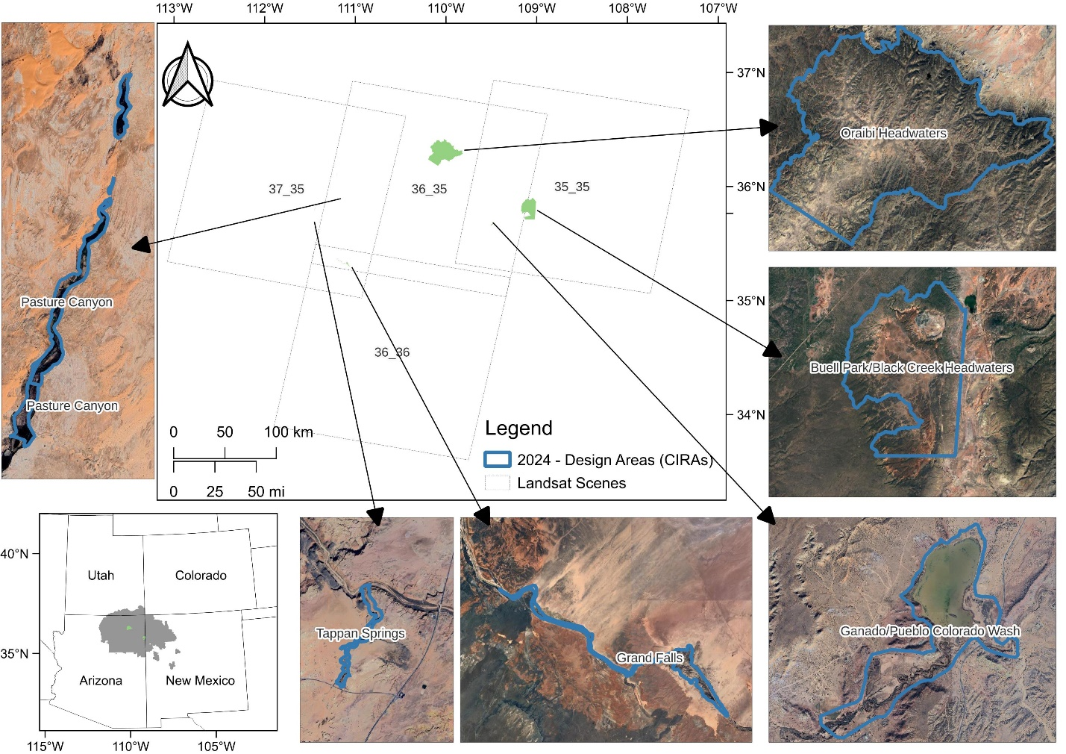
Caption for Graphic or Image: This figure shows two areas on the Navajo Nation in Arizona: a) portions of the Little Colorado River and tributaries where evapotranspiration estimates of riparian corridor vegetation, which were measured with Landsat-8/OLI EVI2 and ET(EVI2) from 2014 through 2020, and b) six sites that were considered for active management using remote sensing for baseline water use through 2024; these six are considered Culturally Important Riparian Areas (CIRAs) by the Navajo Nation.
Author name: Pamela Nagler
Author business email: pnagler@usgs.gov

DOI agency/bureau: USGS
USGS Mission Area: Water Resources
USGS Program: **unspecified​**
Cost Center: **unspecified**
Program Name:
Project title: Remote Sensing of River Discharge Based on Critical Flow Theory
Project description: Information on river discharge is essential for a broad range of applications including water supply planning, flood hazard assessment, habitat monitoring, design and maintenance of infrastructure, and recreation. However, measuring streamflow via conventional methods is laborious and costly and can place equipment and personnel at risk. Although various remote sensing methods have been developed for inferring water depth and flow velocity from images, these techniques tend to be sensitive to environmental conditions and can be difficult to implement. A recent study published in Geophysical Research Letters (https://doi.org/10.1029/2025GL114851) and highlighted in Eos (https://eos.org/editor-highlights/inferring-river-discharge-from-google-earth-images) introduced a simpler alternative approach to remote sensing of discharge that can be applied to rivers with well-defined standing waves. These features occur when the velocity of the water moving downstream is equal to the rate at which the wave propagates upstream such that the wave appears to stand still. Under these conditions, which are referred to as critical flow, simple measurements of the spacing between wave crests and the width of the channel are all that is needed to perform a discharge calculation based on critical flow theory. Images available from public servers such as Google Earth are suitable for this purpose and the required measurements can be made easily in freely available software. This approach is thus more accessible to end users than other remote sensing techniques that require specialized expertise and more complex software tools. In addition, because the images and software are available at no cost and no travel to field sites is required to collect calibration data, the critical flow-based technique is also highly economical. The initial study reported strong agreement between discharges calculated from 82 aerial and satellite images and streamflow measurements from nearby USGS gaging stations. However, the approach is limited to locations with standing waves, which tend to be found in steep streams and/or channel constrictions, and is not applicable to large, lowland rivers with gentler slopes. In addition, the process of selecting standing waves and measuring wavelength and width is subjective and can lead to uncertainty in discharge estimates. Although these limitations are important to keep in mind, remote sensing of river discharge based on critical flow theory could help to expand streamflow monitoring networks.
Desciption Link Overflow:
Sensor Type: Camera;Multispectral (approx. 4-12 bands)
Platform type: Airplane;Satellite
URL: https://doi.org/10.1029/2025GL114851
Graphic or Image Upload: https://doimspp.sharepoint.com/sites/GS-EROSSCIENCESWI/Shared Documents/Communications Outreach/Documentation Science/DOI Remote Sensing Report/DOI RS Activities Report, 2025/Question/grl70464-fig-0002-m_Carl Legleiter.jpg
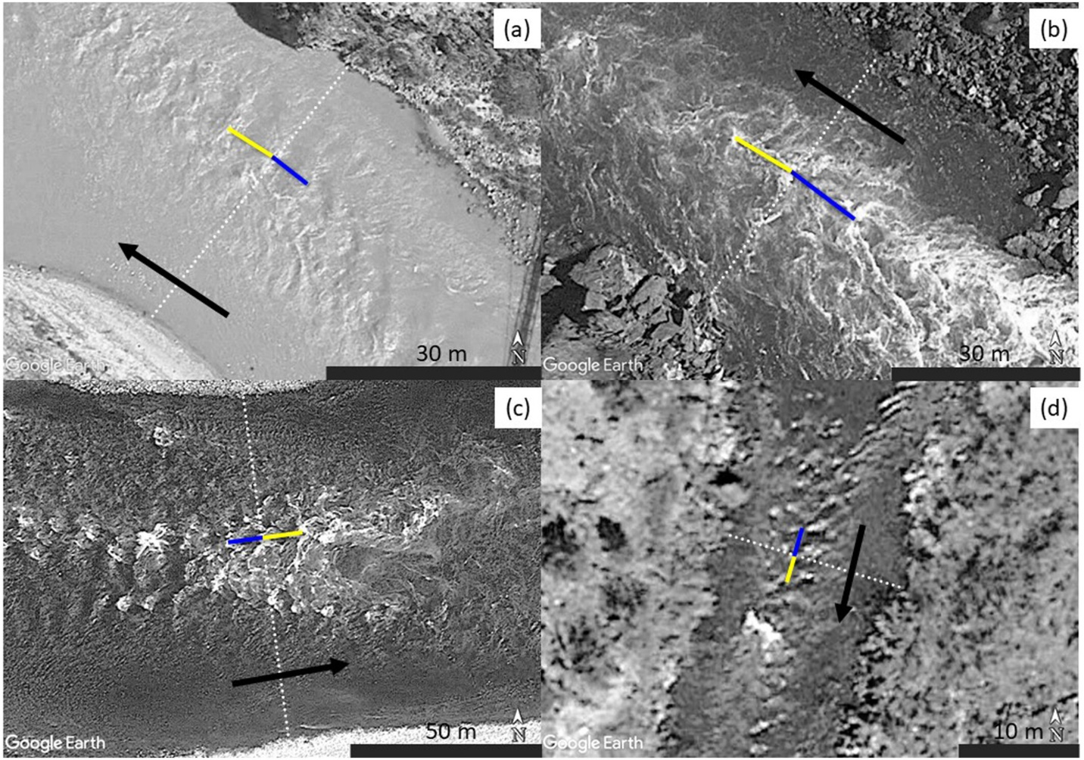
Caption for Graphic or Image: Example rapids and measurements of width (white dotted lines) and two sequential wavelengths (blue and yellow lines) made in Google Earth and used to calculate river discharge based on critical flow theory. Flow direction indicated by black arrows. (a) Bright Angel Rapid, Colorado River, 7 April 2022. (b) Horn Rapid, Colorado River, 26 June 2017. (c) Lewis Rapid, Snake River, 5 August 2014. (d) Hondo Rapid, Rio Grande, 2 March 2021.
Author name: Carl Legleiter
Author business email: cjl@usgs.gov

DOI agency/bureau: USGS
USGS Mission Area: Ecosystems
USGS Program: National Water Quality Program
Cost Center: Oregon Water Science Center
Program Name:
Project title: Airborne Thermal Infrared Surveys of Stream Temperature in the Willamette River Basin, Oregon
Project description: Scientists at the U.S. Geological Survey’s Forest and Rangeland Ecosystem Science Center, Oregon Water Science Center, Washington Water Science Center, and Water Mission Area (WMA) Hydrologic Remote Sensing Branch have compiled thermal infrared (TIR) surveys of stream temperature collected over 1,600 km between 1999 and 2024 in the Willamette River basin in Oregon. This effort is the first comprehensive archiving of TIR data in the Pacific Northwest. A data release (https://www.sciencebase.gov/catalog/item/6851a576d4be027dac17e084) for past surveys conducted in the Santiam River basin in 2000 has been published (see example below with TIR imagery and true-color aerial photography for a section of Quartzville Creek). Past surveys in other basins and a resurvey of rivers in the Santiam River basin in summer 2024 will be available in the coming months. Thermal infrared imaging is used to map water temperature in rivers and streams and help scientists better understand drivers and ecological effects of riverine thermal diversity across the ‘thermalscape’. A thermalscape is a continuous picture of thermal patterns across multiple temporal and spatial scales. The high-resolution images depicting thermal heterogeneity were collected by helicopters equipped with cameras that measured surface temperatures of the surveyed landscape by capturing emitted radiation within the 8-14 μm waveband. Spatially continuous TIR imagery can be integrated with temporally continuous data from in-situ data loggers and process-based and empirical models for entire watersheds and rivers, as well as smaller tributaries and groundwater sources. Now and in the future, these data are critical to (1) understand the context of hydrogeological processes throughout the thermalscape, (2) identify cold-water patches critical to aquatic biota such as salmon and trout, and (3) assess potential human influences on stream temperature dynamics. The Willamette basin is Oregon’s most populous urban and agricultural center, and such information is needed to support local, state, and federal resource managers balancing water availability, water temperature concerns, and salmon recovery. This work is funded by the USGS WMA Next Generation Water Observations System (NGWOS) and Integrated Water Availability Assessments (IWAAs) programs.
Desciption Link Overflow: https://www.sciencebase.gov/catalog/item/6851a576d4be027dac17e084
Sensor Type: Thermal
Platform type: Airplane;Helicopter
URL: https://www.usgs.gov/mission-areas/water-resources/science/integrated-water-science-basins-willamette-river#NGWOS
Graphic or Image Upload: https://doimspp.sharepoint.com/sites/GS-EROSSCIENCESWI/Shared Documents/Communications Outreach/Documentation Science/DOI Remote Sensing Report/DOI RS Activities Report, 2025/Question/RS25_QuartzvilleCreek_TIR_Sylvia Gholson.jpg
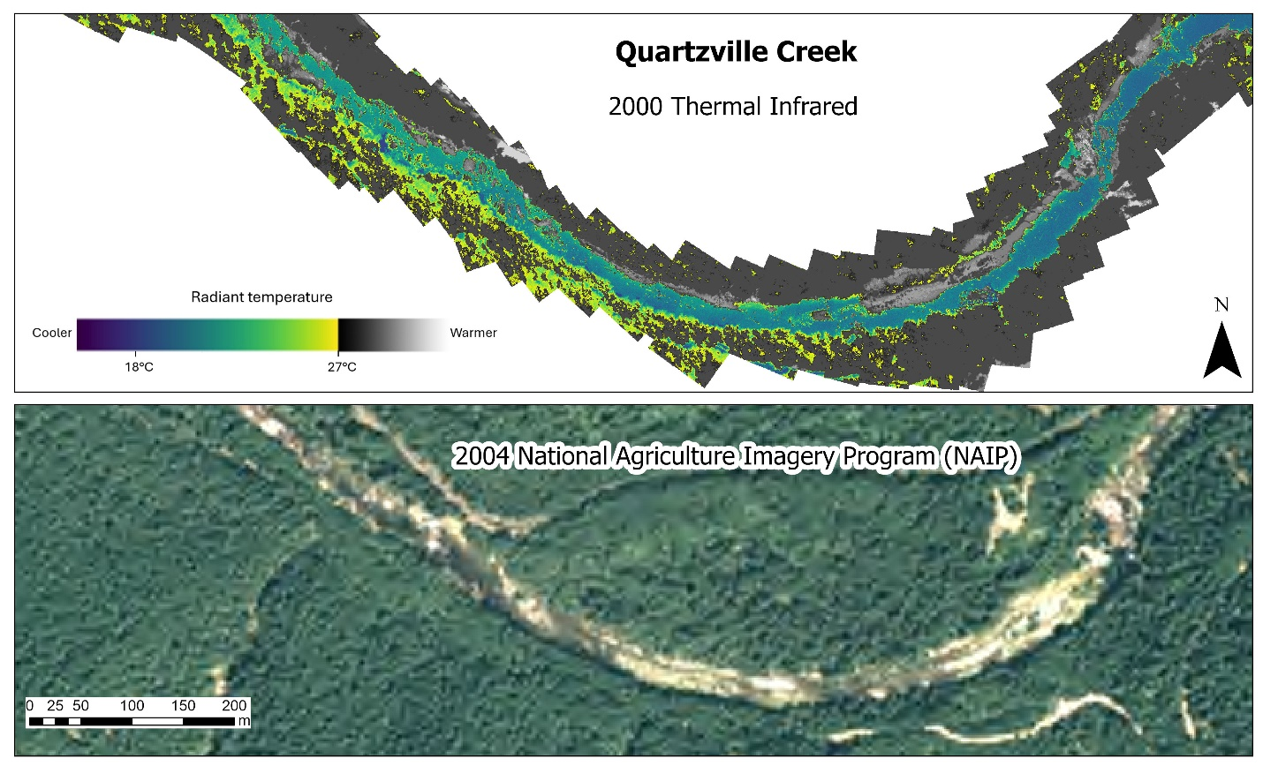
Caption for Graphic or Image: Airborne TIR mosaic of a section of Quartzville Creek in the Santiam River basin where data collection occurred on August 2, 2000 at 15:45 (top); publicly available true-color aerial photography from 2004 is provided to aid in interpretation (bottom).
Author name: Sylvia R. Gholson
Author business email: sgholson@usgs.gov

DOI agency/bureau: USGS
USGS Mission Area: Ecosystems
USGS Program: Land Management Research Program
Cost Center: Upper Midwest Environmental Sciences Center
Program Name:
Project title: AI for Offshore Energy: Innovative Technology Streamlines Marine Wildlife Surveys
Project description: The Atlantic and Gulf of America contain abundant untapped energy and mineral resources, and responsible development requires knowledge of marine wildlife populations. The U.S. Geological Survey (USGS), Bureau of Ocean Energy Management (BOEM), U.S. Fish and Wildlife Service (USFWS), universities, and private industry are collaborating on innovative artificial intelligence (AI) tools and workflows, combined with remotely sensed imagery, to improve the safety and efficiency of aerial wildlife surveys in marine environments.

This initiative will dramatically improve the efficiency of marine wildlife surveys—reducing the analysis timeline from years to days—so that accurate information on the distribution, abundance, and seasonality of seabirds, whales, and sea turtles can be rapidly delivered to decision makers and stakeholders. This information directly supports BOEM's statutory responsibilities under Section 18 of the Outer Continental Shelf Lands Act for balanced leasing program development and Section 20's requirements for comprehensive environmental studies and impact assessment, and USFWS’s statutory obligations under the Migratory Bird Treaty Act to sustainably manage hunting of certain species.

Our partnership is working with private industry to engineer advanced aerial camera systems and onboard processing capabilities for automated detection of marine wildlife. These systems have been designed to address unique challenges and extreme data volumes associated with high-resolution (sub-cm) remote sensing surveys over large geographic regions. To date, nearly 6 million images have been collected in the Atlantic and Gulf of America. We are also leveraging cost-effective commercial applications and custom in-house code for cloud-based hosting of remote sensing imagery and assembling labeled training datasets. Working with New Jersey Audubon, we have compiled a dataset with almost 30K images and 160K labeled objects. We have also customized the open-source Ultralytics YOLO architecture to train AI models capable of detecting and identifying birds, mammals, reptiles, and fish to the family taxonomic level (Figure 1). We are actively working to refine classification at lower taxonomic levels, including species.

Through interagency collaboration, we have established the foundation for an automated workflow to expedite the delivery of environmental information required for oil, gas, and marine minerals leasing and waterfowl harvest management decisions under federal law. The AI-based workflows we have developed and trained on Atlantic and Gulf of America imagery will be deployable across the entire Outer Continental Shelf and will be open and transparent, enabling other agencies and the private sector to replicate and adapt the process.

Desciption Link Overflow:

Sensor Type: Camera
Platform type: Airplane
URL: https://www.usgs.gov/centers/upper-midwest-environmental-sciences-center/science/deep-learning-automated-detection-and
Graphic or Image Upload: https://doimspp.sharepoint.com/sites/GS-EROSSCIENCESWI/Shared Documents/Communications Outreach/Documentation Science/DOI Remote Sensing Report/DOI RS Activities Report, 2025/Question/DOI Remote Sens_2025 Picture_Aaron Murphy.jpg
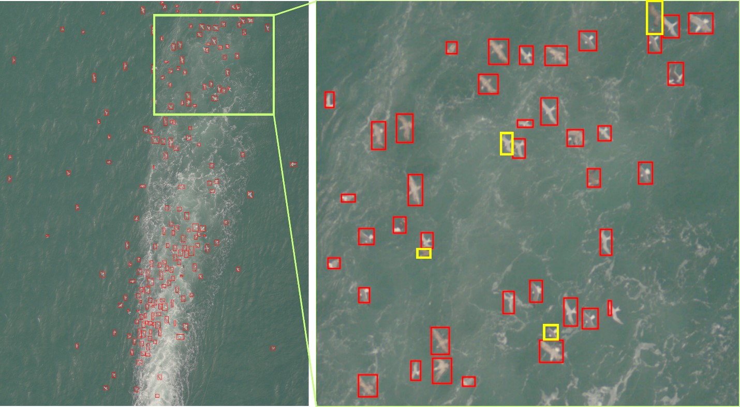
Caption for Graphic or Image: Figure 1. Detections of birds following in the wake of a ship are shown in red boxes. The AI model can process images like this, with large numbers of wildlife, much faster than a human reviewer. The current model still fails to detect some birds (yellow boxes), typically when they are close to another bird or in an unexpected orientation. We are using active learning with human review to verify outputs, make corrections, and retrain models to improve performance.
Author name: Aaron Murphy
Author business email: amurphy@usgs.gov

DOI agency/bureau: USGS
USGS Mission Area: Core Science Systems
USGS Program: National Land Imaging Program
Cost Center: Earth Resources Observation and Science (EROS) Center (Geography)
Program Name:
Project title: National Wildland Fire support through LANDFIRE
Project description: LANDFIRE (Landscape Fire and Resource Management Planning Tools) is a shared interagency wildland fire management data program across the United States and Territories. Leadership, management, and oversight are through the U.S. Department of Agriculture Forest Service - Fire and Aviation Management and the U.S. Department of the Interior – Office of Wildland Fire.

LANDFIRE provides more than twenty landscape-scale geospatial products of biological and ecological data, including data such as (900+) vegetation types and fire behavior fuel models (13&40) that support all land planning, fire and natural resources management, operations, analyses and assessments. LANDFIRE also integrates changes from disturbances such as wildland fires, prescribed fire treatments, insect damage, forest harvest, etc., into its mapped products, all of which are released yearly.

Data and information can be obtained through LANDFIRE.gov, which includes a viewer, national extent downloads, and the LANDFIRE Product Service (LFPS – as shown in the graphic, upper middle below the wording “Fire Behavior Modeling”). Through the LFPS, LANDFIRE data is directly integrated with wildland fire applications such as the Wildland Fire Decision Support System (WFDSS) and the Interagency Fuel Treatment Decision Support System (IFTDSS) supporting wildland fire agencies. These applications utilize the LFPS Application Programming Interface (API) visualized in the graphic to serve data needed for rapid fire behavior and risk modeling. You can learn more about how LANDFIRE data are used in these applications by visiting the IFTDSS Help and LANDFIRE page. LANDFIRE’s LFPS API prioritizes fire agency requests while also allowing public access generating over 400,000 landscape data requests a year, while the website and viewer generate over 350,000 downloads of National and regional maps. LANDFIRE also serves as the starting point for nearly all fire risk assessments, as well as prevention and mitigation efforts across the nation.

Desciption Link Overflow:
Sensor Type: Lidar (terrestrial or bathymetric);Multispectral (approx. 4-12 bands);Thermal;IFSAR / SAR / Radar
Platform type: Ground based / sensor web / web cam;Airplane;Satellite
URL: landfire.gov
Graphic or Image Upload: https://doimspp.sharepoint.com/sites/GS-EROSSCIENCESWI/Shared Documents/Communications Outreach/Documentation Science/DOI Remote Sensing Report/DOI RS Activities Report, 2025/Question/lfps14_Jon Dewitz.jpg
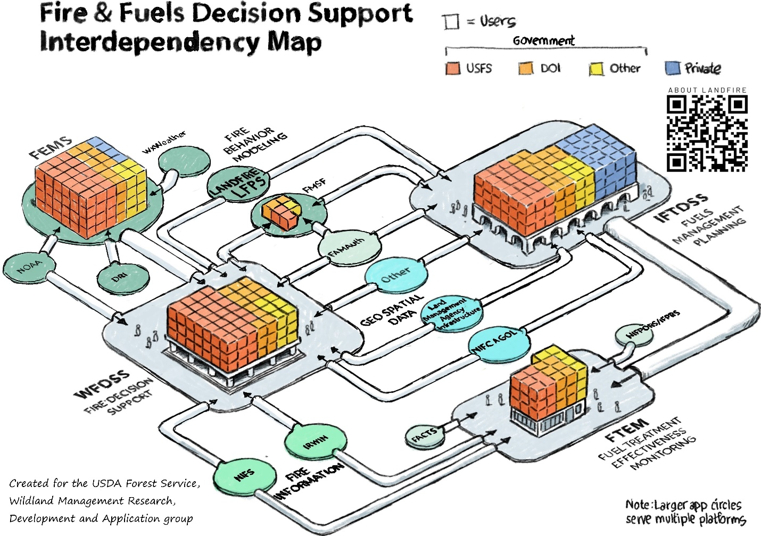
Caption for Graphic or Image: Fire and Fuels Decision Support Interdependency Map
Author name: Jon Dewitz
Author business email: dewitz@usgs.gov

DOI agency/bureau: USGS
USGS Mission Area: Natural Hazards
USGS Program: Coastal and Marine Geology Program
Cost Center: St. Petersburg Coastal and Marine Science Center
Program Name:
Project title: Long‑Term Marsh Migration and Shoreline Erosion
Project description: Coastal wetlands like marshes are valuable ecosystems that help protect shorelines, support fisheries, and store carbon. But they’re under threat from rising seas, stronger storms, and wave erosion. However, marshes aren’t entirely defenseless. They can survive sea level rise by building upward through sediment (called vertical accretion) and by moving inland into higher ground (migration). To understand and document this process, we studied changes in marsh shorelines and migration over time in the Grand Bay estuary, a mostly undeveloped coastal area on the Mississippi-Alabama border. Using satellite and aerial imagery and historic topographic maps from as far back as the 1880s, we tracked how marsh shorelines and boundaries have shifted over more than a century.

We found that the rate of shoreline erosion has increased. Since the 1950s, marsh shorelines have been retreating faster, about 1.55 meters per year compared to 0.84 meters per year before that. The worst erosion happened where marshes are more exposed to wind-driven waves, especially as nearby barrier islands decreased in area and shifted westward, increasing marsh shoreline exposure. At the same time, marshes migrating inland into rivers, forests, and higher ground. Although marshes are migrating inland at rates similar to shoreline erosion, they haven’t been able to fully keep pace; especially in areas where development blocks their movement, resulting in an overall 15% loss of marsh area. Some forested areas have turned into marsh, partly due to changing land management. But if the land is too steep or blocked by development, marshes can’t move inland, and both marsh and forest habitats can shrink. Coastal marshes are adapting to sea level rise, but not quickly enough to prevent habitat loss. Their survival depends on space to migrate and on protecting the natural processes that reduce erosion and build elevation.

Full details on this study can be found in this paper [https://doi.org/10.1016/j.ecss.2024.109106], with details on how we use satellite imagery to map and quantify marsh shoreline changes in this paper [https://doi.org/10.3390/rs13153030].
Desciption Link Overflow:
Sensor Type: Multispectral (approx. 4-12 bands);Camera
Platform type: Airplane;Satellite
URL: https://www.usgs.gov/centers/spcmsc/science/estuarine-shoreline-change-research-project
Graphic or Image Upload: https://doimspp.sharepoint.com/sites/GS-EROSSCIENCESWI/Shared Documents/Communications Outreach/Documentation Science/DOI Remote Sensing Report/DOI RS Activities Report, 2025/Question/1-s2.0-S0272771424004943-gr5_lrg_Kathryn Smith.jpg
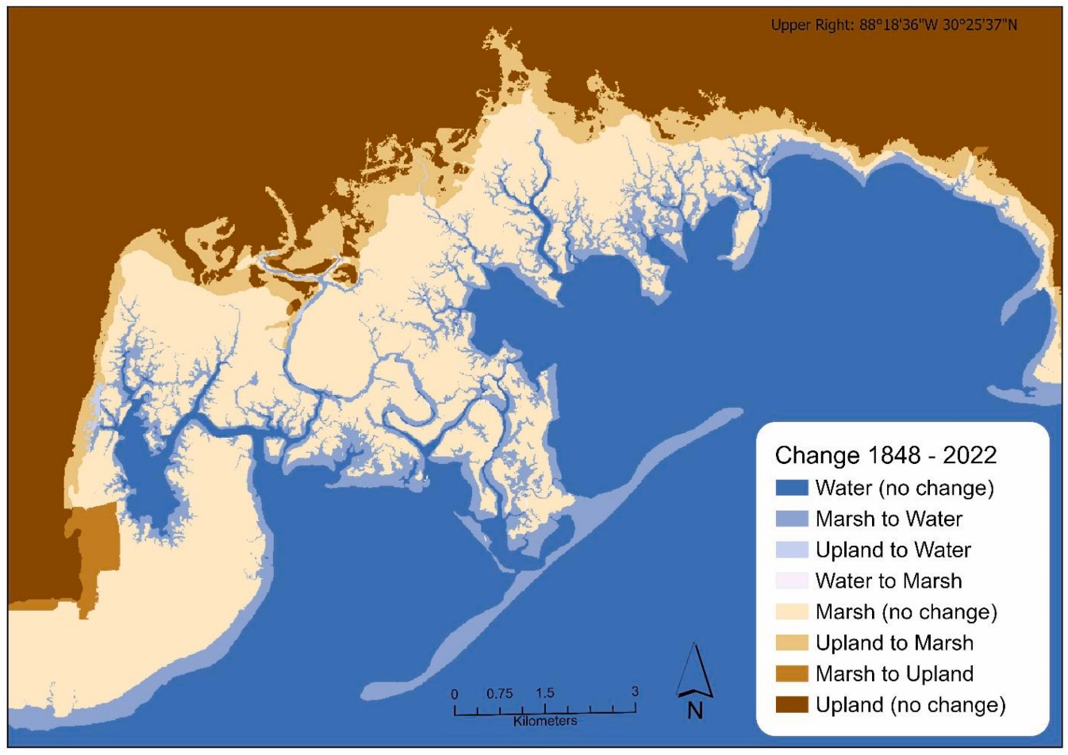
Caption for Graphic or Image: Habitat conversion for three habitat types (water, marsh, and upland in km2) from historical (1848) to modern (2022) for the Grand Bay study area. Figure is from this paper [https://doi.org/10.1016/j.ecss.2024.109106]. Additional maps and data can be found in the supplemental material [https://ars.els-cdn.com/content/image/1-s2.0-S0272771424004943-mmc1.docx] and the data release [https://doi.org/10.5066/P1HZES2R].
Author name: Kathryn Smith
Author business email: kelsmith@usgs.gov

DOI agency/bureau: USGS
USGS Mission Area: Natural Hazards
USGS Program: Coastal/Marine Hazards and Resources Program
Cost Center: Woods Hole Coastal and Marine Science Center
Program Name:
Project title: Seafloor mappers and drone pilots team up to map local municipal water supply
Project description: The USGS Woods Hole Coastal and Marine Science Center (WHCMSC) have partnered with the Town of Falmouth, MA to estimate the volume of available fresh water from the town water supply in Long Pond a large kettle pond on Cape Cod. Members of both the Seafloor Mapping Group (SFMG) and the Aerial Imaging and Mapping Group (AIMG) at USGS WHCMSC collaborated to collect bathymetry and shoreline topography to create a near-continuous 3D model of Long Pond’s reservoir.
Since 1898, Long Pond has been Falmouth’s primary drinking water source and the only pond on Cape Cod that provides water to a municipality. Cape Cod has been in drought conditions since January, making it a priority for the town to have up-to-date reservoir models to estimate available freshwater at different pond levels. The last bathymetry dataset was collected in 2011 by single-beam sonar, which is relatively low resolution compared to modern technology.
In April 2025, when water levels were at their annual peak, the SFMG mapped the bathymetry of the pond using an electric motor-powered boat equipped with a multi-beam echo sounder. Unlike single beam sonar, which measures one depth at a time, multi-beam collects several hundred depth points at each boat position. This greatly improves upon the previous dataset, which failed to detect many boulders on the pond floor. In late Aug 2025, when the water levels were lowest – partly due to the 10,000+ runners of the world-famous Falmouth Road Race – the AIMG collected uncrewed aircraft systems (UAS)-mounted lidar data to map the topography of the exposed banks. In 2011, UAS-mounted lidar was not yet commercially viable, so this provides a completely new dataset. Conducting these surveys at seasonal high and low water levels minimized gaps between the datasets, allowing shoreline topography and bathymetry to be merged into a near-continuous model of Long Pond's geomorphology. This project aligns with agency priorities and supports the executive order “Achieving Efficiency through State and Local Preparedness.” The results enable the Town of Falmouth to make informed decisions to improve drought resiliency and ensure water security for residents. For more information on this project, visit the USGS project page.
Desciption Link Overflow: I had made an embedded link with the final word of my summary "page", but I don't think that translates into this form. The link is below. I also added it in the summary, but I would prefer it to be embedded as "page."

https://www.usgs.gov/centers/whcmsc/news/helping-our-neighbors-usgs-surveys-primary-drinking-water-source-town-falmouth
Sensor Type: Sound (sonar or acoustic);Lidar (terrestrial or bathymetric)
Platform type: UAS;Boat
URL: https://www.usgs.gov/centers/whcmsc/news/helping-our-neighbors-usgs-surveys-primary-drinking-water-source-town-falmouth
Graphic or Image Upload: https://doimspp.sharepoint.com/sites/GS-EROSSCIENCESWI/Shared Documents/Communications Outreach/Documentation Science/DOI Remote Sensing Report/DOI RS Activities Report, 2025/Question/Long_Pond_Graphic_v2_Jennifer Cramer.jpg
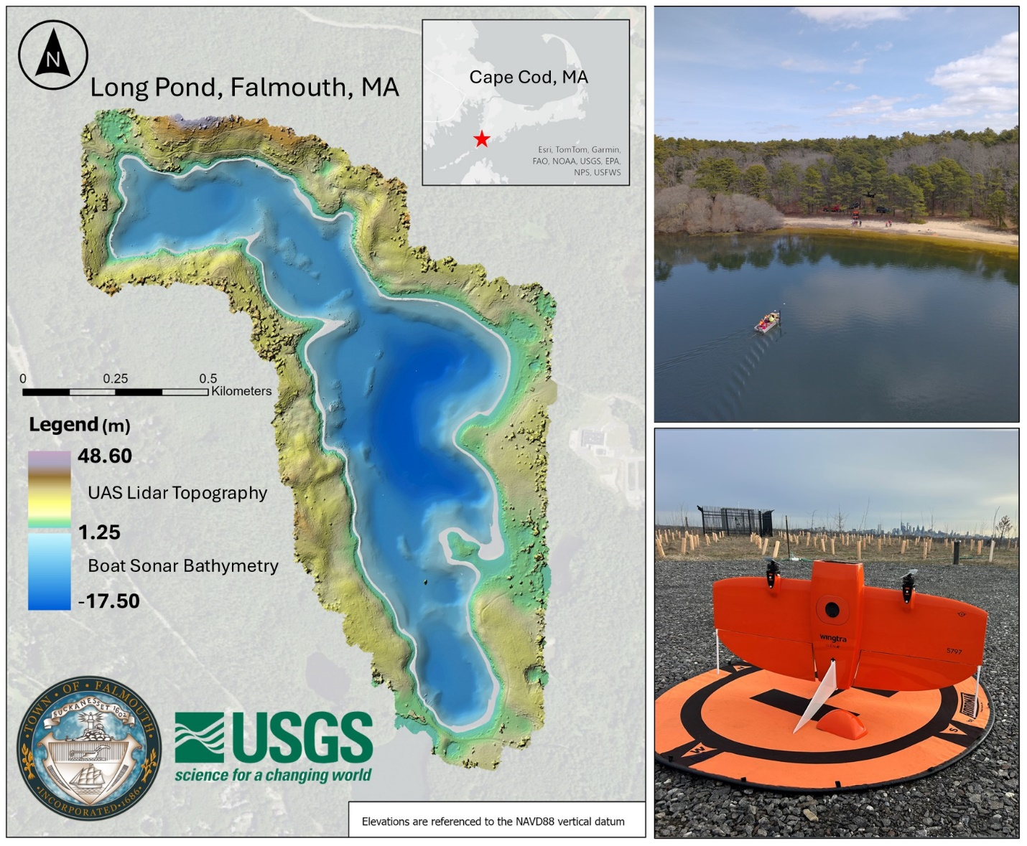
Caption for Graphic or Image: The map on the left shows the merged bathymetry-elevation model of Long Pond. The top right image is a photo taken from a drone of the multi-beam sonar equipped boat and the bottom right image shows the UAS, a WingtraOne Gen II, that was used to collect the lidar data.
Author name: Jennifer Cramer, Seth Ackerman, Sandy Brosnahan
Author business email: jcramer@usgs.gov

DOI agency/bureau: USGS
USGS Mission Area: Water Resources
USGS Program: Groundwater and Streamflow Information Program
Cost Center: **unspecified**
Program Name:
Project title: Water Information from Space (WISP)
Project description: The U.S. Geological Survey recently launched a new web application Water Information from Space, or WISP, which harnesses data from NASA's Surface Water Ocean Topography satellite to monitor water levels across more than 467,000 lakes and reservoirs and approximately 93,000 miles of river networks throughout the United States. The satellite-powered tool is transforming how communities understand and analyze their water systems, providing valuable data for flood recovery, infrastructure planning and long-term water resource management across America. The free, publicly accessible tool makes it easy for anyone to track water conditions in their community. Users can browse water data through an interactive map, search by location or water body name, and download time series information for research or planning purposes. WISP is available at the following link, and is supported by the USGS Water Mission Area Hydrologic Remote Sensing Branch, and developed by Chuck Hansen and his team at the California Water Science Center: https://apps.usgs.gov/wisp. More information on the impact of WISP can be found in the following feature story: https://www.usgs.gov/news/featured-story/seeing-water-space.
Desciption Link Overflow:
Sensor Type: IFSAR / SAR / Radar
Platform type: Satellite
URL: https://apps.usgs.gov/wisp
Graphic or Image Upload: https://doimspp.sharepoint.com/sites/GS-EROSSCIENCESWI/Shared Documents/Communications Outreach/Documentation Science/DOI Remote Sensing Report/DOI RS Activities Report, 2025/Question/WISP1_Merritt Harlan.png
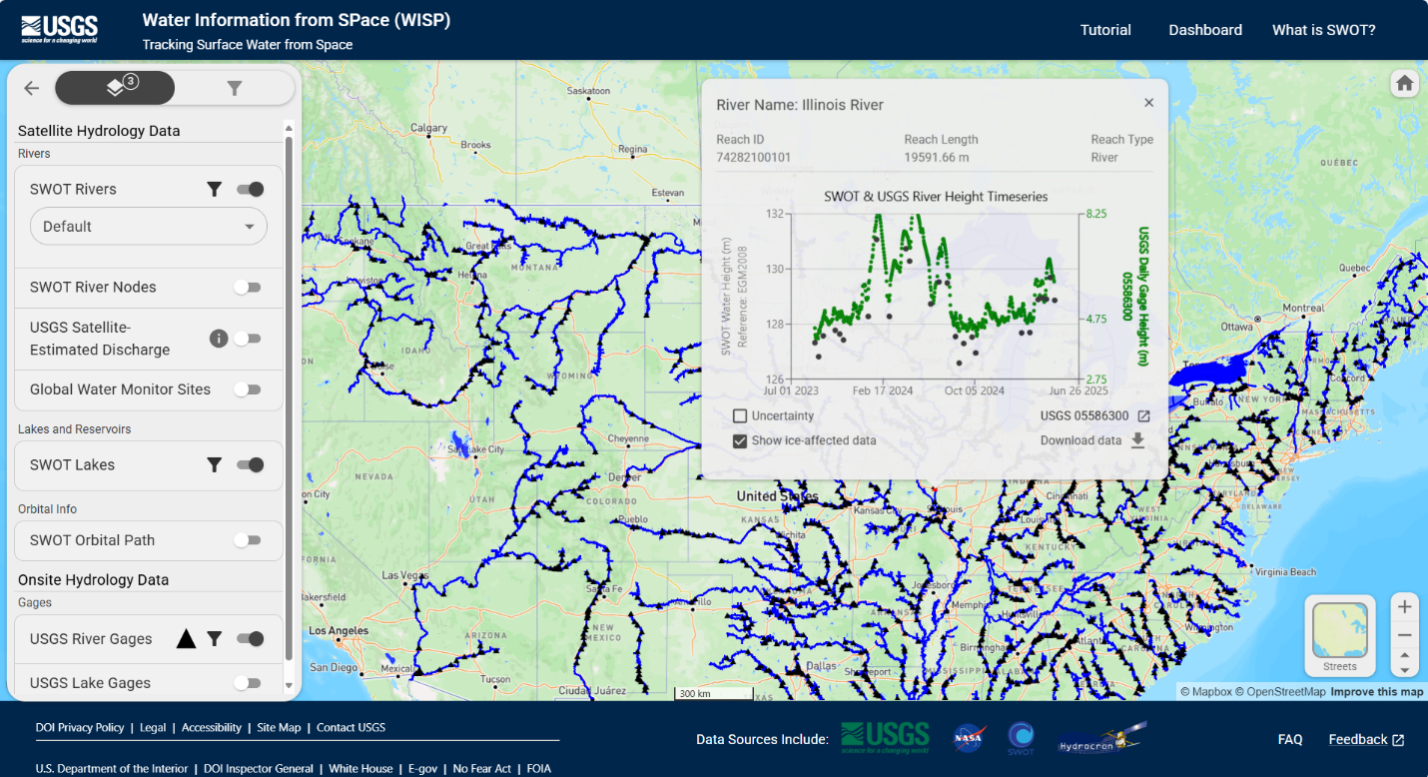
Caption for Graphic or Image: Water Information from Space (WISP) web application, showing water levels from a satellite and a gage on the Illinois River.
Author name: Merritt Harlan
Author business email: mharlan@usgs.gov

DOI agency/bureau: USGS
USGS Mission Area: Core Science Systems
USGS Program: Land Change Science
Cost Center: Earth Resources Observation and Science (EROS) Center (Geography)
Program Name:
Project title: Monthly Actual Evapotranspiration from Landsat for the conterminous United States (2000-2020)
Project description: Remotely sensing-based actual evapotranspiration (ETa) estimates provide useful information for a range of agro-hydrologic applications, from calculating a basin’s water budget to assessment of water consumption for crop yield prediction and drought monitoring. Scientists with the U.S. Geological Survey (USGS) Earth Resources Observation and Science (EROS) Center have developed and published 21 years of monthly ETa layers using Landsat and the Simplified Surface Energy Balance (SSEBop) model, building on years of research by USGS and federal partners, universities, and non-governmental organizations. This data release is a result of using the OpenET implementation of the USGS SSEBop model for historic field-scale data production across the conterminous United States from 2000-2020, provided as time-integrated pixel-based monthly ETa estimates at 30-meter resolution.

Driven by land surface temperature from the Landsat thermal band, SSEBop model results help with decisions about building water budgets and allocations that face increasing pressure from changes in weather and climate, and competing needs from drought impacts on agriculture and growing population needs. For example, across the High Plains Aquifer, satellite-based ETa can accurately estimate crop water consumption from irrigation dependencies and practices – particularly evident in years characterized by ongoing drought, such as periods of continued water-level declines (2004) and extreme seasonal drought events (2011-2013) in parts of the aquifer. Monthly water use patterns and annual trends can illustrate the dynamic spatial and temporal nature of landscape and field-level water consumption across basins, useful for future planning purposes.

This work provides researchers and water resource managers with complete and consistent public domain information on ETa necessary for informing land management applications and many other use cases. The advancement and availability of this data product also benefits National Hydrologic Modeling efforts for modernizing USGS consumptive water use reporting across the United States.

Desciption Link Overflow:
Sensor Type: Thermal;Multispectral (approx. 4-12 bands)
Platform type: Satellite
URL: https://doi.org/10.5066/P1FWGEBU
Graphic or Image Upload: https://doimspp.sharepoint.com/sites/GS-EROSSCIENCESWI/Shared Documents/Communications Outreach/Documentation Science/DOI Remote Sensing Report/DOI RS Activities Report, 2025/Question/Figure3_Gabriel Senay.gif
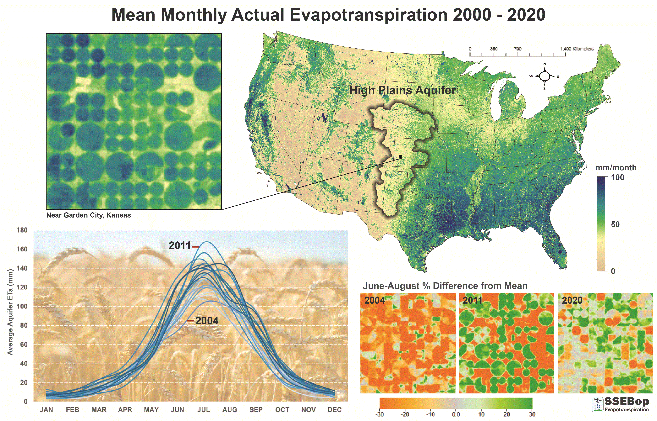
Caption for Graphic or Image: SSEBop Actual Evapotranspiration (ETa) from Landsat, 2000-2020 mean monthly across the conterminous United States. Seasonal chart shows mean monthly ETa for the High Plains Aquifer. June-August ETa anomaly (% Difference from Mean) shown for 2004, 2011, and 2020.
Author name: Gabriel Senay
Author business email: senay@usgs.gov

DOI agency/bureau: USGS
USGS Mission Area: Water Resources
USGS Program: Groundwater and Streamflow Information Program
Cost Center: Office of the AD Water
Program Name:
Project title: Remote sensing of water quality:
Project description: Our ability to map water quality using satellite imagery is enhanced when satellite imagery is processed with aquatic specific methods. In the absence of readily available aquatic reflectance products, the USGS Water Mission Area developed a cloud-based method for processing and publishing aquatic reflectance versions of Sentinel-2 satellite imagery. This process has been used to process more than 500,000 historical satellite images of the contiguous United States and is configured to process new images as they are acquired. The resulting published 200+ terabyte aquatic reflectance dataset is free and publicly available. It serves as a foundation for developing bio-optical models of inland water quality at the national scale. Forthcoming publications focus on comparing the aquatic and surface reflectance products, and on describing aquatic chlorophyll-a fluorescence and turbidity models developed with these data.

Data available here: https://www.sciencebase.gov/catalog/item/640f612dd34e254fd352e1ed
Desciption Link Overflow:
Sensor Type: Multispectral (approx. 4-12 bands)
Platform type: Satellite
URL:
Graphic or Image Upload: https://doimspp.sharepoint.com/sites/GS-EROSSCIENCESWI/Shared Documents/Communications Outreach/Documentation Science/DOI Remote Sensing Report/DOI RS Activities Report, 2025/Question/Acotline_vs_sen2cor_Tyler King.png
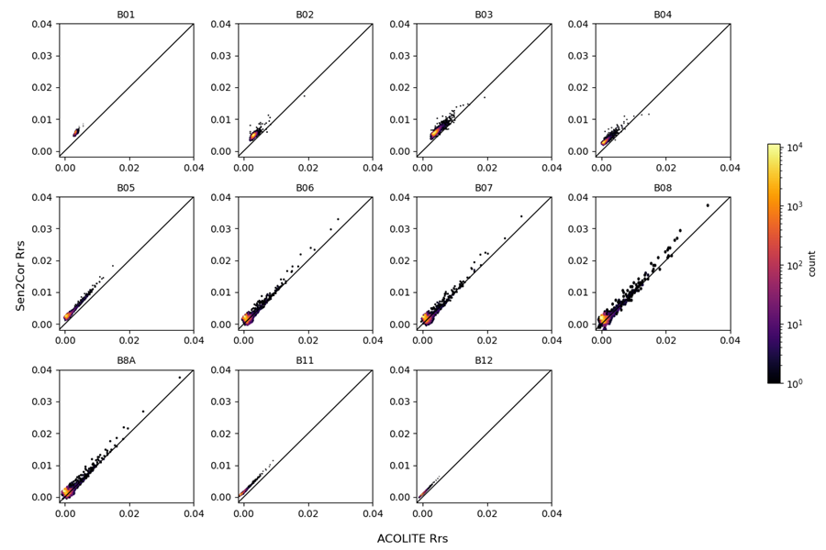
Caption for Graphic or Image: Scatterplots of Sen2Cor against ACOLITE remote sensing reflectance of Lake Cascade, Idaho from July 7, 2022 for band 1 (B01) through band 12 (B12). The black line is the 1:1 line and the color ramp is count of pixels on a log scale.
Author name: Tyler King
Author business email: tvking@usgs.gov

DOI agency/bureau: USGS
USGS Mission Area: Water Resources
USGS Program: National Streamflow Information Program
Cost Center: Office of the AD Water
Program Name:
Project title: Remote Sensing of Water Quality: Field Sampling Guidance
Project description: The U.S. Geological Survey, in partnership with the U.S. Army Corps of Engineers, has compiled a report on considerations and potential methods for collecting field data used in verifying aquatic remote sensing products. The report outlines detailed methods and priority considerations for collecting high-quality field data in inland waters (defined as rivers, lakes, reservoirs, estuaries, streams and wetlands), including best practices for collecting and preparing discretely collected water samples and for calibration, maintenance, and quality assurance and quality control of field sensors. While the priorities will vary between applications, some general guidelines are to collect field samples 1) as close in time to a satellite overpass as possible, 2) from representative areas of the water body to capture the range of spatial variability, and 3) near the surface (within the first optical depth) to match remote sensing reflectance data. The report is written for the aquatic science community that is interested in evaluating remotely sensed products for a waterbody or system of interest.
Desciption Link Overflow:
Sensor Type: Multispectral (approx. 4-12 bands)
Platform type: Satellite
URL:
Graphic or Image Upload: https://doimspp.sharepoint.com/sites/GS-EROSSCIENCESWI/Shared Documents/Communications Outreach/Documentation Science/DOI Remote Sensing Report/DOI RS Activities Report, 2025/Question/sampling_Tyler King.png
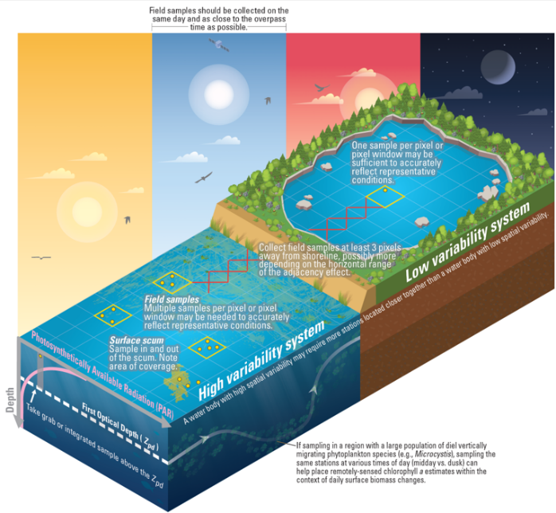
Caption for Graphic or Image: Conceptual diagram illustrating important sampling considerations for developing and verifying remote sensing chlorophyll a models in inland waters.
Author name: Tyler King
Author business email: tvking@usgs.gov

DOI agency/bureau: USGS
USGS Mission Area: Water Resources
USGS Program: National Streamflow Information Program
Cost Center: Office of the AD Water
Program Name:
Project title: Remote Sensing of Water Quality: Paired Field and Satellite Dataset
Project description: Datasets of water quality paired with satellite data are the foundation for developing and testing remote sensing of water quality algorithms. The USGS maintains a series of continuous water quality sensors across the country with specific intensive focus on a few research basins that are part of the “Next Generation Water Observing System”. In these basins “Super Gages” are outfitted with water quality sensor that measure every 15 minutes. This continuous stream of high quality data was matched with Sentinel-2 aquatic reflectance values to produce a dataset with more than 1.7 million same-day match ups of chlorophyll-a fluorescence, turbidity, and dissolved organic matter fluorescence. The published dataset is publicly available for use in model development, benchmarking, and verification.

Data are available here: https://doi.org/10.5066/P1A7T4FV
Desciption Link Overflow:
Sensor Type: Multispectral (approx. 4-12 bands)
Platform type: Satellite
URL:
Graphic or Image Upload:
Caption for Graphic or Image:
Author name: Tyler King
Author business email: tvking@usgs.gov

DOI agency/bureau: USGS
USGS Mission Area: Water Resources
USGS Program: National Streamflow Information Program
Cost Center: Office of the AD Water
Program Name:
Project title: Remote Sensing of Water Quality: Algal Bloom Case Study in Blue Mesa Reservoir, Colorado
Project description: Working in partnership, U.S. Geological Survey and National Park Service scientists recently published a journal article documenting a process for incorporating remote sensing of chlorophyll-a and temperature into harmful algal blooms. The study, focused on Blue Mesa Reservoir, CO, used Sentinel-2 Aquatic Reflectance products and in situ data to train a machine learning model to produce maps of aquatic chlorophyll-a from satellite imagery from 2016 through 2023. Analysis of the processed satellite imagery confirms that algal blooms have historically initiated in the shallow eastern end of the reservoir and propagated to the west. Remotely sensed water temperature from Landsat 5, 7, 8, and 9 were extracted for the reservoir from 2000 through 2023. The long-term temperature record shows that summer water temperature increased at a linearized rate of 0.3°C per decade from 2000 through 2023. In general, remotely sensed chlorophyll and temperature increased as low waters decreased. This approach could be adopted elsewhere to develop site-specific models tuned to answer specific management questions around harmful algal blooms.

The paper is published here: https://doi.org/10.1111/1752-1688.70038
The associated data is published here: https://doi.org/10.5066/P9XULQAS
Desciption Link Overflow:
Sensor Type: Multispectral (approx. 4-12 bands)
Platform type: Satellite
URL:
Graphic or Image Upload: https://doimspp.sharepoint.com/sites/GS-EROSSCIENCESWI/Shared Documents/Communications Outreach/Documentation Science/DOI Remote Sensing Report/DOI RS Activities Report, 2025/Question/jawr70038-fig-0001-m_Tyler King.jpg
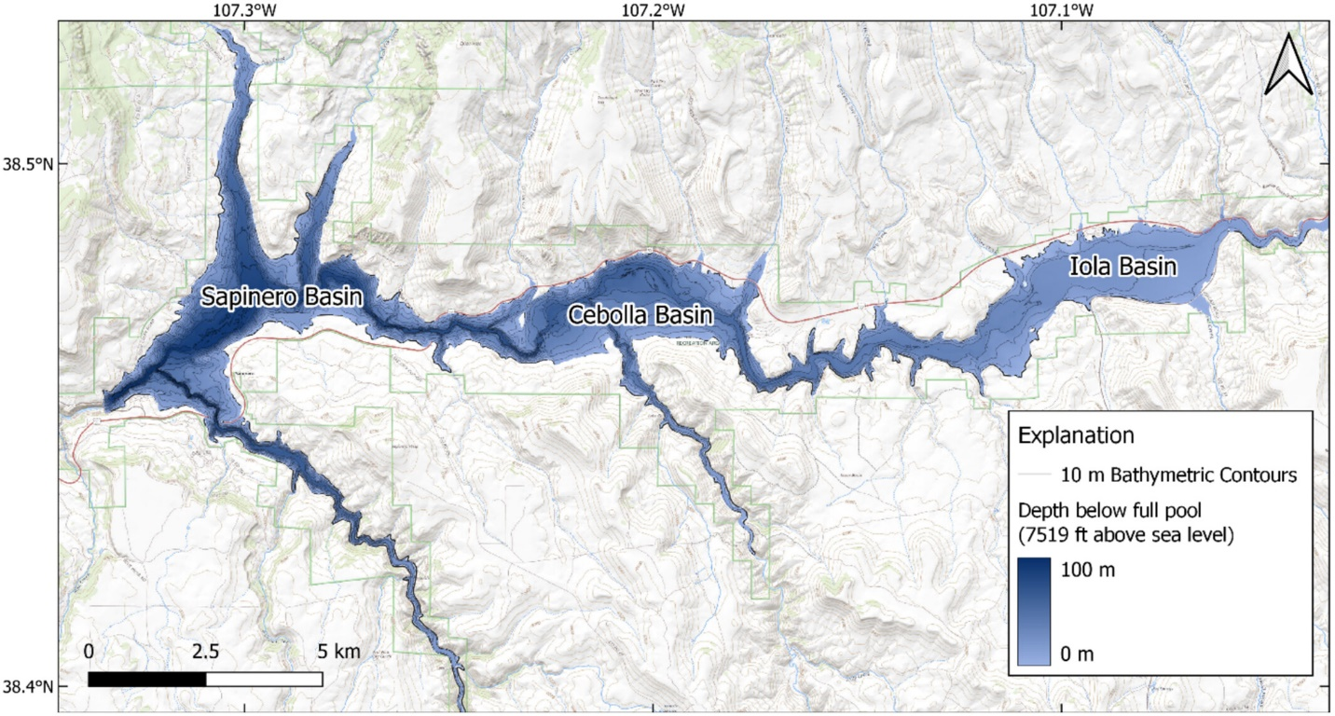
Caption for Graphic or Image: Map of Blue Mesa Reservoir in Gunnison County, Colorado, USA indicating the three major basins, Iola in the east, Cebolla in the middle, and Sapinero in the west. Flow is from east to west. Reservoir bathymetry from in depth below full pool of 7519 ft above sea level (2292 m) is indicated by the blue color flood and shows an increase in depth from east to west.
Author name: Tyler King
Author business email: tvking@usgs.gov

DOI agency/bureau: USGS
USGS Mission Area: Core Science Systems
USGS Program: National Land Imaging Program
Cost Center: **unspecified**
Program Name:
Project title: Responding to Explosive Eruption at Lewotobi’s LakiLaki Crater, Indonesia
Project description: Lakilaki Crater, part of Lewotobi volcano on Flores Island, Indonesia has been experiencing intermittent eruptive activity since December 2023, at which time scientists from the USGS National Civil Applications Center (NCAC) and the Volcano Disaster Assistance Program (VDAP) began monitoring the volcano closely using high spatial resolution satellite data. Activity began to rapidly intensify on November 3rd, 2024. A large, explosive eruption ejected incandescent ballistics and blocks into local villages and generated deadly pyroclastic density currents that rushed down the flanks of the volcano in all directions. Local authorities quickly raised the alert level for Lewotobi, expanded the exclusion zone around the volcano from 3 kilometers to 7 kilometers, and within hours, evacuated an estimated 10,000 people from nearby villages. Local sources reported the eruption claimed nine lives, mostly within the village of Klatanlo, located 3 kilometers northwest of the summit.

Satellite imagery acquired soon after the eruption allowed NCAC and VDAP scientists to rapidly assess the extent of damage, informing products and reports that were promptly delivered to local authorities. WorldView-3 images below show that the eruption’s energy was largely directed northwestward, destroying forested areas within 2 kilometers, launching ballistic ejecta as far away as 7 kilometers, and depositing ash across an area greater than 75 square kilometers.

For more information on this eruption, please visit https://volcano.si.edu/volcano.cfm?vn=264180#November2024

Desciption Link Overflow:
Sensor Type: Multispectral (approx. 4-12 bands)
Platform type: Satellite
URL: https://volcano.si.edu/volcano.cfm?vn=264180#November2024
Graphic or Image Upload: https://doimspp.sharepoint.com/sites/GS-EROSSCIENCESWI/Shared Documents/Communications Outreach/Documentation Science/DOI Remote Sensing Report/DOI RS Activities Report, 2025/Question/CCarbo_Lewotobi Graphic_DOIRS2025_Chelsea Carbo.jpg
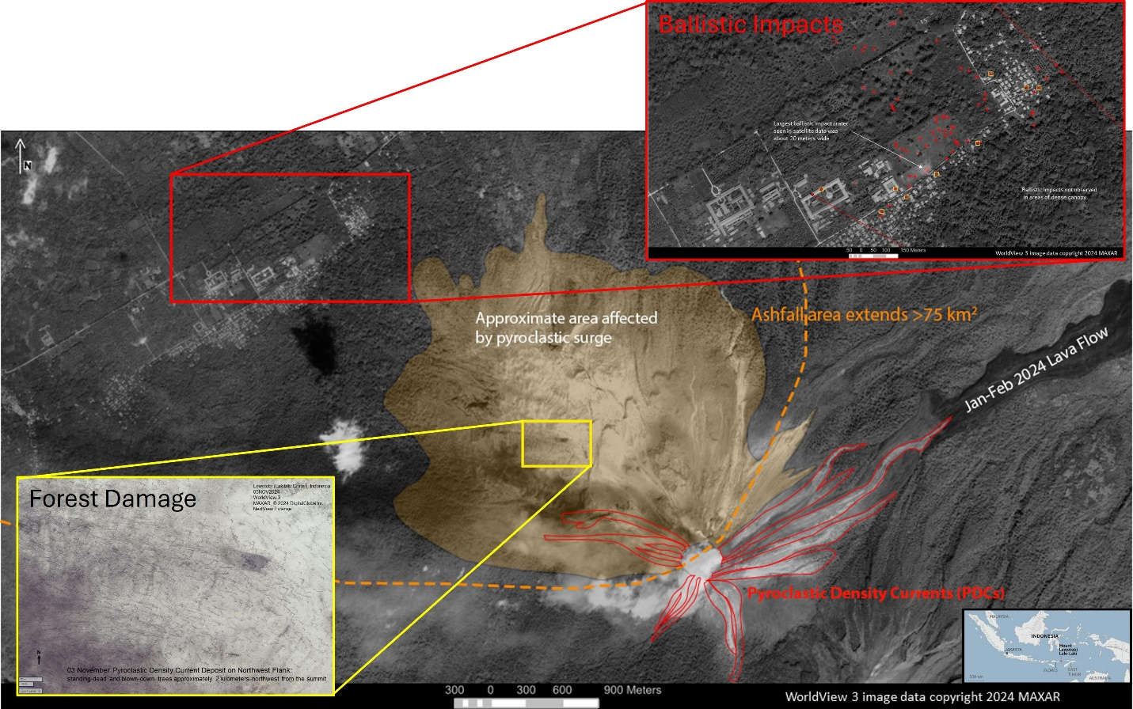
Caption for Graphic or Image: MAXAR WorldView-3 satellite images of Lewotobi’s LakiLaki Crater following the November 3, 2024 eruption (Image date 05NOV24). Lower left inset shows forest damage (standing-dead and blown down trees) caused by pyroclastic surge. Upper right inset shows mapped ballistic impacts within the village of Klatanlo.
Author name: Chelsea Carbo, Rick Wessels, Sally Sennert, Chelsea Cook, Steve Smith, and Julie Griswold
Author business email: ccarbo@usgs.gov

DOI agency/bureau: USGS
USGS Mission Area: Water Resources
USGS Program: Hydrologic Networks and Analysis
Cost Center: Kansas Water Science Center
Program Name:
Project title: A New, Safer Way To Measure Floods with UAS
Project description: One of the principal uses of the more than 11,000 USGS streamgages across the nation is quantifying and warning of floods. To maintain the level of accuracy required, hydrologic technicians must measure discharge during the dynamic events. Remote sensing with UAS (Uncrewed Aerial Systems) allows challenging flood measurements, where flow is outside of the banks, to be measured much more safely than traditional contact methods. Some of the first ever 100% remote sensed discharge measurements have been made using photogrammetry (structure from motion) modeling for bathymetry (depths and width) and image velocimetry for flow speed. for overflows on roadways. This will lead to more accurate flood data at less risk to hydrologic technicians.
Desciption Link Overflow:
Sensor Type: Camera;Video
Platform type: UAS
URL:
Graphic or Image Upload: https://doimspp.sharepoint.com/sites/GS-EROSSCIENCESWI/Shared Documents/Communications Outreach/Documentation Science/DOI Remote Sensing Report/DOI RS Activities Report, 2025/Question/uasinfo_Travis See.png
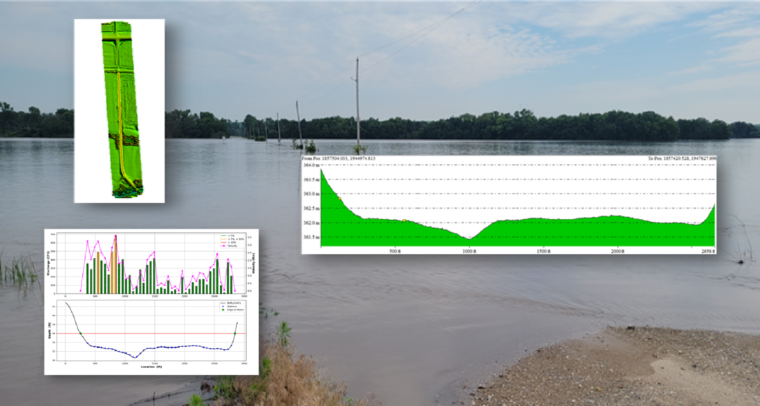
Caption for Graphic or Image: Image shows an overflow condition at USGS streamgage Cottonwood River nr. Cottonwood Falls, KS 07182000. Overlays (clockwise) are the digital elevation model of the road, the cross-section depth of the flooded road, and the velocities obtained from the UAS video with image velocimetry.
Author name: Travis See
Author business email: tsee@usgs.gov

DOI agency/bureau: USGS
USGS Mission Area: Core Science Systems
USGS Program: Land Change Science
Cost Center: Geosciences and Environmental Change Science Center
Program Name:
Project title: Expanding burn severity data across the Southeast
Project description: Scientists from U.S. Geological Survey and Tall Timbers Research Station developed a burn severity model for the southeastern U.S., by relating Composite Burn Index (CBI) plot data from across the conterminous U.S. to Landsat-based spectral measures. Within the United States, the Southeast experiences the largest number of wildland fire ignitions, the greatest occurrence of wildfire in the wildland-urban interface (WUI), and the most active application of prescribed fire. However, the preponderance of small and prescribed fires means that existing burn severity products are incomplete across the region. We optimized our model for fires across the Southeast and applied the model to the annual Landsat Burned Area product for 2000-2022 across the region. This effort produced novel burn severity data for many small and prescribed fires on both public and private lands across the Southeast. Burn severity was consistently lower in areas affected by prescribed burns relative to wildfires. Average burn severity was also higher in forested wetlands, attributable in part to the dominance of highly flammable evergreen shrubs in the understory, and lower in loblolly pine, where prescribed fire is used to maintain timber productivity. The consistency between expected and observed burn severity patterns suggests that our burn severity data can be successfully used for ecological and modeling applications. Additionally, our scalable CBI model provides novel burn severity data that is more inclusive of the many small and prescribed fires across the Southeast compared to prior efforts. A more complete regional characterization of burn severity is critical to improve estimates of fuel loads, emissions, wildfire risk and impacts to natural resources, like timber production, as well as support the prioritization of land management actions including prescribed fire and hazardous fuel reduction.

Publication Link: https://www.publish.csiro.au/wf/WF24137
Desciption Link Overflow:
Sensor Type: Multispectral (approx. 4-12 bands)
Platform type: Satellite
URL: Publication Link: https://www.publish.csiro.au/wf/WF24137
Graphic or Image Upload: https://doimspp.sharepoint.com/sites/GS-EROSSCIENCESWI/Shared Documents/Communications Outreach/Documentation Science/DOI Remote Sensing Report/DOI RS Activities Report, 2025/Question/CBI_burnseverity_Melanie Vanderhoof.jpg
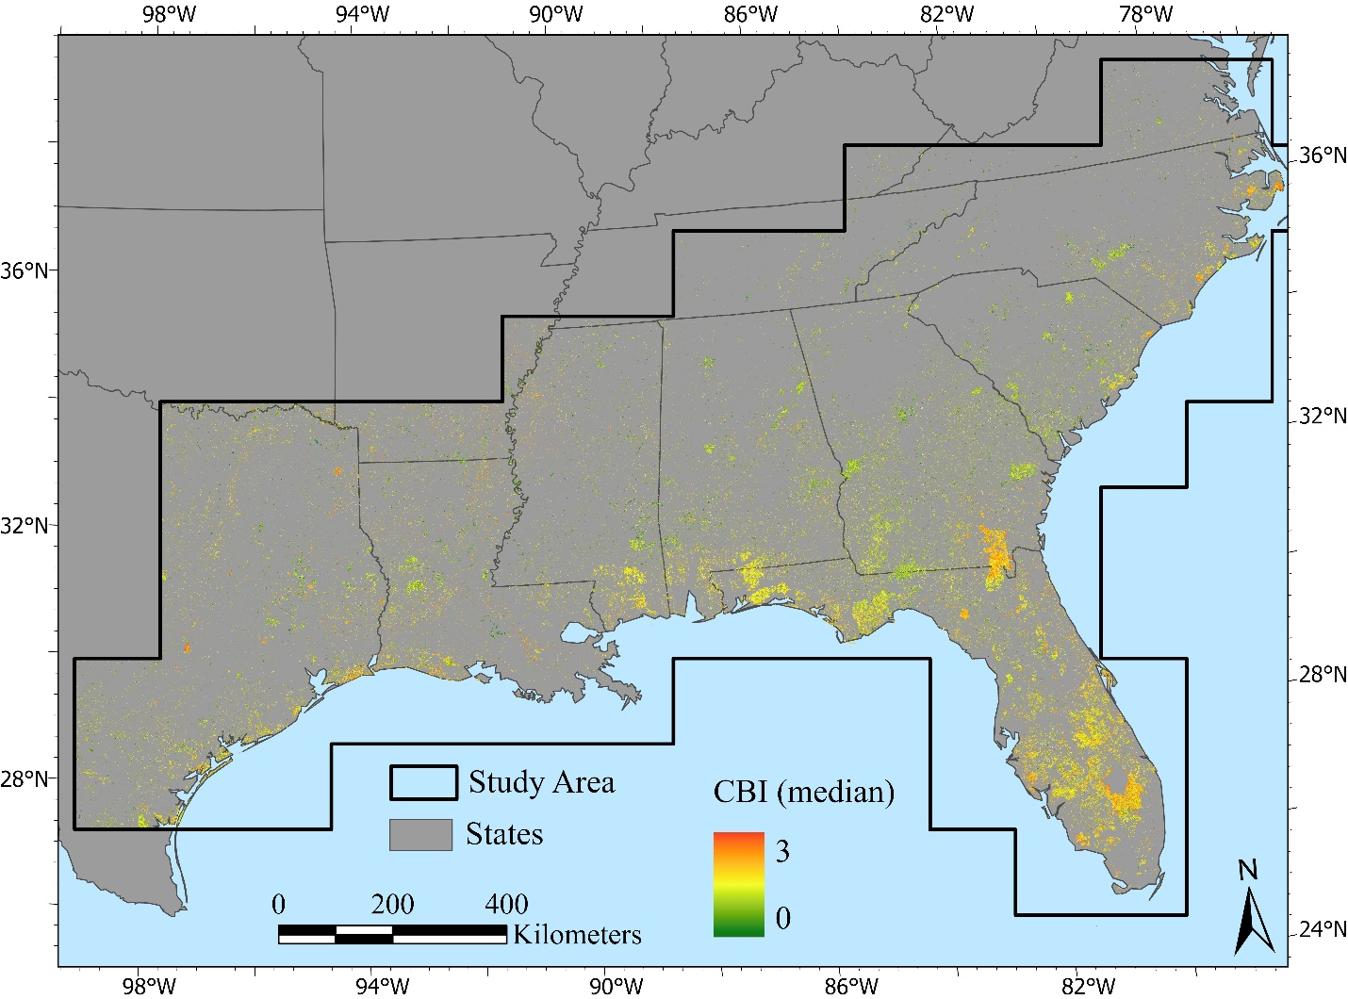
Caption for Graphic or Image: Median burn severity for wildfire and prescribed fires across the Southeast, reported as Composite Burn Index (CBI) values, where 0 is unburned and 3 is high burn severity.
Author name: Melanie Vanderhoof
Author business email: mvanderhoof@usgs.gov

DOI agency/bureau: USGS
USGS Mission Area: Core Science Systems
USGS Program: National Land Imaging Program
Cost Center: **unspecified**
Program Name:
Project title: Monitoring Eruption Episodes at Kīlauea’s Halemaʻumaʻu Crater
Project description: At the National Civil Applications Center (NCAC), scientists use high-resolution data from commercial and U.S. National Imagery Systems (USNIS) to provide timely analysis and reporting to the Volcano Disaster Assistance Program (VDAP) and USGS volcano observatories like the Hawaiian Volcano Observatory (HVO).

On December 23, 2024, an eruption began at Kīlauea volcano within Halemaʻumaʻu crater from two source vents located on the western edge of the crater floor. The eruption has remained episodically active since December 2024 and there have been a total of 32 lava-fountaining events as of the date of report submission (Sep. 12, 2025), most lasting less than twenty-four hours with several days of eruptive pause in between. Episodes have been characterized by lava fountains, some reaching as high as 380 meters (1,247 feet) and lava flows within the crater. These lava fountains have also resulted in significant tephra deposition to the southwest of the source vents, creating a tephra mound over 27 meters (88 feet) thick near the crater rim that continues to grow with each eruptive episode. Continued spattering and lava effusion have raised the crater floor from approximately 917 meters (3,008 feet) above sea level in December 2024 to 970 meters (3,182 feet) above sea level at the time of this writing, or 53 meters (173 feet) of total accumulation since the eruption began.

Using high-resolution satellite imagery, NCAC and HVO scientists have been able to monitor each episode of the eruption. The WorldView-3 image below was captured during Episode 16 on April 1, 2025 during a period of vigorous lava fountaining.

For more information on this eruption, please visit https://www.usgs.gov/volcanoes/kilauea/science/eruption-information

Desciption Link Overflow:
Sensor Type: Multispectral (approx. 4-12 bands)
Platform type: Satellite
URL: https://www.usgs.gov/volcanoes/kilauea/science/eruption-information
Graphic or Image Upload: https://doimspp.sharepoint.com/sites/GS-EROSSCIENCESWI/Shared Documents/Communications Outreach/Documentation Science/DOI Remote Sensing Report/DOI RS Activities Report, 2025/Question/CCarbo_Kilauea DOIRS2025_Chelsea Carbo.jpg
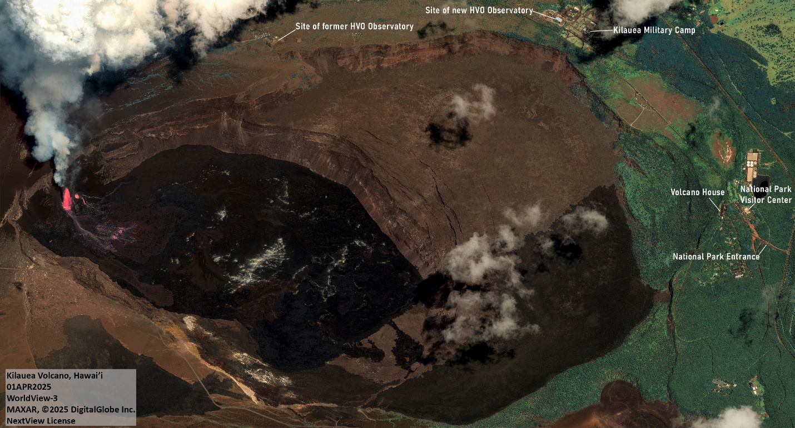
Caption for Graphic or Image: MAXAR WorldView-3 satellite image of Kīlauea’s Halemaʻumaʻu crater in Hawai’i Volcanoes National Park during a period of vigorous lava fountaining
Author name: Chelsea Carbo, Mike Zoeller, Chelsea Cook, and Steve Smith
Author business email: ccarbo@usgs.gov

DOI agency/bureau: USGS
USGS Mission Area: Natural Hazards
USGS Program: Coastal/Marine Hazards and Resources Program
Cost Center: Woods Hole Coastal and Marine Science Center
Program Name:
Project title: Using Drones to Track Canopy Growth at EPA Superfund Cleanup Site
Project description: The USGS Woods Hole Coastal and Marine Science Center (WHCMSC) is in year three of a project with the Environmental Protection Agency (EPA) and the U.S. Fish and Wildlife Service (FWS) to collect seasonal aerial data over the Clearview Landfill in Darby, PA, which operated from the 1950s-mid-1970s and is now part of the Lower Darby Creek Area (LDCA) Superfund Site.
The Clearview Landfill is surrounded by urban neighborhoods and borders the John Heinz National Wildlife Refuge, a tidal wetland system that drains into the Delaware River. The refuge holds historic, ecologic, and recreational importance for neighboring towns and Greater Philadelphia. To protect these areas, the EPA is mitigating groundwater contamination by revegetating the landfill with poplars, locusts, and other fast-growing plantings to divert groundwater through evapotranspiration. Before the site can be transferred to the State of PA for long-term management, the EPA must achieve a certain percentage of closed canopy, when the tree canopy is dense enough to obscure the ground from above. USGS drone pilots from the WHCMSC are supporting this project by collecting, processing, and analyzing uncrewed aircraft systems (UAS) data to evaluate the progress of the evapotranspiration cover.
Seasonal UAS-lidar surveys were collected to produce different topographic datasets. During the winter “leaf-off” period, lidar more easily reaches ground to produce models of the landfill’s surface devoid of vegetation. In the summer, lidar data collected when vegetation is peaking supports the creation of canopy surface elevation models. By comparing these models, USGS scientists can calculate canopy height and estimate vegetation volume and growth.
The winter also presented an opportunity to collect UAS-mounted thermal imagery over the nearby tidal Darby Creek to detect warm water that could indicate groundwater seeps targeted for contaminant sampling. Locations of potential seeps were validated with boat-mounted water quality data collected by USGS scientists from the Maryland/Delaware/DC Water Science Center (MD/DE/DC WSC).
In summer, UAS-mounted visible and multispectral cameras collected overlapping imagery to create high resolution image-mosaic maps of the landfill. Multispectral cameras capture near-infrared wavelengths, which vegetation reflects strongly. When combined with the lidar canopy height models, these visible color and multispectral reflectance maps allow the classification of vegetation types and relative growth among types.
A comprehensive report, containing all data collected, analyses, and results will be provided to the EPA to support informed decisions about future management of the site. For more information on this project, visit the USGS project page.

Desciption Link Overflow: I had this link embedded in the final word of my summary: "page."

https://www.usgs.gov/centers/whcmsc/news/monitoring-change-lower-darby-creek-area-superfund-site
Sensor Type: Camera;Multispectral (approx. 4-12 bands);Lidar (terrestrial or bathymetric);Thermal
Platform type: UAS
URL: https://www.usgs.gov/centers/whcmsc/news/monitoring-change-lower-darby-creek-area-superfund-site
Graphic or Image Upload: https://doimspp.sharepoint.com/sites/GS-EROSSCIENCESWI/Shared Documents/Communications Outreach/Documentation Science/DOI Remote Sensing Report/DOI RS Activities Report, 2025/Question/Darby_Graphic_v2_Jennifer Cramer.jpg
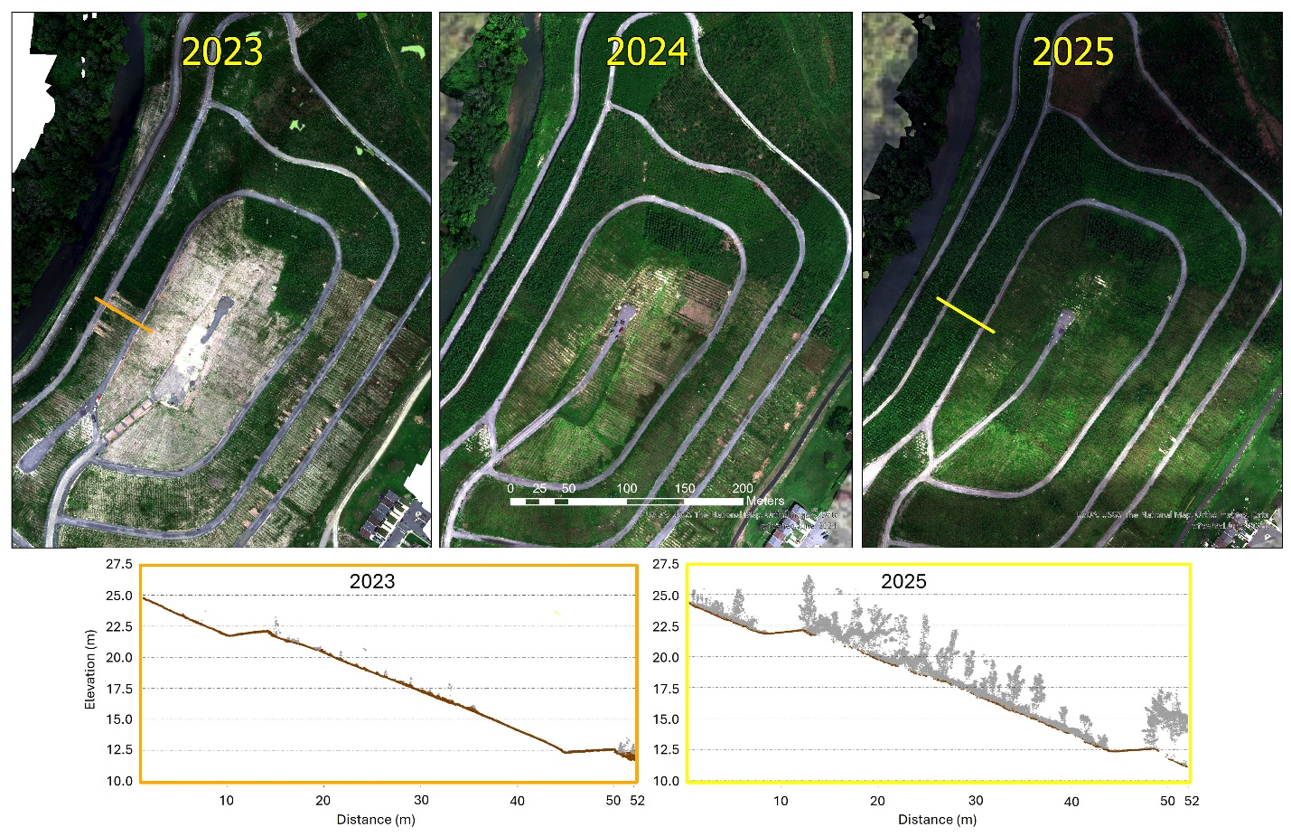
Caption for Graphic or Image: A time-series of multispectral image-mosaics showing vegetation growth at the Clearview Landfill over three summers. The bottom images show cross-section profiles of the same location (denoted by the orange and yellow lines on the imagery maps) within the lidar point cloud and demonstrated the growth of the vegetation and the lidar's ability to capture vegetation structure and volume.
Author name: Jennifer Cramer, Sandy Brosnahan, Amit Millo, Jin-Si Over, Seth Ackerman
Author business email: jcramer@usgs.gov

DOI agency/bureau: USGS
USGS Mission Area: Core Science Systems
USGS Program: National Land Imaging Program
Cost Center: Earth Resources Observation and Science (EROS) Center (Geography)
Program Name:
Project title: Deriving 3D fuels characteristics from GEDI waveform lidar data
Project description: Generating 3D fuels data to drive next-generation, physics-based fire behavior models at landscape or regional scales is challenging. While terrestrial and airborne lidar point clouds provide observations at the level of detail required, their spatial distribution is not comprehensive and temporal resolution is often lacking. To address this issue and help operationalize new fire behavior mode, researchers at the Earth Resources Observation and Science (EROS) Center, via funding from NASA, are demonstrating an approach to derive fire behavior model inputs from the space-based Global Ecosystem Dynamics Investigation (GEDI) waveform lidar system. Specifically, they are leveraging the tree-level detail provided by terrestrial and airborne point clouds to decompose GEDI waveforms, which provide data at a 25 m-diameter footprint level. First, they simulate GEDI waveforms from point clouds using established methods. Next, the team derives stem maps from coincident point clouds. They then model the effects of individual stem properties on waveform shape by manipulating the point clouds and regenerating a waveform. Concurrently, they are deriving stem maps from high-resolution imagery. Lastly, thwill decompose the waveforms by leveraging the stem maps generated from high-resolution imagery to model the vegetation metrics needed to derive the desired fire behavior model inputs. While this approach will not replace inputs derived from high-fidelity point cloud source data, the team anticipates it will generate the required tree-level data with sufficient accuracy to generate useful model outputs. These, in turn, can be interpreted by fire behavior analysts and subsequently used land managers to make informed decisions about issues such as fuel reduction or wildfire risk assessment.
Desciption Link Overflow:
Sensor Type: Lidar (terrestrial or bathymetric);Multispectral (approx. 4-12 bands)
Platform type: Ground based / sensor web / web cam;Satellite;Airplane
URL:
Graphic or Image Upload: https://doimspp.sharepoint.com/sites/GS-EROSSCIENCESWI/Shared Documents/Communications Outreach/Documentation Science/DOI Remote Sensing Report/DOI RS Activities Report, 2025/Question/Picture1_Birgit Peterson.png
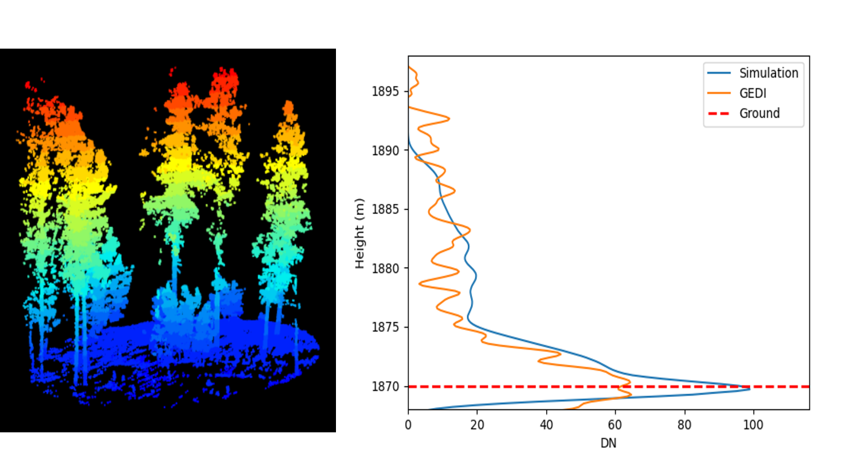
Caption for Graphic or Image: Left: Terrestrial lidar scan collected in June 2024 in the Black Hills of South Dakota. Right: GEDI waveform from 09/25/2022 from same location with simulated waveform overplotted.

Author name: Birgit Peterson
Author business email: bpeterson@usgs.gov

DOI agency/bureau: USGS
USGS Mission Area: Ecosystems
USGS Program: Land Management Research Program
Cost Center: Wetland and Aquatic Research Center
Program Name:
Project title: Characterizing habitat on barrier islands and headlands in Louisiana
Project description: Barrier islands, headlands, and coastal shorelines (hereafter referred to as “barriers”) provide numerous valuable ecosystem goods and services, including storm protection and erosion control for the mainland, habitat for fish and wildlife, salinity regulation in estuaries, carbon sequestration in marshes, and areas for recreation and tourism. Barriers are dynamic environments because of their position at the land-sea interface. Storms, wave energy, tides, currents, and relative sea-level rise are powerful forces that shape local geomorphology and habitat distribution on coastal barriers. In order to make more informed decisions, coastal resource managers require insights into how these barrier systems are changing over time.
Researchers at the U.S. Geological Survey’s Wetland and Aquatic Research Center (WARC) have numerous efforts underway that involve using remote sensing to quantify and characterize habitat on coastal barrier systems in Louisiana. These efforts include mapping habitats in beach, dune, and intertidal environments for 2021 and mapping habitat change from 2015/16 to 2021 along the Louisiana Gulf of America shoreline. WARC researchers are also providing baseline and post-restoration habitat maps to support the Louisiana Outer Coast Restoration Project (https://gulfspillrestoration.noaa.gov/media/document/outercoastfactsheetfinalproof), which includes restoration efforts by the State of Louisiana (https://www.usgs.gov/centers/wetland-and-aquatic-research-center/science/barrier-island-habitat-mapping-louisiana-outer) and the U.S. Fish and Wildlife Service (https://www.usgs.gov/centers/wetland-and-aquatic-research-center/science/natural-resource-damage-assessment-nrda-program). Maps produced for these efforts have helped make restoration decisions. For example, maps produced by WARC researchers is helping reduce costs for the U.S. Fish and Wildlife Service by adapting and/or delaying planting contracts and increasing the chance of restoration success. WARC researchers are combining remote sensing analyses with periodic in situ bird surveys to understand bird habitat utilization after restoration efforts (https://www.usgs.gov/centers/wetland-and-aquatic-research-center/science/restoration-impacts-avian-populations-along). Finally, WARC researchers have collaborated with the researchers from The Water Institute on developing metrics to advance the understanding of the state of barriers regarding resilience (https://www.usgs.gov/centers/wetland-and-aquatic-research-center/science/characterizing-barrier-island-geomorphic-state) For this study, we are defined resilience as the capacity of barriers to maintain their form and function on time scales of years to decades and resistance as the capacity of barriers to maintain geologic and geomorphic form and ecological function on a time scale of days to weeks in the face of hurricanes and other storms. Collectively, these efforts are helping natural resource managers to make informed decisions regarding restoration of Louisiana coastal barriers.

Desciption Link Overflow:
Sensor Type: Lidar (terrestrial or bathymetric);Multispectral (approx. 4-12 bands);Camera
Platform type: UAS;Satellite;Airplane
URL: URLs are included in the project description text
Graphic or Image Upload: https://doimspp.sharepoint.com/sites/GS-EROSSCIENCESWI/Shared Documents/Communications Outreach/Documentation Science/DOI Remote Sensing Report/DOI RS Activities Report, 2025/Question/Enwright_barrier_island_Fig1_Nicholas Enwright.jpg
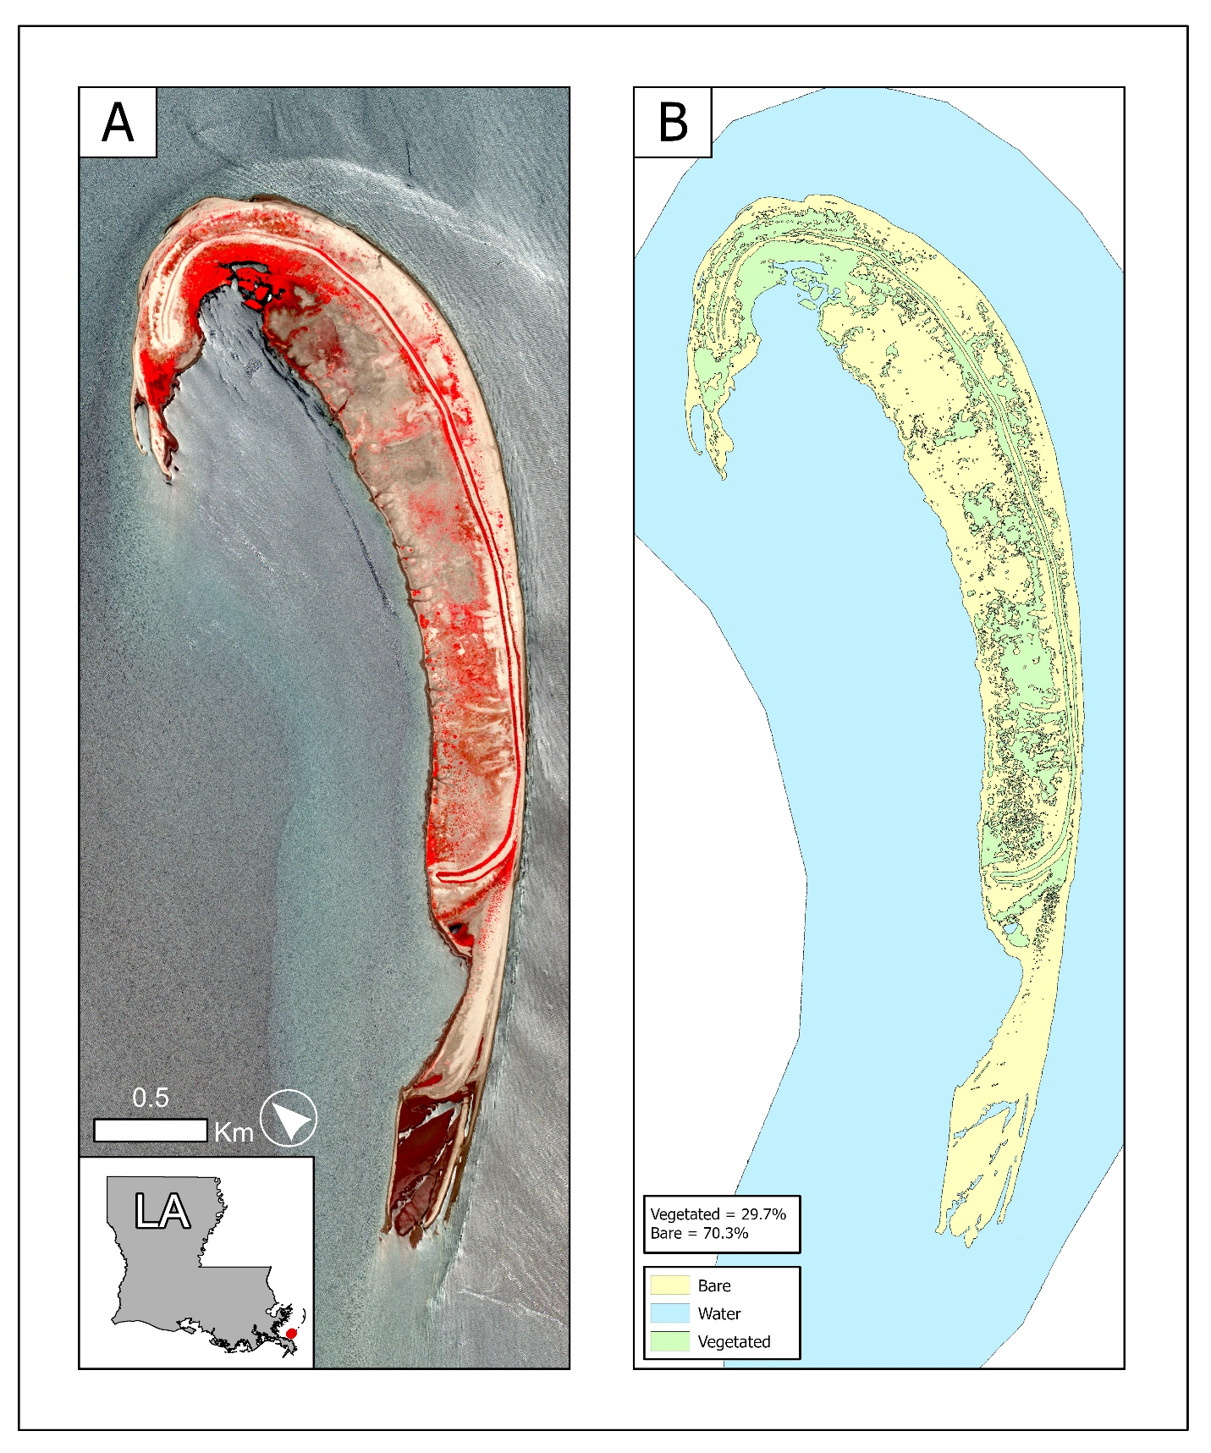
Caption for Graphic or Image: Figure 1. False-color Worldview-3 imagery (A) from June 2025 and simple map vegetation, bare and water for North Breton Island for the same date (B).
Author name: Nicholas Enwright
Author business email: enwrightn@usgs.gov

DOI agency/bureau: USGS
USGS Mission Area: Ecosystems
USGS Program: Land Management Research Program
Cost Center: Wetland and Aquatic Research Center
Program Name:
Project title: Enhancing elevation error for coastal wetlands in digital elevation models
Project description: Digital elevation models (DEMs) for coastal wetlands have been found to have a high amount of elevation error and bias, especially in areas with dense and tall vegetation. A recent literature review of wetland elevation error in DEMs for a total of 23 studies, including sites on the three main oceanic coasts in the United States, found that wetlands had a mean 95th percentile error of 0.46 m (Enwright et al., 2023; https://doi.org/10.1016/j.rse.2023.113451). This elevation bias can be problematic since vegetation often leads to a positive bias, which is an overestimation of elevation. Elevation bias and error in DEMs for coastal wetlands has been addressed using regression-based or statistical correction at the estuary-level (Medeiros et al., 2015 [https://doi.org/10.3390/rs70403507]; Buffington et al., 2016 [https://doi.org/10.1016/j.rse.2016.09.020]; Warner et al., 2023 [https://doi.org/10.1016/j.ecss.2023.108442]; Enwright et al., 2024 [https://doi.org/10.1007/s12237-024-01363-6]) and, for regional scales, through the use of Monte Carlo simulations (Enwright et al., 2023; https://doi.org/10.1016/j.rse.2023.113451).
Through multiple USGS- and partner-funded efforts, researchers at the U.S. Geological Survey’s Wetland and Aquatic Research Center are expanding the applied knowledge of reducing elevation bias and error by using Monte Carlo simulations with the best available in situ elevation observations and wetland biomass maps to develop enhanced DEMs. In general, the approach has involved summarizing DEM realizations from the Monte Carlo simulations and using in situ elevation data to determine the percentile that represents the best elevation estimate (the output from Monte Carlo that has a mean bias error of 0 or close to 0) and an upper and lower estimate (the percentile that is farthest from the best estimate, but is within +/- 5 cm for mean bias error). This approach has been used to develop products with reduced elevation error and bias for a number of study areas, including: (1) Everglades Depth Estimation Network (https://sofia.usgs.gov/eden/); (2) along the South Atlantic Bight through a projects funded by the National Oceanographic Atmospheric Administration (Salt Marsh Evolution along the South Atlantic Bight - NCCOS - National Centers for Coastal Ocean Science) and the National Park Service; (3) along the Mississippi barrier islands for a project funded by the National Park Service (https://www.usgs.gov/centers/wetland-and-aquatic-research-center/science/understanding-ecosystem-response-and-0); (4) along the middle and upper Texas coast for a project funded by the USGS Science Support Partnership Program (https://www.usgs.gov/centers/wetland-and-aquatic-research-center/science/barriers-and-opportunities-landward-migration); and (5) for Grand Bay, Mississippi, Plum Island Estuary (Fig. 1), and San Francisco Bay for the Coastal Ecosystem Prediction System project (Toward a National Coastal Ecosystem Prediction System - NCCOS - National Centers for Coastal Ocean Science). Collectively, these efforts highlight how Monte Carlo simulations can be used as an effective and efficient way of reducing the elevation bias and error for DEMs for coastal wetlands at the regional to national scale. These enhanced DEMs can be used to further our understanding of current wetland elevations for contemporary applications (e.g., mapping wetlands zones using elevations or delineating estuary boundaries) and be used to project how wetlands may change with sea-level rise.

Desciption Link Overflow: Digital elevation models (DEMs) for coastal wetlands have been found to have a high amount of elevation error and bias, especially in areas with dense and tall vegetation. A recent literature review of wetland elevation error in DEMs for a total of 23 studies, including sites on the three main oceanic coasts in the United States, found that wetlands had a mean 95th percentile error of 0.46 m (Enwright et al., 2023; https://doi.org/10.1016/j.rse.2023.113451). This elevation bias can be problematic since vegetation often leads to a positive bias, which is an overestimation of elevation. Elevation bias and error in DEMs for coastal wetlands has been addressed using regression-based or statistical correction at the estuary-level (Medeiros et al., 2015 [https://doi.org/10.3390/rs70403507]; Buffington et al., 2016 [https://doi.org/10.1016/j.rse.2016.09.020]; Warner et al., 2023 [https://doi.org/10.1016/j.ecss.2023.108442]; Enwright et al., 2024 [https://doi.org/10.1007/s12237-024-01363-6]) and, for regional scales, through the use of Monte Carlo simulations (Enwright et al., 2023; https://doi.org/10.1016/j.rse.2023.113451).
Through multiple USGS- and partner-funded efforts, researchers at the U.S. Geological Survey’s Wetland and Aquatic Research Center are expanding the applied knowledge of reducing elevation bias and error by using Monte Carlo simulations with the best available in situ elevation observations and wetland biomass maps to develop enhanced DEMs. In general, the approach has involved summarizing DEM realizations from the Monte Carlo simulations and using in situ elevation data to determine the percentile that represents the best elevation estimate (the output from Monte Carlo that has a mean bias error of 0 or close to 0) and an upper and lower estimate (the percentile that is farthest from the best estimate, but is within +/- 5 cm for mean bias error). This approach has been used to develop products with reduced elevation error and bias for a number of study areas, including: (1) Everglades Depth Estimation Network (https://sofia.usgs.gov/eden/); (2) along the South Atlantic Bight through a projects funded by the National Oceanographic Atmospheric Administration (Salt Marsh Evolution along the South Atlantic Bight - NCCOS - National Centers for Coastal Ocean Science) and the National Park Service; (3) along the Mississippi barrier islands for a project funded by the National Park Service (https://www.usgs.gov/centers/wetland-and-aquatic-research-center/science/understanding-ecosystem-response-and-0); (4) along the middle and upper Texas coast for a project funded by the USGS Science Support Partnership Program (https://www.usgs.gov/centers/wetland-and-aquatic-research-center/science/barriers-and-opportunities-landward-migration); and (5) for Grand Bay, Mississippi, Plum Island Estuary (Fig. 1), and San Francisco Bay for the Coastal Ecosystem Prediction System project (Toward a National Coastal Ecosystem Prediction System - NCCOS - National Centers for Coastal Ocean Science). Collectively, these efforts highlight how Monte Carlo simulations can be used as an effective and efficient way of reducing the elevation bias and error for DEMs for coastal wetlands at the regional to national scale. These enhanced DEMs can be used to further our understanding of current wetland elevations for contemporary applications (e.g., mapping wetlands zones using elevations or delineating estuary boundaries) and be used to project how wetlands may change with sea-level rise.

Sensor Type: Lidar (terrestrial or bathymetric);Multispectral (approx. 4-12 bands)
Platform type: Satellite;Airplane
URL: Links listed in project description
Graphic or Image Upload: https://doimspp.sharepoint.com/sites/GS-EROSSCIENCESWI/Shared Documents/Communications Outreach/Documentation Science/DOI Remote Sensing Report/DOI RS Activities Report, 2025/Question/Enwright_DEM_error_fig1_Nicholas Enwright.jpg
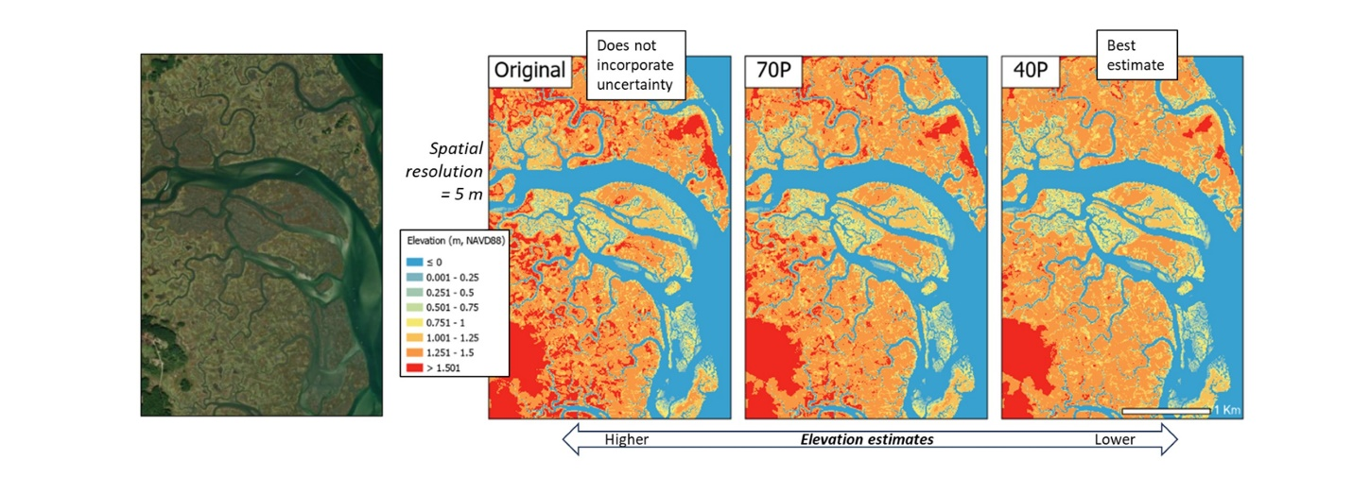
Caption for Graphic or Image: Fig. 1. Elevation error reduction for a digital elevation model from 2021 for Plum Island Estuary in Massachusetts. The basemap imagery on the left is imagery from Esri. The DEMs highlight the original DEM and two Monte Carlo outputs — the 70th percentile DEM and the 40th percentile DEM. The 40th percentile DEM was the best estimate based on in situ elevation data.
Author name: Nicholas Enwright
Author business email: enwrightn@usgs.gov

DOI agency/bureau: USGS
USGS Mission Area: Core Science Systems
USGS Program: Astrogeology
Cost Center: Astrogeology Science Center
Program Name:
Project title: USGS involved with Hera, Europe’s first planetary defense mission
Project description: USGS involved with Hera, Europe’s first planetary defense mission, in a flyby of Mars.

The USGS Astrogeology Science Center is working with international partners in a planetary defense mission to the Potentially Hazardous Asteroid, Didymos, but first – a stop at Mars! Astrogeology is working with National Aeronautics and Space Administration (NASA), European Space Agency (ESA), and the Japanese Aerospace Exploration Agency (JAXA), in support of the ESA Hera mission to the Didymos binary asteroid system, which includes Didymos and its companion, Dimorphos. On September 26, 2022, the NASA Double Asteroid Redirection Test (DART) successfully impacted into Dimorphos, the smaller of the two asteroids. The Hera mission, launched from Cape Canaveral on October 7, 2024, will rendezvous with the asteroids around December 14, 2026, where it will conduct a science campaign to characterize the surfaces and interiors of both asteroids. Hera will conduct an extensive imaging campaign of the DART impact crater to determine the effectiveness of the DART mission.
Planetary defense is a global effort to protect humanity from asteroid impacts. Our atmosphere is the first line of defense as most small asteroids safely burn up. Some get through, however, such as Chelyabinsk in 2013, which caused a shock wave that broke windows city-wide, and resulted in 1,500 injuries. Larger asteroids have the potential to take out whole cities. The NASA DART mission was a demonstration that we could deflect an asteroid by impacting it with a spacecraft. DART was a success, but we still need more data to determine how big of an impact occurred, which is where HERA will provide data.

While enroute to the Didymos system, the Hera spacecraft was able to test its cameras as the spacecraft flew by Mars on March 12, 2025. Visible and thermal images were acquired and analyzed against the martian surface, in comparison to other remotely sensed thermal images of Mars. Figure 1 shows one of these thermal images acquired by TIRI in both grayscale and color. USGS Astrogeology, with its expertise of Mars remote sensing, is assisting the JAXA thermal camera team to ensure that the instrument can determine surface temperatures accurately by comparing the Hera thermal images to Mars temperature data taken by other Mars obiters, such as Odyssey THEMIS and Hope EMIRS. This activity will ensure that the TIRI thermal camera asteroid surface temperatures are accurate, which will help determine the surface properties and how much damage DART did. USGS will continue its involvement in this mission for the next several years.

Desciption Link Overflow: https://www.isas.jaxa.jp/en/topics/003968.html
Sensor Type: Multispectral (approx. 4-12 bands);Thermal
Platform type: Satellite
URL: https://www.usgs.gov/centers/astrogeology-science-center/news/fire-and-ice-astrogeology-involved-october-spacecraft
Graphic or Image Upload: https://doimspp.sharepoint.com/sites/GS-EROSSCIENCESWI/Shared Documents/Communications Outreach/Documentation Science/DOI Remote Sensing Report/DOI RS Activities Report, 2025/Question/20240314_1a_en-thumb-700xauto-15982_Timothy Titus.png
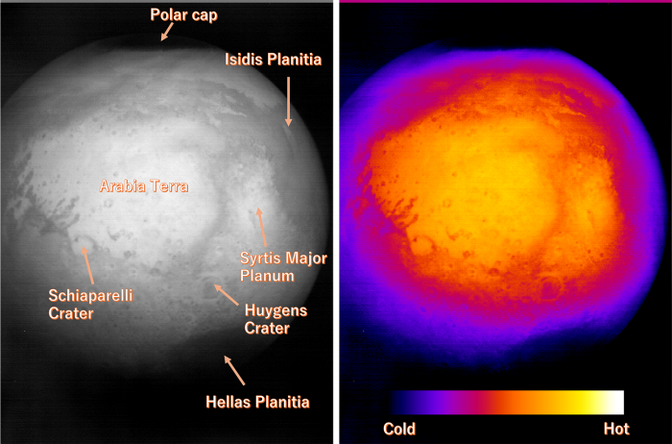
Caption for Graphic or Image: Figure 1: The red planet Mars imaged by the TIRI from a distance of approximately 40000 km. The Arabia Terra region can be seen, as well as the Polar Cap, below the detection limit of TIRI, and the Hellas Planitia, the largest crater in the Solar System, as a cold region. (Left) brightness temperature image, (right) Image showing high temperatures as warm colors. (credit: ESA/JAXA/https://www.isas.jaxa.jp/en/topics/003968.html)
Author name: Timothy Titus
Author business email: ttitus@usgs.gov

DOI agency/bureau: USGS
USGS Mission Area: Core Science Systems
USGS Program: Land Change Science
Cost Center: Earth Resources Observation and Science (EROS) Center (Geography)
Program Name:
Project title: Development of three dimensional fuels data libraries within the Sierra Nevada Mountains, CA U.S.
Project description: New three dimensional (3D) fire behavior modeling tools (e.g., QuicFire) have been developed that can be used to test the effect of fuel treatments on subsequent fire behavior. By iterating models through multiple fuel treatment and fire behavior scenarios, optimal fuel treatments could be determined to reduce the threats of future wildfires. These new models are data hungry in that they require large amounts of data that characterize the landscape to predict fire behavior. To test fuel treatment effectiveness (e.g., reduced fire behavior) data need to be assimilated and interpreted to represent pre- and post-treatment conditions. To develop a data library that can serve as a reference database for modeling inputs, fire science researchers at the USGS Earth Resources Observation and Science (EROS) Center in Sioux Falls, SD collected 3D terrestrial lidar data along with other field-based observations in the Sierra Nevada Mountains in the summers of 2024 and 2025 both inside and outside of fuel treatment areas (Fig. 1) using the plot-based terrestrial lidar IntELiMon (Interagency LiDAR Monitoring & Research Applications) data collection protocols. These data libraries are part of a multi-faceted approach to derive inputs for 3D fuel models that include: 1) Deriving data inputs from lidar point clouds that are within a fuel treatment; 2) Producing data inputs from untreated locations that are nearby treated areas; 3) Manipulating untreated point clouds to represent a theoretical treatment. For example, a thinning treatment could be simulated within a point cloud by removing all points associated with trees within a defined size class (e.g., < 10 cm diameter at breast height); and 4) Developing treated and untreated datasets from additional data sources (e.g., NAIP high resolution raster or GEDI satellite lidar point clouds) that can be used in the creation of data inputs for the 3D fuel modeling processes and compared to these derived from terrestrial lidar. 3D fuel model outputs using these various input datasets will then be assessed to determine whether real or simulated fuel treatments change fire behavior, thereby providing a data-driven assessment of fuel treatment effectiveness.
Desciption Link Overflow: Links for keywords include:

QuicFire: https://wifire.ucsd.edu/next-generation-models
EROS: https://www.usgs.gov/earth-resources-observation-and-science-eros-center
2024: https://www.sciencebase.gov/catalog/item/67c4c76ed34ea599a3b98f1d
IntELiMon: https://dmsdata.cr.usgs.gov/lidar-monitoring/
NAIP: https://naip-usdaonline.hub.arcgis.com/
GEDI: https://gedi.umd.edu/
Sensor Type: Lidar (terrestrial or bathymetric);Camera
Platform type: Ground based / sensor web / web cam
URL: https://dmsdata.cr.usgs.gov/lidar-monitoring/
Graphic or Image Upload: https://doimspp.sharepoint.com/sites/GS-EROSSCIENCESWI/Shared Documents/Communications Outreach/Documentation Science/DOI Remote Sensing Report/DOI RS Activities Report, 2025/Question/Sierra25_213.v3_Joshua Picotte.png
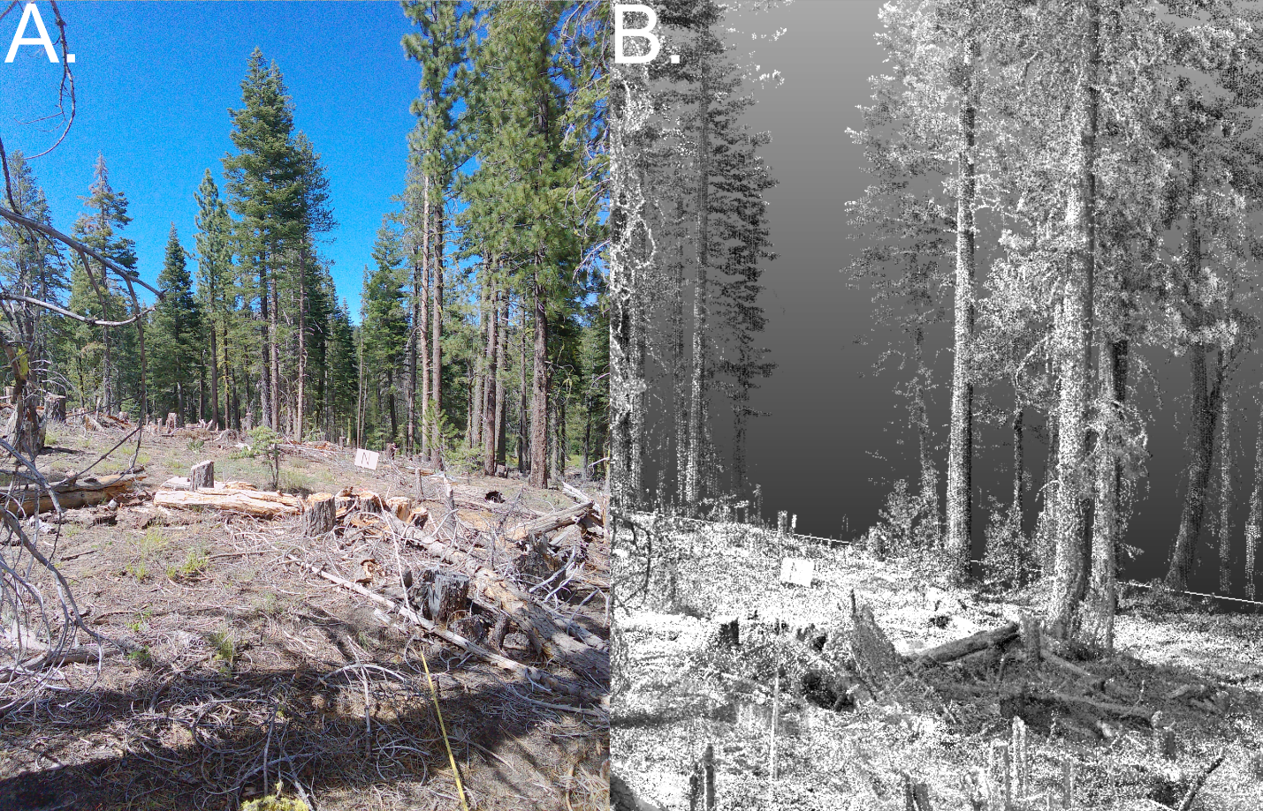
Caption for Graphic or Image: Figure 1: A treated area within the Plumas National Forest (near Susanville, CA) was sampled to capture fuels characteristics using the IntELiMon (Interagency LiDAR Monitoring & Research Applications) plot-based field (A.) and a terrestrial lidar (B.) data collection methods. Within A. and B. you can see tree stumps and downed woody debris that was the result of a 2023 thinning treatment.
Author name: Joshua Picotte
Author business email: jpicotte@usgs.gov

DOI agency/bureau: USGS
USGS Mission Area: Natural Hazards
USGS Program: Coastal and Marine Geology Program
Cost Center: St. Petersburg Coastal and Marine Science Center
Program Name:
Project title: Documenting Coastal Impacts and Recovery of Back-to-Back Hurricanes with Aerial Imagery
Project description: In the fall of 2024, much of the Florida Gulf Coast experienced the rare and destructive impacts of two powerful back-to-back hurricanes Helene and Milton, which made landfall just 13 days apart. To capture the resulting coastal landscape changes, the U.S. Geological Survey (USGS) Remote Sensing of Coastal Change (RSCC) project within the Coastal and Marine Hazards and Resources Program conducted two aerial imagery surveys covering over 250 kilometers of coastline within days of each landfall. The low-altitude aerial imagery was acquired with a crewed, fixed-wing aircraft in shore-parallel flightlines with optimized endlap/sidelap, and processed with Structure-from-Motion photogrammetry techniques to produce high-resolution orthomosaic photos and 3D digital elevation models. These products provide quantitative measures of landcover and elevation, and captured the change from each hurricane as well as the cumulative impacts of the two storms. Observations show Helene caused erosion or dune-overtopping on nearly all ocean-facing beaches from Clearwater to Naples. As a result, natural coastal defenses were reduced when Milton struck, compounding effects in many locations and opening several inlets across barrier islands. New inlets, like Midnight Pass, now connect the ocean to inland bay waters with implications for ecosystem health and coastal protection. In July 2025, the USGS conducted a follow-up aerial imagery survey of the same region to evaluate how the coast is recovering and evolving, and to better understand the vulnerability of the coast to future storms. By comparing data from the surveys, researchers can track patterns of natural recovery and identify areas where additional restoration or protection may be needed. Understanding coastal recovery is vital to improving resilience planning and habitat restoration in regions increasingly vulnerable to extreme weather.

These aerial imagery surveys are a continuation of ongoing monitoring efforts since Hurricane Ian made landfall in 2022, and demonstrate how the RSCC project supports disaster response, hazard research, and coastal management by providing standardized and publicly available geospatial data. The images and derived products provide critical information for evaluating storm impacts, planning recovery actions, and improving long-term resilience strategies. Without this kind of detailed, repeat imagery, much of the short- and long-term story of these storms would be missed.
Desciption Link Overflow:
Sensor Type: Camera
Platform type: Airplane
URL:
Graphic or Image Upload: https://doimspp.sharepoint.com/sites/GS-EROSSCIENCESWI/Shared Documents/Communications Outreach/Documentation Science/DOI Remote Sensing Report/DOI RS Activities Report, 2025/Question/Figure_Jennifer (Jenna) Bro.jpg
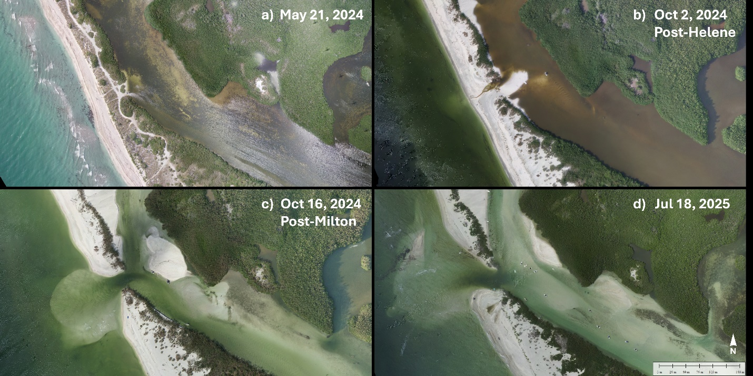
Caption for Graphic or Image: Aerial images of Midnight Pass on the Florida Gulf Coast, captured from a crewed fixed-wing aircraft, showing storm-induced coastal change and recovery over time: a) spring 2024 when there was no inlet present, b) post-Hurricane Helene (landfall on Sep 26, 2024) showing where the dune was breached and a sand spit was formed, as well as beach erosion and dune overwash on either side of the breach, c) post-Hurricane Milton (landfall on Oct 9, 2024) showing the inlet completely open and allowing exchange between the ocean and inland waters, including sand being deposited landward, welding to the mainland, and seaward forming a depositional fan , and d) 9 months later at the start of the 2025 hurricane season showing the inlet widening and changing orientation and the evolution of the sand deposit features, as well as a change in water quality of the inland waterway. Aerial imagery can be accessed from the RSCC Simple Data Service: https://cmgds.marine.usgs.gov/data-services/rscc/PrecisionAirborneCameraSystem/.
Author name: Jenna A. Brown
Author business email: jennabrown@usgs.gov

DOI agency/bureau: USGS
USGS Mission Area: Core Science Systems
USGS Program: National Land Imaging Program
Cost Center: Lower Mississippi-Gulf Water Science Center
Program Name:
Project title: Agricultural Crop Residue Characterization with Current and Next Generation Landsat
Project description: Crop residues are the remains of prior summer crops including senescent leaves, stems, stalks, and stubbles. Managing agricultural fields with high levels of crop residue cover (CRC) provides many agroecosystem benefits including the stabilization of soil moisture levels, minimization of soil erosion, increases in soil organic matter, and in-field retention of nutrients – reducing runoff to nearby waterways. CRC is inversely related to tillage intensity and thus provides an indicator of tillage that can be characterized with spaceborne sensors like Landsat. However, there are limitations estimating CRC with the current Landsat 5-9 data record as the two spectrally broad shortwave infrared (SWIR1 and SWIR2) bands most useful for CRC assessment are impacted by surface moisture variability, green vegetation presence, and background soil spectral properties.

Our team has been developing approaches to improve estimation of CRC with current Landsat imagery, while also identifying optimal spectral band placements for Landsat Next. As part of the Landsat Next Crop Residue expert review panel, we identified new specifications showing great improvements in CRC estimation by splitting the current Landsat “SWIR2” band into three narrow bands positioned at 2038, 2108, and 2211 nm (Hively et al. 2021; Lamb et al. 2022; Dennison et al 2023). Our current research further investigates the capabilities of next-generation narrow SWIR bands for CRC estimation and continuity with the Landsat 5-9 data record. In Lamb et al. (2025), we found that narrow-band WorldView-3 satellite imagery outperforms current Landsat SWIR bands in CRC estimation, but current Landsat can be greatly improved by using statistical approaches incorporating spectral indices characterizing the presence of green vegetation and surface moisture (Figure 1).

We are currently working with USDA colleagues Prasad Bandaru and Rohit Nandin to develop a physically based moisture correction approach expected to be more globally applicable to current Landsat than our statistical approaches (Nandin et al., in review). Because our crop residue characterization approaches are biophysically based, rather than agronomic, the techniques are applicable to the characterization of other types of non-photosynthetic vegetation (NPV) outside of the agricultural setting. Some of these broader application areas include drought monitoring and wildfire risk assessment.
Desciption Link Overflow: Authors:

Brian T. Lamb1, W. Dean Hively1, Jyoti Jennewein2, Alex Soroka3, Alison Thieme4

1. Lower Mississippi Gulf Water Science Center, U.S. Geological Survey
2. Sustainable Agricultural Systems Laboratory, U.S. Department of Agriculture
3. Maryland-Delaware-DC Water Science Center, U.S. Geological Survey
4. University of Maryland

References:

Dennison, P.E., Lamb, B.T., Campbell, M.J., Kokaly, R.F., Hively, W.D., Vermote, E., Dabney, P., Serbin, G., Quemada, M., Daughtry, C.S. Modeling global indices for estimating non-photosynthetic vegetation cover. Remote Sens. Environ. 2023, 295, 113715.

Hively, W.D., Lamb, B.T., Daughtry, C.S.T., Serbin, G., Dennison, P., Kokaly, R.F., Wu, Z., Masek, J.G., 2021. Evaluation of SWIR crop residue bands for the Landsat Next mission. Remote Sens. 13, 3718.

Lamb, B.T., Dennison, P.E., Hively, W.D., Kokaly, R.F., Serbin, G., Wu, Z., Dabney, P.W., Masek, J.G., Campbell, M., Daughtry, C.S.T., 2022. Optimizing Landsat Next shortwave infrared bands for crop residue characterization. Remote Sens. 14, 6128.

Lamb, B.T., Hively, W.D., Jennewein, J., Thieme, A., Soroka, A.M., Santos, L., Jones, D., Mirsky, S., 2025. Multiyear crop residue cover mapping using narrow-band vs. broad-band shortwave infrared satellite imagery, Soil Tillage Res. 251.

Nandi, R., Bandaru V., Lamb, B.T., Hively W.D. A novel surface moisture correction approach to improve satellite-based tillage intensity mapping. Remote Sensing of Environment (in review).
Sensor Type: Multispectral (approx. 4-12 bands);Hyperspectral
Platform type: Satellite
URL: https://www.sciencedirect.com/science/article/pii/S0167198725000789
Graphic or Image Upload: https://doimspp.sharepoint.com/sites/GS-EROSSCIENCESWI/Shared Documents/Communications Outreach/Documentation Science/DOI Remote Sensing Report/DOI RS Activities Report, 2025/Question/crop_residue_figure_lamb_png_Brian Lamb.png
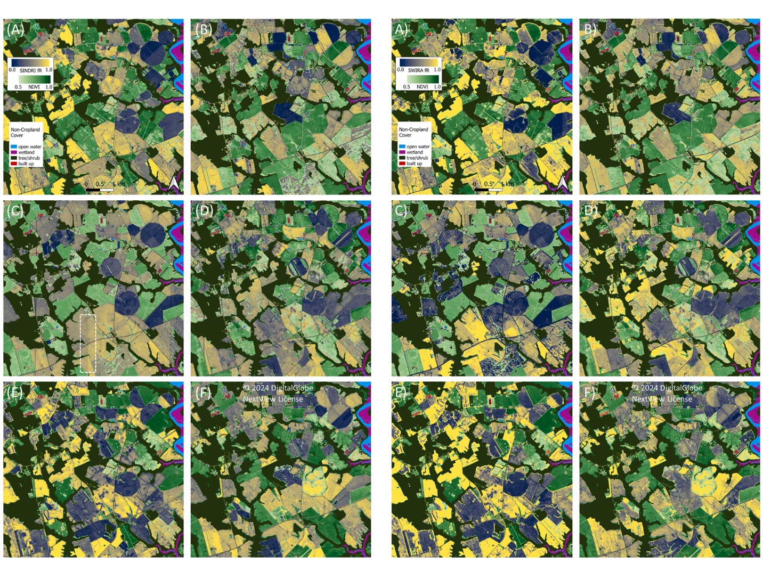
Caption for Graphic or Image: Figure 1. Crop residue cover (CRC) maps for a portion of Maryland’s Eastern Shore (Lamb et al., 2025). The left-side panels show six years of CRC estimated from a single index based on narrow SWIR bands of WorldView-3. The right-side panels show CRC estimates from current Landsat bands convolved from WorldView-3 imagery. The right-side panel required a multiple linear regression model with three spectral indices to produce comparable, but slightly lower accuracies than the single narrow band index in the left panel, highlighting the importance of future missions like Landsat Next.
Author name: Brian T. Lamb
Author business email: blamb@usgs.gov

DOI agency/bureau: USGS
USGS Mission Area: Core Science Systems
USGS Program: National Land Imaging Program
Cost Center: Western Geographic Science Center
Program Name:
Project title: UAS and high-resolution commercial satellite remote sensing to support efficient livestock production on Department of Interior lands
Project description: Rangelands constitute approximately 50% of the world’s land area globally, providing forage for livestock and supporting rural livelihoods. As collaborative rangeland research study with private ranchers, researchers from Utah State University, and the USGS is seeking to better understand landscape and forage use patterns between Red Angus, a conventional breed of cattle, and Raramuri Criollo, a heritage breed adapted to harsh dryland conditions. Criollo have been shown to navigate more rugged parts of the landscapes and are expected to venture farther from scarce water sources than conventional breeds, and thereby access forage in under-utilized areas of the landscape.

To support this effort, we are leveraging USGS HPC resources and AI to identify livestock forage at the level of individual plant species from very high-resolution UAS (2 cm) and Worldview-2 (46 cm) commercial satellite imagery. In June of 2024 we collected RGB and multispectral UAS imagery at three sites (215 acres total) near Monticello, Utah and just outside of Canyonlands National Park. 8-band Worldview-2 imagery was acquired at this same time, covering a larger 54,000 acres of pastures in the study area. Data and GPS locations of key forage plant species were recorded across the 3 sites. For the UAS data we developed a semi-automatic training dataset using an NDVI threshold to first mask vegetation then a supervised random forest to classify a subset. This classified subset was then used to train a U-Net CNN semantic segmentation model using Torchgeo to run inference across the larger UAS image areas. These 2-cm species-level vegetation maps in turn are used to train, classify and validate a landscape-scale map based on Worldview-2 imagery.

These remote sensing products will allow ranchers with GPS collar data to track which vegetation types livestock are utilizing, compare landscape use patterns among breeds, and support improved efficiency of beef production on public lands.

POC: Miguel Villarreal (mvillarreal@usgs.gov), Josh von Nonn (jvonnonn@usgs.gov) and Michael Duniway (mduniway@usgs.gov).

Figure a) Wingtra UAS equipped with MicaSense RE-P multispectral sensor b) Field team measuring the size and location of target species used for training data c) Semantic segmentation showing mapped canopies of key forage species

Desciption Link Overflow:
POC: Miguel Villarreal (mvillarreal@usgs.gov), Josh von Nonn (jvonnonn@usgs.gov) and Michael Duniway (mduniway@usgs.gov).

Figure a) Wingtra UAS equipped with MicaSense RE-P multispectral sensor b) Field team measuring the size and location of target species used for training data c) Semantic segmentation showing mapped canopies of key forage species
Sensor Type: Multispectral (approx. 4-12 bands)
Platform type: UAS;Satellite
URL:
Graphic or Image Upload: https://doimspp.sharepoint.com/sites/GS-EROSSCIENCESWI/Shared Documents/Communications Outreach/Documentation Science/DOI Remote Sensing Report/DOI RS Activities Report, 2025/Question/DOI RS Crilollo UAS_Miguel Villarreal.png
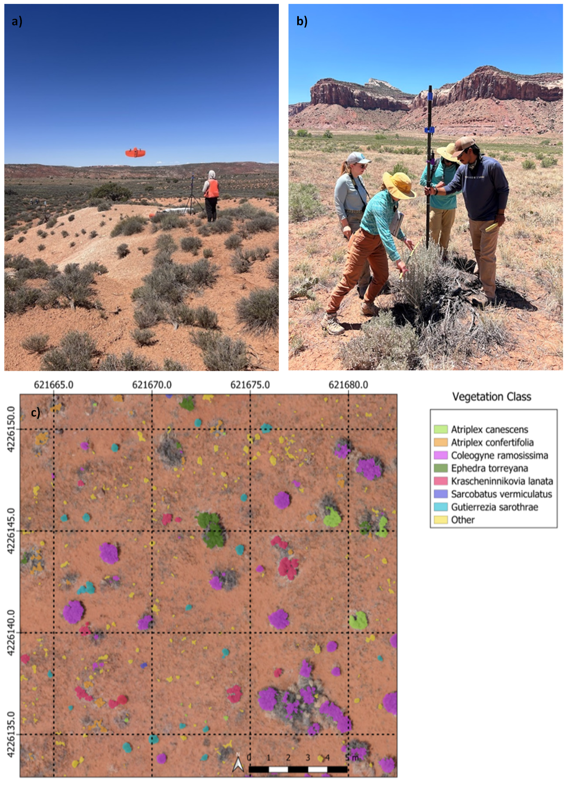
Caption for Graphic or Image: Figure a) Wingtra UAS equipped with MicaSense RE-P multispectral sensor b) Field team measuring the size and location of target species used for training data c) Semantic segmentation showing mapped canopies of key forage species
Author name: Miguel Villarreal (mvillarreal@usgs.gov), Josh von Nonn (jvonnonn@usgs.gov) and Michael Duniway (mduniway@usgs.gov).
Author business email: mvillarreal@usgs.gov

DOI agency/bureau: USGS
USGS Mission Area: Core Science Systems
USGS Program: National Land Imaging Program
Cost Center: Earth Resources Observation and Science (EROS) Center (Geography)
Program Name:
Project title: Diurnal Surface Temperature at the Urban-Natural Interface
Project description: Urban land use expansion significantly alters ecosystems and impacts the interface between urban and natural environments, thereby affecting the essential services they provide. This growth modifies land cover, leading to increased surface temperatures (ST) in urban areas compared to surrounding rural regions, a phenomenon known as the surface urban heat island (SUHI) effect. The SUHI effect is quantified by comparing temperatures between urban and rural areas. Remotely sensed ST has been extensively used to monitor thermal conditions, hydrologic modeling, and surface energy balance, with multiple thermal sensors measuring Earth’s thermal radiance since 1982.

Enhancing our understanding of thermal radiance measurements, the drivers of ST change, and the potential consequences on human and natural systems is crucial for assessing the impacts of human activities and climate shifts. The geospatial community focused on the urban-natural interface has called for improved monitoring data, including ST and SUHI intensity change products that cover the majority of urban centers, extend over longer time periods, and offer higher spatial resolutions with systematic information. In response to these demands, the USGS Earth Resources Observation and Science (EROS) Center has developed the annual ST Collection 2 Science Products for communities studying the SUHI and urban-natural environment interface.

Recent advancements in satellite technology have significantly improved the acquisition of surface temperature data at various spatial and temporal resolutions from multiple thermal sensors, both day and night. These developments raise important questions about the effectiveness of remotely sensed data for monitoring the SUHI phenomenon and the accuracy of different thermal datasets in estimating land surface temperature across varied scales. The EROS SUHI team evaluates the explanatory power and information content of several remote sensing data sources for retrieving time-series ST while incorporating land cover information. The datasets analyzed include U.S. Landsat Analysis Ready Data (ARD), the Moderate Resolution Imaging Spectroradiometer (MODIS), the Visible Infrared Imaging Radiometer Suite (VIIRS), and the Ecosystem Spaceborne Thermal Radiometer Experiment on Space Station (ECOSTRESS). These datasets were compared to NOAA Global Historical Climatology Network (GHCN) station data, which provides daily maximum and minimum temperature observations corresponding to the remotely sensed daytime and nighttime surface temperatures. Utilizing multivariate and geospatial analysis methods, we assessed the performance of various satellite thermal bands in capturing surface temperatures in urban-natural environments, focusing on selected major urban centers in the contiguous United States (e.g., Phoenix, Arzona, and Washington, D.C.).

Desciption Link Overflow:
Sensor Type: Thermal
Platform type: Satellite
URL:
Graphic or Image Upload: https://doimspp.sharepoint.com/sites/GS-EROSSCIENCESWI/Shared Documents/Communications Outreach/Documentation Science/DOI Remote Sensing Report/DOI RS Activities Report, 2025/Question/PHX_DCA2_Christopher Barber.jpg
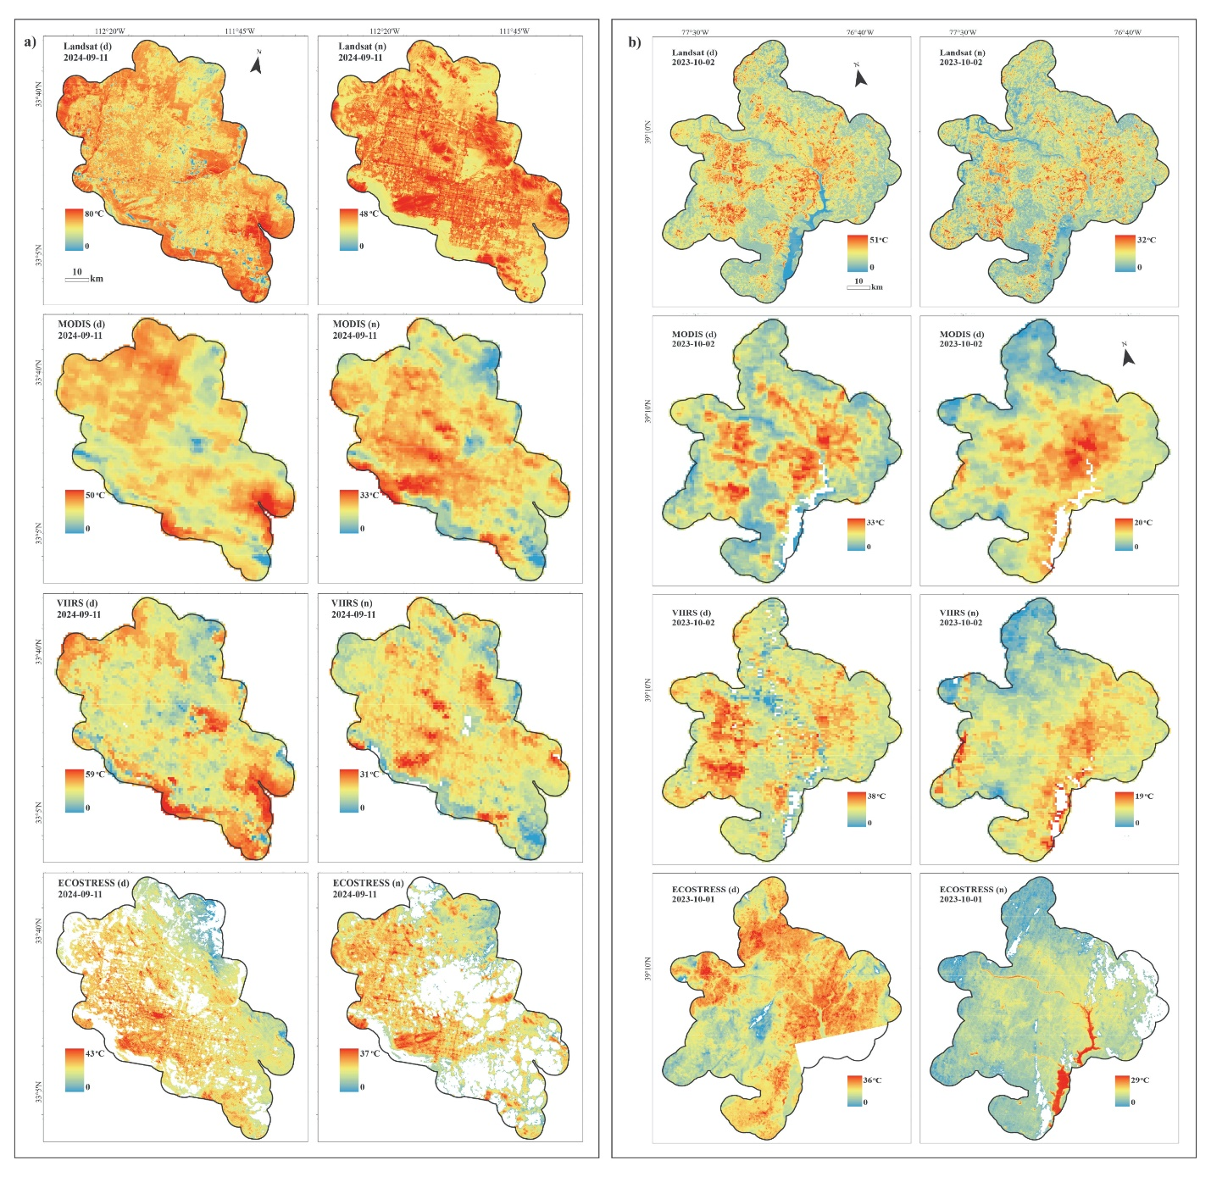
Caption for Graphic or Image: Daytime and nighttime surface temperatures (ST) from Landsat, MODIS, VIIRS, and ECOSTRESS for the Phoenix (a) and Washington D.C. (b) areas, captured on the same or closely aligned dates. The analysis boundary is defined as a 5 km buffer around the 2023 city boundaries for both cities.
Author name: Christopher Barber
Author business email: cbarber@usgs.gov

DOI agency/bureau: USGS
USGS Mission Area: Core Science Systems
USGS Program: National Land Imaging Program
Cost Center: Earth Resources Observation and Science (EROS) Center (Geography)
Program Name:
Project title: New Reference and Validation Data for Annual NLCD
Project description: The USGS Earth Resources Observation and Science (EROS) Center has released new data products supporting the Annual National Land Cover Database [https://www.usgs.gov/centers/eros/science/annual-national-land-cover-database] (NLCD). The NLCD Reference and Validation (R&V) team has produced an independent reference dataset spanning the conterminous United States (CONUS) and completed the first validation report that compares the map data of Annual NLCD with the reference data to help users understand how reliable Annual NLCD is and support better decisions in research, land use planning, and resource management.

The Reference Dataset [https://www.sciencebase.gov/catalog/item/6813a71bd4be023163051775], available on ScienceBase, is comprised of 30-meter plots across CONUS derived from an initial sampling of 5,000 plots chosen via simple random selection and a follow-on set of 3,360 chosen by a mix of simple random and map-defined strata targeting (figure background). Land use, land cover, and change information for the 8,360 plots is collected annually for the years 1984-2023 using the TimeSync tool (figure lower-right), a web-based interface for manually interpreting and recording information from the Landsat data record. Manual interpretation is assisted with fine resolution imagery and other ancillary data. Annual interpretations for each of the 8,360 plots results in a reference dataset of 334,000 records in total. This Reference Dataset is produced primarily to assess quality and uncertainty in Annual NLCD Anderson Level II land cover products and land cover change, but it is a standalone dataset used by the user community as both a reference and training dataset in various land cover applications.

The Validation Report [https://www.sciencebase.gov/catalog/item/6813a741d4be02316305177d], also available on ScienceBase, is produced by comparing the Reference Dataset with the Annual NLCD land cover and land cover change products. Comparison data for each reference point and the NLCD map data are collected annually for the years 1985-2023 (figure upper-right) and compiled into annual confusion matrices that report the user’s/producer’s agreement with standard errors and map bias for each class along with overall agreement and standard error in each year. Additional information is reported on types of change, timing of change, and area estimates as well as the methods used in producing the report. Overall, the Annual NLCD land cover matched the expert-reviewed Reference Dataset 83% of the time when grouped into broad Anderson Level I land cover classes such as forest, shrubland, or developed land. With this information, users can gain a greater understanding of the strengths and limitations of the data and make more informed decisions about how to use it.

Desciption Link Overflow:
Sensor Type: Multispectral (approx. 4-12 bands)
Platform type: Satellite
URL: https://www.usgs.gov/centers/eros/science/annual-national-land-cover-database
Graphic or Image Upload: https://doimspp.sharepoint.com/sites/GS-EROSSCIENCESWI/Shared Documents/Communications Outreach/Documentation Science/DOI Remote Sensing Report/DOI RS Activities Report, 2025/Question/ANLCD_DOIreport2_Christopher Barber.png
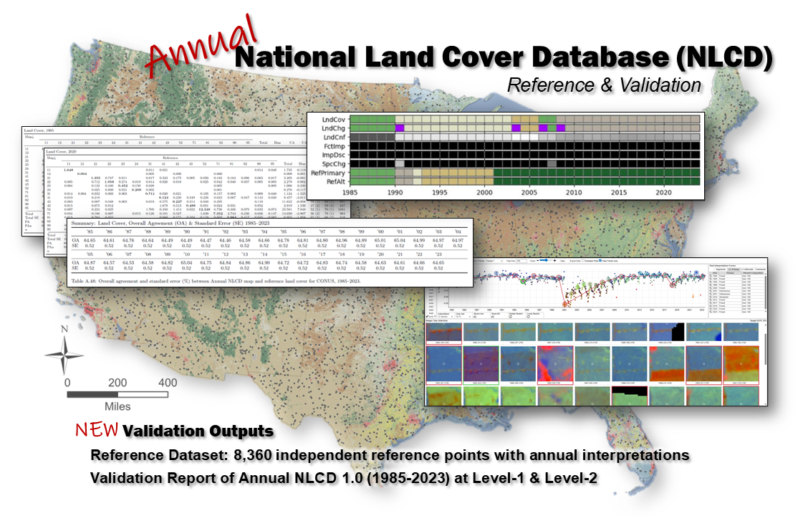
Caption for Graphic or Image: Annual National Land Cover Database (NLCD) Reference & Validation effort sample outputs showing the 8,360 Reference Dataset plots across CONUS (background), the TimeSync tool (lower right) used for plot interpretation from the Landsat data record, tools for comparing the Reference Data to the NLCD map data (upper right), and sample contingency & summary tables from the Validation Report (left).
Author name: Christopher Barber
Author business email: cbarber@usgs.gov

DOI agency/bureau: USGS
USGS Mission Area: Water Resources
USGS Program: Water Availability and Use Science Program
Cost Center: Oregon Water Science Center
Program Name:
Project title: Airborne Lidar Maps Underwater Sediment Size
Project description: The nature of the sediment cover on the bed of a river helps determine what form that river takes and what types of flora and fauna can live within it. However, measuring and mapping the size of river‐bed sediment is challenging, especially creating detailed maps of underwater sediment across large distances. This work uses specialized Lidar data collected from a crewed fixed‐wing aircraft paired with field measurements of underwater river‐bed sediment size to create detailed maps of grain size across 260 km of river. The resulting data were then used to map where in these there is sediment that is suitable for Chinook salmon to spawn. Results show this method reliably replicates ground‐based measurements across a range of stream conditions and that the distribution of spawning habitat above and below dams is notably different.
Desciption Link Overflow:
Sensor Type: Lidar (terrestrial or bathymetric)
Platform type: Airplane
URL: https://doi.org/10.1029/2024WR039219
Graphic or Image Upload: https://doimspp.sharepoint.com/sites/GS-EROSSCIENCESWI/Shared Documents/Communications Outreach/Documentation Science/DOI Remote Sensing Report/DOI RS Activities Report, 2025/Question/Figure10_James White.jpg
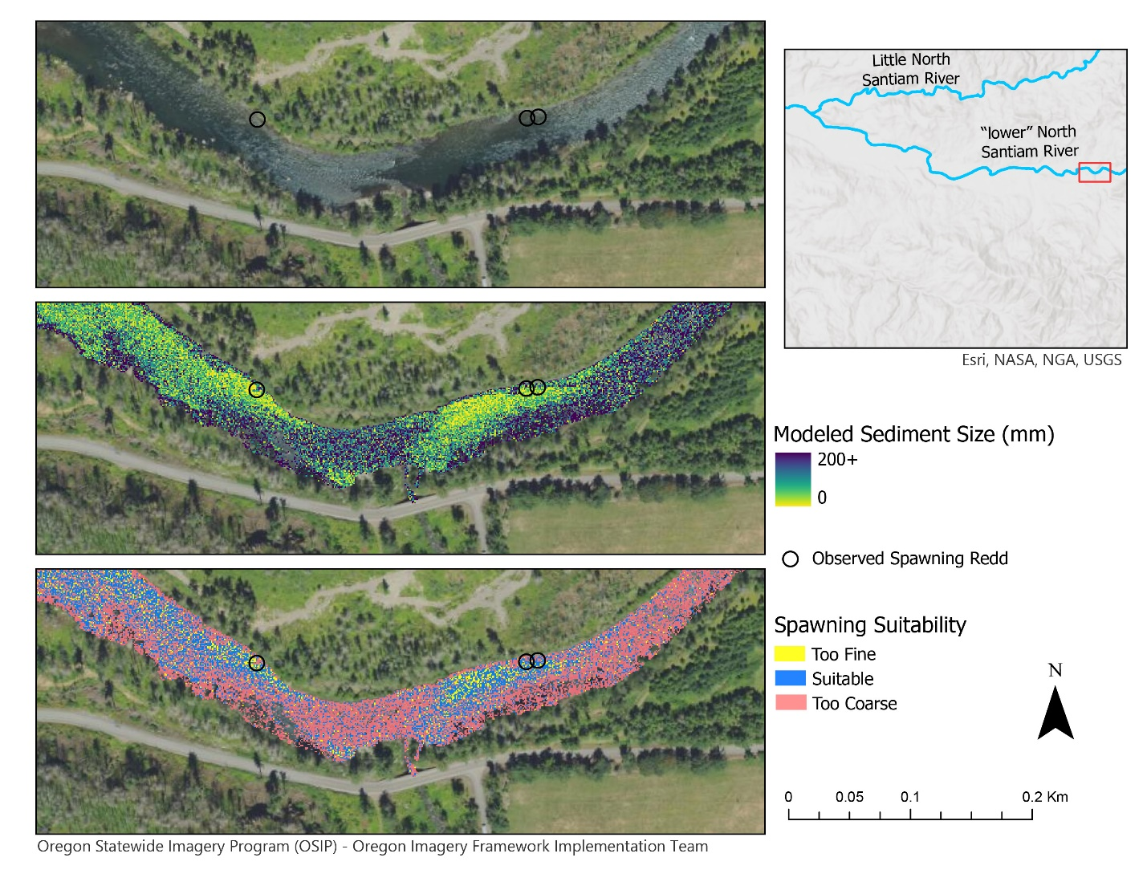
Caption for Graphic or Image: Example of grain size and spawning mapping in the North Santiam River, Oregon.
Author name: James White
Author business email: jameswhite@usgs.gov

DOI agency/bureau: USGS
USGS Mission Area: Natural Hazards
USGS Program: Coastal/Marine Hazards and Resources Program
Cost Center: Woods Hole Coastal and Marine Science Center
Program Name:
Project title: Monitoring the evolution of an engineered salt marsh using drone data
Project description: An interdisciplinary group of scientists and drone pilots from the USGS Woods Hole Coastal and Marine Science Center (WHCMSC) have partnered with the Buzzards Bay Coalition (BBC) for a unique opportunity to monitor the evolution of an engineered Salt Marsh from its infancy. Marsh Island lies within New Bedford Harbor in New Bedford, MA. The site once held extensive salt marsh, but was quarried for granite in the 1800s, then filled with dredged sediment from New Bedford Harbor in the early to mid-1900s. The BBC, working with local, state, and federal partners, acquired the land to restore 11-acres of salt marsh, supporting improved water quality, aquatic wildlife, and urban coastal resilience. In 2022, Phase 1 construction of a tidal channel was completed and native salt marsh vegetation was introduced. A pedestrian walkway was built to promote recreation at the site when open to the public. Phase 2 would expand the channel to the southern half of the island at a future time. By studying this site, coastal scientists from the USGS WHCMSC, aim to understand how an engineered salt marsh will respond to tides and storms, and provide better knowledge for future management efforts at this site and beyond.
In-situ sensors installed within the tidal channel at Marsh Island provide time-series measurements of water level, current, turbidity, temperature, salinity, chlorophyl, dissolved oxygen, pH, and more; these data quantify how water and constituents move in and out of the marsh complex. Uncrewed aircraft systems (UAS) provide a complementary, spatially continuous dataset over the marsh plain that help relate those material exchanges to spatial patterns in elevation and vegetation.
Seasonal UAS datasets have been collected at Marsh Island since 2023, including lidar-derived topography and visible-color, multispectral, and thermal image-mosaics. Lidar-derived topography highlights where the marsh is experiencing elevation change over time. Multispectral imagery captures light in the near-infrared wavelengths, which vegetation reflects strongly. This enables the creation of vegetation indices, like the Normalized Difference Vegetation Index (NDVI), which highlights healthy vegetation and aids in determining where there is growth and dieback. Thermal imagery of the channel aids in detecting potential groundwater seeps that may be targeted for further sampling.
Together, these datasets provide a holistic view of Marsh Island and over time will contribute to improved knowledge of where restoration efforts succeed and fail, why, and how to mitigate these challenges to inform future restoration and preservation activities.

Desciption Link Overflow:
Sensor Type: Camera;Lidar (terrestrial or bathymetric);Thermal
Platform type: UAS
URL: https://www.savebuzzardsbay.org/news/marsh-island-phase-1/
Graphic or Image Upload: https://doimspp.sharepoint.com/sites/GS-EROSSCIENCESWI/Shared Documents/Communications Outreach/Documentation Science/DOI Remote Sensing Report/DOI RS Activities Report, 2025/Question/MarshIsland_Graphic_Jennifer Cramer.jpg
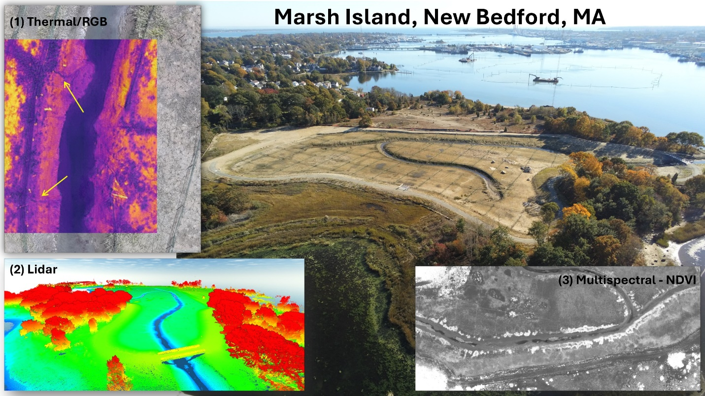
Caption for Graphic or Image: An aerial photo of Marsh Island taken by drone. Surrounding this image are examples of (1) the thermal imagery overlaying the visible RGB imagery, with yellow arrows pointing to possible cooler groundwater entering the channel, (2) a 3D view of the lidar point cloud elevation data, and (3) a NDVI image of the marsh, highlighting healthy vegetation.
Author name: Jennifer Cramer, Sandy Brosnahan, Seth Ackerman, Amit Millo, Jin-Si Over, Neil Ganju
Author business email: jcramer@usgs.gov

DOI agency/bureau: USGS
USGS Mission Area: Core Science Systems
USGS Program: National Land Imaging Program
Cost Center: Lower Mississippi-Gulf Water Science Center
Program Name:
Project title: Coastal Inundation Monitoring with NISAR
Project description: Accurate coastal inundation monitoring is of high importance with direct applications to flood risk estimation, coastal hydrology studies, and habitat suitability assessment. Common approaches that characterize inundation state include in situ sensors, hydrologic models, and satellite imagery. At present each of these approaches have limitations; with in situ sensors being limited in spatial coverage, hydrologic models being limited by input data quality, and satellite imagery being limited by the operating frequency of current sensors. Optical imagery cannot resolve inundation state during cloudy conditions and C-band radar sensors like Sentinel-1 are limited by signal wavelengths that cannot penetrate vegetated canopies and resolve surface inundation state.

The recent launch of the NASA-ISRO Synthetic Aperture Radar (NISAR) satellite, operating at L-band frequency, will provide improved inundation state characterization, particularly in vegetated regions. Our previous research has demonstrated that L-band imagery provides more consistent and accurate characterization of wetland inundation state than C-band and optical imagery, while also requiring less complex classification algorithms (Lamb et al. 2025) (Figure 1). Building on this previous research, we have re-deployed grids of water level sensors in two tidal wetland complexes in the central Long Island Sound (Milford, Connecticut). These sensor grids serve as calibration/validation for NISAR inundation product development (NISAR Science Team grant; McDonald and Steiner) and comparison to a broader array of satellite products (NASA Carbon Monitoring System grant; Tzortziou and Lamb).

Our prior deployment of wetland water level sensors demonstrated highly accurate calibration to local tide gauges for water levels (R2 = 0.95 to 0.99) (Lamb et al. 2025). This enabled accurate estimation of wetland inundation state using the longer tide gauge data record. Our current water level sensor deployment also targets regions of these wetland complexes with less tidal influence including tidally restricted, brackish, and higher elevation regions. The current deployments will provide direct inundation state observations for the calibration/validation of NISAR, Sentinel-1, and Landsat inundation products. While our efforts are focused on coastal wetlands presently, the algorithms and products that we develop will be applicable to inundation assessment in other vegetated systems (e.g., flooded agricultural fields), and for various landcover types within the coastal and inland domains.
Desciption Link Overflow: Authors: Brian T. Lamb1, Kyle C. McDonald2,3, Nicholas Steiner2, Maria A. Tzortziou2
1. Lower Mississippi Gulf Water Science Center, U.S. Geological Survey
2. Department of Earth and Atmospheric Sciences, The City College of New York
3. Carbon Cycle and Ecosystems Group, Jet Propulsion Laboratory

References:

Lamb, B.T.; McDonald, K.C.; Tzortziou, M.A.; Tesser, D.S. Characterizing Tidal Marsh Inundation with Synthetic Aperture Radar, Radiometric Modeling, and In Situ Water Level Observations. Remote Sens. 2025, 17, 263. https://doi.org/10.3390/rs17020263

Sensor Type: IFSAR / SAR / Radar
Platform type: Satellite
URL: https://www.mdpi.com/2072-4292/17/2/263#app1-remotesensing-17-00263
Graphic or Image Upload: https://doimspp.sharepoint.com/sites/GS-EROSSCIENCESWI/Shared Documents/Communications Outreach/Documentation Science/DOI Remote Sensing Report/DOI RS Activities Report, 2025/Question/lamb_nisar_remotesensing-17-00263-g006_Brian Lamb.png
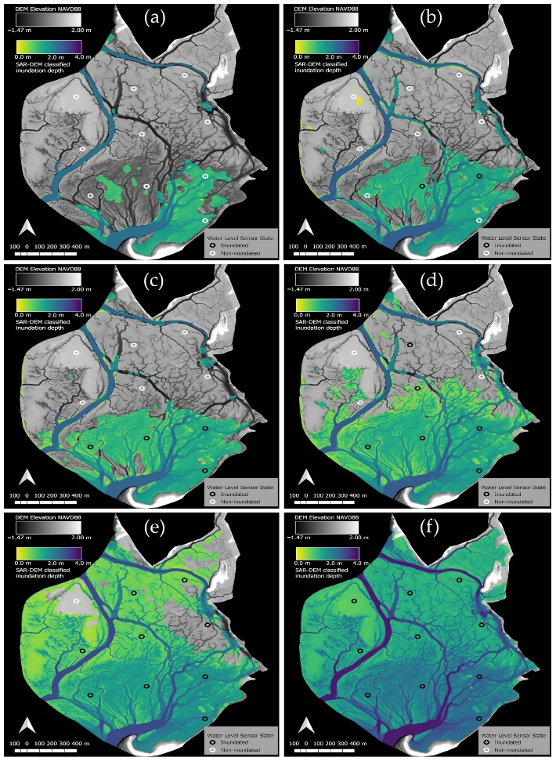
Caption for Graphic or Image: Figure 1. Tidal-sequence of L-band inundation products derived from the PALSAR/PALSAR-2 imagery over Wheeler Marsh (Milford, Connecticut). These products were derived from a simple backscatter threshold algorithm and achieved 90% accuracy. Tide gauge estimated wetland inundation state was needed for the PALSAR record. The improved 12-day revisit of publicly available NISAR imagery will enable direct validation with our current water level sensor deployments.
Author name: Brian T. Lamb
Author business email: blamb@usgs.gov

DOI agency/bureau: USGS
USGS Mission Area: Core Science Systems
USGS Program: National Land Imaging Program
Cost Center: **unspecified**
Program Name:
Project title: FY25 National Civil Applications Center: Satellite Imagery Support to Federal Civil Agencies
Project description: In Fiscal Year 2025, the National Civil Applications Center (NCAC) Source Department coordinated more than 92,000 satellite images through approximately 1,150 requests in support of Department of the Interior (DOI) agencies, as well as broader Earth science and public safety needs. These efforts advanced the Civil Applications Committee’s (CAC) mission—celebrating 50 years of enabling civil uses of space-based remote sensing—and ensured that critical information reached the communities that depend on it.

Wildfire response and recovery remained a top priority. NCAC Source provided satellite data to U.S. Geological Survey (USGS) analysts and interagency partners, including the Bureau of Land Management and the National Interagency Fire Center, to assess burn scars, vegetation loss, and post-fire recovery. This information helped guide ecosystem restoration, reduce erosion, and plan fire mitigation strategies. By coordinating repeat imagery across burned landscapes, NCAC Source enabled agencies to prioritize rehabilitation and safeguard nearby communities. NCAC Source also supported Aircraft 3 (AC3) operations by submitting collection requests for 47 wildfires. These data were used by analysts to produce perimeter and intensity maps for incident commanders, providing timely information for firefighting operations.

Volcano monitoring and hazard assessment also expanded. NCAC Source coordinated imagery for more than 100 volcanoes worldwide, capturing information on ground deformation, lava flows, pyroclastic activity, and ash deposits. These observations strengthened situational awareness and improved preparedness for communities near active volcanoes.

Flood monitoring was another key area. NCAC Source coordinated 15 flood-related collections in FY 2025. The satellite data helped agencies generate maps of inundation, flood extent, and storm damage. These products gave emergency managers the ability to direct resources effectively, protect at-risk communities, and speed recovery operations.

Together, these activities show how NCAC Source operations translate space-based capabilities into direct public benefit. By coordinating satellite collection requests across a wide spectrum of hazards and Earth science applications, NCAC Source ensures that national space assets contribute to science, safety, and society—protecting lives, advancing Earth knowledge, and delivering trusted data to decision-makers across the Nation.
Desciption Link Overflow:
Sensor Type: Hyperspectral;IFSAR / SAR / Radar;Multispectral (approx. 4-12 bands);Thermal
Platform type: Satellite
URL: https://pubs.usgs.gov/fs/2022/3085/fs20223085.pdf
Graphic or Image Upload: https://doimspp.sharepoint.com/sites/GS-EROSSCIENCESWI/Shared Documents/Communications Outreach/Documentation Science/DOI Remote Sensing Report/DOI RS Activities Report, 2025/Question/DOI Remote Sensing_Graphic_Ross Rogers.jpg
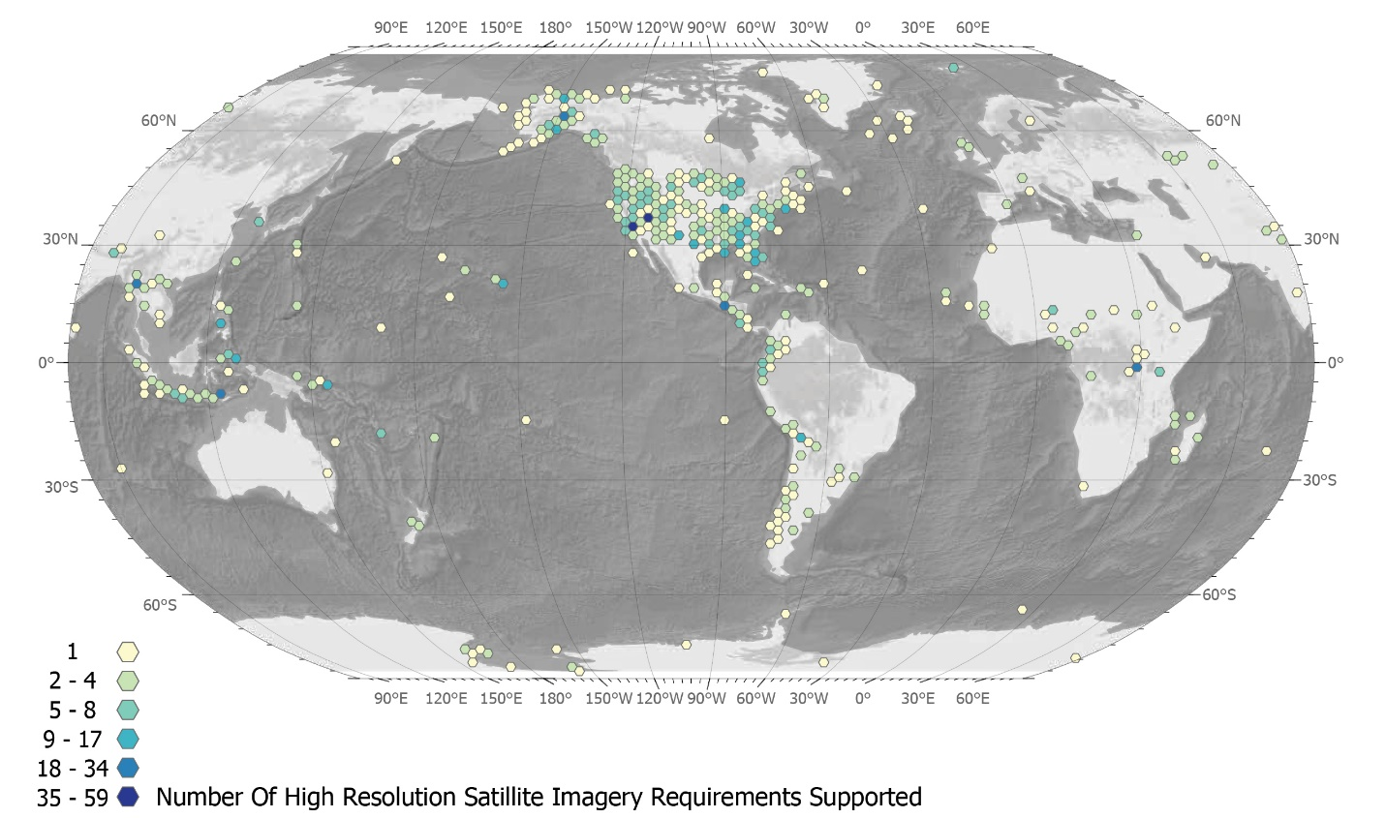
Caption for Graphic or Image: FY25 National Civil Applications Center: Satellite Imagery Support to Federal Civil Agencies
Author name: Ross T. Rogers
Author business email: rtrogers@usgs.gov

DOI agency/bureau: USGS
USGS Mission Area: Ecosystems
USGS Program: Climate Adaptation Science Center
Cost Center: Northwest Climate Science Center
Program Name:
Project title: Climate change amplifies threats to sagebrush ecosystems
Project description: Scientists from the U.S. Geological Survey, U.S. Fish and Wildlife Service, USDA Agricultural Research Service, and several universities used remote sensing and ecological modeling to project how climate change, wildfire, and invasive annual grasses will shape the future of sagebrush ecosystems across the western United States.

Sagebrush ecosystems, which span about 76 million hectares across 13 states, provide habitat for hundreds of wildlife species, including the greater sage-grouse, and support grazing, recreation, and other ecosystem services. Yet these landscapes are declining in large part due to increasing invasive annual grasses and more frequent wildfires. Climate change is expected to intensify these threats.

To better anticipate future conditions, researchers combined high-resolution remote sensing (Landsat) based estimates of current sagebrush ecological integrity, a proxy of general sagebrush habitat quality, with simulations from an individual-based plant model (STEPWAT2). The model estimated how sagebrush, perennial grasses, and annual grasses might respond to different climate scenarios, while incorporating wildfire dynamics. By integrating satellite-derived results with process-based modeling, the team assessed where conditions are likely to remain climatically suitable to maintain the highest quality “Core Sagebrush Areas” in the future.

The researchers estimated that areas in cooler portions of the region, including large parts of Wyoming, are more likely to retain high sagebrush ecological integrity. Importantly, about two-thirds of today’s highest-quality Core Sagebrush Areas were projected to remain climatically suitable through the end of the century, making them potentially stronger candidates for long-term conservation investments. In places where Core Sagebrush Areas were projected to be lost as a result of climate change, the losses were mainly attributed to expected increases in invasive annual grasses or declines in sagebrush.

This work highlights the power of combining remote sensing estimates of current vegetation conditions with ecological modeling projections of vegetation responses to climate change. The results provide land managers with a long-term perspective to help support the goal of “defending and growing the core” of sagebrush ecosystems.

Desciption Link Overflow:
Sensor Type: Multispectral (approx. 4-12 bands)
Platform type: Satellite
URL: https://sagebrushconservation.org/climate-change-amplifies-ongoing-declines-of-sagebrush-ecological-integrity/
Graphic or Image Upload: https://doimspp.sharepoint.com/sites/GS-EROSSCIENCESWI/Shared Documents/Communications Outreach/Documentation Science/DOI Remote Sensing Report/DOI RS Activities Report, 2025/Question/fig1_cropped_Martin Holdrege.jpg
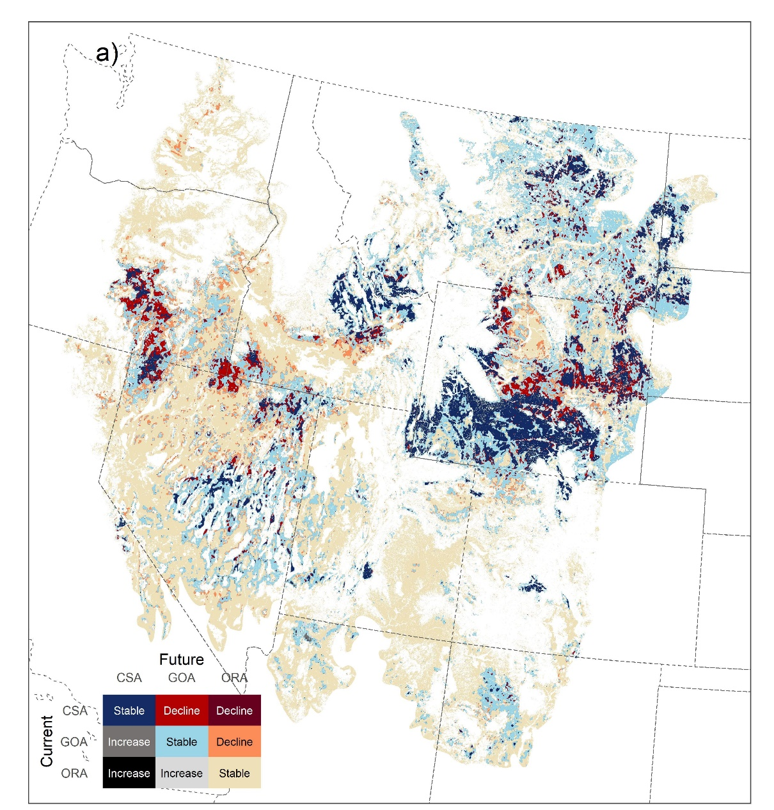
Caption for Graphic or Image: Map of the western United States showing projections of changes in sagebrush ecological integrity categories from current (2020) to future (2071 -- 2100) conditions. Core Sagebrush Areas (CSA) represent the most intact sagebrush ecosystems with high sagebrush ecological integrity, and Growth Opportunity Areas (GOA) represent areas with intermediate sagebrush ecological integrity. Other Rangeland Areas (ORA) have low sagebrush ecological integrity meaning they have lower abundance of sagebrush or herbaceous perennial plants, or they have a greater abundance of ecosystem threats such as invasive annual grasses. Red colors on the map show places where a decline in the sagebrush ecological integrity class was projected because of an expected decline in the climatic suitability of those locations.
Author name: Martin Holdrege
Author business email: mholdrege@usgs.gov

DOI agency/bureau: USGS
USGS Mission Area: Water Resources
USGS Program: Water Availability and Use Science Program
Cost Center: Washington Water Science Center
Program Name:
Project title: Columbia River at Tri-Cities HABs study
Project description: This study focuses on developing predictive tools to forecast toxin concentrations from harmful algal blooms (HABs) in the Columbia River near the Tri-Cities area of Washington. The project combines real-time water quality monitoring, satellite data, and toxin verification to understand and manage algal toxins. Researchers are using water quality sondes and collecting samples to correlate toxin concentrations with continuous data. Satellite data, including multispectral images, are guiding proactive field monitoring. The ultimate goal is to use statistical models to create actionable predictive tools for the early identification of toxic bloom events to support the proactive management of HABs in the river.
Desciption Link Overflow:
Sensor Type: Multispectral (approx. 4-12 bands)
Platform type: Satellite;Ground based / sensor web / web cam
URL: https://www.usgs.gov/centers/washington-water-science-center/science/columbia-river-tri-cities-habs-study
Graphic or Image Upload: https://doimspp.sharepoint.com/sites/GS-EROSSCIENCESWI/Shared Documents/Communications Outreach/Documentation Science/DOI Remote Sensing Report/DOI RS Activities Report, 2025/Question/Columbia River at Tri-Cities HABs study_Audrey Martinez.jpg
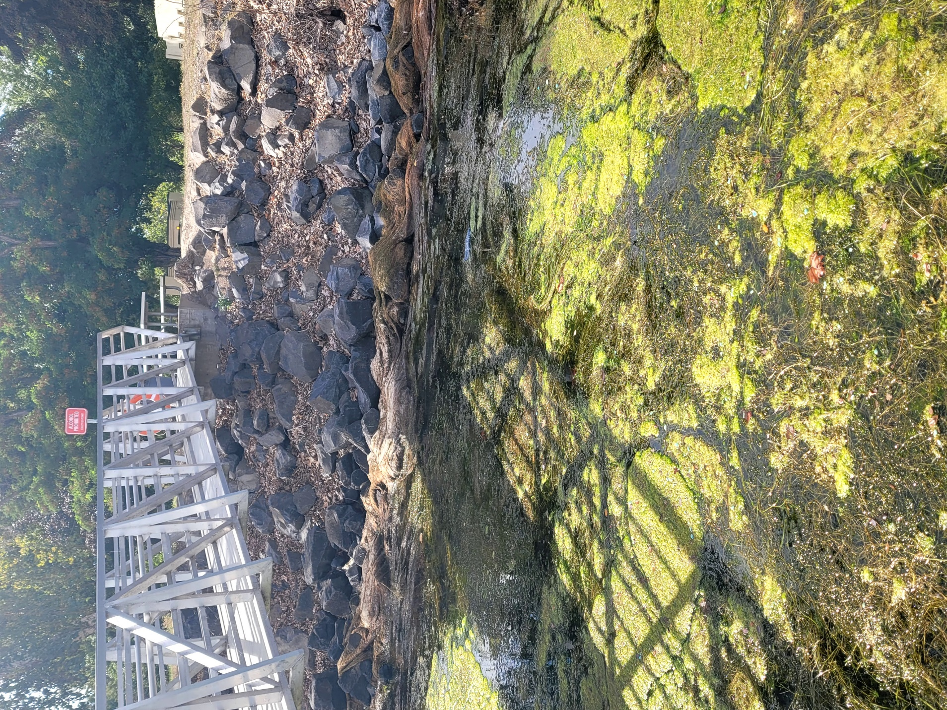
Caption for Graphic or Image: Visualizing the impact: A dense mat of algae covers the surface of the water beneath a footbridge, highlighting potential water quality challenges.
Author name: Audrey Martinez
Author business email: ammartinez@usgs.gov

DOI agency/bureau: USGS
USGS Mission Area: Ecosystems
USGS Program: Land Change Science
Cost Center: Western Geographic Science Center
Program Name:
Project title: The Mercurial Bay: Using Remote Sensing to Track Mercury Pollution after Storms in South San Francisco Bay
Project description: Mercury (Hg) is a pollutant of high concern in south San Francisco Bay (SFB). When released into aquatic environments, Hg binds to sediments and dissolved organics and is severely toxic to humans and wildlife. In California’s Coast Range, rich deposits of mercury were discovered and extensively mined for use in gold processing during the California Gold Rush, polluting the surrounding watershed and south SFB. Increasingly, frequent atmospheric rivers can re-suspend buried Hg and flush Hg laden sediment plumes into the bay. The legacy of Hg pollution, combined with the dynamism of the estuarine environment result in constantly shifting distributions of Hg and its organic form, methylmercury (MeHg). As such, there is a need for spatially resolved total Hg and MeHg monitoring. In this study, we use remote sensing of total suspended solids (TSS) and colored dissolved organic matter (CDOM) to map estimated total-Hg and MeHg in south SFB surface waters. We conducted a field campaign to collect in situ water samples and radiometric water color measurements to quantify the relationships between total-Hg and MeHg, TSS and CDOM, and water color. We used the resulting empirical relationships to create a workflow for mapping both Hg species from Sentinel-2 imagery and continuous in-water data from the USGS National Water Information System (NWIS), then generated a two-year timeseries (n=57) of total-Hg and MeHg maps encompassing two seasons of above average atmospheric river activity. We found that while anomalies in mercury distributions frequently followed atmospheric rivers, not all atmospheric rivers preceded detectable anomalies. Instead, mercury patterns appeared to be influenced by an interplay of tides, wind speed and direction, precipitation events, and sequences of atmospheric rivers. These results highlight the complexity of total-Hg and MeHg dynamics in south SFB and demonstrate how remote sensing–based mapping can provide new insights into pollutant transport in estuarine environments. Our workflow can be extended to other systems where Hg contamination poses ecological and human health risks. More information about the project can be found here and here.
Desciption Link Overflow: https://waterdata.usgs.gov/nwis/uv?site_no=373015122071000&legacy=1
https://www.usgs.gov/centers/western-geographic-science-center/news/mapping-mercury-san-francisco-bay
https://www.usgs.gov/centers/western-geographic-science-center/science/remote-sensing-mercury-pollution-south-san

Sensor Type: Multispectral (approx. 4-12 bands);Hyperspectral
Platform type: Ground based / sensor web / web cam;Satellite
URL: https://www.usgs.gov/centers/western-geographic-science-center/science/remote-sensing-mercury-pollution-south-san
Graphic or Image Upload: https://doimspp.sharepoint.com/sites/GS-EROSSCIENCESWI/Shared Documents/Communications Outreach/Documentation Science/DOI Remote Sensing Report/DOI RS Activities Report, 2025/Question/z011923_DOIRSFY25_Nicole Taylor.png
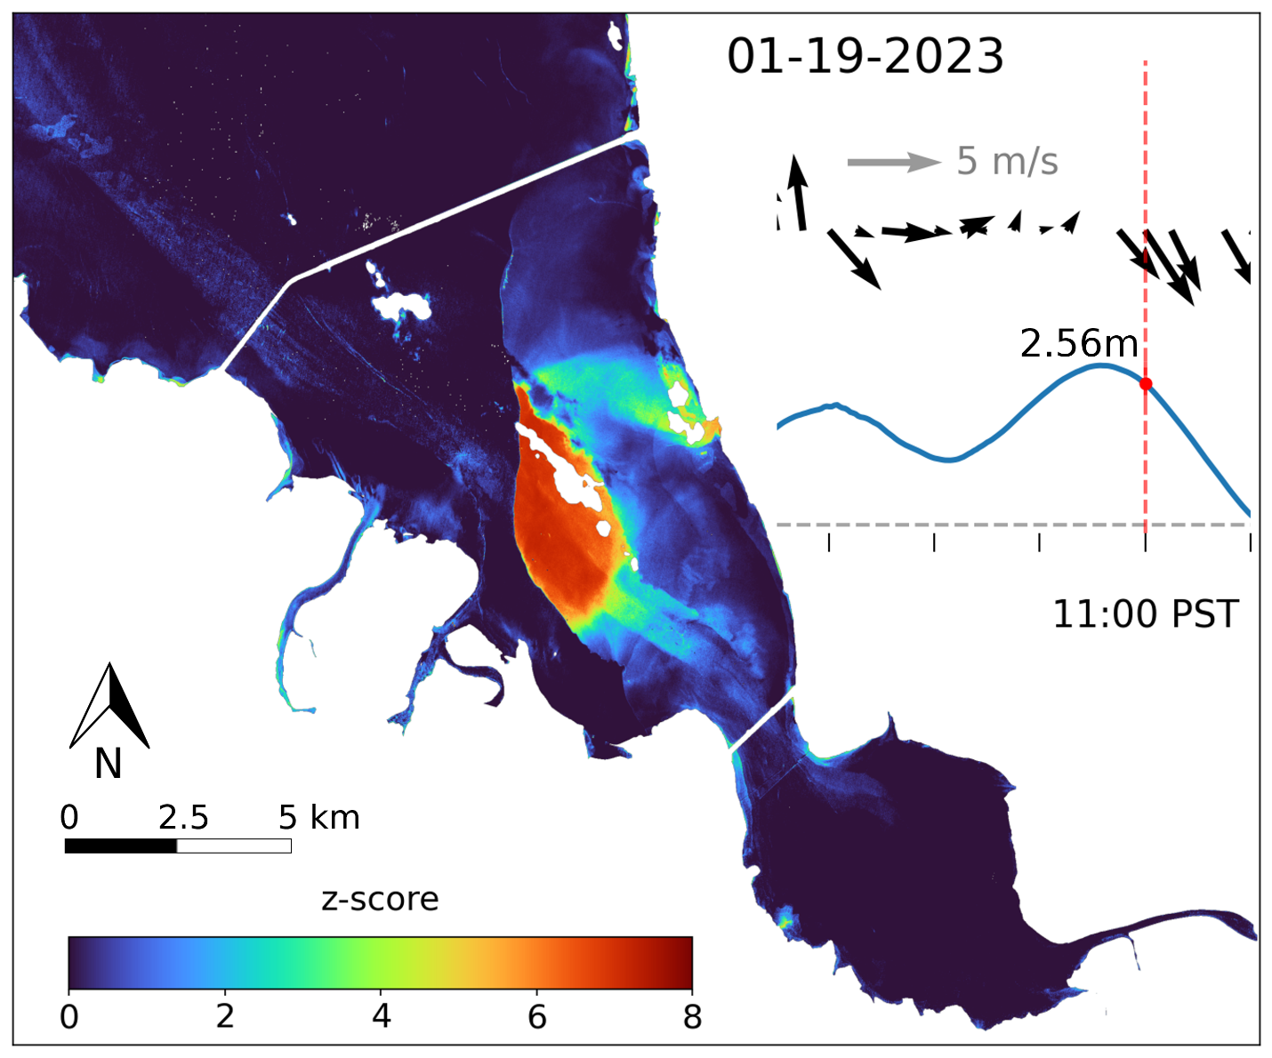
Caption for Graphic or Image: Map of anomalous conditions in south San Francisco Bay on January 19, 2023 after a sequence of atmospheric rivers impacted the area. Above average precipitation triggered runoff and sewage overflow events in the region. In this image, a sediment plume washing out of Alameda creek is flagged as anomalously high concentrations of whole water total mercury (wwTHg). Inset plots show the wind (top) and tide (bottom) conditions for the 18 hours prior and 4 hours after the image acquisition time (marked with a red dashed vertical line).
Author name: Niky C. Taylor
Author business email: ntaylor@usgs.gov

DOI agency/bureau: USGS
USGS Mission Area: Water Resources
USGS Program: National Land Imaging Program
Cost Center: Office of the AD Water
Program Name:
Project title: How often each year was any US location inundated?
Project description: “Dynamic Surface Water Extent” (DSWE) is an operationally generated, openly distributed USGS product created from every Landsat image collected and archived over the United States (US), including Alaska and Hawaii, from 1984 to present (Landsat Dynamic Surface Water Extent Products | U.S. Geological Survey). DSWE shows where land surfaces are covered by water at a ground spacing below 30m because even water mixed with vegetation and soil at Landsat resolution is targeted (Hydrological Sciences | Care to get your boots wet? The ‘Partial Surface Water Challenge’). DSWE users apply these data to characterize lake, pond, river, and wetland function, improve drought detection, evaluate amphibian and fish habitat, model ground/surface water fluxes, estimate flood extents, and map water quality, among other applications. This variety of applications is possible because of the inundated vegetation detection objective and because every Landsat image over the US that meets USGS Landsat Collection 2 accuracy standards is automatically processed to DSWE. Anyone with an internet connection can access DSWE through USGS EarthExplorer (EarthExplorer) or, with USGS provided credentials, directly via Amazon Web Services. DSWE can be used to derive inundation frequency time series by dividing the number of clear Landsat observations through time into the number of DSWE water detections for the same time period over particular locations or the entire US. We express the result as a percent and call these calculations “DSWE Proportions”. Annual DSWE proportions from 1984 to 2024 at 30 m spatial resolution were derived for the conterminous US and made publicly available this year: Collection 2 Dynamic Surface Water Extent (DSWE) Proportions: CONUS Annual Proportions 1984-Present | U.S. Geological Survey. Subsets of this DSWE Proportions time series can be animated to illustrate inundation frequency changes on an annual basis (see figure below) and tabular data can be extracted for areas of interest using Geographic Information Software. The data are stored on a USGS Analysis Ready Data (ARD) tile basis. ARD tile metadata in the database can be queried to select years with various characteristics, such as the “wettest” and “driest” years based on inundation area estimated from DSWE. Inundation frequencies for 2025 over the conterminous US will be added to the database in early 2026.
Desciption Link Overflow: Editor please note: Cut and paste of descriptions in word that have links fails to transfer the hyperlink. Here's a "lookup" for the URLs that are paired with the text that should be shown as the hyperlink in the text:
Landsat Dynamic Surface Water Extent Products | U.S. Geological Survey - https://www.usgs.gov/landsat-missions/landsat-dynamic-surface-water-extent-science-products
Hydrological Sciences | Care to get your boots wet? The ‘Partial Surface Water Challenge’ - https://blogs.egu.eu/divisions/hs/2023/10/26/care-to-get-your-boots-wet-the-partial-surface-water-challenge/
EarthExplorer - https://earthexplorer.usgs.gov/
Collection 2 Dynamic Surface Water Extent (DSWE) Proportions: CONUS Annual Proportions 1984-Present | U.S. Geological Survey - https://www.usgs.gov/data/collection-2-dynamic-surface-water-extent-dswe-proportions-conus-annual-proportions-1984#:~:text=DSWE%20Annual%20Proportions%20data%20are%20statistical%20summaries%20of,on%20the%20analysis%20of%20Landsat%204-9%20satellite%20imagery

Sensor Type: Multispectral (approx. 4-12 bands)
Platform type: Satellite
URL: Embedded in the description
Graphic or Image Upload: https://doimspp.sharepoint.com/sites/GS-EROSSCIENCESWI/Shared Documents/Communications Outreach/Documentation Science/DOI Remote Sensing Report/DOI RS Activities Report, 2025/Question/DOI_RS_Rep_DSWE_Fig_JWJONES_John Jones.png
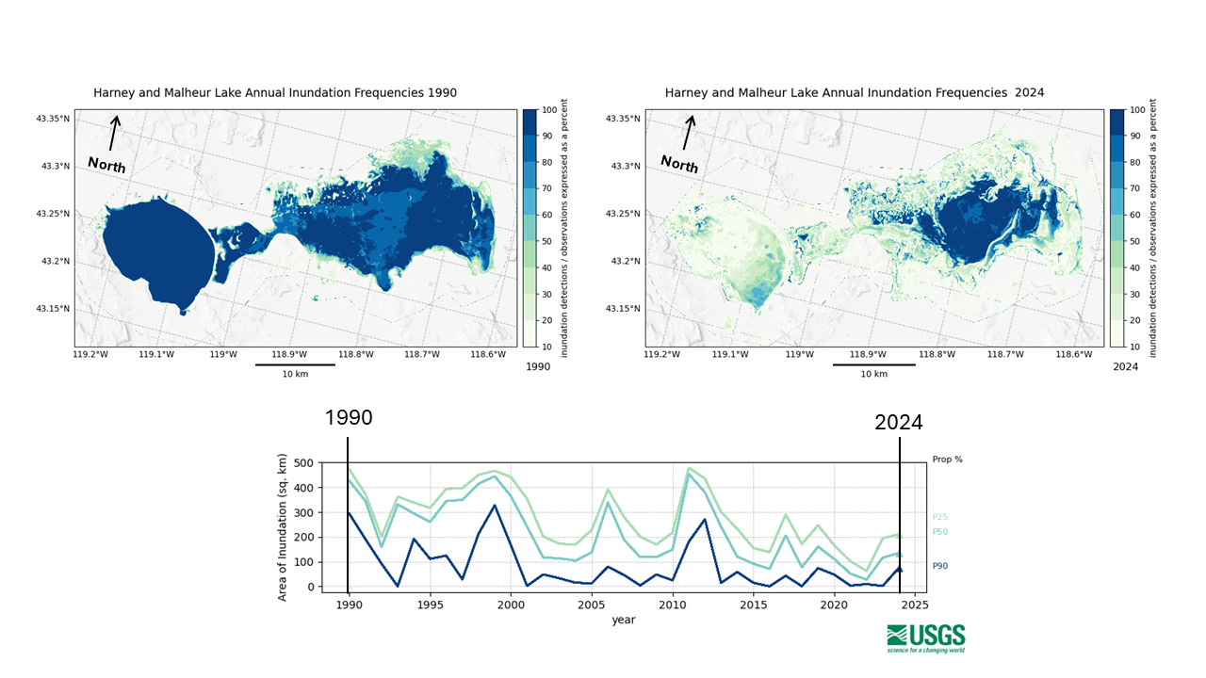
Caption for Graphic or Image: Top: Two frames (1990 – left, and 2024 – right) extracted from an animation of annual DSWE-derived inundation frequencies for Harney and Malheur Lakes north of the Malheur National Wildlife Refuge in east central Oregon, USA. These maps show per-pixel frequencies of 10 to 100 percent with increasing saturation from light green to dark blue color in 10 percent steps (frequencies below 10 percent are not shown to minimize noise). Darkest blue areas were inundated in 90 – 100 percent of the Landsat observations that year. Lighter colored locations weren’t inundated that often. Bottom: The lines in this chart show the area of the 25th, 50th, and 90th inundation frequencies on an annual basis for the animation period (1990 – 2024). For example, the area inundated for 90-100 percent of the observations in 1990 was about 300 square kilometers. In 2024, the area of this range was less than 100 square kilometers. Differences among years are due to combinations of weather and upstream water use each year. Animations and tabular information can be derived from the DSWE Proportions database for any place in the conterminous US.
Author name: John W. Jones
Author business email: jwjones@usgs.gov

DOI agency/bureau: USGS
USGS Mission Area: Core Science Systems
USGS Program: Land Change Science
Cost Center: Western Geographic Science Center
Program Name:
Project title: Above the shrub: UAS and satellite imagery delineates rangeland vegetation and invasive plants
Project description: Invasive annual grasses like cheatgrass (Bromus tectorum) are spreading rapidly across rangelands in the western United States, including into lands managed by all DOI agencies. These early-season invaders outcompete native vegetation, alter habitats, and significantly increase wildfire risk. At the same time, land managers are increasingly turning to fuel breaks—linear strips of modified vegetation—to reduce wildfire spread and intensity and aid in fire suppression activities, particularly in fire-prone rangelands and at-risk ecosystems like sagebrush. Over 11,000 miles of new fuel breaks have been authorized in the Great Basin alone, highlighting the scale of this strategy. However, questions remain about their usefulness, long-term maintenance needs, and unintended ecological impacts, such as increasing the spread of invasive species within and around treated areas. Effective vegetation management could benefit from high-resolution, timely data on where and how fast these species are expanding, and how vegetation is responding to disturbance and manipulation in and near fuel breaks to evaluate fuel break longevity and effectiveness. To support land managers, researchers are developing multi-scale monitoring tools using satellite imagery (Landsat, Sentinel, Planet), drone-based multispectral imagery, and machine learning to map and track invasive grasses throughout the growing season, and to develop rapid, scalable UAS methods for assessing changes in fuel load and vegetation structure across fuel breaks. Initial findings near Yellowstone resulted in the identification of small cheatgrass patches at accuracies of up to 94%. These efforts aim to create actionable early detection systems and high-resolution maps to guide vegetation management decision-making and assessment in dynamic landscapes. Together, these efforts provide crucial tools and insights for managing the dual challenges of invasive species and wildfire in increasingly vulnerable western landscapes.

Further project info may be found here ('here' should have the link)

Desciption Link Overflow:
Sensor Type: Camera;Multispectral (approx. 4-12 bands)
Platform type: UAS;Satellite
URL: https://www.usgs.gov/centers/western-geographic-science-center/science/remote-sensing-invasive-annual-grasses-greater
Graphic or Image Upload: https://doimspp.sharepoint.com/sites/GS-EROSSCIENCESWI/Shared Documents/Communications Outreach/Documentation Science/DOI Remote Sensing Report/DOI RS Activities Report, 2025/Question/UASfuelbreaks_Jason Kreitler.jpg
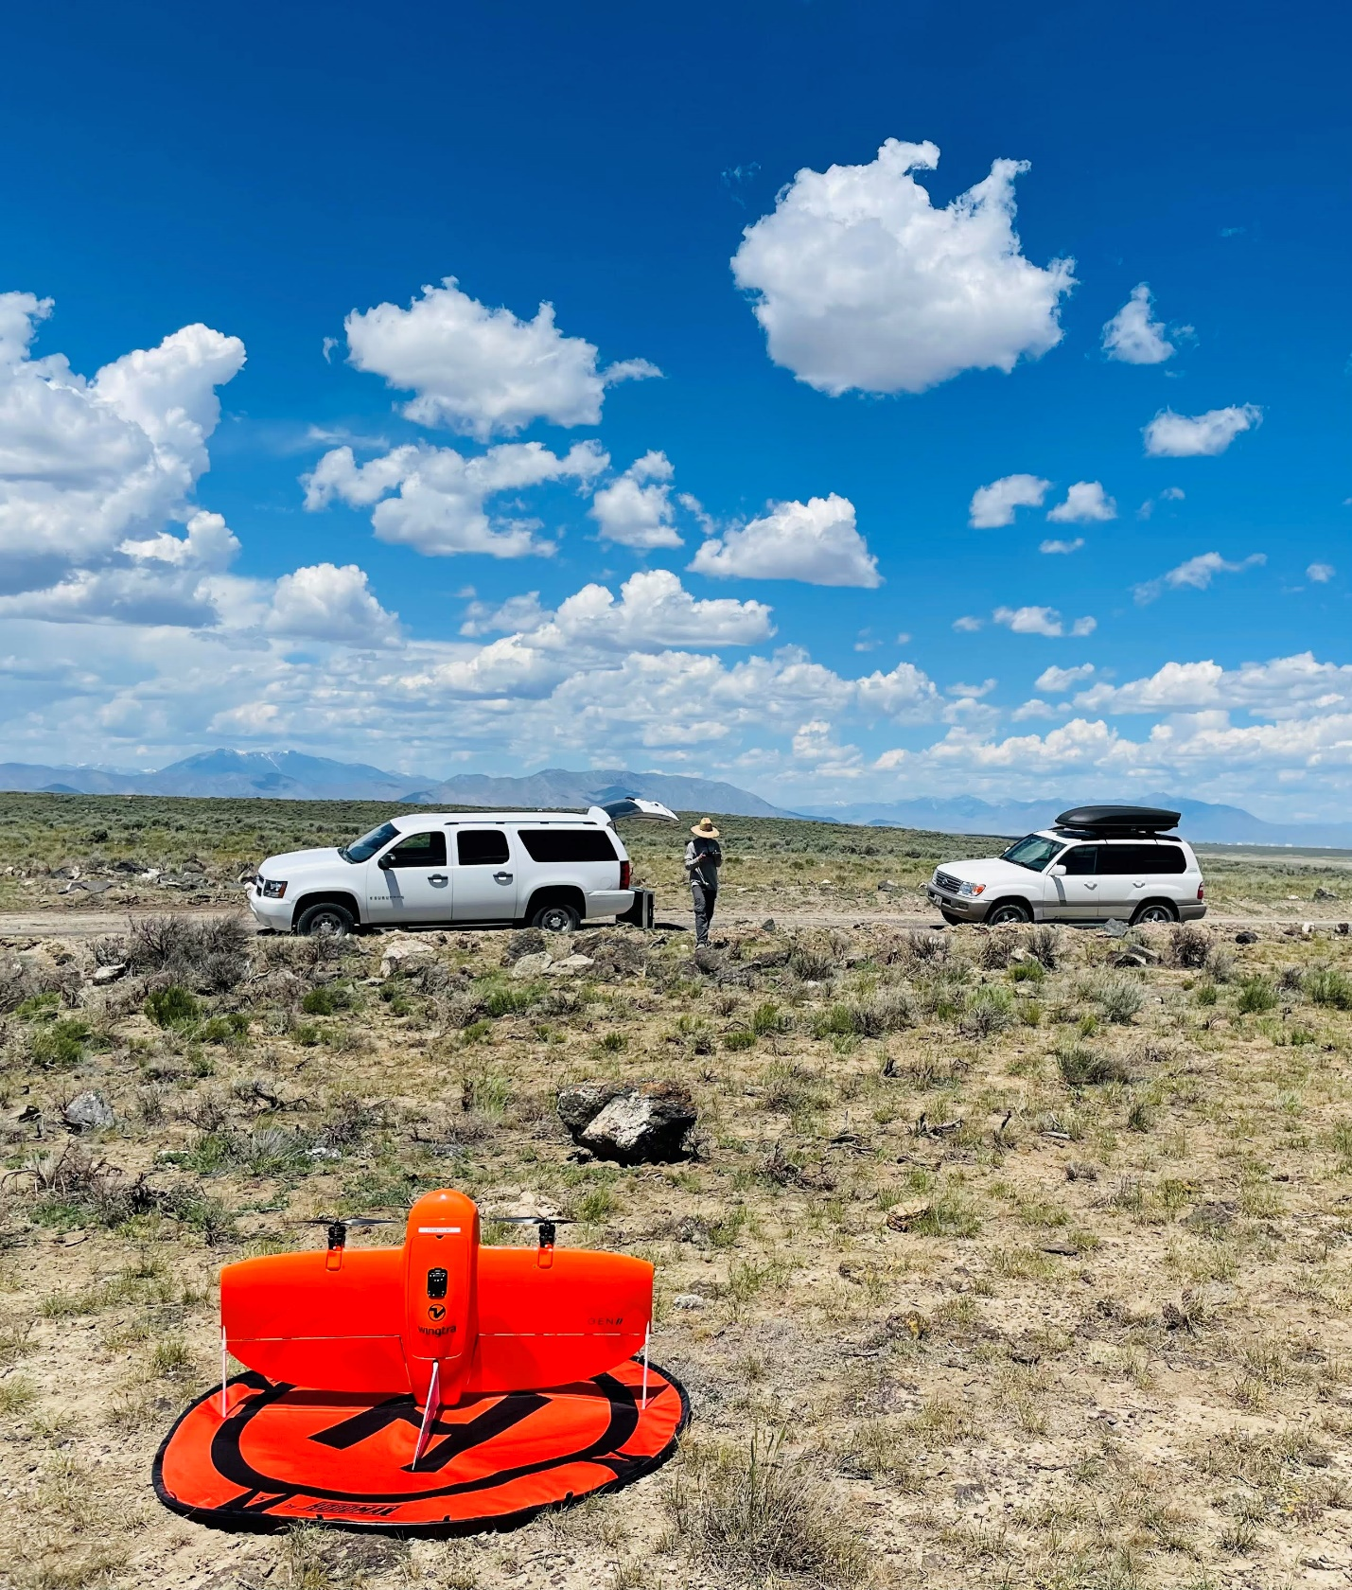
Caption for Graphic or Image: Taylor Dudunake (USGS) prepares for liftoff during a survey of sagebrush fuel breaks near Arco, ID. (Photo by Jason Kreitler, USGS).
Author name: Jason Kreitler
Author business email: jkreitler@usgs.gov

DOI agency/bureau: USGS
USGS Mission Area: Core Science Systems
USGS Program: National Land Imaging Program
Cost Center: Western Geographic Science Center
Program Name:
Project title: Rapid remote sensing Updates of land cover for Storm and Hurricane forecast models (RUSH)
Project description: Coastal vegetated ecosystems, including tidal marshes, vegetated dunes, and shrub-and-forest-dominated wetlands, play a critical role in mitigating hurricane impacts such as coastal flooding and erosion. These ecosystems enhance surface roughness and dissipate wave energy, thereby reducing the severity of storm impacts. Surface roughness is commonly quantified using Manning’s n, a coefficient widely employed in coastal hydrodynamic modeling. Incorporating land cover maps into advanced hydro-morphological models can improve the representation of surface roughness for vegetation and other land cover types. Thus, there is a need for efficient tools to generate up-to-date land cover maps that include the accurate distribution of vegetation and other land cover types prior to an extreme storm.

USGS scientists developed the RUSH tool (Rapid remote sensing Updates of land cover for Storm and Hurricane forecast models), which uses Planet Labs’ imagery Application Programming Interface (API), a robust pre-trained random forest machine learning model, and newly available Planet Labs Super Dove satellite images to deliver 3-meter resolution, near-daily coastal land cover maps for near-real-time or historical conditions. The land cover maps contain classes relevant to coastal settings, especially along mainland beaches, headlands, and barrier islands, as follows: (1) open water; (2) emergent wetlands; (3) dune grass; (4) woody wetlands; and (5) bare ground.

(Planet images are provided free to federal employees and contractors through the NASA Commercial Smallsat Data Acquisition Program)

Desciption Link Overflow:
Sensor Type: Multispectral (approx. 4-12 bands)
Platform type: Satellite
URL: https://www.usgs.gov/software/rush-rapid-remote-sensing-updates-landcover-storm-and-hurricane-forecasts-version-100
Graphic or Image Upload: https://doimspp.sharepoint.com/sites/GS-EROSSCIENCESWI/Shared Documents/Communications Outreach/Documentation Science/DOI Remote Sensing Report/DOI RS Activities Report, 2025/Question/RSReport_Chak Wa (Winston) Ch.png
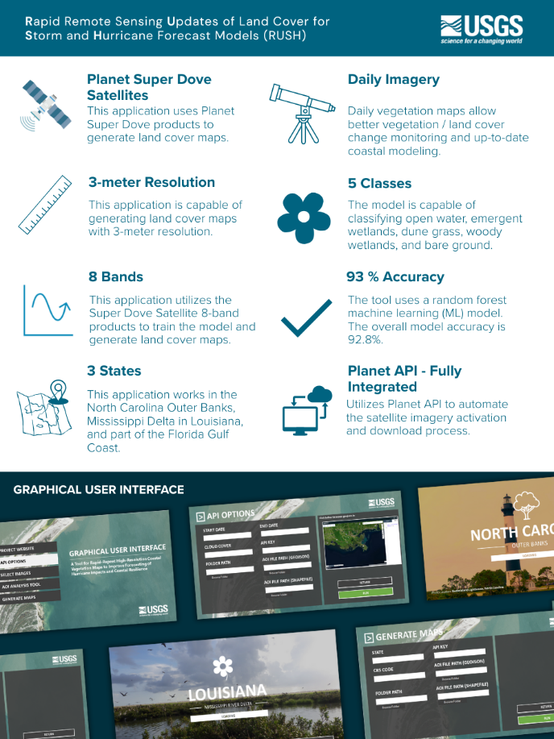
Caption for Graphic or Image: A fact sheet that shows the tool’s characteristics and graphical user interface.
Author name: Chak Wa (Winston) Cheang
Author business email: ccheang@usgs.gov

DOI agency/bureau: USGS
USGS Mission Area: Natural Hazards
USGS Program: Earthquake Hazard Program
Cost Center: Earthquake Science Center
Program Name:
Project title: Leveraging satellite optical imagery for earthquake rapid response and characterization
Project description: When a large earthquake occurs in the United States or globally, the U.S. Geological Survey generates products that quantify the impacts of the event as rapidly as possible, including estimates of economic loss and fatalities. This includes rapid measurement of the extent of shaking and the length of the fault that ruptured the Earth’s surface, which can guide humanitarian and scientific response. Large surface-rupturing earthquakes have occurred in the past in the United States, including along the San Andreas Fault in California in 1857 and 1906. Similar events will happen again, and satellite optical images will likely capture the first full picture of the earthquake.

A recent example of USGS response occurred following the March 28th, 2025, M7.7 Burma (Myanmar) earthquake, which initiated near Mandalay and extended almost 500 kilometers along the Sagaing fault through central Myanmar. The Sagaing fault is one of the best analogs in the world to the San Andreas Fault, prompting heightened national scientific and humanitarian interest. The earthquake caused economic losses in the billions of dollars and more than 5,000 known fatalities. Initial estimates underestimated the extent of the affected region and population due to lack of adequate observational data. The first full constraints on the rupture extent and movement of the Earth’s surface were obtained through sub-pixel correlation of pre- and post-earthquake European Space Agency Sentinel-2 satellite optical images. The analyses revealed a surface rupture length over 475 km, more than double the expected length for an earthquake of this magnitude, and maximum surface displacements of nearly 6 meters. Similar results from USGS Landsat 8/9 and Planet Lab’s Dove satellites validated these observations. USGS staff then used these, and other higher-resolution optical satellite images from Maxar WorldView and BlackSky sensors to map the visible rupture traces and measure the surface slip using visibly offset features. The displacement maps, mapped fault surface rupture, and derived metrics were distributed through an interactive online map: “Remote Surface Rupture Observations for the M7.7 2025 Mandalay, Burma (Myanmar) Earthquake” (https://doi.org/10.5066/P1RYMWCK). This work demonstrates new capabilities that can be brought to bear during response to future earthquakes and demonstrates rapid dissemination of critical earthquake information to the public.
Desciption Link Overflow:
Sensor Type: Camera
Platform type: Satellite
URL:
Graphic or Image Upload: https://doimspp.sharepoint.com/sites/GS-EROSSCIENCESWI/Shared Documents/Communications Outreach/Documentation Science/DOI Remote Sensing Report/DOI RS Activities Report, 2025/Question/Hanagan_Reitman_Shane Detweiler.jpg
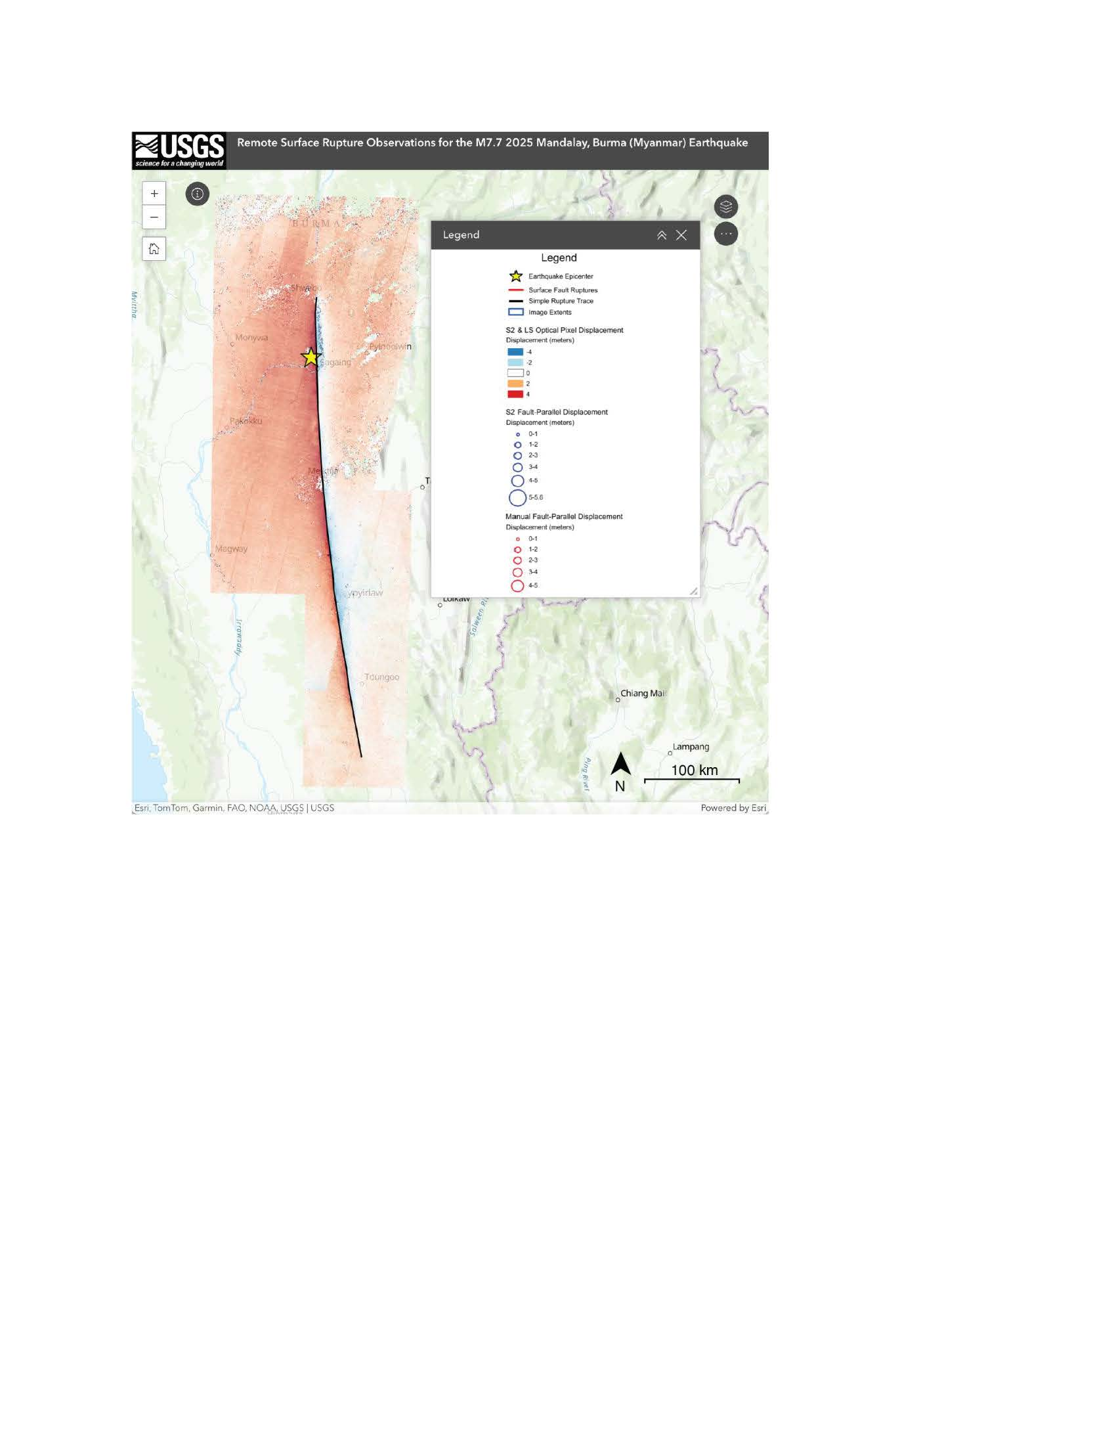
Caption for Graphic or Image: Screenshot of the web map displaying the north-south displacement field derived from analysis of pre- and post-earthquake satellite imagery.
Author name: Catherine Hanagan
Author business email: chanagan@usgs.gov

DOI agency/bureau: USGS
USGS Mission Area: Natural Hazards
USGS Program: Earthquake Hazard Program
Cost Center: Earthquake Science Center
Program Name:
Project title: Airborne Lidar provides insight into landslide hazards in low-relief glaciated landscapes
Project description: Formerly glaciated continental landscapes are more susceptible to landsliding than current national-scale susceptibility maps indicate because even though they are low-relief, they are underlain by weak sediments and can have steep slopes. Across the state of Minnesota, landslides are common on steep slopes created by the drainage of glacial lakes and streams cutting into material that was left from past glacial activity. Motivated by recent fatalities and other impacts from landslides, scientists from the United States Geological Survey (USGS), and several academic and non-governmental partners generated the state’s first inventory of modern and recent landslides. The inventory was derived from airborne lidar and satellite and aerial imagery data and historic accounts and contains nearly 10,000 landslides. The inventory was used in statistical analyses to create susceptibility maps that indicate where landslides are most likely to occur based on landscape characteristics and the occurrence of past landslides. Slope is the most important factor in controlling landsliding, especially when hillslopes are underlain by weak, glacial materials such as diamicton or glaciolacustrine silt and clay. The inventory and susceptibility maps are intended to bring awareness of landsliding within the state, aid in future site-specific hazard characterizations, guide zoning and planning, and mitigate these hazards to the public. Technical analysis of the factors influencing landslides in Minnesota, the inventory, and susceptibility mapping methods can be found at the associated publication in Natural Hazards.
Desciption Link Overflow:
Sensor Type: Camera;Lidar (terrestrial or bathymetric)
Platform type: Airplane;Satellite
URL: https://link.springer.com/article/10.1007/s11069-025-07262-8
Graphic or Image Upload: https://doimspp.sharepoint.com/sites/GS-EROSSCIENCESWI/Shared Documents/Communications Outreach/Documentation Science/DOI Remote Sensing Report/DOI RS Activities Report, 2025/Question/Delong_Shane Detweiler.jpg
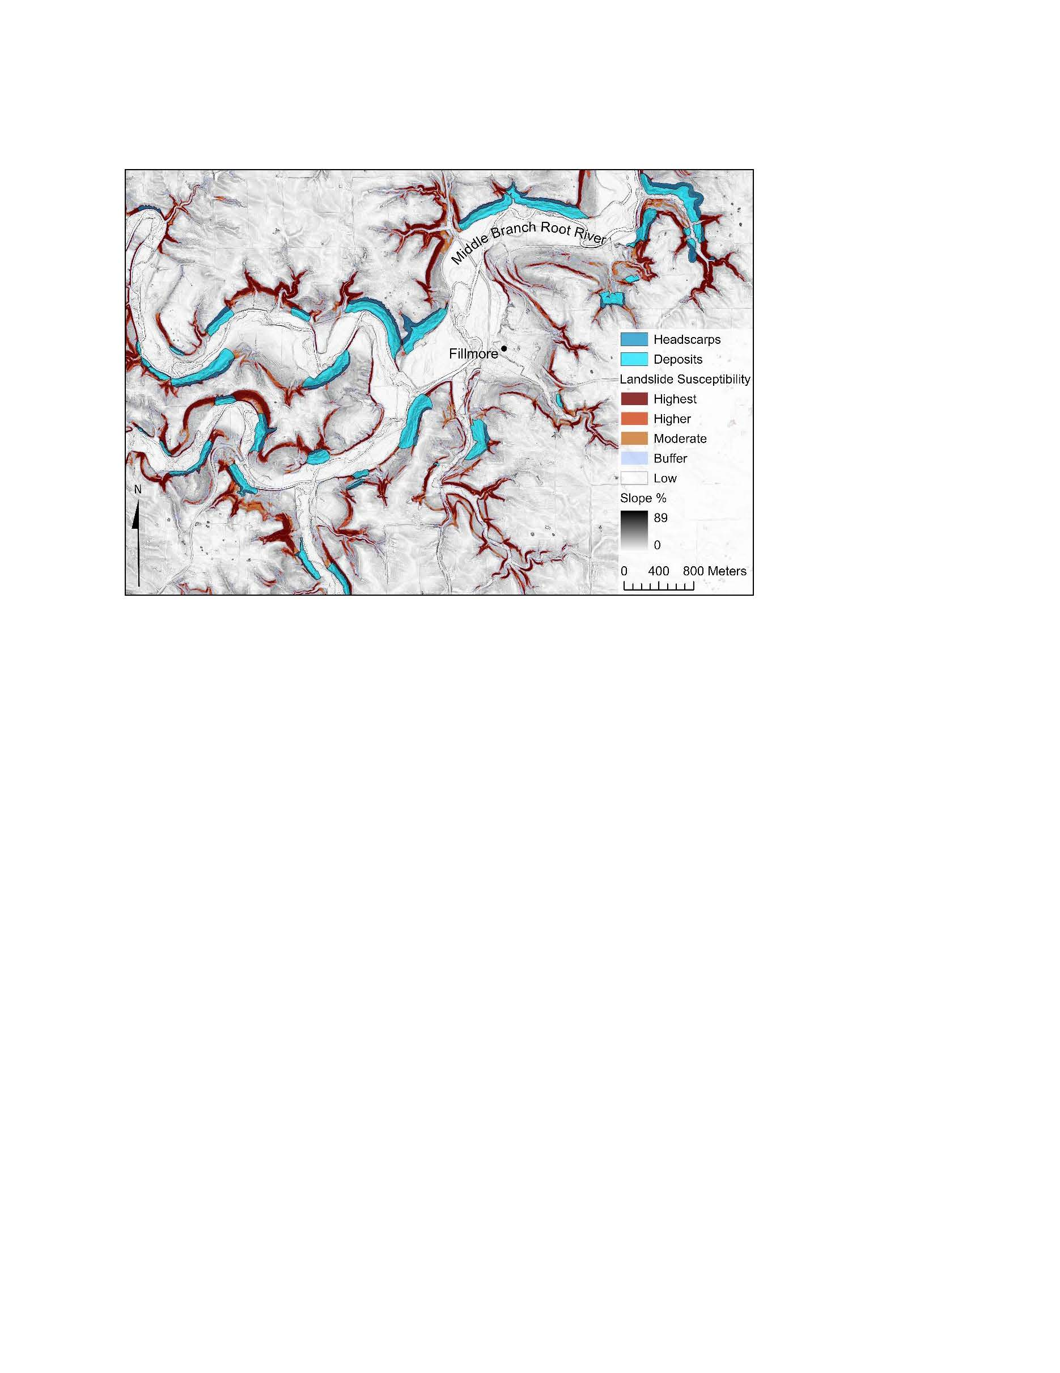
Caption for Graphic or Image: Susceptibility map and landslide inventory in southeast Minnesota along the Middle Branch Root River near Filmore, MN. Blue hue polygons represent the mapped landslide headscarps and deposits. The orange and red hue polygons underlying the mapped inventory is the landslide susceptibility map, representing probability from highest to lowest.
Author name: Steve DeLong
Author business email: sdelong@usgs.gov

DOI agency/bureau: USGS
USGS Mission Area: Natural Hazards
USGS Program: Earthquake Hazard Program
Cost Center: Earthquake Science Center
Program Name:
Project title: Earthquake Surface Motions Revealed through Space-based Radar Image Data
Project description: On June 5th, 2021 a magnitude (M) 5.3 earthquake occurred near Calipatria, CA at the southern end of the Salton Sea, approximately 150 miles southeast of Los Angeles, between the southern San Andreas Fault system to the north, and the Gulf of California to the south (see: https://earthquake.usgs.gov/earthquakes/eventpage/ci39919392/executive). Seismicity rates in the region are relatively high for California (see nearby seismicity URL below), and the region has hosted numerous moderate magnitude (~M 4.5-6.6) earthquakes in the past decades. Earthquakes here release the stress along systems of faults that run between the San Andreas and faults to the south. One goal of research at the Earthquake Science Center of the USGS is to understand not only this Mw 5.3 earthquake, but also the conditions which lead to earthquakes like it, in the context of the region, and the hazards these kinds of events generate for communities living near these faults (see: https://geonarrative.usgs.gov/saltonsea/). For instance, characterizing the behavior of these earthquakes is important because they are located so close to the southern San Andreas Fault and could portend a much larger event.

The most common source of data on earthquake occurrence comes from networks of seismometers placed on the ground. Radar remote sensing measurements from satellites, however, provide additional observations that complement existing ground-based datasets by allowing us to see images of the ground motion caused by earthquakes. The image displayed in the figure shows an estimate of earthquake motion caused by the M 5.3 Calipatria event, calculated from observations made by the European Space Agency’s Sentinel-1 Synthetic Aperture Radar (SAR) satellite system. Orange indicates motion towards the satellite (approximately up motion, with the maximum at ~35 mm / ~3.5 cm / ~1.4 in), and blue indicates motion away from the satellite (approximately down motion), where the satellite is moving SSW and looking towards the West as it collects its images from space. Being able to calculate an image of surface motion allows inference of a surface fault location (red dashed line) and the spatial extent of earthquake motion. In this case, this image reveals that this M 5.3 earthquake occurred on a different fault than was previously mapped (black dashed lines at the edge of the Salton Sea), an observation that would be very difficult to make using seismometer data alone. This radar image data enables the mapping of earthquake surface motion and will be used to monitor, discover, and map new fault motion in the future.

Desciption Link Overflow:
Sensor Type: IFSAR / SAR / Radar
Platform type: Satellite
URL: https://earthquake.usgs.gov/earthquakes/map/?currentFeatureId=ci39919392&extent=28.91201,-123.39844&extent=37.23908,-107.85278&range=search&timeZone=utc&search=%7B%22name%22:%22Search%20Results%22,%22params%22:%7B%22endtime%22:%222021-06-26T17:55:58.820Z%22,%22latitude%22:33.14,%22longitude%22:-115.6348333,%22maxradiuskm%22:250,%22minmagnitude%22:2,%22starttime%22:%222021-05-15T17:55:58.820Z%22%7D%7D
Graphic or Image Upload: https://doimspp.sharepoint.com/sites/GS-EROSSCIENCESWI/Shared Documents/Communications Outreach/Documentation Science/DOI Remote Sensing Report/DOI RS Activities Report, 2025/Question/Figure_DOI_Report_Calipatria_20250911_Shane Detweiler.jpg
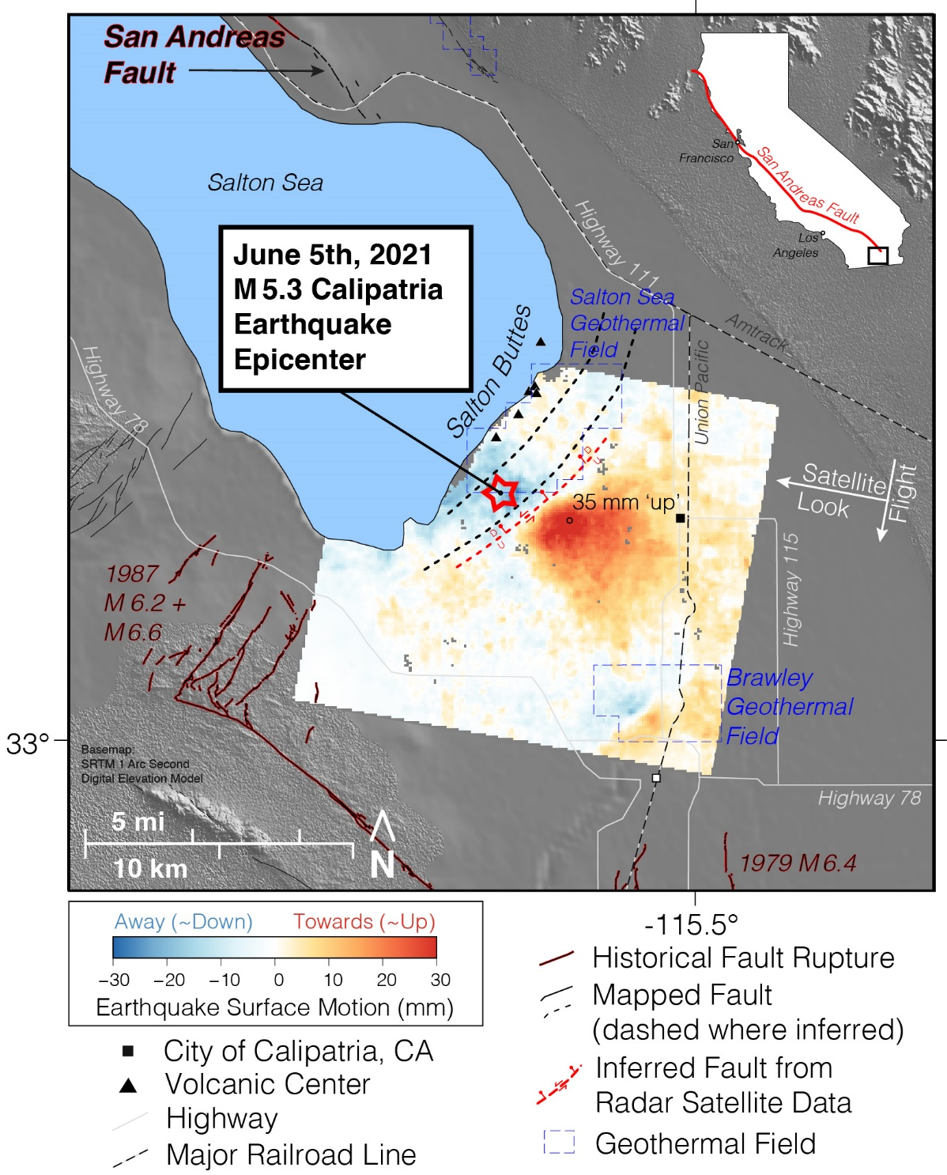
Caption for Graphic or Image: Synthetic Aperture Radar measurements reveal a two-dimensional image of surface motion caused by the 2021 M 5.3 Calipatria, CA earthquake in the Imperial Valley, southern California.
Author name: Katherine Guns
Author business email: kguns@usgs.gov

DOI agency/bureau: USGS
USGS Mission Area: Ecosystems
USGS Program: Land Change Science
Cost Center: Western Geographic Science Center
Program Name:
Project title: Mapping fire intensity in Alaska’s boreal ecosystems
Project description: The wildfire regime in Alaska is trending towards larger, more frequent, and more severe fires. To investigate the impacts of these changes on boreal ecosystems, U.S. Geological Survey (USGS) researchers from the Western Geographic Science Center conducted a study that focused on patterns of fire radiative power (FRP), a metric of fire intensity derived from satellite thermal imagery. The team used a 19-year dataset of FRP data collected by National Aeronautics and Space Administration (NASA) Moderate Resolution Imaging Spectroradiometer (MODIS) sensors to examine the relationship between fire intensity and factors such as vegetation type and past fire history. The fires detected by MODIS spanned a diverse range of ecosystems in Alaska, from dense forests in the state interior to arctic tundra in the far north.

The study found that FRP distributions were statistically distinct among different vegetation functional groups, reflecting variations in fuel availability and condition. Geographical location and topography were also dominant controls on FRP, as these factors strongly influence vegetation community composition across the state. The findings suggest that although FRP can serve as a valuable proxy for assessing wildfire consumption across varied vegetation types, its utility is dependent on the local geographic and environmental context. Overall, this research provides insight into how FRP can contribute to studies of fire behavior and post-fire recovery dynamics in Alaska's remote, high-latitude environments.

MODIS citation: https://www.earthdata.nasa.gov/data/catalog/lpcloud-mod14a1-061
Paper citation: https://www.publish.csiro.au/wf/WF24062

Desciption Link Overflow:
Sensor Type: Multispectral (approx. 4-12 bands)
Platform type: Satellite
URL:
Graphic or Image Upload: https://doimspp.sharepoint.com/sites/GS-EROSSCIENCESWI/Shared Documents/Communications Outreach/Documentation Science/DOI Remote Sensing Report/DOI RS Activities Report, 2025/Question/IMG_3404_Jessica Walker.JPG
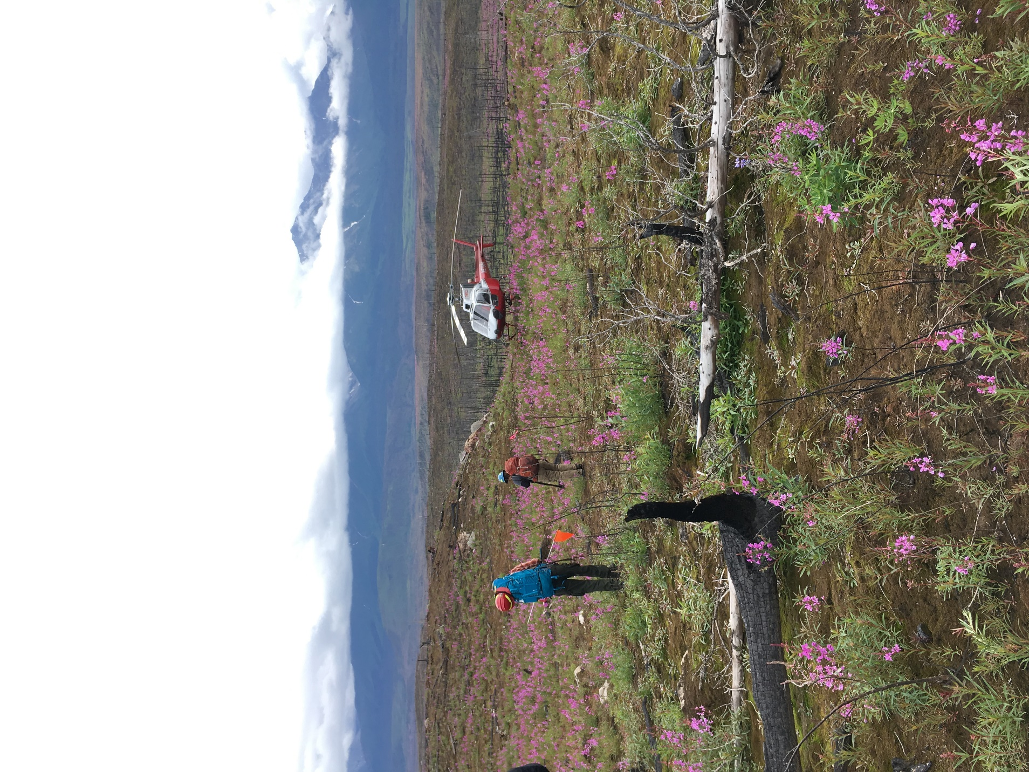
Caption for Graphic or Image: Figure 1. U.S. Geological Survey (USGS) scientists conducting field work in a burned area of Wrangell-St. Elias National Park, Alaska. Photo credit: Jessica Walker, USGS.
Author name: jjwalker@usgs.gov
Author business email: jjwalker@usgs.gov

