**DOI agency/bureau:** OSMRE

**USGS Mission Area:**

**USGS Program:**

**Cost Center:**

**Program Name:** Geospatial & Technology Transfer Branch, Technical Services Branch

**Project title:** SMCRA from Above: Advanced Surveying with UAS and LiDAR

**Project description:** Uncrewed Aerial Systems (UAS), commonly known as drones, play a crucial role in supporting OSMRE’s mission under the Surface Mining Control and Reclamation Act (SMCRA) by enhancing operations on both regulatory and abandoned mine land sites. Early in fiscal year 2025, staff from OSMRE’s Alton, Illinois office met with Tulsa Field Office personnel in Eastern Oklahoma, where the team used the Wingtra UAS to map three Title V sites over two days.

The group captured surface data on these sites using aerial LiDAR and high-resolution aerial imagery with the RGB sensors. In addition, a Hydrone bathymetric survey system, coupled with a high-accuracy Global Navigation Satellite System (GNSS) and sonar, was used to survey the underwater terrain of water-filled mine pits, areas currently unmappable with LiDAR alone. This approach ensures full terrain data coverage of both terrestrial and submerged areas. GNSS equipment was also used to survey ground control points, which are used to correct and verify the accuracy of the UAS data.

Permit boundaries of the sites covered a combined area of approximately 692 acres. As more drone missions are completed, the speed, safety, and efficiency of UAS-based surveying demonstrates significant advantages over traditional ground-based methods.

Technical Innovation and Professional Services (TIPS) software, including Pix4D and Global Mapper, was used after field data collection to classify LiDAR point clouds, produce high-resolution orthomosaic images, and create digital terrain models and contour maps. These deliverables will be used by Tulsa Field Office technical staff for subsequent design, construction, and maintenance of acid mine drainage passive treatment systems and other mine reclamation activity.

Through this effort, three OSMRE UAS pilots also obtained Department of the Interior certification on the new Skydio X10 UAS system. Multiple staff members were cross trained in UAS data collection and bathymetric GNSS surveying. The group created and shared How-To guides so others can adopt these step-by-step processing workflows on future projects. Collaboration with UAS specialists across other Department of the Interior agencies continues as OSMRE shares field and data-processing strategies.

**Desciption Link Overflow:**

**Sensor Type:** Camera;Lidar (terrestrial or bathymetric);Sound (sonar or acoustic)

**Platform type:** UAS

URL:

**Graphic or Image Upload:** https://doimspp.sharepoint.com/sites/GS-EROSSCIENCESWI/Shared Documents/Communications Outreach/Documentation Science/DOI Remote Sensing Report/DOI RS Activities Report, 2025/Question/OSMRE-staff-from-Alton-Tulsa-and-Pittsburgh-p_Krystal Pankey.png

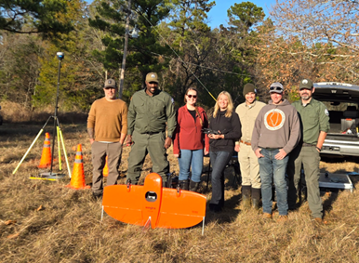

**Caption for Graphic or Image:** OSMRE staff from Alton, Tulsa, and Pittsburgh pictured with the Wingtra UAS.

**Author name:** Chris Kiser

**Author business email:** ckiser@osmre.gov

**DOI agency/bureau:** OSMRE

**USGS Mission Area:**

**USGS Program:**

**Cost Center:**

**Program Name:** Geospatial & Technology Transfer Branch, Technical Services Branch

**Project title:** OSMRE Showcases UAS Capabilities During Alabama Technology Roadshow

**Project description:** The Office of Surface Mining Reclamation and Enforcement’s (OSMRE) Mid-Continent Regional office (MCR) recently partnered with the Alabama Abandoned Mine Lands Division and the Alabama Surface Mining Commission for a weeklong technology roadshow across the state. The initiative highlighted the tools and services the MCR’s Technical Services Division provided to support reclamation work under the Surface Mining Control and Reclamation Act (SMCRA) of 1977.

The roadshow began in Birmingham, where OSMRE staff provided on-site training to Alabama AML Division personnel on their newly purchased uncrewed aircraft system (UAS). Geographic Information Systems (GIS) specialists received hands-on instruction using the WingtraOne Gen II UAS, equipped with an RGB camera and a light detection and ranging (LiDAR) sensor. The Wingtra is a fully autonomous system designed to map large areas more efficiently and precisely than older drone models. To improve data accuracy, OSMRE also demonstrated how to set up Global Navigation Satellite System (GNSS) control points during the training.

In Jasper, OSMRE staff met with the Alabama Surface Mining Commission to continue the roadshow. Technical Services Division staff showcased capabilities in the following areas:

• Hydrology: Monitoring and managing water flow.

• UAS Operations: Autonomous aerial data collection.

• Photogrammetry: Generating 3D models from imagery.

• Bathymetry: Mapping underwater terrain.

• NEPA (National Environmental Policy Act): Assessing environmental impacts.

• Geographic Information Systems (GIS): Visualizing and analyzing spatial data.

These tools are essential for modern reclamation work, helping states improve public safety, environmental outcomes, and long-term land use.

While there is no fixed schedule for roadshows, the MCR aims to conduct three to four state visits annually, allowing OSMRE staff to connect with each Mid-Continent state every three to four years. Roadshows are a strategic priority for the region, enabling OSMRE staff to provide consistent, hands-on technical support and strengthen partnerships across its jurisdiction.

This event demonstrated MCR’s evolving technology offerings and the agency’s commitment to innovation and collaboration in mine reclamation.

**Desciption Link Overflow:**

**Sensor Type:** Camera;Lidar (terrestrial or bathymetric)

**Platform type:** UAS

URL: https://www.osmre.gov/news/stories/osmre-showcases-uas-capabilities-during-alabama-technology-roadshow

**Graphic or Image Upload:** https://doimspp.sharepoint.com/sites/GS-EROSSCIENCESWI/Shared Documents/Communications Outreach/Documentation Science/DOI Remote Sensing Report/DOI RS Activities Report, 2025/Question/OSMRE-Showcases-UAS-Capabilities-During-Alaba_Krystal Pankey.jpg

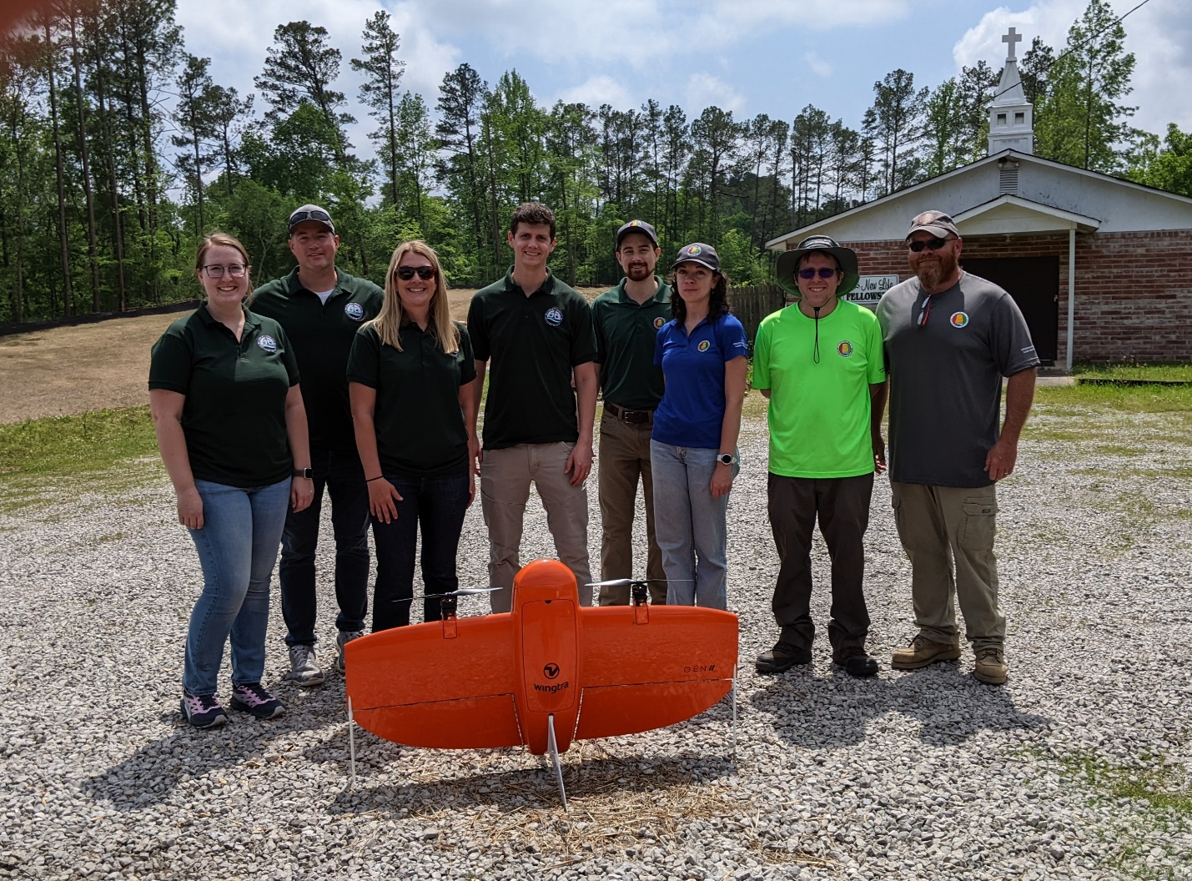

**Caption for Graphic or Image:** OSMRE staff from Mid-Continent Region and Alabama staff on site at an AML Project with the WingtraOne Gen II UAS.

**Author name:** Krystal Pankey

**Author business email:** kpankey@osmre.gov

**DOI agency/bureau:** OSMRE

**USGS Mission Area:**

**USGS Program:**

**Cost Center:**

**Program Name:** Geospatial Information Services Branch

**Project title:** Enhancing Mine Inspections with Satellite Remote Sensing

**Project description:** The Office of Surface Mining Reclamation and Enforcement (OSMRE) leverages commercial satellite imagery to enhance the efficiency and effectiveness of its field operations. High-resolution satellite imagery provides OSMRE personnel with a valuable tool for monitoring surface coal mining and reclamation activities. This imagery supports the agency's oversight responsibilities by offering timely, cost-effective, and broad-scale visual information that complements traditional on-the-ground inspections.

One of the key applications of satellite imagery within OSMRE is the integration of imagery and remote sensing-derived products into web-based mapping applications. These platforms enable inspectors and field personnel to visualize surface changes over time, monitor mining progression, and assess compliance with reclamation standards. By layering historical and current satellite images, users can evaluate the success of revegetation in reclaimed areas—an important factor in determining whether a site qualifies for bond release.

Unlike regular mine inspections that require a physical presence on-site, OSMRE inspectors may conduct “aerial inspections” as part of partial inspection procedures. In these cases, they leverage high-resolution commercial satellite imagery to remotely evaluate conditions at the site. This remotely sensed data allows inspectors to identify potential issues and determine whether a follow-up field visit is necessary. These remote inspections are particularly useful in reducing travel costs and increasing the frequency of site monitoring.

Figure 1 illustrates a 3D rendering of the Navajo Mine in New Mexico, based on satellite imagery collected by Maxar’s WorldView-2 sensor on April 2, 2025. This product was generated using stereo satellite imagery to create a digital elevation model, with high-resolution imagery overlaid for added detail. Tools like these provide inspectors with a more realistic and comprehensive view of the site, enhancing their ability to assess conditions remotely.

By incorporating satellite imagery and remote sensing into its workflows, OSMRE enhances situational awareness, supports data-informed decisions, and enhances oversight of surface coal mining operations.

**Desciption Link Overflow:**

**Sensor Type:** Multispectral (approx. 4-12 bands)

**Platform type:** Satellite

URL:

**Graphic or Image Upload:** https://doimspp.sharepoint.com/sites/GS-EROSSCIENCESWI/Shared Documents/Communications Outreach/Documentation Science/DOI Remote Sensing Report/DOI RS Activities Report, 2025/Question/Figure 1_Navajo_Aldo Plascencia.jpg

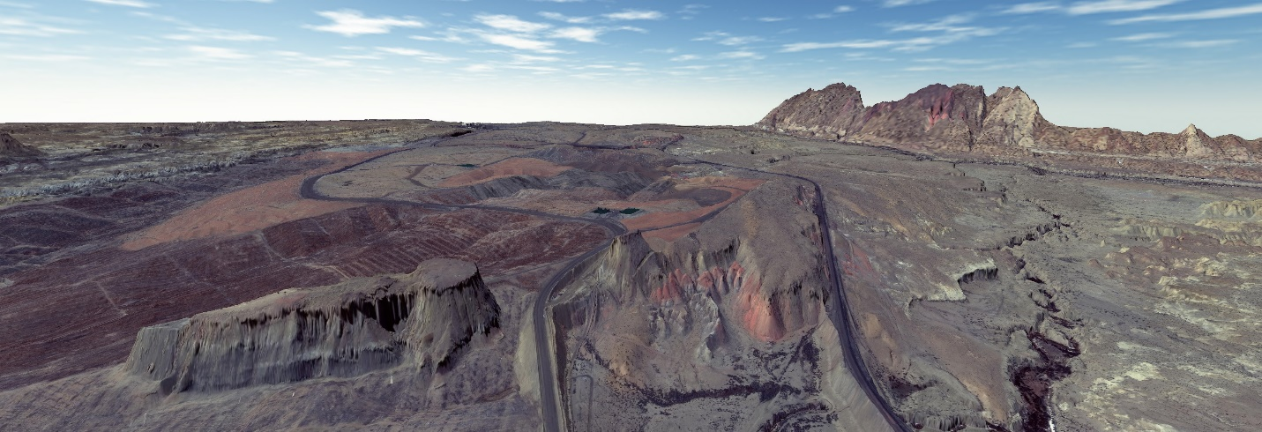

**Caption for Graphic or Image:** 3D model of the Navajo Mine in New Mexico, generated from Maxar WorldView-2 satellite imagery collected on April 2, 2025.

**Author name:** Aldo Plascencia

**Author business email:** aplascencia@osmre.gov