**DOI agency/bureau:** NPS

**USGS Mission Area:**

**USGS Program:**

**Cost Center:**

**Program Name:** Inventory and Monitoring Program, Arctic Inventory and Monitoring Network

**Project title:** Decreasing Area of Lakes and Ponds in the Arctic

**Project description:** Lakes and ponds in lowland permafrost regions are both abundant and uniquely dynamic. The National Park Service monitors the area of surface water in the five National Parks, Monuments, and Preserves in northern Alaska. We determine the area of lakes and ponds from the U.S. Geological Survey's "Landsat Dynamic Surface Water Extent" product, which provides digital maps of surface water derived from Landsat satellite images.

During the period for which annual Landsat data are available (2000–2024), most of the study area showed declining surface water area. The areas where loss was most rapid were flat lowlands with lakes in shallow depressions surrounded by permafrost (permanently frozen ground). Most loss of lake area was due to sudden lake drainage events, which occurred as a result of thaw and erosion of the frozen ground around the lakes. The years 2017–2019 and 2021 had the most lake drainage events during the study time interval, and the majority of lake drainages occurred in the lowlands of northern Bering Land Bridge National Preserve.

**Desciption Link Overflow:**

**Sensor Type:** Multispectral (approx. 4-12 bands)

**Platform type:** Satellite

URL: https://irma.nps.gov/DataStore/Reference/Profile/2313920

**Graphic or Image Upload:** https://doimspp.sharepoint.com/sites/GS-EROSSCIENCESWI/Shared Documents/Communications Outreach/Documentation Science/DOI Remote Sensing Report/DOI RS Activities Report, 2025/Question/bela4irAadj.png

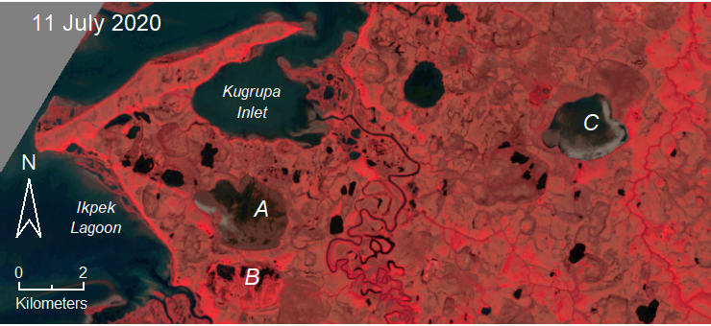

**Caption for Graphic or Image:** Example of lakes draining in western Bering Land Bridge National Preserve. This is a Landsat image, displayed using visible and infrared light data such that water is black and dense vegetation is red. In 2019, lakes A and C were water-filled, but by the date of this image (July 2020), drainage had exposed the lake bottom over most of lake A and part of lake C. The outline of a lake that drained in the 1970s is visible at B.

**Author name:** David Swanson

**Author business email:** david_swanson@nps.gov

**DOI agency/bureau:** NPS

**USGS Mission Area:**

**USGS Program:**

**Cost Center:**

**Program Name:** Water Resources Division, Ocean and Coastal Resources Program

**Project title:** Bathymetry data collection at Pedersen Lagoon

**Project description:** NPS scientists from the Ocean and Coastal Resources Program (OCRP) and Alaska Region conducted seafloor mapping at Pedersen Lagoon in Kenai Fjords National Park. The effort was in response to a landslide-generated tsunami that occurred in August 2024, causing a 62-meter wave run-up that propagated across the lagoon and caused minor structural damage to the nearby campground and lodge. Mapping was conducted in the interconnected upper and lower lagoons using an autonomous survey vessel (ASV) equipped with a multibeam sonar system capable of collecting high resolution, high accuracy bathymetry data. The data will be provided to scientists at USGS to document and characterize the underwater landslide deposits and parameterize a new tsunami model for this region to help assess landslide hazards in Pedersen Lagoon. The upper lagoon has only been accessible in recent years due to the rapid recession of the Pedersen Glacier. This field effort marks the first time water depths in the upper lagoon have been documented – further highlighting the importance of this data. The bathymetry revealed a maximum depth of 45 meters in the lower lagoon, and 185 meters in the upper lagoon.

**Desciption Link Overflow:**

**Sensor Type:** Sound (sonar or acoustic)

**Platform type:** autonomous survey vessel (ASV)

URL:

**Graphic or Image Upload:** https://doimspp.sharepoint.com/sites/GS-EROSSCIENCESWI/Shared Documents/Communications Outreach/Documentation Science/DOI Remote Sensing Report/DOI RS Activities Report, 2025/Question/IMG_7894_Nicole Laroche.jpg

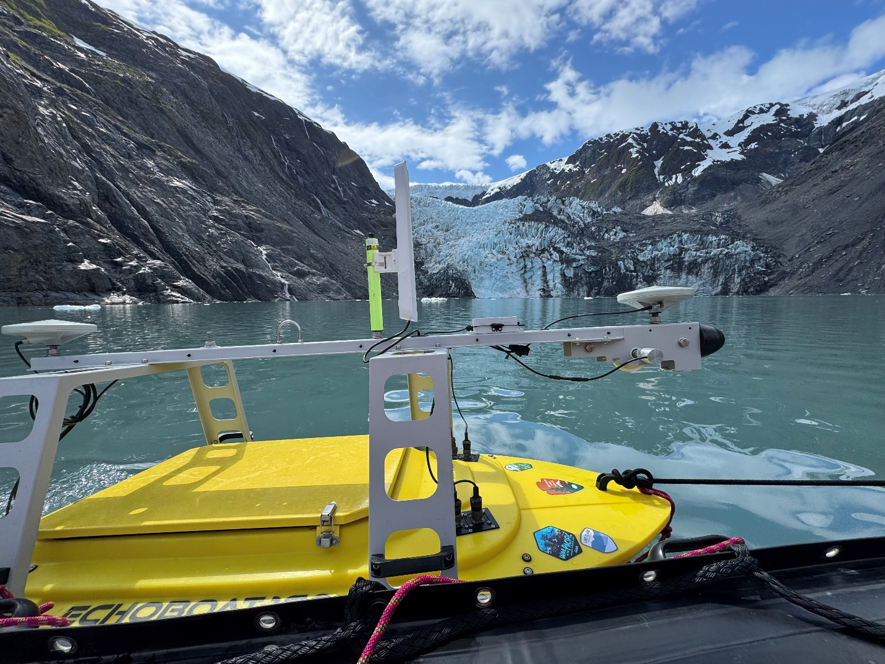

**Caption for Graphic or Image:** Autonomous survey vessel (ASV) tethered to inflatable skiff in front of Pedersen Lagoon, in Kenai Fjords National Park, Alaska.

**Author name:** Nicole LaRoche

**Author business email:** nicole_laroche@nps.gov

**DOI agency/bureau:** NPS

**USGS Mission Area:**

**USGS Program:**

**Cost Center:**

**Program Name:** Water Resources Division, Ocean and Coastal Resources Program

**Project title:** Bathymetry data collection in Tuxedni Channel, Alaska

**Project description:** Scientists with the NPS Ocean and Coastal Resources Program (OCRP) conducted a seafloor mapping survey in Tuxedni Channel at Lake Clark National Park. This work is a part of the Johnson Port Tract Development planning process, involving an easement for mineral exploration transportation needs. OCRP scientists collected fine-scale seafloor data using an autonomous surface vessel (ASV) equipped with a multibeam sonar system capable of collecting high resolution, high accuracy bathymetry data. This data will be used in conjunction with previously collected aerial structure from motion (SfM) and terrestrial LiDAR data to create a seamless topobathymetric dataset to characterize the structure, elevation, water depth, and features of interest, which will improve our limited understanding in this area. Park staff will advise port and road construction locations with this topobathymetric dataset.

**Desciption Link Overflow:**

**Sensor Type:** Sound (sonar or acoustic)

**Platform type:** Autonomous surface vessel (ASV)

URL:

**Graphic or Image Upload:** https://doimspp.sharepoint.com/sites/GS-EROSSCIENCESWI/Shared Documents/Communications Outreach/Documentation Science/DOI Remote Sensing Report/DOI RS Activities Report, 2025/Question/IMG_3949_Nicole Laroche.jpeg

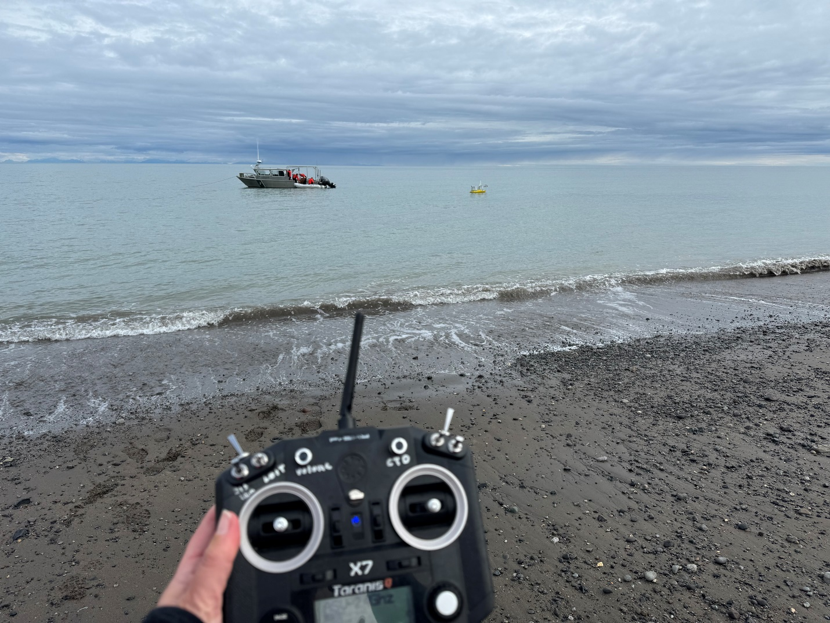

**Caption for Graphic or Image:** Remote control for autonomous surface vessel (asv) in the background at Silver Salmon Creek beach in Lake Clark National Park, Alaska.

**Author name:** Nicole LaRoche

**Author business email:** nicole_laroche@nps.gov

**DOI agency/bureau:** NPS

**USGS Mission Area:**

**USGS Program:**

**Cost Center:**

**Program Name:** Yukon-Charley Rivers National Preserve

**Project title:** Combining Lidar and Photogrammetry to Restore and Rediscover Alaska's Mining Past

**Project description:** Established in 1980 to preserve placer gold mining history in Alaska’s interior, Yukon-Charley Rivers National Preserve also contains the Coal Creek Historic Mining District, a site listed on the National Register of Historic Places, which is representative of dredge mining operations between the 1930’s to 1970’s in Alaska.

Although gold dredge tailings are a significant contributing feature to the historic district, the mining led to an altered and incised stream channel with high rates of erosion, overly simplified habitat, and a disconnected floodplain in some reaches. A stream restoration project was initiated to maintain park facilities and improve Chinook salmon rearing habitat. To assist with the restoration design, in the summer of 2023, NPS staff used fixed-wing structure-from-motion (SfM) to create orthomosaics (9cm GSD), while contractors used a Lidar sensor to create a bare earth digital elevation model (DEM,45 cm GSD). In the spring of 2024, aufeis at the mouth of tributary streams feeding Coal Creek required additional mapping using structure-from-motion (SfM) methods to collect imagery that captured seasonal stream changes.

In the fall of 2024, cultural resources staff from Yukon-Charley Rivers National Preserve also assessed eligibility of an extension to the historic site based on open-cut mining that took place after the dredge mining operations ended (1980’s), since open-cut mining differs significantly from dredge mining in both impacts to the landscape and cultural significance. Based on a local account, NPS staff started the search for the open-cut tailings, as well as a steel sluice box used for open-cut mining that was thought to be destroyed or buried.

Archaeologists georeferenced historic aerial imagery to compare to the 2023 imagery and DEM for signs of the open-cut tailings and sluice box. Tailings sites were identified, but due to the resolution of the lidar and vegetation in the 2023 SfM leaf-on imagery, it was not possible to determine if a sluice box was still at any of the sites. However, when viewing the 2024 SfM leaf-off imagery, staff were able to clearly identify the sluice box that was previously thought to be destroyed, resulting in a visit to the site in summer 2025. Park staff believe these new insights will extend the area of significance for the historic district. Additionally, there is scarce documentation of an existing in-situ sluice box site from this time period within the state, increasing the significance of the find for Alaska mining history.

**Desciption Link Overflow:**

**Sensor Type:** Camera;Lidar (terrestrial or bathymetric)

**Platform type:** Airplane

URL:

**Graphic or Image Upload:** https://doimspp.sharepoint.com/sites/GS-EROSSCIENCESWI/Shared Documents/Communications Outreach/Documentation Science/DOI Remote Sensing Report/DOI RS Activities Report, 2025/Question/8x11 Tailings Comparison_9mb_Britta Schroeder.jpg

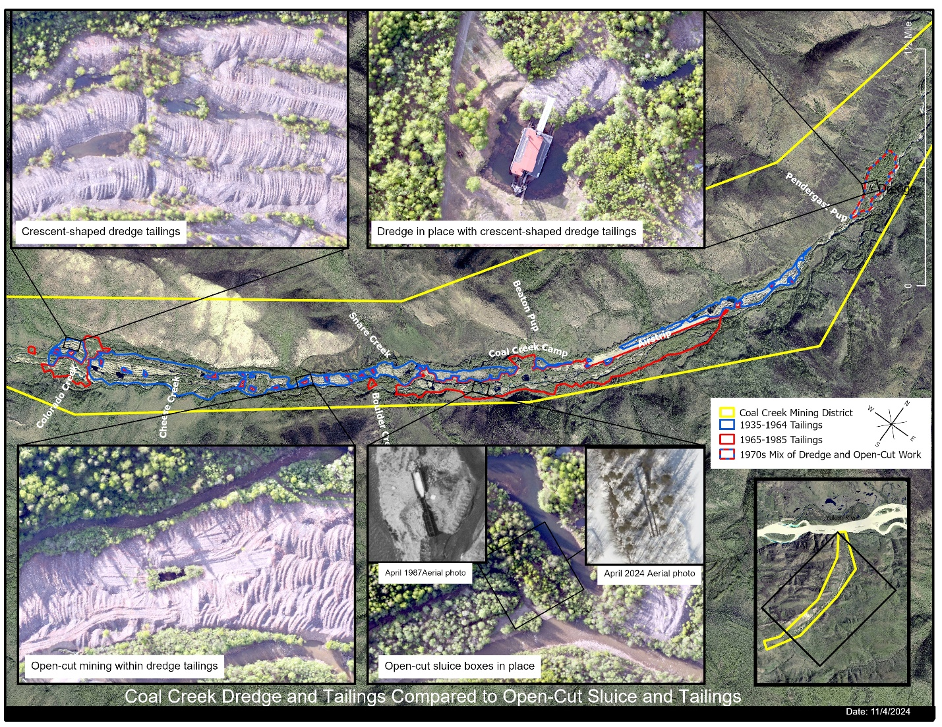

**Caption for Graphic or Image:** Aerial imagery from 2023 showing examples of mining tailings, as well as an in-situ dredge and sluice box in Coal Creek Historic District, Yukon-Charley Rivers National Preserve. Map Credit: Whitney McLaren

**Author name:** Britta Schroeder, Whitney McLaren

**Author business email:** britta_schroeder@nps.gov, whitney_mclaren@nps.gov

**DOI agency/bureau:** NPS

**USGS Mission Area:**

**USGS Program:**

**Cost Center:**

**Program Name:** Southwest Alaska Inventory and Monitoring Network

**Project title:** Mapping thermal refuges of Pacific salmon in southwest Alaskan parklands

**Project description:** Pacific salmon are keystone species in southwest Alaska, possessing substantial cultural, ecological, and economic importance. Annual salmon returns sustain a subsistence way of life, providing a primary food source for indigenous and local populations. These salmon also support some of the highest densities of brown bears in the world and a significant recreational fishery, which combined maintain a multimillion-dollar wildlife viewing and fishing tourism industry.

Salmon depend on cold water temperatures to survive their migration through freshwater habitats and spawn successfully. With Alaska’s changing climate however, the surface water temperatures of these habitats are warming. Surface water temperatures that approach or exceed salmon species’ biological thresholds can impede migration, cause pre-spawn mortality, and decrease reproductive success. Discrete areas of colder water – often associated with groundwater upwellings, confluences of cooler tributaries, and/or heavily shaded banks – can provide short-term protection and increase salmon resiliency. Water temperatures are expected to continue increasing, making the identification and protection of these discrete areas of colder water increasingly important.

Previous monitoring efforts of water temperature in salmon habitat by the National Park Service Southwest Alaska Inventory and Monitoring Network (SWAN), while temporally rich, were spatially poor. They were designed to capture localized, long-term temperature trends rather than stream-scale, cross-sectional thermal differences. As such, SWAN began using aerial thermal photogrammetry to map and characterize the location, distribution, connectivity, extent, and persistence of discrete cold spots in high-priority, anadromous streams.

Aerial mid-wave infrared and red-green-blue imagery covering approximately 445 river kilometers in 21 rivers and streams across Lake Clark National Park and Preserve, Katmai National Park and Preserve, and Kenai Fjords National Park have been collected by aircraft so far. Photogrammetric orthomosaics created from the collected imagery were used to manually identify 130 cold-water refuges, defined as areas with temperatures at least 2°C colder than the surrounding waters. Based on accessibility and fish use, a subset of these refuges was selected to be outfitted with an array of water temperature loggers. Paired with additional thermal photogrammetric imagery, the data provided by these loggers will help characterize the extent and persistence of the cold-water refuges. This information, in combination with spatial distributions, will be used to inform management of thermal refuge conditions and their potential to be impacted by projected warming.

**Desciption Link Overflow:**

**Sensor Type:** Thermal

**Platform type:** Airplane

URL:

**Graphic or Image Upload:** https://doimspp.sharepoint.com/sites/GS-EROSSCIENCESWI/Shared Documents/Communications Outreach/Documentation Science/DOI Remote Sensing Report/DOI RS Activities Report, 2025/Question/Necons_RemoteSensing_Lauren Hintenlang.png

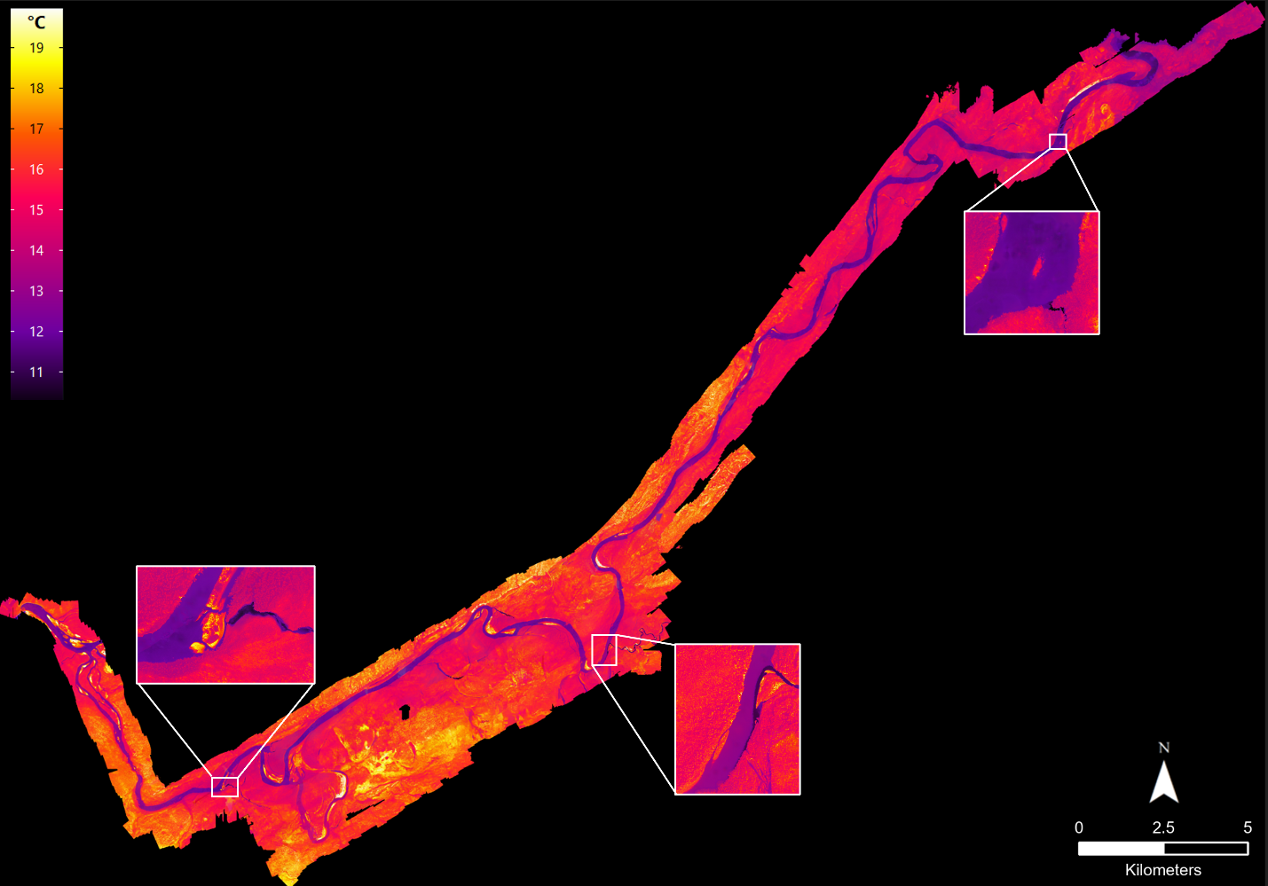

**Caption for Graphic or Image:** Mid-wave infrared orthomosaic of the Necons River in Lake Clark National Park and Preserve scaled 10-20°C. Imagery was collected August 3, 2024. Inset boxes highlight three cold water refuges.

**Author name:** Lauren Hintenlang

**Author business email:** lauren_hintenlang@partner.nps.gov