DOI agency/bureau: FWS
USGS Mission Area:
USGS Program:
Cost Center:
Program Name: Marine National Monuments of the Pacific
Project title: Assessment of the spatial distribution of Chondria tumulosa
Project description: In 2019, a red macroalgal species, Chondria tumulosa, was discovered overgrowing native coral and algal species and changing the benthic communities of Manawai (Pearl and Hermes Atoll) in Papahānaumokuākea Marine National Monument (PMNM). The main objective of this study was to assess the spatial distribution of C. tumulosa across the forereef and backreef of Manawai using satellite remote sensing. WorldView-2 and -3 commercial high-resolution satellite images were obtained for a 12-year period from 2010 to 2021, from which, time-series animations were created. Previous studies reported that C. tumulosa appeared as distinctively dark features in satellite imagery with the first evidence of C. tumulosa in 2015. Thus, the animations were visually inspected to identify dark patches that became visible around the time of discovery and persisted in subsequent years. Field survey data of C. tumulosa cover collected in 2019–2021 were used to gain confidence in the identification of dark patches. Using those dark features as a reference and a support vector machine, the latest high-resolution satellite images from the 12-year period were classified into a map of distinctive dark patches suspected to be C. tumulosa with an average overall accuracy of 78%. Accuracy assessments of the classification results of C. tumulosa based on field survey data collected in 2019–2021 resulted in an overall accuracy of 79%. This study leverages the use of remote sensing to map a newly discovered alga in a remote area in the hopes of providing managers with a methodology to further monitor the species for long-term management.
Desciption Link Overflow:
Sensor Type: Multispectral (approx. 4-12 bands)
Platform type: Satellite
URL: http://doi.org/10.1111/jpy.70025
Graphic or Image Upload: https://doimspp.sharepoint.com/sites/GS-EROSSCIENCESWI/Shared Documents/Communications Outreach/Documentation Science/DOI Remote Sensing Report/DOI RS Activities Report, 2025/Question/Figure 5_Leiana Beyer.png
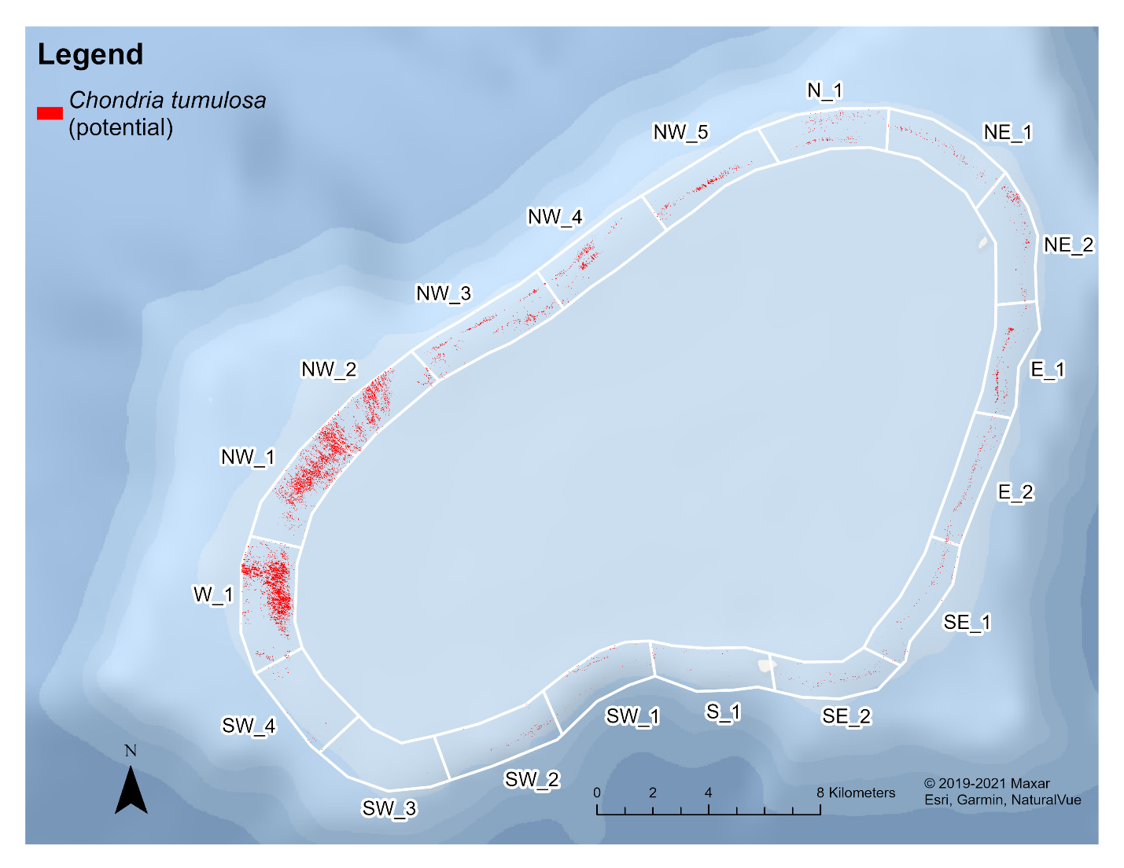
Caption for Graphic or Image: Estimated species distribution of Chondria tumulosa (potential) at Manawai. Red represents the dark patches suspected to be C. tumulosa (potential) based on image classification. The study area was divided into 18 polygons with its corresponding name to reference the area of interest.
Author name: Leiana Beyer
Author business email: leiana_beyer@fws.gov

DOI agency/bureau: FWS
USGS Mission Area:
USGS Program:
Cost Center:
Program Name: Division of Biological Sciences; Fire Management
Project title: Eastern redcedar (Juniperus virginiana) mapping, monitoring and modeling for Southwest Region National Wildlife Refuge Lands
Project description: Eastern redcedar (Juniperus virginiana) is a native conifer whose range extends from the eastern to midwestern United States. It exhibits broad ecological tolerance and efficient seed dispersal, enabling rapid expansion across diverse landscapes. In the Great Plains, it is considered invasive due to its aggressive encroachment into prairie grasslands and woodlands, where historical fire regimes have been substantially altered. In response, the U.S. Fish and Wildlife Service is restoring grassland habitats on National Wildlife Refuges in Texas and Oklahoma through mechanical removal and prescribed fire to reduce eastern redcedar (ERC) cover and hazardous fuels. To evaluate treatment outcomes, we are leveraging archived and newly acquired Worldview-2 (WV2) imagery via the CRSSP Imagery-Derived Requirements (CIDR) tool and MAXAR GEGD Pro platform, along with USGS 3DEP airborne lidar. WV2 imagery is selected during the deciduous ‘leaf-off’ period to better differentiate ERC, the only evergreen conifer in these systems. Our workflow includes correction and calibration steps to ensure reliable and repeatable observations across treatment sites. We are testing machine learning ensemble models, combinations of multiple algorithms, for classifying ERC cover at 2-meter resolution (Figure 1). Preliminary results show that ensemble models outperform single-model approaches, and that indices such as the Worldview Vegetation Index (WVVI) and Modified Triangular Vegetation Index (MTVI2) are key predictors for accurate ERC identification. However, confusion with photosynthetically active vegetation, such as seasonal grasses and winter crops, during the leaf-off window remains a challenge. To address this, a lidar-derived canopy height model (CHM) is being used to distinguish ERC from low-stature vegetation. Classified outputs are supporting the development of regression models to estimate ERC expansion between 2014 and 2025. This analysis aims to: (1) accurately map ERC cover within refuge management units; (2) assess the effectiveness of past and ongoing treatments; and (3) predict future ERC expansion rates. These forecasts can help prioritize areas most at risk for rapid encroachment and guide future management. Next steps include further field validation and data harmonization to improve model reliability and ensure timely delivery of updated ERC cover information.
Desciption Link Overflow:
Sensor Type: Lidar (terrestrial or bathymetric);Multispectral (approx. 4-12 bands)
Platform type: Airplane;Satellite
URL:
Graphic or Image Upload: https://doimspp.sharepoint.com/sites/GS-EROSSCIENCESWI/Shared Documents/Communications Outreach/Documentation Science/DOI Remote Sensing Report/DOI RS Activities Report, 2025/Question/Figure1_ERC_PrePost_treatement_Sesnie_Steven Sesnie.png
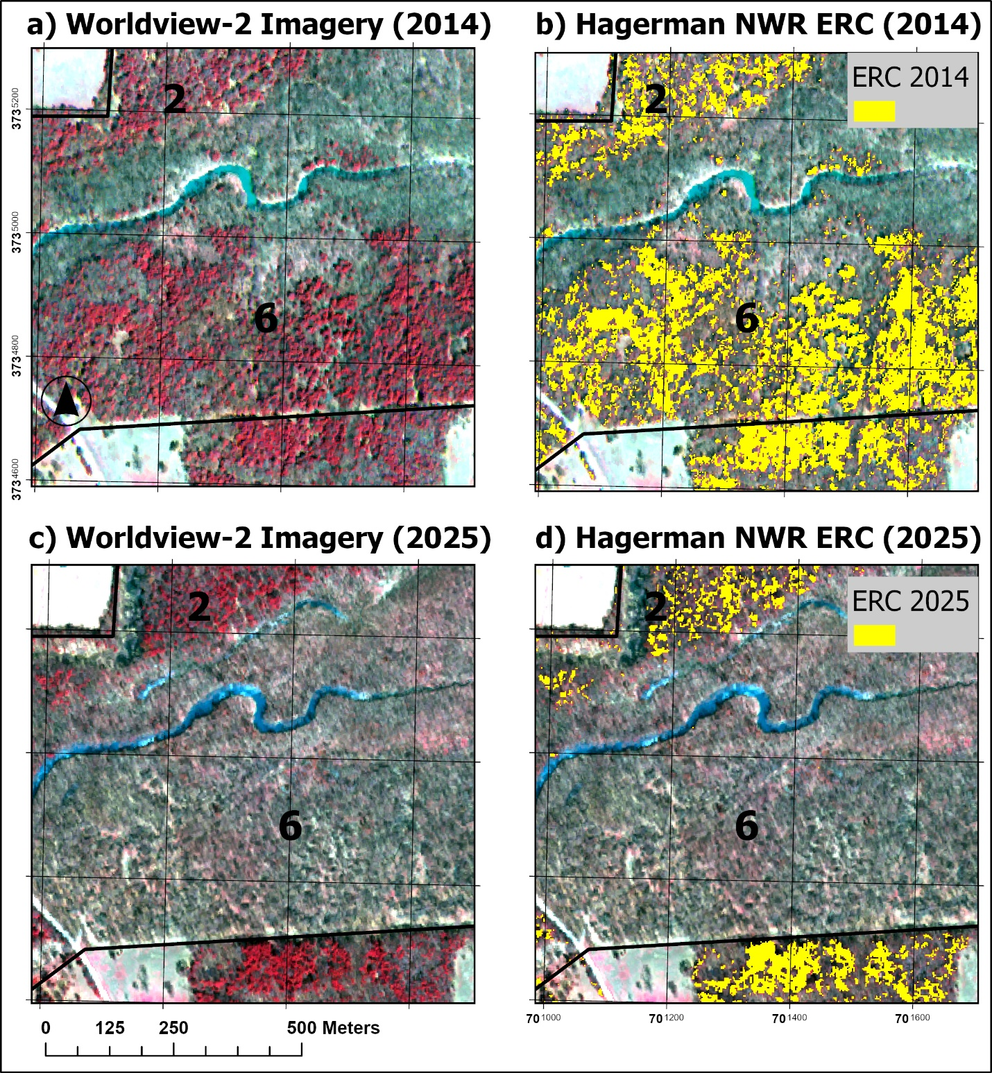
Caption for Graphic or Image: Figure 1. A a) pre-treatment WV2 image and b) image classification result with ERC pixels (yellow) for 2014 compared to a c) post-treatment WV2 image and d) ERC classified pixels (yellow) for 2025 on the Hagerman National Wildlife Refuge (NWR) in Texas. Image band combinations are near infrared (765nm – 901nm), red (624nm – 694nm) and green (506nm – 586nm) spectral regions. Treatment areas in management units 2 and 6 are divided by the river at the center of the image.
Author name: Steven E. Sesnie; Howard Boss
Author business email: steven_sesnie@fws.gov; howard_boss@fws.gov

DOI agency/bureau: FWS
USGS Mission Area:
USGS Program:
Cost Center:
Program Name: Refuges
Project title: Using remote sensing in invasive annual grass management
Project description: Sagebrush ecosystems are crucial for ranching communities and wildlife. They increasingly face significant threats from invasive annual grasses like Japanese brome and cheatgrass. These invasives alter wildfires, making fires larger and more frequent. This in turn threatens communities, energy development, and wildlife that occur across the west. Historically, sagebrush areas experienced infrequent, low-severity fires that maintained the integrity of the ecosystem. Invasive grasses fuel wildfires that are more intense and destructive, converting sagebrush rangelands into invasive annual grasslands. Satellite imagery can provide data that can assist invasive annual grass management. By using remote-sensing data to make more informed decisions, refuge staff are optimizing management efforts to both reduce fire risk and improve habitat for wildlife and rural communities.
Staff from the Charles M. Russell NWR (CMR) Complex and the Regional Invasive Species Program have been working on the issue of invasive annual grasses across central Montana for several years. Initial surveys and subsequent modeling effort indicated Japanese brome was widespread across the refuge complex and that habitat suitability for annual invasive grasses was moderate to high. The Division of Scientific Resources provided funding to map invasive annual grass across priority sagebrush areas within Montana including the CMR Complex using Landsat and Sentinel satellite imagery. The combination of satellite imagery with local ground data created a product more finely tuned to local range conditions than ecosystem-wide efforts and provided needed context for rangeland conditions.
This year the refuge complex treated over 12,000 acres of invasive annual grasses in core sagebrush habitat in collaboration with the U.S. Fish and Wildlife fire program. The treatments were focused on both fuel reduction and habitat improvement. Areas were prioritized using multiple remote-sensing spatial data products, including the Sagebrush Conservation Design, the Invasive Annual Grass Priority layer, USGS Estimates of Exotic Grass Cover, and multiple other spatial data products describing potential fire metrics and invasive annual grass cover. These products are produced from multiple satellite platforms, including Landsat, Sentinel, and Worldview. Treatment effectiveness will be evaluated using a combination of satellite imagery and fieldwork.
Current work is focused on creating a CMR specific rangeland fuel model also produced using satellite imagery. By being better able to account for the contribution of current vegetation to fire severity and risk we are hoping to better optimize future invasive annual grass treatments for both fuel reduction and habitat improvement in 2026.

Desciption Link Overflow:
Sensor Type: Multispectral (approx. 4-12 bands)
Platform type: Satellite
URL:
Graphic or Image Upload: https://doimspp.sharepoint.com/sites/GS-EROSSCIENCESWI/Shared Documents/Communications Outreach/Documentation Science/DOI Remote Sensing Report/DOI RS Activities Report, 2025/Question/DOI Remote sensing report_William Sparklin.png
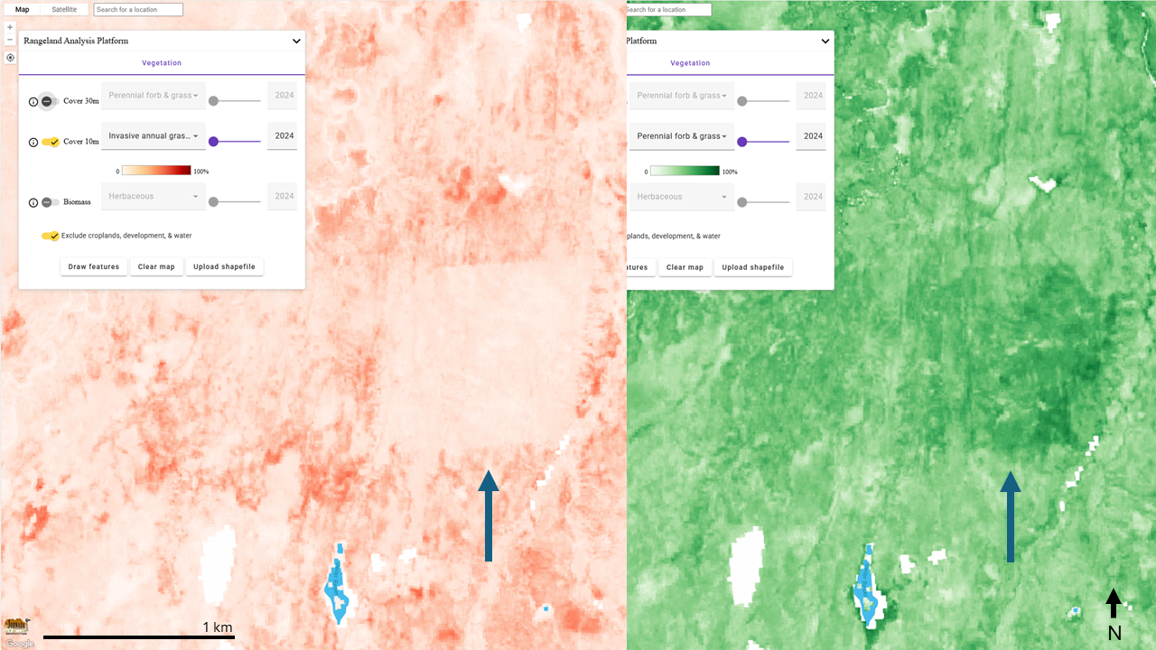
Caption for Graphic or Image: In these screen captures from the Rangeland Analysis Platform (RAP), you can see the effect of a Rejuvra (Indaziflam) herbicide treatment on the estimated % cover of invasive annual grass (left) and subsequent response in estimated % cover of perennial vegetation (right). Treated area is approximately 200 acres and was treated the year prior. The new 10m Sentinel imagery-based RAP product is shown.
Author name: Bill Sparklin
Author business email: William_Sparklin@fws.gov

DOI agency/bureau: FWS
USGS Mission Area:
USGS Program:
Cost Center:
Program Name: Division of Migratory Bird Management
Project title: AI for Offshore Energy: Innovative Technology Streamlines Marine Wildlife Surveys
Project description: The Gulf of America and Atlantic contain abundant untapped energy and mineral resources, and responsible development requires knowledge of marine wildlife populations. The U.S. Geological Survey (USGS), Bureau of Ocean Energy Management (BOEM), U.S. Fish and Wildlife Service (USFWS), universities, and private industry are collaborating on innovative artificial intelligence (AI) tools and workflows, combined with remotely sensed imagery, to improve the safety and efficiency of aerial wildlife surveys in marine environments. This project will dramatically improve the efficiency of marine wildlife surveys—reducing the analysis timeline from years to days—so that accurate information on the distribution, abundance, and seasonality of seabirds, whales, and sea turtles can be rapidly delivered to decision makers and stakeholders. This information directly supports BOEM's statutory responsibilities under Section 18 of the Outer Continental Shelf Lands Act for balanced leasing program development and Section 20's requirements for comprehensive environmental studies and impact assessment, and USFWS’s statutory obligations under the Migratory Bird Treaty Act to sustainably manage hunting of certain species. Our partnership is working with private industry to engineer advanced aerial camera systems and onboard processing capabilities for automated detection of marine wildlife. These systems have been designed to address unique challenges and extreme data volumes associated with high-resolution (sub-cm) remote sensing surveys over large geographic regions. To date, nearly 6 million images have been collected in the Atlantic and Gulf of America. We are also leveraging cost-effective commercial applications and custom in-house code for cloud-based hosting of remote sensing imagery and assembling labeled training datasets. Working with New Jersey Audubon, we have compiled a dataset with almost 30K images and 160K labeled objects. We have also customized the open-source Ultralytics YOLO architecture to train AI models capable of detecting and identifying birds, mammals, reptiles, and fish to the family taxonomic level (Figure 1). We are actively working to refine classification at lower taxonomic levels, including species. Through interagency collaboration, we have established the foundation for an automated workflow to expedite the delivery of environmental information required for oil, gas, and marine minerals leasing and waterfowl harvest management decisions under federal law. The AI-based workflows we have developed and trained on Atlantic and Gulf of America imagery will be deployable across the entire Outer Continental Shelf and will be open and transparent, enabling other agencies and the private sector to replicate and adapt the process.

For more information on this project: https://www.usgs.gov/centers/upper-midwest-environmental-sciences-center/science/deep-learning-automated-detection-and

Desciption Link Overflow:
Sensor Type: Camera
Platform type: Airplane
URL:
Graphic or Image Upload: https://doimspp.sharepoint.com/sites/GS-EROSSCIENCESWI/Shared Documents/Communications Outreach/Documentation Science/DOI Remote Sensing Report/DOI RS Activities Report, 2025/Question/seabirds1_Bradley Pickens.png
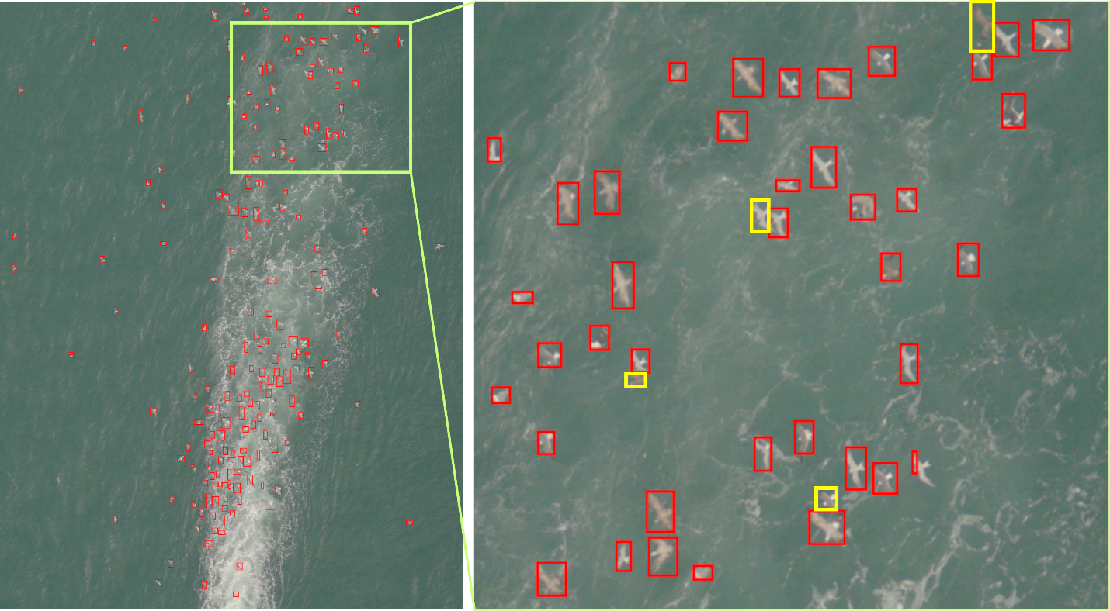
Caption for Graphic or Image: Figure 1. Detections of birds following in the wake of a ship are shown in red boxes. The AI model can process images like this, with large numbers of wildlife, much faster than a human reviewer. The current model still misses some birds (yellow boxes), typically when they are close to another bird or in an unexpected orientation. We are using active learning with human review to verify outputs, make corrections, and retrain models to improve performance.
Author name: Bradley Pickens
Author business email: bradley_pickens@fws.gov

DOI agency/bureau: FWS
USGS Mission Area:
USGS Program:
Cost Center:
Program Name: Southwest Region Inventory and Monitoring program, USFWS Division of Migratory Bird Management
Project title: AI-Powered Wildlife Monitoring on National Wildlife Refuges
Project description: The U.S. Fish and Wildlife Service (USFWS) Southwest Region Inventory and Monitoring program, USFWS Division of Migratory Bird Management, and the University of New Mexico Center for the Advancement of Spatial Informatics Research and Education are improving migratory bird surveys by combining aerial imagery and artificial intelligence to automate data collection with the goal of estimating population sizes of waterfowl and whooping cranes. These advanced technologies reduce survey costs, lessen wildlife disturbance, and improve count accuracy while increasing aircrew safety. In January 2025, we used a Daher Kodiak 100 airplane mounted with a 7-camera array to produce ~450,000 digital aerial images from Aransas, McFaddin, and Jocelyn Nungaray National Wildlife Refuges in coastal Texas (~1 cm spatial resolution). For whooping crane, the team used GPS telemetry and a concurrent low-level crewed airborne survey to manually identify birds in aerial imagery. This information supplied data to train and test deep learning detection and classification models. Upon completion of the initial classification model, we doubled the amount of training and testing images available. With this enhanced dataset, we developed a refined deep learning ‘YOLO’ (You Only Look Once) object detection model and then improved upon the initial classification model. Overall, the deep learning models quickly detect and identify whooping cranes in images, poised to be applied in future whooping crane surveys. We are using similar approaches to identify and count waterfowl species and various bird guilds, expanding on prior work piloting monitoring waterfowl using drones at Bosque del Apache National Wildlife Refuge and along both the Atlantic and Texas coasts. These emerging remote sensing and artificial intelligence technologies have the potential to improve survey efficiency and safety, while increasing the validation and reproducibility of survey results, leading to higher-quality data for population modeling, better-informed management decisions, and more effective species recovery efforts. The precise spatial information provided by these approaches also enables population data to be readily integrated with other geospatial data, increasing its utility in applications such as habitat management and conservation planning. The methods and workflows developed are scalable to regional or continental population monitoring for informing harvest and other population-level management decisions. Ongoing advances in computing and software will make these methods faster, more affordable and impactful.
Desciption Link Overflow:
Sensor Type: Camera
Platform type: Airplane
URL:
Graphic or Image Upload: https://doimspp.sharepoint.com/sites/GS-EROSSCIENCESWI/Shared Documents/Communications Outreach/Documentation Science/DOI Remote Sensing Report/DOI RS Activities Report, 2025/Question/whcr photo doi remote sensing_Bradley Pickens.png
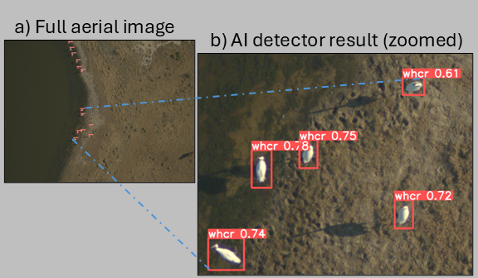
Caption for Graphic or Image: Figure 1. An example image showing the detection of whooping crane at Aransas National Wildlife Refuge in Texas, USA. The full aerial image (a) is approximately 64 m (width) x 48 m (height). Each box shows where an AI (artificial intelligence) model detected a whooping crane (“whcr”). The number represents the relative probability (e.g., 76%) that the box detected each bird.
Author name: Grant Harris
Author business email: Grant_Harris@fws.gov

DOI agency/bureau: FWS
USGS Mission Area:
USGS Program:
Cost Center:
Program Name: Division of Migratory Bird Management
Project title: Implementation of Artificial Intelligence to Estimate Population Size of a Migratory Bird from Aerial Thermal Imagery
Project description: The U.S. Fish and Wildlife Service (USFWS) Division of Migratory Bird Management is working to improve monitoring of the heavily hunted Mid-Continent Population of sandhill crane (Antigone canadensis) by utilizing aerial thermal imagery combined with artificial intelligence to automate crane counts. The goal is to improve the accuracy of population estimates that inform harvest management, while reducing risk to air crews by allowing aerial surveys to occur at higher altitudes. While a low-level population survey has historically been conducted to estimate population size, there are concerns about possible biases related to shifts in crane foraging distributions. Use of thermal imaging at night, while the cranes are aggregated on roost sites, may help reduce possible biases related to shifting diurnal distributions. In 2025 we collaborated with the U.S. Geological Survey Northern Prairie Wildlife Research Center, the Crane Trust, and the International Crane Foundation to conduct the second thermal survey for this population. A primary objective of the second year of this study was to test the AI model, previously trained on 2023 data, to determine how well it would perform on a new year of data. Although AI model generality is important for cost efficiency of remote sensing methods, the issue has been under-emphasized in previous research. The first complete thermal survey conducted in 2023. A YOLO (‘You Only Look Once’) model was used to detect and count sandhill cranes. During the 2025 survey, air temperatures during the thermal acquisition were substantially warmer than during the 2023 survey, which initially affected the performance of the model trained on earlier data. Encouragingly, minimal effort was necessary to label 2025 imagery to retrain the model to achieve the needed improvement. Another advantage of the imagery-based counts over the traditional survey is detailed spatial record of crane location roosting locations which is valuable to managers working to improve habitat for this species. Overall, this study demonstrates that at least in some circumstances remote sensing and AI methods can be implemented and replicated at a broad spatial scale and over multiple years.

Desciption Link Overflow:
Sensor Type: Thermal
Platform type: Airplane
URL: https://www.fws.gov/story/using-cutting-edge-technology-monitor-sandhill-cranes
Graphic or Image Upload: https://doimspp.sharepoint.com/sites/GS-EROSSCIENCESWI/Shared Documents/Communications Outreach/Documentation Science/DOI Remote Sensing Report/DOI RS Activities Report, 2025/Question/SACR_flocks_Bradley Pickens.png
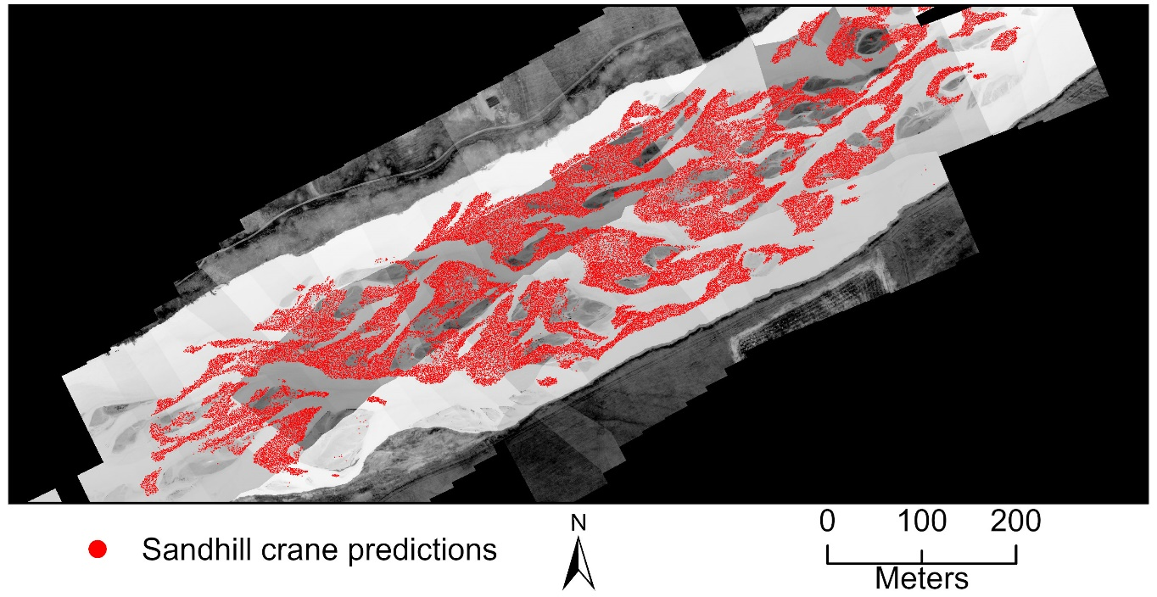
Caption for Graphic or Image: Figure 1. An example mosaic of thermal images showing sandhill crane on the Platte River of Nebraska, USA with sandhill crane predictions indicated by red circles.
Author name: Bradley Pickens
Author business email: bradley_pickens@fws.gov

DOI agency/bureau: FWS
USGS Mission Area:
USGS Program:
Cost Center:
Program Name: US Fish & Wildlife Service Dam Safety Program
Project title: Flood Warning & Monitoring for US FWS High Hazard Dams
Project description: In Fiscal Year 2025, the U.S. Fish and Wildlife Service Dam Safety Program advanced its monitoring capabilities by implementing automatic real-time remote sensing instrumentation at 40 percent of the Service’s high hazard potential dams. These systems provide critical management and flood warning data by measuring piezometric pressures, reservoir water levels, and foundation drain flows. Piezometric readings reveal how water moves through a dam or its foundation, while reservoir and drain measurements help identify abnormal changes that may signal safety concerns.

The program employs vibrating wire piezometers, radar water level sensors, and bubbler gages. Vibrating wire devices detect pore pressure through changes in the resonant frequency of a tensioned wire responding to water pressure. Radar sensors measure reservoir elevations, and bubbler gages track weir flows. All data is transmitted via satellite to NOAA’s Hydrometeorological Automated Data System (HADS), ensuring highly accurate and consistent records.

Previously, staff collected readings manually through site visits, a process limited by weather, access, and time. These visits provided only periodic snapshots of conditions and required significant staff effort. By contrast, the new remote systems deliver continuous, automated readings that are instantly transmitted to databases. This reduces field exposure, improves efficiency, and provides dam safety engineers with higher-frequency, real-time data for analysis.

The advantages extend well beyond convenience. Continuous monitoring allows abnormal changes, such as those caused by seepage or extreme hydrological events, to be detected early. Early detection supports faster response, lowers the risk of dam failure, and enhances public safety. Long-term data trends will also deepen understanding of seasonal and hydrological patterns affecting each structure, strengthening future risk assessments.

Data handling is streamlined as well. Automated systems eliminate paper logs and manual transfers, providing organized digital records ready for analysis and reporting. This not only enhances operational efficiency but also ensures consistent, reliable documentation of dam conditions.

By combining proven sensor technology with modern satellite transmission, the USFWS Dam Safety Program has taken a significant step forward in managing high hazard potential dams. Automatic remote monitoring improves safety, efficiency, and decision-making while protecting both the environment and downstream communities.

Desciption Link Overflow:
Sensor Type: IFSAR / SAR / Radar
Platform type: Satellite;Ground based / sensor web / web cam
URL:
Graphic or Image Upload: https://doimspp.sharepoint.com/sites/GS-EROSSCIENCESWI/Shared Documents/Communications Outreach/Documentation Science/DOI Remote Sensing Report/DOI RS Activities Report, 2025/Question/DK Remote Sensing_Constantine Pappas.jpg
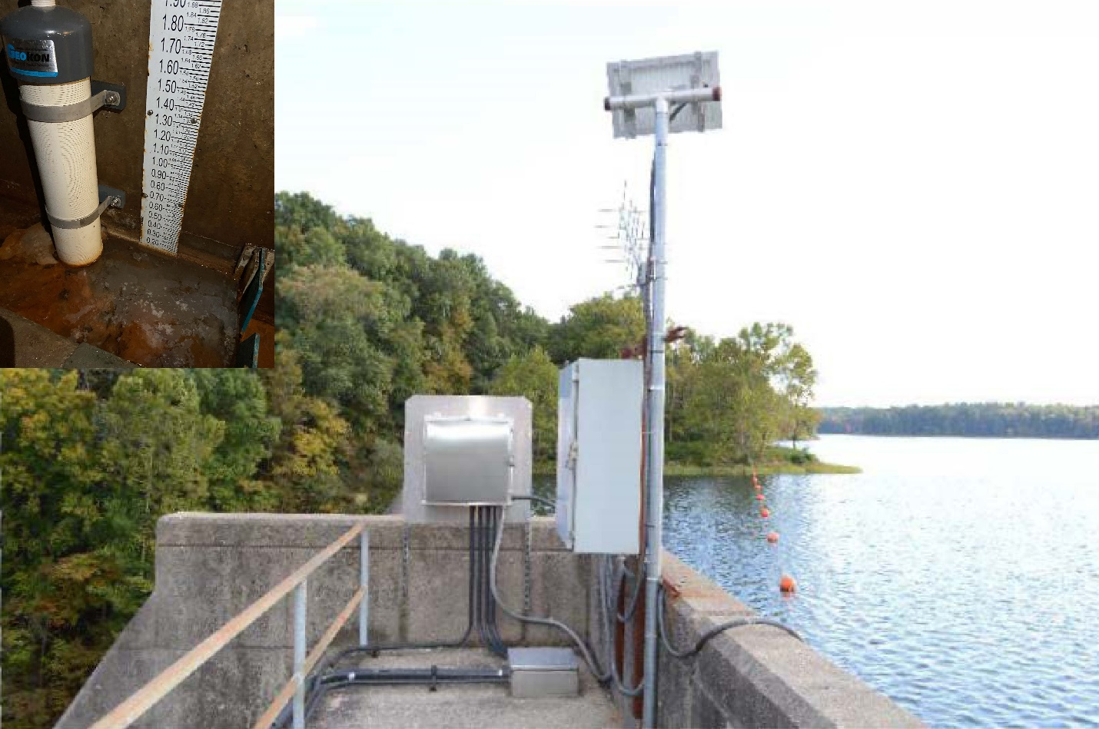
Caption for Graphic or Image: Main photo consists of Devil's Kitchen Dam's reservoir level radar indicator; smaller photo in upper left corner is the bubbler system located in the dam's concrete gallery.
Author name: Constantine Pappas and David Hibbs
Author business email: constantine_pappas@fws.gov

DOI agency/bureau: FWS
USGS Mission Area:
USGS Program:
Cost Center:
Program Name: Habitat and Population Evaluation Team
Project title: Landscape-scale predictions of future grassland conversion to cropland or development
Project description: US Fish and Wildlife Service Habitat and Population Evaluation Team are advancing grassland conservation by using remote sensing and machine learning to predict where grasslands are most at risk of being converted to cropland or development. Many existing conservation models lack multidimensional risk assessments and are misaligned with the scales of conservation delivery. To address this, we developed new landscape-scale models that assess risk across 20 ecoregions in the contiguous United States.

Using satellite-derived data and other geospatial information, we analyzed patterns of grassland conversion from 2011 to 2021. We then applied random forest regression—a type of machine learning—to forecast future loss from 2021 to 2031. These models incorporate a wide range of factors, including proximity to cities, ethanol plants, and large-scale livestock operations, as well as the amount of cropland and grassland in the surrounding area.

Our results show that grasslands are most vulnerable in areas with moderate levels of existing development and agriculture. In some regions, grasslands enrolled in the Conservation Reserve Program were more likely to be converted, highlighting the need for targeted conservation strategies.

The models performed well across all regions and offer a flexible tool for conservation planners. By identifying areas with the highest risk of grassland loss, these models help prioritize where to invest in protection efforts. This work supports national conservation goals and can be adapted globally to guide land management decisions.

Desciption Link Overflow:
Sensor Type: Multispectral (approx. 4-12 bands)
Platform type: Satellite
URL: https://conbio.onlinelibrary.wiley.com/doi/epdf/10.1111/cobi.14346
Graphic or Image Upload: https://doimspp.sharepoint.com/sites/GS-EROSSCIENCESWI/Shared Documents/Communications Outreach/Documentation Science/DOI Remote Sensing Report/DOI RS Activities Report, 2025/Question/TotalPropGrassLossFigure_Kevin Barnes.jpg
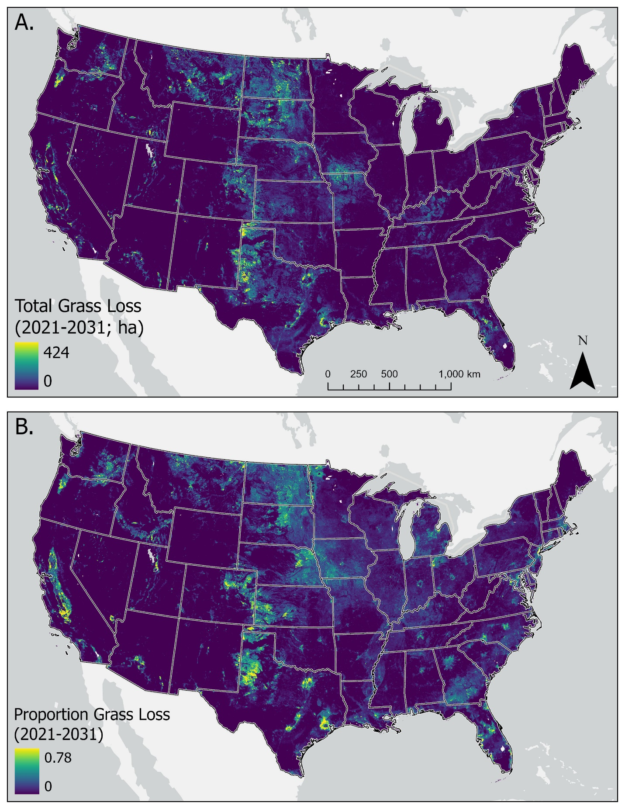
Caption for Graphic or Image: Landscape-scale (3.6 × 3.6 km) estimates of (A, B) predicted total and proportional grass loss (2021–2031) to cropland or development across the contiguous US.
Author name: Kevin W. Barnes
Author business email: kevin_barnes@fws.gov

DOI agency/bureau: FWS
USGS Mission Area:
USGS Program:
Cost Center:
Program Name: Habitat and Population Evaluation Team
Project title: Spatial predictions of potentially undisturbed grassland across the conterminous US
Project description: The US Fish and Wildlife Service Habitat and Population Evaluation Team are using remote sensing and geospatial analysis to help identify grasslands that have remained undisturbed by agriculture across the contiguous United States. These lands, which have never been tilled, are especially valuable for conservation because they support native species, biodiversity, and essential ecosystem services.

To locate these areas, we combined historical land use data with satellite imagery and environmental variables. Using USDA datasets that track cropping history back to the 1950s, we mapped lands likely to be undisturbed. We then applied machine learning techniques to classify land cover types, using inputs from Sentinel-2 satellite data along with topographic, soil, and climate information.

Our models performed strongly, with high accuracy across different regions and land cover types. We estimate that approximately 1.2 million square kilometers of potentially undisturbed grassland remain, mostly concentrated in the western Great Plains.

This work provides a critical foundation for conservation planning and monitoring. By identifying where intact grasslands still exist, we can better target protection efforts and track future changes. The approach is scalable and could be applied globally using similar remote sensing datasets.

Desciption Link Overflow:
Sensor Type: Multispectral (approx. 4-12 bands)
Platform type: Satellite
URL: https://link.springer.com/article/10.1007/s10980-025-02187-w
Graphic or Image Upload: https://doimspp.sharepoint.com/sites/GS-EROSSCIENCESWI/Shared Documents/Communications Outreach/Documentation Science/DOI Remote Sensing Report/DOI RS Activities Report, 2025/Question/PUDL_Grs2_Kevin Barnes.png
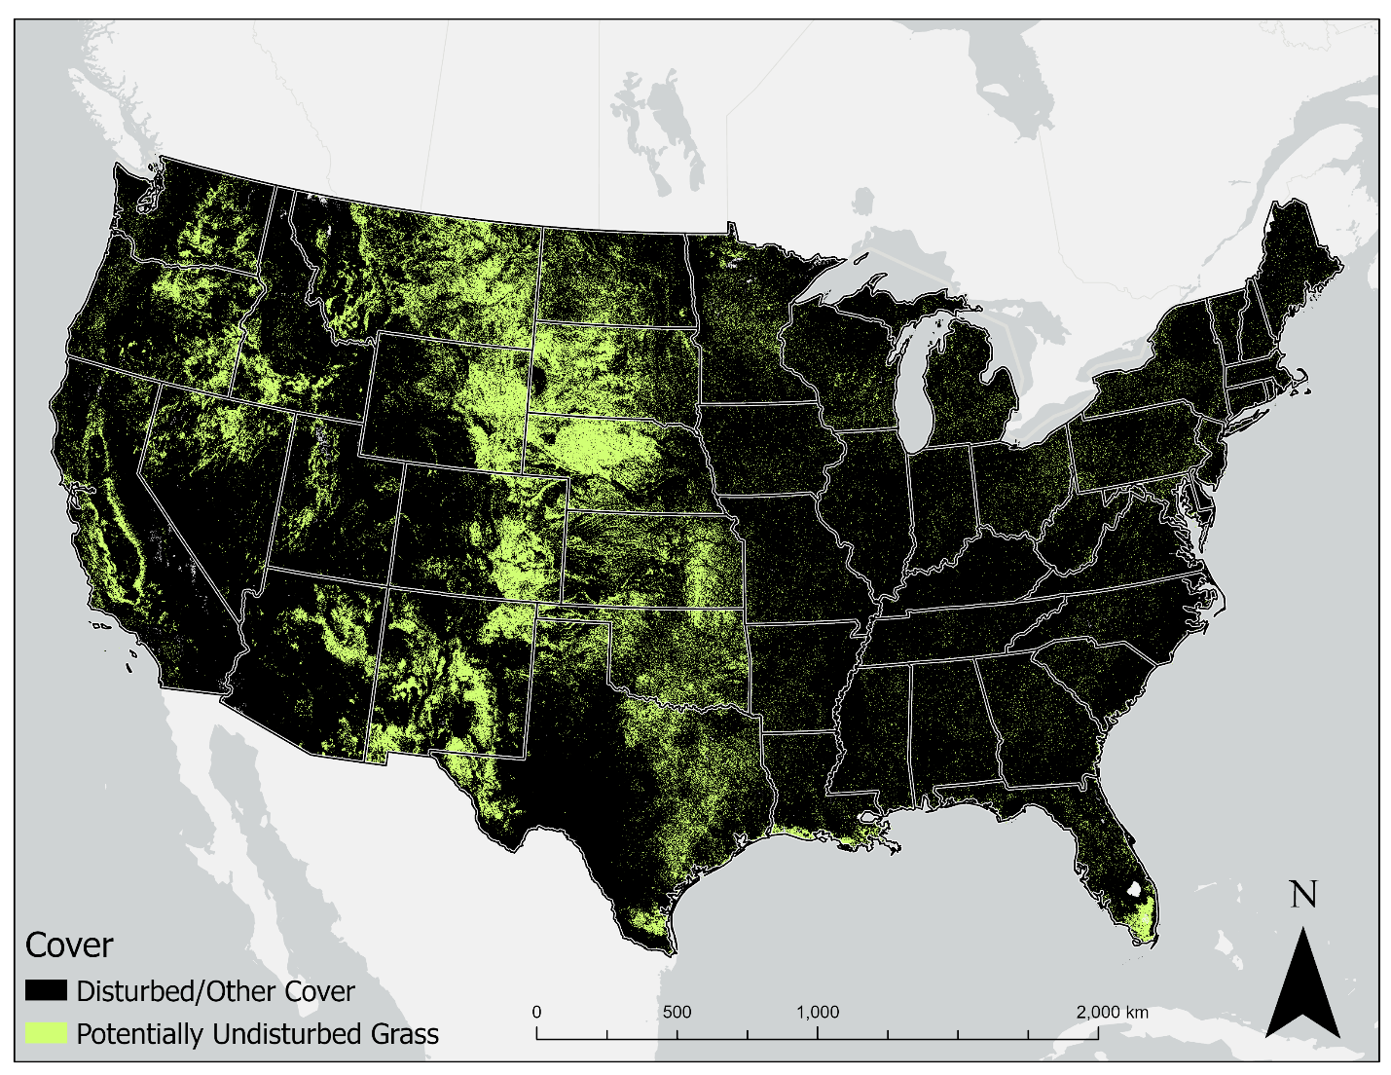
Caption for Graphic or Image: Potentially undisturbed grass cover (i.e. never tilled) predictions across the contiguous US.
Author name: Kevin W. Barnes
Author business email: kevin_barnes@fws.gov

DOI agency/bureau: FWS
USGS Mission Area:
USGS Program:
Cost Center:
Program Name: Habitat and Population Evaluation Team
Project title: Landscape suitability and range expansion estimates for the North American Interior Population of trumpeter swans
Project description: Trumpeter swans are making a remarkable comeback. Since reintroduction efforts began in the 1980s, the Interior Population has grown steadily, and we now expect continued expansion into new areas like the Prairie Pothole Region. To help wildlife managers prepare, the US Fish and Wildlife Service Habitat and Population Evaluation Team developed models that predict where swans are likely to breed and expand their range between 2023 and 2033.

Using GPS collar data from swans in the western Great Lakes region, we analyzed where swans are currently found and what types of landscapes they prefer by relating occurrence to upland and wetland features derived from Sentinel-2 remote sensing data. The model identified wetland-rich landscapes with good foraging habitat. Combining this information with timeseries citizen-science observations we were able to estimate future range expansion. Our models show that swans are most likely to move into areas with suitable wetlands and nearby existing populations, and that expansion is happening at an estimated rate of 4.4% per year.

This work helps identify priority areas for habitat protection and public outreach. For example, North Dakota and South Dakota allow hunting of tundra swans but not trumpeter swans, which look very similar. Our findings highlight the need for targeted hunter education to avoid accidental take and support the long-term success of trumpeter swan populations.

By using remote sensing and geospatial modeling, we’re helping agencies anticipate change and plan proactively for conservation in FY2025 and beyond.

Desciption Link Overflow:
Sensor Type: Multispectral (approx. 4-12 bands)
Platform type: Satellite
URL: https://wildlife.onlinelibrary.wiley.com/doi/full/10.1002/jwmg.70077
Graphic or Image Upload: https://doimspp.sharepoint.com/sites/GS-EROSSCIENCESWI/Shared Documents/Communications Outreach/Documentation Science/DOI Remote Sensing Report/DOI RS Activities Report, 2025/Question/LocalRegionalScalePlanning_Kevin Barnes.jpg
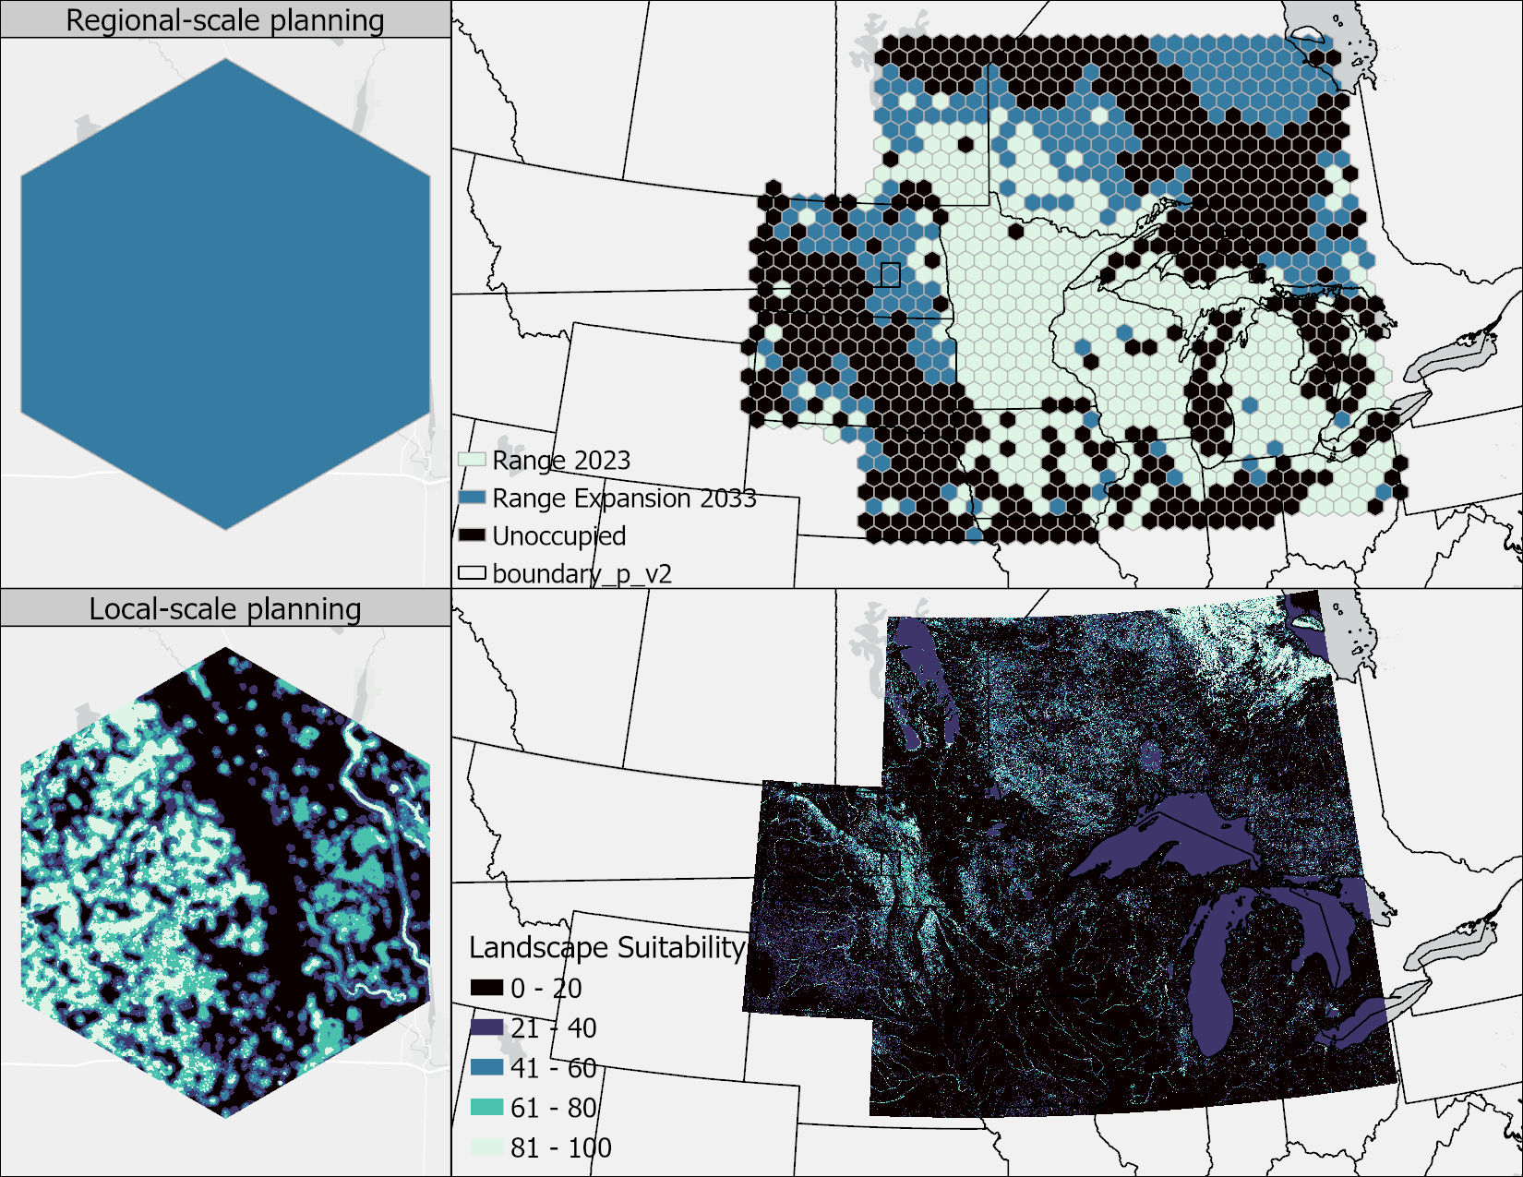
Caption for Graphic or Image: Trumpeter swan landscape suitability and range expansion models that can be used for regional and local scale conservation efforts in the western Great Lakes Region.
Author name: Kevin W. Barnes
Author business email: kevin_barnes@fws.gov

