**DOI agency/bureau:** BSEE

**USGS Mission Area:**

**USGS Program:**

**Cost Center:**

**Program Name:** Oil Spill Preparedness Division

**Project title:** Algorithm Development for Multispectral Sensor-Based Oil Spill Response

**Project description:** Uncrewed Aerial Vehicles (UAVs) have become essential assets in oil spill response operations. They are employed for real-time monitoring and detection of oil spills, guiding tactical deployment of containment or dispersant strategies, and conducting detailed mapping throughout the response effort. The oil spill response community has leveraged UAV technology in numerous research initiatives focused on spill detection and mapping. Depending on operational requirements, UAVs can be equipped with a range of sensors, including visual, thermal, and multispectral imaging systems.

The objective of this project is to develop a new automated algorithm optimized for the MicaSense Altum-PT, a recently acquired multispectral sensor by BSEE and the U.S. Coast Guard Research and Development Center (RDC). The Altum-PT represents a significant advancement over previously used sensors, as it integrates multispectral, visual, and thermal imaging capabilities into a single system. This integration enables simultaneous data collection across all modalities over the same geographic area, improving spatial alignment, reducing processing time, and enhancing overall accuracy. Additionally, the Altum-PT offers substantially higher resolution, allowing for more detailed detection and characterization of oil features. The Ohmsett experiment will serve as a testbed for evaluating the performance of the Python-based algorithm and software application in conducting near real-time mapping of floating oil using this advanced sensor.

(Disclaimer: Any use of trade, firm, or product names is for descriptive purposes only and does not imply endorsement by the U.S. Government.)

**Desciption Link Overflow:**

**Sensor Type:** Multispectral (approx. 4-12 bands);Thermal;Camera

**Platform type:** UAS

URL:

**Graphic or Image Upload:** https://doimspp.sharepoint.com/sites/GS-EROSSCIENCESWI/Shared Documents/Communications Outreach/Documentation Science/DOI Remote Sensing Report/DOI RS Activities Report, 2025/Question/IMG_0005_Jay Cho.PNG

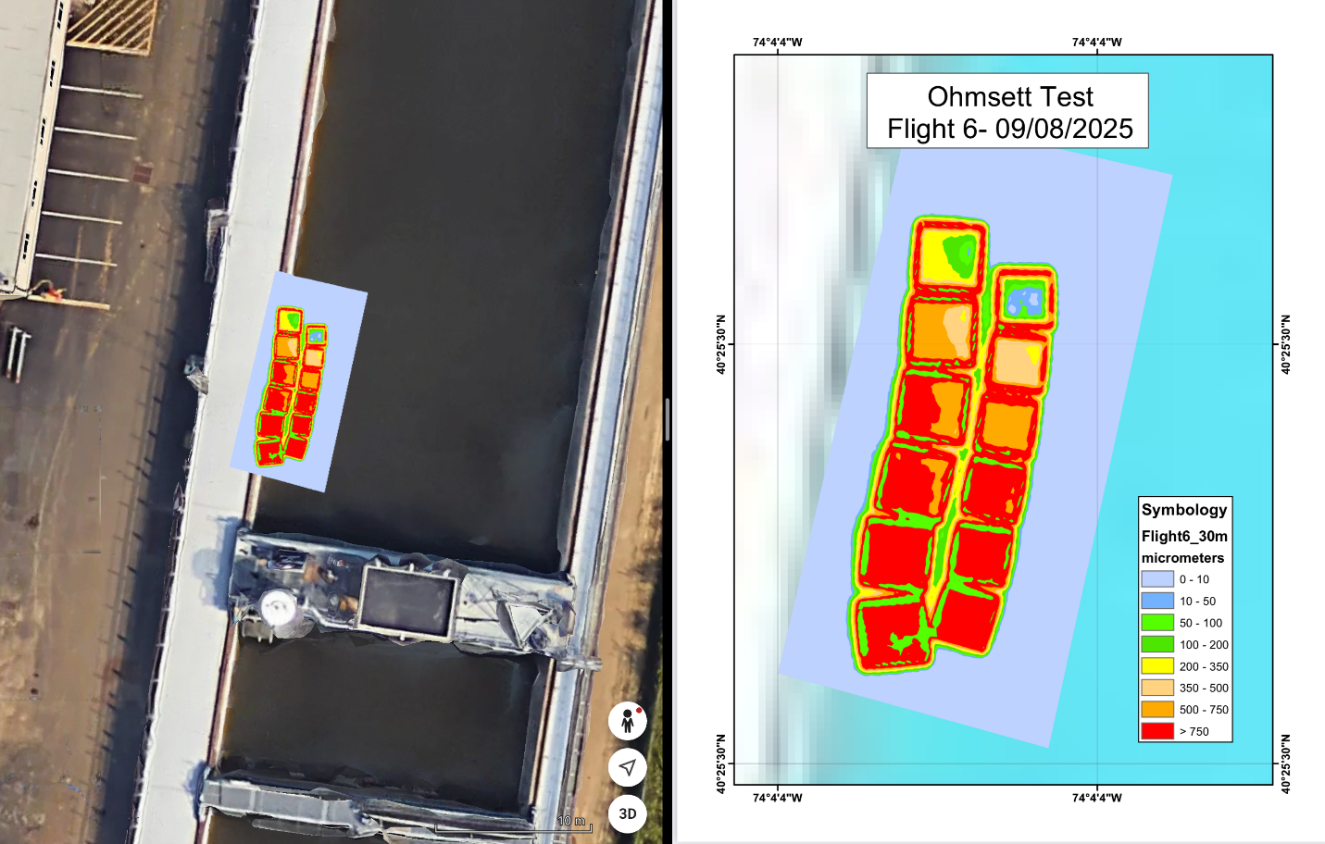

**Caption for Graphic or Image:** Multispectral imagery depicting crude oil layers of varying thickness at Ohmsett tank.

(Disclaimer: Any use of trade, firm, or product names is for descriptive purposes only and does not imply endorsement by the U.S. Government.)

**Author name:** Jay Cho

**Author business email:** jay.cho@bsee.gov