**DOI agency/bureau:** BOR

**USGS Mission Area:**

**USGS Program:**

**Cost Center:**

**Program Name:** Technical Service Center

**Project title:** Santa Ana River Watershed-Wide Water Budget Image Analysis Classification Methods Using Deep Learning

**Project description:** The Bureau of Reclamation (Reclamation) in conjunction with the Santa Ana Watershed Project Authority (SAWPA) are conducting an ongoing pilot study to support the development of water budgets at the customer and water retailer level using land cover datasets derived from high resolution aerial imagery. This Water Management Option Pilot (WMOP) is funded under the WaterSMART Basin Study Program and is a key element of the larger Santa Ana Watershed Basin Study designed to create efficient customer level water budgets for retail water agencies. The State of California provided water retailers and managers with a land cover dataset derived from lower-resolution imagery (12-inch spatial resolution) as part of the California Department of Water Resources (CADWR) Irrigated Landscape Area Measurement Project. The Landscape Area Measurements (LAM) Project is a state-wide remote sensing and machine learning project designed to estimate areas of land cover and land use across urban residential spaces of California.

The LAM Project was implemented because of the 2018 Assembly Bill (AB) 1668 and the 2018 Senate Bill (SB) 606. With the goal of water conservation and drought planning after the 2012–2016 droughts in California, AB 1668 and SB 606 became effective under Governor Brown’s Executive Order B-37-16. Assembly Bill 1668 directs the CADWR, in coordination with the California State Water Resources Control Board, to develop new water use efficiency standards and guidelines for urban retail water suppliers.

The intent of this study is to provide additional, higher-resolution land cover data derived from, (3-inch spatial resolution) imagery data.

Aerial images often have very high spatial resolution, providing higher levels of detail of the Earth’s surface—including the shape, structure, size, texture of ground features, and even topology and thematic information among features. The study area includes two Southern California watersheds: the Orange County (Lower Santa Ana River Watershed) and the Western Riverside and San Bernardino Counties (Upper Santa Ana River Watershed). These data will be used to create efficient outdoor water budgets for individual customers based upon the California State Water Efficient Landscape ordinance formula from AB 1881 for calculating Maximum Applied Water. Semantic segmentation deep learning models were deployed to classify aerial imagery covering the study area ensuring consistent classification across the watersheds.

**Desciption Link Overflow:**

**Sensor Type:** Camera

**Platform type:** Airplane

URL:

**Graphic or Image Upload:** https://doimspp.sharepoint.com/sites/GS-EROSSCIENCESWI/Shared Documents/Communications Outreach/Documentation Science/DOI Remote Sensing Report/DOI RS Activities Report, 2025/Question/SAWPA Image Analysis Classification Methods_Jonathan Pomeroy.jpeg

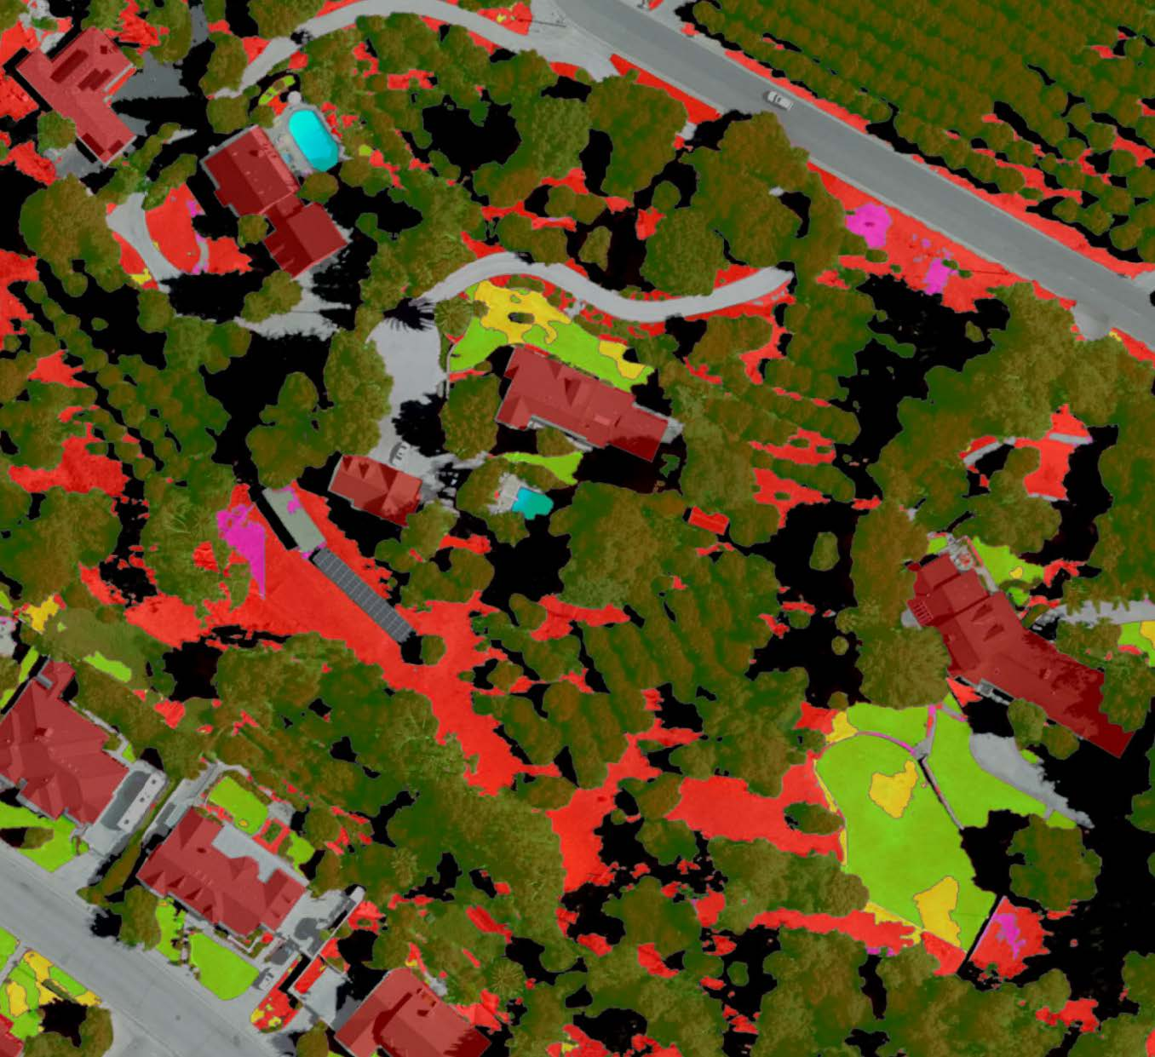

**Caption for Graphic or Image:** An image of the GeoAi classification from the Upper Santa Ana River Watershed

**Author name:** Jonathan Pomeroy

**Author business email:** jpomeroy@usbr.gov

**DOI agency/bureau:** BOR

**USGS Mission Area:**

**USGS Program:**

**Cost Center:**

**Program Name:** Bureau of Reclamation's Science and Technology Program

**Project title:** Resolving Spatiotemporal Distribution of Suspended Sediment Concentration over the Columbia and Snake River Using Remote Sensing

**Project description:** Ground measurements of suspended sediment concentrations are expensive, and lack the temporal and spatial resolution and coverage required for informed water-related decisions. This project leveraged cloud computing with Google Earth Engine and Harmonized satellite imagery from Landsat and Sentinel 2 satellites to develop a remote sensing-based model for monitoring of suspended sediment concentrations over all water bodies in the Pacific Northwest between 1984-present. The underlying Random Forest model uses reflectance in VIS, NIR and SWIR bands to estimate suspended sediment concentrations, and achieves a coefficient of determination of 0.76 over the test data. Findings implied that limits-of-predictability might have been reached with the available data, i.e., more complex models may not markedly improve the modeling accuracy. This is attributed to several factors, including (1) the temporal lag/lead between satellite and ground observation used for training might implicate model performance, (2) preprocessing algorithms for satellite imagery might implicate water reflectance, (3) spectral mixing and bed reflectance might implicate water reflectance. Future projects may focus on synchronized ground observations at the time of satellite overpass, or fusion of coordinated airborne, ground, and satellite observations.

**Desciption Link Overflow:**

**Sensor Type:** Multispectral (approx. 4-12 bands)

**Platform type:** Satellite

URL: https://water-delineation.users.earthengine.app/view/north-western-us-suspended-sediment-concentration

**Graphic or Image Upload:** https://doimspp.sharepoint.com/sites/GS-EROSSCIENCESWI/Shared Documents/Communications Outreach/Documentation Science/DOI Remote Sensing Report/DOI RS Activities Report, 2025/Question/Picture1_Michael Poulos.png

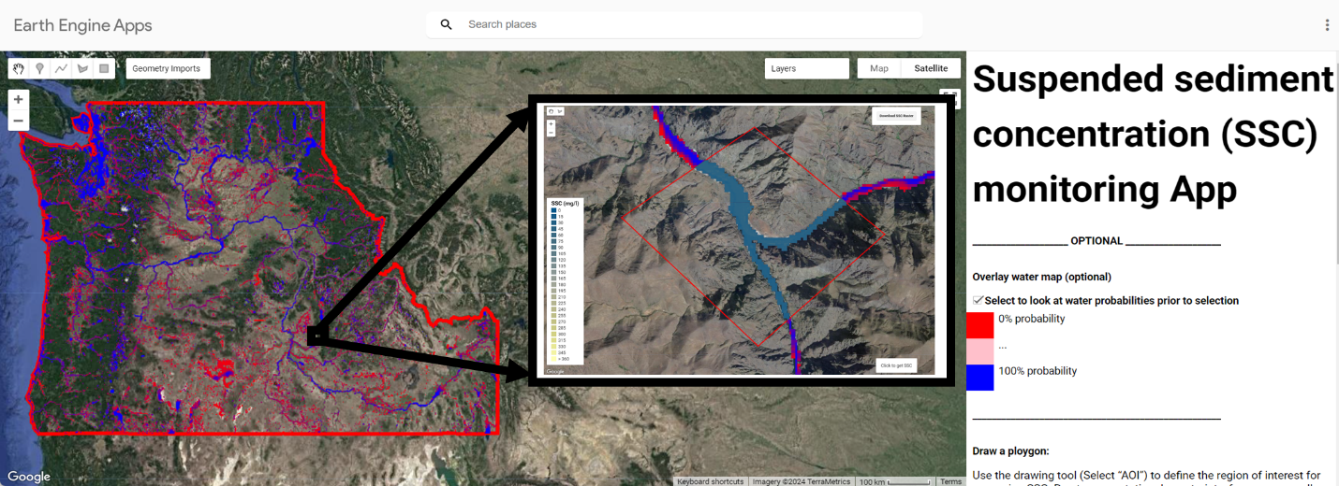

**Caption for Graphic or Image:** Figure 1. Suspended Sediment Concentration App Using Google Earth Engine and Landsat/Sentinel Imagery.

**Author name:** Michael Poulos

**Author business email:** mpoulos@usbr.gov

**DOI agency/bureau:** BOR

**USGS Mission Area:**

**USGS Program:**

**Cost Center:**

**Program Name:** Lower Colorado River Multi-Species Conservation Program (LCR MSCP)

**Project title:** Fusion of Satellite Imagery and Soil Moisture Data

**Project description:** The US Bureau of Reclamation’s Lower Colorado River Multi-Species Conservation Program (LCR MSCP) has developed a soil moisture network to support the creation and monitoring of landcover types which require irrigation throughout much of the year. Although these soil moisture data loggers provide continuous and accurate information, their use is limited due to cost and logistics. Imagery from satellites cover large areas, are of high quality and spatial resolution, and have numerous applications. However, these data are not always well suited to the areas of interest due to the reflectance characteristics of the landcover itself, primarily in areas of high, dense canopy. Physical Scientists at LCR MSCP therefore tested methods which integrate both data types to leverage the advantages of each in order to identify and model the spatial and temporal characteristics of irrigated water.

Two approaches incorporating satellite imagery were investigated: 1) the measurement of soil moisture via surface reflectance values and 2) the effect the presence of moisture has on the visual qualities of soil. In both methods, the in-situ soil moisture data was integrated with imagery in a stepwise regression algorithm. Sentinel-2 and Planet Labs imagery acquired before, during, and after irrigation events at specific sites were processed.

The resulting imagery products identified irrigation events, allowed the tracking of water as it progressed from the irrigation source, and, perhaps most importantly, showed areas of persistently moist and dry soils. These features will allow LCR MSCP managers to adjust irrigation strategies, resulting in more efficient and effective use of water resources. From an adaptive management standpoint, frequent, extensive, and high-resolution soil moisture data can help determine if irrigation is a significant variable when considering changes in vegetation health. By utilizing low cost and/ or free global imagery, the findings described here allow for analyses at multiple scales that is not feasible using existing ground-based data alone. Additionally, we are greatly encouraged by the prospect of forthcoming data from the recently launched NASA-ISRO Synthetic Aperture Radar (NISAR) mission. Finally, the methods described here can be adapted to other correlated onsite/imagery data combinations, thereby presenting opportunities to those looking to augment the capabilities of their programs.

**Desciption Link Overflow:**

**Sensor Type:** Multispectral (approx. 4-12 bands);Soil Moisture Data Logger

**Platform type:** Satellite;Ground based / sensor web / web cam

URL: https://www.lcrmscp.gov

**Graphic or Image Upload:** https://doimspp.sharepoint.com/sites/GS-EROSSCIENCESWI/Shared Documents/Communications Outreach/Documentation Science/DOI Remote Sensing Report/DOI RS Activities Report, 2025/Question/DATA_FUSION_David Gundlach.jpg

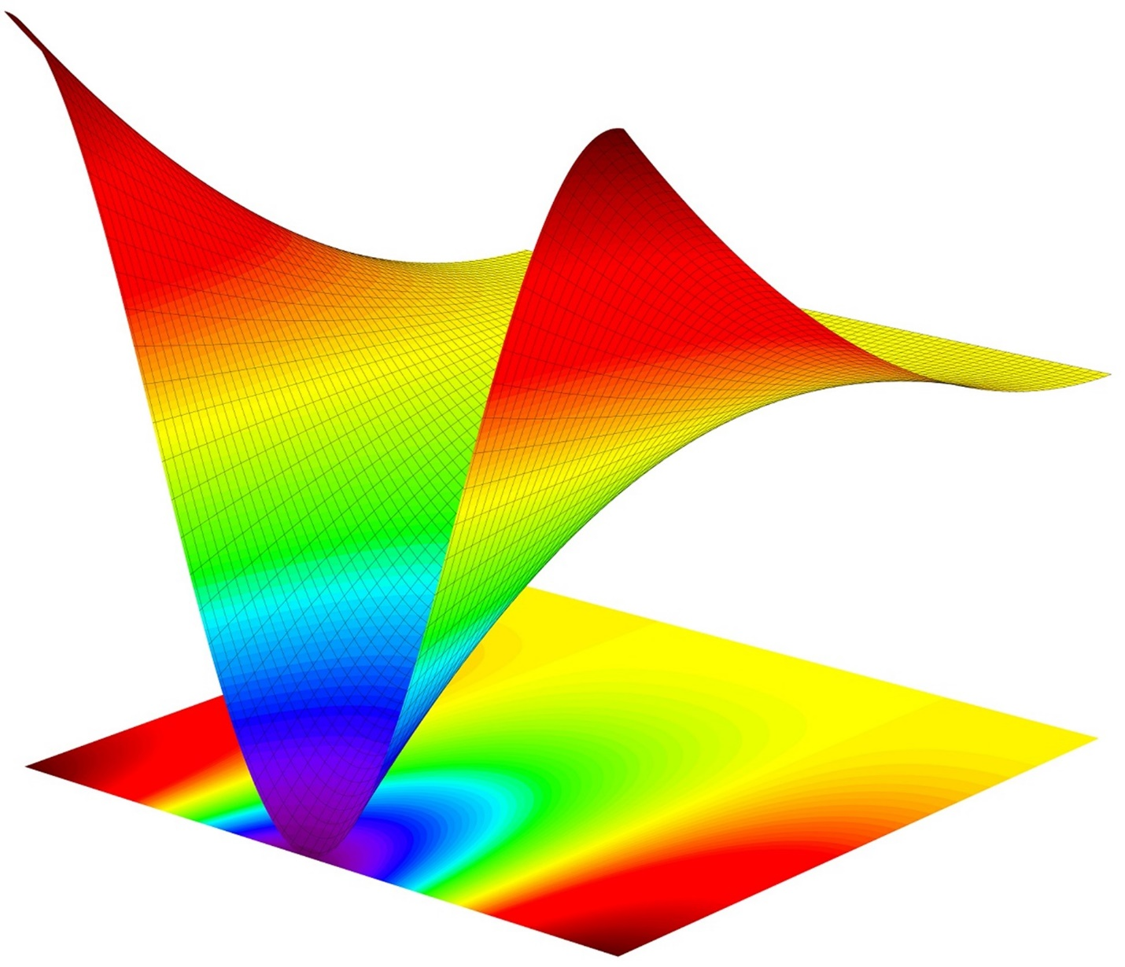

**Caption for Graphic or Image:** Graphical representation of the fusion of multiple data sources.

**Author name:** David Gundlach

**Author business email:** dgundlach@usbr.gov

**DOI agency/bureau:** BOR

**USGS Mission Area:**

**USGS Program:**

**Cost Center:**

**Program Name:** Reclamation S&T Facilitated Adoption

**Project title:** Reservoir Sedimentation Satellite Pilot Study

**Project description:** Reclamation owns 296 reservoirs. Over time, reservoirs lose water storage space due to sediment infilling. Bathymetric surveys to measure reservoir sediment volumes can be very expensive. We are using Google Earth Engine (GEE) to track reservoir surface area through time on satellite imagery. Because we measure daily water surface elevation, we can track surface area loss across a range of elevations through time.

**Desciption Link Overflow:**

**Sensor Type:** Multispectral (approx. 4-12 bands)

**Platform type:** Satellite

URL:

**Graphic or Image Upload:**

**Caption for Graphic or Image:**

**Author name:** Melissa Foster

**Author business email:** mfoster@usbr.gov