**DOI agency/bureau:** BOEM

**USGS Mission Area:**

**USGS Program:**

**Cost Center:**

**Program Name:** Office of Environmental Programs

**Project title:** BOEM/NASA Interagency Agreement "Offshore Air Quality from NASA’s Satellites and Related Experiments in the Gulf of America"

**Project description:** DOI’s Bureau of Ocean Energy Management (BOEM) has air quality regulatory authority on the Outer Continental Shelf (OCS) in the Western and parts of the Central Gulf of America and is required to analyze the air quality impacts from OCS oil and gas (ONG) activities as mandated by the Outer Continental Shelf Lands Act (OCSLA) and the National Environmental Policy Act (NEPA). BOEM needs to assess the impacts of emissions from BOEM-authorized activities and their contributions to onshore compliance with the National Ambient Air Quality Standards (NAAQS). The primary goal of this BOEM-NASA inter-agency agreement is to investigate the applicability of existing satellite datasets for offshore environments over the Gulf of America region, assess the satellite data with offshore monitoring measurements through field campaigns, and determine the potential application of satellite observations for NAAQS for criteria and other air pollutants.

Under the interagency agreement, BOEM and NASA conducted two Satellite Coastal and Oceanic Atmospheric Pollution Experiment (SCOAPE) field campaigns analyzing air quality observations over the Gulf of America using ground-, vessel-, and satellite-based measurement systems. The SCOAPE-I campaign, held in May 2019, analyzed the multi-platform data and a HYSPLIT back trajectory model to identify air quality events associated with oil and gas platforms and demonstrated usefulness of satellite observations for BOEM’s monitoring needs. The recent SCOAPE-II campaign extended the prior efforts with improved measurement capabilities and additional emphasis placed on assessing methane emissions from ONG activities. This project included a Gulf air quality cruise near ONG operations in June 2024 that in addition to ship in-situ measurements, involved airborne measurements of methane from 3rd generation Airborne Visible InfraRed Imaging Spectrometer (AVIRIS-3). A second aircraft-only campaign was held over the Gulf in October 2024 with Geostationary Coastal and Air Pollution Events Airborne Simulator (GCAS) remote sensing measurements of nitrogen dioxide (NO2) and other trace gases on the NASA B200 King Air. The analysis included complementary observations from Tropospheric Monitoring Instrument (TROPOMI) and NASA’s first geostationary air quality mission: Tropospheric Emissions Monitoring of Pollution (TEMPO), which has been collecting hourly daytime measurements of key air pollutants over North America since August 2023. Analysis of these observations suggests similar diurnal patterns and fair correlation between satellite and ground-based Pandora observations, but the high bias in current satellite products could be resolved with future algorithm updates.

**Desciption Link Overflow:**

**Sensor Type:** Hyperspectral

**Platform type:** Airplane;Satellite;Vessel

URL: https://www-air.larc.nasa.gov/missions/scoape/index.html

**Graphic or Image Upload:** https://doimspp.sharepoint.com/sites/GS-EROSSCIENCESWI/Shared Documents/Communications Outreach/Documentation Science/DOI Remote Sensing Report/DOI RS Activities Report, 2025/Question/DOI Remote Sensing Report Graphic_Holli Wecht.jpg

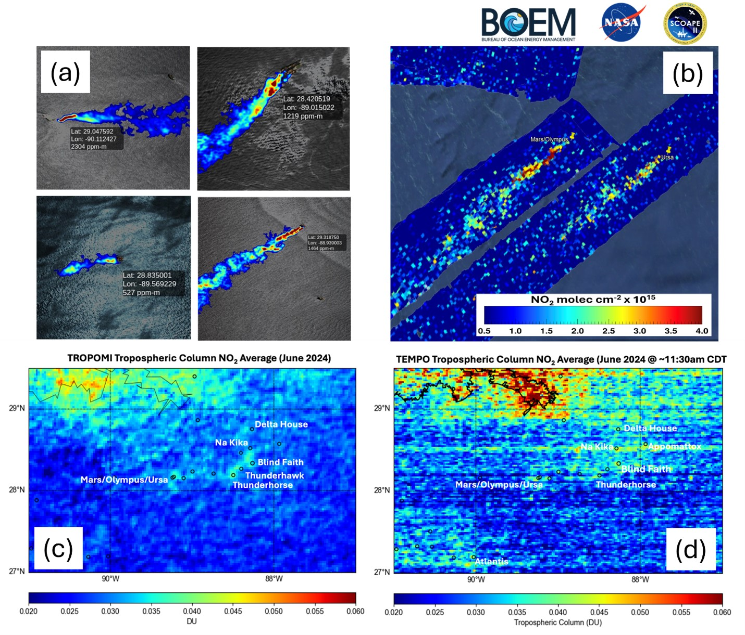

**Caption for Graphic or Image:** Caption for Graphics or Image: (a) Methane plumes from ONG facilities as observed by AVIRIS-3 during the SCOAPE-II campaign in June 2024. Geolocations and observed peak methane concentration estimates are noted. (b) GCAS differential slant column NO2 over Mars, Olympus, and Ursa platforms on October 11, 2024. (c) average tropospheric column NO2 from TROPOMI for June 2024 shows enhanced concentrations over polluted coastal areas and ONG facilities. (d) TEMPO-observed average tropospheric column NO2 around 11:30 am central daylight time (CDT) that corresponds to TROPOMI measurement time; mild striping artifact in the current TEMPO NO2 product will be corrected in future updates. The black circles in lower maps show the location of deep-water platforms and drill ship sites that were targeted during SCOAPE-II GCAS flights in October.

**Author name:** Holli Wecht

**Author business email:** Holli.Wecht@boem.gov

**DOI agency/bureau:** BOEM

**USGS Mission Area:**

**USGS Program:**

**Cost Center:**

**Program Name:** Environmental Studies Program

**Project title:** AI for Offshore Energy: Innovative Technology Streamlines Marine Wildlife Surveys

**Project description:** The Gulf of America and Atlantic contain abundant untapped energy and mineral resources, and responsible development requires knowledge of marine wildlife populations. The Bureau of Ocean Energy Management (BOEM), The U.S. Geological Survey (USGS), U.S. Fish and Wildlife Service (USFWS), universities, and private industry are collaborating on innovative artificial intelligence (AI) tools and workflows, combined with remotely sensed imagery, to improve the safety and efficiency of aerial wildlife surveys in marine environments.

This project will dramatically improve the efficiency of marine wildlife surveys—reducing the analysis timeline from years to days—so that accurate information on the distribution, abundance, and seasonality of seabirds, whales, and sea turtles can be rapidly delivered to decision makers and stakeholders. This information directly supports BOEM's statutory responsibilities under Section 18 of the Outer Continental Shelf Lands Act for balanced leasing program development and Section 20's requirements for comprehensive environmental studies and impact assessment, and USFWS’s statutory obligations under the Migratory Bird Treaty Act to sustainably manage hunting of certain species.

Our partnership is working with private industry to engineer advanced aerial camera systems and onboard processing capabilities for automated detection of marine wildlife. These systems have been designed to address unique challenges and extreme data volumes associated with high-resolution (sub-cm) remote sensing surveys over large geographic regions. To date, nearly 6 million images have been collected in the Atlantic and Gulf of America. We are also leveraging cost-effective commercial applications and custom in-house code for cloud-based hosting of remote sensing imagery and assembling labeled training datasets. Working with New Jersey Audubon, we have compiled a dataset with almost 30K images and 160K labeled objects. We have also customized the open-source Ultralytics YOLO architecture to train AI models capable of detecting and identifying birds, mammals, reptiles, and fish to the family taxonomic level (Figure 1). We are actively working to refine classification at lower taxonomic levels, including species.

Through interagency collaboration, we have established the foundation for an automated workflow to expedite the delivery of environmental information required for oil, gas, and marine minerals leasing and waterfowl harvest management decisions under federal law. The AI-based workflows we have developed and trained on Atlantic and Gulf of America imagery will be deployable across the entire Outer Continental Shelf and will be open and transparent, enabling other agencies and the private sector to replicate and adapt the process.

**Desciption Link Overflow:** For more information on this project: https://www.usgs.gov/centers/upper-midwest-environmental-sciences-center/science/deep-learning-automated-detection-and

**Sensor Type:** Camera

**Platform type:** Airplane

URL: https://www.usgs.gov/centers/upper-midwest-environmental-sciences-center/science/deep-learning-automated-detection-and

**Graphic or Image Upload:** https://doimspp.sharepoint.com/sites/GS-EROSSCIENCESWI/Shared Documents/Communications Outreach/Documentation Science/DOI Remote Sensing Report/DOI RS Activities Report, 2025/Question/overhead_camera_imagery_Timothy White.png

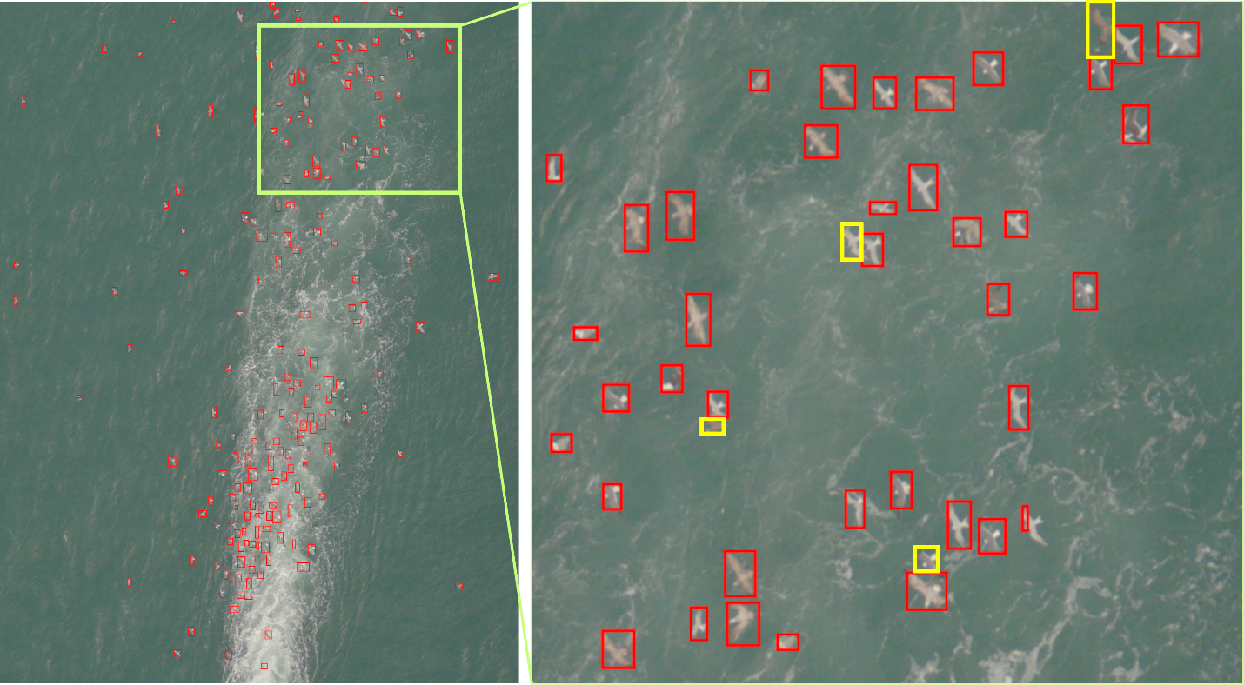

**Caption for Graphic or Image:** Figure 1. Detections of birds following in the wake of a ship are shown in red boxes. The AI model can process images like this, with large numbers of wildlife, much faster than a human reviewer. The current model still misses some birds (yellow boxes), typically when they are close to another bird or in an unexpected orientation. We are using active learning with human review to verify outputs, make corrections, and retrain models to improve performance.

**Author name:** Timothy White

**Author business email:** timothy.white@boem.gov