DOI agency/bureau: BLM
USGS Mission Area:
USGS Program:
Cost Center:
Program Name: Abandoned Mine Lands program
Project title: BLM-Bentonite Mine Spoil Remediation in Butte County, South Dakota
Project description: South Dakota Wing, Civil Air Patrol (CAP), has completed a major drone photography data collection project for researchers at the South Dakota Mines Center for Sustainable Solutions funded by the U.S. Bureau of Land Management.
The CAP team collected and processed over 786,000 multispectral images covering 13 square miles along Middle Creek, a tributary of the Belle Fourche River. The Center’s scientists are assessing the imagery to help study the influence of past bentonite mining, which has significantly reduced vegetation, and to understand the best potential approaches for restoring the landscape.
Lisa Kunza, Ph.D., director of South Dakota Mines Center for Sustainable Solutions, said “The multispectral imagery is crucial to our understanding of the study area. The CAP personnel were knowledgeable and professional helping aid in the project completion, prompt, and fun to work with.”
To capture data, CAP deployed a WingtraOne Gen II fixed-wing drone equipped with a multispectral camera. This UAS took off vertically and mapped pre-set routes, requiring 100 flights over 64.5 hours across 20 days in a 4-month period. Two or more CAP crew members assisted daily, with six UAS pilots completing the project despite frequent delays due to wind, rain, and clouds.
“Working with CAP provides a shared opportunity for education and outreach in the Black Hills,” said Patrick Kozak, research scientist for the Center for Sustainable Solutions. Kozak oversees the bentonite reclamation project including the drone data collection “The Center for Sustainable Solutions gets to show the positive work that CAP brings to the stakeholders on the science of our current projects. In addition, it allows for joint outreach between CAP and the Center for Sustainable Solutions, demonstrating the benefits of CAP and STEM to K-12 education regionally and nationally.”
CAP is the civilian auxiliary of the Air Force. In addition to directly supporting non-combatant Air Force missions, CAP has responsibilities that are part of the USAF’s support to civil authorities. The Mines project was conducted in accordance with CAP’s Memorandum of Understanding with the State of South Dakota. The research is funded under the U.S. Bureau of Land Management grant.
CAP and the university’s Center for Sustainable Solutions plan another round of drone-based multispectral photo data collection in 2025 to continue documenting the Middle Creek area over time.
Desciption Link Overflow: https://www.sdsmt.edu/news/releases/CAPcollectsdataformines.html
Sensor Type: Camera;Multispectral (approx. 4-12 bands)
Platform type: UAS
URL: https://www.sdsmt.edu/news/releases/CAPcollectsdataformines.html
Graphic or Image Upload: https://doimspp.sharepoint.com/sites/GS-EROSSCIENCESWI/Shared Documents/Communications Outreach/Documentation Science/DOI Remote Sensing Report/DOI RS Activities Report, 2025/Question/Lift off Wingtra.jpg
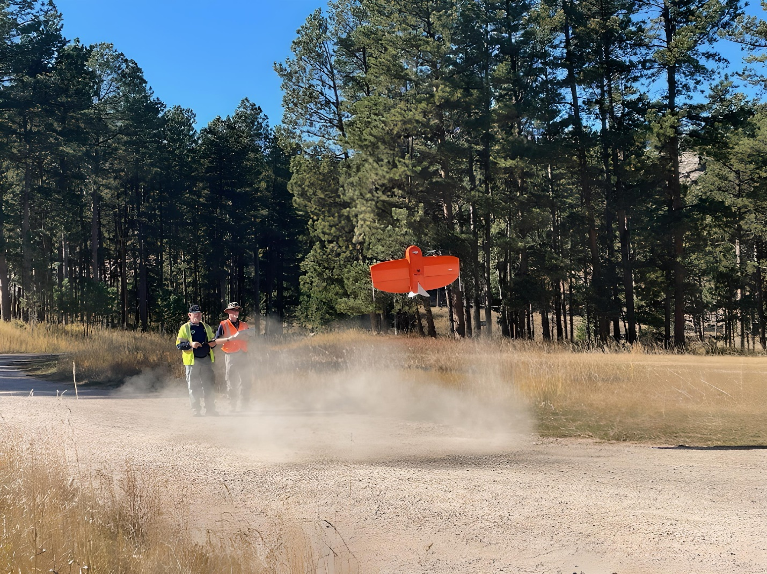
Caption for Graphic or Image: Image is failing to upload on web form - please use photo and map images available in this article: https://www.sdsmt.edu/news/releases/CAPcollectsdataformines.html
Author name: Dan Seifert
Author business email: dseifert@blm.gov

DOI agency/bureau: BLM
USGS Mission Area:
USGS Program:
Cost Center:
Program Name: Remote Sensing, Mineral Materials
Project title: Carlsbad FO Implements LIDAR for Mineral Product Verification
Project description: In April of 2024, Carlsbad FO (CFO) Geologists utilized money procured from mineral material trespass cases to purchase a terrestrial LIDAR sensor and GNSS GPS receiver to help track production from mineral pits. These trespasses were detected using technology developed by the BLM National Operations Center’s CDEDT program (Change Detection Event Disturbance Tool) which implements the Google Earth Engine platform and compares 10m resolution satellite photos from two specified dates. Since May of 2024, CFO Geologists have been conducting terrestrial LIDAR surveys of exclusive mineral material quarries using this new LIDAR equipment. The data is processed and transferred to a GIS as raster files. From there, the data is analyzed for cut/fill volumes by creating a new raster surface that represents the pit in an “unmined” state. This new raster is subtracted from the measured raster surface and compared to reported production from the operator. Various assumptions must go into the comparison such as the swell of the material as it is extracted from the ground, previous production values, and some legacy data inconsistencies. The LIDAR data provides a highly accurate snapshot of the volume removed from a pit and can detect theft through under reporting of production.

The method is proving to be an effective tool for mineral product verification but has led to several challenges. These challenges include the culmination of large datasets and collocation of multiple raster files that overlap each other. For example, geologists conduct surveys on each pit on an annual basis, though there are approximately 50 mineral pits that need measuring per year, they must go out to the field every week to collect these data. As a result, a single pit location can have multiple raster surfaces overlap each other per year, rendering the data unreadable. The CFO is finding ways to effectively display the data to the office for ease of use by specialists.

CFO Geologists continue to refine these processes.

Desciption Link Overflow:
Sensor Type: Lidar (terrestrial or bathymetric)
Platform type: Ground based / sensor web / web cam
URL:
Graphic or Image Upload: https://doimspp.sharepoint.com/sites/GS-EROSSCIENCESWI/Shared Documents/Communications Outreach/Documentation Science/DOI Remote Sensing Report/DOI RS Activities Report, 2025/Question/Layout1_Robert Salaz.jpg
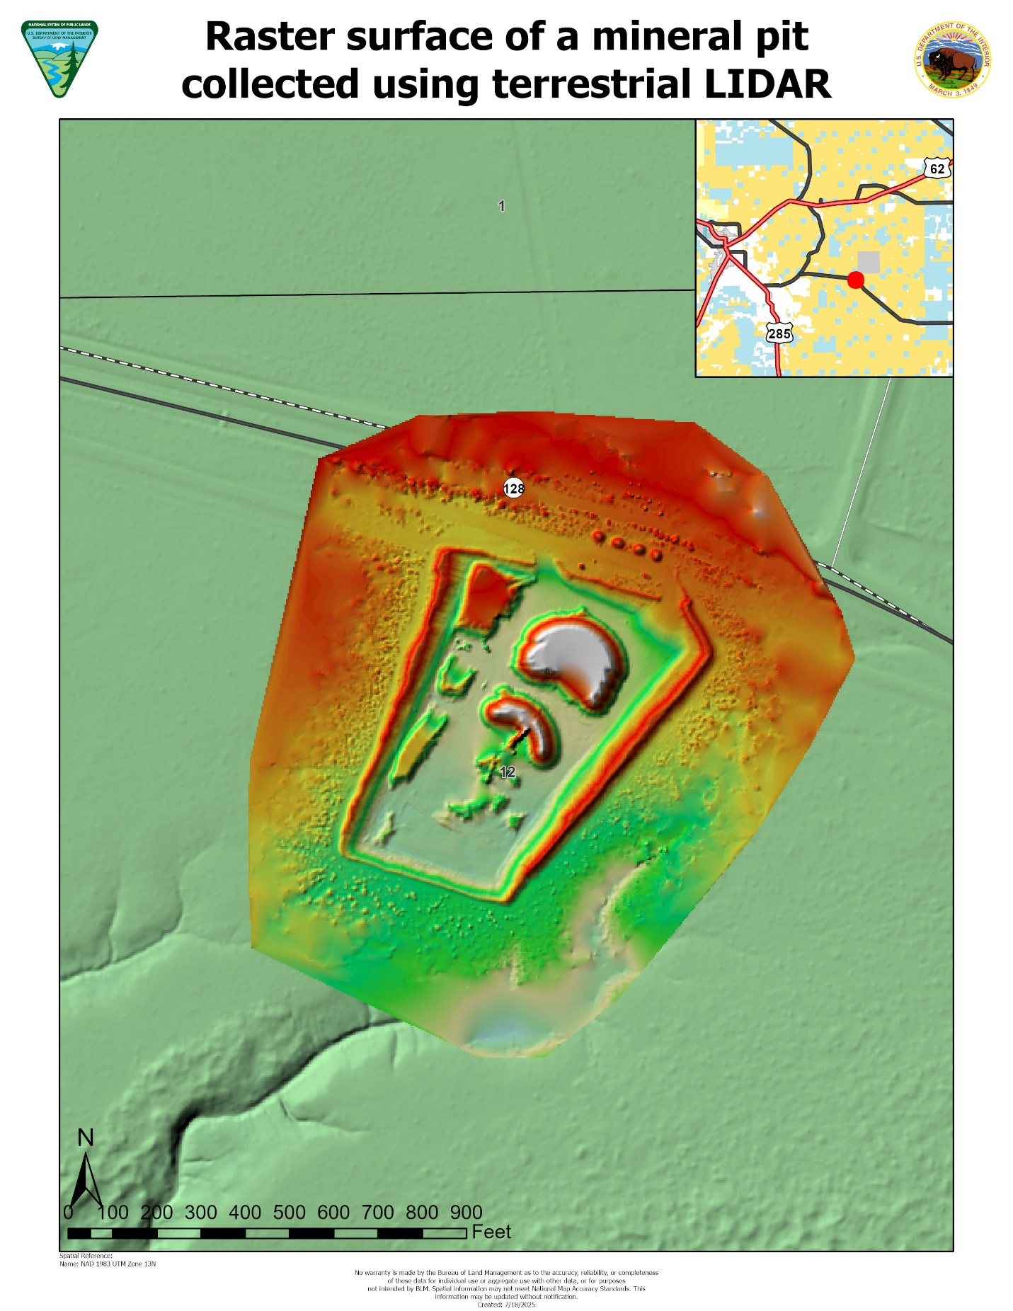
Caption for Graphic or Image: Map view of a raster surface from a mineral material pit (caliche) collected in Southeastern New Mexico utilizing terrestrial LIDAR scanner.
Author name: Robert Zeke Salaz
Author business email: rsalaz@blm.gov

DOI agency/bureau: BLM
USGS Mission Area:
USGS Program:
Cost Center:
Program Name: National Operations Center, Division of Resource Services, Remote Sensing Section
Project title: UAS Mapping Supports Fuels Treatment Planning in Southwest Colorado
Project description: In April 2025, the BLM Remote Sensing Section supported a collaborative fuels treatment research effort by mapping approximately 2,000 acres of the Dawson Unit near Cortez, Colorado. Located in upland pinyon-juniper shrubland within the Tres Rios Field Office, the site is part of the Southwest Colorado Pinyon-Juniper Adaptive Silviculture Project—a partnership between the BLM and researchers from the University of California Berkeley, University of Nevada Reno, Colorado State University, the U.S. Forest Service, and U.S. Geological Survey. The project aims to evaluate the effectiveness of various vegetation treatments, applied in Fall 2023, in improving landscape health and reducing wildfire risk. To support this effort, BLM staff used an Uncrewed Aerial System (UAS) to derive detailed geospatial data, enabling land managers and researchers to better understand vegetation condition and structure across the site.

Over two days, BLM remote pilots completed 24 UAS flights (~6 hours total) using the NDAA-compliant Freefly Astro multirotor platform equipped with a Sony ILX-LR1 camera. Approximately 5,500 stereo images were collected with high front and side overlap at 800 feet AGL under the DOI Certificate of Authorization from the FAA, which allows for UAS flights above 400 feet AGL. A Global Navigation Satellite System (GNSS) receiver was setup as a base station to log raw GNSS satellite data every second during flights on both days. The GNSS data were used to apply post-processing kinematic (PPK) corrections to the Astro’s on-board GNSS position information, improving the positional accuracy of final products. The stereo-imagery was processed photogrammetrically to generate a suite of high-resolution products, including a 3D point cloud, 2.5-cm resolution orthomosaic, and a 5-cm resolution digital surface model (DTM). Ground points were classified in the 3D point cloud and bare-earth digital terrain model (DTM) was interpolated from these.

The geospatial products from this mapping effort will support ongoing research and land management planning at the Dawson site. By providing detailed, accurate baseline data, the BLM is helping researchers and fire managers evaluate treatment effectiveness and plan future actions to reduce wildfire risk and enhance landscape health.

Desciption Link Overflow:
Sensor Type: Camera
Platform type: UAS
URL:
Graphic or Image Upload: https://doimspp.sharepoint.com/sites/GS-EROSSCIENCESWI/Shared Documents/Communications Outreach/Documentation Science/DOI Remote Sensing Report/DOI RS Activities Report, 2025/Question/Dawson_UAS_Multi_Figure_Julian Cross.jpg
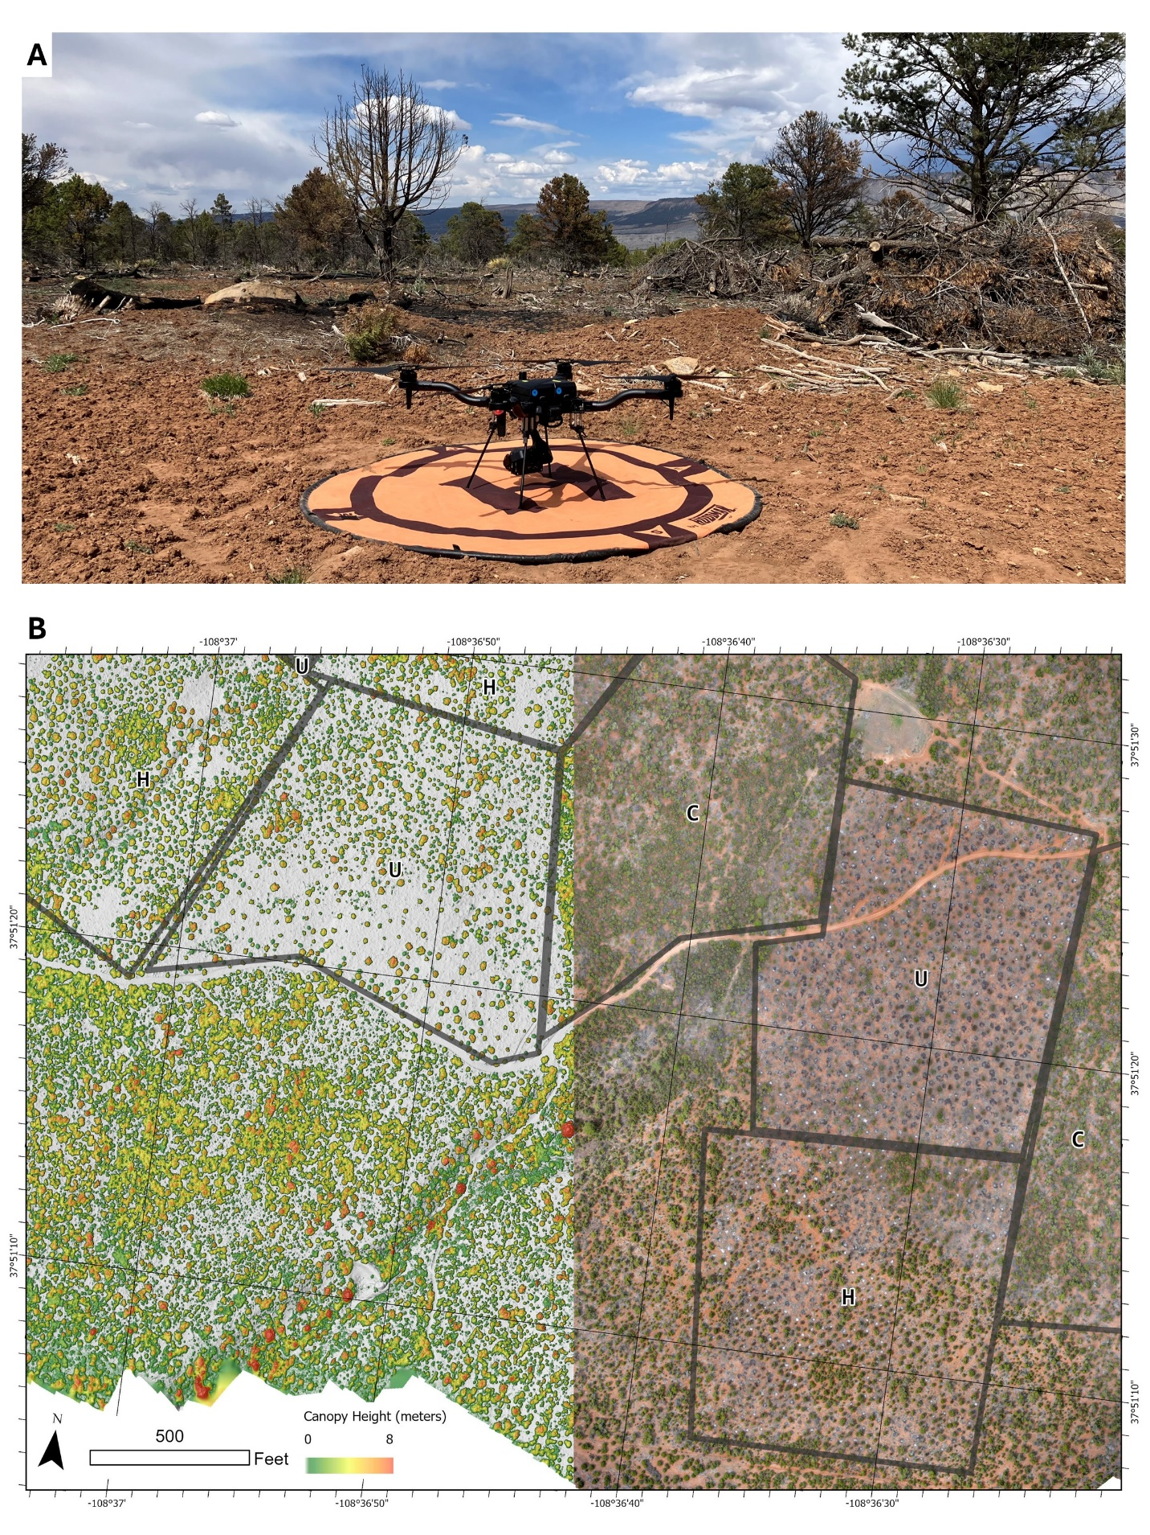
Caption for Graphic or Image: A) The Astro multirotor UAS at one of the take-off and landing locations at the Dawson site. Burned slash piles from the thinning treatments are visible in the background (photo by Chris Harris, BLM NOC). B) Map of the Dawson site showing the orthomosaic (right) and a canopy height model (CHM), calculated as the difference between the DSM and the bare-earth DTM, displayed over a hillshade (left). These products show vegetation height and condition, canopy spacing, and both burned and unburned slash piles. The differences between the control (C), uniform thinning (U) and heterogeneous thinning (H) experimental treatments at each unit (grey polygons) are visible on the map.
Author name: Julian Cross
Author business email: jcross@blm.gov

DOI agency/bureau: BLM
USGS Mission Area:
USGS Program:
Cost Center:
Program Name: National Operations Center, Division of Resource Services, Remote Sensing Section
Project title: Maryland Point Observatory Radio Tower Assessment
Project description: In November of 2024, the National Operations Center, Division of Resource Services, Remote Sensing section participated in a data collection effort led by the BLM Eastern States office at the Maryland Point Radio Tower Observatory. The observatory is located on the Maryland side of the Potomac River 47 miles south of Washington D.C. In 2004, the United States Navy donated approximately 37 acres of land on Maryland Point to the BLM. This parcel houses two radio telescope towers that the Navy used for research activities. These towers are approximately 90 and 120 feet tall and are being evaluated for either stabilization or potential removal and recycling of applicable materials. The BLM would like to open Maryland Point to the public; however, the site must first be evaluated for safety, primarily surrounding the structural integrity of the telescopes.

The Remote Sensing section was tasked with capturing a bird’s eye view of the radio towers with the primary goal of evaluating their structural condition. The Remote Sensing section’s UAS pilots utilized the new NDAA-compliant Skydio X10 platform to complete aerial surveys of both radio towers. In addition to sharing live video feeds on site for Eastern States staff to view the telescopes’ condition in detail, the Remote Sensing section delivered photos, videos, and 3D models to aid in further structural condition assessments. A high resolution orthomosaic was also supplied to the project requestor to help evaluate ground conditions at the site and potentially track change over time as the site is remediated. The Remote Sensing section enjoyed collaborating with the Eastern States at a unique BLM property and looks forward to future collaborations. View the collection of Maryland Point 3D models through the following link: https://skfb.ly/pAKtF

Desciption Link Overflow:
Sensor Type: Camera;Video
Platform type: UAS
URL: https://skfb.ly/pAKtF
Graphic or Image Upload: https://doimspp.sharepoint.com/sites/GS-EROSSCIENCESWI/Shared Documents/Communications Outreach/Documentation Science/DOI Remote Sensing Report/DOI RS Activities Report, 2025/Question/MP_Figure_Christopher Harris.jpg
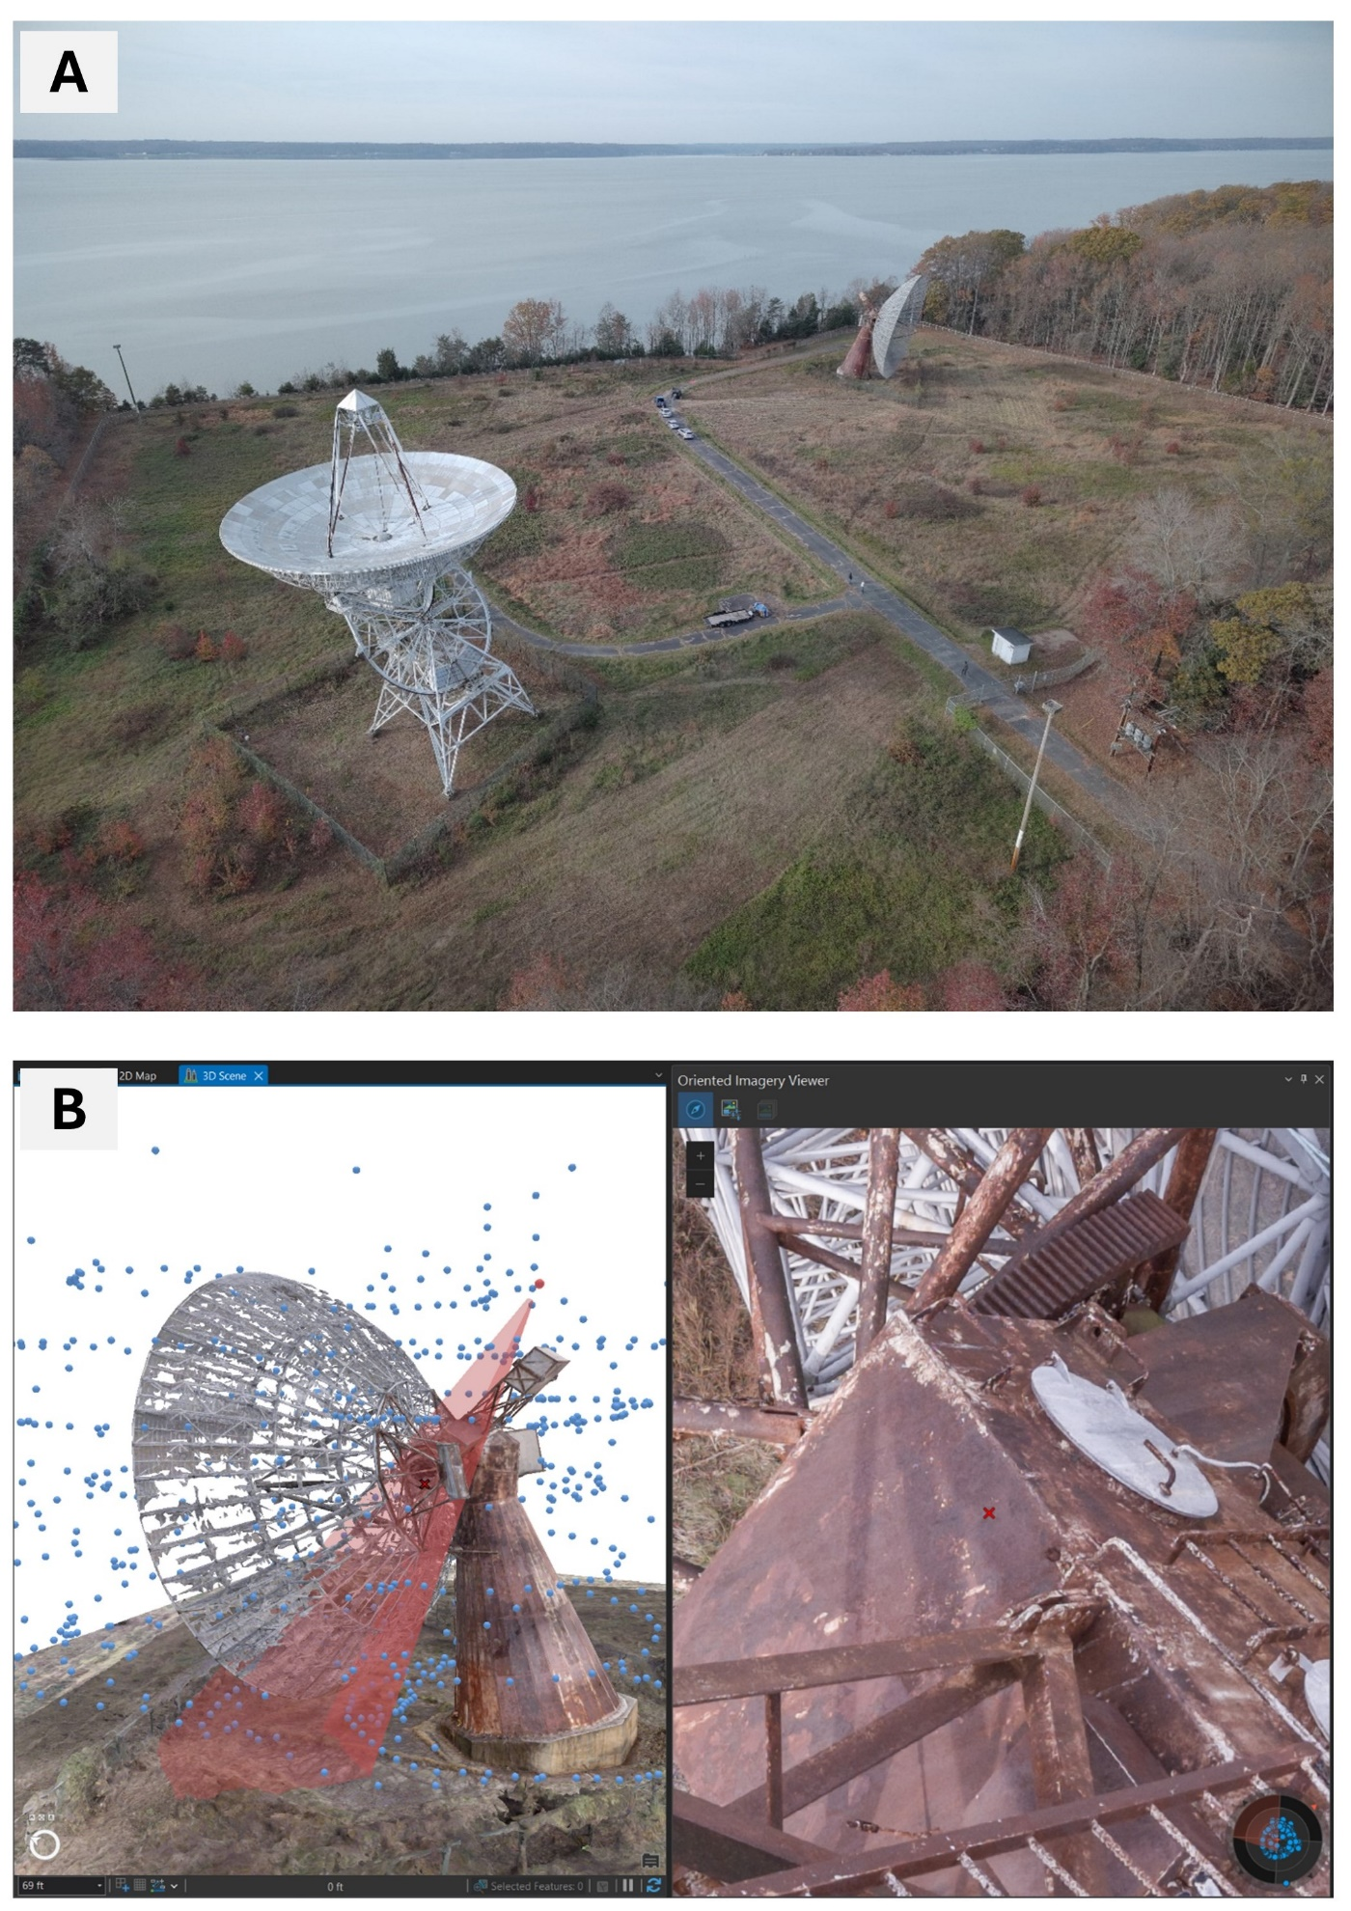
Caption for Graphic or Image: A) Maryland Point Observatory site overview. Two radio telescopes in the foreground and the Potomac River in the background. B) Imagery collected at the site is oriented in 3D space and can be used in the future for detailed inspection of the radio telescopes.
Author name: Christopher Harris
Author business email: cmharris@blm.gov

DOI agency/bureau: BLM
USGS Mission Area:
USGS Program:
Cost Center:
Program Name: National Operations Center, Division of Resource Services, Remote Sensing
Project title: UAS Lidar for Boundary Determination to Increase Recreation Access
Project description: Responsible for boundary determinations of federal lands, the Bureau of Land Management’s (BLM) Cadastral Survey program is one of the oldest and most fundamental functions of the U.S. Government. In areas of mixed public and private land, accurate boundary determinations are necessary before the implementation of public access projects. The Bighorn River Blueway Project is a join effort among state, federal, and private partners in increase recreational opportunities along this river in north-central Wyoming. As part of the project, BLM intends to create water access and designated camping areas along the Bighorn River north of Greybull, Wyoming. In certain areas, boundaries are designated based on dynamic, natural boundaries such as rivers. Sometimes these areas have not been surveyed, or if they have, the surface may have changed considerably.

The increasing accessibility of Lidar scanners for Uncrewed Aerial Systems (UAS) allow for the collection of detailed point clouds in these riparian areas to facilitate boundary determination. In August 2025, UAS Pilots from the BLM National Operation’s Center, Division of Resource Services, Remote Sensing Section flew UAS Lidar over four project areas along the river. With low flying height and high point density, UAS Lidar can be used to generate a bare-earth surface in vegetated areas that can show both the current banks as well as historic banks from previous river courses. Using these data, the cadastral group will define accurate land boundaries so that access facilities are accurately placed on publica land, and the public can recreate responsibly on public land while avoiding unintentional trespassing.

Desciption Link Overflow:
Sensor Type: Lidar (terrestrial or bathymetric)
Platform type: UAS
URL:
Graphic or Image Upload: https://doimspp.sharepoint.com/sites/GS-EROSSCIENCESWI/Shared Documents/Communications Outreach/Documentation Science/DOI Remote Sensing Report/DOI RS Activities Report, 2025/Question/All Points vs Ground Points_Jacob (Jake) Slyder.png
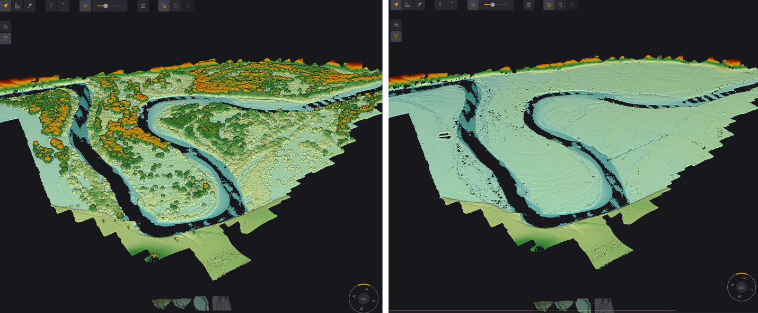
Caption for Graphic or Image: UAS Lidar point cloud of the Dry Point project area along the Bighorn River. The river channel can be seen moving through the center of both in the areas of patchy points (due to the low near-infrared reflectivity of water). Extensive vegetation is visible in the scan (left), but after a point cloud classification and manual cleanup, many of the historic channels are visible (right).
Author name: Jake Slyder
Author business email: jslyder@blm.gov

DOI agency/bureau: BLM
USGS Mission Area:
USGS Program:
Cost Center:
Program Name: Monitoring
Project title: Cloud-based Fractional Vegetation Cover Trend Analysis
Project description: Satellite data support informed land management by revealing patterns of vegetation change over time that would be difficult or impossible to detect through field monitoring alone. The Bureau of Land Management (BLM) uses satellite-derived products like the Rangeland Analysis Platform (RAP) to monitor vegetation across millions of acres of public lands in the United States. RAP delivers annual, high-resolution data on the fractional cover of key vegetation types, including perennial and annual grasses and forbs, shrubs, bare ground, and trees. With data going back to 1984 across the contiguous United States, RAP offers a consistent and comprehensive view of how landscapes are changing over time.

To make the most of this data, BLM analysts at the Montana/Dakotas State Office developed a trend analysis workflow that applies statistical tests to RAP’s fractional cover products. Using Google Earth Engine, the script evaluates each pixel across a selected time period to determine whether a trend exists and how strong it is. The Mann-Kendall test identifies the presence of a statistically significant trend, while Sen’s slope or linear regression calculates the direction and rate of change. The result is a spatially explicit heat map that shows how vegetation has changed over time. The script can then mask out non-BLM lands or other user-specified polygons and summarize statistics for specific areas of interest. This approach can help identify where vegetation-based projects are successfully meeting management goals and objectives. For example, it can show where vegetation is recovering after a prescribed fire. It can also highlight areas where conditions are declining, such as those experiencing increasing dominance of invasive annual grasses. By using cloud-based platforms like Earth Engine, this analysis can be run efficiently across large landscapes and time periods.

The fractional cover trend analysis script is publicly available on the RAP website, giving land managers the tools to explore vegetation change independently and support transparent, data-driven land stewardship decisions. This work benefits a wide range of stakeholders, including federal agencies, conservation groups, researchers, ranchers, and members of the public who rely on healthy rangelands. Learn more and access the script here: https://rangelands.app/support/66-analyze-cover-trends
Desciption Link Overflow:
Sensor Type: NA - remote sensing product
Platform type: Satellite
URL: https://rangelands.app/support/66-analyze-cover-trends
Graphic or Image Upload: https://doimspp.sharepoint.com/sites/GS-EROSSCIENCESWI/Shared Documents/Communications Outreach/Documentation Science/DOI Remote Sensing Report/DOI RS Activities Report, 2025/Question/TrendRasterMapDemo_final_Kaitlyn (Kaity) Rein.jpg
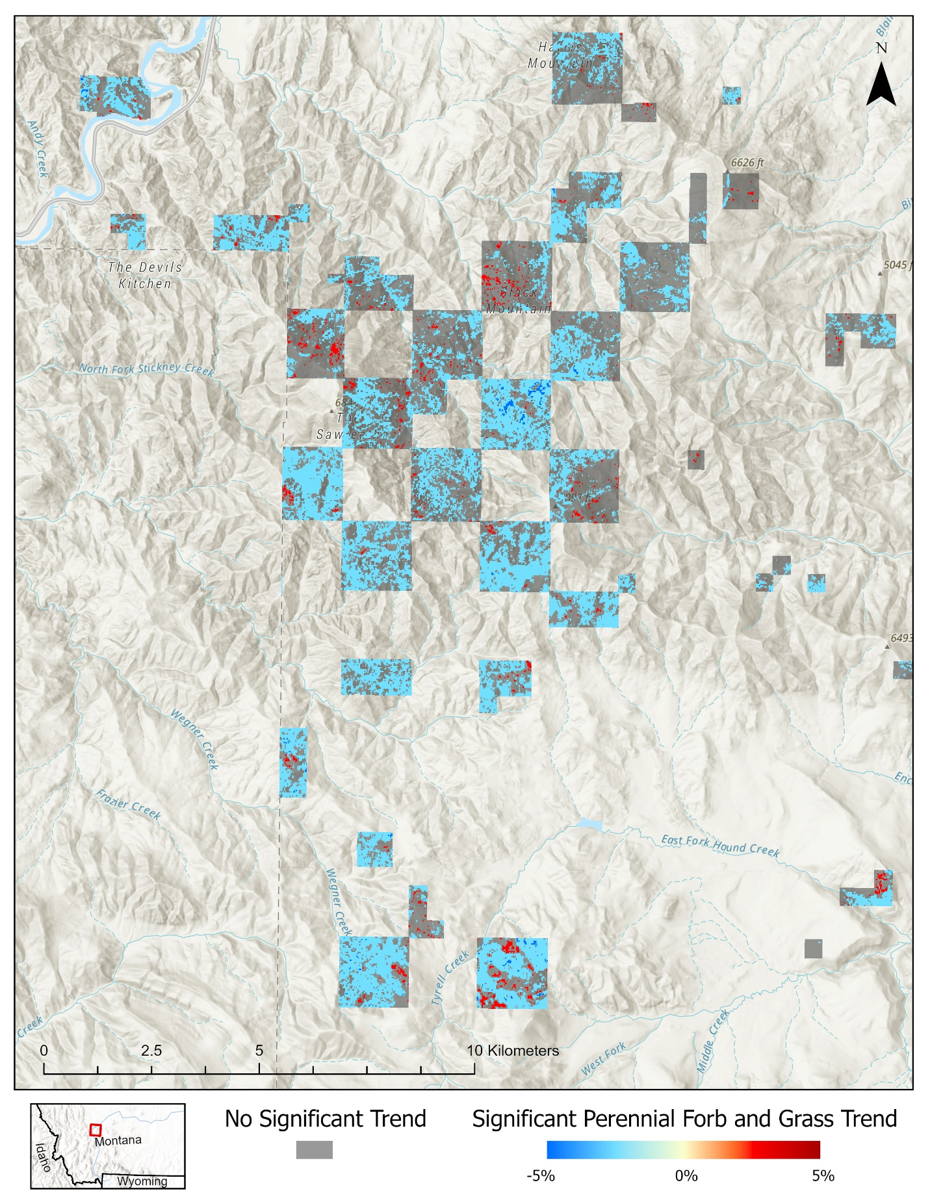
Caption for Graphic or Image: A demonstration of the output from the fractional vegetation cover trend analysis script. This map shows annual linear regression slope for perennial forb and grass from 2004 to 2024 for BLM land in central Montana.
Author name: Jessica McDermott and Kaitlyn Reintsma
Author business email: jmcdermott@blm.gov and kreintsma@blm.gov

DOI agency/bureau: BLM
USGS Mission Area:
USGS Program:
Cost Center:
Program Name: Livestock grazing, GIS, wildlife biology, fuels and fire management,
Project title: Ensuring Contractor Compliance Using Remote Sensing
Project description: The BLM has been working extensively with contractors to implement vegetation management projects that reduce wildfire risk and improve the health of rangelands. With the projects being located hours away down gravel roads in remote locations, it can be time consuming for resource management specialists to visit frequently and ensure they are being completed according to contract requirements. The BLM Arizona Strip District field personnel have been using commercial satellite imagery to assist with monitoring these contracts.

One of the main vegetation management project types we use are mastications, which is chipping standing juniper and pinyon trees and leaving the mulch on the ground. This type of project is easily visible in PlanetScope and SkySat imagery, which we’ve been using through the Electro Optical Commercial Layer (EOCL). The high temporal resolution of the Planet imagery allows us to evaluate contract progress on a near daily basis. We stream the imagery into GIS software or view imagery online and calculate acreages completed. This helps us ensure the contract will be completed on time, and it ensures the contractor invoices include the actual work they’ve completed.

This process also allows us to overlay data from our planning process. We have sensitive sites near project areas where the mastication cannot occur, such as archaeological exclusion areas. The aerial perspective from the satellite saves immense amounts of time walking these sensitive areas to be sure they were maintained intact by contractors. Having the high spatial and temporal resolution of these satellite systems allows us to more accurately and efficiently map these projects. Given the need for detailed information, this would not be possible with coarser resolution satellite systems. Access to this satellite data is improving the efficiency and accuracy of the work we do on public lands.
Desciption Link Overflow:
Sensor Type: Multispectral (approx. 4-12 bands)
Platform type: Satellite
URL:
Graphic or Image Upload: https://doimspp.sharepoint.com/sites/GS-EROSSCIENCESWI/Shared Documents/Communications Outreach/Documentation Science/DOI Remote Sensing Report/DOI RS Activities Report, 2025/Question/DOIRemoteSensingReportGraphics_for_upload_Wol_Pamela Blackmore.jpg
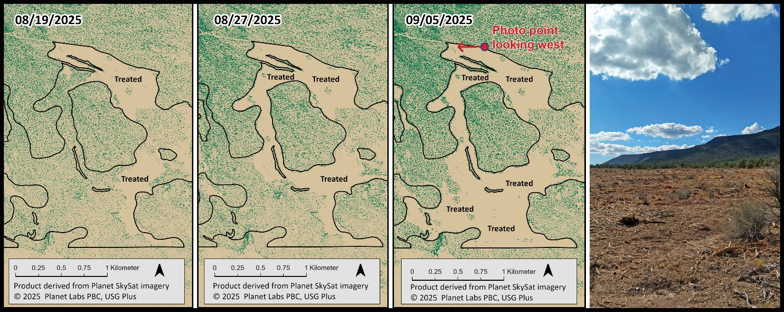
Caption for Graphic or Image: Planet SkySat-derived high-resolution cover maps identifying vegetation treatment site progress through three dates from August to September of 2025. Green pixels identify standing tree cover. Treated areas are identified on the graphic. A photo taken during a site visit to the treated area on 09/08/2025 is shown on the right.
Author name: Christopher Cole, Pamela Blackmore, Mike Cutler, Luke Seelhoff, and Jenna Moore
Author business email: cjcole@blm.gov

DOI agency/bureau: BLM
USGS Mission Area:
USGS Program:
Cost Center:
Program Name: fire and fuels, GIS, remote sensing, livestock grazing
Project title: Multi-sensor Response to the White Sage Wildfire
Project description: The BLM is increasingly using commercial satellite imagery to assist with wildfire response. In line with Executive Order 14308, the BLM used the Electro Optical Commercial Layer (EOCL) to acquire SkySat and PlanetScope imagery for the White Sage Fire in northern Arizona on the Arizona Strip District. U.S. Geological Survey (USGS) National Civil Application Center (NCAC) officials assisted with the acquisition of WorldView imagery as well. The Bureau used these data to identify and document fire suppression damage and to prioritize repair work.

Over 24 miles of unrecorded dozer lines were created on BLM lands to combat the wildfire. Because GPS tracking failed while the dozer operator was creating these lines, resource advisors would have needed to manually walk and document their locations to plan their repair. We used PlanetScope and SkySat to digitize these lines in the office, saving hours of field labor. This time saving allowed us to more quickly estimate seed and get it on the ground in time for precipitation. The high temporal resolution of the Planet imagery was integral to making this possible.

We used WorldView-2 imagery for informing local resource specialists and management. The large footprint captured by the imagery and high spatial resolution allowed BLM officials to identify in detail the damage to the land they manage, and to prioritize sites to visit on the ground. For example, fence line in moderate severity burn areas was checked to determine the extent of repairs needed. In addition, water catchment damage was visible in the imagery.

The fire burned in a heterogenous pattern, with some areas much more affected than others. An opportunity became available for Forest Service permittees to request funding for seed from the NRCS. However, the deadline was imminent, and we needed to prioritize seeding areas with the greatest severity given the lack of funding to seed the entire burn scar. For this, we used Sentinel 2 imagery accessed via the BLM’s Change Disturbance and Event Detection Tool (CDEDT) to rapidly delineate burned and unburned areas and calculate their acreages. We next developed a cover segmentation from PlanetScope high resolution imagery to identify areas at a finer scale that were burned and required seeding. These expanding satellite sources the DOD agencies are making available to the federal civil community allows the field to improve their timely response to these wildfires.

Desciption Link Overflow:
Sensor Type: Multispectral (approx. 4-12 bands)
Platform type: Satellite
URL:
Graphic or Image Upload: https://doimspp.sharepoint.com/sites/GS-EROSSCIENCESWI/Shared Documents/Communications Outreach/Documentation Science/DOI Remote Sensing Report/DOI RS Activities Report, 2025/Question/DOIRemoteSensingReportGraphics_for_upload_Whi_Pamela Blackmore.jpg
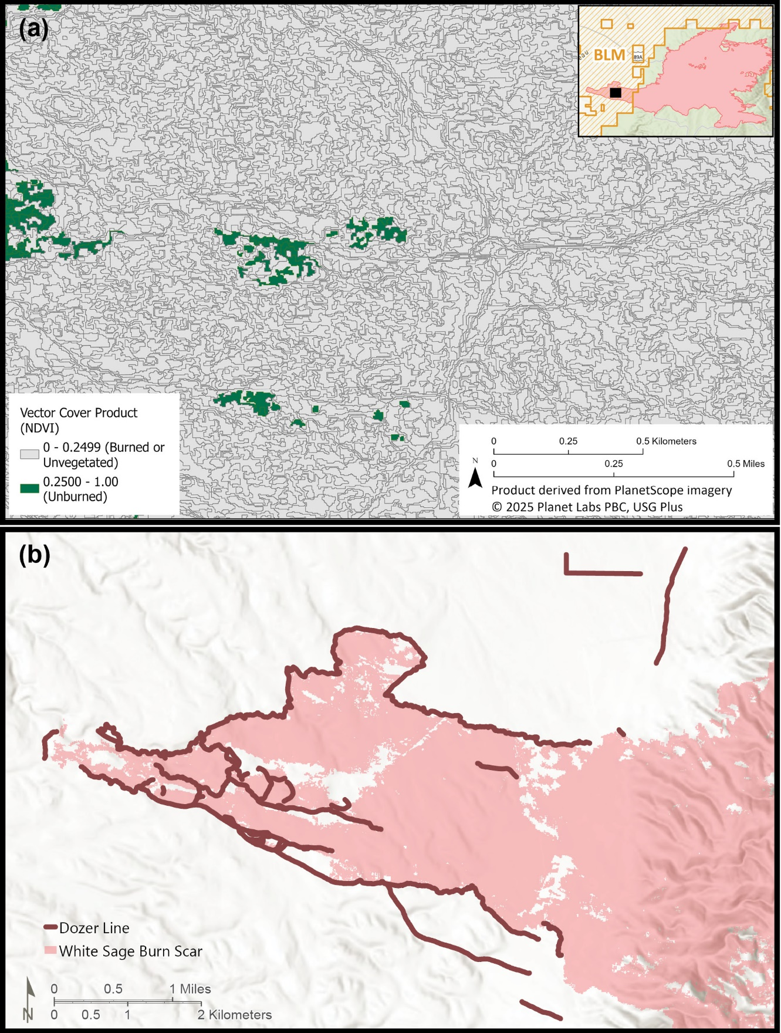
Caption for Graphic or Image: (a) Vector cover product derived from PlanetScope commercial satellite imagery for the White Sage Fire in Arizona. A Normalized Difference Vegetation Index (NDVI) was calculated to identify burned and unburned vegetation cover, to support post-fire recovery planning. (b) A portion of the White Sage wildfire on the BLM Arizona Strip District burned quickly across the rangeland. Dozer line fuel breaks (shown in brown) were used to slow the spread of the wildfire and prevent damage to nearby structures and communities.
Author name: Pamela Blackmore, Christopher Cole, and Rachel Shively
Author business email: pblackmore@blm.gov

DOI agency/bureau: BLM
USGS Mission Area:
USGS Program:
Cost Center:
Program Name: Remote Sensing Section, Division of Resource Services, National Operations Center
Project title: Use of AI and High-Resolution Imagery to Map and Monitor Burning Man
Project description: The BLM’s National Operations Center (NOC) Division of Resource Services (DRS) Remote Sensing Section used artificial intelligence-based machine learning to map surface cover at Burning Man in Nevada. Burning Man is an art and music event which has been held yearly upon Bureau lands in Nevada’s Black Rock Desert since 1990. It ran from August 24 to September 1 in 2025 and was attended by more than 70,000 people.
The NOC harnessed daily to sub-daily imagery from multiple high-resolution commercial satellite systems collected over Burning Man, including electro-optical (BlackSky, Planet SkySat) and Synthetic Aperture Radar (Umbra). Imagery were systematically collected by the NOC prior to, during, and following the end of the event. This integrated acquisition strategy provided, for the first time, a detailed fine-scale image record of cover and site conditions, and supported multiple monitoring needs including public safety and law enforcement.
Random Forest machine learning was used to classify 50-centimeter resolution Planet SkySat imagery and derived spectral indices, and to produce maps delineating surface cover. The daily classification products mapped the (barren) playa, as well as Burning Man cover including event materials, structures, and vehicles. This approach produced spatially detailed maps, with an accuracy of 95 percent or greater.
This effort demonstrated the efficacy of employing a multi-sensor approach to provide fine-scale, high-frequency monitoring of site conditions during Burning Man, in conjunction with the use of artificial intelligence to efficiently and accurately develop spatially explicit products supporting resource management needs.

Desciption Link Overflow:
Sensor Type: IFSAR / SAR / Radar;Multispectral (approx. 4-12 bands)
Platform type: Satellite
URL:
Graphic or Image Upload: https://doimspp.sharepoint.com/sites/GS-EROSSCIENCESWI/Shared Documents/Communications Outreach/Documentation Science/DOI Remote Sensing Report/DOI RS Activities Report, 2025/Question/BLM_Burning_Man_Mapped_SkySat_DOI_RS_Report_C_Christopher Cole.jpg
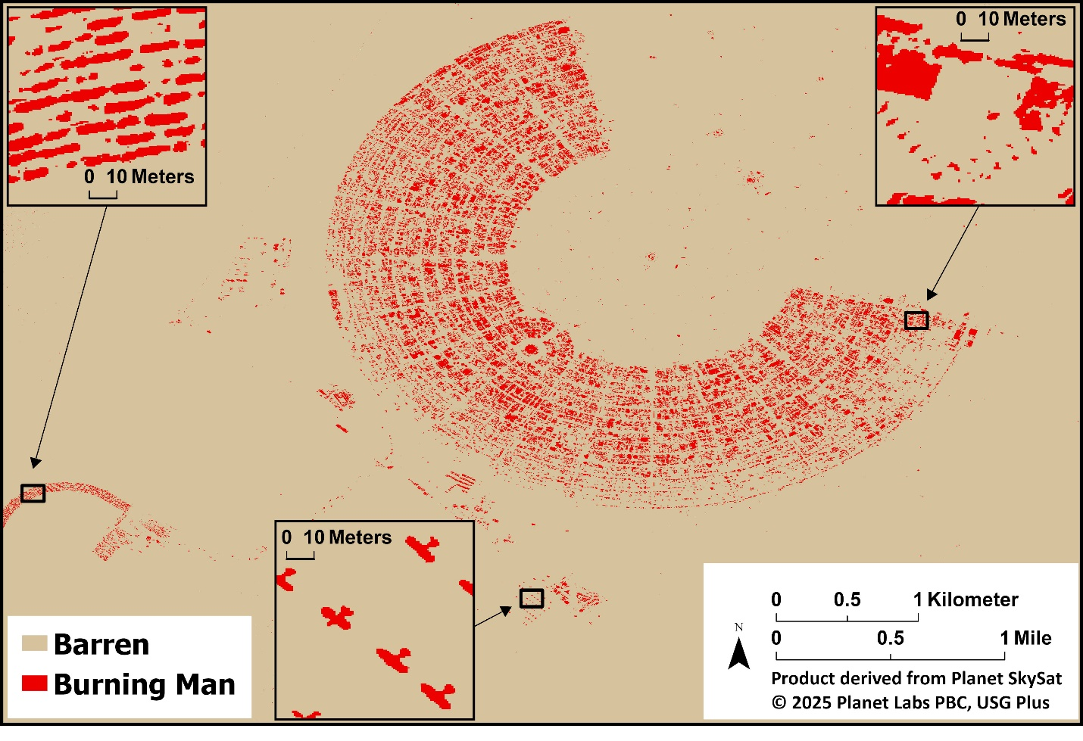
Caption for Graphic or Image: Planet SkySat-derived high-resolution cover map showing surface cover on August 25, 2025. Inset maps seen to the left, center, and right identify event motor vehicles; aircraft; and erected structures, respectively.
Author name: Christopher Cole
Author business email: cjcole@blm.gov

DOI agency/bureau: BLM
USGS Mission Area:
USGS Program:
Cost Center:
Program Name: Assessment, Inventory and Monitoring
Project title: Fractional Vegetation Cover products change the game for land managers
Project description: Multiple remotely sensed vegetation datasets have become operational for the western United States, enabling managers to monitor shrubland, grassland, and woodland ecosystems at broad spatial and temporal scales. The availability of multiple Fractional Vegetation Cover products include the Rangeland Analysis Platform (RAP), developed by the U.S. Department of Agriculture (USDA), the Rangeland Condition Monitoring Assessment and Projection (RCMAP), created by the U.S. Geological Survey (USGS), and the Landscape Cover Analysis and Reporting Tools (LandCART), developed in conjunction with the University of California Los Angeles (UCLA) and the Bureau of Land Management (BLM). These FVC products provide unprecedented information on the condition and trends of public lands, critical for agencies such as the BLM who is responsible for managing 10% of the countries’ surface area land base.
These products utilize extensive training data from BLM’s Assessment, Inventory, and Monitoring (AIM) program, coupled with the Landsat satellite archive (30 m) to model major plant functional types from the mid-1980s to present. However, recent advancements have incorporated data from the Sentinel-2 satellite to allow users to examine rangeland processes at finer-scales (e.g., RAP 10 meter vs. RAP 30 meter) using more discrete plant functional groups. The BLM continues to collaborate with FVC producers and the Climate Engine team at the Desert Research Institute (DRI) to streamline the availability of remotely sensed data to the management community.

Desciption Link Overflow:
Sensor Type: Multispectral (approx. 4-12 bands)
Platform type: Satellite
URL:
Graphic or Image Upload: https://doimspp.sharepoint.com/sites/GS-EROSSCIENCESWI/Shared Documents/Communications Outreach/Documentation Science/DOI Remote Sensing Report/DOI RS Activities Report, 2025/Question/DOI-RS-graphics_Timothy Assal.jpg
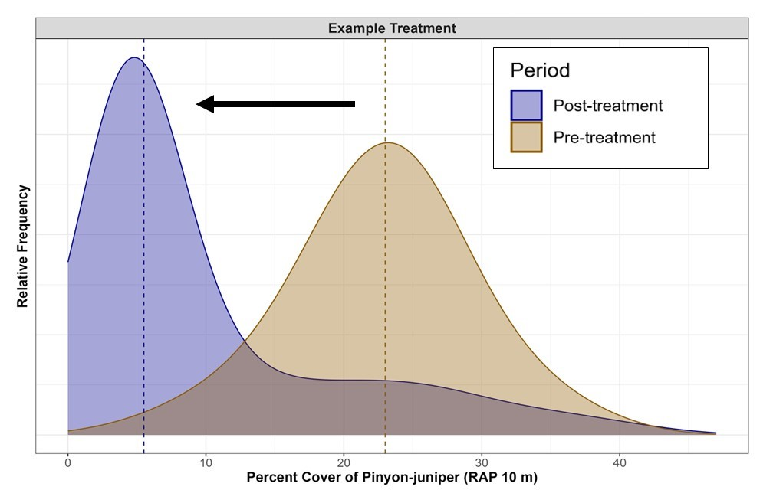
Caption for Graphic or Image: A density plot identifies the distribution of Pinyon-juniper cover values before and after a fuels reduction treatment. FVC values are summarized across the treatment area for each time period to illustrate the shift in Pinyon-juniper cover from a mean of 23% to 7%.
Author name: Tim Assal
Author business email: tassal@blm.gov

