Advancing water security in Africa with new high-resolution discharge data
Komlavi Akpoti^{1, *}, Naga Manohar Velpuri², Naoki Mizukami³, Stefanie Kagone⁴, Mansoor Leh², Kirubel Mekonnen⁵, Afua Owusu¹, Primrose Tinonetsana², Michael Phiri², Lahiru Madushanka², Tharindu Perera², Paranamana Thilina Prabhath², Gabriel E. L. Parrish⁶, Gabriel B. Senay⁷, Abdulkarim Seid⁵
¹International Water Management Institute (IWMI), Accra, Ghana
²International Water Management Institute (IWMI), Colombo, Sri Lanka
³National Center for Atmospheric Research, Boulder, CO, USA
⁴ASRC Federal Data Solutions LLC, Contractor to the U.S. Geological Survey (USGS) Earth Resource Observation and Science (EROS) Center, Sioux Falls, SD 57198, USA
⁵International Water Management Institute (IWMI), Addis Ababa, Ethiopia
⁶Innovate!, Inc., Contractor to USGS EROS Center, Sioux Falls, SD 57198, USA
⁷U.S. Geological Survey EROS Center, Sioux Falls, SD, USA and North Central Climate Adaptation Science Center, Boulder, CO 80303, USA
*Corresponding author at International Water Management Institute (IWMI), Accra, Ghana. E-mail address: k.akpoti@cgiar.org (K. Akpoti).

Abstract
VegDischarge v1 is a comprehensive river discharge across Africa (2000–2021), produced by coupling the agro-hydrologic VegET model and the mizuRoute routing framework. Using remote sensing data and hydrological modeling, the 1-km runoff field simulated by VegET, and routed with mizuRoute, covers over 64,000 river segments in Africa. The VegET model simulates runoff based on vegetation and soil moisture dynamics, while mizuRoute processes this runoff through a detailed river network. Performance metrics show strong model reliability, with coefficient of determination (R²) ranging from 0.5 to 0.9, Nash-Sutcliffe efficiency (NSE) between 0.6 and 0.9, and Kling-Gupta Efficiency (KGE) from 0.5 to 0.8. The total average annual discharge for Africa is quantified at 3238.1 km³·year⁻¹, with contributions to various oceanic basins: 989.9 km³·year⁻¹ to the North Atlantic, primarily from West African rivers like the Senegal, Gambia, Volta, and Niger; 1313.7 km³·year⁻¹ to the South Atlantic, largely from the Congo River; 212.5 km³·year⁻¹ to the Mediterranean Sea, predominantly from the Nile River; and 722.0 km³·year⁻¹ to the Indian Ocean, with substantial inputs from rivers such as the Zambezi. This VegDischarge v1 is valuable for policymakers, stakeholders, and researchers to better understand water availability, its temporal and spatial variations that affect water-related infrastructure planning, sustainable resource allocation, and the development of climate resilience mitigation strategies.

Background & Summary
Global freshwater scarcity is a pressing issue that affects millions of people around the world^{1,2}. Population growth increases demand for water resources, and negative effects of climate change and population growth has intensified the need for sustainable water management practices^{3–5}. In this context, comprehensive hydrological modeling gains importance in the development of improved water management techniques. Clark et al.⁶ showed the importance of modeling in assessing continental runoff into the oceans, a key factor in understanding the global water cycle and its implications for regions like Africa, where water scarcity is acutely prevalent⁷. Therefore, such modeling is relevant for regions experiencing climate variability and rapid population growth, as it aids in understanding, predicting, and managing the distribution and availability of often limited freshwater resources^{8–10}.
Africa, a continent characterized by diverse landscapes, climate zones, and socio-economic conditions, is facing numerous challenges related to water quantity and quality, ranging from droughts and floods to limited access to clean water^{11,12}. These challenges are further exacerbated by the effects of climate change ¹³, which has intensified the frequency and severity of extreme weather events, altered precipitation patterns¹⁴, and disrupted the hydrological balance across the continent^{15–17}. Labat (2010)¹⁸ provides an understanding of how large-scale atmospheric and oceanic circulation fluctuations affect the hydrological cycle, including freshwater discharge, a key issue for African countries grappling with climate change. Consequently, understanding the dynamics of hydrological processes, such as evapotranspiration, soil moisture, surface runoff, and discharge, is fundamentally essential for addressing these challenges and informing evidence-based decision-making in water resource management, agriculture, and environmental conservation^{19–21}. Additionally, insights into these processes can inform conservation strategies^{22,23} and improve our knowledge of climate change effects, contributing to the refinement of regional and global earth system models²⁴.
Hydrological modeling in Africa is often hindered by limited availability of high-quality, spatially distributed, and long-term hydrological observations such as river discharge²⁵. This issue is prevalent in smaller catchments with a sparse or poorly maintained hydro-meteorological network^{26,27}. Inconsistencies in data collection methods, gaps in historical records, and uncertainties in future climate projections amplify these challenges, making it difficult to develop robust models that can adequately capture the spatial and temporal variability of hydrological processes in Africa²⁸. For example, Schmied et al.²⁹ emphasize the complexities introduced by climate forcing uncertainty and human water use, factors that are particularly relevant in the African context, add other layers of difficulty in developing robust hydrological models. Furthermore, the diverse landscapes and climate zones in Africa introduce substantial spatial and temporal variability in hydrological processes, which can be challenging to capture in models, as it requires an adequate representation of the complex interactions between topography, land cover, soil properties, and hydro-meteorological conditions at various scales³⁰. Such complexity is shown in the work by Boschetti et al.³¹ on the Congo River Basin using Earth observation data (river discharge based on ENVISAT radar altimeter data, FEWS-NET RFE estimations of rainfall and vegetation indices available from long-term series of SPOT–VGT data), highlighting the potential challenges of integrating various data sources in hydrological modelling.
Many hydrological models are constrained by scale-dependent parameters and process representations, which limit their applicability and transferability across different spatial scales. For example, scale-dependent parameters such as Manning's roughness coefficient, soil hydraulic properties, and vegetation characteristics can vary with spatial resolution. These parameters are often calibrated at specific scales and may not be directly applicable or accurate when the model is applied to different regions or at different scales. Similarly, process representations like infiltration, evapotranspiration, and runoff generation can also be scale dependent. For instance, the representation of infiltration processes might differ between small-scale plots and larger watershed scales due to variations in soil heterogeneity and land cover. Such differences can lead to inaccuracies when models developed for one scale are applied to another without appropriate adjustments or recalibration. These limitations highlight the importance of developing hydrological models that can accommodate or adjust for scale dependencies to improve their robustness and transferability. The calibration of these models is often a daunting task in regions where observational data are scarce. This challenge is compounded in Africa, where hydro-meteorological networks are less dense, as pointed out by Hughes et al.³², who emphasize the need for region-specific calibration approaches in African river basins. Moreover, advanced hydrological models that merge remote sensing data and complex process representations frequently demand substantial computational resources. This requirement can be a barrier to their widespread adoption, especially in resource-limited settings. Striking a balance between model complexity and computational demands is relevant for the practicality and accessibility of hydrological models. Addressing these challenges requires innovative approaches that can accurately represent the intricacies of water balance components in diverse environments like Africa. These innovative approaches help to mitigate the limitations of traditional hydrological modelling methods, providing valuable insights for decision-making in water resource management. They are particularly essential in the context of Africa, where data constraints are a challenge. By adopting these advanced techniques, we can better understand and predict hydrological responses to environmental changes, thus supporting improvements to sustainable water management strategies in the future.
In this study, we use a hydrological model, developed by the U.S. Geological Survey (USGS) called VegET³³, and the mizuRoute river routing model^{34,35} to transfer the gridded runoff simulated by the hydrological model through the river network, providing discharge estimations for more than 64,000 river reaches across Africa. This integrated approach allows us to estimate various components of the root zone water balance and accurately route river discharge across the entire African continent at a high resolution of 1 km. The VegET model is driven by precipitation and Normalized Difference Vegetation Index (NDVI) phenology to estimate the various components of root zone water balance to the entire African continent. By incorporating remote sensing data for precipitation and NDVI, the spatial and temporal variability of hydrological processes are better represented, improving the model's performance and applicability across the continent. The use of remote sensing data in the model also helps to overcome some of the limitations associated with data scarcity and quality, allowing the development of a more reliable and robust hydrological model for Africa. Furthermore, the VegET model's simplicity and computational efficiency make it suitable for use in resource-constrained settings. Despite the advantages of using the VegET model driven by remote sensing data, challenges in hydrological modelling remain, such as scale-dependent parameters and process representation, model validation, and uncertainty quantification. Addressing these challenges is a prerequisite for providing reliable hydrological information for decision-making in Africa's water resources and environmental sectors. Thus, the primary objective of this study is to present and evaluate the performance of 1-km resolution, spatially distributed, remote sensing-based hydrological model for estimating evapotranspiration, runoff (surface and subsurface), and soil moisture across Africa for the period 2000-2021 at monthly and annual time steps. The study assessed the model's sensitivity to different input data sources, model parameters, and assumptions, quantifying the uncertainties associated with model predictions and providing insights into model improvements.

Methods

Computational workflow
We developed a cloud-based implementation of the VegET and mizuRoute models within Amazon Web Services (AWS), comprising four main components (Fig. 1). This setup includes (1) preparation of dynamic and static inputs for VegET and data formatting for mizuRoute; (2) operational deployment of the VegET model; (3) compilation and integration of the mizuRoute routing scheme; and (4) rigorous technical validation of both models' outputs. The methods and technical validation sections detailed the underlying functions and data used for the two models. The technical validation (refer to section on technical validation) was conducted to evaluate gridded runoff and the routed discharge, with available ground-based observations and other independent datasets, such as satellite-derived products. VegET and mizuRoute were implemented at daily time steps from 2000-2021 at the spatial resolution of 1 km. The temporal coverage of the dataset (2000-2021) is chosen to focus on contemporary hydrological conditions. This period allows us to capture contemporary climate and hydrological dynamics, which are relevant for understanding and managing current water resources. Additionally, the VegET model is phenology-based and relies on Moderate Resolution Imaging Spectroradiometer (MODIS) data, which is available from 2000 onwards. This availability of high-quality remote sensing data constrains the choice of the temporal span to 2000-2021.
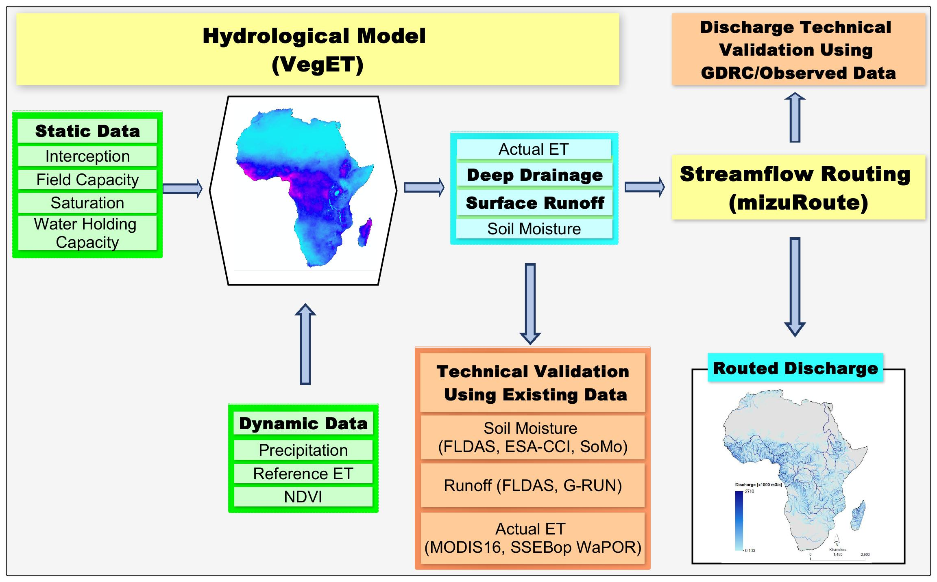
Fig. 1. Summary workflow of VegET³³ and mizuRoute³⁴ models implementation. This diagram represents the workflow of the VegET and mizuRoute models and their input and output data. VegET, coded in Python, and mizuRoute, developed in Fortran, work in synergy for the discharge estimation. Input parameters for VegET are divided into static categories, such as soil and interception parameters, and dynamic data relating to climate and phenology, represented by time series.

VegET hydrological model implementation and calibration
VegET is a bucket-type, physically based large-scale hydrological model³³. VegET initializes its simulations of soil moisture (SM) levels set to zero and undergoes an initial stabilization period of one year (refer to Fig. 2 for VegET conceptual model). For the simulation period of 2000-2021, the year 2000 is used as the spin-up period. Within the model, the soil water store's characteristics are determined by the physical properties of the soil. Here, soil properties are defined by ISRIC gridded data for Africa (ISRIC³⁶– refer to Table 2). Soil porosity (POR), as sourced from soil databases, corresponds to the saturation (SAT) within the model. The field capacity (FC) quantifies the upper limit of water the soil matrix can hold for plant utilization. At the same time, the permanent wilting point (WP) denotes the critical moisture threshold below which plants cannot sufficiently extract water. The difference between FC and WP, known as the water holding capacity (WHC), represents the quantity of water accessible to plants. However, as soil moisture declines and falls below the maximum allowable depletion (MAD) limit, the model predicts an increase in plant water stress.
The VegET model advances the understanding and management of agricultural water demands, particularly in regions where crop coefficients (Kc values) are challenging to define over large areas³³. This difficulty arises from the uncertainty in crop types and the limited applicability of published Kc values outside their original experimental contexts. To address some of these limitations, VegET integrates land surface phenology (LSP) derived from the remotely sensed Normalized Difference Vegetation Index (NDVI). Here, NDVI is generated using MODIS (Aqua and Terra – 1-km, 8-day) data (MODIS NDVI³⁷ – refer to Table 2). This approach allows for a more realistic and dynamic representation of vegetation status and growth patterns. By doing so, the VegET model simulates crop water demands through a landscape lens, offering a holistic and region-specific assessment. This method not only enhances the precision of water requirement estimations but also adapts to the diverse agricultural practices and environmental conditions across different regions. Such a landscape-focused perspective is effective for water resources management, especially in areas with complex agricultural systems and varying climatic conditions. More specifically, this concept is depicted by the replacement of the traditional tabular crop coefficient (Kc) by Allen et al.³⁸ with a landscape coefficient (Kcp) derived from the NDVI. This phenology-based Kcp is presumed to reflect the aggregate water needs of the landscape in areas with stable land cover. The use of NDVI in a climatological framework yields more consistent and accurate patterns of seasonal water usage than traditional Kc values³³. When soil moisture levels exceed SAT, the model simulates surface runoff; however, moisture within the critical zone between SAT and FC is apportioned between surface runoff and deep drainage. The model generates runoff (R) when soil moisture levels rise above the WHC, delineating the excess as either surface runoff or deep drainage, contingent on its position relative to SATfc, which is the volume between SAT and FC.
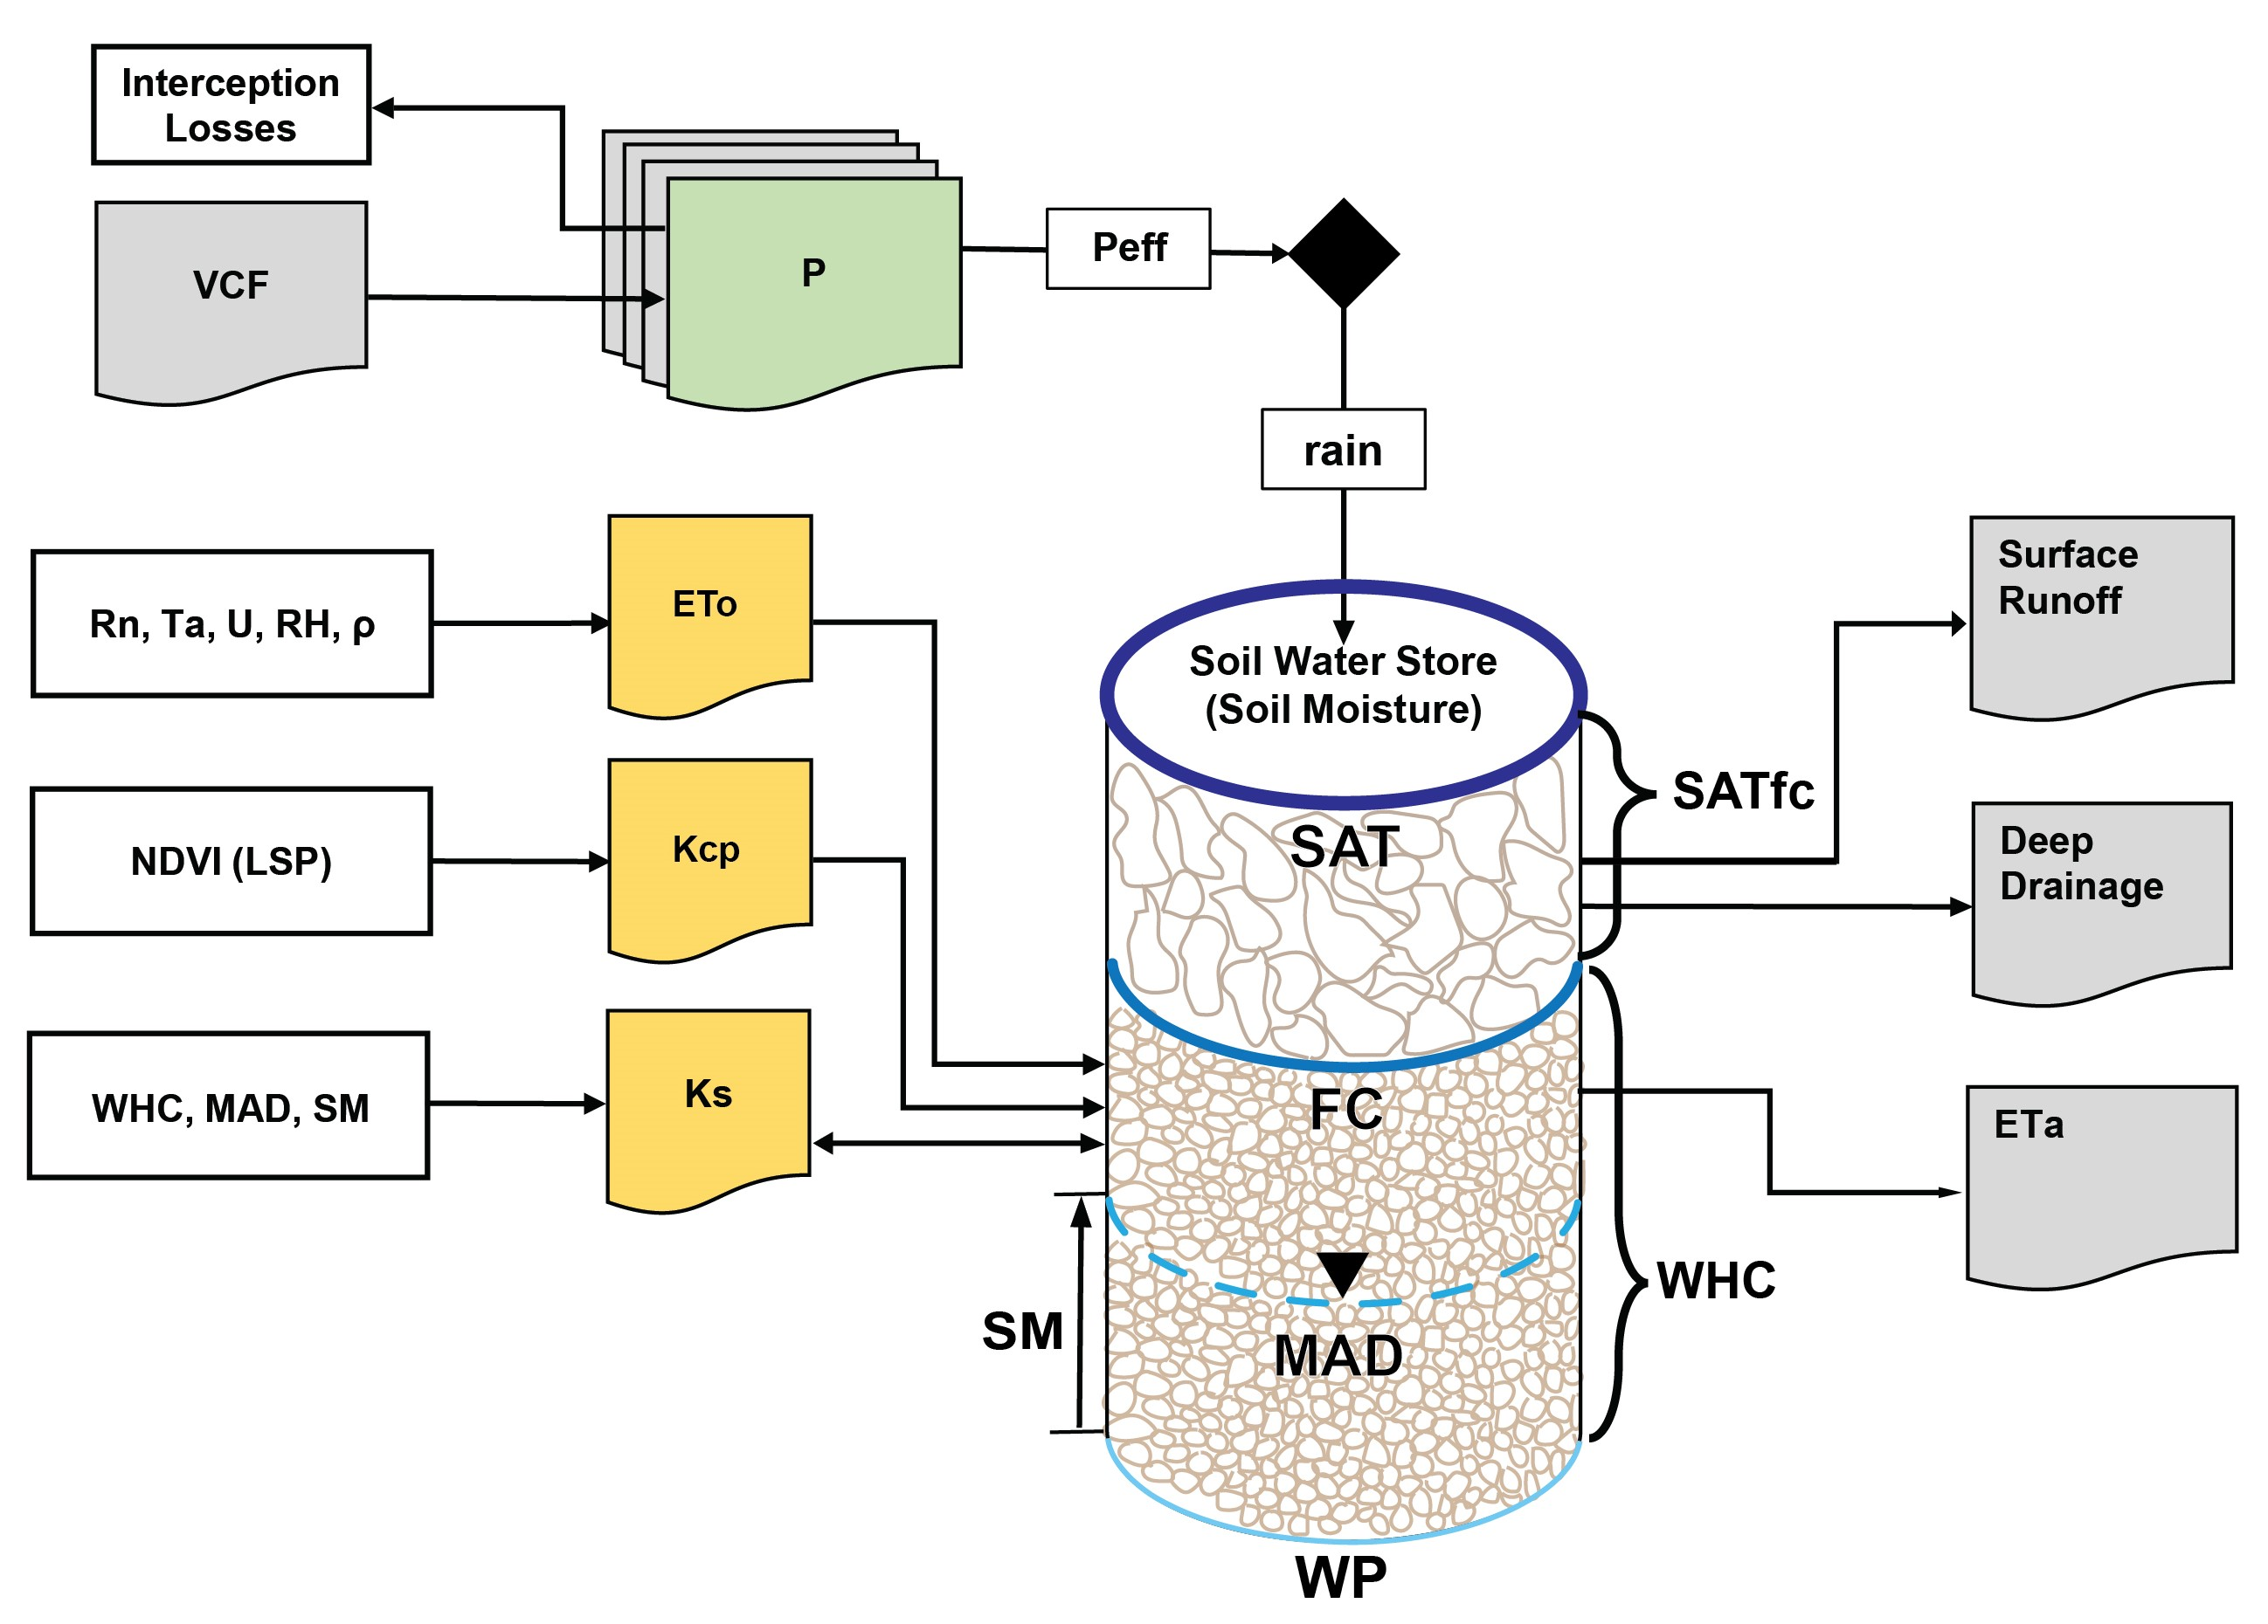Fig. 2. Conceptual diagram of the VegET model version 2.0 as modified from Senay et al ³³. This figure illustrates the updated VegET hydrological model, depicting the flow of water through the ecosystem. Key components include vegetation and climatic inputs that influence soil water dynamics, distinguishing between gravity water, which is filled once the soil moisture is above field capacity (FC) and plant available water, which is the section between FC and permanent wilting point (WP). The model integrates data such as Moderate Resolution Imaging (MODIS) Vegetation Continuous Fields (VCF) to derive interception fraction layer, precipitation (P), reference evapotranspiration (ETo), landscape water use coefficient (Kcp), land surface phenology (LSP), soil stress coefficient (Ks), water holding capacity (WHC), maximum allowable depletion (MAD), soil saturation (SAT), and volume between SAT and FC (SATfc). Outputs of the model include gridded surface runoff, deep drainage, soil moisture (SM), and actual evapotranspiration.

Deep drainage and surface runoff partitioning in VegET
In the VegET model's configuration, total runoff (R) is calculated as the sum of the rapid surface runoff and slower-moving deep drainage. A runoff coefficient approximation was introduced in VegET v2.0, allowing for the separation of the quick flow—runoff that immediately contributes to the stream network as surface water—from the deep drainage, which includes both lateral subsurface flow and the percolation reaching the groundwater table. Although this distinction does not affect the model's soil moisture or actual evapotranspiration (ETa) estimates, it enhances the model's utility for simulating flood dynamics and discharge. The deep drainage (dd) amount is estimated as the difference between total runoff (R) and quick flow (srf) (Eq. 1)
$dd=R-srf$ (1)
where R is determined as the daily SM greater than the soil water holding capacity; srf is estimated based on the daily soil water, a quick-flow coefficient (qc), drainage coefficient (dc), soil saturation (SAT), and field capacity (FC) parameters as in Eq. 2&3:
${SAT}_{fc}=SAT-FC$ (2)
$srf= \left\{\begin{aligned}qc×R, if \left(R≤{SAT}_{fc}\right) \\ R-{SAT}_{fc}+qc×{SAT}_{fc} , if \left(R{>SAT}_{fc}\right)\end{aligned}\right.$ (3)
where SATfc is the difference between SAT and FC; qc is the quick flow coefficient, which is a complement to the drainage coefficient (dc) as qc = 1 - dc. In this study, a sensitivity analysis of various combinations of 0.20, 0.30, 0.40, 0.45, and 0.50 of qc values were tested. Ultimately, a uniform value of 0.30 was used for qc as a first approximation; however, this partitioning coefficient is expected to vary by soil type and topography, and thus a calibration procedure is required to estimate this coefficient more accurately.

MizuRoute routing model implementation
Developed by Mizukami et al.³⁴, mizuRoute is a vector-based approach of river network routing tool. This tool utilizes river networks and their associated Hydrological Response Units (HRUs) to route gridded runoff into discharge. The HRUs and stream networks used in the mizuRoute implementation for Africa are sourced from the Hydrologic Derivatives for Modeling and Analysis (HDMA)³⁹ database, encompassing a network of 64,000 HRUs and streams across the African continent. The routing mechanism in mizuRoute begins with the allocation of gridded runoff data to river network HRUs, utilizing a weighted-area runoff method. Subsequently, hillslope routing, where water flow on slopes is modeled using a gamma distribution-based unit-hydrograph, and then river channel routing is executed. For simulating water movement through river channels, we used all five routing algorithms available in mizuRoute: Impulse Response Function-Unit Hydrograph (IRF), Lagrangean-based Kinematic Wave Tracking (KWT), Eulerian based Kinematic Wave (KW), Muskingum-Cunge (MC), and Diffusive Wave (DW).

Total runoff used in discharge routing and mizuRoute parametrization for Africa
In implementing mizuRoute for Africa, total gridded runoff is the primary input. However, it is important to recognize that not all components of deep drainage—including lateral subsurface flow and the percolation reaching the groundwater table—uniformly contribute to river discharge across Africa's varied landscapes. Consequently, only a fraction of base flow effectively contributes to discharge. To quantify this contribution, we computed the deep drainage fraction coefficient ($α)$. This coefficient is derived as a function of long-term (1970-2019) annual groundwater recharge⁴⁰ and long-term (2000-2020) independent annual runoff data from the Land Data Assimilation System (FLDAS)⁴¹. This relationship is described in Eq. 4:
$α=1-\frac{{GWR}_{mean}}{Q_{mean}}$ (4)

where ${GWR}_{mean}$ represents the mean annual total groundwater recharge and $Q_{mean}$ is the mean annual total runoff for Africa. This output is subsequently mapped into the HydroSHEDs-level Hydrological Response Units (HRUs) by averaging within each HRU (refer to Fig. 3a).
Additionally, our analysis of discharge estimation reveals that the VegET-based surface runoff tends to underestimate the surface runoff in tropical rainforests, notably in the Congo River Basin. The underestimation of surface runoff by the VegET model in tropical rainforests, such as the Congo River Basin, can be attributed to several factors. High vegetation density in tropical rainforests increases interception and evapotranspiration, making it challenging for models to accurately capture the complex interactions between vegetation and water processes⁴². Additionally, tropical regions often experience high-intensity rainfall events, and models like VegET may have limitations in simulating rapid surface runoff generation during such storms⁴³. Furthermore, precipitation recycling, where moisture evaporated from the land contributes to local precipitation, is particularly high in the Congo River Basin. Inaccuracies in representing this process can lead to underestimations of surface runoff^{44–46}. These factors collectively contribute to the observed underestimation of surface runoff in tropical rainforest regions by the VegET model.
To enhance the accuracy of discharge estimations in these areas, we introduced bias correction factors, as defined in Eq. 5:
$β=\frac{{srf}_{mean(FLDAS)}}{{srf}_{mean(VegET)}}$ (5)
Here, ${srf}_{mean(FLDAS)}$ is the mean annual surface runoff from FLDAS for the period 2000-2020, and ${srf}_{mean(VegET)}$ represents the VegET-based mean annual runoff for the same period (refer to Fig. 3b). The final total daily runoff field calculated for routing, therefore, is defined by Eq. 6:
R=(α×dd)+(β×srf) (6)
where R denotes the total daily runoff, α is the deep drainage fraction coefficient, dd signifies deep drainage, and β is the bias correction factor for surface runoff (srf).

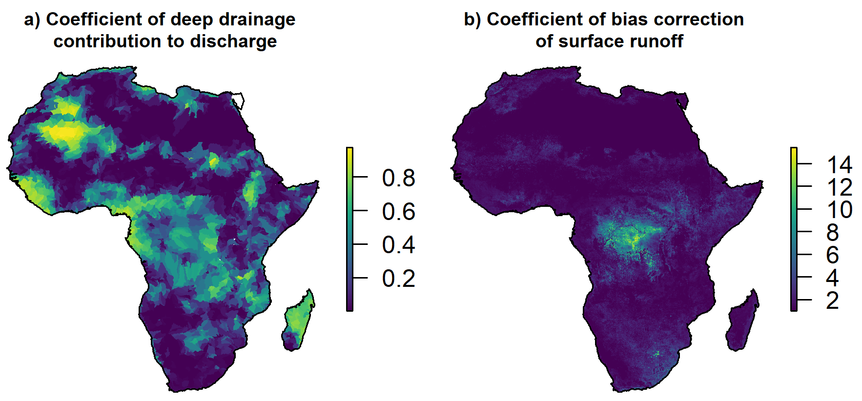 Fig. 3. Spatial distribution of hydrological coefficients across Africa. Fig. 3a) The map displays the coefficient of deep drainage contribution to discharge (α). High values indicate contribution of deep drainage to river discharge, predominantly as base flow, with varying intensities across the continent. Fig. 3b) The map illustrates the coefficient of bias correction for surface runoff (β). This coefficient adjusts for the underestimation of surface runoff by VegET, especially evident in the tropical rainforests of the Congo River Basin. The color gradients provide insights into the spatial variability of both coefficients.
Sensitivity analysis during mizuRoute parametrization
We conducted a thorough sensitivity analysis using 12 different parameter options to optimize mizuRoute's performance (Table 1), taking reference from Mizukami et al.³⁵. Key parameters such as Manning's coefficient and river width scale factor were adjusted across a range of values to understand their influence on the routing process. For hillslope routing, we examined the shape and timescale factors, whereas for channel routing, the wave velocity and diffusivity parameters in the Impulse Response Function-Unit Hydrograph (IRF-UH) and Kinematic Wave Tracking (KWT) algorithms were varied.

Table 1. Sensitivity analysis of mizuRoute routing parameters. This table presents the configurations tested in the sensitivity analysis of the mizuRoute model for the Kinematic Wave Tracking (KWT) and Impulse Response Function-Unit Hydrograph (IRF-UH) routing methods. The parameters include shape and timescale factors for hillslope routing, Manning coefficient, and river width scale factor for KWT, as well as wave velocity and diffusivity for IRF-UH. Twelve optimization options (Opt0 through Opt12) were evaluated against default values to determine their effect on model performance, with the 'Values used' column representing the chosen settings for the final model run based on optimal results.
Parameters | Routing  methods | Descriptions | Default Values | Values used | Opt0 | Opt1 | Opt2 | Opt3 | Opt4 | Opt5 | Opt6 | Opt7 | Opt8 | Opt9 | Opt10 | Opt11 | Opt12
$$a$$ | Hillslope | Shape  factor [–] | 2.5 | 2.5 | 2.5 | 2.5 | 2.5 | 2.5 | 2.5 | 2.5 | 2.5 | 2.5 | 2.5 | 2.5 | 2.5 | 2.5 | 2.5
$$θ$$ | Hillslope | Timescale factor [s] | 86400 | 86400 | 86400 | 86400 | 86400 | 86400 | 86400 | 86400 | 86400 | 86400 | 86400 | 86400 | 86400 | 86400 | 86400
$$n$$ | KWT, KW, MC, DW | Manning coefficient [–] | 0.01 | 0.07 | 0.01 | 0.02 | 0.02 | 0.03 | 0.04 | 0.05 | 0.06 | 0.07 | 0.07 | 0.07 | 0.08 | 0.08 | 0.08
$$W$$ | KWT, KW, MC, DW | River width scale factor [–] | 0.001 | 0.002 | 0.001 | 0.001 | 0.002 | 0.002 | 0.002 | 0.002 | 0.002 | 0.002 | 0.001 | 0.003 | 0.001 | 0.002 | 0.003
$$C$$ | IRF | Wave velocity [ms⁻¹] | 1.5 | 3 | 1.5 | 1.6 | 1.8 | 2 | 2.2 | 2.5 | 2.8 | 3 | 1.4 | 1.2 | 1 | 0.8 | 0.5
$$D$$ | IRF | Diffusivity [m²s⁻¹] | 800 | 1000 | 800 | 820 | 840 | 860 | 880 | 900 | 950 | 1000 | 700 | 600 | 400 | 300 | 200

Dataset used in VegET, mizuRoute implementation and evaluation
The VegET v2.0, deployed across continental Africa, integrates a variety of input datasets, such as precipitation, reference evapotranspiration (ETo), land surface phenology, and soil properties (refer to Table 2 for dataset details). Using a previous multi-scale assessment of eight products for continental application on the accuracy of satellite and reanalysis rainfall estimates over Africa⁴⁷, we considered 3 rainfall products, namely Climate Hazards Group InfraRed Precipitation with Station Data (CHIRPS)⁴⁸, the European Centre for Medium-Range Weather Forecasts (ECMWF) Reanalysis (ERA5)⁴⁹, Multi-Source Weighted-Ensemble Precipitation (MSWEP)⁵⁰. The land surface phenology (LSP) within the model is derived from the MODIS NDVI, sourced from NASA’s Land Processes Distributed Active Archive Center (LP DAAC)³⁷. We established a daily median NDVI for the period 2003–2017 using linear interpolation from the 8-day composite data from both Aqua and Terra satellites. The reference evapotranspiration (ETo) data was acquired from NOAA⁵¹. We developed an interception fraction layer based on the MODIS Vegetation Continuous Fields (VCF)⁵². This layer calculates interception as a function of the proportion of tree, herbaceous, and bare coverage in each pixel, following Eq. 7 as defined in Senay et al.³³:
$Interception=0.15×Tcover+0.1×Hcover + 0.0 ×Bcover$ (7)
where Tcover represents tree cover (%) with a maximum interception of 15%, Hcover represents herbaceous cover (%) with a maximum interception of 10%, and Bcover represents bare ground cover (%) which contributes no interception.
Soil property data are used for generating Water Holding Capacity (WHC), Field Capacity (FC), and Porosity (POR) layers, were obtained from the International Soil Reference and Information Centre (ISRIC) via their Soil Data Hub³⁶. The POR layer was particularly used to indicate soil saturation (SAT) levels. To transform these raster data from a volumetric percentage (m³/m³) to depth (mm) per meter of root-zone, a unit conversion factor of 10 was applied³³. Additionally, we ensured that the SAT values did not fall below the FC levels. Specific datasets, including ETo, were converted from their native NetCDF format to the GeoTiff format. We used G-RUN⁵³ and FLDAS runoff⁴¹ data to evaluate VegET runoff data. For VegDischarge data evaluation, the Global Runoff Data Centre (GRDC) discharge data for Africa⁵⁴ was used.

Table 2. Summary of data used in the study.
Parameters | Spatial Resolution | Temporal Resolution | Reference
Precipitation: CHIPRS | 0.05  ° | Daily; 1981—current | CHIRPS⁴⁸
Precipitation: ERA5 | 0.25  ° | Daily; 1979 —current | ERA5⁴⁹
Precipitation: MSWEP | 0.1  ° | Daily; 1979 —current | MSWEP⁵⁰
Land Surface Phenology | 1km | Every 8 days (Aqua and Terra); 2003–2017 | MODIS NDVI³⁷
Reference Evapotranspiration | 0.625°  x 0.5  ° | daily; 1980-present | NOAA ETo⁵¹
Soil Properties | 250 m | Static | ISRIC³⁶
Interception | 250 m | Static | MODIS VCF⁵²
Runoff (surface and sub surface and total runoff) (FLDAS) | 1km | Monthly; 2000-2020 | FLDAS⁴¹
Global RUNoff ENSEMBLE (G-RUN ENSEMBLE) | 0.5° | Static | G-RUN⁵³
HRU and river segments | 3-arc- second | Static | HDMA⁵⁵
Discharge data (GRDC) | - | Multiple date availability | GRDC⁵⁴

Data Records
The VegHydro v1 dataset is a comprehensive hydrological dataset that offers monthly and annual discharge data across Africa from 2000 to 2021. This dataset is derived from the VegET hydrological model coupled with the mizuRoute routing framework. The VegET model simulates high-resolution (1-km x 1-km) monthly gridded data, including deep drainage (subsurface runoff), surface runoff, and total runoff for the African continent, collectively called VegHydro v1 dataset. This model is forced by multiple previously mentioned (Table 2) precipitation datasets, such as CHIRPS, ERA5, and MSWEP, to cater to different hydrological analyses.
In addition to gridded runoff data, the VegHydro v1 dataset includes annual routed discharge data for over 64,000 river segments in Africa. This is achieved using various routing algorithms, including Direct Wave (DW), Kinematic Wave (KW), Kinematic Wave Tracking (KWT), Muskingum-Cunge (MC), and Instantaneous Response Function (IRF), to capture the diversity in discharge behavior across different river systems. Each river segment within the dataset is uniquely identified by a 'seg_id', allowing for detailed spatial analyses. The discharge values are presented in columns corresponding to each year from 2000 to 2021.
The data are stored in NetCDF format for the gridded monthly runoff and shapefile format for the annual total discharge, both of which are available for download (described below) to facilitate their use in water resource management, climate change studies, and various other hydrological analyses. However, the monthly routed discharge data are a critical component of the VegDischarge v1 dataset that provides a detailed temporal resolution of discharge patterns and is made available upon request. This provision ensures that researchers and policymakers have access to the most relevant and detailed information for their specific needs.
The complete VegHydro dataset is available at https://doi.org/10.5066/P14H6TFY⁵⁶.

Technical Validation
In the technical validation of the model, several statistical measures are used to evaluate its performance. The Nash-Sutcliffe efficiency (NSE)⁵⁷ (Eq. 8) is a key metric that assesses the predictive power of the model, with values closer to 1 indicating higher accuracy. The Kling-Gupta Efficiency (KGE)⁵⁸ (Eq. 9) is another measure, developed to provide a more nuanced understanding of the model's performance by analysing the correlation, bias, and variability in the simulated and observed data. The Percent Bias (PBIAS) (Eq. 10) is also used to assess the model's accuracy. PBIAS measures the average tendency of the simulated data to be larger or smaller than their observed counterparts, indicating the overall bias in the model's predictions. A PBIAS value close to zero indicates an accurate model, whereas positive or negative values reveal the degree and direction of bias. Lastly, the coefficient of determination (R²) (Eq. 11) is used, offering insight into the correlation strength between the observed and simulated values. These metrics collectively offer a comprehensive evaluation of the model's predictive capabilities in the context of hydrological modelling.
$NSE=1-\frac{\sum_{t=1}^{n}{{\left(X_{s,t}-X_{o,t}\right)}^{2}}}{\sum_{t=1}^{n}{{\left(X_{o,t}-μ_{o}\right)}^{2}}}$ (8)
$KGE=1-\sqrt{{\left(r-1\right)}^{2}+{\left(α-1\right)}^{2}+{\left(β-1\right)}^{2}}$ (9)
$PBIAS=100×\frac{\sum_{t=1}^{n}{\left(X_{s,t}-X_{o,t}\right)}}{\sum_{t=1}^{n}{\left(X_{o,t}\right)}}$ (10)
$R^{2}= {\left[\frac{\sum_{t=1}^{n}{\left(X_{o,t}-μ_{o}\right)\left(X_{s,t}-μ_{s}\right)}}{\sqrt{\sum_{t=1}^{n}{{\left(X_{o,t}-μ_{o}\right)}^{2}}}\sqrt{\sum_{t=1}^{n}{{\left(X_{s,t}-μ_{s}\right)}^{2}}}}\right]}^{2}$ (11)
where n is the total number of time-steps, $X_{s,t}$ is the simulated value at time-step t, $X_{o,t}$ is the observed value at time-step t, $μ_{o}$ and $σ_{o}$ are the mean and standard deviation, respectively, of the observed values, and $μ_{s}$ is the mean of the simulated values.
$β={μ_{s}}/{μ_{o}}$; $β$ is the ratio between the mean simulated and mean observed flows; where $r$ is the linear correlation coefficient between $X_{s}$ and $X_{o}$; $α= {σ_{s}}/{σ_{o}}$; αwhere the quantity α is a measure of relative variability in the simulated and observed values.

Annual Discharge evaluation
Fig. 4 illustrates a comprehensive performance evaluation of the VegET-mizuRoute discharge (hereafter called VegDischarge v1) for selected river basin outlets near the oceans, demonstrating its efficacy in simulating annual discharge across various African river basins. Although the model performed well across the board, certain nuances in basin-specific hydrology have led to variations in accuracy. Notably, the model slightly underestimated the annual discharge of the Congo River Basin (long-term average of 1100 km³·year⁻¹ from VegDischarge data compared to 1200 km³·year⁻¹), the largest contributor to Africa's total river flow, accounting for approximately 30% of the continent's discharge⁵⁹. Our estimates indicate an annual discharge of around 1100 km³·year⁻¹, which falls short of the observed 1200 km³·year⁻¹ ⁵⁹. This underestimation may be attributed to the complexity of the Congo River Basin's hydrological processes⁶⁰, which the VegET component of the model struggled to fully capture.
Conversely, the discharge into the Mediterranean Sea from the Nile River Basin was overestimated by 156 km³·year⁻¹against 38 km³·year⁻¹suggested by Struglia et al.⁶¹ (note that other studies suggest a value of 2.5-4.0 km³·year⁻¹ ⁶²). Despite the model's calibration to observed flows, it tends to simulate a naturalized flow scenario for many basins. In the case of the Nile River, the important human withdrawals within Egypt⁶² and Sudan (estimated for both countries to about 84 km³·year⁻¹ for irrigation alone with reference to 2011⁶³) are not accounted for in the model, leading to a simulated discharge that is considerably higher than the actual flow reaching the Mediterranean. Given Egypt's heavy reliance on the Nile River for its water needs, the disparity between the simulated and actual flows into the sea emphasizes the importance of incorporating human water use and management practices into the model for a more accurate representation of discharge volumes.

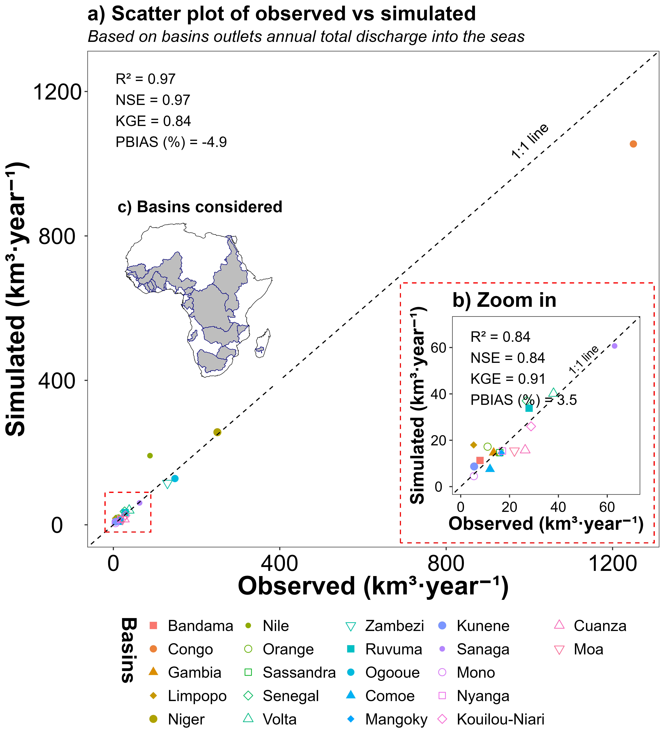Fig. 4. Performance evaluation of the VegDischarge v1 data for selected African river basins. The scatter plot a) compares the annual observed discharge (x-axis) with the simulated discharge (y-axis) from the VegDischarge v1 data for selected river basin outlets discharge into the seas in Africa. Inset b) provides a detailed view of basins with lower discharge volumes (≤ 70 km³·year⁻¹), and c) shows the African map with considered basins. R²=coefficient of determination; NSE=Nash-Sutcliffe efficiency; KGE=Kling-Gupta Efficiency; PBIAS=Percent Bias.
Fig. 5 presents an expansive evaluation of the VegDischarge v1 performance using a comprehensive dataset of 242 Global Runoff Data Centre (GRDC)⁵⁴ stations spread across Africa with different time periods of data availability. The scatter plot demonstrates the model's ability to simulate annual total discharge with high fidelity when compared to observed data, as indicated by robust performance metrics: R² value of 0.97, NSE of 0.95, KGE of 0.84, and PBIAS of 1.2%. These statistics indicate that the model's simulations align closely with observed runoff patterns across various hydrological environments and temporal data availability within the continent.

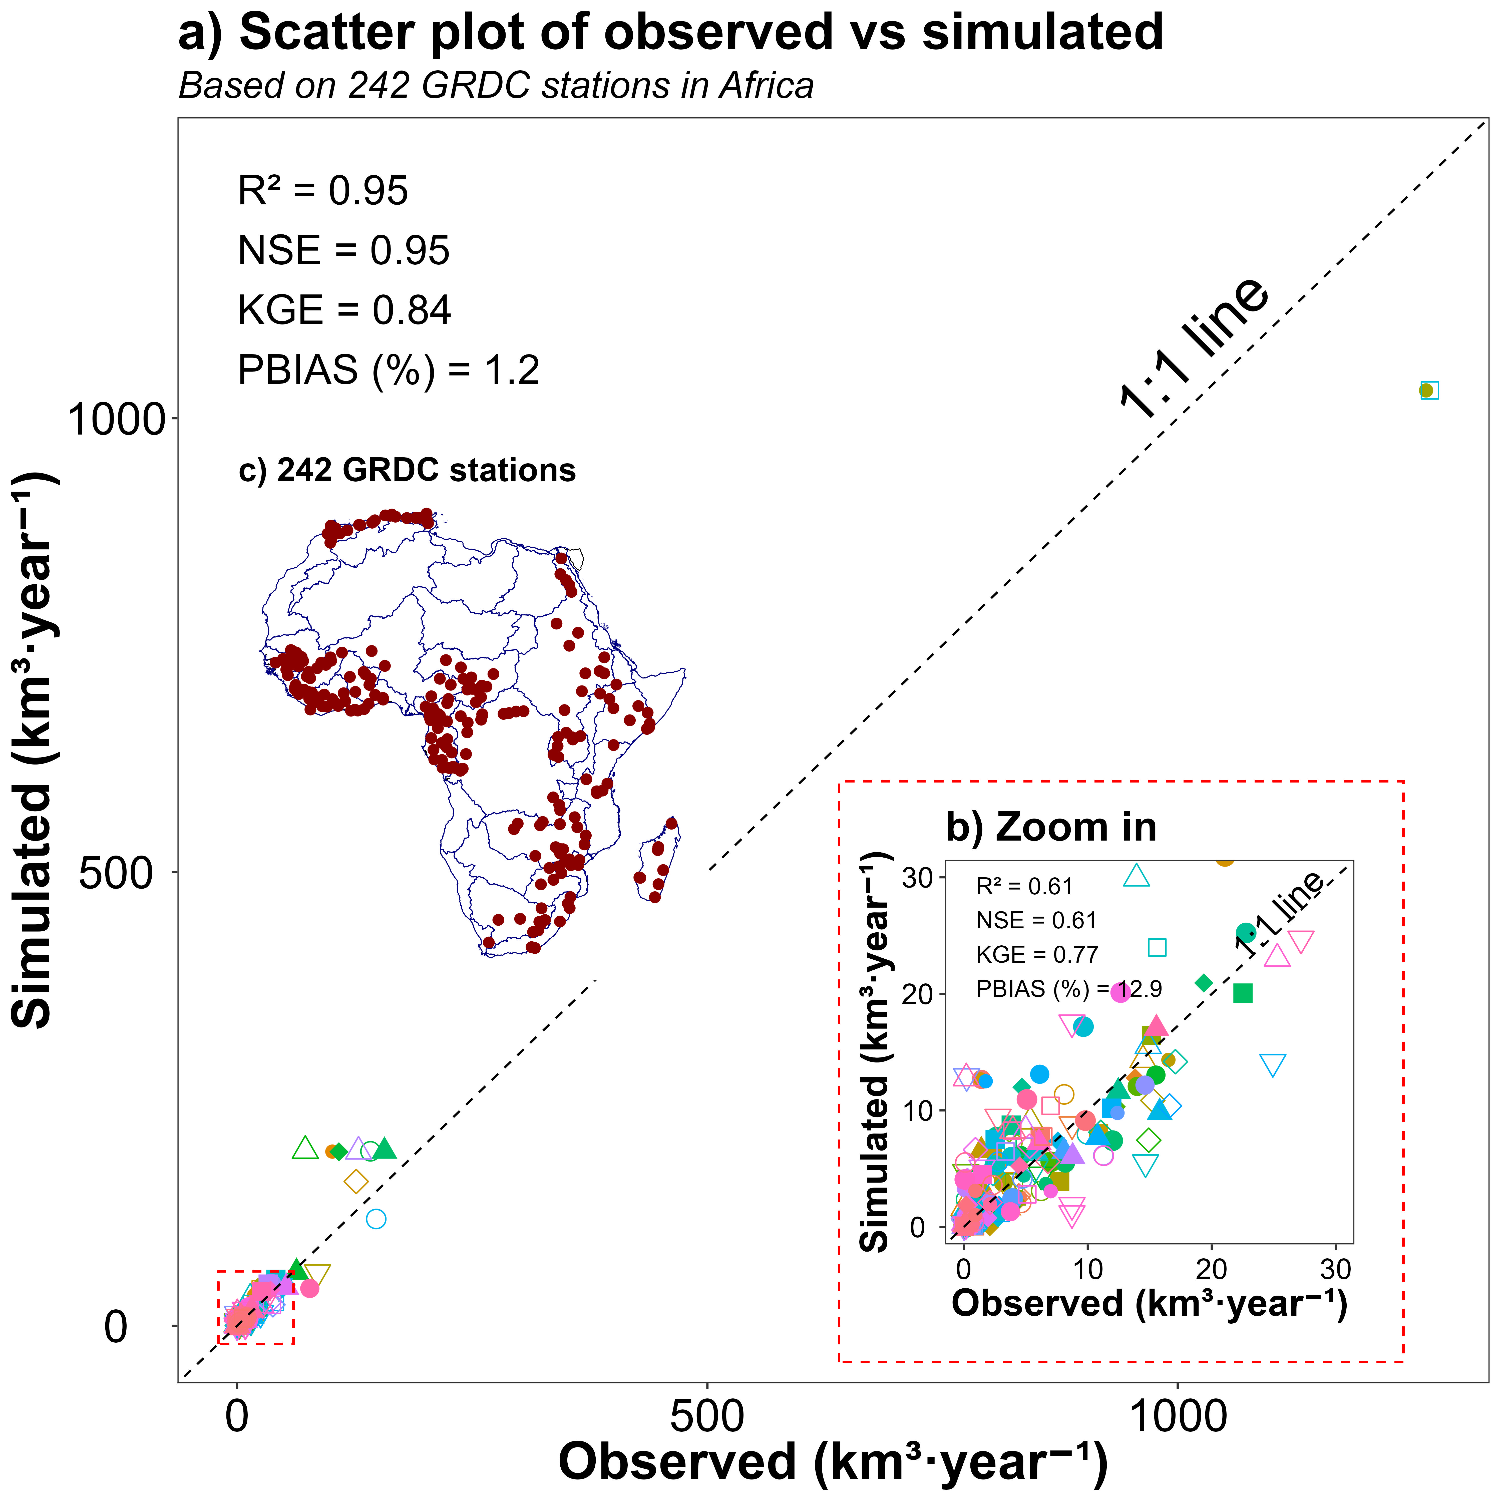
Fig. 5. Comprehensive validation of the VegDischarge v1 across Africa using GRDC data. Fig. 5a) contrasts observed annual total discharge data from 242 Global Runoff Data Centre (GRDC)⁵⁴ stations with simulated values from the VegDischarge v1 data, reflecting the model's high accuracy in replicating discharge across varying hydrological contexts and time frames within the African continent. The inset b) zooms in on stations with lower discharge volumes (≤ 30 km³·year⁻¹), ensuring a granular analysis of model performance in smaller basins, and c) shows the African map with the locations of the gauge stations. R²=coefficient of determination; NSE=Nash-Sutcliffe efficiency; KGE=Kling-Gupta Efficiency; PBIAS=Percent Bias.
Fig. 6&7 show a regional analysis of the VegDischarge v1 performance in North Africa and the Nile River Basin within Egypt and Sudan, respectively. Fig. 6 focuses on Morocco, Algeria, and Tunisia, where a divergence from the 1:1 line is evident, indicating discrepancies between observed and simulated flows. This divergence is reflective of the historical dataset used from the GRDC⁵⁴, which spans several decades prior to the period modeled by VegET/mizuRoute (2000-2021). Given the years of drought in North Africa^{64,65}, these discrepancies, particularly in magnitude, can be attributed to changes in hydrological patterns over time⁶⁶. Despite this, the R², KGE, and NSE values remain within values ≥ 0.5 indicating the model’s ability to capture the overall variability of the hydrological regime. Fig. 7 shows the performance in Egypt and Sudan, where downstream flows are notably overestimated. This overestimation is due to the model's representation of naturalized flow, which does not account for substantial human withdrawals, especially in Egypt, where the Nile River is extensively utilized for agricultural and domestic purposes. However, for basins located downstream, the model reflects more accurately the observed flows, mainly in Sudan (refer to Fig. 7a).

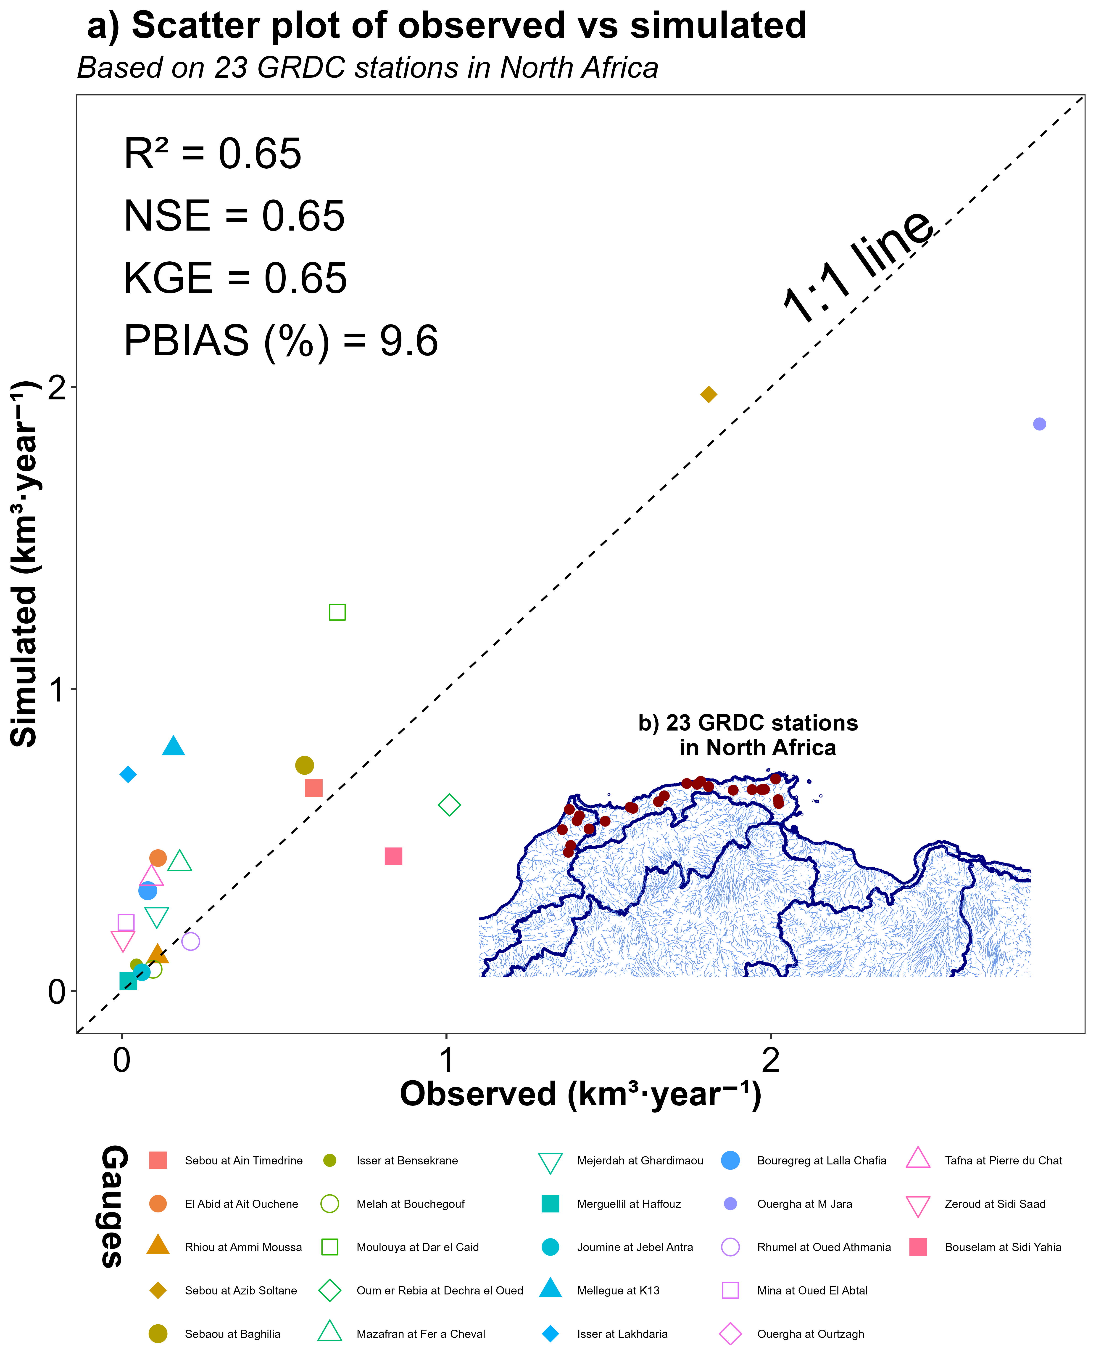
Fig. 6. Regional comparison of simulated discharge by VegDischarge v1 to observations from various years of historical data availability in the Global Runoff Data Centre (GRDC)⁵⁴ database for North Africa. Panel a) depicts the model's performance in Morocco, Algeria, and Tunisia, showing less agreement with observed data due to historical hydrological changes and droughts in the years 2000-2021⁶⁵. Panel b) shows the spatial distribution of 23 GRDC gauge stations in North Africa. R²=coefficient of determination; NSE=Nash-Sutcliffe efficiency; KGE=Kling-Gupta Efficiency; PBIAS=Percent Bias.
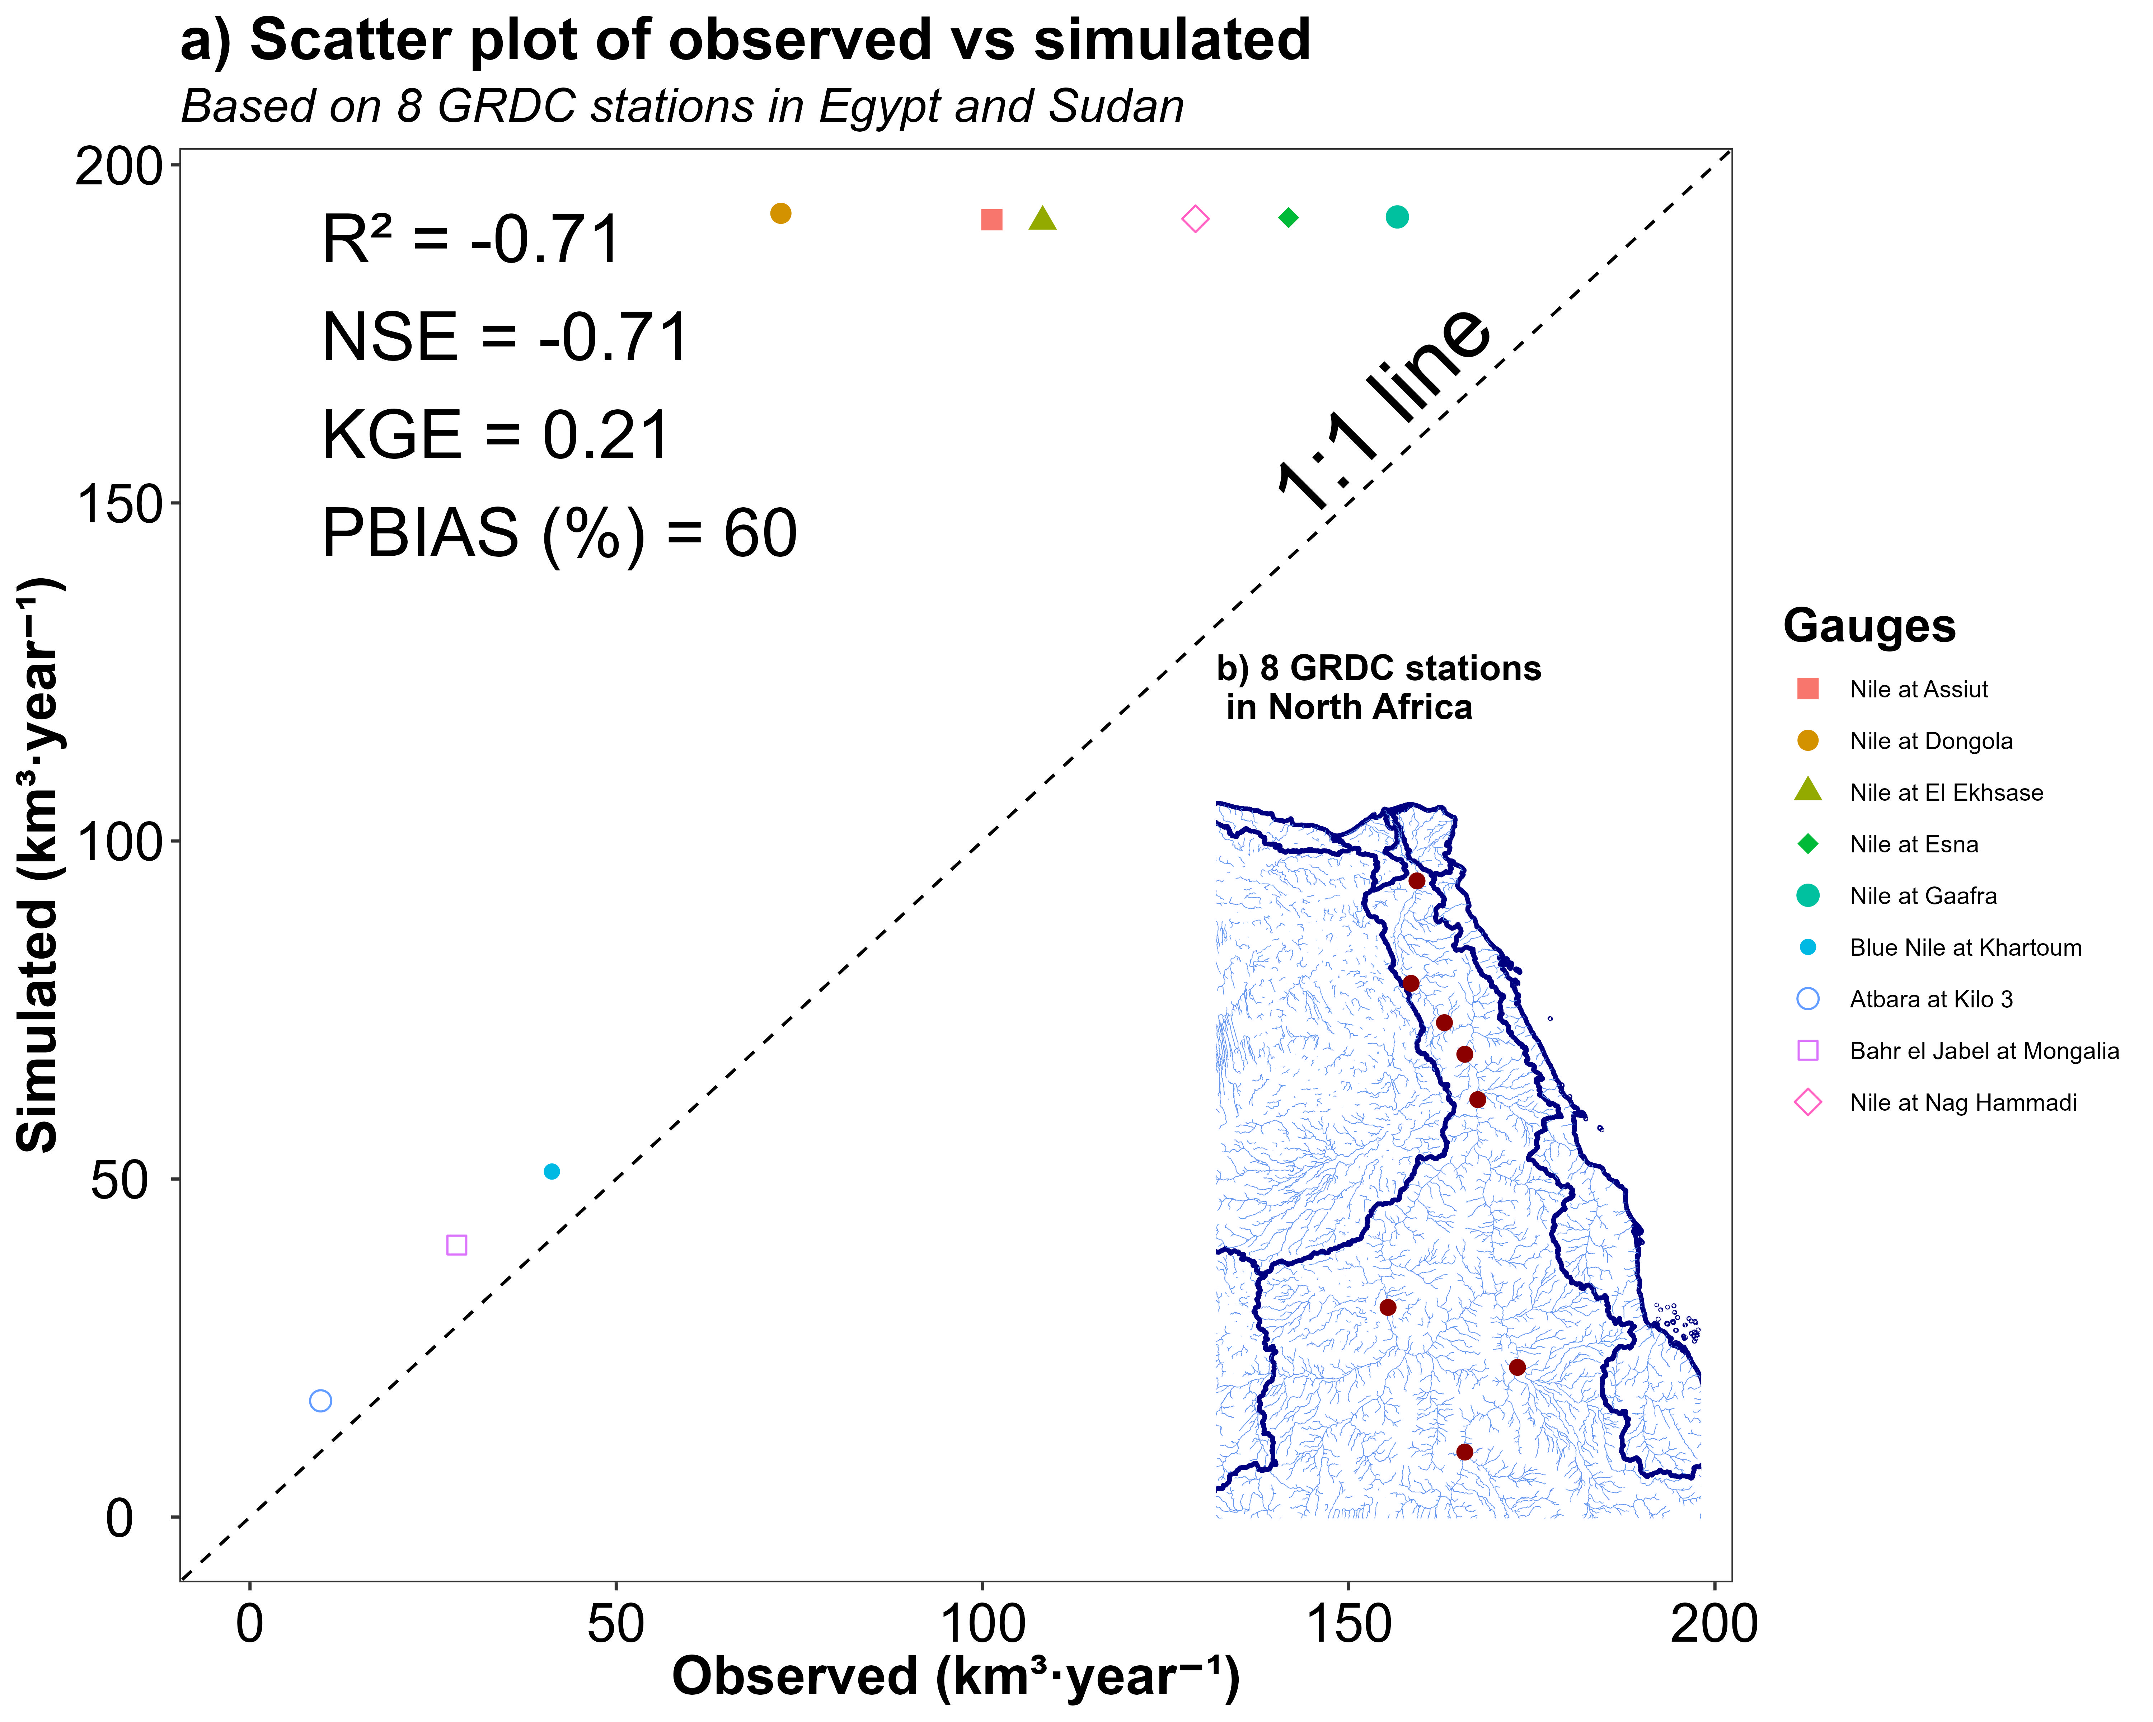
Fig. 7. Regional comparison of simulated discharge by VegDischarge v1 to observations from various years of historical data availability in the Global Runoff Data Centre (GRDC)⁵⁴ database for the Nile River Basin. Panel a) illustrates overestimated downstream flows in Egypt and Sudan due to the model's naturalized flow representation not accounting for human withdrawals, although it captures observed flows accurately in lower basins. Panel b) shows the spatial distribution of 9 GRCD gauge stations in the Nile River Basin. R²=coefficient of determination; NSE=Nash-Sutcliffe efficiency; KGE=Kling-Gupta Efficiency; PBIAS=Percent Bias.
Blank due to formatting
VegDischarge v1 performance in East and Southern Africa, based on the observed vs. simulated discharge data from GRDC stations, is presented in Fig. 8&9. Fig. 8a showcases the model's performance in East Africa, based on data from 30 GRDC stations. The scatter plot indicates a good agreement between observed and simulated discharge values, with an R² of 0.72, which indicates that the model explains the variance in the observed data. The NSE of 0.68 and KGE of 0.61 further confirm the model's satisfactory performance in this region. However, the PBIAS of -7.6% indicates a slight underestimation of the observed flows by the model, which is more evident for gauges with flows ≤ 18 km³·year⁻¹ (Fig. 8b). Fig. 9a provides a visualization of the model's performance in Southern Africa, utilizing data from 51 GRDC stations. The model demonstrates a strong correlation with observed data, as evidenced by the R² of 0.82. The NSE of 0.82 and KGE of 0.78 reflect a high level of accuracy in the model's simulations relative to the observed flows. However, the PBIAS of 20.4% points to a more substantial overestimation of discharge for some stations in this region, especially at the gauges with discharge ≤ 0.7 km³·year⁻¹ (Fig. 9b). The hydrological extremes observed in East and Southern Africa, evidenced by contrasting episodes of droughts and floods, may not be adequately captured by VegDischarge v1 due to several factors. In regions such as the Horn of Africa and Southern Africa, recurrent drought conditions (drought has prevailed in Greater Horn of Africa during much of the period 2008-2011⁶⁷, while in Southern Africa, one drought occurred every three to five years in the period from 1980 to 2007⁶⁸) can affect the parameterization of hydrological models, leading to underestimation of actual water stress^{69,70}.
Fig. 8. Regional comparison of simulated discharge by VegDischarge v1 to observations from various years of historical data availability in the Global Runoff Data Centre (GRDC)⁵⁴ database East Africa (Panel a), while b) zooms in on stations with lower discharge volumes (≤ 18 km³·year⁻¹). Panel c) shows the spatial distribution of 30 GRDC gauge stations in East Africa. R²=coefficient of determination; NSE=Nash-Sutcliffe efficiency; KGE=Kling-Gupta Efficiency; PBIAS=Percent Bias.

Fig. 9. Regional comparison of simulated discharge by VegDischarge v1 to observations from various years of historical data availability in the Global Runoff Data Centre (GRDC)⁵⁴ database for Southern Africa (Panel a). Panel b) zooms in on stations with lower discharge volumes (≤ 0.7 km³·year⁻¹). Panel c) shows the spatial distribution of 51 GRDC gauge stations in Southern Africa. R²=coefficient of determination; NSE=Nash-Sutcliffe efficiency; KGE=Kling-Gupta Efficiency; PBIAS=Percent Bias.
Fig. 10&11 offer a comprehensive analysis of the VegDischarge v1 performance in West and Central Africa based on GRDC station data. Fig. 10a reflects the performance in West Africa with data from 73 GRDC stations. The scatter plot shows a high coefficient of determination (R²) of 0.83, indicating a strong linear relationship between the observed and simulated discharge. The Nash-Sutcliffe efficiency (NSE) of 0.83 and Kling-Gupta Efficiency (KGE) of 0.7 indicate the model's simulations are in good agreement with the observed data. However, the positive Percent Bias (PBIAS) of 28.4% indicates an overestimation in the simulated discharge, with bias higher for gauges with ≤ 10 km³·year⁻¹ (Fig. 10b). Fig. 11a depicts the model's performance in Central Africa, where data from 56 GRDC stations were used. Here, the model achieves an R² of 0.96 and an NSE of 0.96, indicating excellent model accuracy and predictive power. The KGE value of 0.76 further confirms the strong performance. The PBIAS of -15% indicates a moderate underestimation of discharge volumes, which could be due to factors not captured by the model. Furthermore, the complexity of capturing high-intensity rainfall that leads to flooding, especially in regions like the Congo River Basin, poses a challenge. Bias in the model's ability to simulate surface runoff in tropical rainforests contributes to discrepancies in flood estimation⁷¹. More specifically, underestimation of surface runoff by the VegET model in tropical rainforests, such as the Congo River Basin, can be attributed to several key factors: (1) high vegetation density in these regions increases interception and evapotranspiration, posing challenges for models to accurately capture the complex interactions between vegetation and water processes, leading to runoff underestimation⁴²; (2) tropical regions such as Congo River Basin often experience high-intensity rainfall events, which can be difficult for models like VegET to simulate accurately, resulting in potential underestimation of rapid surface runoff generation during such storm⁴³; (3) precipitation recycling, where moisture evaporated from the land contributes to local precipitation. The Amazon and Congo River Basins have the highest precipitation recycling rates globally, and inaccuracies in modeling this process can lead to further underestimations of surface runoff^{44–46}. Collectively, these factors contribute to the observed underestimation of surface runoff in tropical rainforest regions by the VegET model.

Fig. 10. Regional comparison of simulated discharge by VegDischarge v1 to observations from various years of historical data availability in the Global Runoff Data Centre (GRDC)⁵⁴ database for West Africa (Panel a). Panel b) zooms in on stations with lower discharge volumes (≤ 10 km³·year⁻¹). Panel c) shows the spatial distribution of 73 GRDC gauge stations in West Africa. R²=coefficient of determination; NSE=Nash-Sutcliffe efficiency; KGE=Kling-Gupta Efficiency; PBIAS=Percent Bias.

Fig. 11. Regional comparison of simulated discharge by VegDischarge v1 to observations from various years of historical data availability in the Global Runoff Data Centre (GRDC)⁵⁴ database for Central Africa (Panel a). Panel b) zooms in on stations with lower discharge volumes (≤ 50 km³·year⁻¹). Panel c) shows the spatial distribution of 56 GRDC gauge stations in Central Africa. R²=coefficient of determination; NSE=Nash-Sutcliffe efficiency; KGE=Kling-Gupta Efficiency; PBIAS=Percent Bias.

Monthly discharge evaluation
We assessed skills of monthly discharges simulated by VegDischarge v1 throughout Africa for the period (2000-2021). In Fig. 12, we compared two routing algorithms, Kinematic Wave (KW) (Fig. 12a) and Kinematic Wave Tracking (KWT) (Fig. 9b) routing algorithms using monthly discharge data of the GRDC dataset. The spatial distributions delineate areas where the model accurately simulates discharge versus regions where model performance is suboptimal. Fig. 12a&b show that VegDischarge v1 data for northern Africa and the Horn of Africa are less accurate (R² <0.3) as compared to other regions due to reasons previously discussed. Histograms in Fig. 12c and 12d categorize the number of stations by R² intervals for the KW and KWT algorithms, respectively, revealing the distribution of model performance metrics. Most stations are clustered in the higher R² categories (0.7-0.9) (Fig. 12c&d), indicating a robust model agreement with observations. Yet, several stations fall into lower R² categories, with 78 stations for KW and 77 stations for KWT being below 0.5, indicating regions where model improvements are necessary, potentially due to structural model issues, data quality, or complex regional hydrological phenomena such precipitation recycling^{44–46} not adequately captured. The findings imply that stations with low R² would benefit from refined calibration processes, integrating specific hydrological behaviors and catchment characteristics. These insights could also inform targeted enhancements in data collection to diminish uncertainties and refine model inputs, thereby advancing the model's utility for hydrologists and water resource managers.

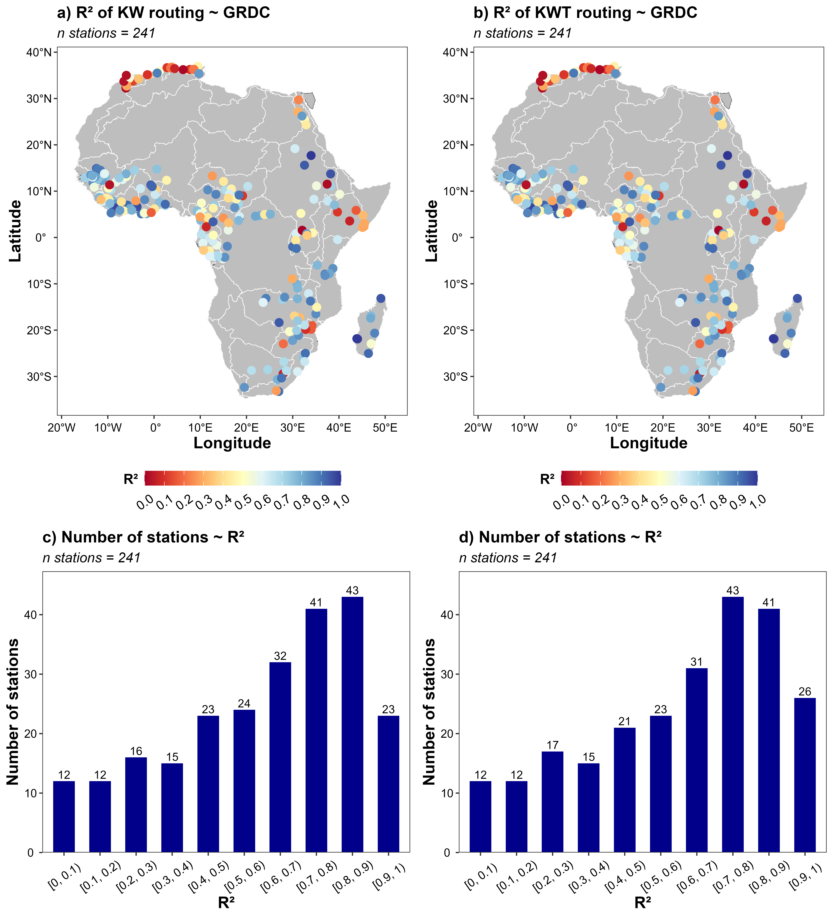

Fig. 12. Spatial distribution and frequency of coefficient of determination (R²) values for VegDischarge v1 performance from 2000-2021 using Kinematic Wave (KW) and Kinematic Wave Tracking (KWT) routing algorithms. Panels a) and b) map the R² values for each Global Runoff Data Centre (GRDC)⁵⁴ station using KW and KWT routing, respectively, while Panels c) and d) show the number of stations within specific R² bins, illustrating the model's performance ranges across Africa.
Blank due to formatting
Spatial distribution of VegDischarge v1
The spatial distribution of monthly average discharge derived from the VegDischarge v1 for the period 2000-2021 is depicted in a series of maps representing each month of the year (Fig. 13). These maps illustrate the dynamic nature of river discharge across major African river basins, including the Niger, Congo, Nile, Zambezi, Orange, Volta, Senegal, and Ogoue. During the periods from November through April, high flow conditions are primarily simulated in river basins situated south of the equator, with the notable exception of the Niger and Nile Rivers, where large discharge is observed. This pattern aligns with the southern hemisphere's wet season, which is influenced by the seasonal migration of the Intertropical Convergence Zone (ITCZ). As the ITCZ shifts southward, it brings increased precipitation rates, contributing to higher river flows. Conversely, from May to October, the high flow regimes shift predominantly to the Congo River Basin and extend to rivers north of the equator. This transition corresponds with the northern hemisphere's wet season, particularly affecting the West African monsoon system, which influences discharge rates in rivers such as the Niger, Senegal, Gambia, and Volta. This climatological pattern underscores the influence of seasonal precipitation variations driven by the ITCZ across the continent. The equatorial rivers, especially the Congo River, exhibit less variability in discharge throughout the year, reflecting the region's precipitation patterns. In contrast, the seasonal patterns of the Niger and Zambezi Rivers exhibit marked fluctuations that correspond to their respective wet and dry seasons. The VegDischarge v1 depiction of average discharge offers valuable insights for water resource management, highlighting the temporal and spatial variations in water availability. Understanding these patterns is critical for the planning and operation of water-related infrastructure, such as dams and irrigation systems, and for the formulation of strategies to mitigate the effects of both floods and droughts within the basins.

Fig. 13. Monthly average discharge in major African river basins (2000-2021) derived from the VegDischarge v1. These maps present the monthly distribution of river discharge across Africa, revealing the seasonal dynamics of flow in major river basins. High flow periods south of the equator from November to April and north of the equator from May to October are highlighted, illustrating the influence of latitudinal shifts in precipitation patterns on river discharge.
Fig. 14 offers a comprehensive representation of the total average annual discharge across African river networks, delineated using the Kinematic Wave (KW) routing approach for the period 2000-2021. The lighter hues in Fig. 14a&b correspond to higher discharge volumes, predominantly concentrated along the main streams of Africa's largest rivers, including the Nile, Congo, Zambezi, and Niger Rivers. This visual contrast reveals the disparity in flow magnitude across the continent's diverse hydrological landscapes. The histograms in Fig. 14c&d categorize the total of 64,000 river segments into discrete discharge bins, reflecting the hydrological activity of the river network. The majority of river segments fall into the lowest discharge bin (less than 0.4 km³·year⁻¹), indicating a predominance of low-flow conditions within the network. These segments, accounting for the vast majority of the network's total, likely represent smaller streams and ephemeral rivers, particularly prevalent in arid and semi-arid regions (Sahel, Sahara, arid Northen Africa, Horn of Afrca, and the majority of southern Africa).
This dominance of low-flow segments is representative of the extensive arid zones across Africa, such as the Sahara and Sahel in the north, the Kalahari in the south, and parts of the Horn of Africa. These regions are characterized by water scarcity, which is exacerbated by recurrent drought conditions^{72,73}, contributing to the complex challenges of water resource management and sustainable development. The histograms underscore the hydrological contrast between these arid regions and the more water-abundant equatorial and tropical zones. The relative scarcity of river segments within higher discharge bins shows the concentration of water resources in fewer, larger river systems. These systems play a critical role in supporting the socio-economic activities, ecosystems, and biodiversity of the continent. Furthermore, the distribution of river segments across discharge bins conveys the vulnerability of African regions to hydrological extremes. The arid and semi-arid zones, including the Sahara, Sahel, and the Horn of Africa, are particularly susceptible to the effects of climate variability, with recurrent droughts threatening water security, food production, and livelihoods.
In summary, the VegDischarge v1 discharge average across African river segments highlights the continent's intricate hydrological patterns and the stark disparities in water availability. The prevalence of low-flow conditions across the majority of river segments accentuates the pressing issues of water scarcity, particularly in arid and drought-prone regions, necessitating strategic water management and adaptation measures to secure water for both human and ecological needs.

Fig. 14. Distribution of average annual discharge in African river segments (2000-2021). Panels a) and b) display the spatial variation of discharge across the continent, with lighter colours indicating higher flows. Panels c) and d) detail the number of river segments within specific discharge bins, revealing a predominance of low-flow conditions and emphasizing the hydrological challenges faced by arid and drought-affected regions in Africa.

Comparing VegDischarge v1 with global model estimates
Fig. 15 visualizes the total average annual discharge from the African continent to the surrounding oceans, as simulated by the Kinematic Wave (KW) routing algorithm over the period 2000-2021. The map highlights the African river networks and quantifies the cumulative discharge into the Mediterranean Sea, South Atlantic Ocean, and Indian Ocean. The total outflow to all oceans is quantified at 3238.1 km³ ·year⁻¹, which is comparable to other studies as reported in Table 3. These studies utilize various models and approaches to estimate discharge, each with unique factors affecting their outputs. For instance, Nijssen et al.⁷⁴ used the Variable Infiltration Capacity (VIC) model, which uses macroscale hydrologic modeling calibrated for specific river basins and then extrapolated to broader regions based on Köppen climate zones. This reliance on climate zone calibration may introduce variability in regions with complex hydrological dynamics. Oki et al.⁷⁵ integrated multiple land surface models to estimate annual runoff, emphasizing total runoff pathways, potentially introducing biases due to uncorrected runoff estimates. Sheffield and Wood⁷⁶ used the VIC model for soil moisture simulation and drought index derivation based on observation-based meteorological data, which may differ from the high-resolution remote sensing data utilized in VegDischarge v1. Van Vliet et al. ^{77,78} combined hydrological and water temperature models, adding complexity not directly addressed in VegDischarge v1. Dai et al.⁷⁹ used community land surface models to fill gaps in river discharge data, relying heavily on regression methods and correlations between precipitation and river discharge, which may not capture all hydrological processes accurately. Syed et al.⁸⁰ used Gravity Recovery and Climate Experiment (GRACE)-derived water storage changes with reanalysis data to estimate freshwater discharge, providing an integrated land-atmosphere water balance perspective. Döll et al.⁸¹ used the WaterGAP Global Hydrology Model, focusing on surface runoff, groundwater recharge, and river discharge, emphasizing different hydrological components compared to VegDischarge v1.
In contrast, VegDischarge v1 utilizes a high-resolution (1-km grid) VegET model coupled with the mizuRoute framework, providing detailed hydrological dynamics across more than 64,000 river segments. This high-resolution modeling offers a granular view of surface and subsurface runoff processes, enhancing the accuracy of discharge estimations. Additionally, the VegDischarge v1 dataset spans the period of 2000-2021, making it more relevant for contemporary hydrological and climatic studies compared to previous studies with earlier time frames. These differences in methodologies, input data, model configurations, and temporal coverage highlight the unique contributions of VegDischarge v1, providing a robust and detailed hydrological dataset for Africa that accounts for the continent's diverse and dynamic water systems.
Table 3. Comparing the VegDischarge v1 data of 3238.1 km³·year⁻¹ (2000-2021) with estimated discharge (in km³·year⁻¹) from previous studies for different time periods.
Reference | Approach | Period | Africa | World
Nijssen et al.⁷⁴ | Variable Infiltration Capacity (VIC) land surface model, a macroscale hydrologic model (MHM) was used to calibrate selected river basins. The calibrated parameters were then transferred to Köppen climate zones over the globe. | 1979–1993 | 3,640 | 36,103
Oki et al.⁷⁵ | Annual water availability was derived from annual runoff estimated by multiple land surface models using total runoff integrating pathways. Results may have biases due to uncorrected estimates of runoff. | 1987–1988 | 3,616 | 29,485
Sheffield & Wood⁷⁶ | VIC land surface model simulation was used for soil moisture and derivation of drought Index, forced by the observation-based meteorological dataset. | 1950–2008 | 3,540 | 45,300
Van Vliet et al.^{77,78} | Hydrological-water temperature modeling framework was developed based on the VIC land surface model and one-dimensional stream temperature model. | 1960–2001 | 2,990 | 49,680
Dai et al.⁷⁹ | Analysis and production of monthly river discharge data of 925 rivers. River discharge data gaps were infilled with estimates derived using the community land surface model’s simulated river discharge through regression, which makes use of precipitation data and the correlation between precipitation and river discharge. | 1949–2004 | 3,530 | 36,690
Syed et al.⁸⁰ | Monthly estimates of freshwater discharge using Gravity Recovery and Climate Experiment (GRACE) derived monthly terrestrial water storage changes in a combined land-atmosphere water mass balance, using ECMWF global reanalysis data. | 1994–2006 | 2,520 | 28,590
Syed et al.⁸⁰ | Monthly estimates of freshwater discharge using Gravity Recovery and Climate Experiment (GRACE) derived monthly terrestrial water storage changes in a combined land-atmosphere water mass balance, using NCEP–NCAR global reanalysis data. | 1994–2006 | 4,720 | 30,350
Döll et al.⁸¹ | Used the WaterGAP Global Hydrology Model to compute surface runoff, groundwater recharge, and river discharge. | 1961–1990 | 3,529 | 36,687
The distribution of the 3238.1 km³·year⁻¹ to the various oceans is as follows:
- The North Atlantic is particularly influenced by the discharge from the Senegal, Gambia, and Volta Rivers in West Africa. These rivers contribute to the freshwater input into the North Atlantic, affecting regional ocean circulation and ecosystems⁸². The contribution to the North Atlantic Ocean is about 989.9 km³·year⁻¹.
- The South Atlantic Ocean receives the largest discharge from the African continent (1313.7 km³·year⁻¹), accounting for 40.6% of Africa's total river discharge. This substantial outflow is mainly attributed to the discharge Congo River, which is one of the world's most voluminous rivers, contributing to the freshwater input into the Atlantic.
- The Mediterranean Sea receives 212.5 km³·year⁻¹, making up 6.6% of the total discharge. This is primarily through the Nile River, which is the longest river in the world and serves as the primary source of water for several North African countries before it drains into the Mediterranean.
- The Indian Ocean's share is 722 km³·year⁻¹, which is 22.3% of the total discharge. Major flow contributions come from rivers such as the Zambezi River, which flows through several East and Southern African countries, and other rivers along the Swahili coast.

The discharge into these oceans reflects the hydrological regime of the continent, influenced by climatic patterns, watershed characteristics, and temporal variations in rainfall. The Congo River's substantial contribution to the South Atlantic Ocean results from the high rainfall in the Congo River Basin. In contrast, the Nile River's flow, which is heavily regulated by the dams and diversions for human consumption and irrigation, into the Mediterranean Sea is characterized by its extensive catchment area, which traverses various climatic zones and includes the complex management of its waters through dams and irrigation systems. This spatial distribution of river discharge has implications for marine environments, as it influences oceanic salinity, nutrient fluxes, and sediment transport. For the continent, these rivers are vital for agriculture, industry, and urban water supply, and their flows are used for improving the economies and livelihoods of millions of people.
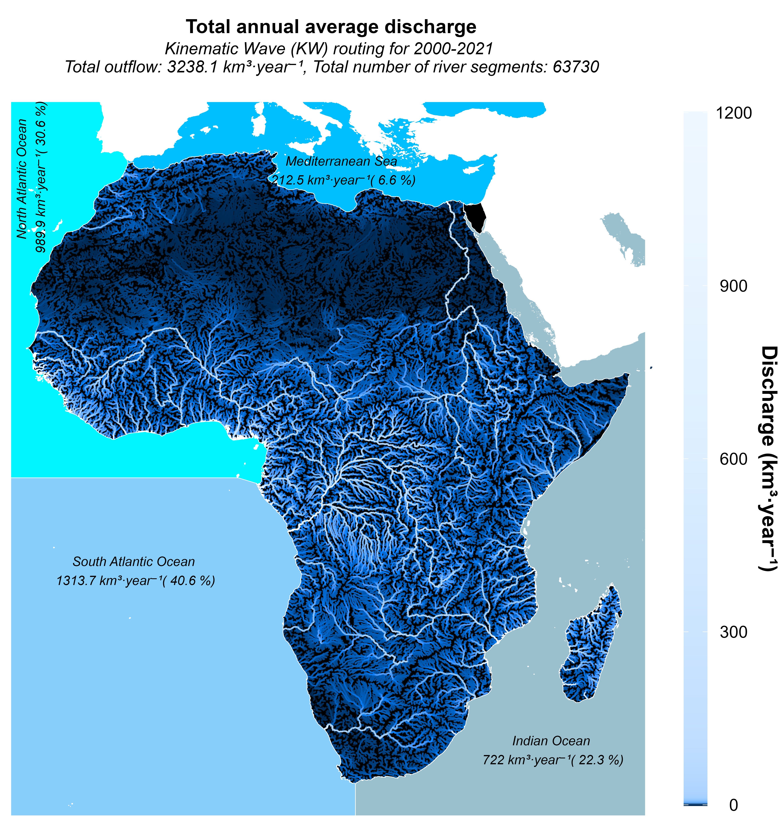
Fig. 15. Total average annual discharge from Africa to adjacent oceans (2000-2021). This map delineates the discharge of African rivers into the Mediterranean Sea, North and South Atlantic Ocean, and Indian Ocean, revealing the proportional contributions of each basin to the corresponding marine environments.

Usage Notes
Despite extensive calibration and evaluation of the VegET and mizuRoute models across Africa's diverse climates, landscapes, and hydrological conditions, further refinement is possible. Notably, observed data for calibration were predominantly available for larger basins at their outlets, where model results tend to be more accurate. The discharge has been routed for over 64,000 river segments, yet smaller and ungauged coastal basins remain uncalibrated and ideally would be considered in their naturalized state, necessitating prior evaluation to comprehend their limitations fully.
Additionally, the modeling did not account for reservoir influence and water withdrawals, which may lead to overestimated flow predictions downstream in certain basins, such as the Nile River Basin, particularly in Sudan and Egypt. The VegDischarge v1 dataset includes discharge data based on three precipitation datasets: CHIRPS, ERA5, and MSWEP. However, CHIRPS based discharge is recommended for use because it has shown improved performance, especially in the Congo River Basin, in comparison to ERA5 and MSWEP based discharges.
Finally, mizuRoute provides five routing algorithms for flow simulation: Impulse Response Function-Unit Hydrograph (IRF), Kinematic Wave Tracking (KWT), Kinematic Wave (KW), Muskingum-Cunge (MC), and Diffusive Wave (DW). Although VegDischarge v1 data are made available for all 5 models, for broader applications, the usage of KWT or KW is suggested to yield the best results. Users are encouraged to select the routing algorithm that best fits their specific study context and to perform their own validation when applying the model outputs to new regions or applications.

Code Availability
The computational codes used for evaluation and the generation of graphical outputs in this study are openly accessible to ensure transparency and reproducibility of our results. The complete set of codes can be found at the following GitHub repository: https://github.com/AKPOTI/Hydro-Discharge-Paper. The VegET model, developed by USGS, is available to the scientific community at https://code.usgs.gov/eros_hydro/veget_model. For the mizuRoute routing framework, the source code and related resources are hosted on GitHub by the Earth System CoG and can be accessed at https://github.com/ESCOMP/mizuRoute. In addition, the data are available in a data release at https://doi.org/10.5066/P14H6TFY.

Acknowledgments
The authors would like to acknowledge the all-dataset providers and developers for producing and making their datasets free of charge. This study is part of the International Water Management Institute's Digital Innovations for Water Secure Africa (DIWASA) project. We gratefully acknowledge The Leona M. and Harry B. Helmsley charitable trust for their financial support. The author's views are their own and do not necessarily reflect the views of the funding agency but do represent the views of the U.S. Geological Survey. Any use of trade, firm, or product names is for descriptive purposes only and does not imply endorsement by the U.S. Government or the authors.

Author contributions
Komlavi Akpoti: Conceptualization, Methodology, Software, Formal analysis, Investigation, Writing – Original draft, Writing – Review & Editing, Validation, Visualization. Naga Manohar Velpuri: Conceptualization, Methodology, Resources, Writing – Review & Editing, Supervision, Project administration. Naoki Mizukami: Software, Data Preparation, Review & Editing. Stefanie Kagone: Software, Data Preparation, Review & Editing. Mansoor Leh: Writing – Review & Editing. Kirubel Mekonnen: Writing – Review & Editing. Afua Owusu: Writing – Review & Editing. Primrose Tinonetsana: Writing – Review & Editing. Michael Phiri: Writing – Review & editing. Lahiru Madushanka: Software and Data Preparation. Tharindu Perera: Data Preparation. Paranamana Thilina Prabhath: Software and Data Preparation. Gabriel Parrish: Software, Gabriel B. Senay: Conceptualization, Methodology. Abdulkarim Seid: Writing – Review & Editing, Project administration.

Competing interests
The authors declare that they have no known competing financial interests or personal relationships that could have appeared to influence the work reported in this paper.

References
1. Schyns, J. F., Hoekstra, A. Y., Booij, M. J., Hogeboom, R. J. & Mekonnen, M. M. Limits to the world’s green water resources for food, feed, fiber, timber, and bioenergy. Proc. Natl. Acad. Sci. U. S. A. 116, 4893–4898 (2019).
2. Fitton, N. et al. The vulnerabilities of agricultural land and food production to future water scarcity. Glob. Environ. Chang. 58, 101944 (2019).
3. He, C. et al. Future global urban water scarcity and potential solutions. Nat. Commun. 12, 1–11 (2021).
4. Dinar, A., Tieu, A. & Huynh, H. Water scarcity impacts on global food production. Glob. Food Sec. 23, 212–226 (2019).
5. Huang, Z., Yuan, X. & Liu, X. The key drivers for the changes in global water scarcity: Water withdrawal versus water availability. J. Hydrol. 601, 126658 (2021).
6. Clark, E. A., Sheffield, J., van Vliet, M. T. H., Nijssen, B. & Lettenmaier, D. P. Continental runoff into the oceans (1950-2008). J. Hydrometeorol. 16, 1502–1520 (2015).
7. Trambauer, P., Maskey, S., Winsemius, H., Werner, M. & Uhlenbrook, S. A review of continental scale hydrological models and their suitability for drought forecasting in (sub-Saharan) Africa. Phys. Chem. Earth 66, 16–26 (2013).
8. Abbott, B. W. et al. Human domination of the global water cycle absent from depictions and perceptions. Nat. Geosci. 12, 533–540 (2019).
9. Yang, S. et al. A physical process and machine learning combined hydrological model for daily river discharge simulations of large watersheds with limited observation data. J. Hydrol. 590, 125206 (2020).
10. Burek, P. et al. Development of the Community Water Model (CWatM v1.04) - A high-resolution hydrological model for global and regional assessment of integrated water resources management. Geosci. Model Dev. 13, 3267–3298 (2020).
11. McNally, A. et al. Acute water-scarcity monitoring for Africa. Water (Switzerland) 11, (2019).
12. Hasan, E., Tarhule, A., Hong, Y. & Moore, B. Assessment of physical water scarcity in Africa using GRACE and TRMM satellite data. Remote Sens. 11, 1–17 (2019).
13. Leal Filho, W. et al. Understanding responses to climate-related water scarcity in Africa. Sci. Total Environ. 806, 150420 (2022).
14. Feng, X., Porporato, A. & Rodriguez-iturbe, I. Changes in rainfall seasonality in the tropics. Nat. Clim. Chang. 3, 1–5 (2013).
15. Schilling, J., Hertig, E., Tramblay, Y. & Scheffran, J. Climate change vulnerability, water resources and social implications in North Africa. Reg. Environ. Chang. 20, (2020).
16. Ahmadalipour, A., Moradkhani, H., Castelletti, A. & Magliocca, N. Future drought risk in Africa: Integrating vulnerability, climate change, and population growth. Sci. Total Environ. 662, 672–686 (2019).
17. Haile, G. G. et al. Projected impacts of climate change on drought patterns over East Africa. Earth’s Futur. 8, 1–23 (2020).
18. Labat, D. Cross wavelet analyses of annual continental freshwater discharge and selected climate indices. J. Hydrol. 385, 269–278 (2010).
19. Soltani, S. S., Ataie-Ashtiani, B. & Simmons, C. T. Review of assimilating GRACE terrestrial water storage data into hydrological models: Advances, challenges and opportunities. Earth-Science Rev. 213, 103487 (2021).
20. Souffront Alcantara, M. A. et al. Hydrologic Modeling as a Service (HMaaS): A new approach to address hydroinformatic challenges in developing countries. Front. Environ. Sci. 7, (2019).
21. Dai, A. & Trenberth, K. E. Estimates of freshwater discharge from continents: Latitudinal and seasonal variations. J. Hydrometeorol. 3, 660–687 (2002).
22. Nel, J. L. et al. Rivers in peril inside and outside protected areas: A systematic approach to conservation assessment of river ecosystems. Divers. Distrib. 13, 341–352 (2007).
23. Jacobson, P. J. & Jacobson, K. M. Hydrologic controls of physical and ecological processes in Namib Desert ephemeral rivers: Implications for conservation and management. J. Arid Environ. 93, 80–93 (2013).
24. Clark, M. P. et al. Improving the representation of hydrologic processes in Earth System Models. Water Resour. Res. 51, 5929–5956 (2015).
25. Ndehedehe, C. E. The water resources of tropical West Africa: Problems, progress, and prospects. Acta Geophys. 67, 621–649 (2019).
26. Akpoti, K., Antwi, E. & Kabo-bah, A. Impacts of rainfall variability, land use and land cover change on stream flow of the Black Volta Basin, West Africa. Hydrology 3, 26 (2016).
27. Baioni, E., Porta, G. M., Cattaneo, N. & Alberto, G. Assessment of hydrological processes in an ungauged catchment in Eritrea. Hydrology 9, 1–24 (2022).
28. Hughes, D. A. Facing a future water resources management crisis in sub-Saharan Africa. J. Hydrol. Reg. Stud. 23, 100600 (2019).
29. Schmied, H. M. et al. Impact of climate forcing uncertainty and human water use on global and continental water balance components. Proc. Int. Assoc. Hydrol. Sci. 374, 53–62 (2016).
30. Stephens, C. M., Lall, U., Johnson, F. M. & Marshall, L. A. Landscape changes and their hydrologic effects: Interactions and feedbacks across scales. Earth-Science Rev. 212, 103466 (2021).
31. Boschetti, M., Nutini, F., Brivio, P. A., Bartholome, E. & Stroppiana, D. Contribution of earth observation data to Congo River basin hydrology understanding. Remote Sens. Agric. Ecosyst. Hydrol. XII 7824, 78241C (2010).
32. Hughes, D. A., Kapangaziwiri, E. & Tanner, J. Spatial scale effects on model parameter estimation and predictive uncertainty in ungauged basins. Hydrol. Res. 44, 441–453 (2013).
33. Senay, G. B. et al. Improvements and evaluation of the agro-hydrologic VegET model for large-area water budget analysis and drought monitoring. Hydrology 10, (2023).
34. Mizukami, N. et al. A vector-based river routing model for Earth System Models: Parallelization and global applications. J. Adv. Model. Earth Syst. 13, 1–20 (2021).
35. Mizukami, N. et al. mizuRoute version 1 : a river network routing tool for a continental domain water resources applications. Geosci. Model Dev. 9, 2223–2238 (2016).
36. ISRIC (International Soil Reference and Information Centre). ISRIC—World Soil Information. Soil Data Hub.
37. Didan, Kamel & Alfredo, H. MOD13Q1 MODIS/Terra Vegetation Indices 16-Day L3 Global 250m SIN Grid. NASA LP DAAC. (2015).
38. Allen, R. G., Pereira, L. S., Raes, D. & Smith, M. FAO Irrigation and Drainage Paper No. 56 - Crop Evapotranspiration. (1998).
39. Verdin, K. Hydrologic Derivatives for Modeling and Analysis - A New Global High-Resolution Database. U.S. Geological Survey Data Series (2017) doi: 10.3133/ds1053.
40. MacDonald, A. M. et al. Mapping groundwater recharge in Africa from ground observations and implications for water security. Environ. Res. Lett. 16, (2021).
41. McNally, A. et al. A land data assimilation system for sub-Saharan Africa food and water security applications. Sci. Data 4, 1–19 (2017).
42. Gash, J. H. C., Nobre, C. A., Roberts, J. M., & Victoria, R. L. Amazonian Deforestation and Climate. vol. 34 (Wiley, 1997).
43. Arora, V. K. Modeling vegetation as a dynamic component in soil-vegetation-atmosphere transfer schemes and hydrological models. Rev. Geophys. 40, 3-1-3–26 (2002).
44. Brubaker, K. L., Entekhabi, D., & Eagleson, P. S. Estimation of continental precipitation recycling. J. Clim. 6, 1077–1089.
45. Eltahir, E. A., & Bras, R. L. Precipitation recycling in the Amazon basin. Q. J. R. Meteorol. Soc. 120, 861–880 (1994).
46. Van Der Ent, R. J., Savenije, H. H. G., Schaefli, B. & Steele-Dunne, S. C. Origin and fate of atmospheric moisture over continents. Water Resour. Res. 46, 1–12 (2010).
47. Mekonnen, K. et al. Accuracy of satellite and reanalysis rainfall estimates over Africa: A multi-scale assessment of eight products for continental applications. J. Hydrol. Reg. Stud. 49, 101514 (2023).
48. Funk, C. et al. The climate hazards infrared precipitation with stations - A new environmental record for monitoring extremes. Sci. Data 2, 1–21 (2015).
49. Hersbach, H. et al. The ERA5 global reanalysis. Q. J. R. Meteorol. Soc. 146, 1999–2049 (2020).
50. Beck, H. E. et al. MSWep v2 Global 3-hourly 0.1° precipitation: Methodology and quantitative assessment. Bull. Am. Meteorol. Soc. 100, 473–500 (2019).
51. Hobbins, M., Dewes, C., & Jansma, T. Global reference evapotranspiration for food-security monitoring (ver. 2.0, October 2023): U.S. Geological Survey data release (2023), doi: 10.5066/P9IIQMV1.
52. Hansen, M. C. et al. Global percent tree cover at a spatial resolution of 500 meters: First results of the MODIS Vegetation Continuous Fields Algorithm. Earth Interact. 7, 1–15 (2003).
53. Ghiggi, G., Humphrey, V., Seneviratne, S. I. & Gudmundsson, L. G-RUN ENSEMBLE: A multi-forcing observation-based global runoff reanalysis. Water Resour. Res. 57, (2021).
54. GRDC (Global Runoff Data Centre). GRDC - Global Runoff Data Centre. 1–7.
55. Munene, P., Chabala, L. M. & Mweetwa, A. M. Land suitability assessment for soybean (Glycine max (L.) Merr.) production in Kabwe District, Central Zambia. J. Agric. Sci. 9, 74 (2017).
56. Akpoti, K., Velpuri, N. M., Mizukami, N., Kagone, S., Leh, M., Mekonnen, K., Owusu, A., Tinonetsana, P., Phiri, M., Madushanka, L., Perera, L., Prabhath, P. T., Senay, G. B. & Seid, A. Hydrologic gridded runoff and routed discharge data for Africa from 2000-2021: U.S. Geological Survey data release. (2024) doi: 10.5066/P14H6TFY.
57. Nash, J. E. & Sutcliffe, J. V. River flow forecasting through conceptual models part I — A discussion of principles. Journal of Hydrology vol. 10 282–290 (1970).
58. Gupta, H. V., Kling, H., Yilmaz, K. K. & Martinez, G. F. Decomposition of the mean squared error and NSE performance criteria: Implications for improving hydrological modelling. J. Hydrol. 377, 80–91 (2009).
59. Fekete, B. M., Vörösmarty, C. J. & Grabs, W. Global Composite Runoff Fields on Observed River Discharge and Simulated Water Balances. GRDC Reports (2000).
60. Alsdorf, D. et al. Opportunities for hydrologic research in the Congo Basin. Rev. Geophys. 54, 378–409 (2016).
61. Struglia, M. V., Mariotti, A. & Filograsso, A. River discharge into the Mediterranean Sea: Climatology and aspects of the observed variability. J. Clim. 17, 4740–4751 (2004).
62. Nikiel, C. A. & Eltahir, E. A. B. Past and future trends of Egypt’s water consumption and its sources. Nat. Commun. 12, 1–11 (2021).
63. Multsch, S. et al. Improving irrigation efficiency will be insufficient to meet future water demand in the Nile Basin. J. Hydrol. Reg. Stud. 12, 315–330 (2017).
64. Belhassan, K. et al. Potential impact of drought on Mikkes River flow (Morocco). Iran. J. Earth Sci. 15, 21–33 (2023).
65. Tanarhte, M., De Vries, A. J., Zittis, G. & Chfadi, T. Severe droughts in North Africa: A review of drivers, impacts and management. Earth-Science Rev. 250, 104701 (2024).
66. Wanders, N. & Wada, Y. Human and climate impacts on the 21st century hydrological drought. J. Hydrol. 526, 208–220 (2015).
67. Nicholson, S. E. A detailed look at the recent drought situation in the Greater Horn of Africa. J. Arid Environ. 103, 71–79 (2014).
68. Chivangulula, F. M., Amraoui, M. & Pereira, M. G. The drought regime in Southern Africa: A systematic review. Climate 11, 1–23 (2023).
69. Mathivha, F. I., Nkosi, M. & Mutoti, M. I. Evaluating the relationship between hydrological extremes and groundwater in Luvuvhu River Catchment, South Africa. J. Hydrol. Reg. Stud. 37, (2021).
70. Afolayan, A., Ongoma, V. & Kooperman, G. J. Evaluation of CMIP6 models in simulating the statistics of extreme precipitation over Eastern Africa. Atmos. Res. 254, 105509 (2021).
71. Hughes, D. A. & Gray, R. Correcting bias in rainfall inputs to a semi-distributed hydrological model using downstream flow simulation errors. Hydrol. Sci. J. 62, 2427–2439 (2017).
72. Han, X., Li, Y., Yu, W. & Feng, L. Attribution of the extreme drought in the Horn of Africa. Water (Switzerland) 14, 1–16 (2022).
73. Qu, C., Hao, X. & Qu, J. J. Monitoring extreme agricultural drought over the Horn of Africa (HOA) using remote sensing measurements. Remote Sens. 11, 902 (2019).
74. Nijssen, B., O’Donnell, G. M., Lettenmaier, D. P., Lohmann, D. & Wood, E. F. Predicting the discharge of global rivers. J. Clim. 14, 3307–3323 (2001).
75. Oki, T. et al. Global assessment of current water resources using total runoff integrating pathways. Hydrol. Sci. J. 46, 983–995 (2001).
76. Sheffield, J. & Wood, E. F. Characteristics of global and regional drought, 1950-2000: Analysis of soil moisture data from off-line simulation of the terrestrial hydrologic cycle. J. Geophys. Res. Atmos. 112, 1–21 (2007).
77. Van Vliet, M. T. H. et al. Coupled daily river discharge and water temperature modelling in large river basins. Hydrol. Earth Syst. Sci. 16, 4303–4321 (2012).
78. Van Vliet, M. T. H. et al. Global river discharge and water temperature under climate change. Glob. Environ. Chang. 23, 450–464 (2013).
79. Dai, A., Qian, T., Trenberth, K. E. & Milliman, J. D. Changes in continental freshwater discharge from 1948 to 2004. J. Clim. 22, 2773–2792 (2009).
80. Syed, T. H., Famiglietti, J. S. & Chambers, D. GRACE-based estimates of terrestrial freshwater discharge from basin to continental scales. J. Hydrometeorol. 10, 22–40 (2009).
81. Döll, P., Kaspar, F. & Lehner, B. A global hydrological model for deriving water availability indicators: Model tuning and validation. J. Hydrol. 270, 105–134 (2003).
82. Diop, S. et al. The Western and Central Africa land–sea interface: A vulnerable, threatened, and important coastal zone within a changing environment. In Diop, S., Barusseau, J. P., & Descamps, C. (eds), The land/ocean interactions in the coastal zone of west and Central Africa 1–8 (Springer, 2014). doi: 10.1007/978-3-319-06388-1_1.

