Spotlight on International Charter Data Contributors: Planet

A brief introduction of Planet
Planet is a leading provider of global, daily satellite imagery and geospatial solutions. Founded in 2010 by three NASA scientists, Planet designs, builds, and operates the largest Earth observation fleet of imaging satellites, with hundreds currently in orbit. With this technology, Planet provides mission-critical data, advanced insights, and software solutions to a myriad of industries, including agriculture, forestry, intelligence, finance, and governments, enabling users to derive unique value simply and effectively from satellite imagery.

Motivation for participating in the Charter
Planet is driven by a mission to image the world every day, and make change visible, accessible, and actionable. This work is particularly relevant to disaster response and risk mitigation efforts. With Planet’s unique product suite, including near-daily satellite imaging, high-resolution tasking, and various analytics feeds, users can gain enhanced situational awareness following a natural disaster. Planet is proud to be participating in the Charter to improve disaster preparedness and emergency management. By providing access to timely satellite data, revealing pre- and post-event information, authorities can make data-informed decisions, verify damage, allocate resources, and provide swift aid more effectively.

The specific types of data Planet provides
Planet primarily provides their high frequency, near-daily 3.7-meter PlanetScope imagery from their constellation of Dove satellites. Planet also provides its 50cm high-resolution imagery from their fleet of tasked SkySat satellites to the Charter on a case-by-case basis.

Example of a recent activation

Widespread flooding has occurred in Botswana due to days of heavy rain. Officials have suggested that inadequate drainage in urban areas may have contributed to water building up in some of the worst-hit low-lying areas.
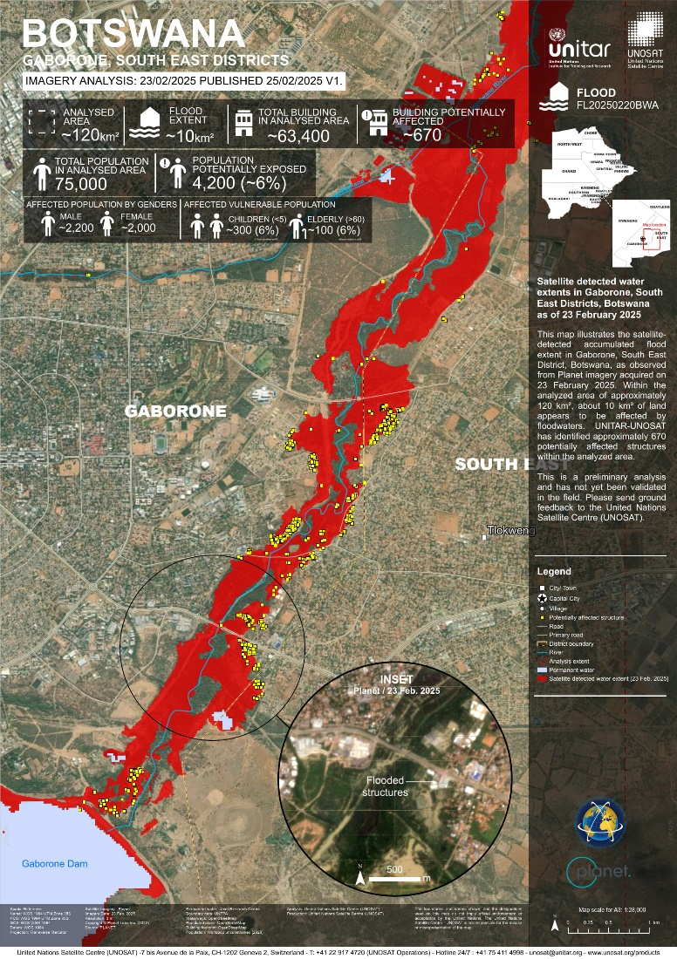
A local dam in the capital city, Gaborone, had overflowed, washing away cars. Residential homes and businesses have suffered extensive damage. Authorities have temporarily closed schools and blocked roads.
So far, it has been reported that seven people have died, and more rain is expected over the coming days.

The map at right illustrates satellite-detected flood extent in the Southeast District of Gaborone, Botswana, as observed from Planet imagery acquired on 23 February 2025.

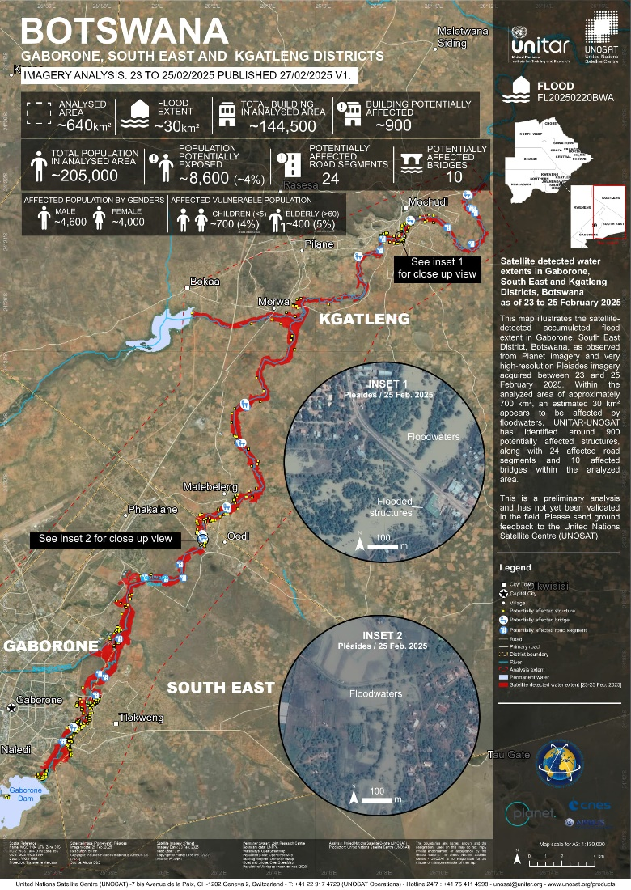
This map illustrates the use of Planet imagery for inundation mapping over a larger area of Gaborone including both the Southeast and Kgatleng districts. Inset images utilizing very high-resolution Pleiades imagery acquired between 23 & 25 February 2025, are used to supplement the large area mapping effort.

List of contributions
Planet has contributed data for recent activations in the following countries:
- Flood in Botswana (Activation 945)
- Flood, Landslide in Costa Rica (Activation 929)
- Flood in India (Activation 907)
- Flood in Chad (Activation 904)
- Flood in Nepal (Activation 901)
- Landslide in India (Activation 900)
- Landslide in Ethiopia (Activation 899)

