## 

## International Charter Space & Major Disasters

**Organized by USGS**

**Sioux Falls, SD**

## PM Refresher Training

## Agenda

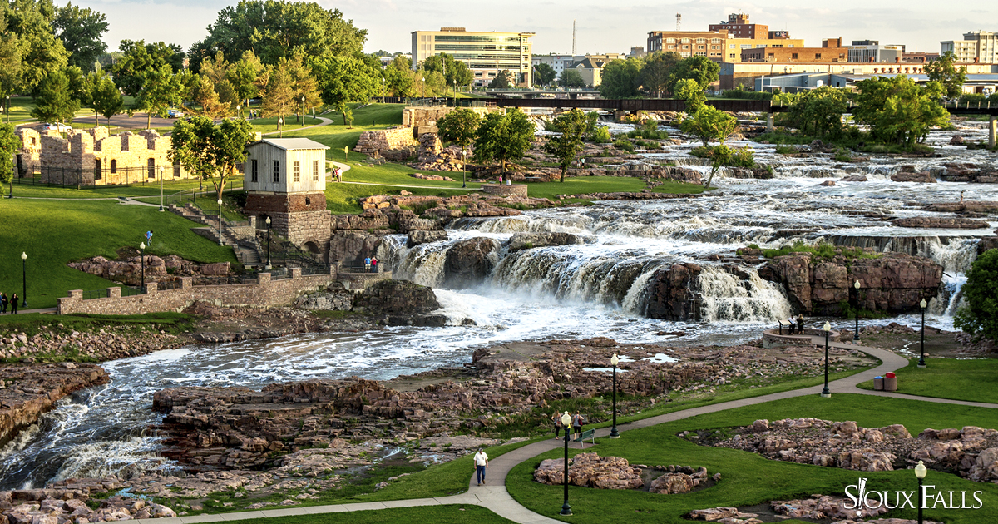**June 17-18, 2019**

## Monday, June 17, 2019 (PM Training Session)

*USGS/EROS training room B*

|  |  |  |  |
| --- | --- | --- | --- |
| *08.15* | *Depart Holiday Inn City Centre for EROS* | | |
| *08:45* | *Arrive at EROS and Register at Front Desk* | | |
| 09:20 | 1) | Welcome & Introductions | USGS – Director’s Office/MB/ALL |
| 09:50 | 2) | Charter General Presentation | USGS (MB) |
| 10:10 | 3) | Operational organization and interfaces | ESA |
| 10:30 | 4) | Project Manager Role & Procedures / Discussion | USGS (MB) – ESA - ULRAC |
| 11:10 | 5) | Scenarios for different types of disasters covered by the Charter | USGS (EW) |
| *11:30* | *Lunch* | | |
| 12:30 | 6) | Earth Observation Data and Information Products | USGS (EW) |
| 12:50 | 7) | The Charter web-based system: COS-2 + CGT | ESA |
| 13:30 | 8) | Charter PM experiences / Discussion | ULRAC - Brent |
| *14:15* | *Break* | | |
| 14:40 | 9) | Charter PM experiences | Julie - Ramesh |
| 15:15 | 10) | USGS Hazards Data Distribution System (HDDS) | USGS (DM, BE) |
| 15:45 | 11) | What the PM delivers /FAQs | USGS (MB) - ESA |
| 16:15 | 12) | Discussion | ALL |
| *16:30* | *Adjourn* | | |
| *17:30 – 19:00* | *Social Gathering @ Monk’s House of Ale Repute* | | |

## Tuesday, June 18 2019 (PM Training Session)

*USGS/EROS training room B*

|  |  |  |  |
| --- | --- | --- | --- |
| *08.00* | *Depart Holiday Inn City Centre for EROS* | | |
| 08:30 | 1) | Hands-on training: PM work with the help of COS-2 | ESA |
| 11:30 | 2) | Closure of the PM Training | USGS |
|  | 3) | Tour of the USGS/EROS Facility (optional) | USGS |
| *12:30* | *End of the PM Training* | | |

## USEFUL INFORMATION:

1. **Trainers:**

European Space Agency (ESA) – Roberto Biasutti

Regional Applications Center (RAC), University of Louisiana at Lafayette – Brent Yantis

US Geological Survey (USGS) – Mike Budde, Eric Wood, Brenda Ellis, Dean Mierau

1. **Address of venue:**

## USGS EROS

47914 252nd Street

Sioux Falls, SD 57198

(605) 594-6511

1. **Transportation:**

Holiday Inn City Center offers shuttle service to/from the Sioux Falls Regional Airport and will be providing transportation to and from the venue on Monday and Tuesday (17 & 18 June).

# **Lunch**:

# Lunch is available at the USGS EROS cafeteria or you’re welcome to bring something with you.

**Things to see and do in downtown Sioux Falls:**

**Falls Park**

* Located north of downtown Sioux Falls, the park covers 123 acres and an average of 7,400 gallons of water drop 100’ per second.
* Visit the information center and observation tower
* Have a beverage or snack at the Falls Overlook Café
* View the permanent sculptures

**Sculpture Walk**

* Over 50 sculptures displayed from the Washington Pavilion to Falls Park

**Restaurants (all within 3-4 blocks of the Holiday Inn)**

* Crave American Kitchen and Sushi Bar (Hilton Garden Inn) – 6am-10pm Sun & Mon
* Ode to Food and Drinks – closed Sun, 7am-9pm Mon
* Phillips Avenue Diner – 8am-9pm Sun, 7am-9pm Mon
* PAve – 11am-2am Sun & Mon
* Crawford’s Bar & Grill – 3-11pm Sun,, 4pm – 12am Mon
* MacKenzie River Pizza, Grill & Pub – 11am-10pm Sun & Mon
* Minerva’s – closed Sun, 11am-10pm Mon
* JL Beers – 11am-11pm Sun & Mon
* Blarney Stone Irish Pub – 10am-1am Sun, 11am-1am Mon
* Fernson Downtown – 2-10pm Sun & Mon

**Directions to EROS to avoid road construction:**

