International Charter
Space and Major Disasters



Charter Activation | 920
Charter Call ID | 1050
Disaster Event | Storm & Hurricane
Disaster Location | UNITED STATES
Date of Final Reporting | 09-Jan-2025

PM Report

*Reporting forms completed by: Brent Yantis

*Reporting forms reviewed by:

Project Managers for Charter activations are expected to provide the PM report to the Charter Executive Secretariat within 45 days after the start of the activation.

A. Disaster Event Summary
*A1. Disaster type: | Storm & Hurricane
*A2. Date disaster started: 09-Oct-2024
*A3. Disaster location and extent: UNITED STATES
A4. Estimated number of deaths: 24
A5. Estimated number of people affected: Estimated number of people affected: 3.4 million
A6. Estimated economic losses: Estimated economic losses: $160 - $180 billion
A7. Additional impacts of disaster (environmental, infrastructure, etc): Agricultural damage estimated to be $190 million in damages with total damages estimated to be $642 million by the Institute of Food and Agricultural Sciences (Source: https://apnews.com/article/hurricane-milton-florida-agriculture-loss-f2e49fa9f6df2bb8a170cadb160c1295). Total infrastructure and crop damage is estimated by the Florida Commissioner of Agriculture to be between $1.5 - $2.5 billion (Source: Agriculture Dive; https://agriculturedive.com/news/hurricane-milton-florida-farm-damage usda/730404/#:~:text=Total%20crop%20and%20infrastructure%20damage,to%20%241.5%20billion%20in%20damages.).
Hurricane Milton caused significant environmental damage in Florida, releasing over 70 million gallons of pollutants, including raw sewage, partially treated wastewater, and toxins from coal ash ponds. The Tampa Bay area alone accounted for approximately 50 million gallons, contaminating major water bodies like the Manatee and Hillsborough Rivers (Source: Environment Florida; https://environmentamerica.org/florida/center/resources/pollution-spills-caused-by-hurricane-milton/)
A8. Additional disaster event details: Hurricane Milton made landfall near Siesta Key, Florida as a Category 3 hurricane. Originally a Category 5, Milton weakened due to increasing wind shear but maintained an expansive wind field as it approached the Florida Peninsula. East-central Florida experienced severe impacts, including a tornado outbreak. Hurricane-force wind gusts caused widespread damage, toppling trees and power lines, and damaging homes and businesses. On the northern side of the storm, torrential rainfall produced totals of 10 to 15 inches or more, leading to localized flooding and rising water levels in rivers and creeks. Source: National Weather Service – Melbourne, FL, Hurricane Milton Impacts (https://www.weather.gov/mlb/HurricaneMilton_Impacts). The hurricane generated 45 tornadoes, including one rated EF3 near Palm Beach Gardens, causing significant damage (Source: AccuWeather; https://www.accuweather.com/en/hurricane/hurricane-milton-by-the-numbers-an-ef3-tornado-and-blowout-tide/1702670).

* mandatory

B. Affected Areas
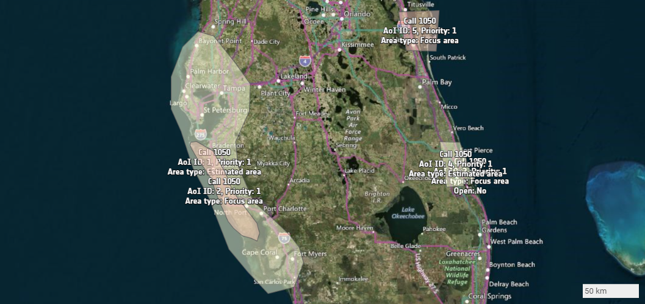
Area of Interest ID | Priority | AoI Name | Comments | KML
Call-1050 ID: 1 | 1 | polygon_1 | Major coastal impact zone | download
Call-1050 ID: 2 | 1 | polygon_2 | Coastal area of highest projected storm surge | download
Call-1050 ID: 3 | 1 | St. Lucie_0 | St Lucie County | download
Call-1050 ID: 4 | 1 | ST_Lucie_0 | St Lucie | download
Call-1050 ID: 5 | 1 | CapeCanaveral_CocoaBeach_0 | Cape Canaveral & Cocoa Beach | download

* Please remember, that the priority given in URF or Area Extension could have changed during activation processing.

The full history of Area Extension and Area Modification that happened during the activation processing is available in a separate document that can be accessed at the following link:
Area Modification Details Report

C. People Involved
*C1a. Authorized User/Requestor:  Michael Budde | *C1b. Organization:  USGS | *C1c. Date AU/CB requested activation:  09-Oct-2024 17:42:00
Identify the agency if any that requested the Charter activation:
*C3a. ECO:  ECO_CNES CNES | *C3b. Organization:  CNES | *C3c. Date of Dossier generation:  09-Oct-2024 21:13:22
*C4a. Project Manager:  Brent Yantis | *C4b. Organization:  University of Louisiana at Lafayette | *C4c. Date of PM nomination:  09-Oct-2024 21:09:23 by USGS
*C4a. Project Manager:  Brent Yantis | *C4b. Organization:  University of Louisiana at Lafayette | *C4c. Date of PM nomination:  09-Oct-2024 21:09:23 by USGS
*C5a. Deputy Project Manager:  Courtney Poirier Chicola | *C5b. Organization:  University of Louisiana-Lafayette | *C5c. Date of Deputy PM nomination:  09-Oct-2024 21:18:12 by USGS
*C6a. Value-adding Reseller:  NOAA VA | *C6b. Organization:  NOAA | *C6c. Date of Value-adding Reseller nomination:  10-Oct-2024 13:19:33 by USGS
*C6a. Value-adding Reseller:  Ramesh Sivanpillai | *C6b. Organization:  University of Wyoming | *C6c. Date of Value-adding Reseller nomination:  10-Oct-2024 13:20:51 by USGS
*C6a. Value-adding Reseller:  Mathias Studer | *C6b. Organization:  SERTIT | *C6c. Date of Value-adding Reseller nomination:  10-Oct-2024 13:21:26 by CNES
*C6a. Value-adding Reseller:  Konstantin Homenkov | *C6b. Organization:  Geoniformation systems | *C6c. Date of Value-adding Reseller nomination:  10-Oct-2024 13:30:43 by USGS
*C6a. Value-adding Reseller:  Talbot Brooks | *C6b. Organization:  Geospatial Center - Delta State University | *C6c. Date of Value-adding Reseller nomination:  10-Oct-2024 15:39:58 by USGS
*C6a. Value-adding Reseller:  Devon Maloney | *C6b. Organization:  Federal Emergency Management Agency (FEMA) | *C6c. Date of Value-adding Reseller nomination:  16-Oct-2024 21:20:58 by USGS
*C6a. Value-adding Reseller:  Rusti Liner | *C6b. Organization:  River Parishes Community College | *C6c. Date of Value-adding Reseller nomination:  24-Oct-2024 14:51:51 by USGS

* mandatory

D. Product List

see appendix

E. Chronology of Events
Date | Call ID | Performed by | Action
09-Oct-2024 17:42:31 | 1050 | AU_US_MBudde | AU call submission
09-Oct-2024 17:42:31 | 1050 | AU_US_MBudde | Call 1050:
09-Oct-2024 17:49:05 | 1050 | ODO | ODO confirmation, ECO call notification
09-Oct-2024 19:08:25 | 1050 | ECO_CNES | ECO URF validation
09-Oct-2024 19:08:25 | 1050 | ECO_CNES | ECO was not able to contact AU/CB within 1 hour after URF reception
09-Oct-2024 20:54:11 | 1050 | ECO_CNES | ERF v.1 sent to MPP of ABAE
09-Oct-2024 20:54:20 | 1050 | ECO_CNES | ERF v.1 sent to MPP of CNES
09-Oct-2024 20:54:28 | 1050 | ECO_CNES | ERF v.1 sent to MPP of CNSA
09-Oct-2024 20:54:36 | 1050 | ECO_CNES | ERF v.1 sent to MPP of CONAE
09-Oct-2024 20:54:44 | 1050 | ECO_CNES | ERF v.1 sent to MPP of DLR
09-Oct-2024 20:54:53 | 1050 | ECO_CNES | ERF v.1 sent to MPP of ESA
09-Oct-2024 20:55:01 | 1050 | ECO_CNES | ERF v.1 sent to MPP of GEOSAT
09-Oct-2024 20:55:10 | 1050 | ECO_CNES | ERF v.1 sent to MPP of INPE
09-Oct-2024 20:55:17 | 1050 | ECO_CNES | ERF v.1 sent to MPP of ISRO
09-Oct-2024 20:55:26 | 1050 | ECO_CNES | ERF v.1 sent to MPP of JAXA
09-Oct-2024 20:55:35 | 1050 | ECO_CNES | ERF v.1 sent to MPP of KARI
09-Oct-2024 20:55:44 | 1050 | ECO_CNES | ERF v.1 sent to MPP of MBRSC
09-Oct-2024 20:55:53 | 1050 | ECO_CNES | ERF v.1 sent to MPP of NAS
09-Oct-2024 20:56:02 | 1050 | ECO_CNES | ERF v.1 sent to MPP of UKSA
09-Oct-2024 20:56:11 | 1050 | ECO_CNES | ERF v.1 sent to MPP of USGS
09-Oct-2024 21:09:24 | 1050 | ES_USGS_MBudde | PM nominated by USGS
09-Oct-2024 21:13:22 | 1050 | ECO_CNES | ECO Dossier completed
09-Oct-2024 21:18:12 | 1050 | ES_USGS_MBudde | PM Deputy nominated by ES: PM_USGS_CPoirier Chicola
09-Oct-2024 22:06:21 | 1050 | MPP_DLR | AAP received from MPP of DLR
10-Oct-2024 00:00:18 | 1050 | MPP_USGS | AAP received from MPP of USGS
10-Oct-2024 00:02:16 | 1050 | MPP_USGS | AAP received from MPP of USGS
10-Oct-2024 00:04:07 | 1050 | MPP_USGS | AAP received from MPP of USGS
10-Oct-2024 00:05:39 | 1050 | MPP_USGS | AAP received from MPP of USGS
10-Oct-2024 00:48:49 | 1050 | MPP_KARI | AAP received from MPP of KARI
10-Oct-2024 02:25:17 | 1050 | PM_USGS_BYantis | ECO Dossier validated by PM
10-Oct-2024 06:40:52 | 1050 | MPP_ESA | AAP received from MPP of ESA
10-Oct-2024 14:37:59 | 1050 | MPP_CONAE | AAP received from MPP of CONAE
10-Oct-2024 15:07:50 | 1050 | MPP_CSA | AAP received from MPP of CSA
10-Oct-2024 15:09:20 | 1050 | MPP_CSA | AAP received from MPP of CSA
11-Oct-2024 00:43:14 | 1050 | ES_USGS_MBudde | AOI added: ID: 3, KML: https://disasterscharter.org/documents/10180/64961/AOI-1050-3.kml/dc76b756-807b-4a34-891c-7d0735dd5c3f?version=1.0
11-Oct-2024 07:30:20 | 1050 | MPP_CNSA | AAP received from MPP of CNSA
11-Oct-2024 12:14:24 | 1050 | ES_USGS_MBudde | AOI added: ID: 4, KML: https://disasterscharter.org/documents/10180/64961/AOI-1050-4.kml/9e0f6806-eb09-47aa-8a78-d544f7924456?version=1.0
11-Oct-2024 18:20:22 | 1050 | PM_USGS_CPoirier Chicola | AOI added: ID: 5, KML: https://disasterscharter.org/documents/10180/64961/AOI-1050-5.kml/d9bdf604-b969-48c8-8aeb-674c284d6664?version=1.0
11-Oct-2024 18:46:47 | 1050 | PM_USGS_CPoirier Chicola | ERF v.1 sent to MPP of CSA
11-Oct-2024 18:46:54 | 1050 | PM_USGS_CPoirier Chicola | ERF v.2 sent to MPP of KARI
11-Oct-2024 19:00:34 | 1050 | PM_USGS_CPoirier Chicola | ERF v.2 sent to MPP of CNES
11-Oct-2024 19:00:44 | 1050 | PM_USGS_CPoirier Chicola | ERF v.1 sent to MPP of PLANET
11-Oct-2024 19:34:25 | 1050 | PM_USGS_CPoirier Chicola | AOI modified: AoI call 1050 ID 5. Comment: -> Cape Canaveral & Cocoa Beach  KML: <a href="https://disasterscharter.org/documents/10180/64961/AOI-1050-5.kml/d9bdf604-b969-48c8-8aeb-674c284d6664?version=1.0">https://disasterscharter.org/documents/10180/64961/AOI-1050-5.kml/d9bdf604-b969-48c8-8aeb-674c284d6664?version=1.0</a> -> <a href="https://disasterscharter.org/documents/10180/64961/AOI-1050-5.kml/c28f0f89-d32a-4156-b5ec-8a1f7e70eb56?version=1.0">https://disasterscharter.org/documents/10180/64961/AOI-1050-5.kml/c28f0f89-d32a-4156-b5ec-8a1f7e70eb56?version=1.0</a>
11-Oct-2024 19:37:41 | 1050 | PM_USGS_CPoirier Chicola | AOI modified: AoI call 1050 ID 4. KML: <a href="https://disasterscharter.org/documents/10180/64961/AOI-1050-4.kml/9e0f6806-eb09-47aa-8a78-d544f7924456?version=1.1">https://disasterscharter.org/documents/10180/64961/AOI-1050-4.kml/9e0f6806-eb09-47aa-8a78-d544f7924456?version=1.1</a> -> <a href="https://disasterscharter.org/documents/10180/64961/AOI-1050-4.kml/9dd18cf9-9441-4168-985b-b5d23ce59d88?version=1.0">https://disasterscharter.org/documents/10180/64961/AOI-1050-4.kml/9dd18cf9-9441-4168-985b-b5d23ce59d88?version=1.0</a>
11-Oct-2024 19:40:03 | 1050 | MPP_CSA | AAP received from MPP of CSA
11-Oct-2024 19:59:11 | 1050 | PM_USGS_CPoirier Chicola | ERF v.1 sent to MPP of SATELLOGIC
12-Oct-2024 13:08:23 | 1050 | MPP_CNSA | AAP received from MPP of CNSA
12-Oct-2024 13:09:12 | 1050 | MPP_CNSA | AAP received from MPP of CNSA
12-Oct-2024 13:31:38 | 1050 | PM_USGS_CPoirier Chicola | ERF v.3 sent to MPP of CNES
15-Oct-2024 04:45:00 | 1050 | MPP_ISRO | AAP received from MPP of ISRO
15-Oct-2024 04:46:55 | 1050 | MPP_ISRO | AAP received from MPP of ISRO
15-Oct-2024 07:33:20 | 1050 | MPP_CNSA | AAP received from MPP of CNSA
15-Oct-2024 14:17:12 | 1050 | PM_CNES_MStuder | VAP uploaded
16-Oct-2024 01:40:55 | 1050 | MPP_CNSA | AAP received from MPP of CNSA
16-Oct-2024 01:43:37 | 1050 | MPP_CNSA | AAP received from MPP of CNSA
16-Oct-2024 01:46:48 | 1050 | MPP_CNSA | AAP received from MPP of CNSA
16-Oct-2024 01:49:08 | 1050 | MPP_CNSA | AAP received from MPP of CNSA
16-Oct-2024 04:33:08 | 1050 | MPP_ISRO | AAP received from MPP of ISRO
16-Oct-2024 08:29:00 | 1050 | PM_UA_KHomenkov | VAP uploaded
17-Oct-2024 05:44:07 | 1050 | MPP_ISRO | AAP received from MPP of ISRO
17-Oct-2024 05:50:40 | 1050 | MPP_MBRSC | AAP received from MPP of MBRSC
17-Oct-2024 14:06:21 | 1050 | PM_UA_KHomenkov | VAP uploaded
28-Oct-2024 21:08:33 | 1050 | PM_USGS_RSivanpillai | VAP uploaded
08-Nov-2024 01:39:22 | 1050 | PM_USGS_RSivanpillai | VAP uploaded
20-Nov-2024 23:09:27 | 1050 | PM_USGS_CPoirier Chicola | VAP uploaded
30-Nov-2024 02:58:17 | 1050 | PM_USGS_RSivanpillai | VAP uploaded
08-Dec-2024 05:04:20 | 1050 | PM_USGS_RSivanpillai | VAP uploaded

F. Value Added Product List
*F1a. Sending date to requestor of the first Value-adding products (e.g. maps and charts from the PM or VAR) based on archive images:
16-Oct-2024 07:28 UTC
*F1b. Sending date to requestor of the first Value-adding crisis product (can be a product based on both archive and crisis images):
15-Oct-2024 13:18 UTC
*F1c. The date the first VA crisis product was provided:
15-Oct-2024 13:39 UTC
*F2. Available value added product data list
Title | Category | Source(s) | Acquisition dates
Damaged Structures - Parts of South Venice, Manasota, Englewood, FL. | Delineation Map | GEO_EYE_1  GEO_EYE_1  NOAA_19 | 10-Oct-2024 15:49:36  10-Oct-2024 15:49:39  10-Oct-2024 14:45:59
Damaged Structures - Southwest Sarasota County, Florida | Delineation Monitoring Maps | GEO_EYE_1  GEO_EYE_1  NOAA_19 | 10-Oct-2024 15:49:39  10-Oct-2024 15:49:36  11-Oct-2024 14:38:05
Damaged Structures - Bay Island & Siesta Key, FL | Delineation Map | GEO_EYE_1  GEO_EYE_1  GOES_16 | 10-Oct-2024 15:49:36  10-Oct-2024 15:49:39  11-Oct-2024 14:26:52
Damaged Structures - Manasota Key (Sarasota & Charlotte counties), FL | Delineation Monitoring Maps | GEO_EYE_1  GEO_EYE_1  GOES_16 | 10-Oct-2024 15:49:36  10-Oct-2024 15:49:39  11-Oct-2024 17:22:32
Damaged Structures - Anna Maria Island, Florida, USA | Delineation Monitoring Maps
Flood situation, Cape Canaveral & Cocoa Beach, 15 and 14 October 2024 | Delineation Monitoring Maps | SENTINEL_2B  SENTINEL_1A  SENTINEL_1A | 14-Oct-2024 16:01:29  15-Oct-2024 23:29:12  03-Oct-2024 23:29:12
Flood situation, Cape Canaveral & Cocoa Beach, 14 October 2024 | Reference Map | SENTINEL_2B  SENTINEL_2A | 14-Oct-2024 16:01:29  15-Oct-2023 16:02:24
USA, St Lucie County - Impact Map | Grading Map | PLEIADES_1B  PLEIADES_1A  PLEIADES_1A | 13-Oct-2024 15:55:01  12-Oct-2024 16:03:32  14-Oct-2024 15:47:15

* mandatory

G. Activation Assessment

G1. PM User assessment - usefulness of data provided by the Charter.

*G1.1 Did the post-disaster data ordered by the ECO (prescribed data) meet your expectations?

Service | Greatly exceeded expectations | Exceeded Expectations | Matched Expectations | Less than Expected | Much Less than Expected | Not Applicable
a. Range/type of data (optical, radar) |  | X
b. Number of products provided (type, quantity, volume of data) |  |  | X
c. Coverage (visibility of area of interest) |  | X
d. Usefulness of radar data |  |  | X
e. Usefulness of optical data with a resolution higher than 2 m |  | X
f. Usefulness of optical data with a resolution lower than 2 m |  |  | X
g. Timeliness of data delivery |  | X

*G1.2 Did the pre-disaster data ordered by the ECO (prescribed data) meet your expectations?

Service | Greatly exceeded expectations | Exceeded Expectations | Matched Expectations | Less than Expected | Much Less than Expected | Not Applicable
a. Range/type of data (optical, radar) |  |  | X
b. Number of products provided (type, quantity, volume of data) |  | X
c. Coverage (visibility of area of interest) |  |  | X
d. Usefulness of radar data |  |  | X
e. Usefulness of optical data with a resolution higher than 2 m |  | X
f. Usefulness of optical data with a resolution lower than 2 m |  |  | X
g. Timeliness of data delivery |  | X

*G1.3 If you requested additional Charter data, did these data meet your expectations?

Service | Greatly exceeded expectations | Exceeded Expectations | Matched Expectations | Less than Expected | Much Less than Expected | Not Applicable
a. Range/type of data (optical, radar) |  |  | X
b. Number of products provided (type, quantity, volume of data) |  | X
c. Coverage (visibility of area of interest) |  | X
d. Usefulness of radar data |  |  | X
e. Usefulness of optical data with a resolution higher than 2 m |  | X
f. Usefulness of optical data with a resolution lower than 2 m |  |  | X
g. Timeliness of data delivery |  | X

G1.4 If you were not fully satisfied with the Charter data, please provide further details:

G1.5 Did you use satellite data from outside the Charter to support this event? If so, please indicate the type and their source

Aerial imagery collected by the National Oceanic and Atmospheric Administration (NOAA) that was made available on the United States Geological Survey (USGS) Hazards Data Distribution System (HDDS) Explorer was used to help identify the amount and extent of damaged structures in the areas of interest.

G2. Usefulness of value adding service provided through the Charter

G2.1 Did you generate Value Added Products yourself?

a. Yes | _
b. No | X

G2.2 Did you received Value Added Products from Value Added Providers?

a. Yes | X
b. No | _

*G2.3 List the value-added products provided to the End User from the Charter data:

a. Shape files | X
b. Image files | X
c. Web mapping services | _
d. Others, please state | Pdfs of AOI damage assessment maps

G3. Assessment of overall Charter process in support of this call

*G3.1 Did the following steps in the Charter process meet with your expectations? (Indicate your level of satisfaction by placing an [X] in the appropriate box):

Service | Greatly exceeded expectations | Exceeded Expectations | Matched Expectations | Less than Expected | Much Less than Expected | Not Applicable
a. Assignment of PM (e.g. role acknowledgement, PM Welcome Package) | X
b. Communication with the ECO (e.g. Delivery of ECO Dossier) | X
c. Interface between the PM and Order Desks (if applicable) | X
d. Performing licensing / signature of EULAs | X
e. Interface between the PM and the End User(s) | X
f. Interface between the PM and ES | X
g. Quality of the VAPs received from the external Value Adder(s) | X
h. Use of the COS-2 system | X
i. Usability of the Charter Mapper | X
j. Processing Services available in the Charter Mapper | X

*G3.2 If you had to accept some End User Licence Agreements during this Charter call, did the procedure run smoothly?

a. Yes | X
b. No | _
c. Not applicable | _

If you experienced problems during the process, please provide further details:

G3.3 Did you contact the helpdesk for support in the COS-2 or Charter Mapper access/use?

a. Yes | X
b. No | _

G3.4 If yes, how you rate the helpdesk service:

a. Greatly exceeded expectations | X
b. Exceeded Expectations | _
c. Matched Expectations | _
d. Less than Expected | _
e. Much Less than Expected | _
f. Not Applicable | _

G3.5 If you were not satisfied with any step in the Charter process, please let us know why:

G4. How could we improve the service to better support Project Managers?

H. Supporting Documentation
*H1. Provide samples of media coverage of the disaster event from TV, radio, newspapers, websites, etc. Where possible, copy the content of the article into the PM report rather than only the web addresses:
https://apnews.com/article/hurricane-milton-florida-agriculture-loss-f2e49fa9f6df2bb8a170cadb160c1295
Florida agriculture hit with $190M losses from Hurricane Milton
BY CURT ANDERSON
Updated 2:46 PM CST, December 20, 2024
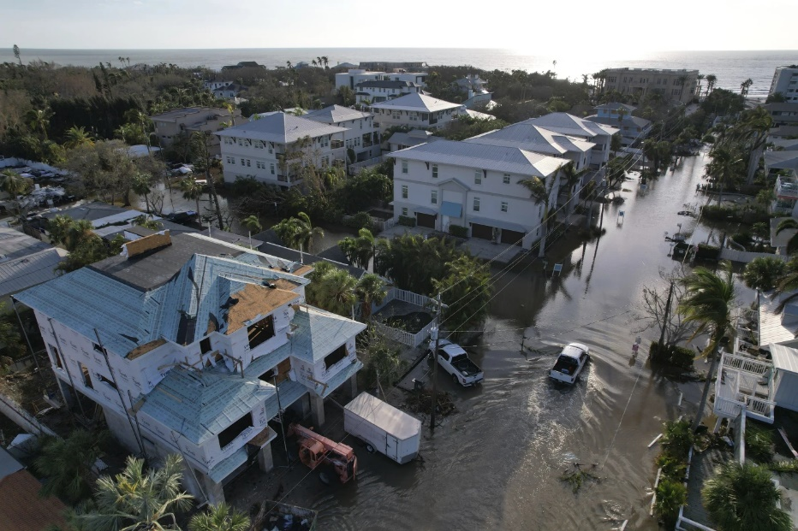
ST. PETERSBURG, Fla. (AP) — Florida agriculture suffered more than $190 million in losses from Hurricane Milton, making it the costliest for farmers and ranchers of three cyclones that pummeled the state in 2024, according to University of Florida researchers.
When all the data is in, the university’s Institute of Food and Agricultural Sciences (IFAS) estimates the losses from Milton could reach over $642 million. That compares with farm-related damages of $170 million from Hurricane Debby in August and up to $162 million caused by Hurricane Helene in September.
Milton came ashore Oct. 9 near Siesta Key on the Gulf coast as a Category 3 storm, sweeping across the central part of the state with hurricane-force winds striking 14 counties. The storm impacted more than 5.7 million acres (2.3 million hectares) of agricultural land, much of it used for cattle and other livestock grazing.
Total production value on that land annually is pegged at about $8.6 billion, according to the report.
“Milton resulted in higher agricultural losses than Hurricane Helene, not only because it caused more intense weather conditions overall, but also because areas producing high-value commodities experienced higher-intensity weather conditions,” said Xiaohui Qiao, an IFAS research assistant professor.
Helene, which came ashore Sept. 27 along the Big Bend region of Florida, impacted about 6 million acres (2.4 million hectares) of agricultural lands, the report said.
The Milton report is broken down into low and high estimates of loss. For example, researchers say losses to vegetable crops range between $52.5 million and $233 million. Greenhouse and nursery costs are estimated at between $66.9 million and $177 million.
The dominant livestock operations in the region had estimated losses of between $29.4 million and $86.5 million, the researchers said. That includes sickened and dead animals but also such things as damaged fencing and structures and loss of feed.
There also were delays in planting crops crucial to Florida’s winter growing season.
“Some growers have delayed winter crop planting due to Helene and Milton, disrupting the production schedule and potentially affecting the value of future harvests,” the report says.
The loss estimates are based on a survey of agriculture producers around the state. A final report on Milton’s impact is expected in the first quarter of 2025 and will include additional survey results.

https://www.agriculturedive.com/news/hurricane-milton-florida-farm-damage-usda/730404/#:~:text=Total%20crop%20and%20infrastructure%20damage,to%20%241.5%20billion%20in%20damages.
Hurricane Milton caused up to $2.5B in Florida farm damage
The storm ravaged infrastructure and flooded the state’s orange crops, with some growers expecting tree death.
Published Oct. 21, 2024
Sarah Zimmerman
Editor
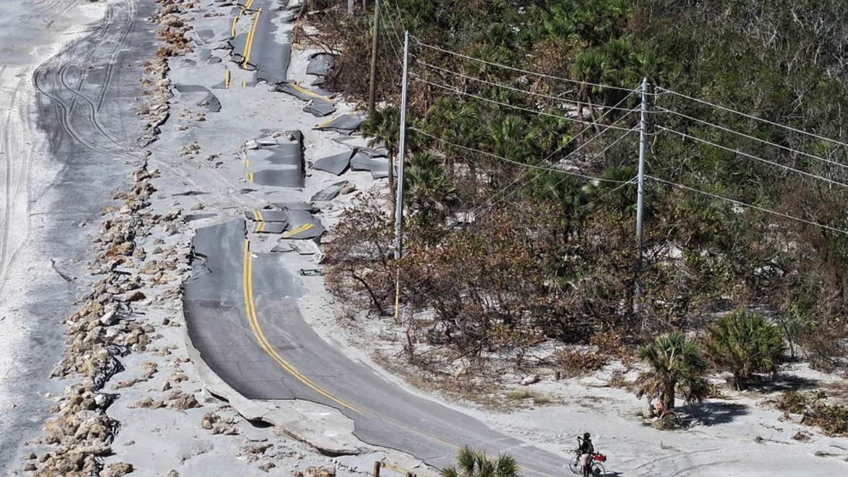
In an aerial view, a bicycle rider navigates a damaged road along the Gulf of Mexico on October 13, 2024 in Manasota Key, Florida. Joe Raedle via Getty Images
Strong winds and flooding from Hurricane Milton generated up to $2.5 billion in damages to Florida’s farms, with the state’s agriculture department reporting wrecked infrastructure and “significant production losses” among orange crops.
Total crop and infrastructure damage is between $1.5 billion to $2.5 billion, according to an estimate from Florida Commissioner of Agriculture Wilton Simpson. That’s more than the losses from hurricanes Helene, Idalia and Debby, which, combined, led to $1.5 billion in damages.
Milton, a Category 3 hurricane which made landfall with maximum sustained winds of 120 mph, hit the majority of Florida’s citrus producing counties. The hurricane also devastated agricultural equipment and infrastructure, affecting dairies and cattle raising operations.
“Hurricane Milton has left a broad path of devastation, impacting our farmers and threatening Florida’s position as a leading agricultural producer,” Simpson said in a statement. “With four major hurricanes in just over a year, our agriculture communities have been hit repeatedly, causing unprecedented financial strain.”
The damage to Florida’s orange groves could last for years, with growers expressing concern that flooding could lead to “tree mortality in the near future,” according to a report from the state’s agriculture department. Most of the citrus production losses from Milton were due to fruit drop, with the storm passing through as growers were preparing to start harvest.
Despite concerns around Milton disrupting the state’s lucrative fertilizer industry, those facilities were largely spared after the path of the storm changed, according to an update from The Fertilizer Institute.
Simpson is pushing the USDA to issue a disaster declaration for affected Florida counties, pressing the department to expedite approval of farm assistance and issue additional help where possible. However, the USDA does not need to declare a disaster in order to issue assistance if the president already issued a declaration, which was the case with Milton.
A department spokesperson reiterated that USDA program flexibilities are already available in a statement to local paper Florida Phoenix, saying Simpson’s request “unfortunately distracts from the accelerated assistance, expanded flexibilities, and resources that USDA is making available.”
Following destruction from Hurricane Helene, the USDA announced indemnity payments for producers who lost livestock to the storm, plus expedited crop insurance payments and new flexibilities for disaster assistance programs. These resources are also available to producers affected by Milton, according to the department’s website.
In addition to requests for a disaster declaration, Florida Sen. Rick Scott has urged the USDA to provide the state with a block grant to help producers recover, similar to what the Trump administration did following hurricanes Michael and Florence in 2018.

https://environmentamerica.org/florida/center/resources/pollution-spills-caused-by-hurricane-milton/
Pollution spills caused by Hurricane Milton
At least 70 million gallons of pollution flooded waterways, neighborhoods and communities across Florida after Hurricane Milton.
October 25, 2024

Mia McCormick
Advocate, Environment Florida Research & Policy Center

Environment Florida Research & Policy Center did an analysis of pollution reports submitted to the Florida Department of Environmental Protection in connection to Hurricane Milton.
A conservative estimate of 70,483,875 gallons of pollution was reportedly spilled into our waterways, communities, and neighborhoods as a result of the storm over a period of 7 days. Most of the reports were for raw sewage or partially treated wastewater, but overflows containing toxins from a coal ash pond and toxic phosphate mining wastewater were also reported. Of the 271 reports associated with Hurricane Milton from across the state, more than 100 of them were missing the amounts of pollution spilled. That means the estimate we have is only a portion of what spilled from the storm and because of ongoing storm related activities some agencies may not have reported pollution data yet. The real number is likely much higher.
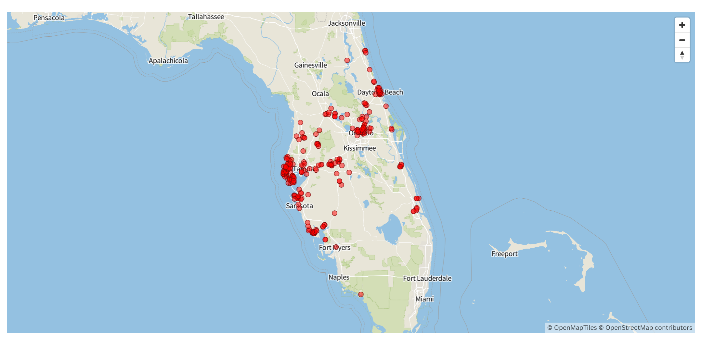
Spills from the Tampa Bay area (Hillsborough, Pinellas, Manatee and Sarasota counties) accounted for 50,869,950 gallons of the reported total. Water bodies and wetlands across the state were impacted by the pollution. Including but not limited to the Manatee and Hillsborough rivers, Lake Tarpon, Lake Seminole and Hillsborough bay. Four million gallons of stormwater runoff that included waste from a coal burning utility near Palatka was reported. The largest spill was an estimated 20 million gallons of partially treated wastewater that flowed from the City of Bradenton Water Reclamation Facility into the Manatee River.
While some agencies reported that they vacuumed or cleaned the area, many reported that flood waters washed the contamination away before crews could address the problem. If water contaminated with fecal matter, like sewage, comes in contact with people or wildlife it can cause nausea, diarrhea, ear infections and rashes. It also fuels toxic algae blooms which cover the surface of the waters, poisoning wildlife, choking out the sunlight so food sources like seaweed can’t grow, and closing popular swimming spots.

Methodology
We downloaded Notices of Pollution from the Florida Department of Environmental Protection’s website between the dates of 10/9 through 10/18 at 8am and documented several things.
- First we made sure the incident was associated with Hurricane Milton through notation. Most reports included the ultimate cause of the incident whether it was from flooding, power outages or overflow caused by the hurricane.
- Second we looked at what was reportedly spilled. The majority of the reports indicated it was untreated wastewater or sewage.
- Third we looked to see if the report noted how much was spilled. That data is reported in gallons. About 39% of the reports did not contain this data, and we considered those unknown and they could not be calculated in our totals. In some locations officials attempted to recover the pollution with vacuum trucks; we did not adjust the spilled amount for any that was reported recovered.
- We tried to remove duplicate data when agencies made initial reports, then followed up with additional information.
- And finally we checked each report to see if a waterway or body of water was affected by the spill. Even tainted storm and retention ponds can affect local wildlife. If the report indicated that spilled pollution reached a waterway we noted it.

https://www.weather.gov/mlb/HurricaneMilton_Impacts
Hurricane Milton Impacts to East Central Florida
Weather.gov > Melbourne, FL > Hurricane Milton Impacts to East Central Florida
Overview
- Major Hurricane Milton made landfall near Siesta Key at 8:30 PM EDT on Wednesday, October 9, 2024, as a category 3 hurricane. Milton approached Florida as an extremely dangerous category 5 hurricane before it encountered increasing wind shear.
- Despite shear imparting some weakening effect on the storm's winds, Milton's wind field expanded as it approached the Florida Peninsula, extending impacts far and away from the storm's center.
- Impacts to east central Florida were significant, including a tornado outbreak that produced at least 19 confirmed tornadoes and hurricane-force wind gusts that downed trees and power lines. Many homes and businesses were damaged.
- Additionally, on the northern side of Milton, torrential rainfall produced total rainfall amounts of 10 to 15 inches (and higher), leading to localized flooding and rises on area rivers and creeks.

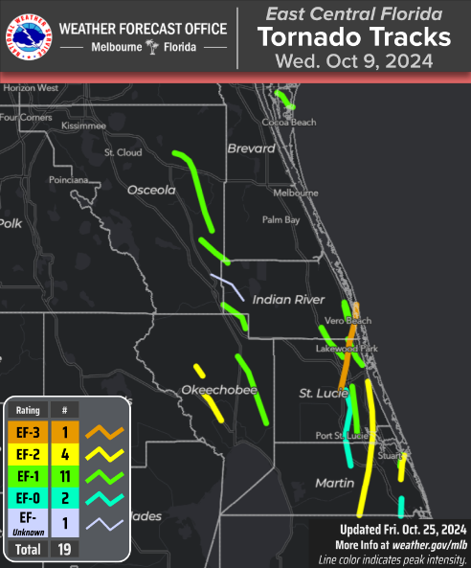
Tornadoes:

Confirmed Tornado Tracks Over East Central Florida
Tornado - Rural Okeechobee County, Near Dixie Ranch Acres
Okeechobee County
Date10/09/2024Time (EDT)2:04 PM - 2:20 PMEF RatingEF-2Est. Peak Winds115 mphPath Length8.5 milesMax Width250 yardsInjuries/Deaths2 / 0Summary:
A tornado touched down near Okeechobee County Airport, producing EF-1 and EF-2 damage along US-98. It destroyed a manufactured home, injured two people, and damaged a steel barn with winds reaching 90-115 mph. Agricultural equipment and several homes sustained roof damage, while a palm tree was snapped, and a farm outbuilding collapsed. In Dixie Ranch Acres, multiple homes and trees were damaged, with one home losing over 20% of its roof and winds reaching up to 110 mph. The tornado then moved into open pasture before lifting about 4 miles northwest of the area. More...
Track Map
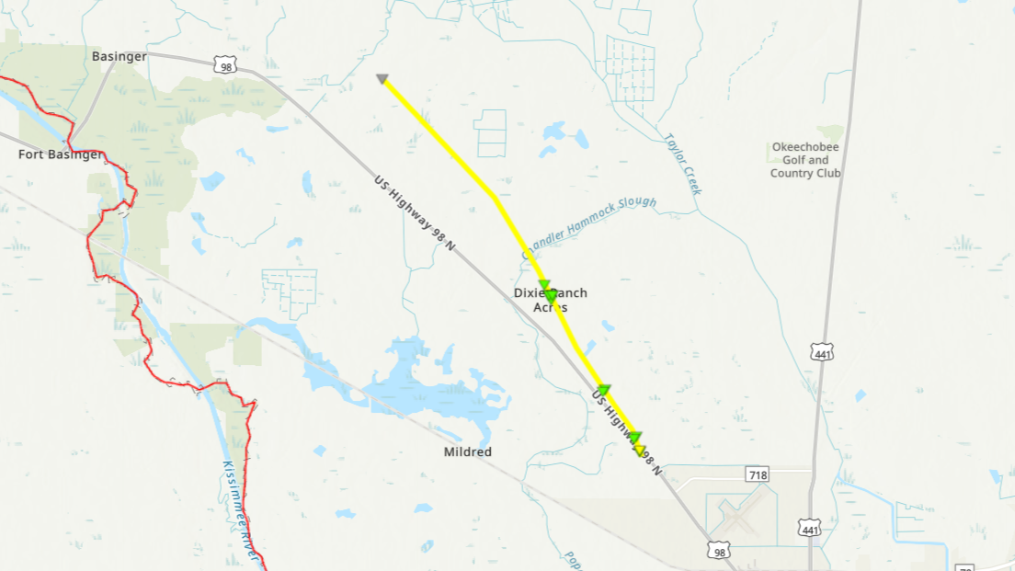
Tornado - Along I-95 near Port St Lucie
Martin & St Lucie Counties
Date10/09/2024Time (Local)2:05 PM - 2:40 PMEF RatingEF-0Est. Peak Winds75-85 mphPath Length18.1 milesMax Width200 yardsInjuries/Deaths0 / 0Summary:
An EF-0 tornado impacted Martin and St. Lucie counties on October 9, 2024, as Hurricane Milton's rainbands swept across the Treasure Coast. The tornado touched down near SW Martin Hwy and I-95, flipping a tractor-trailer and downing trees with winds of 75-85 mph. In the Rosser Reserve subdivision, residential structures sustained minor to moderate damage. A home in the Hidden Oaks community suffered major roof damage. The tornado weakened as it entered St. Lucie West, causing minimal damage before dissipating near the I-95 and Midway Interchange. More...
Track Map
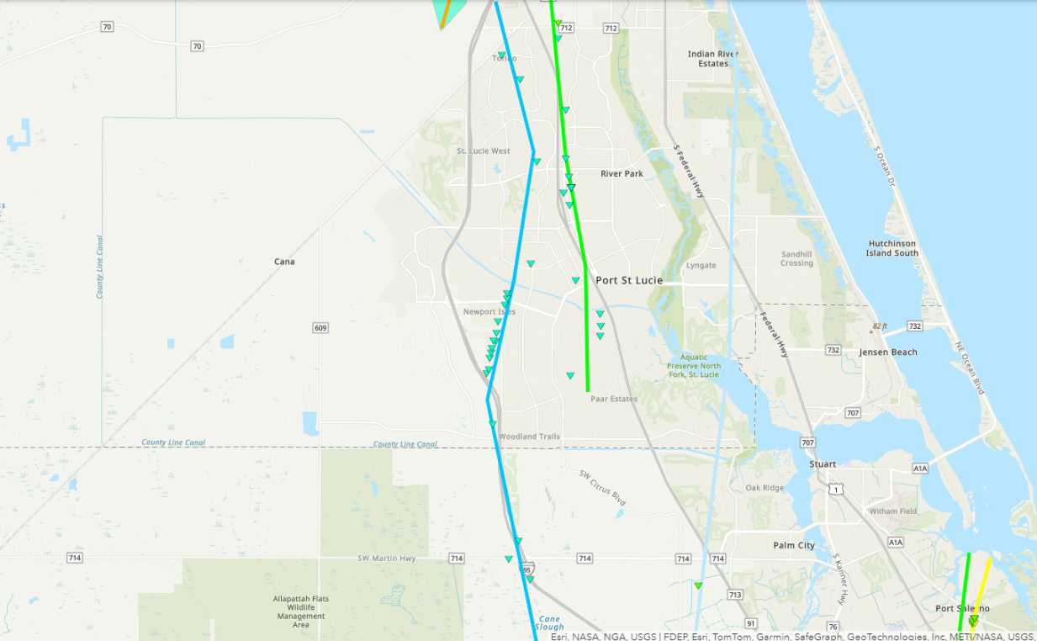
Tornado - Rural NE Okeechobee County
Okeechobee County
Date10/09/2024Time (EDT)2:10 PM - 2:39 PMEF RatingEF-1Est. Peak Winds110 mphPath Length17.1 milesMax Width300 yardsInjuries/Deaths0 / 0Summary:
A tornado with a long path struck northeastern Okeechobee County on October 9, 2024. The tornado touched down south of SR-70, flipping irrigation equipment with EF-0 winds of 75-85 mph. It caused roof damage and tree uprooting near NE 120th St. and Sunshine Grove with EF-0 to EF-1 winds of 75-95 mph. Significant damage occurred at Pine Creek Sporting Club, where outbuildings were destroyed by EF-1 winds of 100-110 mph. The tornado continued northwest, snapping trees along US-441, before lifting near Fort Drum around 2:39 PM EDT. More...
Track Map
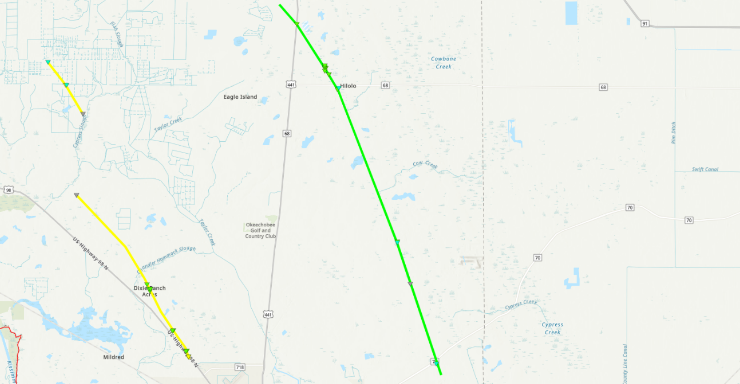
Tornado - Rural Okeechobee County, Near C & M Rucks Dairy
Okeechobee County
Date10/09/2024Time (EDT)2:27 PM - 2:32 PMEF RatingEF-2Est. Peak Winds115 MPHPath Length2.6 milesMax Width100 yardsInjuries/Deaths0 / 0Summary:
A tornado touched down near NW 144th Ave in northwestern Okeechobee County, producing EF-1 and EF-2 damage. It partially destroyed a large steel barn at C & M Rucks Dairy, with winds reaching 105-115 mph, while nearby power poles were downed. Despite the damage, the tornado's path was narrow, leaving nearby buildings untouched. The tornado lifted south of NW 240th St after strewing sheet metal along NW 203rd St. More...
Track Map
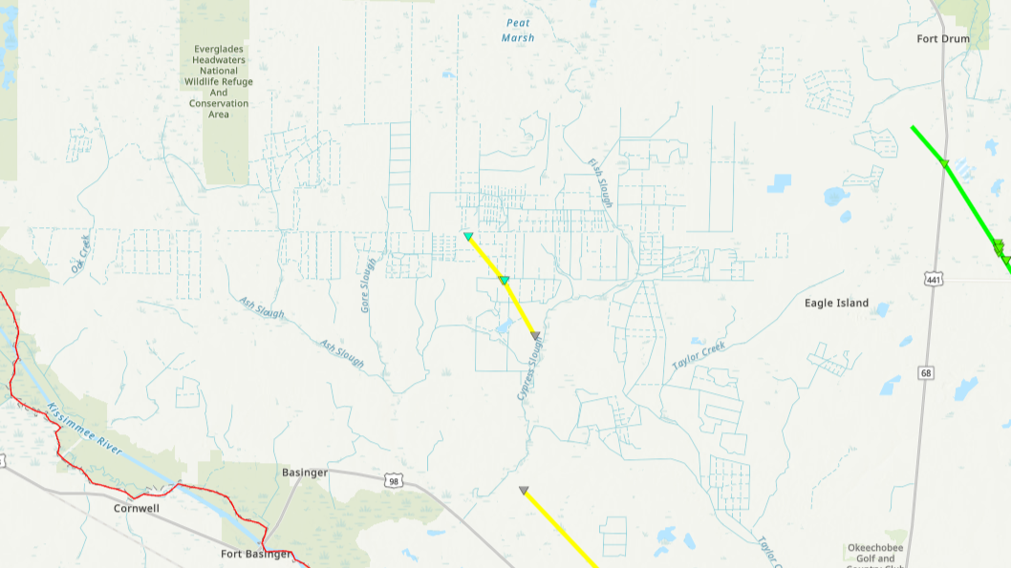
Tornado - Fort Drum
Okeechobee and Indian River County
Date10/09/2024Time (EDT)2:47 PM - 3:01 PMEF RatingEF-1Est. Peak Winds90 MPHPath Length7.9 milesMax Width100 yardsInjuries/Deaths0 / 0Summary:
Radar polarimetric data from the Melbourne WSR-88D indicates touch down occurred in NE Okeechobee County. The circulation continued northwest where it intersected the Fort Drum and Cavendish Solar Farms with estimated winds of up to 90 mph. The tornado dissipated in rural Indian River County shortly thereafter. More...
Track Map
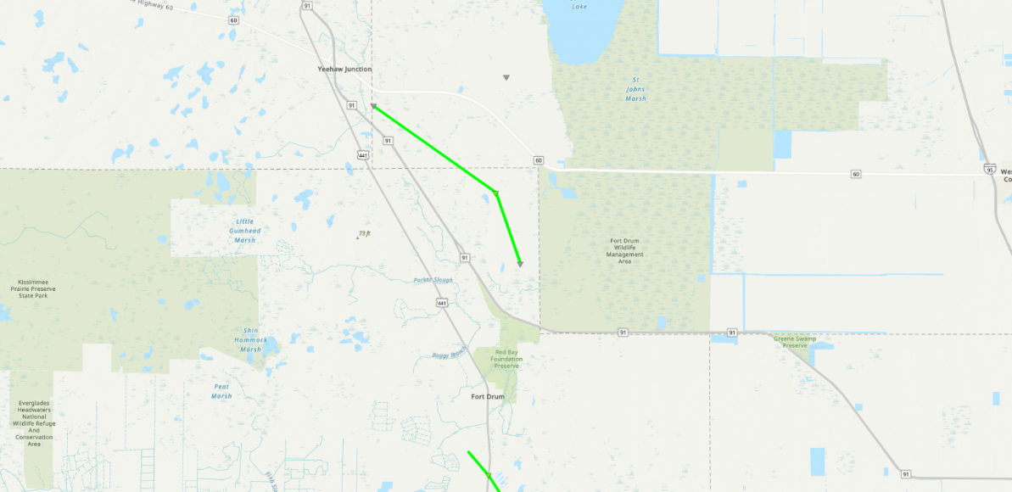
Tornado - Blue Cypress
Indian River and Osceola County
Date10/09/2024Time (EDT)2:58 PM - 3:18 PMEF RatingEF-UEst. Peak WindsUnknownPath Length9.9 milesMax WidthUnknownInjuries/Deaths0 / 0Summary:
Dual-polarimetric data from the Melbourne WSR-88D indicates the tornado touched down just west of Blue Cypress Lake in Indian River County before continuing on a west-northwest trajectory. The circulation moved into rural Osceola County where it appears to have briefly intensified before dissipating near US Highway 441. More...
Track Map
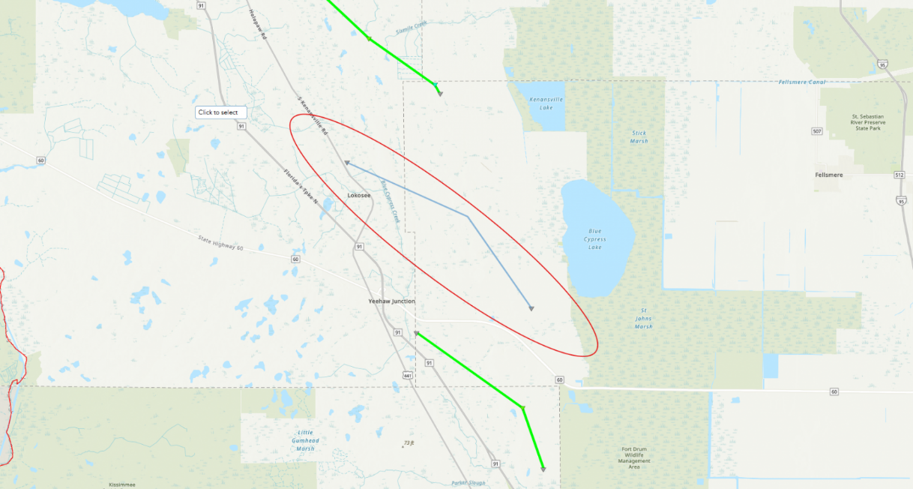
Tornado - Port St Lucie to Fort Pierce
St Lucie County
Date10/09/2024Time (Local)2:59 PM - 3:13 PMEF RatingEF-1Est. Peak Winds80-90Path Length11.8 milesMax Width 150 yardsInjuries/Deaths0 / 0Summary:
An EF-1 tornado impacted St. Lucie County on October 9, 2024, as Hurricane Milton's outer rainbands moved across the Treasure Coast. The tornado caused minor residential damage in the Crane Landing, Sawgrass Lakes, and Tulip Park subdivisions, with missing shingles and tree damage. It continued north through areas near Florida's Turnpike, including Cashmere Cove and Northport Village, with peak winds of 65-75 mph. In Fort Pierce, the tornado caused significant structural damage to a metal canopy at the St. Lucie County Sheriff's Office, with peak winds estimated at 90 mph before weakening and lifting near the I-95 and Okeechobee interchange. More...
Track Map
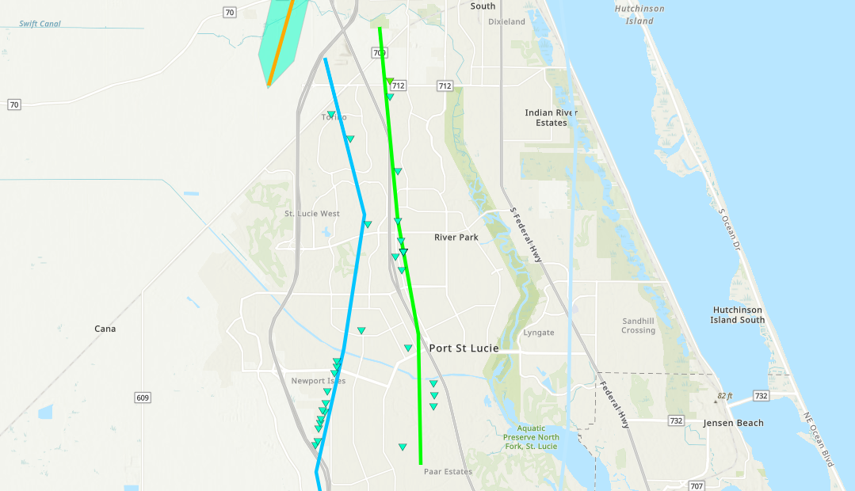
Tornado - St. Lucie Indrio Road
St Lucie & Indian River County
Date10/09/2024Time (Local)3:05 PM - 3:19 PMEF RatingEF-1Est. Peak Winds80-90Path Length8.5 milesMax Width 100 yardsInjuries/Deaths0 / 0Summary:
An EF-1 tornado developed in northern St. Lucie County and was likely spawned from the same supercell that produced the EF-0 tornado that impacted portions of Martin and St. Lucie County along I-95. The circulation impacted mainly rural pars of St. Lucie and Indian River counties, but intersected a few residences and businesses producing generally minor to moderate damage with winds up to 90 mph. More...
Track Map
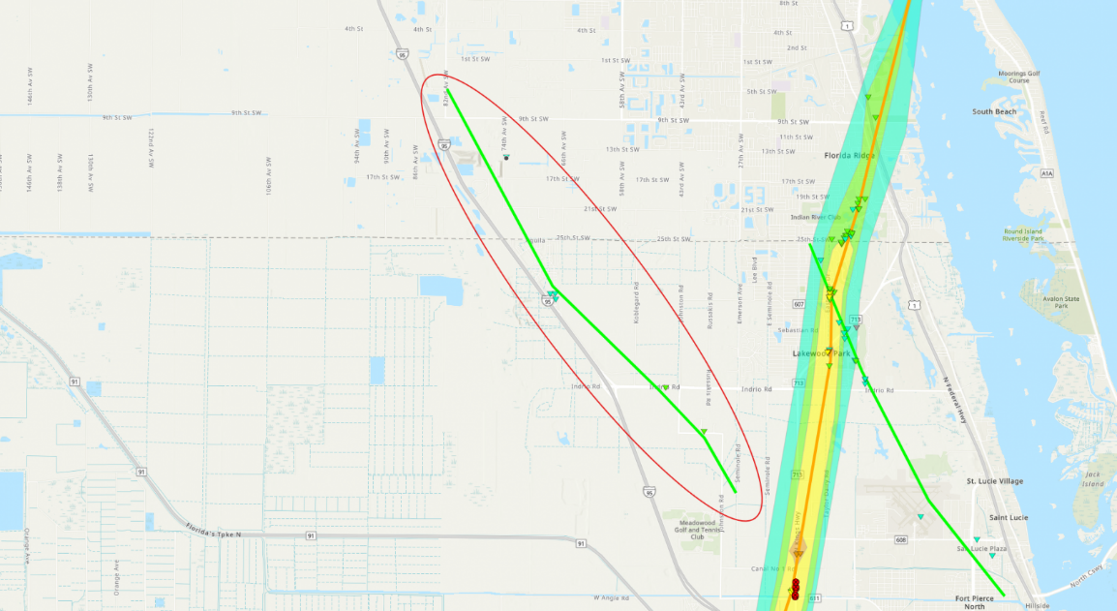
Tornado - SE Osceola Escape Ranch
Indian River and Osceola County
Date10/09/2024Time (Local)3:14 PM - 3:30 PMEF RatingEF-1Est. Peak Winds85 - 95 mphPath Length8.2 milesMax Width 150 yardsInjuries/Deaths0 / 0Summary:
A tornado developed near the Indian River and Osceola County border south of Fellsmere Rd. where it quickly intensified as it moved to the northwest. A large number (50 - 100) of pine trees on both sides of Six Mile Rd were snapped and uprooted, indicative of peak winds reaching 85 - 95 mph. The circulation continued into rural sections of Osceola where it dissipated before approaching US Hwy 441. More...
Track Map
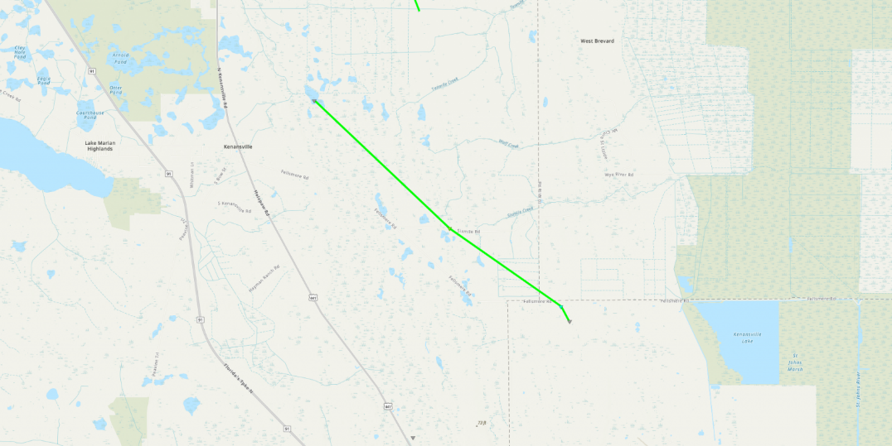
Tornado - East to North of Holopaw
Osceola County
Date10-09-2024Time (Local)3:28 PM - 4:07 PMEF RatingEF-1Est. Peak Winds100 mphPath Length21.1 miles (approx.)Max Width100 yardsInjuries/Deaths0 / 0Summary:
A confirmed EF-1 tornado, associated with Hurricane Milton, passed through remote areas of Osceola County on October 9, 2024. The tornado intersected portions of the Escondido and Deseret ranches to the east of US Hwy 441 where it downed and snapped numerous pine and oak trees, and destroyed a barn, with winds up to 100 mph. A storm spotter video showed the rain-wrapped tornado crossing US-192, 5.5 miles east of Holopaw, around 3:53 PM. The tornado curved westward before dissipating north of Holopaw. More...
Track Map
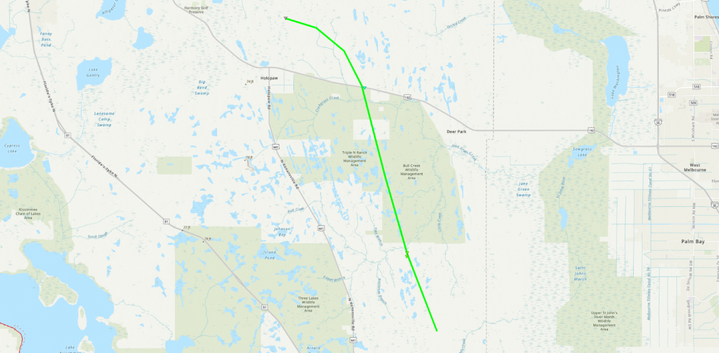
Tornado - First Downtown Vero Beach
Indian River County
Date10/09/2024Time (EDT)3:48 PM - 3:57 PMEF RatingEF-1Est. Peak Winds95 mphPath Length4.5 milesMax Width150 yardsInjuries/Deaths0 / 0Summary:
This was the first of two tornadoes to touchdown near downtown Vero Beach along US-1 and the railroad tracks. This tornado stayed mainly along and east of US-1 where it downed trees and produced structural damage to roofs of both homes and businesses. The tornado was caught on camera at the Vero Beach Police Department at around 3:53 PM EDT and an on-site weather station recorded a peak wind gust of 92 mph at 3:55 PM EDT. More...
Track Map
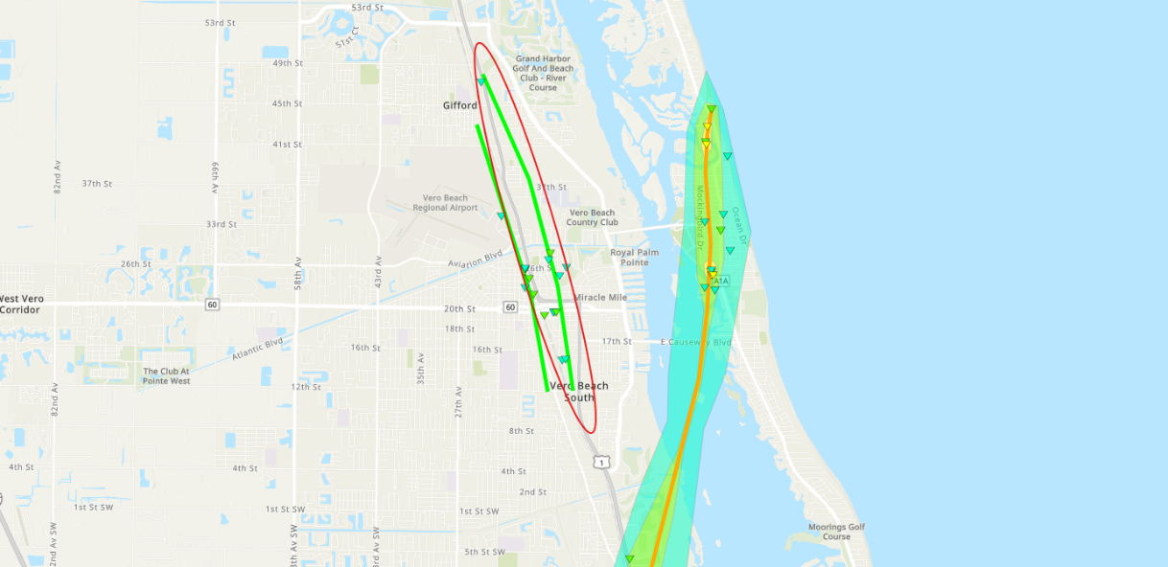
Tornado - First Stuart Tornado
Martin County
Date10/09/2024Time (EDT)4:03 PM - 4:12 PMEF RatingEF-1Est. Peak Winds95 mphPath Length3.0 milesMax Width250 yardsInjuries/Deaths1 / 0Summary:
An EF1 tornado from Hurricane Milton's outer rainbands touched down south of US-1, tossing a camper home and injuring its occupant. It caused significant damage to mobile homes in the Colonial Heights subdivision, with some moved off their foundations. In the New Monrovia subdivision, numerous homes and Murray Middle School suffered roof and vegetative damage, while a house in Rocky Point lost its roof completely. The tornado became a waterspout as it moved over the St. Lucie River and Intracoastal, dissipating before reaching the Jensen Beach Causeway.More...
Track Map
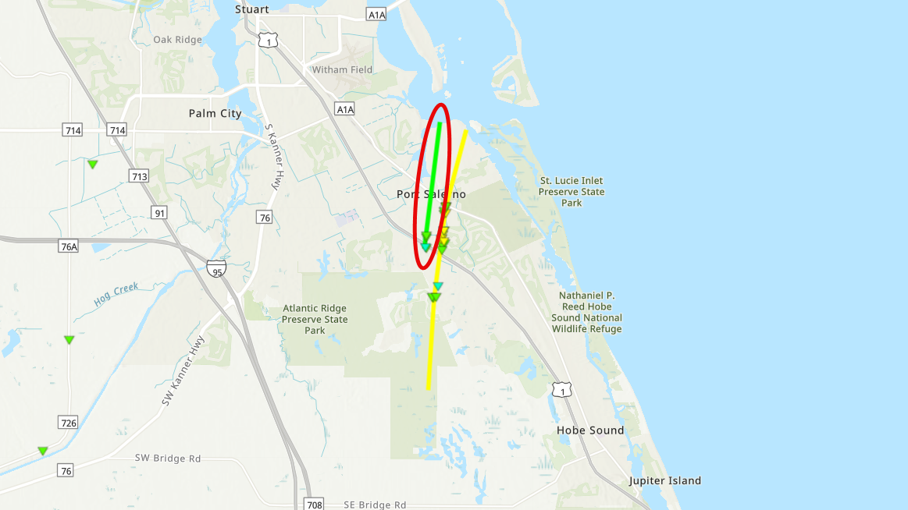
Tornado - Second Downtown Vero Beach
Indian River County
Date10/09/2024Time (EDT)4:09 PM - 4:16 PMEF RatingEF-1Est. Peak Winds100 mphPath Length3.4 milesMax Width100 yardsInjuries/Deaths0 / 0Summary:
This was the second tornado to impact downtown Vero Beach within approximately 20 minutes of the first. This tornado developed in Vero Beach very near and west of US-1, traveling north where it produced significant vegetative damage in the form of downed trees. Several homes and businesses, particularly between 16th and 26th St. suffered extensive damage, particularly to roofs. The circulation affected the east side of the Vero Beach Airport before lifting shortly thereafter. More...
Track Map
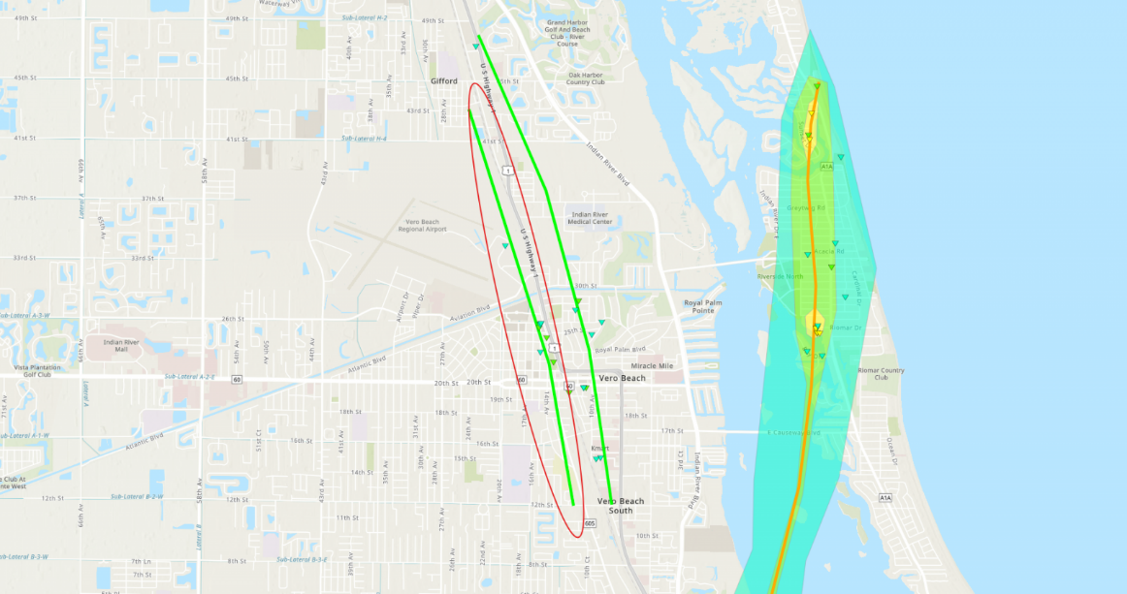
Tornado - Fort Pierce
St Lucie County
Date10/09/2024Time (Local)4:14 PM - 4:24 PMEF RatingEF-1Est. Peak Winds95 mphPath Length6.75 milesMax Width150 yardsInjuries/Deaths0 / 0Summary:
An EF-1 tornado touched down near the Belcher Canal in Fort Pierce, causing vegetative damage and partial roof loss near St. Lucie Blvd and N 25th St. The tornado continued northwest across Treasure Coast International Airport, where several small planes were tossed and recorded gusts of 60 mph. Damage indicated winds of 85 to 95 mph in residential areas, particularly on Sparkling Pines Dr. and within the Island Pines Golf Club. It then moved toward Lakewood Park, intersecting with a stronger EF-2/EF-3 tornado about an hour later. Residents reported minor to moderate damage from winds of 65 to 75 mph. The radar debris signature continued north, but no significant damage was noted beyond the county line, indicating the circulation likely lifted before reaching Indian River Co. More...
Track Map
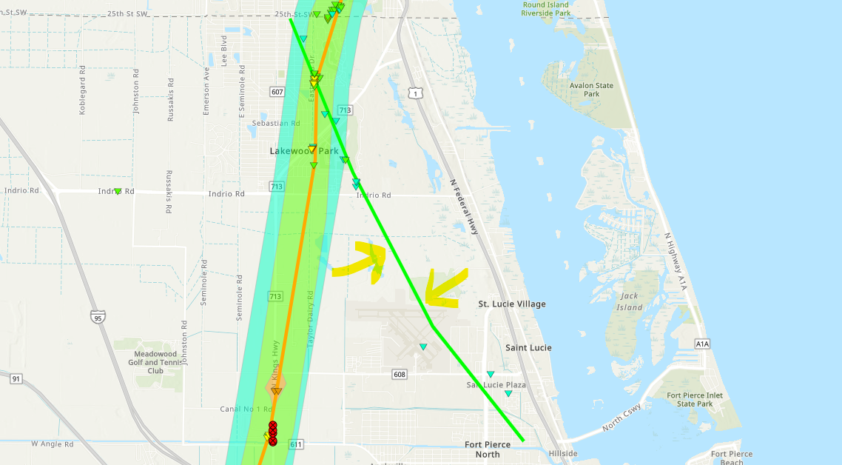
Tornado - Fort Pierce, Spanish Lakes, and Vero Beach Area
St. Lucie and Indian River Counties
Date10/09/2024Time (EDT)4:59 PM - 5:30 PMEF RatingEF-3Est. Peak Winds155 mphPath Length21.2 milesMax Width500 yardsInjuries/DeathsUnknown / 6Summary:
A long-tracked tornado, associated with Hurricane Milton, caused widespread EF-1 to EF-3 damage across Fort Pierce and Vero Beach, FL. It touched down near Midway Rd. and traveled over 18 miles before moving offshore north of Jaycee Park. Significant structural and vegetative damage began in Creekside Subdivision and Sunnier Palms, where many mobile homes were destroyed. The tornado strengthened to EF-3 near S Kings Hwy, severely damaging warehouses and a truss company. In the Spanish Lakes community, the tornado caused six fatalities and destroyed numerous homes with EF-2 winds. Vero Beach saw additional damage, including roof damage, a flipped car, and broken windows at a Publix. The tornado finally moved offshore after causing EF-2 damage along Bethel Creek. More...
Track Map
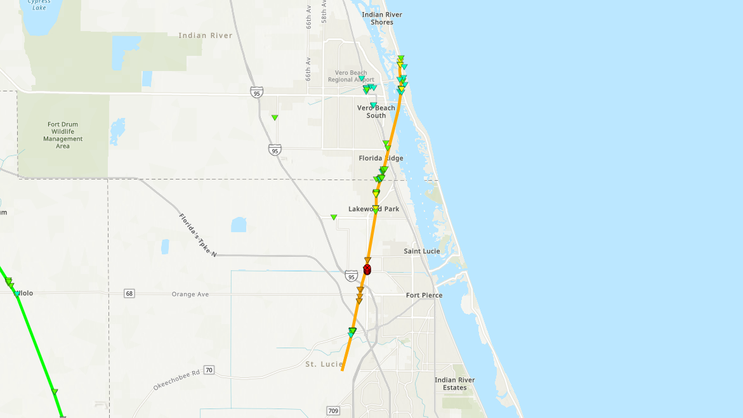
Tornado - Palm City and Port St. Lucie
St. Lucie and Indian River Counties
Date10/09/2024Time (EDT)5:00 PM - 5:50 PMEF RatingEF-2Est. Peak Winds125 mphPath Length31.6 milesMax Width300 yardsInjuries/Deaths0 / 0 Summary:
A long-tracked tornado moved across the Palm Beach and Martin County lines producing scattered instances of residential and vegetative damage as it moved near and parallel to Citrus Blvd. in Palm City. Here, EF-2 damage was noted to a newly-constructed home. The tornado continued north-northeast, producing a swath of EF-0 and EF-1 damage as it moved through Palm City. The circulation became a waterspout over the St. Lucie River before crossing back onto land and into Port St. Lucie. The tornado remained on the ground as it moved into the Indian River Estates subdivision and Fort Pierce South. More...
Track Map
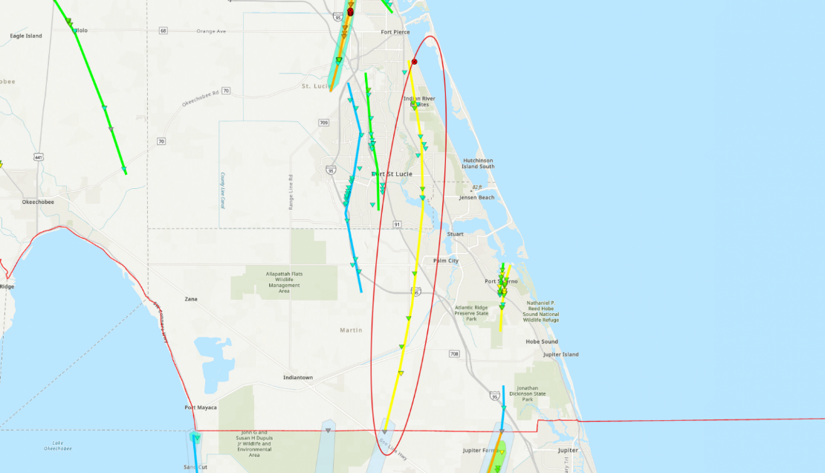
Tornado - Southeast Martin County
Martin County
Date10/09/2024Time (Local)5:21 PM - 5:30 PMEF RatingEF-0Est. Peak Winds80 mphPath Length4.0 milesMax Width100 yardsInjuries/Deaths0 / 0Summary:
This tornado is a continuation of the EF-3 tornado that impacted Palm Beach Gardens and Wellington, FL. The circulation, in a weakened state, moved out of Jupiter and into Martin County where it flipped a tractor trailer and damaged several trees near Interstate 95's mile marker 91. The tornado likely lifted in a rural area north of the interstate; however, it is believed the same supercell went on to produce the EF-2 tornado that impacted Port Salerno (Second Stuart Tornado). More...
Track Map
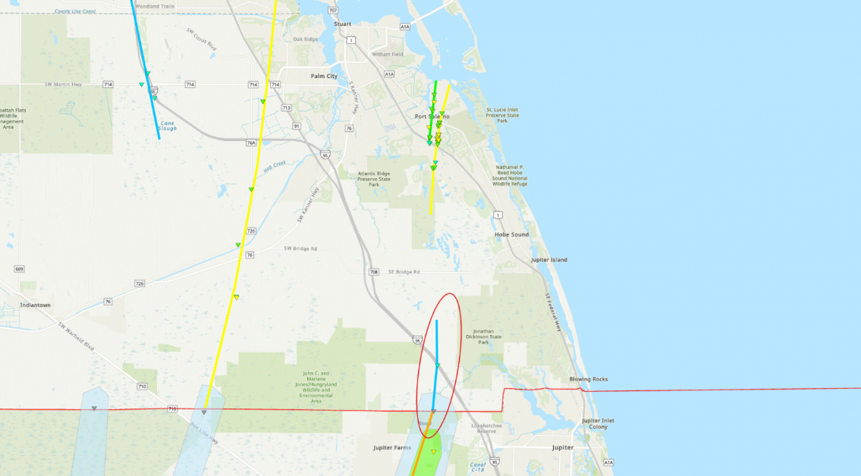
Tornado - Second Stuart Tornado
Martin County
Date10/09/2024Time (Local)5:35 PM - 5:46 PMEF RatingEF-2Est. Peak Winds120 mphPath Length5.7 milesMax Width400 yardsInjuries/Deaths1 / 0Summary:
A confirmed EF-2 tornado, part of Hurricane Milton's outer rainbands, impacted Stuart, FL, on October 9, 2024. The tornado touched down near I-95 and US-1, causing damage in the Lost Lake subdivision and moving north into The Preserve, where several concrete block homes lost roof tiles. It intensified in Mariner Sands, with wood-framed homes suffering total roof loss and partial wall collapse, injuring one resident. The tornado continued into the Manatee Creek subdivision, damaging nearly 30 homes with winds up to 120 mph. It then caused sporadic damage in Rocky Point before becoming a waterspout and dissipating over the Intracoastal. More...
Track Map
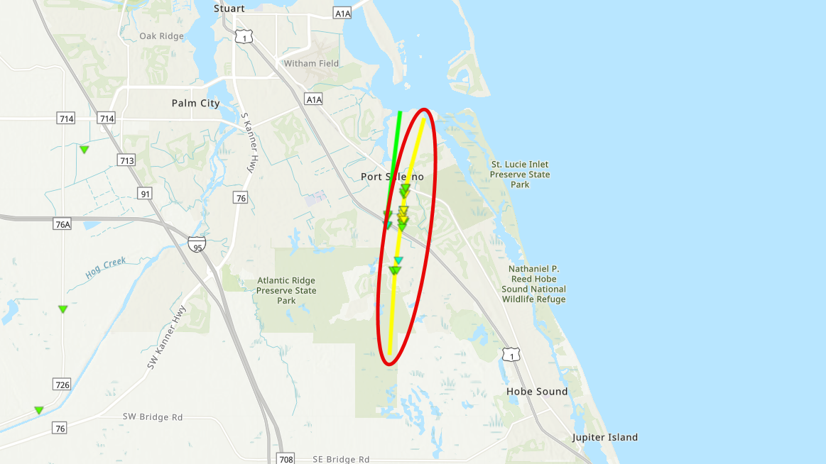
Tornado - Cocoa Beach Tornado
Brevard County
Date10/09/2024Time (EDT)5:53 PM - 6:09 PMEF RatingEF-1Est. Peak Winds95 mphPath Length5.2 milesMax Width250 yardsInjuries/Deaths0 / 0Summary:
A confirmed EF-1 tornado from Hurricane Milton impacted Cocoa Beach, FL, on October 9, 2024. Likely starting as a waterspout, it came ashore near Royale Towers Condominiums, damaging roofs and garages. The tornado then crossed A1A, removing a large portion of a bank's roof with winds of 90-95 mph. It continued through a residential area, causing partial roof loss, broken windows, and downed trees along St. Croix and S. Banana River Blvd with winds of 80-90 mph. The tornado emerged into the Banana River where it moved to the northwest, crossed SR 520, and pushed ashore just south of Kelly Park on Merritt Island. More...
Track Map
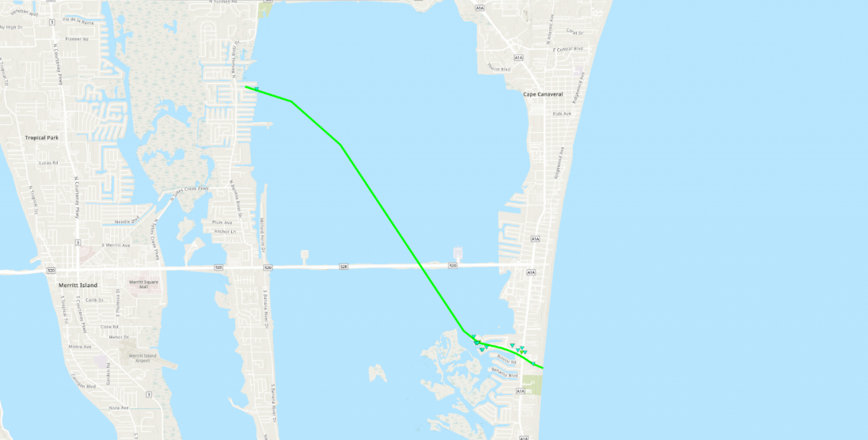

https://www.accuweather.com/en/hurricane/hurricane-milton-by-the-numbers-an-ef3-tornado-and-blowout-tide/1702670

Hurricane Milton by the numbers: an EF3 tornado and 'blowout tide'
Hurricane Milton set several meteorological records this week, and brought extreme rainfall, surge and wind gusts with it. Here's a look at the numbers.
By Jesse Ferrell, AccuWeather meteorologist and senior weather editor
Published Oct 10, 2024 2:07 PM CST | Updated Oct 11, 2024 10:38 AM CST
Hurricane Milton made landfall near Siesta Key, Florida, at 8:30 p.m. EDT Wednesday. The storm has knocked out power to millions of people in Florida and has caused at least 10 deaths. As residents pick up the pieces, these are some of the astounding numbers associated with the destructive storm.
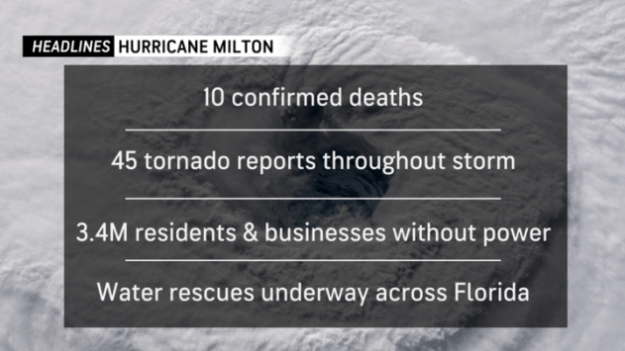

$160-180 billion
AccuWeather preliminarily estimates the total damage and economic loss from historic Hurricane Milton will be between $160 billion and $180 billion. Milton will go down as one of the most damaging and impactful storms in Florida history, along with Hurricane Helene’s estimated total damage and economic loss of $225-250 billion just two weeks ago, which resulted in significant damage from the Gulf Coast of Florida to the southern Appalachians, where a catastrophic flooding disaster occurred.
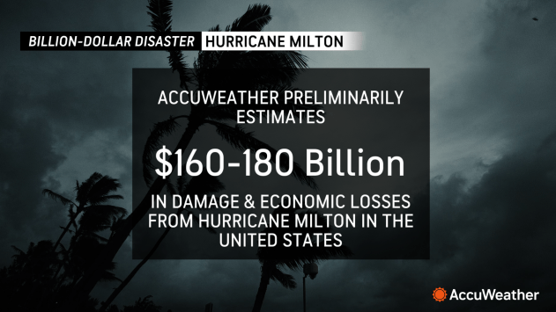

45 tornado reports, one EF3
National Weather Service offices in Florida issued 126 tornado warnings as Hurricane Milton approached. There were 45 tornadoes reported to the Storm Prediction Center. One tornado killed several people in St. Lucie on the east coast of Florida.
Another tornado near Palm Beach Gardens on the eastern shore of the state has been preliminarily rated EF3 by the NWS.
The record-holder for tornadoes spawned by a hurricane is 120 with Hurricane Ivan in 2004. In 2023, Hurricane Beryl spawned 68 twisters.
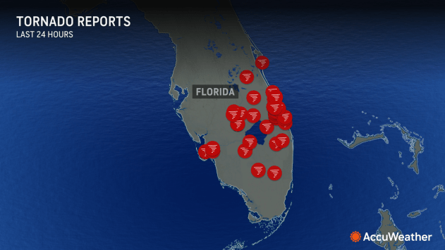

5th hurricane landfall
Hurricane Milton is the fifth hurricane to make landfall on the Gulf Coast this season, after Beryl, Debby, Francine and Helene. The 2005 and 2020 hurricane seasons also had five. Only the year 1886 had more, with six hurricanes making landfall in the Gulf that season. For continental U.S., having five landfalling hurricanes ranks third for number of strikes.
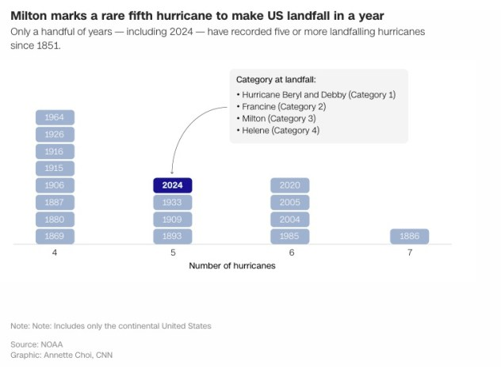
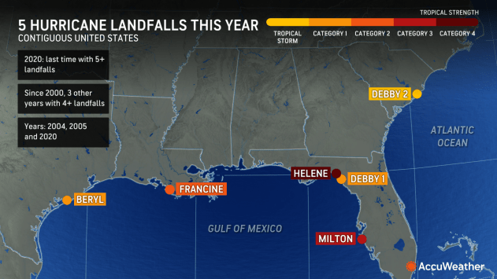
Milton is the third hurricane to hit the state of Florida this year. No other year on record has more than three. After an early pause, the 2024 Atlantic hurricane season is now above normal by all measures.

3,539,158 customers
Although most customers in Florida who lost power from Helene were restored before Milton approached, 100,000 customers had lost power in Florida because of the new storm by Wednesday morning. As Hurricane Milton got closer to the coast, numbers spiked, and 2.5 million had lost power by midnight. Outages were still going up Thursday morning, eclipsing 3.5 million. Hardee and Highlands counties reported that nearly 100% of customers were in the dark.
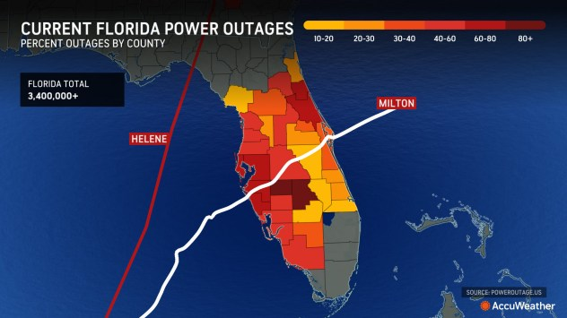

16 deaths
In the wake of Hurricane Milton, the death toll has risen to at least 16 people. St. Lucie County on Florida’s Atlantic coast first confirmed five deaths, attributed to tornadoes that touched down during the storm, WPBF News reported. In St. Petersburg, police confirmed two storm-related deaths. Volusia County has also reported fatalities, with Sheriff Michael J. Chitwood confirming that three people died in his jurisdiction.
16.67 inches of rain
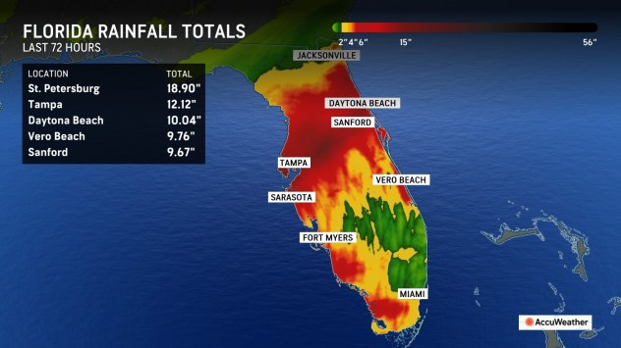
At the St. Petersburg Albert Whitted Airport, 18.87 inches of rain fell during Hurricane Milton. In just one hour, the rain gauge recorded 5.09 inches, an extremely rare rainfall rate. As Milton moved across Florida, an AccuWeather/Ambient Weather rain gauge recorded 16.67 inches at Lakeland, 32 miles northeast of Tampa.
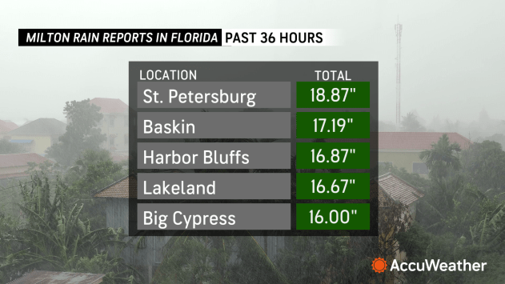

+5.78 storm surge
The storm surge at Naples, Florida, reached 5.78 feet above normal tide, nearly a foot higher than Hurricane Helene on Sept. 26 and almost 3 feet above Hurricane Debby on Aug. 4.
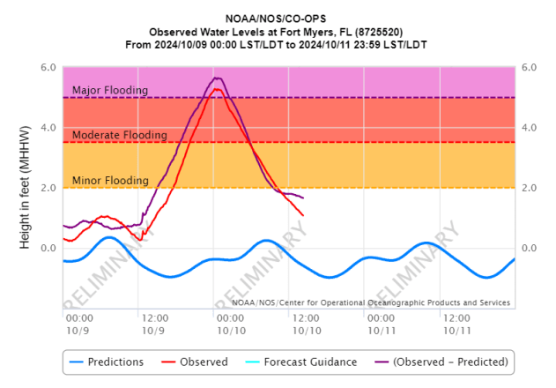
At Fort Myers, the gauge rose to 5.26 feet, slightly above the crest reached during Hurricane Helene at 5.12, but short of the 50-year record set by Hurricane Ian of 7.26 feet on Sept. 28, 2022.

-4.85 feet blowout
Instead of the water rising in Tampa Bay, a tidal gauge downtown, just north of the storm's landfall where winds were from the land, experienced a "blowout tide" or anti-storm surge. This happens when high winds from a tropical storm or hurricane blow from the land instead of the ocean, temporarily pushing water in bays out to sea. The water level fell to nearly 5 feet below normal as winds blew water in the bay out into the Atlantic Ocean.

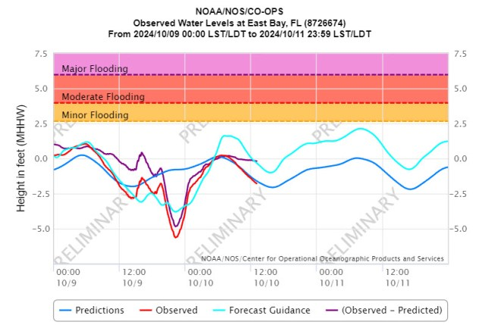

105-mph wind gust
The strongest wind gust reported during the storm was 105 mph at a WeatherFlow weather station in the Egmont Channel, southwest of St. Petersburg. The Bradenton and St. Petersburg airports also gusted to 102 and 101 mph, respectively.
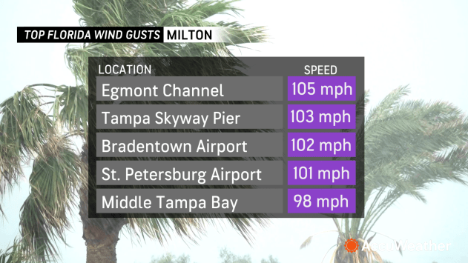

26.64 inches of mercury
Hurricane Milton's central pressure fell to 26.64 inches of mercury (902 mb) on Oct. 8, making it the fifth-strongest hurricane ever observed in the Atlantic Basin and the second-lowest for this late in the year. Milton's sustained winds were estimated at 180 mph, and only five Atlantic hurricanes have had estimated winds higher than Milton's.
2,000 gas stations
As of the morning of October 11, about a quarter of gas stations – around 2,000 – across Florida didn’t have fuel, according to gas price-tracking platform GasBuddy. In harder hit areas, these numbers were higher: nearly two-thirds of the gas stations in the Tampa and St. Petersburg area had no fuel as of 10:30 a.m. and 44% in Sarasota were dry on October 11.
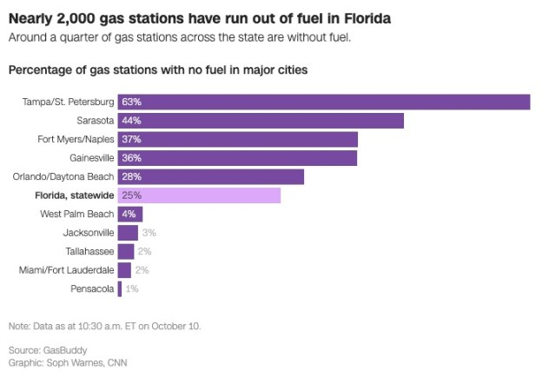

https://www.cnn.com/2024/10/10/weather/map-charts-milton-hurricane-dg/index.html?

Maps and charts: Visualizing Milton’s historic impact across Florida
By Amy O’Kruk, Matt Stiles, Renée Rigdon, Curt Merrill, Soph Warnes and Annette Choi, CNN
3 minute read
Updated 4:15 PM EDT, Fri October 11, 2024
CNN — Hurricane Milton slammed into Florida’s Gulf Coast on Wednesday night, making landfall as a powerful Category 3 storm. The intense hurricane spawned tornadoes, dumped rain across much of the state, left millions without power and claimed at least 16 lives, including five people in St. Lucie County.
As the storm has moved into the Atlantic Ocean, roughly 10 million residents remain under threat from dangerous coastal conditions through Friday. The storm’s dramatic and rapid intensification set a record as the fastest-ever Atlantic hurricane to escalate from a tropical depression to Category 5 status in just over 48 hours, according to NASA.

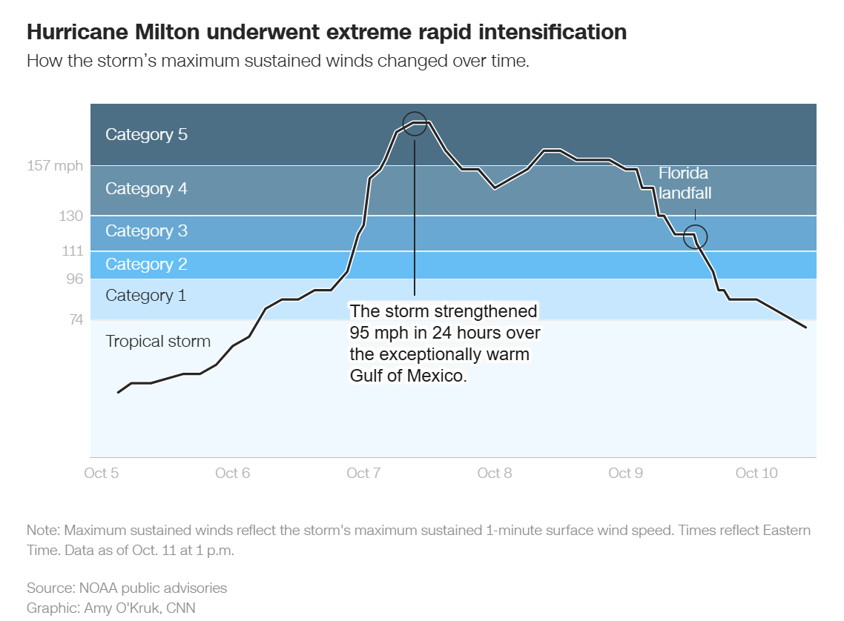
Milton’s sustained wind speeds peaked at 180 miles per hour on Monday, before dropping to around 120 mph when the storm made landfall near Siesta Key around 8:30 p.m. Wednesday — less than two weeks after Hurricane Helene made landfall in the state as a Category 4 storm.
Milton is the third hurricane to hit Florida this year — which has only happened during five other hurricane seasons since 1871. No season on record has had more than three hurricanes strike Florida.
Extremely warm water in the Gulf of Mexico acted like rocket fuel for the hurricane, a phenomenon that’s been made hundreds of times more likely by climate change, according to a recent analysis by nonprofit research group Climate Central. Satellite data shows that sea surface temperatures in the gulf are around 1 to 3 degrees Celsius warmer at this time compared to the long-term average for 1985 through 2012.
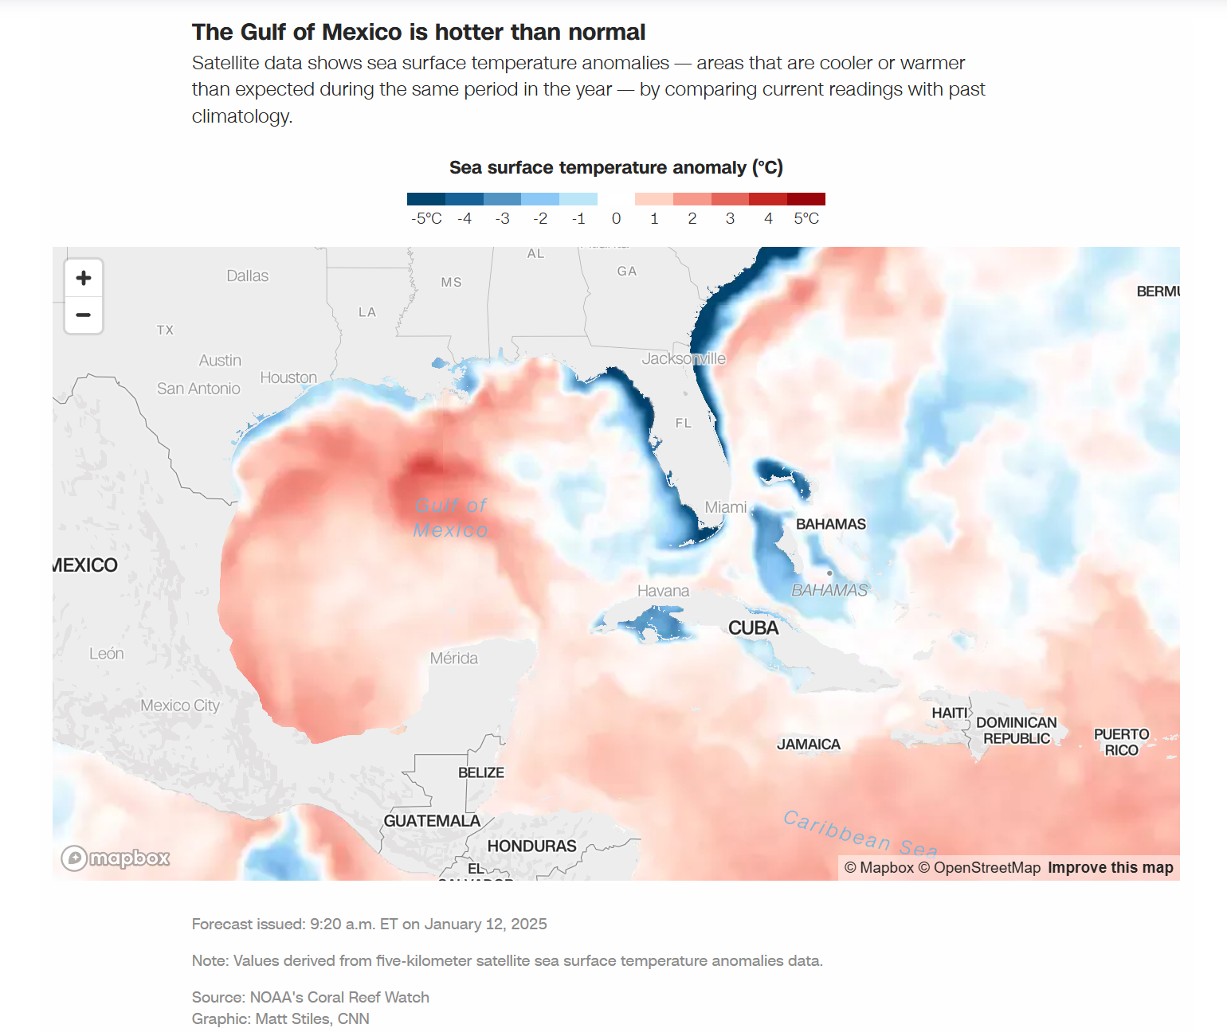
More than 18 inches of rain fell in St. Petersburg, marking a 1-in-1,000 year rainfall event. Flooding is still expected through the weekend. See where the heaviest rain hit the state:

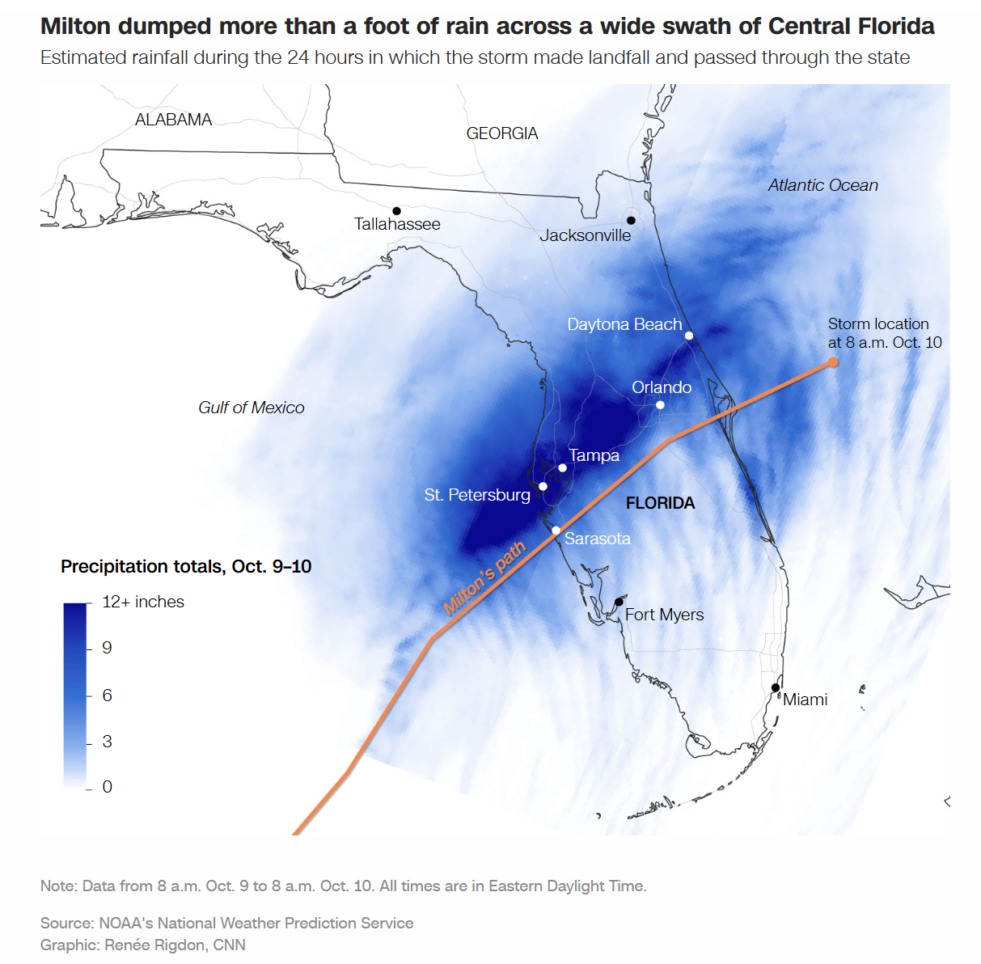
While Milton’s prolific rain is causing major flooding and swelling rivers to historic highs in some places, FEMA Director Deanne Criswell said Florida dodged the worst-case scenario. Relief efforts are ongoing, including a rescue of at least 135 peoplefrom an assisted living facility.
As of Thursday, nearly a dozen river gauges across the state are in major flood stage.. The Hillsborough River had already surged to 15.46 feet, beating the previous record of 15.33 feet set in 1960.
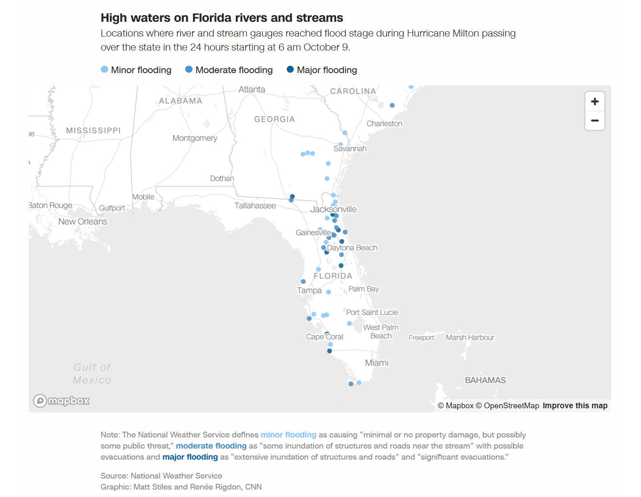
All of these gauges are expected to remain at moderate, or higher, flood stage through the weekend, with some not cresting until at least Sunday.
Many areas in Florida are also recovering from the aftermath of a Milton-spurred torrent “supercharged” tornadoes, according to National Hurricane Center Director Michael Brennan. At least nine tornadoes plowed through St. Lucie County on Wednesday, including three in less than 25 minutes.
“We’ve never seen anything like that before,” Port St. Lucie Mayor Shannon Martin told CNN’s Jim Acosta on Thursday. “I know I’ve never seen anything like that before in almost 20 years that I’ve been here.”
Statewide, there have been more than 30 tornadoes reported since Wednesday with more than 125 warnings issued by the National Weather Services offices in Tampa Bay, Melbourne, and Miami. This is the most tornado warnings ever in a single day in Florida’s history, beating the previous record of 69 set during Hurricane Irma in 2017.
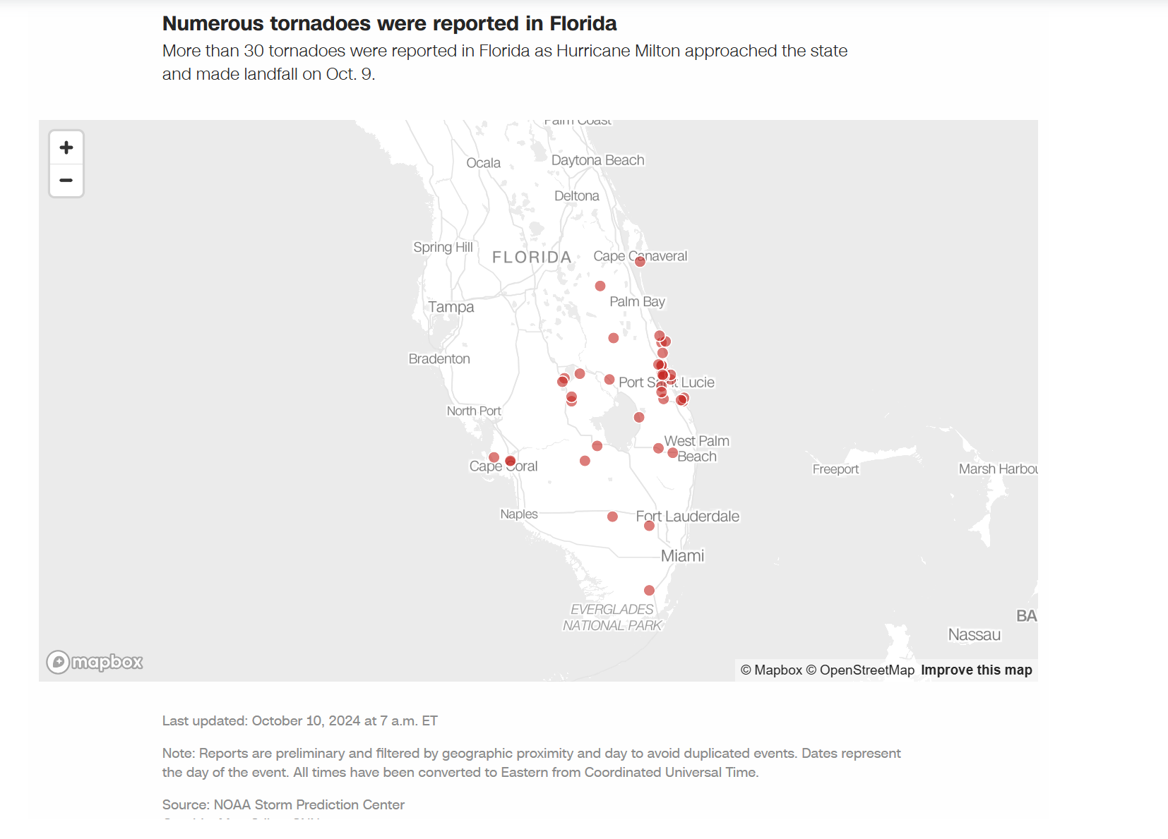
As Floridians survey the damage, more than 3 million people were without power as of Thursday morning. Florida’s power outages were most significant along its west coast, especially in the Hardee and Highlands counties.
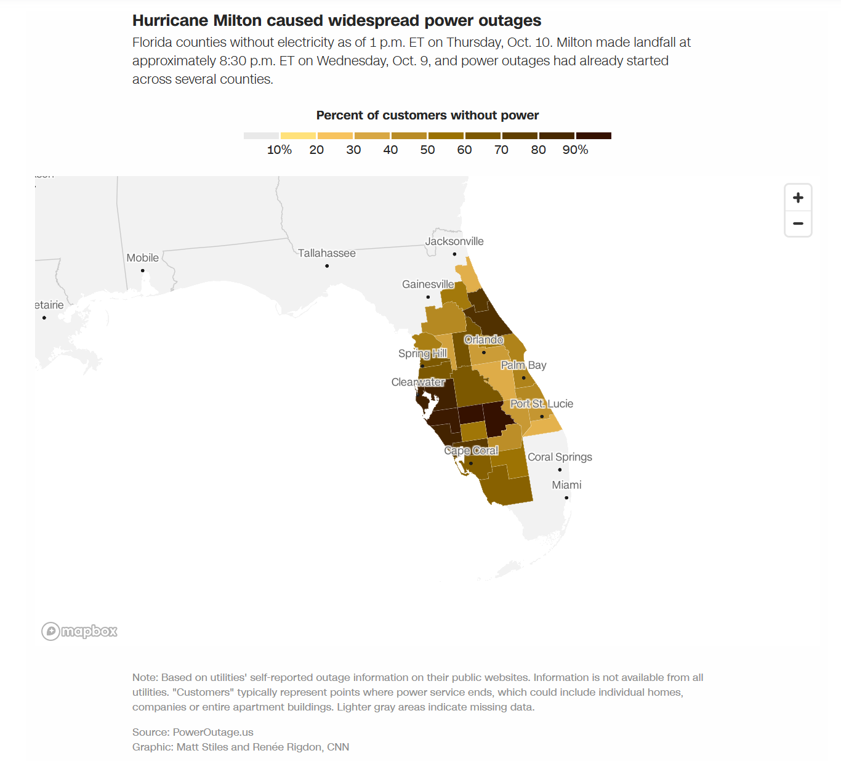
As of Friday, more than 2,200 gas stations – around 29% – across Florida didn’t have fuel, according to gas price-tracking platform GasBuddy. In harder hit areas, these numbers were higher: nearly three-quarters of the gas stations in the Tampa and St. Petersburg area had no fuel as of mid-morning Friday and 54% in Sarasota were dry.
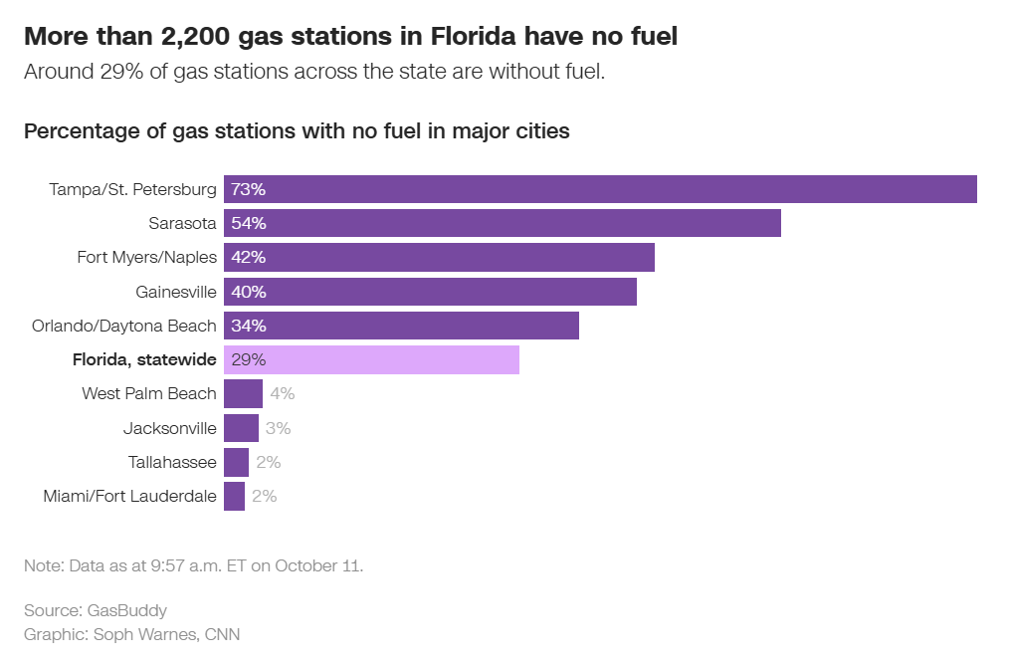
Milton emerged toward the end of a busy Atlantic hurricane season. Milton was the fifth hurricane to make landfall in the United States this year, joining Category 1 Beryl, Category 1 Debby, Category 2 Francine and Category 4 Helene. More hurricanes have made landfall in the United States this year than from 2021 to 2023 combined.

https://www.uwyo.edu/news/2024/12/uw-instructional-professor-and-students-provide-disaster-mapping-assistance-after-hurricane.html

UW Instructional Professor and Students Provide Disaster Mapping Assistance After Hurricane
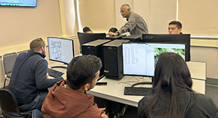
Published December 10, 2024
Ramesh Sivanpillai (center), an instructional professor in UW’s School of Computing and Wyoming Geographic Information Science Center, monitors several UW students who helped him with mapping damaged homes and structures in Florida after Hurricane Milton hit the state in October. Students mapped 3,470 damaged structures in five west Florida communities. Mekhriddin Rakhimov, a visiting faculty member in the UW School of Computing, is pictured on the far right. Rakhimov is the head of computer systems at Tashkent University of Information Technologies in Tashkent, Uzbekistan. (Tim Musselman Photo)
After Hurricane Milton decimated many parts of Florida in early October, Ramesh Sivanpillai received a familiar call.
No stranger to assisting with natural disasters, Sivanpillai, a University of Wyoming instructional professor in the School of Computing and Wyoming Geographic Information Science Center (WyGISC), was tapped by the International Charter Space and Major Disasters to help with mapping damaged homes, buildings and other infrastructure in Florida caused by Milton.
The International Charter Space and Major Disasters, formed in 1999 by the United Nations, consists of members from 17 charter countries and has responded to disasters in 136 countries, providing free satellite data from 270 contributing satellites for the impacted regions. To date, there have been 933 activations.
Sivanpillai was called to serve as a value-added data provider (VAP) by Brent Yantis, Regional Application Center director at the University of Louisiana at Lafayette, who is serving as project manager. VAPs process raw satellite and other data and generate value-added products.
“Working with the project manager, I identified the priority areas for identifying damaged structures and accident sites from satellite and aerial images acquired before and after the hurricane,” Sivanpillai explains. “Since Florida and other areas on the East Coast were hit hard by Hurricane Helene (Sept. 27), agencies needed any additional help they could get. The maps we generated will be used during field visits by federal and state emergency manage agencies.”
Milton hit Florida’s Gulf Coast Oct. 5 as a Category 3 hurricane. As the powerful storm made its way across the state, the hurricane caused record-setting storm surge, spawned numerous tornados and unleashed heavy rains that resulted in extreme flooding.
To help with the work, Sivanpillai recruited 32 UW students and five UW faculty/staff members who have identified more than 3,470 damaged structures in five Florida communities -- Anna Maria Island, Fort Myers, Manasota City and adjacent areas, Manasota Key and Siesta Key -- during five separate disaster mapping sessions that began Oct. 10. To date, students have contributed more than 250 hours of disaster mapping work, he says.
Before the disaster mapping sessions, three lead student volunteers downloaded the post-disaster images from the U.S. Geologic Survey website. During the sessions, volunteers viewed them in ArcGIS, a geospatial data analysis software. The software allowed students to obtain the geographic location of each home, building, marina dock, accident site and flooded area. These locations were transferred to the damage assessment maps.
“In this software, everyone displayed the pre-damage images that showed the conditions in these locations before Hurricane Milton, and possibly Hurricane Helene, passed through,” Sivanpillai says. “Volunteers compared both pre-damage and post-damage images and labeled damages and accidents to one of 16 categories.”
Much of the damage found to residential properties and other building structures, including mobile homes, condominiums and businesses, was in the form of roof damage, missing roofs and other structural damage. Several structures and debris material were physically moved to new locations due to the force of the hurricane. For example, volunteers identified numerous locations where debris was strewn across backyards and in roads.
“Since these images show the vertical perspective or a birds-eye view, it was not possible to determine if the side walls were damaged or gave way,” Sivanpillai says. “We also identified numerous sites with damages to docks and piers that were partially damaged or missing, and debris strewn across backyards.”
To date, Sivanpillai and his team have identified 3,476 points of damage, with several points that correspond to multiple damage sites. For example, if a cluster of buildings was damaged in a similar way, such as having a missing roof, volunteers placed only 1 point and mentioned in the comments column that there were multiple, similar damages.
The point totals include parts of South Venice through Englewood, 1,051 points; Siesta Key, 816 points; Manasota City and adjacent areas, 696 points; Anna Maria Island, 555 points; and Manasota Key, 358 points. The team has yet to finalize another 300 points of damage in Fort Myers and neighboring locations.
The extent and severity of damage was eye-opening, Sivanpillai says.
“In addition to flooding, several tornadoes touched down or high gusts went through these areas. It was extremely sad to see that people living in those areas have lost so much, and some lost almost everything they had in these areas,” he says. “At the same time, we found several sections with no damages that could be identified from these photos.”
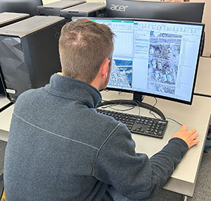
Sivanpillai was pleasantly surprised at the number of students and a few staff members who came to the five mapping sessions.
Jackson Alford, a UW master’s student from Panama City, Fla., studying rangeland ecology and watershed management, interprets data of damaged homes and structures in Anna Maria Island, a community that was hit by Hurricane Milton in October. (Devon Borthwick Photo).
“Their contributions were invaluable,” Sivanpillai says. “Without their contributions, we could not have made such progress. After two sessions, several volunteers asked me about the next session. Students who initially said they had only 45 minutes to spare were working after two hours or so.”
He adds, “It was gratifying to see that several domestic and international students from UW volunteered for this project, whether they had a relative or friend or knew someone in Florida.”
Participating UW students, listed by their hometowns and majors, are:
Ackley, Iowa -- Taryn Day, zoology.
Cheyenne -- Kaeden Adams, geospatial information science and technology; Ellie Birge, geography; Morgan Bugg, geospatial information science and technology; Andrea Edwards, history; Anna Erdmann, international studies; and Kristen Huffman, management.
Elgin, Ill. -- Robert Anderson, wildlife and fish biology and management.
Hartland, Wis. -- Sophia Nowak, wildlife and fish biology and management.
Jakarta Bar, Indonesia -- Friets Menanti, energy resource development/management; Aris Wanimbo, environmental systems science; and Jaineth Youwe, energy resource development/management.
Koforidua, Ghana -- Ivy Kwashie, geospatial information science and technology (master’s).
Lagos, Nigeria -- Francis Okwuzu, environmental engineering (master’s).
Lander -- Shayla Babits, environmental and natural resources.
Laramie -- Samantha Bemis, biology; Martin Buchanan, religious studies; Jeremy Chappell, environmental systems science; Annalee Galley, outdoor recreation and tourism management; Madaline Huffman, marketing; Colb Stickelman, environmental systems science; Korrin Sutherburg, geospatial information science and technology; Andi Swedborg, environmental systems science; Natalie Williams-Todd, undeclared major (master’s); and Sage Wright, geospatial information science and technology.
Loveland, Colo. -- Devon Borthwick, geospatial information science and technology (master’s).
Mexico City, Mexico -- Samuel Gonzalez Garcia, computer science.
Montrose, Colo. -- Reina Galvan, zoology and physiology (master’s).
Panama City, Fla. -- Jackson Alford, rangeland ecology and watershed management (master’s).
Ramarosha, Nepal -- Purna Saud, geospatial information science and technology (master’s).
Rock Springs -- Kyle Ridenour, environmental systems science.
Sheridan -- Emma Oettken, environmental systems science.
In 2011, Sivanpillai was tapped by the charter to assist with major flooding along the Mississippi River that started in Illinois, an event that lasted roughly five months. Two years before that, Sivanpillai was selected by the U.S. Geological Survey for project manager training in Denver. While a student at Texas A&M University in 1999, he volunteered to help with relief efforts in Nicaragua.
In 2018, Sivanpillai was again called by the charter to serve as a project manager for the Camp Fire that engulfed the town of Paradise, a community located in northern California. And, in fall 2022, Sivanpillai was tapped to be a project manager in response to Hurricane Fiona in the Dominican Republic.
Federal and state management agencies will use the maps generated by UW and other volunteers to conduct field visits and assessments. After these assessments, the agencies will estimate the hurricane damage in dollar amounts, Sivanpillai says. The International Charter is not involved in determining the monetary value of the damages, he adds.
The disaster mapping work at UW will conclude Sunday, Dec. 15, Sivanpillai says.

https://rac.louisiana.edu/news-events/news/20241104/yantis-leads-activation-hurricane-milton-international-disaster-charter

Yantis leads the activation of the Hurricane Milton International Disaster Charter
Mon, 11/04/2024 - 9:04am

Mr. Brent Yantis is leading the activation of the Hurricane Milton International Disaster Charter.
Hurricane Milton made landfall as a Category 3 storm in western Florida early on Thursday, 10 October. The eye of the storm hit Florida's Gulf Coast and densely populated areas such as Tampa, St. Petersburg, Sarasota, and Fort Myers.
The International Charter Space and Major Disasters is a key provider of Earth-observation satellite data and works with experts to derive information products to support disaster relief organizations in saving lives, property, infrastructure, and the environment following major disasters worldwide.
Learn more about the Hurricane Milton charter - https://disasterscharter.org/web/guest/activations/-/article/storm-hurricane-in-united-states-activation-920-

*H2. Most relevant value-added products
VAP title: Damaged Structures - Parts of South Venice, Manasota, Englewood, FL.
VAP creation date: 08-Dec-2024
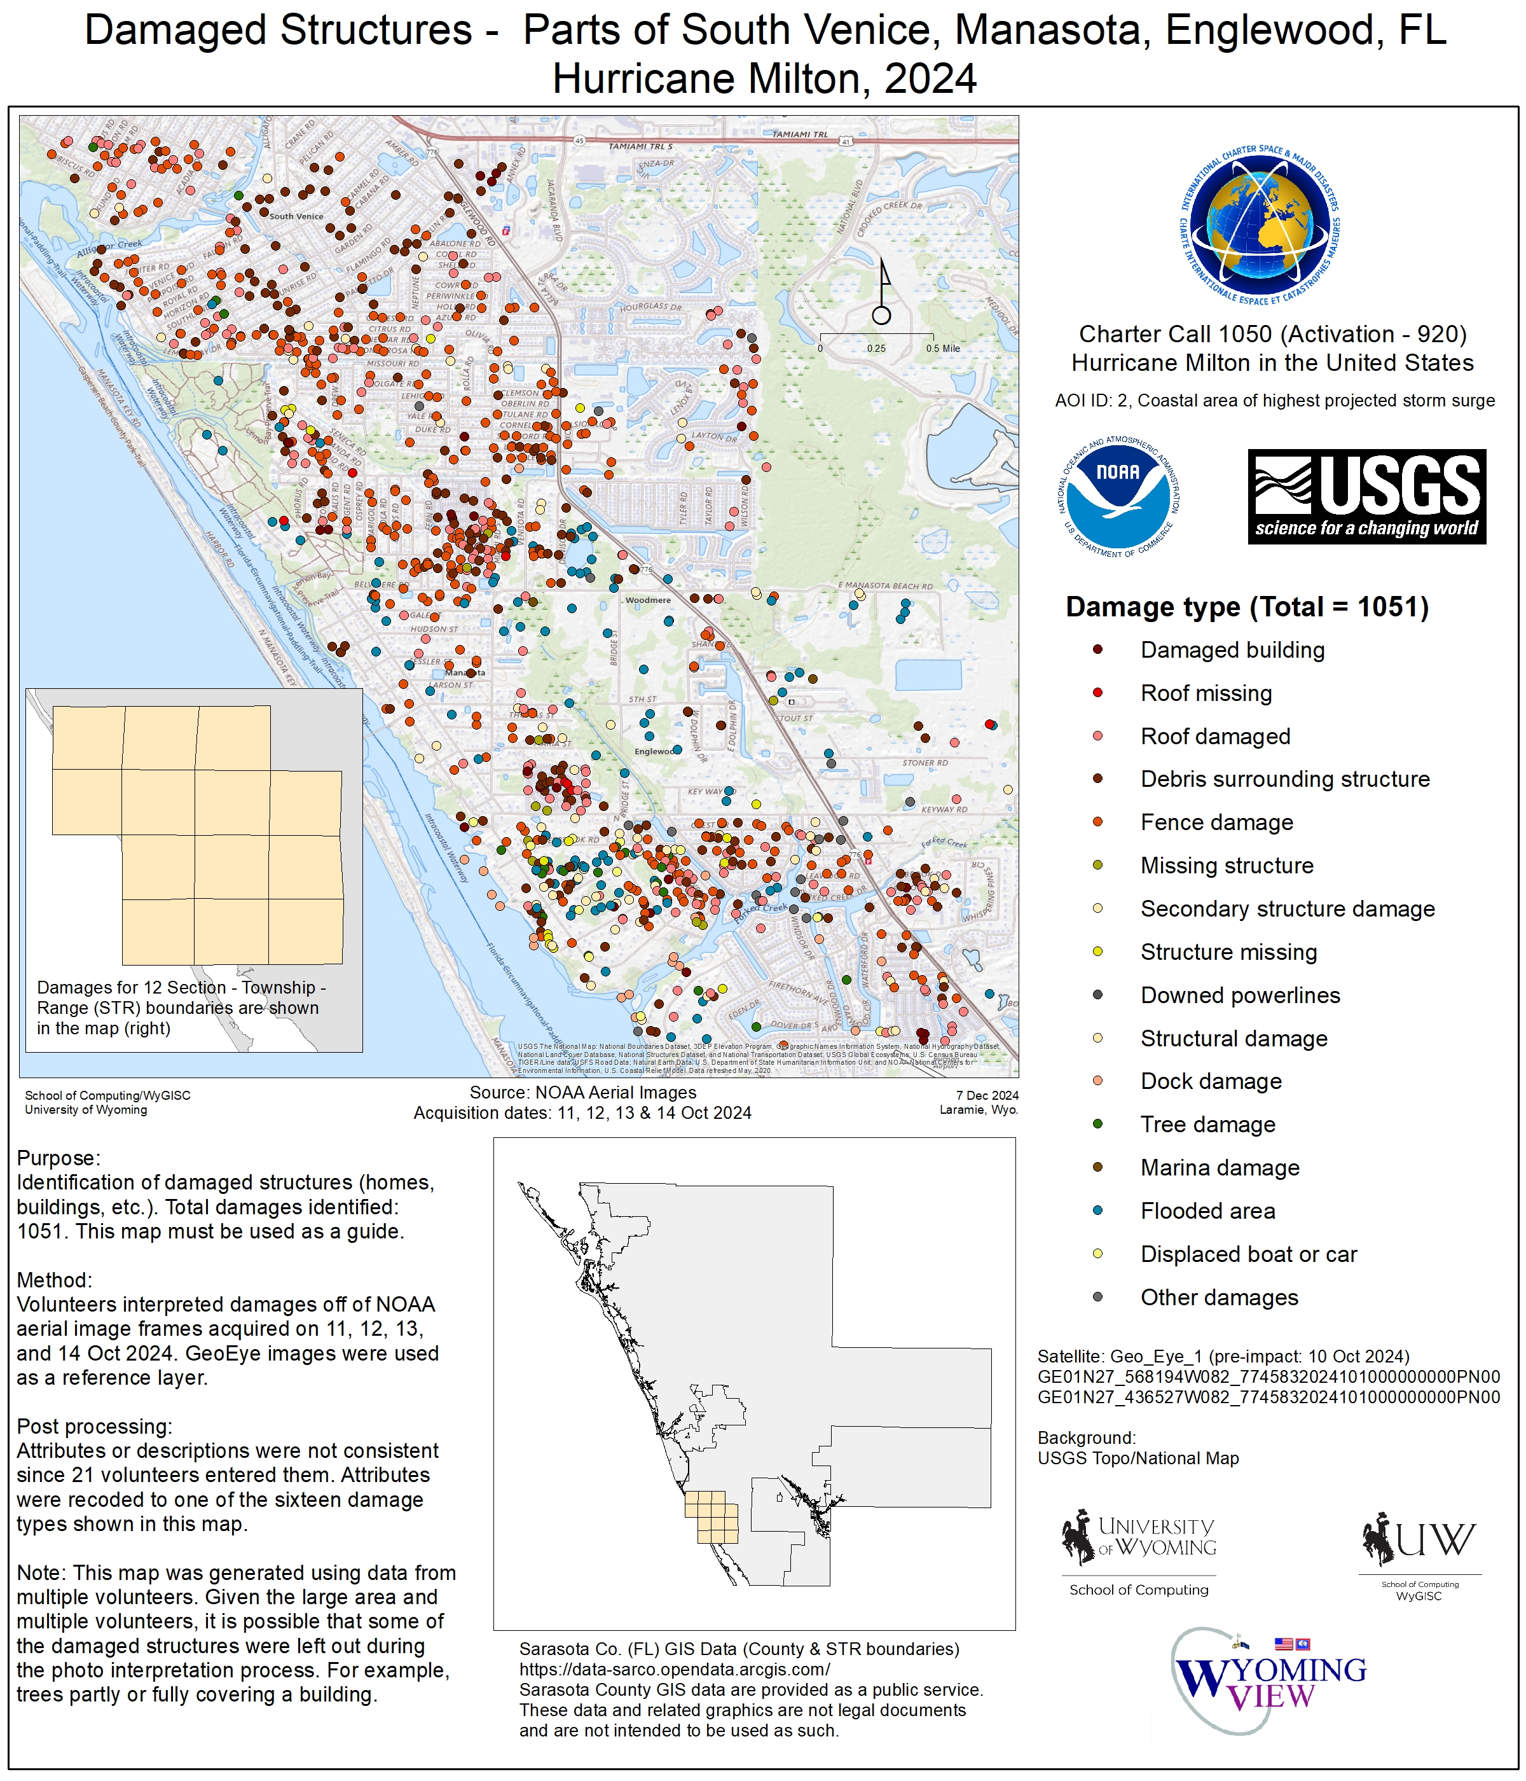
VAP title: Damaged Structures - Southwest Sarasota County, Florida
VAP creation date: 30-Nov-2024
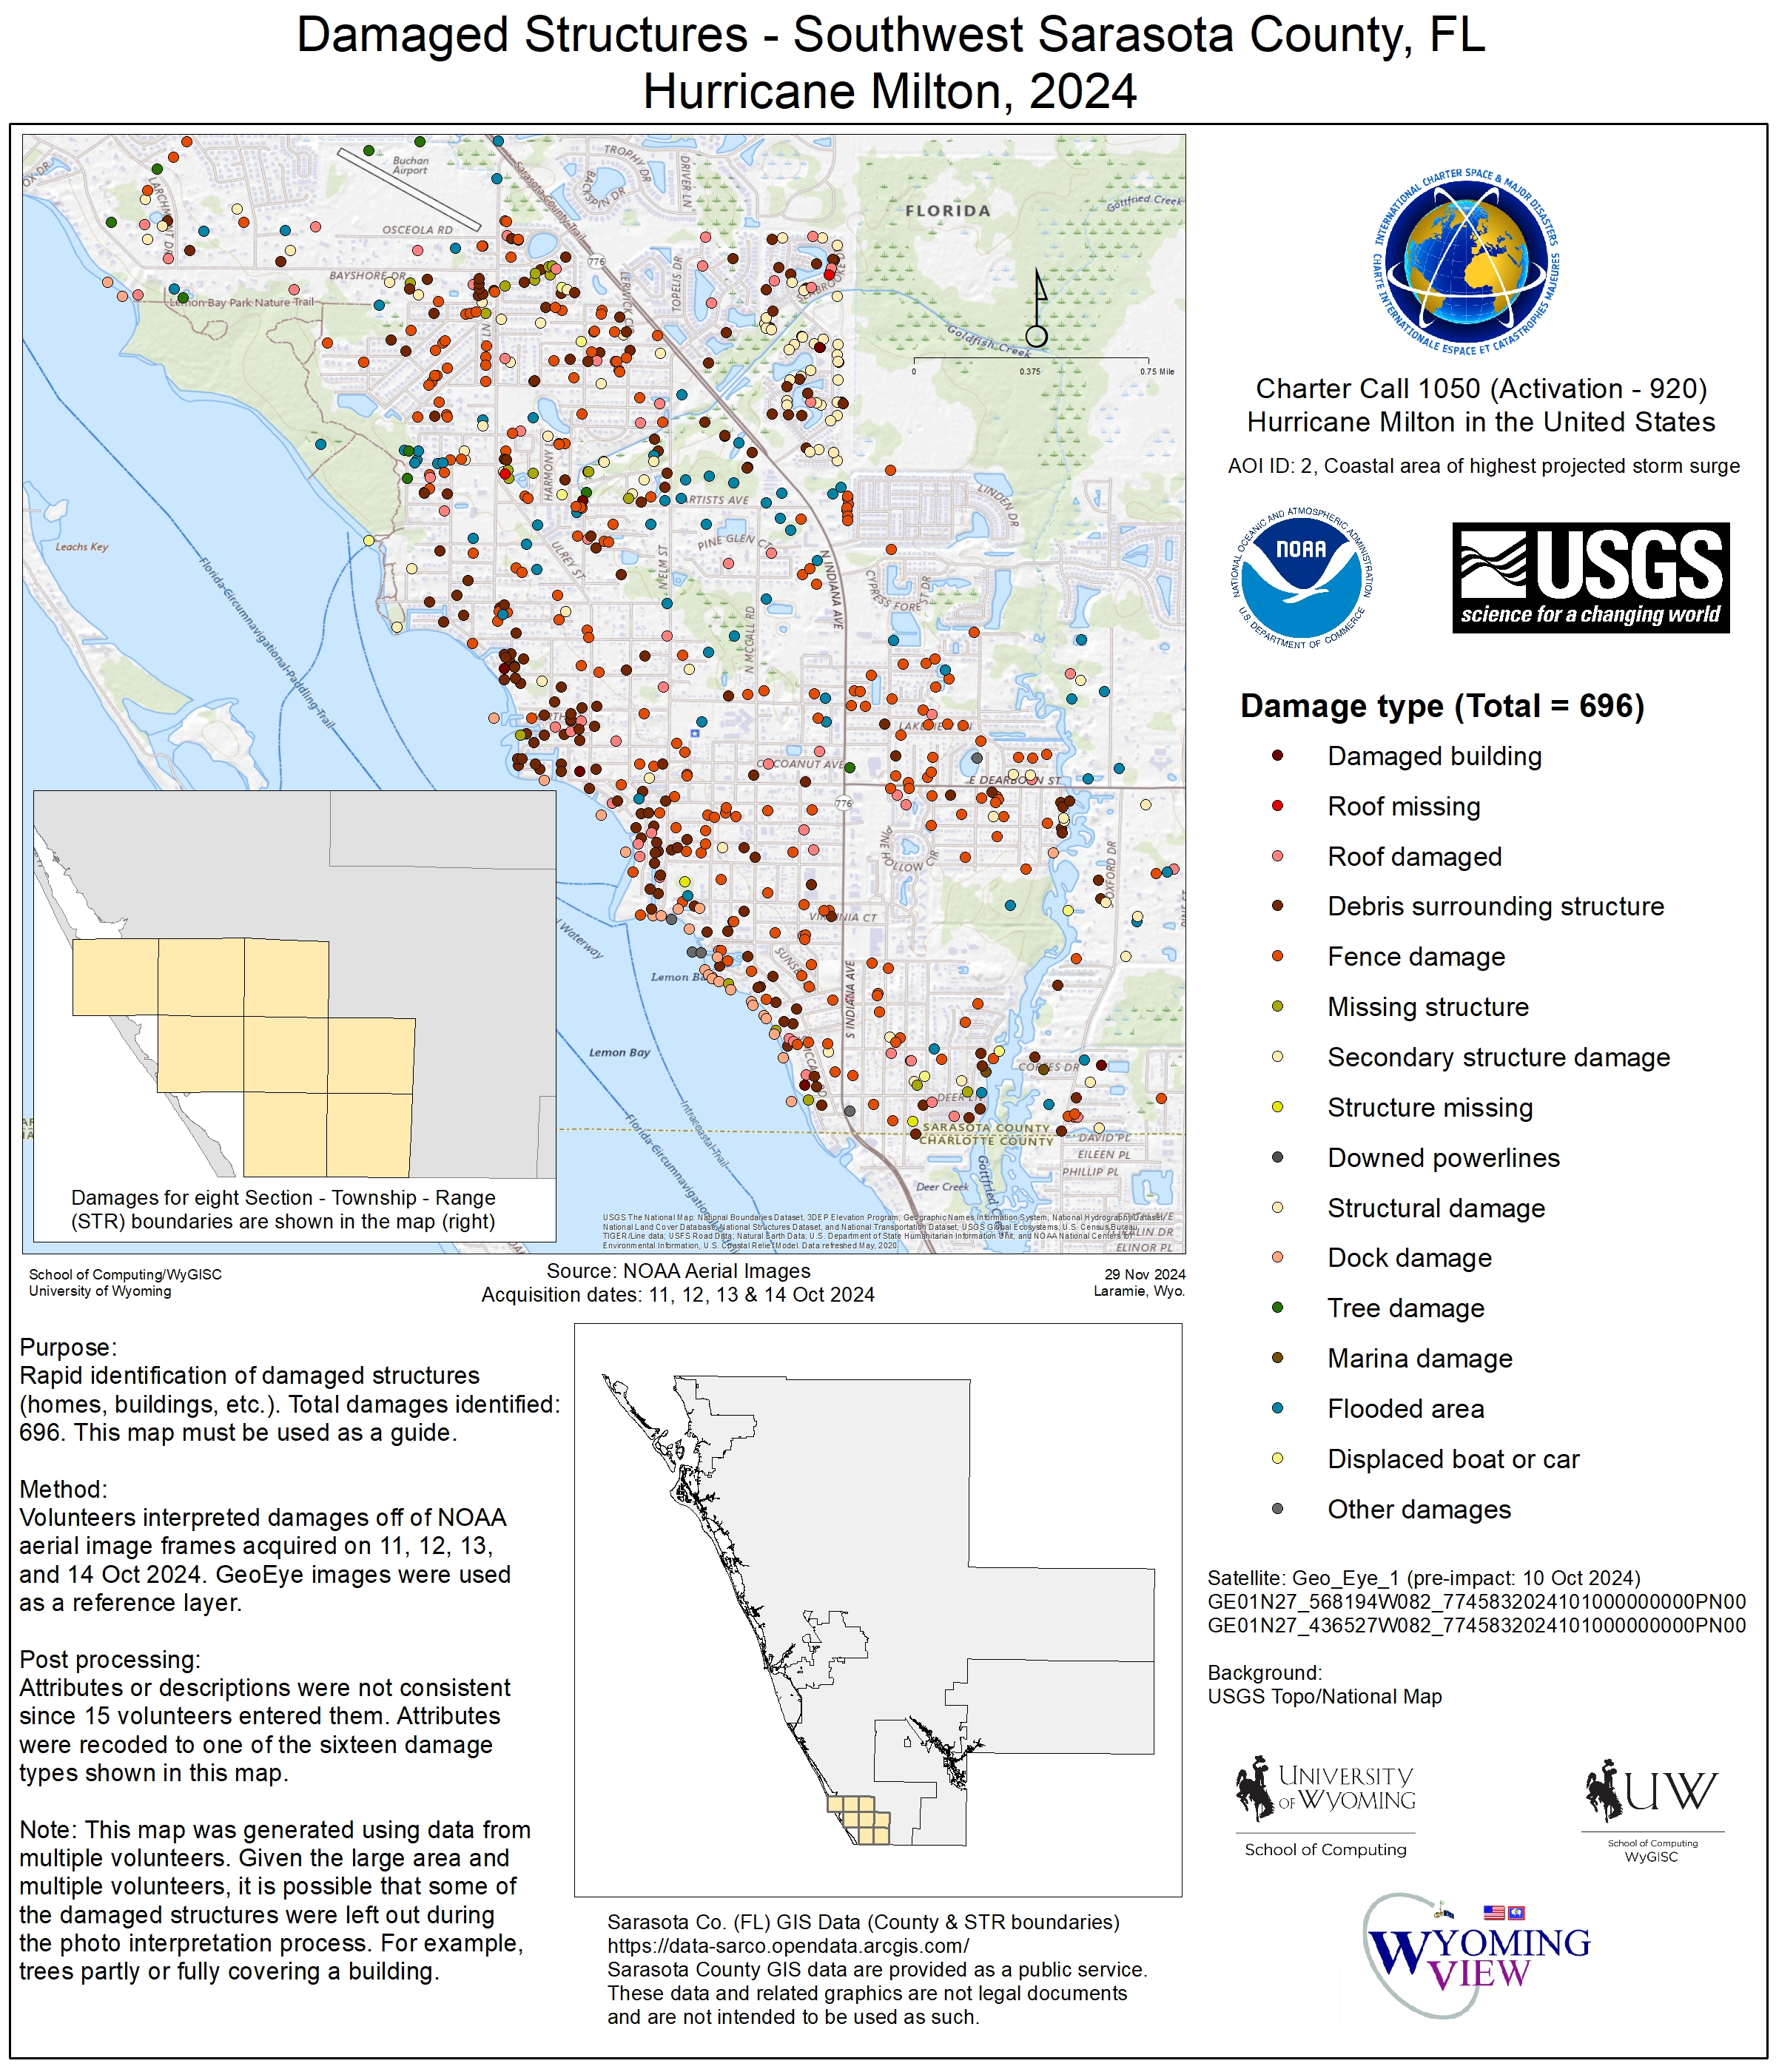
VAP title: Damaged Structures - Bay Island & Siesta Key, FL
VAP creation date: 20-Nov-2024
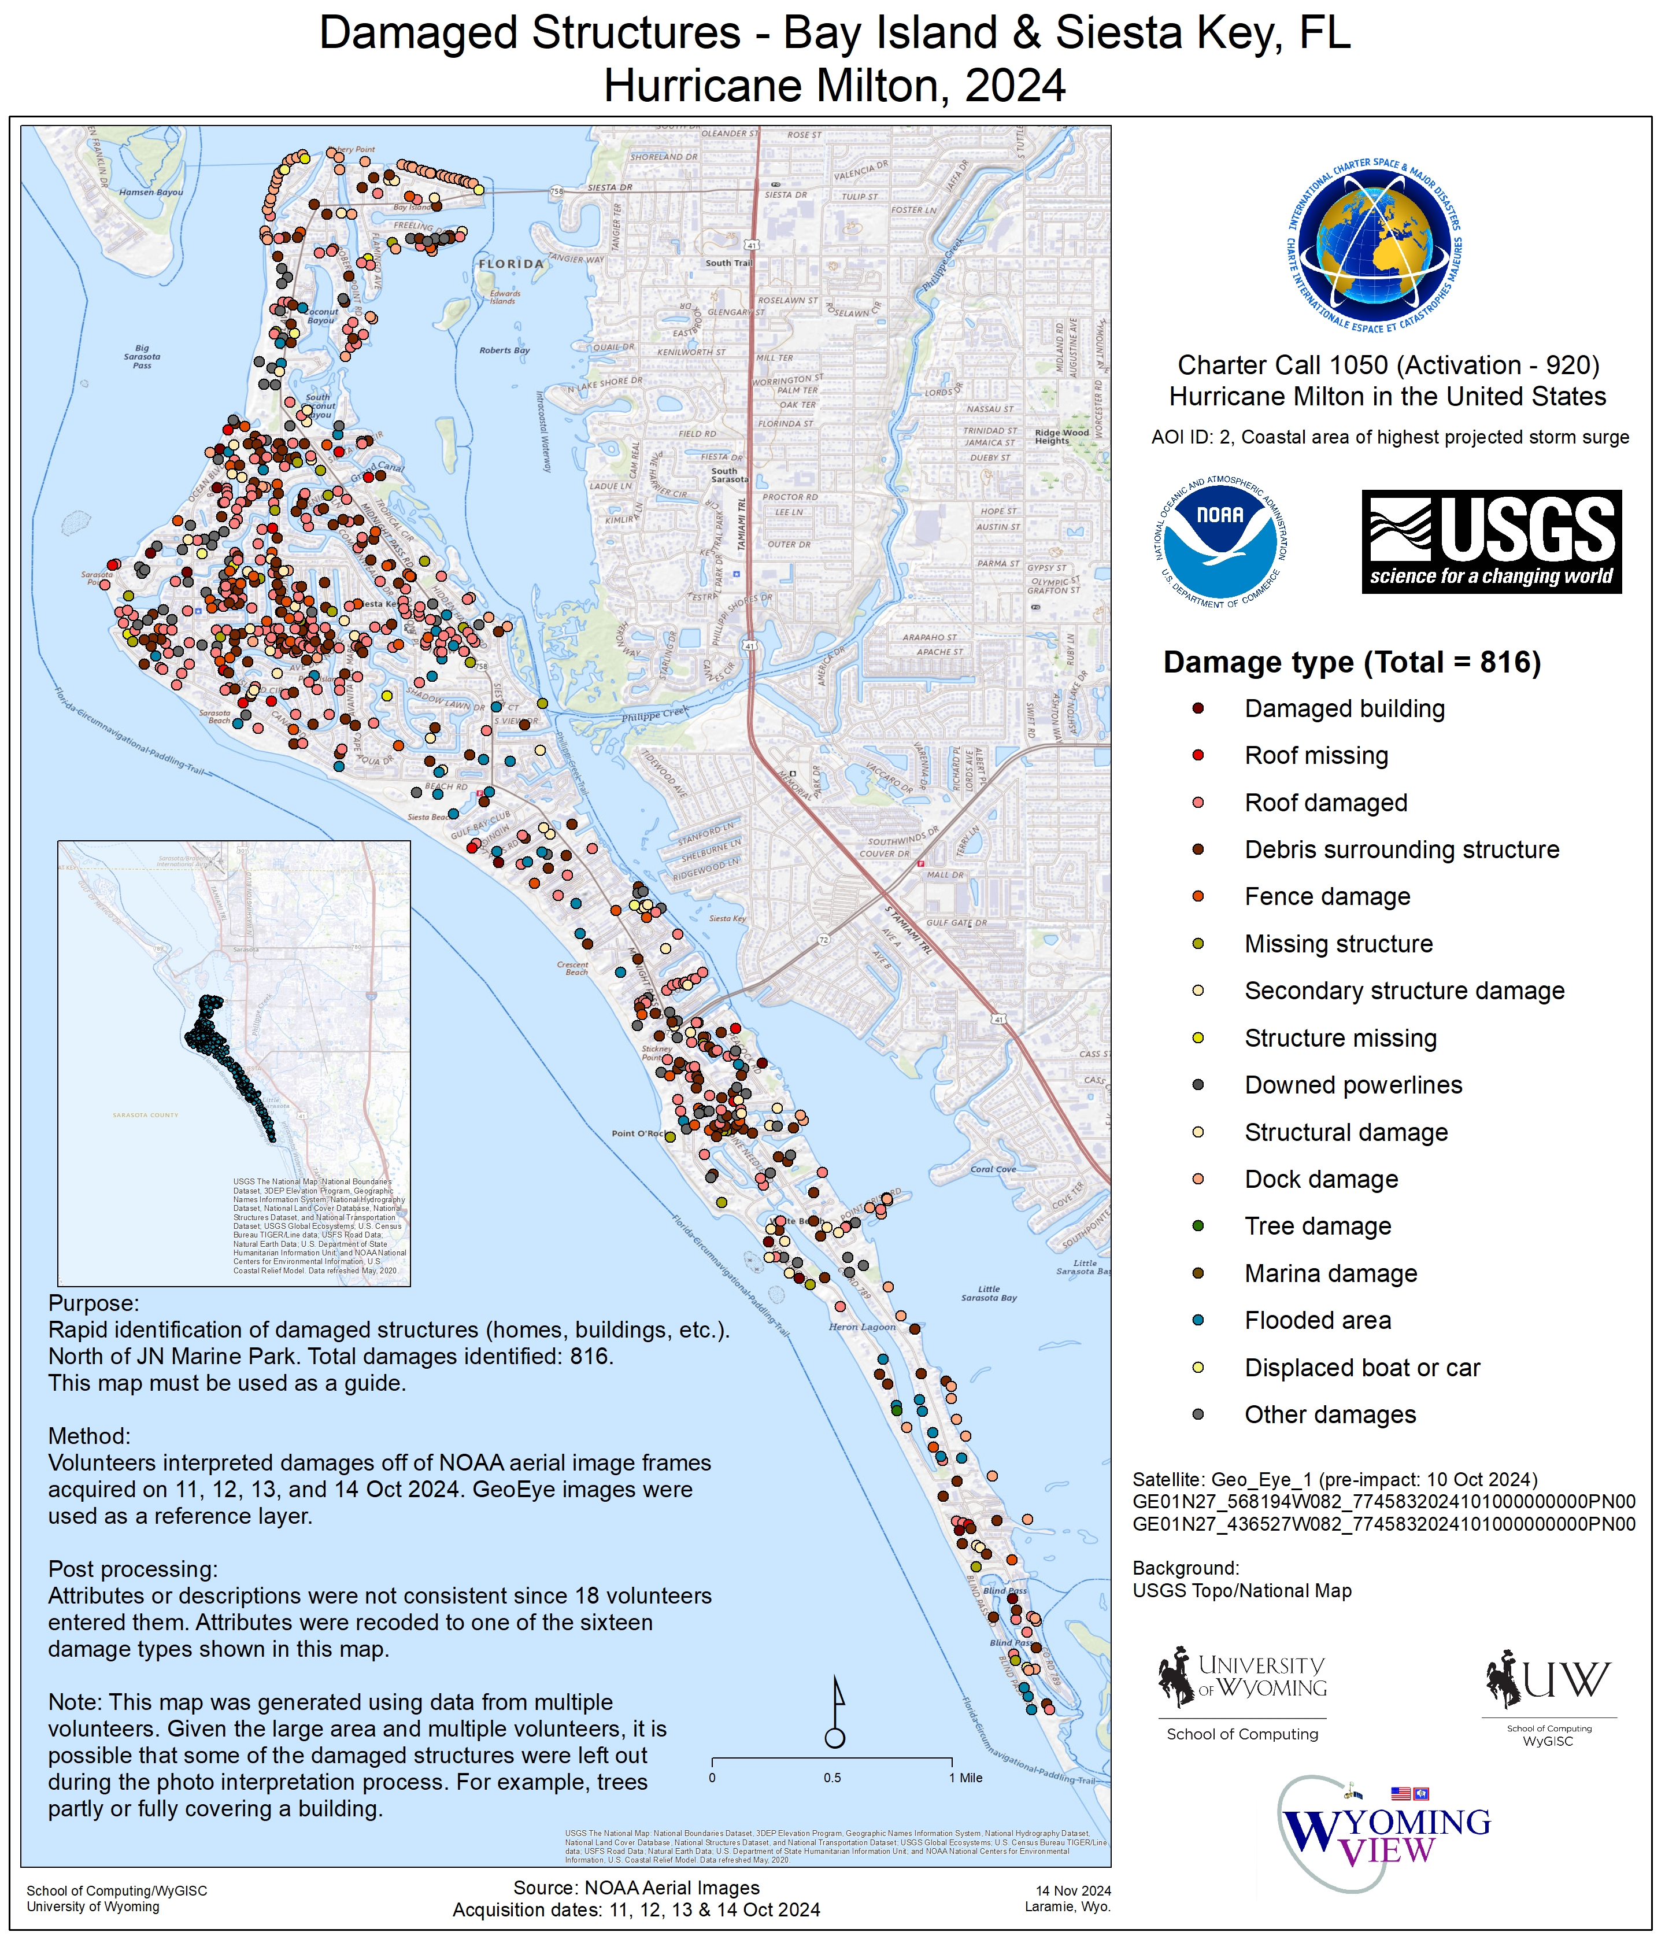
VAP title: Damaged Structures - Manasota Key (Sarasota & Charlotte counties), FL
VAP creation date: 08-Nov-2024
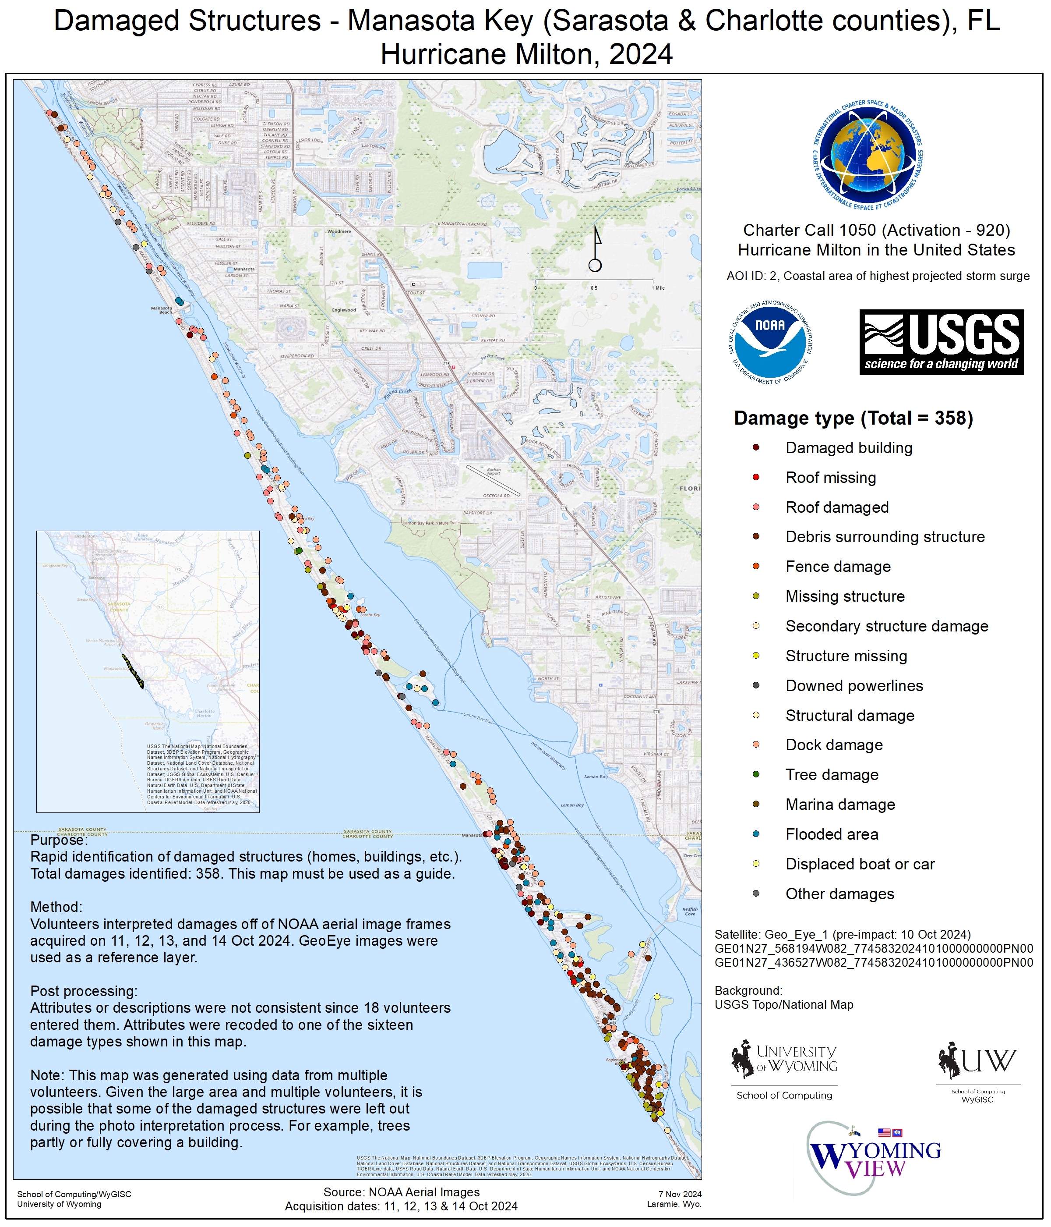
VAP title: Damaged Structures - Anna Maria Island, Florida, USA
VAP creation date: 30-Oct-2024
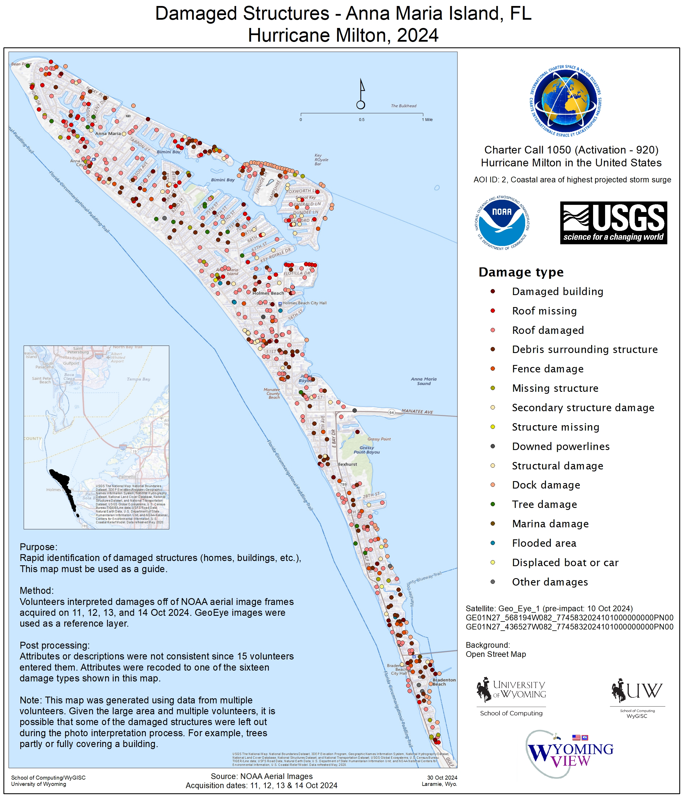
VAP title: USA, St Lucie County - Impact Map
VAP creation date: 15-Oct-2024
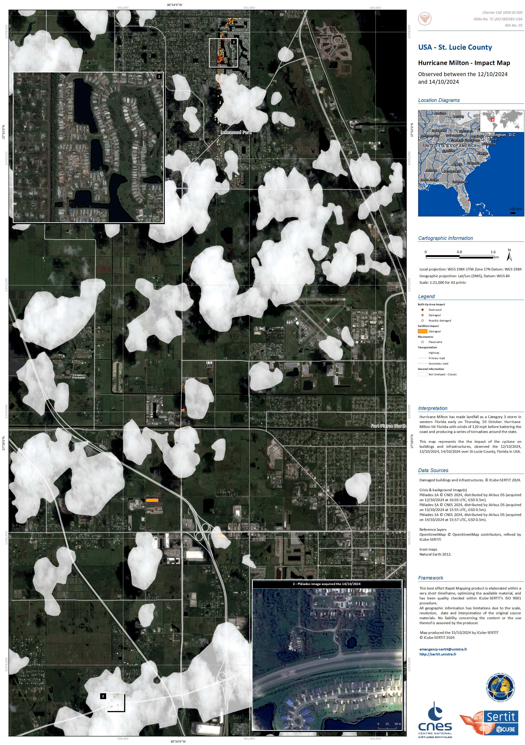

* mandatory

I. End User Feedback

Attach a copy of user feedback forms (Annex G) submitted by the end users or email correspondence regarding the end user(s).

I1. Describe the activation in detail and describe the interaction between the PM and the AU:

The activation went well. The original AOI's identified areas on the west coast of Florida where hurricane Milton made landfall and highest storm surge was experienced. Damage classification focused on inhabited barrier islands within this area. Further attention was then focused on the path of Milton and the spawning of multiple tornados, mainly along the east coast of Florida. The Saint Lucie County area was hardest hit by tornados with areas along Cocoa Beach and Cape Canaveral also highlighted for study. New AOI's for these areas were generated for further focused imagery collection. Data collection was intensified for these tornado impacted areas and back on the barrier islands of the west coast highlighting damaged areas, structures, and property including Anna Maria Island (555 points), Manasota Key (358 points), Siesta Key (816 points), Southwest Sarasota County (696 points), and parts of South Venice, Manasota, and Englewood, Florida (1,051 points). The maps over many of these collection areas were developed by graduate and undergraduate students working under the direction of an IC PM, who verified data collection, generation and final impacted point counts for the value added products generated over these areas. The article highlighting this outreach effort developing value added products has been added in section H of this document. https://www.uwyo.edu/news/2024/12/uw-instructional-professor-and-students-provide-disaster-mapping-assistance-after-hurricane.html
There were no complications between the PM and AU for this event.

International Charter
Space and Major Disasters

End User Feedback Report

End User | Michael Budde
Organization | USGS
Charter Call ID # | 1050
Disaster Event | Storm & Hurricane
Disaster Location | UNITED STATES
Filled by | Michael Budde

Activating of the Charter:

Did you encounter difficulties in triggering the Charter? | _ Yes | X No
Did you use COS-2 to activate the Charter? | X Yes | _ No

If you used COS-2 to activate the Charter, how would you rate it?

Greatly exceeded expectations | _
Exceeded Expectations | X
Matched Expectations | _
Less than Expected | _
Much Less than Expected | _

Provision of Charter Data and Value-added Products:

Did you provide your own value adding service for this activation? |  |  |  |  | _ Yes | X No

How you rate the Value Added Products you received?

Greatly exceeded expectations | _
Exceeded Expectations | X
Matched Expectations | _
Less than Expected | _
Much Less than Expected | _

How were the Charter Value Added Products used?

Communication | X
Planning | X
Documentation | X
Lessons Learned / Training | _
Not used | _

How could the Charter Value Added Products be improved to make them more useful?

No suggested improvements.

Working with the Charter:

How would you rate the communication between you and the Project Manager during this call?

Greatly exceeded expectations | _
Exceeded Expectations | X
Matched Expectations | _
Less than Expected | _
Much Less than Expected | _

How would you rate the contribution made by the Charter to this emergency?

Greatly exceeded expectations | _
Exceeded Expectations | X
Matched Expectations | _
Less than Expected | _
Much Less than Expected | _

How could we improve the service provided by the Charter for the end user(s)?

No suggested improvements.

Did you participate in the last couple of years Charter training? |  |  |  |  | X Yes | _ No

Appendix

PM Report

D. Product List
Agency | Satellite / Instrument / Mode | Satellite Sensing date | Date PM received image | Archive | Useful Products
NAS | BKA / MSS_PSS | 20-Jun-2016 | 10-Oct-2024 | Yes | No
UKSA | VISION-1 / S1 / | 24-Jan-2022 | 15-Oct-2024 | Yes | No
UKSA | VISION-1 / S1 / | 24-Jan-2022 | 15-Oct-2024 | Yes | No
UKSA | VISION-1 / S1 / | 24-Jan-2022 | 15-Oct-2024 | Yes | No
UKSA | VISION-1 / S1 / | 24-Jan-2022 | 15-Oct-2024 | Yes | No
INPE | CBERS-4 / WFI | 18-Oct-2022 | 14-Oct-2024 | Yes | No
CONAE | Saocom 1B / SAR-SAO1B / Strip Map DP | 21-Nov-2022 | 13-Oct-2024 | Yes | No
UKSA | VISION-1 / S1 / | 04-Dec-2022 | 15-Oct-2024 | Yes | No
UKSA | VISION-1 / S1 / | 04-Dec-2022 | 15-Oct-2024 | Yes | No
UKSA | VISION-1 / S1 / | 04-Dec-2022 | 15-Oct-2024 | Yes | No
UKSA | VISION-1 / S1 / | 19-Dec-2022 | 15-Oct-2024 | Yes | No
UKSA | VISION-1 / S1 / | 19-Dec-2022 | 15-Oct-2024 | Yes | No
UKSA | VISION-1 / S1 / | 19-Dec-2022 | 15-Oct-2024 | Yes | No
UKSA | VISION-1 / S1 / | 19-Dec-2022 | 15-Oct-2024 | Yes | No
CONAE | Saocom 1B / SAR-SAO1B / Strip Map DP | 23-Dec-2022 | 13-Oct-2024 | Yes | No
ISRO | EOS-04 / SAR / MRS | 04-Aug-2023 | 17-Oct-2024 | Yes | No
ISRO | EOS-04 / SAR / MRS | 04-Aug-2023 | 17-Oct-2024 | Yes | No
CNSA | GF2 / PMS / PMS | 11-Nov-2023 | 11-Oct-2024 | Yes | No
ESA | SENTINEL_2B / MSI | 23-Jul-2024 | 11-Oct-2024 | Yes | No
CNSA | GF1 / PMS / PMS | 12-Aug-2024 | 11-Oct-2024 | Yes | No
ESA | SENTINEL_2B / MSI | 04-Sep-2024 | 11-Oct-2024 | Yes | No
ESA | SENTINEL_2A / MSI | 06-Sep-2024 | 11-Oct-2024 | Yes | No
ESA | SENTINEL_2B / MSI | 11-Sep-2024 | 11-Oct-2024 | Yes | No
ESA | SENTINEL_2B / MSI | 14-Sep-2024 | 09-Oct-2024 | Yes | No
USGS | LANDSAT8 / OLI_TIRS | 24-Sep-2024 | 10-Oct-2024 | Yes | No
ESA | SENTINEL_2A / MSI | 29-Sep-2024 | 09-Oct-2024 | Yes | No
ESA | SENTINEL_2A / MSI | 29-Sep-2024 | 09-Oct-2024 | Yes | No
USGS | LANDSAT9 / OLI_TIRS | 02-Oct-2024 | 10-Oct-2024 | Yes | No
USGS | LANDSAT9 / OLI_TIRS | 02-Oct-2024 | 10-Oct-2024 | Yes | No
USGS | LANDSAT9 / OLI_TIRS | 02-Oct-2024 | 10-Oct-2024 | Yes | No
USGS | LANDSAT9 / OLI_TIRS | 02-Oct-2024 | 10-Oct-2024 | Yes | No
USGS | LANDSAT9 / OLI_TIRS | 02-Oct-2024 | 10-Oct-2024 | Yes | No
USGS | LANDSAT8 / OLI_TIRS | 03-Oct-2024 | 10-Oct-2024 | Yes | No
USGS | LANDSAT8 / OLI_TIRS | 03-Oct-2024 | 10-Oct-2024 | Yes | No
USGS | LANDSAT8 / OLI_TIRS | 03-Oct-2024 | 10-Oct-2024 | Yes | No
USGS | LANDSAT8 / OLI_TIRS | 03-Oct-2024 | 10-Oct-2024 | Yes | No
USGS | LANDSAT8 / OLI_TIRS | 03-Oct-2024 | 10-Oct-2024 | Yes | No
ESA | SENTINEL_1A / SAR_ESA / Interferometric Wide Swath | 03-Oct-2024 | 10-Oct-2024 | Yes | No
ESA | SENTINEL_1A / SAR_ESA / Interferometric Wide Swath | 03-Oct-2024 | 10-Oct-2024 | Yes | No
ESA | SENTINEL_1A / SAR_ESA / Interferometric Wide Swath | 03-Oct-2024 | 10-Oct-2024 | Yes | First useful archive (pre-event) image
CNSA | GF3 / SARC / Ultra-Fine Strip | 08-Oct-2024 | 11-Oct-2024 | Yes | No
INPE | AMAZONIA-1 / WFI | 08-Oct-2024 | 14-Oct-2024 | Yes | No
ESA | SENTINEL_1A / SAR_ESA / Interferometric Wide Swath | 08-Oct-2024 | 10-Oct-2024 | Yes | No
ESA | SENTINEL_1A / SAR_ESA / Interferometric Wide Swath | 08-Oct-2024 | 10-Oct-2024 | Yes | No
CSA | RCM-1 / SAR_RCM / Low Noise | 09-Oct-2024 | 10-Oct-2024 | No | No
BLACKSKY | GLOBAL / IMAGER | 10-Oct-2024 | 11-Oct-2024 | No | No
BLACKSKY | GLOBAL / IMAGER | 10-Oct-2024 | 11-Oct-2024 | No | No
BLACKSKY | GLOBAL / IMAGER | 10-Oct-2024 | 11-Oct-2024 | No | No
BLACKSKY | GLOBAL / IMAGER | 10-Oct-2024 | 11-Oct-2024 | No | No
BLACKSKY | GLOBAL / IMAGER | 10-Oct-2024 | 11-Oct-2024 | No | No
BLACKSKY | GLOBAL / IMAGER | 10-Oct-2024 | 11-Oct-2024 | No | No
BLACKSKY | GLOBAL / IMAGER | 10-Oct-2024 | 11-Oct-2024 | No | No
BLACKSKY | GLOBAL / IMAGER | 10-Oct-2024 | 11-Oct-2024 | No | No
CSA | RCM-1 / SAR_RCM / Medium Resolution 30m | 10-Oct-2024 | 10-Oct-2024 | No | No
CSA | RCM-1 / SAR_RCM / Medium Resolution 30m | 10-Oct-2024 | 10-Oct-2024 | No | No
USGS | GEO_EYE_1 / EO_IMAGER | 10-Oct-2024 | 11-Oct-2024 | No | No
USGS | GEO_EYE_1 / EO_IMAGER | 10-Oct-2024 | 11-Oct-2024 | No | No
USGS | GEO_EYE_1 / EO_IMAGER | 10-Oct-2024 | 11-Oct-2024 | No | First useful crisis (post-event) image
USGS | GEO_EYE_1 / EO_IMAGER | 10-Oct-2024 | 11-Oct-2024 | No | Second useful crisis (pre-event) image
USGS | GEO_EYE_1 / EO_IMAGER | 10-Oct-2024 | 11-Oct-2024 | No | Yes
USGS | GEO_EYE_1 / EO_IMAGER | 10-Oct-2024 | 11-Oct-2024 | No | Yes
USGS | GEO_EYE_1 / EO_IMAGER | 10-Oct-2024 | 11-Oct-2024 | No | No
USGS | GEO_EYE_1 / EO_IMAGER | 10-Oct-2024 | 11-Oct-2024 | No | No
USGS | GEO_EYE_1 / EO_IMAGER | 10-Oct-2024 | 11-Oct-2024 | No | No
USGS | GEO_EYE_1 / EO_IMAGER | 10-Oct-2024 | 11-Oct-2024 | No | No
USGS | GEO_EYE_1 / EO_IMAGER | 10-Oct-2024 | 11-Oct-2024 | No | No
USGS | GEO_EYE_1 / EO_IMAGER | 10-Oct-2024 | 11-Oct-2024 | No | No
USGS | GEO_EYE_1 / EO_IMAGER | 10-Oct-2024 | 11-Oct-2024 | No | No
USGS | GEO_EYE_1 / EO_IMAGER | 10-Oct-2024 | 11-Oct-2024 | No | No
USGS | GEO_EYE_1 / EO_IMAGER | 10-Oct-2024 | 11-Oct-2024 | No | No
USGS | GEO_EYE_1 / EO_IMAGER | 10-Oct-2024 | 11-Oct-2024 | No | No
USGS | GEO_EYE_1 / EO_IMAGER | 10-Oct-2024 | 11-Oct-2024 | No | No
USGS | GEO_EYE_1 / EO_IMAGER | 10-Oct-2024 | 11-Oct-2024 | No | No
USGS | GEO_EYE_1 / EO_IMAGER | 10-Oct-2024 | 11-Oct-2024 | No | No
USGS | GEO_EYE_1 / EO_IMAGER | 10-Oct-2024 | 11-Oct-2024 | No | No
USGS | GEO_EYE_1 / EO_IMAGER | 10-Oct-2024 | 11-Oct-2024 | No | No
USGS | GEO_EYE_1 / EO_IMAGER | 10-Oct-2024 | 11-Oct-2024 | No | No
USGS | GEO_EYE_1 / EO_IMAGER | 10-Oct-2024 | 11-Oct-2024 | No | No
USGS | GEO_EYE_1 / EO_IMAGER | 10-Oct-2024 | 11-Oct-2024 | No | No
USGS | GEO_EYE_1 / EO_IMAGER | 10-Oct-2024 | 11-Oct-2024 | No | No
USGS | GEO_EYE_1 / EO_IMAGER | 10-Oct-2024 | 11-Oct-2024 | No | No
USGS | GEO_EYE_1 / EO_IMAGER | 10-Oct-2024 | 11-Oct-2024 | No | No
USGS | GEO_EYE_1 / EO_IMAGER | 10-Oct-2024 | 11-Oct-2024 | No | No
USGS | LANDSAT8 / OLI_TIRS | 10-Oct-2024 | 12-Oct-2024 | No | No
USGS | LANDSAT8 / OLI_TIRS | 10-Oct-2024 | 12-Oct-2024 | No | No
USGS | LANDSAT8 / OLI_TIRS | 10-Oct-2024 | 12-Oct-2024 | No | No
USGS | LANDSAT8 / OLI_TIRS | 10-Oct-2024 | 12-Oct-2024 | No | No
USGS | WORLDVIEW_3 / EO_IMAGER | 10-Oct-2024 | 11-Oct-2024 | No | No
USGS | WORLDVIEW_3 / EO_IMAGER | 10-Oct-2024 | 11-Oct-2024 | No | No
USGS | WORLDVIEW_3 / EO_IMAGER | 10-Oct-2024 | 11-Oct-2024 | No | No
USGS | WORLDVIEW_3 / EO_IMAGER | 10-Oct-2024 | 11-Oct-2024 | No | No
USGS | WORLDVIEW_3 / EO_IMAGER | 10-Oct-2024 | 11-Oct-2024 | No | No
USGS | WORLDVIEW_3 / EO_IMAGER | 10-Oct-2024 | 11-Oct-2024 | No | No
USGS | WORLDVIEW_3 / EO_IMAGER | 10-Oct-2024 | 11-Oct-2024 | No | No
USGS | WORLDVIEW_3 / EO_IMAGER | 10-Oct-2024 | 11-Oct-2024 | No | No
USGS | WORLDVIEW_3 / EO_IMAGER | 10-Oct-2024 | 11-Oct-2024 | No | No
USGS | WORLDVIEW_3 / EO_IMAGER | 10-Oct-2024 | 11-Oct-2024 | No | No
USGS | WORLDVIEW_3 / EO_IMAGER | 10-Oct-2024 | 11-Oct-2024 | No | No
USGS | WORLDVIEW_3 / EO_IMAGER | 10-Oct-2024 | 11-Oct-2024 | No | No
USGS | WORLDVIEW_3 / EO_IMAGER | 10-Oct-2024 | 11-Oct-2024 | No | No
USGS | WORLDVIEW_3 / EO_IMAGER | 10-Oct-2024 | 11-Oct-2024 | No | No
USGS | WORLDVIEW_3 / EO_IMAGER | 10-Oct-2024 | 11-Oct-2024 | No | No
USGS | WORLDVIEW_3 / EO_IMAGER | 10-Oct-2024 | 11-Oct-2024 | No | No
USGS | WORLDVIEW_3 / EO_IMAGER | 10-Oct-2024 | 11-Oct-2024 | No | No
USGS | WORLDVIEW_3 / EO_IMAGER | 10-Oct-2024 | 11-Oct-2024 | No | No
USGS | WORLDVIEW_3 / EO_IMAGER | 10-Oct-2024 | 11-Oct-2024 | No | No
USGS | WORLDVIEW_3 / EO_IMAGER | 10-Oct-2024 | 11-Oct-2024 | No | No
USGS | WORLDVIEW_3 / EO_IMAGER | 10-Oct-2024 | 11-Oct-2024 | No | No
USGS | WORLDVIEW_3 / EO_IMAGER | 10-Oct-2024 | 11-Oct-2024 | No | No
USGS | WORLDVIEW_3 / EO_IMAGER | 10-Oct-2024 | 11-Oct-2024 | No | No
USGS | WORLDVIEW_3 / EO_IMAGER | 10-Oct-2024 | 11-Oct-2024 | No | No
USGS | WORLDVIEW_3 / EO_IMAGER | 10-Oct-2024 | 11-Oct-2024 | No | No
USGS | WORLDVIEW_3 / EO_IMAGER | 10-Oct-2024 | 11-Oct-2024 | No | No
USGS | WORLDVIEW_3 / EO_IMAGER | 10-Oct-2024 | 11-Oct-2024 | No | No
USGS | WORLDVIEW_3 / EO_IMAGER | 10-Oct-2024 | 11-Oct-2024 | No | No
USGS | WORLDVIEW_3 / EO_IMAGER | 10-Oct-2024 | 11-Oct-2024 | No | No
USGS | WORLDVIEW_3 / EO_IMAGER | 10-Oct-2024 | 11-Oct-2024 | No | No
USGS | WORLDVIEW_3 / EO_IMAGER | 10-Oct-2024 | 11-Oct-2024 | No | No
USGS | WORLDVIEW_3 / EO_IMAGER | 10-Oct-2024 | 11-Oct-2024 | No | No
USGS | WORLDVIEW_3 / EO_IMAGER | 10-Oct-2024 | 11-Oct-2024 | No | No
USGS | WORLDVIEW_3 / EO_IMAGER | 10-Oct-2024 | 11-Oct-2024 | No | No
USGS | WORLDVIEW_3 / EO_IMAGER | 10-Oct-2024 | 11-Oct-2024 | No | No
USGS | WORLDVIEW_3 / EO_IMAGER | 10-Oct-2024 | 11-Oct-2024 | No | No
USGS | WORLDVIEW_3 / EO_IMAGER | 10-Oct-2024 | 11-Oct-2024 | No | No
USGS | WORLDVIEW_3 / EO_IMAGER | 10-Oct-2024 | 11-Oct-2024 | No | No
USGS | WORLDVIEW_3 / EO_IMAGER | 10-Oct-2024 | 11-Oct-2024 | No | No
USGS | WORLDVIEW_3 / EO_IMAGER | 10-Oct-2024 | 11-Oct-2024 | No | No
USGS | WORLDVIEW_3 / EO_IMAGER | 10-Oct-2024 | 11-Oct-2024 | No | No
USGS | WORLDVIEW_3 / EO_IMAGER | 10-Oct-2024 | 11-Oct-2024 | No | No
USGS | WORLDVIEW_3 / EO_IMAGER | 10-Oct-2024 | 11-Oct-2024 | No | No
USGS | WORLDVIEW_3 / EO_IMAGER | 10-Oct-2024 | 11-Oct-2024 | No | No
USGS | WORLDVIEW_3 / EO_IMAGER | 10-Oct-2024 | 11-Oct-2024 | No | No
USGS | WORLDVIEW_3 / EO_IMAGER | 10-Oct-2024 | 11-Oct-2024 | No | No
USGS | WORLDVIEW_3 / EO_IMAGER | 10-Oct-2024 | 11-Oct-2024 | No | No
USGS | WORLDVIEW_3 / EO_IMAGER | 10-Oct-2024 | 11-Oct-2024 | No | No
USGS | WORLDVIEW_3 / EO_IMAGER | 10-Oct-2024 | 11-Oct-2024 | No | No
USGS | WORLDVIEW_3 / EO_IMAGER | 10-Oct-2024 | 11-Oct-2024 | No | No
INPE | CBERS-4A / WFI | 10-Oct-2024 | 14-Oct-2024 | No | No
INPE | CBERS-4A / MUX | 10-Oct-2024 | 13-Oct-2024 | No | No
INPE | CBERS-4A / MUX | 10-Oct-2024 | 13-Oct-2024 | No | No
INPE | CBERS-4A / MUX | 10-Oct-2024 | 13-Oct-2024 | No | No
INPE | CBERS-4A / WPM | 10-Oct-2024 | 12-Dec-2024 | No | No
INPE | CBERS-4A / WPM | 10-Oct-2024 | 12-Dec-2024 | No | No
INPE | CBERS-4A / WPM | 10-Oct-2024 | 12-Dec-2024 | No | No
INPE | CBERS-4A / WPM | 10-Oct-2024 | 12-Dec-2024 | No | No
INPE | CBERS-4A / WPM | 10-Oct-2024 | 12-Dec-2024 | No | No
INPE | CBERS-4A / WPM | 10-Oct-2024 | 12-Dec-2024 | No | No
USGS | WORLDVIEW_2 / EO_IMAGER | 10-Oct-2024 | 10-Oct-2024 | No | No
USGS | WORLDVIEW_2 / EO_IMAGER | 10-Oct-2024 | 10-Oct-2024 | No | No
USGS | WORLDVIEW_2 / EO_IMAGER | 10-Oct-2024 | 10-Oct-2024 | No | No
USGS | WORLDVIEW_2 / EO_IMAGER | 10-Oct-2024 | 10-Oct-2024 | No | No
USGS | WORLDVIEW_2 / EO_IMAGER | 10-Oct-2024 | 10-Oct-2024 | No | No
USGS | WORLDVIEW_2 / EO_IMAGER | 10-Oct-2024 | 10-Oct-2024 | No | No
USGS | WORLDVIEW_2 / EO_IMAGER | 10-Oct-2024 | 10-Oct-2024 | No | No
USGS | WORLDVIEW_2 / EO_IMAGER | 10-Oct-2024 | 10-Oct-2024 | No | No
USGS | WORLDVIEW_2 / EO_IMAGER | 10-Oct-2024 | 10-Oct-2024 | No | No
USGS | WORLDVIEW_2 / EO_IMAGER | 10-Oct-2024 | 10-Oct-2024 | No | No
USGS | WORLDVIEW_2 / EO_IMAGER | 10-Oct-2024 | 10-Oct-2024 | No | No
USGS | WORLDVIEW_2 / EO_IMAGER | 10-Oct-2024 | 10-Oct-2024 | No | No
USGS | WORLDVIEW_2 / EO_IMAGER | 10-Oct-2024 | 10-Oct-2024 | No | No
USGS | WORLDVIEW_2 / EO_IMAGER | 10-Oct-2024 | 10-Oct-2024 | No | No
USGS | WORLDVIEW_2 / EO_IMAGER | 10-Oct-2024 | 10-Oct-2024 | No | No
USGS | WORLDVIEW_2 / EO_IMAGER | 10-Oct-2024 | 10-Oct-2024 | No | No
USGS | WORLDVIEW_2 / EO_IMAGER | 10-Oct-2024 | 10-Oct-2024 | No | No
USGS | WORLDVIEW_2 / EO_IMAGER | 10-Oct-2024 | 10-Oct-2024 | No | No
USGS | WORLDVIEW_2 / EO_IMAGER | 10-Oct-2024 | 10-Oct-2024 | No | No
USGS | WORLDVIEW_2 / EO_IMAGER | 10-Oct-2024 | 10-Oct-2024 | No | No
USGS | WORLDVIEW_2 / EO_IMAGER | 10-Oct-2024 | 10-Oct-2024 | No | No
USGS | WORLDVIEW_2 / EO_IMAGER | 10-Oct-2024 | 10-Oct-2024 | No | No
USGS | WORLDVIEW_2 / EO_IMAGER | 10-Oct-2024 | 10-Oct-2024 | No | No
USGS | WORLDVIEW_2 / EO_IMAGER | 10-Oct-2024 | 10-Oct-2024 | No | No
USGS | WORLDVIEW_2 / EO_IMAGER | 10-Oct-2024 | 10-Oct-2024 | No | No
USGS | WORLDVIEW_2 / EO_IMAGER | 10-Oct-2024 | 10-Oct-2024 | No | No
USGS | WORLDVIEW_2 / EO_IMAGER | 10-Oct-2024 | 10-Oct-2024 | No | No
USGS | WORLDVIEW_2 / EO_IMAGER | 10-Oct-2024 | 10-Oct-2024 | No | No
USGS | WORLDVIEW_2 / EO_IMAGER | 10-Oct-2024 | 10-Oct-2024 | No | No
USGS | WORLDVIEW_2 / EO_IMAGER | 10-Oct-2024 | 10-Oct-2024 | No | No
USGS | WORLDVIEW_2 / EO_IMAGER | 10-Oct-2024 | 10-Oct-2024 | No | No
USGS | WORLDVIEW_2 / EO_IMAGER | 10-Oct-2024 | 10-Oct-2024 | No | No
USGS | WORLDVIEW_2 / EO_IMAGER | 10-Oct-2024 | 10-Oct-2024 | No | No
USGS | WORLDVIEW_2 / EO_IMAGER | 10-Oct-2024 | 10-Oct-2024 | No | No
USGS | WORLDVIEW_2 / EO_IMAGER | 10-Oct-2024 | 10-Oct-2024 | No | No
USGS | WORLDVIEW_2 / EO_IMAGER | 10-Oct-2024 | 10-Oct-2024 | No | No
USGS | WORLDVIEW_2 / EO_IMAGER | 10-Oct-2024 | 10-Oct-2024 | No | No
USGS | WORLDVIEW_2 / EO_IMAGER | 10-Oct-2024 | 10-Oct-2024 | No | No
USGS | WORLDVIEW_2 / EO_IMAGER | 10-Oct-2024 | 10-Oct-2024 | No | No
USGS | WORLDVIEW_2 / EO_IMAGER | 10-Oct-2024 | 10-Oct-2024 | No | No
USGS | WORLDVIEW_2 / EO_IMAGER | 10-Oct-2024 | 10-Oct-2024 | No | No
USGS | WORLDVIEW_2 / EO_IMAGER | 10-Oct-2024 | 10-Oct-2024 | No | No
USGS | WORLDVIEW_2 / EO_IMAGER | 10-Oct-2024 | 10-Oct-2024 | No | No
USGS | WORLDVIEW_2 / EO_IMAGER | 10-Oct-2024 | 10-Oct-2024 | No | No
USGS | WORLDVIEW_2 / EO_IMAGER | 10-Oct-2024 | 10-Oct-2024 | No | No
USGS | WORLDVIEW_2 / EO_IMAGER | 10-Oct-2024 | 10-Oct-2024 | No | No
USGS | WORLDVIEW_2 / EO_IMAGER | 10-Oct-2024 | 10-Oct-2024 | No | No
USGS | WORLDVIEW_2 / EO_IMAGER | 10-Oct-2024 | 10-Oct-2024 | No | No
USGS | WORLDVIEW_2 / EO_IMAGER | 10-Oct-2024 | 10-Oct-2024 | No | No
USGS | WORLDVIEW_2 / EO_IMAGER | 10-Oct-2024 | 10-Oct-2024 | No | No
USGS | WORLDVIEW_2 / EO_IMAGER | 10-Oct-2024 | 11-Oct-2024 | No | No
USGS | WORLDVIEW_2 / EO_IMAGER | 10-Oct-2024 | 11-Oct-2024 | No | No
USGS | WORLDVIEW_2 / EO_IMAGER | 10-Oct-2024 | 11-Oct-2024 | No | No
USGS | WORLDVIEW_2 / EO_IMAGER | 10-Oct-2024 | 11-Oct-2024 | No | No
DLR | TERRASAR_X / SAR / High Res. Spotlight | 10-Oct-2024 | 11-Oct-2024 | No | No
BLACKSKY | GLOBAL / IMAGER | 11-Oct-2024 | 12-Oct-2024 | No | No
BLACKSKY | GLOBAL / IMAGER | 11-Oct-2024 | 12-Oct-2024 | No | No
BLACKSKY | GLOBAL / IMAGER | 11-Oct-2024 | 12-Oct-2024 | No | No
BLACKSKY | GLOBAL / IMAGER | 11-Oct-2024 | 12-Oct-2024 | No | No
BLACKSKY | GLOBAL / IMAGER | 11-Oct-2024 | 12-Oct-2024 | No | No
BLACKSKY | GLOBAL / IMAGER | 11-Oct-2024 | 12-Oct-2024 | No | No
BLACKSKY | GLOBAL / IMAGER | 11-Oct-2024 | 12-Oct-2024 | No | No
BLACKSKY | GLOBAL / IMAGER | 11-Oct-2024 | 12-Oct-2024 | No | No
BLACKSKY | GLOBAL / IMAGER | 11-Oct-2024 | 12-Oct-2024 | No | No
BLACKSKY | GLOBAL / IMAGER | 11-Oct-2024 | 12-Oct-2024 | No | No
BLACKSKY | GLOBAL / IMAGER | 11-Oct-2024 | 12-Oct-2024 | No | No
BLACKSKY | GLOBAL / IMAGER | 11-Oct-2024 | 12-Oct-2024 | No | No
BLACKSKY | GLOBAL / IMAGER | 11-Oct-2024 | 12-Oct-2024 | No | No
BLACKSKY | GLOBAL / IMAGER | 11-Oct-2024 | 12-Oct-2024 | No | No
BLACKSKY | GLOBAL / IMAGER | 11-Oct-2024 | 12-Oct-2024 | No | No
BLACKSKY | GLOBAL / IMAGER | 11-Oct-2024 | 12-Oct-2024 | No | No
BLACKSKY | GLOBAL / IMAGER | 11-Oct-2024 | 12-Oct-2024 | No | No
BLACKSKY | GLOBAL / IMAGER | 11-Oct-2024 | 12-Oct-2024 | No | No
BLACKSKY | GLOBAL / IMAGER | 11-Oct-2024 | 12-Oct-2024 | No | No
BLACKSKY | GLOBAL / IMAGER | 11-Oct-2024 | 12-Oct-2024 | No | No
BLACKSKY | GLOBAL / IMAGER | 11-Oct-2024 | 12-Oct-2024 | No | No
BLACKSKY | GLOBAL / IMAGER | 11-Oct-2024 | 12-Oct-2024 | No | No
ESA | SENTINEL_1A / SAR_ESA / Interferometric Wide Swath | 11-Oct-2024 | 11-Oct-2024 | No | No
ESA | SENTINEL_1A / SAR_ESA / Interferometric Wide Swath | 11-Oct-2024 | 11-Oct-2024 | No | No
ESA | SENTINEL_1A / SAR_ESA / Interferometric Wide Swath | 11-Oct-2024 | 11-Oct-2024 | No | No
ESA | SENTINEL_1A / SAR_ESA / Interferometric Wide Swath | 11-Oct-2024 | 11-Oct-2024 | No | No
PLANET | PlanetScope / PlanetScope | 11-Oct-2024 | 12-Oct-2024 | No | No
PLANET | PlanetScope / PlanetScope | 11-Oct-2024 | 12-Oct-2024 | No | No
PLANET | PlanetScope / PlanetScope | 11-Oct-2024 | 12-Oct-2024 | No | No
USGS | WORLDVIEW_2 / EO_IMAGER | 11-Oct-2024 | 11-Oct-2024 | No | No
USGS | WORLDVIEW_2 / EO_IMAGER | 11-Oct-2024 | 11-Oct-2024 | No | No
USGS | LANDSAT9 / OLI_TIRS | 11-Oct-2024 | 12-Oct-2024 | No | No
USGS | LANDSAT9 / OLI_TIRS | 11-Oct-2024 | 12-Oct-2024 | No | No
USGS | LANDSAT9 / OLI_TIRS | 11-Oct-2024 | 12-Oct-2024 | No | No
USGS | LANDSAT9 / OLI_TIRS | 11-Oct-2024 | 12-Oct-2024 | No | No
USGS | LANDSAT9 / OLI_TIRS | 11-Oct-2024 | 12-Oct-2024 | No | No
ESA | SENTINEL_2B / MSI | 11-Oct-2024 | 11-Oct-2024 | No | No
ESA | SENTINEL_2B / MSI | 11-Oct-2024 | 11-Oct-2024 | No | No
PLANET | PlanetScope / PlanetScope | 11-Oct-2024 | 12-Oct-2024 | No | No
PLANET | PlanetScope / PlanetScope | 11-Oct-2024 | 12-Oct-2024 | No | No
PLANET | PlanetScope / PlanetScope | 11-Oct-2024 | 12-Oct-2024 | No | No
PLANET | PlanetScope / PlanetScope | 11-Oct-2024 | 12-Oct-2024 | No | No
PLANET | PlanetScope / PlanetScope | 11-Oct-2024 | 12-Oct-2024 | No | No
PLANET | PlanetScope / PlanetScope | 11-Oct-2024 | 12-Oct-2024 | No | No
PLANET | PlanetScope / PlanetScope | 11-Oct-2024 | 12-Oct-2024 | No | No
PLANET | PlanetScope / PlanetScope | 11-Oct-2024 | 12-Oct-2024 | No | No
CSA | RCM-2 / SAR_RCM / High Resolution 5m | 11-Oct-2024 | 12-Oct-2024 | No | No
CSA | RCM-2 / SAR_RCM / High Resolution 5m | 11-Oct-2024 | 11-Oct-2024 | No | No
BLACKSKY | GLOBAL / IMAGER | 12-Oct-2024 | 13-Oct-2024 | No | No
BLACKSKY | GLOBAL / IMAGER | 12-Oct-2024 | 13-Oct-2024 | No | No
BLACKSKY | GLOBAL / IMAGER | 12-Oct-2024 | 13-Oct-2024 | No | No
BLACKSKY | GLOBAL / IMAGER | 12-Oct-2024 | 13-Oct-2024 | No | No
BLACKSKY | GLOBAL / IMAGER | 12-Oct-2024 | 13-Oct-2024 | No | No
BLACKSKY | GLOBAL / IMAGER | 12-Oct-2024 | 13-Oct-2024 | No | No
BLACKSKY | GLOBAL / IMAGER | 12-Oct-2024 | 13-Oct-2024 | No | No
BLACKSKY | GLOBAL / IMAGER | 12-Oct-2024 | 13-Oct-2024 | No | No
BLACKSKY | GLOBAL / IMAGER | 12-Oct-2024 | 13-Oct-2024 | No | No
BLACKSKY | GLOBAL / IMAGER | 12-Oct-2024 | 13-Oct-2024 | No | No
BLACKSKY | GLOBAL / IMAGER | 12-Oct-2024 | 13-Oct-2024 | No | No
BLACKSKY | GLOBAL / IMAGER | 12-Oct-2024 | 13-Oct-2024 | No | No
BLACKSKY | GLOBAL / IMAGER | 12-Oct-2024 | 13-Oct-2024 | No | No
BLACKSKY | GLOBAL / IMAGER | 12-Oct-2024 | 13-Oct-2024 | No | No
BLACKSKY | GLOBAL / IMAGER | 12-Oct-2024 | 13-Oct-2024 | No | No
BLACKSKY | GLOBAL / IMAGER | 12-Oct-2024 | 13-Oct-2024 | No | No
BLACKSKY | GLOBAL / IMAGER | 12-Oct-2024 | 13-Oct-2024 | No | No
BLACKSKY | GLOBAL / IMAGER | 12-Oct-2024 | 13-Oct-2024 | No | No
BLACKSKY | GLOBAL / IMAGER | 12-Oct-2024 | 13-Oct-2024 | No | No
BLACKSKY | GLOBAL / IMAGER | 12-Oct-2024 | 13-Oct-2024 | No | No
BLACKSKY | GLOBAL / IMAGER | 12-Oct-2024 | 13-Oct-2024 | No | No
BLACKSKY | GLOBAL / IMAGER | 12-Oct-2024 | 13-Oct-2024 | No | No
BLACKSKY | GLOBAL / IMAGER | 12-Oct-2024 | 13-Oct-2024 | No | No
BLACKSKY | GLOBAL / IMAGER | 12-Oct-2024 | 13-Oct-2024 | No | No
CSA | RCM-2 / SAR_RCM / High Resolution 5m | 12-Oct-2024 | 12-Oct-2024 | No | No
CONAE | Saocom 1A / SAR-SAO1A / Strip Map DP | 12-Oct-2024 | 13-Oct-2024 | No | No
CONAE | Saocom 1A / SAR-SAO1A / Strip Map DP | 12-Oct-2024 | 13-Oct-2024 | No | No
UKSA | VISION-1 / S1 / | 12-Oct-2024 | 16-Oct-2024 | No | No
UKSA | VISION-1 / S1 / | 12-Oct-2024 | 16-Oct-2024 | No | No
UKSA | VISION-1 / S1 / | 12-Oct-2024 | 16-Oct-2024 | No | No
UKSA | VISION-1 / S1 / | 12-Oct-2024 | 16-Oct-2024 | No | No
UKSA | VISION-1 / S1 / | 12-Oct-2024 | 15-Oct-2024 | No | No
UKSA | VISION-1 / S1 / | 12-Oct-2024 | 15-Oct-2024 | No | No
UKSA | VISION-1 / S1 / | 12-Oct-2024 | 15-Oct-2024 | No | No
UKSA | VISION-1 / S1 / | 12-Oct-2024 | 15-Oct-2024 | No | No
UKSA | VISION-1 / S1 / | 12-Oct-2024 | 15-Oct-2024 | No | No
UKSA | VISION-1 / S1 / | 12-Oct-2024 | 15-Oct-2024 | No | No
UKSA | VISION-1 / S1 / | 12-Oct-2024 | 16-Oct-2024 | No | No
USGS | LANDSAT8 / OLI_TIRS | 12-Oct-2024 | 13-Oct-2024 | No | No
USGS | LANDSAT8 / OLI_TIRS | 12-Oct-2024 | 13-Oct-2024 | No | No
USGS | LANDSAT8 / OLI_TIRS | 12-Oct-2024 | 13-Oct-2024 | No | No
USGS | LANDSAT8 / OLI_TIRS | 12-Oct-2024 | 13-Oct-2024 | No | No
CNES | PLEIADES_1A / PHR1A / PMS | 12-Oct-2024 | 12-Oct-2024 | No | No
CNES | PLEIADES_1A / PHR1A / PMS | 12-Oct-2024 | 12-Oct-2024 | No | Yes
ESA | SENTINEL_2A / MSI | 12-Oct-2024 | 12-Oct-2024 | No | No
ESA | SENTINEL_2A / MSI | 12-Oct-2024 | 12-Oct-2024 | No | No
PLANET | PlanetScope / PlanetScope | 12-Oct-2024 | 13-Oct-2024 | No | No
PLANET | PlanetScope / PlanetScope | 12-Oct-2024 | 13-Oct-2024 | No | No
PLANET | PlanetScope / PlanetScope | 12-Oct-2024 | 13-Oct-2024 | No | No
PLANET | PlanetScope / PlanetScope | 12-Oct-2024 | 13-Oct-2024 | No | No
PLANET | PlanetScope / PlanetScope | 12-Oct-2024 | 13-Oct-2024 | No | No
PLANET | PlanetScope / PlanetScope | 12-Oct-2024 | 13-Oct-2024 | No | No
USGS | WORLDVIEW_1 / EO_IMAGER | 12-Oct-2024 | 13-Oct-2024 | No | No
USGS | WORLDVIEW_1 / EO_IMAGER | 12-Oct-2024 | 13-Oct-2024 | No | No
USGS | WORLDVIEW_1 / EO_IMAGER | 12-Oct-2024 | 13-Oct-2024 | No | No
USGS | WORLDVIEW_1 / EO_IMAGER | 12-Oct-2024 | 13-Oct-2024 | No | No
USGS | WORLDVIEW_1 / EO_IMAGER | 12-Oct-2024 | 13-Oct-2024 | No | No
USGS | WORLDVIEW_1 / EO_IMAGER | 12-Oct-2024 | 13-Oct-2024 | No | No
USGS | WORLDVIEW_1 / EO_IMAGER | 12-Oct-2024 | 13-Oct-2024 | No | No
USGS | WORLDVIEW_1 / EO_IMAGER | 12-Oct-2024 | 13-Oct-2024 | No | No
CONAE | Saocom 1A / SAR-SAO1A / Strip Map DP | 12-Oct-2024 | 13-Oct-2024 | No | No
CONAE | Saocom 1A / SAR-SAO1A / Strip Map DP | 12-Oct-2024 | 13-Oct-2024 | No | No
CONAE | Saocom 1A / SAR-SAO1A / Strip Map DP | 12-Oct-2024 | 13-Oct-2024 | No | No
BLACKSKY | GLOBAL / IMAGER | 13-Oct-2024 | 14-Oct-2024 | No | No
BLACKSKY | GLOBAL / IMAGER | 13-Oct-2024 | 14-Oct-2024 | No | No
BLACKSKY | GLOBAL / IMAGER | 13-Oct-2024 | 14-Oct-2024 | No | No
BLACKSKY | GLOBAL / IMAGER | 13-Oct-2024 | 14-Oct-2024 | No | No
BLACKSKY | GLOBAL / IMAGER | 13-Oct-2024 | 14-Oct-2024 | No | No
BLACKSKY | GLOBAL / IMAGER | 13-Oct-2024 | 14-Oct-2024 | No | No
BLACKSKY | GLOBAL / IMAGER | 13-Oct-2024 | 14-Oct-2024 | No | No
BLACKSKY | GLOBAL / IMAGER | 13-Oct-2024 | 14-Oct-2024 | No | No
BLACKSKY | GLOBAL / IMAGER | 13-Oct-2024 | 14-Oct-2024 | No | No
BLACKSKY | GLOBAL / IMAGER | 13-Oct-2024 | 14-Oct-2024 | No | No
BLACKSKY | GLOBAL / IMAGER | 13-Oct-2024 | 14-Oct-2024 | No | No
BLACKSKY | GLOBAL / IMAGER | 13-Oct-2024 | 14-Oct-2024 | No | No
BLACKSKY | GLOBAL / IMAGER | 13-Oct-2024 | 14-Oct-2024 | No | No
BLACKSKY | GLOBAL / IMAGER | 13-Oct-2024 | 14-Oct-2024 | No | No
BLACKSKY | GLOBAL / IMAGER | 13-Oct-2024 | 14-Oct-2024 | No | No
BLACKSKY | GLOBAL / IMAGER | 13-Oct-2024 | 14-Oct-2024 | No | No
BLACKSKY | GLOBAL / IMAGER | 13-Oct-2024 | 14-Oct-2024 | No | No
BLACKSKY | GLOBAL / IMAGER | 13-Oct-2024 | 14-Oct-2024 | No | No
BLACKSKY | GLOBAL / IMAGER | 13-Oct-2024 | 14-Oct-2024 | No | No
BLACKSKY | GLOBAL / IMAGER | 13-Oct-2024 | 14-Oct-2024 | No | No
BLACKSKY | GLOBAL / IMAGER | 13-Oct-2024 | 14-Oct-2024 | No | No
BLACKSKY | GLOBAL / IMAGER | 13-Oct-2024 | 14-Oct-2024 | No | No
BLACKSKY | GLOBAL / IMAGER | 13-Oct-2024 | 14-Oct-2024 | No | No
BLACKSKY | GLOBAL / IMAGER | 13-Oct-2024 | 14-Oct-2024 | No | No
BLACKSKY | GLOBAL / IMAGER | 13-Oct-2024 | 14-Oct-2024 | No | No
BLACKSKY | GLOBAL / IMAGER | 13-Oct-2024 | 14-Oct-2024 | No | No
BLACKSKY | GLOBAL / IMAGER | 13-Oct-2024 | 14-Oct-2024 | No | No
BLACKSKY | GLOBAL / IMAGER | 13-Oct-2024 | 14-Oct-2024 | No | No
BLACKSKY | GLOBAL / IMAGER | 13-Oct-2024 | 14-Oct-2024 | No | No
BLACKSKY | GLOBAL / IMAGER | 13-Oct-2024 | 14-Oct-2024 | No | No
BLACKSKY | GLOBAL / IMAGER | 13-Oct-2024 | 14-Oct-2024 | No | No
BLACKSKY | GLOBAL / IMAGER | 13-Oct-2024 | 14-Oct-2024 | No | No
CNSA | GF3 / SARC / Ultra-Fine Strip | 13-Oct-2024 | 14-Oct-2024 | No | No
CSA | RCM-2 / SAR_RCM / High Resolution 5m | 13-Oct-2024 | 13-Oct-2024 | No | No
PLANET | PlanetScope / PlanetScope | 13-Oct-2024 | 14-Oct-2024 | No | No
PLANET | PlanetScope / PlanetScope | 13-Oct-2024 | 14-Oct-2024 | No | No
PLANET | PlanetScope / PlanetScope | 13-Oct-2024 | 14-Oct-2024 | No | No
PLANET | PlanetScope / PlanetScope | 13-Oct-2024 | 14-Oct-2024 | No | No
PLANET | PlanetScope / PlanetScope | 13-Oct-2024 | 14-Oct-2024 | No | No
PLANET | PlanetScope / PlanetScope | 13-Oct-2024 | 14-Oct-2024 | No | No
PLANET | PlanetScope / PlanetScope | 13-Oct-2024 | 14-Oct-2024 | No | No
USGS | LANDSAT9 / OLI_TIRS | 13-Oct-2024 | 14-Oct-2024 | No | No
KARI | CAS500-1 / AEISS-C / PMS | 13-Oct-2024 | 14-Oct-2024 | No | No
CNES | PLEIADES_1B / PHR1B / PMS | 13-Oct-2024 | 13-Oct-2024 | No | Yes
CNES | PLEIADES_1B / PHR1B / PMS | 13-Oct-2024 | 13-Oct-2024 | No | No
USGS | GEO_EYE_1 / EO_IMAGER | 13-Oct-2024 | 14-Oct-2024 | No | No
USGS | GEO_EYE_1 / EO_IMAGER | 13-Oct-2024 | 14-Oct-2024 | No | No
USGS | GEO_EYE_1 / EO_IMAGER | 13-Oct-2024 | 14-Oct-2024 | No | No
USGS | GEO_EYE_1 / EO_IMAGER | 13-Oct-2024 | 14-Oct-2024 | No | No
USGS | GEO_EYE_1 / EO_IMAGER | 13-Oct-2024 | 14-Oct-2024 | No | No
USGS | GEO_EYE_1 / EO_IMAGER | 13-Oct-2024 | 14-Oct-2024 | No | No
USGS | GEO_EYE_1 / EO_IMAGER | 13-Oct-2024 | 14-Oct-2024 | No | No
USGS | GEO_EYE_1 / EO_IMAGER | 13-Oct-2024 | 14-Oct-2024 | No | No
USGS | GEO_EYE_1 / EO_IMAGER | 13-Oct-2024 | 14-Oct-2024 | No | No
USGS | GEO_EYE_1 / EO_IMAGER | 13-Oct-2024 | 14-Oct-2024 | No | No
USGS | GEO_EYE_1 / EO_IMAGER | 13-Oct-2024 | 14-Oct-2024 | No | No
USGS | GEO_EYE_1 / EO_IMAGER | 13-Oct-2024 | 14-Oct-2024 | No | No
USGS | GEO_EYE_1 / EO_IMAGER | 13-Oct-2024 | 14-Oct-2024 | No | No
PLANET | PlanetScope / PlanetScope | 13-Oct-2024 | 14-Oct-2024 | No | No
PLANET | PlanetScope / PlanetScope | 13-Oct-2024 | 14-Oct-2024 | No | No
PLANET | PlanetScope / PlanetScope | 13-Oct-2024 | 14-Oct-2024 | No | No
PLANET | PlanetScope / PlanetScope | 13-Oct-2024 | 14-Oct-2024 | No | No
USGS | WORLDVIEW_2 / EO_IMAGER | 13-Oct-2024 | 14-Oct-2024 | No | No
USGS | WORLDVIEW_2 / EO_IMAGER | 13-Oct-2024 | 14-Oct-2024 | No | No
USGS | WORLDVIEW_2 / EO_IMAGER | 13-Oct-2024 | 14-Oct-2024 | No | No
USGS | WORLDVIEW_2 / EO_IMAGER | 13-Oct-2024 | 14-Oct-2024 | No | No
USGS | WORLDVIEW_2 / EO_IMAGER | 13-Oct-2024 | 14-Oct-2024 | No | No
USGS | WORLDVIEW_2 / EO_IMAGER | 13-Oct-2024 | 14-Oct-2024 | No | No
USGS | WORLDVIEW_2 / EO_IMAGER | 13-Oct-2024 | 16-Oct-2024 | No | No
USGS | WORLDVIEW_2 / EO_IMAGER | 13-Oct-2024 | 16-Oct-2024 | No | No
USGS | WORLDVIEW_2 / EO_IMAGER | 13-Oct-2024 | 16-Oct-2024 | No | No
USGS | WORLDVIEW_2 / EO_IMAGER | 13-Oct-2024 | 16-Oct-2024 | No | No
CNSA | GF1 / PMS / PMS | 13-Oct-2024 | 14-Oct-2024 | No | No
CNSA | GF1 / PMS / PMS | 13-Oct-2024 | 14-Oct-2024 | No | No
USGS | WORLDVIEW_1 / EO_IMAGER | 13-Oct-2024 | 16-Oct-2024 | No | No
USGS | WORLDVIEW_1 / EO_IMAGER | 13-Oct-2024 | 16-Oct-2024 | No | No
KARI | KOMPSAT5 / COSI / Wide Swath | 13-Oct-2024 | 14-Oct-2024 | No | No
KARI | KOMPSAT5 / COSI / Wide Swath | 13-Oct-2024 | 14-Oct-2024 | No | No
KARI | KOMPSAT5 / COSI / Wide Swath | 13-Oct-2024 | 14-Oct-2024 | No | No
BLACKSKY | GLOBAL / IMAGER | 14-Oct-2024 | 15-Oct-2024 | No | No
BLACKSKY | GLOBAL / IMAGER | 14-Oct-2024 | 15-Oct-2024 | No | No
BLACKSKY | GLOBAL / IMAGER | 14-Oct-2024 | 15-Oct-2024 | No | No
BLACKSKY | GLOBAL / IMAGER | 14-Oct-2024 | 15-Oct-2024 | No | No
BLACKSKY | GLOBAL / IMAGER | 14-Oct-2024 | 15-Oct-2024 | No | No
BLACKSKY | GLOBAL / IMAGER | 14-Oct-2024 | 15-Oct-2024 | No | No
BLACKSKY | GLOBAL / IMAGER | 14-Oct-2024 | 15-Oct-2024 | No | No
BLACKSKY | GLOBAL / IMAGER | 14-Oct-2024 | 15-Oct-2024 | No | No
BLACKSKY | GLOBAL / IMAGER | 14-Oct-2024 | 15-Oct-2024 | No | No
BLACKSKY | GLOBAL / IMAGER | 14-Oct-2024 | 15-Oct-2024 | No | No
BLACKSKY | GLOBAL / IMAGER | 14-Oct-2024 | 15-Oct-2024 | No | No
BLACKSKY | GLOBAL / IMAGER | 14-Oct-2024 | 15-Oct-2024 | No | No
BLACKSKY | GLOBAL / IMAGER | 14-Oct-2024 | 16-Oct-2024 | No | No
BLACKSKY | GLOBAL / IMAGER | 14-Oct-2024 | 16-Oct-2024 | No | No
BLACKSKY | GLOBAL / IMAGER | 14-Oct-2024 | 16-Oct-2024 | No | No
BLACKSKY | GLOBAL / IMAGER | 14-Oct-2024 | 16-Oct-2024 | No | No
BLACKSKY | GLOBAL / IMAGER | 14-Oct-2024 | 15-Oct-2024 | No | No
BLACKSKY | GLOBAL / IMAGER | 14-Oct-2024 | 15-Oct-2024 | No | No
BLACKSKY | GLOBAL / IMAGER | 14-Oct-2024 | 15-Oct-2024 | No | No
BLACKSKY | GLOBAL / IMAGER | 14-Oct-2024 | 15-Oct-2024 | No | No
BLACKSKY | GLOBAL / IMAGER | 14-Oct-2024 | 15-Oct-2024 | No | No
BLACKSKY | GLOBAL / IMAGER | 14-Oct-2024 | 15-Oct-2024 | No | No
BLACKSKY | GLOBAL / IMAGER | 14-Oct-2024 | 15-Oct-2024 | No | No
BLACKSKY | GLOBAL / IMAGER | 14-Oct-2024 | 15-Oct-2024 | No | No
BLACKSKY | GLOBAL / IMAGER | 14-Oct-2024 | 15-Oct-2024 | No | No
BLACKSKY | GLOBAL / IMAGER | 14-Oct-2024 | 15-Oct-2024 | No | No
BLACKSKY | GLOBAL / IMAGER | 14-Oct-2024 | 15-Oct-2024 | No | No
BLACKSKY | GLOBAL / IMAGER | 14-Oct-2024 | 15-Oct-2024 | No | No
BLACKSKY | GLOBAL / IMAGER | 14-Oct-2024 | 15-Oct-2024 | No | No
BLACKSKY | GLOBAL / IMAGER | 14-Oct-2024 | 15-Oct-2024 | No | No
BLACKSKY | GLOBAL / IMAGER | 14-Oct-2024 | 15-Oct-2024 | No | No
BLACKSKY | GLOBAL / IMAGER | 14-Oct-2024 | 15-Oct-2024 | No | No
BLACKSKY | GLOBAL / IMAGER | 14-Oct-2024 | 15-Oct-2024 | No | No
BLACKSKY | GLOBAL / IMAGER | 14-Oct-2024 | 15-Oct-2024 | No | No
BLACKSKY | GLOBAL / IMAGER | 14-Oct-2024 | 15-Oct-2024 | No | No
BLACKSKY | GLOBAL / IMAGER | 14-Oct-2024 | 15-Oct-2024 | No | No
BLACKSKY | GLOBAL / IMAGER | 14-Oct-2024 | 15-Oct-2024 | No | No
BLACKSKY | GLOBAL / IMAGER | 14-Oct-2024 | 15-Oct-2024 | No | No
BLACKSKY | GLOBAL / IMAGER | 14-Oct-2024 | 15-Oct-2024 | No | No
BLACKSKY | GLOBAL / IMAGER | 14-Oct-2024 | 15-Oct-2024 | No | No
BLACKSKY | GLOBAL / IMAGER | 14-Oct-2024 | 15-Oct-2024 | No | No
BLACKSKY | GLOBAL / IMAGER | 14-Oct-2024 | 15-Oct-2024 | No | No
BLACKSKY | GLOBAL / IMAGER | 14-Oct-2024 | 15-Oct-2024 | No | No
BLACKSKY | GLOBAL / IMAGER | 14-Oct-2024 | 15-Oct-2024 | No | No
BLACKSKY | GLOBAL / IMAGER | 14-Oct-2024 | 15-Oct-2024 | No | No
BLACKSKY | GLOBAL / IMAGER | 14-Oct-2024 | 15-Oct-2024 | No | No
BLACKSKY | GLOBAL / IMAGER | 14-Oct-2024 | 15-Oct-2024 | No | No
BLACKSKY | GLOBAL / IMAGER | 14-Oct-2024 | 15-Oct-2024 | No | No
BLACKSKY | GLOBAL / IMAGER | 14-Oct-2024 | 15-Oct-2024 | No | No
BLACKSKY | GLOBAL / IMAGER | 14-Oct-2024 | 15-Oct-2024 | No | No
BLACKSKY | GLOBAL / IMAGER | 14-Oct-2024 | 15-Oct-2024 | No | No
BLACKSKY | GLOBAL / IMAGER | 14-Oct-2024 | 15-Oct-2024 | No | No
BLACKSKY | GLOBAL / IMAGER | 14-Oct-2024 | 15-Oct-2024 | No | No
BLACKSKY | GLOBAL / IMAGER | 14-Oct-2024 | 15-Oct-2024 | No | No
BLACKSKY | GLOBAL / IMAGER | 14-Oct-2024 | 15-Oct-2024 | No | No
BLACKSKY | GLOBAL / IMAGER | 14-Oct-2024 | 15-Oct-2024 | No | No
BLACKSKY | GLOBAL / IMAGER | 14-Oct-2024 | 15-Oct-2024 | No | No
BLACKSKY | GLOBAL / IMAGER | 14-Oct-2024 | 15-Oct-2024 | No | No
BLACKSKY | GLOBAL / IMAGER | 14-Oct-2024 | 15-Oct-2024 | No | No
BLACKSKY | GLOBAL / IMAGER | 14-Oct-2024 | 15-Oct-2024 | No | No
BLACKSKY | GLOBAL / IMAGER | 14-Oct-2024 | 15-Oct-2024 | No | No
BLACKSKY | GLOBAL / IMAGER | 14-Oct-2024 | 15-Oct-2024 | No | No
BLACKSKY | GLOBAL / IMAGER | 14-Oct-2024 | 15-Oct-2024 | No | No
BLACKSKY | GLOBAL / IMAGER | 14-Oct-2024 | 15-Oct-2024 | No | No
BLACKSKY | GLOBAL / IMAGER | 14-Oct-2024 | 15-Oct-2024 | No | No
BLACKSKY | GLOBAL / IMAGER | 14-Oct-2024 | 15-Oct-2024 | No | No
BLACKSKY | GLOBAL / IMAGER | 14-Oct-2024 | 15-Oct-2024 | No | No
BLACKSKY | GLOBAL / IMAGER | 14-Oct-2024 | 15-Oct-2024 | No | No
BLACKSKY | GLOBAL / IMAGER | 14-Oct-2024 | 15-Oct-2024 | No | No
BLACKSKY | GLOBAL / IMAGER | 14-Oct-2024 | 15-Oct-2024 | No | No
BLACKSKY | GLOBAL / IMAGER | 14-Oct-2024 | 15-Oct-2024 | No | No
BLACKSKY | GLOBAL / IMAGER | 14-Oct-2024 | 15-Oct-2024 | No | No
BLACKSKY | GLOBAL / IMAGER | 14-Oct-2024 | 15-Oct-2024 | No | No
BLACKSKY | GLOBAL / IMAGER | 14-Oct-2024 | 15-Oct-2024 | No | No
BLACKSKY | GLOBAL / IMAGER | 14-Oct-2024 | 15-Oct-2024 | No | No
BLACKSKY | GLOBAL / IMAGER | 14-Oct-2024 | 15-Oct-2024 | No | No
BLACKSKY | GLOBAL / IMAGER | 14-Oct-2024 | 15-Oct-2024 | No | No
BLACKSKY | GLOBAL / IMAGER | 14-Oct-2024 | 15-Oct-2024 | No | No
BLACKSKY | GLOBAL / IMAGER | 14-Oct-2024 | 15-Oct-2024 | No | No
CONAE | Saocom 1B / SAR-SAO1B / Strip Map QP | 14-Oct-2024 | 15-Oct-2024 | No | No
CONAE | Saocom 1B / SAR-SAO1B / Strip Map QP | 14-Oct-2024 | 15-Oct-2024 | No | No
CSA | RCM-2 / SAR_RCM / High Resolution 5m | 14-Oct-2024 | 14-Oct-2024 | No | No
CNSA | OHS-2A / HS / | 14-Oct-2024 | 15-Oct-2024 | No | No
CNSA | OHS-2A / HS / | 14-Oct-2024 | 15-Oct-2024 | No | No
CNSA | OHS-2A / HS / | 14-Oct-2024 | 15-Oct-2024 | No | No
CNSA | OHS-2A / HS / | 14-Oct-2024 | 15-Oct-2024 | No | No
CNSA | OHS-2A / HS / | 14-Oct-2024 | 15-Oct-2024 | No | No
CNSA | OHS-2A / HS / | 14-Oct-2024 | 15-Oct-2024 | No | No
CNSA | OHS-2A / HS / | 14-Oct-2024 | 15-Oct-2024 | No | No
CNSA | OHS-2A / HS / | 14-Oct-2024 | 15-Oct-2024 | No | No
CNSA | OHS-2A / HS / | 14-Oct-2024 | 15-Oct-2024 | No | No
CNSA | OHS-2A / HS / | 14-Oct-2024 | 15-Oct-2024 | No | No
CNSA | OHS-2A / HS / | 14-Oct-2024 | 15-Oct-2024 | No | No
PLANET | PlanetScope / PlanetScope | 14-Oct-2024 | 16-Oct-2024 | No | No
PLANET | PlanetScope / PlanetScope | 14-Oct-2024 | 16-Oct-2024 | No | No
PLANET | PlanetScope / PlanetScope | 14-Oct-2024 | 16-Oct-2024 | No | No
PLANET | PlanetScope / PlanetScope | 14-Oct-2024 | 16-Oct-2024 | No | No
CNES | PLEIADES_1A / PHR1A / PMS | 14-Oct-2024 | 14-Oct-2024 | No | No
CNES | PLEIADES_1A / PHR1A / PMS | 14-Oct-2024 | 14-Oct-2024 | No | Yes
CNES | PLEIADES_1A / PHR1A / PMS | 14-Oct-2024 | 14-Oct-2024 | No | No
ESA | SENTINEL_2B / MSI | 14-Oct-2024 | 14-Oct-2024 | No | No
ESA | SENTINEL_2B / MSI | 14-Oct-2024 | 14-Oct-2024 | No | No
ESA | SENTINEL_2B / MSI | 14-Oct-2024 | 14-Oct-2024 | No | No
ESA | SENTINEL_2B / MSI | 14-Oct-2024 | 14-Oct-2024 | No | No
ESA | SENTINEL_2B / MSI | 14-Oct-2024 | 14-Oct-2024 | No | Yes
PLANET | PlanetScope / PlanetScope | 14-Oct-2024 | 15-Oct-2024 | No | No
PLANET | PlanetScope / PlanetScope | 14-Oct-2024 | 16-Oct-2024 | No | No
PLANET | PlanetScope / PlanetScope | 14-Oct-2024 | 15-Oct-2024 | No | No
PLANET | PlanetScope / PlanetScope | 14-Oct-2024 | 16-Oct-2024 | No | No
PLANET | PlanetScope / PlanetScope | 14-Oct-2024 | 15-Oct-2024 | No | No
PLANET | PlanetScope / PlanetScope | 14-Oct-2024 | 16-Oct-2024 | No | No
PLANET | PlanetScope / PlanetScope | 14-Oct-2024 | 15-Oct-2024 | No | No
PLANET | PlanetScope / PlanetScope | 14-Oct-2024 | 16-Oct-2024 | No | No
PLANET | PlanetScope / PlanetScope | 14-Oct-2024 | 15-Oct-2024 | No | No
PLANET | PlanetScope / PlanetScope | 14-Oct-2024 | 15-Oct-2024 | No | No
PLANET | PlanetScope / PlanetScope | 14-Oct-2024 | 15-Oct-2024 | No | No
PLANET | PlanetScope / PlanetScope | 14-Oct-2024 | 15-Oct-2024 | No | No
PLANET | PlanetScope / PlanetScope | 14-Oct-2024 | 15-Oct-2024 | No | No
PLANET | PlanetScope / PlanetScope | 14-Oct-2024 | 15-Oct-2024 | No | No
PLANET | PlanetScope / PlanetScope | 14-Oct-2024 | 15-Oct-2024 | No | No
PLANET | PlanetScope / PlanetScope | 14-Oct-2024 | 15-Oct-2024 | No | No
PLANET | PlanetScope / PlanetScope | 14-Oct-2024 | 15-Oct-2024 | No | No
PLANET | PlanetScope / PlanetScope | 14-Oct-2024 | 15-Oct-2024 | No | No
PLANET | PlanetScope / PlanetScope | 14-Oct-2024 | 15-Oct-2024 | No | No
PLANET | PlanetScope / PlanetScope | 14-Oct-2024 | 15-Oct-2024 | No | No
CSA | RCM-3 / SAR_RCM / High Resolution 5m | 14-Oct-2024 | 14-Oct-2024 | No | No
CSA | RCM-3 / SAR_RCM / High Resolution 5m | 14-Oct-2024 | 14-Oct-2024 | No | No
BLACKSKY | GLOBAL / IMAGER | 15-Oct-2024 | 16-Oct-2024 | No | No
BLACKSKY | GLOBAL / IMAGER | 15-Oct-2024 | 16-Oct-2024 | No | No
BLACKSKY | GLOBAL / IMAGER | 15-Oct-2024 | 16-Oct-2024 | No | No
BLACKSKY | GLOBAL / IMAGER | 15-Oct-2024 | 16-Oct-2024 | No | No
BLACKSKY | GLOBAL / IMAGER | 15-Oct-2024 | 16-Oct-2024 | No | No
BLACKSKY | GLOBAL / IMAGER | 15-Oct-2024 | 16-Oct-2024 | No | No
BLACKSKY | GLOBAL / IMAGER | 15-Oct-2024 | 16-Oct-2024 | No | No
BLACKSKY | GLOBAL / IMAGER | 15-Oct-2024 | 16-Oct-2024 | No | No
BLACKSKY | GLOBAL / IMAGER | 15-Oct-2024 | 16-Oct-2024 | No | No
BLACKSKY | GLOBAL / IMAGER | 15-Oct-2024 | 16-Oct-2024 | No | No
BLACKSKY | GLOBAL / IMAGER | 15-Oct-2024 | 16-Oct-2024 | No | No
BLACKSKY | GLOBAL / IMAGER | 15-Oct-2024 | 16-Oct-2024 | No | No
BLACKSKY | GLOBAL / IMAGER | 15-Oct-2024 | 16-Oct-2024 | No | No
BLACKSKY | GLOBAL / IMAGER | 15-Oct-2024 | 16-Oct-2024 | No | No
BLACKSKY | GLOBAL / IMAGER | 15-Oct-2024 | 16-Oct-2024 | No | No
BLACKSKY | GLOBAL / IMAGER | 15-Oct-2024 | 16-Oct-2024 | No | No
BLACKSKY | GLOBAL / IMAGER | 15-Oct-2024 | 16-Oct-2024 | No | No
BLACKSKY | GLOBAL / IMAGER | 15-Oct-2024 | 16-Oct-2024 | No | No
BLACKSKY | GLOBAL / IMAGER | 15-Oct-2024 | 16-Oct-2024 | No | No
BLACKSKY | GLOBAL / IMAGER | 15-Oct-2024 | 16-Oct-2024 | No | No
BLACKSKY | GLOBAL / IMAGER | 15-Oct-2024 | 16-Oct-2024 | No | No
BLACKSKY | GLOBAL / IMAGER | 15-Oct-2024 | 16-Oct-2024 | No | No
BLACKSKY | GLOBAL / IMAGER | 15-Oct-2024 | 16-Oct-2024 | No | No
BLACKSKY | GLOBAL / IMAGER | 15-Oct-2024 | 16-Oct-2024 | No | No
BLACKSKY | GLOBAL / IMAGER | 15-Oct-2024 | 16-Oct-2024 | No | No
BLACKSKY | GLOBAL / IMAGER | 15-Oct-2024 | 16-Oct-2024 | No | No
BLACKSKY | GLOBAL / IMAGER | 15-Oct-2024 | 16-Oct-2024 | No | No
BLACKSKY | GLOBAL / IMAGER | 15-Oct-2024 | 16-Oct-2024 | No | No
BLACKSKY | GLOBAL / IMAGER | 15-Oct-2024 | 16-Oct-2024 | No | No
BLACKSKY | GLOBAL / IMAGER | 15-Oct-2024 | 16-Oct-2024 | No | No
BLACKSKY | GLOBAL / IMAGER | 15-Oct-2024 | 16-Oct-2024 | No | No
BLACKSKY | GLOBAL / IMAGER | 15-Oct-2024 | 16-Oct-2024 | No | No
BLACKSKY | GLOBAL / IMAGER | 15-Oct-2024 | 16-Oct-2024 | No | No
BLACKSKY | GLOBAL / IMAGER | 15-Oct-2024 | 16-Oct-2024 | No | No
BLACKSKY | GLOBAL / IMAGER | 15-Oct-2024 | 16-Oct-2024 | No | No
BLACKSKY | GLOBAL / IMAGER | 15-Oct-2024 | 16-Oct-2024 | No | No
BLACKSKY | GLOBAL / IMAGER | 15-Oct-2024 | 16-Oct-2024 | No | No
BLACKSKY | GLOBAL / IMAGER | 15-Oct-2024 | 16-Oct-2024 | No | No
BLACKSKY | GLOBAL / IMAGER | 15-Oct-2024 | 16-Oct-2024 | No | No
BLACKSKY | GLOBAL / IMAGER | 15-Oct-2024 | 16-Oct-2024 | No | No
BLACKSKY | GLOBAL / IMAGER | 15-Oct-2024 | 16-Oct-2024 | No | No
BLACKSKY | GLOBAL / IMAGER | 15-Oct-2024 | 16-Oct-2024 | No | No
BLACKSKY | GLOBAL / IMAGER | 15-Oct-2024 | 16-Oct-2024 | No | No
BLACKSKY | GLOBAL / IMAGER | 15-Oct-2024 | 16-Oct-2024 | No | No
PLANET | PlanetScope / PlanetScope | 15-Oct-2024 | 16-Oct-2024 | No | No
PLANET | PlanetScope / PlanetScope | 15-Oct-2024 | 16-Oct-2024 | No | No
PLANET | PlanetScope / PlanetScope | 15-Oct-2024 | 16-Oct-2024 | No | No
PLANET | PlanetScope / PlanetScope | 15-Oct-2024 | 16-Oct-2024 | No | No
PLANET | PlanetScope / PlanetScope | 15-Oct-2024 | 16-Oct-2024 | No | No
PLANET | PlanetScope / PlanetScope | 15-Oct-2024 | 16-Oct-2024 | No | No
PLANET | PlanetScope / PlanetScope | 15-Oct-2024 | 16-Oct-2024 | No | No
PLANET | PlanetScope / PlanetScope | 15-Oct-2024 | 16-Oct-2024 | No | No
PLANET | PlanetScope / PlanetScope | 15-Oct-2024 | 16-Oct-2024 | No | No
PLANET | PlanetScope / PlanetScope | 15-Oct-2024 | 16-Oct-2024 | No | No
PLANET | PlanetScope / PlanetScope | 15-Oct-2024 | 16-Oct-2024 | No | No
PLANET | PlanetScope / PlanetScope | 15-Oct-2024 | 16-Oct-2024 | No | No
PLANET | PlanetScope / PlanetScope | 15-Oct-2024 | 16-Oct-2024 | No | No
PLANET | PlanetScope / PlanetScope | 15-Oct-2024 | 16-Oct-2024 | No | No
PLANET | PlanetScope / PlanetScope | 15-Oct-2024 | 16-Oct-2024 | No | No
PLANET | PlanetScope / PlanetScope | 15-Oct-2024 | 16-Oct-2024 | No | No
PLANET | PlanetScope / PlanetScope | 15-Oct-2024 | 16-Oct-2024 | No | No
PLANET | PlanetScope / PlanetScope | 15-Oct-2024 | 16-Oct-2024 | No | No
PLANET | PlanetScope / PlanetScope | 15-Oct-2024 | 16-Oct-2024 | No | No
PLANET | PlanetScope / PlanetScope | 15-Oct-2024 | 16-Oct-2024 | No | No
PLANET | PlanetScope / PlanetScope | 15-Oct-2024 | 16-Oct-2024 | No | No
PLANET | PlanetScope / PlanetScope | 15-Oct-2024 | 16-Oct-2024 | No | No
PLANET | PlanetScope / PlanetScope | 15-Oct-2024 | 16-Oct-2024 | No | No
CNES | PLEIADES_1A / PHR1A / PMS | 15-Oct-2024 | 15-Oct-2024 | No | No
CNES | PLEIADES_1A / PHR1A / PMS | 15-Oct-2024 | 15-Oct-2024 | No | No
USGS | WORLDVIEW_2 / EO_IMAGER | 15-Oct-2024 | 15-Oct-2024 | No | No
USGS | WORLDVIEW_2 / EO_IMAGER | 15-Oct-2024 | 15-Oct-2024 | No | No
USGS | WORLDVIEW_2 / EO_IMAGER | 15-Oct-2024 | 15-Oct-2024 | No | No
USGS | WORLDVIEW_2 / EO_IMAGER | 15-Oct-2024 | 15-Oct-2024 | No | No
USGS | WORLDVIEW_2 / EO_IMAGER | 15-Oct-2024 | 15-Oct-2024 | No | No
USGS | WORLDVIEW_2 / EO_IMAGER | 15-Oct-2024 | 15-Oct-2024 | No | No
USGS | WORLDVIEW_2 / EO_IMAGER | 15-Oct-2024 | 15-Oct-2024 | No | No
USGS | WORLDVIEW_2 / EO_IMAGER | 15-Oct-2024 | 15-Oct-2024 | No | No
USGS | WORLDVIEW_2 / EO_IMAGER | 15-Oct-2024 | 15-Oct-2024 | No | No
USGS | WORLDVIEW_2 / EO_IMAGER | 15-Oct-2024 | 15-Oct-2024 | No | No
USGS | WORLDVIEW_2 / EO_IMAGER | 15-Oct-2024 | 15-Oct-2024 | No | No
USGS | WORLDVIEW_2 / EO_IMAGER | 15-Oct-2024 | 15-Oct-2024 | No | No
ISRO | EOS-04 / SAR / FRS-1 | 15-Oct-2024 | 16-Oct-2024 | No | No
ISRO | EOS-04 / SAR / FRS-1 | 15-Oct-2024 | 16-Oct-2024 | No | No
ISRO | EOS-04 / SAR / FRS-1 | 15-Oct-2024 | 16-Oct-2024 | No | No
ISRO | EOS-04 / SAR / FRS-1 | 15-Oct-2024 | 16-Oct-2024 | No | No
ISRO | EOS-04 / SAR / FRS-1 | 15-Oct-2024 | 16-Oct-2024 | No | No
KARI | KOMPSAT5 / COSI / Wide Swath | 15-Oct-2024 | 16-Oct-2024 | No | No
KARI | KOMPSAT5 / COSI / Wide Swath | 15-Oct-2024 | 16-Oct-2024 | No | No
CSA | RCM-3 / SAR_RCM / Spotlight | 15-Oct-2024 | 16-Oct-2024 | No | No
ESA | SENTINEL_1A / SAR_ESA / Interferometric Wide Swath | 15-Oct-2024 | 16-Oct-2024 | No | No
ESA | SENTINEL_1A / SAR_ESA / Interferometric Wide Swath | 15-Oct-2024 | 16-Oct-2024 | No | No
ESA | SENTINEL_1A / SAR_ESA / Interferometric Wide Swath | 15-Oct-2024 | 16-Oct-2024 | No | Yes
ISRO | EOS-04 / SAR / MRS | 16-Oct-2024 | 17-Oct-2024 | No | No
ISRO | EOS-04 / SAR / MRS | 16-Oct-2024 | 17-Oct-2024 | No | No
PLANET | PlanetScope / PlanetScope | 16-Oct-2024 | 18-Oct-2024 | No | No
PLANET | PlanetScope / PlanetScope | 16-Oct-2024 | 18-Oct-2024 | No | No
PLANET | PlanetScope / PlanetScope | 16-Oct-2024 | 18-Oct-2024 | No | No
PLANET | PlanetScope / PlanetScope | 16-Oct-2024 | 18-Oct-2024 | No | No
PLANET | PlanetScope / PlanetScope | 16-Oct-2024 | 18-Oct-2024 | No | No
PLANET | PlanetScope / PlanetScope | 16-Oct-2024 | 18-Oct-2024 | No | No
PLANET | PlanetScope / PlanetScope | 16-Oct-2024 | 18-Oct-2024 | No | No
PLANET | PlanetScope / PlanetScope | 16-Oct-2024 | 18-Oct-2024 | No | No
PLANET | PlanetScope / PlanetScope | 16-Oct-2024 | 18-Oct-2024 | No | No
CNSA | GF1 / PMS / PMS | 16-Oct-2024 | 18-Oct-2024 | No | No
CNSA | GF1 / PMS / PMS | 16-Oct-2024 | 18-Oct-2024 | No | No
CNSA | GF1 / PMS / PMS | 16-Oct-2024 | 18-Oct-2024 | No | No
CNSA | GF1 / PMS / PMS | 16-Oct-2024 | 18-Oct-2024 | No | No
CNSA | GF1 / PMS / PMS | 16-Oct-2024 | 18-Oct-2024 | No | No
ESA | SENTINEL_2A / MSI | 16-Oct-2024 | 16-Oct-2024 | No | No
PLANET | PlanetScope / PlanetScope | 16-Oct-2024 | 18-Oct-2024 | No | No
PLANET | PlanetScope / PlanetScope | 16-Oct-2024 | 18-Oct-2024 | No | No
PLANET | PlanetScope / PlanetScope | 16-Oct-2024 | 18-Oct-2024 | No | No
PLANET | PlanetScope / PlanetScope | 16-Oct-2024 | 18-Oct-2024 | No | No
PLANET | PlanetScope / PlanetScope | 16-Oct-2024 | 18-Oct-2024 | No | No
PLANET | PlanetScope / PlanetScope | 16-Oct-2024 | 18-Oct-2024 | No | No
PLANET | PlanetScope / PlanetScope | 16-Oct-2024 | 18-Oct-2024 | No | No
PLANET | PlanetScope / PlanetScope | 16-Oct-2024 | 18-Oct-2024 | No | No
PLANET | PlanetScope / PlanetScope | 16-Oct-2024 | 18-Oct-2024 | No | No
PLANET | PlanetScope / PlanetScope | 16-Oct-2024 | 18-Oct-2024 | No | No
PLANET | PlanetScope / PlanetScope | 16-Oct-2024 | 18-Oct-2024 | No | No
PLANET | PlanetScope / PlanetScope | 16-Oct-2024 | 18-Oct-2024 | No | No
PLANET | PlanetScope / PlanetScope | 16-Oct-2024 | 18-Oct-2024 | No | No
PLANET | PlanetScope / PlanetScope | 16-Oct-2024 | 18-Oct-2024 | No | No
PLANET | PlanetScope / PlanetScope | 16-Oct-2024 | 18-Oct-2024 | No | No
PLANET | PlanetScope / PlanetScope | 16-Oct-2024 | 18-Oct-2024 | No | No
PLANET | PlanetScope / PlanetScope | 16-Oct-2024 | 18-Oct-2024 | No | No
KARI | KOMPSAT3A / AEISS / PMS | 16-Oct-2024 | 17-Oct-2024 | No | No
KARI | KOMPSAT5 / COSI / Wide Swath | 16-Oct-2024 | 17-Oct-2024 | No | No
USGS | LANDSAT8 / OLI_TIRS | 17-Oct-2024 | 18-Oct-2024 | No | No
USGS | WORLDVIEW_3 / EO_IMAGER | 17-Oct-2024 | 18-Oct-2024 | No | No
USGS | WORLDVIEW_3 / EO_IMAGER | 17-Oct-2024 | 18-Oct-2024 | No | No
USGS | WORLDVIEW_3 / EO_IMAGER | 17-Oct-2024 | 18-Oct-2024 | No | No
USGS | WORLDVIEW_3 / EO_IMAGER | 17-Oct-2024 | 18-Oct-2024 | No | No
USGS | WORLDVIEW_3 / EO_IMAGER | 17-Oct-2024 | 18-Oct-2024 | No | No
USGS | WORLDVIEW_3 / EO_IMAGER | 17-Oct-2024 | 18-Oct-2024 | No | No
USGS | WORLDVIEW_3 / EO_IMAGER | 17-Oct-2024 | 18-Oct-2024 | No | No
USGS | WORLDVIEW_3 / EO_IMAGER | 17-Oct-2024 | 18-Oct-2024 | No | No
USGS | WORLDVIEW_3 / EO_IMAGER | 17-Oct-2024 | 18-Oct-2024 | No | No
USGS | WORLDVIEW_3 / EO_IMAGER | 17-Oct-2024 | 18-Oct-2024 | No | No
USGS | WORLDVIEW_3 / EO_IMAGER | 17-Oct-2024 | 18-Oct-2024 | No | No
USGS | WORLDVIEW_3 / EO_IMAGER | 17-Oct-2024 | 18-Oct-2024 | No | No
USGS | WORLDVIEW_3 / EO_IMAGER | 17-Oct-2024 | 18-Oct-2024 | No | No
USGS | WORLDVIEW_3 / EO_IMAGER | 17-Oct-2024 | 18-Oct-2024 | No | No
USGS | WORLDVIEW_3 / EO_IMAGER | 17-Oct-2024 | 18-Oct-2024 | No | No
USGS | WORLDVIEW_3 / EO_IMAGER | 17-Oct-2024 | 18-Oct-2024 | No | No
USGS | WORLDVIEW_3 / EO_IMAGER | 17-Oct-2024 | 18-Oct-2024 | No | No
USGS | WORLDVIEW_3 / EO_IMAGER | 17-Oct-2024 | 18-Oct-2024 | No | No
USGS | WORLDVIEW_3 / EO_IMAGER | 17-Oct-2024 | 18-Oct-2024 | No | No
USGS | WORLDVIEW_3 / EO_IMAGER | 17-Oct-2024 | 18-Oct-2024 | No | No
USGS | WORLDVIEW_3 / EO_IMAGER | 17-Oct-2024 | 18-Oct-2024 | No | No
USGS | WORLDVIEW_3 / EO_IMAGER | 17-Oct-2024 | 18-Oct-2024 | No | No
CNSA | GF3 / SARC / Ultra-Fine Strip | 18-Oct-2024 | 20-Oct-2024 | No | No
CNSA | GF3 / SARC / Ultra-Fine Strip | 18-Oct-2024 | 20-Oct-2024 | No | No
USGS | LANDSAT9 / OLI_TIRS | 18-Oct-2024 | 21-Oct-2024 | No | No
USGS | LANDSAT9 / OLI_TIRS | 18-Oct-2024 | 21-Oct-2024 | No | No
USGS | LANDSAT9 / OLI_TIRS | 18-Oct-2024 | 21-Oct-2024 | No | No
USGS | LANDSAT9 / OLI_TIRS | 18-Oct-2024 | 21-Oct-2024 | No | No
KARI | KOMPSAT3 / AEISS / PMS | 18-Oct-2024 | 24-Oct-2024 | No | No
KARI | KOMPSAT3 / AEISS / PMS | 18-Oct-2024 | 24-Oct-2024 | No | No
USGS | LANDSAT8 / OLI_TIRS | 19-Oct-2024 | 21-Oct-2024 | No | No
USGS | LANDSAT8 / OLI_TIRS | 19-Oct-2024 | 21-Oct-2024 | No | No
USGS | LANDSAT8 / OLI_TIRS | 19-Oct-2024 | 21-Oct-2024 | No | No
USGS | LANDSAT8 / OLI_TIRS | 19-Oct-2024 | 21-Oct-2024 | No | No
MBRSC | KhalifaSat / KHCS / | 19-Oct-2024 | 31-Oct-2024 | No | No
CNSA | GF3 / SARC / Ultra-Fine Strip | 19-Oct-2024 | 22-Oct-2024 | No | No
USGS | LANDSAT9 / OLI_TIRS | 20-Oct-2024 | 21-Oct-2024 | No | No
USGS | LANDSAT9 / OLI_TIRS | 20-Oct-2024 | 21-Oct-2024 | No | No
USGS | LANDSAT9 / OLI_TIRS | 20-Oct-2024 | 21-Oct-2024 | No | No
USGS | LANDSAT9 / OLI_TIRS | 20-Oct-2024 | 21-Oct-2024 | No | No
ESA | SENTINEL_1A / SAR_ESA / Interferometric Wide Swath | 20-Oct-2024 | 21-Oct-2024 | No | No
ESA | SENTINEL_1A / SAR_ESA / Interferometric Wide Swath | 20-Oct-2024 | 21-Oct-2024 | No | No
ESA | SENTINEL_1A / SAR_ESA / Interferometric Wide Swath | 20-Oct-2024 | 21-Oct-2024 | No | No
USGS | LANDSAT8 / OLI_TIRS | 26-Oct-2024 | 28-Oct-2024 | No | No
USGS | LANDSAT8 / OLI_TIRS | 26-Oct-2024 | 31-Oct-2024 | No | No
USGS | LANDSAT8 / OLI_TIRS | 26-Oct-2024 | 28-Oct-2024 | No | No
USGS | LANDSAT8 / OLI_TIRS | 26-Oct-2024 | 31-Oct-2024 | No | No
USGS | LANDSAT8 / OLI_TIRS | 26-Oct-2024 | 28-Oct-2024 | No | No
USGS | LANDSAT8 / OLI_TIRS | 26-Oct-2024 | 31-Oct-2024 | No | No
USGS | LANDSAT8 / OLI_TIRS | 26-Oct-2024 | 28-Oct-2024 | No | No
USGS | LANDSAT8 / OLI_TIRS | 26-Oct-2024 | 31-Oct-2024 | No | No
USGS | LANDSAT9 / OLI_TIRS | 27-Oct-2024 | 28-Oct-2024 | No | No
USGS | LANDSAT9 / OLI_TIRS | 27-Oct-2024 | 31-Oct-2024 | No | No
USGS | LANDSAT9 / OLI_TIRS | 27-Oct-2024 | 28-Oct-2024 | No | No
USGS | LANDSAT9 / OLI_TIRS | 27-Oct-2024 | 31-Oct-2024 | No | No
USGS | LANDSAT9 / OLI_TIRS | 27-Oct-2024 | 28-Oct-2024 | No | No
USGS | LANDSAT9 / OLI_TIRS | 27-Oct-2024 | 31-Oct-2024 | No | No
USGS | LANDSAT9 / OLI_TIRS | 27-Oct-2024 | 28-Oct-2024 | No | No
USGS | LANDSAT9 / OLI_TIRS | 27-Oct-2024 | 31-Oct-2024 | No | No
USGS | LANDSAT8 / OLI_TIRS | 28-Oct-2024 | 31-Oct-2024 | No | No
USGS | LANDSAT8 / OLI_TIRS | 28-Oct-2024 | 31-Oct-2024 | No | No
USGS | LANDSAT8 / OLI_TIRS | 28-Oct-2024 | 31-Oct-2024 | No | No
USGS | LANDSAT9 / OLI_TIRS | 29-Oct-2024 | 31-Oct-2024 | No | No
USGS | LANDSAT9 / OLI_TIRS | 29-Oct-2024 | 31-Oct-2024 | No | No
USGS | LANDSAT9 / OLI_TIRS | 03-Nov-2024 | 08-Nov-2024 | No | No
USGS | LANDSAT9 / OLI_TIRS | 03-Nov-2024 | 08-Nov-2024 | No | No
USGS | LANDSAT9 / OLI_TIRS | 03-Nov-2024 | 08-Nov-2024 | No | No
USGS | LANDSAT9 / OLI_TIRS | 03-Nov-2024 | 08-Nov-2024 | No | No
USGS | LANDSAT8 / OLI_TIRS | 04-Nov-2024 | 08-Nov-2024 | No | No
USGS | LANDSAT8 / OLI_TIRS | 04-Nov-2024 | 08-Nov-2024 | No | No
USGS | LANDSAT8 / OLI_TIRS | 04-Nov-2024 | 08-Nov-2024 | No | No
USGS | LANDSAT8 / OLI_TIRS | 04-Nov-2024 | 08-Nov-2024 | No | No
USGS | LANDSAT8 / OLI_TIRS | 04-Nov-2024 | 08-Nov-2024 | No | No
USGS | LANDSAT9 / OLI_TIRS | 05-Nov-2024 | 08-Nov-2024 | No | No
USGS | LANDSAT9 / OLI_TIRS | 05-Nov-2024 | 08-Nov-2024 | No | No
USGS | LANDSAT9 / OLI_TIRS | 05-Nov-2024 | 08-Nov-2024 | No | No
USGS | LANDSAT9 / OLI_TIRS | 05-Nov-2024 | 08-Nov-2024 | No | No
USGS | LANDSAT8 / OLI_TIRS | 11-Nov-2024 | 13-Nov-2024 | No | No
USGS | LANDSAT8 / OLI_TIRS | 11-Nov-2024 | 13-Nov-2024 | No | No
USGS | LANDSAT8 / OLI_TIRS | 11-Nov-2024 | 13-Nov-2024 | No | No
USGS | LANDSAT8 / OLI_TIRS | 11-Nov-2024 | 13-Nov-2024 | No | No
USGS | LANDSAT9 / OLI_TIRS | 12-Nov-2024 | 13-Nov-2024 | No | No
USGS | LANDSAT9 / OLI_TIRS | 12-Nov-2024 | 13-Nov-2024 | No | No
USGS | LANDSAT9 / OLI_TIRS | 12-Nov-2024 | 13-Nov-2024 | No | No
USGS | LANDSAT9 / OLI_TIRS | 12-Nov-2024 | 13-Nov-2024 | No | No
USGS | LANDSAT9 / OLI_TIRS | 12-Nov-2024 | 13-Nov-2024 | No | No
INPE | CBERS-4A / WPM | 20-Nov-2024 | 16-Dec-2024 | No | No

