Base-Map and Data Credit Notes for Page-Size Maps—SPN Guidance1


Contents
Introduction 1
Credits on Page-Size Maps 1
Credits on Oversized Maps (Sheets or Plates) 1
Base-Map Credit Notes 2
When to Include a Base-Map Credit Note on a
Page-Size Map 2
Contents of a Base-Map Credit Note 2
Format and Placement of a Base-Map Credit Note 4
Table of Example Base-Map Credit Note Text for
Page-Size Maps 4
Data Credit Notes 8
Types of Data Credit Notes 8
Placement of a Data Credit Note 8
Format of a Data Credit Note 8
Figures Showing Example Base-Map and Data Credit Notes for Page-Size Maps 9

Introduction
This document describes base-map and data credit notes for maps in U.S. Geological Survey page-size figures—that is, maps that would fit on an 8.5”×11” page or on a two-page (11”×17”) spread.
This document is structured into three main parts:
- text that explains base-map and data credit note guidelines,
- a table of examples of many commonly used base-map credit note text elements, and
- many example figures that demonstrate the appropriate
use and formatting of credit notes.
This structure helps to facilitate ease of use, providing readers multiple formats to reference the guidelines.

¹Updated January, 2023; v. 1.0. This guidance serves as an addendum to the Science Publishing Network’s (SPN) “Standards for U.S. Geological Survey Page-Size Illustrations, Version 2.0” (https://internal.usgs.gov/publishing/tool-boxes/illustrations/standards_guide.pdf) and will be incorporated into the next version of that document.

Credits on Page-Size Maps
Credits shown on page-size maps are separated into the following two categories:
- Base-map credit note—Provides the source(s) for
an underlying base map, reference map, or any base layer that accompanies data layers on the map figure. It also includes the projection or coordinate system and the datum of the map (as presented in the figure, not necessarily of the source map or dataset). Base maps can
consist of raster images, vector datasets, or a combination of both
- Data credit—Provides credit for any data being presented on a map figure; this includes (1) previously published datasets or mapping and (2) newly collected data or mapping being published as part of the study or accompanying the report
Some layers shown on maps could arguably be considered either base-map or data elements; in these cases, judgment should be made on the most appropriate location to credit the data and be consistent throughout the report.
Overall, credit to all data shown on a map needs to be noted
somewhere on or with the figure.

Credits on Oversized Maps (Sheets or Plates)
For credit notes on oversized maps, guidance is provided in SPN’s “map templates” (https://internal.usgs. gov/publishing/toolboxes/maptemplates/index.html) and
Suggestions to Authors—8th edition (https://internal.usgs.gov/ publishing/sta/).
This guidance for page-size maps is based on guidance for oversized maps (on sheets or plates), but it has been modified for suitability for use within the space limitations of page-size illustrations. It is important to note that these
page-size standards for base-map and data credit notes are not intended for use with oversized maps because base-map credit notes and data/mapping credit notes for oversized maps are typically more comprehensive than for page-size figures. This guidance may be used for page-size maps that accompany oversized maps, such as map figures in the pamphlet of a scientific investigations map.

Base-Map Credit Notes
A base-map credit note provides the details that allow for (1) understanding the source and context of the map and base map elements in relation to the presented data and
(2) duplicating or repurposing of the figure, including any
copyright limitations.

When to Include a Base-Map Credit Note on a Page-Size Map
A base-map credit note is Required when the base map is generated from:
- Digital data not in the public domain, such as from
Esri, Google, or Bing images or datasets (fig. 1)
- Reproducing a published map, such as a scanned topographic map (fig. 2)
- Open-source data that require or suggest providing attribution, such as from OpenStreetMap and Natural Earth datasets
- Digital data in the public domain, such as USGS or other Federal or State digital datasets. These data can be credited inclusively or individually depending on source, use, and intent
  - All-inclusive credit statement—A more general statement may be used to credit common base-map datasets that are in the public domain and not pertinent to the specific purpose of the map
- Base-map information—Credits the source of the
base-map features displayed on the map; it must include documentation of the originating agency or source, and should include date and scale, as applicable and if known. Base-map information should be concise yet informative; additional details, if lengthy, can be noted elsewhere, such as in the figure caption.
  - Private or copyrighted base-map datasets, such as those from Esri, Google, or Bing, must include explicit source and copyright credits. Note that table 1 contains examples of explicit language that is appropriate for the copyright credits, as provided by the particular agencies; if this language is used, then no further copyright permissions are needed
    - Esri’s default “service layer credits” often are extensive and can be condensed down to a shorter, simple statement (table 1; fig. 5)
    - All Google imagery must come from the Google Earth application; USGS is not allowed to publish screenshots from the Google Maps website (see https://atthecore. usgs.gov/science-support/ocap-digital-services/faq/are-we-allowed-use-google-maps)
    - For example, a general overview map of a study area is created with base datasets all from the public
domain (such as shaded relief, hydrography, counties, and roads from USGS digital data); in this case, an all-inclusive statement is used instead of citing each individual base layer (fig. 3)
  - Crediting individual datasets—Individual base-map datasets should be credited for any unique or project-pertinent public base-map datasets. Examples include:
    - A specific USGS hydrography dataset is shown on a map because the features are used as the network of a hydrologic model performed as part of the study (fig. 4)
    - A boundary layer from a specific entity (such as a shapefile of urban areas produced by a local zoning agency) is shown on a map because the author analyzed and symbolized data for those areas during the study
    - A specific resolution of shaded relief (such as
1-meter lidar) is used to show unique landforms on
the map
A base-map credit note is Not Required with:

Location, index, or overview maps
- Sketch (cartoon-like) or generalized maps
- Base maps that consist only of a coordinate-system grid (graticule); however, the coordinate system should be mentioned
- Maps depicting very large geographic areas (small-scale or zoomed-out maps), such as maps showing the conterminous Unites States or Earth; these are often used in USGS circulars and fact sheets

Contents of a Base-Map Credit Note
Base-map credit notes are generally composed of three elements (see table 1 for examples of each): (1) base-map information, (2) projection or coordinate system, and (3) datum. To highlight the different elements within a base-map credit note, this section and table 1 are color coded as follows:
Base-map credit note elements
3. Datum
2. Projection or coordinate system
1. Base-map information
Example
North American Datum of 1983
Universal Transverse Mercator, zone 18 north
Base modified from U.S. Geological Survey digital data

- Date should be included, if known; use either (1) the
access date for any copyrighted, web-hosted base images,
(2) the access date for any web-hosted datasets, or (3) the
publication date of any downloaded base-map datasets
- Reference fraction or ratio scale (for example, 1:50,000) of the base map or base-map data is only needed if the published scale of the original base-map data source is necessary to understand the figure (fig. 4)
  - Note that the reference fraction or ratio scale of the map figure itself is never included on page-size maps; instead, a rake scale, which is required, is used to show map scale because it will adjust if a figure is resized
- Projection or coordinate system—Denotes the projection or coordinate system of the current map figure; note that the projection of the current map figure may differ from the projection of the original source map or datasets. An
overview of map projections and coordinate systems can be found in the “Standards for U.S. Geological Survey Page-Size Illustrations, Version 2.0” (https://internal.usgs.gov/ publishing/toolboxes/illustrations/standards_guide.pdf; pages 50–55 and 73); U.S. Geological Survey Professional Paper 1395 (https://doi.org/10.3133/pp1395) is a comprehensive reference on map projections.
Map projections and coordinate systems are inherently complex. This guidance provides examples for some commonly used projections and coordinate systems, but many others exist. Modifications and exceptions to this guidance can be made for complex or unique situations.
  - Official projection or coordinate system names should be fully capitalized, such as “Albers Equal-Area Conic” projection; the words “projection” and “coordinate system” are not capitalized unless they are part of the formal name (typically, only in a State Plane Coordinate System name).
  - If using a conic projection, the credit note must include
the standard parallel(s) and central meridian (fig. 6)
    - An exception is made for any unique, named conic projection that has specific values for the standard parallel(s) and central meridian. Examples include “Albers Equal-Area Conic, U.S. Geological Survey contiguous United States” projection (fig. 7) and the many State-specific conic projections, such as “Oregon Statewide Lambert Conformal Conic” projection (fig. 8)
  - If using the Universal Transverse Mercator (UTM) projected coordinate system, the credit note must include the zone number and either “north” or “south” (always use “north” in the United States; fig. 1)
    - Do not use zones from the Military Grid Reference System for maps in the United States unless specifically used in the study—this system includes lettered zones instead of “north” and “south,” which may cause confusion
- If using the State Plane Coordinate System, the credit note must include the State name and, where applicable, the State-specific zone
- Using Web Mercator or Geographic coordinate system (GCS) is discouraged for USGS map figures because of their distortions of area (see explanations in table 1)
- Include any map rotation applied to the map frame, if applicable (fig. 9)
- Note that EPSG codes (European Petroleum Survey Group codes; https://spatialreference.org/ref/epsg/) are reserved for metadata and are not required for (or recommended on) base-map credit notes on page-size figures in USGS series publications
- Datum—Denotes the datum of the current map figure; note that the datum of the current map figure may differ from the datum of the original source map or datasets. An overview of map datums can be found in the “Standards for U.S. Geological Survey Page-Size Illustrations, Version 2.0” (https://internal.usgs.gov/publishing/toolboxes/illustrations/ standards_guide.pdf; pages 74–75)
  - Horizontal datum is typically the only datum included in a base-map credit note
    - The horizontal datum usually is either North American Datum of 1983, North American Datum of 1927, or World Geodetic System of 1984 (do not abbreviate unless absolutely necessary; if an abbreviation is used, it must be defined in the figure caption)
    - The horizontal datum of a digital base-map image (such as a scanned topographic map) may also be noted if it is different from the datum of the map figure (fig. 2)
  - Vertical datum is rarely included in a base-map credit note
    - Vertical datum on a map is usually associated with a specific data layer shown in a figure—for example, topographic or potentiometric contours—and such vertical datum should be noted with the layer’s entry in the explanation (fig. 10)
    - Vertical datum may be included in the base-map credit note if topographic contours and labels are part of the base map but are not defined in the explanation (this is often the case when using a scanned topographic map as a base map; fig. 2)
    - The vertical datum usually is either North American Vertical Datum of 1988, National Geodetic Vertical Datum of 1929, or some relation to local sea level (do not abbreviate unless absolutely necessary; if an abbreviation is used, it must be defined in the figure caption)
    - If vertical datum is included in the base-map credit
note, place it below or after the horizontal datum note

Format and Placement of a Base-Map Credit Note
- The first line usually begins with the words “Base from” or “Base modified from”
  - If a base map dataset has been modified (such as removing rivers in the study area to simplify the map)—or if there is any doubt that it has been modified—use “Base modified from” (fig. 10)
  - In some cases, such as when crediting certain layers of the base map, a more specific term may be used, such as “Shaded relief from” or “Hydrography from” (fig. 4)
- No period is added at the end of any lines in the base-map credit note, including the end of the text block, unless it is part of a cardinal direction (for example, 101° W.)
- Ideally, each of the three elements (base-map information, projection or coordinate system, and datum) should be on separate lines
  - Including each element on separate lines can be challenging with some longer base-map and projection or coordinate-system information. When three separate lines will not feasibly fit or are not clearly delineated as separate lines of information, the three lines may be combined and separated by semicolons; the width or height of the text block can be condensed or expanded as needed (fig. 11)
  - Make the first line longer than succeeding lines,
wherever possible
- Ideally, the base-map credit note should be placed beneath the lower left corner of the map; however, if necessary
for layout purposes, it may be moved elsewhere along or near the bottom of the map, including in a box inside the neatline (fig. 8)
  - Remember that the placement of any credit note will depend on the size and shape of the map figure and the layout of the page; optimal positioning sometimes
requires good judgment and discretion by the illustrator
(and agreement with the editor and author)
- Base-map credit notes should use Univers 47 Condensed Light, 7 pt, 8 pt leading, left justified type
- For unedited or minimally edited figures (such as for some open-file reports), information typically contained in the base-map credit note can be incorporated into the figure caption

Table of Example Base-Map Credit Note Text for Page-Size Maps
The examples in table 1 provide recommended wording of elements within a base-map credit note placed below the lower left corner of the map figure. More lengthy or detailed information can be added to the figure caption, if necessary. See figure 11 for additional guidance on base-map credit note sizing.
To highlight the different elements within a base-map
credit note, the sections of table 1 are color coded as follows:

Base-map credit note elements
3. Datum
2. Projection or coordinate system
1. Base-map information
Example
North American Datum of 1983
Universal Transverse Mercator, zone 18 north
Base modified from U.S. Geological Survey digital data

Table 1. Examples of the three different elements in a base-map credit note on a page-size map.
[Note that the words “projection” and “coordinate system” are not capitalized unless they are part of the official name (typically, only in a State Plane Coordinate System name). For all base-map information entries, use “Base modified from” if applicable. Items in brackets in the examples indicate fields that would be filled in, as appropriate]

Explanation, notes on usage, and additional information | Example base-map credit note text
1. Base-map information
First item(s) in base-map credit note; may include multiple lines if necessary to credit multiple base-map data elements (fig. 4)
Vector datasets
USGS vector dataset, known scale and date—Base from USGS vector dataset(s) originally drawn/published in 2012 at a scale of 1:100,000 (includes USGS DLG [digital line graph] datasets) | Base from U.S. Geological Survey digital data, 1:100,000, 2012
USGS vector datasets, different scales and dates—Base from multiple USGS vector datasets that have different scales and dates | Base from U.S. Geological Survey digital data, various scales and dates
USGS’ The National Map (TNM)—Base consisting of multiple datasets from TNM downloaded in 2021; give year of download, if known | Base from U.S. Geological Survey, The National Map, 2021
USGS National Hydrography Dataset (NHD)—Base from USGS NHD published at a scale of 1:100,000. Note that the NHD is produced at multiple scales, so the scale should be provided if known | Base from U.S. Geological Survey National Hydrography Dataset, 1:100,000
U.S. Census Bureau’s TIGER line dataset—Base containing political boundaries from the U.S. Census Bureau’s TIGER line dataset published in 2020 | Political boundaries from U.S. Census Bureau TIGER digital line data, 2020
Generic vector dataset, ideal format—Generic structure for crediting a vector dataset. Note that the scale is that of the original dataset and not the current map figure | Base from [entity] digital data, [scale], [year]
Generic vector dataset, alternate format—Alternate generic structure for crediting a vector dataset. Note that the scale is that of the original dataset and not the current map figure | Base from [entity] 1:[number]-scale digital data, [year]
Raster datasets
USGS raster dataset—Base from USGS raster dataset (for example, elevation or land cover) published in 2012 that had an original resolution (pixel or cell size) of 10 meters | Base from U.S. Geological Survey 10-meter digital data, 2012
USGS shaded-relief image—Base from a USGS shaded-relief image published in 2016 that had an original resolution (pixel or cell size) of 30 meters; resolution may be omitted if not known or not important to the map. Do not use the term “hillshade,” which is a specific command in Esri software. It is not necessary to include the terms “elevation model,” as that is implied with a shaded relief | Shaded relief from U.S. Geological Survey 30-meter digital data, 2016
Lidar data—Base from lidar data from [source] published in 2021 that had an original resolution (pixel or cell size) of 1 meter. Note that [source] is the entity that owns or published the dataset (Federal/State agency,  University, others) and not the company contracted to collect the data for  the publishing entity | Base from [source] 1-meter lidar data, 2021
Topographic map—Base from a raster image of a USGS topographic map, either as a DRG (digital raster graphic) or a scan of the published map (for example, Saint Peter 7.5-minute quadrangle), that was published in 1992 at a scale of 1:24,000 (use original scale of the published topographic map, not the current map figure’s scale); scale and year must be included for topographic map images | Base from U.S. Geological Survey, Saint Peter, 1:24,000, 1992
National Agricultural Imagery Program (NAIP) imagery—Base from NAIP imagery taken in 2015 | Base from U.S. Department of Agriculture National Agricultural Imagery Program, 2015
Generic raster dataset—Generic structure for crediting a publicly available  raster image dataset | Base from [entity] [number]-[unit] digital data, [year]

Explanation, notes on usage, and additional information | Example base-map credit note text
1. Base-map information—Continued
First item(s) in base-map credit note; may include multiple lines if necessary to credit multiple base-map data elements (fig. 4)
Private or open-source map images or datasets
Esri-hosted base-map image—Base from an Esri-hosted base-map image exported out of Arc in 2022; this text has been shortened from Esri’s much longer recommended attribution (https://doc.arcgis.com/en/arcgis-online/ reference/static-maps.htm). (fig. 5A) | Base map from Esri and its licensors, copyright 2022
Google Earth (with and without additional attribution)—Examples showing base from Google Earth taken in 2018 (upper example) and base from Google Earth taken in 2015 with noted attribution to DigitalGlobe (lower example). Google’s imagery includes attribution text that varies—depending on geography, date, scale, and content type—that should be used for imagery credit (fig. 5). Some images come from providers other than Google; if using such imagery, attribution must include “Google” and names of the relevant data providers (lower example). The copyright date should be the year of the original imagery collection, if known; if  unknown, use the year the imagery was accessed. Note that adding “Earth” is not required, but it may be added if desired; do not use the Google logo. For help determining correct attribution, see https://about.google/brand-resource-center/products-and-services/geo-guidelines/#required-attribution. All Google imagery must come from the Google Earth application; USGS may not publish screenshots from the Google Maps website (https:// atthecore.usgs.gov/science-support/ocap-digital-services/faq/are-we-allowed-use-google-maps) (fig. 5B–D). Note that Google Earth uses the “General Perspective projection” with the “World Geodetic System of 1984” datum. | Base image from Google, copyright 2018  Base image from Google and DigitalGlobe, copyright 2015
Bing (Microsoft) imagery—Base from Bing imagery; exact text required by  Microsoft (https://www.microsoft.com/en-us/maps/product/print-rights) | Base from Microsoft product screen shot(s) reprinted with permission from Microsoft Corporation, [year, if applicable]
Natural Earth—Base from vector or raster datasets from Natural Earth’s 1:10,000,000-scale data downloaded in 2022 (Natural Earth is an open-source geospatial resource used for very small scale mapping, such as national- or world-scale page-size maps; https://www.naturalearthdata.com/ about/terms-of-use/) | Base from Natural Earth 1:10,000,000-scale digital data, 2022
OpenStreetMap—Base from OpenStreetMap data (note that the URL is required; https://www.openstreetmap.org/copyright) | Base from OpenStreetMap and its contributors  (see https://www.openstreetmap.org/copyright), [year, if applicable]
Generic for base maps from private entities—Generic credit for base maps from other private entities. Look for their “terms of use,” “copyright,” or “attribution” details and include as required; research, science, and Federal uses are often allowed if cited appropriately | Base from [entity], copyright [date], [any specific copyright attributes from entity], [year]
2. Projection or coordinate system of map figure
Second item in base-map credit note; second line, or following base-map information and semicolon (fig. 11)
Conic projections
Conic projection—Conic projections have standard parallels and central meridians that must be noted unless using a unique, named projection (see below) that is unmodified. Conic projections may have one or two standard parallels, depending on the type of conic projection | Albers Equal-Area Conic projection, standard parallels 29°30’ and 45°30’ N., central meridian 101° W.
USGS conic projection for the contiguous United States—This is a unique, named conic projection, so it does not require specific conic projection details if unmodified (fig. 7) | Albers Equal-Area Conic, U.S. Geological Survey contiguous United States projection
State-specific conic projection—Example of a unique, named conic projection, which does not require specific conic projection details if unmodified | Oregon Statewide Lambert Conformal Conic projection
Alaska-specific conic projection—This is a unique, named conic projection for Alaska; it is recommended to include the specific conic projection details since the central meridian is commonly adjusted for maps of Alaska, but is not required if unmodified | Alaska Albers Equal-Area Conic projection, standard parallels 55° and 65° N., central meridian 154° W.

Explanation, notes on usage, and additional information | Example base-map credit note text
2. Projection or coordinate system of map figure—Continued
Second item in base-map credit note; second line, or following base-map information and semicolon (fig. 11)
Coordinate systems
Universal Transverse Mercator (UTM) projected coordinate system—Contains a zone number and “north” or “south” that must be included (always use “north” in the United States). Note that “projected coordinate system” is implied with UTM and therefore is omitted. Avoid using the Military Grid Reference System (which includes lettered zones instead of “north” and “south”) unless specifically used in the report | Universal Transverse Mercator, zone 12 north
State-specific Transverse Mercator coordinate system—Example of a unique, named Transverse Mercator coordinate system that is different from UTM zones | Idaho Transverse Mercator coordinate system
State Plane Coordinate System (SPCS) for a State that has multiple zones—Always include the State name and the zone. Note that “Coordinate System” is part of the name and so is capitalized, and FIPS numbers (often shown when choosing an SPCS in Esri) are not included | Ohio State Plane Coordinate System, south zone
State Plane Coordinate System for a State that does not have multiple zones—Always include the State name. Note that “Coordinate System” is part of the name and so is capitalized, and FIPS numbers (often shown when choosing an SPCS in Esri) are not included | Massachusetts State Plane Coordinate System
Other
Two coordinate systems shown on the same map—Often a latitude/ longitude system and a UTM grid (dual grid; fig. 10). Note that “Coordinate System” is part of the State Plane Coordinate System name and so is capitalized | North Carolina State Plane Coordinate System and Universal Transverse Mercator, zone 18 north
Rotated map frames—Map frames may be rotated to better align the map content with cardinal directions. This example is for a map frame that is rotated 13° so that the Pacific Northwest is better aligned when using a conic projection centered in the contiguous United States (fig. 9) | Albers Equal-Area Conic projection, standard parallels 29°30’ and 45°30’ N., central meridian 96°00’ W., rotated 13°
Web Mercator—This projection has become popular for digital or online maps and almost always uses the World Geodetic Datum of 1984. Note that this projection should be avoided for small-scale maps (such as those zoomed out beyond a single State) because of distortion that increases with distance from the equator | Web Mercator projection
Geographic coordinate systems (GCS) or Cartesian coordinates—This coordinate system is not truly projected but instead displays geographic coordinates (latitude and longitude values) on a Cartesian coordinate grid (evenly spaced X–Y grid); note that this display should be avoided, especially for area-focused data representations | Geographic coordinate system
General Perspective projection—This projection is often used to show the Earth or other planets and satellites as seen from space, including how Google Earth portrays Earth as a digital globe | General Perspective projection
3. Datum of map figure
Third item in base-map credit note; last line, or following projection information and semicolon (fig. 11)
North American Datum of 1983—Used for most modern maps; should not abbreviate to “NAD 83” | North American Datum of 1983
World Geodetic System of 1984—Used for many digital or online mapping programs and some GPS-collected datasets; should not abbreviate to “WGS 84” | World Geodetic System of 1984
North American Datum of 1927—Used on older maps, especially topographic maps prior to the ~2000s, and many Army Corps of Engineers projects; should not abbreviate to “NAD 27” | North American Datum of 1927
Different datums—Map where the datum of the scanned base image is different than the datum of the map frame (this is not common; fig. 2) | North American Datum of 1927 (base image) shown in World Geodetic System of 1984

Data Credit Notes
A data credit is required for all data being shown on a map. For page-size maps, all data credits are treated similarly.

Types of Data Credit Notes
- Credits for previously published data or mapping—Includes previously published datasets that are not part of the base map, such as ecosystem classifications, regional aquifers, or previously mapped geology. Examples include:
  - Water-level changes are analyzed in an aquifer that has a boundary defined in a previous study (fig. 6)
  - Previously mapped geologic units and faults are shown in relation to wells within the study area of a current groundwater investigation (fig. 3)
- Credits for new data or mapping—Includes newly collected data being published as a data release alongside a report or in a citable database, or new geologic mapping being published as part of the study. Examples include:
  - New bathymetry data collected as part of a study and being released alongside the report as an associated ScienceBase data release; the data release is cited when the bathymetry is used on any figures in that report (fig. 12)
    - Note that ScienceBase data releases are considered separate publications from the report and therefore have a unique citation associated with each one
  - Geologic mapping as part of a current study being
shown on the figures in that report (fig. 2)
    - Note that geologic mapping data is often published as part of a scientific investigations map; therefore, new mapping does not have a separate citation if being shown on figures in that report

Placement of a Data Credit Note
Data credits can be located in several places, depending on the length and complexity of the credit(s), the complexity of the illustration, and the available space around the illustration:
- With the illustration—Placing the data credit information with the illustration (in the .AI file) is the ideal option, including:
  - As a separate data credit note placed beneath the lower right corner of the map (or elsewhere on or near the figure if there isn’t adequate space beneath the lower right corner of the map) (fig. 6)
  - In the explanation, as part of the symbol entry for the related dataset; works best for data sources that have a single symbol entry (fig. 1)
  - In the explanation, as a bracketed headnote; works best
for data sources that have multiple symbol entries (fig. 3)
- In the figure caption—Placing the data credit information at the end of the figure caption is a viable option, especially:
  - When abundant space is needed to describe that multiple datasets are from the same source
  - If there are several data sources and there is not enough room on the illustration to fit the data credit(s) (fig. 13)
  - If the figure is not easily editable (such as an entirely raster image) or is not edited at all (such as in some open-file reports)

Format of a Data Credit Note
- Credits for previously published data or mapping or newly published data releases are written like an in-text citation, and the source is listed in the report’s References Cited list (figs. 1, 6):
  - Model data from Smith and others (2020)
- New geologic mapping credits describe who did the mapping and when the mapping was completed; they may also include who initially mapped the area and any additional mapping or compilation of geologic information (fig. 2):
  - Geology mapped by E.H. Pampeyan and E.E. Brabb, 1982–86. Structure conours by G.J. Saucedo, 1988. Potassium-argon geochronology by J.K. Nakata, 1989
- If placed around the illustration, use Univers 47 Condensed Light, 7 pt, 8 pt leading, left justified type
  - If placed beneath the lower right corner of a page-size map, right justified type may be used (fig. 2)
- If placed in the explanation or figure caption, use the standard text size and style appropriate for where the credit is located—see “Standards for U.S. Geological Survey Page-Size Illustrations, Version 2.0” for specifications (https://internal.usgs.gov/publishing/ toolboxes/illustrations/standards_guide.pdf)

Figures Showing Example Base-Map and Data Credit Notes for Page-Size Maps
Note that figures may have been modified slightly from their original content to better show examples and, in some instances, conform to updated guidance. Note also that some elements in an explanation may not appear in a figure if it has been cropped.

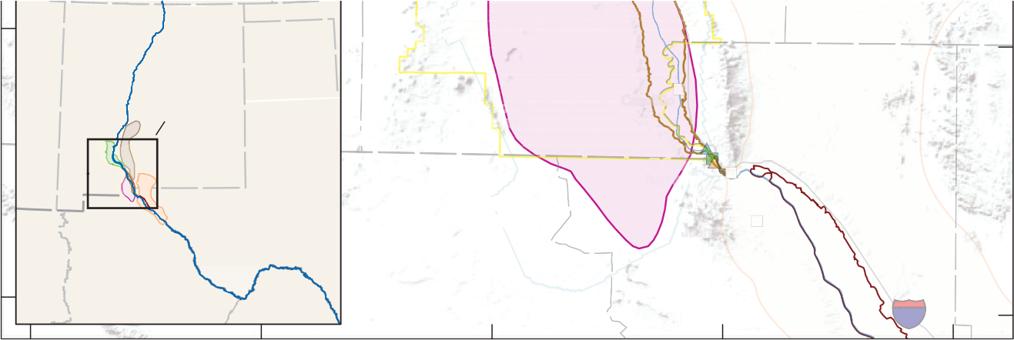
32°00'
NEW MEXICO
West Potrillo Mountains
NEW MEXICO
TEXAS
Area enlarged
East Potrillo Mountains
Canutillo
EL PASO COUNTY
El Paso
MUNICIPIO DE ASCENSIÓN
El Paso Narrows
Sierra de Juárez
Ciudad Juárez
MUNICIPIO DE JUÁREZ
CHIHUAHUA
COAHUILA
CHIHUAHUA
10
UNITED STATES
Franklin
Mountains
ARIZONA
Ri
o
e
G
r
a
d
n
OKLAHOMA
TEXAS

31°30'
MEXICO
UNITED
STATES
SONORA

Base modified from U.S. Geological Survey and other Federal and State digital data, various scales Shaded relief from Esri and its licensors, copyright 2022
Universal Transverse Mercator, zone 13 north North American Datum of 1983

0 15 30 MILES
MEXICO
0 15 30 KILOMETERS

New Mexico Office of the State Engineer Lower Rio Grande Water Master District (modified from Serrano, 2015)
Rio Grande Transboundary Integrated Hydrologic Model (RGTIHM) active model
area (study area)
EXPLANATION

Valley along the Rio Grande (Hanson and others, 2020)

Hatch Valley (also known as Rincon Valley in the study area)
Selden Canyon Mesilla Valley El Paso Valley

Groundwater basin
Hueco (Driscoll and Sherson, 2016) Palomas (Driscoll and Sherson, 2016) Mesilla (modified from J.W. Hawley,
New Mexico Bureau of Geology
and Mineral Resources, written commun., 2021)
Jornada del Muerto (modified from Witcher and others, 2004)

Diversion to El Paso Valley Streamgage
Rio Grande at El Paso, Texas (U.S. Geological Survey
site number 08364000)
Rio Grande below American Dam at El Paso, Texas (U.S. Geological Survey site number 08365000)

Figure 1. Example map figure showing a multipart base-map credit note containing an all-inclusive statement for the publicaly available base data as well as a specific credit for the Esri shaded-relief image. Also shown are data credits included with each data entry in the explanation.

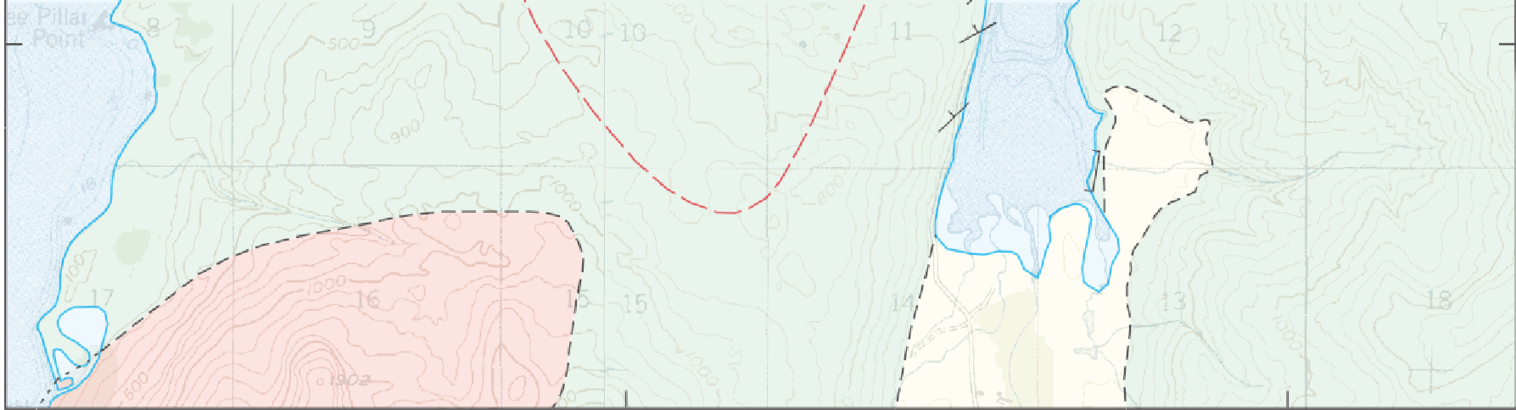
57°51'
Kk
34
71
Kk
84
SHERATIN BAY PLUTON
Qu
Tgl

57°49'50"

Base from U.S. Geological Survey, 1:63,360, Kodiak D-2, 1949 (revised 1980); Kodiak D-3, 1947 (revised 1979); Universal Transverse Mercator, zone 5 north; North American Datum of 1927 (base images) shown in World Geodetic System of 1984; National Geodetic Vertical Datum of 1929

Geologic mapping from Capps (1937) and Moore (1967), compiled with additional work by David W. Farris and
Peter J. Haeussler (2001–03)

Figure 2. Example map figure showing base-map and data credit notes that include several complex elements: the base map is a mosaic of two scanned historical USGS topographic maps (the seam is visible just east of the Sheratin Bay pluton) that were published and updated in different years; the original datum of the scanned maps was North American Datum of 1927, but the datum of this map figure is World Geodetic System of 1984; the topographic base contains elevation contours, so the vertical datum is included after the horizontal datum in the base-map credit note; and the data credit note acknowledges the compilation of published geologic mapping (consisting of citations from the References Cited list) and additional mapping by the authors.

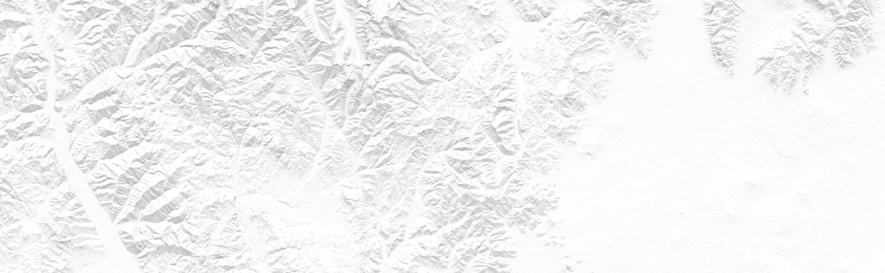
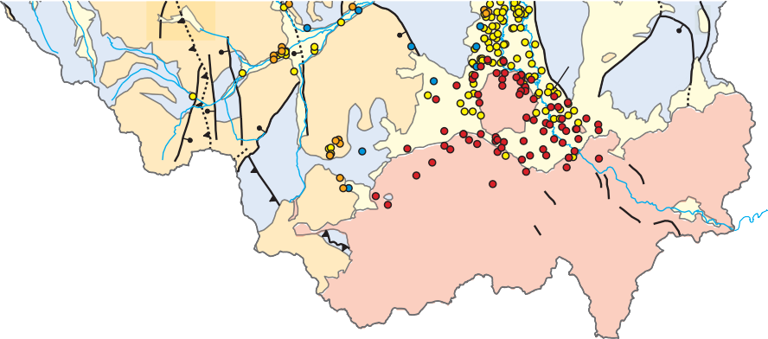
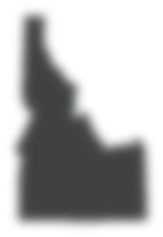
43°40'
Qa
Tv
Arco
Butte City
Qb
Map
area
IDAHO

Base from U.S. Geological Survey digital data, various scales Idaho Transverse Mercator coordinate system
North American Datum of 1983

Hydrogeologic unit
Qa
Qb
Tv
Pzc

Quaternary unconsolidated sediments Quaternary basalt rocks
Tertiary volcanic rocks Paleozoic sedimentary rocks
Archean-Proterozoic rocks, undivided
e

EXPLANATION
[Geology generalized from Lewis and others (2012)]
Fault—Dashed where concealed Movement in the last 15,000 years
High-angle normal fault—Bar and ball on downthrown block
Thrust fault—Sawteeth on upper plate Detachment fault—Hachures on
upper plate
0 10 20 MILES

0 10 20 KILOMETERS

Study basin
Well—Colored by intercepted lithology
Unconsolidated sediments
Basalt
Volcanic rocks
Sedimentary rocks

Figure 3. Example map figure showing a data credit for previously published geologic mapping included in a bracketed headnote in the explanation. In this example, the mapping credit applies to multiple level-one headings in the explanation, so it was easier and cleaner to use a bracketed headnote instead of including the credit with each level-one heading.

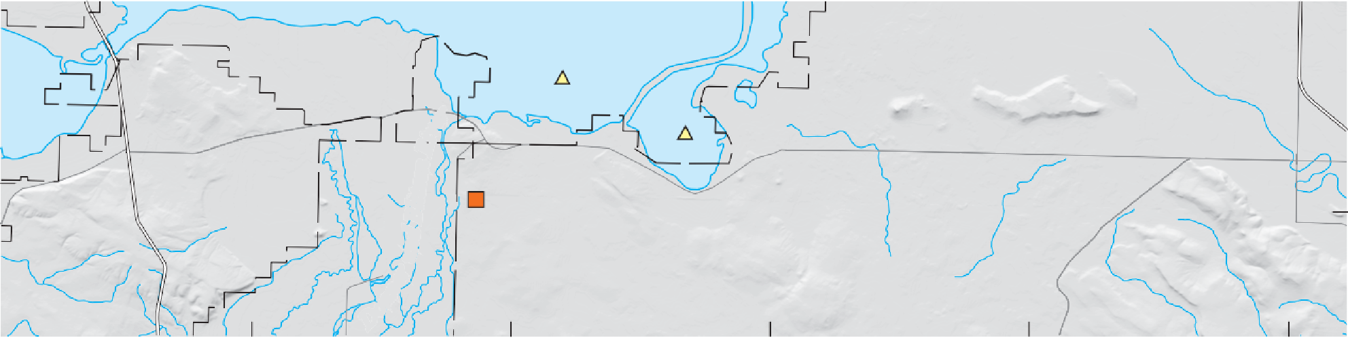
43°15'
Mud
Lake
SE
SE2
RGL
Bli
d tz
e
n
n
R
u
i
v
e
r

Shaded relief from U.S. Geological Survey (USGS) 30-meter digital data Hydrography from USGS National Hydrography Dataset, 1:100,000 Universal Transverse Mercator, zone 11 north
r
e
n
n
o
D
North American Datum of 1983
0 1 2 3 MILES

0 1 2 3 KILOMETERS

Figure 4. Example map figure showing a base-map credit note for a shaded-relief base image and hydrography dataset, both at specific scales. This information was included in the base-map credit note because both layers are base-map features and the scale of data shown were both specifically used for analyses in the study.

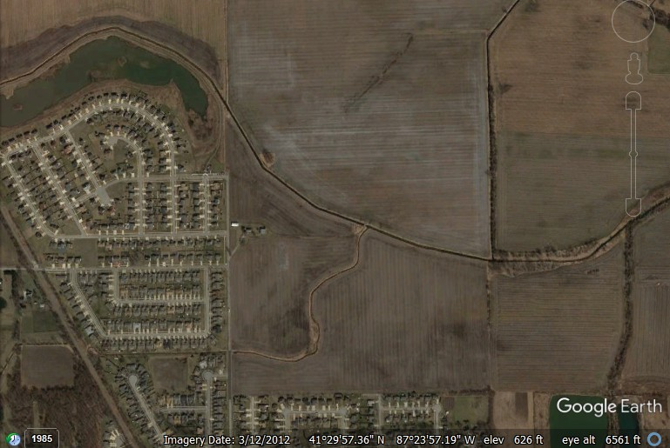
B
Do not show marginal items; plan to crop image here
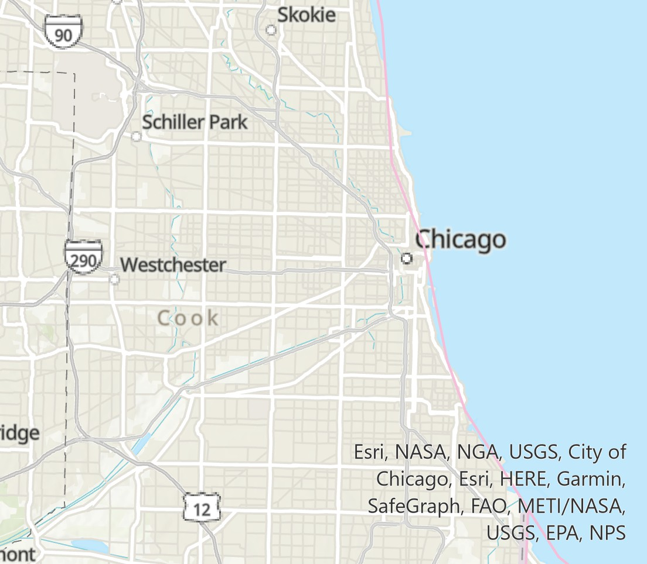
Base from Google Earth, copyright 2012 General Perspective projection
Do not show marginal items; plan to crop image here
A
World Geodetic System of 1984

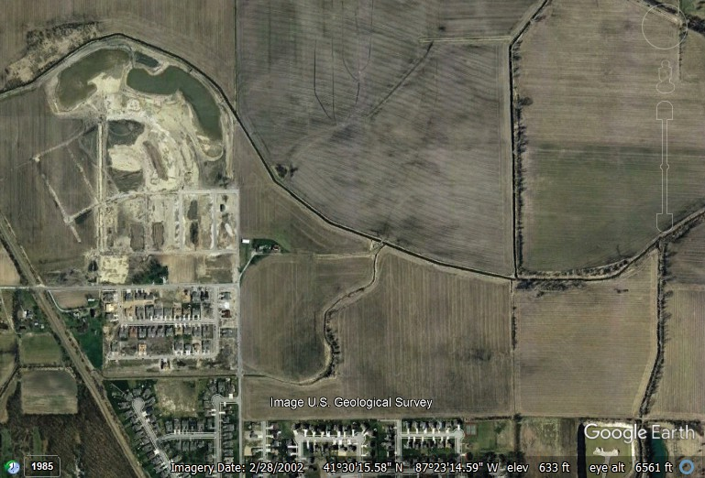
Base map from Esri and its licensors, copyright 2022 [Projection]
C
[Datum]

Figure 5. Examples of creating base-map credit notes from (A) Esri-hosted base maps and (B–D) Google Earth-hosted imagery. In A, the “service layer credits” that are auto-generated in ArcGIS (orange box) can be simplified to just “Esri and its licensors”—the non-Esri entities are included in the “and its licensors” statement. This wording is a shortened version of Esri’s longer recommended attribution statement provided at https://about.google/brand-resource-center/products-and-services/geo-guidelines/#required-attribution. In B–D, different Google Earth base-map credit notes are shown depending on the image credit shown on Google Earth (orange boxes). When an image credit is not shown in Google Earth (B), the credit note is simply “Google Earth.” When an image credit is shown in Google Earth (C, D), the listed entities must be listed following “Google Earth” in the base-map credit note. The copyright date should be the date of the original imagery collection (yellow boxes), if known; if not known, use the date that the imagery was accessed. See https://about.google/brand-resource-center/products-and-services/geo-guidelines/#required-attribution for more details on determining Google Earth imagery credits. The image credit shown in Google Earth—
and all other marginal items—should not be included on the base image itself; crop the image accordingly (white dashed line). Note that Google Earth uses the “General Perspective projection” with the “World Geodetic System of 1984” datum.

Base from Google Earth and U.S. Geological Survey, copyright 2002 General Perspective projection
World Geodetic System of 1984
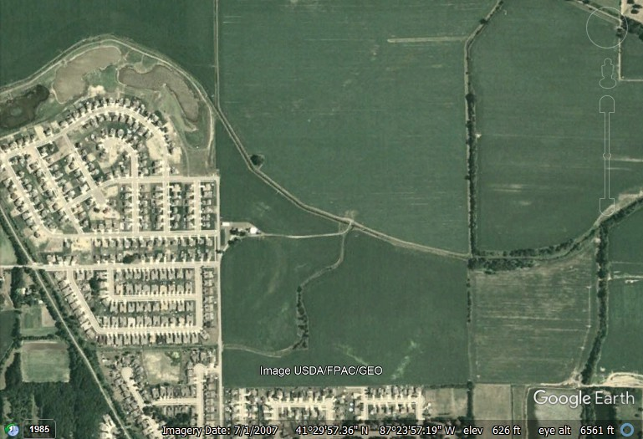
D
Base from Google Earth and USDA/PFAC/GEO, copyright 2007 General Perspective projection
World Geodetic System of 1984

3
EXPLANATION










Water-level change, in feet Declines
OKLAHOMA
34°
33°
TEXAS
2°
0 25 50 75 100 MILES

0 25 50 75 100 KILOMETERS
36°
35° NEW MEXICO

More than 75
50 to less than 75
25 to less than 50
10 to less than 25
No substantial change
–9.99 to +9.99
Rises
10 to less than 25
More than 25
Area of little or no saturated thickness
Area of water-level change with few predevelopment water levels, figs. 1 and 3 only
U Faults—U, upthrown side
County boundary

Base from U.S. Geological Survey 1:2,000,000-scale digital data, 2001; Albers Equal-Area Conic projection, standard parallels 29°30' and 45°30' N., central meridian 101°00' W.; North American Datum of 1983
Aquifer boundary from Qi (2010); change in saturated thickness since predevelopment modified from Luckey and others (1981); areas of little or no saturated thickness and faults from Gutentag and others (1984) and Cederstrand and Becker (1999a, b)

iv
e
i
r
R
a
n
Figure 6. Example map figure showing a base-map credit note for a conic projection that includes the standard parallels and central meridian. Although it is similar to the “Albers Equal-Area Conic, U.S. Geological Survey contiguous United States” projection, the cartographer adjusted the central meridian from 96° W. to 101° W. so that the orientation of the map was better aligned with the graticule. This is an alternate method to the example shown in figure 9.

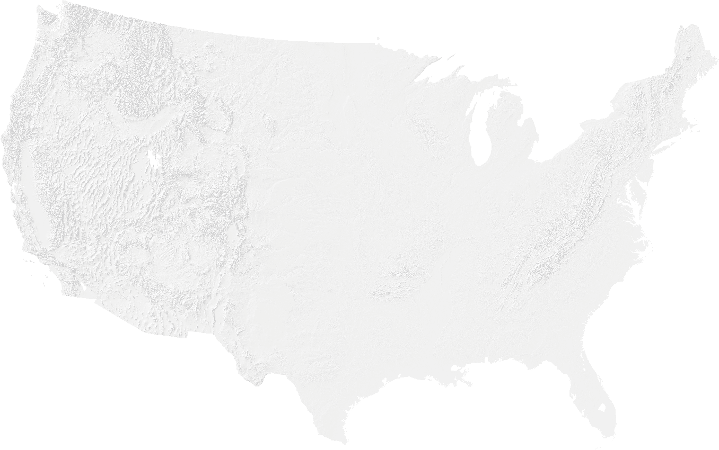
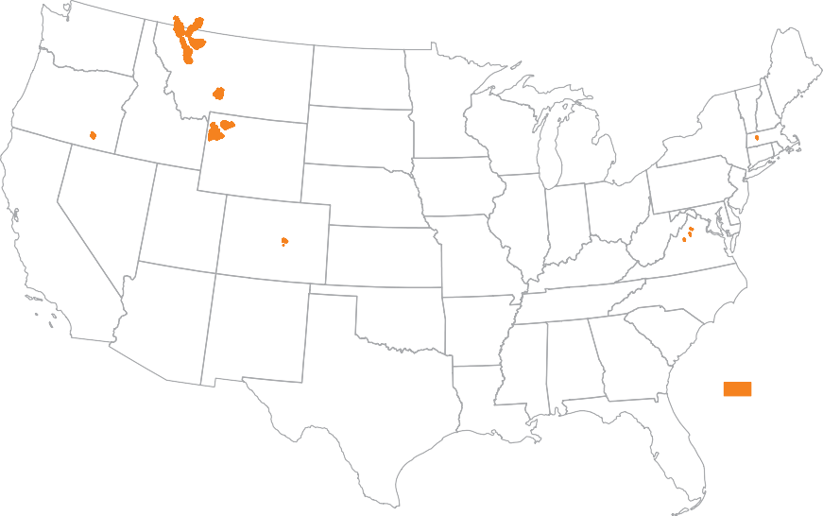
Glacier National Park area
Donner und Blitzen River
Shields River

Spread Creek and Shoshone River
West Brook-Mill River
Monument and Bear Creeks
Shenandoah National Park area
EXPLANATION
Focus area
Base from U.S. Geological Survey digital data, various scales; Albers Equal-Area Conic, U.S. Geological Survey contiguous United States projection; North American Datum of 1983

Figure 7. Example map figure showing a map of the contiguous United States and a base-map credit note for the “Albers Equal-Area Conic, U.S. Geological Survey contiguous United States” projection, which is a unique, named projection, and, therefore, the central meridian and standard parallels are omitted from the base-map credit note. If this map was shown on a fact sheet or in a circular, the base-map credit note would be removed.

119°
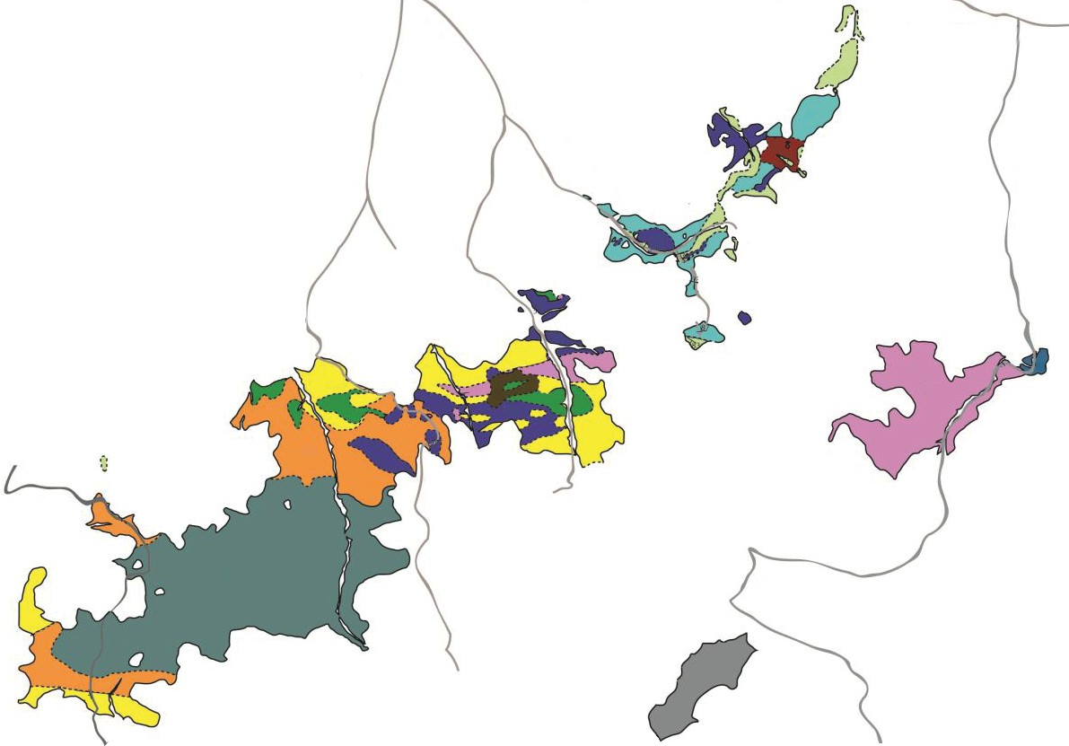
B
0 1 2 3 4 5 KILOMETERS
0 1 2
3 MILES
Jgn
Jtc
Jtj
Jgr
RJh
Jtp
Jda
PRms
PRmv
RJg
Jnc
Jtg
N

45°
Y
E
L
L
O
W A
J
20'
U
S
H
W
Y
3
9
5

45°
16'
118°56' 118°52' 118°48' 118°44'

EXPLANATION
Gabbronorite of Ridenor Canyon (145.7 Ma) Tonalite of Granite Meadows (147 Ma) Norite of Carney Butte (147.8 Ma)
Jgr
Jtg
Jnc
Jda
Jtj
Jgn
Jtc
RJg
RJh
Jtp
PRmv
PRms

Diorite of Alexander Creek (149.4 Ma) Trondhjemite of Johnson Creek (149.5 Ma) Hornblende Gneiss
Tonaline of California Gulch (152.5 Ma) Metagabbro
Hornblendite
Trondhjemite of Pearson Creek (159.5 Ma) Keratophrye of Pearson Creek
Schist of Yellow Jacket Road Road
D

Base modified from Anderson (2013)
Oregon Statewide Lambert Conformal Conic projection North American Datum of 1983

Figure 8. Example map figure showing a base-map credit note placed on the side of a figure instead of below the lower left corner. Given space constraints during layout (this example figure had a large panel A above it), it was necessary to place the credit note to the side of the figure instead of below it, but it was still kept near the bottom.
O
S
R
A
E
P
R
K
E
E
R
C

125° W
120° W
115°

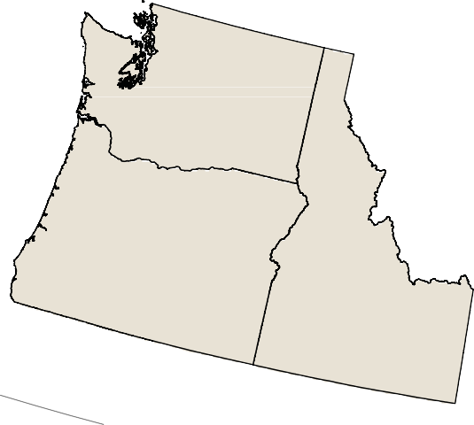
50°
125°
120°
115°
110°

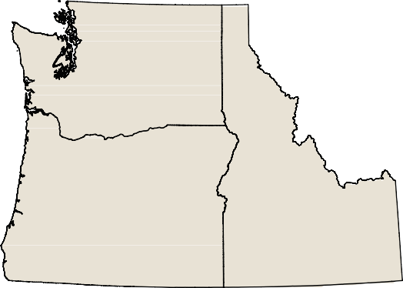
45°

45°

40°

Base from U.S. Geological Survey (USGS) digital data; Albers Equal-Area Conic, U.S. Geological Survey contiguous United States projection; North American Datum of 1983
Base from U.S. Geological Survey (USGS) digital data; Albers Equal-Area Conic, U.S. Geological Survey contiguous United States projection, rotated 13°; North American Datum of 1983

Figure 9. Examples showing how a map frame can be rotated in ArcGIS to better align a region with the graticule. On the left, the Pacific Northwest is shown using “Albers Equal-Area Conic, U.S. Geological Survey contiguous United States” projection, which is centered on Kansas and makes the Pacific Northwest look tilted. On the right, the same projection is used, but the map has been rotated 13° within the map frame so that the Pacific Northwest is more accurately displayed. This is an alternate method to the example shown in figure 6.
D
C
R R
E
E
K
Y
E
S
T
A
L
N
D
RD
EK
ET
E
R
K
W
R
BI
C
RC
H
C

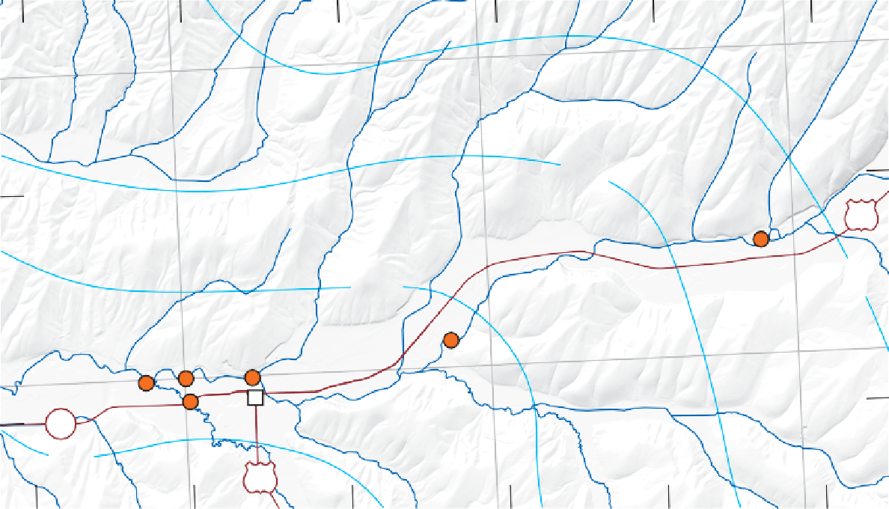
118°12'
12
14016810
350
14016935
14016820
14016960 14016930
124 14016955 Waitsburg
300
12

46°18'

46°16'
118°10'
118°08'
118°06'
118°04'
118°02'

5,130,000

5,125,000
450

EXPLANATION
Surface contour—Shows altitude of model surface B. Contour interval 50 meters. Datum is North American Vertical Datum of 1988
Sample site
e
r
T
o
u
c
h
e
t
R
i
v

410,000

Base modified from U.S. Geological Survey digital data, various dates and scales; Washington State Plane Coordinate System, south zone, and Universal Transverse Mercator, zone 11 north; North American Datum of 1983
415,000
420,000
0 1 2 MILES

0 1 2 KILOMETERS

Figure 10. Example map figure showing a map and base-map credit note that includes two coordinate systems. The primary system (black ticks and labels along the top and left sides) shows latitudes and longitudes for the State Plane Coordinate System; the secondary system (gray grid lines and labels along bottom and right sides) shows a Universal Transverse Mercator grid. Both are noted in the base-map credit note. Additionally, the vertical datum associated with the contour data lines on the map is noted in the explanation, not in the base-map credit note.

Not ideal—Although the elements of the base-map credit note are on separate lines, the projection or coordinate system line is much longer than other lines.

Not ideal—When reducing the width of the text box, the projection or coordinate system line becomes two lines; a lack of punctuation makes it unclear which lines are related.
Shaded relief from U.S. Geological Survey 30-meter digital data
Alaska Albers Equal-Area Conic projection, standard parallels 55° and 65° N., central meridian 154° W.
North American Datum of 1983

Shaded relief from U.S. Geological Survey 30-meter digital data
Alaska Albers Equal-Area Conic projection, standard parallels
55° and 65° N., central meridian 154° W.
North American Datum of 1983

Ideal—If height is limited, this three-line example uses semicolons to separate the three elements of the base-map credit note while reducing the overall height of the note.
Shaded relief from U.S. Geological Survey 30-meter digital data; |  | Alaska
Albers Equal-Area Conic projection, standard parallels 55° and 65° N.,
central meridian 154° W.; | North American Datum of 1983

Ideal—If width is limited, this four-line example uses semicolons to separate the three elements of the base-map credit note while reducing the overall width of the note.

Base-map credit note elements
Shaded relief | from U.S. Geological Survey 30-meter
digital data; | Alaska Albers Equal-Area Conic
projection, standard parallels 55° and 65° N., central
meridian 154° W.; |  | North American Datum of 1983

Text box outline

400
2. Projection or coordinate system
1. Base-map information
3. Datum

Figure 11. Examples showing formatting of base-map credit notes (right column) into different widths and heights, depending on space constraints during layout.

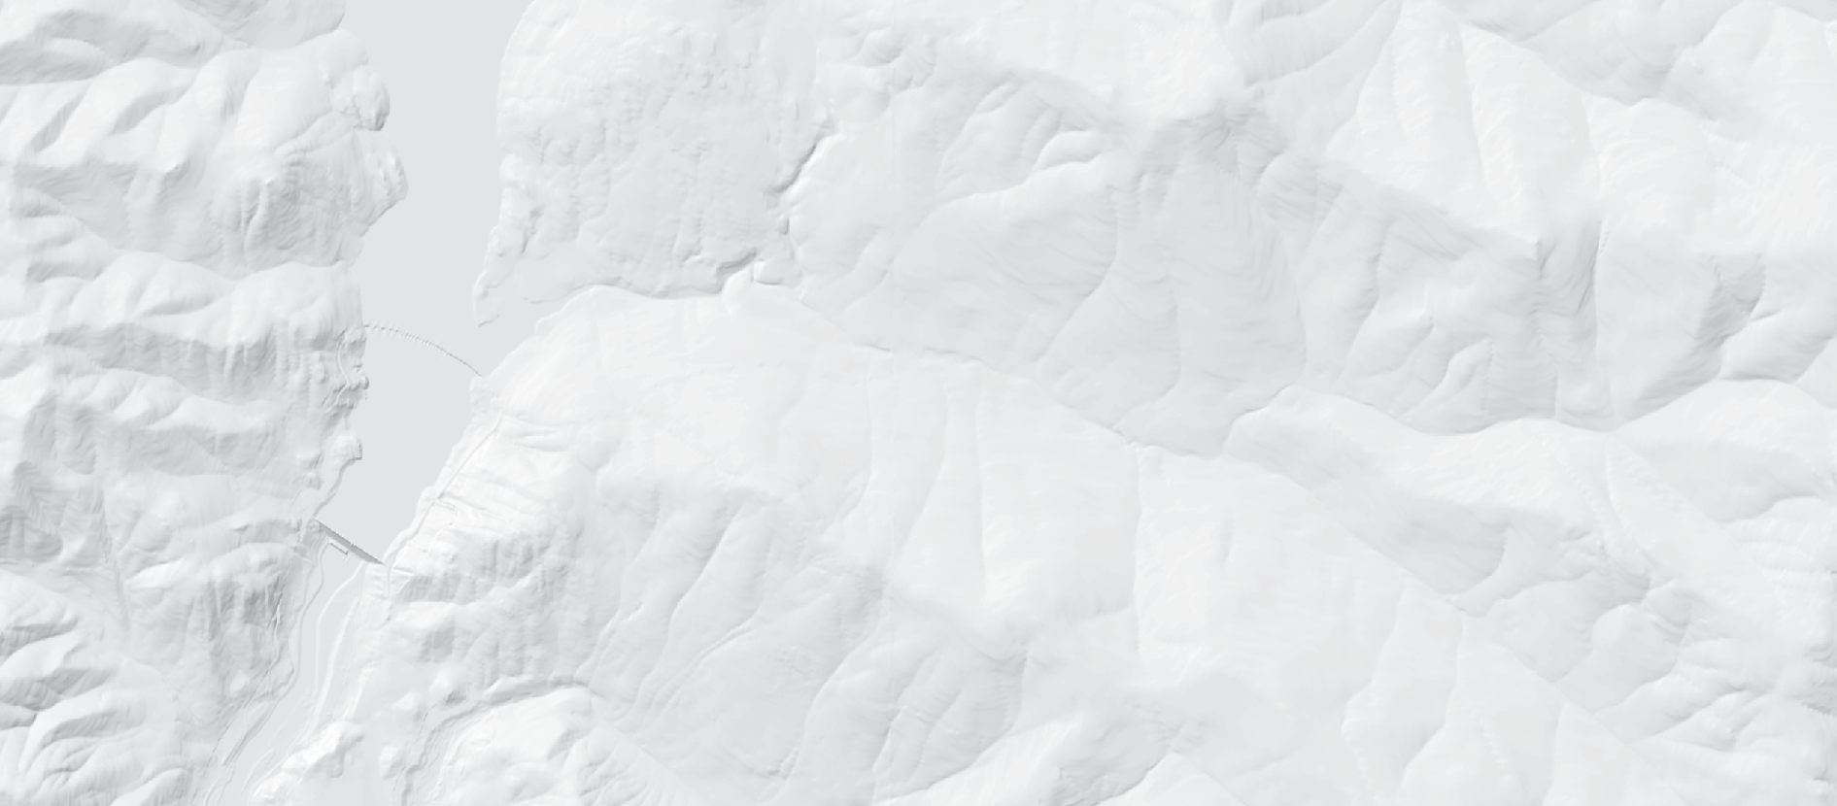
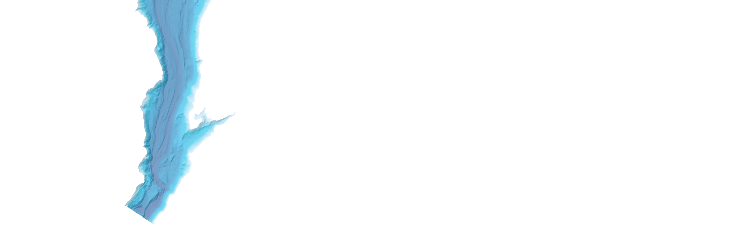

48°25'
C
LPCP-3-RESET
LIBBY DAM
37
n
e
C
e
c
a
e
s C
a
u
e
o
r
S
C
P
r
e
e
e
k
A
l
e
e
x
a
k
n
d
e
r
C
v
r
on
k
k
e
e
y
r

Base modified from U.S. Geological Survey digital data, various scales Shaded relief from U.S. Geological Survey 10-meter digital data Montana Lambert Conformal Conic projection
r
e
e
k
i Ri e
a
n
e
t
o
o
K
North American Datum of 1983
Bathymetry data from Fosness and Dudunake (2021)
NOT INTENDED FOR NAVIGATIONAL USE

Figure 12. Example map figure showing a data credit note beneath the lower right corner of a map. Bathymetry was collected as part of this study and released as a ScienceBase data release associated with the report and, therefore, is credited with the map figure. This citation would also have been appropriate next to the bathymetery entry in the figure’s explanation (not shown). Additionally, the resolution of the shaded relief was explicitly noted in the base-map credit note by request of the author; if not specifically requested to include separately, the shaded relief information could be removed as it would pertain to the first line of the base-map credit note.
Arivaca Wash

31˚30'
UNITED STATES
MEXICO
ARIVACA BASIN
Arivaca Creek
A L T A R

Base image from Esri and its licensors, copyright 2020 Universal Transverse Mercator, zone 12 north
North American Datum of 1983
Figure 3. Map showing distribution of soil units within Altar Valley groundwater area (as delineated by U.S. Geological Survey [USGS]) and Buenos Aires National Wildlife Refuge (BANWR), Arizona. Soil units are from the Natural Resources Conservation Service’s State Soil Geographic Database (STATSGO) (Soil Survey Staff, U.S. Department of Agriculture, 2019a, c); see table 2 for brief descriptions of soil units.
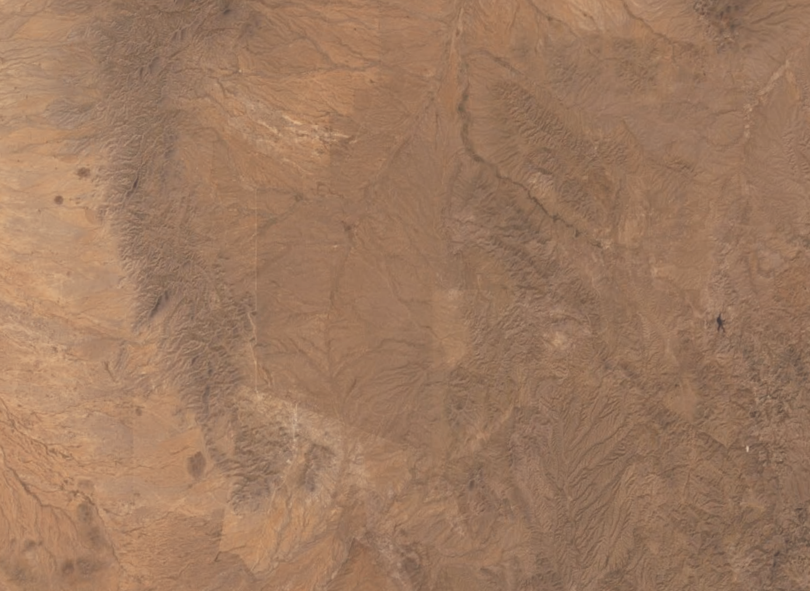
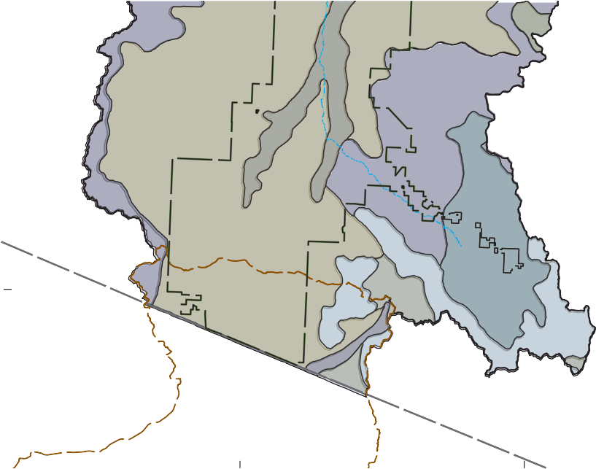
Boundary of Altar Valley groundwater area from Wilson (1991); BANWR boundary from U.S. Fish and Wildlife Service; watershed boundaries from USGS (2018). Drainage features, national boundary, and road from USGS’ The National Map (https://viewer.nationalmap.gov).
0
4
8 MILES
0
4
8 KILOMETERS
WILDLIFE REFUGE
s386
s326
s303
s329
s329
s326
s483
s325
s478
SONORA
s478
s462
s478
s483
s478
s483

Figure 13. Example map figure showing base-map (more detailed parts) and data credits placed in the figure caption of a page-size map. Note that the figure caption shown as part of this example has been lightened so that it is not confused with the actual caption for figure 13.
e
r
C

