Saving Lives and Livelihoods: Satellite-based Flood Forecasts in South Sudan for Humanitarian Response.

Karyn Tabor, Kim Slinski, Shahriar Pervez, Amy McNally, Mike Budde, Jim Verdin

South Sudan is one of the most food insecure countries in the world due to a combination of social and environmental factors. Returnees and migrants fleeing neighboring countries with growing political instability and conflict have settled in South Sudan, increasing the number of people vulnerable to weather hazards and food insecurity.

South Sudan has experienced devastating floods in four of the past five years (2019-2023). Above average precipitation in early 2024, a slow recession of flooding during the dry season, and large volumes of water being released from Lake Victoria all raised concerns of another year of extensive flooding in the region. However, the extent and location of inundated areas remained highly uncertain due to the lack of information of flow releases from dams upstream along the Victoria Nile River. The Famine Early Warning Systems Network (FEWS NET) Decision Support Team and United States Agency for International Development (USAID) Disaster Response Team needed to know which areas were likely to flood in the coming months to prepare to relocate refugee camps, if necessary, and allocate humanitarian assistance.

Generating accurate forecast models is challenging in data poor regions of the world such as South Sudan. In-situ weather station data is limited and unreliable, and there is a scarcity of reliable field data to validate satellite imagery.

Fortunately, an increasing number of satellites are available from the US and European space agencies to improve the accuracy of forecast models. FEWS NET scientists from National Aeronautics and Space Administration (NASA) Goddard Space Flight Center (GSFC) and U.S. Geological Survey (USGS) Earth Resources Observation and Science (EROS) Center built a model to meet the needs of the international Technical Working Group supporting the United Nations Office for the Coordination of Humanitarian Affairs (UN OCHA).

FEWS NET scientists relied on the Visible Infrared Imaging Radiometer Suite (VIIRS), Climate Hazards Group InfraRed Precipitation with Station (CHIRPS), Landsat, hydrological model forecasts (FEWS NET Land Data Assimilation System-forecasts), and radar altimetry data to rapidly develop a 3–6-month statistical forecast model of the spatial likelihood of inundation. The model also used historical frequency of inundation derived from VIIRS flood products. By June 2024, the team accurately forecasted a September inundation area of **73,000** km2, predicting that approximately 11,000 hectares of cropland and 830,000 people would be vulnerable to flooding. The working group, in turn, advised the South Sudan Flood Preparedness and Response Taskforce, co-led by the Ministry of Humanitarian Affairs and OCHA.

The USAID Juba office saved time and money by avoiding costly relocations for the refugees and mission staff in Juba. Furthermore, informed by FEWS NET’s independent assessment of food insecurity, the U.S. government delivered $600 million USD in humanitarian assistance to help the estimated 65-70 percent of the population of South Sudan increase their coping capacity in the face of continued economic crises, violence, and natural hazards.

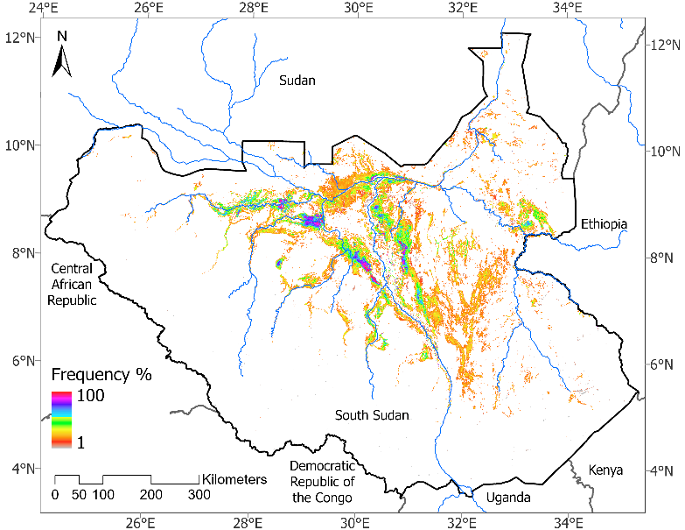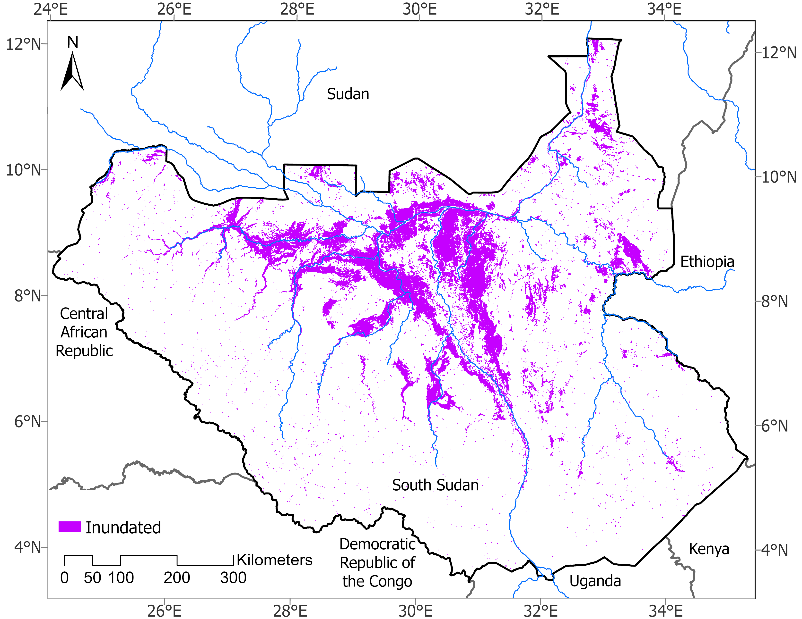

Figure 1: Left panel: map of predicted flooding (72,882 km2 based on 2020 analog year) for September of 2024 with April initial conditions shown with historical frequency of flooding for each pixel. Right panel: shows the map of observed flooding (72,515 km2) in September of 2024 from Visible Infrared Imaging Radiometer Suite flood product.