AGU Hydrology Blog 2025

Title: Saving Lives and Livelihoods: Satellite-based Flood Forecasts in South Sudan for Humanitarian Response.

Title option 2: Forecasting Floods in South Sudan: Leveraging Satellite Data for Humanitarian Response

Karyn Tabor, Kim Slinski, Shahriar Pervez, Amy McNally, Mike Budde, Jim Verdin

South Sudan ranks as one of the most food insecure countries in the world due to a combination of social and environmental factors. Migrants fleeing neighboring areas with growing political instability and conflict have settled in South Sudan, increasing the number of people vulnerable to weather hazards and food insecurity.

Extreme weather events are occurring more frequently, with the country experiencing devastating floods in four of the past five years. The combination of above average precipitation in early 2024 brought about by La Niña, a slow recession of flooding during the dry period, and large volumes of water being released from Lake Victoria in Uganda, raised concerns of another year of extensive flooding for the region. However, the extent and location of inundated areas remained highly uncertain due to the lack of information of flow releases from dams upstream. The U.S. Agency for International Development (USAID) South Sudan field team in Juba needed to know which areas are likely to flood in the coming months to plan for possible relocation of refugee camps and the evacuation of the USAID mission. In response, the field team convened a technical flood monitoring task force consisting of local experts and scientists including Famine Early Warning Systems Network (FEWS NET) scientists from the National Aeronautics and Space Administration Goddard Space Flight Center (GSFC), U.S. Geological Survey (USGS) Earth Resources Observation and Science (EROS) Center, USAID, academic researchers and regional experts.

While multiple flood monitoring data products are available through various initiatives, none of the products met the needs of the taskforce to address the urgent and evolving humanitarian crises. Generating accurate forecast models of environmental conditions and natural hazards from satellite remote sensing is challenging in data poor regions of the world such as South Sudan. The availability of in situ weather station data is limited and unreliable, and there is a scarcity of reliable field data to validate satellite imagery. Fortunately, with the increased number of satellites available to researchers from the U.S. and European space agencies, researchers from GSFC and USGS EROS leveraged Visible Infrared Imaging Radiometer Suite, Landsat, hydrological model forecasts (FLDAS-forecasts), and radar altimetry data to rapidly develop a 3–6-month statistical forecast model of the spatial likelihood of inundation. By June of 2024, the team accurately forecasted September inundation area of **73,000** km2, predicting that, roughly 11,000 hectares of cropland and 830,000 people would be vulnerable to flooding.

Due to the responsive development of the inundation forecast models, the USAID Juba office saved time and money by avoiding costly relocations for the refugees and mission staff in Juba. Furthermore, informed by FEWS NET’s independent assessment of food insecurity, the U.S. government delivered $600 million USD in humanitarian assistance to help the estimated 65-70 percent of the population of South Sudan increase their coping capacity in the face of continued economic crises, violence, and natural hazards.

Blog image suggestions

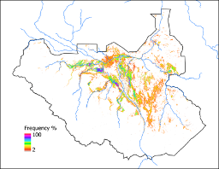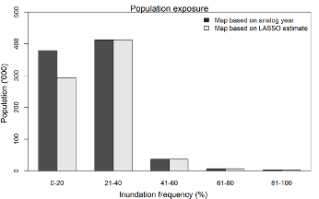

Figure 1: left panel: Predicted flooding for September of 2024, prediction was made in May with April initial conditions. Predicted inundated area was 72,882 km2 (based on 2020 analog year) compared to observed September of 2024 inundation of 72,515 km2. Right panel: shows number of people exposed to flooding directly based on September 2024 predicted flooding.