DOI agency/bureau2: USGS
USGS Mission Area: Core Science Systems
USGS Program: **unspecified​**
Cost Center: Earth Resources Observation and Science (EROS) Center (Geography)
Program Name2:
Project title: Rangeland Condition Monitoring Assessment and Projection (RCMAP)
Project description: Rangeland ecosystems in the western United States (U.S.) are vulnerable to climate change, fire, and anthropogenic disturbances. Scientists from the USGS Earth Resources Observation and Science (EROS) Center and the Bureau of Land Management developed the Rangeland Condition Monitoring Assessment and Projection (RCMAP) project. This project quantifies the percent cover of rangeland components across the western U.S. using Landsat imagery from 1985–2021 in the current generation. The RCMAP product suite includes nine fractional components (annual herbaceous, bare ground, herbaceous, litter, non-sagebrush shrub, perennial herbaceous, sagebrush, shrub, and tree) and the temporal trends of each. The latest generation of RCMAP data has been enhanced with additional training data, improved imagery composites, inclusion of a Neural Network modelling framework, expansion of study area to the Pacific Northwest, and addition of tree canopy cover component-designed specifically for applications in stands of pinyon-juniper. These changes resulted in a 5-7 percent reduction in error measured at independent validation sites.

Results showed the net cover of shrub, sagebrush, and litter significantly (p < 0.05) decreased across the range, while bare ground and herbaceous cover had no significant change and annual herbaceous cover significantly (p < 0.05) increased. Change was ubiquitous, with a mean of 92% of pixels with some change and 38% of pixels with significant change (p < 0.05). However, most change was gradual; well over half of pixels had a range of less than 10%, and most change occurred outside of known disturbances such as fires and vegetation treatments. Data depict the effects of disturbance such as fire, the interannual variation related to yearly weather cycles, and long-term patterns of response to climate change.

RCMAP fractional component time-series data spanning 1985–2021 and trends analysis products are now available for download at www.MRLC.gov and on the rangelands viewer application. This dataset is designed for out-of-the-box application and provides a foundation for both historical and future monitoring at ecosystem scales. Land managers and scientists can use annual fractional cover maps to monitor changes to vegetation composition, evaluate past management practices, target future improvements, determine locations of critical wildlife habitat, assess effects of climate change and interannual variation, and appraise landscape health and fragmentation.

Sensor Type: Multispectral (approx. 4-12 bands);
Platform type: Ground based / sensor web / web cam;Satellite;
URL:
Graphic or Image Upload: https://doimspp.sharepoint.com/sites/GS-EROSSCIENCESWI/Shared Documents/Apps/Microsoft Forms/DOI RS Activities Report, 2022 (2)/Graphic or Image Upload/graphic_prim_comp300_Matthew Rigge.png
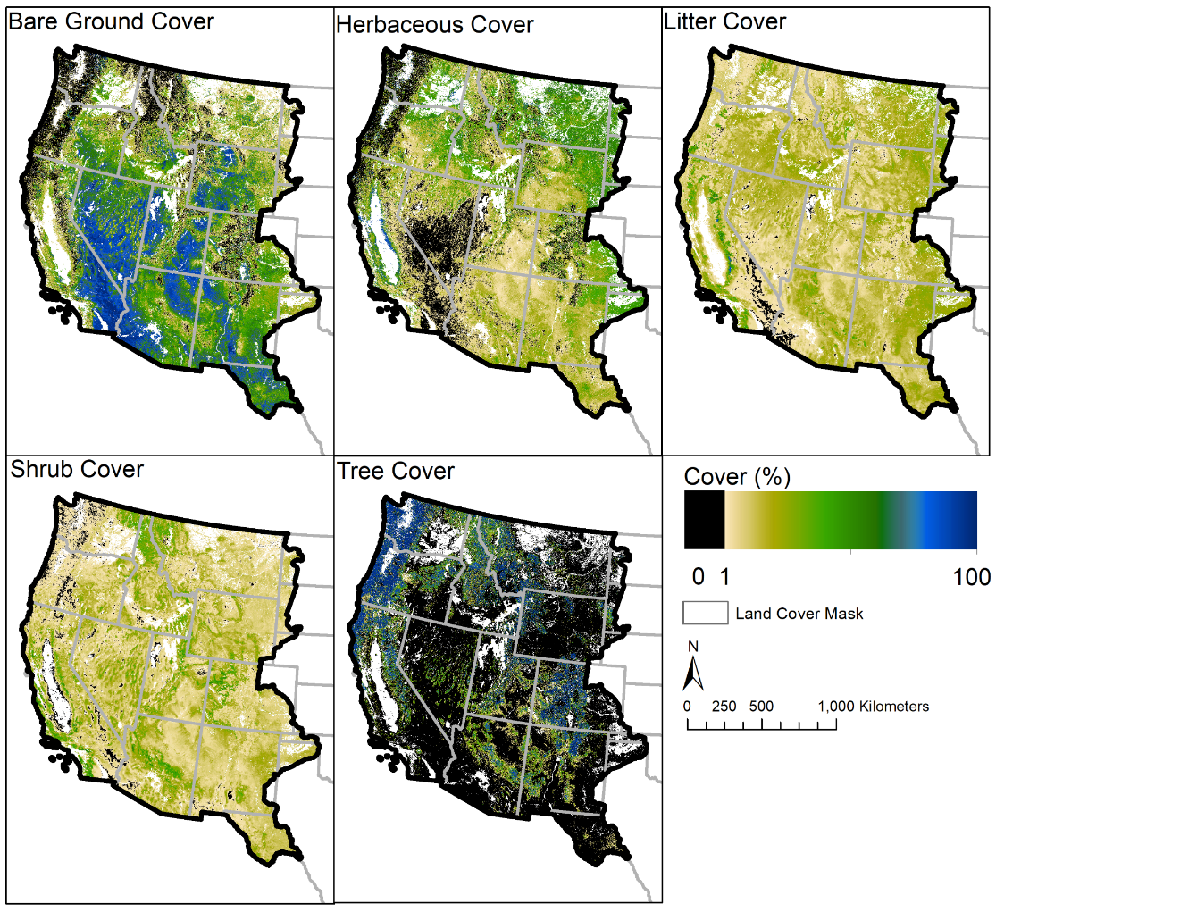
Caption for Graphic or Image: Spatial distribution of percent cover of key RCMAP components mapped for 2021.
Author name: Matthew Rigge
Author business email: mrigge@usgs.gov

DOI agency/bureau2: USGS
USGS Mission Area: Core Science Systems
USGS Program: Land Change Science
Cost Center: Geosciences and Environmental Change Science Center
Program Name2:
Project title: Development of open and vegetated water algorithms from Sentinel-1 and Sentinel-2 satellites across the U.S.
Project description: Frequent observations of surface water at fine spatial scales will provide critical data to support the management of aquatic habitat, flood risk and water quality. Sentinel-1 and Sentinel-2 satellites can provide such observations, but algorithms are still needed that perform well across diverse climate and vegetation conditions. We developed surface inundation algorithms for Sentinel-1 and Sentinel-2, respectively, at 12 sites across the conterminous United States (CONUS), covering a total of >536,000 km2 and representing diverse hydrologic and vegetation landscapes. Each scene in the 5-year (2017-2021) time series was classified into open water, vegetated water, and non-water at 20 m resolution using variables from Sentinel-1 and Sentinel-2, as well as variables derived from topographic and weather datasets. The Sentinel-1 algorithm was developed distinct from the Sentinel-2 model to explore if and where the two time series could potentially be integrated into a single high-frequency time series. Within each model, open water and vegetated water (vegetated palustrine, lacustrine, and riverine wetlands) classes were mapped. The models were validated using imagery from WorldView and PlanetScope. Classification accuracy for open water was high across the 5-year period, with an omission and commission error of only 3.1% and 0.9% for the Sentinel-1 algorithm and 3.1% and 0.5% for the Sentinel-2 algorithm, respectively. Vegetated water accuracy was lower, as expected given that the class represents mixed pixels. The Sentinel-2 algorithm showed higher accuracy (10.7% omission and 7.9% commission error) relative to the Sentinel-1 algorithm (28.4% omission and 16.0% commission error). Patterns over time in the proportion of area mapped as open or vegetated water by the Sentinel-1 and Sentinel-2 algorithms were charted and correlated for a subset of all 12 sites. Our results showed that the Sentinel-1 and Sentinel-2 algorithm open water time series can be integrated at all 12 sites to improve the temporal resolution, but sensor-specific differences, such as sensitivity to vegetation structure versus pixel color, complicate the data integration for mixed-pixel, vegetated water. The methods developed provide inundation at 5-day (Sentinel-2 algorithm) and 12-day (Sentinel-1 algorithm) time steps to improve our understanding of the short- and long-term response of surface water to climate and land use drivers in different ecoregions.

Associated manuscript: https://www.sciencedirect.com/science/article/pii/S0034425723000494

Associated data: https://www.sciencebase.gov/catalog/item/62c5c6ecd34eeb1417bafe09

Sensor Type: IFSAR / SAR / Radar;Multispectral (approx. 4-12 bands);
Platform type: Satellite;
URL: https://www.usgs.gov/centers/geosciences-and-environmental-change-science-center/science/remote-sensing-ecosystem
Graphic or Image Upload: https://doimspp.sharepoint.com/sites/GS-EROSSCIENCESWI/Shared Documents/Apps/Microsoft Forms/DOI RS Activities Report, 2022 (2)/Graphic or Image Upload/Vanderhoof_water_figure_Melanie Vanderhoof.jpg
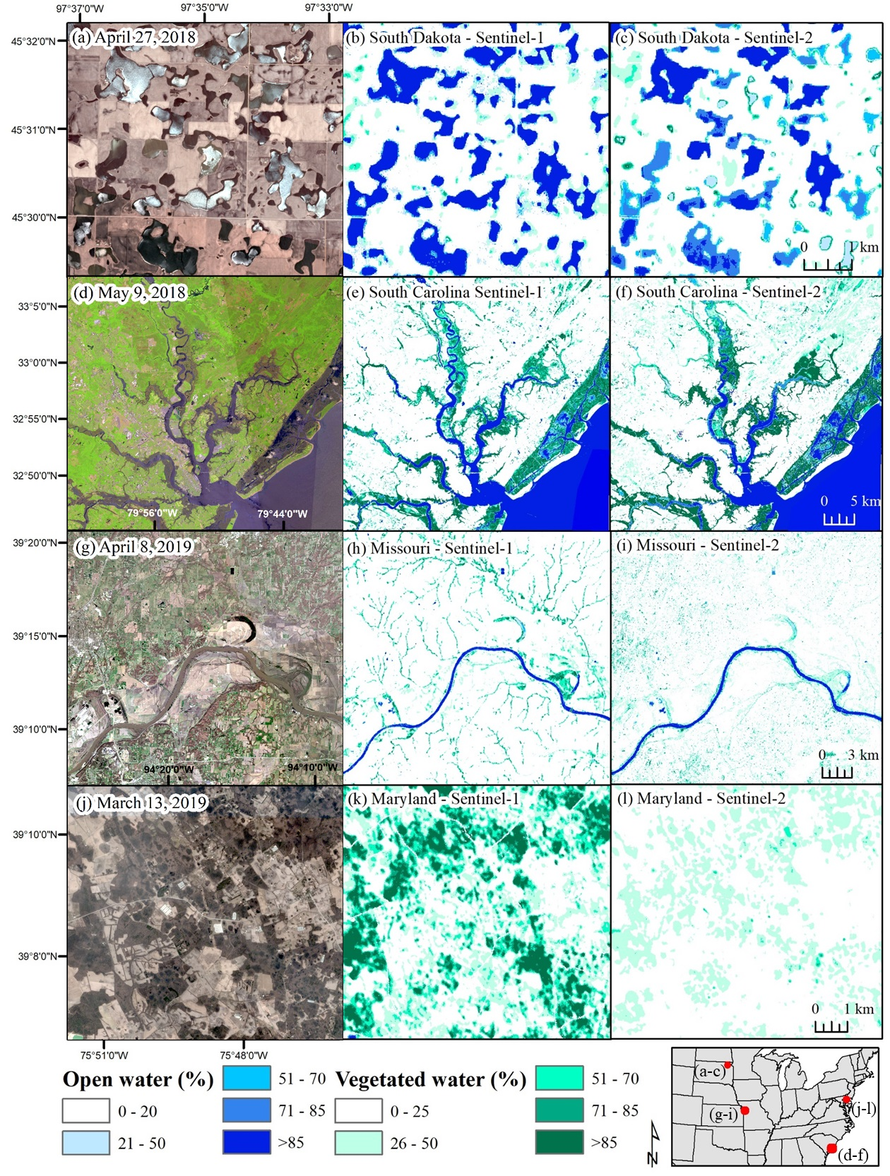
Caption for Graphic or Image: Figure. Examples of different water body types mapped including (a-c) inland wetlands in South Dakota, (d-f) tidal wetlands in South Carolina, (g-i) rivers in Missouri, and (j-l) forested wetlands in Maryland-Delaware. Classifications were derived from all images collected in 2018 and 2019 and open water percentile is layered on top of vegetated water percentile. Reference imagery is PlanetScope, except for (d) a Sentinel-2 image.
Author name: Melanie Vanderhoof
Author business email: mvanderhoof@usgs.gov

DOI agency/bureau2: USGS
USGS Mission Area: Core Science Systems
USGS Program: Land Change Science
Cost Center: Geosciences and Environmental Change Science Center
Program Name2:
Project title: Contemporary (1984-2020) fire history metrics for the conterminous United States
Project description: Contemporary (1984-2022) fire history metrics for the conterminous United States
Remotely sensed burned area products are critical to support fire modelling, policy, and management. While Landsat provides the longest record of burned area across the conterminous U.S., burned area products still require additional processing to summarize and facilitate their use in models and decision-making. Fire management across the U.S. will benefit from comprehensive, burned area data, delivered in a format to facilitate their direct use by diverse stakeholders. Scientists from the Geoscience and Environmental Change Science Center and Tall Timbers Research Station calculated a suite of fire history metrics from the Landsat burned area product (1984-2020) across the conterminous U.S. including: (1) fire frequency, (2) time since last burn (TSLB), (3) year of last burn, (4) longest fire-free interval, (5) average fire interval length, and (6) contemporary fire return interval (cFRI). The metrics were summarized by ecoregion, land ownership, and related to historical and cheatgrass datasets to demonstrate example applications of the products. Fire regimes vary widely across the U.S., with the proportion burned ranging from 0.7% in the Northeast Mixed Woods, to 74.1% in the Kansas Flint Hills over the 37-year period. The appropriate or useful fire metric(s) may therefore depend on the local or regional amount and frequency of burning. We also observed land ownership differences in fire regimes. Compared to private, public land had greater burned area (19 of 31 ecoregions) and shorter contemporary fire return interval (25 of 31 ecoregions), highlighting the importance of accurately tracking fire activity across both public and private land. The fire history metrics are being updated annually and are currently available for 1984-2022. The suite of fire history metrics may help manage future fire risk, meet national fire-related goals, and prioritize areas to focus increased engagement with private landowners. Continued progress towards accurate and complete mapping of burned area, and the consolidation of burned area products into useful and relevant fire history metrics is critical to manage ecosystem condition under climate change and control the growing economic costs of wildfire damage and suppression.

Associated manuscript: https://www.publish.csiro.au/wf/pdf/WF22044

Associated data: https://www.sciencebase.gov/catalog/item/6244bbeed34e21f8276030bf

Sensor Type: Multispectral (approx. 4-12 bands);
Platform type: Satellite;
URL: https://www.landscapepartnership.org/key-issues/wildland-fire/fire-mapping/regional-fire-mapping/se-firemap
Graphic or Image Upload: https://doimspp.sharepoint.com/sites/GS-EROSSCIENCESWI/Shared Documents/Apps/Microsoft Forms/DOI RS Activities Report, 2022 (2)/Graphic or Image Upload/Vanderhoof_fire_history_Melanie Vanderhoof.png
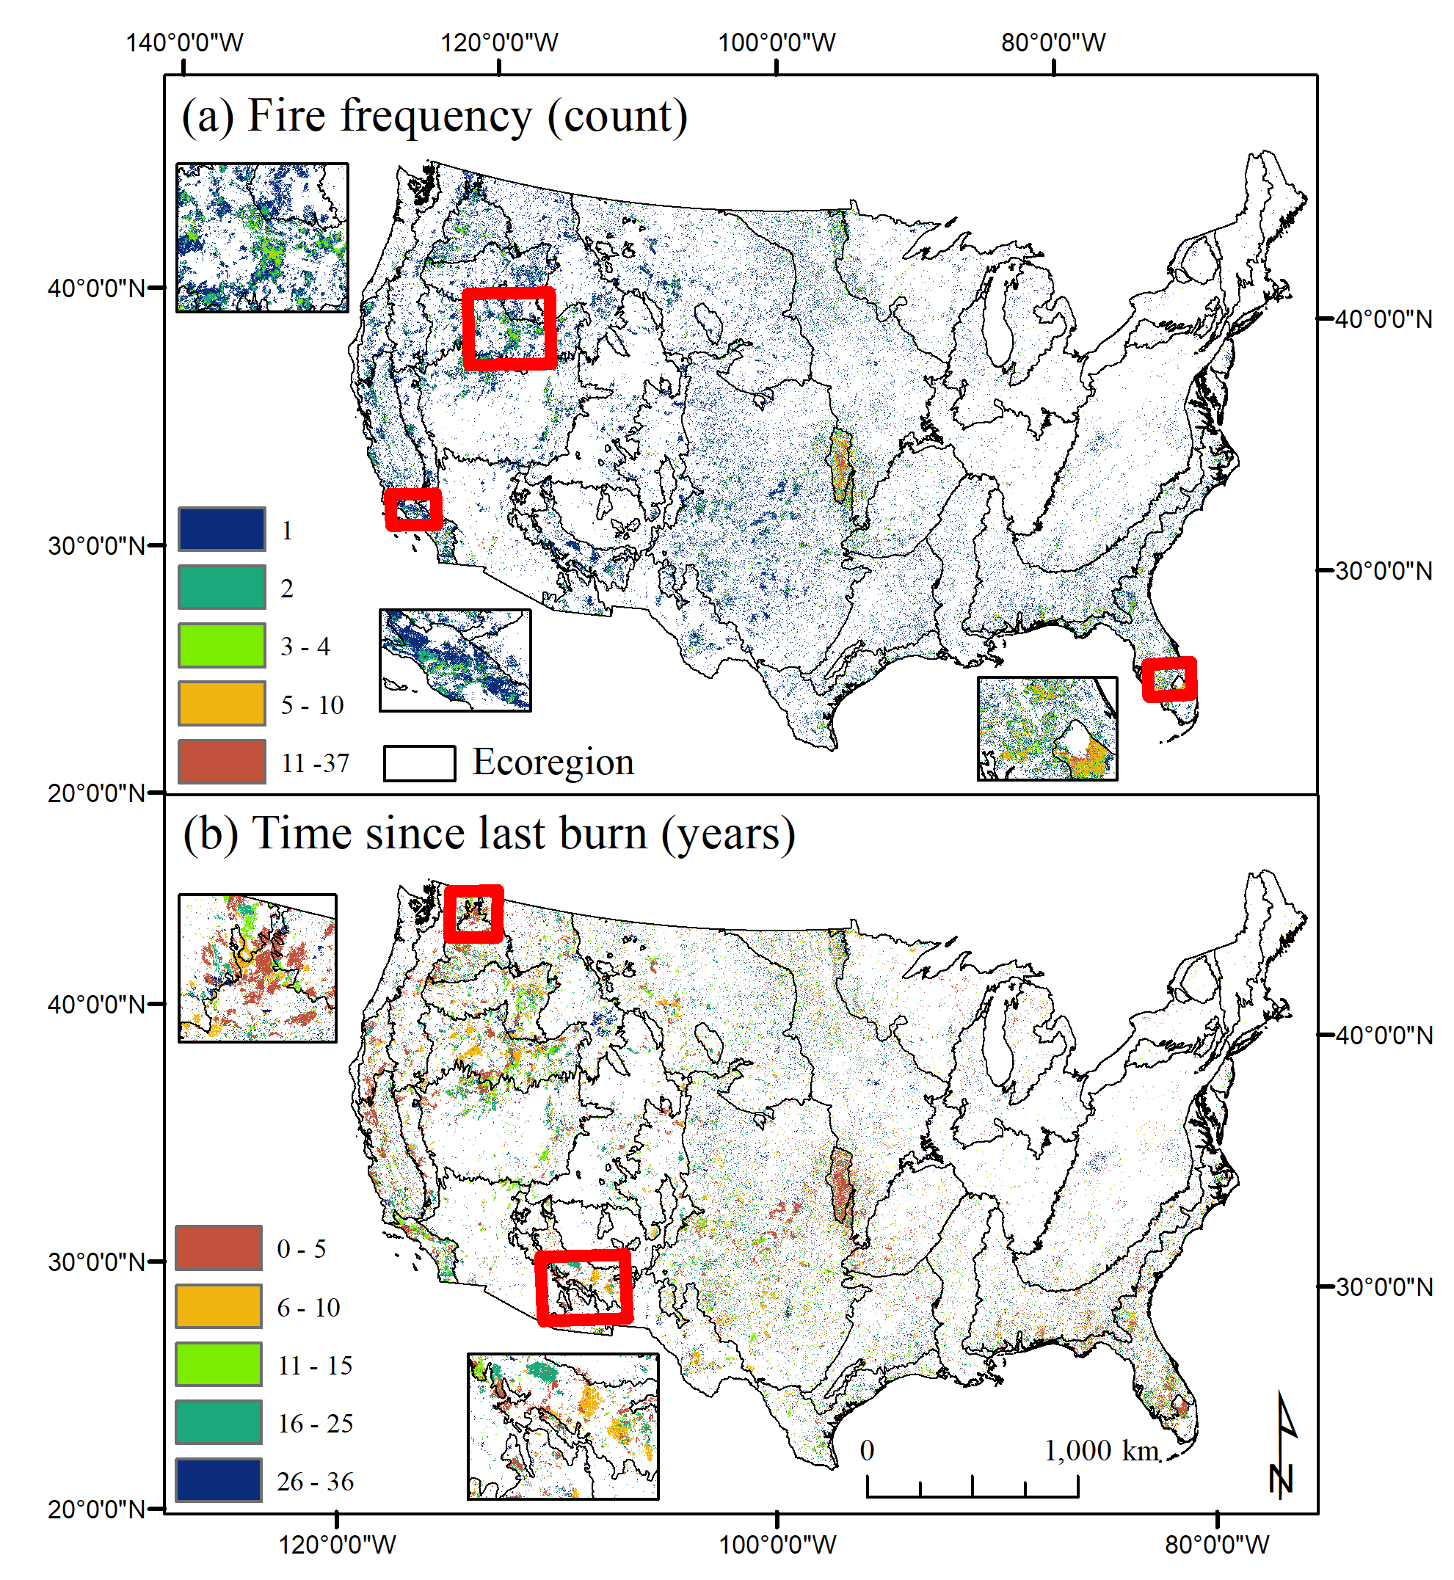
Caption for Graphic or Image: Figure. Fire history metrics calculated from the 1984-2020 burned area data including, a) fire frequency and b) time since last burn.
Author name: Melanie Vanderhoof
Author business email: mvanderhoof@usgs.gov

DOI agency/bureau2: USGS
USGS Mission Area: Ecosystems
USGS Program: Species Management Research Program
Cost Center: Wetland and Aquatic Research Center
Program Name2:
Project title: Monitoring avifauna in the offshore environment
Project description: Over two-billion birds representing some five-hundred species use Gulf of Mexico (Gulf) habitats each year. Bird abundance peaks during spring and fall migrations as the Gulf region hosts one of the greatest concentrations of birds in North America, including federally listed species such as Piping Plover (Charadrius melodus) and Red Knot (Calidris canutus). Very little information exists on the abundance and distribution of birds over the open Gulf, and collecting this data is important because of the growing interest in offshore wind energy development (WED) in the region.

Offshore WED presents a collision risk for migratory birds in the Gulf that may be exacerbated by technological advances that allow for increased size of turbine rotors. Data on bird abundance, distribution, and flight height could help reduce collision risk, which is an important consideration since bird abundance in North America has already declined by 29% over the last 50 years. Using portable radars deployed on NOAA research vessels as well as oil and gas (O&G) platforms, we will collect data on the abundance, distribution, and flight altitude of birds moving over the Gulf. Radar is one of the few remote sensing technologies capable of capturing these data both day and night. This effort would provide data that advances our understanding of how birds use the airspace over the Gulf, and would inform the siting, mitigation, and post-construction impact of WED on birds in the region.

We are deploying portable radars on NOAA research vessel(s) and five O&G platforms located within the outer continental shelf of the northwest Gulf of Mexico. Off-the-shelf radars are modified for biological applications and can gather data on animal speed, direction, range from the radar, and even wing beat rate. From these measures it is possible to estimate animal type, abundance, density, geographic distribution, height, and other behaviors. The survey area overlaps areas under consideration by the Bureau of Ocean Energy Management for offshore wind energy development.

Sensor Type: IFSAR / SAR / Radar;
Platform type: Boat; Off-shore Platforms;
URL:
Graphic or Image Upload: https://doimspp.sharepoint.com/sites/GS-EROSSCIENCESWI/Shared Documents/Apps/Microsoft Forms/DOI RS Activities Report, 2022 (2)/Graphic or Image Upload/IMG_3739_Theodore (TJ) Zenzal.JPG
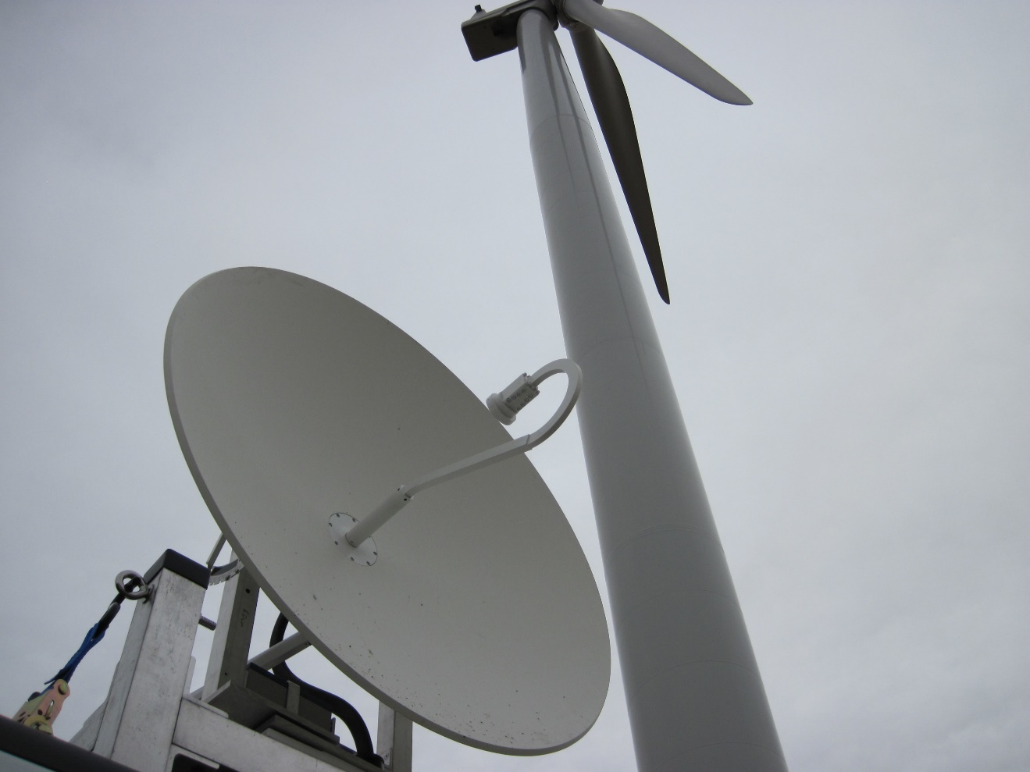
Caption for Graphic or Image: Portable radars collect high spatial and temporal information about bird movement at local scales. Photo by Robb Diehl.
Author name: T.J. Zenzal; Robb Diehl
Author business email: tzenzal@usgs.gov; rhdiehl@usgs.gov

DOI agency/bureau2: USGS
USGS Mission Area: Ecosystems
USGS Program: Species Management Research Program
Cost Center: Wetland and Aquatic Research Center
Program Name2:
Project title: Non-breeding Habitat Use of Flooded Agricultural Fields by Shorebirds
Project description: Bird populations across North America have declined substantially over the last 50 years and those found using non-breeding habitats in the southeast are no exception. The combined effects of urban development, human disturbance events, severe weather events, and global climate change have caused a reduction in non-breeding habitats suitable for birds. Conversion of natural wetlands for agriculture has depleted much of the historically widespread stopover habitat available for shorebirds in North America, which is especially true in the Lower Mississippi Alluvial Valley (MAV). With suitable non-breeding habitats at a premium, land managers and conservation planners are in critical need of tools that can help address habitat loss and increase avian population sizes. One possible solution is to flood post-harvest agricultural fields, which may provide sufficient stopover habitat for many shorebird species. An understanding of habitat use within flooded agricultural sites requires knowledge of stopover duration of birds using these artificial wetland habitats.

Capturing and banding birds to gather data on species occurrence, abundance, and energetic condition of individual birds during autumn migration is key. Having a bird in hand allows an assessment of energetic condition, determination of age, as well as the ability to attach radio transmitters. Attachment of radio tags on select species is providing remotely collected information on the movements of migratory shorebirds within flooded agricultural sites using automated radio telemetry stations. The radio telemetry receivers are on the Motus Wildlife Tracking System network (www.motus.org), which records the identity of birds flying within the antennae detection radius. Birds are tagged with very-high frequency and ultra-high frequency radio tags that produce a coded output, allowing receivers to scan only a narrow frequency band but still identify many individual birds. Data are recorded in the receiver unit attached to the antenna and downloaded at regular intervals. Migrating birds can be detected for ~10-12 km from the tower when flying, or at closer range when foraging or loafing.

Sensor Type: VHF/UHF Telemetry;
Platform type: Ground based / sensor web / web cam;
URL: https://www.usgs.gov/centers/wetland-and-aquatic-research-center/science/non-breeding-habitat-use-flooded-agricultural
Graphic or Image Upload: https://doimspp.sharepoint.com/sites/GS-EROSSCIENCESWI/Shared Documents/Apps/Microsoft Forms/DOI RS Activities Report, 2022 (2)/Graphic or Image Upload/Pectoral Sandpiper (ID# 43038) Map_Theodore (TJ) Zenzal.jpg
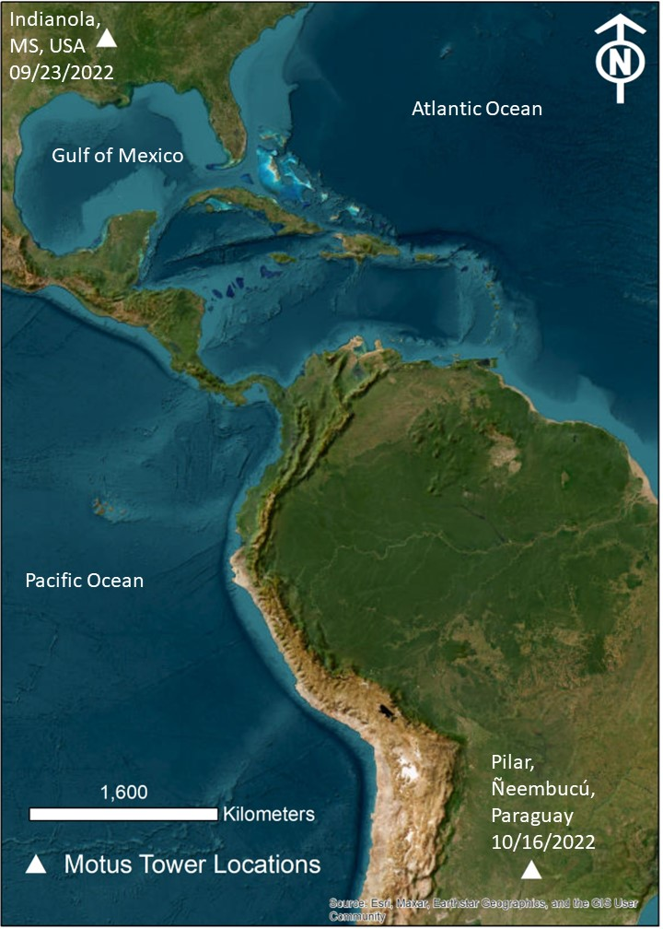
Caption for Graphic or Image: A Pectoral Sandpiper (Calidris melanotos) captured and radio tagged near Indianola, MS, USA on September 23, 2022 was detected near Pilar, Ñeembucú, Paraguay on October 16, 2022. These data suggest that this individual flew at least 7,531 km between two continents over a span of almost 24 days.
Author name: T.J. Zenzal
Author business email: tzenzal@usgs.gov

DOI agency/bureau2: USGS
USGS Mission Area: Ecosystems
USGS Program: Wildlife Program
Cost Center: Wetland and Aquatic Research Center
Program Name2:
Project title: Adapting to Climate Change: Trends and Severe Storm Responses by Migratory Landbirds and Their Habitats
Project description: Over two-thirds of all landbirds in North America migrate long distances to areas in Mexico, Central and South America, and the Caribbean islands. Habitats within Texas and Louisiana support high numbers of birds as they stop to rest and refuel during their migratory journeys through the Gulf of Mexico region. These “stopover” habitats are often at odds with human population growth and are impacted by natural disturbance and climate change. Predicted habitat loss from sea-level rise and extreme weather events, coupled with mismatches in the timing of peak bird migration with peak food abundance, may limit the availability and quality of stopover habitats. There is urgency for the conservation of areas that support migrating landbirds, many of which are already in decline across North America. Information on how birds respond at multiple scales is crucial to management partners such as U.S. Fish and Wildlife Service; U.S. Forest Service; Gulf Coast Bird Observatory; The Nature Conservancy; Louisiana Department of Wildlife and Fisheries; Texas Parks and Wildlife Department; National Audubon Society, Lower Mississippi Valley Joint Venture (JV), Oaks and Prairies JV, Gulf Coast JV; and others.

Our objective is to determine how stopover habitat use by migrating landbirds changes in response to (1) climate change, (2) land cover change, and (3) short-term weather events (i.e., tropical storms, droughts, hurricanes). We are analyzing data from 25 years of weather surveillance radar observations of birds departing stopover habitats to measure the responses of migrants to climate change. We are working to predict bird responses under various climate scenarios and produce maps to visualize where birds stopover and how their stopover distributions change across Texas and Louisiana in response to past and future habitat changes. This decision support tool will assist resource managers in addressing (1) declines of migratory bird populations linked to changes in availability of stopover habitat and (2) how climate change may impact landbird populations.

Sensor Type: IFSAR / SAR / Radar;
Platform type: Ground based / sensor web / web cam;
URL: https://www.usgs.gov/centers/wetland-and-aquatic-research-center/science/adapting-climate-change-trends-and-severe-storm
Graphic or Image Upload: https://doimspp.sharepoint.com/sites/GS-EROSSCIENCESWI/Shared Documents/Apps/Microsoft Forms/DOI RS Activities Report, 2022 (2)/Graphic or Image Upload/SC CASC Image_Theodore (TJ) Zenzal.jpg
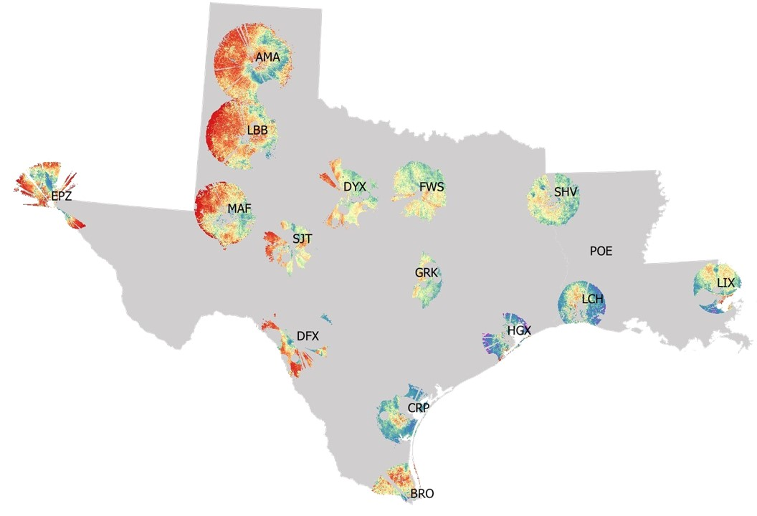
Caption for Graphic or Image: Migratory bird density across 16 Texas and Louisiana weather surveillance radars in Spring 2008. Each radar is denoted by its three-letter name. We are using these data to predict changes in bird densities across each state, providing information about how climate change, land cover change, and extreme weather events impact migrants.
Author name: T.J. Zenzal
Author business email: tzenzal@usgs.gov

DOI agency/bureau2: USGS
USGS Mission Area: Ecosystems
USGS Program: Species Management Research Program
Cost Center: Wetland and Aquatic Research Center
Program Name2:
Project title: Monitoring Impacts of U.S.-Mexico Border Barrier and Lighting on Migratory Birds
Project description: Since 1970, 2.9 billion birds have been lost across the continental U.S. and Canada. The likely primary driver behind bird declines is loss of habitat, which is critical for breeding as well as migration. Human-altered landscapes tend to fragment existing habitats into small, disjointed patches, which can reduce abundance, species richness, and nesting success of birds. Moreover, human development is typically associated with artificial light at night (ALAN), which can disrupt the natural cycles of birds as well as impact migratory behaviors. The infrastructure associated with the barrier established along the U.S.-Mexico border within the Lower Rio Grande Valley (LRGV) is a human development project that has altered habitats by 1) causing fragmentation, 2) creating a physical barrier, 3) producing ALAN, and 4) introducing vehicular traffic. While most flying animals, including migratory birds, are likely able to negotiate the physical barrier, they and other animals can be affected by impacts from fragmentation, ALAN, and vehicular traffic. Management partners within the LRGV need to understand how migratory birds are responding to the presence of the border barrier and its associated infrastructure so they can develop effective mitigation strategies for current and future barrier construction.
Our objective is to determine how barrier construction and lighting may impact migratory birds in the LRGV. We will use a multi-scale approach that addresses how such animals have responded to the border barrier within the LRGV by integrating multiple remote sensing techniques. At the largest scale, data from three weather surveillance radars that provide information at the regional scale from approximately 1995 to present are being used to conduct a before-after-control-impact study (BACI). For a landscape scale approach, we will use portable Doppler radar to strategically sample the airspace of the U.S.-Mexico border with and without a barrier and/or lights. At the finest spatial scale, we have established a network of automated telemetry and audio recording stations that will be placed in areas with and without a barrier and/or lights. All three remote sensing approaches are being conducted during spring and autumn, when birds typically migrate. The automated recording stations are also collecting data during the breeding and non-breeding seasons. Additionally, some of our remote sensing equipment may be capable of investigating how other animals, such as bats or arthropods, are responding to border infrastructure. Our results will assist partners in understanding how infrastructure and lighting along the US-Mexico border may impact wildlife so they can make decisions about future mitigation or construction.

Sensor Type: IFSAR / SAR / Radar;Sound (sonar or acoustic);Automated Radio Telemetry;
Platform type: Ground based / sensor web / web cam;
URL: https://www.usgs.gov/centers/wetland-and-aquatic-research-center/science/monitoring-impacts-us-mexico-border-barrier-and
Graphic or Image Upload: https://doimspp.sharepoint.com/sites/GS-EROSSCIENCESWI/Shared Documents/Apps/Microsoft Forms/DOI RS Activities Report, 2022 (2)/Graphic or Image Upload/Border Fence and Tower_Theodore (TJ) Zenzal.jpg
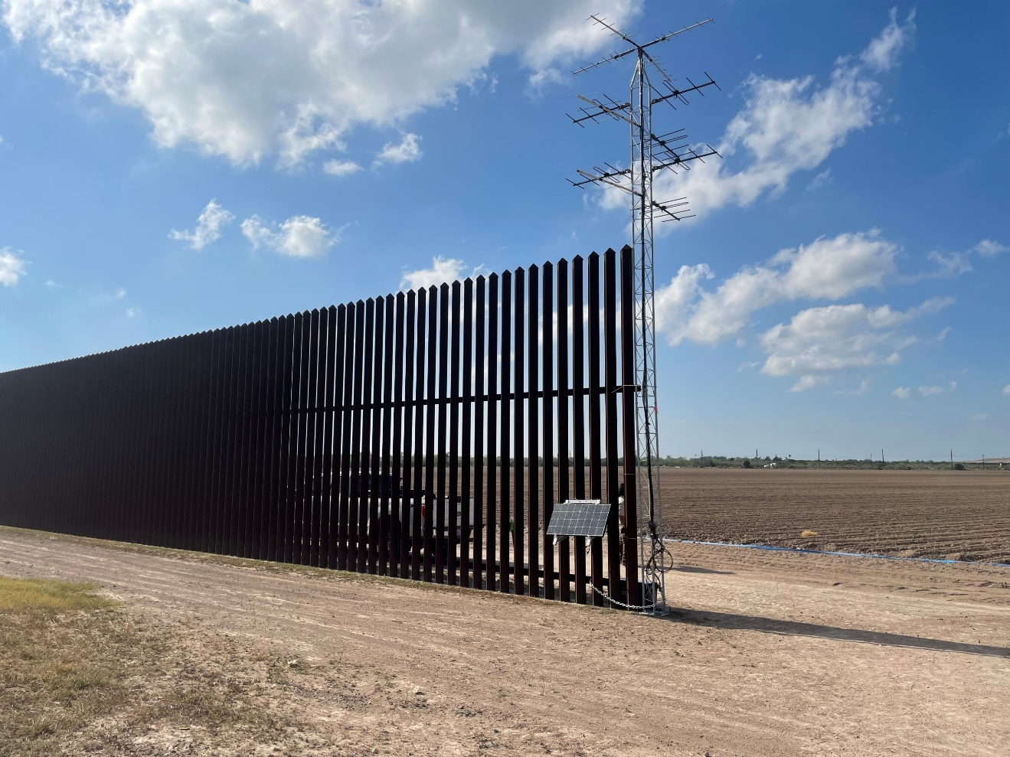
Caption for Graphic or Image: An automated radio telemetry tower used to monitor wildlife along the US-Mexico border within the Lower Rio Grande Valley, Texas. Photo by T.J. Zenzal.
Author name: T.J. Zenzal
Author business email: tzenzal@usgs.gov

DOI agency/bureau2: USGS
USGS Mission Area: Core Science Systems
USGS Program: Land Change Science
Cost Center: Earth Resources Observation and Science (EROS) Center (Geography)
Program Name2:
Project title: Exotic annual grass abundance and weather scenarios
Project description: Invasion of exotic annual grass (EAG), such as cheatgrass (Bromus tectorum) and medusahead (Taeniatherum caput-medusae), can cause irreversible change to dry and semi-dry rangeland ecosystems in the western United States. The abundance of these EAG species is influenced by weather variables such as temperature and precipitation, yet there exists no published spatially explicit EAG distribution and abundance maps driven by multiple precipitation scenarios. Scientists from the USGS Earth Resources Observation and Science (EROS) Center, using harmonized Landsat/Sentinel (HLS) remotely sensed data, developed a machine-learning modelling approach to predict how changes in annual and immediate past precipitation regimes impact the abundance of EAG. The predictive model utilized HLS-derived normalized difference vegetation index data (NDVI) as proxy for vegetation greenness, weather variables, elevation, and estimated EAG percent cover from previous years as proxy for seed source to make the predictions. The model achieved excellent training accuracy (r= 0.94; median absolute error=2.83 percent cover) and test accuracy (r= 0.80; MdAE=6.05 percent cover). Applying the model algorithm to spatial versions of the input variables, we predicted five versions of EAG abundance for 2022 (Figure 1) based on five different precipitation scenarios, i.e., a 9-year average (ppt_1.0), half the average (ppt_0.5), three fourths the average (ppt_0.75), one and one half the average (ppt_1.5), and double the average (ppt_2.0). The approach can be replicated to new study domains, and it is relatively easy to implement the model algorithms with different sets of precipitation and temperature scenarios. Spatially explicit datasets of these five versions of EAG abundance can be important resources to local and regional land managers when they are looking to understand what EAG abundance might be based on variable precipitation scenarios. The datasets are now available for download via the USGS Rangeland Exotic Plant Monitoring System on ScienceBase (Last accessed on 8/18/2023).

Data release: https://doi.org/10.5066/P9X84TAN
Publication: https://doi.org/10.1016/j.rama.2023.04.01

Sensor Type: Multispectral (approx. 4-12 bands);
Platform type: Satellite;
URL: https://doi.org/10.5066/P9X84TAN
Graphic or Image Upload: https://doimspp.sharepoint.com/sites/GS-EROSSCIENCESWI/Shared Documents/Apps/Microsoft Forms/DOI RS Activities Report, 2022 (2)/Graphic or Image Upload/BoyteEROS_EAG_Stephen Boyte.png
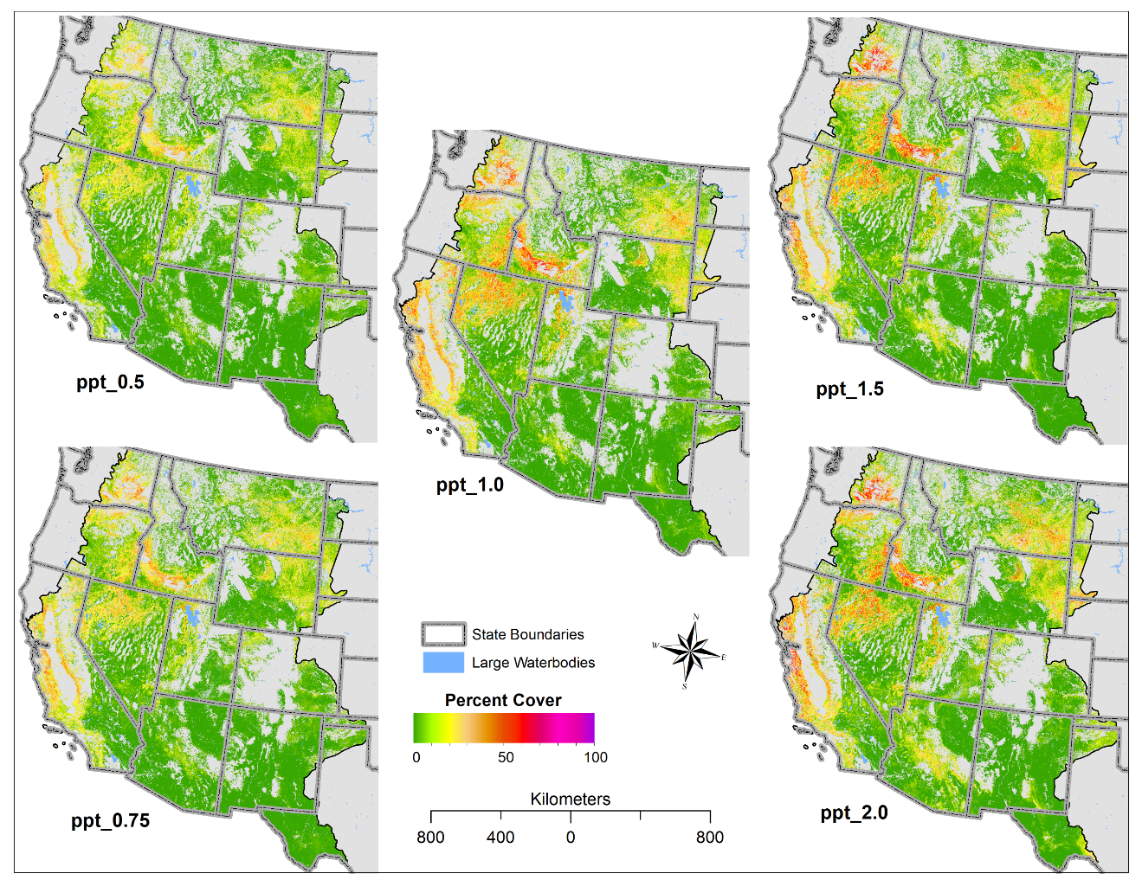
Caption for Graphic or Image: Figure 1. Predicted exotic annual grass abundance maps for 2022 at 30-m spatial resolution developed with multiple precipitation scenarios. The ppt_1.0 (normal) is the average of 9 yrs’ (2012–2021) precipitation, ppt_0.5 (one half), ppt_0.75 (three-fourths), ppt_1.5 (one and one-half), and ppt_2.0 (two times) of normal.
Author name: Stephen Boyte and Devendra Dahal
Author business email: sboyte@usgs.gov; ddahal@contractor.usgs.gov

DOI agency/bureau2: USGS
USGS Mission Area: Core Science Systems
USGS Program: National Land Imaging Program
Cost Center: Earth Resources Observation and Science (EROS) Center (Geography)
Program Name2:
Project title: Landsat Collection 2 Provisional Science Products
Project description: In 2022, Landsat Collection 2 (C2) Provisional Aquatic Reflectance and C2 Provisional Actual Evapotranspiration science products became available on-demand from the USGS. While these products are in provisional states, they are proving to be useful in the advancement of water quality studies and the effects of evaporation/transpiration in cropland areas.

Aquatic Reflectance (AR) is the spectral distribution of reflected visible solar radiation upwelling from beneath water surfaces and is the primary input for characterizing optically active constituents within upper water columns.

Global Landsat C2 Provisional AR products are derived from the Sea-WiFS Data Analysis System (SeaDAS) using the Landsat 8-9 Operational Land Imager (OLI) Level-1 (L1) reflective bands at 30-meter (m) resolution.

Landsat C2 Provisional AR shows potential to greatly contribute to aquatic science and environmental mapping capabilities for aquatic ecosystems. Water resource managers and remote sensing scientists can use this product to systematically monitor the changes in water quality of lakes, rivers and near-shore coastal zones that are otherwise difficult to access by conventional field sampling methods.

Actual Evapotranspiration (ETa) is the quantity of water removed from a surface due to evaporation and transpiration and is measured in millimeters (mm). Global Landsat C2 Provisional ETa 30-m products are generated using an Operational Simplified Surface Energy Balance (SSEBop) model for Landsat 4-5 Thematic Mapper, Landsat 7 Enhanced Thematic Mapper Plus, and Landsat 8-9 OLI/Thermal Infrared Sensor acquisitions that successfully process to a Level-2 Surface Temperature product.

ETa is fundamental in the understanding of spatiotemporal dynamics of water use around the world, providing useful information for a range of applications such as calculating a basin’s water budget and assessment of water consumption and crop yield and drought monitoring.

Note: Landsat C2 AR and ETa products are considered provisional and are subject to revision. The data have not received final approval by the USGS and are provided on the condition that neither the USGS nor the U.S. Government shall be held liable for any damages resulting from the authorized or unauthorized use of the data.

Sensor Type: Multispectral (approx. 4-12 bands);
Platform type: Satellite;
URL: https://www.usgs.gov/landsat-missions/landsat-science-products
Graphic or Image Upload: https://doimspp.sharepoint.com/sites/GS-EROSSCIENCESWI/Shared Documents/Apps/Microsoft Forms/DOI RS Activities Report, 2022 (2)/Graphic or Image Upload/C2 AR example_Linda (Contractor) O.JPG
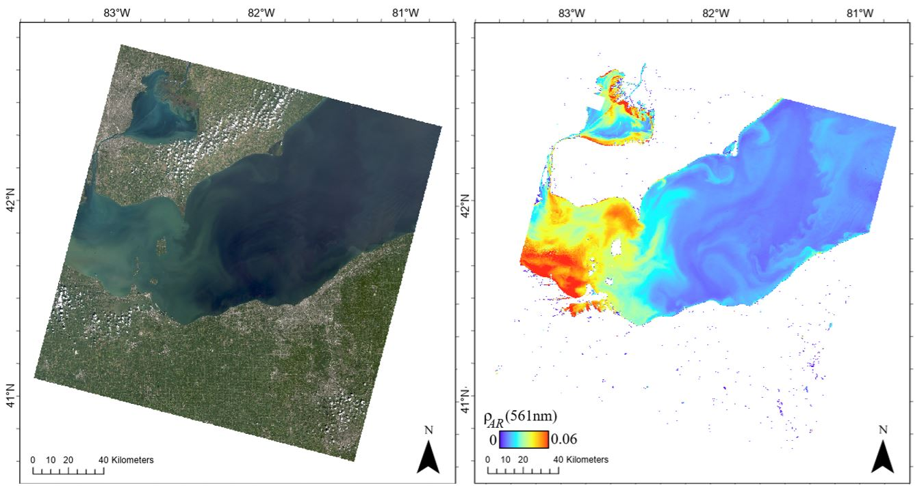
Graphic or Image Upload: https://doimspp.sharepoint.com/sites/GS-EROSSCIENCESWI/Shared Documents/Apps/Microsoft Forms/DOI RS Activities Report, 2022 (2)/Graphic or Image Upload/C2 ETa example_Linda (Contractor) O.JPG
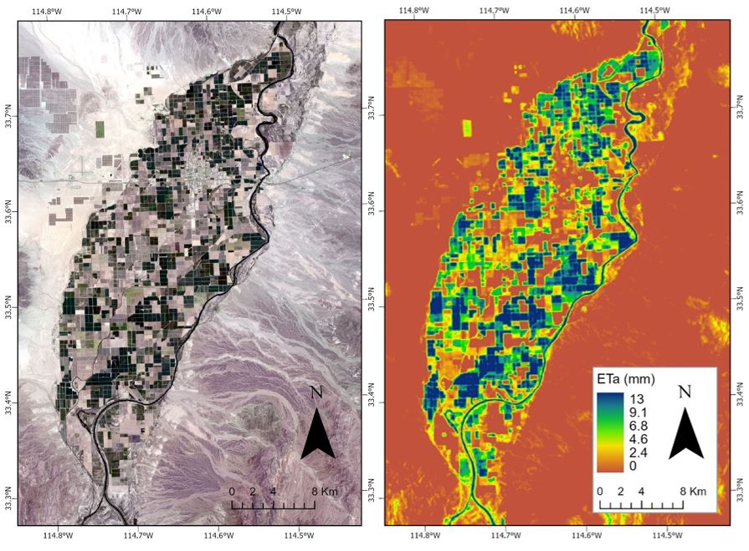
Caption for Graphic or Image: C2 AR caption:
A Landsat 9 natural color composite image (Bands 4,3,2) (left) and the corresponding Landsat Provisional Aquatic Reflectance product (right) display the properties of a massive algal bloom across the surface waters of Lake Erie on September 9, 2022.

C2 ETa caption:
A Landsat 9 natural color composite image (Bands 4,3,2) acquired June 29, 2023 (left) and the corresponding Landsat Actual Evapotranspiration product (right), display the properties of agricultural fields of Palo Verde Irrigation District, California.
Author name: Linda Owen
Author business email: lowen@contractor.usgs.gov

DOI agency/bureau2: USGS
USGS Mission Area: Natural Hazards
USGS Program: Coastal/Marine Hazards and Resources Program
Cost Center: St. Petersburg Coastal and Marine Science Center
Program Name2:
Project title: Landscape-Scale Coastal Evolution Derived from Landsat Satellite Imagery
Project description: Understanding how coasts evolve over 10-100 years is critical for predicting future landscape change. However, there are gaps in existing knowledge of how whole systems behave at these time scales. This is partly due to incomplete historical records but also results from observational bias – until recently, studies commonly focused on sandy beaches without considering their interactions with other coastal environments. Landsat satellite imagery provides a consistent, long-term, high temporal resolution multispectral data source that can be used to quantify landscape-scale coastal changes such as land cover, shoreline position, sand-vegetation boundaries, and barrier-island migration over years to decades.

The USGS St. Petersburg Coastal and Marine Science Center (SPCMSC) Coastal Sediment Availability and Flux (CSAF) project uses Landsat-derived information, in combination with sedimentologic, topo-bathymetric, and geophysical data, to better understand the timing and controls on morphologic evolution of coastal systems and estimate sediment exchanges between coastal environments. For example, using Landsat imagery acquired between 1984 and 2019, Bernier and others (2021) observed alongshore variability in decadal-scale island-area and land-cover changes at the Chandeleur Islands, Louisiana that were related to storm¬ impacts and post-storm recovery cycles. This study also demonstrated that the Chandeleur Islands are transitioning from islands with extensive marshes to islands that are increasingly dominated by mostly sandy intertidal environments. These changes will likely cause the Chandeleur Islands to be more vulnerable to changes induced by future storms and sea-level rise.

After Hurricane Ida made landfall as a Category 4 storm near Port Fourchon, Louisiana, on August 29, 2021, SPCMSC received DOI Supplemental Appropriations for Disaster Recovery Activities for FY22-FY24 to quantify storm impacts and changes in coastal resilience in Louisiana. As part of this effort, CSAF scientists are (a) updating analyses at the Chandeleur Islands to quantify changes that have occurred since 2019 and (b) building on these methods to assess regional-scale changes caused by Hurricanes Laura, Delta, Zeta (2020), and Ida (2021) along the Louisiana coastline. In FY23-FY24, CSAF is using similar approaches to quantify historical and event-scale coastal changes for ongoing and new studies from Delaware Bay, New Jersey, to Long Island, New York, and at Wallops Island, Virginia.

Associated manuscript: https://doi.org/10.3390/rs13183779
Sensor Type: Multispectral (approx. 4-12 bands);
Platform type: Satellite;
URL: https://www.usgs.gov/csaf
Graphic or Image Upload: https://doimspp.sharepoint.com/sites/GS-EROSSCIENCESWI/Shared Documents/Apps/Microsoft Forms/DOI RS Activities Report, 2022 (2)/Graphic or Image Upload/Bernier_DOI RS Report FY23_fig1_Meaghan Emory.jpg
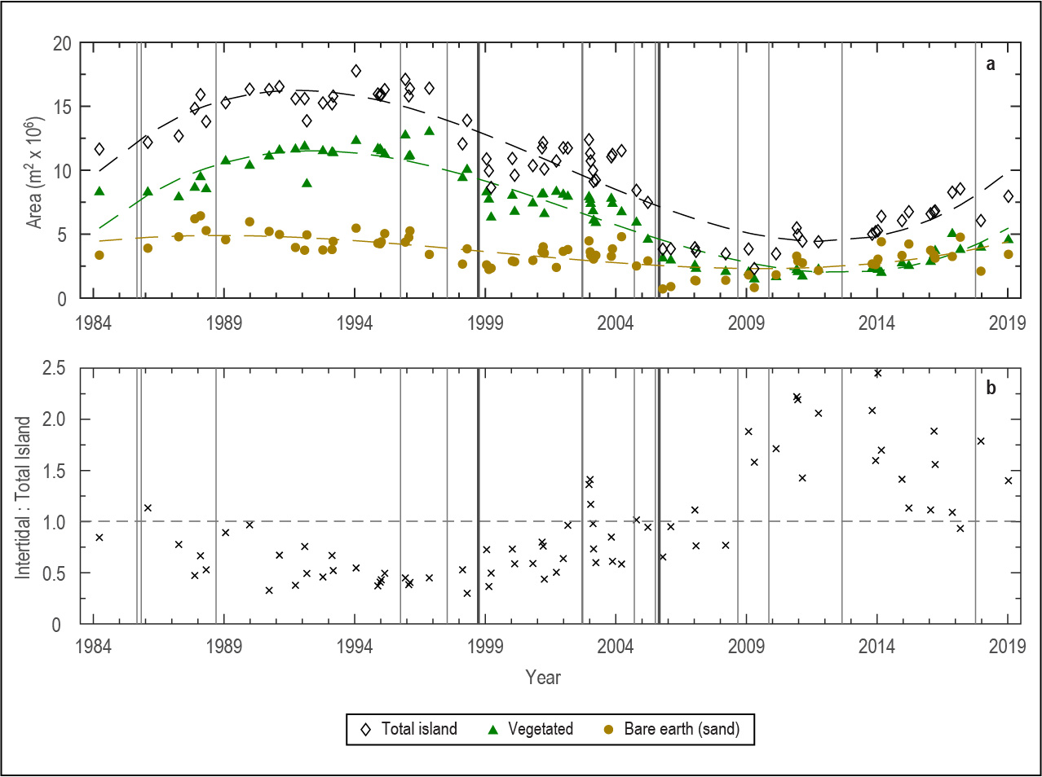
Caption for Graphic or Image: Plots showing changes in (a) land-cover area and (b) the ratio of intertidal to total island (sand plus vegetation) extents over time at the northern Chandeleur Islands, Louisiana. The timing of tropical cyclones that passed within 200 km of the study area are indicated by gray vertical lines. Significant decreases in sand, vegetation, and total island areas were observed after Hurricanes Georges (28-September-1998) and Katrina (29-August-2005) (black vertical lines); long-term changes show somewhat cyclical trends, indicated by dashed lines in (a), that can be related to storm–recovery cycles. After 2010, the barrier platform was dominated by intertidal areas, indicated by values in (b) that are greater than 1 (horizontal dashed line).
Author name: Julie Bernier
Author business email: jbernier@usgs.gov

DOI agency/bureau2: USGS
USGS Mission Area: Water Resources
USGS Program: Groundwater and Streamflow Information Program
Cost Center: **unspecified**
Program Name2:
Project title: Toolbox for River Velocimetry using Images from Aircraft (TRiVIA)
Project description: As part of the USGS’ Next Generation Water Observing Program, we developed a new software package for mapping surface flow velocities in river channels from various types of remotely sensed data. The Toolbox for River Velocimetry using Images from Aircraft (TRiVIA) is a standalone, user-friendly implementation of a Particle Image Velocimetry (PIV)-based workflow described in a paper currently in press (https://doi.org/10.1002/rra.4147). TRiVIA has been approved and is freely available to download as an official USGS Scientific Software product (https://code.usgs.gov/wma/osd/trivia). Knowing the speed of the water flowing through a river is important for understanding geomorphic and ecohydraulic processes and can help to inform resource management. Measuring velocities via remote sensing is often safer and more efficient than conventional field methods, and decades of research have led to powerful algorithms for deriving spatially distributed velocity fields from videos or image time series. Building upon this foundation, we developed a dedicated software tool for particle image velocimetry (PIV) that is intended to facilitate greater use of this approach within the river community. TRiVIA is a standalone app designed for use with data acquired from nadir-viewing platforms like airplanes, helicopters, or drones. The program provides a complete workflow for producing spatially distributed velocity vectors from a video or sequence of images, all within an accessible graphical user interface. TRiVIA includes modules for extracting and resampling frames, stabilizing and geo-referencing images, defining a region of interest, enhancing images, performing PIV with an efficient ensemble correlation algorithm, visualizing results, assessing accuracy, and exporting PIV output. A tutorial accompanying the TRiVIA distribution illustrates the software's capabilities using an example data set from a large river in Alaska. Future work will focus on augmenting TRiVIA to incorporate the bathymetric information needed to enable calculation of discharge.
Sensor Type: Camera;Thermal;Video;
Platform type: Airplane;UAS;Helicopter;
URL: https://doi.org/10.1002/rra.4147, https://code.usgs.gov/wma/osd/trivia
Graphic or Image Upload: https://doimspp.sharepoint.com/sites/GS-EROSSCIENCESWI/Shared Documents/Apps/Microsoft Forms/DOI RS Activities Report, 2022 (2)/Graphic or Image Upload/Fig2_TRiVIAscreenshot_Carl Legleiter.jpg
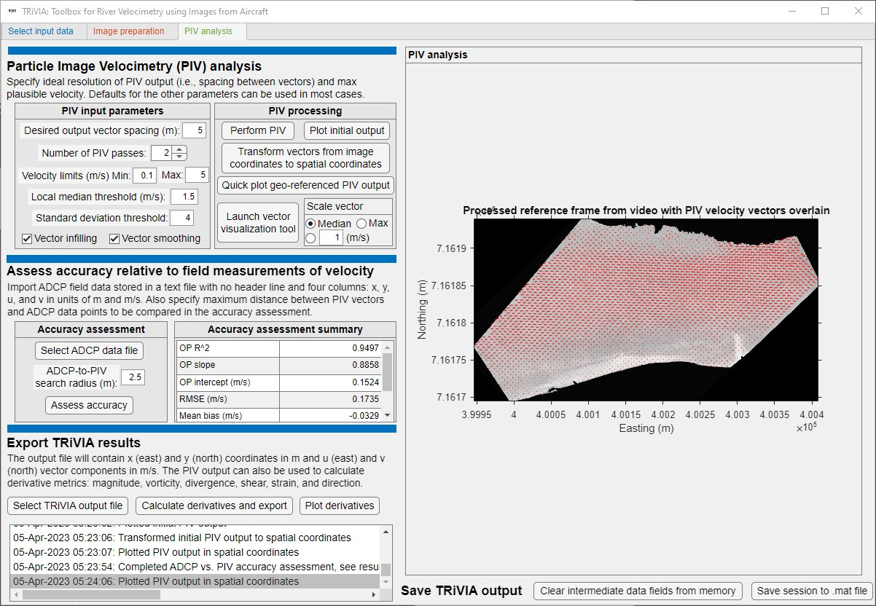
Caption for Graphic or Image: The main Particle Image Velocimetry (PIV) Analysis tab of the graphical user interface for the Toolbox for River Velocimetry using Images from Aircraft (TRiVIA), including a map of velocity vectors overlain on an image from the Tanana River in Alaska. This site is used as an example in a tutorial that provides guidance on how to use the software.
Author name: Carl J. Legleiter
Author business email: cjl@usgs.gov

DOI agency/bureau2: USGS
USGS Mission Area: Core Science Systems
USGS Program: National Land Imaging Program
Cost Center: Geosciences and Environmental Change Science Center
Program Name2:
Project title: UAS Remote Sensing for Carbon Sequestration Research on Public Lands
Project description: USGS Southwest Biological Science Center research ecologist Dr. Sasha Reed and her collaborators are studying ways to quantify and manage carbon sequestration across drylands. Although satellites offer global remote sensing coverage and a long-term data record, estimates of aboveground biomass and plant productivity via spectral indices are known to under-perform in drylands. The Bureau of Land Management (BLM) measures field-based aboveground biomass at Assessment, Inventory, and Monitoring (AIM) sites spread across public lands in the west. However, BLM AIM plots require intensive sampling and offer finite observations over large areas. The National Ecological Observatory Network (NEON) has a long-term monitoring site located on high-desert BLM land 40 kilometers south of Moab, Utah. In addition to collecting meteorological, soil, and vegetation observations, NEON collects and delivers freely available airborne remote sensing data at this site on a semi-annual basis. NEON’s airborne system collects lidar, spectrometer and high-resolution RGB camera data.

Uncrewed aircraft systems (UAS), also known as drones, provide a high spatial resolution (2-4cm) perspective that can help connect field measurements to airborne and satellite observations. In May 2023, the USGS National Uncrewed Systems Office (NUSO) coordinated with BLM and NEON to collect field, UAS, and airborne data at the NEON Moab site. NEON collected airborne data at a flight altitude of 1000 meters above ground level (AGL) on April 28. During the following week, USGS NUSO collected UAS natural color, multispectral, hyperspectral, and lidar data at flight altitudes of 15 to 31 meters over two BLM AIM plots that were imaged by the NEON's airborne platform. BLM AIM teams collected field-based measurements of vegetation and soil at these two sites. USGS researchers will link these data sets to inform carbon storage questions on public lands.
Sensor Type: Camera;Hyperspectral;Lidar (terrestrial or bathymetric);Multispectral (approx. 4-12 bands);
Platform type: UAS;
URL: https://uas.usgs.gov/nupo/missions-2023.shtml#MoabC
Graphic or Image Upload: https://doimspp.sharepoint.com/sites/GS-EROSSCIENCESWI/Shared Documents/Apps/Microsoft Forms/DOI RS Activities Report, 2022 (2)/Graphic or Image Upload/2023-05 Moab UT - USGS UAS pilot flying drone_Victoria Scholl.jpg
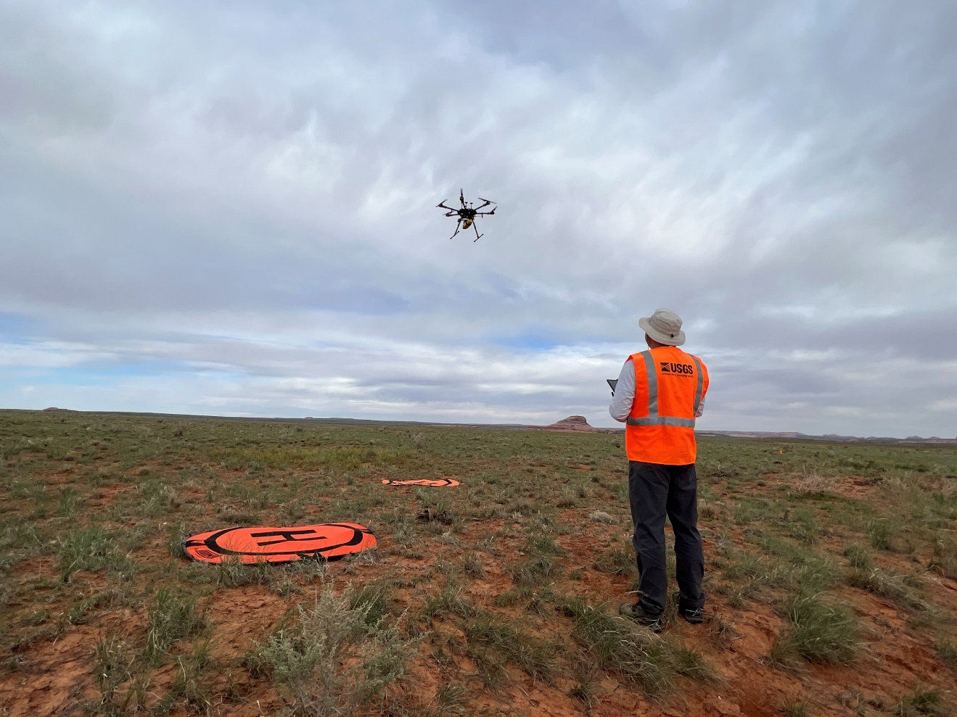
Caption for Graphic or Image: USGS UAS pilot flies lidar sensor over dryland study site near Moab, Utah.
Author name: Victoria M Scholl
Author business email: vscholl@usgs.gov

DOI agency/bureau2: USGS
USGS Mission Area: Core Science Systems
USGS Program: Land Change Science
Cost Center: Earth Resources Observation and Science (EROS) Center (Geography)
Program Name2:
Project title: Irrigation Water Consumption in the High Plains
Project description: Quantification of irrigation water use provide important scientific information for water resources management and conservation. Traditionally, irrigation water use data are collected, compiled, and aggregated at levels of water-right, township, county, hydrological basin, and irrigation district by government agencies, mainly based on reported data and surveys received from water users or water-right holders, along with indirect approaches such as statistical sampling. However, challenges with collecting and compiling water use data include errors from reports and surveys, inconsistent measurements and methods across regions, temporal measurement gaps, and time- and cost-consuming data processes. Alternatively, spatially explicit estimation of irrigation water consumption can be conducted efficiently using satellite-based evapotranspiration (ET) modeling.

In this study, we created blue-water (irrigation) ET data at 250 m resolution to estimate long-term (1986 – 2021) water consumption in the croplands across the High Plains. The blue-water ET was created by integrating an energy balance ET model (Operational Simplified Surface Energy Balance) and a water balance ET model (VegET) with inputs from a suite of satellite (Landsat and Moderate Resolution Imaging Spectroradiometer), climate, and ancillary geospatial datasets. Because the energy balance ET accounts for total actual ET from all different water sources and the water balance ET accounts for green-water (precipitation) ET from soil moisture and precipitation, the difference between the two ET resources constitutes blue-water ET coming from surface water and groundwater, which are primarily attributed to irrigation. Thus, blue-water ET is considered as a surrogate of irrigation water consumption by crops in this approach.

We compared the blue-water ET with the U.S. Geological Survey’s National Water Use data and the Kansas’s Water Information Management and Analysis System data for all counties across the High Plains aquifer region and found significant correlations between the growing season blue-water ET and the annual irrigation water withdrawals. We created long-term blue-water ET timeseries maps for the plains, which agreed closely with the irrigation water withdrawals at county and region scales. Our study demonstrates the capability of using blue-water ET to estimate crop irrigation water consumption and evaluate existing water use data compiled using reported and surveys. The blue-water ET technique illustrates a valuable potential for effective estimation of irrigation water use, with advantages of high spatial resolution, temporal continuity, inter-regional consistency, and time- and cost-efficiency, which will be beneficial for the management of irrigation agriculture and sustainable water resources.
Sensor Type: Thermal;Multispectral (approx. 4-12 bands);
Platform type: Satellite;
URL: https://www.nature.com/articles/s41598-017-06359-w
Graphic or Image Upload: https://doimspp.sharepoint.com/sites/GS-EROSSCIENCESWI/Shared Documents/Apps/Microsoft Forms/DOI RS Activities Report, 2022 (2)/Graphic or Image Upload/doi_highight_map_Gabriel Senay.jpg
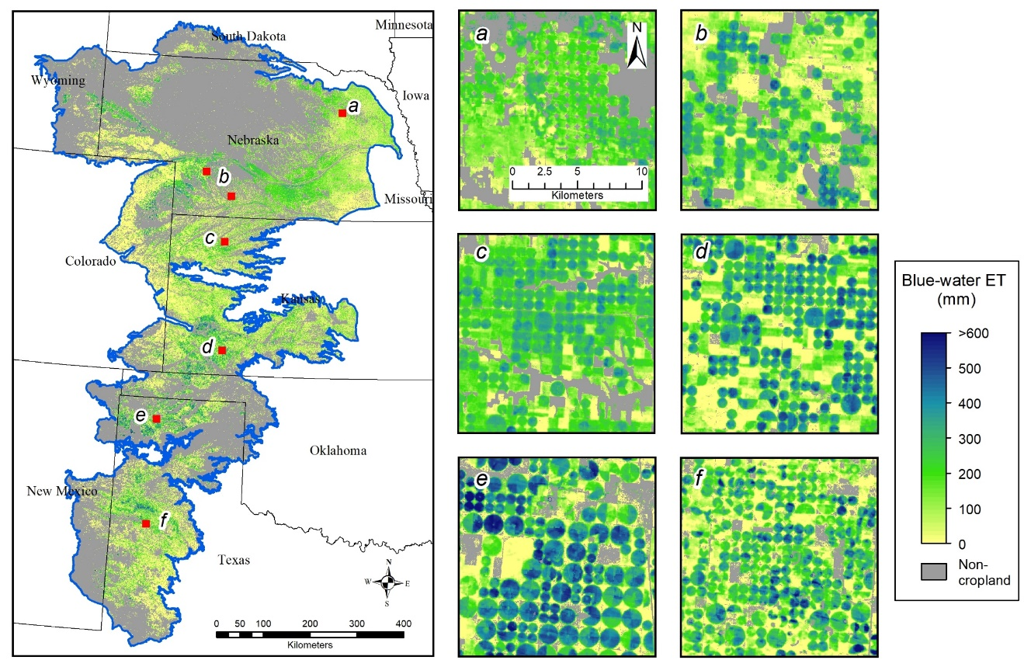
Caption for Graphic or Image: Map of seasonal (May to September total) blue-water ET estimates in 2020 for the High Plains aquifer region. The red squares (labeled as a – f) indicate the locations of the six map subsets with close-up views of blue-water ET in the irrigated croplands.
Author name: Gabriel Senay
Author business email: senay@usgs.gov

DOI agency/bureau2: USGS
USGS Mission Area: Core Science Systems
USGS Program: Land Change Science
Cost Center: Earth Resources Observation and Science (EROS) Center (Geography)
Program Name2:
Project title: Effect of Land Cover Change on Design Peak Flow
Project description: Urbanization increases food risks by increasing the amount and rate of water flow above the earth’s surface, potentially causing devastating effects on lives and livelihoods worldwide. Physical structures such as culverts and storm pipes are widely used in urban areas to remove excess water and minimize flood hazards. Construction of such flood control structures requires the knowledge of design peak flow, i.e., the maximum surface-water flow from a precipitation event (for example, maximum surface-water flow from a 100-year recurrence interval precipitation event). The efficient tools for monitoring the drivers of floods, such as urbanization, and identifying the areas that are more susceptible to floods could help urban planners and local-scale decision makers for efficient resource utilization and building scenarios for the potential future flood risks.

This study investigated the effect of urban developments on the design peak flow of urban watersheds across the conterminous United States (CONUS) and developed a web-based application to visualize the potential changes in the design peak flow from 1985 to 2020. The Rational Method, which requires three main parameters including runoff coefficient, precipitation intensity, and contributing area was applied to compute the design peak flow of 3,535 urban areas (based on the U.S. Census Bureau data for 2019) in the CONUS. The runoff coefficients were computed from the Landsat-derived 30-m resolution land cover data from the U.S. Geological Survey Land Change Monitoring, Assessment, and Projection (LCMAP) program. Precipitation intensity data were acquired from the National Oceanic and Atmospheric Administration (NOAA) and urban area boundaries from the U.S. Census Bureau. The results indicate that about 80% (2,840 out of 3,535) of the total urban areas showed a potential increase in design peak flow, and about 19% (654 out of 3,535) showed a potential decrease in design peak flow in 2020 compared to 1985. The potential maximum increase in design peak flow in urban areas was up to 127%. In general, the design peak flow increased during 1985-2010 and decreased during 2010-2020, primarily driven by respective increasing (decreasing) and decreasing (increasing) in urban (cropland) land cover percentages.
Sensor Type: Multispectral (approx. 4-12 bands);
Platform type: Satellite;
URL: https://doi.org/10.34133/remotesensing.0037
Graphic or Image Upload: https://doimspp.sharepoint.com/sites/GS-EROSSCIENCESWI/Shared Documents/Apps/Microsoft Forms/DOI RS Activities Report, 2022 (2)/Graphic or Image Upload/Washington_v2_Gabriel Senay.jpg
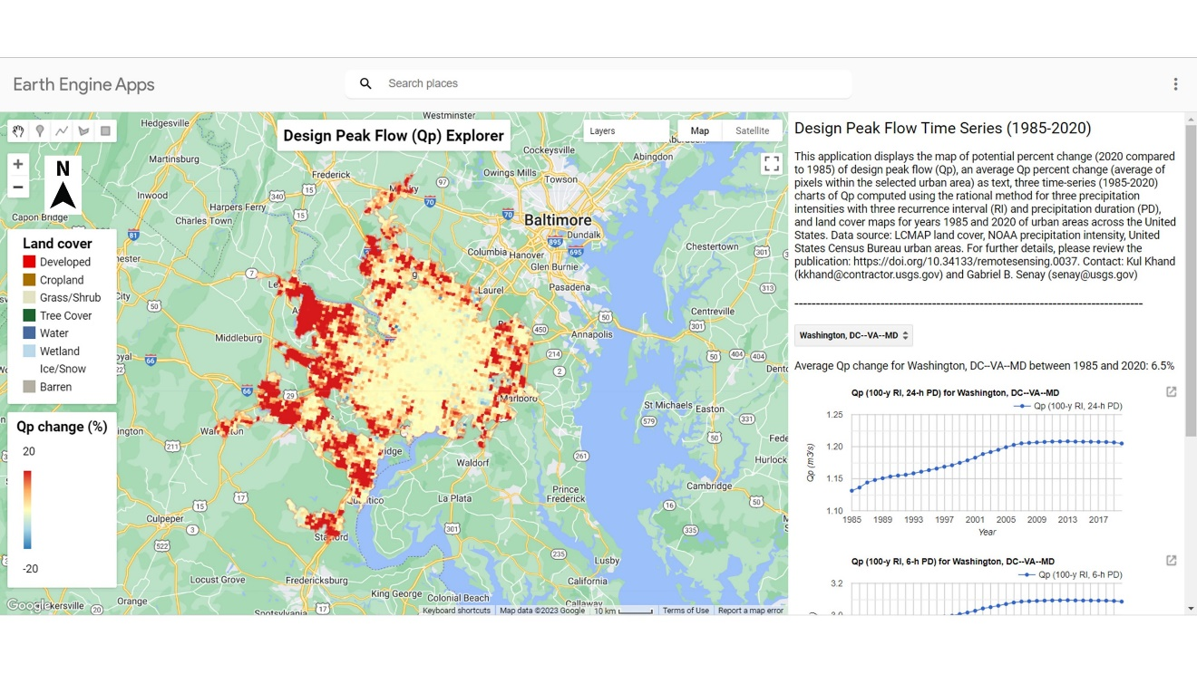
Caption for Graphic or Image: The spatial and temporal changes in design peak flow (Qp) of Washington (DC, VA, MD) urban area between 1985 and 2020.
Author name: Gabriel Senay
Author business email: senay@usgs.gov

DOI agency/bureau2: USGS
USGS Mission Area: Core Science Systems
USGS Program: Land Change Science
Cost Center: Earth Resources Observation and Science (EROS) Center (Geography)
Program Name2:
Project title: Global Operational Actual Evapotranspiration
Project description: Actual evapotranspiration (ETa) is a key landscape response variable that connects the soil-plant-atmosphere system and the hydrologic cycle through the transfer of mass and energy. ETa quantification and mapping over large areas has become an active applied research activity in recent years with the use of satellite-derived inputs and global weather datasets. In addition to improving our understanding of the water budget, ETa is an important indicator of crop water use and crop production. As a landscape response variable, it provides crucial information for monitoring and assessing the extent and severity of drought in both rainfed and irrigated systems at fine spatial resolution.

One of the models widely used for operational global ETa research and application is the Operational Simplified Surface Energy Balance (SSEBop) model. The SSEBop model by Senay et al. (2013, 2023) integrates parametric and surface energy balance modeling techniques for estimating actual ET based on the principles of satellite psychrometry (Senay, 2018). The global implementation of the SSEBop model uses thermal data from multiple satellite sensors (Landsat, Moderate Resolution Imaging Spectroradiometer (MODIS), and the Visible Infrared Imaging Radiometer Suite (VIIRS)) in combination with gridded global weather datasets.

In April 2023, scientists at the USGS Earth Resources Observation and Science (EROS) Center released the most up-to-date global SSEBop ETa model (version 6) which uses the VIIRS data to produce dekadal, monthly, and seasonal ETa and ETa anomaly products. The 1-km spatial resolution data are available from February 2012 to present and can be accessed at https://earlywarning.usgs.gov/fews or https://doi.org/10.5066/P9QJWQ6K. SSEBop V6 (Senay et al., 2023) builds on SSEBop v5 (Senay et al., 2020) that was based on the Aqua MODIS sensor which was discontinued in May 2022 due to poor data quality. It is parameterized using the novel Forcing And Normalizing Operation (FANO) algorithm to establish the wet-bulb boundary condition, allowing to robustly model the spatiotemporal dynamics of ETa in all landscapes and all seasons regardless of vegetation cover density. In addition, ETa anomaly products are created as a ratio (in percent) of “current” to median year ETa (2013-2022) and useful for region-specific drought monitoring applications.

The USGS EROS Center develops these operational global ET products for the Famine Early Warning Systems Network (FEWS NET) for project activities supporting food security mapping, drought monitoring, and water resources assessments. SSEBop v6 data is also freely available for access at the ClimateEngine.org web mapping application.

Sensor Type: Thermal;Multispectral (approx. 4-12 bands);
Platform type: Satellite;
URL: https://www.mdpi.com/2072-4292/15/1/260
Graphic or Image Upload: https://doimspp.sharepoint.com/sites/GS-EROSSCIENCESWI/Shared Documents/Apps/Microsoft Forms/DOI RS Activities Report, 2022 (2)/Graphic or Image Upload/ETa_graphic_Gabriel Senay.jpg
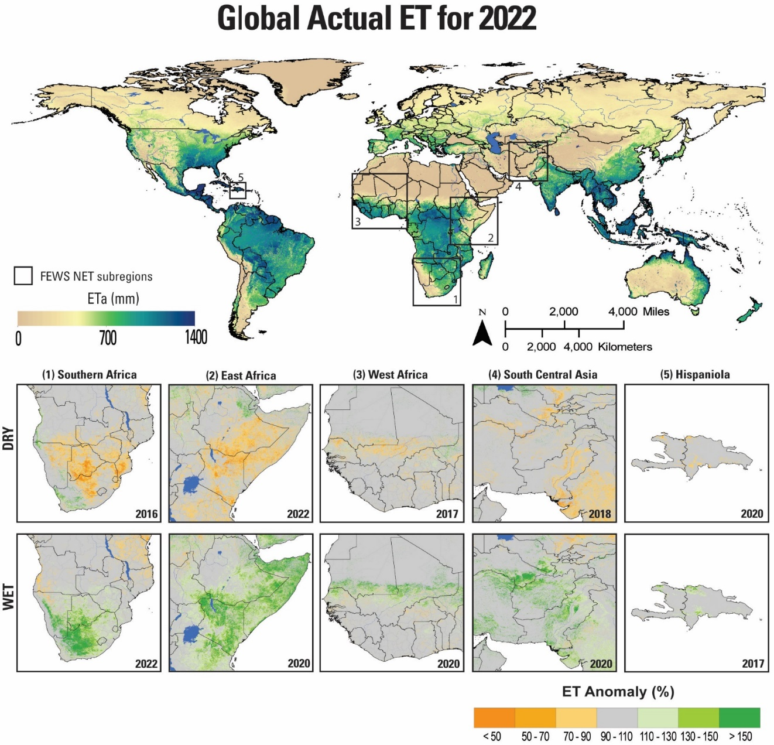
Caption for Graphic or Image: Annual Actual ET (top) for 2022 from the SSEBop VIIRS model capturing 1-km spatial variability of water consumptive use from the landscape. Zoomed subregions (bottom) for FEWS NET focus areas show example ET anomaly results for wet and dry years.
Author name: Gabriel Senay
Author business email: senay@usgs.gov

DOI agency/bureau2: USGS
USGS Mission Area: Ecosystems
USGS Program: **unspecified​**
Cost Center: Upper Midwest Environmental Sciences Center
Program Name2:
Project title: Automating the Detection and Classification of Wildlife in Aerial Imagery
Project description: Monitoring marine wildlife in remote locations is a challenge and incorporating remote sensing and automation tools can improve the quality of monitoring data while reducing risk and cost. The U.S. Geological Survey (USGS) is partnering with the Bureau of Ocean Energy Management (BOEM), the U.S. Fish and Wildlife Service (FWS), and the University of Michigan, to apply deep learning methods to automate the processing of remote sensing imagery for wildlife population surveys. The FWS routinely monitors migratory birds using low-level crewed aircraft and this work will improve safety by reducing the personnel required and allowing pilots to fly at higher altitudes. BOEM is involved with permitting and monitoring of offshore wind energy projects and needs accurate wildlife observations to evaluate project impacts.

Specific objectives of this project include: (1) collecting and annotating an archive of aerial imagery to train deep learning algorithms, (2) developing deep learning algorithms for detection and taxonomic classification, (3) enumerating target species found in aerial imagery, and (4) evaluating image and environmental characteristics that influence algorithm performance.

BOEM and FWS have collected terabytes of imagery data from flights over the Atlantic Outer Continental Shelf and the Great Lakes. The USGS Upper Midwest Environmental Sciences Center (UMESC) developed and hosts the Wildlife Annotation Tool (WAT), a customized annotation tool based on the open-source Computer Vision Annotation Tool (CVAT). The WAT is used to create annotation datasets that can train models using machine learning methods. Imagery provided by BOEM and FWS is manually processed to draw polygons around each wildlife object in an image. Wildlife objects are then classified to the lowest taxonomic level possible by wildlife experts from USGS, FWS, and external partners. The dataset currently includes over 70,000 annotations for 205 unique taxonomic classifications of birds, turtles, marine mammals, and fish.

Machine learning models are being trained for object detection on an initial benchmark dataset and their performance is being evaluated and compared to other model options. Detection models are trained to draw bounding boxes around wildlife objects (Figure 1) and to assign a primary identification, such as bird or reptile. Future algorithm development will expand the model to execute an object classification workflow that assigns a specific taxonomic label to each detected object. Work in this area is being supported by the University of Michigan. For more information regarding our classification work, see our publication (https://doi.org/10.1002/rse2.318).
Sensor Type: Camera;
Platform type: Airplane;
URL: https://www.usgs.gov/centers/upper-midwest-environmental-sciences-center/science/deep-learning-automated-detection-and
Graphic or Image Upload: https://doimspp.sharepoint.com/sites/GS-EROSSCIENCESWI/Shared Documents/Apps/Microsoft Forms/DOI RS Activities Report, 2022 (2)/Graphic or Image Upload/predicted_imagery_Aaron Murphy.PNG
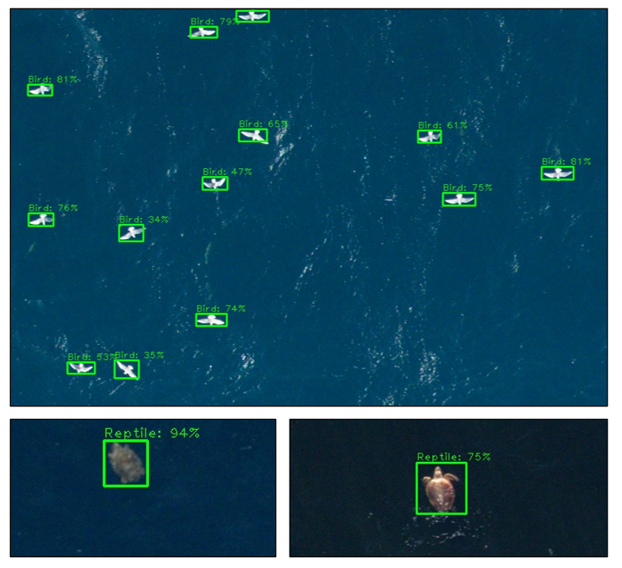
Caption for Graphic or Image: Figure 1. A collage of oceanic wildlife detected by machine learning algorithms and classified at a high level (e.g., bird and reptile with “confidence” values) from aerial imagery (imagery provided by BOEM).
Author name: Aaron Murphy
Author business email: amurphy@usgs.gov

DOI agency/bureau2: USGS
USGS Mission Area: Core Science Systems
USGS Program: National Land Imaging Program
Cost Center: Earth Resources Observation and Science (EROS) Center (Geography)
Program Name2:
Project title: Deep Learning Research Supporting the Development of Annual National Land Cover Data
Project description: The United States Geological Survey (USGS), in collaboration with the Multi-resolution Landscape Consortium (MRLC), has provided the community with the National Land Cover Database (NLCD), a detailed land cover database for more than 30 years. Research is well underway to produce single stream land cover products covering a more than 38-year record. In a planned initial product release, users can expect Anderson Level II type land cover classes (for example, the 16 land cover categories used in the current NLCD classification typology) at 30-meter spatial resolution on an annual time step for the years 1985-2023 for the conterminous United States. Research is ongoing to improve the methodology for producing and validating land cover and change related components included in the next-generation product suite.
In 2023, research progress has focused on experimental development and testing of deep learning methods. This involved development of multiple spatio-temporal deep learning approaches to improve annual land cover and impervious surface mapping from moderate resolution (Landsat) satellite imagery. The map targets for deep learning models are (1) NLCD thematic land cover, (2) NLCD percent developed imperviousness (3) NLCD developed imperviousness descriptor layer which includes a variety of imperious types.
At a high level, the deep learning architecture that comprises the Land Cover Artificial Mapping System (LCAMS) can be divided into three major subunits: a suite of spatial classification models, a suite of spatiotemporal “refinement” classification models, and an impervious timeseries regression model. The design of the system offers a novel solution to processing and leveraging the spatio-temporal information encoded in a timeseries of Landsat imagery, the land cover training in an NLCD time series, and fusing those with the temporal information encoded in harmonic model change detection coefficients created as part of the Land Change Monitoring Assessment and Project (LCMAP) project. This approach is exploiting the strengths of previous NLCD and LCMAP mapping methods to improve the quality and frequency of land cover and impervious surface products.

Sensor Type: Multispectral (approx. 4-12 bands);
Platform type: Satellite;
URL: mrlc.gov
Graphic or Image Upload: https://doimspp.sharepoint.com/sites/GS-EROSSCIENCESWI/Shared Documents/Apps/Microsoft Forms/DOI RS Activities Report, 2022 (2)/Graphic or Image Upload/deep learning flow chat_Jesslyn Brown.png
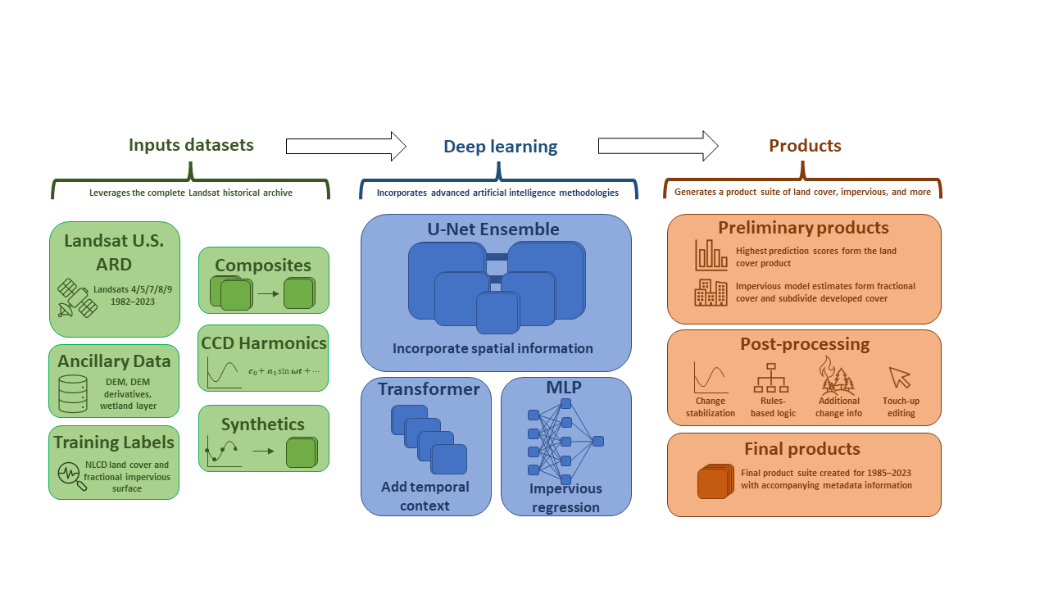
Caption for Graphic or Image: The components of the Land Cover Artificial Mapping System involve data inputs that leverage the long Landsat record, multiple deep learning methods, and a linked product suite of annual land cover and impervious surface.
Author name: Jesslyn Brown
Author business email: jfbrown@usgs.gov

DOI agency/bureau2: USGS
USGS Mission Area: Core Science Systems
USGS Program: Land Change Science
Cost Center: Earth Resources Observation and Science (EROS) Center (Geography)
Program Name2:
Project title: National Land Cover Database
Project description: Topic sentence NLCD: Creating integrated, accurate, and actionable Land Cover for the Nation

The National Landcover Database (NLCD) is produced by The U.S. Geological Survey (USGS) in collaboration with the Multi Resolution Land Characteristics Consortium (MRLC). The MRLC, a consortium of federal agencies who coordinate and generate consistent and relevant land cover information at the national scale for a wide variety of environmental, land management, and modeling applications, have been providing the scientific community with detailed land cover products for more than 30 years. Over that time, NLCD has been one of the most widely used geospatial datasets in the U.S., serving as a basis for understanding the Nation’s landscapes in thousands of studies and applications, trusted by scientists, land managers, students, city planners, and many more as a definitive source of U.S. land cover.
NLCD released the latest version of this collaboration for the conterminous U.S., NLCD 2021. This release includes map products characterizing land cover, land cover change, developed impervious surface estimations and impervious surface descriptors across nine epochs from 2001 to 2021 (2001, 2004, 2006, 2008, 2011, 2013, 2016, 2019, and 2021). The 2021 suite of NLCD products follow the same protocols and procedures of the previously released NLCD epochs (2001-2019), are directly comparable to the 2019 release across the full time series, and are suitable for multi-temporal analysis. Other collaborative work released this year under the NLCD umbrella includes percent forest canopy produced with the U.S. Forest service spanning 2008 to 2021, and the 2020 North American Land Change Monitoring System (NALCMS), which is produced through the Commission for Environmental Collaboration (C.E.C) by the Governments of Canada, Mexico, and the United States and their respective mapping agencies. All data are available through mrlc.gov.
NLCD 2021 will mark the last installment in traditional NLCD land cover mapping methodologies. Land cover data users can look forward to USGS’s premier land cover programs—NLCD and Land Cover Monitoring Assessment and Projection (LCMAP)—advancing the science of land cover. The initial 2024 product release of the next generation of USGS land cover products will include Anderson Level II type land cover classes (for example, the 16 land cover categories used in the current NLCD classification typology) across the conterminous United States at 30-meter spatial resolution, at an annual time step, for the years 1985-2023.

Sensor Type: Multispectral (approx. 4-12 bands);
Platform type: Satellite;
URL: www.mrlc.gov
Graphic or Image Upload: https://doimspp.sharepoint.com/sites/GS-EROSSCIENCESWI/Shared Documents/Apps/Microsoft Forms/DOI RS Activities Report, 2022 (2)/Graphic or Image Upload/NLCD_DOI_rem_sens_2023_Jon Dewitz.jpg
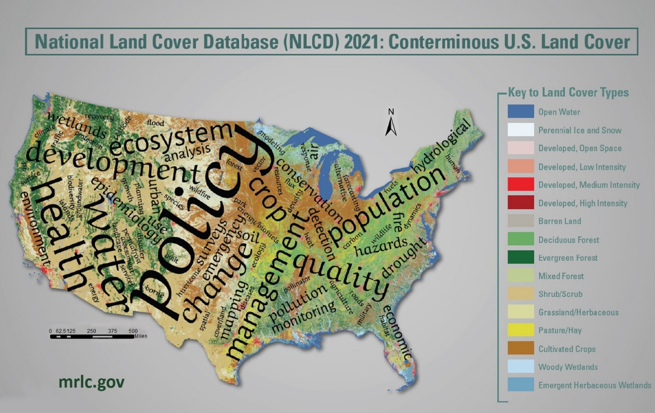
Caption for Graphic or Image: National Land Cover Database (NLCD)
Author name: Jon Dewitz
Author business email: dewitz@usgs.gov

DOI agency/bureau2: USGS
USGS Mission Area: Natural Hazards
USGS Program: National Land Imaging Program
Cost Center: Earth Resources Observation and Science (EROS) Center (Geography)
Program Name2:
Project title: LANDFIRE is now current for previous year disturbances
Project description: For the first time in LANDFIRE's history prior year disturbances are to be represented in current year mapped products. This accomplishment is a milestone in LANDFIRE’s overall plan for moving to annual updates to provide users with the most current and best information for strategic fire and resource management planning.

As part of the move to annual updates, LANDFIRE is now incorporating disturbance events within the fiscal year (October through September) to coincide with reporting by federal agencies. Events collected or received by September are pushed through the update process and released sequentially by region or ‘GeoArea’, which provides current fuels products to the western US the following Spring at the beginning of the typical fire season.

Several major advancements have made it possible to update our maps more frequently and with less latency. We automated our process for removing overlap in the hundreds of polygons compiled in our Events Geodatabase that capture disturbances and land management activities contributed by agencies and obtained from public websites, which shorten the turn-around time for incorporating them into our disturbance products.

Our methods for satellite change detection are better than ever. New algorithms for identifying disturbances (SAFER and percentile MIICA) in conjunction with smoother/cleaner percentile-based satellite image composites using Harmonized Landsat and Sentinel (HLS) data have resulted in far fewer false positives and significantly reduced the time needed for manual review, allowing faster turn-around time for producing annual disturbance products.

The annual disturbance product is used to update vegetation and fuels map products in addition to updates for agriculture and development. New fuel model assignments were developed to accurately portray burnability in the first growing season post disturbance, or Time Since Disturbance 1 (TSD1) in fuel model products. All products are now available on a new and improved web-based viewer: LANDFIRE Data Distribution Site

Next year LANDFIRE is planning for an ‘Image-Based Update’ that incorporates satellite imagery and Machine Learning to update vegetation in disturbed areas instead of expert-opinion rulesets used in the past. Prototyping results suggest that image-based models more accurately depict vegetation structure post-disturbance and would also account for vegetation re-growth in disturbances prior to LF2016 Remap. LANDFIRE continues to leverage LiDAR by incorporating space-borne GEDI for tree height modeling and developing a process to calculate tree canopy cover and height metrics from airborne point-cloud data available from 3DEP in the Cloud.
Sensor Type: Multispectral (approx. 4-12 bands);
Platform type: Satellite;
URL: https://landfire.gov/
Graphic or Image Upload: https://doimspp.sharepoint.com/sites/GS-EROSSCIENCESWI/Shared Documents/Apps/Microsoft Forms/DOI RS Activities Report, 2022 (2)/Graphic or Image Upload/LF22_Releases_Daryn (Contractor) D.png
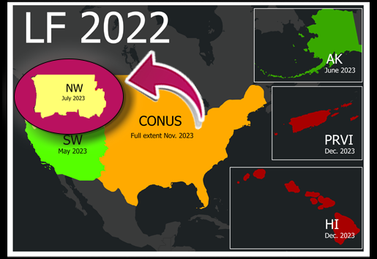
Caption for Graphic or Image: LF 2022 products are being released in 2023 and are updated for prior year disturbances for the first time in LANDFIRE’s history
Author name: Daryn Dockter
Author business email: ddockter@contractor.usgs.gov

DOI agency/bureau2: USGS
USGS Mission Area: Ecosystems
USGS Program: Land Management Research Program
Cost Center: Columbia Environmental Research Center
Program Name2:
Project title: UAS imagery supporting Cuyahoga River restoration
Project description: Restoration Ecologists from the USGS Columbia Environmental Research Center and the Utah Water Science Center used small unoccupied aerials systems (sUAS) to collect imagery and provide baseline data prior to the planned removal of the Ohio-Edison dam near Cuyahoga Falls, Ohio (Figure 1). Removal of the dam will restore fish-passage and expose the currently inundated Cuyahoga Gorge and waterfall that lends its name to the nearby town. Removal of sediment will reduce risk of exposure to contaminants for human and wildlife populations. The exposed area will expand the terrestrial area of county-owned Gorge Metro Park that surrounds the impoundment, increasing recreational opportunities for residents and restoring a key element of local history. The restoration itself is being performed by the US Army Corps of Engineers and the US Environmental Protection Agency as part of the Great Lakes Restoration Initiative. Monitoring of removal effects is a collaborative effort between those agencies, USGS, and numerous other state and federal agencies.

Data collection presented numerous challenges, including limited sight lines and operations within a densely populated urban area. The steepness of the terrain and the limited areas suitable for operational staging constrained the potential area of interest that could be flown while adhering to DOI and FAA safety requirements. Commercial centers and high-traffic roadways and concerns about public safety further restricted potential flight area.

Data provide the basis for developing a vegetation community map and terrain elevation models documenting baseline conditions prior to dam removal. Data collection planned for after dam removal will document vegetation establishment in newly exposed areas and estimation of sediment flow out of the impoundment as restoration progresses. Downstream of the dam, sUAS data will allow assessment of shoreline deposition and erosion for understanding secondary effects of dam removal on downstream water quality, fish habitat, and streamside vegetation communities. Data are available through Earth Explorer (www.earthexplorer.usgs.gov).
Sensor Type: Camera;
Platform type: UAS;
URL: www.earthexplorer.usgs.gov
Graphic or Image Upload: https://doimspp.sharepoint.com/sites/GS-EROSSCIENCESWI/Shared Documents/Apps/Microsoft Forms/DOI RS Activities Report, 2022 (2)/Graphic or Image Upload/Cuyahoga_Matthew Struckhoff.jpg
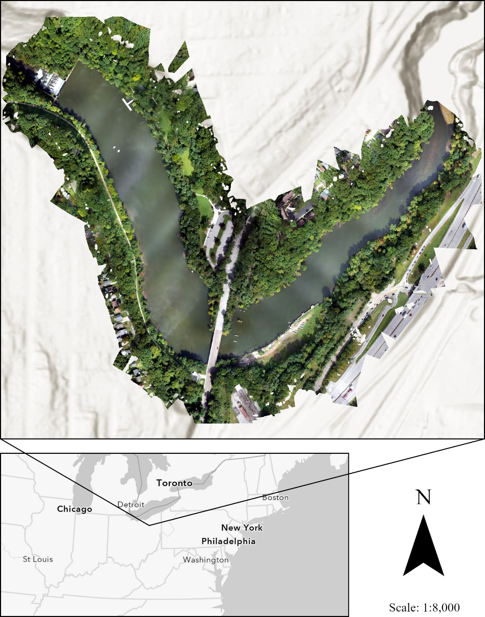
Caption for Graphic or Image: Figure 1. Orthoimage developed from data collected using small unoccupied aerial systems at the Cuyahoga Gorge study area in Ohio, USA. A lack of tie points over the impounded lake hindered development the elevation model (inset), leading to small gaps in the resulting image. Imagery and derived three-dimensional data are being to support restoration planning and monitoring for dam removal (visible in upper left) and restoration of stream habitat as part of the US Environmental Protection Agency (USEPA) Great Lakes Restoration Initiative. Monitoring is a joint effort between the USEPA, US Geological Survey, and other agencies.
Author name: Matthew Struckhoff
Author business email: mstruckhoff@usgs.gov

DOI agency/bureau2: USGS
USGS Mission Area: Ecosystems
USGS Program: Land Management Research Program
Cost Center: Columbia Environmental Research Center
Program Name2:
Project title: UAS and satellite census of bird populations
Project description: Restoration Ecologists from the US Geological Survey (USGS) Columbia Environmental Research Center are applying imagery collected using small Unoccupied Aerial Systems (sUAS) and commercial satellites to detect and census populations of herring gulls (Larus argentatus) and other migrating bird species. Habitat restoration efforts for the Great Lakes Restoration Initiative are being initiated in response to declines of bird populations at the site, which sits at the mouth of River Raisin on the shores Lake Erie, Michigan, USA. Restorations at the site are part of the Environmental Protection Agency (USEPA) Great Lakes Restoration Initiative. Monitoring is a collaborative effort between USEPA, USGS, and numerous other state and federal agencies.

Structure-from-motion processing of sUAS imagery (less than 10 cm ground-surface distance) provide 3-dimensional data products useful for monitoring needs beyond nesting bird populations. These include assessing changes in vegetation associated with restoration efforts and monitoring changes in water level and wetland extent at the site. However, sUAS data collection costs and the site’s proximity to critical infrastructure (a power plant) restrict sUAS operations in ways that may make satellite-based data collection a preferable alternative.

USGS researchers are collaborating with the USEPA and other agencies to compare sUAS-based data collection to that of satellite-based data collection at the site. Satellite imagery (less than 0.5 m ground surface distance) available through USGS agreements with commercial sources were collected at times coinciding with use of the study area by target species for nesting during migration. Complementary ground-based data collected simultaneous with satellite flights will be used to confirm detections based on satellite imagery. Lessons learned in 2023 with be applied to improve data collection and analyses in subsequent years. Results will be used to assess the relative efficacy of satellite imagery and sUAS-based products for detection and identification of nesting birds, compare the safety considerations of each method, and provide cost-benefit analyses of each.
Sensor Type: Camera;
Platform type: Satellite;UAS;
URL:
Graphic or Image Upload: https://doimspp.sharepoint.com/sites/GS-EROSSCIENCESWI/Shared Documents/Apps/Microsoft Forms/DOI RS Activities Report, 2022 (2)/Graphic or Image Upload/Raisin_Matthew Struckhoff.jpg
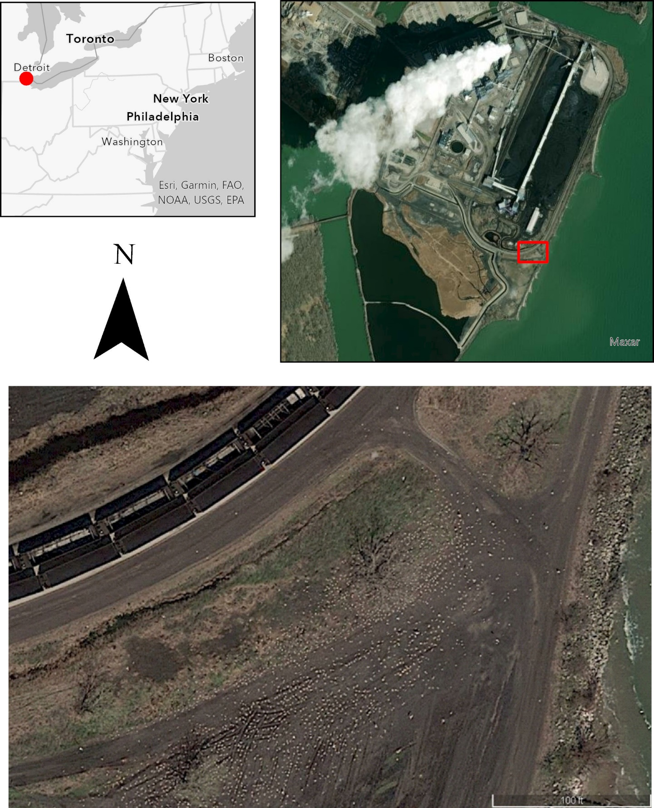
Caption for Graphic or Image: Figure 1. Satellite imagery showing the study site adjacent to a power plant at the mouth of River Raisin, Ohio USA (upper left).The inset image (bottom) shows nesting birds visible as white specks between rail tracks and the lake shore. Declines in bird populations are the impetus for planned habitat restoration at the site as part of the US Environmental; Protection Agency’s Great Lakes Restoration Initiation. Research by USGS is examining the relative efficacy of satellite imagery compared to imagery collected using small unoccupied aerial systems for the detection and identification of nesting birds at the site.
Author name: Matthew Struckhoff
Author business email: mstruckhoff@usgs.gov

DOI agency/bureau2: USGS
USGS Mission Area: Core Science Systems
USGS Program: National Land Imaging Program
Cost Center: Alaska Science Center Geography
Program Name2:
Project title: Using Landsat to detect sudden onset of iron mineralization in Alaska’s arctic rivers
Project description: In arctic Alaska, there are a growing number of independent field observations describing historically clear streams and rivers suddenly transforming into opaque, rust-color water ways (Figure 1). Concern by local communities, land managers, and outdoor user groups prompted a collaborative investigation including the U.S. Geological Survey, National Park Service, University of California-Davis, University of Alaska-Anchorage, and Alaska Pacific University. Research activities are focused on understanding the mechanism behind these changes and quantifying the impacts to aquatic ecosystems. Another research goal is to verify where and when these changes develop and whether there are instances of historical occurrence. The need for a broad, consistent, archive of remotely sensed imagery that can be used to investigate and quantify water quality across northern Alaska was met by the Landsat campaign.

Time series of historical water conditions for select study sites have been produced from Landsat, Collection 2, Tier 1 Surface Reflectance products derived by the USGS and accessed within Google Earth Engine (Figure 2). Areas of interest (AOIs) within study rivers are manually delimited to correspond with Landsat pixel geometry and observed iron-oxide precipitate/staining. From all available Landsat scenes acquired between 1985 and 2022, we filter and retain only scenes acquired over the AOI, for the month of July or August, and with scene-wide cloud cover <30%. Clouds and cloud shadows are masked from the resultant scenes and an "iron index" is calculated for each scene based on the ratio of surface reflectance sensed in the red band and blue band. Available daily values are plotted, and outlier values are inspected and removed from analysis following manual scene inspection for atmospheric contaminants missed in the masking process (primarily smoke from summer wildfires). A mean iron index value is calculated from all pixels intersected by the area of interest for each Landsat scene. Finally, a mean annual iron index value is then summarized from available values for each year and graphed. For our overall study area, mean annual iron index values can range from 0 to +2.5. Assuming the area of interest corresponds with a consistent water surface, values of 0-0.5 can be interpreted as deep clear water, 0.5-1.5 as clear shallow water, and >1.5 as iron oxide stained water.

Associated data release for time series data: Baughman, C.A., 2023, Estimates of iron mineralization in select reaches of three Alaska arctic rivers derived from historical Landsat imagery: U.S. Geological Survey data release, https://doi.org/10.5066/P9TP9TZH

Sensor Type: Multispectral (approx. 4-12 bands);
Platform type: Satellite;
URL: https://www.usgs.gov/centers/alaska-science-center/science/rusting-arctic-rivers-freshwater-ecosystems-respond-rapidly
Graphic or Image Upload: https://doimspp.sharepoint.com/sites/GS-EROSSCIENCESWI/Shared Documents/Apps/Microsoft Forms/DOI RS Activities Report, 2022 (2)/Graphic or Image Upload/Kutuk_2016_2_Carson Baughman.JPG
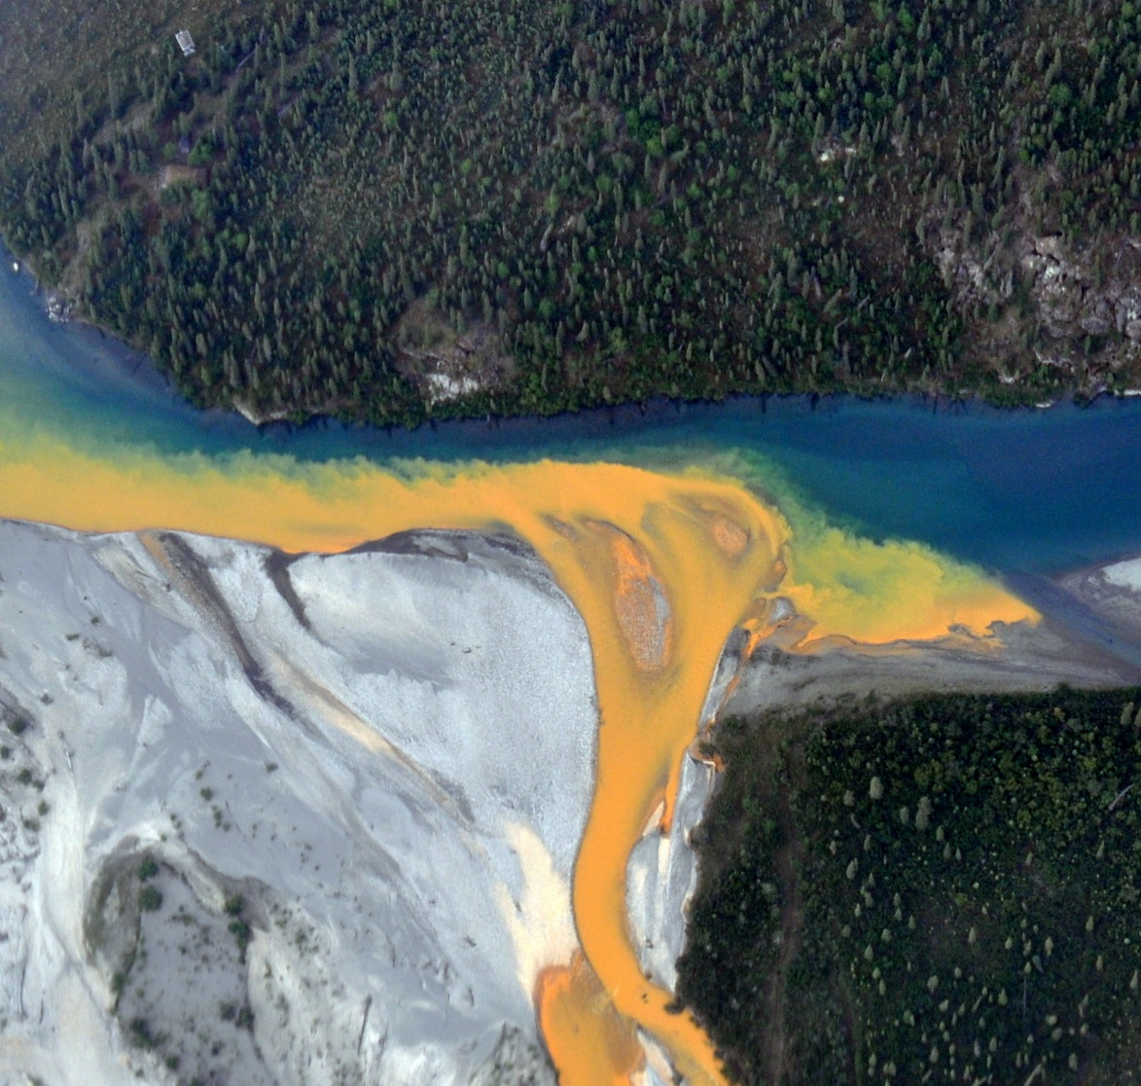
Graphic or Image Upload: https://doimspp.sharepoint.com/sites/GS-EROSSCIENCESWI/Shared Documents/Apps/Microsoft Forms/DOI RS Activities Report, 2022 (2)/Graphic or Image Upload/Kugururok_Carson Baughman.png
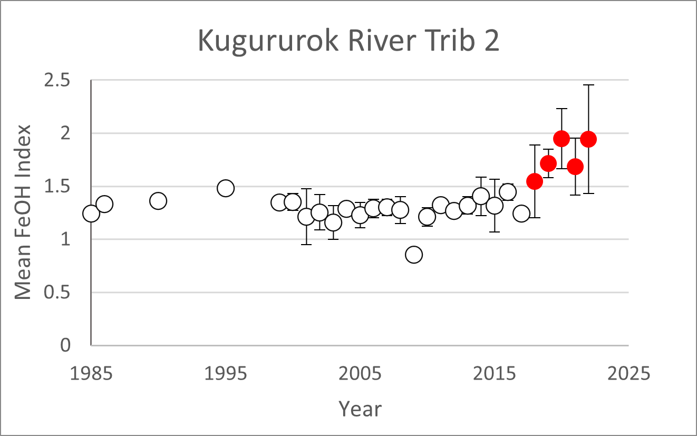
Caption for Graphic or Image: Kutuk_2016_2.JPG: Figure 1. An example of sudden and dramatic shifts in water quality. Confluence of the Kutuk River (orange) and Alatna River in Gates of the Arctic National Park. 26 July 2016. Photo Credit: Kenneth Hill/National Park Service

Kugururok.png: Figure 2. Landsat-derived, time series analysis of the magnitude of iron mineralization in a tributary of the Kugururok River, Noatak National Preserve, Alaska. Red points correspond with and corroborate field observations of onset and magnitude.
Author name: Carson A. Baughman
Author business email: cbaughman@usgs.gov

DOI agency/bureau2: USGS
USGS Mission Area: Water Resources
USGS Program: **unspecified​**
Cost Center: Idaho Water Science Center
Program Name2:
Project title: REmote Aquatic Chlorophyll Tracker (REACT): A Public Web Application for Remote Sensing of Water Quality
Project description: The REmote Aquatic Chlorophyll Tracker (REACT https://webapps.usgs.gov/react/) webtool was published by the USGS in 2022 as a public facing application to map aquatic chlorophyll in near-real time from 10 m multispectral satellite imagery. This webtool assists public health officials and waterbody managers in allocating scarce monitoring resources for timely identification and mapping of potentially harmful algal blooms. The application is based on a 2022 USGS authored journal article (https://doi.org/10.1117/1.JRS.16.044522) that demonstrated success in using an ensemble approach to classifying aquatic chlorophyll concentrations. The same publication demonstrated an approach to address the very common data limitation issue that arises in evaluating remote sensing of water quality methods. Classification models developed from a supervised point classification routine were shown to perform almost as well as models developed on in-situ sample collection alone while an assimilating of in-situ and image derived datasets produced the best performing model capable to accurately classifying chlorophyll concentrations more than 80% of the time.
This trained aquatic chlorophyll ensemble model is now operationally applied to new imagery as it is collected to produce weekly maps of aquatic chlorophyll in 2 dozen waterbodies in Idaho. To facilitate further adoption, relative chlorophyll and turbidity products are also provided at the global scale for imagery from 2019 to present. Data summary and extraction tools are provided to place a given image in context.

Sensor Type: Multispectral (approx. 4-12 bands);
Platform type: Satellite;
URL: https://webapps.usgs.gov/react/
Graphic or Image Upload: https://doimspp.sharepoint.com/sites/GS-EROSSCIENCESWI/Shared Documents/Apps/Microsoft Forms/DOI RS Activities Report, 2022 (2)/Graphic or Image Upload/Picture2_Tyler King.jpg
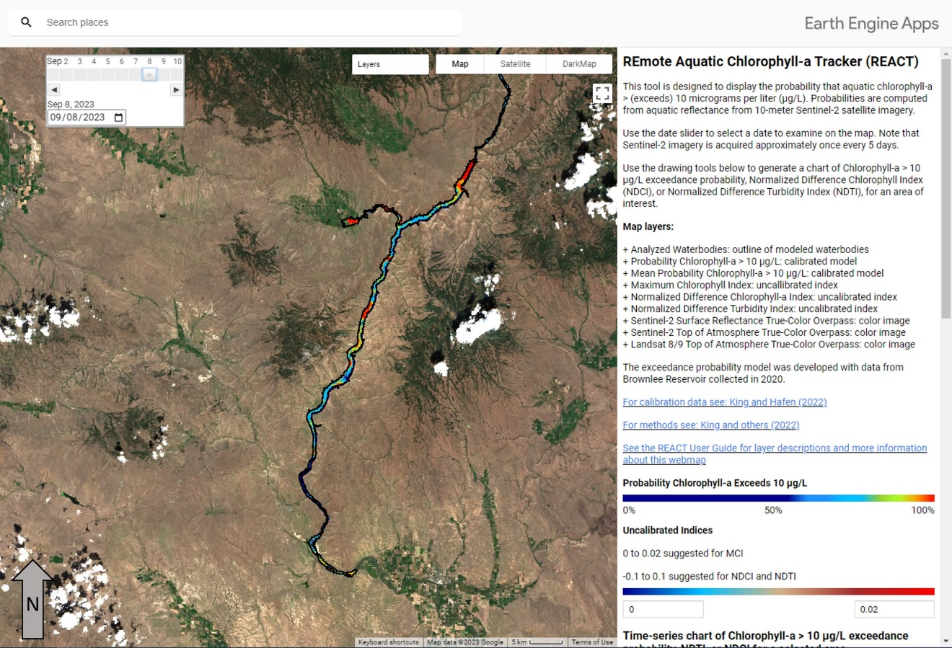
Caption for Graphic or Image: REACT application screenshot showing hot spots of elevated aquatic chlorophyll in Brownlee Reservoir from 8 Sept 2023.
Author name: Tyler King
Author business email: tvking@usgs.gov

DOI agency/bureau2: USGS
USGS Mission Area: Water Resources
USGS Program: Groundwater and Streamflow Information Program
Cost Center: **unspecified**
Program Name2:
Project title: Development of the Software Application for SMASH: A tool for mapping the taxonomic composition of harmful algal blooms from remotely sensed data
Project description: As part of the USGS’ Next Generation Water Observing Program Remote Sensing Research and Development Project, we have developed a new software package for using hyperspectral image data to infer which particular types of algae (technically, cyanobacteria) are present within a potentially harmful algal bloom (HAB). The Software Application for SMASH (SAS) is a standalone, user-friendly implementation of the Spectral Mixture Analysis for Surveillance of HABs (SMASH) framework introduced in a 2022 paper published by several USGS authors (https://doi.org/10.1016/j.rse.2022.113089). Around the world, algal blooms are increasing in frequency and severity and can negatively affect human and ecosystem health. The environmental and economic impacts associated with HABs create a compelling need to advance our ability to monitor these events via remote sensing. Whereas traditional methods yield estimates of cyanobacterial cell counts but no information on the taxonomic composition of a bloom, the SMASH framework is specifically intended to differentiate among types (genera) of cyanobacteria based on their reflectance characteristics. The foundation of SMASH is a multiple endmember spectral mixture analysis (MESMA) algorithm that takes a library of cyanobacteria endmembers and a hyperspectral image as input and estimates the fractional abundance of each genus, plus water, on a per-pixel basis. The library currently includes spectra for 12 genera measured under a microscope and is available through a USGS ScienceBase data release. To build upon this initial proof-of-concept investigation and facilitate application of this approach, we packaged the code underlying SMASH into a software package with a graphical user interface designed for end users who lack specialized remote sensing software and expertise. We also created a tutorial that uses an image from Oregon’s Upper Klamath Lake as an example to guide the user through the workflow. Data products that can be generated via SAS include maps of the normalized difference chlorophyll index and cyanobacterial index, a MESMA-based classification of algal genera, fraction images for each endmember, and a root mean square error (RMSE) image that summarizes uncertainty. SAS is currently under review for public release as an official USGS Scientific Software product, but once approval is granted the software and source code will be freely available via a USGS GitLab repository. This tool will enable further evaluation of the potential of SMASH to enhance our understanding of algal blooms, particularly with respect to their spatial and temporal dynamics.
Sensor Type: Hyperspectral;
Platform type: Satellite;
URL: https://doi.org/10.1016/j.rse.2022.113089
Graphic or Image Upload: https://doimspp.sharepoint.com/sites/GS-EROSSCIENCESWI/Shared Documents/Apps/Microsoft Forms/DOI RS Activities Report, 2022 (2)/Graphic or Image Upload/smoothedRGB_Carl Legleiter.jpg
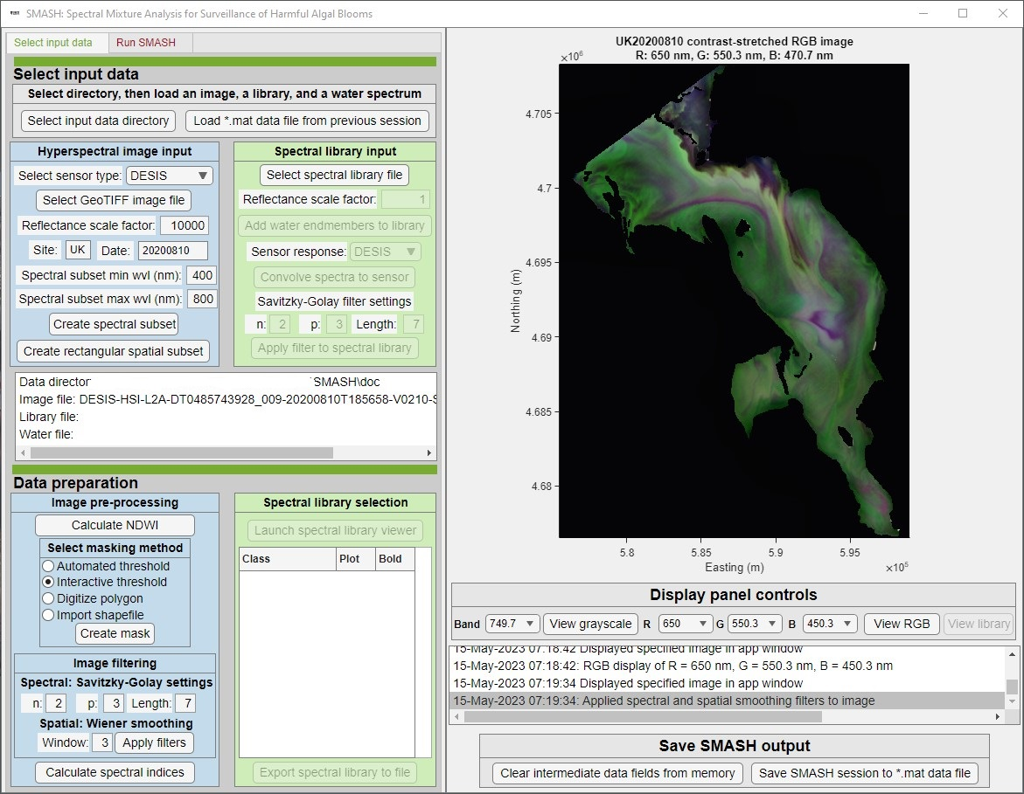
Caption for Graphic or Image: Overview of the graphical user interface for the Software Application for SMASH, including a hyperspectral image of Oregon’s Upper Klamath Lake, which is used as an example case study in a tutorial that provides guidance on how to use the software.
Author name: Carl J. Legleiter
Author business email: cjl@usgs.gov

DOI agency/bureau2: USGS
USGS Mission Area: Ecosystems
USGS Program: Water Availability and Use Science Program
Cost Center: Southwest Biological Science Center
Program Name2:
Project title: Riparian vegetation evapotranspiration trends
Project description: Accurate estimates of riparian vegetation water use are important to quantify, particularly in arid environments. In these narrow riparian corridors, we quantify the loss of water from leaves and soil as one variable, actual evapotranspiration (ETa). Increases in ETa are indicative of increasing vegetation cover and therefore, increasing ‘losses’ of water through ETa represent positive trends in riparian ecosystem health; decreasing ETa may indicate dwindling riparian cover due to less available water for canopy growth due to drought, groundwater flux, beetle defoliation, fire, or increasing salinity.
The objectives of this study were to calculate annual ETa (mmyr-1) for selected riparian areas in the Sonoran Desert in the southwestern U.S. Riparian reaches for a dozen rivers in the Lower Colorado River Basin, mostly in Arizona, were delineated and monitored using the two-band Enhanced Vegetation Index (EVI2). We acquired 30-m resolution Landsat scenes, processed and performed a pixel-wise quality assessment to remove pixels with high aerosols and clouds, and computed EVI2 every 16-days over 20 years. We then computed daily potential ET using the Blaney-Criddle formula with input temperature data from gridded weather data using Daymet (1 km). Riparian ETa was quantified using the Nagler ET(EVI2) model to produce time-series data for the period 2000-2021.
Most rivers in these drylands have regulated flows, such as the Lower Colorado River mainstem, and other rivers in our study including the Salt, Gila and Santa Cruz Rivers. A biocontrol beetle (Diorhabda spp.) defoliated much of the saltcedar (Tamarix spp.) riparian corridor landcover in these Arizona rivers starting in ca. 2008; for example, on the Lower Colorado River mainstem, monitoring of riparian ET(EVI2) showed annual totals with large declines believed to be in part due to biocontrol. However, over the last decade (2013-2021), areas have been restored following the implementation of the Lower Colorado River Multi-Species Conservation Plan. In the Colorado River delta, the average of four restoration sites, which cover only ca. 3% of the riparian corridor showed ET(EVI2) increased by 22.1% (0.60 mmd-1) post-planting (since ca. 2014).
From 2000 to 2021, various rivers were studied to determine the average annual ET(EVI2) (mmyr-1) for riparian corridors, unrestored areas, and restored areas (Figure 1). The findings indicate that the Salt River experienced a 13.7% increase from 800 mmyr-1 to 910 mmyr-1, whereas the Gila River only saw a 2.7% increase from 725 mmyr-1 to 745 mmyr-1 during the same period, with occasional periods of decreases (e.g., 2002, 2013) followed by increases. The Santa Cruz River showed the most significant increase in average annual ET(EVI2) with a 24.0% increase from 770 mmyr-1 to 955 mmyr-1 (2000-2021). The increasing trends on these rivers could be due to riparian species composition altered by the tamarisk beetle followed by secondary or replacement species which established green canopies, restoration efforts or other changes in water or land management. This study provides valuable estimates of riparian water use that may assist with decision-making by natural resource managers tasked with allocating water and managing habitat along these riparian corridors.

Sensor Type: Multispectral (approx. 4-12 bands);
Platform type: Satellite;
URL:
Graphic or Image Upload: https://doimspp.sharepoint.com/sites/GS-EROSSCIENCESWI/Shared Documents/Apps/Microsoft Forms/DOI RS Activities Report, 2022 (2)/Graphic or Image Upload/LowerCORivers_ETa_Pamela Nagler.jpg
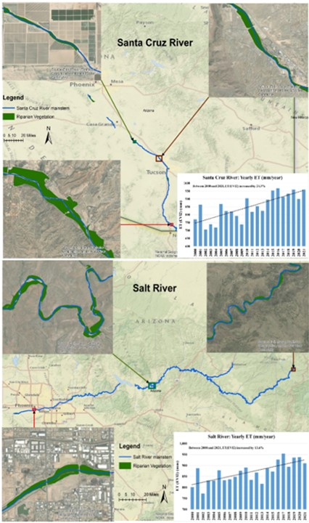
Caption for Graphic or Image: Actual evapotranspiration in the riparian corridor has positive trends using Landsat and weather data (ET(EVI2)) from 2000 through 2021 for the Santa Cruz and Salt Rivers in the Lower Colorado River Basin.
Author name: Pamela Nagler
Author business email: pnagler@usgs.gov

DOI agency/bureau2: USGS
USGS Mission Area: Ecosystems
USGS Program: **unspecified​**
Cost Center: Southwest Biological Science Center
Program Name2:
Project title: High Resolution Aerial Imagery of the Grand Canyon
Project description: The Colorado River provides drinking water to millions of people in the Southwestern United States. The segment of the river flowing through Grand Canyon is renowned for its ecological, cultural, and recreational resources. Operations of the upstream Glen Canyon Dam, which impounds Lake Powell reservoir, have significant effects on these river resources in Grand Canyon. In its role as the science provider to the Glen Canyon Dam Adaptive Management Program (GCDAMP), the U.S. Geological Survey (USGS) Grand Canyon Monitoring and Research Center (GCMRC) periodically publishes a series of high resolution, multispectral, aerial images which cover the entire river corridor in Marble Canyon and Grand Canyon National Park between Lake Powell and Lake Mead. The most recent overflight was completed in May of 2021, and the imagery is currently being preprocessed and prepared for publication.
The 2021 overflight mission was completed under contract by Fugro. The imagery was acquired in four bands (red, green, blue, and near-infrared) at 20 cm spatial (pixel) resolution. Overlapping flight line images were collected along the entirety of the river corridor, and the most shadow free and unsmeared images were mosaicked into a single, continuous image dataset for the entire study area and delivered to USGS GCMRC in 2022. During 2023, USGS GCMRC scientists refined the image mosaic by identifying remaining issues with smear, shadow extent, or cutlines, and replacing them with error-free flight lines. The mosaic is being reviewed by GIS specialists and remote sensing scientists from multiple USGS science centers and will be published with an accompanying report by the end of 2023.
These data will be useful for scientists to map landcover along the river corridor in the Grand Canyon, to detect changes in vegetation or other landcover types, and as high-resolution reference maps for field work. This work allows land managers to make informed decisions regarding the natural and cultural resources of the area.
Sensor Type: Multispectral (approx. 4-12 bands);Camera;
Platform type: Airplane;
URL: https://www.usgs.gov/centers/southwest-biological-science-center/science/airborne-remote-sensing-grand-canyon
Graphic or Image Upload: https://doimspp.sharepoint.com/sites/GS-EROSSCIENCESWI/Shared Documents/Apps/Microsoft Forms/DOI RS Activities Report, 2022 (2)/Graphic or Image Upload/GrandCanyonRSHighlightsFig_Nathaniel Bransky.png
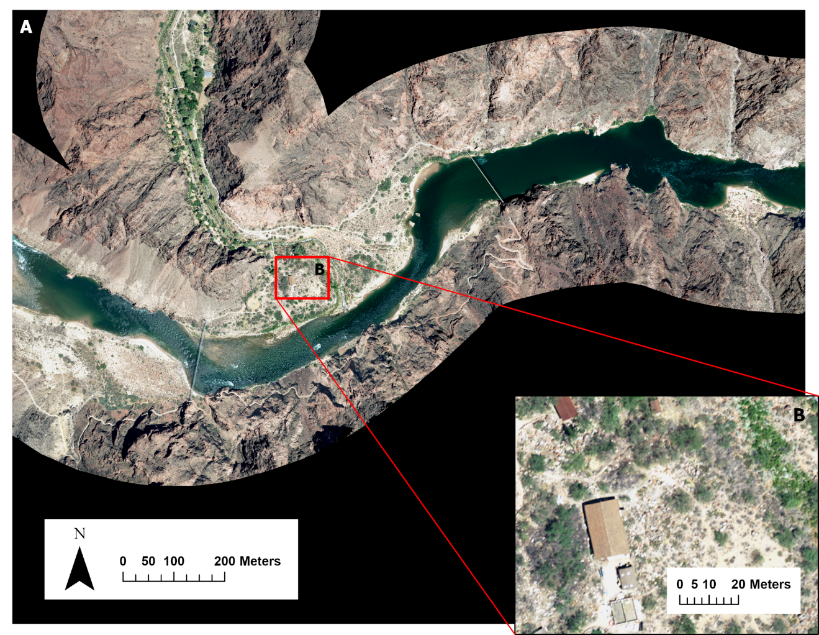
Caption for Graphic or Image: Imagery collected during the 2021 overflight depicting the mouth of Bright Angel Creek in Grand Canyon National Park (A) and a high scale view of buildings at Phantom Ranch (B).
Author name: Nathaniel Bransky, Joel B. Sankey, Lori Pigue
Author business email: nbransky@usgs.gov, jsankey@usgs.gov, lpigue@usgs.gov

DOI agency/bureau2: USGS
USGS Mission Area: Ecosystems
USGS Program: Land Change Science
Cost Center: Southwest Biological Science Center
Program Name2:
Project title: Colorado Delta Riparian Greenness and Water Use
Project description: Restoration efforts have positively impacted the habitats and native plant health of the Lower Colorado River delta riparian corridor, although vegetation greenness and corresponding water use continue to decline in unrestored reaches. The natural grasses, shrubs and trees that grow alongside rivers and streams are collectively called riparian vegetation and their leaves transpire water that is considered a loss to the ecosystem. Bare soil also loses water through evaporation. In the landscape, we quantify both losses as one variable, actual evapotranspiration. As tree canopies expand, water use increases. This study is part of the monitoring efforts and science associated with Minute 323 of the 1944 U.S. and Mexico Water Treaty. This research and findings are supporting better ecohydrological decision-making and are helping a binational team working on protecting, restoring, and maintaining native vegetation within the 150 km long riparian corridor. Our efforts are using Landsat 8 Operational Land Imager (OLI) data (2014-present) and remote sensing geospatial data sciences to generate value-added proxy parameters like the two-band Enhanced Vegetation Index (EVI2) for greenness estimation in restored sites and unrestored reaches. We then computed daily potential ET (ETo, mmd-1) using the Blaney-Criddle formula with input temperature data from a ground meteorological station in Yuma, Arizona. Using the Nagler empirical model, ET(EVI2) is estimated over each 16-day Landsat-8 OLI overpass period, by considering the 8-days before- and after- the overpass date. Annual peak growing season (May 1 to October 30) ET(EVI2) is summarized in this study where increases in riparian plant greenness have led to increases in canopy water use as a result water deliveries water to restoration sites.
In summary, restoration in Reaches 2 and 4, along with in-stream water deliveries, markedly improved vegetation greenness by 41.3% in the recent nine years (2014-2022) (compared to decreases of 27.3% in the unrestored corridor), with corresponding plant water use up by 22.1% (compared to decreases of 30.8% in the unrestored corridor). Our findings are a clear indication that restoration efforts work, and suggest that ecological restoration, such as the ongoing reliance on the following: (1) the use of small surface flows, (2) a greater reliance on directed agricultural return flows, and (3) deliveries of water to active restoration sites is a valuable option. These data, tools, methods, and results can be utilized by decision-makers in their quest to mitigate and understand how declines of riparian ecosystems can be slowed or possibly reversed.
Sensor Type: Multispectral (approx. 4-12 bands);
Platform type: Satellite;
URL:
Graphic or Image Upload: https://doimspp.sharepoint.com/sites/GS-EROSSCIENCESWI/Shared Documents/Apps/Microsoft Forms/DOI RS Activities Report, 2022 (2)/Graphic or Image Upload/deltaET_Pamela Nagler.png
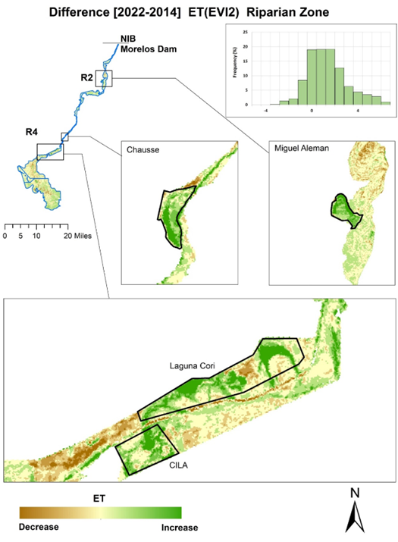
Caption for Graphic or Image: Difference maps showing change in vegetation water use ET(EVI2) in restoration sites within Reaches 2 and 4 of the Colorado River delta between years 2022-2014.
Author name: Pamela Nagler
Author business email: pnagler@usgs.gov

DOI agency/bureau2: USGS
USGS Mission Area: Ecosystems
USGS Program: Land Management Research Program
Cost Center: Wetland and Aquatic Research Center
Program Name2:
Project title: Understanding Avian Habitat Availability and Use
Project description: Barrier islands provide resources and ecological services that are integral to economic and environmental interests, such as protection of coastal infrastructure and providing habitat for wildlife. Therefore, it is imperative that barrier island systems are managed in a way that ensures these systems remain resilient and continue providing ecosystem goods and services, such as sustaining critical wildlife populations over time. However, evaluation of how management actions, such as restoration, and subsequent natural ecological processes impact species of conservation concern is a daunting challenge. This information would allow land managers to target restoration activities that produce the best outcome for multiple stakeholders, including enhancing island sustainability and preserving habitat availability, which may aid species of conservation concern.

Researchers from the U.S. Geological Survey’s Wetland and Aquatic Research Center are investigating habitat use and habitat function for several focal species on Whiskey Island and Caminada Headland in Louisiana to determine how patterns of distribution, abundance, and behavior change before, during, and after restoration (Fig. 1). In this effort, we coupled avian surveys with remotely sensed data products to study several focal bird species surveyed on Whiskey Island and Caminada Headland, which include: piping plover (Charadrius melodus), snowy plover (Charadrius nivosus), Wilson’s plover (Charadrius wilsonia), red knot (Calidris canutus), and American oystercatcher (Haematopus palliatus).

Remotely sensed information included: (1) high-thematic detail land cover maps created from high-resolution orthoimagery, (2) simple land cover maps produced with moderate-resolution satellite imagery, and (3) spectral indices from moderate-resolution satellite imagery related to greenness, brightness, and wetness. Using ecological and geographical data, we are comparing pre- and post-restoration aspects of habitat occupancy, habitat availability, habitat use, and home range estimation.
Sensor Type: Camera;Lidar (terrestrial or bathymetric);Multispectral (approx. 4-12 bands);
Platform type: Airplane;Satellite;
URL: https://www.usgs.gov/centers/wetland-and-aquatic-research-center/science/understanding-avian-habitat-availability-and
Graphic or Image Upload: https://doimspp.sharepoint.com/sites/GS-EROSSCIENCESWI/Shared Documents/Apps/Microsoft Forms/DOI RS Activities Report, 2022 (2)/Graphic or Image Upload/Reference_and_restoration_fig5_Nicholas Enwright.jpg
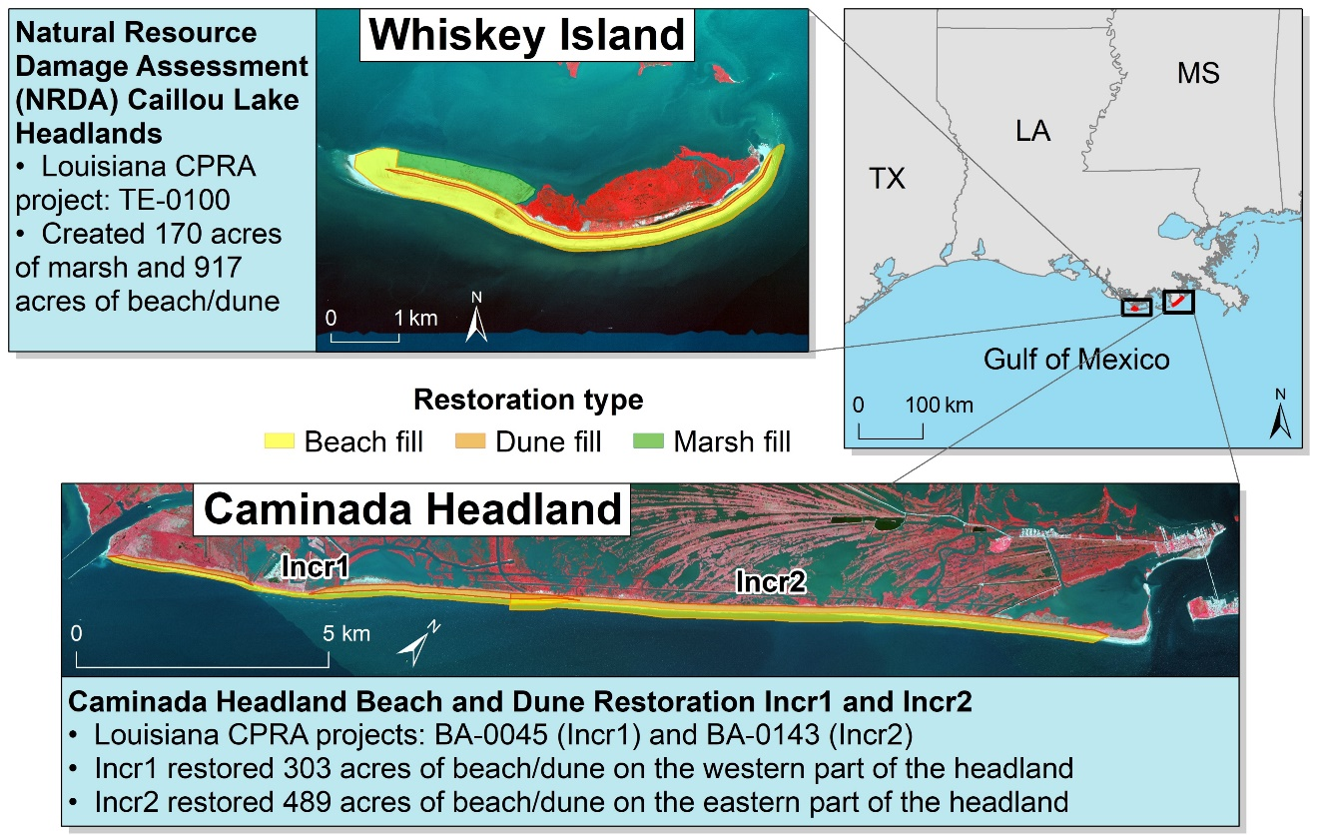
Caption for Graphic or Image: Fig. 1. Overview for restoration actions at Whiskey Island and Caminada Headland, Louisiana.
Author name: T.J. Zenal, Jr. and Nicholas Enwright
Author business email: tzenzal@usgs.gov; enwrightn@usgs.gov

DOI agency/bureau2: USGS
USGS Mission Area: Ecosystems
USGS Program: Land Management Research Program
Cost Center: Wetland and Aquatic Research Center
Program Name2:
Project title: Mapping irregularly flooded wetlands, high marsh, and salt pannes/flats
Project description: Irregularly flooded wetlands provide important ecosystem services, such as providing habitat for fish and wildlife, enhancing water quality enhancement, ameliorating flooding impacts, supporting coastal food webs, and protecting coastlines from erosion. Mapping irregularly flooded wetlands is a daunting challenge given their expansive coverage and dynamic nature. Furthermore, coastal wetlands are expected to change drastically over the coming century due to accelerated sea-level rise and changes in the frequency and intensity of extreme storms. Consequently, coastal managers need baseline information on the current spatial distribution of wetlands along with efficient repeatable methods for observing change in these important and dynamic environments.

Researchers from the U.S. Geological Survey Wetland and Aquatic Research Center and Mississippi State University have jointly produced geospatial datasets of irregularly flooded wetland probability and high marsh and salt panne/flat habitats across the northern Gulf of Mexico coast, from Texas to Florida. Figure 1 shows examples of irregularly flooded wetlands along the northern Gulf of Mexico and Figure 2 shows examples of the two map products. Additionally, the data release produced through this effort also includes a map from Lake Pontchartrain, Louisiana to the Florida Big Bend delineating the coverage of irregularly flooded wetlands dominated by Juncus roemerianus (Black needlerush), a supplemental map with a second high marsh class in Texas dominated by succulents and Distichlis spicata, a project-specific field reference dataset, and spatial metadata showing the elevation data used to create these products. These products are the first regional map of elevation-based irregularly flooded wetland probability map and high marsh and salt panne/flat map along the northern Gulf of Mexico coast and provide a baseline condition from which future changes can be compared.

This effort is the result of research funded by the National Oceanic and Atmospheric Administration's RESTORE Science Program under award NA19NOS4510195 to Mississippi State University and the U.S. Geological Survey. Many other agencies assisted with the development of these products, including the U.S. Fish and Wildlife Service, Tall Timbers Research Station, Texas Tech University, Louisiana State University, Grand Bay National Estuarine Research Reserve, Weeks Bay National Estuarine Research Reserve, Embry-Riddle Aeronautical University, and the Forbes Biological Station. The maps are publicly available (https://doi.org/10.5066/P9MLO26U) and can be viewed via ArcGIS Online (https://usgs.maps.arcgis.com/home/item.html?id=98d03a92d84940b9ac67e5c339c6eb2b). The elevation-based irregularly flooded wetland probability map produced via this study was published in Remote Sensing of Environment (https://doi.org/10.1016/j.rse.2023.113451).

Sensor Type: Lidar (terrestrial or bathymetric);Multispectral (approx. 4-12 bands);
Platform type: Satellite;Airplane;
URL: https://www.usgs.gov/centers/wetland-and-aquatic-research-center/science/mapping-high-marsh-along-northern-gulf-mexico
Graphic or Image Upload: https://doimspp.sharepoint.com/sites/GS-EROSSCIENCESWI/Shared Documents/Apps/Microsoft Forms/DOI RS Activities Report, 2022 (2)/Graphic or Image Upload/Fig3_example_wetland_photos_two_col_Nicholas Enwright.jpg
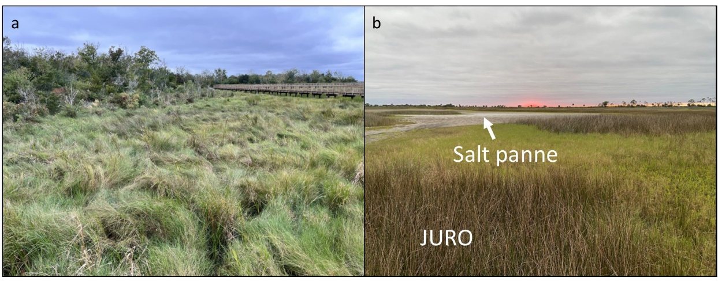
Caption for Graphic or Image: Examples of high marsh and salt pannes/flats along the northern Gulf of Mexico coast, USA. (a) High marsh dominated by Spartina patens (saltmeadow cordgrass) located at Cypremort State Park in south Louisiana (Photo credit: Nicholas Enwright). (b) High marsh with Distichlis spicata (saltgrass) with areas dominated by Juncus roemerianus (black needlerush; labeled as JURO) and salt panne habitat in the Florida Big Bend region (Photo credit: Heather Levy).
Author name: Nicholas Enwright
Author business email: enwrightn@usgs.gov

DOI agency/bureau2: USGS
USGS Mission Area: Natural Hazards
USGS Program: Coastal and Marine Geology Program
Cost Center: St. Petersburg Coastal and Marine Science Center
Program Name2:
Project title: Measuring Coastal Change Impacts from Hurricane Ian
Project description: Hurricane Ian made initial landfall on the Gulf of Mexico coast at Cayo Costa Island, Florida on September 28, 2022, as a strong Category 4 storm. In-situ sensors measured peak water levels of 0.67 – 4.03 m (NAVD88), with the highest surges observed on Fort Myers Beach and Sanibel Island. The Remote Sensing Coastal Change (RSCC) project captured the devastating impacts to coastal infrastructure and storm-induced topographic change within days after the storm (September 30 and October 3, 2022) through collection of aerial imagery and processing with structure-from-motion techniques, resulting in high-resolution three-dimensional point clouds, digital surface models (DSMs) and orthomosaic images. Beach changes were observed along much of the 270 km surveyed, with the most significant impacts observed at Captiva Island, Sanibel Island, and Fort Myers Beach with evidence of beach erosion, dune overtopping and washover sediment deposits, and inundation along many of the low-lying coastal areas (pre-storm dune crests of 2-2.5 m). On Sanibel Island, numerous washout features are seen where the storm surge drained from inland areas to the ocean, forming deep cuts in the beach. These cuts were generally coincident with locations of beach access walkways, which likely produced low-elevation paths where the outwash was concentrated. These observations will be useful for evaluating the extent of the storm impacts, particularly the volumetric change and spatial patterns, and will be used to validate predictive models of coastal change and infrastructure damage, working towards improved forecasts for future storms.
Sensor Type: Camera;
Platform type: Airplane;
URL: https://www.usgs.gov/programs/cmhrp/news/hurricane-ians-scientific-silver-lining
Graphic or Image Upload: https://doimspp.sharepoint.com/sites/GS-EROSSCIENCESWI/Shared Documents/Apps/Microsoft Forms/DOI RS Activities Report, 2022 (2)/Graphic or Image Upload/RSCC_HxIan_Jennifer (Jenna) Bro.png
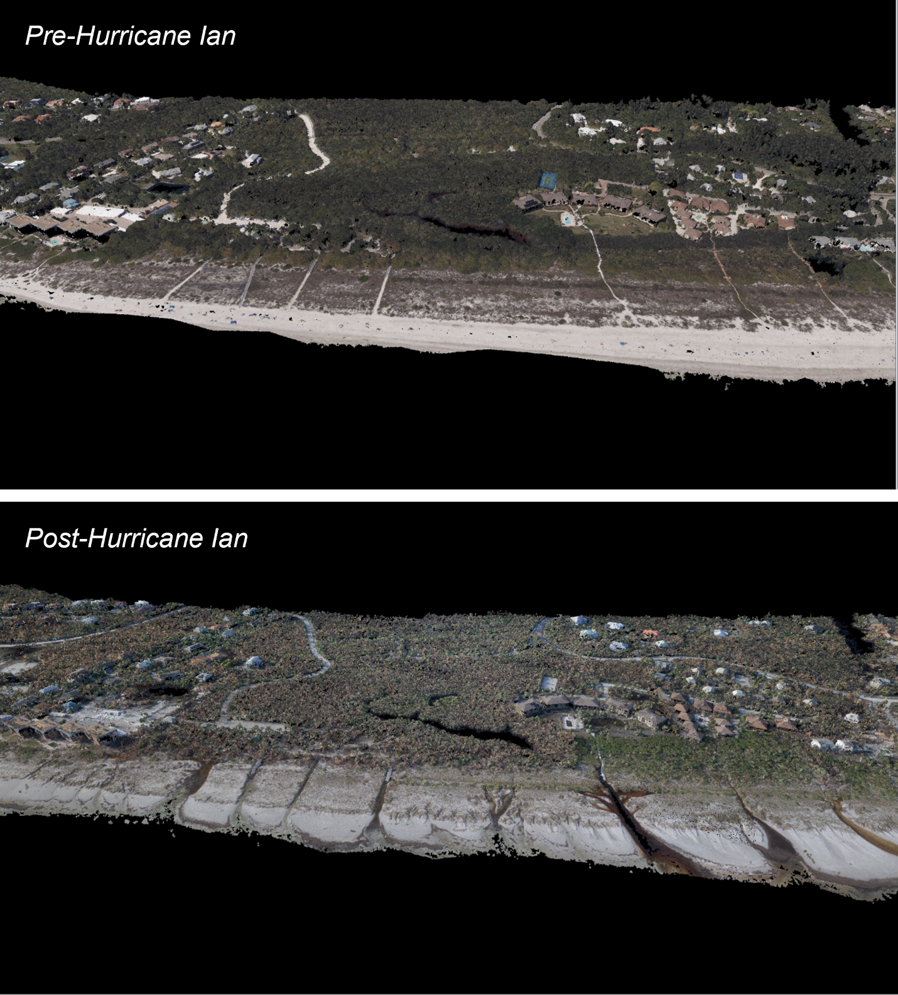
Caption for Graphic or Image: Colorized three-dimensional point cloud data produced using Structure-from-Motion techniques and aerial imagery showing (top) pre-, and (bottom) post-Hurricane Ian coastal conditions observed at Sanibel Island, Florida.
Author name: Jenna A. Brown
Author business email: jennabrown@usgs.gov

DOI agency/bureau2: USGS
USGS Mission Area: Water Resources
USGS Program: **unspecified​**
Cost Center: **unspecified**
Program Name2:
Project title: Assessing 35 years of lake trophic status change in 56,000 lakes across the contiguous US
Project description: USGS Program: Next Generation Water Observing System
USGS Cost Center: Hydrologic Remote Sensing Branch

Lakes are integrators of allochthonous (external) aquatic, terrestrial, and atmospheric inputs as well as autochthonous (internal) processes. In particular, eutrophication and dystrophication are examples of how changes to allochthony or autochthony can lead to shifts in trophic status. Despite being a fundamental limnological metric, understanding the broad spatial and temporal patterns in lake trophic status is limited. To this end, we created the Lake Trophic State – US (LTS-US) dataset by combining remotely sensed Landsat optical reflectance values with in-situ true color and phosphorus data from the U.S. Environmental Protection Agency's National Lake Assessment. This dataset was then used to train classification models of trophic status from satellite imagery. Model accuracy was estimated to be ~76%. Once models were developed, they underwent extensive quality control evaluation to understand why models could misclassify lakes. Lakes were misclassified most frequently when a lake’s constituents were located along a boundary between two trophic state groupings, where models may have a harder time distinguishing the boundaries between categories. In any event, our validation routines suggested that models performed exceptionally well and were able to recreate spatial and temporal patterns documented in the US EPA’s National Lake Assessment, even though models were only given a lake’s annual median red, green, blue, and near-infrared reflectances.
We applied the validated models to 56,000 lakes to conduct a comprehensive nutrient-color assessment of lake trophic status across the contiguous U.S. from 1984 to 2020. Over the 35 year study period, we found that the majority of lakes greater than 10 ha in the US are consistently mixotrophic/eutrophic (~55%). While the proportion of eutrophic/mixotrophic lakes has remained relatively constant, the proportions of dystrophic (i.e., brown) and oligotrophic (i.e., blue) lakes have substantially increased and decreased respectively over the last 35 years. This “brownification” pattern is concentrated in the Upper Midwest and Northern Appalachian regions, where interactions among forest cover, lake morphometry, and acid rain legacy may drive lake dystrophication. Together, these results support previous findings, suggesting that while eutrophication is a pervasive water quality concern, dystrophication is another pathway for lake trophic status change across macroscales.

References and Links for LTS-US
1. Data Product: https://portal.edirepository.org/nis/mapbrowse?scope=edi&identifier=1395
2. Pre-print: https://eartharxiv.org/repository/view/5366/
3. USGS Science Data Catalog: https://data.usgs.gov/datacatalog/data/USGS:26bee400-ee8b-4283-8cf9-050baa61f81d
4. USGS Open Science Success Story: https://www.usgs.gov/special-topics/year-of-open-science/news/lake-trophic-state-us-dataset

Sensor Type: Multispectral (approx. 4-12 bands);
Platform type: Satellite;
URL: https://www.usgs.gov/special-topics/year-of-open-science/news/lake-trophic-state-us-dataset
Graphic or Image Upload: https://doimspp.sharepoint.com/sites/GS-EROSSCIENCESWI/Shared Documents/Apps/Microsoft Forms/DOI RS Activities Report, 2022 (2)/Graphic or Image Upload/LTS_Figure_Tyler King.png
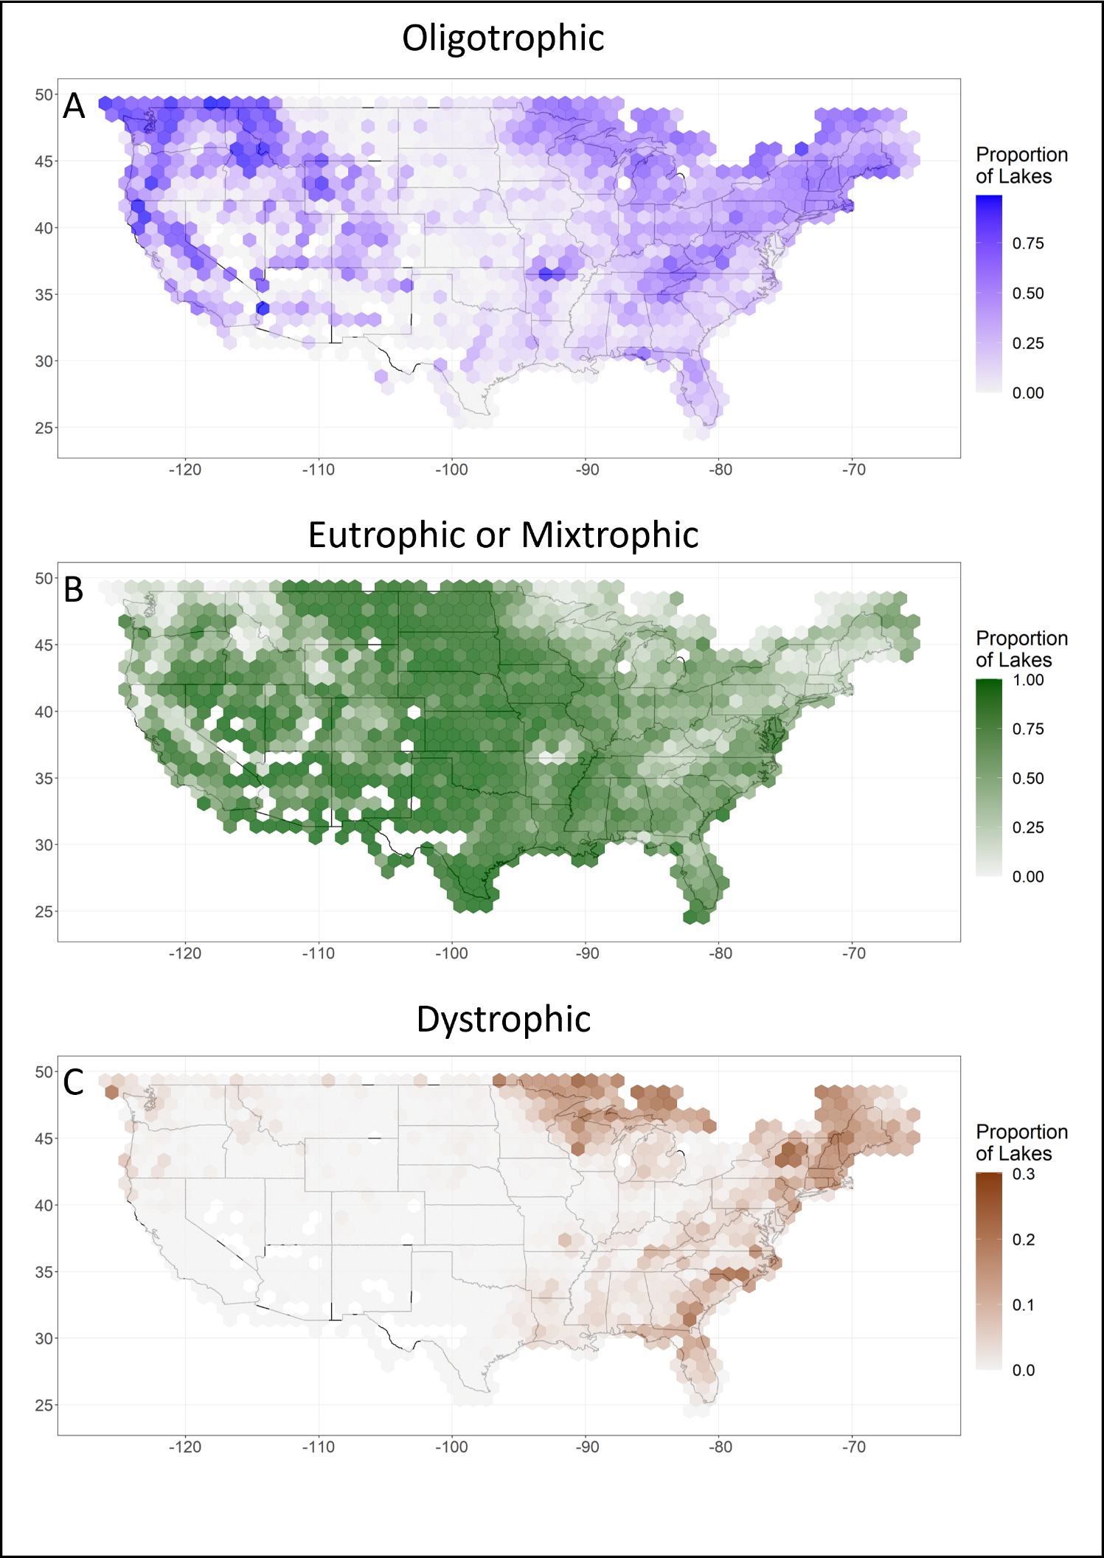
Caption for Graphic or Image: Hexbins of the United States, where hexbins are colored by the proportion of lakes within a given area that are classified as (A) "Oligotrophic", (B) ““Eutrophic or Mixtrophic”, or (C) "Dystrophic”. As expected, (A) oligotrophic lakes tend to be located in the Pacific Northwest, Upper Midwest, and Northeast within the Contiguous U.S., (B) eutrophic and mixtrophic lakes tend to be located in the Great Plains, Southern Plains, and Southeast within the Contiguous U.S., and (C) dystrophic lakes tend to be located in the Northeast within the Contiguous U.S.. However, dystrophic lakes also seem to be concentrated in the Upper Midwest and Coastal Plains. The Upper Midwest and Coastal Plains have anecdotally been associated with lake browning due to an altering hydrological cycle, such as increasing precipitation. We are actively working on understanding drivers of these change.
Author name: Michael Meyer
Author business email: mfmeyer@usgs.gov

DOI agency/bureau2: USGS
USGS Mission Area: Water Resources
USGS Program: **unspecified​**
Cost Center: **unspecified**
Program Name2:
Project title: Remote Sensing of Water Quality
Project description: USGS Program: Next Generation Water Observing System
USGS Cost Center: Hydrologic Remote Sensing Branch

As part of the USGS’ Next Generation Water Observing System Remote Sensing Research and Development Project, we have produced a cloud-based system to apply the dark-spectrum fitting atmospheric correction algorithm in ACOLITE to Sentinel-2 top of atmosphere imagery. This scalable solution allows for simultaneous processing of thousands of images which is necessary to process the nearly 500,000 historical Sentinel-2 images of the continental united states. The resulting aquatic reflectance products will be made publicly available as cloud-optimized geotiffs to support research and development in remote sensing of water quality. An end-user dashboard in being produced to visualize and manipulate water quality datasets derived from the aquatic reflectance datasets.
Sensor Type: Multispectral (approx. 4-12 bands);
Platform type: Satellite;
URL:
Graphic or Image Upload:
Caption for Graphic or Image: Sentinel-2 top of atmosphere imagery (bottom left) is atmospherically corrected to aquatic reflectance (bottom right) using the dark spectrum fitting algorithm in ACOLITE. Atmospheric correction of these images is necessary to produce reflectance spectra (top) used in modeling water quality from satellite imagery.
Author name: Tyler King
Author business email: tvking@usgs.gov

DOI agency/bureau2: USGS
USGS Mission Area: Core Science Systems
USGS Program: National Land Imaging Program
Cost Center: Geosciences and Environmental Change Science Center
Program Name2:
Project title: UAS Mapping of Pleistocene Fossilized Trackways, White Sands National Park, NM
Project description: Although White Sands National Park is widely recognized for its wave-like gypsum sand dunes, this national park is also home to the world’s most extensive collection of fossilized footprints from the Pleistocene epoch. These fossilized tracks were left by ice age megafauna including mammoths, giant ground sloths, dire wolves, and even footprints left by humans along the shores of the ancient Lake Otero in the Tularosa Basin. These footprints are the subject of globally significant archeological research: The oldest human footprints in North America were recently discovered at White Sands, changing the timeline of human arrival in the Americas by nearly 10,000 years (Bennett et al. 2021).

Soil stability, erosion, moisture, and activity at the nearby White Sands Missile Range pose a threat to these ephemeral fossilized tracks. White Sands National Park personnel are exploring the use of uncrewed aircraft systems (UAS) to advance their preservation and applied research capabilities. UAS are scientific tools that could be used to reduce the destructive impact of work around trackway sites and to digitally capture trackways for future studies.

In April 2023, NUSO collected scientific UAS data at White Sands National Park to document trackways before erosion erases them. NUSO collected natural-color and lidar data at a variety of flight altitudes and spatial scales at multiple sites with known fossilized footprints. Note that the UAS data collected at White Sands National Park is protected and not released publicly. It is being utilized by park personnel for resource protection and preservation. The use of drones (UAS) and aircraft is prohibited from flying in the airspace above the park. USGS worked with the National Park Service and White Sands Missile Range to obtain airspace authorizations over the Park within a narrow window of time to conduct this data collection.

Sensor Type: Camera;Lidar (terrestrial or bathymetric);Thermal;
Platform type: UAS;
URL: https://uas.usgs.gov/nupo/missions-2023.shtml#FTrk
Graphic or Image Upload: https://doimspp.sharepoint.com/sites/GS-EROSSCIENCESWI/Shared Documents/Apps/Microsoft Forms/DOI RS Activities Report, 2022 (2)/Graphic or Image Upload/DSM_1_2cm_GSD_Mark Bauer.PNG
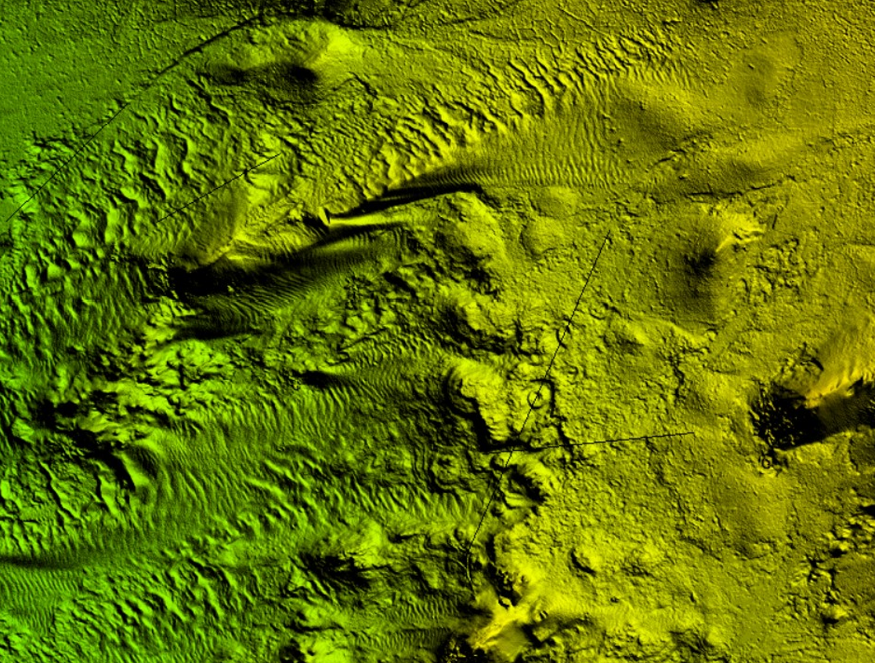
Graphic or Image Upload: https://doimspp.sharepoint.com/sites/GS-EROSSCIENCESWI/Shared Documents/Apps/Microsoft Forms/DOI RS Activities Report, 2022 (2)/Graphic or Image Upload/UAS_image_Mark Bauer.jpg
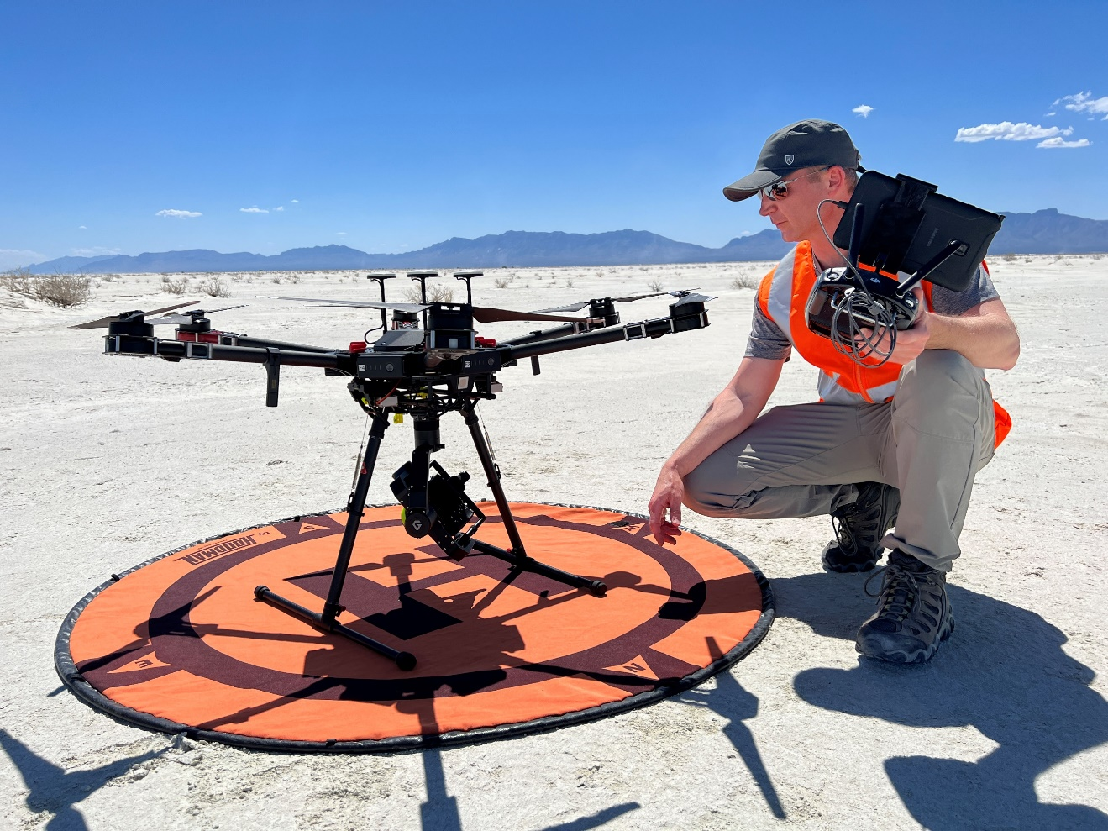
Caption for Graphic or Image: UAS remote pilot Mark Bauer (USGS NUSO) preparing a Sony a7R camera to collect natural-color imagery.

A digital surface model (DSM) with a ground sampling distance of 1.2 cm was acquired over known trackway locations.
Author name: Mark Bauer
Author business email: mabauer@usgs.gov

DOI agency/bureau2: USGS
USGS Mission Area: Water Resources
USGS Program: **unspecified​**
Cost Center: Idaho Water Science Center
Program Name2:
Project title: REmote Aquatic Chlorophyll Tracker (REACT): A Public Web Application for Remote Sensing of Water Quality
Project description: USGS Program: Harmful Algal Bloom Directed Cooperative Matching Funds

The REmote Aquatic Chlorophyll Tracker (REACT https://webapps.usgs.gov/react/) webtool was published by the USGS in 2022 as a public facing application to map aquatic chlorophyll in near-real time from 10 m multispectral satellite imagery. This webtool assists public health officials and waterbody managers in allocating scarce monitoring resources for timely identification and mapping of potentially harmful algal blooms. The application is based on a 2022 USGS authored journal article (https://doi.org/10.1117/1.JRS.16.044522) that demonstrated success in using an ensemble approach to classifying aquatic chlorophyll concentrations. The same publication demonstrated an approach to address the very common data limitation issue that arises in evaluating remote sensing of water quality methods. Classification models developed from a supervised point classification routine were shown to perform almost as well as models developed on in-situ sample collection alone while an assimilation of in-situ and image derived datasets produced the best performing model capable to accurately classifying chlorophyll concentrations more than 80% of the time.

This trained aquatic chlorophyll ensemble model is now operationally applied to new imagery as it is collected to produce weekly maps of aquatic chlorophyll in 2 dozen waterbodies in Idaho. To facilitate further adoption, relative chlorophyll and turbidity products computed are also provided at the global scale for imagery from 2019 to present. Data summary and extraction tools are provided to place a given image in context.

Sensor Type: Multispectral (approx. 4-12 bands);
Platform type: Satellite;
URL: https://webapps.usgs.gov/react/
Graphic or Image Upload: https://doimspp.sharepoint.com/sites/GS-EROSSCIENCESWI/Shared Documents/Apps/Microsoft Forms/DOI RS Activities Report, 2022 (2)/Graphic or Image Upload/Picture2_Tyler King 1.jpg
Caption for Graphic or Image: REACT application screenshot showing hot spots of elevated aquatic chlorophyll in Brownlee Reservoir from 8 Sept 2023.
Author name: Tyler King
Author business email: tvking@usgs.gov

DOI agency/bureau2: USGS
USGS Mission Area: Natural Hazards
USGS Program: Coastal and Marine Geology Program
Cost Center: Woods Hole Coastal and Marine Science Center
Program Name2:
Project title: Aerial Imagery Reveals Erosion and Recovery of a Barrier Island
Project description: The Remote Sensing Coastal Change (RSCC) project had just begun acquiring high-resolution aerial imagery of the Outer Banks of North Carolina when Hurricane Dorian struck (September 2019). The storm just brushed the tip of Cape Hatteras, but the category 1 winds at first caused substantial flooding in the upper reaches of Pamlico Sound, and then reversed to force a 2-m storm surge onto the sound (back) side of North Core Banks, a low-lying barrier island in Cape Lookout National Seashore. The floodwaters inundated the island and poured into the ocean through gaps in the primary dune line, cutting deep channels. In all, about 16% of the island volume was washed into the nearshore, and a great expanse of habitat ideal for endangered shore birds was created.

We acquired a set of more than 2,000 images from a small plane flying along the Outer Banks a week before the storm, and a second set days afterwards. The camera was navigated with ~10-cm accuracy and the images overlapped by 60% with a ground sampling distance of a ~6 cm. Using advanced 4D structure-from-motion photogrammetry, we produced detailed orthomosaics and digital elevation models with vertical accuracy of ~8 cm. We have since mapped the island more than a dozen times, and are documenting a gradual recovery process as the outwash channels fill with marine sands delivered by overwash. Normally we would expect wind-blown sand, trapped by new vegetation, to begin forming proto-dunes, but the revegetation process has been very slow, leading us to wonder if the recovery process from these sound-side events is inherently different from more common ocean-side impacts.

This is one example of how high-resolution aerial imagery and analysis by the RSCC team has provided us with detailed information on storm-induced changes to both landforms and habitats. These results provide our partners at the National Park Service with actionable information they use to manage their natural and cultural resources.
Sensor Type: Camera;
Platform type: Airplane;
URL: https://www.usgs.gov/centers/pcmsc/science/remote-sensing-coastal-change
Graphic or Image Upload: https://doimspp.sharepoint.com/sites/GS-EROSSCIENCESWI/Shared Documents/Apps/Microsoft Forms/DOI RS Activities Report, 2022 (2)/Graphic or Image Upload/Fig_4_Pre_Post_Map_Christopher Sherwood.jpg
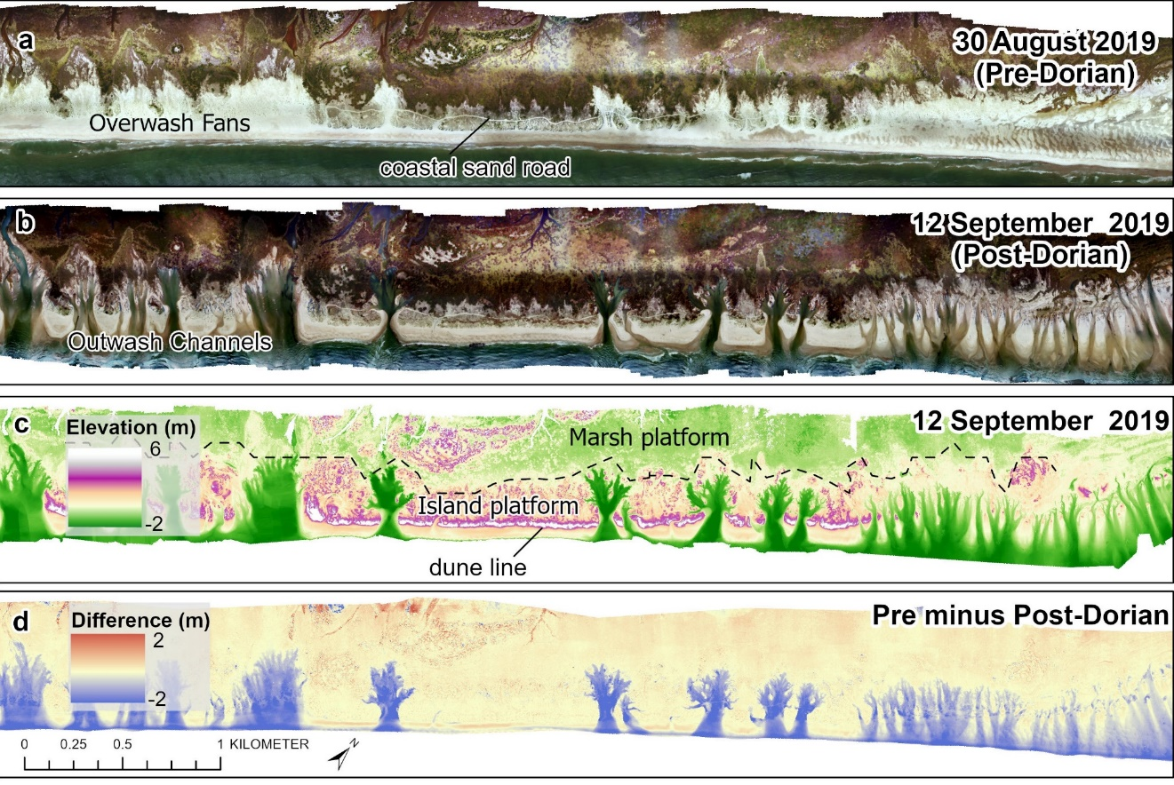
Caption for Graphic or Image: Structure-from-motion photogrammetry products from North Core Banks, Cape Lookout National Seashore, North Carolina. Orthomosaics (0.25-m cells) from (a) pre-Hurricane Dorian survey and (b) post-Dorian survey, (c) digital surface model (1-m grid, ~8-cm vertical accuracy) from the post-Dorian survey, and (d) difference map (post-Dorian minus pre-Dorian), where blue indicates erosion. Extensive washover from Hurricane Florence (2018) is visible in panel (a). Washout channels (b–d) eroded up to 2 m and occupy much of the washover fans. Location of a cross-island channel is marked with an asterisk (*) in panel (b). The sound side is at the top and the ocean is at the bottom of each panel.
Author name: Chris Sherwood, Jin-Si Over, Jon Warrick, Jenna Brown, Andy Richie, Dan Buscombe
Author business email: csherwood@usgs.gov

DOI agency/bureau2: USGS
USGS Mission Area: Natural Hazards
USGS Program: Coastal/Marine Hazards and Resources Program
Cost Center: St. Petersburg Coastal and Marine Science Center
Program Name2:
Project title: Understanding patterns of habitat creation and loss for coastal species
Project description: Although coastal storms have negative consequences for human lives and infrastructure, they are also important natural disturbances that create early successional habitats critical for many species. Early successional coastal habitats are typically flat with minimal to no vegetation—conditions that are created as waves push sand landward and scour existing vegetation in a process known as overwash. Ground-nesting shorebirds like piping plovers (Charadrius melodus) rely on these open overwash features for nesting throughout the species’ Atlantic coast breeding range. In periods between storms, as coastal dunes redevelop and vegetation regrows, early successional habitats used by piping plovers slowly disappear until the next storm. It is important for conservation management to understand these cycles of habitat creation and loss so that natural resource managers can, for example, estimate how much habitat might be available in any given year, plan for changes in these cycles as storm frequency and intensity alter with climate change, and protect areas that reliably contain habitat each year.

Scientists from the U.S. Geological Survey’s St. Petersburg and Woods Hole Coastal and Marine Science Centers are working with managers from the U.S. National Park Service at Cape Lookout National Seashore to learn more about these cycles of habitat creation and loss. The team is using high-resolution aerial imagery and lidar-derived digital elevation models (DEMs) to produce a time series of habitat maps for the Seashore’s three barrier islands (Shackleford Banks, South Core Banks, and North Core Banks). The team is employing machine learning image classification and other remote sensing tools along with manual digitization techniques to produce raster-based maps (5x5 m resolution) of landcover, geomorphic setting, substrate type, vegetation type and density, distance from every raster cell to the (mean high water) ocean shoreline and to low-energy foraging areas (e.g., inlet shorelines), and elevation. These maps are processed through a Bayesian network that assigns a probability to every raster cell that that location would support piping plover habitat, given the aforementioned landscape characteristics in that cell. We are repeating this analysis for aerial imagery and DEMs captured in 2014, 2017, 2018, 2019, and 2022 to produce habitat maps for each year. We will compare the location and amount of habitat predicted across years to better understand these storm-induced cycles of habitat creation and loss.

Sensor Type: Lidar (terrestrial or bathymetric);Multispectral (approx. 4-12 bands);Camera;
Platform type: Airplane;
URL: https://www.usgs.gov/centers/whcmsc/science/beach-dependent-shorebirds
Graphic or Image Upload: https://doimspp.sharepoint.com/sites/GS-EROSSCIENCESWI/Shared Documents/Apps/Microsoft Forms/DOI RS Activities Report, 2022 (2)/Graphic or Image Upload/ZeiglerEtAl_FY23RemoteHighlights_Figure_Sara Zeigler.jpg
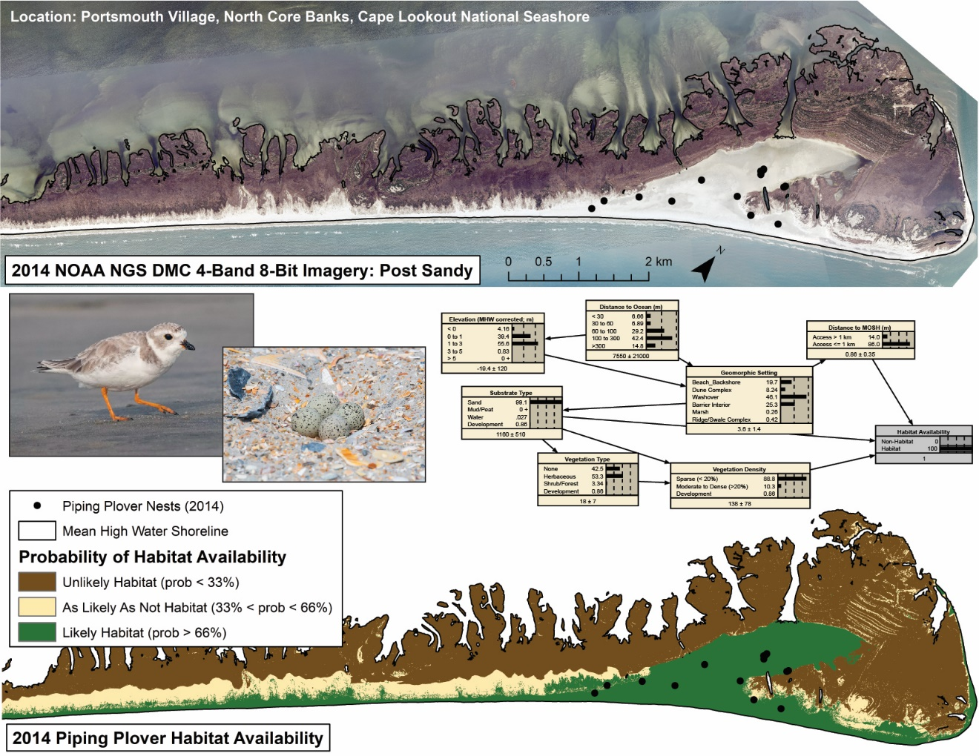
Caption for Graphic or Image: USGS scientists are using aerial imagery and lidar to create maps of landscape characteristics important for piping plover habitat suitability. Landscape maps are combined and processed through a probabilistic Bayesian network (here, showing conditions associated with nest locations) to create habitat availability maps, where each raster cell is given a probability of containing piping plover habitat given underlying landscape characteristics. Piping plover photos are public domain and captured by Morgan Barnes, U.S. National Park Service.
Author name: Sara Zeigler, Alexandra Evans, Kathryn Weber, Jin-Si Over, and Christopher Sherwood
Author business email: szeigler@usgs.gov

DOI agency/bureau2: USGS
USGS Mission Area: Core Science Systems
USGS Program: National Land Imaging Program
Cost Center: Western Geographic Science Center
Program Name2:
Project title: A tool for rapid-repeat high-resolution coastal vegetation maps to improve forecasting of hurricane impacts and coastal resilience
Project description: Along the U.S. East Coast and the U.S. Gulf of Mexico coast, natural coastal vegetated ecosystems play a key role in providing pathways to designing and implementing nature-based solutions for reducing hurricane impacts. Extensive research shows that vegetation cover significantly mitigates coastal flooding, erosion, and barrier island breaching during extreme storms. Coastal numerical models that predict hurricane impacts utilize vegetation characteristics mapped onto spatially varying grids. Thus, coastal modelers are seeking simple and efficient ways to obtain up-to-date and accurate coastal vegetation maps to forecast coastal change and quantify the benefits of vegetation in reducing hurricane impacts. This project addresses this critical need by leveraging Planet Lab’s imagery API, a robust pre-trained random forest machine learning model, and newly available Planet Labs 8-band, 3-m daily images provided through the NASA Commercial Smallsat Data Acquisition (CSDA) program freely available to Federal employees and contractors. The application will be provided as a Jupyter Notebook that is capable of: 1) automatically downloading Planet Super Dove satellite images through the Planet API; 2) clipping images to coastal vegetated areas and masking clouds; and 3) using a pre-trained machine learning model to generate vegetation maps. The remote sensing modeling approach employs a reliable random forest machine learning technique for image classification that is transferable across a large geographic region. The pre-trained model has 93% overall accuracy and is trained on project areas within three states (North Carolina, Louisiana, and Florida). This application can also be used for a wide array of ecosystem research purposes, including coastal zone habitat management and climate adaptation studies.

Sensor Type: Multispectral (approx. 4-12 bands);
Platform type: Satellite;
URL: https://www.usgs.gov/index.php/centers/community-for-data-integration-cdi/science/a-tool-rapid-repeat-high-resolution-coastal
Graphic or Image Upload: https://doimspp.sharepoint.com/sites/GS-EROSSCIENCESWI/Shared Documents/Apps/Microsoft Forms/DOI RS Activities Report, 2022 (2)/Graphic or Image Upload/Image_edited_Chak Wa (Contractor).png
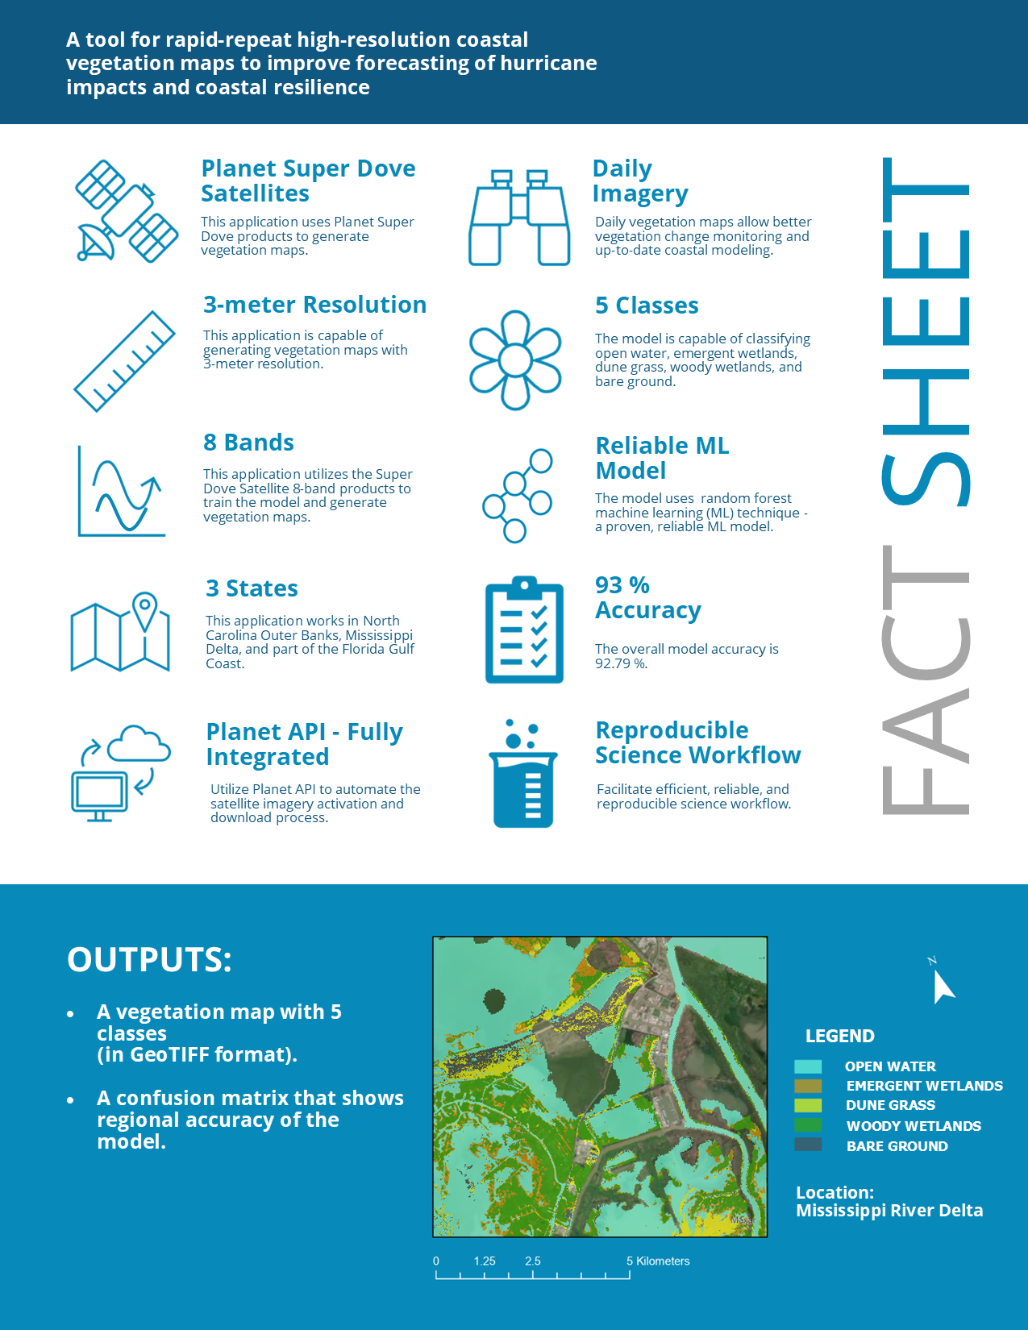
Caption for Graphic or Image: A fact sheet that describes the functionality of the Jupyter Notebook Application.
Author name: Chak Wa Cheang, Kristin B. Byrd, Nicholas M. Enwright, Dean Gesch, and Daniel Buscombe
Author business email: ccheang@contractor.usgs.gov

DOI agency/bureau2: USGS
USGS Mission Area: Water Resources
USGS Program: Land Change Science
Cost Center: Western Geographic Science Center
Program Name2:
Project title: Monitoring and Mapping Mercury Pollution Associated with Atmospheric Rivers in South San Francisco Bay
Project description: Mercury is a neurotoxin which has polluted the San Francisco Bay, California, U.S.A since the Gold-rush era. Mercury pollution comes from both historical mining and modern-day sources. It poses risks to wildlife and human health through bioaccumulation, causing a wide range of impairments at higher trophic levels. Extreme weather events, such as atmospheric rivers, can lead to increased transport of mercury through watersheds. Between fall 2022 and spring 2023, the San Francisco Bay area was hit by a sequence of severe atmospheric rivers, triggering several runoff events which impacted water quality within the Bay. Our previous studies have mapped mercury by taking advantage of the biogeochemical relationships between 1) Colored Dissolved Organic Matter (CDOM) and dissolved mercury and methylmercury, and 2) Total Suspended Sediments (TSS) and particulate mercury and methyl mercury. We are using this strategy to map mercury in South San Francisco Bay, starting by generating a Sentinel-2 satellite image time series of CDOM and TSS over the course of the atmospheric river events from October 2022 through April 2023. The time series includes large fluxes of CDOM and TSS in January and March 2023 at creek outflows, and we are investigating if similar changes in mercury happened in the bay. Future research will aim to quantify these changes, improve our satellite retrievals and mercury model, and provide water quality context to bay-wide managers and restoration groups.
Sensor Type: Multispectral (approx. 4-12 bands);
Platform type: Satellite;Ground based / sensor web / web cam;
URL: https://www.usgs.gov/centers/western-geographic-science-center/science/remote-sensing-mercury-pollution-south-san
Graphic or Image Upload: https://doimspp.sharepoint.com/sites/GS-EROSSCIENCESWI/Shared Documents/Apps/Microsoft Forms/DOI RS Activities Report, 2022 (2)/Graphic or Image Upload/20230119rgb_Nicole Taylor.png
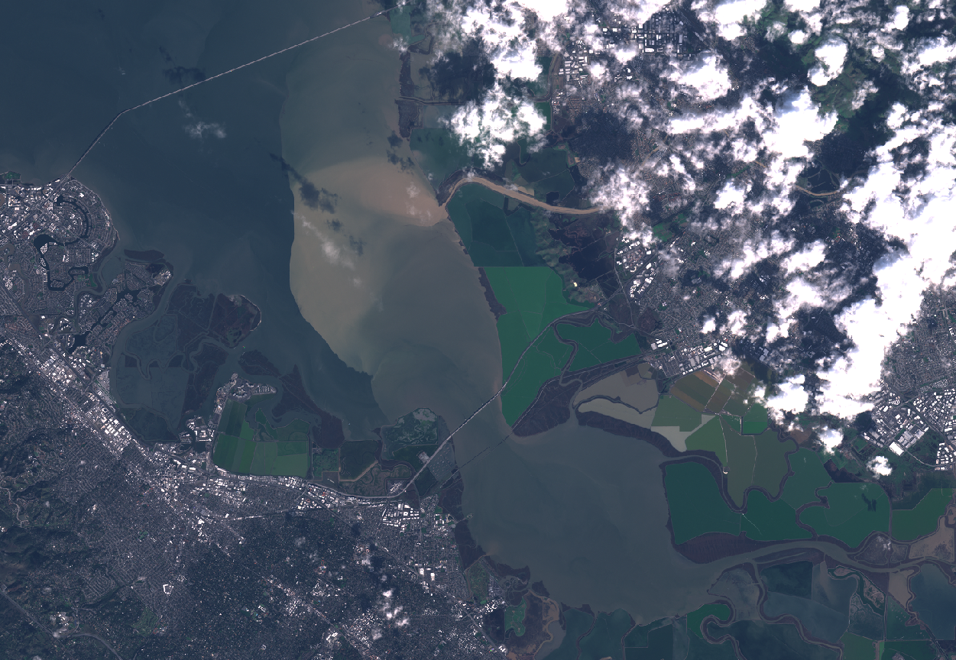
Caption for Graphic or Image: A Sentinel-2 image from January 9, 2023, the day after the largest atmospheric river event concluded the first wave of storms in the Bay Area. A large outflow of murky water is visible extending out of Alameda Creek and into the bay.
Author name: Niky Taylor
Author business email: ntaylor@usgs.gov

DOI agency/bureau2: USGS
USGS Mission Area: Core Science Systems
USGS Program: National Geospatial Program
Cost Center: NGTOC Denver
Program Name2:
Project title: Using Imagery to Crowdsource The National Map
Project description: The National Map Corps (TNMCorps), a crowdsourced mapping project, relies on volunteers to assist the USGS National Geospatial Program by collecting and editing man-made structures data for The National Map. Through their participation, volunteers make important contributions to the USGS’s ability to provide the Nation with accurate mapping information.
Volunteers collect and update different structure feature types in all 50 states, as well as in Puerto Rico and the U.S. Virgin Islands. The Pacific Territories were added in 2022. The structure feature types include schools, colleges and universities, fire and emergency management stations, law enforcement, prisons and correctional facilities, hospitals, ambulance services, cemeteries, post offices, courthouses, and city/town halls. Through a tiered-editing approach, volunteers improve the structures data by adding new features, removing obsolete points, and correcting existing data. The updates are then incorporated into The National Map and ultimately into U.S. Topo maps. As of August 2023, more than 3,700 users have made more than 880,000 edits to over 600,000 unique points.
Getting started is easy. After walking through a simple registration process, volunteers begin editing using an internally developed web-based mapping platform that was released in August 2016. The primary base layer uses The National Map Web services and consists primarily of 1-meter resolution digital orthophoto imagery provided by the U.S. Department of Agriculture National Aerial Imagery Program (NAIP), which is supplemented by 2-foot or better high-resolution orthoimagery over urban areas.
TNMCorps incorporates a variety of strategies to motivate and engage volunteers while simultaneously facilitating focused data collection resulting in high-quality data. These strategies include the tiered-editing process, mapping challenges, virtual recognition badges, social media engagement, bi-monthly newsletters, and regular news releases. Volunteers are from the general public and include retirees, students, geospatial professionals, and anyone with an interest in contributing to The National Map.

https://www.usgs.gov/core-science-systems/ngp/tnm-corps
Sensor Type: Camera;
Platform type: Airplane;
URL: https://www.usgs.gov/core-science-systems/ngp/tnm-corps
Graphic or Image Upload: https://doimspp.sharepoint.com/sites/GS-EROSSCIENCESWI/Shared Documents/Apps/Microsoft Forms/DOI RS Activities Report, 2022 (2)/Graphic or Image Upload/2023.08_status_map_Erin Korris.png
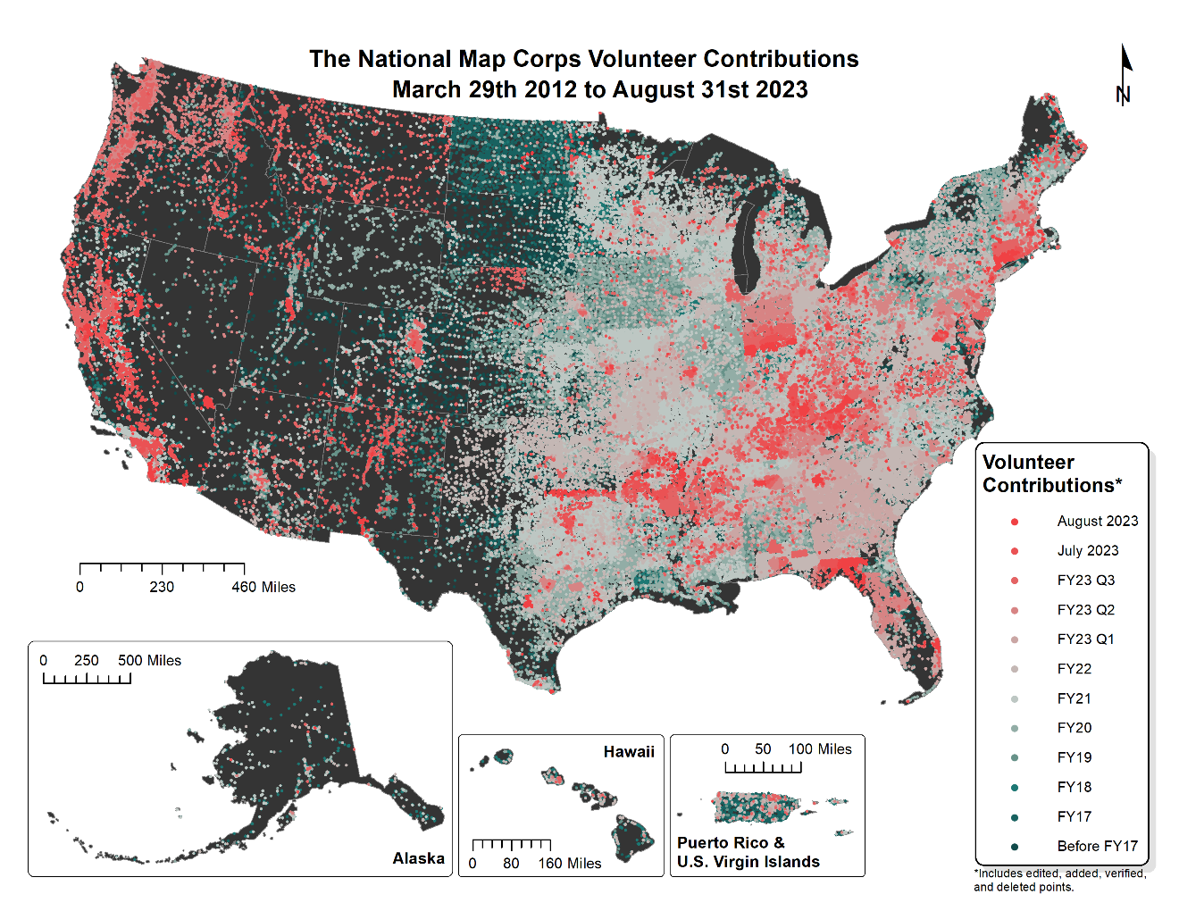
Caption for Graphic or Image: USGS TMNCorps volunteer contributions from March 29, 2012, to August 31, 2023. Each point on the map represents a single volunteer-edited structure feature. These volunteer contributions include edited, added, verified, and deleted points.
Author name: Erin Korris
Author business email: ekorris@usgs.gov

DOI agency/bureau2: USGS
USGS Mission Area: Core Science Systems
USGS Program: Land Change Science
Cost Center: Western Geographic Science Center
Program Name2:
Project title: Detecting Early Season Invasive Plants Using Remote Sensing to Inform Monitoring, Control, and Restoration
Project description: Early-season invasive (ESI) annual grasses such as cheatgrass (Bromus tectorum) have heavily invaded portions of the western United States, rapidly degrading habitats and increasing wildfire risk. Cheatgrass and other ESIs are an emerging threat to the Greater Yellowstone Ecosystem (GYE) as climatic changes, including earlier snowmelt/run-off and warmer spring temperatures, have made the region more suitable for invasive annuals. Wildlife movement and migration can act as vectors for spread and disturbances from human recreation and natural sources aid invasion. ESIs often out-compete native species, have recently expanded at a rapid rate, and pose a threat to wildlife and biodiversity in the internationally known GYE. To address these challenges, managers need high-resolution data on ESI cover to quantify change as well as to develop and prioritize management strategies to address small early-stage infestations. We are developing multi-scale methods to capture the phenology of cheatgrass with harmonized Landsat and Sentinel satellite imagery, high resolution Planet imagery, and experimenting with centimeter-scale uncrewed areal systems (UAS) multispectral imagery. In other studies, time-series analysis techniques show great utility in identifying infestations through the differencing of early-season peak greenness and mid-summer cheatgrass senescence. With field-based training and validation data we will train machine learning models on our seasonal variety of imagery sources to identify ESI infestations and compare the efficacy of different imagery sources on model performance. With input from National Park Service (NPS), US Forest Service, and Country weed managers we are co-producing early detection tools, high-resolution map products to quantify change at management-relevant scales and giving assistance prioritizing management actions considering changing climatic conditions and the spread of invasive annuals.
Sensor Type: Multispectral (approx. 4-12 bands);
Platform type: UAS;Satellite;
URL: https://www.usgs.gov/centers/western-geographic-science-center/science/remote-sensing-invasive-annual-grasses
Graphic or Image Upload: https://doimspp.sharepoint.com/sites/GS-EROSSCIENCESWI/Shared Documents/Apps/Microsoft Forms/DOI RS Activities Report, 2022 (2)/Graphic or Image Upload/UAS and group gardiner_Jason Kreitler.JPG
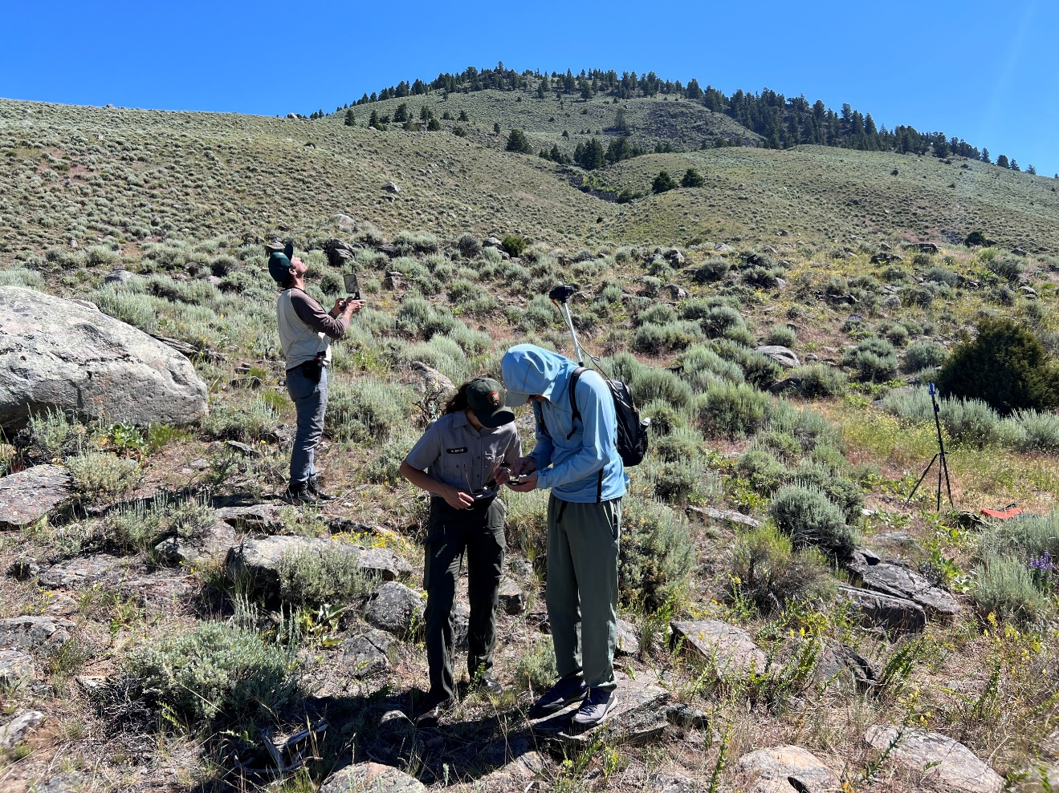
Caption for Graphic or Image: Jason Kreitler (USGS) and Marnie Brice (NPS) work on collecting training/validation data with high-precision GPS while Josh Vonn Nonn (USGS) operates an uncrewed aerial system (UAS) to detect cheatgrass (Bromus tectorum) near Gardiner, MT, outside of Yellowstone National Park. (Photo credit Miguel Villarreal USGS).
Author name: Jason Kreitler
Author business email: jkreitler@usgs.gov

DOI agency/bureau2: USGS
USGS Mission Area: Ecosystems
USGS Program: **unspecified​**
Cost Center: Southwest Biological Science Center
Program Name2:
Project title: Habitat mapping at hot springs fed wetlands
Project description: Remote sensing scientists from the US Geological Survey (USGS) Southwest Biological science Center (SBSC), in cooperation with US Fish and Wildlife and the USGS Western Ecological Research Center (WERC), investigated land cover within geothermal spring-sourced wetland areas in Dixie Valley, Nevada USA. These wetland areas are important habitat for a variety of endemic plant and wildlife species, including the Dixie Valley toad (Anaxyrus williamsi). The volume and temperature of water in the wetlands changes seasonally and interannually due to surface water and geothermal groundwater interactions, and so to better understand habitat, SBSC analyzed 110 images collected by the European Space Agency’s Sentiniel-2A satellite from October 2015 to January 2022. These images were classified as five distinct land cover types based on inferred differences in vegetation and surface water using the Green Normalized Difference Vegetation Index (gNDVI) and its inverse relationship to the Normalized Difference Water Index (NDWI). Land cover classes were defined as bare soil or dry/senescent vegetation (Classes 1 and 2 undistinguished), dense green vegetation (Class 3), mixed shallow water and vegetation (Class 4), and open water (Class 5; Fig 1). SBSC scientists mapped the areal coverage of these five land cover classes for approximately 385 acres comprising six individual wetland complexes as well as a larger 1,298-acre (5,254,000 m2) area of interest inclusive of the wetland complexes and adjacent landscape. As validation, the relative wetness of soil conditions for each land cover class within the study area was estimated by comparison to previously published observations of sub-daily relative conductivity measured by 79 field-based loggers within the wetlands from 2019 to 2021 (https://doi.org/10.5066/P95BHQXT).

Results of this land cover classification (https://doi.org/10.5066/P90U1VAM) show a strong agreement with the 2019-2021 sub-daily moisture observations. Class 5 was primarily within ponds at one of the wetland complexes and comprised 8,333 m2, on average, of the wetland complexes. Class 4 comprised 111,723 m2 on average of the wetland complexes with vegetation and frequent (>71% of observations) underlying surface water or saturated soil conditions. Class 3 contained dense green vegetation that often (46% of observations) had underlying surface water or saturated soil conditions and comprised 592,522 m2 on average of the wetland complexes. Classes 2 and 1 had vegetation or bare soil cover and frequently (>= 67% of observations) had dry soil conditions. This investigation of land cover could inform future efforts to map land cover more precisely via higher resolution remote sensing or ground-based surveying or could be incorporated with other environmental monitoring data to characterize habitat and hydrology of the wetland complexes at Dixie Meadows.
Sensor Type: Multispectral (approx. 4-12 bands);
Platform type: Satellite;
URL: https://doi.org/10.5066/P90U1VAM
Graphic or Image Upload: https://doimspp.sharepoint.com/sites/GS-EROSSCIENCESWI/Shared Documents/Apps/Microsoft Forms/DOI RS Activities Report, 2022 (2)/Graphic or Image Upload/DixieMeadowsRSHighlight_Joshua Caster.jpg
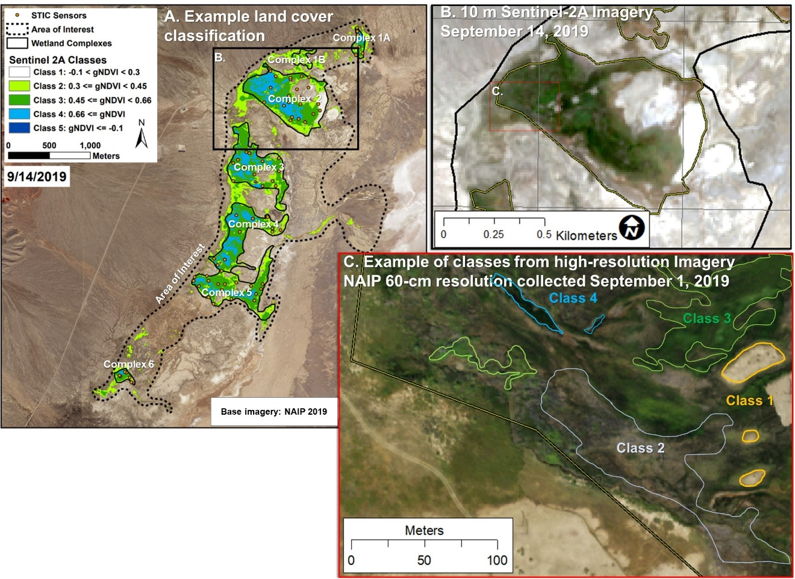
Caption for Graphic or Image: Figure 1. Satellite image classification at the Dixie Meadows geothermal hot springs wetland complex. A. Example of the green Normalized Difference Vegetation Index (gNDVI) classification of land cover within a Sentinal-2A satellite image collected on September 14, 2019 (https://doi.org/10.5066/P90U1VAM). Classifications were limited to an area-of-interest surrounding seven wetland complexes that were monitored by Stream Temperature, Intermittency, and Conductivity (STIC) sensors at sub-daily intervals. B. A zoomed view of the 10 m-resolution Sentinel imagery at one of the wetland complexes to compare with (C) the 0.6 m-resolution National Agricultural Imagery Program (NAIP) imagery that was used to identify the five land cover classes.
Author name: Joshua Caster, Nathaniel Bransky, Joel B. Sankey
Author business email: jcaster@usgs.gov

DOI agency/bureau2: USGS
USGS Mission Area: Ecosystems
USGS Program: **unspecified​**
Cost Center: Southwest Biological Science Center
Program Name2:
Project title: Lidar, vegetation, and archaeological sites in Grand Canyon
Project description: Along the Colorado River in Grand Canyon National Park, Arizona, many archaeological sites are partially buried by wind-blown sand that is sourced from adjacent river sandbars. Burial by sand can help protect archaeological sites from surface weathering but, following six-decades of operations by the upstream Glen Canyon Dam, river sand supplies have been reduced and altered stream flows have promoted vegetation encroachment that has further reduced availability of sediment (https://doi.org/10.1016/j.jenvman.2023.118036). The decrease in supply of river-sourced sand makes sites more vulnerable to erosion by gullying processes. The Grand Canyon Monitoring and Research Center (GCMRC) in cooperation with Grand Canyon National Park (GCNP) are using lidar remote sensing to evaluate whether experimental removal of invasive riparian vegetation located between river sandbars and downwind dunefields can increase the resupply of wind-blown sediment to archaeological sites and thus increase the probability of achieving resource management goals to preserve sites in-situ (https://www.nps.gov/articles/000/parks-look-for-ways-to-alleviate-glen-canyon-dams-downstream-impacts.htm). Example lidar remote sensing datasets illustrate the topographic and vegetation canopy changes over time (Figure 1).
Sensor Type: Camera;Lidar (terrestrial or bathymetric);
Platform type: Ground based / sensor web / web cam;
URL: https://www.nps.gov/articles/000/parks-look-for-ways-to-alleviate-glen-canyo n-dams-downstream-impacts.htm
Graphic or Image Upload: https://doimspp.sharepoint.com/sites/GS-EROSSCIENCESWI/Shared Documents/Apps/Microsoft Forms/DOI RS Activities Report, 2022 (2)/Graphic or Image Upload/VegFigure_Joshua Caster.jpg
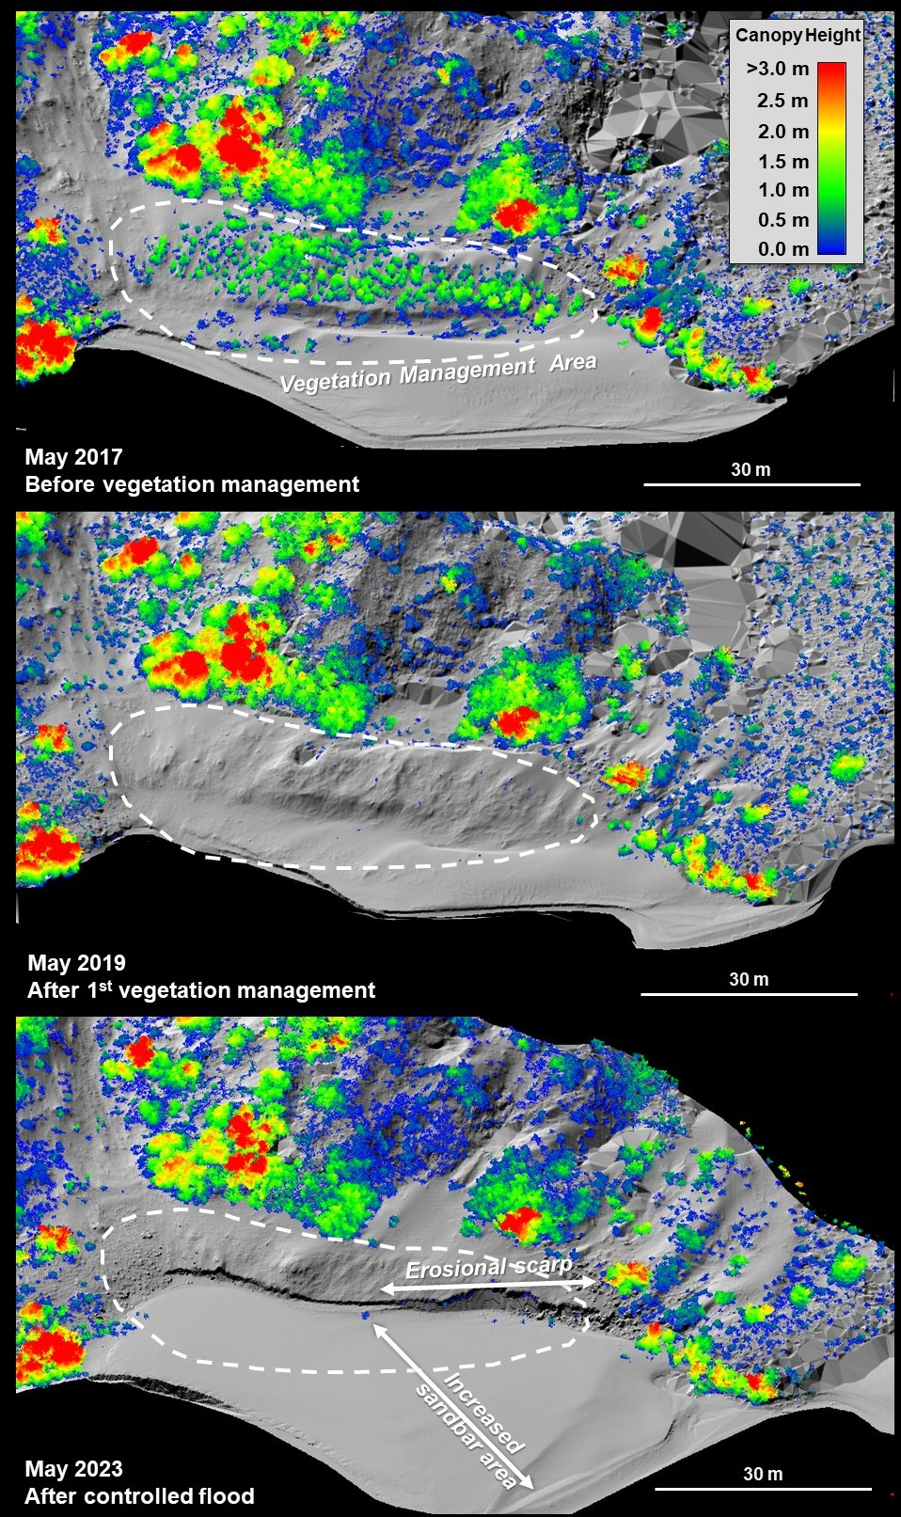
Caption for Graphic or Image: Figure 1: Example of ground-based lidar remote sensing datasets from an experimental vegetation management area on a river sandbar within Grand Canyon National Park, Arizona. Three topographic relief models collected in 2017 (top) before National Park Service vegetation treatments, 2019 (middle) one month after the first NPS vegetation treatments, and 2023 (bottom) after five annual NPS vegetation treatment and a week after a controlled flood release out of Glen Canyon Dam. Vegetation canopy heights (colored) demonstrate the reduction in vegetation within the target area.
Author name: Joshua Caster, Joel B. Sankey, Nathaniel Bransky
Author business email: jcaster@usgs.gov; nbransky@usgs.gov; jsankey@usgs.gov

