DOI agency/bureau2: FWS
USGS Mission Area:
USGS Program:
Cost Center:
Program Name2: Division of Migratory Bird Management, Branch of Migratory Bird Surveys
Project title: Enhancing Migratory Bird Surveys with Thermal Imagery and Deep Learning
Project description: The U.S. Fish and Wildlife Service (USFWS) Division of Migratory Bird Management is aiming to improve upon migratory bird surveys by combining aerial remote sensing with deep learning (a form of artificial intelligence) analyses to automate survey counts. The goal is to provide accurate wildlife counts while reducing risk to pilots by conducting aerial surveys at higher altitudes. In partnership with the College of William and Mary, USFWS has previously demonstrated that thermal remote sensing technology, coupled with deep learning, can provide accurate counts of sandhill cranes (Antigone canadensis) at night during their critically important migratory stopover in the Platte River Valley of Nebraska. In spring of 2023, the project went from a demonstration assessment to a full, operational survey of all areas used by sandhill cranes in the region, including the collection of more than 75,000 nighttime thermal images while the birds were roosting on or near the Platte and North Platte Rivers. In addition, researchers obtained thermal imagery in places where ducks and geese were congregating. Challenges, such as the detection of nontarget species and dealing with large datasets, will be addressed with application and/or development of artificial intelligence detection algorithms. Spatial locations of sandhill cranes will be derived. The result will be the first complete survey of roosting sandhill cranes on the Platte River and will show these innovative surveys can be accomplished at a broad spatial scale. The USFWS has also begun collaborating with the U.S. Geological Survey Northern Prairie Wildlife Research Center, the Crane Trust, and the International Crane Foundation to advance these thermal imagery surveys.
Sensor Type: Camera;Thermal;
Platform type: Airplane;
URL:
Graphic or Image Upload: https://doimspp.sharepoint.com/sites/GS-EROSSCIENCESWI/Shared Documents/Apps/Microsoft Forms/DOI RS Activities Report, 2022 (2)/Graphic or Image Upload/SACR thermal_Bradley Pickens.png
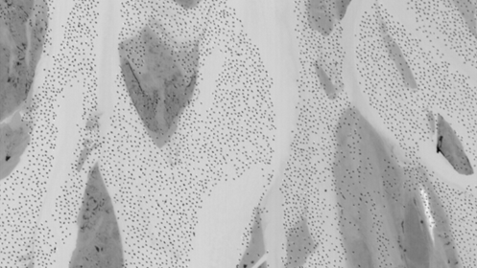
Caption for Graphic or Image: A single thermal image obtained from an aircraft 2,400 ft above ground level of the Platte River in Nebraska, USA. The image shows roosting sandhill crane at night over the Platte River (light color indicating relatively warm temperatures) and sandbars (dark colors representing colder temperatures).
Author name: Bradley Pickens
Author business email: bradley_pickens@fws.gov

DOI agency/bureau2: FWS
USGS Mission Area:
USGS Program:
Cost Center:
Program Name2: Division of Migratory Bird Management
Project title: Applying Deep Learning to Detect and Classify Ocean Wildlife
Project description: The U.S. Fish and Wildlife Service (FWS) is using airborne remote sensing technologies to improve aerial migratory bird surveys. Project objectives are to 1) enhance safety of aircrews by allowing flight at higher altitudes and 2) improve the quality of wildlife population data by minimizing errors and quantifying uncertainty. Deep learning methods are being advanced to automate data processing and improve the cost-efficiency of remote sensing technologies for surveys covering broad geographic areas and generating very large image datasets. The FWS is partnering with the Bureau of Ocean Energy Management (BOEM), U.S. Geological Survey (USGS), academic institutions, and private contractors to accomplish these objectives. Initial focus has been on marine bird and other wildlife surveys given overlapping agency requirements for these data. The project is part of the Atlantic Marine Assessment Program for Protected Species (AMAPPS). Because of the focus on marine wildlife, the project has implications for informing renewable energy development and may increase the efficiency of both public and private environmental monitoring programs. In fiscal year 2023, FWS, with support from BOEM, outfitted a second aircraft with advanced remote sensing technology to be stationed on the Atlantic coast. The two aircraft stationed in Florida and Maine will assist in covering the broad geography where data collection is needed. This updated system includes hardware and software to collect imagery at sub-cm spatial resolution with georeferencing support. The collaboration has now collected more than 3 million images in the marine environment, spanning from Marine to Florida. A cutting-edge artificial intelligence/deep learning algorithm has been developed to automatically detect seabirds in imagery. Onboard hardware and software enable image processing and machine learning computations while in flight. This detection algorithm has higher than 90% accuracy across a wide range of taxa. Avian experts are now labeling species in imagery to provide training data for future species classification models. Preliminary results of deep learning models to classify species have shown promising results, but a wide breadth of imagery will need to be examined to ensure model predictions can be reliably applied to new imagery that is obtained. Overall, the efficiency gained by these technologies will help inform diverse management decisions, such as the development of renewable energy in Outer Continental Shelf systems, population monitoring for species of concern, and the setting of harvest limits for species that utilize these habitats.
Sensor Type: Camera;
Platform type: Airplane;
URL:
Graphic or Image Upload: https://doimspp.sharepoint.com/sites/GS-EROSSCIENCESWI/Shared Documents/Apps/Microsoft Forms/DOI RS Activities Report, 2022 (2)/Graphic or Image Upload/Royal tern shearwater picture FINAL_Bradley Pickens.jpg
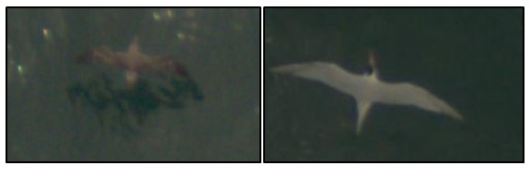
Caption for Graphic or Image: Imagery of Cory's shearwater (left) and a royal tern (right) flying over the Atlantic Ocean as captured from aircraft surveys. High-resolution imagery is being used by the Fish and Wildlife Service to survey migratory seabirds to improve understanding of their abundance and distribution.
Author name: Bradley Pickens
Author business email: bradley_pickens@fws.gov

DOI agency/bureau2: FWS
USGS Mission Area:
USGS Program:
Cost Center:
Program Name2: Division of Biological Sciences
Project title: Mapping Tree Species Alpha-diversity in a Dry Tropical Forest
Project description: The ever-widening variety of remotely sensed data provides information important for assessing tropical tree diversity. Rapid rates of seasonally dry tropical forest (SDTF) loss, fragmentation, and degradation underscore the need to map forest diversity, both prospectively and retrospectively. SDTF diversity is notable in southern Ecuador and northern Peru because of high turnover in species composition at relatively short geographic distances and sub-regional endemic flora. Using remote sensing machine leaning model ensembles (MLME), this project predicted SDTF diversity for permanent forest plots in southwestern Ecuador. Tree census data taken over a 9-ha SDTF served as a basis for the analyses. All trees at least 5 cm in diameter at breast height (DBH, at least 1.3 m above base) were spatially referenced with a Leica TS02-5 total station and used to simulate randomly located 0.10-ha plots for measuring and predicting six local-scale diversity indices. Tree coordinates and height measurements were used to develop 1-m tree canopy height and elevation models, at a scale conventionally obtained from light detection and ranging (lidar). Spectral bands, vegetation indices, and biophysical variables (for example, leaf area index, chlorophyll content, fraction of vegetation cover) taken from multidate, multispectral RapidEye (5-m pixels) and Sentinel-2 (10-m and 20-m pixels) imagery were used as predictors for comparing single and multisensor MLMEs. Combined sensor MLME for tree species richness, Shannon’s H′, inverse Simpson’s, unbiased Simpson’s, and Fisher’s alpha indices typically showed lower root mean squared error (RMSE) and increased goodness of fit (R2). Piélou’s J, a measure of evenness, was poorly predicted with all approaches. Combined sensor models and mapped tree species richness (R2 = 0.54, F = 27.3, p = <0.001) and Shannon’s H′ (R2 = 0.54, F = 26.9, p = <0.001) showed the most favorable agreement with field validation observations (n = 25). The inclusion of predictors such as multidate red-edge vegetation indices and fine-scale topography, related to phenology and the biophysical environment, was important to predicting SDTF tree diversity. Small-scale model experiments revealed essential relationships between tree diversity and data from multiple satellite sensors with repeated global coverage that can help guide larger scale biodiversity mapping efforts.
Sensor Type: Multispectral (approx. 4-12 bands);Simulation of Lidar derived variables ;
Platform type: Satellite;Ground based / sensor web / web cam;
URL: https://doi.org/10.3390/rs15030583
Graphic or Image Upload: https://doimspp.sharepoint.com/sites/GS-EROSSCIENCESWI/Shared Documents/Apps/Microsoft Forms/DOI RS Activities Report, 2022 (2)/Graphic or Image Upload/Sesnie_DOI_RemoteSensingReport_2023_Steven Sesnie.png
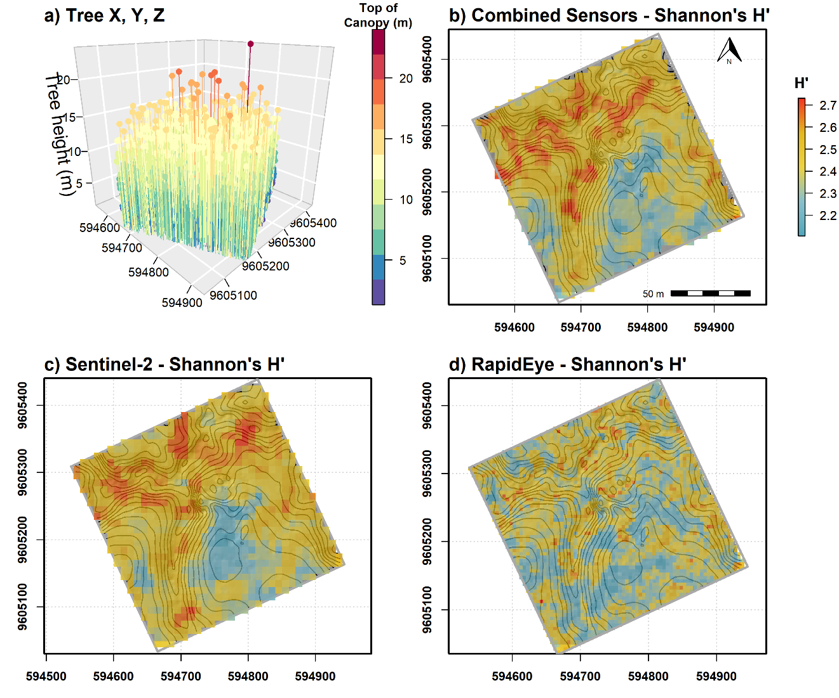
Caption for Graphic or Image: Stem mapped trees at least 5 cm in diameter at breast height (DBH, at least 1.3 m above base) with total height and species recorded on a) a 9-ha SDTF permanent forest inventory plot, that were used to develop MLEMs for mapping Shannon’s H′ diversity index using b) combined sensor models (for example, topography, multispectral bands, and vegetation indices, R2 = 0.54, F = 26.9, p = <0.001), and single c) Sentinel-2 (R2 = 0.24, F = 7.4, p = 0.012) and d) RapidEye (R2 = 0.20, F = 5.66, p = 0.26) sensor models compared with independent 0.10 validation plots (n = 25). Contour lines in b), c), and d) are at 3-m intervals.
Author name: Steven E. Sesnie
Author business email: steven_sesnie@fws.gov

DOI agency/bureau2: FWS
USGS Mission Area:
USGS Program:
Cost Center:
Program Name2: National Wildlife Refuge System
Project title: Mapping Eastern Red Cedar at Valentine National Wildlife Refuge
Project description: Eastern red cedar (cedar) expansion across the Nebraska Sandhills poses great ecological risks to this largely intact (and massive) grassland ecosystem. Centered on Valentine National Wildlife Refuge (NWR, 72,350 acres, plus 2-mile buffer), this project used light detection and ranging (lidar) data and WorldView-2 winter color-infrared imagery to map cedars quickly and effectively, including smaller stature trees.

Within the project area, 567 acres of cedars were mapped in 12,478 patches. Patch size ranged from single trees to 84 acres. Within the refuge, 174 acres of cedars in 5,592 patches were mapped with the largest patch just under 10 acres. Neither lidar nor imagery can differentiate male from seed-bearing female trees; however, each patch was further characterized as potential “seed trees” or “seedlings” using height metrics derived from lidar as a proxy for tree maturity. Patches containing at least one pixel with a height of more than 1.5 m (about 5 ft) were classified as containing seed trees; otherwise, patches were classified as seedlings. Across the project area, most patches (more than 98%) contained potential seed trees.

Although 174 acres of cedars may seem inconsequential (less than 0.25% of the 72,350-acre refuge), the potential vulnerability to intact grasslands is high due to the sheer number and distribution of patches with potential seed-producing trees. Areas within 180 m of seed-bearing trees are at highest risk of seed contamination and eventual seedling recruitment. On the refuge, 3,578 single tree patches exist with each tree affecting a 28-acre area. Over 26% (13,726 acres) of all upland habitat on the refuge is in a dispersal zone.

Refuge staff used these results to successfully compete for Inflation Reduction Act funding. Over the next several years, a systematic effort to mechanically remove cedars on Valentine NWR will occur. Preserving intact core grasslands by eliminating low density seed-producing cedars (single trees or small patches) and working outward toward higher density woodlands will result in larger cedar-free areas where monitoring and repeat treatments using prescribed fire can help keep grasslands free of cedars. Additionally, FWS Partners for Fish and Wildlife staff is working with adjacent ranchers to promote similar actions as cedars negatively affect forage availability for livestock.

Sensor Type: Lidar (terrestrial or bathymetric);Multispectral (approx. 4-12 bands);
Platform type: Airplane;Satellite;
URL: https://ecos.fws.gov/ServCat/Reference/Profile/158669
Graphic or Image Upload: https://doimspp.sharepoint.com/sites/GS-EROSSCIENCESWI/Shared Documents/Apps/Microsoft Forms/DOI RS Activities Report, 2022 (2)/Graphic or Image Upload/CedarDispersalExample_ValentineNWR_Lidar_DOIS_Mike Artmann.jpg
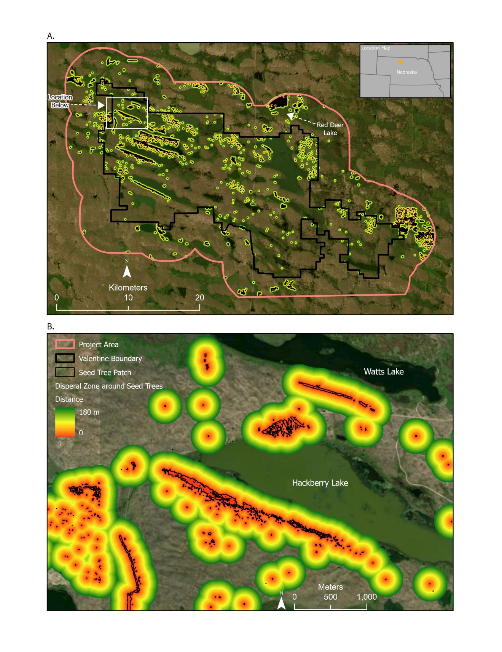
Caption for Graphic or Image: Cedar distribution across the project area (A). Seed dispersal zones and likely areas for seed spread (B). A single tree can affect over 28 acres.
Author name: Mike Artmann
Author business email: mike_artmann@fws.gov

DOI agency/bureau2: FWS
USGS Mission Area:
USGS Program:
Cost Center:
Program Name2: National Wildlife Refuge System (NWRS)
Project title: Orphan Gas and Oil Well Detection in SW National Wildlife Refuges
Project description: Abandoned gas and oil wells present a serious source of pollution emissions in the U.S. There are an estimated 2.3 million onshore abandoned wells in the U.S., according to the U.S. Environmental Protection Agency. Orphan wells are a type of abandoned oil and gas well that have no known owner and must be assessed by State and Federal agencies such as the U.S. Fish and Wildlife Service (USFWS) for remediation. The Bipartisan Infrastructure Law provides aid for remediating orphan wells on Federal lands, including the National Wildlife Refuge System (NWRS). Many well locations are unknown in the NWRS because of their drilling history prior to State regulation or poor record keeping. In addition, known records and geographic locations for wells prior to the 2000s can be inaccurate due to positional error from Global Positioning System (GPS) equipment.

The goal of this project was to improve methods for locating previously unknown orphan gas and oil wells within NWRS Southwest Region (Texas, Oklahoma, New Mexico, Arizona) to aid orphaned well remediation. With light detection and ranging (lidar) data obtained through the USGS 3D Elevation Program (3DEP) at quality level 2 (at least 4.0 ground returns per meter squared), the team created digital elevation models of refuges. The models and aerial imagery from the National Agriculture Imagery Program (NAIP) were used to identify sites with terrain features with characteristics of well activity, such as well platforms, berms, or storage tanks. These features were used as predictor variables to develop automated well detection algorithms such as Faster RCNN. Model outputs consisted of well detection polygons and confidence levels to indicate the location of potential orphan wells, often in unknown and remote locations overgrown by vegetation.

Currently, 1,518 potential wells have been detected in the 22 National Wildlife Refuges in Texas and Oklahoma. The refuges with the most orphan oil and gas wells detected are Deep Fork, Neches River, and Anahuac with 354, 105, and 91 possible orphan detections, respectively. The results of this project will help remediate orphan well sites in refuges in Texas and Oklahoma. Wells that were identified by the deep learning algorithms and visual interpretation will be visited on the ground to assess the accuracy of the model. Once confirmed as orphaned, wells can be marked for plugging and remediation, reducing pollution and greenhouse gas emissions from public lands.
Sensor Type: Lidar (terrestrial or bathymetric);Multispectral (approx. 4-12 bands);
Platform type: Airplane;
URL:
Graphic or Image Upload: https://doimspp.sharepoint.com/sites/GS-EROSSCIENCESWI/Shared Documents/Apps/Microsoft Forms/DOI RS Activities Report, 2022 (2)/Graphic or Image Upload/Figure 1_Kameron Hall.png
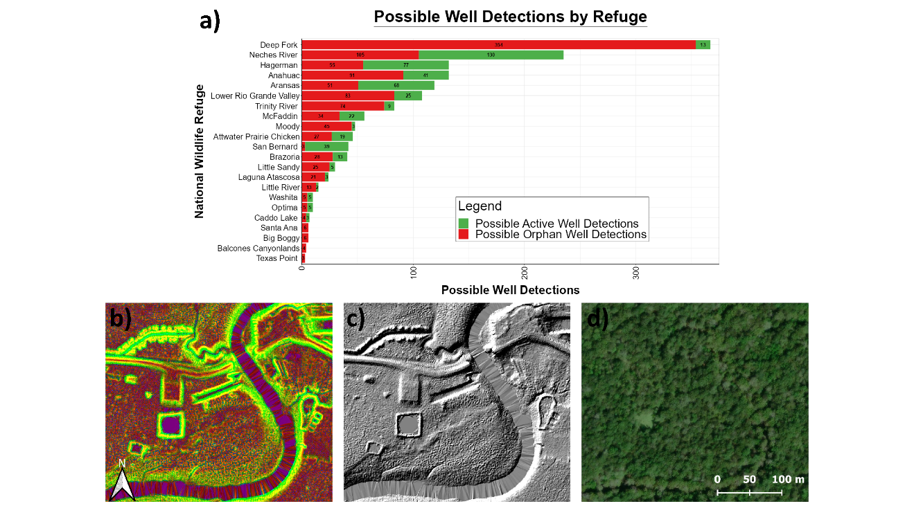
Caption for Graphic or Image: a) Number of possible active and orphan wells detected for each refuge examined. Possible orphan well location in Trinity River NWR identified using deep learning object detection under the b) 3-band composite layer, c) hillshade map, and d) ESRI Satellite imagery of tree canopy overtopping the site. Well detections must be verified in the field as these sites could be associated with other types of land use and ground disturbances.
Author name: Kameron Hall, Annika Benedetti
Author business email: kameron_hall@fws.gov, annika_benedetti@fws.gov

