DOI agency/bureau: USGS
USGS Mission Area: Ecosystems
USGS Program: Land Change Science
Cost Center: Western Geographic Science Center
Program Name:
Project title: Web-based Help for Invasive Species Control (WHISC)
Project description: U.S. Geological Survey’s (USGS) the USGS Western Geographic Science Center (WGSC) is producing and delivering tools based on near-real-time remote sensing data to help the National Park Service (NPS) optimize and prioritize treatment activities for controlling invasive buffelgrass (Cenchrus ciliaris) in their landscapes. The Web-based Help for Invasive Species Control (WHISC) project has many accomplishments to date and is being used by regional land managers, who are finding its tools to be valuable.
Sensor Type: Multispectral (approx. 4-12 bands);Weather Station;
Platform type: Satellite;
URL:
Graphic or Image name: Buffelgrass-test.jpg
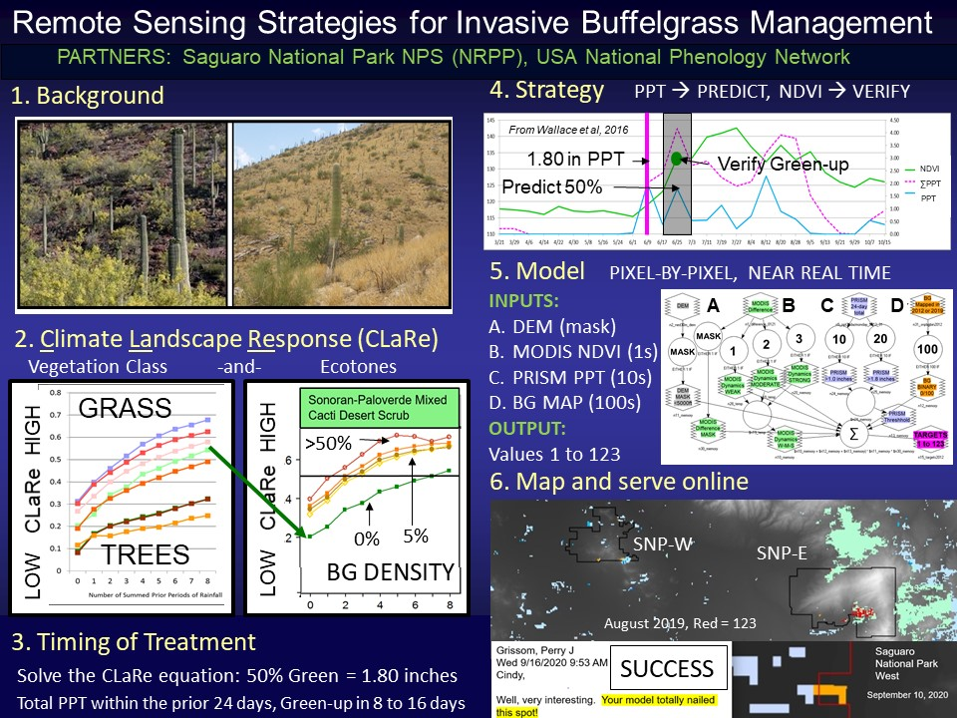
Caption for Graphic or Image: Buffelgrass slide to test portal
Author name and business email: Cynthia SA Wallace; cwallace@usgs.gov

DOI agency/bureau: USGS
USGS Mission Area: Ecosystems
USGS Program: Wildlife Program
Cost Center: Northern Prairie Wildlife Research Center
Program Name:
Project title: Testing a small, portable remote passive acoustic device to monitor wolves
Project description: As part of a broader trial of noninvasive methods to research wild wolves (Canis lupus) in the Superior National Forest (SNF), Minnesota, USA, the USGS Wolf and Deer Project (Northern Prairie Wildlife Research Center) explored whether wolves could be remotely monitored using a new, inexpensive (approximately $80 USD in 2019), remotely deployable, passive acoustic recording device, the AudioMoth. In collaboration with researchers from Spain and the International Wolf Center (IWC), we tested the efficacy of AudioMoths in detecting wolf howls and factors influencing detection by placing them at set distances from the IWC captive wolf packs and compared those recordings with real‐time, on‐site howling data during summer 2019 (Barber-Meyer et al., 2020). We also employed these devices as part of a National Geographic-funded project during summer 2019 to monitor wild-wolf summer homesites (as determined by Global Positioning System [GPS] locations from the breeding female’s radiocollar) in a collaborative study with researchers from Spain, India, and Yellowstone National Park. During winter 2020, we documented the breeding season howling rate of captive wolves at the IWC and also at a wolf center in Spain. During summer 2021, we studied features of sled dog vocalizations and how they differ from wolf choruses, as these domestic dog vocalizations frequently appeared in the audiofiles from the summer 2019 wild wolf research in the SNF. Results from the wild-wolf summer 2019 monitoring, winter 2020 captive studies, and summer 2021 sled-dog vocalizations are pending. Overall, our results confirmed that AudioMoths can be used to monitor howling rates, confirmation of reproduction, and potentially the number of wolves in the pack. AudioMoths are probably most useful in studying specific sites during periods when wolves move less frequently (e.g., during late spring and summer at homesites or potentially during winter at kill sites of very large prey) and also in a passive sampling array (e.g., occupancy studies), especially when used in concert with other methods such as camera‐trapping. We also found AudioMoths useful for documenting interspecies acoustic interactions (Marti-Domken et al., 2021).

References:
Barber-Meyer, S.M., V. Palacios, B. Marti Domken, and L.J. Schmidt. 2020. Testing a new passive acoustic recording device to monitor wolves. Wildlife Society Bulletin 1-10, DOI: 10.1002/wsb.1117.
Marti-Domken, B., Palacios, V., and Barber-Meyer, S.M. 2021. Acoustic interaction between a pair of owls and a wolf. Western North American Naturalist 81(3). Accepted.

Authors:
Shannon Barber-Meyer and L. David Mech. U.S. Geological Survey, Northern Prairie Wildlife Research Center, 8711 – 37th St. NE, Jamestown, ND 58401

Sensor Type: Sound (sonar or acoustic);GPS;
Platform type: Satellite;Ground based / sensor web / web cam;
URL: usgs.gov/staff-profiles/shannon-barber-meyer
Graphic or Image name: IMG_8506.jpg and Figure2GPSWolfMap.png

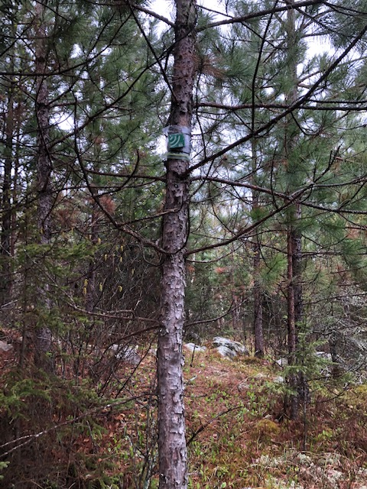

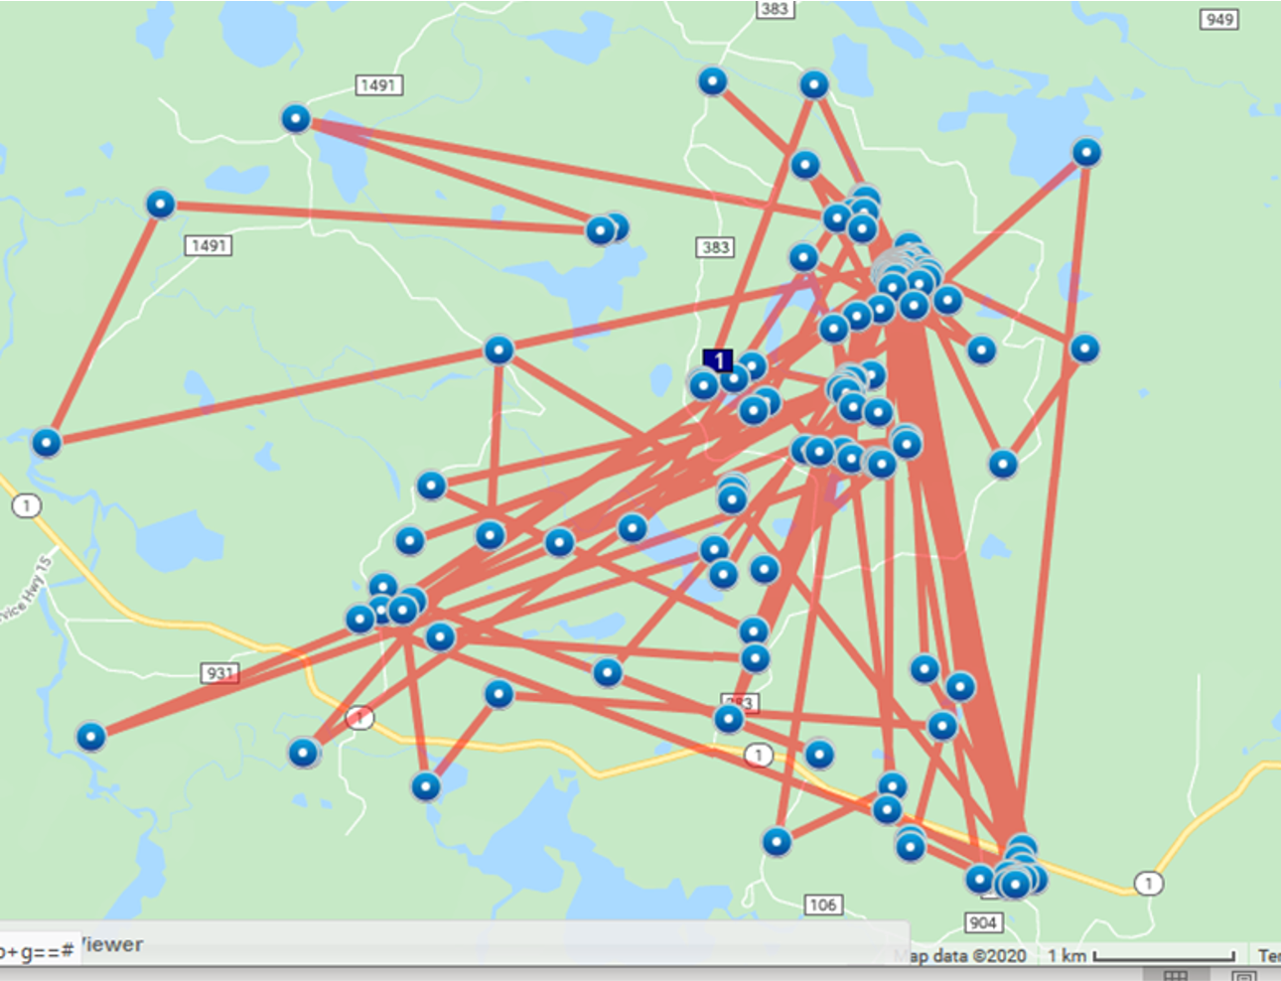
Caption for Graphic or Image: Figure 1. Photo of an AudioMoth deployed in the Superior National Forest.
Figure 2. A female GPS-collared wolf’s summer movements indicating homesite areas by frequent locations.
Author name and business email: Shannon Barber-Meyer, sbarber-meyer@usgs.gov

DOI agency/bureau: USGS
USGS Mission Area: Ecosystems
USGS Program: Wildlife Program
Cost Center: Alaska Science Center
Program Name:
Project title: Walruses are visible in satellite imagery when they rest on shore in large numbers
Project description: During late summer and autumn Pacific walruses are resting on shore north of the Bering Strait more often and in larger numbers in both the United States and Russia. Historically walruses rested primarily on floating sea ice over their offshore foraging grounds in this region, but climate warming has reduced availability of sea ice. With greater numbers of walruses gathering on shore, USGS scientists and collaborators in Russia are capitalizing on the opportunity to improve walrus population monitoring. USGS has evaluated optical and radar satellite imagery ranging in pixel resolutions from 40 m to ~1 m for the detection and quantification of large walrus groups resting on shore. USGS flew UAS orthoimagery surveys and was able to use these images to validate satellite imagery interpretation. Our debut study site at Point Lay, Alaska, was optimal for remote sensing because the beach is fine-grained with negligible topography. Range-wide walrus population monitoring efforts, however, would require reconnaissance of haulouts anticipated to be more challenging to imagery interpretations due to variable beach substrates and adjacent bluffs. This autumn (2021), USGS in collaboration with Russian biologists plan to collect UAS orthoimagery and a variety of satellite imagery types (RADARSAT-2, Sentinel-1, TeraSAR-X, DigitalGlobe, Planet, and Sentinel-2) at a Russian haulout that has a more complex landscape and composition than Point Lay. This collaborative study with Russia is under the auspices of the U.S.-Russia Agreement on Cooperation in the Field of Environmental Protection (1994).
Sensor Type: Hyperspectral;IFSAR / SAR / Radar;Camera;
Platform type: UAS;Satellite;
URL: http://alaska.usgs.gov/science/biology/walrus/
Graphic or Image name: USGS_walrus_imaged_by_satellite_v2.jpg
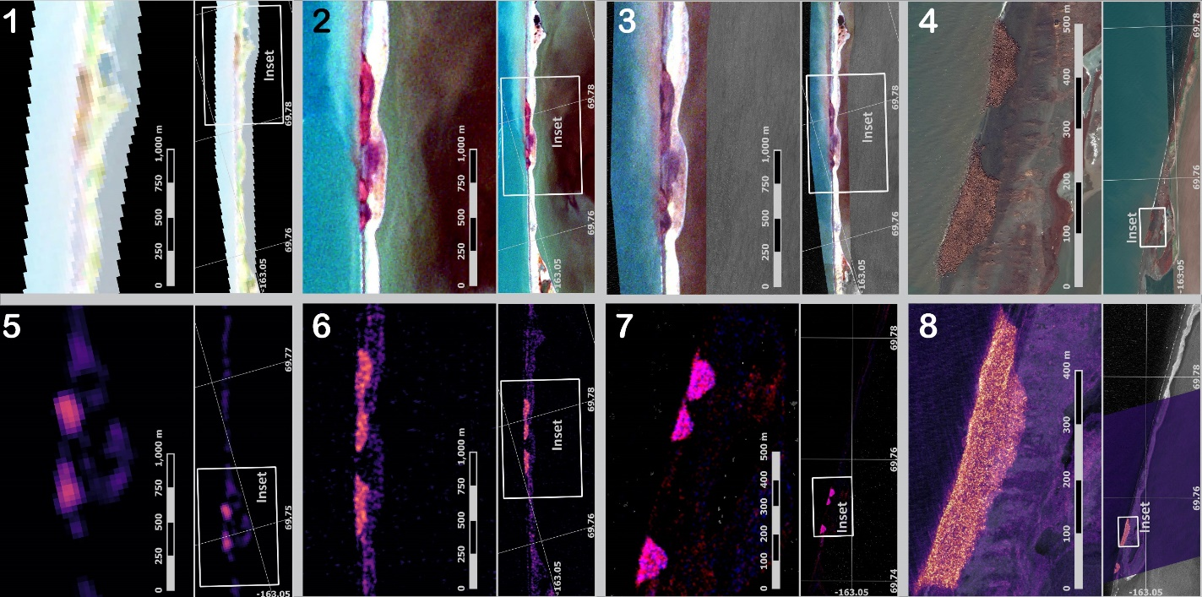
Caption for Graphic or Image: Example satellite imagery types evaluated for detecting Pacific walruses resting on shore near Point Lay Alaska. Top row shows optical imagery types displayed with a true-color RGB enhancement, in which walrus aggregations are more reddish-brown compared to dark-brown soiled beach or lightly-hued untrampled beach: (1) Landsat-8 (30 m resolution), (2) Sentinel-2 (10 m), (3) PlanetScope (4 m), and (4) WorldView-2 (1.5 m). Bottom row shows SAR images of normalized backscatter, in which walrus aggregations return a strong backscatter signal compared to the surrounding flat landscape comprised of fine-grained sediments: (5) Sentinel-1 EW with VV polarization (40 m), and (6) Sentinel-1 IW with HV polarization (10 m), (7) TeraSAR-X stripmap (dual polarization 3.5 m), and (8) TeraSAR-X staring spotlight with VV polarization (1.4 m).
Author name and business email: Anthony Fischbach, afischbach@usgs.gov; David Douglas, ddouglas@usgs.gov

DOI agency/bureau: USGS
USGS Mission Area: Core Science Systems
USGS Program: National Land Imaging Program
Cost Center: Earth Resources Observation and Science (EROS) Center (Geography)
Program Name:
Project title: Exploring VIIRS Continuity with MODIS in an Expedited Capability for Monitoring Drought-Related Vegetation Conditions
Project description: Scientists have effectively monitored vegetation dynamics using remotely sensed time-series vegetation index (VI) data for several decades, and drought monitoring has been a common application of VI data. Perhaps the most used VI data, Normalized Difference Vegetation Index (NDVI), serves as an input for drought-stress models such as the Vegetation Drought Response Index (VegDRI). NDVI composites from the expedited Moderate Resolution Imaging Spectroradiometer (eMODIS) satellite platform were a main input for the VegDRI model, but as the MODIS satellite platforms approach the end of their missions, replacement satellite data was needed to continue developing VegDRI. The U.S. Geological Survey’s (USGS) Earth Resources Observation and Science (EROS) Center developed a parallel temporal version of eMODIS by utilizing data from the Visible Infrared Imaging Radiometer Suite (VIIRS) platform. The expedited VIIRS (eVIIRS) consists of 7-day rolling NDVI composites at 375-m and 1-km spatial resolution.

We developed a simple, robust transformation algorithm to transform eVIIRS NDVI to eMODIS-like NDVI. (The transformed eVIIRS NDVI is referred to as eVIIRS’.) We then designed a research study to test eVIIRS’ NDVI for use in the VegDRI drought monitoring production system. The geometric mean regression (GMR) transformation algorithm was developed from 3 years (2016 – 2018) of eVIIRS 375-m and eMODIS 250-m NDVI data. After transforming 2020 eVIIRS to eVIIRS’ using the GMR transformation algorithm, the NDVI values showed improved results with the mean bias error decreasing by more than 62% and the root mean square error (RMSE) decreasing by more than 17%. The VegDRI map (Figure 1) using eVIIRS’ data showed similar results compared to the VegDRI map using eMODIS data. Also, when eMODIS was replaced with eVIIRS’ in the VegDRI model, the relative RMSE equaled 18%, which indicated the replacement of eMODIS with eVIIRS’ was a good fit for VegDRI.

The approach we used to modify data inputs into the VegDRI model, i.e., using eVIIRS’ NDVI in place of eMODIS NDVI data, demonstrates the ease of use of the GMR transformation for data continuity and longevity. The transformation may allow eVIIRS to continue the twenty-plus year time series of eMODIS NDVI data.
Sensor Type: Multispectral (approx. 4-12 bands);
Platform type: Satellite;
URL: https://doi.org/10.3390/rs13061210
Graphic or Image name: BoyteEROS_eVIIRSVegDRI

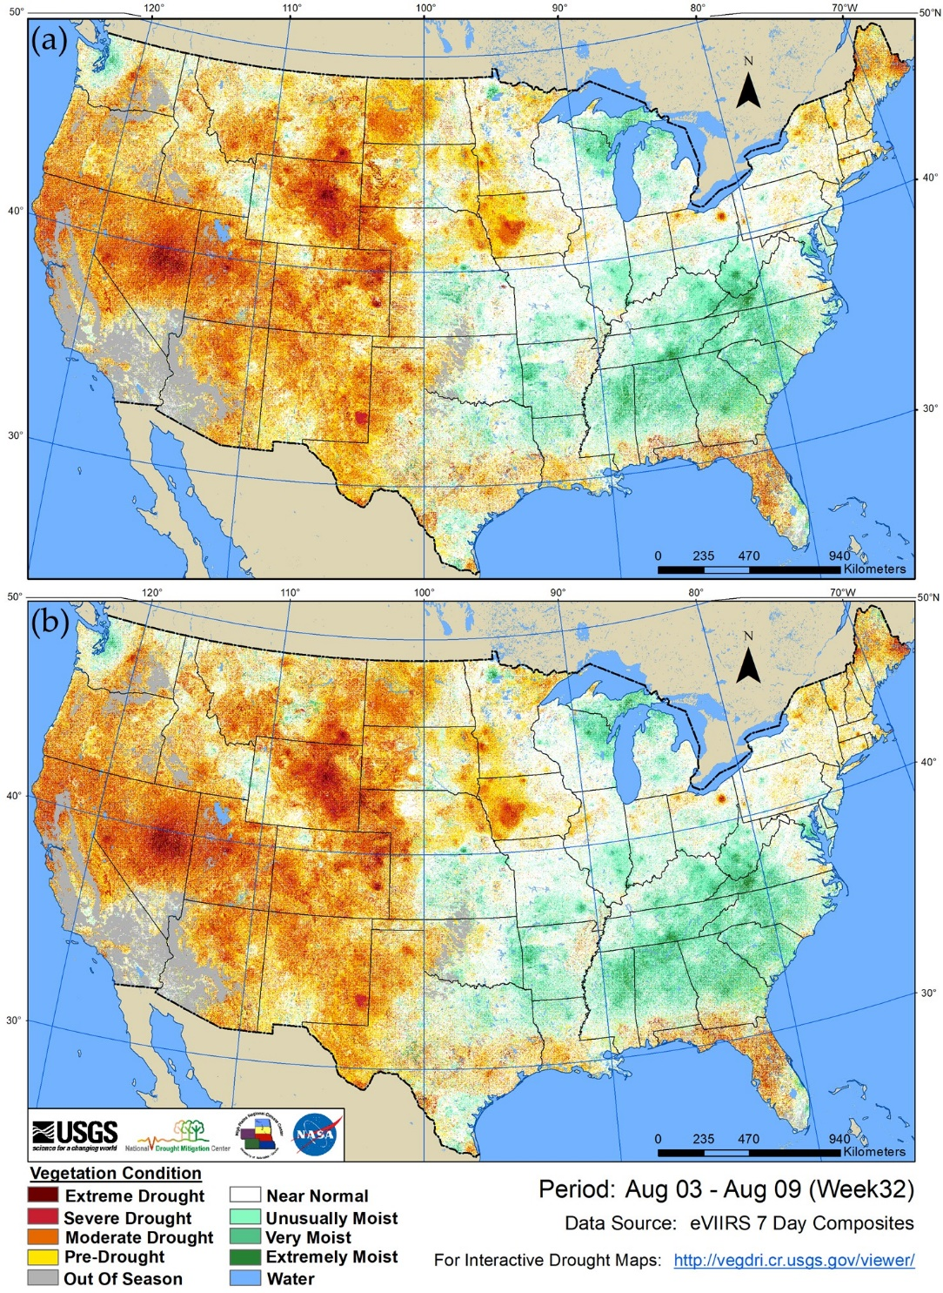

Caption for Graphic or Image: Figure 1. Transforming eVIIRS NDVI data into eMODIS-like NDVI data. The comparison of a Vegetation Drought Response Index (VegDRI) results from (a) expedited Moderate Resolution Imaging Spectroradiometer (eMODIS) and (b) transformed expedited Visible Infrared Imaging Radiometer Suite (eVIIRS’) (eVIIRS’ = 0.9887 × eVIIRS − 0.0398) (b) for week 32, 2020 (August 3, 2020 to August 9, 2020).
Author name and business email: Stephen Boyte; sboyte@usgs.gov

DOI agency/bureau: USGS
USGS Mission Area: Ecosystems
USGS Program: Environments Program
Cost Center: Forest and Rangeland Ecosys Science Center
Program Name:
Project title: Post-fire recovery and fire modeling to support wildland fuels management in sagebrush steppe
Project description: USGS is co-producing science on the science and adaptive management of recovering burned areas in sagebrush steppe, and is evaluating their response to restoration interventsions. Landsat, Sentinel, and USGS vegetation mapping products derived from them are key data inputs. Multiple publications have resulted from this work, which is funded entirely from the BLM and FWS.
Sensor Type: Multispectral (approx. 4-12 bands);Thermal;
Platform type: Satellite;
URL:
Graphic or Image name:

Caption for Graphic or Image:
Author name and business email: Matt Germino, mgermino@usgs.gov

DOI agency/bureau: USGS
USGS Mission Area: Ecosystems
USGS Program: Water Availability and Use Science Program
Cost Center: Southwest Biological Science Center
Program Name:
Project title: Riparian restoration evapotranspiration & drought
Project description: The Colorado River delta riparian vegetation has been declining in greenness and water use since 2000 as measured by Landsat. We use the two-band Enhanced Vegetation Index (EVI2; a proxy for greenness) and evapotranspiration (ET, mmd-1) using EVI2 and ground-based meteorological potential evapotranspiration (ETo) from Yuma, Arizona. Restoration initially started in 2010 and has become more widespread and successful in the recent two years, 2019-2020. Two sources of water have been provided to the region, first in 2014 as the Minute 319 Pulse Flow and as directed flows to the restoration sites under Minute 323, plus any excess flows such as from the MODE canal in 2019. Over the 21-year study period from 2000 through 2020, we focused on the first four reaches of the delta because restoration activities, with 13 sites with initial planting dates between 2010 and 2018, have taken place in two of the reaches, Reach 2 and Reach 4. We assess if restoration sites had an impact on reach-level riparian health and water use by calculating data from the adjacent unrestored areas in Reaches 1-4 including and excluding the restored sites. A key finding is that over 21 years in the unrestored riparian corridor of the Colorado River delta (Reaches 1-4, excluding restoration) greenness decreased by 23.6% and ET decreased by 32.0% (0.87 mmd-1), whereas in “All Restoration Sites” greenness increased by 11.2% and ET increased by 5.4% (0.18 mmd-1). However, for most of these 21 years, very little restored vegetation existed so we focus on restoration activities “All Restoration Sites” over the last decade (2011-2020). During these 10 years, the unrestored riparian corridor of the Colorado River delta, that excluded restoration sites, decreased in vegetation greenness (11.3%) and showed reductions in ET of 28.2% (-0.73 mmd-1); however, restored areas increased in both metrics. Over the period from 2011 to 2020, restored vegetation greenness increased by 35.8% and ET increased by 19.6% (-0.58 mmd-1). Since the Minute 319 pulse flow in 2014, much of the restoration sites have been maintained by base flows and irrigation drainage, and not effects of the pulse flow itself. “All Restoration Sites” after 2014 showed greenness increased by 33.6% and ET increased by as much as 58.0% or 1.29 mmd-1. The corresponding unrestored reaches showed losses of 14.7% greenness and 11.0% in ET (-0.23 mmd-1). When combining restored sites and unrestored reaches, EVI2 and ET as a function of the 3-month standardized precipitation evapotranspiration index (SPEI03) show declines. These findings can be utilized by decision makers in their quest to mitigate declines in riparian woodlands.
Sensor Type: Multispectral (approx. 4-12 bands);
Platform type: Satellite;
URL:
Graphic or Image name: DeltaET
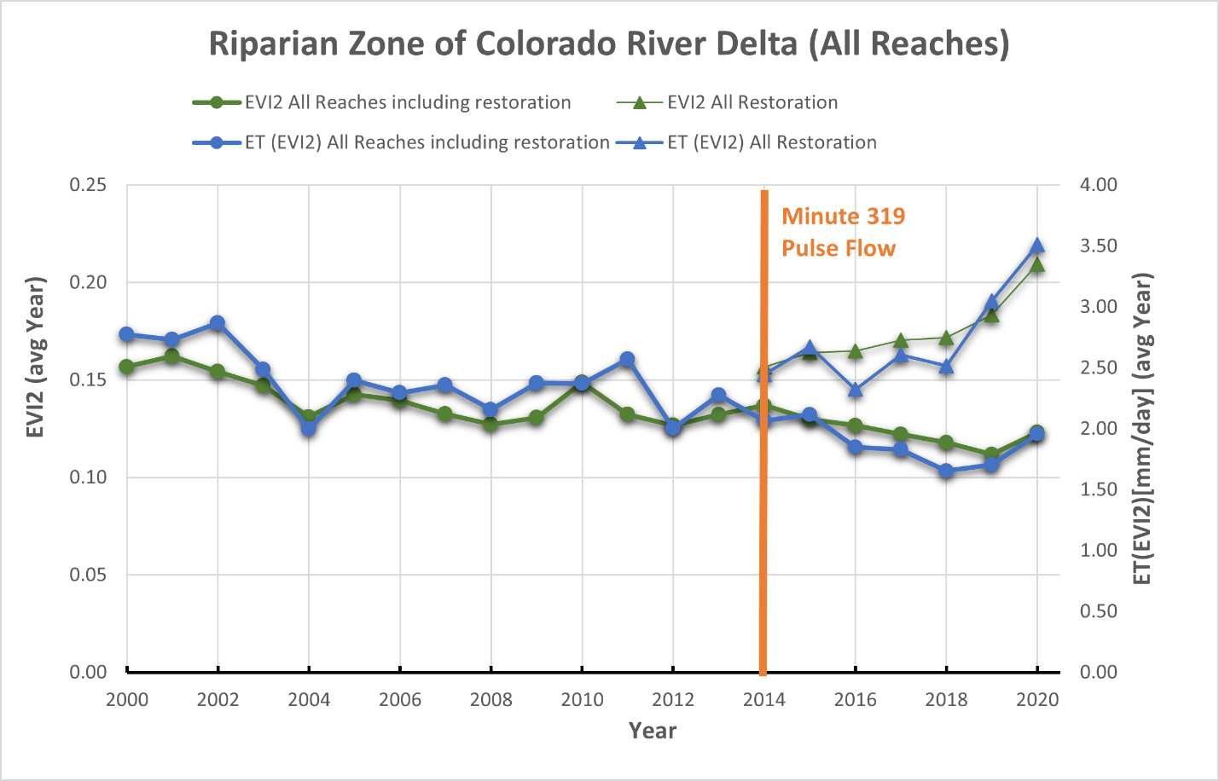

Caption for Graphic or Image: The Colorado River delta riparian corridor greenness and water use change per year as measured by Landsat EVI2 and ET(EVI2) using the weighted average from the All Reaches (Reach 1-4) including restoration sites and “All Restoration Sites” from 2000 through 2020.
Author name and business email: Pamela Nagler; pnagler@usgs.gov

DOI agency/bureau: USGS
USGS Mission Area: Core Science Systems
USGS Program: National Land Imaging Program
Cost Center: Earth Resources Observation and Science (EROS) Center (Geography)
Program Name:
Project title: Land Change Assessments and Applications Supported by LCMAP Science Products
Project description:
The U.S. Geological Survey’s (USGS) Land Change, Monitoring, Assessments, and Projections (LCMAP) project recently released an updated suite of land surface change science products based on the Landsat archive. The most recent LCMAP science collection includes 10 annual land change and land cover map products for the time period 1985–2019 for the conterminous United States. The integrated products are the basis for applications and assessments designed to promote an understanding of the basic drivers of change, identify potential consequences of change on human and natural systems, and offer greater insight into the impacts and feedbacks of climate change. LCMAP leverages the USGS Landsat Program’s decades of land imaging, future Landsat acquisitions, time-series modeling, and USGS Earth Resources Observation and Science (EROS) Center scientific expertise. The annual land cover, and its change, through 2018 was validated using published reference data, providing quantitative measures of product accuracy. An update to the product suite, bringing products up to date through calendar year 2020 is under production and scheduled to be released before the end of 2021.

LCMAP supports and engages with the user community through various forms of communication including instructional videos that describe the land change products, workflows to expedite common data processing and analysis routines, and stakeholder workshops. EROS Center provides geospatial products through a number of public facing websites including USGS’s EarthExplorer, LMCAP’s Web Viewer, and website download access for each annual product compiled for the entire conterminous United States. The LCMAP team also established a collaboration with researchers from the National Center for Atmospheric Research. This effort focuses on developing methodology to improve and enhance tools that enable the management community to visualize, summarize, and incorporate land surface change information through time.

Having access to an annual time series of land cover and surface change enables assessments of land change to improve understanding of their causes and consequences. Several published assessments incorporated annual LCMAP land surface change products. The publications range from new insights on how urban heat islands affected surrounding rural land cover (Xian and others, https://doi.org/10.1080/15481603.2021.1903282) to how droughts with hotter temperatures impacted the extent of tree cover within an endemic California forest type (Dwomoh and others, https://doi.org/10.3389/fclim.2021.689945 ). The latter research analyzed LCMAP land change data, geospatial climatic data, and wildfire mapping to reach their conclusions. While other geographic and topical assessments occurred in 2021, they are in various stages of the publication process.
Sensor Type: Multispectral (approx. 4-12 bands);
Platform type: Satellite;
URL: https://www.usgs.gov/core-science-systems/eros/lcmap
Graphic or Image name: DOI_RSReport_LCMAP_2021_submitted_graphic.PNG
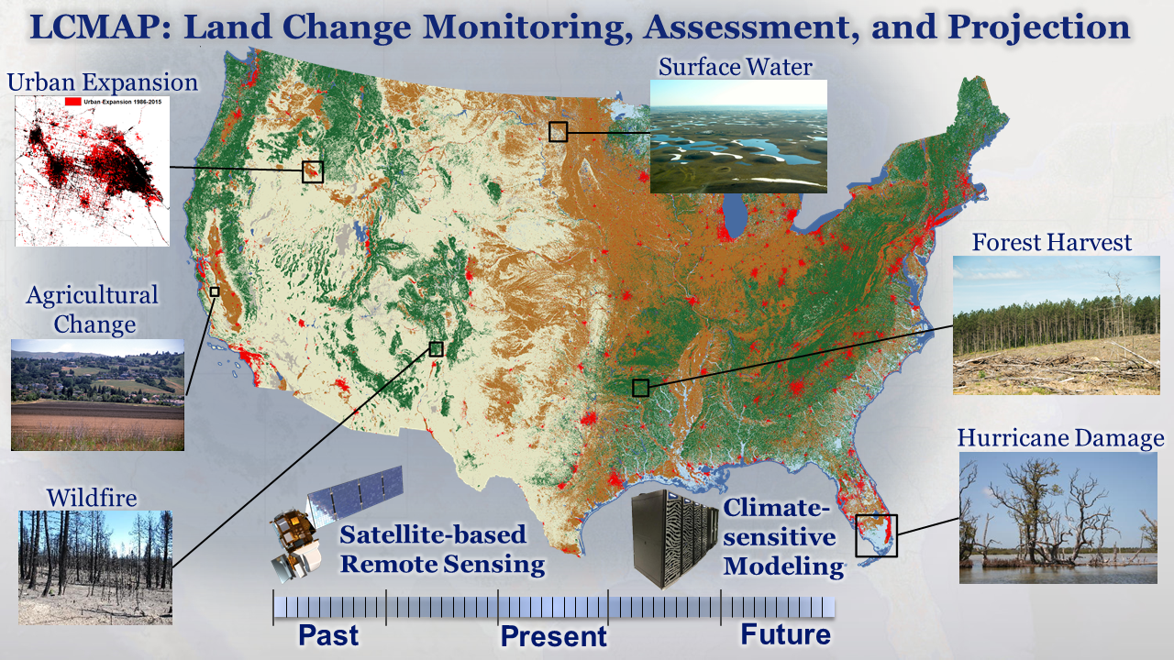
Caption for Graphic or Image: LCMAP science products support a variety of applications and assessments.
Author name and business email: Jennifer Rover jrover@usgs.gov; Roger Auch auch@usgs.gov

DOI agency/bureau: USGS
USGS Mission Area: Core Science Systems
USGS Program: Land Change Science
Cost Center: Earth Resources Observation and Science (EROS) Center (Geography)
Program Name:
Project title: Rangeland Condition Monitoring Assessment and Projection (RCMAP)
Project description: Rangeland ecosystems in the western United States are vulnerable to climate change, fire, and anthropogenic disturbances, yet available geospatial data for assessing trends in conditions, fire risk, and management practices in these areas are often inadequate. To address this need, scientists from the USGS Earth Resources Observation and Science (EROS) Center and the Bureau of Land Management developed the Rangeland Condition Monitoring Assessment and Projection (RCMAP) project. This project quantifies the percent cover of rangeland components across the western U.S. using Landsat imagery from 1985-2020. The RCMAP product suite includes of eight fractional components: annual herbaceous, bare ground, herbaceous, litter, non-sagebrush shrub, perennial herbaceous, sagebrush and shrub, and the temporal trends of each, along with rule-based error maps. We developed an automated method to identify change in spectral conditions between each year in the Landsat archive and the circa 2016 base year. Our results showed the net cover of shrub, sagebrush, and litter significantly (p < 0.05) decreased across the range, bare ground and herbaceous cover had no significant change, and annual herbaceous cover significantly (p < 0.05) increased. Change was ubiquitous, with a mean of 92% of pixels with some change and 38% of pixels with significant change (p < 0.05). However, most change was gradual, well over half of pixels have a range of less than 10%, and most change occurred outside of known disturbances such as fires and vegetation treatments.

RCMAP fractional component time-series data spanning 1985-2020 and trends analysis products are now available for download and on the rangelands viewer application. This dataset is designed for out-of-the-box application and provides a foundation for both historical and future monitoring at ecosystem scales, including research in sage-grouse habitat and population dynamics, restoration success, and treatment effect.

Sensor Type: Multispectral (approx. 4-12 bands);
Platform type: Satellite;
URL: https://www.mrlc.gov/
Graphic or Image name: RCMAP_headline_thumbnail

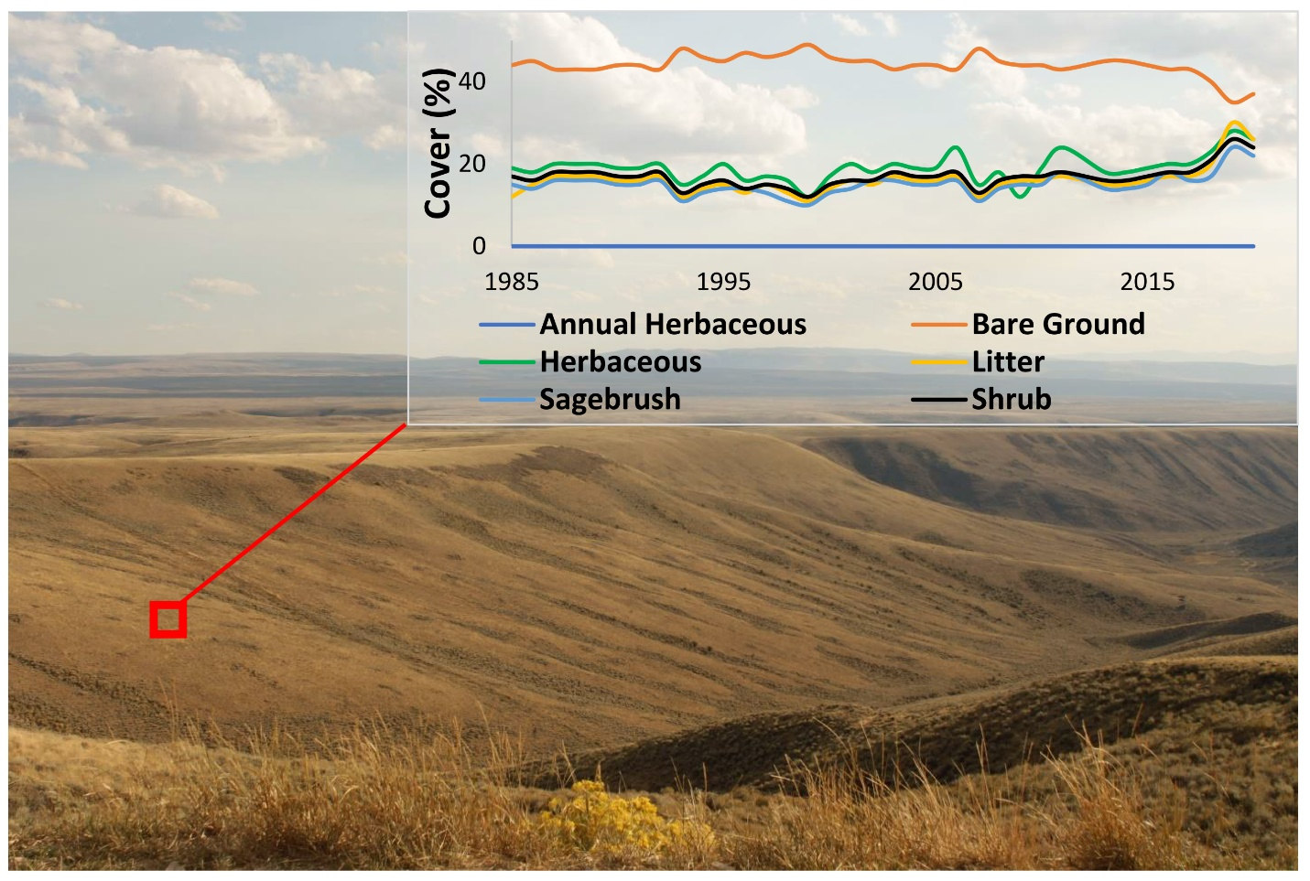
Caption for Graphic or Image: Example of RCMAP fractional component time-series trajectory in southwest Wyoming.
Sensor

Author name and business email: mrigge@usgs.gov

DOI agency/bureau: USGS
USGS Mission Area: Core Science Systems
USGS Program: Land Change Science
Cost Center: Earth Resources Observation and Science (EROS) Center (Geography)
Program Name:
Project title: National Land Cover Database (NLCD) 2019 release
Project description: The National Landcover Database (NLCD) is produced by the Multi Resolution Land Characteristics Consortium (MRLC). This consortium includes the Bureau of Land Management, National Agricultural Statistics Service, National Oceanic and Atmospheric Administration, US Forest Service, National Park Service, US Department of Agriculture, US Fish and Wildlife Service, and the Environmental Protection Agency. This consortium pools resources, expertise, and mapping products to publish NLCD. NLCD 2019 represents the most rapid turnaround for new land cover mapping products in the program’s history, and NLCD products now include 34 different data layers characterizing land cover and land cover change across 8 epochs for all 50 states. Mapped epochs (calendar years) include 2001, 2004, 2006, 2008, 2011, 2013, 2016, and 2019. In collaboration with the Forest Service NLCD produces percent tree canopy cover, and in collaboration with the BLM, RCMAP (Rangeland Condition, Monitoring, Assessment, and Projection) products, which categorize and predict rangeland habitat for the Western United States. These products and other specialized products from the consortium partners are joined to provide integrated mapping for the nation. NLCD is one of the most widely used land cover products with nearly 9000 research citations and over a million downloads. There are also more than 60 US and world policy citations including power grid planning, endangered species assessment, carbon sequestration, weather prediction, environmental impact statements, disease vectors, water resources, ecosystem health, urban planning, and others that rely on NLCD products. NLCD also provides the base for international collaboration with the Commission for Environmental Cooperation (CEC) in producing a North American land cover map with Canada and Mexico that provides change information on the continental scale.
For more information on NLCD and to download or visualize NLCD change, land cover, or data, visit www.mrlc.gov
Sensor Type: Multispectral (approx. 4-12 bands);
Platform type: Satellite;
URL: https://www.mrlc.gov/
Graphic or Image name: nlcd_GRAPHIC_2_1.jpg
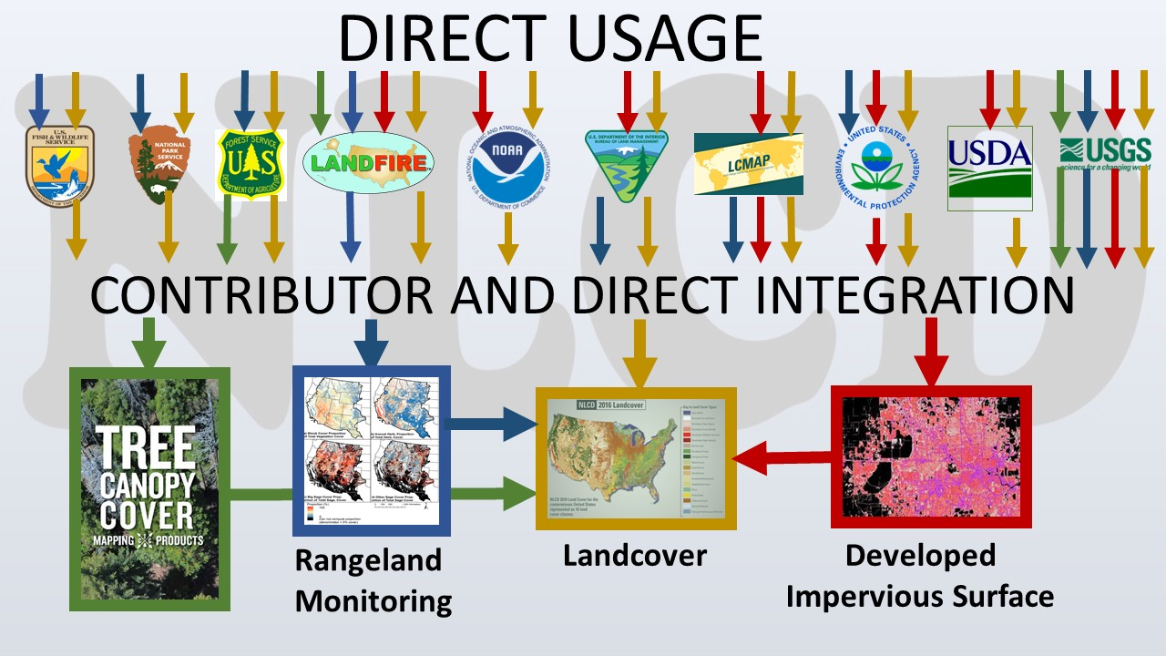
Caption for Graphic or Image: MRLC members both contribute to and use NLCD products.
Author name and business email: Jon Dewitz, dewitz@usgs.gov or Leila Gass, lgass@usgs.gov

DOI agency/bureau: USGS
USGS Mission Area: Core Science Systems
USGS Program: Land Change Science
Cost Center: Earth Resources Observation and Science (EROS) Center (Geography)
Program Name:
Project title: Increase in U.S. Irrigated Cropland Area
Project description: Mapping irrigated agricultural lands to reveal their spatial and temporal dynamics can improve management of and policy concerning the world’s food supply. We applied the latest version (Version 4) of the Moderate Resolution Imaging Spectroradiometer (MODIS) Irrigated Agricultural Dataset (MIrAD) to study change in irrigated croplands over the conterminous United States (CONUS) over a fifteen year period at five-year intervals (2002, 2007, 2012, 2017). The methods employed a geospatial modeling approach that utilized county-level data from the U.S. Department of Agriculture’s National Agricultural Statistic Service, agricultural land cover data from the U.S. Geological Service’s National Land Cover Database, and an annual peak vegetation index from expedited MODIS satellite data. The study uncovered a 7% overall increase in irrigated croplands in CONUS from 2002 – 2017 with large regional variability (Figure 1). For example, the Upper Mississippi watershed had the greatest percent increase in irrigated hectares (ha) of cropland from 2002 – 2017, increasing by 69%. The Lower Mississippi watershed followed with a 28% increase. The Texas-Gulf watershed had the greatest decrease in irrigated cropland, dropping by 18%. The California watershed followed closely behind the Texas-Gulf watershed with about 11% less irrigated cropland in 2017 than in 2002. The study identified various drivers for irrigation dynamics, including regional climate fluctuations and drought events, demand for specific crops, government land or water policies, and economic incentives like crop pricing and land values. The MIrAD-US was assessed for accuracy using a variety of existing regionally-based reference data, and accuracies ranged from 70% to 95%, depending on the region. The reference data was not of sufficient quality to provide robust measures of statistical uncertainty on the area estimates. The MIRAD-US dataset is available at USGS ScienceBase and the supporting journal paper is available (http://doi.org/10.3390/land10040394).
Sensor Type: Multispectral (approx. 4-12 bands);
Platform type: Satellite;
URL: https://www.usgs.gov/core-science-systems/eros/droughtstress/science/moderate-resolution-imaging-spectroradiometer-modis
Graphic or Image name: fig IrrigatedArea for DOI-RS report 2021

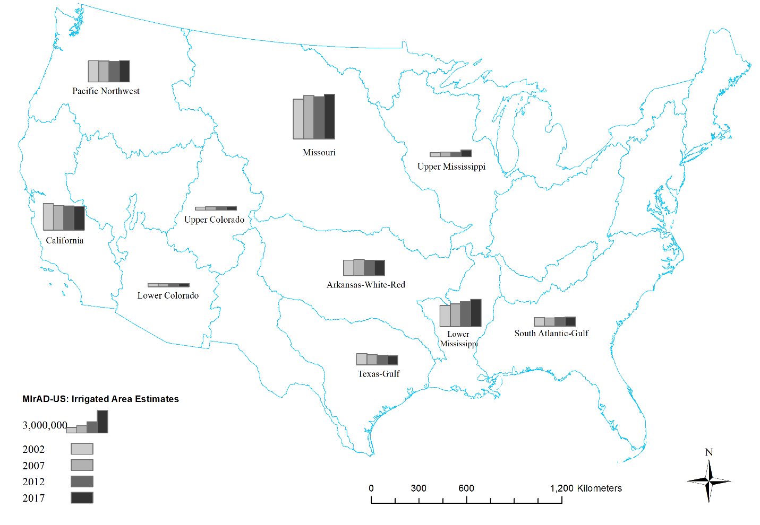
Caption for Graphic or Image: Figure 1. Summary of irrigated area in hectares estimated by MIrAD-US for 2002, 2007, 2012, and 2017. Blue polygons represent CONUS-wide HUC2 watershed boundaries.
Author name and business email: Jesslyn F. Brown

DOI agency/bureau: USGS
USGS Mission Area: Core Science Systems
USGS Program: Environmental Health Program
Cost Center: Columbia Environmental Research Center
Program Name:
Project title: Multi-stage vegetation assessment and monitoring using Unoccupied Aerial Systems imagery for Great Lakes Restoration Initiative contamination sites
Project description: This project uses aerial imagery collected with Unoccupied Aerial Systems (UAS, or “drones”) to assess the condition of vegetation at contaminated sites being remediated and restored under the Great Lakes Restoration Initiative (GLRI). The project is a collaborative effort between the US Environmental Protection Agency, USGS, and a private corporation hired to collect imagery (in lieu of flights by USGS staff currently prohibited under the Department of the Interior UAS flight ban). Researchers at the Columbia Environmental Research Center are using UAS imagery and derived elevation products to map invasive plant species and vegetation communities at multiple sites to provide baseline vegetation data prior to remediation activities. Following remediation and habitat restoration, UAS imagery will be used to monitor and map the same species and communities to assess restoration progress and to support invasive species early detection/rapid response and long-term eradication and control programs. Opportunistic UAS imagery collection will be used to develop elevation models to describe terrestrial topography and as a substitute for or complement to bathymetric models from data collected using traditional methods. These models will be used to monitor fluctuations in water levels at GLRI sites and changes in topography and bathymetry following restoration implementation.
Sensor Type: Video;Camera;
Platform type: UAS;
URL: https://www.usgs.gov/centers/cerc/science/uas-and-other-remote-sensing-and-imagery-analysis-disaster-response-remediation
Graphic or Image name: Struckhoff_GLRI_Phargmites.png

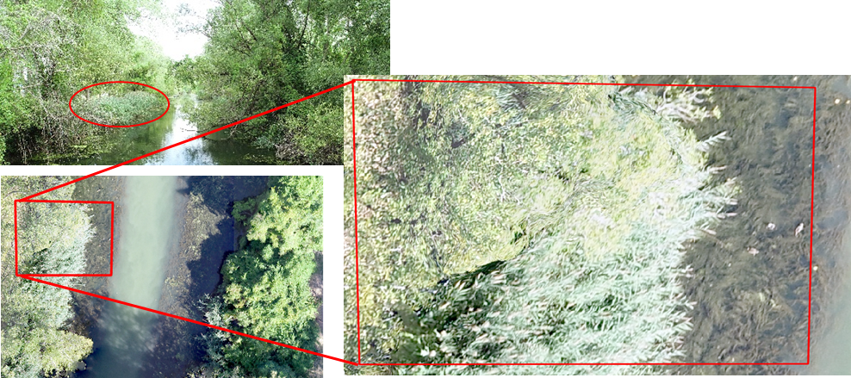
Caption for Graphic or Image: Common reed (Phragmites australis, outlined in red), an invasive non-native plant, visible in a picture taken from a boat (upper left) and at two scales from UAS imagery (lower left, and right).
Author name and business email: Matthew Struckhoff mstruckhoff@usgs.gov

DOI agency/bureau: USGS
USGS Mission Area: Ecosystems
USGS Program: Environmental Health Program
Cost Center: Columbia Environmental Research Center
Program Name:
Project title: Multi-stage UAS-based vegetation assessment and restoration monitoring
Project description: This project uses aerial imagery collected with Unoccupied Aerial Systems (UAS, or “drones”) to assess and monitor vegetation at contaminated wetlands and neighboring lands being remediated and restored under the Great Lakes Restoration Initiative (GLRI). The project is a collaborative effort between the US Environmental Protection Agency, USGS, and a private corporation hired to collect imagery (in lieu of UAS flights by USGS staff currently prohibited under the Department of the Interior UAS flight ban). Researchers at the Columbia Environmental Research Center are using UAS imagery and derived elevation products to map invasive plant species and vegetation communities at multiple sites of interest. These products provide baseline data on site vegetation profiles prior to remediation and restoration activities. Following remediation and habitat restoration, additional UAS imagery will be used to monitor and map the same species and communities to assess restoration progress. Data will also be used to support invasive species early detection/rapid response and long-term eradication and control programs, to ensure that invasive species do not thwart restoration efforts and hinder ecosystem recovery.

Vegetation is just one element being monitored under the GLRI program to assess restoration progress and to determine if restoration goals are being met. When possible, opportunistic UAS imagery collection will be used to develop high-resolution elevation models to describe terrestrial topography and as a substitute for, or complement to, bathymetric (water depth) models from data collected using traditional methods. High resolution elevation models will improve our ability to monitor fluctuations in water levels at GLRI sites and changes in topography and bathymetry following restoration implementation. Further, these models will allow better comprehension of the relative role that water depth (in aquatic systems) and depth to ground water (in terrestrial systems) play in determining vegetation distribution in restored areas. Projects associated with the Great Lakes Restoration Initiative complement ongoing work on assessment, remediation and restoration for the Department of the Interior Natural Resource Damage Assessment and Restoration Program.
Sensor Type: Camera;Multispectral (approx. 4-12 bands);Thermal;Video;
Platform type: UAS;
URL: https://www.usgs.gov/centers/cerc/science/uas-and-other-remote-sensing-and-imagery-analysis-disaster-response-remediation
Graphic or Image name: Struckhoff_GLRI_Phragmites.png
Caption for Graphic or Image: Photographs showing patches of common reed (Phragmites australis) as visible from a boat at water-level (red circle, upper left), and as identified from high resolution (less than 2 cm ground distance resolution) aerial imagery collected using UAS at two scales (red boxes, lower left and right).
Author name and business email: Matthew Struckhoff mstruckhof@usgs.gov. This entry supersedes earlier entry by mstruckhoff.

DOI agency/bureau: USGS
USGS Mission Area: Ecosystems
USGS Program: Environments Program
Cost Center: Upper Midwest Environmental Sciences Center
Program Name:
Project title: 2020 Land Cover Mapping of Upper Mississippi River System
Project description: The U.S. Army Corps of Engineers (USACE) Upper Mississippi River Restoration (UMRR) program, through its Long Term Resource Monitoring (UMRR-LTRM) element, collected systemic imagery of the entire Upper Mississippi River System (UMRS) during the summer of 2020. Development of the 2020 Land Cover/Land Use (LCU) database will provide a fourth systemic dataset to compare to the 1989, 2000, and 2010/11 systemic coverages. Once completed, the 2020 dataset will be invaluable in assessing the current state of floodplain vegetation, as well as evaluating long-term vegetation trends and habitat changes over the past 30 years. The USGS Upper Midwest Environmental Sciences Center in coordination with the US Fish and Wildlife Service conducted the mission planning, aerial image acquisition, image processing from raw to 4-Band (red, green, blue, near-infrared), and vegetation mapping. These images were collected at 0.2 meters (8 inches)/pixel for Pools 1-13 where complex aquatic vegetation requires greater detail, and at 0.4 meters (16 inches)/pixel for Pools 14 through Open River and the Illinois River using mapping-grade, medium format Phase One iXU-RS1000 100mp camera set in a stabilized SOMAG mount that can be directly georeferenced using simultaneously generated exterior orientation (X, Y, Z expressed by GPS and roll, pitch, and yaw as detected by the inertial measurement unit).
Sensor Type: Camera;Multispectral (approx. 4-12 bands);
Platform type: Airplane;
URL: https://www.usgs.gov/centers/umesc/science/2020-systemic-land-coverland-use-aerial-imagery-acquisition-image?qt-science_center_objects=0#qt-science_center_objects
Graphic or Image name: UMRS_LD12

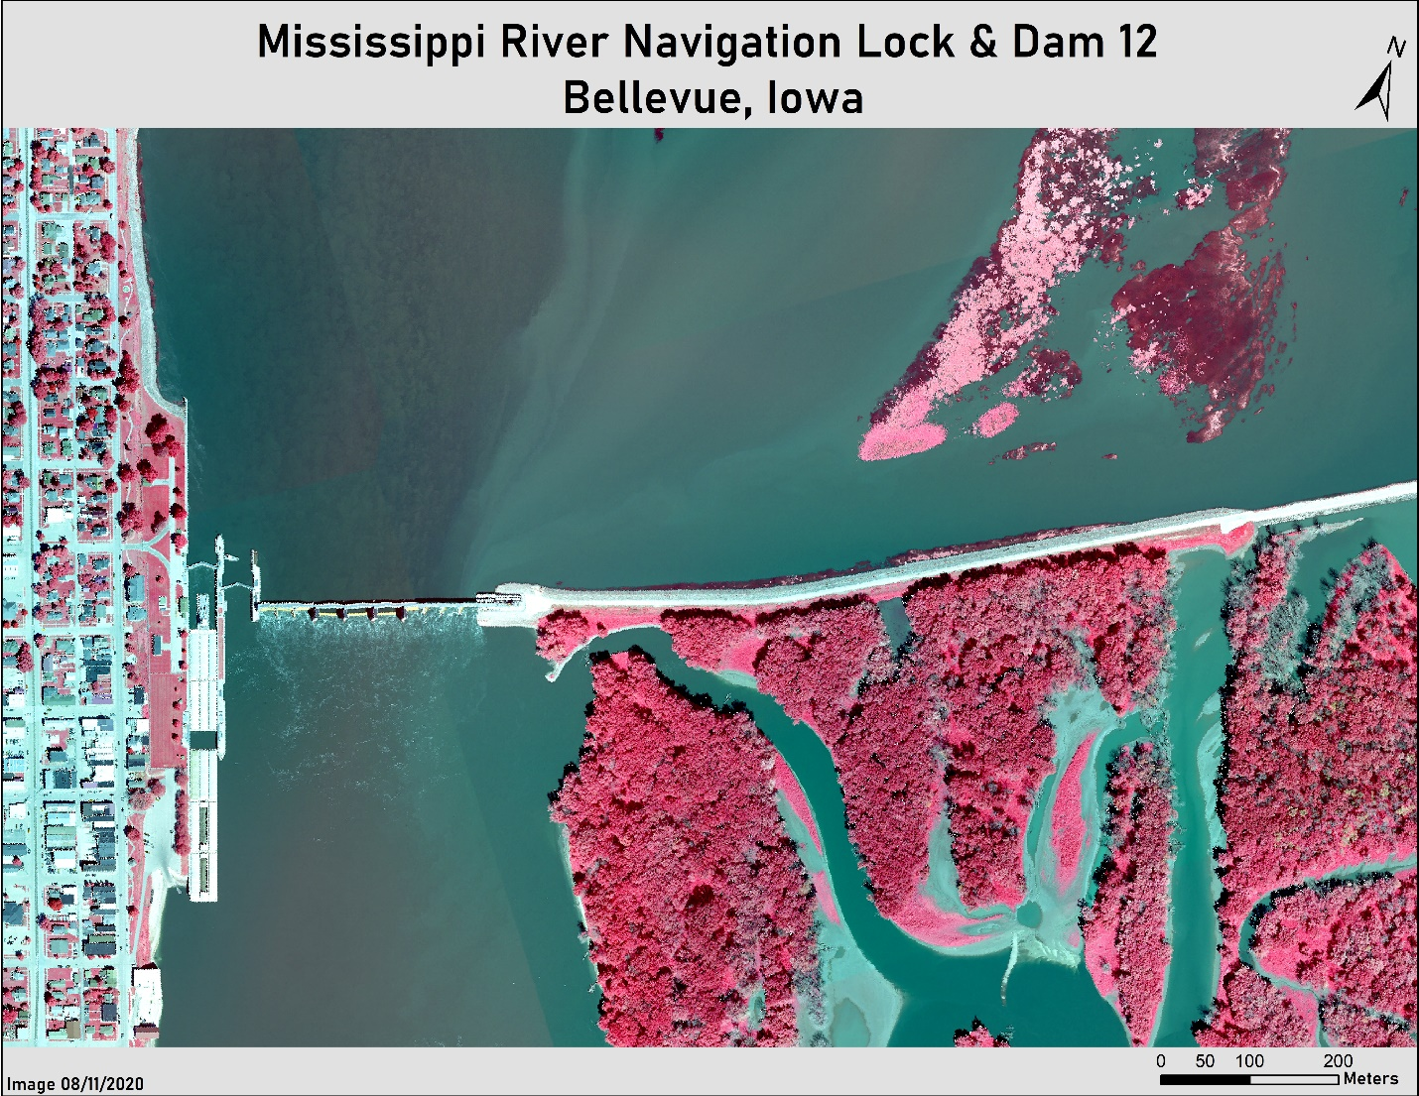
Caption for Graphic or Image: Lock & Dam 12 at Bellevue, Iowa showing barge/tow, spillway, river current, backwater channels, open pool, floating aquatics, treed islands, and part of town.
Author name and business email: Benjamin Finley (bfinley@usgs.gov)

DOI agency/bureau: USGS
USGS Mission Area: Core Science Systems
USGS Program: Land Change Science
Cost Center: Western Geographic Science Center
Program Name:
Project title: Time Series Remote Sensing of Surface Water and Wetland Dynamics
Project description: This project is generating new remote sensing methods for DOI use and across the globe. We recently published research introducing the Augmented Normalized Difference Water Index (ANDWI), which employs an expanded set of spectral bands, RGB, NIR, and SWIR1&2, to maximize the contrast between water and non-water pixels. Using a dynamic thresholding method, the Otsu algorithm, we enhanced ANDWI and find improvement over other water remote sensing indices (NDWI, MNDWI, AWEI, WI). These methods are now being tasked in a study of endorheic inland lakes, which face growing pressures from climatic and anthropogenic stresses, at times causing their recession and desiccation. Determining the relative influence of drivers is problematic in data rich environments, however in less developed regions of the world and in data poor environments it is exceedingly difficult. Here we examine the terminal Hamun Lakes on the border of Iran and Afghanistan that embody amplified challenges of inland waters. We show that although drought triggered the lakes’ recession, they would not have desiccated without increasing anthropogenic pressures. We document rapid growth in irrigated agricultural lands in upstream Afghanistan in the recent decade reaching an annual average of 7,822 km2 from 2015-2019, four times that from 1984-1988. Compounding this pressure, Iran began storing flood water that fed the Hamun Lakes for urban and agricultural consumption in 2009. We estimated that the lakes’ surface area in the recent decade would have been 2.5 times larger without increasing anthropogenic stresses across the basin. Our data integration effort is an unprecedented analysis of the basin hydrology and land use change of the region, thereby allowing us to identify the underlying causes of environmental degradation that caused economic hardship and geopolitical tensions.
Sensor Type: Multispectral (approx. 4-12 bands);
Platform type: Satellite;
URL:
Graphic or Image name: KreitlerTimeSeries.jpg
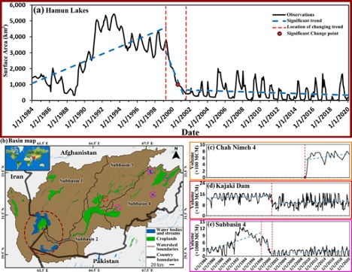
Caption for Graphic or Image: Figure 1: Hamun Lakes desiccated in the recent decade. (a) The Hamun Lakes’ monthly surface area from 1984-2019. (b) Map of the Helmand River Basin, HRB, and considered sub-basins. (c) Monthly water storage in the 4th artificial reservoir (Chah-nimeh 4). (d) Monthly water storage in the Kajaki Dam. (e) Monthly water storage in sub-basin 4 including the Arghandab Dam and three lakes. In (b), the Hamun Lakes in sub-basin 1 are marked with dark red ellipse, the Kajaki dam in sub-basin 3 is marked with light red circle, and the Arghandab Dam and three lakes in sub-basin 4 are marked with pink circles. Blue dashed lines represent statistically significant trends based on the Mann-Kendall test and red dots show statistically significant change points based on the Pettitt test.
Author name and business email: jkreitler@usgs.gov

DOI agency/bureau: USGS
USGS Mission Area: Core Science Systems
USGS Program: Land Change Science
Cost Center: Western Geographic Science Center
Program Name:
Project title: Pre-fire, Post-fire, and Forest Recovery Using LiDAR and Burn Severity Analysis
Project description: The 2012 Pole Creek Fire on the Deschutes National Forest in Oregon continues to provide an exceptional opportunity to study wildland fire effects with remote sensing data. This project builds upon wildland fire remote sensing research by addressing novel questions through the analysis of pre-fire, post-fire, and now a new 8+ year post-fire forest recovery LiDAR acquisition. Using recently approved Planet and Worldview high resolution multispectral data we will also fuse optical remote sensing techniques with LiDAR. Through the analysis of LiDAR from the recovery of the forest we are assessing how pre-fire conditions and forest management activities affected the recovery potential and outcomes for a variety of forest types and along a gradient of burn severity measures.

Recently published research from this project estimates fuel consumption for the 2012 Pole Creek Fire in Oregon and portions of the 2011 Las Conchas Fire in New Mexico, using multitemporal lidar and corresponding field data. Additionally, estimates for change in aboveground biomass (AGB) were compared to energy release estimates using fire radiative energy (FRE) observations from the Moderate Resolution Imaging Spectroradiometer (MODIS) satellite to mechanistically derive a combustion coefficient for top-down estimation. Past research efforts included the evaluation of lidar- and Landsat-derived burn severity indices, and fuel treatment and mountain pine beetle infestation effects on ensuing fire severity using multitemporal lidar data. This research is quantifying how pre-fire forest condition affects burn severity and how various remote sensing techniques can be used to explain fire patterns and improve modeling and remote sensing of wildland fire for natural resource management and forest ecology.

Sensor Type: Lidar (terrestrial or bathymetric);Multispectral (approx. 4-12 bands);
Platform type: Satellite;Airplane;
URL:
Graphic or Image name: Kreitler_PoleCreek_Fig1.jpg
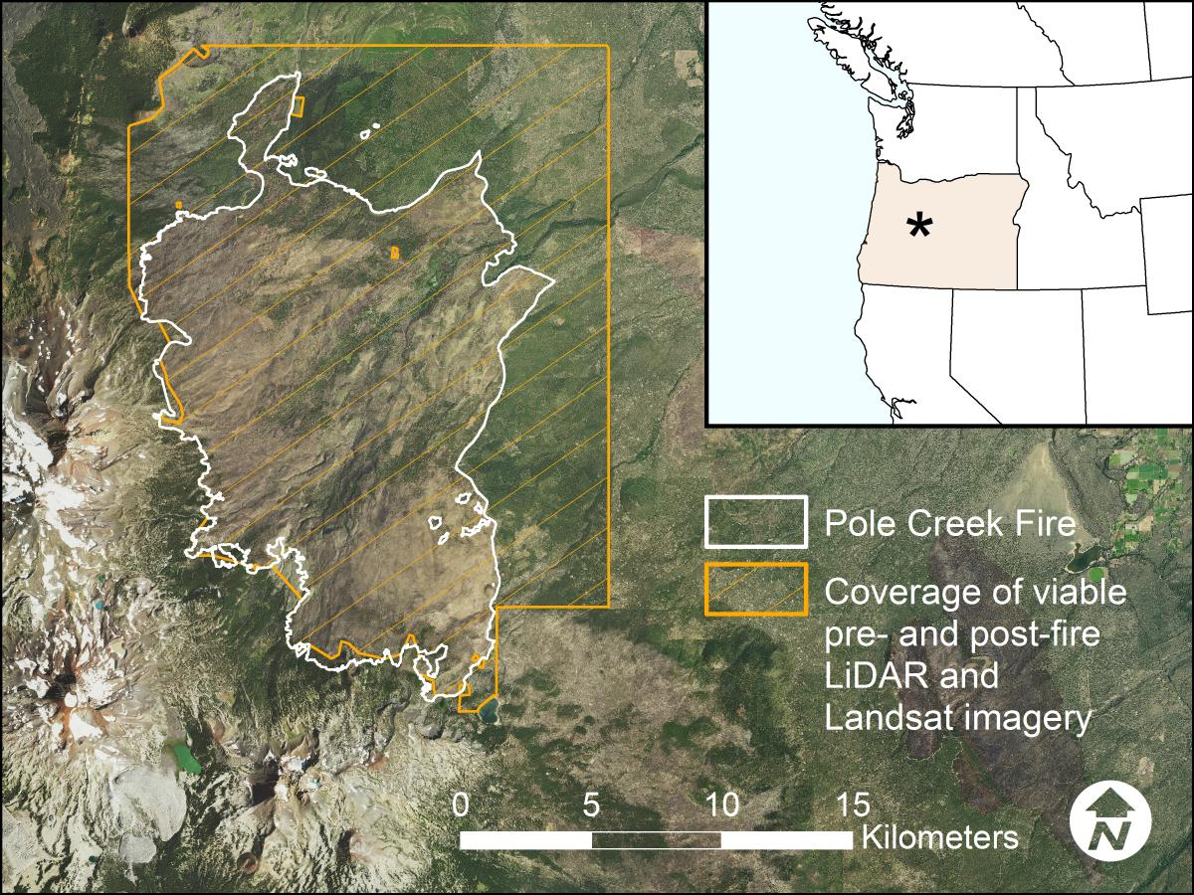
Caption for Graphic or Image: Location of the Pole Creek Fire in central Oregon and the overlap of viable light detection and ranging (lidar) and Landsat imagery.
Author name and business email: jkreitler@usgs.gov

DOI agency/bureau: USGS
USGS Mission Area: Core Science Systems
USGS Program: Wildlife Program
Cost Center: Earth Resources Observation and Science (EROS) Center (Geography)
Program Name:
Project title: Fusion of Spaceborne Lidar and Optical Data for Complete Vegetation Maps.
Project description: Vegetation structure is a key attribute of forested ecosystems, influencing habitat suitability, water quality and runoff, microclimate and wildfire behavior. The Fire-Science Team at the USGS EROS Data Center is fusing space-borne lidar and passive optical data to create spatially complete maps of vegetation structure at a 30 × 30 meter resolution. These maps will allow land-managers to make informed decisions and provide key inputs to fire-simulation models.

The Global Ecosystem Dynamics Investigation (GEDI) is a lidar instrument aboard the International Space Station that makes direct observations of the vertical structure of vegetation on the Earth’s surface. GEDI is a sampling mission, illuminating sparsely distributed 25 meter diameter footprints. The spatial sparsity of GEDI motivates the fusion of spatially complete optical data from Landsat 8. The optical bands of Landsat 8 are correlated with the vegetation variables of interest, allowing statistical models to learn this correlation where GEDI and Landsat 8 overlap and then make predictions where Landsat 8 data is present, but GEDI data is not. In addition, the inherent spatial correlation of the GEDI observations can be used to interpolate variation in vegetation structure not explained by the Landsat 8 optical bands. The result is a statistical modeling procedure that produces spatially complete maps of vegetation structure at the 30 × 30 meter resolution of Landsat.

The ability of the procedure to map canopy height was tested across the Black Hills of South Dakota, an area with coarsely varied canopy structure. Test data consisting of 10% of the GEDI observations within the Black Hills was withheld and predicted with the remaining GEDI observations in addition to Landsat imagery of the area. The method predicted canopy height with a mean absolute error of 0.84 meters, demonstrating accurate prediction. A complete map of canopy height for the entire Black Hills was then generated.

Sensor Type: Lidar (terrestrial or bathymetric);Multispectral (approx. 4-12 bands);
Platform type: Satellite;
URL:
Graphic or Image name: BlackHillsCanopyHeight.png
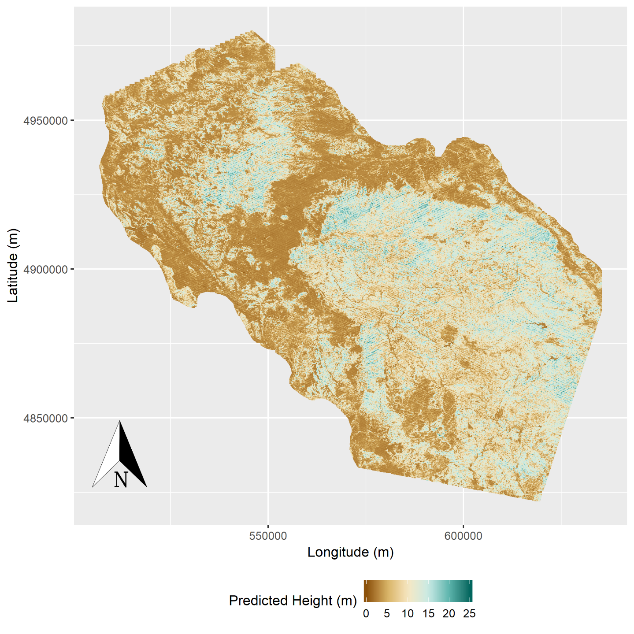
Caption for Graphic or Image: Predictions of canopy height at a 30 x 30 meter resolution across the Black Hills, South Dakota.
Author name and business email: Paul May, pmay@usgs.gov

DOI agency/bureau: USGS
USGS Mission Area: Core Science Systems
USGS Program: National Geospatial Program
Cost Center: NGTOC Denver
Program Name:
Project title: Using Imagery to Crowdsource The National Map
Project description: The National Map Corps (TNMCorps), a crowdsourced mapping project, relies on volunteers to assist the USGS National Geospatial Program by collecting and editing man-made structures data for The National Map. Through their participation, volunteers make important contributions to the USGS’s ability to provide the Nation with accurate mapping information.
Volunteers collect and update different structure feature types in all 50 states, as well as in Puerto Rico and the U.S. Virgin Islands. The structure feature types include schools, colleges and universities, fire and emergency management stations, law enforcement, prisons and correctional facilities, hospitals, ambulance services, cemeteries, post offices, courthouses, and city/town halls. Through a tiered-editing approach, volunteers improve the structures data by adding new features, removing obsolete points, and correcting existing data. The updates are then incorporated into The National Map and ultimately into U.S. Topo maps. As of July 2021, more than 2,900 users have made 740,000 edits to over 514,000 unique points.

Getting started is easy. After walking through a simple registration process, volunteers begin editing using an internally developed web-based mapping platform that was released in August 2016. The primary base layer uses The National Map Web services and consists primarily of 1-meter resolution digital orthophoto imagery provided by the U.S. Department of Agriculture National Aerial Imagery Program (NAIP), which is supplemented by 2-foot or better high-resolution orthoimagery over urban areas.

TNMCorps incorporates a variety of strategies to motivate and engage volunteers while simultaneously facilitating focused data collection resulting in high-quality data. These strategies include the tiered-editing process, mapping challenges, virtual recognition badges, social media engagement, bi-monthly newsletters, and regular news releases. Volunteers are from the general public and include retirees, students, geospatial professionals, and anyone with an interest in contributing to The National Map.

Sensor Type: Camera;
Platform type: Airplane;
URL: https://www.usgs.gov/core-science-systems/ngp/tnm-corps
Graphic or Image name: USGS_TNMCorps_2021.png
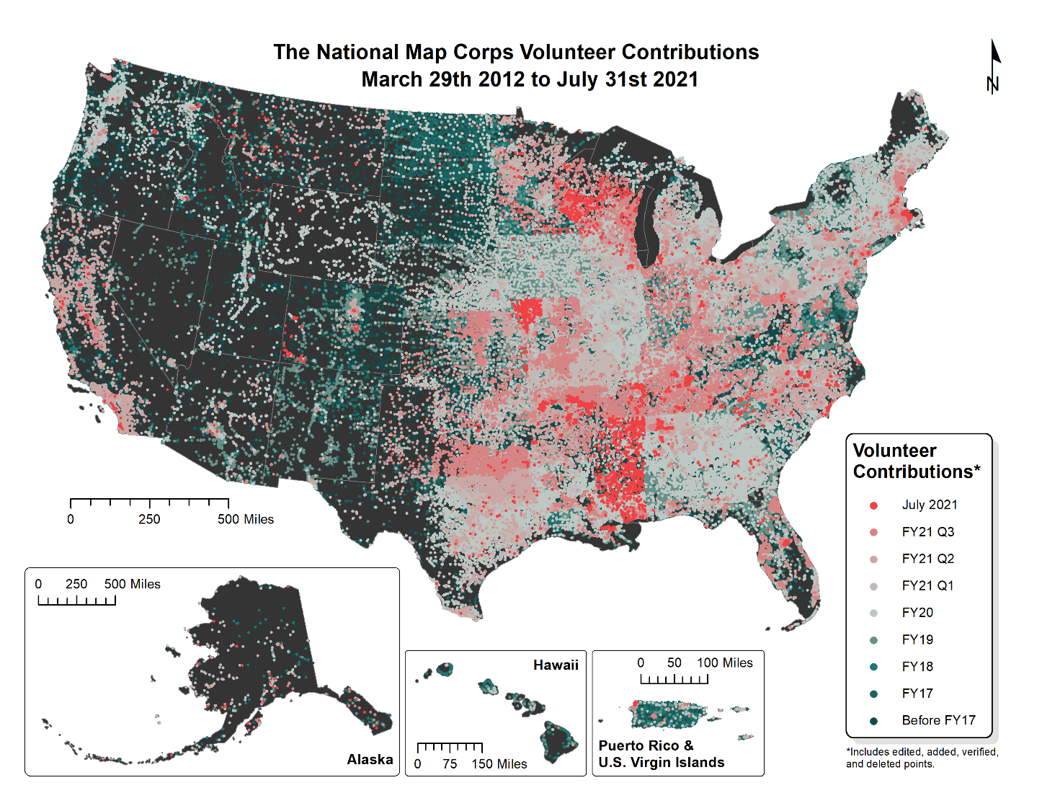
Caption for Graphic or Image: USGS TMNCorps volunteer contributions from March 29, 2012, to July 31, 2021. Each point on the map represents a single volunteer-edited structure feature. These volunteer contributions include edited, added, verified, and deleted points.
Author name and business email: ekorris@usgs.gov

DOI agency/bureau: USGS
USGS Mission Area: Core Science Systems
USGS Program: Land Change Science
Cost Center: Earth Resources Observation and Science (EROS) Center (Geography)
Program Name:
Project title: Early Warning eXplorer for Food Security Monitoring
Project description: Climate-related impacts on food security and water availability continue to impact many parts of the globe. Several regions, including sub-Saharan Africa, are not only susceptible to these impacts, but also lack the ability to monitor climate-related risk and often rely on sub-standard in situ observation networks. Earth observation (EO) satellites have been instrumental in offering large scale monitoring capabilities for analysis of rainfall, evapotranspiration, vegetation condition, soil moisture and other agro-climatological factors that impact food and water security in these data-sparse regions. The US Geological Survey and colleagues at the University of California Santa Barbara Climate Hazards Center have developed the Early Warning eXplorer (EWX) tool to address these regional monitoring limitations by providing easy access to and analysis of EO information in support of the US Agency for International Development Famine Early Warning Systems Network (USAID FEWS NET).

The EWX implementation is based on three primary components (Figure 1). The first is the EWX Viewer which is accessible via an internet browser and offers the ability to visualize various datasets in map form and to derive time series summaries for desired spatial domains (e.g., administrative units, crop zones, etc.). In addition to visualization and analysis, the viewer also provides the ability to download gridded data for specified subset areas. The second component is the GeoEngine processing server, which is at the heart of the EWX system. It provides web services, the graphical user interface, file system management, time series analysis, as well as storage and retrieval of outputs to and from the EWX database. The third component, Support Applications, includes a map server, GeoServer instance and a PostgreSQL database for managing statistics and file systems, all while routinely monitoring for new and/or modified EO inputs from various FEWS NET science sources.

Major strides have been made in terms of development and real-time availability of remote sensing based EOs; however, access to those datasets and their applications for informed decision-making is limited. The EWX is a web service that aims to both fill the in situ data gap and facilitate application of EO information for decision-making to support mitigating the most adverse impacts of climate extreme events and climate adaptation.

Sensor Type: Multispectral (approx. 4-12 bands);Thermal;
Platform type: Satellite;
URL: earlywarning.usgs.gov/fews
Graphic or Image name: EWX DOI RS draft report fig1.png
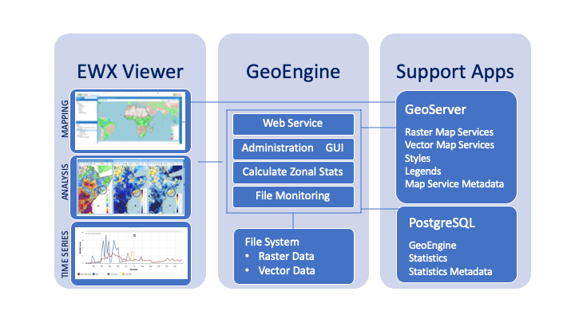
Caption for Graphic or Image: Figure 1. Flow chart of the main components of the Early Warning eXplorer.
Author name and business email: Michael Budde - mbudde@usgs.gov

DOI agency/bureau: USGS
USGS Mission Area: Core Science Systems
USGS Program: Land Change Science
Cost Center: Earth Resources Observation and Science (EROS) Center (Geography)
Program Name:
Project title: Water Use for the Delaware River Basin from 1950 – 2099
Project description:
The Delaware River Basin is located on the Eastern Seaboard and is an important water resource for Philadelphia and other big cities in the region. It was chosen to demonstrate USGS’ model integration efforts to investigate the relationships among water use, land cover, and climate to assess and forecast the impact of changes in these parameters on the environment and water resources. Scientists at the USGS Earth Resources Observation and Science (EROS) Center used the VegetationET (VegET) model to estimate soil moisture, evapotranspiration (ET), and runoff using a combination of daily weather and remotely sensed data to provide daily historical and future estimates of water use from 1950-2099 for the basin. Projected land cover data from the FOREcasting SCEnarios (FORE-SCE) was used to parameterize the model. The vast amount of data needed and created for this study was processed using a cloud computing platform through the USGS Cloud Hosting Service (CHS) Pangeo Framework. The time series of the 150-year annual ET revealed different patterns of dry and wet periods (see figure), as well as an overall increasing trend in ET values on an annual scale. The causes for the increasing trend could be linked to an increase in the potential ET due to increasing temperature and/or favorable vegetation changes associated projected rainfall patterns and land use change. Further investigations are planned to better understand each parameter as well as the relationships among water, land cover, and climate.
Sensor Type: Multispectral (approx. 4-12 bands);Thermal;
Platform type: Ground based / sensor web / web cam;Satellite;
URL:
Graphic or Image name: graphic_DRB_DOIreport21.jpg
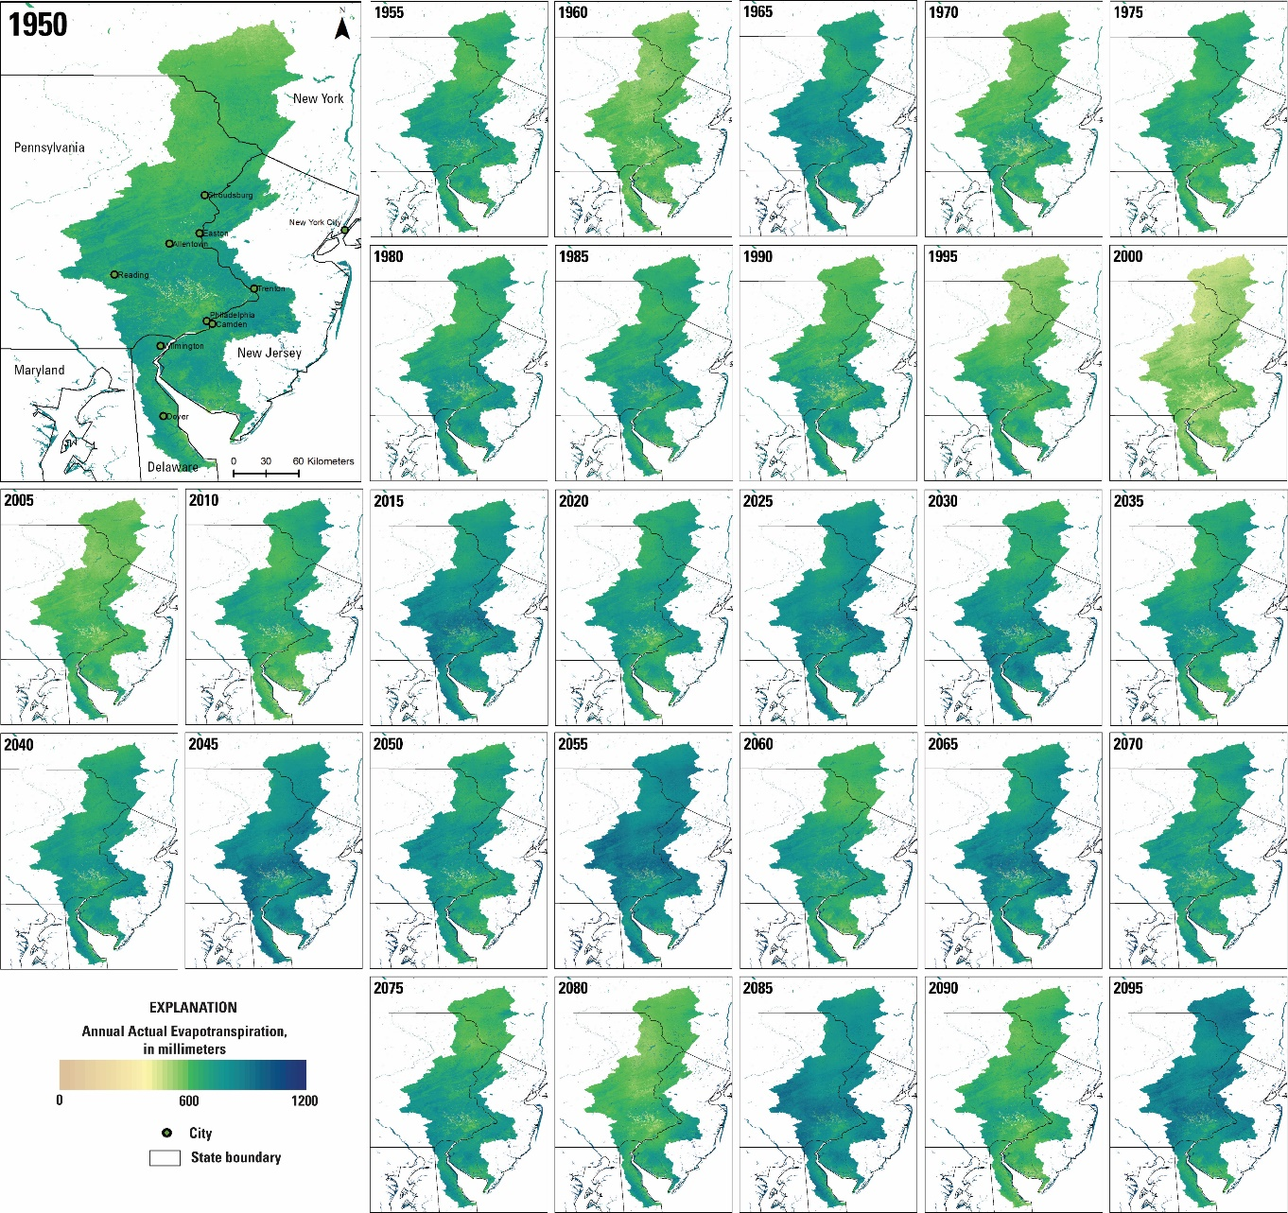
Caption for Graphic or Image: Annual total evapotranspiration (millimeters) for the Delaware River Basin at 250-m resolution from 1950 till 2099 displayed with 5-year increments.
Author name and business email: Gabriel Senay (senay@usgs.gov)

DOI agency/bureau: USGS
USGS Mission Area: Water Resources
USGS Program: Groundwater and Streamflow Information Program
Cost Center: National Research Program - Central Branch
Program Name:
Project title: Surface Flow Velocities From Space
Project description: Conventional, field-based streamflow monitoring in remote, inaccessible locations such as Alaska poses logistical challenges. Safety concerns, financial considerations, and a desire to expand water-observing networks make remote sensing an appealing alternative means of collecting hydrologic data. In an ongoing effort to develop non-contact methods for measuring river discharge, we evaluated the potential to estimate surface flow velocities from satellite video of a large, sediment-laden river in Alaska via particle image velocimetry (PIV). In this setting, naturally occurring sediment boil vortices produced distinct water surface features that could be tracked from frame to frame as they were advected by the flow, obviating the need to introduce artificial tracer particles. In this study, we refined an end-to-end workflow that involved stabilization and geo-referencing, image preprocessing, PIV analysis with an ensemble correlation algorithm, and post-processing of PIV output to filter outliers and scale and geo-reference velocity vectors. Applying these procedures to image sequences extracted from satellite video allowed us to produce high resolution surface velocity fields; field measurements of depth-averaged flow velocity were used to assess accuracy. Our results confirmed the importance of preprocessing images to enhance contrast and indicated that lower frame rates (e.g., 0.25 Hz) lead to more reliable velocity estimates because longer capture intervals allow more time for water surface features to translate several pixels between frames, given the relatively coarse spatial resolution of the satellite data. Although agreement between PIV-derived velocity estimates and field measurements was weak (R2 = 0.39) on a point-by-point basis, correspondence improved when the PIV output was aggregated to the cross-sectional scale. For example, the correspondence between cross-sectional maximum velocities inferred via remote sensing and measured in the field was much stronger (R2 = 0.76), suggesting that satellite video could play a role in measuring river discharge. Examining correlation matrices produced as an intermediate output of the PIV algorithm yielded insight on the interactions between image frame rate and sensor spatial resolution, which must be considered in tandem. Although further research and technological development are needed, measuring surface flow velocities from satellite video could become a viable tool for streamflow monitoring in certain fluvial environments. (Link to full journal article: https://doi.org/10.3389/frwa.2021.652213)
Sensor Type: Video;
Platform type: Satellite;UAS;
URL: https://doi.org/10.3389/frwa.2021.652213
Graphic or Image name: pivMapsByHz2.tiff
Caption for Graphic or Image: Maps of PIV-derived surface flow velocities for different frame rates: (A) 1 Hz, (B) 0.5 Hz, and (C) 0.25 Hz. The locations of the ADCP velocity measurements used for accuracy assessment are shown in red.
Author name and business email: Carl J. Legleiter: cjl@usgs.gov

DOI agency/bureau: USGS
USGS Mission Area: Ecosystems
USGS Program: Biological Threats and Invasive Species Research Program
Cost Center: Southwest Biological Science Center
Program Name:
Project title: A Data Explorer for Tamarisk and Riparian Systems
Project description: The intensification of drought across the Colorado River Basin is causing riparian ecosystem stress and transformations in plant stand structure, species composition and plant water use, resulting in increasing resource management challenges. Over the past two decades, riparian plant canopy and its greenness or vegetation health have declined drastically on reaches of the Lower Colorado River and its tributaries, suggesting further deterioration of biodiversity, wildlife habitat, and key ecosystem services. Researchers from the USGS and the University of Arizona have built an interactive, searchable Lower Colorado River Basin Data Explorer for the purpose of allowing users to monitor riparian woodlands health and water use over selected times and locations. The Riparian Data Explorer provides interactive access for the metrics of greenness, phenology and water use in the riparian-zones using time-series information and it provides plotting tools for remotely sensed measurements of vegetation index (VI), phenology dynamics, daily average peak seasonal evapotranspiration (ET, mmd-1), and an annualized ET (mmyr-1). These data are currently provided at two spatial resolutions: 250m Moderate Resolution Imaging Spectroradiometer (MODIS) and 30m Landsat Enhanced Vegetation Index (EVI and EVI2), as well as the Normalized Difference Vegetation Index (NDVI) for comparison with older studies that use NDVI instead of EVI/EVI2. Remote sensing data fusion from different sources of satellite imagery used in our Riparian Data Explorer tool may be used to track changes due to saltcedar (Tamarix spp.) defoliation events caused by the tamarisk leaf beetle (Diorhabda spp.). End users may currently identify and search twenty years of data from 2000-2020 for their areas of interest for the streamside riparian vegetation for the larger rivers in Arizona. The searchable online system is being expanded to include additional rivers, their uplands, and even the non-riverine borderlands ecosystems, with the main purpose being to evaluate dynamic trends in the landscape vegetation and its phenology changes. In order for our research and outreach to evolve and become a fully functional and an operational service for scientists, land, water, cultural, and resource managers, and the general public, the Data Explorer requires additional time for detecting, discriminating, and validating the riparian plant zones and distinguishing regions of saltcedar from native riparian species cover. We are currently incorporating LiDAR datasets (USGS 3D Elevation Program) to improve the remotely sensed data fusion process used for identification of native and non-native riparian plant communities.
Sensor Type: Multispectral (approx. 4-12 bands);
Platform type: Satellite;
URL:
Graphic or Image name: Riparian Invasive Species

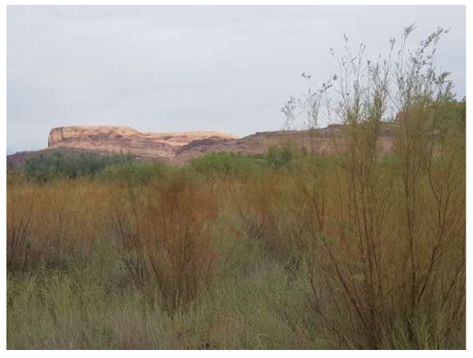
Caption for Graphic or Image: Tamarix spp. (tamarisk or saltcedar), a shrub-like tree, was intentionally introduced to the U.S. from Asia in the mid-1800s and thrives in today’s human-altered streamside habitats; this invasive riparian species can be found along wetlands, rivers, lakes, and streams across the western U.S. In 2001, a biological control agent, Diorhabda spp. (tamarisk leaf beetle), was released and causes widespread defoliation of tamarisk, thus altering tamarisk’s water use and effectiveness as erosion control, as well as dynamics of native and nonnative plant and wildlife species.
Author name and business email: Pamela Nagler; pnagler@usgs.gov

DOI agency/bureau: USGS
USGS Mission Area: Ecosystems
USGS Program: Biological Threats and Invasive Species Research Program
Cost Center: Southwest Biological Science Center
Program Name:
Project title: US–Mexico Desert Ecoregions Vegetation Communities
Project description: Remote sensing research is used in the culturally, ecologically, and topographically complex border region to provide scientific support to inform land management decisions and to meet management needs of stakeholders of the transboundary desert ecoregions. Managing species and habitats across borders is a challenge for those working in conservation in the southwest United States (U.S.) and northwest Mexico. The border areas of southeast California, southern Arizona, southwest New Mexico, northeast Baja California, and Sonora support desert shrublands and semi-desert grasslands, and the Madrean Highlands support a mosaic of oak-juniper and conifer woodlands. The Borderlands is an area of high biodiversity, providing habitat for bird species of concern such as the Yellow-billed Cuckoo, Southwestern Willow Flycatcher, Masked Bobwhite, Bendire’s & LeConte’s Thrashers, Cactus Ferruginous Pygmy-Owl, and Yuma Ridgway’s Rail; for endangered plants such as Bartram’s stonecrop and the Pima pineapple cactus; and for iconic and rare vertebrates such as the jaguar. Drought, climate, and invasive species research is vital to providing high quality science for the borderland’s habitats. The flora and fauna of the border region, while rich, is heavily influence by seasonal and long-term trends in temperature and precipitation. Our science study provides the state-of-knowledge of the transboundary vegetative landscape and provides a vegetation community dynamic map for portions of the Mojave and Sonoran Deserts in support of critical land conservation planning to meet habitat management needs. The goals are to use remote sensing data fusion from ground, aerial and satellite within the majority of the North American Bird Conservation Initiative’s Bird Conservation Region #33 to develop maps of the transboundary vegetation community, to derive the seasonal phenology dynamics of these communities, and to document changing trends in land cover which includes changes due to invasive species in response to anthropogenic and climate stressors. We provide a valuable tool and high-resolution reference map about vegetation community distribution and seasonal dynamics to support land management and conservation planning. We aim to increase the understanding of the binational nature of vegetation communities, which is critical for protection, conservation, and restoration of vegetation, habitat, and ecosystems; this is particularly important for threatened and endangered species. And lastly, we are creating an end-to-end medium and fine resolution remote sensing-based data fusion method and online toolset to map the transboundary vegetation communities in our study region.
Sensor Type: Multispectral (approx. 4-12 bands);
Platform type: Satellite;
URL:
Graphic or Image name: Nagler_BorderlandsMap4mg
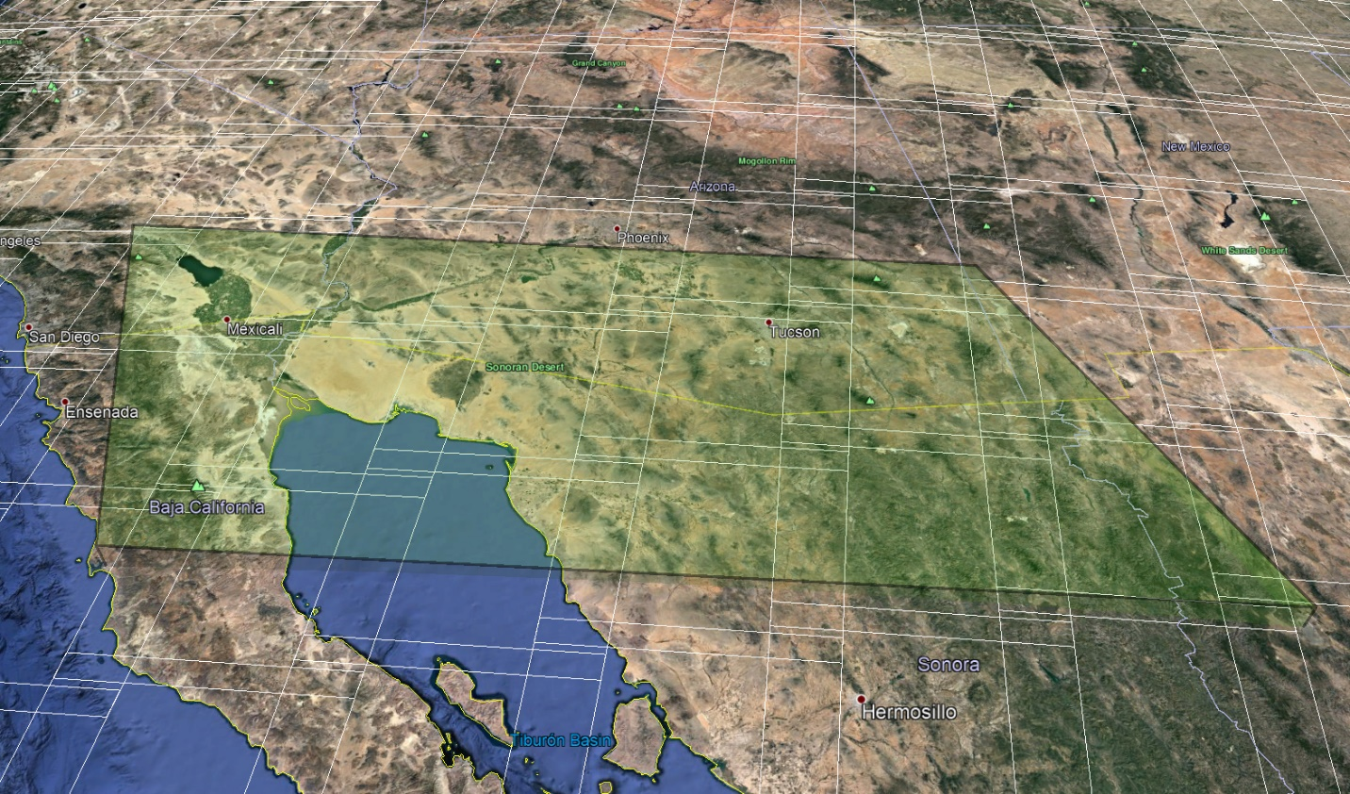
Caption for Graphic or Image: Transboundary Vegetation Community Dynamic Map including the U.S. Fish and Wildlife Service’s Bird Conservation Region #33, that is part of the Migratory Bird Program. Note: the white grid on the inset map delineates the boundary of each Landsat 8 OLI tile. The area is covered by 14-21 scenes and two MODIS tiles. The final product (inset, blue line) required 50 Landsat scenes and 4 MODIS tiles.
Author name and business email: Pamela Nagler; pnagler@usgs.gov

DOI agency/bureau: USGS
USGS Mission Area: Ecosystems
USGS Program: Water Availability and Use Science Program
Cost Center: Southwest Biological Science Center
Program Name:
Project title: Lower Colorado River Riparian Water Use Changes
Project description: The U.S. portion of the Lower Colorado River between Hoover and Morelos Dams has a critically important riparian ecosystem that is used by avian species as one of the only north-south flyways in this arid region. We used Landsat from 2000 through 2020 to measure greenness and water use along five reaches of these riparian woodlands to evaluate trends in riparian ecosystem health. We used the two-band Enhanced Vegetation Index (EVI2; a proxy for greenness) and evapotranspiration (ET, mmd-1) using EVI2 and ground-based meteorological potential evapotranspiration (ETo) from three stations along the river. We also used an annualized ET based on EVI2 Landsat time-series, a new Phenology Assessment Metric (PAM ET). A key finding was that riparian vegetation greenness and its water use has been in decline since 2000 as measured by Landsat, depicting a loss of healthy vegetation over the last two decades. EVI2 results showed a decrease of 14%, while average daily ET(EVI2) between the first and last decade had a decrease of 27%, over -1 mmd-1. The average PAM ET losses were 18% or -171 mmyr-1 between these two decades. The difference between the first and last five-year periods, 2000–2005 and 2016–2020, showed the largest decrease in daily ET(EVI2), a loss of 33% or -1.24 mmd-1. These declines come from a loss in healthy, green, riparian plant-cover, not a change in plant water use efficiency nor efficient use of managed water resources. Our results suggest further deterioration of biodiversity, wildlife habitat and other key ecosystem services on the U.S. portion of the LCR.
Sensor Type: Multispectral (approx. 4-12 bands);
Platform type: Satellite;
URL:
Graphic or Image name: LowerColoradoRiverET

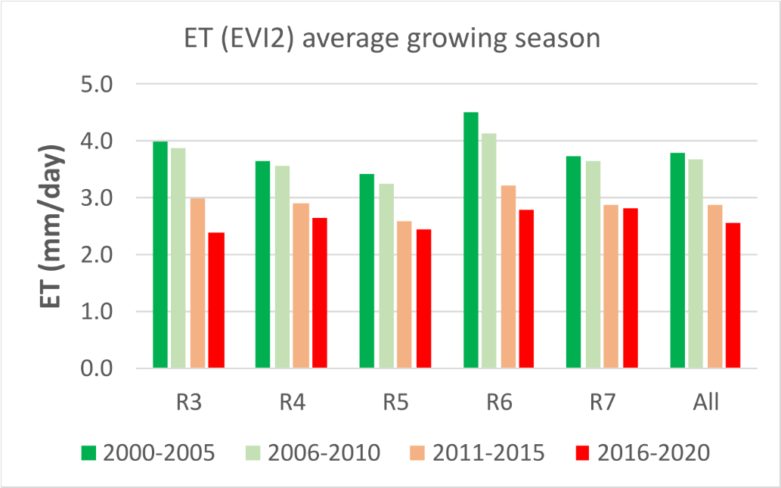
Caption for Graphic or Image: ET (mmd-1) averaged across four groups of years in ~5-year periods (2000–2005 = green, 2006–2010 = light green, 2011–2015 = peach, 2016–2020 = red) for five reaches and the weighted average of All reaches along the Lower Colorado River.
Author name and business email: Pamela Nagler; pnagler@usgs.gov

DOI agency/bureau: USGS
USGS Mission Area: Water Resources
USGS Program: Water Availability and Use Science Program
Cost Center: Earth Resources Observation and Science (EROS) Center (Geography)
Program Name:
Project title: Remote Sensing Model Evaluation for NetET Irrigation Water Use for the Nation
Project description: The USGS Water Availability and Use Science Program (WAUSP) supports designed goals to systematically provide information to water resource managers to assess availability of the Nation’s water. The USGS focuses on development of advanced techniques for Evapotranspiration (ET) estimates to better measure various agricultural-based water budget components for informing decision makers. Specifically, National Water Census (NWC) goals support geospatial analysis and evaluation of joint performance of the Operational Simplified Surface Energy Balance (SSEBop) and Vegetation ET (VegET) models for quantifying Net Irrigation water use, also referred to as NetET.

Scientists at the USGS Earth Resources Observation and Science (EROS) Center are leveraging MODIS (250-meters) and Landsat (30-meters) remote sensing data to generate model analysis products such as VegET (rainfall-based ET), SSEBop ET (total water use), and NetET (irrigation water use), along with rainfall and other ancillary data sets. Project cloud-processing components include both Amazon- and Google-based computing services for creating more accurate and timely raster data maps for the conterminous United States (CONUS) for 2015 annual ET, a target study evaluation year. Data summation and integration includes national scale irrigation layer masks within hydrologic unit boundaries (HUC12) for evaluation of measurements at consistent and appropriate scales.

Results include accuracy assessment feedbacks of NetET information products for the improvement and implementation of current and future national water accounting methods applying satellite-driven techniques. This work supports and advances ongoing investigation of the relationships between optical and thermal datasets for ET modeling, including performance of the SSEBop ET and VegET models using best available physical and process parameters.

The EROS Center develops and shares these NetET products with USGS Water Science Centers and NWC partners around the nation for evaluation and water use reporting needs. For successful development and integration of such new accounting methods for NWC components, multi-layered collaboration from technical components to project coordination is instrumental for ensuring data aggregation and assimilation with other Federal, State, regional, local, and tribal resource managers.

For further information, contact Gabriel Senay, USGS EROS, senay@usgs.gov.

Sensor Type: Multispectral (approx. 4-12 bands);Thermal;
Platform type: Satellite;
URL: https://www.usgs.gov/water-resources/water-availability-and-use-science-program
Graphic or Image name: NetET_HUC12map_irrreq_m3.jpg
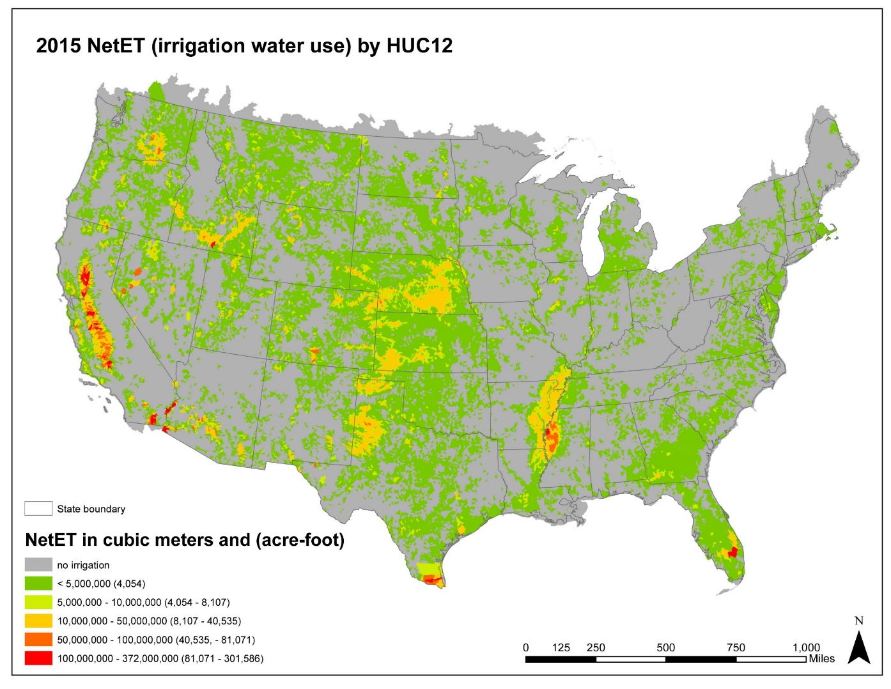
Caption for Graphic or Image: Annual irrigation water use for 2015 summarized by hydrologic unit code level 12 (HUC12).
Author name and business email: Gabriel Senay, senay@usgs.gov

DOI agency/bureau: USGS
USGS Mission Area: Core Science Systems
USGS Program: National Land Imaging Program
Cost Center: Geosciences and Environmental Change Science Center
Program Name:
Project title: Landsat Burned Area Products
Project description: The USGS Geosciences and Environmental Change Science Center in Denver, Colorado and the Earth Resources Observation Center (EROS) in Sioux Falls, SD have led the development, validation, and production of the Landsat Burned Area products. The algorithm producing the products identifies burned areas in Landsat images that have a spatial resolution of 30 meters (m) and a temporal resolution of 16 days or more, depending on cloud cover. Fires are frequently unreported; consequently, existing fire databases are often incomplete. Furthermore, these databases often have location errors and records may be duplicated. The Landsat Burned Area products provide new and unique information about spatial and temporal patterns of fire occurrence that existing fire databases may lack, especially in areas where fire information can be incomplete, such as the Great Plains and in the western and southeastern United States.

The Landsat Burned Area products have been produced for 1984–2019 for the conterminous United States (CONUS). Scene-level products are available through the USGS’s Earth Explorer (www.earthexplorer.usgs.gov) and annual composites are available through the USGS’s Science Base Catalog (https://doi.org/10.5066/P9QKHKTQ). Products for 2020 will be available soon.

Hawbaker, T.J., Vanderhoof, M.K., Schmidt, G.L., Beal, Y, Takacs, J.D., Falgout, J.T., Picotte, J.J., and Dwyer, J.L. 2020. The Landsat Burned Area algorithm and products for the conterminous United States. Remote Sensing of Environment, Vol. 244, https://doi.org/10.1016/j.rse.2020.111801

Hawbaker, T.J., Vanderhoof, M.K., Schmidt, G.L., Beal, Y., Picotte, J.J., Takacs, J.D., Falgout, J.T., and Dwyer, J.L, 2020, The Landsat Burned Area products for the conterminous United States: U.S. Geological Survey data release, https://doi.org/10.5066/P9QKHKTQ.
Sensor Type: Multispectral (approx. 4-12 bands);Thermal;
Platform type: Satellite;
URL: https://www.usgs.gov/core-science-systems/nli/landsat/landsat-burned-area?qt-science_support_page_related_con=0#qt-science_support_page_related_con
Graphic or Image name: Landsat_BA_annual_example.png
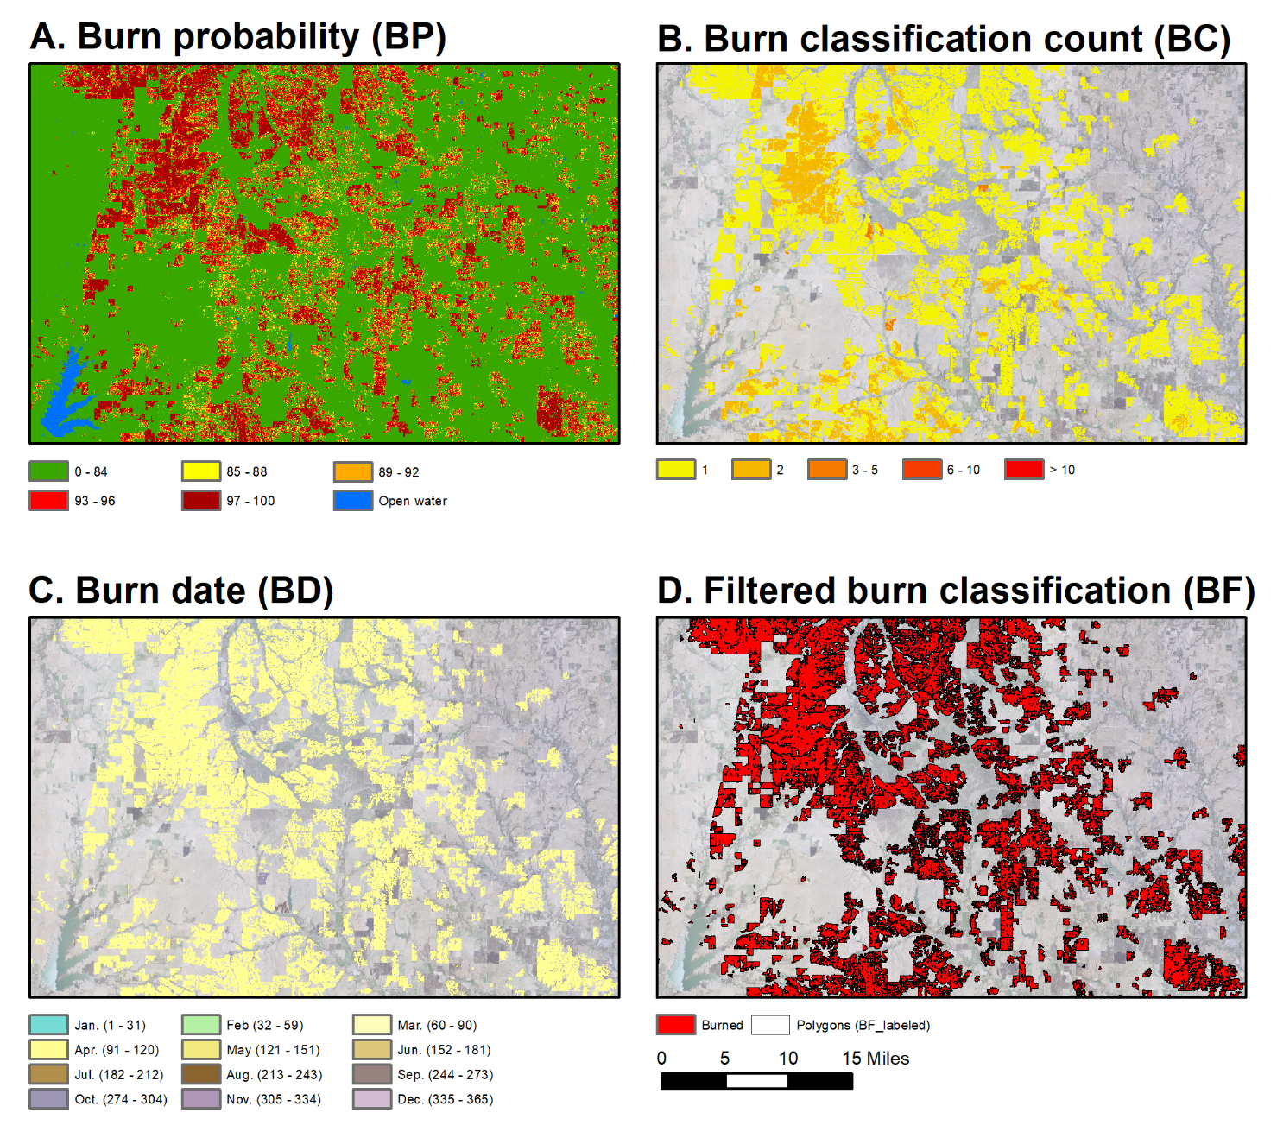
Caption for Graphic or Image: Figure 1. Examples of the Landsat Burned Area annual composite products.
Author name and business email: Todd Hawbaker (tjhawbaker@usgs.gov)

DOI agency/bureau: USGS
USGS Mission Area: Core Science Systems
USGS Program: Land Change Science
Cost Center: Earth Resources Observation and Science (EROS) Center (Geography)
Program Name:
Project title: Parcel-based modeling of land use, water use, and water availability
Project description: The intersection of land-use, water use, water availability, and climate change demands attention as resource constraints increasingly threaten human health and welfare. Long-term analyses of historical-to-current feedbacks among land use, water resources, and climate are needed in order to anticipate potential feedbacks that could threaten human activities in the future. Remote sensing provides the consistent, synoptic data coverage to support analyses of land use and hydrologic change under a changing climate, while anticipatory, scenario-based model can leverage remote-sensing based analyses to explore potential futures and facilitate planning and mitigation activities.

The Earth Resources Observation and Science (EROS) Center completed long-term modeling in the Delaware River Basin (DRB), using remote-sensing based observations of landscape change to inform a spatially explicit model that temporally extended the land cover record both backwards and forwards in time. In FY2021 work has focused on linking monitoring and modeling of water use and water availability in with the EROS Forecasting Scenarios of land use (FORE-SCE) model. The goal is to move towards true parcel-based water accounting, where we track water use and water availability at the field level, informing scenarios of future agricultural and landscape change under a changing climate.

Our initial focus is on assessing feedbacks between water use and land use, using a remote sensing-based approach for assessing evapotranspiration. Two different approaches were applied in the DRB, the Vegetation ET (VegET) model and the operational Simplified Surface Energy Balance (SSEBop). VegET is a water-balance approach that uses remote sensing to categorize land-surface phenology, and precipitation inputs, while SSEBop is an energy-balance approach that uses land-surface temperature from remote sensing. Each characterized ET and water use for the DRB, with an intersection of ET and land use quantifying water use trends by land use type over time. In FY21 we also initiated investigations into models of water availability, with PRMS, MODFLOW, and MODSIM identified as key models for potential model integration with FORE-SCE, with model choice dependent upon scale of application. FY21 work focused on exploring the conceptual and practical issues of water availability model coupling with FORE-SCE, with formal coupling initiated in FY22. Continuing work strives to improve the representation of feedbacks between land use, water use, water availability, and climate, with upcoming work focused on a working proof-of-concept for parcel-based water accounting in the DRB.

Sensor Type: Multispectral (approx. 4-12 bands);Thermal;
Platform type: Satellite;
URL: https://www.usgs.gov/land-resources/eros/lulc
Graphic or Image name: Sohl_LULC_hydrology_feedbacks.jpg
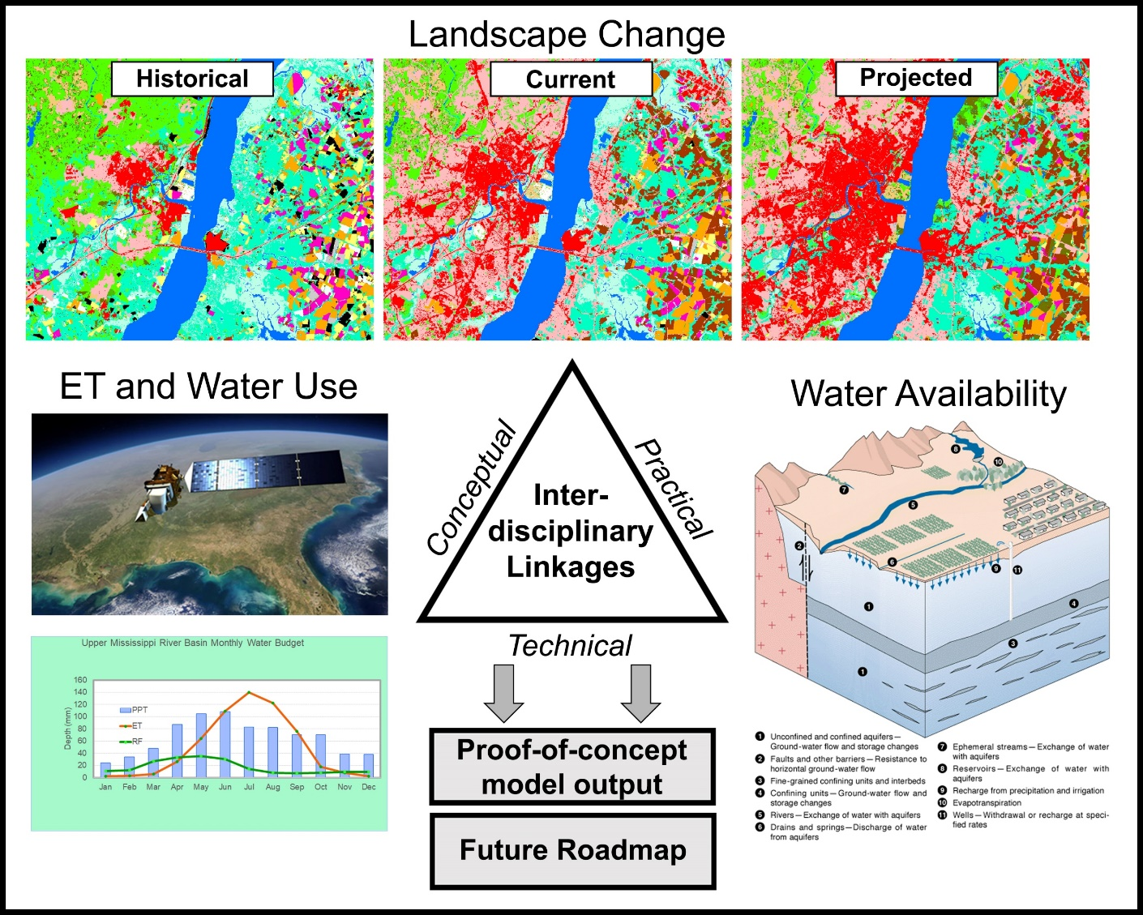
Caption for Graphic or Image: Remote sensing forms the core of a modeling effort in the Delaware River Basin to assess feedbacks among land use, water use, and water availability as we move towards parcel-based water accounting under a changing climate.
Author name and business email: Terry Sohl - sohl@usgs.gov

DOI agency/bureau: USGS
USGS Mission Area: Ecosystems
USGS Program: Land Change Science
Cost Center: Southwest Biological Science Center
Program Name:
Project title: Airborne Remote Sensing in Grand Canyon
Project description: A high-resolution image collection in 2021 is the most recent in a rich archive of aerial imagery that are used to track changes of the Colorado River in Grand Canyon. Imagery was acquired from an airplane in Grand Canyon National Park along the Colorado River corridor and the Little Colorado River starting Memorial Day weekend and continuing through the first week of June 2021. This imagery will be used by the USGS Grand Canyon Monitoring and Research Center (GCMRC) and partners from the Glen Canyon Dam Adaptive Management Program (GCDAMP) to monitor changes in the Colorado River and riparian ecosystem in Grand Canyon and impacts of management including Glen Canyon Dam operations. Water released from Glen Canyon Dam was reduced to a steady discharge of 8,000 cubic feet per second (cfs) in the Colorado River for the duration of the image collection mission. The low river discharge is required because consistent water levels are necessary for remote sensing image analyses that compare this new image dataset to historic datasets which also were collected with constant steady discharge of 8,000 cfs.
Similar to 2021, 4-band multispectral imagery and photogrammetrically derived topography data were also previously acquired in 2002, 2005, 2009, and 2013. With each of those previous digital image acquisitions, USGS GCMRC remote sensing staff developed and improved upon a methodology for producing a spatially seamless, spectrally consistent, and nearly cloud- and blemish-free image mosaic. That proven methodology will be used to develop an image mosaic from the 2021 acquisition.
An abbreviated history of aerial remote sensing of the Colorado River in Grand Canyon:
• The earliest air photos are black and white prints acquired from an airplane in 1935.
• The first set of air photos acquired after Glen Canyon Dam was completed are black and white prints from May 1965
• The first color and color-infrared air photos were acquired during flights in the 1980s
• The first digital multispectral images were acquired in the late-1990s
• The first acquisition similar to this year's overflight (high spatial resolution digital multispectral imagery and digital topography) occurred in May 2002, and then again in 2004, 2005, 2009, 2013, 2021
GCMRC scientists have leveraged this rich archive of data to relate observations of landcover changes to physical, biological and hydrological processes (Figure 1). This remote sensing science helps to support resource management decisions in the iconic Grand Canyon and Colorado River.
Sensor Type: Multispectral (approx. 4-12 bands);Camera;
Platform type: Airplane;
URL: https://www.usgs.gov/centers/sbsc/science/airborne-remote-sensing-grand-canyon
Graphic or Image name: Airborne Remote Sensing Grand Canyon.png
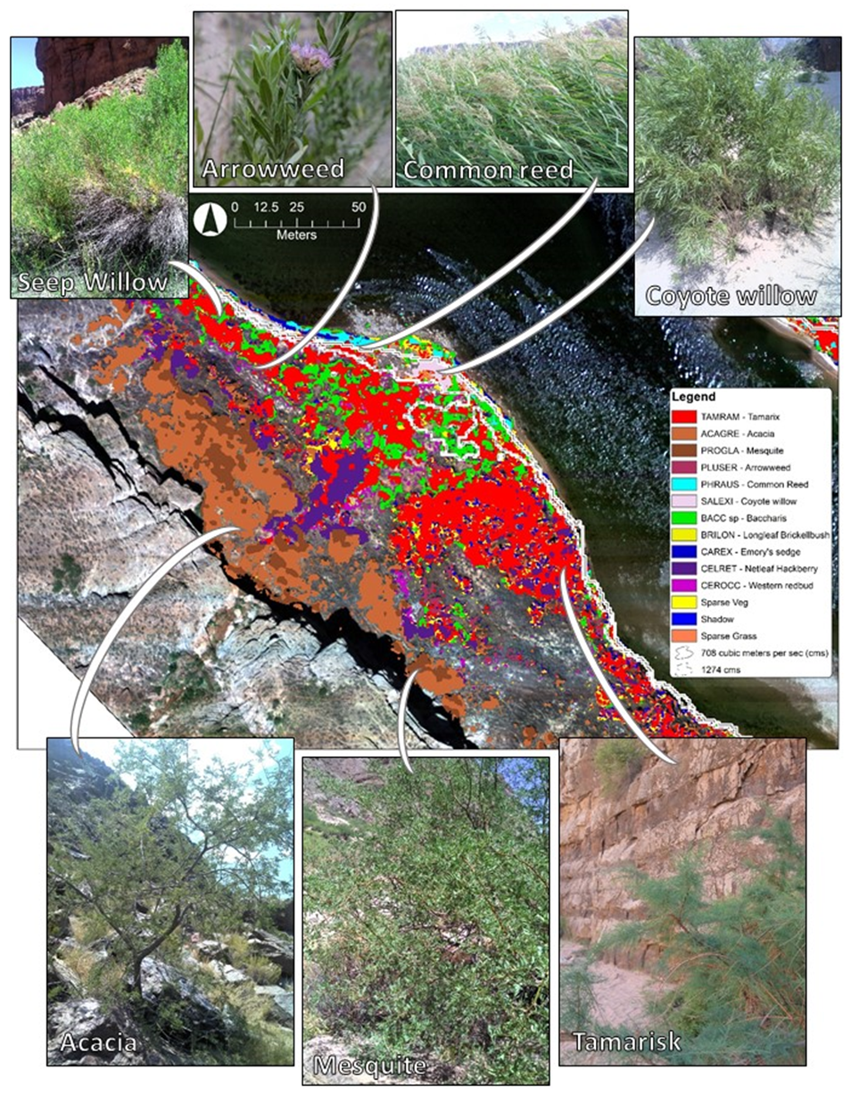
Caption for Graphic or Image: Figure 1. Detailed vegetation classification derived from high-resolution aerial imagery and topography data acquired in the Colorado River in Grand Canyon National Park. Photographs by Laura Durning representing seven of the 26 species included in the analysis of vegeation within the historic Colorado River corridor. (river kilometers from Lees Ferry, 77.6).
Author name and business email: Dr. Joel Sankey jsankey@usgs.gov

DOI agency/bureau: USGS
USGS Mission Area: Water Resources
USGS Program: Science Support
Cost Center: Geosciences and Environmental Change Science Center
Program Name:
Project title: Measuring Snow Depth from Unmanned Aircraft Systems (UAS) Lidar, Winter Park, Colorado
Project description: Approximately 2 billion people are expected to experience diminished water supplies because of seasonal snowpack decline this century. Over the last 50 years, particularly in some regions of the Western U.S., annual snowpack levels have declined and contributed to reduced streamflow levels; a trend supported by both models and in-situ observations. (USGS, From Snow to Flow, https://labs.waterdata.usgs.gov/visualizations/snow-to-flow/index.html#).

The USGS Water Resources Mission Area teamed with the National Unmanned Aircraft Systems Project Office (NUPO) to collect Unmanned Aircraft Systems (UAS) lidar point cloud data (LPC) to calculate centimeter-level snow depth measurements. This data is part of a broader study to measure the snow-water equivalent of watersheds as part of the USGS Next Generation Water Observing System.

The USGS field team conducted three separate UAS data collects of the Winter Park, Colorado study site in September 2020, February 2021, and April 2021. The team flew a UAS equipped with a YellowScan VX20-100 lidar payload and surveyed ground-based targets for control and accuracy validation. A bare-earth digital elevation model and a snow-surface model (vegetation removed) was generated from the LPC data. Snow-depth maps were generated by subtracting the bare-earth terrain from the snow-surface model.

Sensor Type: Camera;Lidar (terrestrial or bathymetric);
Platform type: UAS;
URL:
Graphic or Image name: snow_depth_graphic
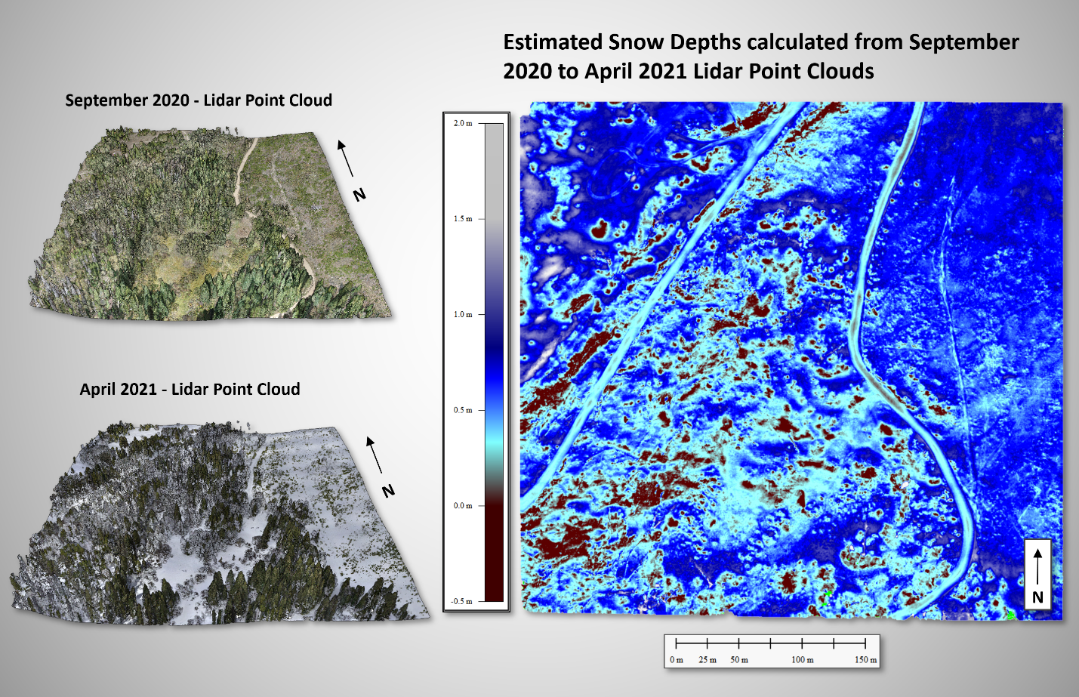
Caption for Graphic or Image: Captions are listed in the Graphic
Author name and business email: Mark Bauer mabauer@usgs.gov, Matt Burgess maburgess@usgs.gov, Joe Adams jdadams@usgs.gov, Graham Sexstone sexstone@usgs.gov

DOI agency/bureau: USGS
USGS Mission Area: Natural Hazards
USGS Program: Science Support
Cost Center: Geosciences and Environmental Change Science Center
Program Name:
Project title: Post Wildfire Mapping using Unmanned Aerial Systems (UAS) of the East Troublesome Fire, Granby, Colorado
Project description: The Office of Wildland Fire (OWF), in partnership with the US Geological Survey (USGS), is conducting evaluations to determine best practices and methodology for data collection of post-fire events utilizing Unmanned Aerial Systems (UAS). Previous efforts have successfully utilized UAS technology to estimate canopy characteristics, interpret fuel model types, and calculate fire behavior.

This project aims to extend previous research into more complex vegetation/fuel types and within a post-catastrophic fire component. Three sample areas exhibiting various levels of fire intensity and fuel types were chosen within the 2020 East Troublesome burn perimeter located near Granby, Colorado. This study collected centimeter-level UAS multispectral (10-band) and natural color (RGB) imagery, processed using Structure-from-Motion (SfM) techniques. In addition to the imagery, centimeter-level lidar point clouds were acquired using UAS to estimate vegetation/fuels characteristics such as Canopy Cover, Canopy Height, Canopy Base Height, and Canopy Bulk Density.

OWF and the USGS desire to implement optimum data gathering and processing techniques to create best practices applying UAS technology into the DOI fuels and BAER programs. This project explores mapping processes that could display contact zones between fire intensity and burn severity. Fire Science is fundamental to understanding the causes, consequences, and benefits of wildfire and helps prevent and manage significant, catastrophic events.

Sensor Type: Camera;Multispectral (approx. 4-12 bands);Lidar (terrestrial or bathymetric);
Platform type: UAS;
URL:
Graphic or Image name: East_Troublesome Wildfire_Graphic
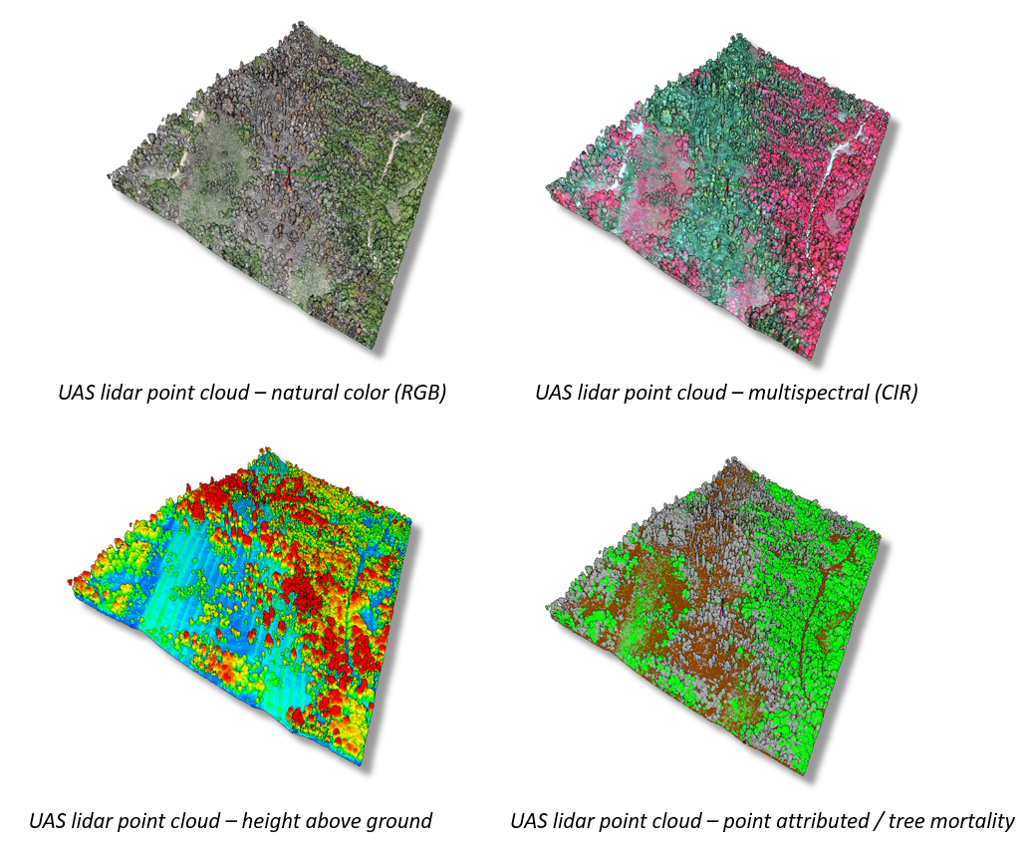
Caption for Graphic or Image: Captions are included in the graphic.
Author name and business email: Mark Bauer mabauer@usgs.gov, Matt Burgess maburgess@usgs.gov, Victoria Scholl vscholl@usgs.gov, Joe Adams jdadams@usgs.gov, Craig Thompson craig_thompson@ios.doi.gov

DOI agency/bureau: USGS
USGS Mission Area: Ecosystems
USGS Program: Environments Program
Cost Center: Upper Midwest Environmental Sciences Center
Program Name:
Project title: Automated Detection of Wildlife Targets in Aerial Imagery
Project description: The U.S. Geological Survey, in collaboration with the Bureau of Ocean Energy Management, the U.S. Fish and Wildlife Service, and the Vision Group at the International Computer Science Institute, is advancing the development of machine learning algorithms to detect and classify seabirds, waterfowl, and other marine wildlife from digital aerial imagery. Improved sensor, computing, and image processing technologies offer promise in enhancing the safety, cost efficiency, and quality of derived data for wildlife population surveys used by natural resource management agencies. Initial machine learning algorithm development has achieved the extraction of targets (individual birds and other wildlife) from imagery; current algorithm development is focused on classifying detected targets to the species level. Algorithm performance based on image and environmental characteristics (e.g., spectral resolution, background water color, sea state, cloud cover, etc.) is being tested to maximize detection and classification accuracy. This project has involved the development of an online feature annotation tool (based on the open-source annotation tool Computer Vision Annotation Tool - CVAT) for easy, streamlined labeling of training data by biologists and to serve as an imagery and annotation database for online data archiving and sharing. These products are intended to provide baseline information on wildlife distributions, abundance, and seasonal movement to inform migratory bird harvest assessments, environmental assessments, and impact analyses of potential wildlife exposure to offshore energy development projects. While digital aerial imagery collection for this project has been targeted along the Atlantic Outer Continental Shelf and the Great Lakes, these processes, algorithms, and associated tools and databases are intended to be applicable across a range of taxa and environments.

Sensor Type: Camera;
Platform type: Airplane;
URL: https://www.usgs.gov/centers/umesc/science/deep-learning-automated-detection-and-classification-waterfowl-seabirds-and?qt-science_center_objects=0#qt-science_center_objects
Graphic or Image name: CVAT_avian_annotations

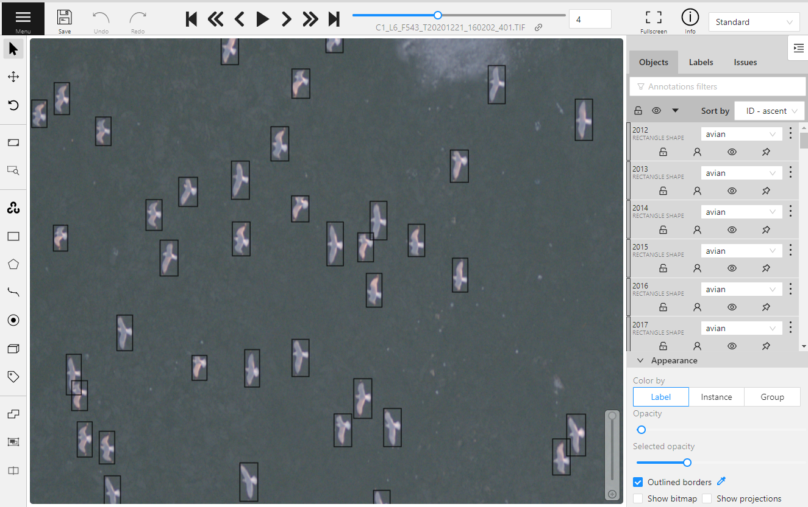
Caption for Graphic or Image: Manually annotated bounding boxes drawn around avian targets in a customized instance of the open-source CVAT (Computer Vision Annotation Tool) application.
Author name and business email: Kyle Landolt; klandolt@usgs.gov

DOI agency/bureau: USGS
USGS Mission Area: Core Science Systems
USGS Program: Land Change Science
Cost Center: Western Geographic Science Center
Program Name:
Project title: Multiscale Spectroscopy of Intertidal Biofilm Quantity, Quality and Composition
Project description: Microbial biofilm communities (comprised of bacteria, diatoms, protozoa, and fungi) inhabit the surface of intertidal mudflats and comprise a large proportion of shorebirds’ diets. Given their major role in intertidal food webs, understanding biofilm distribution, quantity, and nutritional value for shorebirds is of vital importance. South San Francisco Bay is home to the largest tidal wetland restoration project in the Western U.S., the South Bay Salt Pond Restoration Project, where a key uncertainty is whether adjacent mudflats will be a sediment source for the restoration, leading to erosion and potential impacts to biofilm. Given this uncertainty, our objective is to identify seasonal and spatial variations in biofilm distribution, quantity, quality and composition through development and scaling of hyperspectral algorithms. Ecological processes on intertidal mudflats act at very small (mm to cm) to large (tens of km) spatial scales to influence biofilm. Thus, our science plan takes a multi-scalar approach (millimeter to regional scale) to model biofilm parameters using field spectroscopy, ground-based imaging spectroscopy, Unmanned Aerial Systems (UAS) and airborne imaging spectroscopy to capture measurements of chlorophyll-a (chl-a; indicator of biomass), lipids, total organic carbon (TOC), glucose and community composition. In a partnership with the USGS Western Ecological Research Center (WERC), the USGS Western Geographic Science Center, the USGS National UAS Project Office, the USGS Spectroscopy Lab, and California State University Monterey Bay, in spring 2021 we collected multi-scale hyperspectral data on biofilms with a field spectrometer, the HySpex VNIR/SWIR imaging spectrometer (5 mm resolution), The Resonon Pika L VNIR UAS camera (4 cm resolution), and the AVIRIS-NG airborne imaging spectrometer (4 m resolution). High resolution spectra for biofilm end-members will be used to scale algorithms of composition, quality and quantity to the South San Francisco Bay region. This work is part of a larger WERC-led project on “Quantifying Drivers and Stressors of Intertidal Biofilm Resources at the Largest Tidal Wetland Restoration on the U.S. West Coast”. Results will support managers’ need to measure and visualize habitat quality for shorebirds and understand the influence of wetland restoration activities on biofilm resources.
Sensor Type: Camera;Hyperspectral;
Platform type: Ground based / sensor web / web cam;UAS;Airplane;
URL:
Graphic or Image name: Byrd_Biofilm_DOIreport2021.jpg
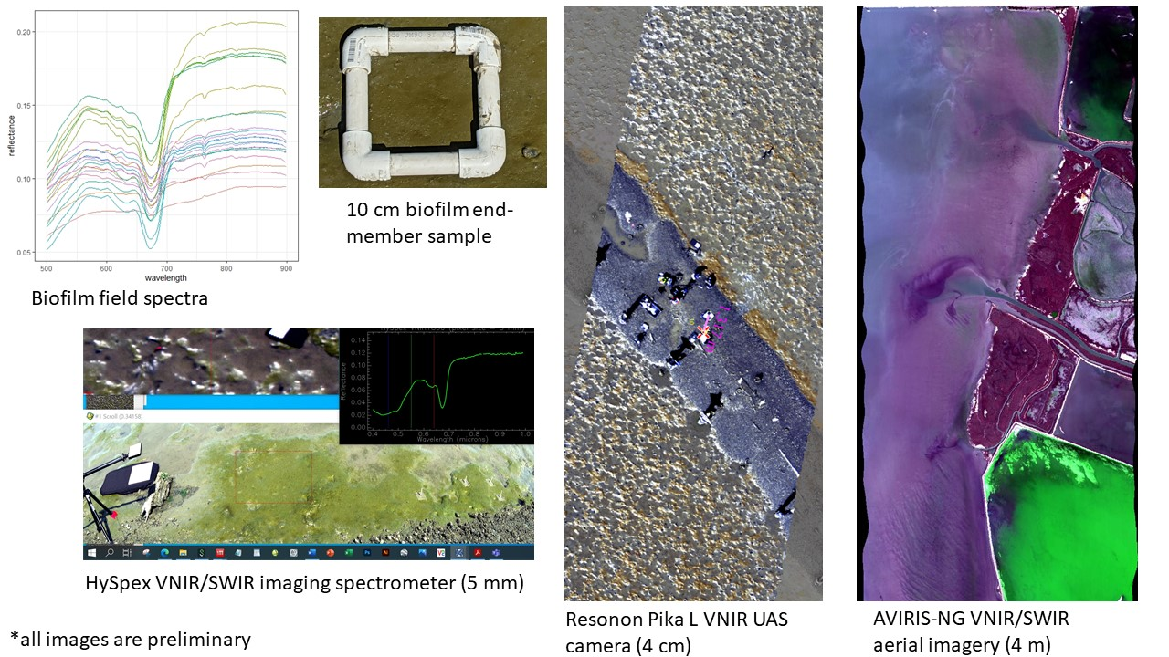
Caption for Graphic or Image: Multiscale spectroscopy of intertidal biofilms with a field spectrometer, HySpex ground-based imaging spectrometer, Resonon Pika L UAS hyperspectral camera and AVIRIS-NG airborne imagery are being used to scale hyperspectral algorithms of biofilm quantity, quality and composition to the South San Francisco Bay region.
Author name and business email: Kristin Byrd, kbyrd@usgs.gov

DOI agency/bureau: USGS
USGS Mission Area: Ecosystems
USGS Program: Climate Research & Development
Cost Center: Alaska Science Center
Program Name:
Project title: Five decades of Glacier Change Across the Crown of the Continent
Project description: Accelerating glacier change in the early 21st century is impacting sea level, water resources, and ecosystems across North America and globally. Yet, direct field measurements of glacier change are laborious and logistically challenging to obtain, and less than 0.001% of glaciers on Earth have detailed long-term (>30 years) records. The USGS Benchmark Glacier project, in conjunction with collaborators at the University of Washington, have automated the production and analysis of Digital Elevation Models (DEMs) using historical aerial and modern satellite imagery to address this data gap and capture glacier change on broad spatial scales. Precision mapping of entire mountain regions allows researchers to quantify the rate of glacier change over several decades and resolve physical drivers of variability between glaciers. Preliminary analysis resolves ice loss across the Crown of the Continent in Glacier National Park, MT, USA, and will expand to include glaciated regions in the Pacific Northwest and Alaska.
Sensor Type: Camera;IFSAR / SAR / Radar;
Platform type: Airplane;Satellite;
URL: https://www2.usgs.gov/landresources/lcs/glacierstudies/default.asp
Graphic or Image name: GNP 1966 2015 glacier change DOI remote sensing.jpg
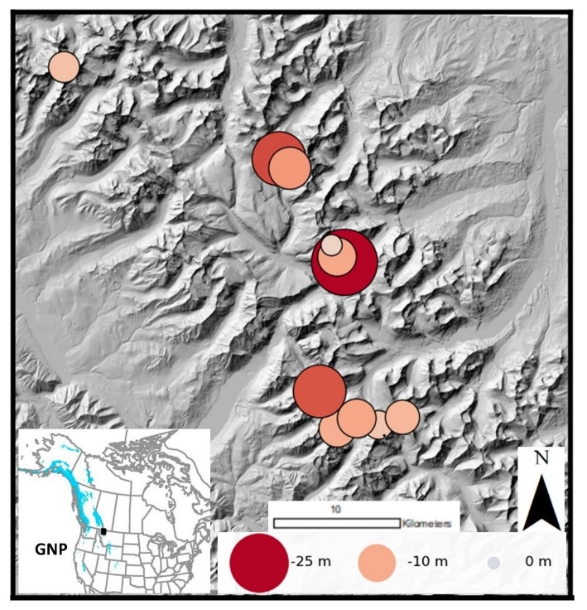
Caption for Graphic or Image: Map of mean surface elevation change of glaciers within Glacier National Park, MT, USA (GNP) during the 1966-2015 period. Each dot represents an individual glacier, with its size and color indicating its average surface elevation change.
Author name and business email: Christopher McNeil cmcneil@usgs.gov

DOI agency/bureau: USGS
USGS Mission Area: Core Science Systems
USGS Program: Land Change Science
Cost Center: Geosciences and Environmental Change Science Center
Program Name:
Project title: Development of a standard database of reference sites for validating global burned area products
Project description: Validation is a critical component of product development that helps evaluate a products utility and limitations for users. In the development of global products, reference data must represent the wide variety of planetary conditions across space and time. While some global variables (e.g. temperature and surface radiation) can be validated from ground sensor networks, other variables, such as land cover or burned area, are far more difficult to validate, as they require generating global reference data that are based on higher-resolution sensors than those used to obtain the global product. Further, because burned area is a temporary land cover condition, additional effort is required to find reference source imagery in which burned areas are visible.

Over the past two decades, several global burned area products have been produced and released to the public. However, the accuracy assessment of such products largely depends on the availability of reliable reference data that have not existed on a global scale or whose production require a high-level dedication of project resources. In an international effort, led by Universidad de Alcalá in Spain, multiple international research teams, including the U.S. Geological Survey, have come together to compile and standardize Landsat and Sentinel-2-based burned area reference datasets.

This effort provides the first publicly available global Burned Area Reference Database (BARD), created by compiling existing reference burned area datasets from different international projects. BARD contains a total of 2661 reference burned area files derived from Landsat and Sentinel-2 imagery. To ensure database consistency, all files were transformed to a common format and were properly documented by following metadata standards. The database can be accessed from: https://edatos.consorciomadrono.es/dataset.xhtml?persistentId=doi:10.21950/BBQQU7. This effort will improve the resource and time efficiency of future efforts to generate new and improved burned are products across the globe.

Sensor Type: Multispectral (approx. 4-12 bands);
Platform type: Satellite;
URL: https://essd.copernicus.org/articles/12/3229/2020/
Graphic or Image name: Vanderhoof_GlobalValidation_figure

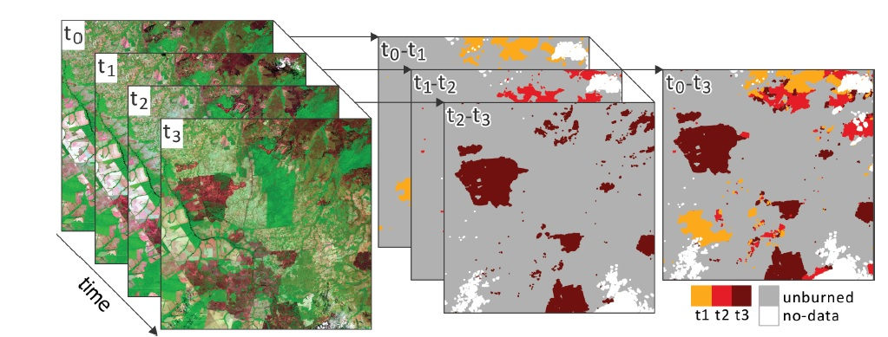
Caption for Graphic or Image: Schematic process of reference data generation. Image pairs were selected from the multitemporal image series at same location (left: Landsat 8 RGB (7;5; 4) images time series) to derive the correspondent classified reference data files.
Author name and business email: Melanie Vanderhoof, mvanderhoof@usgs.gov

DOI agency/bureau: USGS
USGS Mission Area: Core Science Systems
USGS Program: Land Change Science
Cost Center: Geosciences and Environmental Change Science Center
Program Name:
Project title: Tracking rates of post-fire conifer regeneration distinct from deciduous vegetation recovery across the western U.S.
Project description: Post-fire shifts in vegetation composition or successional trajectory will have broad impacts for carbon storage, hydrology, nutrient cycling and wildlife habitat. However, information characterizing post-fire recovery patterns and their drivers are lacking over large spatial extents. We tracked dual season rates of post-fire recovery for more than 12,500 burned points across the western United States. Landsat imagery collected when snow cover (SCS) was present, was used in combination with growing season (GS) imagery, to distinguish evergreen vegetation from deciduous vegetation. The analysis sought to (1) identify spatial and temporal patterns in the rate of post-fire recovery across the western United States, (2) relate remotely-sensed patterns to plot-scale, field-measured patterns of post-fire re-vegetation, and (3) model variability in post-fire rates of recovery as a function of burn severity, site conditions and climatological factors.

In our analysis we found that the post-fire recovery under snow cover reflected evergreen regeneration, while the rate of recovery in the growing season primarily reflected understory vegetation (grass, herbaceous, shrubs). Further, the rates of recovery in the growing season were only weakly correlated with the rates of recovery under snow cover. The seasonal distinction in vegetation type had important implications for understanding the drivers of post-fire recovery. Although temperature was important in both seasons, the seasons showed opposite directionality, with warmer conditions associated with faster rates of evergreen regeneration, and cooler conditions associated with faster rates of deciduous recovery. The temperature finding suggests that in snowy, mountainous areas, conifer regeneration may react differently to warming temperatures compared to deciduous species. Efforts that use both growing season and snow cover NDVI to evaluate post-fire recovery can help guide predictions of where active vegetation management should be focused at the scale of the western United States. This approach provides a powerful tool to inform landscape-scale, post-fire analysis and monitor long-term impacts of fires on ecosystems across the West.

Sensor Type: Multispectral (approx. 4-12 bands);
Platform type: Satellite;
URL: https://esajournals.onlinelibrary.wiley.com/doi/full/10.1002/eap.2237
Graphic or Image name: Vanderhoof_postfire_recovery.jpeg

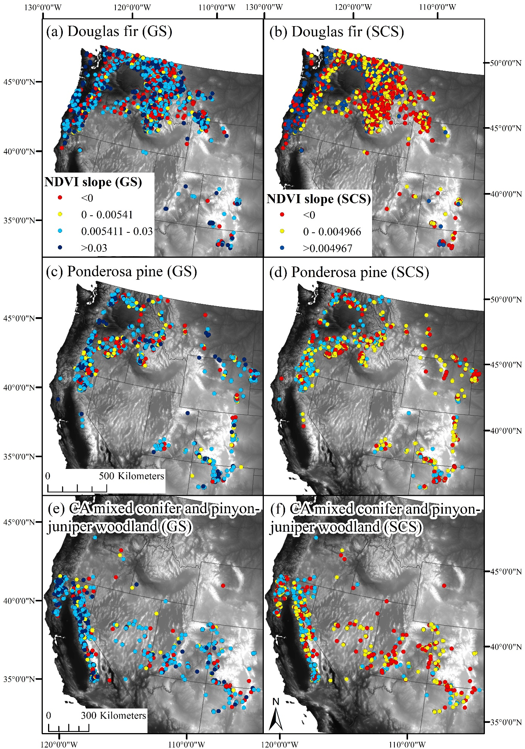
Caption for Graphic or Image: The rate of post-fire recovery, defined using the Normalized Difference Vegetation Index (NDVI), by forest type and season (growing season [GS] and snow cover season [SCS]) including (a) Douglas fir (GS), (b) Douglas fir (SCS), (c) Ponderosa pine (GS), (d) Ponderosa pine (SCS), (e) California mixed conifer (restricted to California) and pinyon–juniper woodland (Nevada, Utah, Colorado, Arizona) in GS, and (f) California mixed conifer and pinyon–juniper woodland (SCS). Blue represents rapid post-fire recovery, yellow represents slow post-fire recovery, while red represents no post-fire recovery.
Author name and business email: Melanie Vanderhoof, mvanderhoof@usgs.gov

DOI agency/bureau: USGS
USGS Mission Area: Core Science Systems
USGS Program: Land Change Science
Cost Center: Geosciences and Environmental Change Science Center
Program Name:
Project title: Isolating anthropogenic wetland loss across the Mid-Atlantic region, U.S.
Project description: Global trends in wetland degradation and loss have created an urgency to monitor wetland extent as well as track the distribution and causes of wetland loss. Satellite imagery can be used to monitor wetlands over time, but few efforts have attempted to distinguish anthropogenic wetland loss from climate-driven variability in wetland extent. Wetland loss due to changes in land use were identified by concurrently tracking disturbance and inundation dynamics across the Mid-Atlantic region (PA, WV, VA, MD, DE, DC), United States using the Landsat archive. We produced annual (2015-2018, 30 m resolution) products including: (1) disturbance extent, (2) inundation extent, (3) declines in inundation extent, and (4) the intersection of disturbance and inundation. Disturbance was identified as a change in greenness, using a harmonic linear regression approach and as a change in growing season brightness. Inundation extent was mapped using a modified version of the U.S. Geological Survey’s Dynamic Surface Water Extent (DSWE) algorithm. Annual (2015-2018) disturbance extent across the region averaged 0.32% of the study area with the primary sources being residential and commercial development, silviculture, and mining. While year to year changes in inundation extent were substantial, the co-occurrence of disturbance and declines in inundation extent represented a minority of both change types, totaling 109 km2 over the four-year period, and 186 km2 using the National Wetland Inventory dataset in place of the Landsat-derived inundation extent. When the annual products were evaluated with wetland and stream fill points permitted by the U.S. Army Corps of Engineers, 95% of the fill points were detected with most found by the disturbance product (89%) and fewer found by the inundation decline product (25%). The results suggest that mapping inundation alone is unlikely to be adequate to find and track anthropogenic wetland loss. Alternatively, remotely tracking both disturbance and inundation can potentially focus efforts to protect, manage, and restore wetlands.
Sensor Type: Multispectral (approx. 4-12 bands);
Platform type: Satellite;
URL: https://www.mdpi.com/2072-4292/12/9/1464
Graphic or Image name: Vanderhoof_tracking_anthropogenic_wetland_loss.png
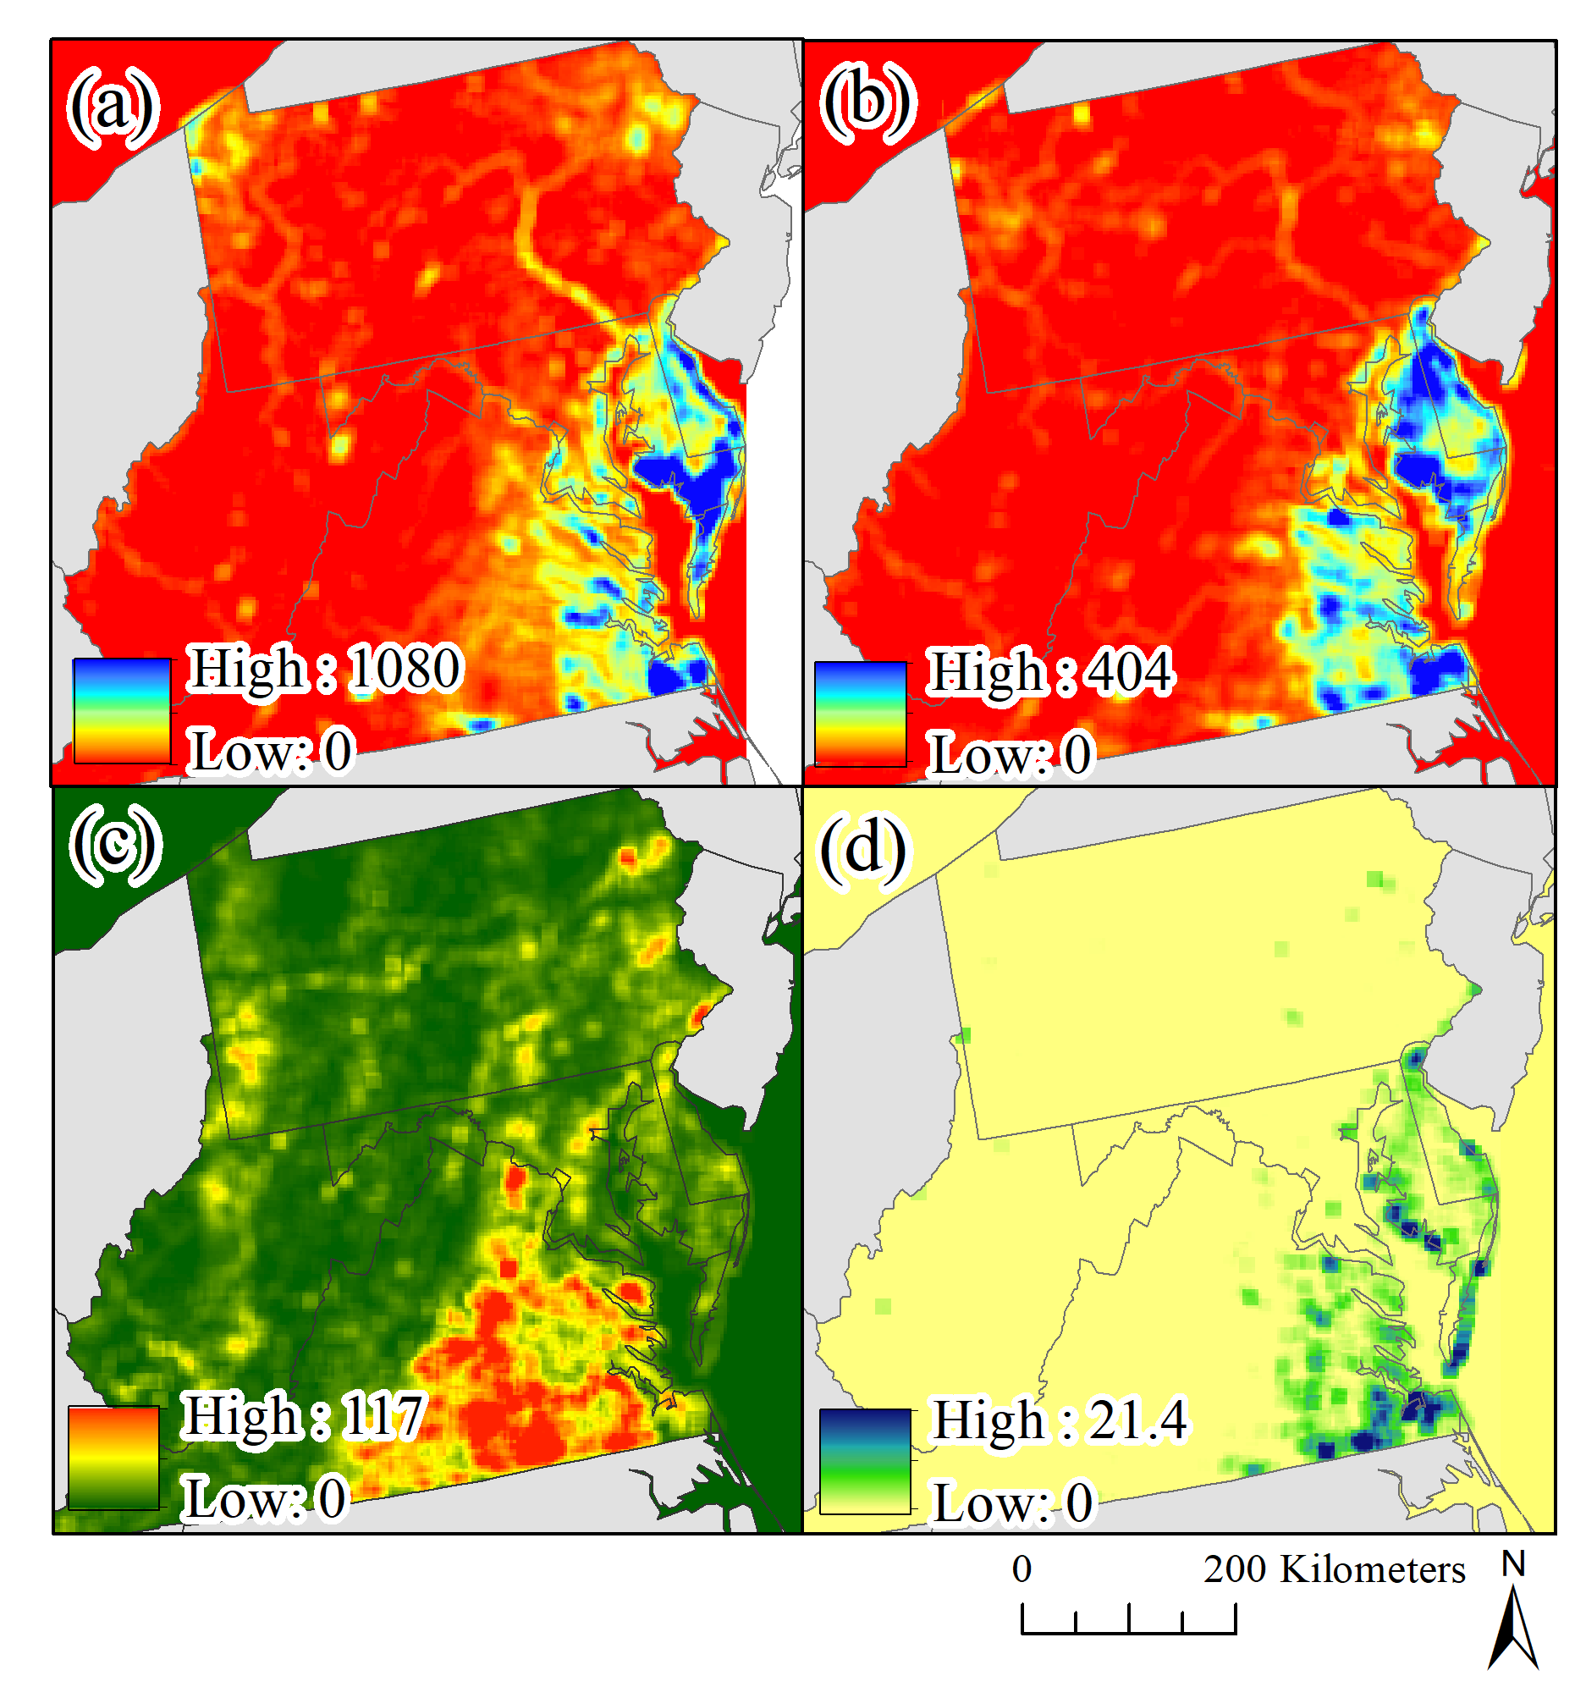
Caption for Graphic or Image: A summary of the geographic distribution of disturbance, water loss, and intersection of the two datasets across the study area including: (a) the density of National Wetland Inventory (NWI) wetlands, the density of (b) water loss, (c) disturbance, and (d) the intersection of disturbance and water loss. For a-d density was calculated from 5 × 5 window of raster cells using a 3 km resolution, for b-d density was based on the summed 2015–2018 annual outputs.
Author name and business email: Melanie Vanderhoof, mvanderhoof@usgs.gov

DOI agency/bureau: USGS
USGS Mission Area: Core Science Systems
USGS Program: Water Availability and Use Science Program
Cost Center: Western Geographic Science Center
Program Name:
Project title: Sediment mobility, vegetation mapping and river corridor assessment using aerial imagery.
Project description: This river corridor assessment documents sediment mobility, vegetation change, and river response to flood disturbance along a 140-kilometer segment of the main-stem Klamath River below Iron Gate Dam, California. Field and remote sensing methods were used to assess fundamental indicators of active sediment transport and river response to a combination of natural runoff events and reservoir releases during the study period from 2005 to 2019. Discharge measurements at two gaged sites and bed-material samples at two ungaged sites provided direct and indirect evidence of mobile bed conditions, scour and fill, and surface flushing of fine sediment. Available remote sensing datasets collected in 2005, 2009, 2010, and 2016 were used to determine sediment storage, flood inundation boundaries, and provide indirect evidence of flood-induced scour. High resolution three- and four-band imagery from the National Agriculture Imagery Program (NAIP) collected in 2005, 2009, and 2016 were used as the base for mapping riparian vegetation. The time series of vegetation maps document the response of riparian vegetation to flood disturbance in 2006 and subsequent recovery during a drier period that included the 2012–16 drought. Example vegetation maps illustrate the shadow, bare ground, and three vegetation classes for a selected reach downstream from Beaver Creek (fig. 1)

During the study period, flows greater than or equal to 6,030 cubic feet per second mobilized the substrate, caused localized scour, and flushed fine sediment from bar surfaces. Flows greater than or equal to 10,400 cubic feet per second stripped vegetation from bars and floodplains and produced deeper scour. Flood disturbance within the study reach is produced by the combined effect of natural flows and reservoir releases, which resulted in mobile bed conditions during the study period. Periodic scour and substrate disturbance are considered by the U.S. Fish and Wildlife Service to be integral for managing disease induced mortality of juvenile and adult salmonids. Substrate conditions conducive to parasites that host infectious diseases, particularly Ceratonova shasta, occur periodically. Study results are useful for interpreting linkages among physical and biological processes and for evaluating the effectiveness of flow management targeted to improve riverbed conditions for endangered salmonid populations.

Sensor Type: Multispectral (approx. 4-12 bands);
Platform type: Airplane;
URL: https://doi.org/10.3133/ofr20201141
Graphic or Image name: t.poitras_klamath_figure_01

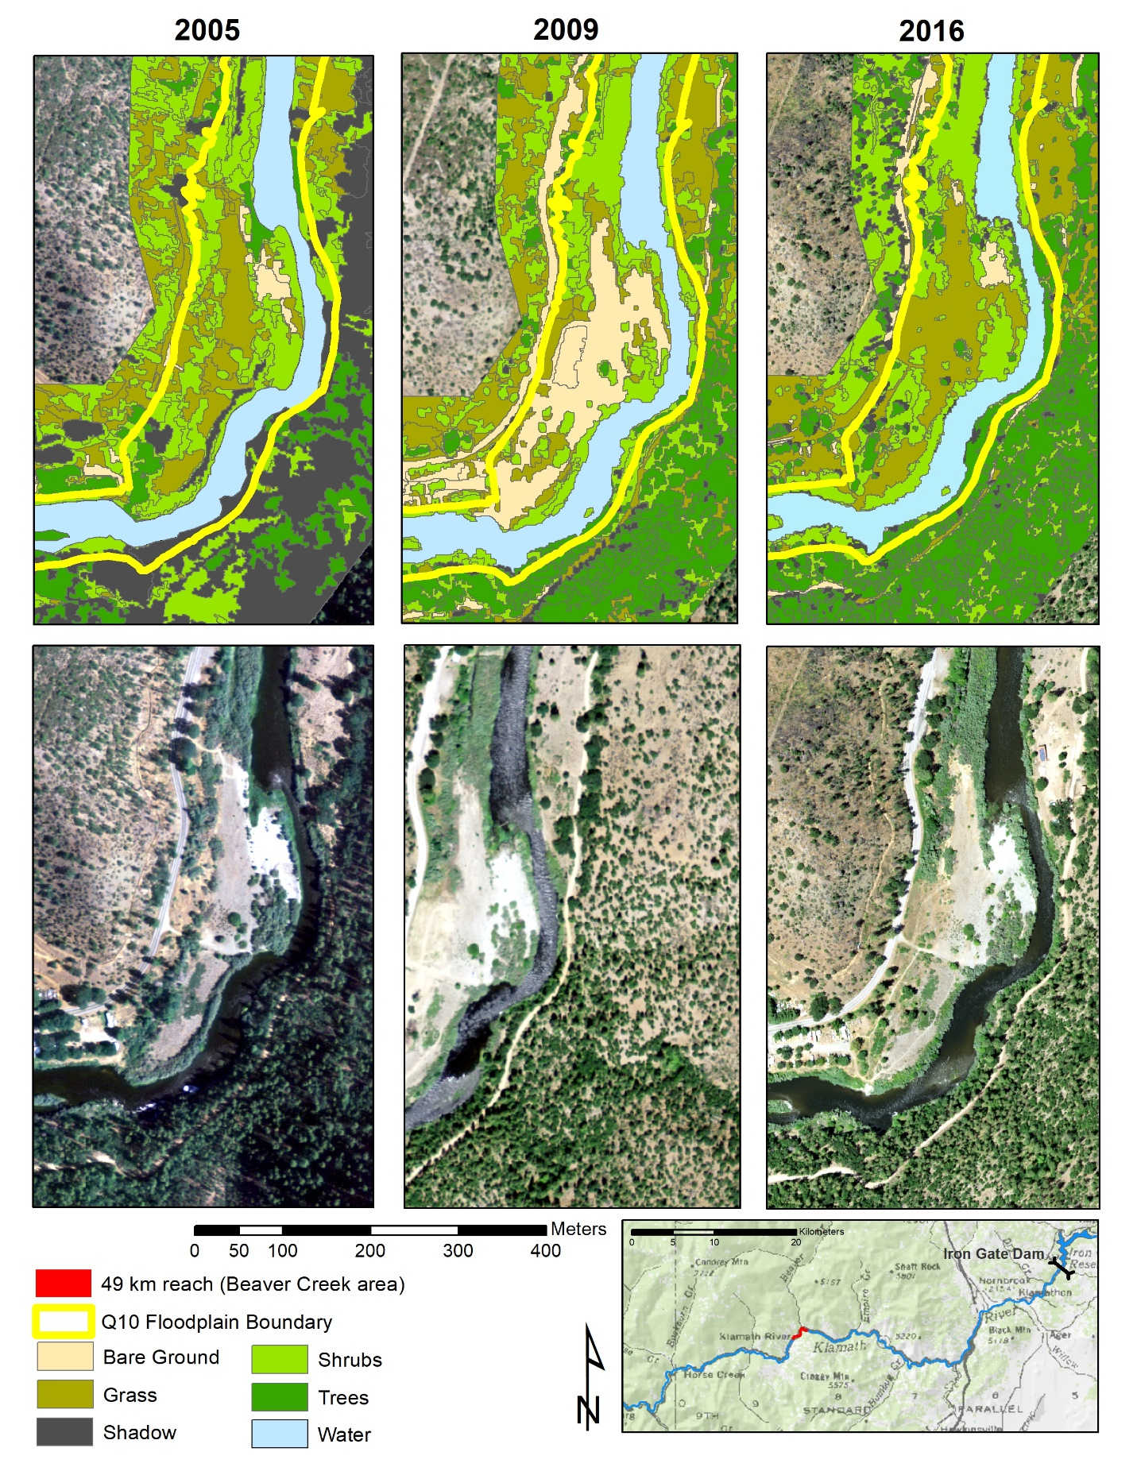
Caption for Graphic or Image: Figure 1. Example maps of riparian vegetation for 2005, 2009, and 2016 for the reach below the confluence of Beaver Creek, located 49 kilometers downstream from Iron Gate Dam along the main-stem Klamath River, California.
Author name and business email: Jennifer Curtis (jacurtis@usgs.gov), Travis Poitras (tpoitras@usgs.gov), Sandra Bond (sbond@usgs.gov), Kristin Byrd (kbyrd@usgs.gov)

DOI agency/bureau: USGS
USGS Mission Area: Core Science Systems
USGS Program: Land Change Science
Cost Center: Earth Resources Observation and Science (EROS) Center (Geography)
Program Name:
Project title: LANDFIRE 2016 Remap includes 90 Kilometer Buffer
Project description: The recent release of LANDFIRE (LF) 2016 Remap for Alaska (AK) concludes a multi-year effort to map vegetation, fuel, and fire regime for the entire United States (CONUS, AK, Hawaii, and Insular Areas) https://landfire.gov. This new product suite will better inform wildland fire decision support systems and facilitate national and regional level strategic fire and resource management (forest, habitat, carbon, wildlife, etc.) planning efforts.

LF’s modeling and mapping process is complex, requiring many iterative steps to generate a suite of 20+ geospatial rasters. The process involves development of composite imagery, disturbance, vegetation (Existing Vegetation Type, Cover and Height, denoted EVT, EVC, EVH) maps, and then from these data fuels and fire regime products. Here are a few examples of how LF used remotely sensed imagery.
For disturbance mapping, late and early-season Landsat Imagery for year prior-to and year-after (i.e., 2015 & 2017, 2016 year of interest) was used to create best-pixel composites by season and year. Subsequently, with the aid of the modified Multi-Index Integrated Change Detection Algorithm (MIICA), Normalized Burn Ratio and Normalized Difference Vegetation Index, analysts compared the composites to identify disturbances on the landscape.

For vegetation mapping, a similar process of creating best pixel composites was used although it drew on more years and dates within year to better distinguish the vegetation. Utilizing these composites EVT, EVC and EVH were mapped to the Nature Serve’s Ecological Systems Classification Vegetation Type, and to National Vegetation Classification (NVC) System with a Classification and Regression Tree (CART) model (Cubist). CART model training utilized plot data from USDA-Forest Inventory and Analysis program among many other sources to acquire dependent variables (e.g. EVT) and a suite of extracted independent variables (from plot centers, e.g., bands, band wavelengths and spectral indices) generated from Landsat Thematic Mapper, Enhanced Thematic Mapper Plus and Operational Land Imager. Other remotely sensed independent variables included digital elevation model data (slope and elevation) and biophysical gradients (precipitation and temperature). Lidar data were acquired and processed from point clouds and used in tandem with cover and height data from plots to model EVC and EVH.

Consistent with the rest of the LF 2016 Remap, project imagery and data were acquired and processed to model and map vegetation for the 90-kilometer buffer along the more than 1,500-mile Canadian border which will support analysis of near- and cross-border incidents and land management planning.

Sensor Type: Lidar (terrestrial or bathymetric);Multispectral (approx. 4-12 bands);Camera;
Platform type: Ground based / sensor web / web cam;Airplane;Satellite;
URL: https://landfire.gov
Graphic or Image name: AK_90k_NoLabels
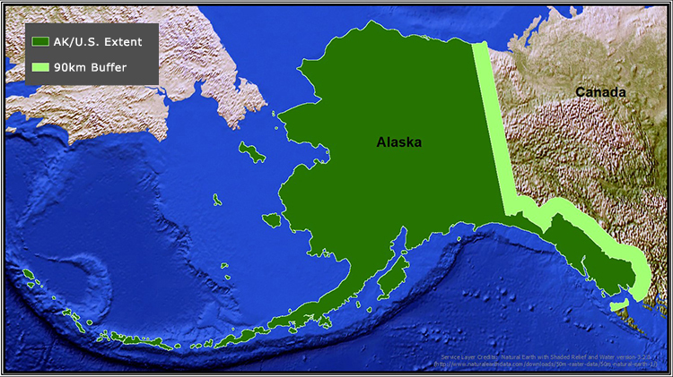
Caption for Graphic or Image: The 90-kilometer buffer will support fire behavior projections and assessments, fuel treatments, risk assessments, firefighter and public safety issues, wildlife habitat, and land management planning that abuts international borders.
Author name and business email: Timothy D Hatten

DOI agency/bureau: USGS
USGS Mission Area: Ecosystems
USGS Program: Land Change Science
Cost Center: Wetland and Aquatic Research Center
Program Name:
Project title: Mapping Phragmites australis Marsh Condition
Project description: The sudden dieback of Phragmites australis, the lynchpin of the Mississippi River Delta (MRD), caused alarm initiating multi-year satellite mapping of normalized difference vegetation index (NDVI) to track the relative P. australis condition. That mapping concluded that the widely believed co-occurring non-native scale infestation was likely not the sole dieback cause. To link cause or causes to dieback required a quantifiable condition index versus the relative NDVI. In cooperation with the U.S. Fish and Wildlife Service, this study designed and implemented a field procedure for simultaneously measuring the live leaf fractional cover (LFC) and spectral reflectance of the 3 to 4 m tall P. australis marsh within a large spatial target (approx. 4.5 m). Using the spectral frequency response of the 10-m Sentinel-2 sensor (closely aligned with 30-m Landsat), the field spectral reflectance was transformed to field-NDVI that was directly related to field-LFC (figure 1). The field-NDVI was then used to calibrate the 2018 fall and 2019 summer Sentinel-2 NDVI images to field-LFC. The similarity of overlapping Sentinel-2 and Landsat LFC maps provided LFC calibration to be applied to transform Landsat images to LFC maps. Yearly, and in some cases, seasonally, Phragmites australis LFC maps were created of the lower MRD from 2009 to 2019 (figure 2). The LFC maps provide direct quantitative assessment of spatial changes at a single date (status) and spatial and temporal changes overtime (trends) at the pixel level (Sentinel-2 from 2016 to 2019 and Landsat from 2009 to 2016). The calibration procedure of field capture of LFC and direct linkage to field-NDVI and ultimately satellite-NDVI and the formulation of a mapping calibration dataset that ranged from summer to late fall (approx. 20% to 100% LFC) for quantitative mapping of P. australis condition are critical developments of this study. .
Sensor Type: Multispectral (approx. 4-12 bands);
Platform type: Satellite;
URL: OFR Citation, Rangoonwala, A., Howard, R.J., and Ramsey, E.W., III, 2020, Mapping Phragmites australis live fractional cover in the lower Mississippi River Delta, Louisiana: U.S. Geological Survey Open-File Report 2020–1131, 24 p., https://doi.org/ 10.3133/ ofr20201131; Date Release Citation, Rangoonwala, A., and Ramsey, E.W., III, 2020, Phragmites australis live fractional cover yearly map from 2009 to 2019 of the lower Mississippi River Delta using Landsat and Sentinel 2 satellite data: U.S. Geological Survey data release, https://doi.org/10.5066/P9ASPB4E
Graphic or Image name: Figure1_SAS_LFC_yaxis_vs_NDVI_xaxis.jpg; Figure2_S2_LFC_Sep2016_Oct2017_Oct2018.jpg

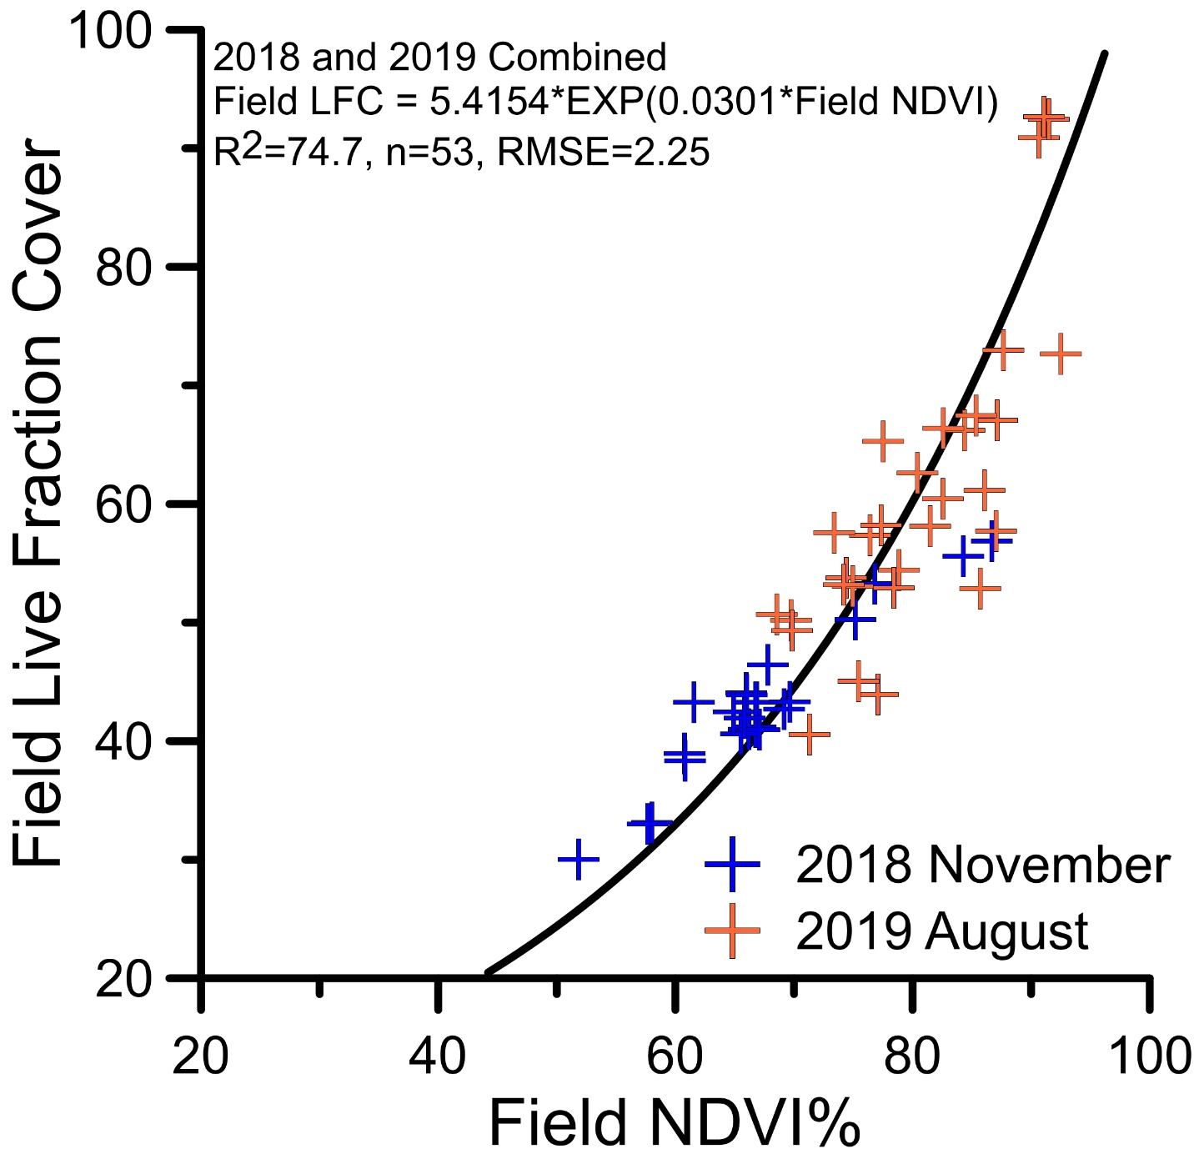

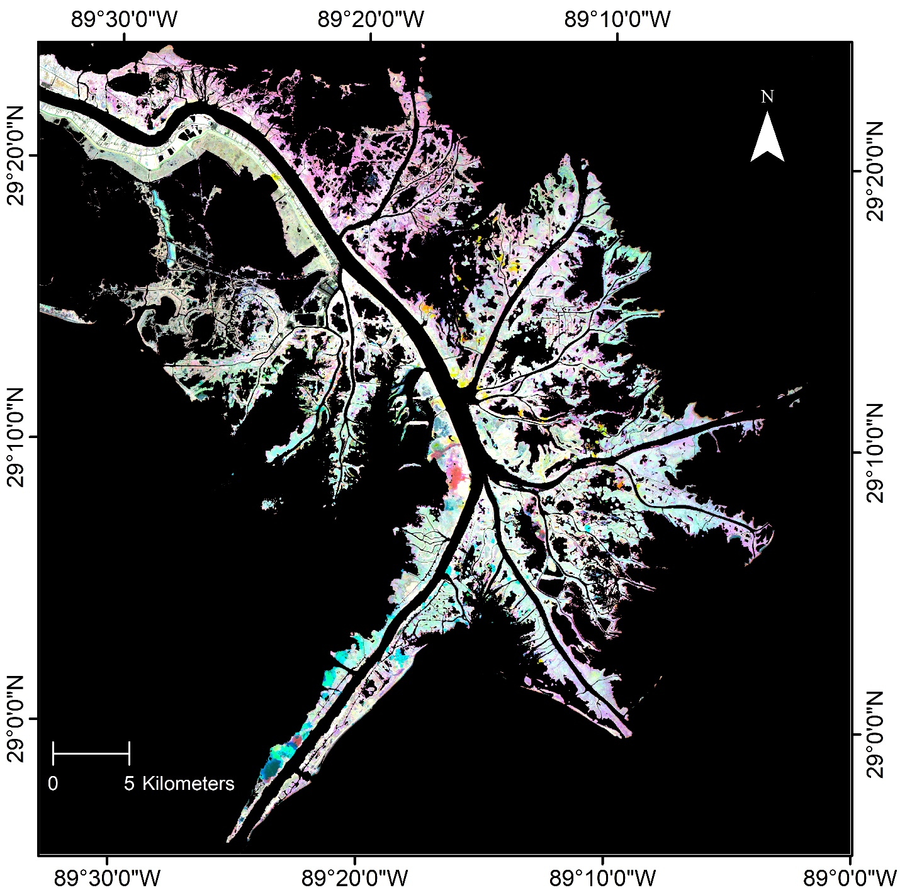
Caption for Graphic or Image: Figure 1. The calibration between the field NDVI calculated from field reflectance data and webcam LFC classifications.
Figure 2. Sentinel-2 LFC color composite displaying the 2016 LFC as red, 2017 LFC as green, and 2018 LFC as blue for the lower Mississippi River Delta, Louisiana.
Author name and business email: Elijah Ramsey III, ramseye@usgs.gov

DOI agency/bureau: USGS
USGS Mission Area: Ecosystems
USGS Program: Land Change Science
Cost Center: Wetland and Aquatic Research Center
Program Name:
Project title: SAR and Optical Trajectory Tool for Monitoring Change
Project description: Synthetic aperture radar (SAR) mapping of density as an enhancement of Phragmites australis optical live fractional cover (LFC) condition mapping and to identify elephant-ear replacement was carried out in the lower Mississippi Delta in cooperation with the U.S. Fish and Wildlife Service during 2018 to 2019. As the marsh density measure, yearly maps from 2016 to 2019 of L-band SAR horizontal send, vertical receive (HV) data were produced. The ALOS-2 L-band data were obtained through nonfunded data agreement between the Japan Aerospace Exploration Agency and the USGS. Like the LFC pattern over the same period, the HV mapping indicated high local density variability within broad yearly density change in P. australis marsh (figure 1)). That density and LFC correspondence was confirmed with regressions of P. australis marsh HV-density and optical-LFC data where local differences reflected as scat¬ter in the plots. Based on those results, a combined LFC and HV-density assessment tracker of P. australis marsh condition was developed. Major findings from the use of the density-LFC trajectory tool were the high decrease in marsh density from 2016 to 2017, identification of severely degraded P. australis marsh and European P. australis marsh, and indications of linkage between the density decline from 2016 to 2017 and the elephant-ear replacement from 2018 to 2019. The trajectory tool application also uncovered an inverse relationship between elephant-ear occurrence and HV-density changes from 2018 to 2019 (figure 2)). If substantiated, direct elephant-ear replacement detection based on canopy structure would be a major development in mapping and management. Relationships uncovered by the trajectory tool demonstrate enhanced detection of P. australis marsh condition change and possibly even future change, differentiation at the taxa level, the indicate a means for early detection of P. aus¬tralis marsh replacement by elephant-ear and other unwanted plant species
Sensor Type: IFSAR / SAR / Radar;Multispectral (approx. 4-12 bands);
Platform type: Satellite;
URL: Ramsey, E.W., III, and Rangoonwala, A., 2021, Synthetic aperture radar and optical mapping used to monitor change and replacement of Phragmites australis marsh in the lower Mississippi River Delta, Louisiana: U.S. Geological Survey Open-File Report 2021–1046, 19 p., https://doi.org/ 10.3133/ ofr20211046
Graphic or Image name: Figure1_ALOS_HV_3Year_2016_2017_2018.jpg; Figure2_2018_2019FieldSiteComposition.jpg

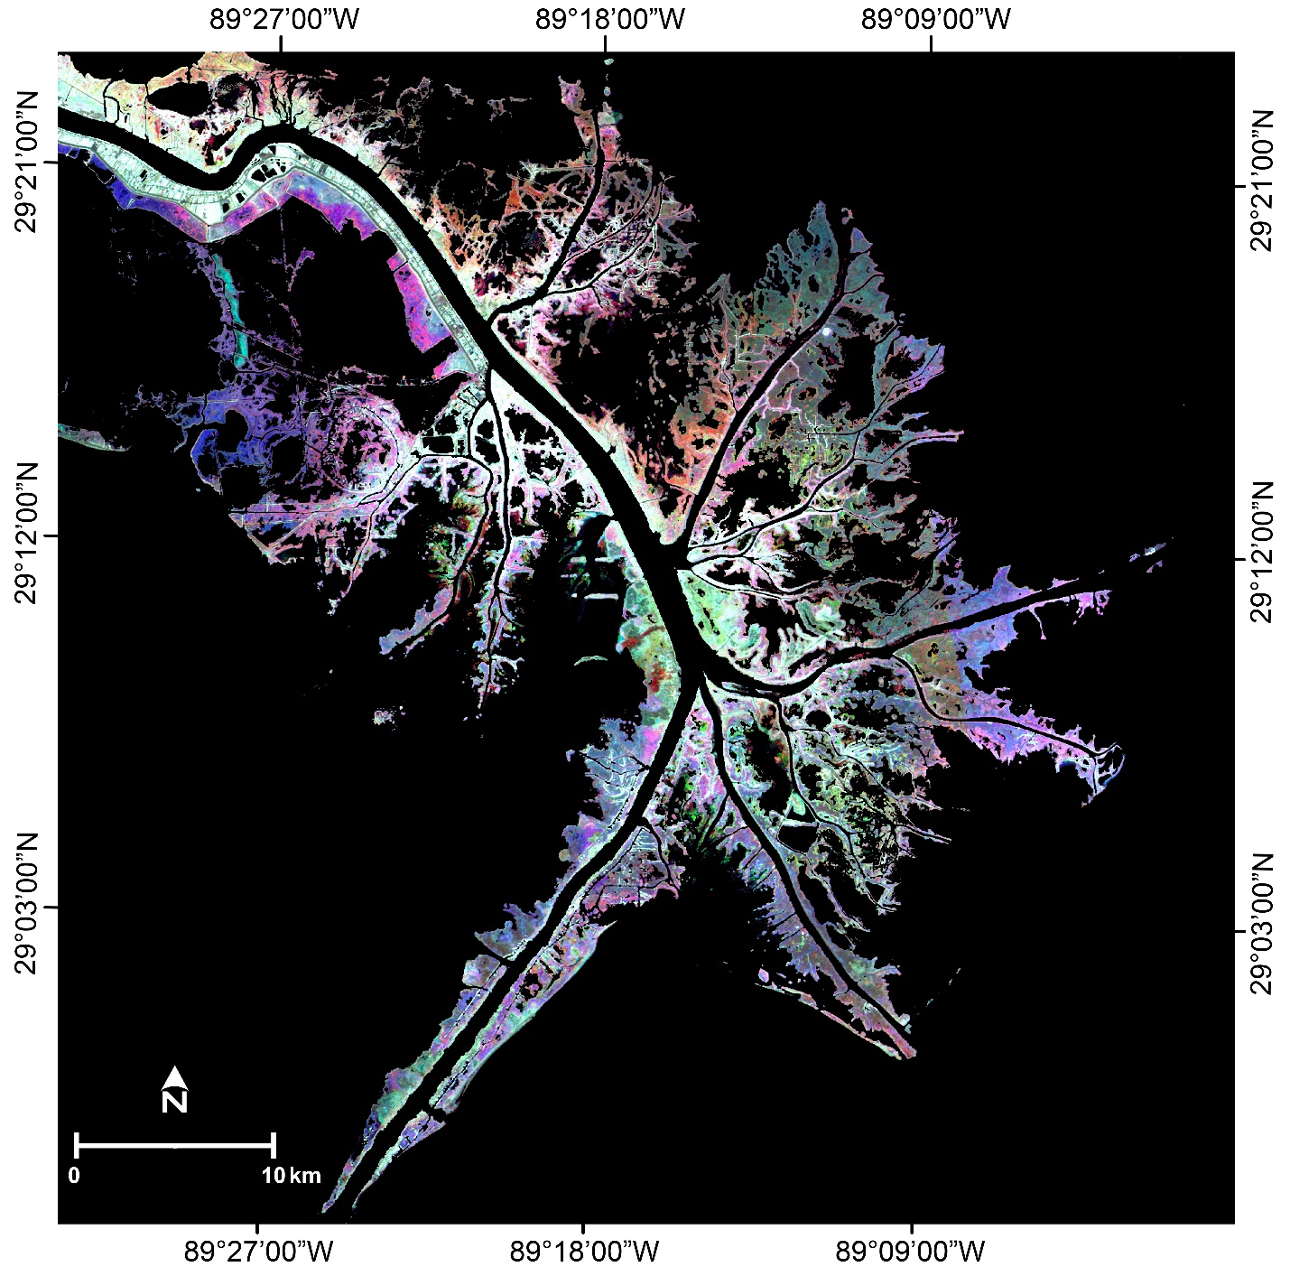

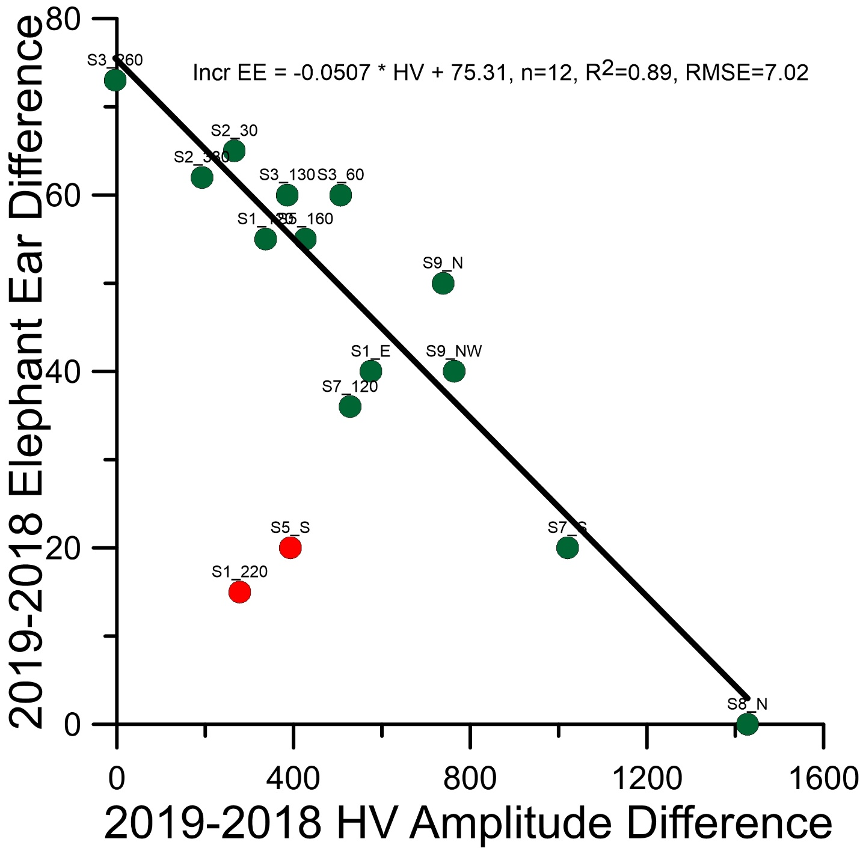
Caption for Graphic or Image: Figure 1. Advanced Land Observing Satellite-2 HV color composite displaying the 2016 HV amplitude as red, 2017 HV amplitude as green, and 2018 HV amplitude as blue; Figure 2. The 2019 minus 2018 elephant-ear difference compared to the 2019 minus 2018 HV-amplitude. Green site symbols were used in the regression and red symbols were not. [RMSE, root-mean-square error]
Author name and business email: Elijah Ramsey III, ramseye@usgs.gov

DOI agency/bureau: USGS
USGS Mission Area: Ecosystems
USGS Program: Land Change Science
Cost Center: Wetland and Aquatic Research Center
Program Name:
Project title: Remote Sensing Mapping Technology for Management
Project description: In cooperation with the U.S. Agency for International Development, instructional media was created for the transfer of remote sensing mapping and GIS technologies used to create and utilize the USGS developed live fractional cover (LFC) mapping of NRT Conservancies in Kenya. Step by step instructions for creating LFC maps from satellite data and using LFC maps for the management of pastoral and wildlife grazing are contained in the workbook and synchronized video recordings. The transfer success relied on the freely available Sentinel-2 optical and Sentinel-1 SAR image data and SeNtinel’s Application Platform (SNAP) for processing of the optical and SAR image data. The final map production and management tools relied on the open source Quantum Geographic Information System (QGIS). The synchronized workbook and video are comprehensive, visual, and specific to the processing, production and use of LFC maps. The workbook and video combination and step by step detail accommodate a workshop structure or individual and group self-instruction. The visual instructions and no cost data and software promote independence and innovative advancement of the mapping and GIS tools to benefit the changing needs of sustainable resource management.
Sensor Type: Multispectral (approx. 4-12 bands);IFSAR / SAR / Radar;
Platform type: Satellite;
URL: Rangoonwala, A., and Ramsey, E., III, 2021, Grassland live fractional cover map creation and Geographic Information System (GIS) analysis for rangeland management supporting Kenya Northern Rangelands Trust Conservancies: U.S. Geological Survey Report 2021–1001, 59 p., https://doi.org/10.3133/ofr20211001
Graphic or Image name: KenyaTraining_P1010946.JPG
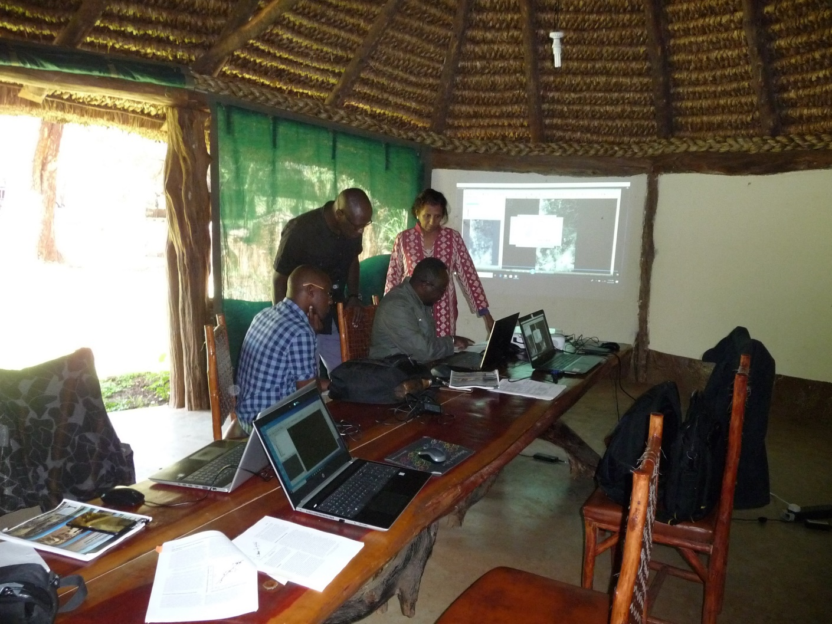
Caption for Graphic or Image: Amina Rangoonwala is helping some workshop participants at the Northern Rangelands Trust Headquarters training facility at Isiolo, Kenya.
Author name and business email: Elijah Ramsey III ramseye@usgs.gov

DOI agency/bureau: USGS
USGS Mission Area: Core Science Systems
USGS Program: Land Change Science
Cost Center: Lower Mississippi-Gulf Water Science Center
Program Name:
Project title: Evaluating Crop Residue Bands for the Landsat Next Mission
Project description: Satellite-based detection and mapping of non-photosynthetic vegetation (NPV), including crop residue cover, supports a better understanding of soil health, adoption of conservation tillage practices, and vegetation dynamics win cropland, pasture, and rangeland settings. Lignin and cellulose, associated with NPV, displays an absorption feature near 2100 nm that can be accurately measured using narrow-band shortwave-infrared (SWIR) indices. However, no current satellites are capable of providing narrow-band SWIR reflectance data at large scale.

The Landsat Next mission, currently in pre-formulation and expected to launch in the late 2020s, provides the opportunity for achieving increased SWIR spectral sampling and resolution at scale with the adoption of new sensor technology. The sensor will provide Landsat data continuity by preserving heritage Landsat spectral bands and will improve synergy with the European Space Agency’s Sentinel-2 sensors by including additional spectral bands and adopting improved spatial resolution. Landsat Next will also include additional spectral bands to address emerging applications such as water quality and quantity, snow and ice detection, crop residue, and improved surface temperature retrieval via temperature/emissivity separation. Narrow spectral bands in the SWIR region are planned to be added for measurement of ligno-cellulose absorption features to support the detection of NPV, including crop residue.

A Landsat Next expert review panel was convened in 2020-21 to focus on the use of narrowband SWIR reflectance to measure ligno-cellulose absorption features. Using a published dataset of 916 surface reflectance spectra collected from agricultural fields that ranged from 0% to 100% NPV cover, we calculated mean reflectance for five SWIR bands (2040, 2100, 2210, 2260, and 2330 nm) at varying bandwidths ranging from 10 to 50 nm. These bands centers were chosen based on demonstrated NPV characterization performance from previous missions like ASTER, WV3, and Hyperion. Using these band centers to calculate 13 NPV indices, we evaluated the effects of bandwidths, atmospheric impacts, sensor signal-to-noise ratios, fractional green vegetative cover, and background soil reflectance on the ability of SWIR-derived indices to measure fractional NPV on agricultural fields, as well as assessing spectral continuity with the existing Landsat 8 OLI Band 7. Several options, including the best 4-band, 3-band, and 2-band solutions, were described for possible inclusion on the Landsat Next mission.

Any of these narrow-band SWIR solutions would provide a greatly improved capability for detecting crop residue cover based on characterization of ligno-cellulose absorption features, providing tools to monitor the adoption of conservation tillage practices, as well as the effects of grassland management, through accurate global characterization of NPV.

Sensor Type: Hyperspectral;Multispectral (approx. 4-12 bands);
Platform type: Satellite;Ground based / sensor web / web cam;
URL: https://doi.org/10.5066/P9XK3867
Graphic or Image name: Hively 2021.png
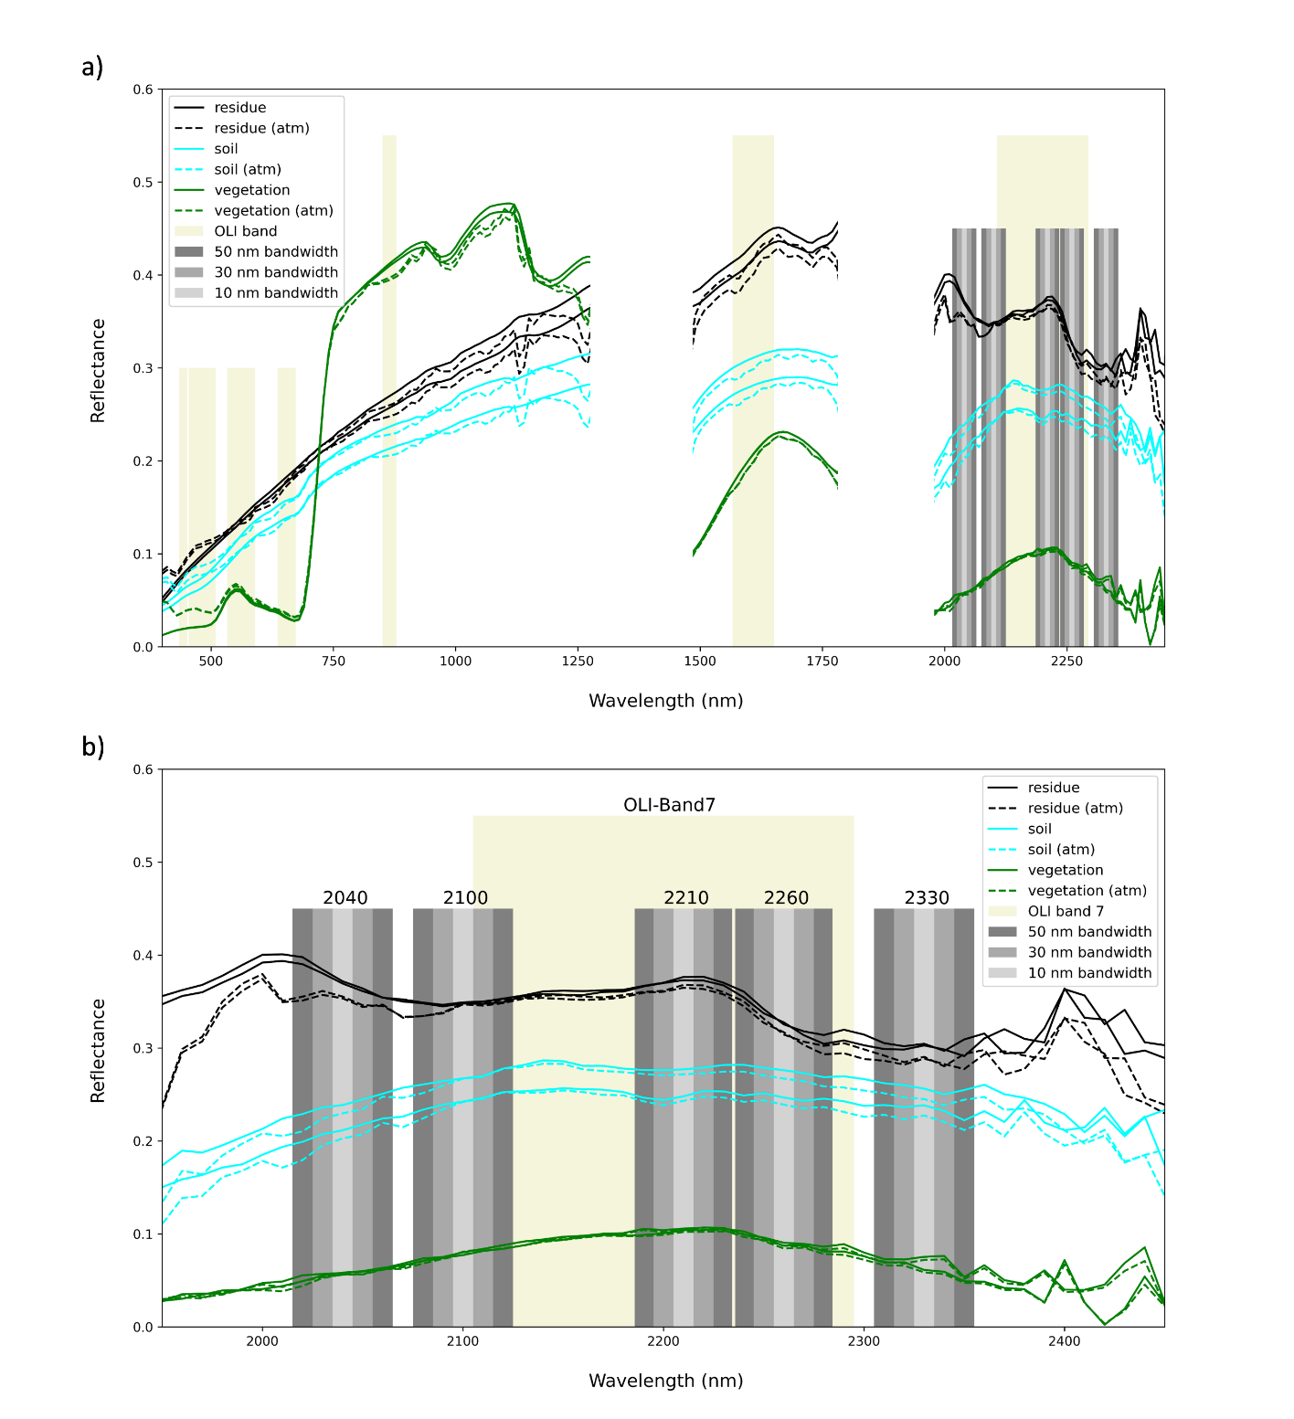
Caption for Graphic or Image: Example spectra for crop residue (NPV), soil, and green vegetation as surface reflectance for a) 400-2500 nm wavelength range, and b) 1950-2450 nm wavelength range for the same spectra, showing the five shortwave infrared bands under consideration at 10, 30, and 50 nm bandwidths (grey bars) as well as current Landsat Operational Land Imager (OLI) bands (tan bars). Note the decreased crop residue reflectance at 2100 nm and 2300 nm due to ligno-cellulose absorption.
Author name and business email: W. Dean Hively, whively@usgs.gov

DOI agency/bureau: USGS
USGS Mission Area: Ecosystems
USGS Program: Wildlife Program
Cost Center: Western Ecological Research Center
Program Name:
Project title: Aerial Seabird and Marine Mammal Surveys
Project description: California’s oceanic waters provide habitat for numerous migratory, resident, and breeding species of seabirds and marine mammals. Recent technological advances have made offshore wind energy infrastructure development a possibility for the deep waters offshore of the U.S. west coast. Multiple wind energy projects have been proposed for the region between the central California Coast and the US-Mexico border and are under consideration by state and federal regulators.

Given existing stresses to marine species, birds and mammals are vulnerable to the added effects of wind energy development. In a recent report, the USGS WERC Seabird Team assessed the vulnerability of seabirds to wind energy infrastructure. Now, with direction and support from the Bureau of Ocean Energy Management (BOEM), the Seabird Team has begun a series of aerial bird and mammal surveys that will provide more current information about animal distributions and abundance at sea to augment the initial vulnerability assessment. The results will inform the offshore wind development permit and planning process and help managers identify potential wildlife interactions with offshore wind energy infrastructure.

In the first part of the project, USGS WERC scientists are conducting aerial surveys from a small airplane from Point Piedras Blancas on the central California Coast to the U.S. California – Mexico border. Survey aircraft are outfitted with sophisticated digital cameras linked to computers to capture thousands of high-resolution digital photographs. Aerial surveys will take place over two years, covering the full study area in summer, fall, and winter, with additional surveys during migratory periods.

The aerial surveys will produce hundreds of thousands of images. Some of the images will contain birds and mammals, but many will only feature the surface of the ocean. Picking out the valuable species data from the vast number of images would be a herculean task for a human and doing so for sets of images dominated by animal-free photos is currently a challenge even for computers. Using rapidly-developing machine learning techniques, the USGS WERC team is designing new methods to automate the detection and counts of seabirds and marine mammals from imagery. Use of artificial intelligence to extract quantitative information from images will allow researchers to share contemporary data about species composition, distribution, abundance, habitat associations, and seasonal variation. Maps of these data can be used to inform the planning process for offshore wind development.

Sensor Type: Camera;
Platform type: Airplane;
URL: https://www.usgs.gov/centers/werc/science/aerial-seabird-and-marine-mammal-surveys
Graphic or Image name: Feet_byLaneyWhite_10112018

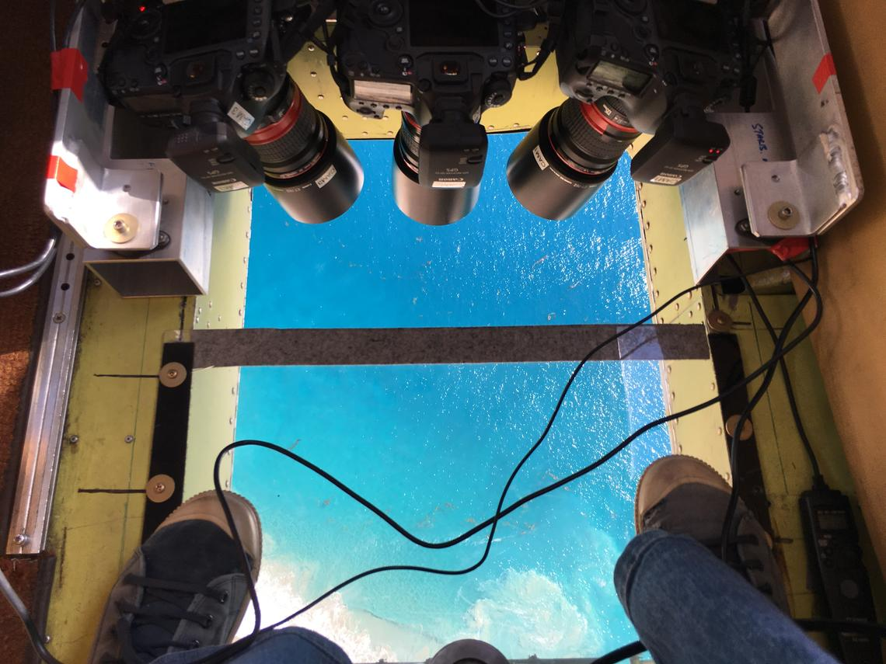
Caption for Graphic or Image: Looking through the belly port of a small airplane before an aerial photographic survey starts, Fall 2018.
(Credit: Laura White. Public domain.)
Author name and business email: Josh Adams, josh_adams@usgs.gov

DOI agency/bureau: USGS
USGS Mission Area: Ecosystems
USGS Program: Wildlife Program
Cost Center: Western Ecological Research Center
Program Name:
Project title: Central Valley Waterfowl Dynamic Habitat Mapping
Project description: Waterfowl populations within California's Central Valley are unusual among most North American waterfowl populations in that the region contains both resident and migratory populations of several species. The region supports 60% of all the Flyway's waterfowl and waterbirds which reside here for at least part of the year. This region is also the center of agricultural output in the nation, producing 8% of the entire nation's crops, and over half of California’s $50b agriculture cash receipts. Competing economic, municipal, and ecological demands for water are immense. As a result, California water policy plays an out-sized role in affecting conditions for waterfowl and waterbirds whether they winter or breed within the state. Decisions about water use can affect the availability and quality of habitats that waterfowl and waterbirds require, and the remaining wetlands are too few and remote to support the entire population of birds that inhabit the Central Valley each year. Agricultural patterns, particularly those involving rice, have supplanted the traditional role that wetlands played in this region.

Alterations in agricultural practices occur due to water policy and economic drivers, producing changes to how agriculture supports the Pacific Flyway. Habitat managers need to understand these changes in order to fill deficiencies and prevent population declines. Understanding what types of habitats are available to waterfowl and how habitat availability changes across the landscape produces important information about potential habitat limitations affecting specific life history stages, disease transfer risk to agriculture (poultry) producers, and energetic supply available to meet conservation/population targets.

To address these needs, researchers at the Dixon Field Station of the USGS Western Ecological Research Center are developing a multi-platform and object-based habitat classification model using Sentinel-2, Landsat 7 ETM and Landsat 8 OLI imagery to achieve classification updates as frequently as every 3 days. Classification is conducted using the Google Earth Engine platform for analysis to allow portability and collaboration. The resulting maps provide data that can inform water management decisions in near real-time.
Sensor Type: Multispectral (approx. 4-12 bands);
Platform type: Satellite;
URL:
Graphic or Image name: WaterfowlHabitatMappingSatellite
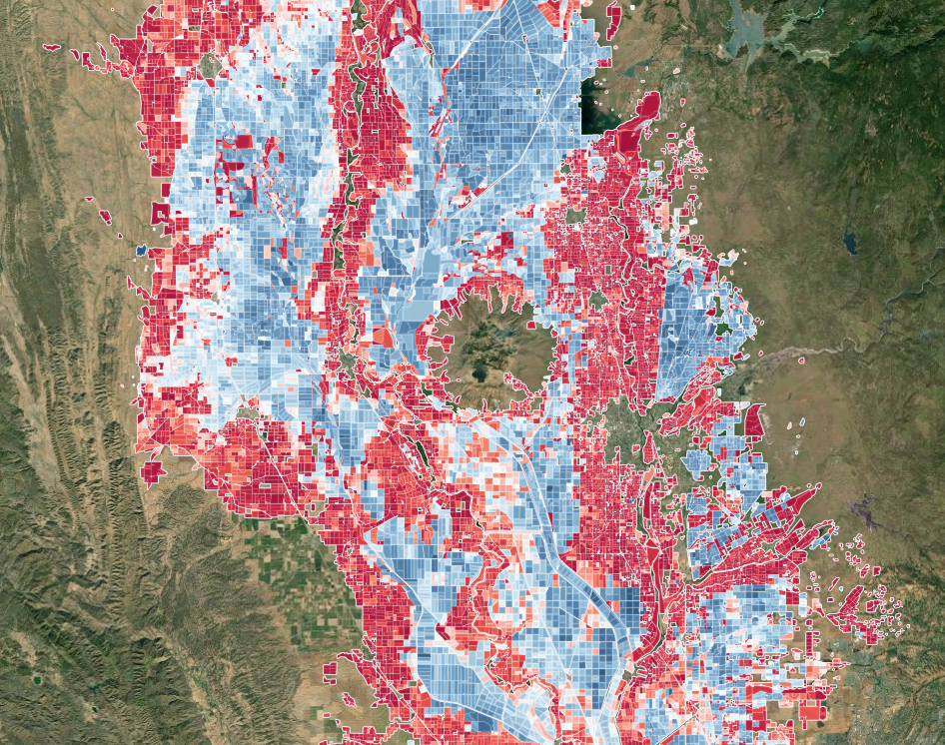

Caption for Graphic or Image: Flooded habitats are derived using satellite imagery (LandSat 7, 8 and Sentinel-2), spatially aggregated to homogenous hydrologic units (agricultural fields or wetland boundaries) and temporally aggregated using a temporal equivalent to a majority filter. Object-based classification and temporal filtering increases overall accuracy which has reach 97.9% among field validated datasets.
Author name and business email: Mike Casazza, mike_casazza@usgs.gov

DOI agency/bureau: USGS
USGS Mission Area: Ecosystems
USGS Program: Wildlife Program
Cost Center: Western Ecological Research Center
Program Name:
Project title: Wildfire and Smoke Affect Bird Migration in Western North America
Project description: The 2020 Western fire season was among the most extreme on record. Over 100 fires were active in September; the majority occurring in California, Oregon, and Washington, where over 16,000 square kilometers burned. The 2020 fire season exemplified patterns of increased wildfire size, number, timing, return frequency, and extent which are linked to climate-driven changes in precipitation and temperature affecting fire ignition and severity. Wildfires have increasingly coincided with the start of fall migration and may present a growing risk to migrating birds. For example, the fall migration of the Tule Goose (Anser albifrons elgasi), a subspecies of Greater White-fronted goose (A. albifrons), occurred as smoke plumes from the wildfires reached the greatest extent.

The Tule goose has a limited breeding range near the Cook Inlet in Alaska and only a few thousand individuals exist, resulting in a designation as a Species of Concern in California where the wintering population resides within the Sacramento Valley. Beginning in the fall of 2018, biologists with the Western Ecological Research Center have worked with California and Oregon wildlife departments to radio-collar and track Tule geese from their principal stopover site at Summer Lake, Oregon. This region is used during both fall and spring migrations by virtually all Tule geese as they transit between Alaska and California.

In 2020, migrating geese encountered dense smoke extending into the Pacific Ocean and across migratory routes where they occurred off the coast of Vancouver Island, British Columbia, Canada and Washington, USA. Comparison of GPS tracks from collared geese and the High Resolution Rapid Refresh with Smoke (HRRR-Smoke) model allowed description of individual response to dense wildfire smoke. Over the next several weeks, individuals encountering the smoke demonstrated several atypical responses including: back-tracking and travelling around mountain ranges, extended at-sea stopovers off the Washington coast, approximately 4,000 meter (13,000’) flights over the smoke plumes, and loss of orientation toward traditional stopover areas (Summer Lake, OR). In total, these effects resulted in over 25% longer migration paths and a doubling of the migration duration between Alaska and Summer Lake. We estimate this resulted in an energetic deficit sufficient to have caused increases in mortality or lowered reproductive outputs and would require at least 4-6 days of elevated feeding activity to offset. Future monitoring of migratory bird populations using telemetry applications will continue to inform managers of the potential risk of wildfires to migrating bird populations.
Sensor Type: IFSAR / SAR / Radar;GPS;
Platform type: Animal-borne, various (HRRR);
URL:
Graphic or Image name: WildfireSmokeGooseMap

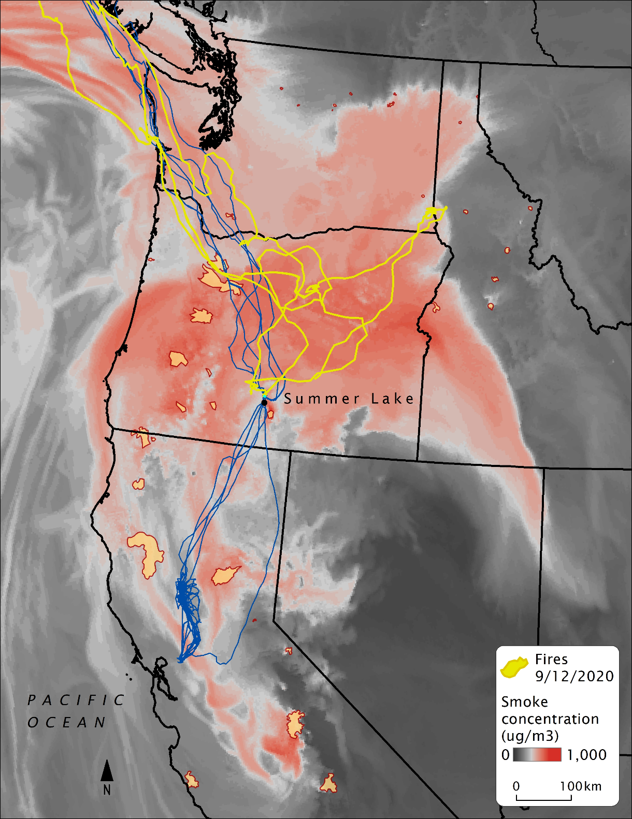
Caption for Graphic or Image: Dense smoke (>161 micrograms/cubic meter) from wildlfires in September 2020 covered an extent equivalent to 64% of California, Nevada, Oregon, and Washington combined. Migration paths of Tule geese (Anser albifrons elgasi) in 2020 (yellow) were more disorganized and resulted in longer migration times and distance flown relative to migration paths occurring in 2019 (blue) when dense smoke did not occur along migration routes.
Author name and business email: Mike Casazza, mike_casazza@usgs.gov

DOI agency/bureau: USGS
USGS Mission Area: Ecosystems
USGS Program: Wildlife Program
Cost Center: Western Ecological Research Center
Program Name:
Project title: Cinnamon Teal Migratory Habitat Selection in Western North America
Project description: Waterfowl rely on continent-wide wetland networks supporting migratory pathways that connect important breeding and wintering grounds. Globally, 30 to 90% of these networks are threatened or have been heavily modified or destroyed by human development. Locally, wetland habitat availability is affected by water policy and regional environmental characteristics that result in substantial annual variation in the quantity and quality of habitats available to waterfowl and other waterbirds. Throughout much of western North America, fall migration coincides with the lowest availability of wetland habitats on the landscape. This suggests that species which migrate through arid and semi-arid regions of western North America may be at risk from habitat limitations during fall migration. Given that persistent drought conditions are resulting in changes in water policy and patterns of use, it is important that patterns of habitat selection by migrating waterfowl are understood so the provisioning of suitable habitats can be continued in the face of climate, and policy changes.

Using high spatiotemporal resolution GSM-GPS transmitters, USGS scientists analyzed 61 fall migration tracks of Cinnamon Teal (Spatula cyanoptera) across western North America during a three-year study (2017-2019), resulting in the identification of 186 stopover sites used during fall migrations. Landsat derived imagery was analyzed for flooding regimes and surface water extent using Google Earth Engine, with wetlands types manually digitized.

Cinnamon Teal selected a variety of flooded habitats including natural, riparian, tidal and managed wetlands, flooded agriculture, wastewater sites, and golf and urban ponds. Wetlands associated with agriculture were the most used habitat type (29.8%), though several other anthropogenic habitat types (chiefly golf and wastewater ponds) were highly selected within some stopover sites. Over 72% of stopover locations were on private land. Resources used by Cinnamon Teal reflect wetland availability across the west, and further emphasize adaptability to dynamic resource conditions in arid and semi-arid landscapes. Such adaptability may be limited by large-scale reductions in wetland extent that result from extended drought or changes in agroeconomic patterns.

Habitat selection by migrating Cinnamon Teal through arid and semi-arid landscapes was highly variable, reflecting both plasticity in the selection of habitats, and local limitations in higher quality habitats within regions of western North America. Dry habitats, whether agriculture or matrix non-habitats, were avoided in all regions. The importance of anthropogenically provided water, e.g., managed wetlands, urbanized water sources, and wet agriculture, was reflected in high selection ratios for these landcover types.

Sensor Type: Multispectral (approx. 4-12 bands);GPS;
Platform type: Satellite;Animal-borne, GSM-cellular;
URL:
Graphic or Image name: CinnamonTealMap

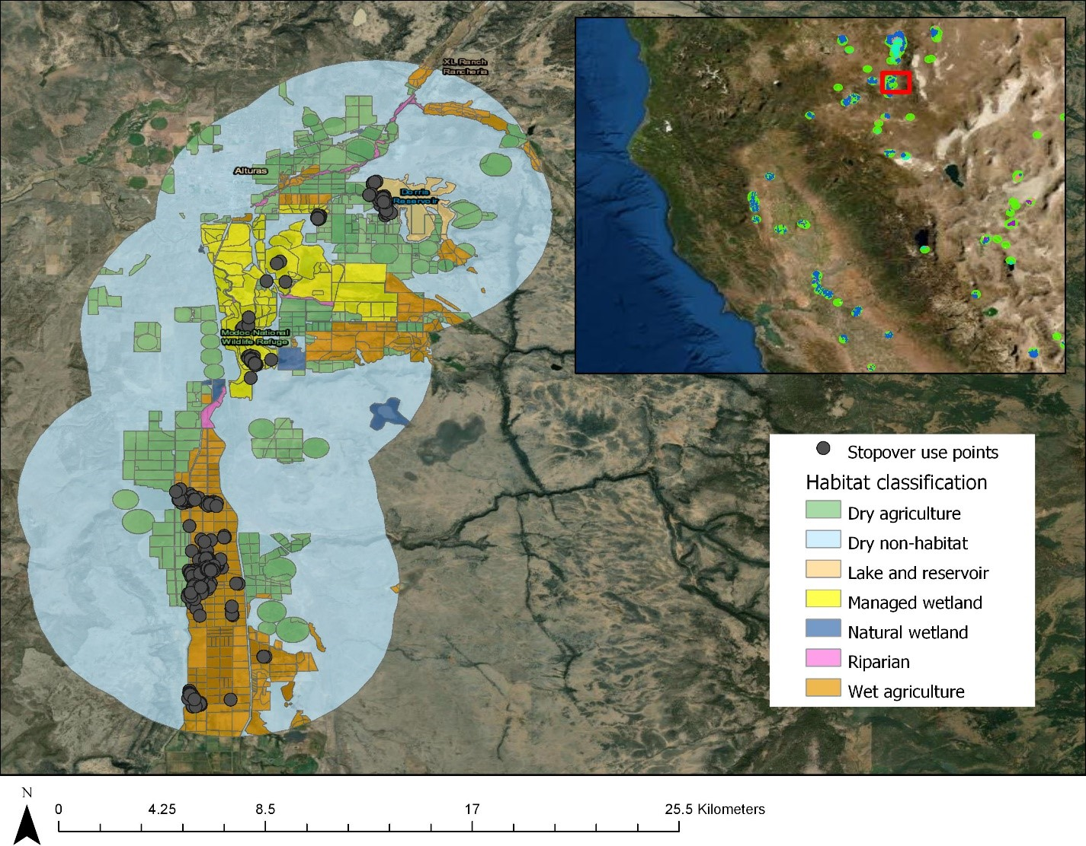
Caption for Graphic or Image: Habitat selection by migrating Cinnamon Teal through arid and semi-arid landscapes was highly variable, reflecting both plasticity in the selection of habitats, and local limitations in higher quality habitats within regions of western North America. Dry habitats, whether agriculture or matrix non-habitats, were avoided in all regions. The importance of anthropogenically provided water, e.g., managed wetlands, urbanized water sources, and wet agriculture, was reflected in high selection ratios for these landcover types.
Author name and business email: Mike Casazza, mike_casazza@usgs.gov

DOI agency/bureau: USGS
USGS Mission Area: Ecosystems
USGS Program: Wildlife Program
Cost Center: Western Ecological Research Center
Program Name:
Project title: Disturbance of ducks informs wetland management
Project description: Disturbances to animals can cause changes in behavior. Therefore, it is critical for wildlife managers to understand what disturbances may impact animals, and how animals adapt to them. USGS scientists analyzed the relationship between human-based disturbance and animal movement and habitat use. Fifteen dabbling ducks were tracked with GSM-GPS units for ~4-weeks before, during and after the start of a recreational hunting season in October/November 2018. Animal locations were recorded every 2-minute across three separate 24-hour tracking phases: Phase 1) two weeks before the start of the hunting season (control (undisturbed) movement); Phase 2) the hunting season opening weekend; and Phase 3) a hunting weekend two weeks after opening weekend. The 24-hour tracking phases were divided into three levels of disturbance related to the time of day: high (lethal human active (hunting)/~daytime); moderate (non-lethal human active/ ~crepuscular); and low (nighttime).

The results showed that during opening weekend flight (% time and distance) more than doubled during moderate (non-lethal human active) and low (nighttime) disturbance and increased by ~50% during high (lethal human active (hunting)) disturbance compared with the pre-season weekend. Sanctuary (non-hunted areas) use increased by three times during moderate and low disturbance and increased ~50% during high disturbance. Two weeks later, flight decreased in all disturbance levels but was only less than the pre-season levels during high disturbance. In contrast, sanctuary use only decreased at night while daytime doubled from ~45% to >80%, although not to pre-season levels. Ducks adjusted rapidly to disturbance.

https://doi.org/10.1016/j.jenvman.2021.113170
Sensor Type: GPS;
Platform type: Animal-borne, GSM-cellular;
URL:
Graphic or Image name:

Caption for Graphic or Image:
Author name and business email: Mike Casazza, mike_casazza@usgs.gov

DOI agency/bureau: USGS
USGS Mission Area: Ecosystems
USGS Program: Wildlife Program
Cost Center: Western Ecological Research Center
Program Name:
Project title: Waterfowl use of wetland habitats informs wetland restoration designs for multi-species benefits
Project description: Tidal marsh wetlands across the world have been lost due to human impacts. Tidal marshes are critical to many wildlife taxa and have become the focus of many restoration projects. In the Suisun Marsh of California, part of the San Francisco Bay Estuary and the largest brackish marsh on the U.S. Pacific coast, tidal marsh restoration must rely on the conversion of existing non-tidal managed wetlands in order to create new tidal marsh. These restorations can cause conflicts among stakeholders and species that win or lose depending on identified restoration priorities.

USGS scientists analyzed the use of tidal marsh and managed wetlands in the Suisun Marsh by dabbling ducks. The analysis examined 422,017 locations within the Suisun Marsh by six dabbling duck species (N = 315) tracked with GPS-GSM units. The study area comprised of approximately 47% managed wetland and 14% tidal marsh. Results indicate that the dabbling ducks used the managed wetlands ~98% of the time compared to 2% in tidal marsh. Even though the ducks preferred managed marsh, almost half of the tracked ducks did use tidal marsh at some point. When the ducks used tidal marsh they preferred pond like features.

Managed wetlands are vital to dabbling ducks. However, when managed wetlands are converted to tidal marsh, incorporating pond features may make tidal marsh wetlands more attractive to waterfowl and provide multi-species benefits. While waterfowl are presently common, previously seen calamitous population declines can be avoided through informed ecosystem-based management that promotes species richness, biodiversity and helps ‘keep common species common’.

https://doi.org/10.1111/1365-2664.13845
Sensor Type: GPS;
Platform type: Animal-borne, GSM-cellular;
URL: https://wim.usgs.gov/geonarrative/waterfowl/
Graphic or Image name: HabitatTypesSuisunMap
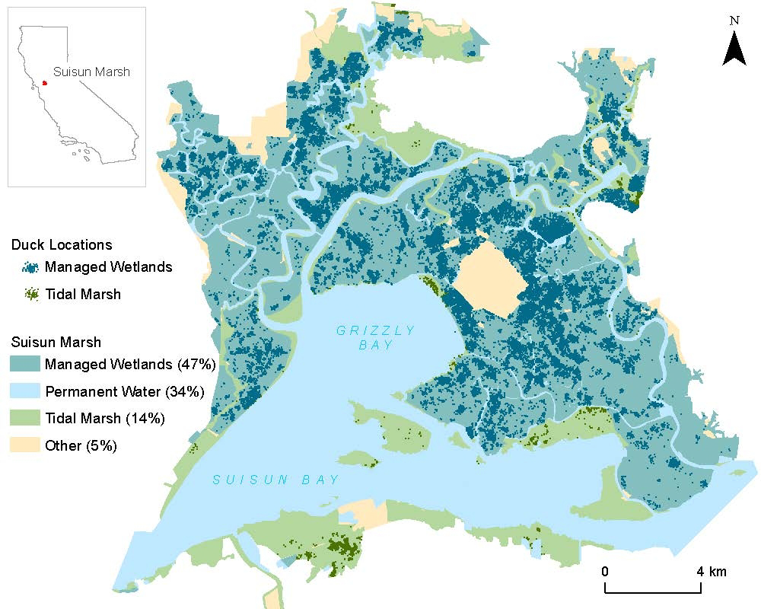

Caption for Graphic or Image: Habitat types and associated duck GPS locations in Suisun Marsh, CA. Percentages represent the proportion of Suisun Marsh that the habitat constitutes.
Author name and business email: Mike Casazza, mike_casazza@usgs.gov

DOI agency/bureau: USGS
USGS Mission Area: Ecosystems
USGS Program: Land Change Science
Cost Center: Western Ecological Research Center
Program Name:
Project title: Mixed Conifer Vulnerability Assessments
Project description: In recent decades, forests worldwide have experienced dramatic and often unexpected drought-related tree mortality events. California recently suffered its most extreme drought on record, resulting in the deaths of tens of millions of trees. Beyond the immediate impact on forests, such mortality events substantially increase the risk of catastrophic fire, which have the potential to change entire landscapes overnight. Faced with forecasts of similar droughts in the future and possessing only limited resources, managers need assessments of forest vulnerability so that they can effectively target treatments to reduce the risk of extreme mortality.

USGS scientists combined high resolution remote sensing imagery obtained by the Global Airborne Observatory (GAO) during the drought with robust ground-based data to develop models of tree survival probability. These models were used to create a drought vulnerability assessment for a large swath of the mixed conifer forests in Sequoia and Kings Canyon National Parks. The researchers then validated these assessments with a large, independent dataset. The models were found to be highly accurate for the most abundant species in the forest. The next step will be to expand the use of these vulnerability tools to the mixed conifer forests of the Sierra Nevada at large.

Sensor Type: Lidar (terrestrial or bathymetric);Hyperspectral;
Platform type: Airplane;
URL:
Graphic or Image name: ConiferVulnerability

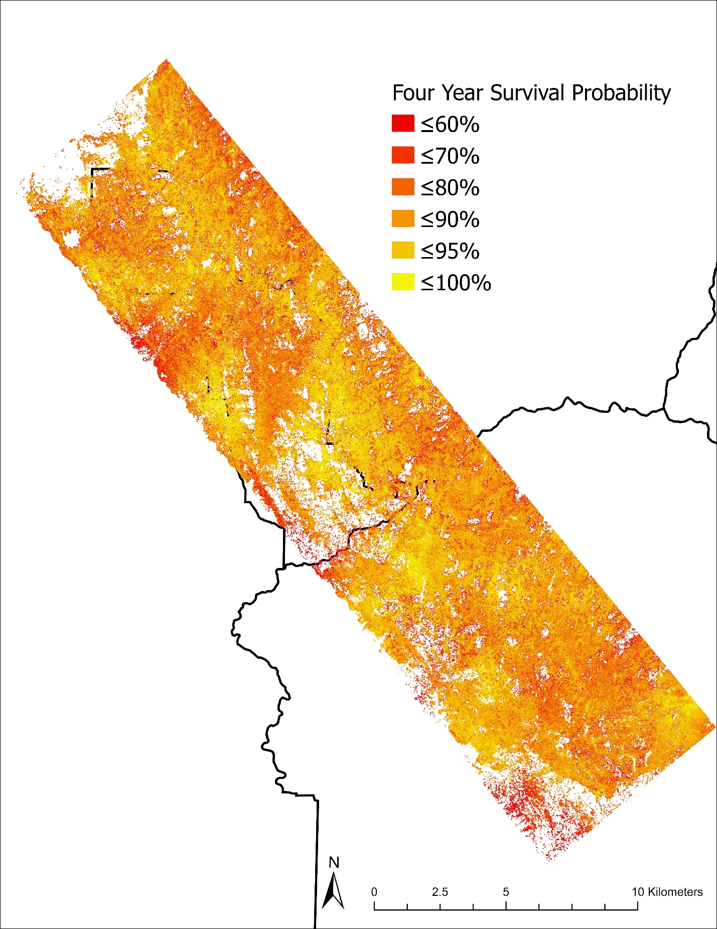
Caption for Graphic or Image: Four-year survival probability for trees in Sequoia and Kings Canyon National Parks.
Author name and business email: Adrian Das, adas@usgs.gov

DOI agency/bureau: USGS
USGS Mission Area: Ecosystems
USGS Program: Land Change Science
Cost Center: Western Ecological Research Center
Program Name:
Project title: Assessing Forest Treatment Effectiveness in the Sierra Nevada
Project description: Drought-related tree mortality events, in which large numbers of trees die suddenly and often unexpectedly, appear to be occurring more frequently worldwide. Such events can have substantial impacts on forests as well as increase the risk of catastrophic fires. Managers have tools available to try to increase the resilience of their forests against such events, including thinning through both mechanical means and prescribed fires. However, there are relatively few landscape-scale studies that assess the effectiveness of these treatments during extreme drought. The recent, very severe, drought in California provided an opportunity to do just such a test.

USGS scientists are combining data from thousands of ground-based plots across the southern and central Sierra Nevada with Landsat-derived remote sensing indices to quantify the relationship between tree mortality during the drought and underlying forest structure and treatment history. The first step in his process is to test how well changes in remote sensing indices relate to actual mortality. Long-term plot data from Sequoia National Park and Yosemite National Park are being used to develop models that show a strong relationship between remote sensing metrics and mortality and also to identify when those metrics are less reliable. The next step will be to use these models across the entire network of plots to develop an assessment of treatment effectiveness.

Sensor Type: Multispectral (approx. 4-12 bands);
Platform type: Satellite;
URL:
Graphic or Image name: TreatmentEffectivenessFigure

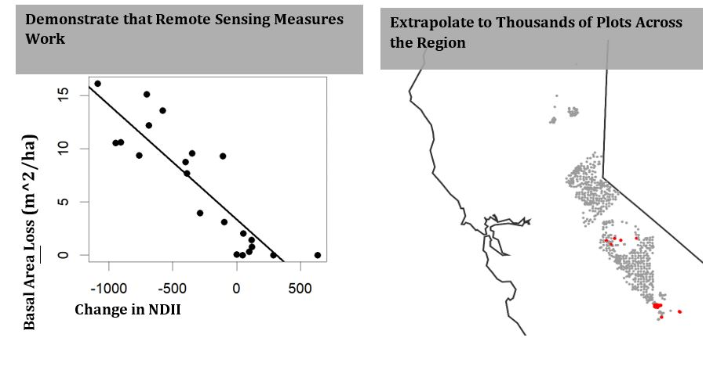

Caption for Graphic or Image: 1) A plot showing a strong relationship between change in remotely-sensed Normalized Difference Infrared Index (NDII) and basal area loss, an example of demonstrating how remote sensing measures may be used as a metric of mortality, 2) A map showing how existing plots (red) may be extrapolated across the region.
Author name and business email: Adrian Das, adas@usgs.gov

DOI agency/bureau: USGS
USGS Mission Area: Ecosystems
USGS Program: Land Change Science
Cost Center: Western Ecological Research Center
Program Name:
Project title: Tree Mortality Maps to Assess Fire Risk in Sequoia and Kings Canyon National Parks
Project description: Tens of millions of trees reportedly died in California during the 2012-2016 drought, resulting in marked increases in heavy fuel loads on the landscape. Combined with over a century of fire suppression, warming temperatures, and drier fuels, such conditions can result in catastrophic fires that are not predictable with traditional fire behavior models and that can do an enormous amount of damage in a short period of time. The 2020 Castle Fire provides a conspicuous example, with the fire having burned into numerous giant sequoia groves at unprecedented severity. Preliminary estimates suggest the fire may have killed over 10% of all large giant sequoias in the species range.

Targeting treatments to reduce the likelihood of these fires requires landscape scale assessments of catastrophic fire risk. USGS scientists and partners have recently launched a collaboration with a statewide consortium to produce fire risk maps at Sequoia and Kings Canyon National Parks (SEKI) using in-development next generation fire behavior models. Production of these risk projections will require robust empirical data quantifying existing fuels—including an accurate map of tree mortality from the drought. USGS scientists are currently working with the USFS Region 5 Remote Sensing Lab (RSL) to develop high quality dead tree maps using remote sensing data from both the Global Airborne Observatory (GAO) and Landsat.

Ground-based data collection is focused in two GAO flight boxes that cover large portions of the conifer forests at SEKI. We are collecting ground-based data that includes precise tree locations, tree species, and tree status (live or dead). The RSL is combining these data with remote sensing measures to develop a species map with dead trees being a category of ‘species’. USGS will then collect additional data to validate the map. This adaptive process will continue until acceptable levels of accuracy are reached. An important incidental product from this project will be a canopy species map for the parks, which will be useful for a variety of applications, including quantifying and locating pine species in decline.
Sensor Type: Lidar (terrestrial or bathymetric);Hyperspectral;
Platform type: Airplane;
URL:
Graphic or Image name: TreeSpeciesandDeathMap
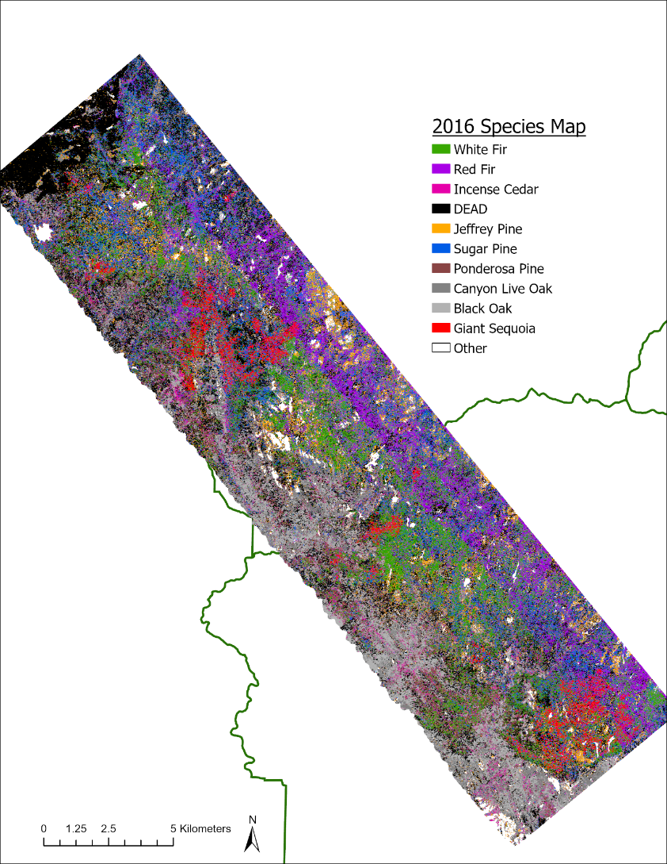

Caption for Graphic or Image: Preliminary species map for mixed conifer forest in the Sierra Nevada, with dead trees shown in black.
Author name and business email: Adrian Das, adas@usgs.gov

DOI agency/bureau: USGS
USGS Mission Area: Ecosystems
USGS Program: Wildlife Program
Cost Center: Western Ecological Research Center
Program Name:
Project title: Percent Shrub Cover in Open Space in San Diego County
Project description: Shrublands in southern California have seen large changes in vegetation composition and structure due to fire and drought. Invasion of nonnative grasses after repeated fire or drought events can inhibit shrub recovery and lead to vegetation type conversion to nonnative grassland. In San Diego County, chaparral and coastal sage scrub vegetation communities are at risk, with some areas seeing large declines in shrub cover. Past vegetation monitoring has focused on field-based methods, which provide great insight on plant composition and small-scale changes but are limited in spatial scope. Remote sensing can be used to identify large-scale changes, expanding the area measured and, in combination with field methods, allowing researchers and managers to prioritize field surveys.

Past studies using remote sensing focused on imagery only. In 2014 and 2015, high-resolution terrestrial Lidar was collected for San Diego County. This project incorporated new information from lidar to refine imagery-based models. A Digital Elevation Model (DEM) and Digital Surface Model (DSM) were created from the lidar point cloud at 1-meter resolution. Using these products, height above the natural surface was calculated (Normalized Digital Surface Model: nDSM) and clipped to open space areas.

Vegetation form was estimated using the height above the natural surface, with grass estimated as less than 0.5 meter, shrubs at 0.5-2m, and at trees greater than 2m. Normalized Difference Vegetation Index (NDVI) was calculated from a 2014 National Agriculture Inventory Program (NAIP) image (also 1-meter resolution, 4 band). Due to an extreme drought in 2014, lidar was essential to understanding the extent of dormant shrubs that dropped leaves even in the growing season. Percent cover of each vegetation form was calculated with an NDVI cutoff used to measure the percent active and the percent dormant or dead.

The natural surface was verified using established National Geodetic Survey benchmarks and exceeded 98% accuracy. Vegetation structure was validated using visual assessments of high-resolution aerial imagery to verify the vegetation form and greenness. Vegetation form and health (as indicated by NDVI) had an accuracy of 82%.

Future analysis will include multiple years of NAIP imagery to understand how shrublands are responding to drought and fire. Landsat imagery will also be used to understand the long-term changes from the 1990s and into the future. Statistical analyses will provide insight into patterns of vegetation change in response to climate and fire processes and assist in prioritizing areas for management and assessing effectiveness of management actions.

Sensor Type: Lidar (terrestrial or bathymetric);Multispectral (approx. 4-12 bands);
Platform type: Airplane;
URL:
Graphic or Image name: ShrubCoverMapSDCounty

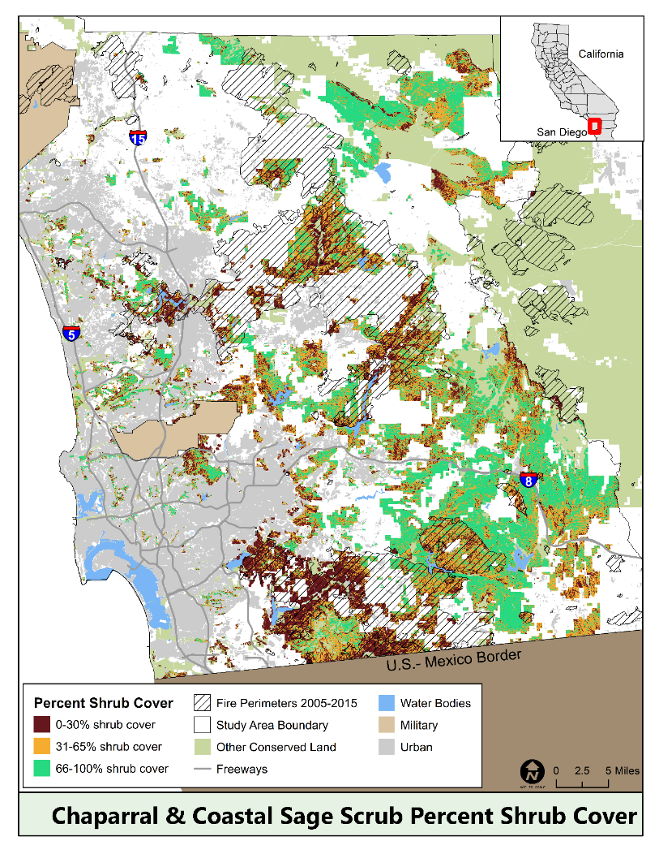
Caption for Graphic or Image: Map of shrub cover in San Diego County, developed using remotely sensed imagery.
Author name and business email: Robert Fisher, rfisher@usgs.gov

DOI agency/bureau: USGS
USGS Mission Area: Natural Hazards
USGS Program: Landslide Hazards Program
Cost Center: Geologic Hazards Science Center
Program Name:
Project title: Monitoring tsunamigenic landslide hazards in Alaska with InSAR
Project description: In Prince William Sound in southern Alaska, climate change-driven glacial retreat is exposing steep, unstable slopes that could generate tsunamis if they failed rapidly and entered the water of the fjords. One such area is the Barry Arm fjord, where the rapid retreat and thinning of the Barry Glacier is associated with several slope instabilities that threaten nearby communities, infrastructure, and marine interests. The largest of these landslides, measuring over two kilometers in width, moved 120 m between 2010 and 2017 as the Barry Glacier retreated from the base of the slope (see https://doi.org/10.1029/2020GL089800). This landslide initiated a state and federal multi-agency response in 2020, which included ground-based, aerial, and satellite monitoring efforts, community stakeholder involvement, and public outreach. In May of 2020, the U.S. Geological Survey began monitoring the landslide movement using RADARSAT-2 synthetic aperture radar (SAR) satellite data. Maps of monthly landslide movement (interferograms) were created using interferometric SAR (InSAR) processing, which measures changes in the ground surface using the difference in the phase of the returning waves in the line of sight of the satellite radar sensor. Between late May and September, the landslide experienced little to no downslope movement. In October, InSAR monitoring captured landslide-wide downslope movement. Using several SAR scenes from both the RADARSAT-2 and Sentinel-1 satellite, USGS scientists determined that the center of the landslide moved about 30 centimeters. Subsequent modeling of landslide failure and tsunami scenarios has shown that a tsunami would impact much of the Prince William Sound, with wave heights of over 200 meters in the northern part of Barry Arm fjord and peak heights of over 2 m offshore the town of Whittier (see https://doi.org/10.3133/ofr20211071). Monitoring active landslides with SAR data such as those in the Prince William Sound can improve emergency management efforts, landslide failure forecasts, and slope stability and tsunami modeling. Full details of the InSAR study can be found at: https://doi.org/10.5066/P9Z04LNK.
Sensor Type: IFSAR / SAR / Radar;
Platform type: Satellite;
URL: https://doi.org/10.5066/P9Z04LNK
Graphic or Image name: Landslide movement in the Barry Arm fjord Alaska

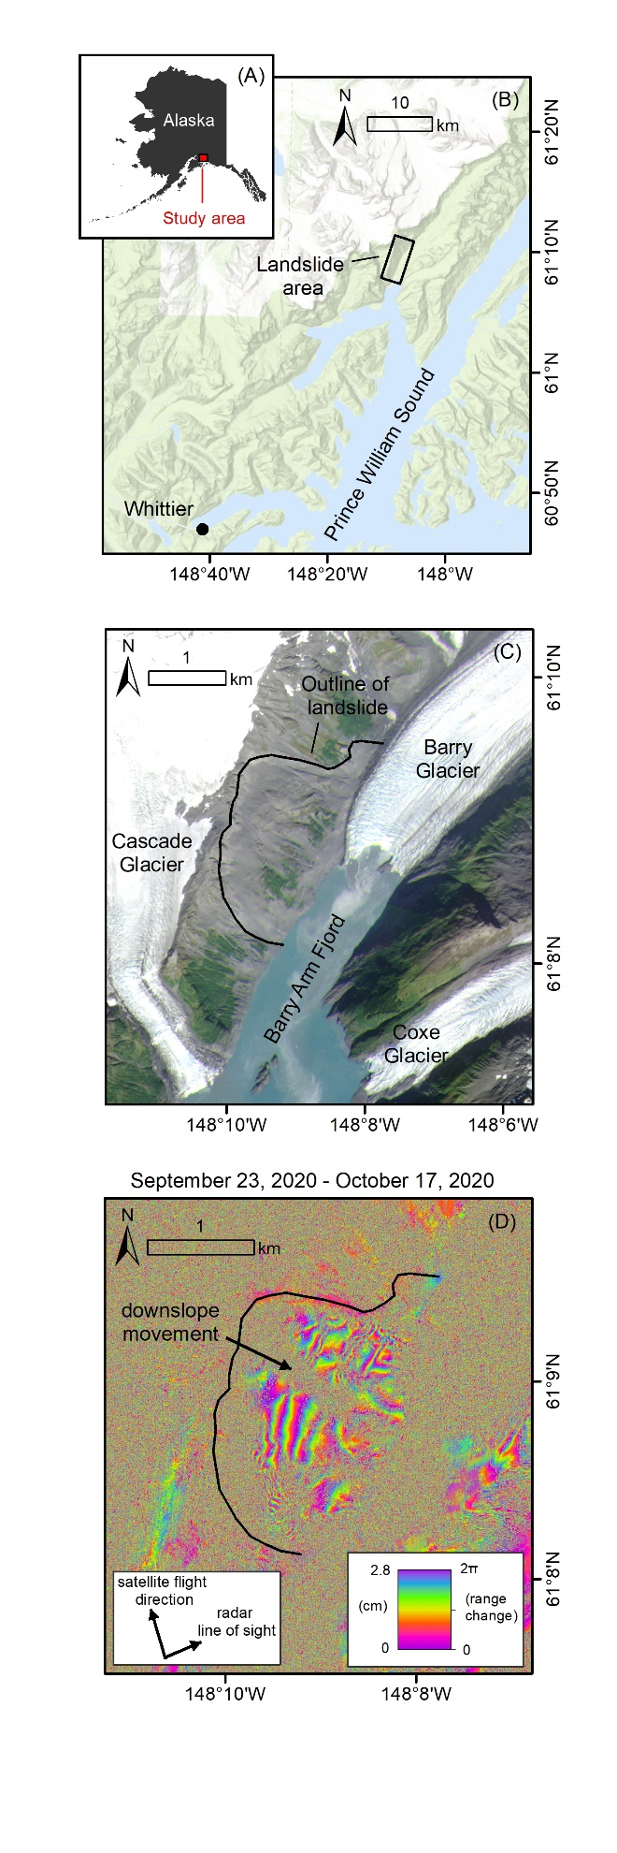
Caption for Graphic or Image: Location and InSAR displacement mapping results. (A) Prince William Sound located in southern Alaska. (B) The landslide area is located in the Barry Arm fjord, about 50 kilometers northeast of the nearest city Whittier, with a year-round population of about 200 residents, which balloons during summer months when it becomes a hub of boating, fishing, and tourism. (C) The largest landslide in the Barry Arm Fjord measures over 2 kilometers wide, and moved ~120 m downslope between 2010 and 2017 as Barry Glacier thinned and retreated from the base of the slope. (D) An interferogram produced from the RADARSAT-2 satellite data shows downslope movement of the landslide. Each fringe (full color cycle i.e. purple-purple) indicates 2.8 centimeters of movement. Speckle indicates areas where satellite measurements could not be made, such as over ice, water, vegetation, and very steep terrain.
Author name and business email: Lauren Schaefer, lschaefer@usgs.gov

DOI agency/bureau: USGS
USGS Mission Area: Ecosystems
USGS Program: Environments Program
Cost Center: Western Ecological Research Center
Program Name:
Project title: The Effects of Prolonged Drought on Chaparral Vegetation and Burn Severity in Two Southern California Fires
Project description: California recently experienced one of the most severe droughts in its history, resulting in extensive dieback of chaparral vegetation in the state’s Mediterranean regions. Though chaparral species are adapted to annual summer drought, the duration or intensity of a drought may exceed the adaptive capabilities of even these plants. The impacts of the recent severe drought were further exacerbated in many chaparral ecosystems by the occurrence of wildfires. The most notorious of these fires in southern California were the 2017 Thomas Fire and the 2018 Woolsey Fire.

USGS researchers are using remote sensing data to detect and verify vegetation dieback in southern California shrubland landscapes and then determine whether there is a relationship between dieback and patterns of fire severity in the Woolsey and Thomas fires. Specific research goals of the project include 1) mapping the spatial extent of chaparral dieback within the perimeters of the Thomas and Woolsey fires prior to them burning by calculating the difference in annual NDVI (Normalized Difference Vegetation Index) between the year prior to the drought and one six years, 2) assessing the effects of potential drivers causing dieback of chaparral vegetation, and 3) evaluating the effect of vegetation dieback on the patterns of burn severity within the Thomas and Woolsey Fires using Monitoring Trends in Burn Severity differenced Normalized Burn Ration (dNBR) data.

These Thomas and Woolsey fires serve as a test of this approach and its usefulness in evaluating relationships between severe drought, vegetation dieback and subsequent fire severity, and to what extent that information could be used to inform land and fire management activities in the region.

Sensor Type: Multispectral (approx. 4-12 bands);
Platform type: Satellite;
URL:
Graphic or Image name:

Caption for Graphic or Image:
Author name and business email: Jon Keeley, jon_keeley@usgs.gov

DOI agency/bureau: USGS
USGS Mission Area: Ecosystems
USGS Program: Status & Trends
Cost Center: Western Ecological Research Center
Program Name:
Project title: Informing hurricane flooding and sea-level rise vulnerability in southwest Florida wetlands
Project description: Remote sensing products from a fusion of satellite sensors allow the development of maps of the current distribution of coastal wetland plants and a more accurate model of coastal elevations to inform sea-level rise and hurricane flooding vulnerabilities. This information is directly being used by DOI partners and state and local agencies to improve management in a changing climate. This year, USGS scientists developed a 10-m resolution vegetation classification model using wet and dry season imagery from Sentinel 1 and 2 (SAR and multispectral, 2015-2017; pre-hurricane Irma). The model was successful in distinguishing mangroves from grassland habitats (88%), and the mean overall accuracy was 81%. The results show where mangroves have expanded their inland range into fresh and salt marshes across National Park Service and US Fish and Wildlife Service lands, threatening important habitats.

Along coastlines, elevation is an important characteristic to understand flooding of tidal wetlands, and even small biases in elevation can translate to large differences in inundation time, which is a crucial for estimating future flooding vulnerability. Elevation data usually comes from airborne LiDAR, but dense vegetation blocks the LiDAR signal from reaching the soil surface, causing a positive bias in bare earth digital elevation models (DEMs). Using a statistical model (LEAN: LiDAR Elevation Adjustment using NDVI) and ground calibration datasets, USGS scientists developed a new DEM for southwest Florida that accounts for the bias from vegetation. The LEAN model assumes that plant density is correlated with the normalized difference vegetation index (NDVI), calculated from National Agriculture Imagery Program (NAIP) imagery. LEAN effectively calibrates LiDAR-derived DEMs to the input survey-grade ground elevation data. The use of the LEAN model has resulted in a 51% improvement in DEM accuracy.

Sensor Type: IFSAR / SAR / Radar;Multispectral (approx. 4-12 bands);Lidar (terrestrial or bathymetric);
Platform type: Satellite;Airplane;
URL:
Graphic or Image name: FloridaWetlandsFigure

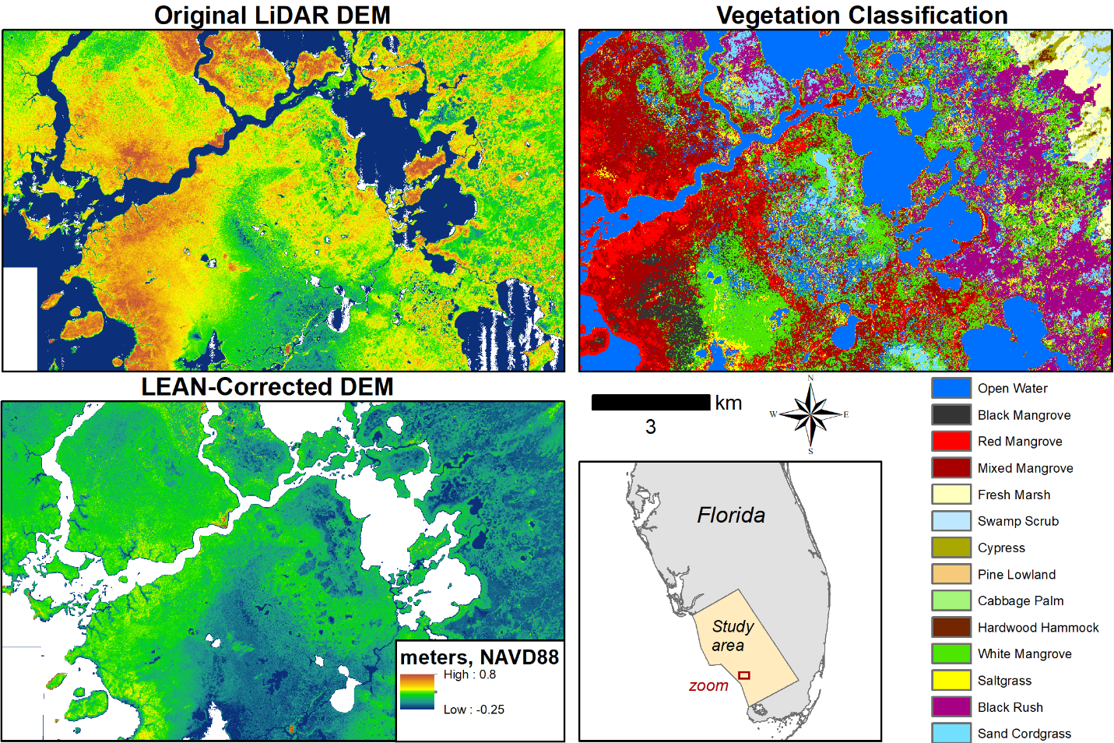
Caption for Graphic or Image: Digital elevation models (DEMs) are calculated using airborne LiDAR, but these data can be biased where vegetation is dense. Using the LEAN model, researchers were able to correct for this bias and generate a more accurate DEM for southwest Florida. A separate vegetation classification model developed using remotely sensed imagery allowed the researchers to generate a vegetation map for the same region.
Author name and business email: Karen Thorne, kthorne@usgs.gov

DOI agency/bureau: USGS
USGS Mission Area: Ecosystems
USGS Program: Wildlife Program
Cost Center: Western Ecological Research Center
Program Name:
Project title: Using UAS to detect elusive wildlife and measure habitats
Project description: Many wildlife species reside in sensitive habitats that make detection and monitoring difficult. For waterfowl, measuring brood production can serve as an early indicator of habitat quality and provide important insight into understanding overall ecosystem drivers. Early and comprehensive detection of duckling production and brood counts can inform recreational hunting, ecosystem function, and community composition. Dense vegetation cover and the secretive nature of ducklings makes comprehensive brood counts difficult to implement. USGS recently began a project to associate waterfowl brood production with habitat quality within Suisun Marsh California using emerging unoccupied aircraft systems (UAS) technology. UAS is being used to conduct waterfowl brood surveys by counting ducklings using thermal imaging and assessing habitat quality using Micasense 5-band multispectral sensors. The goal is to better understand brood production and its relation to habitat characteristics to inform wetland management and restoration efforts. So far, USGS researchers have successfully surveyed 480 hectares of wetland habitats and observed almost 800 unique ducklings. This information will directly benefit both private and public land managers that focus on waterfowl production, recreational hunting, and wetland restoration projects.
Sensor Type: Thermal;Multispectral (approx. 4-12 bands);
Platform type: UAS;
URL:
Graphic or Image name: SuisunThermalFigure

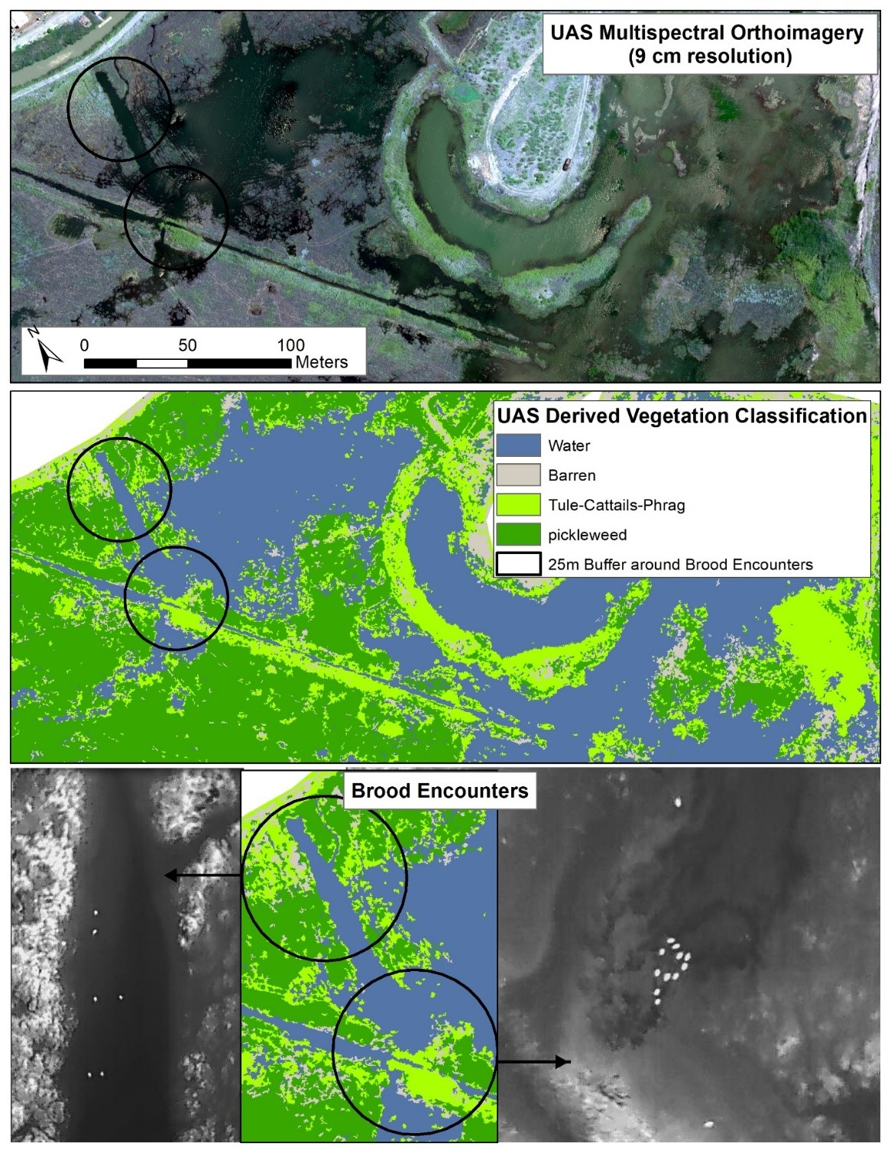
Caption for Graphic or Image: Multispectral imagery indicates habitat type and quality, while thermal imaging allows researchers to count ducklings.
Author name and business email: Karen Thorne, kthorne@usgs.gov

DOI agency/bureau: USGS
USGS Mission Area: Core Science Systems
USGS Program: National Geospatial Program
Cost Center: National Geospatial Program
Program Name:
Project title: Alaska Statewide Satellite Imagery Mosaic Acquired
Project description: USGS has acquired an updated statewide satellite imagery mosaic for Alaska. The 4-band (Red/Green/Blue natural color and near-infrared) 0.5-meter ground resolution mosaic was orthorectified using recently acquired statewide InSAR data to meet desired accuracy requirements. Source imagery for the mosaic comes from archived satellite scenes acquired predominantly from 2017 to present during summer months. Older scenes were used to fill gaps in more recent scenes present due to persistent cloud cover over some locations in Alaska. The mosaic is licensed for public viewing and is available through the USGS National Map Viewer and the State of Alaska’s Geoportal. Additional imagery services provided by the State of Alaska allow non-commercial users with Geospatial Information Systems (GIS) to link to and use the imagery as a backdrop within their GIS applications. Also, agencies participating in the Alaska Mapping Executive Committee are licensed to receive a copy for internal use. The powerful combination of an updated statewide imagery mosaic and the recently completed statewide InSAR dataset that was acquired under direction of the 3D Elevation Program supports a wide variety of mapping, resource management, and public safety applications. These two substantial Alaska mapping efforts have been coordinated through the Alaska Mapping Executive Committee (AMEC), an executive body co-chaired by the Department of the Interior and the Department of Commerce. AMEC members represent multiple Federal agencies and the State of Alaska.
Sensor Type: Multispectral (approx. 4-12 bands);
Platform type: Satellite;
URL: https://www.usgs.gov/core-science-systems/ngp/user-engagement-office/alaska-mapping-initiative
Graphic or Image name: Great Kobuk Sand Dunes

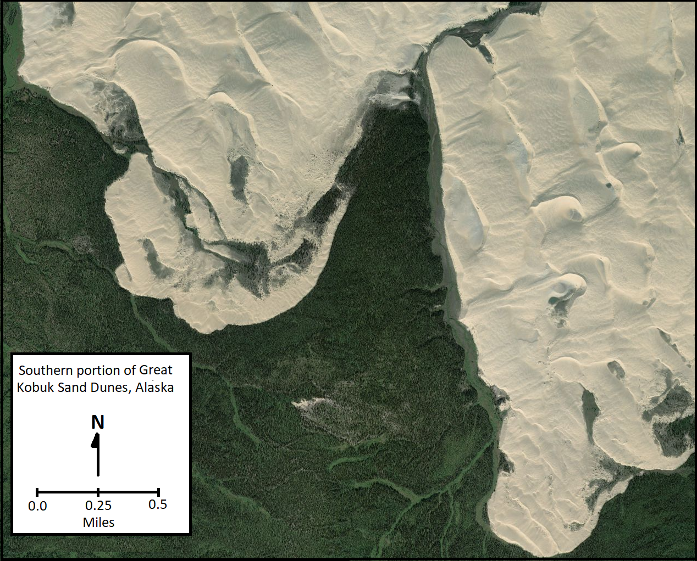
Caption for Graphic or Image: Satellite image view of a portion of the Great Kobuk Sand Dunes, Kobuk Valley National Park, Alaska.
Author name and business email: Tracy Fuller tfuller@usgs.gov

DOI agency/bureau: USGS
USGS Mission Area: Ecosystems
USGS Program: Status & Trends
Cost Center: Western Ecological Research Center
Program Name:
Project title: Evaluating landscape change following catastrophic fires in National Parks
Project description: The western US, including California, has experienced extreme weather events that have resulted in catastrophic and deadly fires. These destructive fires have resulted in loss of life and properties, as well as burning through some of the most iconic landscapes within the National Park Service (NPS). This ongoing project measures the impact and landscape response of these fires on three National Parks in California. Whiskeytown National Recreation Area burned in the 2018 Carr Fire, where 97% of the park burned across mixed coniferous communities. In 2020, 70% of Lava Beds National Monument burned across its sagebrush and native grassland ecosystem. Also in 2020, the Dome Fire burned over 43,000 acres across the Mojave National Preserve damaging one of the most extensive and robust Joshua tree stands. USGS is providing technical support and using multi-scale remote sensing tools to assess: 1) fire impacts to vegetation and cultural resources, and 2) vegetation landscape recovery or change. USGS staff are conducting field surveys of topography (RTK GPS), fire effects on vegetation, and vegetation recovery following fire. Results of the field surveys are being paired with data collected using unoccupied aircraft systems (UAS) and satellite imagery to create spatial products at different scales. This information is directly being used by NPS staff to inform management intervention and plan for recovery. This year, Worldview 2 imagery was acquired for Lava Beds National Monument and Mojave National Preserve to delineate the fire extent across these remote regions. UAS acquisition occurred in Whiskeytown for the third sampling year, which is being paired with Landsat imagery to estimate forest change and recovery. Field surveys were done for ground validation for all three locations. With the continued threats of wildfire to DOI lands, a multi-scale approach can help inform ecosystem change, landscape conversion, and management intervention to prevent invasive species expansion.
Sensor Type: Multispectral (approx. 4-12 bands);Orthoimagery;
Platform type: UAS;Satellite;
URL: https://www.usgs.gov/centers/werc/science/using-drone-imagery-assess-impacts-2018-carr-fire
Graphic or Image name: Whiskeytown NRA
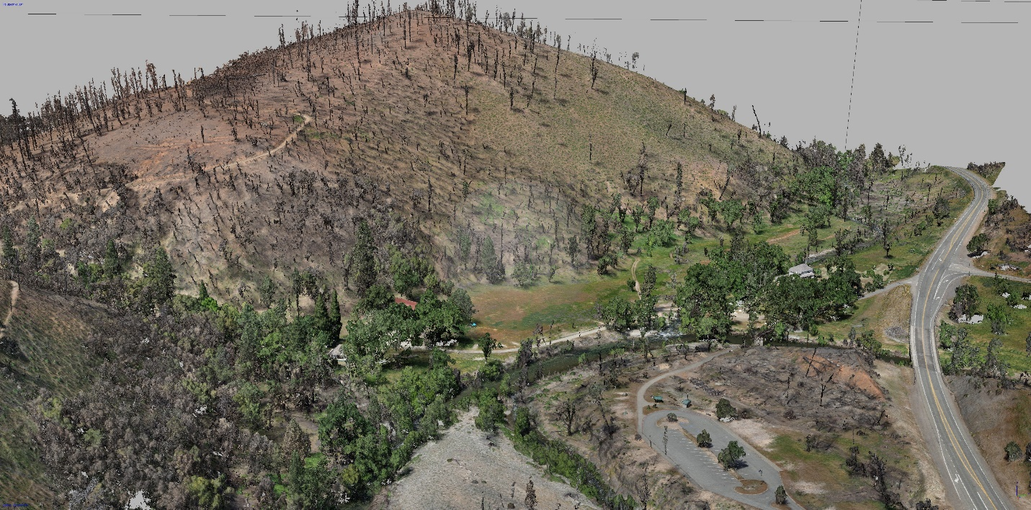
Caption for Graphic or Image: 3D dense point cloud created from unoccupied aircraft system (UAS) surveys with a Ricoh GR II sensor and processed in metashape (structure from motion) software. The dense point cloud is the base to producing derived products including orthoimagery and digital elevation models.
Author name and business email: Karen Thorne, kthorne@usgs.gov

DOI agency/bureau: USGS
USGS Mission Area: Ecosystems
USGS Program: Wildlife Program
Cost Center: Western Ecological Research Center
Program Name:
Project title: A customized image classification framework to develop regional-scale, high-resolution conifer maps
Project description: The substantial distributional expansion and infill of pinyon (Pinus monophylla) and juniper (Juniperus sp.) trees (hereafter, "conifer") into sagebrush (Artemisia spp.) ecosystems since the late 1800s threatens the ecological function and economic viability of these ecosystems and represents a major contemporary challenge facing land and wildlife managers. The ecological consequences of conifer expansion are nuanced by the proportion of cover within the ecosystem. Conifer expansion into sagebrush systems can lower resilience to disturbance and resistance to invasion, reduce forage for cattle, increase soil erosion from water runoff, and promote wildfire activity. Even relatively low conifer cover represents a primary threat to wildlife populations such as the greater sage-grouse (Centrocercus urophasianus; hereafter, "sage-grouse"). Conifer cover as low as five percent decreases sage-grouse survival and population persistence. Therefore, managers require accurate and high-resolution maps of conifer distribution and abundance across broad geographic extents to help guide land management decisions that better target areas for conifer treatment projects, especially for sage-grouse habitat restoration in sites characterized by scattered, isolated trees. However, previously available remotely sensed layers that cover a regional spatial extent lacked the spatial resolution or accuracy to meet this need. We developed a framework to map conifers at a high resolution (1 m2) across the majority of Nevada and northeastern California using image classification. We used digital orthophoto quad tiles from National Agriculture Imagery Program (2010 and 2013) to classify conifers using automated feature extraction (Feature Analyst™, Overwatch, 2013). Overall accuracy was >86% across all mapped areas for both image validation and ground referencing methods. We provided four sets of full-extent maps for land managers: (1) a shapefile representing accuracy results linked to mapping subunits; (2) binary rasters representing conifer presence or absence at a 1-m2 resolution; (3) a 900-m2 resolution raster representing percentages of conifer canopy cover within each cell; and (4) 1-m2 resolution canopy cover classification rasters derived from a 50-m radius moving window analysis. These products improve upon or complement existing conifer maps for the western U.S. and will facilitate sagebrush ecosystem restoration through an accurate understanding of conifer distribution and abundance at multiple spatial scales.

Publications:
Coates, P.S., Gustafson, K.B., Roth, C.L., Chenaille, M.P., Ricca, M.A., Mauch, Kimberly, Sanchez-Chopitea, Erika, Kroger, T.J., Perry, W.M., and Casazza, M.L., 2017, Using object-based image analysis to conduct high-resolution conifer extraction at regional spatial scales: U.S. Geological Survey Open-File Report 2017-1093, 40 p., https://doi.org/10.3133/ofr20171093.

Gustafson, K.B., Coates, P.S., Roth, C.L., Chenaille, M.P., Ricca, M.A., Sanchez-Chopitea, E., and Casazza, M.L., 2018, Using Object-Based Image Analysis to Conduct High- Resolution Conifer Extraction at Regional Spatial Scales. Int. J. Appl. Earth Obs. Geoinf. 73: 148-155, https://doi.org/10.1016/j.jag.2018.06.002

Roth, C.L, Coates, P.S., Gustafson, K.B., Chenaille, M.P., Ricca, M.A, Sanchez-Chopitea, E., and Casazza, M.L., 2021, A customized framework for regional classification of conifers using automated feature extraction. MethodsX 8, https://doi.org/10.1016/j.mex.2021.101379
Sensor Type: Multispectral (approx. 4-12 bands);
Platform type: Satellite;
URL:
Graphic or Image name: ConiferExpansionSagebrushMaps

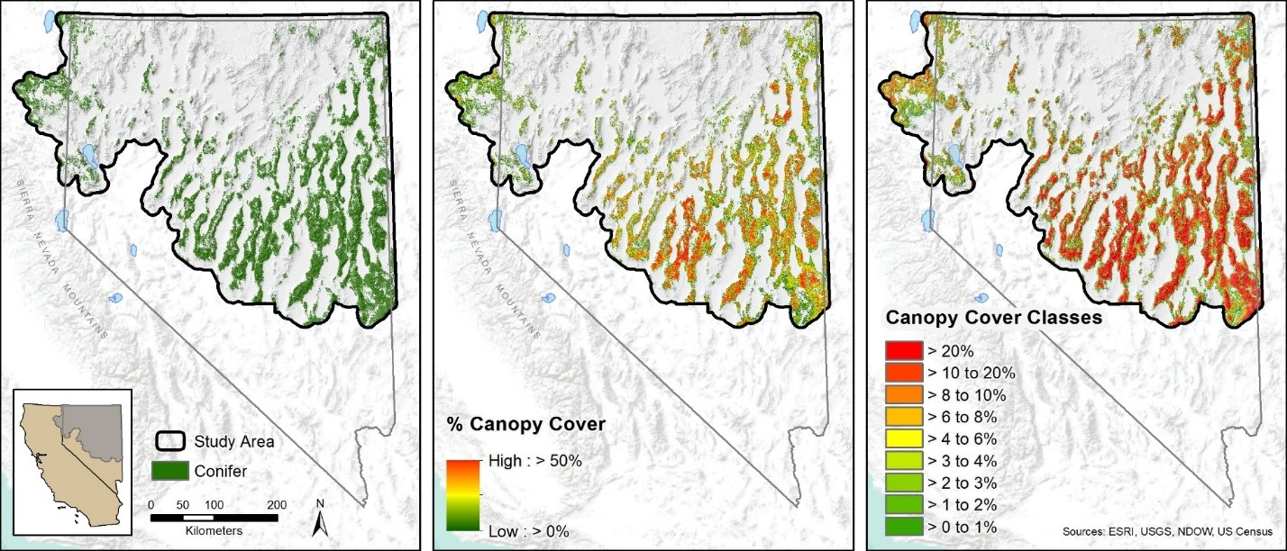
Caption for Graphic or Image: Spatial layers produced using automated feature extraction methods across greater sage-grouse habitat in Nevada and California depicting: a) conifer presence or absence at a 1-m2 resolution; b) continuous conifer canopy cover at 900-m2 resolution raster, and c) example of using canopy cover bins at a 1-m2 resolution produced from a 50-m radius moving window to depict progressive phases of conifer expansion.
Author name and business email: Peter Coates, pcoates@usgs.gov

DOI agency/bureau: USGS
USGS Mission Area: Ecosystems
USGS Program: Wildlife Program
Cost Center: Western Ecological Research Center
Program Name:
Project title: Developing high-resolution vegetation cover maps for greater sage-grouse habitat in Nevada
Project description: Accurate maps of seasonal habitat for greater sage-grouse (Centrocercus urophasianus) across broad extents are of paramount importance to conservation efforts in sagebrush ecosystems across the Great Basin, particularly for habitat assessments and mitigation efforts. However, the ability to model sage-grouse habitat at fine spatial scales necessary for microhabitat assessment is constrained by the spatial and spectral resolution of most remotely sensed measurements of vegetation composition. As a continuation of previous shrub mapping efforts, the Western Ecological Research Center is currently utilizing multispectral imagery from unmanned aircraft systems (UAS) collected by the Center for Transformative Environmental Monitoring Programs (CTEMPS) at the University of Nevada, Reno, and Worldview satellite imagery from Maxar, Inc. to generate fractional cover maps containing detailed vegetation components. These high-resolution fractional cover maps will identify sagebrush, non-sagebrush shrub, forbs, and grasses. Estimates of vegetation components in training plots derived from ultra-high-resolution (< 3 cm2) UAS imagery and object-based image analysis (OBIA) are applied to high-resolution (2 m2) WorldView scenes using regression tree (RT) models. The approach yields fractional estimates of vegetation cover at a resolution that more closely correlate with actual microhabitat conditions compared to other widely available fractional products better suited for macrohabitat applications. An advantage of the UAS-RT approach is that large volumes of training data can be collected rapidly from UAS compared to traditional ground-based vegetation surveys, which could ultimately yield previously lacking estimates of microhabitat availability across macrohabitat or landscape level extents.
Sensor Type: Multispectral (approx. 4-12 bands);
Platform type: UAS;Satellite;
URL:
Graphic or Image name: ShrubCoverCoates

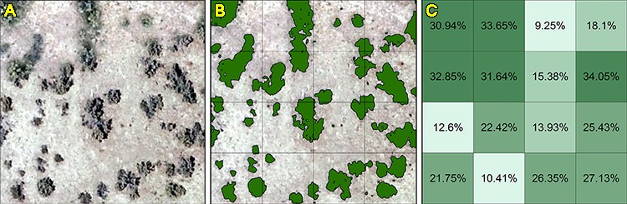
Caption for Graphic or Image: (A) Example of Artemisia tridentata in ultra-high-resolution UAS imagery. (B) OBIA classification of sagebrush features. (C) Calculated percentage of sagebrush cover per 2 m2 Worldview pixel.
Author name and business email: Peter Coates, pcoates@usgs.gov

DOI agency/bureau: USGS
USGS Mission Area: Ecosystems
USGS Program: Climate Research & Development
Cost Center: Western Geographic Science Center
Program Name:
Project title: Surface water inundation of California’s croplands
Project description: California’s croplands cover roughly 3.8 million hectares (ha) with crop products valued at 33 billion U.S. dollars according to the UDSA’s 2017 Census of Agriculture. Because of their value, monitoring surface water inundation in these croplands is of interest for disaster preparedness and water management. The sources of surface water inundation include both intentional inundation for irrigation and unintentional flooding. Irrigation is the most common source of intentional water inundation in California’s croplands; nearly 90% of crops grown in California rely on irrigation. Surface irrigation, whereby fields are flooded and water flows across the surface, is the most common type of irrigation practiced in the state.

While many crops are intentionally inundated, flooding is also a threat to agricultural yields. More than 1.1 million ha of California’s croplands reside within the 500-year flood plain, accounting for nearly 7 billion U.S. dollars in crop value. While drought conditions are forecasted to increase in frequency with changing climate patterns, so too are extreme precipitation events that contribute to flooding. As a result, monitoring surface water inundation that results from flooding can help farmers and resource managers with risk assessments for crop types and locations.

Using satellite imagery, we can observe patterns of surface water inundation in California’s croplands at frequent time scales across the entire state. We examined eight different crop types to extract patterns of inundation from 2003 to 2020. We utilized the processing power of Google Earth Engine to quantify monthly composite images of surface water and extract inundation for each crop type.

Results indicate that rice crops have high winter and spring surface water inundation, which was expected based on typical irrigation patterns. We also found relatively high surface water inundation in grain and field crop types. During winter months, citrus crop parcels show a mean inundation between 1 and 1.3 percent, suggesting unintentional flooding. Regions that had high surface water in relation to crop area included the northern Sacramento River valley, where rice is predominantly grown, and the southern San Juaquin River valley, particularly Fresno county, which produces a large portion of the state’s deciduous and grain crops.

Sensor Type: Multispectral (approx. 4-12 bands);
Platform type: Satellite;
URL:
Graphic or Image name: SW inundation CA crops - Smith
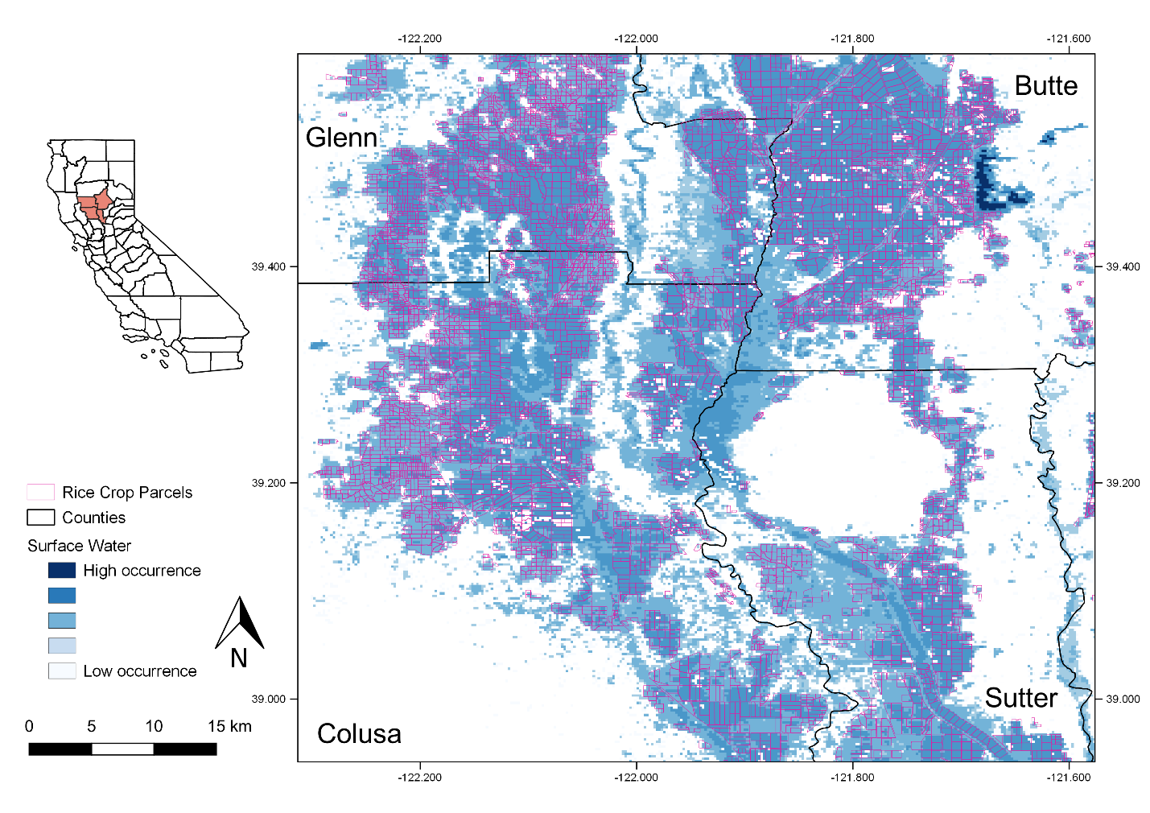
Caption for Graphic or Image: Surface water inundation from low to high occurrence from 2003 - 2020 in California rice croplands in the northern Sacramento River valley.
Author name and business email: bwsmith@usgs.gov

DOI agency/bureau: USGS
USGS Mission Area: Ecosystems
USGS Program: Climate Research & Development
Cost Center: Western Geographic Science Center
Program Name:
Project title: Applying Existing Land Cover Information to Train a Machine Learning Classification
Project description: Large-scale investigations into land-use/land-cover change (LULCC) often rely on repeatable image classification processes. The process of labeling of images into one of several classes can range from human-intensive manual interpretations to trained supervised classifications to computer-led unsupervised classifications. Machine learning (ML) has recently arisen as viable way to create models to accurately classify images derived from aerial and satellite platforms. The one caveat in any successful ML process is that ML is highly dependent on quality training data.

The Patterns in the Landscape – Analyses of Cause and Effect (PLACE) project is actively working towards applying ML to improve its LULCC mapping procedures. The project is beginning ML development focused on a use case of mapping water and wetland. To meet this goal, the project team is evaluating a range of possible training data, including surface water inundation maps generated by PLACE, wetland maps generated by USFWS National Wetland Inventory, and legacy LULC information hand-interpreted by experts who worked on the USGS Land Cover Trends project. Testing a variety of existing geospatial data as possible training data is intended to help the team identify whether legacy data represent a viable alternative to creating training data from scratch. Training data are being fed into image classification models set up in Amazon Sagemaker (in Amazon Web Services) with help from USGS Cloud Hosting Solutions. A second approach using open source convolutional neural network software is also being tested. The team is currently in the process of tuning hyperparameters and analyzing model outputs prior to a wider implementation.

Sensor Type: Multispectral (approx. 4-12 bands);
Platform type: Airplane;Satellite;
URL: https://www.usgs.gov/centers/wgsc/science/patterns-landscape-analyses-cause-and-effect
Graphic or Image name: DOI Activity Report - Soulard2

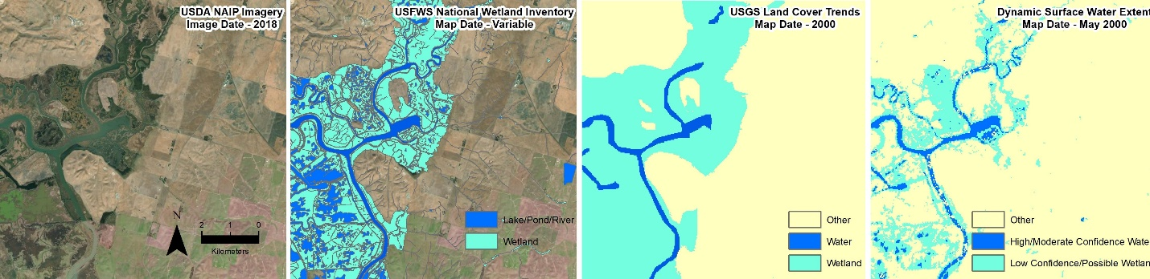
Caption for Graphic or Image: A wide range of existing water and wetland maps exist, including wetland maps from USFWS National Wetland Inventory, hand-classified LULC maps from USGS Land Cover Trends, Dynamic Surface Water Extent maps generated by PLACE. The location of these maps is just southeast of Fairfield, CA.
Author name and business email: Chris Soulard, csoulard@usgs.gov

DOI agency/bureau: USGS
USGS Mission Area: Ecosystems
USGS Program: Environments Program
Cost Center: Wetland and Aquatic Research Center
Program Name:
Project title: Assessing Habitat Change and Migration of Barrier Islands
Project description: Barrier islands are dynamic environments that can evolve with currents, waves, and tides. While these systems help with storm surge reduction and wave attenuation, accelerated sea-level rise and more frequent and intense storms are expected to drastically change these islands in the future. Although many habitat change studies have evaluated habitat shifts by examining net change over time, understanding spatial dynamics can also be important.

To fully capture the dynamic nature of barrier islands, a team of U.S. Geological Survey researchers utilized an existing approach called change component analysis. This approach can quantify habitat oscillation, which is change that does not contribute to overall net gain or loss of a specific habitat. The team applied this tool to predicted habitat maps generated from a previously published habitat modeling effort that utilized numerical model outputs of potential geomorphology. The objective of this initial study was to assess climate change effects on habitat distribution with and without various restoration measures on Alabama’s Dauphin Island. One finding from the assessment was that more extensive changes without the a beach and dune restoration. This new work built on those results by explicitly quantifying how the study area changed under the modeled scenarios. The results showed that much of the modeled change that occurred was spatially complex—with habitat oscillations and shifts in habitat types that were masked when only the total gains and losses of individual habitat types were considered (Fig. 1). An example of a habitat oscillation would be when the habitat type of one area changes (such as from beach to dune) while the reverse change occurs in another area, there would be no net change between the two categories.

The additional information provided by change component analysis—whether applied to historical and contemporary habitat maps or to predicted habitat maps generated by models—will provide land mangers with nuanced observations needed to evaluate the efficacy of restoration activities and assist with complex natural resource management decisions on dynamic barrier islands.
Sensor Type: Camera;Lidar (terrestrial or bathymetric);
Platform type: Airplane;
URL: https://doi.org/10.1007/s12237-021-00971-w; https://doi.org/10.3133/ofr20201003
Graphic or Image name: Enwright_hab_chg_DOI_report.jpg
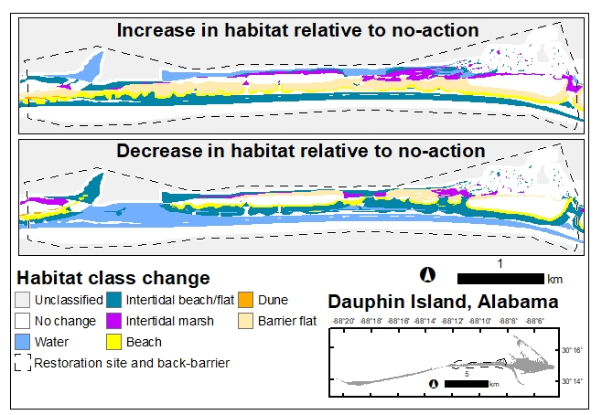
Caption for Graphic or Image: Fig. 1. Comparison of habitat prediction for the restoration site and back-barrier area on Dauphin Island, Alabama (USA), for future with and without restoration action after a 10-year simulation. The simulation included a static sea-level change of 0.96 m and predicted decadal geomorphic evolution with simulated storms. Modified from Enwright et al. (2021) with permission.
Author name and business email: Nicholas Enwright; enwrightn@usgs.gov

DOI agency/bureau: USGS
USGS Mission Area: Core Science Systems
USGS Program: Land Change Science
Cost Center: Western Geographic Science Center
Program Name:
Project title: Structure from Motion (SfM) photogrammetric processing of historical aerial photographs for National Park resource monitoring
Project description: Ecologists and natural resource managers have used historical aerial photography to analyze long-term vegetation changes in a wide range of ecosystems. In National Park units like Lassen Volcanic National Park, historical aerial photographs can provide baseline information for a wide range of geophysical and ecological studies (i.e., geomorphology changes, post-fire regeneration, tree/shrub encroachment). Historical aerial images are challenging to work with if not accurately georeferenced and orthorectified, and images taken prior to 1973 lack camera calibration reports that provide interior orientation parameters (principal point, fiducial measurements, lens focal length) that are required for traditional photogrammetric processing. Structure from Motion photogrammetry (SfM), a technique that uses multiple overlapping photographs to create 3-D point clouds, overcomes this limitation by automatically estimating internal camera geometry, position, and orientation based on image data alone.

USGS has made high resolution (800 dpi) scans of ~1,250 hard copy aerial photos collected between 1941-2004 over Lassen Volcanic National Park, which includes partial or complete coverage of the park for the years 1941, 1952-56, 1966, 1973-74, 1988, 1998 and 2004. We are using Structure from Motion (SfM) algorithms in Agisoft Metashape to automate the process of photogrammetric mosaicking and orthorectification. SfM image matching algorithms do not require detailed flight paths or orientation files and require only a small number of Ground Control Points (GCPs) to locate and match the raw, unstructured images. Within a 430 km2 area of Lassen NP, we identified three hundred GCPs from surface features identifiable in both historical and current images. Camera calibration reports were obtained from the USDA Forest Service RSAC Camera Report Database when available. For each photo year we are generating a georeferenced dense point cloud and polygonal mesh model that are used to build orthomosaics (Figure A) with high spatial accuracy.

The resulting images will be used to quantify changes in forest density and fuel loads in Lassen NP, and to estimate rates of conifer encroachment into wetlands and meadows (Figure B). The geodatabase of high resolution and high quality historical orthomosaics produced through this project will provide baseline geospatial data that can help address many other geoscience and ecological investigations and support park decision-making for years to come.

Sensor Type: Camera;
Platform type: Airplane;
URL:
Graphic or Image name: Villarreal_Lassen_SfM

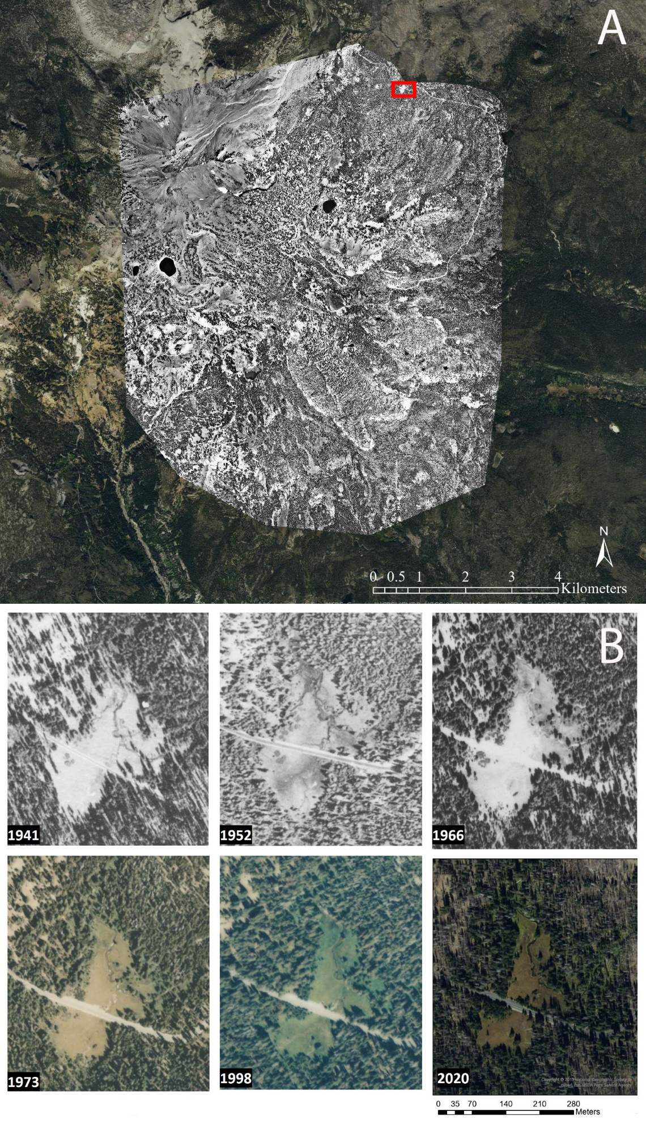
Caption for Graphic or Image: Figure A) Example of Structure from Motion (SfM) orthomosaic of Lassen National Park generated from 39 aerial photographs taken in 1966. Original black and white photographs were taken with a camera focal length of 208.27 mm at 1:15840 scale. The red box indicates approximate location of Dersch Meadows. Figure B shows increasing conifer encroachment into Dersch Meadows based on imagery from 1941, 1952, 1966, 1973, 1998 and 2020.
Author name and business email: Miguel Villarreal; mvillarreal@usgs.gov, and Olivia Duane; oduane@contractor.usgs.gov

DOI agency/bureau: USGS
USGS Mission Area: Ecosystems
USGS Program: Environments Program
Cost Center: Wetland and Aquatic Research Center
Program Name:
Project title: Developing bare-earth digital elevation models from structure-from-motion data on barrier islands
Project description: Unoccupied aerial systems (UAS) can be used to collect monitoring data, including elevation information via structure from motion (SfM) and vegetation information from multispectral imagery, with a temporal resolution that is well-suited for dynamic barrier island environments. However, SfM data represents the elevation of the surface including the vegetation canopy. Processing is required for estimating bare-earth elevation, which is critical for understanding the underlying geomorphology.

As part of the Coastal Resource Evaluation for Management Application (CREMA) project, scientists from the U.S. Geological Survey Wetland Aquatic Research Center and St. Petersburg Coastal and Marine Science Center developed methods to develop bare-earth digital elevation models from SfM data acquired during repeated surveys on Dauphin Island, Alabama. Vegetation correction model were produced to develop bare-earth elevation surfaces from SfM data for two sites on Dauphin Island, Alabama. One site was exposed to high wave energy and was dominated by beach, dunes, and supratidal herbaceous vegetation, whereas the second site was exposed to low wave energy and was dominated by intertidal marsh. The team tested several machine learning algorithms to predict elevation contribution from vegetation by using spectral indices from UAS-based multispectral imagery and landscape position information (e.g., relative topography and distance from shore). Gaussian process regression performed the best and led to a reduction in the root mean square error for elevation of at least 29% and 69% for the high energy and low energy sites, respectively. ​The final error estimates were within common elevation standards for light detection and ranging-based elevation data. Fig. 1​ highlights an example of the spatially explicit elevation bias correction for the high energy site using a map and results along a transect. This research is in press in the ISPRS Journal of Photogrammetry and Remote Sensing. This effort is portable to other areas with calibration and could provide an efficient and repeatable framework for monitoring changing geomorphology and/or provide baseline elevations for predicting changes to these environments under future conditions.
Sensor Type: Multispectral (approx. 4-12 bands);
Platform type: UAS;
URL: Can a URL be added later? This research is in press in the ISPRS Journal of Photogrammetry and Remote Sensing. CREMA (https://www.bing.com/search?q=usgs+crema&cvid=6b54cddab7684519b54023cf9859ce04&aqs=edge..69i57.2611j0j1&pglt=163&FORM=ANNAB1&PC=U531)
Graphic or Image name: Enwright_DSM_corr_DOI_report.jpg
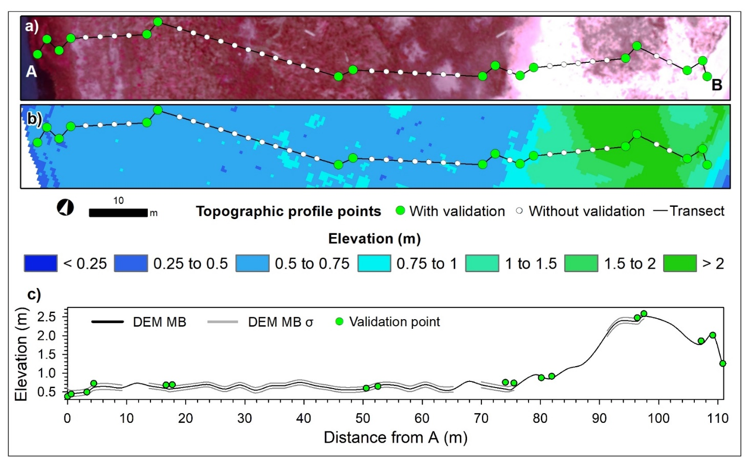
Caption for Graphic or Image: Illustration of the elevation bias correction along a transect for the digital surface model (DSM) for April 2019 for Pelican Island, Alabama (USA). Vegetated areas appear as red in (a) the false-color orthomosaic (i.e., near infrared, red, and green bands). (b) shows the corrected 0.5-m bare-earth digital elevation model (DEM). (c) shows the relation between the corrected, bare-earth elevation with one standard deviation and the validation points. Modified from Enwright et al. (2021) with permission.
Author name and business email: Nicholas Enwright; enwrightn@usgs.gov

DOI agency/bureau: USGS
USGS Mission Area: Ecosystems
USGS Program: Environments Program
Cost Center: Western Geographic Science Center
Program Name:
Project title: High resolution mapping of energy infrastructure and impacts on mule deer movement
Project description: Mule deer are known to avoid human disturbances, including energy infrastructure and development. Combing remote sensing data, GIS modeling and information on energy expenditure of mule deer we developed a spatiotemporal model to map the minimum energy expenditure required for mule deer to traverse a landscape with increasing levels of oil and gas development on the northern Colorado Plateau.

State oil and gas energy databases in our study area of Utah, Colorado and New Mexico contain point coordinates of locations that have been developed for energy extraction as well as many that have been assessed but not developed. Because oil and gas pads are relatively small (~1 ha), there are no regional map products depicting the extent of surface disturbances, and past mapping efforts have been limited to hand digitizing small areas of interest from aerial imagery. We used USDA National Agriculture Imagery Program (NAIP) 1-m resolution aerial photography in Google Earth Engine to identify and map oil and gas pads across the Colorado Plateau Ecoregion. We implemented a feature extraction procedure based NAIP red band pixel reflectance that exploits the brightness of reflectance values occurring in areas disturbed by energy development. Rules were based on percentile calculations of the highest red band reflectance that captured brightness of disturbed pixels relative to lower brightness of undisturbed pixels within a 90-m polygon surrounding oil and gas point locations. With high accuracy we mapped ~ 40,000 active well pads across the region at 1-m spatial resolution.

Well pad maps, combined with data on access roads, were used to develop density rasters measuring the percent of area developed within a 750 meter moving window. Areas with greater than 3% development were classified as avoidance areas for mule deer. Using a 1-arc second DEM and a past regression analyses of energy expenditure by deer weight, terrain slope, and slope direction, we developed a spatiotemporal model mapping the minimum energy expenditure required for mule deer to traverse a landscape. By incorporating avoidance areas, we were able to measure changes in energy expenditure with the increasing size of avoidance for five time series: pre-development, 2001 and prior, 2002-2006, 2007-2011, and 2012-2016. In addition we developed a terrain index so that we could analyze results not only by time but also by level of ruggedness. Using a 1km grid system of potential starting points to measure expenditure from multiple directions, we were able to calculate average expenditures by terrain and time and estimate the impacts of oil and gas development on the bioenergetic requirements of mule deer.

We confirmed, with spatial precision, that not only does steep terrain increase energy expenditure, but energy expenditure typically increases with travel distance to avoid development and by the limiting of less costly terrain. As the energy costs of movement correlate across multiple species of large mammals, our analysis of change can serve as quantitative representative of the impacts of oil and gas development for not only mule deer but multiple species—including those listed as threatened or endangered.

Sensor Type: Camera;
Platform type: Airplane;
URL: https://www.usgs.gov/centers/wgsc/science/remote-sensing-energy-development?qt-science_center_objects=0#qt-science_center_objects
Graphic or Image name: Villarreal_SWEDRFig

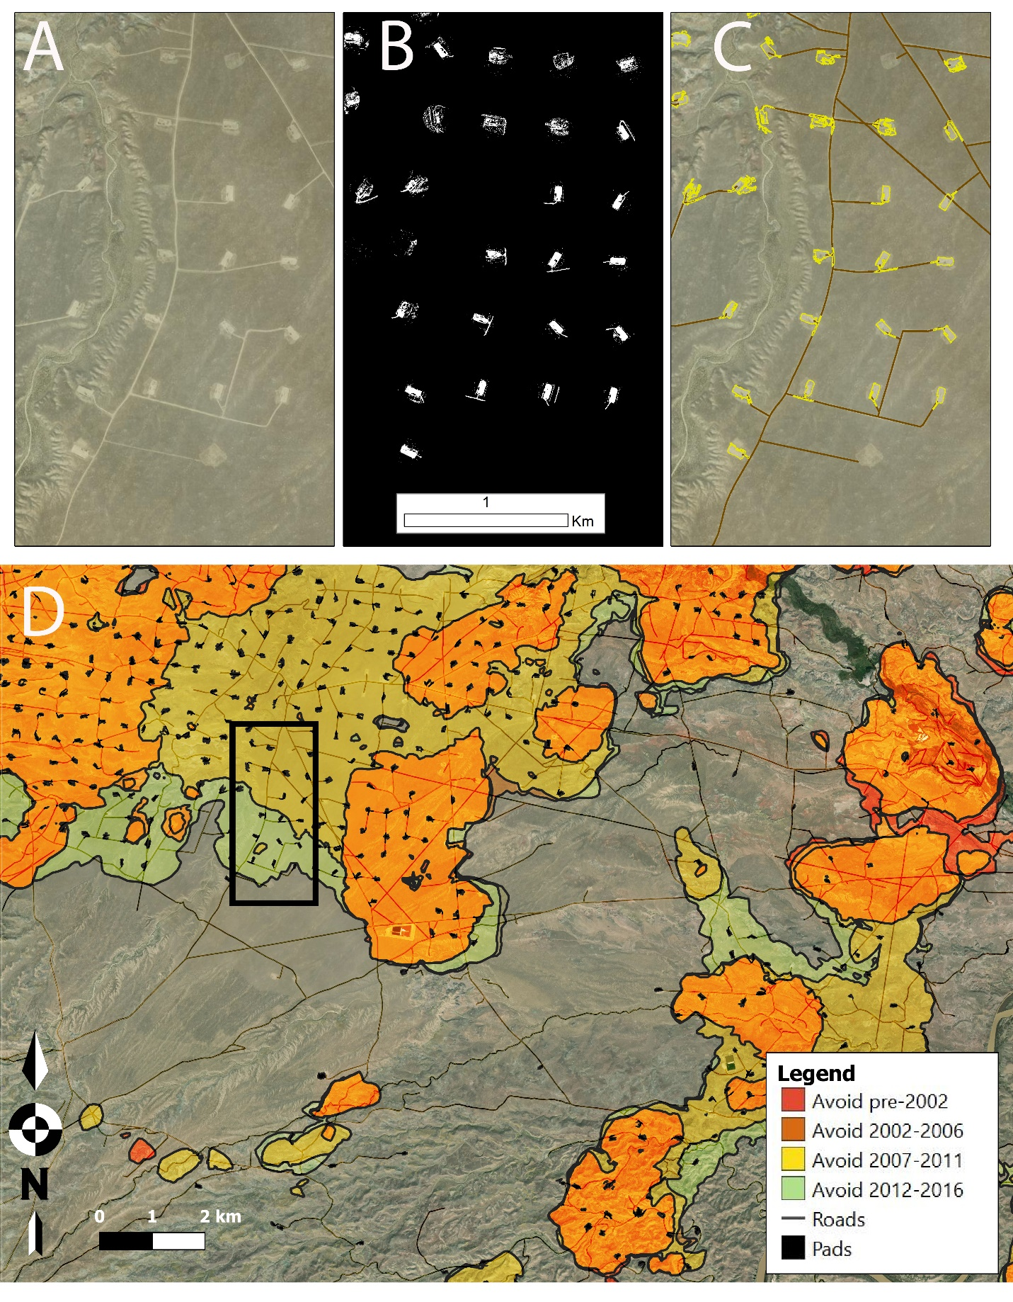
Caption for Graphic or Image: Figure. A) 1-m USDA National Agriculture Imagery Program (NAIP) imagery showing detail of energy development, B) results of NAIP oil and gas pad extraction algorithm, C) polygon perimeters of mapped oil and gas pads with layer of access roads, and D) mule deer avoidance zones based on density of roads and pads, mapped for different time periods.
Author name and business email: Miguel Villarreal (mvillarreal@usgs.gov); Sam Chambers (schambers@usgs.gov)

DOI agency/bureau: USGS
USGS Mission Area: Ecosystems
USGS Program: Environments Program
Cost Center: Wetland and Aquatic Research Center
Program Name:
Project title: Mapping High Marsh along the Northern Gulf of Mexico Coast
Project description: Although extensive work has been devoted to understanding the role of fire in maintaining ecosystem functions in upland systems, little research has focused on understanding the impact of fire on coastal wetlands or the response of birds to fire in high marsh wetlands. High marsh is a unique habitat type threatened by sea-level rise and characterized by a community of specialized emergent vegetation that tolerates irregular tidal inundation. Land managers’ decisions about prescribed fire in high marsh systems are complicated by uncertainty around the response of birds to the application of prescribed fire. Without an understanding of how prescribed fire impacts high marsh ecosystems, including several high-priority bird species, natural resource managers will be limited in their ability to manage and conserve the biodiversity of the Gulf Coast.

In response, a new multidisciplinary project will investigate the effects of fire on Gulf of Mexico marshes by mapping high marsh and monitoring black rail (Laterallus jamaicensis), yellow rail (Coturnicops noveboracensis), and mottled duck (Anas fulvigula) responses to prescribed fire application using an adaptive management framework. The framework will inform decisions by helping researchers and resource managers test predictions and improve the understanding of how these birds interact with high marsh ecosystems and prescribed fire. This project, led by Mississippi State University, includes co-investigators and collaborations with 12 universities, Federal and State agencies, and non-governmental organizations.

Scientists from USGS Wetland and Aquatic Research Center and Mississippi State University are collaborating on the high marsh mapping associated with this project. This effort will include two components. The first component, which was completed in FY21, involved developing a rapid high marsh potential dataset. Light detection and ranging (lidar) and tide data was be used to refine existing marsh habitat maps and produce a rapid high marsh potential dataset for the northern Gulf of Mexico coast. This process involved using Monte Carlo simulations to develop probabilistic outputs for high marsh delineation. These data will be used to assist with site selection for avian monitoring efforts in subsequent years for this project. The second component, which was initiated in FY21, included developing a contemporary high marsh habitat map. Although elevation is a major factor in determining the distribution of high and low marshes, zonation within salt marshes is complex and influenced by topography and groundwater hydrology. This component will involve satellite imagery, including Sentinel-2 imagery, which has reflectance in three red edge bands, and the aforementioned lidar-based probabilistic outputs to produce contemporary maps of high marsh for the northern Gulf of Mexico coast. Both map products will be validated with real-time kinematic GPS and vegetation assessments.
Sensor Type: IFSAR / SAR / Radar;Lidar (terrestrial or bathymetric);Multispectral (approx. 4-12 bands);
Platform type: Satellite;
URL: https://noaafirebird.home.blog/
Graphic or Image name: High_marsh_Enwright.jpg
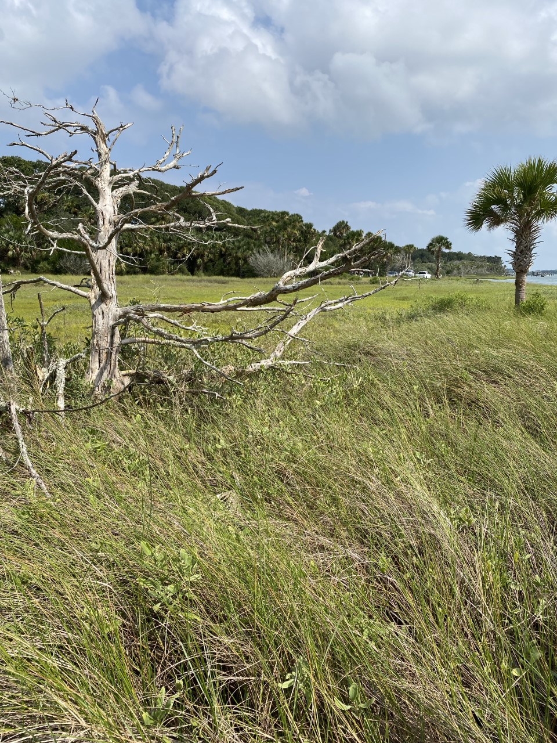
Caption for Graphic or Image: Patch of high marsh in Timucuan Ecological and Historical Preserve in Jacksonville, Florida.
Author name and business email: Nicholas Enwright; enwrightn@usgs.gov

DOI agency/bureau: USGS
USGS Mission Area: Core Science Systems
USGS Program: National Geospatial Program
Cost Center: Geology, Minerals, Energy, and Geophysics Science Center
Program Name:
Project title: Stratospheric lidar and remote sensing CONOPS research and development
Project description: The USGS National Geospatial Program, National Land Imaging Program, and other elements of USGS, have a compelling national interest in operationalizing technologies that increase the accuracy and efficiency of mapping the Nation. Sceye is a specialist aerospace company, operating in New Mexico, developing a new class of uncrewed airships for long-endurance flights. They have developed and tested airships for long-endurance, high-payload missions in the stratosphere. Their airship is designed to lift 100's kg payload and provide over 10kWs of power, with a wide range of payload swap opportunities as desired. Stratospheric airships provide an ideal platform from which to survey given their stability, size, weight, power, persistence, station stability, and the ability to both land and fly – returning payloads, samples, and data. These characteristics may offer a significant operating and economic benefit over traditional aircraft methods of collecting lidar and other remotely sensed data for the USGS (fig 1). If equipped with lidar, Sceye airships may be able to rapidly acquire data to complement the conventional acquisition of the USGS 3D Elevation Program (3DEP), and other remote sensing. This has the potential to increase overall coverage quickly and offer a model for annual coverage of both lidar and imagery, akin to U.S. Department of Agriculture's National Agricultural Imagery Program. The efficiency, persistence, and ability to provide multiple surveys per year may yield an improvement in data quality at significant cost savings. Airship collection may cost 1/10th of current methods, delivering high quality, precisely aligned lidar/imagery data sets for either part or the whole of the US, depending on the funding model. The return on this investment would be substantial, involving industries as diverse as emerging 5G, Artificial Intelligence, and Smallsat providers. Although driven by imagery and lidar needs, Sceye airships can carry additional instruments (gravity, magnetometers, hyperspectral imagers, radar) to provide a strategic layer of science infrastructure for the U.S.

The purpose of this partnership is to explore and develop a concept of operations (CONOPS) for stratospheric airship missions that would collect lidar and other hosted payloads at national scale. This CRADA will primarily focus on the lidar/3D elevation component. With input from other governmental entities and industry, USGS and Sceye will jointly develop CONOPS for a national program that includes: (1) data requirements, (2) sensor requirements, (3) mission requirements, (4) estimated operational costs; (5) needed research gapsand investments to operationalize.

Sensor Type: Hyperspectral;Lidar (terrestrial or bathymetric);IFSAR / SAR / Radar;Multiple sensor types - magnetometers, etc. ;
Platform type: High Altitude Long Endurance (HALE) Airship;
URL:
Graphic or Image name: HALE CRADA Image.png
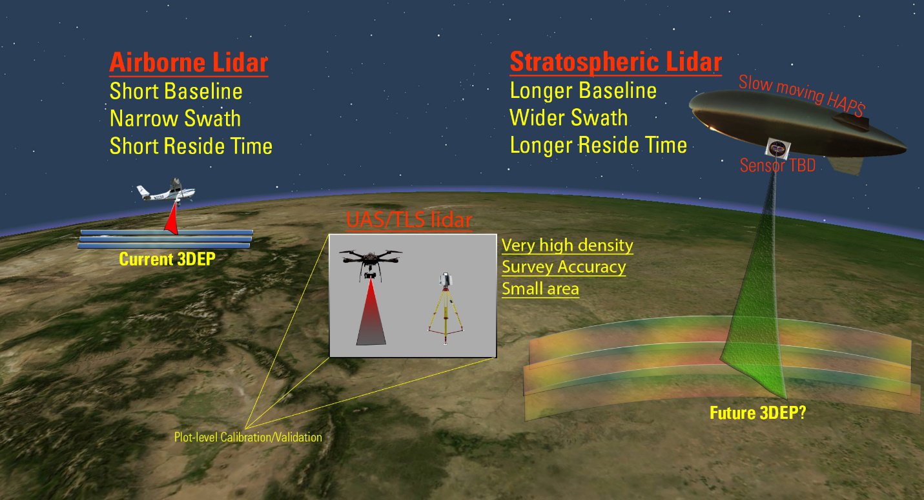
Caption for Graphic or Image: Figure 1. Comparison of airborne, survey ground and near-ground lidar and potential stratospheric lidar
(UAS is Uncrewed Aerial System, TLS is Tripod Laser Scanner, HAPS is High-Altitude Pseudo-Satellite, a
synonym for High Altittude Long Endurance (HALE).
Author name and business email: Jonathan Stock

DOI agency/bureau: USGS
USGS Mission Area: Natural Hazards
USGS Program: Volcano Hazards Program
Cost Center: Geology, Minerals, Energy, and Geophysics Science Center
Program Name:
Project title: Using small unmanned aircraft (sUAS) to expand our understanding of methane fluxes
Project description: Our scientists in the Volcano Hazards Program and Land Change Science Program are partnering with NASA Ames, industry, and NASA Jet Propulsion Laboratory (JPL) to measure gases from UAS. Kristin Manies USGS) is partnering with JPL to measure methane emissions in the thawing Arctic using next-generation gas sensors on small rotorcraft. This effort promises to augment sparse flux towers as a more mobile way to measure emissions. Christoph Kern and Angie Diefenbach (USGS) are partnering with Black Swift Technologies and NASA to develop the ability to measure baseline volcanic gas emissions over remote edifices. They are flying a beyond-visual-line-of-sight UAS mission over Makushin Volcano, on Unalaska Island in Alaska’s Aleutian Islands, this summer 2021 as proof of concept. NASA Ames has funded a follow up mission in California.
Sensor Type: Gas detector;
Platform type: UAS;
URL:
Graphic or Image name: sUAS Methane Emissions.png
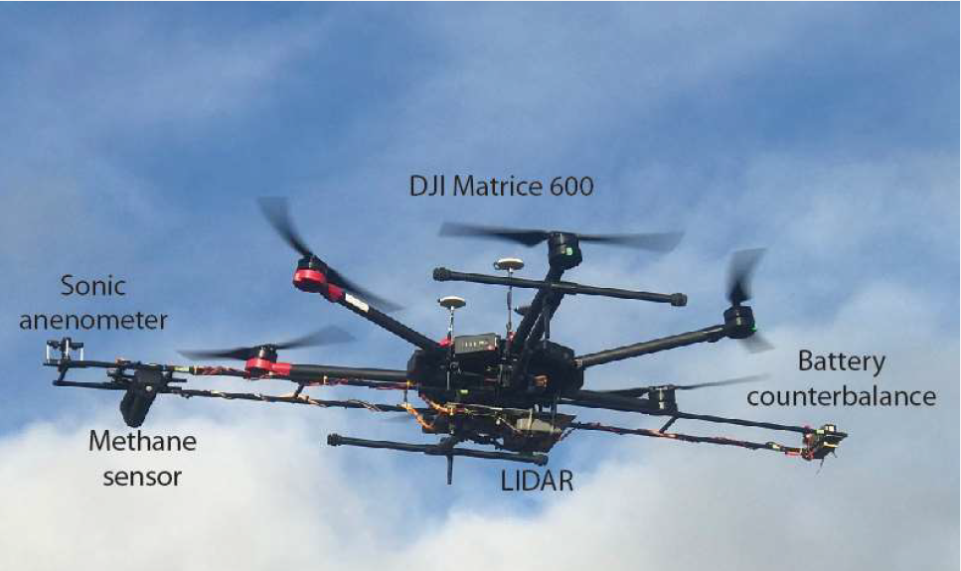
Caption for Graphic or Image: sUAS to estimate methane emissions from thawing permafrost, in partnership with JPL and NASA Ames. (Photo Credit: Kristen Manies, USGS)
Author name and business email: Kristen Manies kmanies@usgs.gov

DOI agency/bureau: USGS
USGS Mission Area: Water Resources
USGS Program: National Land Imaging Program
Cost Center: National Research Program - Central Branch
Program Name:
Project title: Inferring surface flow velocities in rivers with sUAS: Toward measuring discharge from drones
Project description: USGS researchers in the Water Resources Mission Area are partnering with NASA and the University of Southern California (USC) to measure stream surface velocity using a spectrum of sensors and edge-computing tools on UAS. Carl Legleiter and Paul Kinzel are pursuing the use of optical and thermal Particle Image Velocimetry (PIV) to map surface streamflow velocity autonomously with NASA’s Intelligent Systems Division. Timely, reliable information on streamflow is critical for water supply, flood risk mitigation, ecosystem conservation, and recreation. Effective management of the Nation’s rivers thus relies upon discharge data provided by USGS stream gages, but the gage network is sparse, declining, and difficult and costly to maintain and operate. In addition, data collection during high flows can place personnel at risk. For all of these reasons, the agency seeks to develop innovative, non-contact methods for measuring river discharge. Motivated by this objective, a research group comprised of USGS and NASA scientists is working toward a new system for inferring surface flow velocities via particle image velocimetry (PIV) of thermal video acquired from a small unmanned aircraft system (sUAS). This presentation will review previous applications of this approach using data acquired from sUAS and helicopters deployed above rivers in Colorado and Alaska, describe the current status of a new self-contained payload specifically intended for measuring surface flow velocities, and outline plans for future work. Ongoing efforts focus on deriving velocity information in real-time via embedded, on-board computing and facilitating quality control by quantifying the uncertainty associated with surface velocity estimates.
Sensor Type: Thermal;Camera;
Platform type: UAS;
URL: https://pubs.er.usgs.gov/publication/70220904
Graphic or Image name: UAS Stream Velocity.png
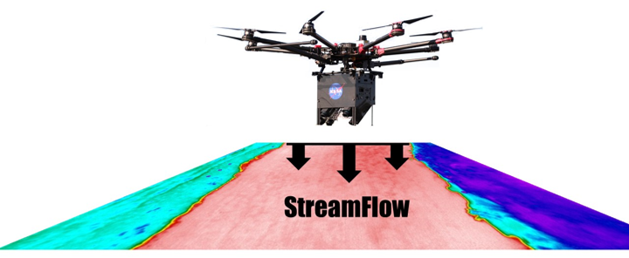
Caption for Graphic or Image: Small Unmanned Aircraft Systems (sUAS) including rotorcraft and Particle Image Velocimetry (PIV) payload for mapping surface streamflow velocity.
Author name and business email: Tamara Wilson tswilson@usgs.gov

DOI agency/bureau: USGS
USGS Mission Area: Core Science Systems
USGS Program: National Land Imaging Program
Cost Center: Earth Resources Observation and Science (EROS) Center (Geography)
Program Name:
Project title: Release of Landsat Collection 2 U.S. Analysis Ready Data
Project description: Landsat Collection 2 (C2) U.S. Analysis Ready Data (ARD) became available in fiscal year 2021 and are the most recent publicly released Landsat science products. Landsat C2 U.S. ARD are pre-packaged and pre-processed bundles of tiled Landsat data products that make the Landsat archive more accessible, easier to analyze, and reduce the amount of time users spend on data processing for time-series analysis. The bundled data tiles consist of surface reflectance (SR), surface temperature (ST), top of atmosphere (TA) reflectance, brightness temperature (BT), and quality assessment (QA) data that are consistently processed using per pixel solar zenith angle corrections, gridded to a common cartographic projection, and accompanied by appropriate metadata to enable further processing while retaining traceability of data provenance. Subsequently, numerous products are derived from ARD that are used as direct inputs to monitoring and assessment activities, including maps of land cover and land cover change, spectral indices, temporal composites, and higher-level science products such as burned area, dynamic surface water extent, and fractional snow covered area. Landsat C2 U.S. ARD are generated in the Albers Equal Area Conic (AEA) for conterminous U.S. and Hawaii map projection. Alaska is generated to Alaska Albers map projection. They are processed directly from Level-1 AEA scenes through Level-2 products using the World Geodetic System 1984 (WGS84) datum. The products cover the conterminous United States (CONUS)(1982-present), Alaska (1984–present), and Hawaii (1989-1993 and 1999-present). The tiles are units of uniform dimension bounded by static corner points in a defined grid system. An ARD tile is defined as 5,000 x 5,000 30-m pixels.

For additional information about Landsat science products, visit the Landsat Missions website https://www.usgs.gov/core-science-systems/nli/landsat.

Sensor Type: Multispectral (approx. 4-12 bands);
Platform type: Satellite;
URL: https://www.usgs.gov/core-science-systems/nli/landsat/landsat-collection-2-us-analysis-ready-data
Graphic or Image name: C2_ARD_Tiles.png
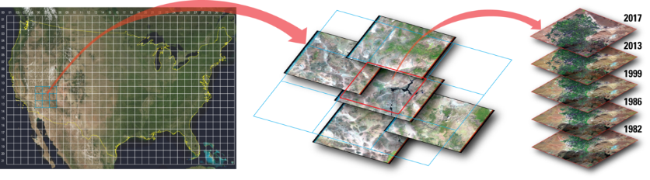
Caption for Graphic or Image: Landsat Collection 2 U.S. Analysis Ready Data (ARD) are tiled, georegistered, top of atmosphere, and atmospherically corrected products defined in a common projection for immediate use in monitoring and assessing landscape change.
Author name and business email: mbouchard@contractor.usgs.gov

DOI agency/bureau: USGS
USGS Mission Area: Ecosystems
USGS Program: Species Management Research Program
Cost Center:
Program Name: Amphibian Research and Monitoring Initiative
Project title: Linking Aquatic Habitat Inundation Variations with Sensitive Species Population Monitoring using a USGS Landsat Science Product
Project description:
Human water use that alters river flow can shape ecology and biodiversity in many riverine and associated environments. Population viability is often linked to the timing and extent of floodplain and wetland inundation. And disruptions to historical flow regimes can have significant impacts on species that have difficulty adapting to altered environments. Explicit information on the inundated extent of riverine and wetland habitats and the timing of the inundation, particularly as it may have varied over the span of decades, is rare. However, the multi-decade record of intra-annual surface inundation provided by the USGS Landsat Science Product named Dynamic Surface Water Extent (DSWE) provides a potential data source to fill this information need.

The Oregon spotted frog (Rana pretiosa), which is endemic to northwestern North America, has experienced population losses associated with hydrological changes. In the species’ core extant range in the Upper Deschutes and Little Deschutes subbasins in Oregon, dam operations have significantly altered historic flow regimes. On-going field-based studies of R. pretiosa seasonal habitat, including wetted extent, along with published data on drought, reservoir storage, and hydrology (Deschutes River streamflow), were combined with DSWE area of inundation estimates and compared against a variety of R. pretiosa population metrics. This allowed for long-term exploration of relationships among core site inundation, R. pretiosa population viability, and streamflow regulation. Seasonal patterns of abundance and survival varied among sites and were linked to relationships between streamflow and habitat that result from various mechanisms and levels of connectivity among stream and wetlands. All specifics of this analysis are provided in Rowe et. al. 2021 (https://doi.org/10.1002/ecs2.3634). While further study across a variety of environments is necessary to uncover limits of DSWE performance for such purposes, this study highlighted the potential of long-term, systematically produced data like DSWE for use in science and resource management by scientists and managers who have expertise in fields other than remote sensing.

Sensor Type: Satellite; Multispectral (approx. 4-12 bands)
Platform type:
URL:
Graphic or Image name: Wtlnd_OSF_2_dates_masked_by_habitat
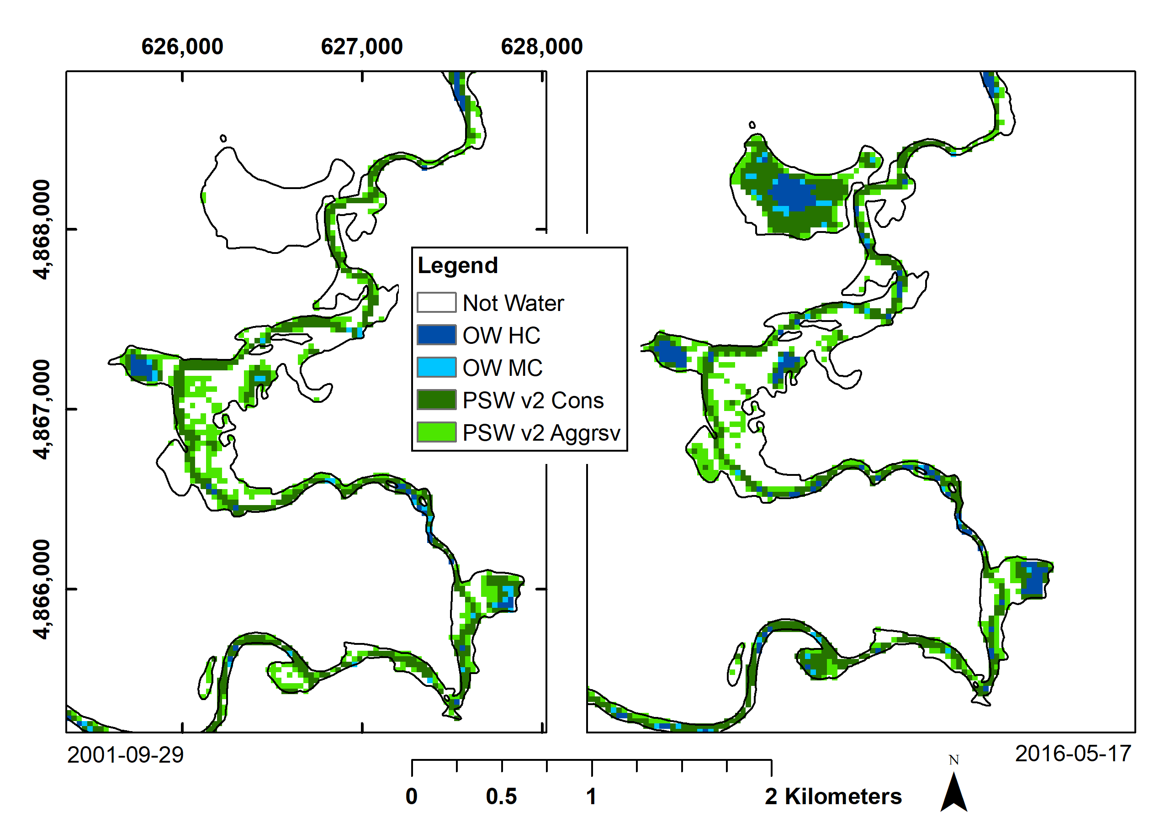
Caption for Graphic or Image: USGS Dynamic Surface Water Extent (DSWE) data for two dates show the variable nature of wetland inundation among core sites for a threatened species and allow improved analyses of streamflow management impacts on population viability. Legend: OW HC (Open water, High Confidence); OW MC (Open water Moderate Confidence); PSW v2 Cons (Partial Surface Water at Landsat resolution [30m], conservative); PSW v2 Aggrsv (Partial Surface Water at Landsat resolution [30m], aggressive). Figure from Jones 2019 (https://doi.org/10.3390/rs11040374).
Author name and business email: John Jones; jwjones@usgs.gov

DOI agency/bureau: USGS
USGS Mission Area: Core Science Systems
USGS Program: National Geospatial Program
Cost Center:
Program Name:
Project title: The 3D Elevation Program and the Next Generation: The 3D National Topography Model
Project description:
The goal of the 3D Elevation Program (3DEP) is to complete acquisition of nationwide lidar (IfSAR in AK) to provide the first-ever national baseline of consistent high-resolution elevation data – both bare earth and 3D point clouds – collected in a timeframe of less than a decade. Thanks in large part to partner investments from Federal, state, local and other partners, over 80 percent of the Nation, including 100 percent of Alaska, has available or in progress elevation data that meet 3DEP specifications for high accuracy and resolution. As we approach the completion of the 3DEP baseline dataset, the USGS is developing a vision for the 3D National Topography Model (3DNTM), a new initiative that updates and integrates USGS elevation and hydrography data to model the Nation in 3D. The 3DNTM is the terrestrial component of the joint USGS and NOAA 3D Nation vision to provide a continuous elevation surface from the depths of our waters to the peaks of our mountains. The 3DNTM will integrate elevation and hydrography data to underpin critical applications including flood forecasting i mitigation and response; 3D geologic modeling, and other applications. It will better support the National Water Model, National Water Census, drought forecasts, and water availability visualization and analyses. The 3DNTM development tracks include the completion of current baseline 3DEP and National Hydrography Datasets, piloting the integration of elevation and hydrography data, and developing the 3D Hydrography Program and next generation of 3DEP, including inland bathymetry, hydrography derived from lidar, and connections to groundwater and engineered hydrologic systems. Later development phases of the 3DNTM will include a transition to a 3D data model and inclusion of additional topographic datasets of The National Map managed by the USGS National Geospatial Program. The USGS is developing program plans for the 3D National Topography Model (3DNTM) in two parts, with the first focused on the 3D Hydrography Program and second on the next generation of 3DEP.

Sensor Type: Lidar
Platform type:
URL:
Graphic or Image name: Kootenai_tile9_cloudcompare_RGB; 3DNTM

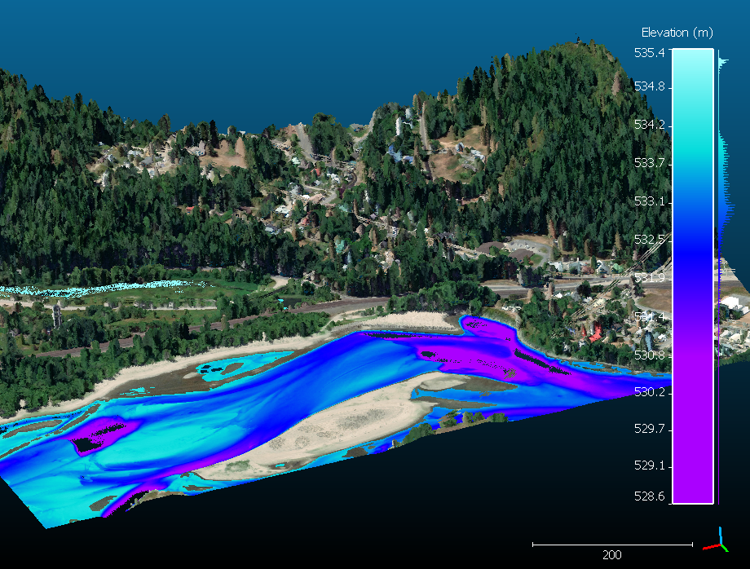
Caption for Graphic or Image: Bathymetric lidar point cloud for the Kootenai River, ID. The bathymetry lidar points are shaded by depth, and the topographic lidar points are shaded by RGB values from concurrent aerial photography.

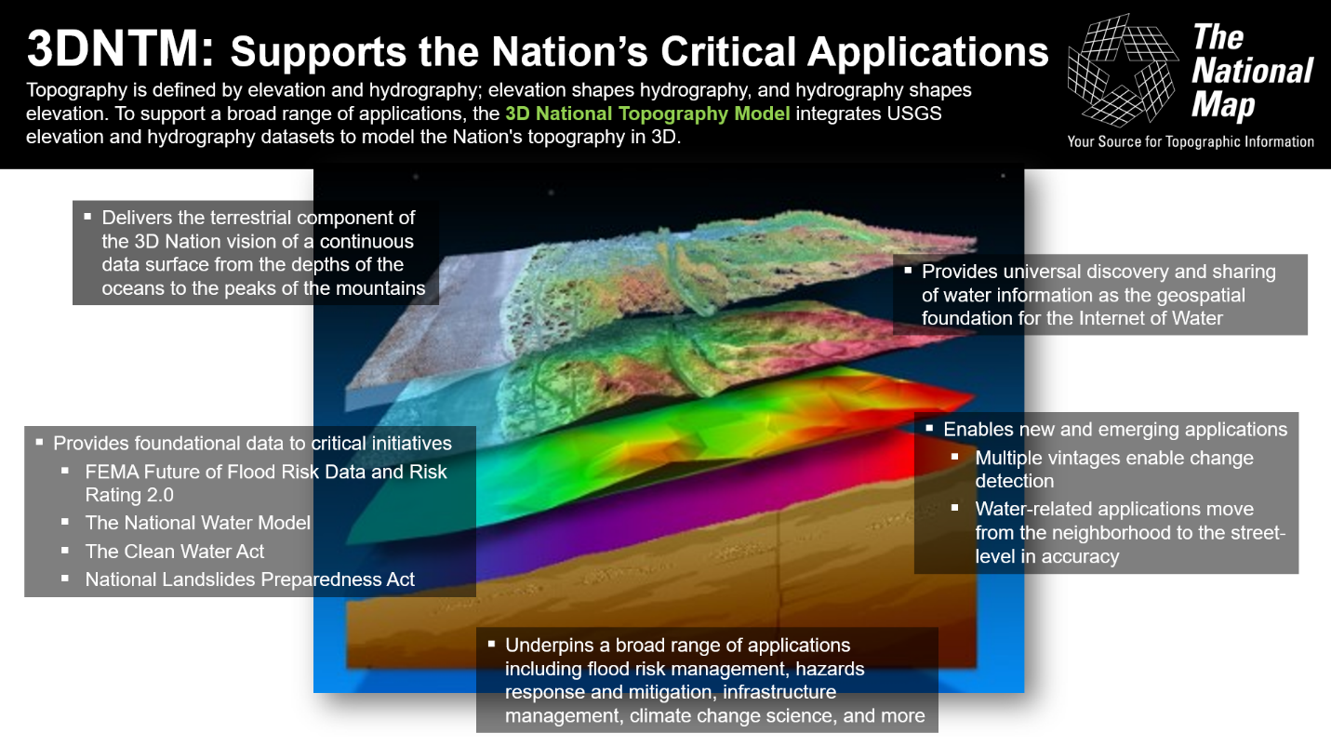
Caption for Graphic or Image: Conceptual graphic representing the 3D National Topography Model (3DNTM), and the many science applications that the 3DNTM will support.
Author name and business email: Cindy Thatcher, thatcherc@usgs.gov

