DOI agency/bureau: NPS
USGS Mission Area:
USGS Program:
Cost Center:
Program Name: Arctic Inventory and Monitoring Network
Project title: Monitoring the Snow and Growing Seasons
Project description: The snow season has become shorter and the growing season longer over the past 20 years in Alaska's Arctic National Parks. The NPS Arctic Inventory and Monitoring Network (ARCN) uses MODIS (Moderate Resolution Imaging Spectroradiometer) satellite images and remote automated cameras to monitor the timing of the growing season and the snow cover in five large national parks in northern Alaska. To monitor the snow season, researchers use the National Snow and Ice Data Center's MODIS daily snow cover product, with additional processing by cooperators at the University of Alaska to fill cloud-related gaps. On-the-ground camera observations generally show good agreement with the MODIS satellite results. The trend across the study area over the 20 years of MODIS satellite observations was toward earlier snow-off and later snow-on. Linear models suggest average snow-off in the study area became earlier by about 1 week and snow-on later by about 5 days across the 20-year period, with about a month of year-to-year variation at any location. Start and end of the green season were located using curves fit to plots of Normalized Difference Vegetation Index (NDVI) vs. date. NDVI was calculated from all available MODIS satellite observations, extracted for sample points using the AppEEARS (Application for Extracting and Exploring Analysis Ready Samples) data extraction tool. Much of the annual variation in NDVI was due to gain and loss of snow and not vegetation growth. Researchers located the NDVI level of snow-free, senesced vegetation from multi-year data for the fall and used it to locate the true start and end of the green season on annual NDVI curves. Comparison of the satellite green season dates with those obtained from on-the-ground cameras showed good agreement in the spring but weak agreement in the fall. The study area-wide trend over 20 years of satellite observations was toward earlier start of green season (SOG) and later end of green season (EOG). Linear models suggest that average SOG became about 11 days earlier across the 20 years of observations, and EOG became later by a similar amount, with about a month of year-to-year variation between years in both SOG and EOG.

Sensor Type: Camera;Multispectral (approx. 4-12 bands);
Platform type: Ground based / sensor web / web cam;Satellite;
URL: https://home.nps.gov/im/arcn/landscapedynamics.htm
Graphic or Image name: Fig15_sogs_mann_ken.png
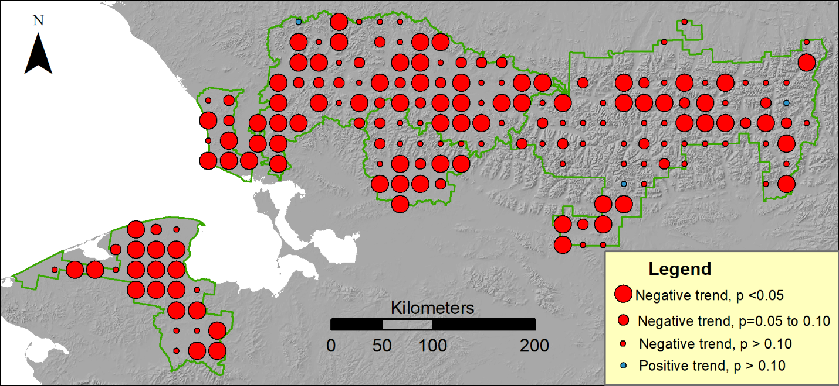
Caption for Graphic or Image: Trend in start of the green season in Alaska's Arctic National Parks, 2000–2020. At nearly all of the sample points (marked with circles) the trend was negative, meaning the start of the growing season has become earlier. Most of these trends were highly statistically significant (large red circles indicate p < 0.05, Mann-Kendall test).
Author name and business email: David Swanson, david_k_swanson@nps.gov

DOI agency/bureau: NPS
USGS Mission Area:
USGS Program:
Cost Center:
Program Name: Gates of the Arctic National Park and Preserve
Project title: New Methods to Assess Forage Quality for Moose
Project description: Twenty years ago, ecological studies were often limited by the number of times biologists could find (relocate) their study animals. With the advent and now widespread use of GPS collars, that is no longer a primary concern. Previously, researchers showed that using more detailed, accurate, and informative habitat information provided stronger, more insightful results than using additional animal relocations.

Animals do not randomly move across the environment. One of the biggest drivers of movement is finding high-quality food sources. High-quality food for ungulates, like moose, is often indexed by how easily its proteins and dry matter are digested. Researchers from the University of Idaho and National Park Service teamed up to show that these measures of forage quality can be determined using specialized cameras mounted in drones. It is hoped that these techniques can be “scaled up” so that key indices of forage quality can be mapped across landscapes and that biologists can better understand how and why animals utilize their landscape.
Sensor Type: Camera;Multispectral (approx. 4-12 bands);Lidar (terrestrial or bathymetric);
Platform type: Ground based / sensor web / web cam;UAS;
URL: https://www.nps.gov/articles/000/mooseforagequality.htm
Graphic or Image name: Moose-Healy4.jpg
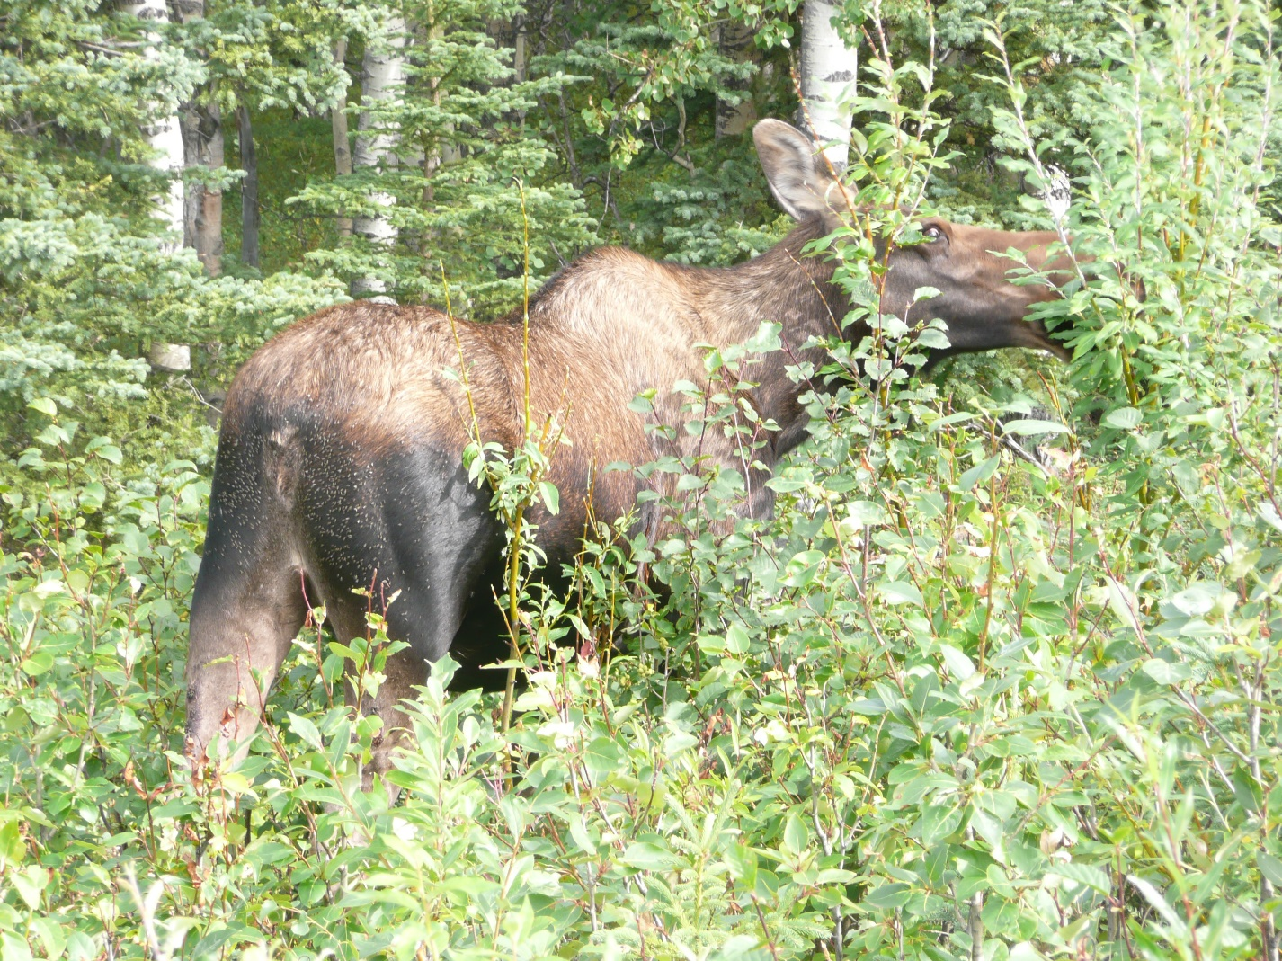
Caption for Graphic or Image: Forage quality is an important component of wildlife habitat. This study shows that forage quality can now be determined using specialized cameras mounted on drones. (Photo: K. Joly)
Author name and business email: kyle_joly@nps.gov

DOI agency/bureau: NPS
USGS Mission Area:
USGS Program:
Cost Center:
Program Name: Inventory and Monitoring, Southwest Alaska Network
Project title: Monitoring Snow Phenology and the Spring Flood Pulse of the Yukon
Project description: The Yukon River basin encompasses 832,000 km² and is one of Earth's largest boreal-Arctic rivers. Characterized by a long frozen winter season, the river demonstrates an abrupt ice breakup and spring snowmelt-driven flood pulse. Capabilities for regional monitoring and forecasting of the flood pulse and river ice breakup in the Yukon and other northern basins are limited but critical to informing flood-related risks to regional communities and impacts to natural resources.

We used satellite multi-frequency daily microwave brightness temperatures (18.7, 36.5 GHz) from SSM/I and AMSR sensors to derive a consistent multi-year record (1988–2016) of key spring snow metrics, including the date of snowmelt onset (MMOD) and ice breakup (RIB), mapped to a consistent 6.25-km grid resolution. The satellite retrievals showed good agreement between station observations of and ice breakup (r = 0.61). The snowmelt onset date retrieval was also found to be an effective 14–27-day leading indicator for ice breakup within catchments.

These observations show the capability for all-weather satellite monitoring and forecasting of the spring flood pulse and ice breakup in the Yukon and other northern latitude basins where cloud cover inhibits other forms of remote sensing. Details of this study can be found at https://doi.org/10.3390/rs13122284.
Sensor Type: Multispectral (approx. 4-12 bands);Passive Microwave;
Platform type: Satellite;
URL:
Graphic or Image name: Snow Phenology and Hydrologic Timing in the Yukon River Basin
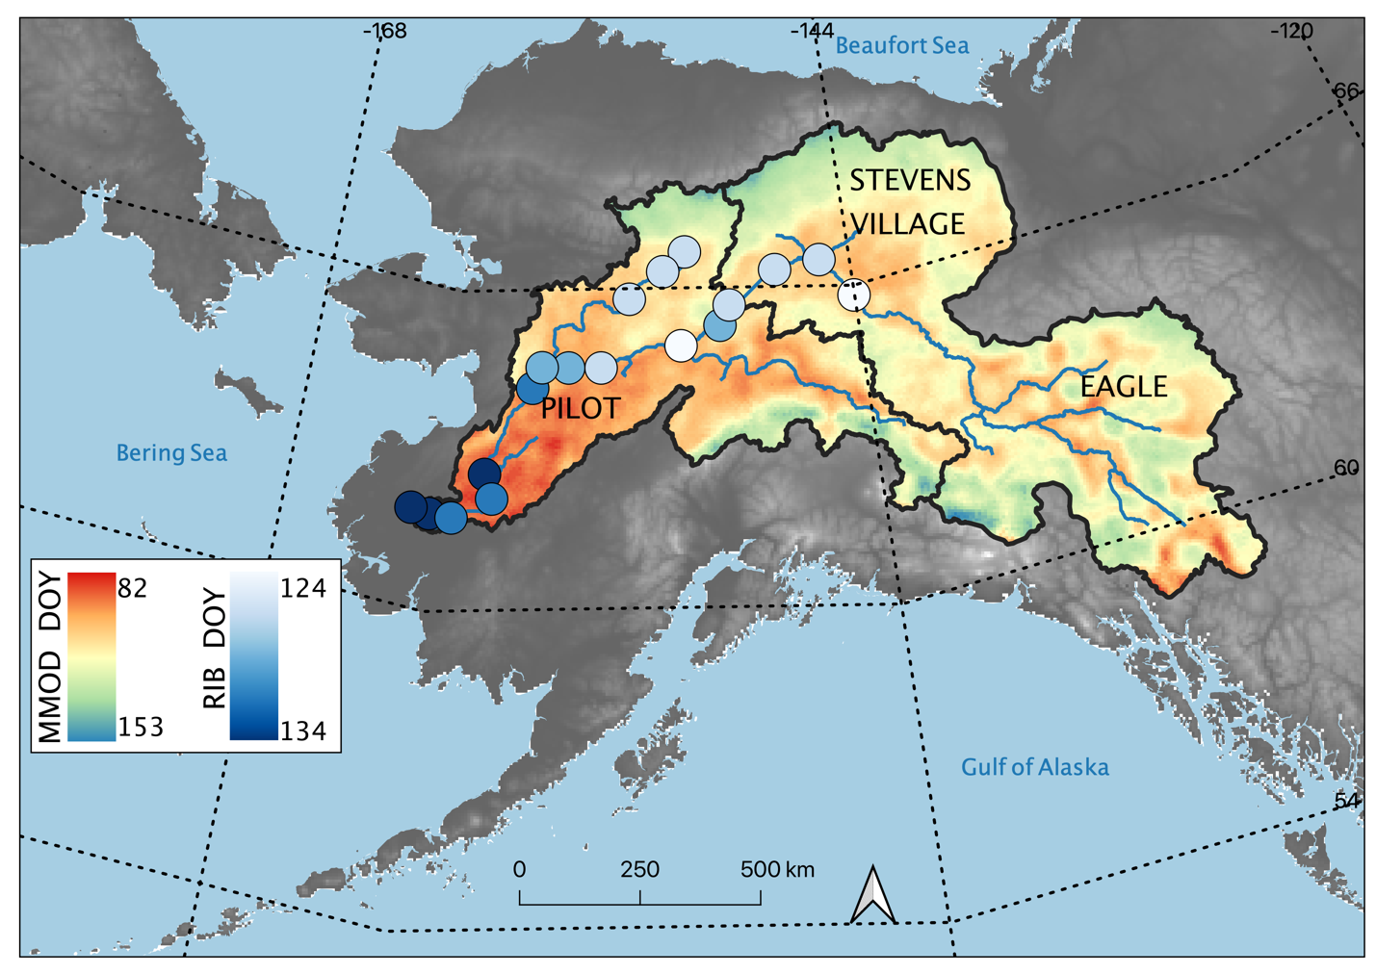
Caption for Graphic or Image: A new suite of passive microwave satellite-derived snow metrics, including Main Melt Onset Date (MMOD), snowoff date, and snowmelt duration from 1988–2016, is presented and validated using in situ observations and other complementary satellite data. Researchers found Day of Year (DOY) correspondence between these satellite-derived snow metrics and measured streamflow quantiles and River Ice Breakup (RIB) observations, demonstrating their potential for regional monitoring and forecasting of hydrologic events.
Author name and business email: peter_kirchner@nps.gov

