DOI agency/bureau: BOR
USGS Mission Area:
USGS Program:
Cost Center:
Program Name: Lower Colorado River Annual Summary of Evapotranspiration and Evaporation
Project title: Estimates of Evapotranspiration along the Lower Colorado River
Project description: The Colorado River is the principal source of water for agriculture and riparian vegetation in Arizona, southern California, and southern Nevada. In the Lower Colorado River Basin, the BOR accounts for water use in each State, verifies water conservation programs, and fulfills other water management information needs. To accomplish this, BOR monitors more than 3.5 million acres of agricultural land, riparian vegetation, and open water areas along the Lower Colorado River, from Hoover Dam south to the international boundary with Mexico.

Four times per year, BOR performs supervised classifications on every field of rotational crops along the main-stem Colorado River, Imperial and Coachella Valleys, and Gila River. This task is accomplished using a combination of multispectral satellite data (Landsat 7 and 8, Sentinel-2), aerial imagery (NAIP), and ground-based field verifications. Roughly half of the collected verified fields are used to train the satellite imagery and determine the crop growing on each field for each time period. The other half of verified field data are used to assess the accuracy of each classification. Fields that have static crops such as citrus and dates are manually mapped each year. Changes in these crops are identified during field verification trips and using high-resolution satellite imagery (primarily WorldView).

Data about the crop type and acreage, along with evapotranspiration (ET) crop coefficients, are then used to estimate the ET from crops within each area. Total ET from agricultural irrigation is typically close to 3 million acre-feet per year. The most prevalent crops by acreage are alfalfa, lettuce, Sudan grass, small grains, and Bermuda grass.

BOR also maintains riparian vegetation and open water datasets to determine ET and evaporation from these sources. Each year, these datasets are updated using the best possible imagery (satellite or aerial) by performing change detection analyses. Results from these efforts are reported annually in the report “Lower Colorado River Annual Summary of Evapotranspiration and Evaporation.” Annual ET from riparian vegetation is usually over 400,000 acre-feet and annual evaporation from open water sources is over 300,000 acre-feet.

This information assists the BOR in meeting its U.S. Supreme Court mandate to provide detailed and accurate records of diversions, return flows, and consumptive use estimates of water diverted from the main stem of the Lower Colorado River. This program is an example of implementing remote-sensing-based methodologies to meet the BOR’s water management needs.

https://www.usbr.gov/lc/region/g4000/wtracct.html

Sensor Type: Multispectral (approx. 4-12 bands);
Platform type: Satellite;
URL:
Graphic or Image name: LCRAS_Program_Area_2021.jpg
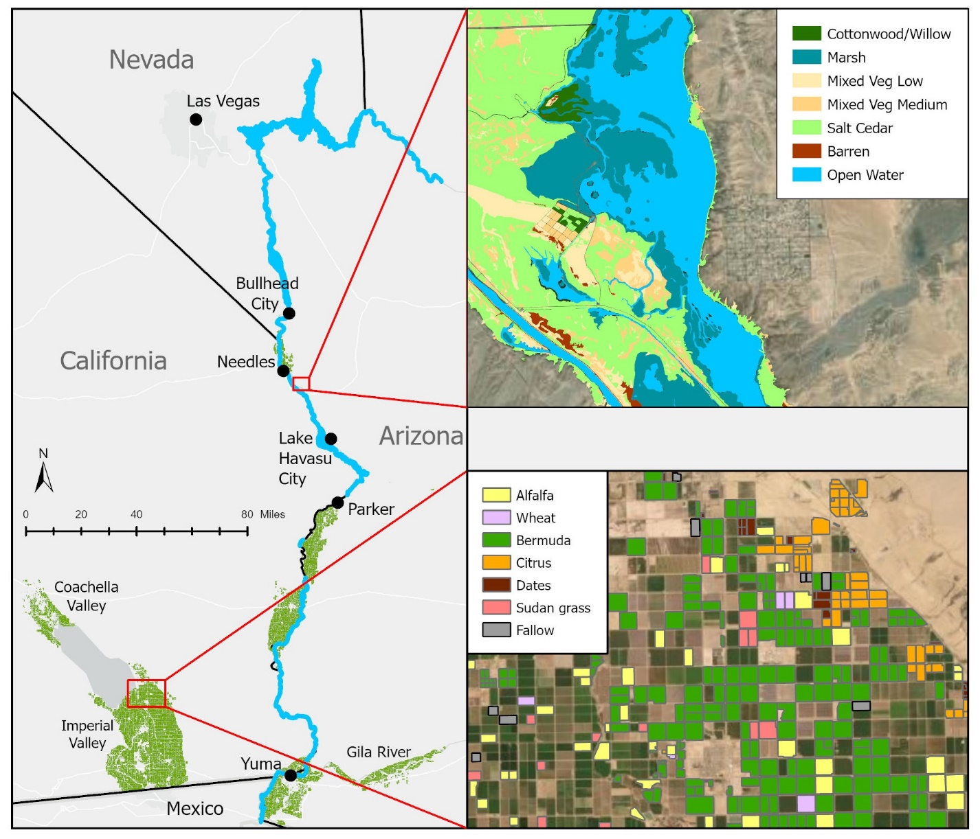
Caption for Graphic or Image: The BOR uses remote sensing and geographic information system (GIS) to map agricultural fields, riparian vegetation, and open water to estimate evapotranspiration and evaporation within the Lower Colorado Region (left). Examples of the riparian/open water databases near the Havasu National Wildlife Refuge, Arizona (top right), and the agricultural database near Calipatria, California (lower right).
Author name and business email: Troy Wirth twirth@usbr.gov

