DOI agency/bureau: BOEM
USGS Mission Area:
USGS Program:
Cost Center:
Program Name: Office of Environmental Programs
Project title: Assessing the Feasibility of Using Satellite Data for Offshore Air Quality Applications
Project description: BOEM is required to analyze the air quality impacts from Outer Continental Shelf (OCS) oil and gas activities as mandated by the Outer Continental Shelf Lands Act (OCSLA) and the National Environmental Policy Act (NEPA). This interagency agreement involves working with NASA’s Atmospheric Chemistry and Dynamics Laboratory at Goddard Space Flight Center to assess the use of satellite data for offshore air quality assessments.

The purposes of this interagency agreement were to conduct a scoping study to assess the applicability of existing satellite datasets for offshore environments and validate the satellite data with offshore monitoring in a field campaign. Specifically, this scoping study determined the feasibility of using satellite data in offshore environments in the Gulf of Mexico Region for estimating and monitoring trends of the ground level concentrations of criteria National Ambient Air Quality Standards (NAAQS), precursors, and visibility pollutants.

The final results indicated two air quality "regimes" exist in the Gulf of Mexico Region: (1) clean marine, when the wind direction is from the south, or ocean based and (2) polluted continental air, when the wind direction is from the north, or land based. In addition, using the TROPOspheric Monitoring Instrument (TROPOMI) NO₂ data, Visible Infrared Imaging Radiometer Suite (VIIRS), and a HYSPLIT back trajectory model, a flaring event was seen from two oil and gas (O&G) platforms. These data, along with other ground and ship-based Pandora NO₂ observations on the cruise, indicate that TROPOMI is useful to BOEM for measuring the Gulf of Mexico and coastal pollution. TROPOMI Total Column NO₂ satellite data correlated well with both the coastal and shipboard Pandora spectrometers that provided independent ground truth. Under clean air conditions, satellite-Pandora agreement was 5%; for more polluted conditions, agreement was 15–20%. These results indicate that satellite data can be used for offshore applications. Final reports and collection of monitoring data are posted at https://marinecadastre.gov/espis/#/search/study/100183.
Sensor Type: Satellite;
Platform type: Ground based / sensor web / web cam;Satellite;
URL:
Graphic or Image name: BOEM NASA IA TROPOMI vs Pandora 07082021
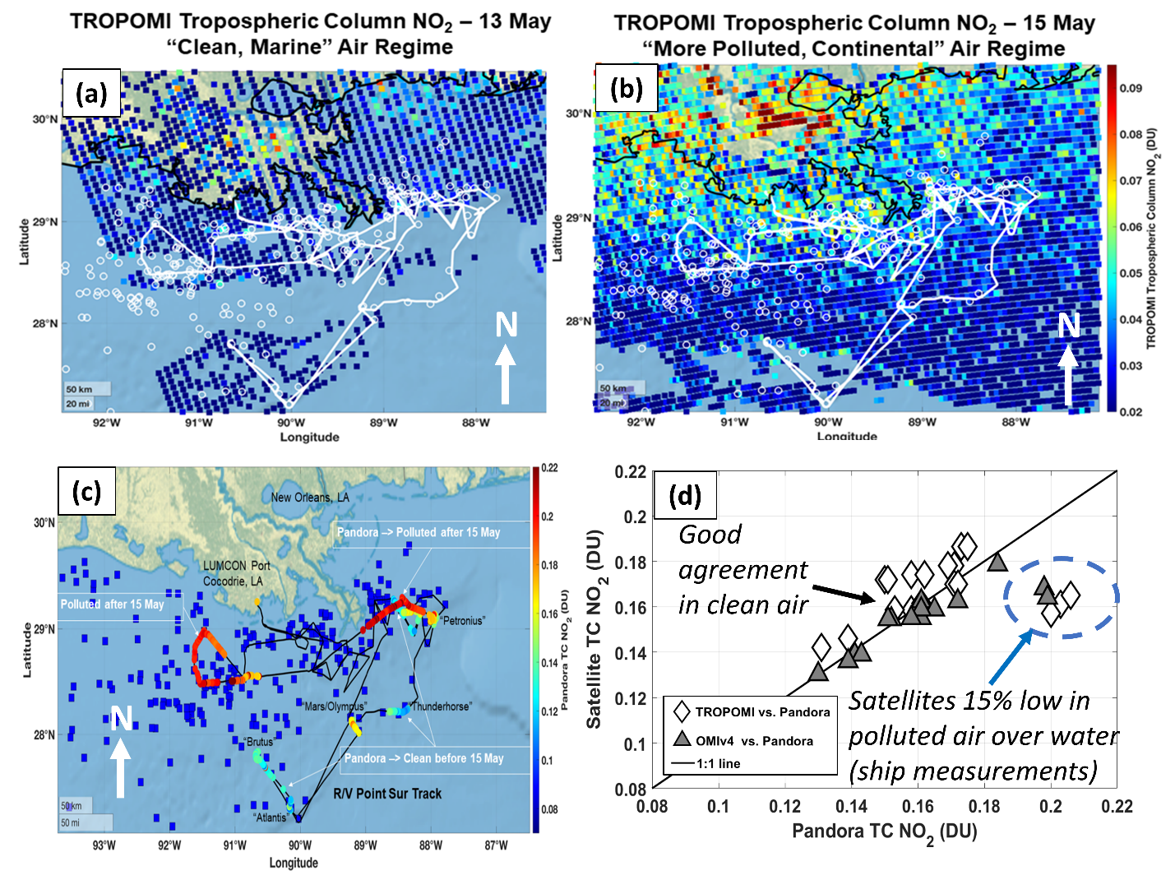
Caption for Graphic or Image: (a) Map of TROPOMI tropospheric column NO₂ on 13 May 2019, during the cleaner portion of the SCOAPE cruise. Shown are the SCOAPE ship cruise track (white line), and the top 200 platform NOx emitters in BOEM’s emissions inventory (white circles). (b) Map of TROPOMI tropospheric column NO₂ on 15 May 2019, during the more polluted portion of the cruise. Shown are the SCOAPE ship cruise track (white line), and the top 200 platform NOx emitters in BOEM’s emissions inventory (white circles). (c) Cruise track (black line) with Pandora ship-based observations of total column NO₂ (TC NO₂) overlaid, showing the cleaner first half of the cruise (blue/green colors), and the more polluted second half (red colors). The top 200 platform NOx emitters in BOEM’s emissions inventory are shown as blue squares. (d) Scatterplot of TROPOMI (white diamonds) and OMI (grey triangles) total column NO₂ (TC NO₂) comparisons with Pandora during the cruise from both land and ship observations. Agreement is generally within 5%, except during the more polluted period during the cruise from shipboard Pandora observations (blue circle). OMI agreement is slightly better than TROPOMI.
Author name and business email: Holli Ensz; Holli.Ensz@BOEM.gov

DOI agency/bureau: BOEM
USGS Mission Area:
USGS Program:
Cost Center:
Program Name: Environmental Studies Program
Project title: Detecting Whale Aggregations from Space
Project description: Monitoring whales and seals is of broad interest to BOEM, academic and commercial institutions, and other Federal entities. Advancements in very high resolution (VHR) satellite imagery, cloud computing, and artificial intelligence have tremendous potential for developing an operational system to detect marine mammals worldwide. Recent research has demonstrated the feasibility of identifying whales from VHR satellite imagery with manual and machine learning approaches. In collaboration with NOAA Fisheries, the Naval Research Laboratory, and the British Antarctic Survey, BOEM has been exploring developing an operational system to detect marine mammals from VHR imagery. While still in the early stages, researchers hope to raise awareness of this effort's research community and invite further information exchange. Large volumes of Maxar imagery over known seasonal aggregations of the North Atlantic right whale, the Cook Inlet beluga whale, and bowhead whales in the Beaufort Sea were acquired from the WorldView-3, WorldView-2, and GeoEye satellites. Explorations into satellite imagery formats and processing led to the decision to focus on using level 1A Standard GeoTIFFs projected in UTM and pansharpening after image acquisition. The team continues to explore different software platforms for image annotation and plans to annotate some imagery in the coming year in collaboration with Maxar's GeoHive platform. Creating a sizeable standardized dataset of high-quality annotations is a necessary precursor to successful machine learning approaches. Working closely with the Microsoft AI for Earth program, the team will develop marine mammal detection algorithms and cloud processing workflows. These efforts should lay the groundwork for future generations of scientists to have another tool in the toolbox as we seek to understand and protect marine mammals worldwide.
Sensor Type: Multispectral (approx. 4-12 bands);
Platform type: Satellite;
URL:
Graphic or Image name: boem_whales_from_space.png
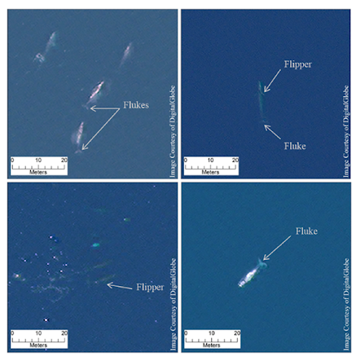
Caption for Graphic or Image: WorldView-3 satellite image detections of four “definite” gray whales (top left), a “definite” fin whale (top right), two “definite” humpback whales (bottom left), and a “definite” Southern right whale (bottom right). Adapted from “Whales from space: Four mysticete species described using new VHR satellite imagery,” by Hannah Cubaynes et al, 2018.
Author name and business email: Timothy White timothy.white@boem.gov

