DOI agency/bureau: BOEM
USGS Mission Area:
USGS Program:
Cost Center:
Program Name: Office of Environmental Programs
Project title: Assessing the Feasibility of using Satellite Data for Offshore Air Quality Applications
Project description: DOI’s Bureau of Ocean Energy Management (BOEM) is required to analyze the air quality impacts from Outer Continental Shelf (OCS) oil and gas activities as mandated by the Outer Continental Shelf Lands Act (OCSLA) and the National Environmental Policy Act (NEPA). This interagency agreement involves working with the National Aeronautics and Space Administration’s (NASA) Atmospheric Chemistry and Dynamics Laboratory at Goddard Space Flight Center to assess the probability of use of satellite data for offshore air quality assessments.

The purposes of this inter-agency agreement were to conduct a scoping study to assess the applicability of existing satellite datasets for offshore environments and validate the satellite data with offshore monitoring in a field campaign. Specifically, this scoping study determined the feasibility of using satellite data in offshore environments in the Gulf of Mexico Region for estimating and monitoring trends of the ground level concentrations of criteria National Ambient Air Quality Standards (NAAQS), precursors, and visibility pollutants.

The final results indicated two air quality "regimes" exist in the Gulf of Mexico Region: (1) clean marine, when the wind direction is from the south, or ocean based and (2) polluted continental air, when the wind direction is from the north, or land based. In addition, using the TROPOspheric Monitoring Instrument (TROPOMI) NO2 data, Visible Infrared Imaging Radiometer Suite (VIIRS), and a HYSPLIT back trajectory model, a flaring event was seen from two oil and gas (O&G) platforms. This data, along with other ground and ship-based Pandora NO2 observations on the cruise, indicates that TROPOMI is useful to BOEM for measuring the Gulf of Mexico and coastal pollution. TROPOMI Total Column NO2 satellite data correlated well with both the coastal and shipboard Pandora spectrometers that provided independent ground-truth. Under clean air conditions, satellite-Pandora agreement was 5%; for more polluted conditions, agreement was 15-20%. These results indicate that satellite data can be used for offshore applications. Final reports and collection of monitoring data are posted at the URLs listed below.
Sensor Type: Satellite;
Platform type: Ground based / sensor web / web cam;Satellite;
URL: https://marinecadastre.gov/espis/#/search/study/100183
Graphic or Image name: BOEM NASA IA TROPOMI vs Pandora 07082021
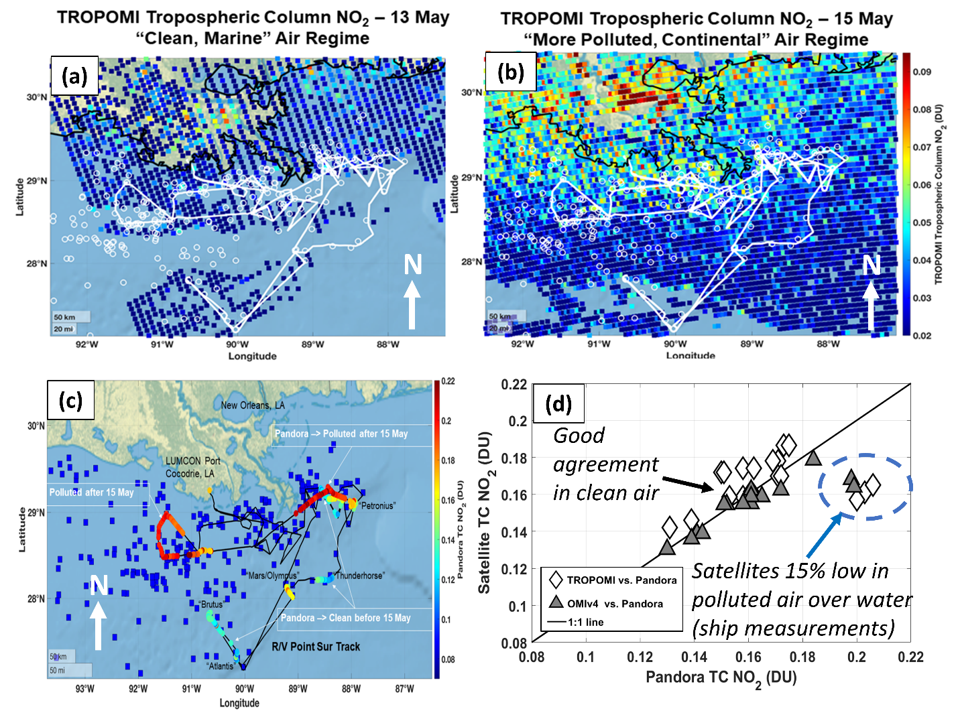
Caption for Graphic or Image: (a) Map of TROPOMI tropospheric column NO2 on 13 May 2019, during the cleaner portion of the SCOAPE cruise. Shown are the SCOAPE ship cruise track (white line), and the top 200 platform NOx emitters in BOEM’s emissions inventory (white circles). (b) Map of TROPOMI tropospheric column NO2 on 15 May 2019, during the more polluted portion of the cruise. Shown are the SCOAPE ship cruise track (white line), and the top 200 platform NOx emitters in BOEM’s emissions inventory (white circles). (c) Cruise track (black line) with Pandora ship-based observations of total column NO2 (TC NO2) overlaid, showing the cleaner first half of the cruise (blue/green colors), and the more polluted second half (red colors). The top 200 platform NOx emitters in BOEM’s emissions inventory are shown as blue squares. (d) Scatter plot of TROPOMI (white diamonds) and OMI (grey triangles) total column NO2 (TC NO2) comparisons with Pandora during the cruise from both land and ship observations. Agreement is generally within 5%, except during the more polluted period during the cruise from shipboard Pandora observations (blue circle). OMI agreement is slightly better than TROPOMI. (Debra Kollonige, Ryan Stauffer, Anne Thompson 2019).
Author name and business email: Holli Ensz; Holli.Ensz@BOEM.gov

DOI agency/bureau: BOEM
USGS Mission Area:
USGS Program:
Cost Center:
Program Name: Environmental Studies Program
Project title: Detecting Whale Aggregations from Space
Project description: Monitoring whales and seals is of broad interest to the Bureau of Ocean Energy Management, academic and commercial institutions, and other federal entities. Advancements in very high resolution (VHR) satellite imagery, cloud computing, and artificial intelligence have tremendous potential for developing an operational system to detect marine mammals worldwide. Recent research has demonstrated the feasibility of identifying whales from VHR satellite imagery with manual and machine learning approaches. In collaboration with NOAA Fisheries, the Naval Research Laboratory, and the British Antarctic Survey, the Bureau of Ocean Energy Management has been exploring developing an operational system to detect marine mammals from VHR imagery. While still in the early stages, we hope to raise awareness of this effort's research community and invite further information exchange. We have acquired large volumes of Maxar imagery over known seasonal aggregations of the North Atlantic right whale, the Cook Inlet beluga whale, and bowhead whales in the Beaufort Sea from WorldView-3, WorldView-2, and GeoEye satellites. Explorations into satellite imagery formats and processing have led to our decision to focus on using level 1A Standard GeoTIFFs projected in UTM and doing our pansharpening after image acquisition. We continue to explore different software platforms for image annotation and plan to annotate some imagery in the coming year in collaboration with Maxar's GeoHive platform. Creating a sizeable standardized dataset of high-quality annotations is a necessary precursor to successful machine learning approaches. We will be working closely with the Microsoft AI for Earth program to develop marine mammal detection algorithms and cloud processing workflows. These efforts should lay the groundwork for future generations of scientists to have another tool in the toolbox as we seek to understand and protect marine mammals worldwide.
Sensor Type: Multispectral (approx. 4-12 bands);
Platform type: Satellite;
URL:
Graphic or Image name: boem_whales_from_space.png
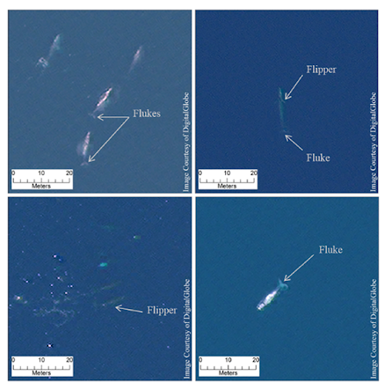
Caption for Graphic or Image: WorldView-3 satellite image detections of four “definite” gray whales (top left), a “definite” fin whale (top right), two “definite” humpback whales (bottom left) and a “definite” Southern right whale (bottom right). Adapted from “Whales from space: Four mysticete species described using new VHR satellite imagery,” by Hannah Cubaynes et al, 2018.
Author name and business email: Timothy White timothy.white@boem.gov

